MSc Data and Artificial Intelligence
Advanced Statistical Programming
ACCA7022
Data Analysis

Student Name: Jure Jurcevic
Student Number: 2212275
Lecturer: Dr. Aliyu Sambo
Date: 18/03/2026
Contents
Visualisations 3
Time Series Line Plots (CO and NO₂) 3
Scatterplots with LOESS Smoothers 4
Correlogram and Boxplots 5
Challenges and Things Learned 6
Improvements for Future Work 8

Use of AI: During the project, I used generative AI as a research aid to deepen my understanding of statistical concepts, explore which tests are appropriate for skewed environmental data, and learn about the atmospheric science behind pollutant dispersion patterns. All code was written and executed by me in RStudio, and all results were independently interpreted by me in the context of the dataset.

Visualisations
The analysis required translating raw hourly sensor data into visual narratives that could reveal temporal patterns, bivariate relationships, and distributional differences. Every plot type was chosen deliberately to match the structure of the question being asked, and the ggplot2 package provided the grammatical flexibility needed to layer aesthetics consistently across all figures.

Time Series Line Plots (CO and NO₂)
I chose line plots for temporal exploration of CO and NO₂ because time series data is inherently ordered and continuous, a line naturally communicates the trajectory and rhythm of reading across months. As shown in Figure 1, the plots revealed clear seasonality, CO concentrations peaked during winter months (December to February, reaching 8-10 mg/m³) and fell sharply during summer (bellow 1 mg/m³). NO₂ displayed a similar pattern, with winter spikes exceeding 250 µg/m³. The rapid oscillations within each month reflect diurnal rush hour traffic cycles. To manage the density of nearly 9400 hourly observations, I sampled 3000 points with a fixed random seed for reproducibility, using semi transparent lines so that overlapping regions still communicated density.
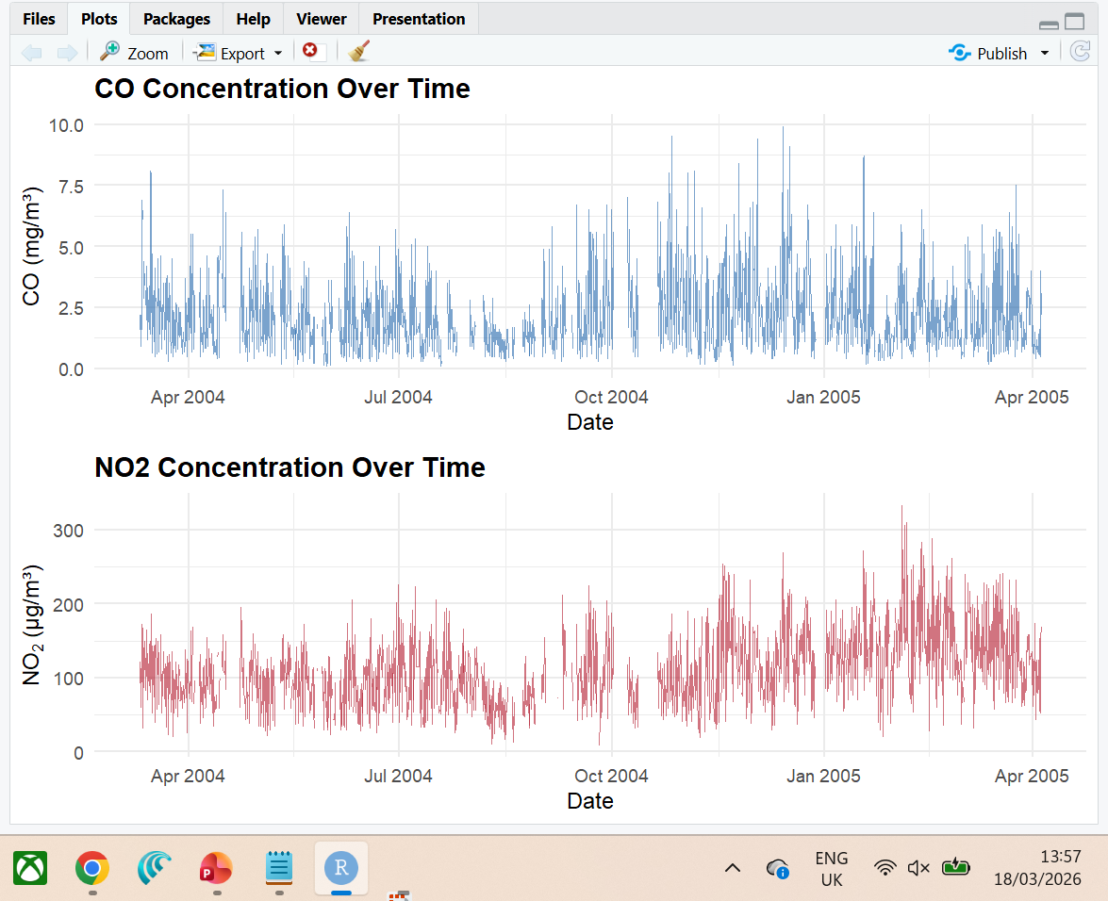
Figure 1 Time-series plots of CO (top) and NO₂ (bottom) concentrations from March 2004 to April 2005.

Scatterplots with LOESS Smoothers
Scatterplots were the natural choice for investigating bivariate relationships because they display every observation as a point, revelling both the overall trend and the spread of residuals. I added LOESS smoothers to capture non-linear trends. As visible in Figure 2, the NO₂ vs Temperature plot showed a downward curve – NO₂ peaked around 5 – 10°C and fell at higher temperatures, consistent with better atmospheric dispersion in warm conditions. The CO vs Humidity plot showed a slightly positive trend, suggesting that humid, stagnant conditions trap CO near ground level.
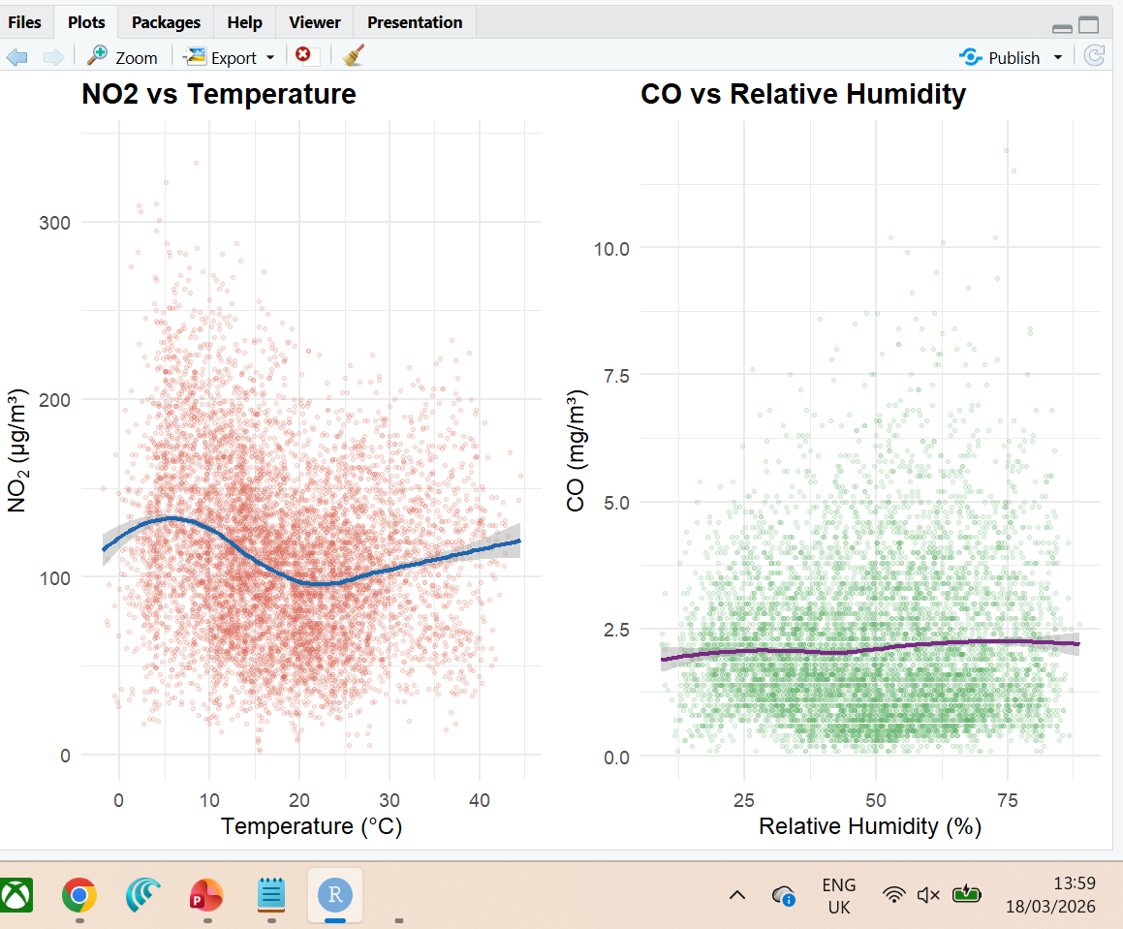
Figure 2 Scatterplots with LOESS smoothers, NO₂ vs Temperature (left) and CO vs Relative Humidity (right).

Correlogram and Boxplots
The correlogram (Figure 3) was selected over a raw numeric matrix because colour intensity communicates magnitude instantly; hierarchical clustering re-ordered the variables so that correlated groups sat adjacent. The results confirmed that CO and C₆H₆ are very strongly correlated (r = 0.93), which is chemically expected since both are products of incomplete combustion from vehicular traffic. NO₂ and NOx showed strong positive correlation (r = 0.76), and Temperature was negatively correlated with both NOx (r = -0.27) and NO₂ (r = -0.19), reflecting greater atmospheric dispersion in warm conditions. For the hypothesis testing and seasonal comparison tasks, boxplots were chosen because they display the median, interquartile range, and outliers in a single glyph, making group comparisons immediate (Figures 4 and 5).
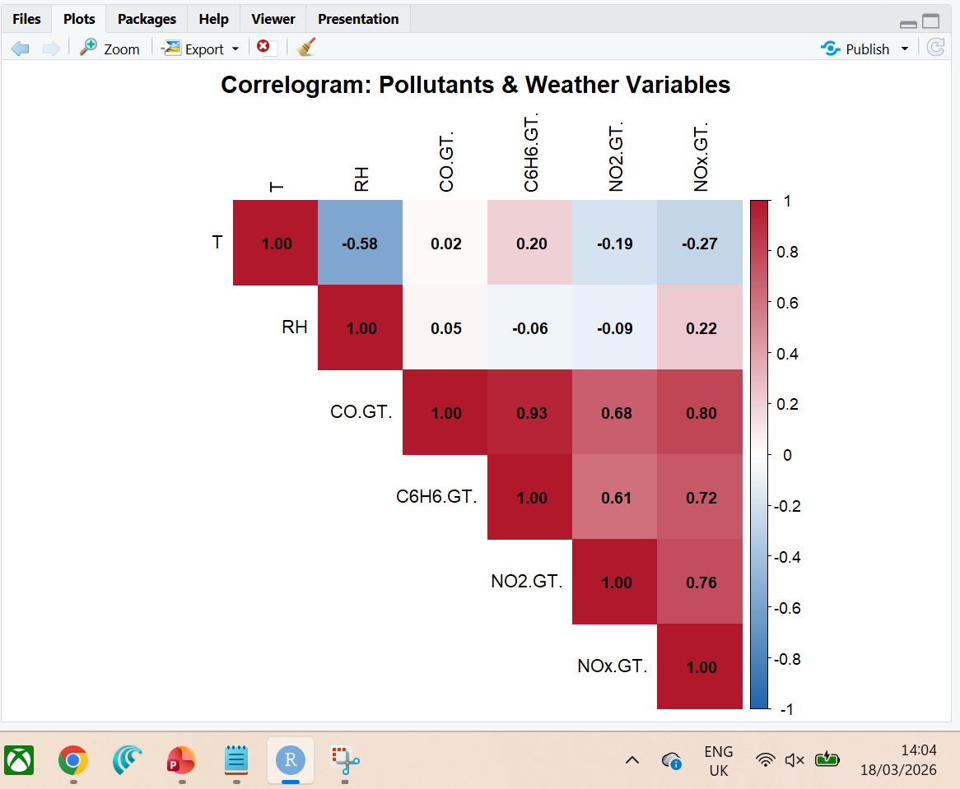
Figure 3 Correlogram heatmap with hierarchical clustering and numeric coefficients.

Challenges and Things Learned
The most immediate challenge was the dataset’s European formatting: semicolon delimiters, commas as decimal separators, and a time column encoded with periods instead of colons (e.g. 18.00.00). Misreading the separator would have produced a single column data frame of concatenated strings, so careful use of read.csv with sep = “;” and dec = “,” was critical. The sentinel value of -200 for missing readings was a second problem, it left uncleaned, it dragged down means dramatically and distorted every correlation. Replacing -200 with NA across all numeric columns was one of the first preprocessing steps.
Choosing between parametric and non-parametric tests was an important learning moment. I researched the assumptions behind the two-sample t-test and learned that the NO₂ data’s heavy right skew and outliers reaching 340 µg/m³ violate the normality assumption. Switching to the Wilcoxon rank sum test produced a highly significant results (p = 4.84 × 10⁻⁶²), confirming that NO₂ levels are significantly higher during low temperature conditions (Figure 4) The same reasoning guided the choice of Kruskal Wallis over one way ANOVA for the seasonal comparison, which also proved highly significant (χ² = 248.43, p < 2.2 × 10⁻¹⁶). Post hoc pairwise Wilcoxon test with Bonferroni correction confirmed that all six pairs differed significantly, with Winter showing the highest mean CO (2.32 mg/m³) and Summer the lowest (1.69 mg/m³), as visualised in Figure 5.
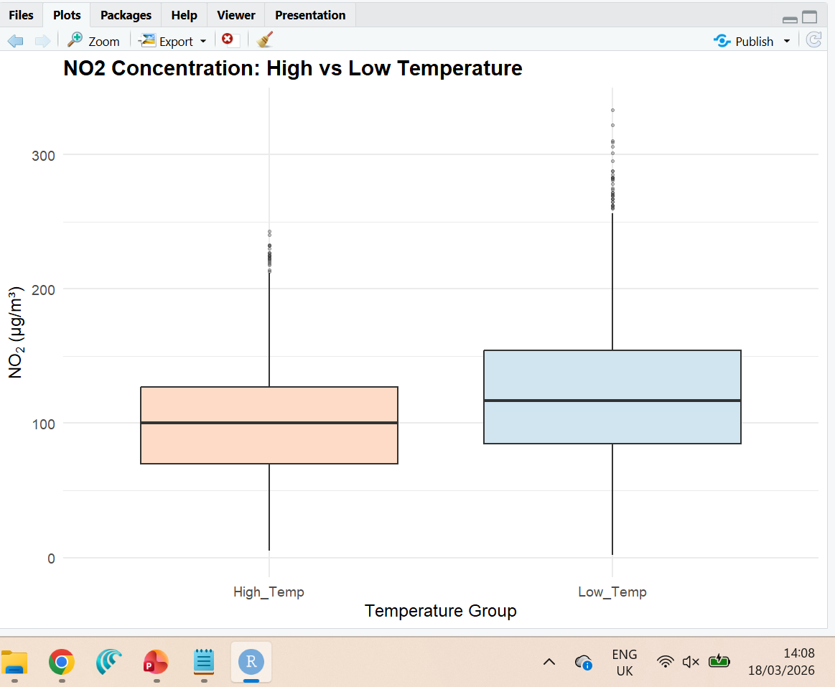
Figure 4 Boxplot of NO₂ concentration by temperature group, higher levels in cooler conditions.
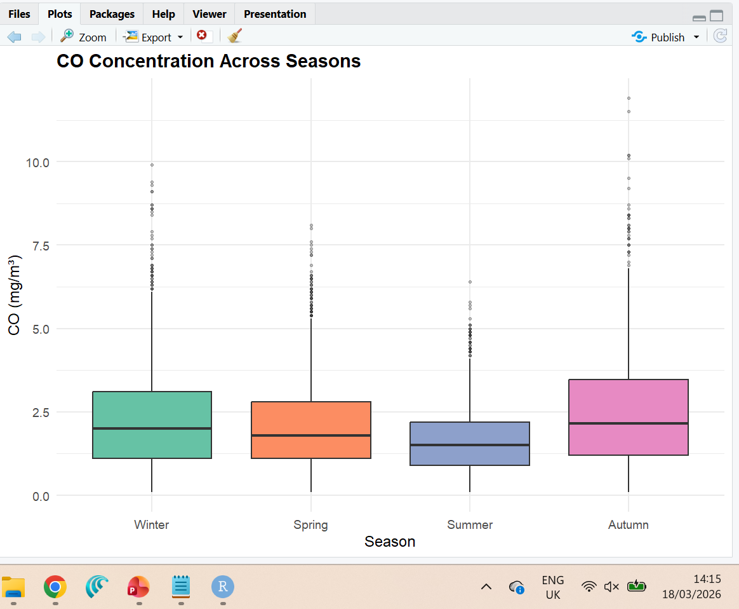
Figure 5 Boxplot of CO concentration across seasons, Winter highest, Summer lowest.
Another challenge was the absence of a direct wind speed variable in the dataset. Through my research into atmospheric science, I learned that surface temperature is a strong proxy for convective mixing and pollutant dispersion. I applied this domain knowledge by splitting the data at the median temperature and comparing NO₂ levels between the two groups. This required reasoning beyond pure statistics and taught me that effective data analysis demands understanding the domain context behind the variables, not just the numbers themselves.

Improvements for Future Work
If I were to repeat this analysis, I would integrate external wind speed data from a nearby weather station so that the hypothesis test could compare pollutant levels under genuinely different wind conditions rather than relying on a temperature proxy. I would also explore time lagged correlation, since pollutant concentrations at hour t may be influenced by meteorological conditions at hours t-1 or t-2, a cross corelation functions would capture this dynamic more accurately than a statis Pearson coefficient.
On the modelling side, fitting a multiple linear regression or a random forest model to predict NO₂ from the remaining variables would move the project from descriptive to predictive analytics. Also, interactive visualisations using the plotly package would allow a reader to hover over points and zoom into specific time windows, which is far more informative than static plots for exploratory work.
Finally, I would adopt a more rigorous approach to outlier treatment. In this analysis I simply excluded -200 sentinels, but some genuine extreme readings may also be sensor errors, applying a robust outlier detection method such as the IQR rule or DBSCAN clustering on multivariate sensor readings could further improve data quality and the reliability of downstream statistical tests. I would also consider using the tidyverse ecosystem more fully, including dplyr for data wrangling and purr for functional programming, to make the pipeline more concise and reproducible.

