Serena Jonathan (2306363)

Maze Pathfinding implementation
ACCB5011: Advanced Software Development

Contents
Dijkstra’s Algorithm 2
A* Algorithm 3
Comparison 5
Reflection of the Developing Process 5
Conclusion 10
Bibliography 11

Dijkstra’s Algorithm
Dijkstra’s algorithm is a path-finding algorithm that is used to discover the shortest path within a graph between two nodes. [1] A visual demonstration of such as graph has been included below.
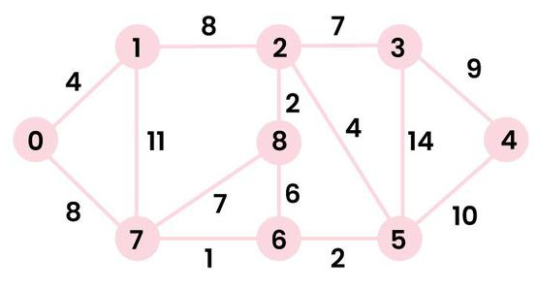
Figure 1: Graph with No Negative Edges Showing Dijkstra's Algorithm [2]
The diagram within ‘Figure 1’ has nodes which are also known as vertices and also has edges with weights. But it does not have any negative edges. This means that between these nodes have assigned weights, representing the cost or distance to traverse from one node to another and do not hold any negative values. The root node for this graph above is ‘0’, Dijkstra’s algorithm will then find the shortest path from here to all other vertices within the graph.
The Dijkstra’s algorithm is a very popular algorithm, useful for solving various single-source problems because of its ability to find the shortest path. Single-source problems involve finding the shortest path from a source node to every other node within a weighted graph [3]
finding the shortest path from a source node to all other nodes in a weighted graph
It was implemented by a computer scientist by the name of Edsger W. Dijkstra in 1956. [4] This algorithm keeps track of two separate groups of nodes simultaneously. This includes the nodes it has already visited and the nodes that it has yet to visit. It begins at the root node and repeatedly chooses the nodes it has yet to visit that are closest to the root node. The process in which it does this is once the root node is visited it will select the closest unvisited node. Next, Dijkstra’s algorithm will check all nodes connected to its neighbours and calculate the distance between these neighbours and the current node. If it discovers that the distance is less than the one previously recorded with other nodes it will update this distance to the neighbour. The algorithm will repeat this behaviour until it reaches its final node destination or until it has exhausted all options of which nodes it can get to. [5]
There are various scenarios in which this algorithm would be a useful tool for software engineers. For example, many video game developers may use it to concoct the shortest path for non-player characters to navigate the game’s world efficiently. [6] It may also be used within navigation systems to calculate the shortest route between one location to another [7] or also for within routers to calculate the shortest route to use when sending data. [8]

A* Algorithm
A* algorithm is a path-finding algorithm for finding the shortest path between two points within a graph which in turn retrieves the quickest solution to a problem. It is very popular with path-finding and graph traversals. [9] This algorithm is built on concepts established within Dijkstra’ algorithm but provides a quicker solution. It does this by including a heuristic element to assist with deciding the next node to consider simultaneously with its movements along the path. [10] A heuristic element will provide a higher level of efficiency by reducing the search space. It prioritises which paths to take. This leads to a faster and more practical approach to solving problems, especially within environments which are complex or very large in scale. The heuristic must always remain admissible and consistent. [11]
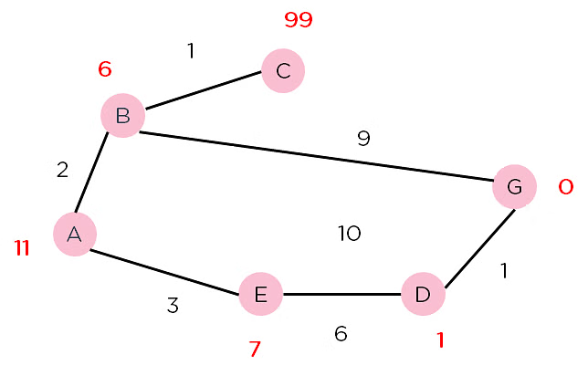
Figure 2: A* Algorithm Process with a Weighted Graph [12]
Figure 2 shows a graph with the nodes represented by pink circles and the heuristic values are represented by numbers above the nodes. Whereas the weights of the paths along the node are presented by black numbers. This graph represents the process of the A* algorithm. The process includes two sets when conducting a search. This includes open set and closed set. [13] The open set involves nodes waiting to be evaluated. Whereas closed set include nodes have already been checked. [14] Firstly, the algorithm will begin with adding the root node to the open set and then will begin exploring neighbouring nodes based on their costs. The cost refers to the amount of effort taken to reach a certain node from its starting point. Each node is evaluated with three values. These include ‘g(n)’, ‘h(n)’ and ‘f(n)’. ‘g(n)’ is known as the actual cost from the beginning. ‘h(n)’ is the estimated cost to the final goal and ‘f(n)’ is the sum of ‘g(n)’ and ‘h(n)’, Finally, A* algorithm will identify and use the node with the lowest f(n) from the open set so that the quickest path to solve an issue is achieved. [15]
The A* algorithm is used by many software developers for features such as pathfinding within video games. It helps characters navigate the virtual world but in a more advanced way than Dijkstra’s algorithm, it helps characters find the quickest path and avoid obstacles, creating a sense of realism within the character. [16] It is also used in air traffic control systems to discover the most efficient flight paths to avoid collisions and reduce fuel use and used within self-driving cars to ensure obstacles are avoiding and the best routes are taken. [17]

Comparison
Although Dijkstra’s algorithm and the A* algorithm are very similar, there still have their differences. The similarities to note firstly would be that they are both path-finding algorithms with the aim of finding the shortest path within a weighted graph. They both share the aim of finding the shortest path between root node and goal node. Another similarity would be that they both explore nodes in a similar nature, keeping track of nodes that have been visited and those that have yet to be visited until the goal node is reached. However, some differences would be that the A* algorithm uses the heuristic function whereas Dijkstra’s Algorithm does not. Furthermore, the A* algorithm is seen as the more efficient algorithm because of this function, as it prioritises the best paths. This means it will have less search space than if Dijkstra’s algorithm was used. Unlike the A* algorithm, Dijkstra’s algorithm explores all possibilities in a uniform manner, some of these possible paths may be unnecessary. To conclude, although they both have very similar uses, Dijkstra’s algorithm is more suited for generalised path-finding problems with short paths where the main goal is to discover the shortest path to all nodes. Whereas the A* algorithm is best suited for specific known goals where it is crucial that obstacles are avoided to find the most efficient path, such as video games with realistic characters or self-driving cars.

Reflection of the Developing Process
The initial strategy for guiding the player to complete the maze involved keeping the player close to the left wall until the target was reached. The written code uses methods such as initialisation, with the ‘(moveresults::ok)’ section which begins with setting a result to signify that the movement was successful and prints the grid in its current state. This is shown in the screenshot below.
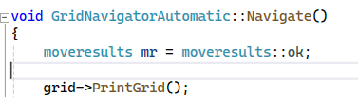
It also uses a direction setup to set up the possible directions the player can move in. This is shown in the below code with “up (0), right (1), down (2), and left (3)”. Then the navigator will begin by trying to move the player upward, as shown on the last line on the screenshot below.
Furthermore, this technique also uses a while loop to navigate the maze, this while loop with continue until the maze is complete or the player is unable to make another move. This is shown below with ”moveresults::complete)”
The outcome of this strategy of staying by the wall on the left until the maze is complete is shown below.
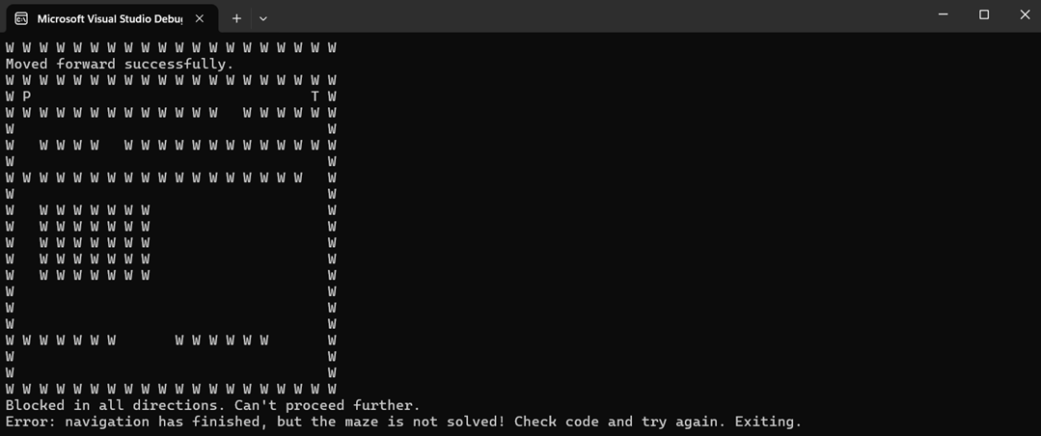 As you can see from the above screenshot, the player becomes blocked in the left-hand corner, opposite the target and exits the loop. However, it quickly became evident that this approach caused difficulties, with the player either getting stuck or struggling to reach the target on the far right of the maze. Since the target is always located in the top right corner, regardless of the maze's design, it seemed more effective to modify the code, so the player stays close to the right wall instead. This adjustment is shown in the screenshots of the updated below.
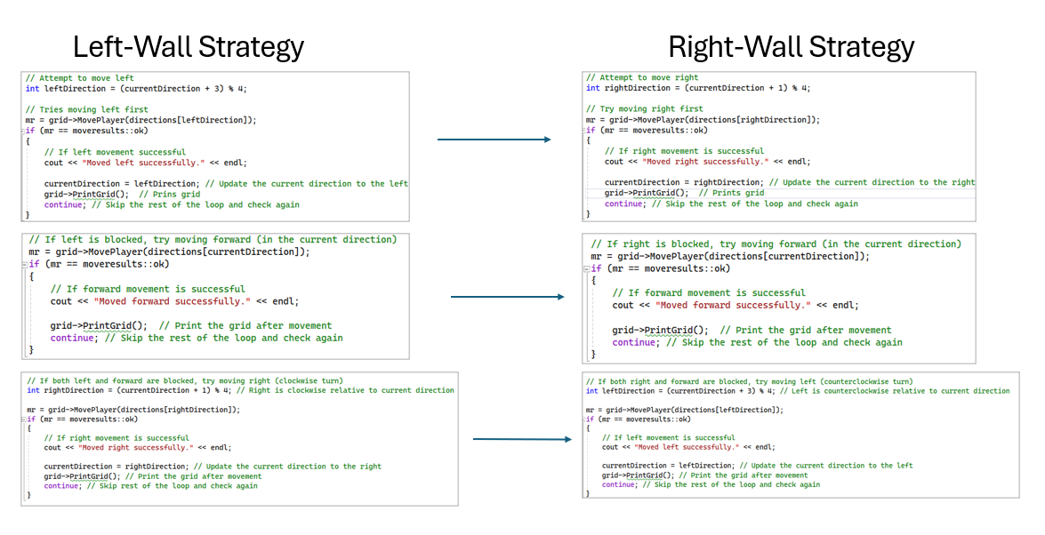The outcome of the right-wall strategy is shown below.
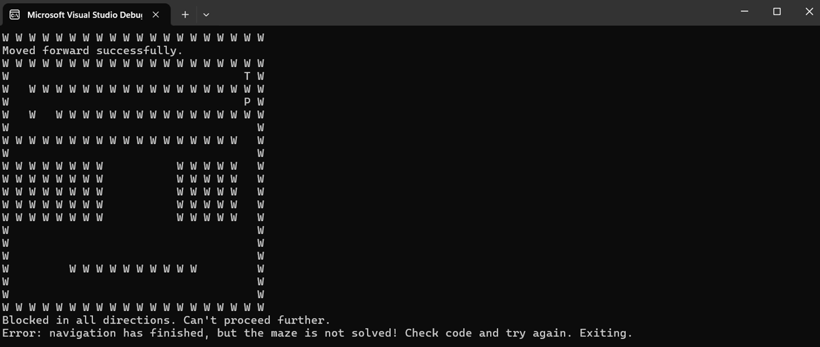
This approach brought the player significantly closer to the 'T' target, as shown in the screenshot above, but some issues remain. It seems that the player becomes trapped in the corner as there is a wall to the right, upward and downward. Although, the player can move left it is behaving as if it is unable to do so. The issue with this solution was that, although the left movement would be open, when the player was unable to move right, up or down the player would become stuck and the code’s process would be terminated. This is undesirable as the player clearly has an opening to the left, but the code’s process would get cut short as the player’s behaviour deemed it not possible to move in this direction.
However, that stated there were some iterations of the maze’s grid design where the code would work, and the player would in fact reach the target. Thus, this approach can be successful sometimes but relies on the structure of the maze.

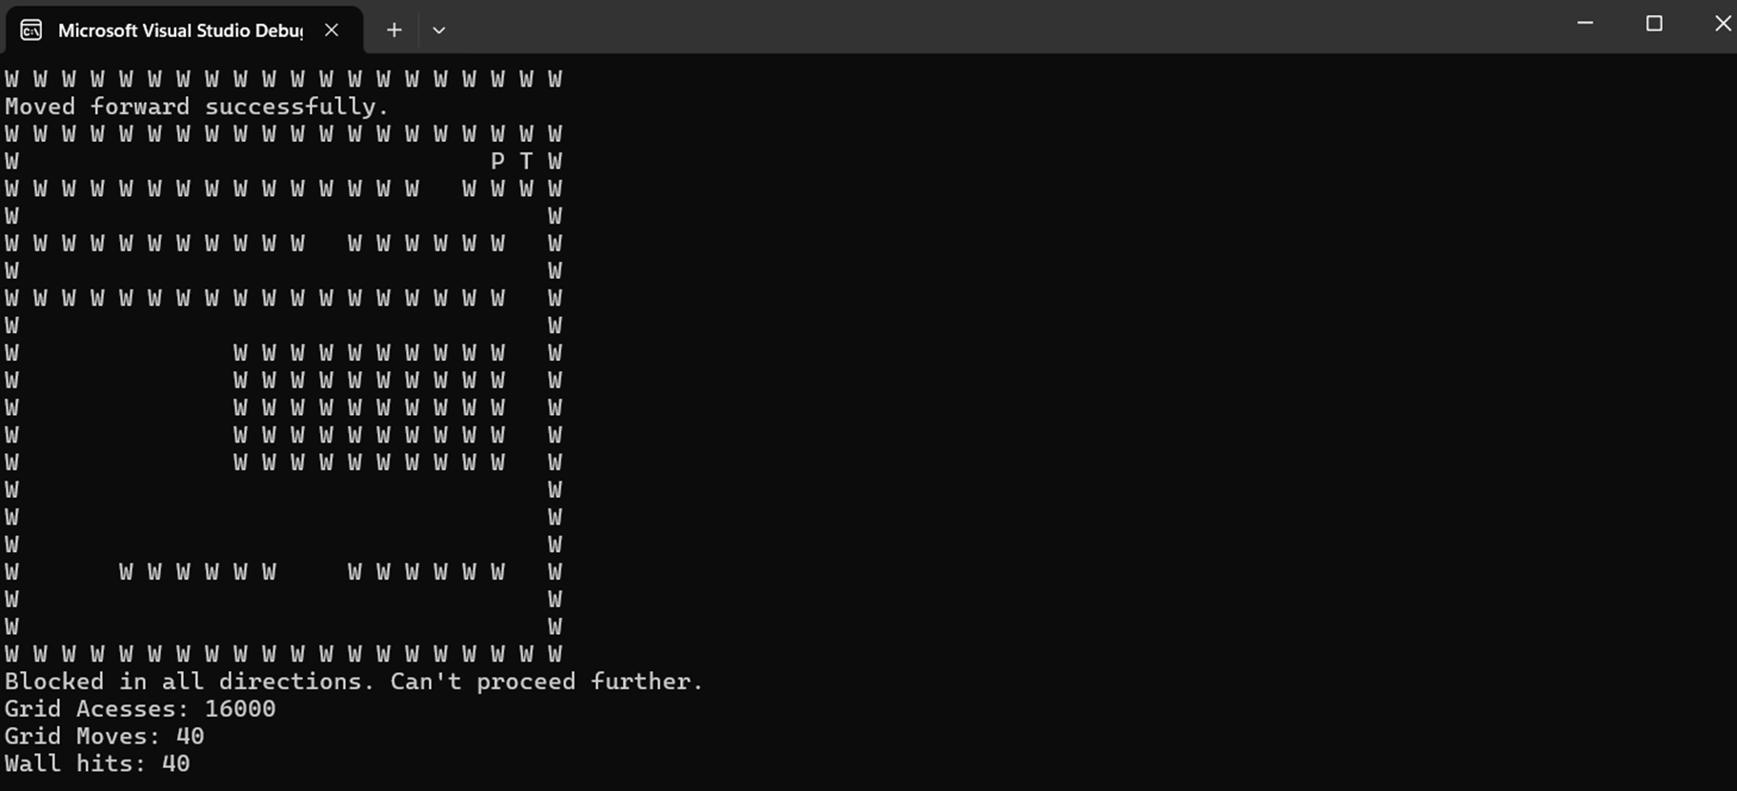
Thus, as shown above, the right-wall strategy has a possibility of being successful depending on the maze’s structure. So, it was thought to add some more strategies onto this one so that the right-wall strategy would be successful every time and would not have to rely on the structure on the maze to reach the target. To do this, the logic within the navigation algorithm must be addressed. The above strategy relies on trying to move in a specific order (right, forward, left) to ensure to stay by the right wall. However, this does not consider times where the play may be trapped in a loop or read a dead end.
Thus, a strategy of programming the player to move horizontally when blocked until it can move vertically was added to the right-wall strategy. So, both strategies have combined to program the player’s movements until the target is reached and the maze is complete.

However, when this approach was first tested, the player became trapped in an infinite loop as shown in the screenshot below.
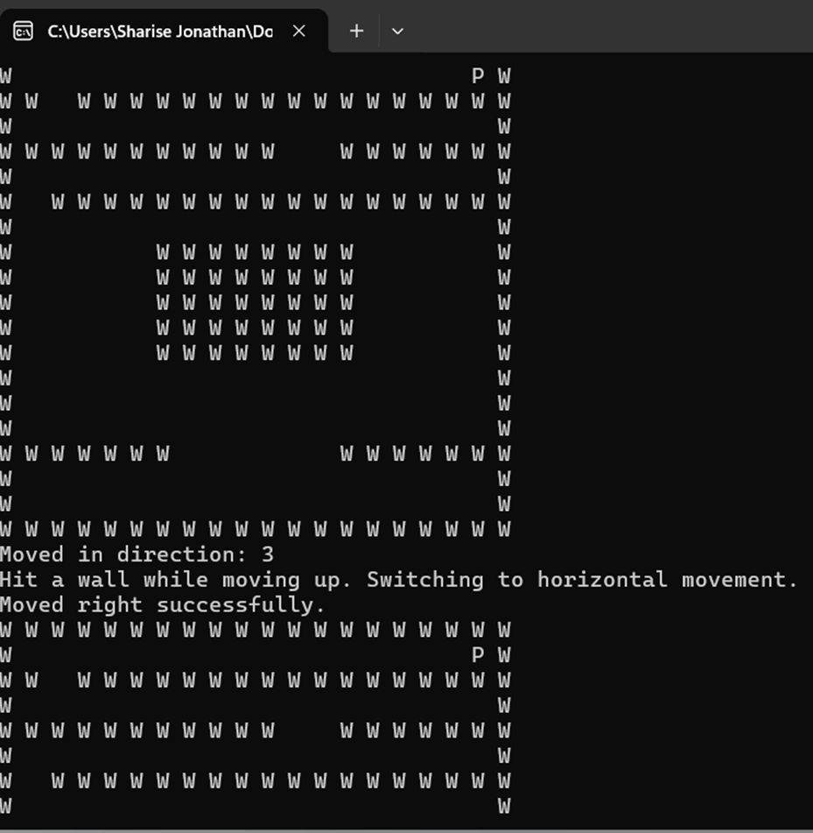
This infinite loop was happening because the player keeps moving horizontally and vertically without checking if it is just repeating the exact same movements repeatedly in a cycle. To solve this, a mechanism was added to track if the player has already visited a position or not so it can break the loop and not become stuck. Thus, for the player to avoid an infinite loop, several important mechanisms must be implemented to handle situations where no further valid movements are possible. The first mechanism is an exit condition for the main loop which is shown below.
This mechanism is a fail safe for the primary condition of the while loop which is based on whether the player has completed the maze or not. The mechanism ensures that the loop is exited if its conditions are not met.
Furthermore, if the player cannot move in its current direction the newly modified code makes it so that the player attempts to move in the other directions, as presented below.
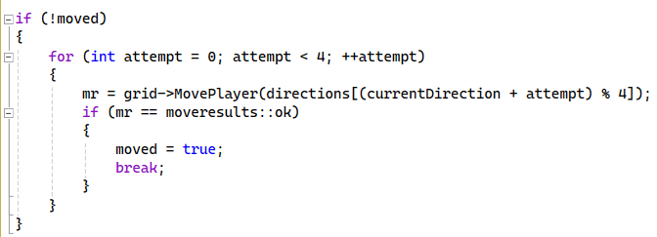
The above code uses a for loop to program the player to try moving in each direction one by one until a valid move is made which is shown in the code with ‘moveresults::ok). If a valid movement is found the loop breaks and the player continues its movements.
Another strategy that is used to avoid the infinite loop is reversing the movement directions as shown in the screenshot below.
This ensures that the player is not stuck in a dead-end or loop where it keeps hitting the same wall in the same direction. Reversing the direction gives the player a chance to break free from a dead end.
A further technique used is early exit on target reached. This ensures that if the player successfully reaches the target on any move, horizontally or vertically, the loop is immediately exited. The written code for this technique is presented below.
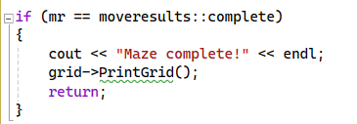
This early exit prevents further unnecessary movements once the maze has been solved, ensuring the program finishes promptly and the player reaches the target efficiently and effectively.
Thus, all these strategies combined help exit the infinite loop and ensure that the player reached the target and successfully completes the maze every time, no matter the structure as demonstrated below.
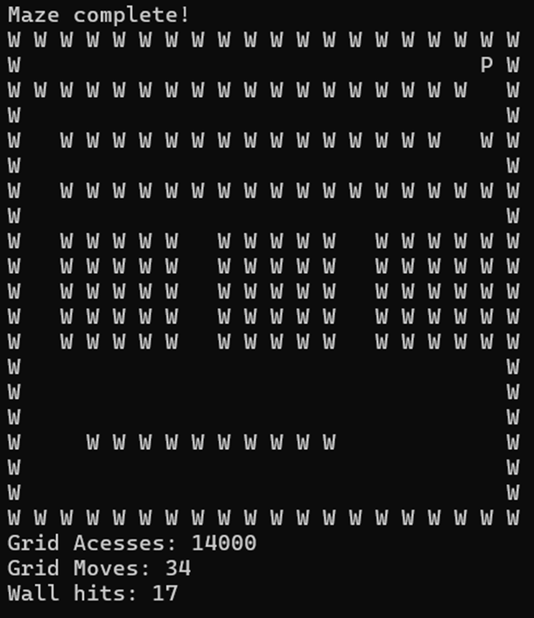
To summarise, the successful code incorporates the right-hand rule but does so in a slightly modified manner and uses a heuristic-based approach. This is because overall successful technique of finishing the maze attempts to prioritise vertical movement first. When this movement becomes blocked it attempts alternating horizontal movements. Then, if the player becomes stuck, it checks every possible direction to find a move that is valid. After this, the navigation continues until the player reaches the target and completes the maze or is blocked in all directions, at which point the loop exits.
Although this approach used heuristics and exhaustive search to complete the maze successfully, there are improvements that could be made. To enhance future iterations, implementing an algorithm could significantly improve the player’s ability to complete the maze more efficiently. Dijkstra's algorithm would be a suitable option as it efficiently finds the shortest path from a starting node to all other nodes in a graph making a great tool for mazes. However, for the most optimal solution, the A* algorithm is ideal, as it finds the best and most efficient path while avoiding obstacles which is perfect for completing a maze with minimal wall hits. Controversy, as the programmer is currently more familiar with C and is relatively new to C++, it may be better to start with simpler algorithms, such as linear or binary search or DFS. Once it is guaranteed that a simpler algorithm is working to assist the player reach the target, they can then progress to more complex ones like the optimal A* algorithm.

Conclusion
To conclude, the maze-solving technique evolved from a left-wall to a right-wall strategy, with added features to avoid the player becoming stuck, such as tracking visited positions, reversing directions, and early exit conditions. The final solution combines the right-wall rule with a heuristic approach, ensuring efficient navigation. Future improvements could include using algorithms like Dijkstra's or A* for better pathfinding, starting with simpler approaches like DFS or linear search for easier implementation.

Bibliography
[1] Getting, “Getting Started with Pathfinding using Dijkstra’s Algorithm,” YouTube, Jun. 24, 2020. https://youtu.be/KGUY2BpC72c?si=UzDcdE9k1CFN9Vr4 (accessed Jan. 09, 2025).

[2] Image. Geeksforgeeks.org, 2025. https://media.geeksforgeeks.org/wp-content/uploads/20240111182238/Working-of-Dijkstras-Algorithm-768.jpg (accessed Jan. 09, 2025). (accessed Jan. 09, 2025).

[3] NVIDIA, “Shortest Path Problem,” NVIDIA Developer, Jul. 29, 2016. https://developer.nvidia.com/discover/shortest-path-problem (accessed Jan. 09, 2025).
‌
[4] “What is Dijkstra’s Algorithm? | Introduction to Dijkstra’s Shortest Path Algorithm,” GeeksforGeeks, Mar. 10, 2023. https://www.geeksforgeeks.org/introduction-to-dijkstras-shortest-path-algorithm/#dijkstras-algorithm (accessed Jan. 09, 2025).

[5] Book. R. Burduk, M. Choras, A. Giełczyk, R. Kozik, and T. Marciniak, Advances in Computer Recognition, Image Processing and Communications, Selected Papers from CORES 2021 and IP&C 2021. MDPI - Multidisciplinary Digital Publishing Institute, 2022. doi: 10.3390/books978-3-0365-5314-6. (accessed Jan. 10, 2025).

[6] M. Ismail, “Comparing the efficiency of Pathfinding Algorithms for NPCs in platform games,” Journal of Positive School Psychology , vol. 6, no. 3, pp. 8434–84418434–8441, 2022, Accessed: Jan. 09, 2025. [Online]. Available: https://mail.journalppw.com/index.php/jpsp/article/view/5109 (accessed Jan. 11, 2025).

[7] Chuang Ruan, Jianping Luo and Yu Wu, "Map navigation system based on optimal Dijkstra algorithm," 2014 IEEE 3rd International Conference on Cloud Computing and Intelligence Systems, Shenzhen, 2014, pp. 559-564, doi: 10.1109/CCIS.2014.7175798. keywords: {Navigation;Algorithm design and analysis;Impedance;Roads;Heating;Optimal path;Dijkstra Alogorithm;Map navigation;Vehicle navigation}, (accessed Jan. 12, 2025).
[8] A. Alam and O. Faruq, “Finding Shortest Path for Road Network Using Dijkstra’s Algorithm,” Centre for Research on Islamic Banking & Finance and Business , Sep. 2019. Accessed: Jan. 11AD. [Online]. Available: https://www.cribfb.com/journal/index.php/BJMSR/article/view/366/600 (accessed Jan. 12, 2025).
[9] R. Belwariar, “A* Search Algorithm - GeeksforGeeks,” GeeksforGeeks, Sep. 07, 2018. https://www.geeksforgeeks.org/a-search-algorithm (accessed Jan. 12, 2025).
[10] “Ada Computer Science,” Ada Computer Science, 2024. https://adacomputerscience.org/concepts/path_a_star (accessed Jan. 12, 2025).
[11] GeeksforGeeks, “Heuristic Function In AI,” GeeksforGeeks, Jun. 2024, doi: https://doi.org/10190709/download-(13). (accessed Jan. 13, 2025).
[12] R. A. S, “A* Algorithm Concepts and Implementation,” Simplilearn.com, Jul. 22, 2021. https://www.simplilearn.com.cach3.com/tutorials/artificial-intelligence-tutorial/a-star-algorithm.html (accessed Jan. 13, 2025).
[13] archenil, “A* (A Star) Algorithm Clarification,” Stack Overflow, Nov. 27, 2012. https://stackoverflow.com/questions/13578287/a-a-star-algorithm-clarification (accessed Jan. 13, 2025).
[14] “Summary of the A* Algorithm.” Available: https://robotics.caltech.edu/wiki/images/e/e0/Astar.pdf (accessed Jan. 13, 2025).
[15] “Algorithms,” cs.stanford.edu. https://cs.stanford.edu/people/eroberts/courses/soco/projects/2003-04/intelligent-search/astar.html (accessed Jan. 14, 2025).
[16] D. Nikolaeva, M. Safi, M. Mihailov, A. Georgiev, V. Bozhikova and M. Stoeva, "Algorithm A* and Design Patterns used in Unity Video Game development," 2020 International Conference Automatics and Informatics (ICAI), Varna, Bulgaria, 2020, pp. 1-3, doi: 10.1109/ICAI50593.2020.9311327 (accessed Jan. 14, 2025).
[17] Book. O. Roeva, Real-World Applications of Genetic Algorithms. BoD – Books on Demand, 2012 (accessed Jan. 14, 2025).
‌

‌

‌

‌

‌

‌

‌

‌

‌

‌

