Improving Social Skills and Emotional Wellbeing

(Community learning project for young people aged 13–16 in Cardiff)
Module: ECES5017
Name: Gundo Susso
Lecturer: Ross

Table of Contents
1 Needs analysis 3
2 Gaps in service 4
3 Plan of action 6
3.1 Learning sequence 7
3.2 Resources and delivery costs 8
3.3 Success criteria and evaluation 9
4 Participation 10
5 Barriers 12
6 Conclusion 14
7 References 15

Needs analysis
This proposal outlines an eight-week community learning programme for 12 young people (aged 13–16) in Cardiff who wish to be supported in relation to peer relationships and emotional wellbeing. The participants would engage in activities that would allow them to communicate, as well as a small community project. The main thesis is that structured learning can be beneficial if youth are able to influence the delivery and have practical support to participate. However, there is a need for an additional programme only if consultation has identified needs that are not being met by existing programmes. It would be used initially to determine feasibility and to evaluate initial changes, not to claim that it would reduce mental illness.
Social skills here are defined as expressing likes and dislikes, listening, disagreeing and asking for assistance. Emotional wellbeing relates to the way that young people feel and cope with their day-to-day emotions and relationships. These outcomes are not interchangeable and improvement in one does not indicate improvement in the other. A participant may feel more comfortable voicing his or her disagreement but still feel distress at home. Similarly, quiet participation can be an indication of a comfortable communication style. The programme would thus not consider sociability, eye contact or compliance to be signs of wellbeing.
There is Welsh evidence that provides a rationale for needs assessment. The School Health Research Network (SHRN) survey in 2023 found that 35% of 11–16-year-olds felt lonely at least some of the time in the previous summer holidays, with almost 42% of girls and 27% of boys reporting this (Strawbridge, Boffey and Wooders, 2025). This covers a specific time frame and an age range that is broader than that of the proposed cohort. It does not estimate the prevalence of loneliness in Cardiff, nor does it show that loneliness is a consequence of poor social skills. Limited contact with friends might also contribute to loneliness. Recruitment should therefore seek to understand from young people what is hindering their social connections, rather than assume that they need an educational solution.
Cardiff's own profile makes it difficult to give a simple answer to the question of poor wellbeing. In 2023, it had a higher-than-average mental wellbeing score for 11–16-year-olds in Wales and was ranked second highest among local authorities in Wales. However, provisional data for 2023/24 revealed that 23.4% of Cardiff children under 16 were living in low-income families, with the highest proportion in Butetown (Cardiff Public Services Board, 2025) at 52.6% and the lowest in Llandaff and Radyr at 5.2%. Whilst these area statistics cannot tell you what an individual's needs are, city averages can mask inequalities in opportunities. They inform accessible recruitment throughout neighbourhoods, and further outreach where the costs of participation may be more difficult to meet.
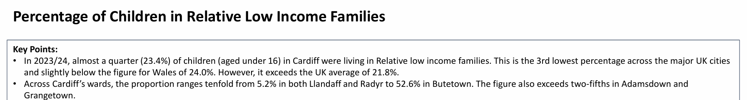
(Cardiff Public Services Board, 2025)
These sources are used for various reasons. School survey responses refer to experiences reported and income statistics refer to household situations. Demand for this specific programme is not established by either measure. The SHRN survey uses a repeated cross-sectional design, as described by Page et al. (2024), and in 2023, 75% of pupils responded.
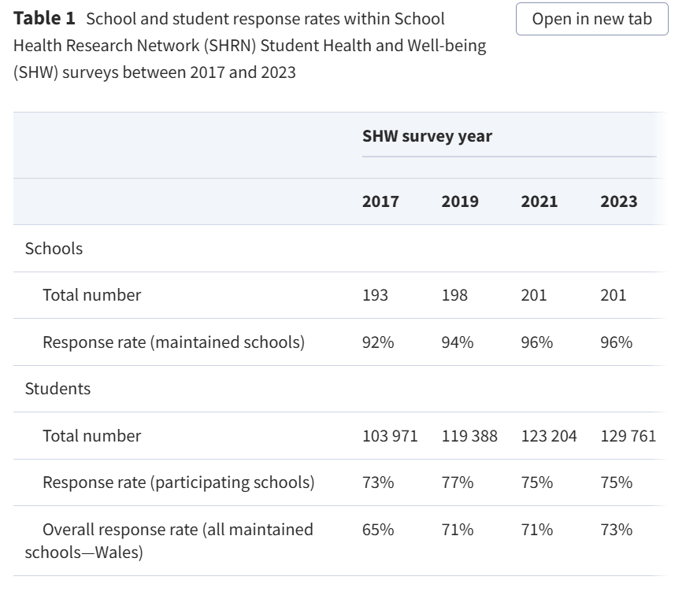
(Page et al., 2024)
It is on a scale that can be used for population planning, though it is difficult to interpret due to self-report and non-response. Youth who are not in school on the day of the survey may also not be captured in school-based surveys. Any changes between survey years are not necessarily changes within the same individuals. The needs assessment would thus include published evidence and two small listening groups and an anonymous paper or online questionnaire, provided via proposed school and youth-service contacts. Questions would cover preferred activities, provision in place, language, transport and circumstances when support is desired. Participation would be voluntary and there would be no request for diagnostic histories.
Targeted consultation would be carried out with young people who are not currently involved in youth groups. If not, then the programme organisers risk creating a programme that repeats the exclusions these young people are already experiencing. No identifiable subgroup profiles would be published, and responses would be compared by recruitment route. Organisational constraints may be explained by staff accounts, but young people's accounts would indicate whether the proposed learning goals are of importance to them.

Gaps in service
There is statutory and voluntary provision in Cardiff which is relevant to this proposal. Cardiff Youth Service supports young people aged 11–25, both individually and through group activities, including those at youth centres (Cardiff Council, 2026a). Schools also offer an avenue to independent counselling. In 2024/25, 13,428 children and young people were counselled across Wales with education staff making 61% of referrals. 19% of the recipients were in Year 9 (Welsh Government, 2026a). These numbers show that support is provided to adolescents and there is a support system in place. They do not show the number of Cardiff young people who are not accessing help or establish that provision is inadequate.
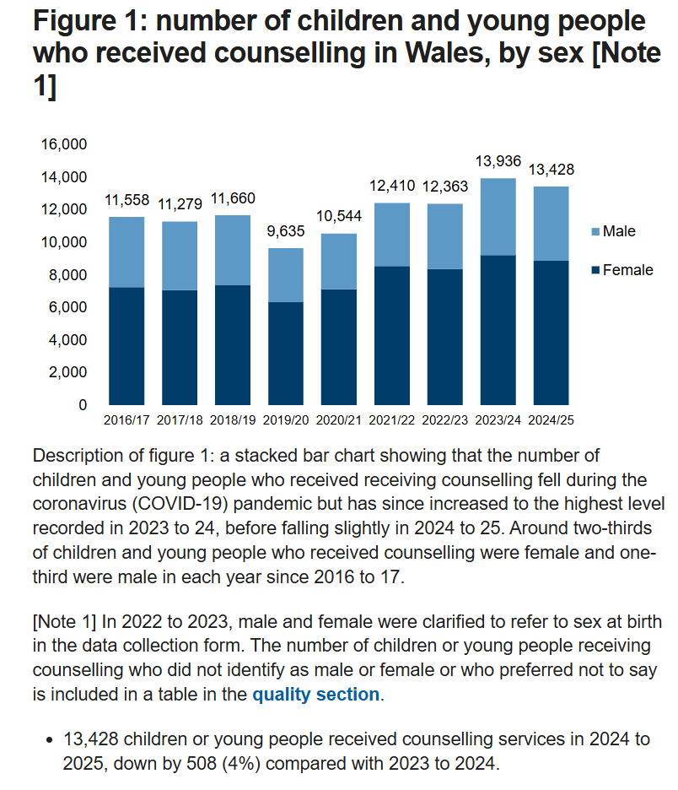
(Welsh Government, 2026a)
Cardiff Council (2026b) reports that there is a named counsellor in each secondary school in the area and that self-referrals are accepted. It also outlines school waiting lists: youth are invited to an initial meeting within two months, and counselling is initiated when a place becomes available. This is an indication of a potential waiting period before counselling, not a maximum waiting period of two months. Community learning may provide social contact in that time, if appropriate, but not counselling. The group would therefore not be offered as treatment, and young people would not have to give up an existing referral.
Third-sector provision is directly related to the proposed topic. Platfform's Hangout in Cardiff is a place for young people aged 11–17 to connect with other young people, to participate in groups and access wellbeing support. It offers open-access support, which means that there is no waiting list for an initial conversation in its published offer (Platfform, 2026). Thus, it is not correct to say that Cardiff is lacking in informal social and emotional support. There is a risk of creating a separate generic wellbeing club which competes for participants and staff and adds little value.
The potential gap is more specific, as some young people may be interested in joining a regular small group to practise relationship skills for a number of weeks and then being supported to attend regular community activities. Published service descriptions are a way of communicating what organisations offer, but not a way of providing evidence that this format is accessible at appropriate times or to the target groups. The proposal thus considers this gap to be a question to test. A service map would be a comparison of age eligibility, location, accessibility, cost, referral requirements, session format and opportunities for progression.
Referral pathways also need to be looked at. A national dependence on the education workforce might benefit youth who have been identified as having challenges in school. But a percentage of referrals cannot establish whether young people outside school are excluded. The pragmatic solution would be to have self-referral via community contacts in addition to school invitations and to look at which routes lead to enquiry and attendance. Counselling and community learning would have separate roles: a group would provide practice and belonging; a counsellor would provide a therapeutic relationship and address personal distress.
There is a policy in Wales that promotes links between the education system and communities beyond the classroom. The whole-school wellbeing framework acknowledges shared responsibility, going beyond an individual classroom (Welsh Government, 2026c). Implementation research also indicates that leadership, relationships and ongoing engagement are important and that resources and professional differences can be a challenge to delivery (Welsh Government, 2026b).

Plan of action
The proposed programme would be delivered in an accessible venue in Cardiff, chosen in consultation with young people and communities. Twelve participants would be involved in eight weekly 90-minute sessions, plus one planning session prior to delivery and one follow-up session four weeks after the final weekly session. The service review and consultation, recruitment and access arrangements would be covered in four preparation weeks. The project would start with the host's approval, and follow-up and a final review would conclude the project at week 12 of the delivery timetable. The provisional age range allows for shared experiences of secondary school, and the cohort size keeps the group small enough to provide individual support. Entry would be on the basis of a young person's interest in the learning goals and not require a diagnosis. Group participation would be determined by a private introductory conversation, which would also clarify preferences and support needs and whether it is currently appropriate.
There would be two practitioners at each session: one qualified youth worker to deliver the session and a facilitator with experience of inclusive group learning. The host would take care to provide safeguarding oversight, secure record-keeping and supervision. Potential referral and delivery partners would include schools, Cardiff Youth Service and Platfform, and partnerships would need to be agreed prior to launch. The programme would only be run following confirmation of funding, staff checks and training, insurance, an accessible venue and referral arrangements.
The educational strategy is based on social and emotional learning (SEL). In their review of 424 studies with 575,361 students, Cipriano et al. (2023) reported improvements in a variety of outcomes, such as skills and peer relationships. Evidence is useful for selecting structured practice but insufficient to predict the effect of this programme as there is a lot of variation between interventions. The review relates to school-based provision, in a broad age band. Testing is required to assess transfer to a voluntary community group. Each session would thus involve a skill being demonstrated, rehearsal and reflection on how to apply the skill in a participant's setting of choice.
The idea is that repeated, manageable interaction helps to develop confidence and functional communication skills; a stable group helps to build a sense of belonging and support. If young people feel safe and valued in the setting, these changes can help to improve wellbeing. That chain of events may be broken by transport difficulties, peer relationships and adult behaviour. Evaluation would look at these contextual conditions, as well as outcomes, in line with Skivington et al. (2021). Evidence of the use of a skill outside of the activity would indicate possible transfer and a completed activity would count as delivery.
There are alternative approaches that involve trade-offs. An open drop-in would be able to reach more youth and would allow flexible attendance; however, changing membership would decrease the chances for repeated practice with familiar peers. Individual coaching may be more private, but would be less likely to allow for real group decision-making. Where consultation shows a desire for continuity and shared activity, the small cohort is preferred. If young people chose either of these alternatives, they would be given information regarding existing provision.

Learning sequence
Week | Learning focus | Planned activity and evidence
1 | Safety and individual goals | Establish group expectations; conduct baseline measures; select two personally significant communication goals.
2 | Listening and communication | Practice asking questions and checking meaning in pairs using speech, writing or visual communication.
3 | Recognising emotions | Discuss hypothetical scenarios; identify emotions and a desired response without forced sharing.
4 | Boundaries and disagreement | Practice refusal, negotiation and ask for assistance; discuss goals in private.
5 | Shared decision making | Select a small community contribution, e.g. a welcoming activity for other young people; assign voluntary roles.
6 | Collaborative preparation | Plan and rehearse the contribution; agree how to resolve task difficulties with the help of the facilitator.
7 | Community participation | Conduct the agreed-upon activity in the host venue; document participant reflections and partner feedback.
8 | Review and continuation | Repeat outcome measures; discuss learning, concerns and personally chosen next steps.

Each meeting would consist of a brief arrival activity, 15 minutes of explicit learning, 35 minutes of practice, a break and a reflection period. Transitions and individual support would be provided in the time remaining. Participants would have the opportunity to observe prior to participating in an exercise.

Resources and delivery costs
The cash budget is estimated at £4,466. This includes 45 lead-worker hours (at £30 per hour), 32 facilitator hours (at £25 per hour), 10 two-hour venue bookings (at £25 per hour), £5 per participant for transport support for 10 meetings, £2 per participant per meeting for refreshments, materials (£150), an accessibility reserve (£300), and £120 to recognise planning contributions. These costs total £4,060, with a 10% contingency of £406. The ten meetings comprise one planning session, eight weekly sessions and one follow-up session. Rates are assumptions of what it will cost to do the work and will need to be confirmed by local quotations and funding approval; costs would remain even if absorbed by the host, as they represent the use of existing resources.
The lead allocation includes 15 meeting hours, 12 hours for consultation and introductory conversations, ten for preparation and eight for evaluation. Existing partner sessions (as agreed during preliminary listening groups) would be used. Host supervision and consultation space are assumed to be contributions in kind and would be documented prior to approval in terms of capacity and value.
This is equivalent to around £372 per participant at full enrolment. That number is a measure of delivery spending, not cost-effectiveness. Lower attendance would result in a higher cost per regular attendee. The accessibility reserve may not be enough for ongoing specialist support and identified needs would be costed prior to the close of recruitment. The host would openly make changes to the cohort or delivery plan if funding were not available to provide safe and inclusive delivery. Funds for transport and accessibility provision would be protected in preference to expenditure on optional materials as this support would be essential for a young person to be able to participate.

Success criteria and evaluation
SMART objectives would specify the expected change, evidence and deadline. The thresholds below are suggested pilot targets and are not validated clinical thresholds. The lead worker would keep attendance and delivery records, and a host colleague (not the facilitator) would gather private feedback, if possible.
Measure | Proposed criterion | Evidence and timing
Retention | At least 90% of participants attend 6 or more sessions. | Weekly register, to be checked at week 8.
Social learning | 8 or more of the 12 participants achieve two behavioural progression goals agreed at baseline. | Similar practical activities in weeks 1 and 8 and reflection by participants.
Emotional wellbeing | There is a positive change in scores for at least 8 of 12 participants who provide paired WHO-5 responses. | Private baseline and week 8 questionnaires; report all changes and missing responses.
Influence | Two or more viable participant proposals modify delivery by week 4. | Decision record with the proposal, response and change.
Continuation | By week 12, at least 6 of 12 participants report attempting one selected community or relationship activity. | Follow-up conversation (optional) with an example of what happened.

The communication rubric would include checking what another person means, expressing a preference/boundary, and negotiating a task. Levels would be defined as substantial support, occasional prompting and independent use in the agreed activity. Practitioners would agree examples prior to assessment and compare ratings of selected examples. Communication aids would be provided at both assessments. Progression would be evidenced by an improvement of one level and transfer would be demonstrated when participants who are already independent apply their skills to an unfamiliar task that is pre-agreed. This local rubric is not a validated rubric, and ratings would be used in conjunction with participants' descriptions, which may include disagreement with staff's ratings.
The WHO-5 asks about wellbeing over the past 2 weeks. It has five item scores which add up to a total score of 0–25, which is then multiplied by four to provide a score of 0–100 (World Health Organization, 2024). Accessibility and suitability for the cohort would be checked by the host prior to use. A positive median change would not necessarily mean clinically meaningful recovery but rather a preliminary group-level signal. The agreed support procedure would be followed with a private check-in if an individual's wellbeing deteriorated. Participants would not be required to answer questions to participate in activities.
There would be no comparison groups and only 12 participants, so changes might be due to external events or to familiarity with assessment or selective follow-up. Evaluation would include counts and percentages, paired changes, and negative experiences and missing data. If a participant had a missing score, the score would not be assumed to have improved. Results could be explained with the help of attendance, feedback and contextual notes. Prior to continuation, the host and youth representatives would check to see if they were getting more out of it than they were putting in, if there were any missing participants, and if delivery was causing distress. If a threshold were not met, this would result in investigation and revision rather than blaming the participants.

Participation
Participation is dependent on the presence of reasons to be there and influence if present. Self-determination theory states that there are three conditions that are necessary for motivation: autonomy, competence, and relatedness (Ryan and Deci, 2000).Recruitment would be done with a brief description of activities and potential benefits, and not with terms like 'socially deficient'. Youth could have an orientation visit with a trusted adult, a one-on-one meeting with a facilitator, or a chance to ask questions in private. School personnel would make it clear that attendance is not mandatory and non-attendance does not have any disciplinary consequences. This is important as a well-meaning referral by an adult authority figure can be felt as pressure. The young person's consent would be reviewed following the introduction, as well as the host's plans for parental involvement and consent.
Lundy's (2007) participation model links opportunities to voice opinions with an audience and influence. In this project, there would be opportunities for young people to participate, a named adult who would follow up on their decisions, and a public record of decisions. They would be involved in the planning meeting to select timing and expectations for the group and shortlist community contributions for final selection in week 5. Discussion would be complemented by anonymous suggestions and individual conversations, thus preventing verbal confidence from being the deciding factor for influence. The group would review the changes that had occurred by week 4. An explanation and an invitation to suggest an alternative would be provided when a decision could not be implemented.
Co-production is more than an initial preference exercise. In their review of school-based health interventions for 11–16-year-olds, Reed et al. (2021) found iterative problem setting and problem solving. Their findings support shared development, but do not show that co-production itself leads to an improvement in wellbeing. Staff would thus differentiate between the quality of participation and health outcomes. Adults would still be held accountable for safeguarding and participants would be able to question the methods of the sessions and pick out the unhelpful assumptions. It would be appropriate to offer a small payment for planning time, so that contributions are rewarded without creating financial pressure to continue.
Facilitation would involve brief demonstrations and then work in pairs or small groups and would allow for pausing and/or selecting an alternative role. Feedback would focus on specific behaviour, for example, checking a partner's understanding, and not on a personality trait. No public ranking would be done as it could deter experimentation. Shared tasks would enable participants to contribute to the planning, artwork, organising or speaking. The facilitator would notice those who are being left out repeatedly and adjust the task arrangements. The fact that choice is given does not mean that when apparently voluntary roles reproduce an unequal division of work there is no need for intervention.
Leadership would involve clear adult responsibility for fulfilling the duty of care and shared responsibility for day-to-day decisions. The participants could take turns in the different roles (welcoming, collecting suggestions etc.) without taking responsibility for the emotional safety of the other participants. The lead worker would take responsibility for boundaries and the quality of sessions, and the host safeguarding lead would take responsibility for concerns outside of the remit of the group. Staff debriefing would be done on a weekly basis to look at adaptations and conflicts. Welsh implementation research indicates that relationships and leadership are important factors in supporting wellbeing work (Welsh Government, 2026b) and school findings must be interpreted carefully in an informal setting.
Non-attendance would be considered as a possible relationship or access problem. If for some reason a participant were not present, then the practitioner would use the agreed contact method, asking if support or a change was required. Participants would set up acceptable contact arrangements as repeated reminders might be intrusive. Short and optional exit feedback would be requested. The numbers recruited, retention rates and the reasons given for leaving would then be used to inform delivery.

Barriers
The project may be jeopardised by economic and logistical obstacles before learning can begin. Data on Cardiff's neighbourhood differences in the proportions of children in low-income families inform budgeting but cannot identify which families need support (Cardiff Public Services Board, 2025). There would still be travel costs, time commitments and potentially caring responsibilities with free sessions. Practical barriers to youth co-production include time constraints and a lack of trust (Reed et al., 2021), which are not addressed by an invitation. Transport support would be provided without being made public, and without the need for the hardship to be declared. The venue and timing would be determined by consultation, including consideration of routes home and school commitments. Financial assistance is not a solution for an inappropriate timetable and alternatives would be explored before absence is assumed to reflect low motivation.
Digital participation would be available as an option. Recruitment, consent information and feedback would be provided in both paper and verbal formats. Reminders would be via the agreed channel, and no smartphone application would be needed. If the person is unable to travel, online options can be used, but this can restrict privacy and an online session may not be as interactive. The project would thus not assume that an online activity is accessible. If there is remote participation, it would be assessed for suitability, moderated and supported separately.
Language and communication differences may impact entry and assessment. Information would be accessible in Welsh and English and other language and communication support would be provided according to identified needs. Practitioners would assess understanding through discussion, rather than treating a signed form as proof of understanding. Activities would allow for further processing time and visual and/or written responses. Adaptation should not alter the purpose of the learning: a role play can be adapted to a written exchange, but if the assessment requires fluent public speech, it may be measuring anxiety or familiarity with the language.
The sensory environment and/or the typical social norms can be disabling for neurodivergent participants. Chapman and Botha (2023) make the case for focusing on environmental fit and individual agency, but this is not direct evidence for this programme and is in the context of therapy. The design implication is to provide a predictable session outline, a quieter environment and options other than high-demand group interaction. Success criteria would not include eye contact, suppression of self-regulating movement or imitation of one communication style.
Peer relationships can be harmful and supportive. Pre-existing friendship groups may be able to dominate decisions and bullying or discriminatory remarks may make it unsafe to attend. Initial discussions would identify concerns without placing blame on individuals. Facilitators would have clear boundaries and provide private reporting options and a quick response to incidents. A restorative conversation would be voluntary and would not be a substitute for taking protective action. The group agreement might ask for confidentiality; staff would make it clear that confidentiality between group members is not guaranteed. Activities would never rely on the disclosure of trauma or a personal family situation.
Explicit procedures are needed for safeguarding and trust. The host would discuss the boundaries of confidentiality and who the safeguarding lead is, and agree referral pathways prior to enrolment. Practitioners would adhere to the host's protocols if a disclosure of harm or need for support beyond the scope of their practice was made. There would be no delay in access to clinical care as a result of group participation. Evaluation records would be labelled with participant codes, kept with limited access and for a specified period of time; consent to programme participation and optional evaluation would be dealt with separately. Reports would not include identifiable quotes or highly specific demographic details. These procedures should not be restricted to organisational documentation and should be understood by young people. The Welsh framework helps to ensure clear responsibilities between partners (Welsh Government, 2026c) and a named accountable host is preferred to informal arrangements between volunteers.
Lastly, short-term financing can cause valuable relationships to be terminated too soon. Continuation planning would start during the programme and supported introductions to existing activities would be made when desired by the participants. No continued service would be guaranteed without resources. A handover conversation would document the agreed support and who would be providing this. Shared session plans and supervision would be used to manage the effects of staff turnover and opportunities for adaptation would be maintained.

Conclusion
A small voluntary community learning programme may be a valuable opportunity for Cardiff teenagers to learn how to communicate and to form supportive relationships. There is evidence to suggest that unequal access and individual needs should be explored and Cardiff's provision and relatively high average wellbeing mean it is not necessarily an under-served city. An additional cohort should only be considered following consultation and service mapping, to establish if it provides enough value.
The proposed approach is to link structured practice with the choice of the participant, accessible delivery and a purposeful contribution to the community. It must be realistic in terms of costs, and have clear safeguarding responsibilities and measures that differentiate attendance, learning and emotional wellbeing. An uncontrolled pilot can show whether or not delivery is workable and acceptable and indicate possible changes in outcomes, but not that the programme caused them.

References
- Cardiff Council (2026a) Cardiff Youth Service. Available at: https://cardiff.gov.uk/CardiffYouthService
- Cardiff Council (2026b) Counselling in schools. Available at: https://www.cardiff.gov.uk/counsellinginschools
- Cardiff Public Services Board (2025) Cardiff in 2025. Available at: https://cardiffpartnership.co.uk/wp-content/uploads/2025/12/Cardiff-in-2025.pdf
- Chapman, R. and Botha, M. (2023) 'Neurodivergence-informed therapy', Developmental Medicine & Child Neurology, 65(3), pp. 310–317. https://doi.org/10.1111/dmcn.15384
- Cipriano, C., Strambler, M.J., Naples, L.H., Ha, C., Kirk, M., Wood, M., Sehgal, K., Zieher, A.K., Eveleigh, A., McCarthy, M., Funaro, M., Ponnock, A., Chow, J.C. and Durlak, J. (2023) 'The state of evidence for social and emotional learning: A contemporary meta-analysis of universal school-based SEL interventions', Child Development, 94(5), pp. 1181–1204. https://doi.org/10.1111/cdev.13968
- Lundy, L. (2007) 'Voice is not enough: conceptualising Article 12 of the United Nations Convention on the Rights of the Child', British Educational Research Journal, 33(6), pp. 927–942. https://doi.org/10.1080/01411920701657033
- Page, N., Liu, S., Morgan, K., Angel, L., Ogada, E., Roberts, C., Young, H. and Murphy, S. (2024) 'Data Resource Profile: The School Health Research Network (SHRN) Student Health and Well-being (SHW) survey of 11–16-year-olds (2017–2023)', International Journal of Epidemiology, 53(6), dyae161. https://doi.org/10.1093/ije/dyae161
- Platfform (2026) Information for trusted adults. Available at: https://platfform4yp.org/hangout-info/
- Reed, H., Couturiaux, D., Davis, M., Edwards, A., Janes, E., Kim, H.S., Melendez-Torres, G.J., Murphy, S., Rotevatn, T.A., Smith, J. and Evans, R. (2021) 'Co-production as an emerging methodology for developing school-based health interventions with students aged 11–16: Systematic review of intervention types, theories and processes and thematic synthesis of stakeholders’ experiences', Prevention Science, 22(4), pp. 475–491. https://doi.org/10.1007/s11121-020-01182-8
- Ryan, R.M. and Deci, E.L. (2000) 'Self-determination theory and the facilitation of intrinsic motivation, social development, and well-being', American Psychologist, 55(1), pp. 68–78. https://doi.org/10.1037/0003-066X.55.1.68
- Skivington, K., Matthews, L., Simpson, S.A., Craig, P., Baird, J., Blazeby, J.M., Boyd, K.A., Craig, N., French, D.P., McIntosh, E., Petticrew, M., Rycroft-Malone, J., White, M. and Moore, L. (2021) 'A new framework for developing and evaluating complex interventions: Update of Medical Research Council guidance', BMJ, 374, n2061. https://doi.org/10.1136/bmj.n2061
- Strawbridge, Z., Boffey, M. and Wooders, C. (2025) 'Turning data into action: Using the SHRN dashboard to support youth work in Wales', The School Health Research Network, 8 October. Available at: https://www.shrn.org.uk/turning-data-into-action-using-the-shrn-dashboard-to-support-youth-work-in-wales/
- Welsh Government (2026a) Counselling for children and young people: September 2024 to August 2025. Available at: https://www.gov.wales/counselling-children-and-young-people-september-2024-august-2025-html
- Welsh Government (2026b) Delivering a Whole School Approach to Emotional and Mental Wellbeing: helpful practice examples. Available at: https://www.gov.wales/delivering-whole-school-approach-emotional-and-mental-wellbeing-helpful-practice-examples
- Welsh Government (2026c) Framework on embedding a whole-school approach to emotional and mental wellbeing. Updated 5 January 2026. Available at: https://www.gov.wales/framework-embedding-whole-school-approach-emotional-and-mental-wellbeing
- World Health Organization (2024) The World Health Organization-Five Well-Being Index (WHO-5). Geneva: World Health Organization. Available at: https://www.who.int/publications/m/item/WHO-UCN-MSD-MHE-2024.01

