

Does Dyfed-Powys Police learn from, and share lessons from failings identified within critical incidents?
MSc Policing (Operational & Strategic Leadership)
Jolene Mann
Student No: 2011697
Module: BMP0700


Date of Submission: July 202
‘Lightbulb Moments’ – Moments of inspiration, revelation, or recognition (Collins Dictionary, 2023)

Declaration

I declare no part of the dissertation has been submitted for any other degree. I have not been a registered candidate or enrolled student for another award of the University, or other academic or professional institution.
Signed: Jolene Mann
Date: 26 06 2023
STATEMENT 1
I declare the work in this research dissertation was carried out in accordance with the Regulations of University of Wales Trinity Saint David (UWTSD).
Signed: Jolene Mann
Date: 26 06 2023
STATEMENT 2
This dissertation is the result of my own independent work/investigation, except where otherwise stated.
Other sources are acknowledged by giving explicit references. A bibliography is appended.
Signed: Jolene Mann
Date: 26 06 2023
STATEMENT 3
Any views expressed are those of the author, and in no way represent those of UWTSD.
Signed: Jolene Mann
Date: 26 06 2023

Acknowledgements

There are many people whom I would like to thank for their help and support. I wish to demonstrate my appreciation to employees within Dyfed-Powys Police (DPP) who participated in this research, with specific recognition to Chief Constable Dr Richard Lewis in supporting the research proposal and recognizing the potential benefit to the organisation and policing nationally.

I owe a great deal of gratitude to my lecturers Peter Doyle, Mike Durke, Wynne Jones, Dr Jonathan Edwards, Steven Thompson and Alison Cooke for their support and guidance. I am especially grateful to Alison, for her direction and support in my final year, it really has made all the difference, when at times when it has felt overwhelming and impossible. Thank you so much / Diolch yn fawr iawn.

Finally, I would like to thank my husband Stuart, and our two wonderful children Shannon and Harrison for always being there for me. I could not have done this without their patience, encouragement, and support throughout the three years of study, over, and above myself working full-time, running three London Marathons, and undertaking a new role within the National Police Chief’s Council (NPCC). They have given me much needed time and space, and well-needed words of encouragement to stay focused, whilst reinforcing our family mantra to never give up.

Contents
Declaration i
Acknowledgements ii
Abstract v
Glossary of terms and definitions 1
List of Appendices 4
List of Figures and Tables 5
Chapter One 6
Introduction 6
Background 7
Aim and Objectives 10
Research Value 10
Structure and Approach 11
Chapter Summary 11
Chapter Two 12
Review of Literature 12
Introduction 13
Police Organisations 13
Theoretical Perspectives 15
Learning Theories 23
Chapter Summary 28
Chapter Three 29
Research Methodology 29
Introduction 30
What is research? 30
Aim and Objectives 30
Design 31
Philosophy 32
Approach 33
Methodological Choice 34
Strategy 34
Time Horizon 36
Techniques and Procedures 36
Ethical Considerations 37
Reliability and Validity 38
Chapter Four 39
Data Analysis 39
Introduction 40
Objective One 41
Objective Two 46
Internal stakeholders 46
Recording 46
Coordinating 49
Sharing 51
External Stakeholders 54
Chapter Summary 57
Chapter Five 58
Conclusion and Recommendations 58
Introduction 59
Conclusion: Findings & Results 61
Research Limitations 63
Recommendations for DPP Senior Leadership Team 64
Closing Remarks 65
Bibliography 67
Appendices 80
Appendix A – Dyfed-Powys Police Learning the Lessons Framework 1
Appendix B – Gibbs Model of Self Reflection 1
Appendix C – National Decision-Making Model 2
Appendix D – Police Socio-technical systems 1
Appendix E – Ethical Risk Considerations for research project 1
Appendix F – Research questionnaire 1
Appendix G – Questionnaire Responses 1

Abstract

Public trust and confidence in the police are fundamental for fostering a safe and harmonious society. However, recent years have witnessed a concerning decline in public trust, primarily attributable to recurrent failures and mistakes within policing practices. This study addresses the imperative of identifying and rectifying past shortcomings to restore public trust and confidence in the service. The researcher, a seasoned officer with over two decades of operational experience in Dyfed-Powys Police (DPP), has witnessed first-hand the detrimental impact of these failures on public perception.

The research aims to answer the central question: “Does Dyfed-Powys Police (DPP) learn from and share lessons from failings identified within critical incidents?”. By investigating this question, the study endeavours to enhance the effectiveness, accountability, and public perception of policing, ultimately leading to an improved service for the communities served by DPP. The research question is particularly compelling as there is a scarcity of academic literature on policing organisations learning from past mistakes within critical incidents. Thus, the study contributes to establishing accountability mechanisms and informing future strategies to enhance public trust and confidence. Additionally, the recommendations from this study can be valuable for the wider public sector in mitigating similar recurring failures.

To achieve the research objectives, the study compares organisational business functions to determine how the learning was being managed within DPP. It critically examines whether DPP transparently records, coordinates, and shares learning from internal and external stakeholders with employees across the organisation. The literature review provides a comprehensive overview of existing literature that surrounds the topic, while the research methodology details the interpretive qualitative approach employed. Primary data was gathered through a self-completed questionnaire, electronically distributed to a sample population of DPP employees, resulting in an impressive 91% response rate.

The research draws several key conclusions. First, DPPs’ learning framework requires further development, as a notable absence of a prominent learning culture results in inconsistent, siloed, and fragmented approaches to learning management across the organisations diverse business functions. Second, learning is not effectively coordinated or routinely shared with internal or external stakeholders, leading to a failure to identify and address comparable failings. Third, although debriefing processes serve as the primary means of managing lessons learned, their utilisation is irregular and lacks standardisation.
Fourth, lessons learned are not readily accessible or available to employees throughout the organisation. Lastly, DPP lacks a technological repository to access or evaluate lessons learned, raising the risk of repeating past failures and a loss of corporate memory.

Based on the primary data analysis, the study offers recommendations for improvement. These include establishing and implementing a centrally governed, integrated technical repository that facilitates the systematic management and sharing of lessons learned. Such an initiative would address the shortcomings identified and foster a culture of continuous learning within DPP, ultimately enhancing organisational effectiveness, accountability, and public perception.

Keywords: public trust, policing, organisational learning, lessons learned, accountability, qualitative research, Dyfed-Powys Police

Glossary of terms and definitions

CoP College of Policing. Professional body for policing in England and Wales. Established in 2012, as an independent organisation and operates under the oversight of the Home Secretary. The College of Policing (CoP) are responsible for setting standards, providing training, and promoting best practices within the police service.

Chief Constable The highest-ranking position within a police force in England and Wales. Responsible for the overall management and operation of the force. Operationally independent of the Police and Crime Commissioner (PCC).

CCA Civil Contingencies Act. A legal framework for emergency planning, response, and recovery in the UK. It establishes a clear set of responsibilities for local authorities, emergency services, and other organisations involved in emergency management.

CID Criminal Investigation Department. A specialised unit within the police force that focuses on investigating serious crime.

Critical Incident The college of policing define a critical incident as ‘any incident where the effectiveness of the police response is likely to have a significant impact on the confidence of the victim, their family and/or the community’ (CoP, 2023).

DCC Deputy Chief Constable. An executive leadership position. Serves as second-in-command to the Chief Constable.

DPP Dyfed-Powys Police

Force Refers to a Police Force / a constabulary. Policing is carried out by individual police forces at a local level. Each police force is led by a Chief Constable who is responsible for the day-to-day operational management of the force.

HMICFRS (HMIC) His Majesty’s Inspectorate of Constabulary and Fire & Rescue Services. An independent inspectorate responsible for inspecting and regulating police forces and the fire and rescue service. The primary role of HMICFRS is to provide independent oversight to the effectiveness, efficiency, and legitimacy of the services. It operates under the authority of the Home Secretary and reports directly to parliament. Prior to 2017, the Inspectorate did not have responsibility for Fire & Rescue Services and were referred to as HMIC.

Home Office The Home Office is a government department responsible for oversight and accountability of policing across England and Wales. It sets the overall strategic direction, policies, budget allocation, legislation, and legal framework.

IL Isomorphic Learning (Chapter 2)

IOPC Independent Office of Police Complaints. A public body responsible for overseeing the police complaints system across England and Wales. The IOPC investigate complaints and allegations of misconduct, as well as incidents resulting in death and/or serious injury, command failings and other serious matters that may impact public confidence (IOPC, 2023).

JESIP Joint Emergency Services Interoperability Programme. A framework established in the UK to enhance the coordination and interoperability among the emergency services during major incidents and emergencies. JESIP defines a set of agreed principles to guide the response of emergency services, to improve communication, coordination, and effectiveness in emergency services.

KM Knowledge Management (Chapter 2)

Likert Scale A psychometric scale commonly used to measure the extent of agreement or disagreement with a statement.

LRF Local Resilience Forum. A partnership of organisations that work together at a local level to enhance preparedness, response, and recovery from emergencies and major incidents. LRFs are established in each local authority area, to coordinate and integrate the efforts of agencies and organisations involved in emergency management and response, including emergency services (police, fire, ambulance, health, local authority, environment agency, utility companies).

Major Incident The college of policing define a major incident as ‘an event or situation with a range of serious consequences, which requires special arrangements to be implemented by one or more emergency responder agencies’ (CoP, 2020).

NDM National Decision Model (Appendix C)

NPCC National Police Chief’s Council. NPCC brings together Chief Officers from across England and Wales, to coordinate national policing strategies, policies, and operations. It acts as a collective voice on policing matters and works closely with the Home Office.

Officer A warranted Police Constable / Police Officer. Authorised to enforce the law, maintain public order, prevent, and detect crime, ensure the safety and security of the community.

OK Organisational Knowledge (Chapter 2)

OL Organisational Learning (Chapter 2)

PCC Police and Crime Commissioner. An elected official in England and Wales who are responsible for holding the Chief Constable to account for the performance of a police force in their respective area. The role of the PCC was established by the Police Reform and Social Responsibility Act 2011, with the first elections taking place in 2012. They serve a fixed term of for four years.

PCSO Police Community Support Officer. A non-warranted uniformed member of a police force in England and Wales.

PRI Practice Requiring Improvement. PRI is defined as ‘underperformance or conduct not amounting to misconduct or gross misconduct, which falls short of the expectations of the public and the police service as set out in the policing code of ethics (Regulation 3(1) Police Conduct Regulations 2020). PIR is designed to give officers and staff an opportunity to reflect on what could have gone better and look for ways to improve future behaviour (IOPC, 2022b).

SOC Serious Organised Crime. Criminal activities planned, coordinated, and committed by people working individually, in groups or as part of a transnational network. It usually centres on acquiring money, profit, influence, and power. The main categories of crime include sexual exploitation, illegal drugs, illegal firearms, fraud, economic crime, modern slavery and human trafficking and cyber enabled crime (Home Office, 2019).

SPR Strategic Policing Requirement. A framework set up by the UK Government that outlines the national policing capabilities and resources needed to address national security threats. SPR provides a strategic direction for police forces to align their capabilities, and priorities with national security objectives.

STORM System for Tasking and Operational Response Management – Command and Control System

TLO The Learning Organisation (Chapter 2)

UK United Kingdom (Scotland, England, Wales, and Northern Ireland).

UK Policing UK Policing relates to the Police force structure in England and Wales. There are 43 territorial police forces in England and Wales. (Note: In the context of the research, UK Policing does not include Police Scotland or the Police Service of Northern Ireland).

UWTSD University of Wales Trinity Saint David.

List of Appendices

Appendix A Dyfed-Powys Police Learning the lessons framework
Appendix B GIBBS Model of Self Reflection
Appendix C National Decision-Making Model
Appendix D Police Socio-Technical Systems
Appendix E Ethical Risk Considerations for Research Study
Appendix F Research Questionnaire
Appendix G Questionnaire Responses

List of Figures and Tables

Figure 1 - Socio-Technical Systems (STS) Theory (University of Leeds, 2023) 14
Figure 2 – Forty-three Police Forces of England and Wales (Ritchie, 2010) 14
Figure 3 - Mapping the Key Topics (Easterby-Smith, M., and Lyles, M. A, 2011, pg.4) 15
Figure 4 - Knowing and Learning in Organisations (Vera and Crossan, 2003; Ritchie, 2010) 18
Figure 5 - Spiral of Organizational Knowledge Creation (Nonaka and Konno, 1998) 20
Figure 6 - Isomorphic Learning Categories (adapted from Toft and Reynolds, 1994) 22
Figure 7 - Single and Double Loop Learning (Argyris and Schön, 1978) 24
Figure 8 - The Experiential Learning Model (adapted from Kolb, 1984; Webapi, 2022) 26
Figure 9 - The Research Onion (Saunders et al, 2016, pg.124) 31
Figure 10 - Deductive and Inductive Reasoning (Trochim, 2023) 33
Figure 11 - Six Steps to Thematic Analysis (Adapted from Braun and Clarke, 2006) 37
Figure 12 - Four stages to developing question validity and reliability (Foody, 1994 cited by Saunders et al, 2016, pg.450) 38
Figure 13 - Primary Data results for Question (1) 41
Figure 14 - Word Cloud representing qualitative data for Question (2) 42
Figure 15 - Primary data results for Question (5) 44
Figure 16 - Primary data results for Question (12) 45
Figure 17 - Primary data results for Question (14) 47
Figure 18 - Primary data results for Question (23) 48
Figure 19 - Primary data results for Question (26) 50
Figure 20 - Word cloud representing qualitative data for Question (28) 50
Figure 21 - Primary data results for Question (16) 51
Figure 22 - Primary data results for Question (20) 52
Figure 23 - Primary data results for Question (18) 53
Figure 24 - Primary data results for Question (30) 55
Figure 25 - Primary data results for Question (25) 56

Chapter One

Introduction

Background

UK-policing is experiencing a crisis in confidence (Barber, 2022) as public trust hangs by a thread and has reached its lowest point in living history (Cooke, 2023; James, 2018). The notion ‘only perfection is incapable of improvement, and the police are far from perfect’ (Winsor, 2021, pg.14) exacerbates this point. This perfect storm is intensified by the stark reality that mistakes occur, particularly in critical incidents where the stakes are high. Unfortunately, police failures continue to emerge, even though lessons from past high-profile critical incidents like the Brixton Riots (Scarman, 1981), Hillsborough disaster (Jones, 2017), Mayhill Riots (Swansea Council, 2022), Manchester Arena Terrorist Attack (Home Office, 2022a, 2022b), and the Keyham Shootings have long been acknowledged. In the latter case, the Coroner cited, catastrophic police failures and ignored warning signs had resulted in the offender being granted a license to kill (Arrow, 2023).

Moreover, public confidence suffered a significant blow when UK-policing was first labelled institutionally racist in the Macpherson Report (1999). However, despite the evident need for learning, the Hotton report some 23-years later has drawn sharp attention that lessons were not learned, as police racism is even more prevalent today (IOPC, 2022; Waddington, 2015). Additionally, in 2021, Sarah Everard was murdered by a serving police officer (Casey, 2023), and in 2022, another serving officer was convicted of committing 85 sexual offences. HMICFRS findings revealed, warning signs spanning several years had been overlooked in both cases (Cooke, 2023). Moreover, the inspection into Vetting, Misconduct, and Misogyny unveiled a disheartening trend, highlighting consistent failures by policing to acknowledge warning signs and implement recommended preventative measures (HMICFRS, 2022b).

National guidance emphasises the importance of learning from critical incidents through formal post-incident debriefs to identify learning outcomes, and improve future preparedness. Furthermore, legislation mandates joint organisational learning among emergency service responders (CoP, 2018; CCA, 2004; JESIP, 2023). However, evidence from a vast array of public inquiries shows a tendency for emergency services, including the police, to repeat the same mistakes (Toft and Reynolds, 2005). For instance, the Inquest into the 2005 London Bombings identified inadequate information sharing, communication failures, and a lack of clarity among emergency-responders regarding roles and responsibilities (Hallet, 2012; H.M. Government, 2006), and research by Pollock (2013) uncovered consistent organisational deficiencies in 32 major incidents that occurred between 1986 and 2010. These failings encompassed ineffective communications, inadequate information-sharing, a prevailing no-blame culture, the absence of systems to facilitate learning and knowledge-sharing with employees, and a failure to act on previous lessons. According to Muir (2018) the blame-game yields no winners, and Baroness Casey’s findings (2023) echo this notion, revealing compelling evidence of a defensive blame-free mindset within policing, coupled with a culture of denial. Lord Laming’s (2003) investigation into the death of Victoria Climbié further highlighted the inexcusable nature of policing’s blame-free culture and called for a learning culture to be adopted, emphasising that its absence leads to repeated, severe, and indefensible failures.
Despite recognition for decades that lessons must be learned to prevent the repetition of failures (Waddington, 2015). One must question, why a series of identical and inexcusable failures have again occurred in response to the 2017 Manchester Arena attack, involving poor communication, and a significant lack of information sharing between emergency-response agencies that could have saved lives (Home Office, 2022a). Notably, 28-years before Manchester, the Hillsborough disaster had occurred, and Lord Taylor’s review revealed eight reports containing lessons from previous disasters had been disregarded before the tragedy unfolded. The review emphasised ‘there is no point in holding inquiries or publishing guidance unless the recommendations are followed diligently. That must be the first lesson’ (cited by Pollock, 2013, pg.16).

Waddington (2015, pg.117) argues, when organisations declare ‘lessons will be learnt’, it often serves as futile rhetoric to deflect criticism, offering little hope that actual learning will occur. Senge (2006, pg.23) similarly asserts a learning disability for organisations, lies in ‘the delusion of learning from experience’, where organisations assume they have learned from an experience when, in reality, they have not. The alarming recurrence of failures, shocking revelations, and calls for reform have influenced this research project (IOPC, 2022a; HMICFRS, 2022a; Pollock, 2013). Multiple studies consistently indicate that policing struggles to establish a culture of learning from past experiences (Torrible, 2022). Despite increased public scrutiny through regulatory bodies and independent investigations, similar failures continue to emerge, suggesting a systemic issue. Halkon (2022) emphasises the importance of policing taking its history seriously, if policing is genuinely committed to rebuilding public trust, for ‘those who forget history, are condemned to repeat it’ (Santayana, 2015). Learning opportunities arise daily for policing, through incidents, debriefs, inspections, inquiries, complaints, inquests, and case reviews. However, it’s unclear whether policing effectively utilises, and shares these learning opportunities to improve practices across the workforce.

The researcher’s professional background as a serving officer within Dyfed-Powys Police, along with over 20-years of operational experience, including work in Professional Standards (PSD) investigating officer misconduct, and as a Post Incident Manager facilitating communication between officers and IOPC investigators regarding public deaths following police contact, provides the researcher with first-hand knowledge and insights into the repeat failings and mistakes of policing. The researcher’s passion for this topic arises from a genuine concern for improving the effectiveness, accountability, and public perception of policing, based on the researcher’s first-hand exposure to the consequences of policing, and in particular DPP inadequately addressing past mistakes.

Therefore, the focus of this research study, aims to answer the research question “Does Dyfed-Powys Police (DPP) learn from, and share lessons from failings identified within critical incidents?”. DPP makes an interesting case study, covering a landmass over half of Wales and a population exceeding half a million. The geographically dispersed workforce consists of 1,209 police officers (3.91 per 100,000 population) and 943 police staff (HMICFRS, 2019). The research seeks to compare learning practices, identify areas for improvement, and add value by presenting recommendations.
Failure to learn from past mistakes undermines public trust, rooted in the Peelian principles (Innes et al, 2020) of policing by public consent (Home Office, 2012). Emphasising the need for willing cooperation from the public, since law enforcement suffers without it (Bolger and Walters, 2019). Moreover, policing neglecting to learn from past failures can result in fatalities and costly legal and financial ramifications which are remunerated from the public purse, thus diverting resources away from crime prevention and public safety to compensate for police failures.

Limited academic research exists explicitly addressing the study’s topic. A Scopus (2023) search using the keywords “police, learning, lessons, failings” yielded 1,435 academic journals. The scarcity of research can be attributable to practical challenges associated with sensitivities surrounding studying law enforcement, and difficulties researchers face in obtaining restricted and confidential data. Furthermore, inconsistent data collection and reporting practices across policing pose difficulties in acquiring comprehensive and comparable data for systematic analysis. Next, to provide contextual background, a concise overview of learning practices within DPP is presented.

In 2021, Dr. Lewis assumed the role of Chief Constable and outlined his vision for DPP (DPP, 2021). In response, DPP initiated actions to formalise OL processes, including the establishment of governance arrangements through a Learning-the-Lessons Board, which operates within a learning framework (Appendix A). The terms-of-reference mandates strategic oversight, promoting organisational learning, and implementation of changes based on analysis of incident and near-miss data. Moreover, the objective is to disseminate local and national lessons learned to drive improvements, enhance efficiency, and build capability.

On the internal intranet site, a dedicated page titled ‘Learning-the-Lessons’ exists, primarily focused on sharing lessons related to custody issues. However, this page lacks the functionality to hold debriefs or learning-lesson reports, and it omits lessons from other policing areas. CID have a separate intranet page with the same title, conversely, this page does have functionality to store debriefing and learning lesson reports. Presently, it contains six debrief reports, including one for a homicide investigation and five for Organised Crime Investigations. Notably, the page promotes the Gibbs Reflective Model for debriefing practices (CoP, 2020b) (Appendix B). An observation is made at this juncture. Despite DPP conducting 38 homicide investigations between 2017 and 2022, averaging four murders per year (DCPP, 2023), only one debrief report for a homicide investigation is available on the CID learning-the-lessons intranet page. This suggests lessons learned from homicides are not routinely shared with the broader organisation. An Inspection by the HMICFRS in 2021 highlighted two areas for improvement in DPP’s learning practices (HMICFRS, 2022c). Firstly, DPP lacked a corporate debriefing process to capture and learn lessons from serious and organised crime incidents. Secondly, the performance framework failed to identify learning opportunities for broader improvements. Conversely, the inspection commended DPP for its effective collaboration in sharing learning with partners in the Local Resilience Forum (LRF) to prepare for critical and major incidents (Home Office, 2013), aligned with the Civil Contingencies Act (CCA, 2004) and Strategic Policing Requirements (Home Office, 2023).

Aim and Objectives

The research aims to determine whether DPP is a learning organisation that learns lessons from failings identified within critical incidents or, whether it is an organisation that learns in silos and fails to maximise opportunities to capture corporate memory and shares lessons across the wider organisation to prevent reoccurrences emerging.

To achieve this, the researcher has set the following objectives:

    - Compare and contrast organisational business functions, to determine how learning is being managed.

    - Critically examine whether DPP transparently records, coordinates, and shares learning from internal and external stakeholders with employees across the organisation.

    - Use the findings of this research to identify areas for improvement, formulate conclusions and make recommendations to the DPP Senior Leadership Team.

Research Value

The empirical findings and recommendations of this study serve two purposes: firstly, to assist DPP Senior Leadership Team to improve public services, and secondly, to enhance workforce competence by enhancing employee knowledge and skills. This, in turn, will enable employees to make informed decisions and perform their duties more effectively, thereby preventing similar mistakes in the future. Moreover, this study will enable DPP to identify systemic issues, develop evidence-based practices, and implement improvements to avert repeating similar errors.

By addressing the limited literature on learning from past mistakes in policing, this research contributes to establishing accountability mechanisms and informing future strategies to enhance public trust and confidence, reduce instances of misconduct, and better safeguard the public. Noteworthy, studying one police force out of the 43-force structure across England and Wales, may limit the researcher’s ability to generalise the findings to the entire policing system, affecting reliability and generalisability.

Structure and Approach

The report comprises five main chapters, each serving a distinct purpose:

- Chapter 1: Introduction - Provides background information on the research area, including research aims, objectives, and significance of the study.

- Chapter 2: Literature Review – Presents and discusses relevant literature, concepts, and theories pertaining to the research aim.

- Chapter 3: Research Methodology – Introduces the primary research and justifies the use of a questionnaire as the chosen method.

- Chapter 4: Analysis and Findings – Presents and discusses the primary research findings, along with a synthesis of existing literature.

- Chapter 5: Conclusions and Recommendations – Draws conclusions from primary research and provides meaningful recommendations to enhance policy and practice.

Chapter Summary

This chapter highlights the challenges faced by policing in rebuilding public trust and confidence, revealing recurring failures within the broader policing system. As a result, there is a pressing need for research to examine the capacity of DPP to learn from these failures and undertake meaningful reform. The research aims and objectives are outlined, emphasising the value it will bring to DPP. Next, the following chapter will explore relevant theories through a comprehensive literature review.

Chapter Two

Review of Literature

Introduction

This chapter presents key theoretical insights derived from a literature review on learning from critical incidents. Credible scholarly sources were reviewed to establish the theoretical foundation for this research. The review is divided into subsections, beginning with an overview of police organisations to provide context. Then it examines theoretical perspectives on organisational learning and the chapter concludes with a summary.

Police Organisations

Organisational learning (OL) cannot be studied in isolation; it must be examined within the broader context of a functioning organisation (Ritchie, 2010). Scholars define organisations as goal-orientated socio-technical systems (STS), consisting of interacting sub-systems (Figure 1) that influence each other to achieve specific objectives (Toft and Reynolds, 2005; March and Simon, 1981). In policing, it extends beyond legal and technical solutions, encompassing the interactions among police officers, communities, and supporting organisational structures and systems (theory applied by the researcher, in Appendix D). Failure in any of these sub-systems, whether human or technical, undermines the overall functioning of the entire system (Campbell and Craig, 2005; Huber, 1991). Such failures in policing can significantly impact public trust, at local, national, and international levels, as exemplified by the murder of George Floyd in the United States, and subsequent global and UK protests (HMICFRS, 2021).

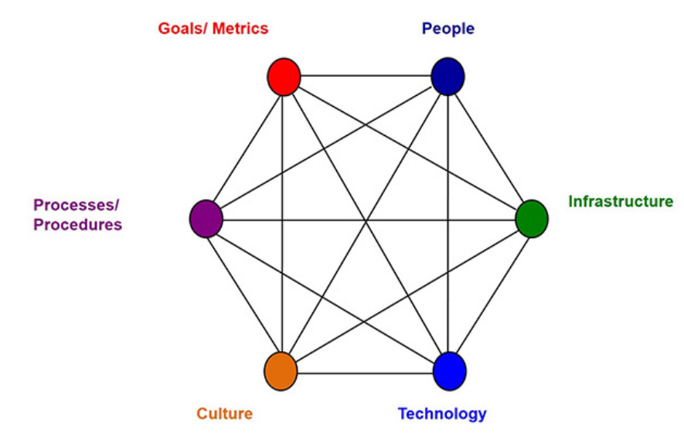

Figure 1 - Socio-Technical Systems (STS) Theory (University of Leeds, 2023)

UK-Policing has a hierarchical structure comprising National, Regional, and Local levels of authority. Nationally the Home Office set overarching policies and provides strategic direction. Regionally, there are 43 police forces, each responsible for a designated geographical area (Figure 2). Locally, a Chief Constable leads each force and is held accountable by a PCC. While individual forces have unique practices, structures, and policies, their fundamental objectives remain the same, to serve and protect the public. Consequently, lessons learned in one force can be applied to others.


Figure 2 – 43 Police Forces of England and Wales (Ritchie, 2010)
According to Kim (1993) all organisations learn, but some learn poorly, while others maximise learning opportunities for continuous improvement. In this context, policing faces political and public pressure to learn quickly, to improve performance by learning from the past to prevent comparable errors (Barber, 2022).

OL is advocated as a concept aiding organisations to acquire, retain, and apply knowledge to improve performance and adapt to changing environments (Ritchie, 2010). However, implementation challenges arise from limited guidance and empirical research, hindering the adoption of a single all-encompassing theory for OL (Basten and Haamann, 2018; Garvin et al, 2008). This literature review investigates diverse theoretical perspectives to elucidate essential theories, mechanisms, and practical implications of OL.

Theoretical Perspectives

The Easterby-Smith and Lyles (2011) framework outlines theory-practice and content-process dichotomies, encompassing four key concepts: Organisational Learning, The Learning Organisation, Organisational Knowledge, and Knowledge Management (Figure 3). Next, the subsequent sub-sections will explore their relevance within the research domain.
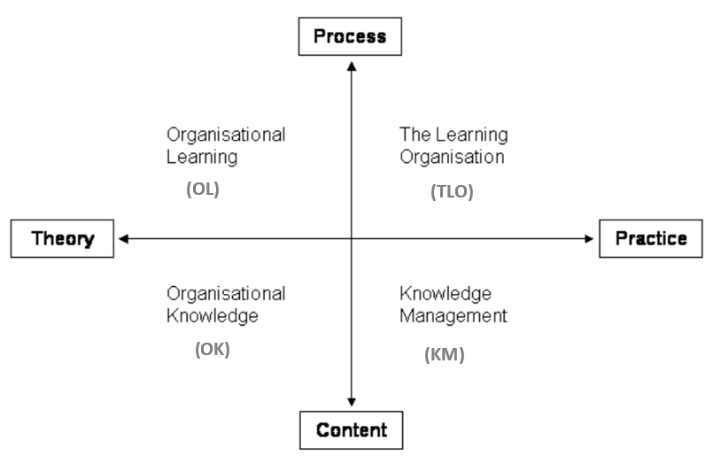

Figure 3 - Mapping the Key Topics (Easterby-Smith, M., and Lyles, M. A, 2011, pg.4)

Organisational Learning (OL)

OL, situated in the theoretical-process quadrant, explores how an organisation learns (Örtenblad, 2001). Early 1950s literature briefly referenced the concept as a structure fostering organisational transformation through individuals learning (Prange, 2006; Ritchie, 2010). In the mid-1990s, OL gained prominence as scholars recognised its benefits for organisations to learn from past experiences to gain competitive advantage (Argyris and Schön, 1996; Argyis, 1994; Collis, 1994; Senge, 1990). However, in policing, achieving strategic advantage outweighs the pursuit of competitive advantage (Ritchie, 2010).

Learning is a lasting change in thoughts, feelings, or behaviour resulting from experience (Lachman, 1997). Research suggests OL allows individuals and organisations to understand decision-making by reflecting on event outcomes (Yang, 2007). Many definitions of OL exist, but the core principles encompass learning from experience, reflective practice, continuous improvement, and adapting to the environment (Cyert and March, 1963). Easterby-Smith and Araujo (2006) define OL as processing, interpreting, and responding to information. While Fiol and Lyles (1985) define OL as enhancing actions through knowledge sharing. Senge (2006) provides the most precise definition; OL involves developing increased knowledge capacity to enable effective action, through a supportive process of collective learning.

HMICFRS defines OL as ‘creating, retaining, and transferring knowledge within an organisation’ (HMICFRS, 2022a). This process enables organisations to learn from experiences, both successes and failures to prevent similar shortcomings in the future. In 2006, an inspection highlighted the lack of robust mechanisms across policing nationally, to capture and share OL from public complaints (HMIC, 2006). The inspection concluded that no force had demonstrated a ‘systematic and structured approach to organisational learning’ (pg.221), emphasising the need for OL to be captured and shared promptly. Research indicates that successful organisations learn quickly (Peters and Waterman, 1982; Mullins, 2019), however many organisations are slow to adapt (Finger and Bürgin Brand, 2006), often reacting to events instead of proactively designing whole-system solutions based on foresight and learning to prevent failings reoccurring (Senge, 2006).

Senge (2006) has long influenced management literature, sparking debates on the theory of a learning organisation. Advocates argue OL promotes a safety culture, creates foresight to prevent adversities, and enhances organisational performance (Hakkyong, 2016), which is vital in a rapidly changing environment (Hsu and Lamb, 2020). However, implementation challenges persist due to the concept’s theoretical nature and a lack of practical guidance (Garvin et al, 2008). Critics dismiss it as a short-lived management fad without a clear definition (Pedler and Burgoyne, 2017; Pedler and Hsu, 2014; Hsu and Lamb, 2020). Additionally, Akella (2007) argues, the concept fosters managerial control and inequality, while Pedler and Burgoyne (2017) highlight limited research supporting the notion that learning organisations outperform others. Some consider the concept devoid of practical value, and lacking real-world engagement (Argyris and Schön, 1996; Adžic, 2018).

Despite differing opinions, applying OL in policing offers advantages for enhancing public services (CoP, 2022a; Brockbank et al, 2002). Specifically, OL facilitates knowledge accumulation and dissemination throughout the organisation, enabling officers to gain deeper insights into the root-cause of failures, learn from past experiences, and enhance their problem-solving abilities to make informed decisions. Furthermore, by analysing past successes and failures, policing can develop best-practice, refine policies and procedures and adopt new technologies. This iterative process, helps organisations continuously improve performance (Saunders et al, 2016).

However, drawbacks exist. Huber (1991) argues OL can be dysfunctional, where organisations may possess accurate but misinterpreted knowledge, or inaccurate but consistently applied knowledge, thereby undermining the reliability of the information. Additionally, policing’s institution culture often resists change due to hierarchical structures and rigid command-and-control systems (Higgins, 2018). The prevailing culture values conformity, and adherence to existing norms, making it challenging to acknowledge lessons learned and for new practices to embed (Reisig and Parks, 2004).

Furthermore, Goldstein (2003) highlights the lack of effective learning mechanisms in policing, which hinders the dissemination of best practices, and impedes learning from internal and external sources. Without such mechanisms, policing will struggle to leverage lessons learned from past experiences. Furthermore, learning is impossible when failures are concealed. Organisations consist of people, and if knowledge remains confined to individuals, without being shared with the wider organisation, the organisation will have less knowledge than its people (Argyris and Schön, 1996). This increases the risk of hidden errors and recurring failures. Therefore policing, especially DPP, should adopt a holistic, whole-system approach to facilitate OL (Boreham and Morgan, 2004).

When considering the best approach, Vera and Crossan (2003) argue against applying OL in isolation, and propose an integrative framework encompassing three key concepts (Figure 4). Moving horizontally, Organisational Knowledge (OK) creates a knowledge need, which converts into potential through Knowledge Management (KM) and translates into behaviour and action through OL.

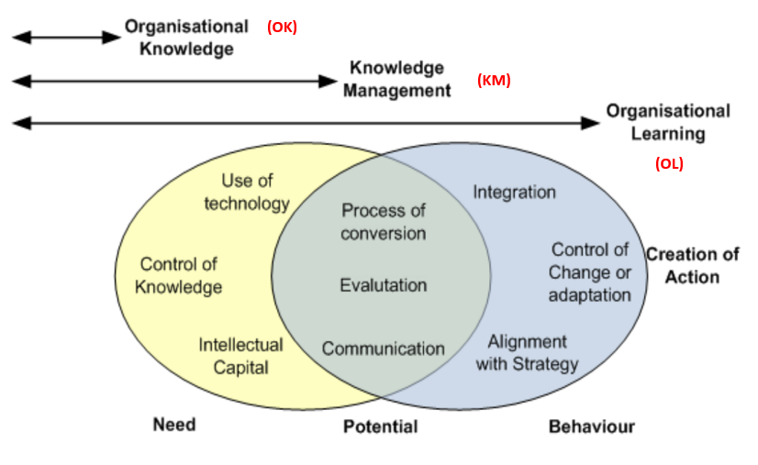

Figure 4 - Knowing and Learning in Organisations (Vera and Crossan, 2003; Ritchie, 2010)

The Learning Organisation (TLO)

TLO is in the process-practice quadrant, focusing on an organisations ability to learn and change behaviour (Örtenblad, 2001). Literature emerged in the 1980s (Garratt, 1987; Pedler et al, 1989) and was popularised by Senge (1990), advocating for organisational renewal and growth for improved performance. It emphasises creating a supportive culture and structure for continuous learning and knowledge sharing, adopting a systems-thinking approach (Ritchie, 2010). However, contrasting views exist. Lipshitz et al, (2002) argue no organisation can truly become a learning organisation, while Ritchie (2010) suggests TLO is a fleeting notion, overlooking organisational dynamics and prioritising goals over employee autonomy (Yeo, 2005; Örtenblad, 2004).

Nonetheless, in policing, TLO offers advantages by promoting adaptability in a dynamic policing environment (FOE, 2020). Learning organisations facilitate collective learning, problem-solving, and accountability through knowledge sharing. Additionally, the mindset encourages experimentation with new strategies, technologies, and approaches, leading to more effective and efficient policing methods. However, implementing a TLO model necessitates a cultural shift as policing resists change due to traditions, hierarchical structures, and fear of disrupting routines (HMICFRS, 2022a). Overcoming these barriers enhances policing’s ability to learn lessons and prevent recurring failings (Senge, 1990).

Organisational Knowledge (OK)

OK is in the theory-content quadrant, centred on the collective knowledge of individuals within an organisation (Nonaka, 1991). It encompasses employees’ knowledge of experiences, processes, cultures, skills, and operating models. OK is critical component of OL (Cheng et al, 2014) and relates to corporate memory, representing latent knowledge held by organisations (Bedford and Mazerolle, 2014; Ritchie, 2010). OK encapsulates and retains an organisations history and wisdom learned from past successes-and-failures, to enhance decision-making and performance (Walsh and Ungson, 1991; Stein and Zwass, 1995). However, caution is advised, as Hayek (1945) argues, OK consists of dispersed, incomplete, and often contradictory knowledge possessed by individuals.

Corporate memory is a dynamic resource of data and information (Huber, 1991) existing in various forms: technical repositories (documentation, electronic databases), and human repositories (knowledge held in individuals’ minds) (Alavi and Leidner, 2001). Developing corporate memory involves active-learning methods. Some organisations rely on technology as a knowledge repository, while others depend on employee recollections (Hansen et al, 1999). However, the latter approach is risky due to knowledge gaps from employee departures (Handzic, 2007). Active-learning entails using past events to drive improvements and overcome adversity (Parent, 2017). Handzic (2007), highlights two goals of corporate memory: preventing the recurrence of past mistakes and integrating knowledge across the organisation. Home Office (2020) guidance supports this concept, emphasising the sharing of learning beyond individuals directly involved in an incident to the wider organisation.
OK, theory, influenced by economists Nelson and Winter (1982) focuses on tacit knowledge (personal experience) and explicit knowledge (codified, formal). Nonaka and Takeuchi (1995) expanded the theory, creating a highly influential model in knowledge literature (Gourlay, 2006). The model consists of four continuous phases (Figure 5), for the socialisation of tacit and explicit knowledge (Nonaka, 1991; Nonaka and Konno, 1998), namely:

- Socialization (tacit-to-tacit): sharing tacit knowledge through observation
- Externalization (tacit-to-explicit): expression of tacit knowledge and sharing ideas among groups
- Combination (explicit-to-explicit): processing knowledge into a system (e.g., electronic record), for wider organisational sharing
- Internalization (explicit-to-tacit): internalising explicit knowledge for use as tacit knowledge throughout the organisation.

The purpose is to make tacit knowledge explicit, unlocking an individual’s knowledge, and sharing it with the wider organisation to future-proof corporate memory. This concept is important for policing to learn lessons from the past, prepare for the future and prevent comparable errors. However, Gourlay’s (2006) research, argues Nonaka’s proposition is an ambitious one, lacking in empirical and conceptual support. Gourlay argues against the claim that only tacit knowledge generates new knowledge, as new knowledge can also originate from explicit knowledge. Moreover, according to Bereiter (2002) observing someone during socialisation, doesn’t guarantee the transfer or replication of knowledge, he argued that merely observing and mimicking birds, for example, does not enable us to fly. Therefore, the assumption that tacit-to-tacit knowledge leads to transformation is flawed. Bereiter advocates that true transformation necessitates learning-by-doing.
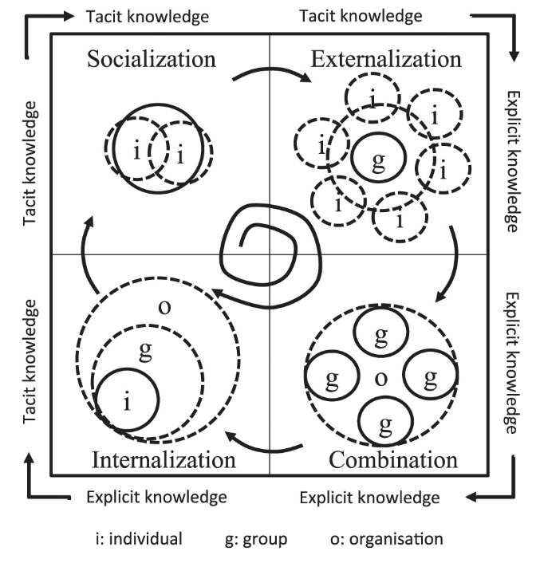

Figure 5 - Spiral of Organizational Knowledge Creation (Nonaka and Konno, 1998)
Despite the benefits of adopting OK models in policing, certain drawbacks should be acknowledged. Policing faces high turnover and retirement of experienced personnel. Maintaining a comprehensive corporate memory preserves valuable institutional knowledge and expertise, preventing loss when employees leave. Capturing and sharing lessons learned from past investigations, operations, and incidents enables informed decision-making, and effective response, promoting continuity and workforce development.

However, policing may encounter information overload as it generates a vast amount of data and information daily. Without proper management and filtering mechanisms, this volume could become overwhelming, hindering the organisations’ ability to locate relevant, and useful knowledge. Furthermore, knowledge may become compartmentalised within different police departments, leading to siloed knowledge sharing and restricted information flow. Therefore, implementing strategies that facilitate knowledge exchange becomes crucial to breakdown these silos.

Knowledge Management (KM)

KM is in the practice-content quadrant. It starts with acknowledging the significance of OK and uses a technical solution (Salder-Smith, 2006) to facilitate action through the systematic ‘creation, storage, retrieval, transfer, sharing and application’ of knowledge (Scarborough et al, 1999; Easterby-Smith and Lyles, 2011, pg.106). Knowledge creation generates new knowledge in organisations. Storage and retrieval rely on the development of internal and external corporate memory: Internal memory includes indivdiuals’ knowledge, while external encompasses codified and explicit organisational knowledge from policies and databases (Easterby-Smith and Lyles, 2011). Knowledge transfer involves acquiring knowledge from a source, so it is learned and applied by the recipient (Ko et al, 2005). Sharing exchanges knowledge between individuals through repositories, while application utilises knowledge for decision-making and problem-solving (Easterby-Smith and Lyles, 2011).
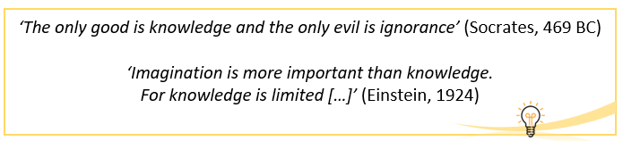

Two quotes, from two prominent figures, present contradictory assumptions about the value of knowledge. While these quotes lack academic findings, they should prompt scholars to pause (Schultze and Stabell, 2004). Some argue knowledge and management are contradictory concepts (Alvesson and Kärreman, 2001), given the dual nature of knowledge. On one hand, insufficient knowledge leads to uncertainty and inefficiencies, while excessive knowledge can result in counterproductive inflexibilities and hinder diverse perspectives (March, 1991; Leonard-Barton, 1992; Bowker and Star, 1999). Whilst, KM theory has garnered minimal critique, it is widely advocated as one of the most crucial learning resources for organiations (Schultze and Stabell, 2004).
Therefore, KM is a valuable notion for policing to learn from the past and prepare for the future, utilising internal and external sources like independent inquiries. However, maintenance and updates pose disadvantages as technological solutions require regular investment to stay effective. Neglecting system maintenance leads to outdated, unreliable, and error-prone systems. Policing deals with sensitive and confidential information and adheres to robust data protection legislation. Therefore, KM systems must ensure security measures to prevent unauthorised access or breaches.

KM offers advantages to future-proof organisational efficiency. However, to be effective, the police knowledge bank (corporate memory) requires a continuous flow of knowledge that is ‘created, stored, shared, and applied’ through a secure, user-friendly technological solution accessible to the wider organisation (Handzic, 2007, pg.24; Handzic and Zhou, 2005).

Isomorphic learning (IL)

IL examines the relationship between organisations and their ability to learn from disasters. While each disaster is unique, they share common features at certain analysis levels (Parent, 2017). IL involves organisations in the same field sharing lessons, knowledge, and insights derived from events to prevent similar occurrences in the future (Buchanan, 2011). Theoretical assumptions of Toft and Reynolds (2005) argue systems are formed on ‘underlying similarities and common characteristics’ (cited in Hakkyong, 2016, pg.1218). Sharing lessons from one system failure with another enables the implementation of measures to prevent errors in other areas. Instead of focusing on improving a specific sub-system, such as an individual, it is prudent to consider repeated failures for similar reasons as a whole-system issue, identifying root causes, and improving future practices (Campbell and Craig, 2005).

Toft and Reynolds (2005) classify isomorphism into four categories (Figure 6). Isomorphism theory offers advantages and disadvantages for policing, with the researcher exploring two areas:

Cross-organisational Isomorphism: Police forces have identical functions and operate under identical regulations, making them susceptible to similar errors. Sharing knowledge among forces enables sector-wide learning to prevent recurring failures elsewhere. However, contextual differences exist between forces, as they all operate in diverse environments with unique challenges and cultural variations. Blindly, adopting practices from other organisations without considering these factors may result in inefficiencies.

Self-isomorphism: Police forces have sub-units that perform similar functions, like custody suites that share the common goal of safely detaining arrested individuals. Should an adverse incident occur in one suite due to local practice, the lessons learnt should be applied to all other suites to prevent comparable failings. However, caution is necessary to address resistance and unintended consequences that may arise from implementing broad-brush changes without proper evaluation.
Isomorphism offers a valuable framework for policing to learn from similar functions, mitigating risk and enhancing practice by developing foresight through hindsight (Hakkyong, 2016). Nonetheless, police policymakers should adapt IL theories to the specific needs, cultural context, community dynamics, and legal frameworks of their respective organisations. Striking a balance is crucial to account for the unique challenges and characteristics of modern-day policing.

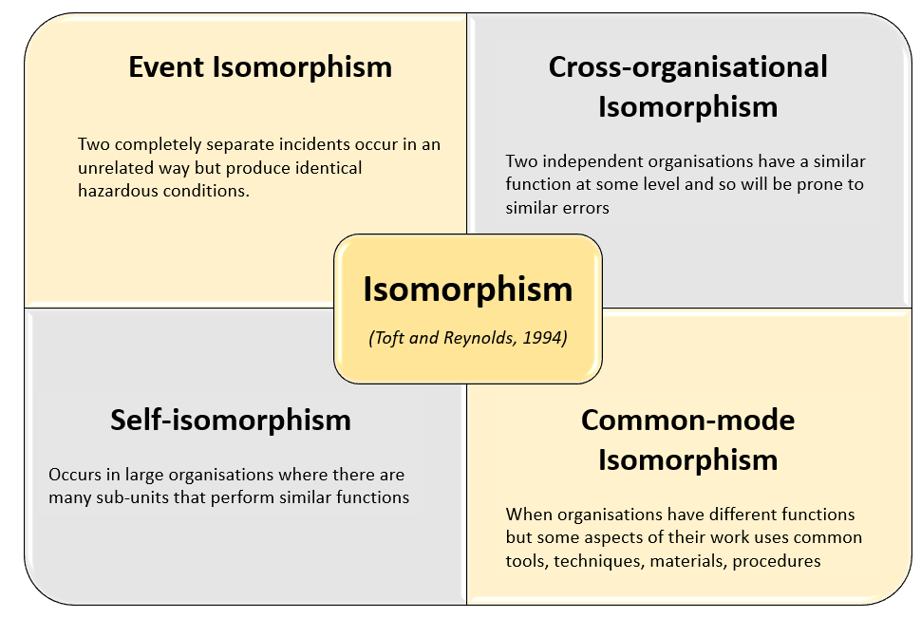

Figure 6 - Isomorphic Learning Categories (adapted from Toft and Reynolds, 1994)

Learning Theories

Single-and-double loop learning

Argyris and Schön’s (1978; 1996) theory, categorises OL into two levels: Single-loop-learning and double-loop-learning (Figure 7). Single-loop-learning involves making minor adjustments to existing practices based on evaluating successes-and-failures, without challenging assumptions or changing established modes of operation (Salder-Smith, 2006). It achieves immediate improvements but leaves underlying values and practices unchanged (Brockbank et al, 2002). In policing, this could include modifying patrol plans, or implementing a training program. While single-loop-learning improves short-term efficiency, it falls short in addressing more complex issues.

In contrast, double-loop-learning questions ‘taken-for-granteds’ and evaluates underlying assumptions, values, and beliefs (Brockbank et al, 2002, pg.11). Disentangling these ‘taken-for-granteds’ can be challenging due to human nature, when individuals have an unpleasant experience or their professionalism is threatened to self-preserve and offer defensive reasoning (Easterby-Smith and Lyle, 2011, Whittingham, 2004). Defensive reasoning, described as cognitive dissonance by Festinger (1957), involves individuals justifying and excusing their actions when feeling threatened or embarrassed (Argyris, 2010).

Higgins (2018, pg.5) argues policing is plagued by ‘unconscious organisational defensiveness’, due to concerns about legal and civil ramifications. Syed (2016) highlights society’s psychological belief that failure is shameful, leading individuals to delete failures from memory to conceal errors and protect themselves. However, valuable learning opportunities are missed when errors are disregarded, since ‘we progress fastest when we face up to failure and learn from it’ (Syed, 2016, pg.282). Double-loop-learning enables organisations to examine contributory factors and comprehend the impact of decisions and actions. It involves critical reflection and may require transformative changes, or the implementation of new systems (Salder-Smith, 2006). While time-consuming, double-loop-learning is crucial for evaluating whether the organisation is achieving its objectives, and addressing systematic issues to create sustainable change. Both types of learning are valuable to policing, depending on the nature of the issue being addressed.

According to Bedford and Mazerolle (2014), defensive reasoning tends to creep into single-loop-learning, as attitudes go unchallenged and policing often relies on single-loop-learning to make short-term adjustments within existing frameworks to address challenges. Many cases exist highlighting this point, specifically in the Stephen Port Murders, police failed to identify similarities between the deaths of four homosexual males, attributing them to accidental drug overdoses, while Port used date-rape drugs to incapacitate each victim. An inspection conducted eight years later revealed the same failings could occur today, as minor changes were made to working practices, and underlying assumptions were unaddressed (HMICFRS, 2023).
This example indicates a problem within the policing system and highlights the risks of relying solely on single-loop-learning. In this case, double-loop-learning, by questioning assumptions, and examining contributing factors, could have identified links and similarities. While single-loop-learning improves efficiencies by promptly rectifying errors within established procedures, overreliance without critical evaluation can result in recurring failures. Double-loop-learning, despite being more time-intensive, is preferable as it allows policing to learn by critically examining underlying assumptions. It challenges existing paradigms, and enhances adaptability in complex, and rapidly changing environments, thereby better preparing for the future.
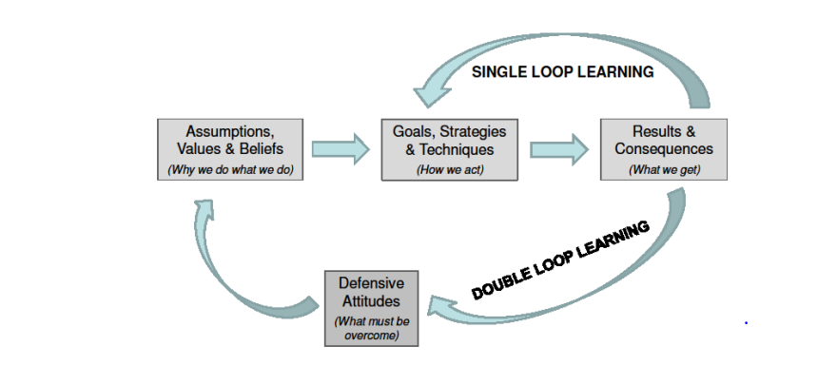

Figure 7 - Single and Double Loop Learning (Argyris and Schön, 1978)

Experiential Learning Theory (ELT)

Experiential learning is reflection-in-action (Nonaka, 1994) and involves learning through firsthand experience during task engagement (Schön, 1983). However, the practice of ELT can be thorny, as individuals have varying interpretations of an experience (Godé and Barbaroux, 2012), leading to potential inaccuracies in OL (Bedford and Mazerolle, 2014). Combining experiential learning with other knowledge forms generates comprehensive insights for informed decision-making (Bedford and Mazerolle, 2014). Psychologist David Kolb's Experiential Learning Model emphasises active learning through 'doing' rather than passive methods like observing or reading (Kayes, 2002; Kolb, 1984). The cyclical model consists of concrete experience, reflective observation, abstract conceptualisation, and active experimentation (Figure 8). Incorporating experiential learning in policing facilitates OL and focuses on identifying knowledge flow opportunities in the initial three-quarters of the cycle.

Concrete experience in policing refers to first-hand physical encounters, such as responding to incidents serving as the foundation for learning. Reflective observation enables individuals to reflect on these experiences, evaluate strengths and weaknesses, and gain valuable insights into unconscious bias and decision-making. Abstract conceptualisation connects concrete experiences to existing knowledge, theories, and concepts. In policing, this involves reflecting on experiences and analysing them against legislative and policy requirements. This enables the derivation of meaningful lessons and the identification of areas for improvement. Active experimentation entails applying lessons learned from these experiences.
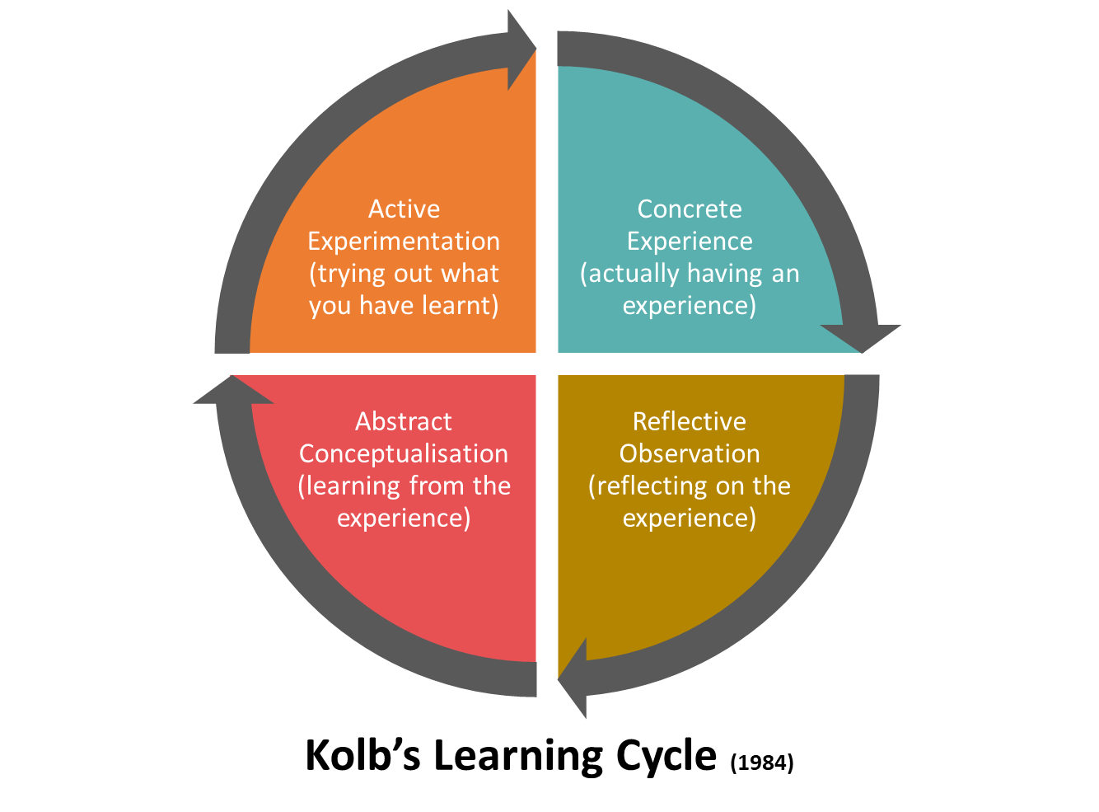

Figure 8 - The Experiential Learning Model (adapted from Kolb, 1984; Webapi, 2022)
The effective application of ELT in policing is crucial for addressing cultural defensive reasoning (Bedford and Mazerolle, 2014). Successful implementation, driven by an open mindset, facilitates productive reasoning. However, the process fails if improvements are not translated into actionable changes. OL occurs when behaviours change, and knowledge is stored for future use (Huber, 1991; Bedford and Mazerolle, 2014). Despite ELT’s evident benefits in supporting RP and practically applying theoretical knowledge, counterarguments exist based on empirical (Freedman and Stumpf, 1980) and theoretical grounds (Holman et al, 1997).

Critics argue prioritising individual concrete experience neglects cognitive, social, and conceptual learning (Holman et al, 1997; Vince, 1998), as direct experiential knowledge acquisition may not always lead to deep understanding and may overlook cognitive activities like problem-solving. Therefore, while ELT offers reflective learning opportunities, a comprehensive approach that combines experiential learning with other OL methods would enhance police effectiveness. Embedding solutions into organisational culture and routine practice (Milburn, 2000) is crucial for long-term change. Police forces need to learn from critical incidents to improve, and Kolb’s learning cycle plays a key role in encouraging reflection, innovation, and making better-informed decisions to serve the public more effectively.

Debriefing

There is a disparity between the ideal of transparently sharing every mistake to facilitate mutual learning, and the inclination of individuals to withhold knowledge (Firing, et al, 2020). Police debriefs hold significant potential to facilitate OL (Firing, et al., 2020) and contribute to the welfare-recovery process after a traumatic incident (CoP, 2013). Additionally, learning from lived experience provides valuable insight to inform future practice (Kolb, 1984).

Debriefing provides a safe and supportive platform for offices and staff to collectively reflect on experiences, emotions, and actions. Its purpose is to identify best practices, areas for improvement, and strategies for effectively managing similar incidents in the future. The CoP (2013) advises police forces to conduct debriefing processes after challenging incidents or police operations before employees end their duties. CoP (2013) recommends using the National Decision Model (Appendix C) as a debrief structure and emphasises the importance of retaining comprehensive debrief records for auditing purposes, as required by the Criminal Procedures and Investigation Act (CPIA, 1996).

However, scholars caution that debriefs alone may not suffice as an OL tool, as their effectiveness relies on participants’ willingness to truthfully engage and share insights (Firing, et al., 2020). Furthermore, researchers have observed that participants tend to withhold knowledge of mistakes, and selectively share information due to distrust in the process and concerns of self-incrimination or embarrassment in an open forum (Godé and Barbaroux, 2012; Zigmont et al, 2011; JALLC, 2016).

Debriefing following critical incidents offers several advantages, including providing a structured outlet for officers to process and express their emotions, thus promoting psychological well-being, and reducing the risk of post-traumatic stress. It also serves as an opportunity to gather first-hand information that supports OL. However, the actual implementation of effective debrief practices in policing is insufficient, as revealed by alarming admissions from police experts during the Manchester Arena Inquest, highlighting a lack of debriefing protocols (Home Office, 2022a).

Arguments against debriefing processes highlight potential limitations, such as reliance on subjective and potentially distorted recollections of an incident due to stress or individual biases, which in turn compromises the accuracy and reliability of shared information (Firing, et al., 2020). Moreover, if an organisation lacks a supportive culture that values open communication and learning from critical incidents, officers may hesitate to participate or provide honest feedback. Trust and confidentially concerns may further discourage officers from openly sharing their experiences.

Chapter Summary

This chapter provides a comprehensive overview of research in a policing context, examining various learning perspectives and theories. The literature review offers valuable insights into the conceptualisations, mechanisms, and practical implications of learning, highlighting how these perspectives can support policing and DPP in capturing and sharing lessons from critical incidents.

By examining various theoretical perspectives, the review emphasises the significance of individual and collective learning and the benefits of knowledge creation and transfer for developing learning capabilities. Understanding these theories and their implications can assist DPP in designing effective strategies for creating a learning organisation, adapting to dynamic environments, and achieving long-term success. However, while these concepts are thought-provoking, their adoption in everyday practice remains ambiguous (Brockbank et al, 2002).

Compelling arguments support implementing OL concepts for continuous improvement in response to the pace of change (Senge, 2006; Pedler et al, 1991). However, achieving sustainable change requires time, flexibility, and a holistic approach (Brockbank et al, 2002). The literature review indicates policing has historically focused on short-term solutions for long-standing cultural issues, relying on single-loop learning and defensive reasoning, resulting in persistent failures. Embracing double-loop learning can foster a culture of critical reflection, continuous improvement, and innovation to prevent recurring mistakes. Yet, research shows organisations are limited if they adopt only one of the key concepts since none of the approaches fully support all OL theories.

Therefore, it’s important for DPP to combine multiple theories to address the unique needs of the organisation (Basten and Haamann, 2018). Further empirical research is required to determine if UK-policing effectively learns from past incidents, to prevent future occurrences, and to identify best-practice knowledge management approaches that benefit the broader sector.

Next, the methodology chapter introduces the primary research and justifies the researchers’ choice of a self-administered questionnaire to fulfil the research aims.

Chapter Three

Research Methodology

Introduction

This chapter explains how the research goals will be accomplished and why a specific methodology was chosen. These methodological decisions direct the overall empirical investigation.

What is research?

Research is the systematic collection and interpretation of information with the specific purpose to gain knowledge on a particular topic (Saunders et al, 2016). It involves a methodical and structured approach to gathering data, enabling evidence-based conclusions and recommendations (Shuttleworth and Wilson, 2008).

Aim and Objectives

The research project aims to determine if DPP is a learning organisation that effectively learns from critical incidents, or whether it operates in silos and misses opportunities to capture corporate memory and share lessons across the wider organisation to prevent reoccurrences. To accomplish this, the researcher has formulated objectives that ‘operationalise’ the research question and outline the steps taken (Saunders et al, 2016, pg.46):

    - Compare and contrast organisational business functions, to determine how learning is being managed.

    - Critically examine whether DPP transparently records, coordinates, and shares learning from internal and external stakeholders with employees across the organisation.

    - Use the findings of this research to identify areas for improvement, formulate conclusions and make recommendations to the DPP Senior Leadership Team.

Design

Research design guides the research process by providing a systematic roadmap. It outlines the steps involved in collecting and analysing data to generate meaningful findings to answer the research question and draw conclusions. A well-defined research design is essential as it ensures alignment with the research objectives, enhances validity and reliability, allows for control and comparison, incorporates ethical considerations, and facilitates visualisation of the findings (Saunders et al, 2016).

The chapter utilises the ‘Research Onion’ as a structure, discussing each layer in sub-sections. This conceptual framework by Saunders et al (2016), helps researchers understand the interconnected components of a research study. The model ensures a thorough and systematic approach to research design (Orth and Maçada, 2021) and consists of six layers, representing different aspects of the research process. The two outer layers reflect the theory surrounding the project, the next three represent the strategy, and the center depicts data collection and analysis (Figure 9).

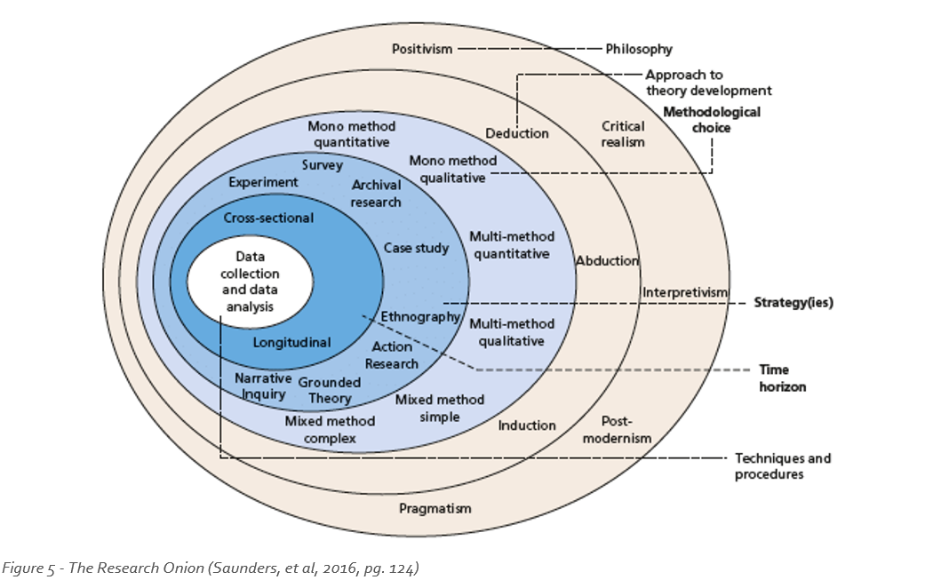

Figure 9 - The Research Onion (Saunders et al, 2016, pg.124)

Philosophy

Research philosophy forms the foundation of the study, shaping knowledge development through a set of beliefs and assumptions. These assumptions influence the researcher’s approach and findings throughout each stage of the research process. They revolve around ontology (what we know), epistemology (how knowledge is acquired), and axiology (researcher’s values and biases) (Saunders et al, 2016).

Research is categorised as primary or secondary based on data sources. Primary research involves collecting first-hand data specifically for the project, whereas secondary research utilises existing data from other researchers. Secondary research has been excluded in this study, due to limited control over data reliability, validity, and contextual alignment to the research objectives. Instead, the primary research involves engaging with DPP employees to gather their perspectives regarding learning lessons. This approach provides control over data collection and ensures alignment with the research objectives. However, limitations exist, including time constraints and biases from both the researcher and participants. Primary data will be collected through a self-administered questionnaire.

Ontology subjectivism is the most appropriate assumption for the research project. Ontology questions the nature of reality, what is known about the organisation, and subjectivism assumes reality is subjective and constructed based on individuals’ perceptions, interpretations, and experiences. A subjectivist researcher aims to comprehend different perspectives and interpretations of individuals, to make assumptions about the reality of a situation (Saunders et al, 2016).

The chosen research philosophy for this study is interpretivism, emphasising qualitative research. It seeks to understand and interpret subjective meanings, experiences, and social contexts (Saunders et al, 2016). Ontological assumptions associated with interpretivism, accept various, equally valid interpretations of reality exist (Biggam, 2011; 2021), as ‘different people of different cultural backgrounds, under different circumstances and at different times, make different meanings’ (Saunders et al, 2016, pg.140). Interpretivism provides valuable insights into the complex dynamics and experiences of police practices, allowing flexibility for the researcher to use mixed-methods, exploring diverse perspectives on policing learning lessons from the past and enabling the researcher to identify positive action-orientated outcomes. Given the researcher’s position as a senior officer in DPP, caution was exercised regarding ontological and axiological assumptions and their influence on the research process. In summary, interpretivism is well-suited for this study, as it bridges the theory-practice gap and provides evidence-based recommendations for DPP.

Approach

Two opposing research approaches based on logical reasoning exist (Figure 10). Deductive reasoning starts with a general theory, tests specific hypotheses using logical inference, and aims to answer the research question. It follows a top-down approach, deriving predictions from theory, which are then tested using empirical data to evaluate theory validity (Trochim, 2023). Deductive research is commonly associated with quantitative methods like surveys, to confirm or reject specific hypotheses (Saunders et al, 2016).

Inductive reasoning, in contrast, starts with data or observations to identify patterns, themes, or generalisations. It takes a bottom-up approach, progressing from specific observations to general theories. Inductive research is typically linked to qualitative methods like interviews, enabling the discovery of new knowledge through pattern detection, hypothesis formulation, and theory development (Saunders et al, 2016).

Although both approaches have merit, the research project adopts deductive reasoning. The researcher has conducted a comprehensive review of theories and literature on Organisational Learning (OL) and has formulated an initial hypothesis. Subsequently, primary data has been gathered to verify or refute the hypothesis.
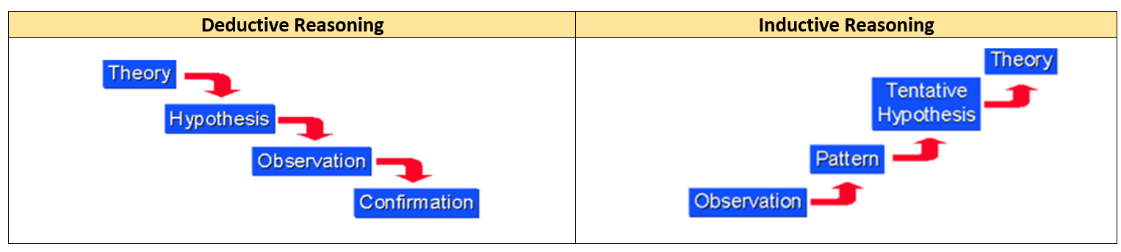

Figure 10 - Deductive and Inductive Reasoning (Trochim, 2023)

Methodological Choice

This study adopts a mixed-method approach to gather primary data, combining both qualitative and quantitative methods. This approach enables a comprehensive understanding of the intricate dynamics of policing, integrating objective data and subjective experiences. Bell and Waters (2018) highlight that mixed-methods allow for triangulation and consideration of diverse perspectives, enhancing comprehension through various methods and techniques. Quantitative methods involve structured research techniques like surveys to collect numerical data, while qualitative methods involve techniques like interviews and focus groups to capture perceptions. In this study, a concurrent mixed-method approach is adopted, incorporating both quantitative and qualitative methods in a single phase of data collection and analysis using a questionnaire (Saunders et al, 2016). This approach offers a holistic response to address the research question.

Strategy

A survey strategy adopting a questionnaire is used to collect primary data from participants (Appendix F), following a deductive research approach (Saunders et al, 2016). The questionnaire gathers both qualitative and quantitative data through the targeted selection of individuals in a controlled manner (Biggam, 2011). The researcher adheres to DeVaus’ (2014) definition of a survey, which encompasses a method where each person responds to the same set of questions in a predetermined order (cited by Saunders et al, 2016).

Various survey methods exist, such as in-person and telephone interviews, postal, web-based, and group questionnaires (Biggam, 2011; 2021). Considering advantages and disadvantages, a structured web-based questionnaire was chosen for its higher response rate (Beebe et al, 1997). Across policing, employees work various hours to ensure continuous 24-hour coverage. Thus, a web-based survey is a cost-effective method that ensures accessibility for participants during their working hours, enabling diverse representation across the expansive geography of DPP (Saunders et al, 2016). Additionally, as the researcher occupies a senior-officer position within the hierarchical organisation, the survey approach ensures participant anonymity and disregards the researcher’s biases (Sincero, 2012). However, surveys have limitations. According to Robson (2011), online surveys often yield low response rates, and lack design flexibility, resulting in a limited depth of information compared to methods like observations. Surveys lack direct researcher-participant interaction and rely on closed-ended questions, restricting participants’ expression and depth of insights. Surveys are also perceived as tedious, leading to less thoughtful responses (Sincero, 2012).

To address these impacts, the questionnaire is designed to be concise to reduce participant disinterest (Sahlqvist et al, 2011). It incorporates a combination of predetermined questions and free-text narrative functionality to enable participants to express themselves freely. Open-ended questions allow unrestricted responses, while closed-ended questions with predefined response options (e.g., “yes/no”) ensure standardisation. Closed-ended questions offer advantages, such as saving time and alleviating survey fatigue, enhancing participant engagement.
However, closed-ended questions have limitations as they restrict participants from providing additional context beyond the given options. Conversely, open-ended questions pose challenges for data aggregation and comparisons. To strike a balance, the researcher adopted an approach that combined both question types.

The questionnaire was distributed electronically via secure email using Microsoft Forms. Notably, Saunders et al (2016) cite web-based questionnaires have a low likelihood of answer contamination or distortion, with a response rate of 30-50%. In contrast, telephone questionnaires have a higher response rate of 50-70% but are more prone to contamination. Telephone questionnaires and structured one-to-one interviews are considered alternatives should the web-based approach yield a low response rate. However, telephone questionnaires require additional considerations such as call-backs and call abandonment criteria, which can be time-consuming for both participants and the researcher. Accessibility to technology is assumed for all DPP participants, but accommodations such as providing a paper version and translation will be arranged if necessary. Questionnaire design plays a crucial role in response rates and data validity. Therefore, careful consideration was given to ensure the questions effectively collect the required data to address the research question. As recommended by Fink (2013), a pilot test was conducted with ten employees to address design flaws, confusing questions, and data collection issues. Minor modifications were made based on feedback before the final distribution to participants (NcNeill and Chapman, 2005).

Two sampling techniques exist: probability and non-probability. The distinction lies in how the samples are selected and their representativeness of the target population (Saunders et al, 2016). Probability sampling involves random selection, while non-probability sampling employs non-random methods. Due to technical challenges and time constraints, obtaining a probability sample was not feasible for this study. Therefore, a non-probability sample is chosen to gather insights from a diverse range of employees, ensuring representation from different levels within the organisation. Non-probability sampling offers practicable advantages, such as quick data collection, and fewer resource requirements compared to probability sampling. However, non-probability sampling is susceptible to bias as the sample is not randomly selected, and participants self-select based on their willingness to participate, potentially leading to differences in characteristics and experiences compared to the overall population, thus resulting in biased representation (Olsen, 2008).

The sample size greatly impacts the validity of the study findings. A larger sample, as recommended by Saunders et al (2016), enhances representation and increases the likelihood of capturing variations and patterns. However, determining the ideal sample size is a complex task, and sample size formulas can be useful (Saunders et al, 2016). For this research project, the researcher estimated the sample size ranging from 50 to 70 employees to achieve a comprehensive and representative sample. The questionnaire was sent to 70 employees.

Time Horizon

A cross-sectional time horizon was chosen to fulfil the research objectives. This approach involves collecting data from a population at a specific point in time, allowing for the examination of variables related to OL across the organisation and making simultaneous comparisons. Alternatively, longitudinal research tracks change in variables over an extended period by collecting data to track changes and developments in variables over-time, providing insights into patterns, trends, and cause-and-effect relationships. However, due to time constraints placed upon the dissertation, longitudinal research was not a feasible option (Sedgwick, 2014).

Techniques and Procedures

Research generates vast amounts of information, requiring purposeful data collection to minimise bureaucracy and facilitate meaningful interpretation (White, 2014). The researcher employed Braun and Clarke’s six-step thematic analysis framework (2006) (Figure 11) for effective comparisons. Thematic analysis groups and codes qualitative data, enabling identification, analysis, and interpretation of patterns or themes (Smith, 2015). This approach allows for exploration and comparison of relationships within data (Saunders et al, 2016). Thematic analysis provides an in-depth understanding of qualitative data, uncovering nuanced perspectives, and factors influencing policing issues. This understanding assists the researcher to formulate recommendations for practice improvement. However, thematic analysis has limitations. Researchers’ preconceptions and biases, may influence theme identification, leading to subjective interpretations. Different researchers may identify different themes or interpret the same data differently, impacting objectivity. Nevertheless, thematic analysis remains a well-established analytical tool (Saunders et al, 2016).

The Microsoft questionnaire facilitated mixed-method data collection. Responses were exported to Excel for analysis, allowing for structured organisation and critical interpretation (Bell and Waters, 2018). Before analysis, the researcher cleaned and prepared the data, coding duplicates, incomplete responses, and addressing missing values to ensure accuracy. Excel’s cross-tabulation and filtering explored variable relationships, while basic summary statistics like percentages analysed quantitative data. Data visualisation techniques, including tables and pie-charts, presented variables, trends, and findings.

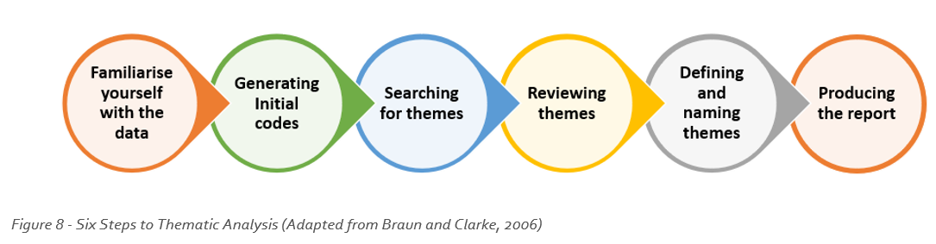

Figure 11 - Six Steps to Thematic Analysis (Adapted from Braun and Clarke, 2006)

Ethical Considerations

Ethics guide our everyday behavior and determine what is morally right or wrong. However, ethics are subjective, as people interpret acceptable behavior differently (Biggam, 2011). Primary research with human participation presents unique challenges requiring research ethics to protect the integrity, validity, and well-being of both participants and the researcher (Walton, 2016). Research ethics involve the ‘application of a code of conduct when human participants are the focus of empirical research’ (Biggam, 2011, pg.249).

Biggam’s (2011) five ethical principles were followed:

- Informed consent was obtained transparently. An information sheet included the researchers’ identification, contact details, supervisors’ information, research purpose, and data usage intentions.

- Participant confidentiality was maintained using anonymous codes, and data was stored in a password-protected Excel spreadsheet accessible only to the researcher and supervisor.

- Participation was entirely voluntary, with participants informed of their right to withdraw.

- Participants were not identifiable or exposed to harm or asked for personal information.

- The researcher, an employee of DPP and having a working relationship with participants, declared their impartiality and adherence to UWTSD’s (2022) Research Ethics and Integrity Code of Practice.

The full ethical considerations and measures taken by the researcher for this study are detailed in Appendix E, addressing potential psychological harms and reputational issues arising from the research findings.

Reliability and Validity

Research reliability and validity are essential for ensuring the credibility and applicability of research findings. According to Merriam and Tisdell (2016), rigorous research is vital for establishing credibility. Reliability refers to the consistency, stability, and replication of research results. A study is regarded as reliable if it produces consistent findings when repeated under similar conditions. Replication is a fundamental principle as it validates initial findings and increases confidence in the conclusions (Saunders et al, 2016). Conversely, validity relates to the accuracy, appropriateness, and generalisability of inferences and conclusions drawn from a study (Merriam and Tisdell, 2016). It ensures data represents the investigated topic accurately and measures the intended aspects (Field, 2005).

The questionnaire prioritised reliability and consistency. A pilot test ensured face validity, comprehensibility, internal validity, and data reliability aligned with the research question. Participant feedback led to minor adjustments enhancing reliability. The questionnaire was modified with 32 tick-box and multiple-choice questions to promote clarity and standardisation. In this context, Foddy (1994, pg.17) highlights the importance of ensuring mutual understanding, stressing ‘the question must be understood by the respondent in the way intended by the researcher, and the answer given by the respondent must be understood by the researcher in the way intended by the respondent’ (Figure 12).

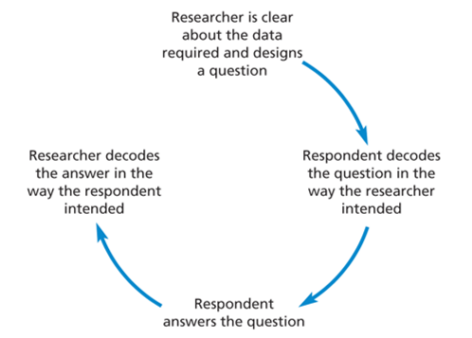

Figure 12 - Four stages to developing question validity and reliability (Foody, 1994 cited by Saunders et al, 2016, pg.450)

Chapter Four

Data Analysis

Introduction

The chapter presents data analysis and outcomes for the research question. According to Bogdan and Biklen (2007), data analysis involves systematically organising and disaggregating data to reveal patterns and significant findings. The study investigates whether DPP is a learning organisation that learns from failings identified within critical incidents or, whether it’s an organisation that learns in silos, and fails to maximise opportunities to capture corporate memory and share lessons across the wider organisation to prevent reoccurrences. A self-administered questionnaire with 32 tick-box questions was used. However, some questions required textual justifications to triangulate preceding responses. These aimed to gather insights into DPPs’ management of local and national lessons from critical incidents. Additionally, a subset of questions used Likert scales to assess participants’ perceptions.

Respondents could choose only one response option per question, with no mandatory requirements, allowing participants to skip or opt out. A response rate of 91% was achieved, involving a total of 64 participants, including police officers and staff members across different ranks, roles, and departments. All participants fully engaged with the questionnaire, responding to all questions, demonstrating a high-level of participation. The questionnaire investigated four key areas. Firstly, it gathered data on the respondents’ length of service, providing five options for selection. The findings showed that 48% of the sample had over 20-years of service, while the smallest proportion (8%), had between 1 to 5 years’ service. The substantial number of employees with over 20-years’ service, enriches the data by providing valuable institutional knowledge. Furthermore, the remaining proportion represents a variety of tenure, experience, and skills, which equally ensures a comprehensive and well-rounded understanding of the issues under investigation. This diversity, encompassing various demographics, ranks, and experiences, contributes to a holistic examination of DPP’s effectiveness regarding the research question.



Figure 13 - Primary Data results for Question (1)
Secondly, the questionnaire examined the management of OL and the influence of culture within DPP. It also evaluated DPP’s effectiveness in recording, coordinating, and sharing learning internally and externally with stakeholders. A qualitative free-text section is included at the end of the questionnaire, for participants to provide additional comments.

To analyse the results effectively, the researcher has aligned them with the research objectives. Therefore, the primary data collected will be examined based on the categories of objectives one and two, while objective three will be addressed later as the foundation for Chapter Five.

Objective One
- Compare and contrast organisational business functions to determine how learning is being managed

DPP encompasses an array of departments and functions that fulfil a wide range of responsibilities essential for upholding law and order. These are broadly categorised into Operational (e.g., incident response, custody), Investigations (e.g., offender management, CID), and Administrative (e.g., Human Resources, Finance). This study sought to compare business functions, to uncover how critical incidents are managed to gather comparative data.

Question (2) aimed to investigate and evaluate the presence of OL management processes in individual teams and/or business areas. Out of 64 responses, 63% reported the existence of OL management processes, while 28% expressed a negative stance, and 9% were uncertain. To delve deeper into the affirmative responses, a qualitative follow-up question was posed to gather additional details regarding the specific OL processes being adopted. Among 41 responses, a range of mixed insights was obtained. Notably, one participant remarked “We discuss lessons at weekly departmental meeting, and these are recorded on the shared drive for staff to access”, conversely another participant stated local arrangements are not formalised, with no recording or storage of learning, and relies on verbal conversations. Additionally, another remarked “There is no process to manage learning in my team. I work in a CID/Investigatory department’.

The word cloud below visually represents textual data analysis, highlighting the frequency and significance of specific terms. It provides an overall summary, with “debrief, team, meetings, and verbal” being the most frequently mentioned terms. Leveraging the philosophical position of interpretivism the findings indicate that DPP has a loosely defined OL process, primarily centred around informal team debriefs conducted locally, and predominantly in verbal form. These findings align with existing literature, that across UK-policing there is an absence of a systematic and structured OL approach (HMIC, 2006).

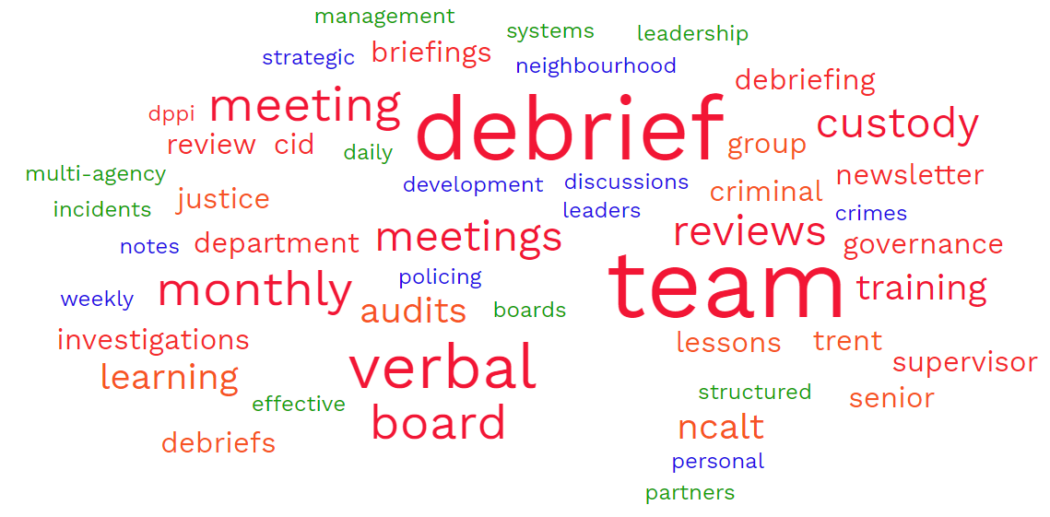

Figure 14 - Word Cloud representing qualitative data for Question (2)
Debrief emerged as the primary method for managing OL within DPP. This aligns with the reflective observation phase of Experiential Learning Theory defined by Kolb (1984) where individuals actively analyse and reflect on their experiences. Leveraging Nonaka’s (1991) theory of knowledge socialisation, debrief sessions facilitate the transfer of explicit knowledge to enhance learning within the organisation. Additionally, the findings align with Argyris and Schön (1996) concept of single-loop learning, focusing on improving current practices. Debriefs serve as a mechanism for transferring explicit knowledge, enabling participants to reflect, share insights, and learn from their experiences.

To triangulate and enhance the reliability of the qualitative data, question (22) investigated the frequency of debriefing sessions in DPP. Quantitative findings indicate a significant majority of participants (60%), perceived a lack of regular debriefs in the organisation. These deficiencies in the socialisation of explicit knowledge highlight the limitations of single-loop learning, which focuses on incremental improvements within existing frameworks but neglects to address systemic issues. The absence of regular debriefs implies a potential failure for DPP in addressing underlying issues that contribute to recurring failures. This finding aligns with HMICFRS (2022c) findings which identified an inadequate corporate debriefing process within DPP.

In contrast, 21% of respondents reported regular debrief sessions, while 19% expressed uncertainty, indicating potential ambiguity in the socialisation process. This ambiguity may arise from a lack of clarity regarding the purpose or structure of debriefing sessions. To address this, it is crucial for DPP to assess and address the reasons behind the perceptions that regular debriefs are not occurring. This may involve evaluating existing practices and commissioning future research in this regard. Analysing the data from a socialisation theory perspective, one argues that if briefings were regular and well-established, participants would not have uncertainties. Interpreting the data, debriefs are the primary process for managing lessons within DPP, yet they are irregular in sharing explicit knowledge. Considering the concepts of single-loop and double-loop learning, the findings reveal that relying solely on sporadic debriefs falls short of effectively embracing OL to extract lessons to improve future preparedness.
Addressing potential gaps in debrief implementation and establishing clear guidelines within DPP can enhance the socialisation process, enabling the transfer of tacit knowledge and utilisation of explicit knowledge to strengthen OL. To promote the socialisation of explicit knowledge, DPP should embrace double-loop learning, encouraging critical reflection, challenging assumptions, and facilitating the deeper exploration of underlying issues and systemic dynamics. However, heavy reliance on debriefs as the primary method for managing OL in DPP raises concerns. Scholars argue this approach alone is inadequate for capturing valuable lessons. As distorted recollections of events can compromise the reliability of shared learning (Firing, et al., 2020) and unconscious defensive reasoning can undermine the process (Bedford and Mazerolle, 2014; Higgins, 2018).

Additionally, the literature indicates the efficacy of debriefs depends on participants’ wholehearted engagement and willingness to share their experiences, including mistakes. However, research indicates that individuals tend to withhold knowledge of errors, particularly when their competence is threatened (Godé and Barbaroux, 2012). To address these limitations, DPP must enhance its OL practices by triangulating debriefs with other methods, promoting a more comprehensive and effective approach to OL.

Question (4) examined whether lessons learned within specific teams or business areas were shared with others in the same team or area, in alignment with the fundamentals of isomorphism. Results showed a significant majority of respondents (88%) confirmed the sharing of learning in this context, while 8% perceived it was not shared, and 5% expressed uncertainty. This data indicates that learning is shared among individuals in immediate teams or business areas, and a subsequent qualitative question explored the methods used for sharing lessons learned, 36% indicated the use of verbal briefings, while 31% referred to “other” methods. The “other” category enabled participants to describe their method of sharing and receiving lessons learned. Overall, the responses indicate, verbal and email communication are the primary means of knowledge dissemination.

Figure 15 - Primary data results for Question (5)
Question (6) examined the extent to which self-isomorphism lessons learned were shared beyond immediate teams or business areas with the wider organisation. Half the participants (50%), responded affirmatively, indicating they perceive lessons are shared beyond immediate areas. Conversely, 31% responded negatively, while 19% expressed uncertainty. To gain further insights into the methods used for sharing lessons, a qualitative question followed. Out of 31 responses, seven participants mentioned email, seven referred to the intranet page, and 13 selected “other” as their chosen method. Overall, the narrative indicated a combination of approaches, with email, the intranet, and written briefings being the primary means of disseminating lessons learned.

Moving onto Question (8), it explored the sharing of cross-organisational isomorphism lessons learned with external stakeholders, e.g., Local authority. The results revealed that 41% responded negatively, indicating perceptions that lessons were not shared with external stakeholders. Conversely, 30% responded positively, indicating they perceived lessons are shared. Interestingly, 30% expressed uncertainty. A subsequent qualitative question followed, aimed to identify the methods used. Out of 19 responses, 26% mentioned email or written briefing, while 47% indicated “other”. Analysis of the responses indicates a combination of email, written briefings, and online platforms (such as Teams) as the primary means of sharing learning with external stakeholders.

Applying the philosophy of interpretivism, one can draw assumptions based on the high percentage of negative and uncertain responses that DPP is ineffective at sharing lessons across the wider organisation and with external stakeholders, for if, the sharing process were well-established and successful, the percentage of negative and uncertain responses would likely be reduced.

To assess the level of guidance and support provided by DPP to manage OL, question (10) explored the availability of guidance to enhance employee contribution to OL. The findings indicate that most participants (80%) have not received specific guidance or instruction from DPP regarding OL. Conversely, 19% responded affirmatively, indicating they had received guidance, while 2% expressed uncertainty. Interestingly, 96% of participants expressed a desire for guidance to help them manage OL. These findings align with the literature, highlighting the practical challenges and limited availability of practical guidance in implementing OL in the real world (Garvin et al, 2008). The data emphasises, while a small percentage reported receiving guidance, further attention is necessary to ensure consistent and widespread adoption of effective learning practices across the organisation.

Lastly, the study evaluated DPPs’ effectiveness in extracting learning from critical incidents. Findings from question (12) revealed mixed perceptions among participants. Using a Likert scale, 47% viewed DPP as somewhat effective, while 23% expressed uncertainty. Notably, 20% considered DPP somewhat ineffective, while 8% regarded them as very ineffective. Interestingly, only 2%, believed DPP to be very effective in learning lessons from critical incidents. While a significant proportion acknowledged some level of effectiveness, there is a notable portion that perceives there is room for improvement.

Figure 16 - Primary data results for Question (12)
To investigate whether DPP embodies the attributes of a learning organisation, question (32) asked: “Would you describe DPP to be a learning organisation, which has learning lessons embedded into its culture?”. The inquiry aimed to assess DPPs’ commitment to continuous learning and knowledge sharing. The quantitative findings indicate a significant perception that DPP lacks a learning culture.

Most participants (63%) do not perceive DPP as a learning organisation with lessons embedded in its culture. Conversely, 22% acknowledge the existence of a learning culture, while 14% express uncertainty. These findings indicate that DPP has significant room for improvement in fostering an environment conducive to OL. The findings align with the argument of Lipshitz et al (2002), that no organisation can truly achieve the status of a learning organisation. To gain deeper insights, future qualitative analysis would prove beneficial to explore underlying factors influencing perceptions and attempt to identify obstacles within DPPs’ practices, systems, or leadership that potentially hinder the development of a learning culture for improvements to be made. Comparative studies with successful learning-oriented public-sector organisations could provide valuable insights and strategies for DPP.

In summary, objective one uncovers variations in learning management across DPP and highlights concerns regarding the absence of a prominent learning-organisation culture. Triangulated data reveals inconsistencies in learning practices, primarily centred around informal and sporadic debriefs. The absence of regular debriefs indicates limitations in capturing valuable lessons. Moreover, lessons are predominantly shared within immediate teams and/or business areas by email or verbally, raising doubts about sharing beyond these boundaries with the broader organisation and external stakeholders. The study emphasised the importance of promoting knowledge sharing, establishing clear guidelines, and utilising varied communication channels to disseminate lessons learned.

Objective Two
2. Critically examine whether DPP transparently records, coordinates, and shares learning from internal and external stakeholders with employees across the organisation.

The primary data findings for this objective are crucial to informing the research question as it examines whether DPP transparently records, coordinates, and shares lessons from critical incidents with employees to minimise repeat failings for comparable reasons. The data provides insights into DPP’s active engagement in learning from such incidents and its effectiveness in capturing and disseminating knowledge for future practice. Next, the primary data is presented under sub-headings formed from the objective and categorised under internal and external stakeholders.

Internal stakeholders

Internal Stakeholders refer to individuals or groups within DPP with an interest in the forces’ activities, goals, and outcomes. These stakeholders, are socio-technical sub-systems within the wider organisation, encompassing officers and support staff.

Recording

To assess participant perceptions of DPPs effectiveness in recording and documenting lessons learned from incidents, question (14) utilised a Likert scale. The results unveiled divergent views among participants: 31% considered DPP somewhat effective in this aspect, while 30% deemed DPP somewhat ineffective. Furthermore, 28% expressed uncertainty, and 11% viewed DPP as very ineffective, with no participants indicating DPP as very effective. These findings highlight the lack of consensus regarding DPPs’ effectiveness in recording lessons learned. The discovery that 11% regarded DPP as very ineffective, suggests strong reservations about the organisations ability to capture and retain knowledge from incidents in the force.

Figure 17 - Primary data results for Question (14)
A qualitative question followed to gather contextual insights. Among 52 responses analysed, most participants expressed a perception that DPP is largely ineffective at recording and documenting lessons. One participant remarked, “Whilst learning is captured in debrief process, the documenting of learning is inconsistent”, and another remarked, “Learning is recorded locally perhaps by the manager, but it’s not accessible to others”. Conversely, one remarked, “I have not seen anything that would make me believe the force document lessons that have been learnt in a formalised process”. The findings indicate, if any learning documentation is generated, it is done through local arrangements, and not through formalised, central coordination. These findings highlight concerns about DPPs’ approach to recording lessons learned. Therefore, an assumption is made that DPP ineffectively, and inconsistently records and documents lessons learned from incidents that have occurred locally. Strengthening this assumption, some notable remarks indicated:
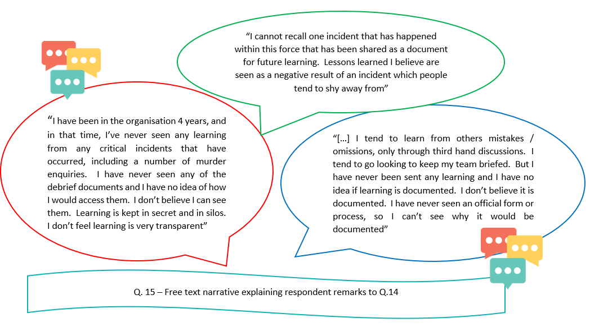

Question (23) sought to examine the extent to which lessons or debriefs from critical incidents within DPP are recorded, stored, and shared in an accessible format across the organisation. The question provided a supplementary point for clarity, prompting participants to consider if they have easy access to past and present lessons and debrief documentation from critical incidents. Of the 64 responses, a significant 77% indicated a lack of access to recorded lessons or debriefs, suggesting that valuable knowledge is not being effectively captured, stored, or shared, while only 8% indicated having access. This deficiency in knowledge preservation raises concerns about the organisations ability to learn from past experiences and improve future practice.



Figure 18 - Primary data results for Question (23)
Additionally, a qualitative inquiry was conducted to gather contextual insights on participants’ access to information and storage practices within DPP. Of the six responses analysed, it is evident that individuals working in CID functions have limited access to relevant documents. These findings support an earlier observation, regarding the distinct absence of accessible homicide debriefs on the DPP ‘learning-the-lessons’ intranet page.

These findings highlight a significant gap in the availability and accessibility of recorded lessons or debrief documents from critical incidents within DPP. The notable percentage of participants lacking access raises questions about the organisations KM practices and its commitment to learning from past experiences. According to Schultze and Stabell (2004), the absence of accessible documentation, and shared knowledge, results in valuable insights and best-practices being overlooked, leading to missed opportunities for improvement.

Furthermore, 16% of participants expressing uncertainty indicates a lack of clarity of communication regarding the availability and sharing of lessons learned. This ambiguity hampers effective learning and collaboration throughout the organisation. Overall, the results accentuate the need for further investigation and improvement of DPPs practices and procedures in documenting, coordinating, and sharing lessons learned. The divergent perceptions and substantial proportion perceiving DPP as somewhat ineffective emphasises the significance of addressing potential shortcomings and enhancing the organisations approach to knowledge management. Additionally, efforts to enhance transparency, communication, and collaboration within the force may help alleviate uncertainties and foster a more cohesive perception of effectiveness in this domain.

Coordinating

Question (13) sought to investigate the extent of central coordination of OL within DPP, as opposed to localised management within teams. The quantitative findings yielded intriguing patterns. A considerable proportion (47%) of participants indicated learning is managed locally in teams, while 25% perceived central management and 28% expressed uncertainty. These results indicate a notable lack of clarity within the organisation regarding the management of learning.

Triangulating these findings with data from questions (16-24), it can be inferred that learning is not centrally coordinated, and there is no technological platform for accessing and sharing lessons learned. Consequently, lessons are not effectively recorded, stored, shared, or easily accessible to the wider organisation. Synthesising the literature with the data, it’s evident that DPPs KM processes are ineffective, and lack centralised coordination. Scholars argue KM is crucial for organisations as it enables them to learn from the past to prepare for the future (Schultze and Stabell, 2004). However, the absence of a technological solution accessible to the wider organisations hinders the continuous flow of knowledge to replenish DPPs’ corporate memory.

Question (26) aimed to evaluate DPPs’ effectiveness in identifying recurring lessons from critical incidents. It sought to determine whether DPP has a centralised and robust system in place to recognise commonalities, trends, and underlying factors across critical incidents. The quantitative findings revealed that 31% of participants perceived DPP to be somewhat effective in identifying recurring lessons and themes from critical incidents. Conversely, 28% expressed uncertainty, while an equal percentage perceived DPP to be somewhat ineffective. Moreover, 13% of respondents perceived DPP to be very ineffective. These findings signify that a small proportion of participants strongly believe that DPP’s current approach and practices are largely ineffective at recognising patterns and extracting valuable insights. Notably, no participants regarded DPP as very effective in this aspect.

0

Figure 19 - Primary data results for Question (26)
The study findings reveal participants’ reservations regarding DPPs’ proficiency in identifying recurring lessons and themes. These reservations align with HMICFRS (2022c) findings, that DPP falls short in identifying opportunities for improvement. These findings raise concern, as literature emphasises the criticality of an organisations ability to analyse past experiences, identify patterns and trends, to revise policies and procedures to prevent comparable failures (Saunders et al, 2016). Therefore, if DPP is unable to identify recurring themes and patterns in lessons learned, it raises questions about its preparedness to prevent their recurrence.

To further investigate this aspect, question (27) aimed to determine whether DPP has an analytical process in place to identify recurring lessons and themes to prevent the emergence of reoccurrences. The findings highlight a significant lack of awareness among the workforce, with 59% expressing uncertainty, 30% perceiving the absence of such a process, and 11% indicating affirmatively. A qualitative question was posed to gather contextual analysis of the affirmative responses. Among the ten responses, the qualitative data contradicts this assertion, casting doubt, as most participants explicitly expressed a lack of awareness regarding the existence of such a process. Some indicated the learning-the-lessons board may perform this function, or a process may exist within PSD. The prominent terms extracted presented below included “lessons board” (mentioned by 30%), “PSD”, and “misconduct” (both cited by 20%).
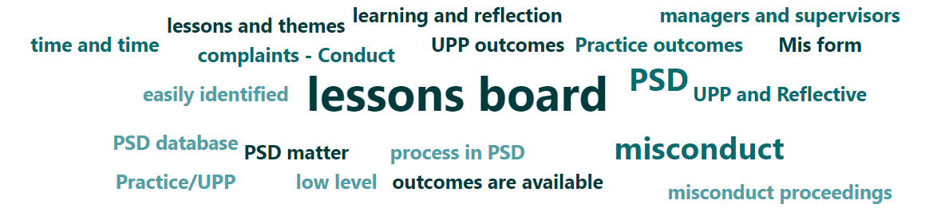

Figure 20 - Word cloud representing qualitative data for Question (28)
An additional qualitative inquiry was conducted to assess the value of implementing a process to identify themes to educate and raise awareness of issues across DPP, thereby minimising the reoccurrence of comparable failings. The data derived from 41 responses showed an overwhelming majority of 95% responded affirmatively, indicating a positive inclination towards the idea, and 5% expressed uncertainty.

In short, analysis of the quantitative and qualitative data has revealed DPP is ineffective at identifying recurring lessons and themes. Furthermore, DPP lacks a centralised process and dedicated system to facilitate KM and prevent the emergence of similar incidents in the future.

Sharing

Question (16) aimed to evaluate the effectiveness of DPP in sharing lessons learned from local incidents with the organisation. It examined DPPs’ KM practices and the extent to which valuable insights and experiences from past incidents are actively shared. The findings, obtained using a Likert scale, revealed varying perspectives among participants. Notably, 33% perceived DPP to be somewhat ineffective in this regard, while 29% considered the force somewhat effective. Interestingly, 11% regarded DPP as very ineffective, and no participants considered it very effective. These results highlight the divergent opinions regarding DPPs’ effectiveness in sharing lessons from local incidents, emphasising the need for improvement in knowledge dissemination practices within DPP.

Figure 21 - Primary data results for Question (16)
A qualitative inquiry examined participants’ perceptions regarding DPPs’ effectiveness in sharing lessons learned within the force and disseminating them to the broader organisation. Of the 53 responses analysed, the majority expressed perceptions that DPP was ineffective in this regard. Notably, participant remarks uncovered significant issues. One respondent emphasised, “Same mistakes are made repeatedly regardless of what department or business area”, highlighting a concerning pattern of repetition. Another participant commented “Lessons get lost in the avalanche of information passed to officers”, suggesting that important insights are overwhelmed by an excessive amount of information. Furthermore, a participant noted “The cascading of key learning/messages is often ineffective. Often, it’s luck of the draw on what information you receive at the coalface”, indicating a lack of consistency in disseminating crucial knowledge. While another remarked “In all my service I cannot think of one incident that has been shared with all rank and staff for learning”, and another “In 21-years’, I have never had access to any force learning from incidents. I would not know where to go or how to find learning”, revealing a significant gap in accessing learning resources.
To verify these findings, question (20) assessed participants’ access to comprehensive and regular information concerning locally derived lessons learned from critical incidents. The results indicate a significant proportion of participants (72%) reported a lack of regular access to such information, while conversely, 20% indicated consistent access.

Figure 22 - Primary data results for Question (20)
To gain contextual insights, validate the quantitative data, and explore participants’ information-receiving methods, a subsequent qualitative question was administered. Among the 14 responses analysed, the majority confirmed that emails, verbal communication, and the force’s intranet site, were the primary channels for disseminating this information. Notably, despite two participants mentioning a newsletter, DPP has not published a learning-the-lessons newsletter since May 2021. Additionally, one participant expressed scepticism regarding the effectiveness of the information received, stating “The only learning I see regularly, is when someone has been disciplined for misconduct, but this is not necessarily learning. This information provides a brief outcome following misconduct investigation. Wider learning is not available to police officers like me”. Triangulation of these findings demonstrates a prevalent perception of DPPs’ inefficiency in sharing lessons learned. Participants’ remarks highlight recurring mistakes, information overload, inconsistent knowledge dissemination, and limited access to learning materials.

Question (18) examined the accessibility and availability of a technological platform for accessing lessons learned during periods of absence. It aimed to assess whether employees had the means to review past and recent lessons learned from incidents upon their return-to-work. This question served a dual purpose: evaluating the organisations IT infrastructure and systems, particularly the existence of a dedicated platform for accessing and reviewing lessons and assessing the organisations approach to KM by enabling employees to benefit from others’ experiences even during their absence. The findings revealed that 29% of participants perceived they would have access to an IT platform, while a significant majority of 51% perceived a lack of access. Additionally, 21% were uncertain about the availability of such a platform.
Analysing the data through the lens of socialisation theory, it can be contended that had a well-established platform existed, the high percentage of negative responses would have been mitigated, and the uncertainties expressed would have been alleviated. Thus, one can assume such a platform does not exist.



Figure 23 - Primary data results for Question (18)
To gather contextual insights from affirmative responses, a qualitative question was posed. The analysis of textual data from 18 responses, is visually represented in the word cloud below, highlighting key terms: “laptop, daily-state, intranet, and email”. However, it is evident that some participants misunderstood the question, as they mentioned “laptop”, instead of specifying the learning platform.

This emphasises the importance of question clarity, and mutual understanding between researchers and respondents, as highlighted by Foody (1994). Despite a pilot study, some misinterpretations still occurred. Nonetheless, it was determined that the main platforms used for accessing learning are email, the intranet site, and daily-state records. Moreover, it should be clarified that daily-state is not a platform for highlighting lessons learned, despite some participants mentioning it as such. Daily-state serves as a briefing platform, providing information on significant events within DPP that have taken place over a 24-hour period. Daily-state has never been intended or used for the purpose of learning lessons.

Notably, participants’ remarks highlight perceived KM issues, with concerns expressed regarding the organisations limited focus on learning. One remarked “There is very little time dedicated to learning within the organisation”, and another commented, “I wouldn’t know where to find lessons learned”. Additionally, a participant revealed that upon returning from maternity leave, they were “not signposted to any learning-the-lessons documentation”. The collected data collected exposes a concerning gap in knowledge accessibility and availability during periods of absence.

Triangulating the data reveals a clear assumption: DPP lacks an accessible technological platform and/or IT infrastructure designed for learning lessons from past experiences. Consequently, employees are unable to stay updated upon returning to work after an absence. This deficiency is supported by quantitative data, with a significant 51% of respondents expressing a lack of access to such a platform, which is further substantiated by qualitative findings. These findings align with research of Goldstein (2003), which argues that policing lacks effective learning mechanisms, hindering the sharing of insights across the workforce. This revelation highlights a potential obstacle that impedes DPPs’ ability to develop a culture of continuous learning, effectively manage knowledge, and retain valuable insights and experiences. This analysis provides insights into different platforms used by participants, highlighting a lack of consistency and the absence of a dedicated learning platform.

External Stakeholders

External stakeholders refer to individuals and organisations outside the police force who have an interest in policing activities, policies, and outcomes. These stakeholders include governmental bodies and Criminal Justice agencies. Sharing lessons from external stakeholders, such as the HMICFRS and IOPC, is crucial for policing. Firstly, they can identify areas for improvement, highlight systematic issues, and offer fresh perspectives. Research by Toft and Reynolds (2005), suggests public inquiries help institutionalise learning from catastrophic events. Incorporating lessons from external stakeholders align policing strategies with public expectations.

The researcher aimed to assess the recognition of isomorphic learning (Toft and Reynolds, 2005), by exploring whether events outside DPP are perceived as learning opportunities. Additionally, the researcher investigated whether DPP effectively records, stores, and shares these lessons within the organisation. Question (30) gathered participants’ perspectives, and by means of reference included examples of national learning opportunities like high-profile IOPC investigations. Respondents’ answers revealed varying perceptions regarding the effectiveness of DPP in recording, storing, and sharing lessons from national incidents. Results showed, 28% acknowledged DPP to be somewhat effective in this regard. However, 23% considered it to be very ineffective and an equal percentage found it somewhat ineffective, and interestingly 25% expressed uncertainty. Notably, no participants perceived DPP to be highly effective.

Figure 24 - Primary data results for Question (30)
Participants were asked to explain their responses. Among the 50 responses, one mentioned receiving information on critical incidents from other forces through their counterparts in neighbouring forces or nationally from portfolio leads. Another participant noted that DPP has recently started sharing national reports. The data demonstrates recognition of cross-organisational isomorphism. Additionally, another remarked on being involved in structured debriefs with third-party agencies, like Coastguard and Mountain Rescue, highlighting recognition of common-mode isomorphism. However, some expressed scepticism, one remarked “This just doesn’t happen in operational policing”, and another “I’m not aware that we cascade national learning through the force”. These differing insights indicate that some level of isomorphic learning exists within DPP, but it lacks consistency.

Question (25) examined DPPs’ effectiveness in sharing lessons from joint operations with external stakeholders. Results showed that 41% of participants expressed uncertainty regarding DPPs’ effectiveness in this area. Additionally, 33% perceived DPP to be somewhat ineffective in this regard, while no participants considered DPP to be highly effective.

Figure 25 - Primary data results for Question (25)
The participants expressed uncertainty and perception of relative ineffectiveness, highlighting limitations and inefficiencies in DPPs’ current practice of sharing lessons with stakeholders. Conducting future qualitative analysis with external stakeholders would benefit the investigation into these findings. Further analysis would facilitate a deeper exploration of underlying factors influencing participants’ perceptions.

In summary, objective two highlights significant shortcomings, and a lack of consensus among participants regarding the effectiveness of DPP in transparent recording, coordinating, and sharing learning with employees from internal and external stakeholders. Concerns are raised about limited access to debriefing documentation, and the availability and accessibility of recorded lessons, or debriefs from critical incidents within DPP are inadequate, raising concerns about DPPs’ ability to learn from past experiences and improve future practices. Furthermore, there is a lack of clarity and awareness regarding the coordination of learning, and identification of recurring lessons and themes from critical incidents.

Final questionnaire comments reiterate participants’ perceptions that DPP has ineffective organisational-learning processes and procedures. Notable remarks included:
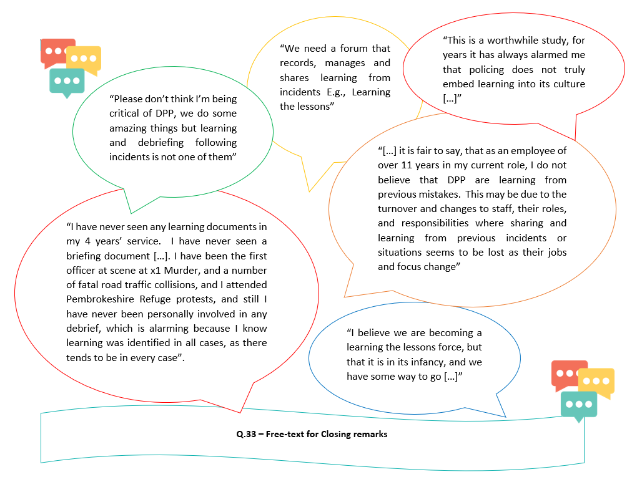

Chapter Summary

In conclusion, data analysis reveals significant variations in the management of learning from critical incidents across DPP, emphasising inconsistencies in organisational-learning practices. The absence of a centralised and coordinated learning platform that systematically analyses and identifies recurring failures and lessons learned suggests inadequate knowledge-management within DPP, leading to ineffective learning from identified failings within critical incidents.

The study emphasises that learning within DPP primarily occurs through localised, informal, and sporadic verbal debriefing sessions and learning is not consistently shared across the broader organisation or indeed with stakeholders. This indicates that DPP operates and learns in siloed groups, lacking collaboration and relying on insufficient single-loop-learning practices. Furthermore, DPP falls-short in recording, storing, coordinating, and sharing lessons learned, missing opportunities to leverage isomorphic-learning, and to enhance organisational-knowledge (corporate memory). Consequently, DPP is ineffective in capturing the knowledge of employees and stakeholders to preserve lessons learned, and therefore, lessons are not shared or made readily available/accessible to the wider organisation to prevent reoccurrences.

The final chapter will consolidate the research conclusions and provide recommendations to fulfil Objective Three.

Chapter Five

Conclusion and Recommendations

Introduction

This chapter provides a summary of the research findings, draws relevant conclusions from the analysis, and responds to the research question. It begins by contextualising the project and outlining the underlying background that influenced its development. This is followed by a brief overview of the theories and a summary of the questionnaire methodology. The chapter then presents the findings of the research pertaining to the objectives, acknowledging limitations encountered and offering conclusions, and making recommendations to the DPP Senior Leadership Team to fulfil the third objective. Finally, the chapter concludes by addressing the research aim and title question.

The study aimed to “Determine whether Dyfed-Powys Police (DPP) is a learning organisation that learns-lessons from failings identified within critical incidents or, whether it is an organisation that learns in silos, and fails to maximise opportunities to capture corporate memory and share lessons across the wider organisation to prevent reoccurrences emerging”. Chapter One highlights the challenges faced by the police in terms of rebuilding public trust and confidence. It highlighted concerns about policing’s apparent inability to learn from failings identified within past critical incidents to prevent recurring failures. The research area is significant in terms of enhancing DPPs’ approach to organisational learning, identifying systemic issues, and improving policy and practice to provide an enhanced service for public protection and to prevent repeat errors to rebuild public trust and confidence and minimise legal and financial litigation.

The research objectives were:

- Compare and contrast organisational business functions, to determine how learning is being managed.

- Critically examine whether DPP transparently records, coordinates, and shares learning from internal and external stakeholders with employees across the organisation.

- Use the findings of this research to identify areas for improvement, formulate conclusions and make recommendations to the DPP Senior Leadership Team.

A literature review followed, delving into established theories on organisational learning and their applicability in creating a customised framework tailored for DPP to consider addressing its unique needs. These theories emphasised the importance of fostering a learning organisation that promotes continuous learning and development, empowering individuals to acquire new knowledge, skills, and competence while sharing their experiences with the wider organisation. Furthermore, the development of organisational knowledge is facilitated through systematic knowledge management, preserving lessons learned in corporate memory.
Research supports the notion that adopting a combination of OL theories, it offers advantages not only for today’s workforce but also for the workforce of tomorrow, thus enabling DPP to learn from the past and implement policy and practice improvements to better prepare for the future.

The research followed a subjectivism mixed-method approach, collecting quantitative and qualitative primary data within an interpretivism philosophy. A cross-sectional time horizon was adopted to understand and interpret the subjective meanings derived from the data. Given the practical constraints of time and resources, a non-probability sample was selected, and a self-completed questionnaire was utilised, combining closed and open justification questions to enhance data validity and reliability. The questionnaire design, delivery, collection, and analysis are detailed extensively in Chapter Three.

Next, the main conclusions drawn from the analysis of the primary data are presented and aligned with the research objectives.

Conclusion: Findings & Results

- Objective One: Compare and contrast organisational business functions, to determine how learning is being managed.

The study’s findings lead to an overarching conclusion that DPPs’ learning framework requires further development as there is an evident absence of a prominent learning culture in the organisation, resulting in inconsistent approaches to learning management across its diverse business functions. Despite 88% of participants acknowledging the occurrence of lessons being learned, the focus remains on localised learning arrangements rather than implementing a comprehensive OL management system. This approach leads to fragmented learning practices that fail to encompass the broader organisation and external stakeholders. Furthermore, these localised approaches lack clear guidance and structure, leading to inconsistencies.

DPP heavily relies on debriefing processes as the primary means of managing learning through self-isomorphism. However, these debrief practices suffer from irregularities in sharing explicit knowledge, are largely underutilised, and lack standardisation. Existing literature emphasises the ineffectiveness of debriefings as the sole method of learning due to the introduction of biases and subjective interpretations. Consequently, relying solely on debriefings is neither reliable nor objective in facilitating meaningful and comprehensive learning experiences. Localised learning management within DPP, primarily at the team or business area level, sporadically disseminates lessons from critical incidents through email or verbal communication with employees. These informal practices result in debriefs not being routinely recorded, stored, or made accessible, indicating the ineffectiveness of DPPs’ methods of disseminating and managing learning. Relying on verbal communication and individual employees as knowledge repositories pose risks such as misunderstandings, knowledge discrepancies, and information loss. This approach increases the likelihood of repeat comparable errors being made. The study’s findings support the conclusion, that DPP primarily relies on human repositories, contradicting the principles of OK development, and the establishment of corporate memory as supported by literature of Alavi and Leidner (2001).

Moreover, in an environment heavily reliant on email communication, the inundation of overflowing inboxes may inadvertently lead to valuable lessons being overlooked, challenging employees to locate or prioritise critical information promptly. Newport (2020) contends the prevailing reactive mindset associated with emails often compels employees to engage in superficial scanning and deletion of non-urgent emails to alleviate the burden on their inboxes. Therefore, the dissemination of key messages through email proves to be an unreliable method, contradicting established principles of KM. In conclusion, DPP does not effectively, consistently, or systematically manage lessons learned from critical incidents, aligning with the observations made by HMIC (2006), that policing at a national level fails to demonstrate a systematic and structured methodology toward OL.

- Objective Two: Examining whether DPP transparently records, coordinates, and shares lessons from internal and external stakeholders with employees across the organisation.

The study coded elicited responses, focusing on key areas of analysis delineated with objective two, and organised the subsequent presentation of findings into specific sub-headings. A comprehensive synthesis of the findings yields an overarching conclusion: that DPP fails to transparently record, coordinate, and disseminate lessons from internal and external stakeholders to employees throughout the organisation effectively. Therefore, it can be concluded that DPP does not incorporate the foundational principles underlying the key theories informing this research study.

Regarding the recording aspect, qualitative analysis revealed pronounced shortcomings in transparently and consistently documenting lessons within DPP. Triangulated data provided a compelling argument, supporting the conclusion that DPP relies on insular and informal recording practices within individual teams and business areas, leading to a lack of formal documentation and dissemination of valuable knowledge across the organisation. This conclusion was further corroborated by 77% of participants who endorsed the dearth of readily available learning lessons documentation and debrief material from critical incidents.

In terms of coordinating lessons, it was inferred that DPP lacks central coordination in capturing insights from stakeholders, with a high percentage of participants perceiving this as ineffective. Triangulated data highlighted the absence of a technological platform or centrally governed policies to enhance coordination efforts. The significance of central coordination lies in its potential to improve organisational effectiveness, decision-making, innovation, and adaptability. Findings also indicated the absence of an analytical process, or system to collect, analyse and evaluate data in this regard.

Regarding sharing lessons, the study concluded that whilst DPP exhibits some degree of cross-organisational and self-isomorphism, the lack of consistency and standardisation hinders the effective identification and dissemination of lessons throughout the wider organisation. This deficiency increases the likelihood of recurring errors within DPP. Additionally, the absence of a technological platform for accessing and evaluating lessons further limits structured and coordinated means for employees to review past and present learning.

In summary, the findings highlight the ineffectiveness of DPPs’ current approach to recording, coordinating, and sharing lessons from stakeholders. The study suggests that theories such as Organisational Learning, The Learning Organisation, Organisational Knowledge, Knowledge Management, Isomorphic Learning, and single-loop-learning can offer significant benefits to DPP. These theories can guide the development of an organisational learning framework that aligns with the complex nature of policing, and the unique needs of DPP.

Research Limitations

The study’s findings were constrained by limitations encountered during primary research. One limitation arose from a research objective outlined in the project proposal, which aimed to evaluate data to determine if recurring lessons and themes from critical incidents were being identified within DPP. However, analysis of the collected questionnaire data revealed that DPP lacked a centralised process or technical system for gathering, storing, and analysing such data. To address this limitation, the researcher sought to obtain a sample of data related to critical incidents through consultation with the Information Manager for DPP. Unfortunately, the request for this information under the Freedom of Information Act (FOI, 2000) was denied due to the significant time implications involved in redacting sensitive information across a wide spectrum of systems and preparing the data for release. Access would have facilitated analysis of qualitative data to identify recurring lessons/themes, as well as evaluate the feasibility of conducting predictive analysis to anticipate future potential failures for DPP to implement mitigating measures. Therefore, the researcher was unable to evaluate the effectiveness of DPP in terms of its capabilities of identifying reoccurring lessons and themes and its ability to mitigate recurring failings within critical incidents.

Another limitation emerged due to the researcher’s senior position in DPP, which required careful consideration for data collection. The small workforce of DPP, despite its large geographical reach, made it easier to identify respondents based on rank, role, position, department, or location. This jeopardised participant confidentiality and exposed them to potential harm within the organisation, particularly if their responses were sceptical of DPPs’ management of organisational learning (Biggam, 2021). Thus, research interviews were not chosen for the same reason. To address these limitations, the researcher reframed questions to inquire about the presence of OL processes without specifically requesting participant identification data. Therefore, the researcher was unable to make direct comparisons across specific business functions. Nevertheless, the study still provided important insights into how learning is managed and enabled the researcher to make informed recommendations.

Lastly, limitations arose specifically related to the questionnaire itself. By restricting participants to choose only one response option per question, the researcher unintentionally forced participants to select the “other” option to provide additional information or combine response choices. This affected the analytical technique of cross-tabulation, which relies on multiple response options to identify relationships or patterns within data. However, the reliability of the data was unaffected, as the “other” option allowed participants to provide valuable insights through a free-text narrative. This enabled the identification and analysis of key themes, leading to triangulated assumptions.

In conclusion, the study’s limitations in evaluating recurring lessons and themes within DPP, ensuring participant confidentiality and the design of the questionnaire influenced the research process. Despite these limitations, important insights were gained, enabling the researcher to make informed recommendations for improving learning management within DPP.

Recommendations for DPP Senior Leadership Team

Recommendation 1:

It is recommended that DPP proactively addresses the shortcomings highlighted in this study. This can be achieved by further developing the forces’ organisational learning framework so that it aligns with the theoretical organisational learning foundations of the study and ensures clear guidance is developed and made accessible to all employees. By transcending localised learning approaches, and breaking free from siloed practices, DPP can position itself as a leading learning organisation, equipped with the necessary tools and guidance to actively promote knowledge sharing, capture corporate memory, and establish a robust framework that effectively analyses learning to identify themes and patterns and drive improvements. Importantly, this approach will not only minimise the recurrence of failures but also enhance the level of service provided to the public, thereby reinforcing public trust and confidence.

Recommendation 2:

It is strongly recommended that DPP establishes and implements a centrally governed, integrated technical repository that facilitates the systematic management and sharing of isomorphism lessons learned. This repository, grounded in the theoretical fundamentals of knowledge management and organisational knowledge, would serve as a vital resource enabling the workforce to learn from internal and external stakeholders, develop hindsight, preserve knowledge, enhance corporate memory, mitigate risks, and improve the availability and accessibility of key lessons learned. Importantly, such a repository would not only enhance DPPs’ operations but also benefit stakeholders by providing a solid foundation for regular data analysis and rapid learning, enabling the identification of repeat patterns and trends, and facilitating evidence-based foresight and predictive analysis. This approach aligns with Senge’s (2006) emphasis on designing a whole-system solution rooted in learning foresights to prevent the recurrence of failures.

Recommendation 3:

It is recommended, once a technical repository has been fully integrated and an ample collection of learning data has been established, for DPP to undertake additional research to advance the researchers abandoned objective of “Evaluating data to discover if reoccurring lessons and themes from critical incidents are being identified”. By commissioning additional research, DPP can gain valuable insights to further inform policy and practice, and this step would further contribute to enhancing DPPs’ organisational learning capabilities to facilitate the prevention of comparable failings occurring.

Recommendation 4:

It is recommended that DPP initiates supplementary research involving external stakeholders (e.g., Fire and Rescue Service and Ambulance) to validate and triangulate the study findings, by utilising partnership data. This essential research endeavour should encompass a comprehensive assessment of DPPs’ effectiveness in disseminating incident-related lessons to its partners, as well as a critical evaluation of the methods employed for knowledge-sharing. Moreover, it should explore DPPs’ capacity to identify and capitalise on learning opportunities from organisations with similar functions, aligning with the theoretical foundations of isomorphism. Further analysis will deepen the understanding of factors influencing participants’ perceptions within this study and, will further assist DPP identify and address additional areas for improvement.

Closing Remarks

Returning to the research aim to, ‘Determine whether Dyfed-Powys Police (DPP) is a learning organisation that learns lessons from failings identified within critical incidents or, whether it is an organisation that learns in silos, and fails to maximise opportunities to capture corporate memory and share lessons across the wider organisation to prevent reoccurrences emerging’. The data collected represents the perspectives of a non-probability sample comprising DPP employees from various ranks, grades, roles, and responsibilities. All 64 participants completed the questionnaire without omissions or skipped responses, lending credibility to the conclusions drawn.

The critical analysis of the findings reveals that DPP sporadically learns lessons from critical incidents, but its practices are largely siloed and inconsistent. The limited integration of lessons learned from critical incidents signifies a lack of effective knowledge transfer mechanisms, hindering the organisations’ development of corporate memory and its ability to leverage past experiences. The absence of a cohesive approach to organisational learning and knowledge sharing hampers the development of a collective understanding and inhibits the dissemination of best practices. Therefore, DPP not only faces difficulties in preventing the repetition of failures but also struggles to foster continuous improvement and innovation.

The research question posed, “Does Dyfed-Powys Police (DPP) learn from and share lessons from failings identified within critical incidents?”. Based on the responses gathered it can be concluded that DPP does exhibit some level of learning from and sharing lessons in this regard. However, the practices are heavily localised, and therefore there is ample room for improvement.

Bibliography

Bibliography
Adžic, S., 2018. Learning organizations; a fine example of a management fad. Business and Economic Horizons, 14(3), pp. 477-487.

Akella, D., 2007. Pain and stress in learning organizations; a question of career. Global Business Review, 8(2), pp. 323-333.

Alavi, M., and Leidner, D. E., 2001. Knowledge management and knowledge management systems; Conceptual foundations and research issues. MIS Quarterly, 25(1), pp. 107-136.

Alvesson, M, and Kärreman, D, 2001. Odd couple: making sense of the curious concept of knowledge management. Journal of Management Studies , 38(7), pp. 995-1018.

Argyis, C., 1994. On Organisational Learning. Cambridge: Blackwell Publishers .

Argyris, C., and Schön, D. A., 1978. Organisational Learning. Reading, MA: Addison Wesley.

Argyris, C., and Schön, D. A., 1996. Organizational Learning II; Theory, Method and Practice. 1st ed. USA: Addison-Wesley Publishing Company.

Argyris, C., 2010. Organizational traps; leadership, culture, organizational design. Oxford: Oxford University Press.

Arrow, I., 2023. Report to Prevent Future Deaths by Senior Coroner Ian Arrow; made under Regulation 28 of the Coroners (Investigations) Regulations 2013. [Online]
Available at: https://tgchambers.com/wp-content/uploads/2023/03/KEYHAM-INQUESTS-Combined-PFD-reports-1.pdf
[Accessed 11 May 2023].

Barber, M., 2022. Strategic Review of Policing in England and Wales; A New Mode of Protection; Redesigning policing and public safety for the 21st Century. [Online]
Available at: https://www.policingreview.org.uk/wp-content/uploads/srpew_final_report.pdf

Basten, D., and Haamann, T, 2018. Approaches for Organizational Learning; A Literature Review. SAGE Open, 8(3), pp. 1-20.

Bedford, L. and Mazerolle, L. , 2014. Beyond the Evidence; Organizational Learning from RCTs in Policing. Policing, 8(4), pp. 402-416.

Beebe, T. J., Mika, T., Harrison, P. A., Anderson, R. E., and Fulkerson, J. A, 1997. Computerized school surveys. Design and development issues. Social Science Computer Review, 15(2), pp. 159-169.

Bell, J. and Waters, S. , 2018. Doing your research project; a guide for first-time researchers. 7th ed. London: McGraw-Hill.

Bereiter, C., 2002. Education and Mind in the Knowledge Age. Mahwah, NJ and London: Lawrence Erlbaum Associates.

Biggam, J., 2011. Succeeding with your Master's Dissertation; A step-by-step handbook. 2nd ed. Berkshire: Open University Press .

Biggam, J., 2021. Succeeding with Your Master's Dissertation; A step-by-step handbook. 5th ed. London: Open University Press .

Bogdan, R. & Biklen, S. K., 2007. Qualitative Research for Education: An Introduction to Theories and Methods. London: Pearson Education Ltd.

Bolger, C. P., and Walters, G. D, 2019. The relationship between police procedural justice, police legitimacy, and people's willingness to cooperate with law enforcement; A meta-analysis. Journal of Criminal Justice , Volume 60, pp. 93-99.

Boreham, N., and Morgan, C. , 2004. A Sociocultural Analysis of Organizational Learning. Oxford Review of Education , 30(3), pp. 307-325.

Bowker, G. C., and Star, S. L, 1999. Sorting Things Out; Classification and Its Consequences. Cambridge: MIT Press.

Braun, V. and Clarke, V. , 2006. Using thematic analysis in psychology. Qualitative Research in Psychology, 3(2), pp. 77-101.

Brockbank, A., McGill, I., and Beech, N. , 2002. Reflective Learning in Practice. Aldershot : Gower Publishing Limited.

Buchanan, D. A., 2011. Reflections; Good Practice, Not Rocket Science; Understanding Failures to Change After Extreme Events. Journal of Change Management , 11(3), pp. 273-288.

Campbell, D., and Craig, T., 2005. Organisations and the business environment. 2nd ed. Oxford: Elsevier Butterworth-Heinemann.

Casey, L., 2023. Baroness Casey Review; Final Report; An independent review into the standards of behaviour and internal culture of the Metropolitan Police Service, London: Metropolitan Police Service.

CCA, 2004. Civil Contingencies Act. [Online]
Available at: https://www.legislation.gov.uk/ukpga/2004/36/section/2
[Accessed 6th May 2023].

Cheng, H., Niu, M.-S., and Niu, K. -H, 2014. Industrial cluster involvement, organizational learning, and organizational adaptation; An exploratory study in high technology indistrial districts. Journal of Knowledge Management , Volume 18, pp. 971-990.

Collis, D. J., 1994. Research Note - How valuable are organizational capabilities?. Strategic Management Journal, Volume 15, pp. 143-152.

Cooke, A., 2023. State of Policing; The Annual Assessment of Policing in England and Wales, by His Majesty's Chief Inspector of Constabulary 2022. [Online]
Available at: https://www.justiceinspectorates.gov.uk/hmicfrs/wp-content/uploads/state-of-policing-2022.pdf
[Accessed 9 6 2023].

CoP, 2013. Briefing and debriefing; Authorised Professional Practice. [Online]
Available at: https://www.college.police.uk/app/operations/briefing-and-debriefing#debriefing-structure
[Accessed 6th May 2023].
CoP, 2018. Phase 1 - preparing for critical incidents; Authorised Professional Practice College of Policing. [Online]
Available at: https://www.college.police.uk/app/critical-incident-management/phase-1-preparing-critical-incidents
[Accessed 5 May 2023].

CoP, 2020b. Resources for reflective practice; Version 1.0; College of Policing. [Online]
Available at: https://assets.college.police.uk/s3fs-public/2020-11/Resources_for_reflective_practice_v1_0.pdf
[Accessed 7 May 2023].

CoP, 2020. Civil contingencies; Authorised Professional Practice. [Online]
Available at: https://www.college.police.uk/app/civil-emergencies/civil-contingencies/civil-contingencies#major-incident
[Accessed 5 May 2023].

CoP, 2021. Phase 2 - managing critical incidents; College of Policing Authorised Professional Practice. [Online]
Available at: https://www.college.police.uk/app/critical-incident-management/phase-2-managing-critical-incidents#post-incident-evaluation
[Accessed 5 May 2023].

CoP, 2022a. Performance and Improvement; College of Policing. [Online]
Available at: https://www.college.police.uk/guidance/leadership-expectations/performance-and-improvement
[Accessed 5 May 2023].

CoP, 2022b. Understanding Self and Others; Leadership expectations. [Online]
Available at: https://www.college.police.uk/guidance/leadership-expectations/understanding-self-and-others
[Accessed 7 May 2023].

CoP, 2023. Introduction and types of critical incidents; College of Policing Authorised Professional Practice. [Online]
Available at: https://www.college.police.uk/app/critical-incident-management/introduction-and-types-critical-incidents
[Accessed 5 May 2023].

CPIA, 1996. Criminal Procedure and Investigations Act. [Online]
Available at: https://www.legislation.gov.uk/ukpga/1996/25/contents
[Accessed 6th May 2023].

Cyert, R. M., and March, J G, 1963. A Behavioural Theory of the Firm. Englewood Cliffs : Prentice-Hall.

DCPP, 2023. Public Digitial Crime Performance Pack. [Online]
Available at: https://www.justiceinspectorates.gov.uk/hmicfrs/our-work/article/digital-crime-performance-pack/
[Accessed 13 June 2023].

De Vaus, D. A., 2014. Surveys in Social Research. Abingdon: Routledge.

Deahl, M. P., Gillhman, A. B., Thomas, J., Searle, M. M., and Srinivasan, M. , 1994. Psychological sequelae following the Gulf wars; Factors associated with subsequent morbidity and the effectiveness of psychological debriefing. British Journal of Psychiatry , Volume 165, pp. 60-65.

DPP, 2021. New Chief clear that there’s always more to do, and starts as he means to go on. [Online]
Available at: https://www.dyfed-powys.police.uk/news/dyfed-powys/news/2021/december-2021/dyfed-powys-police-welcomes-new-chief-constable/
[Accessed 9 May 2023].

Easterby-smith, M., and Araujo, L., 2006. Organizational Learning; Current Debates and Opportunities. In: Organizational Learning and the Learning Organization; Developments in theory and practice by Easterby-smith, M., Burgoyne, J., and Araujo, L.. London: Sage Publications, pp. 1-21.

Easterby-Smith, M., and Lyles, M. A, 2011. Handbook of of Organizational Learning and Knowledge Management. 2nd ed. Malden, MA: Wiley.

Einstein, A., 1924. Wikiversity. [Online]
Available at: https://en.wikiversity.org/wiki/Talk:Albert_Einstein_quote
[Accessed 7 May 2023].

Festinger, L., 1957. A Theory of Cognitive Dissonance. California, CA: Stanford University Press.

Field, A. P., 2005. Discovering Statistics Using SPSS. London: Sage Publications Inc.

Finger, M., and Bürgin Brand, S. , 2006. The Concept of the 'Learning Organization' Applied to the Transformation of the Public Sector; Conceptual Contributions for Theory Development. In: Organizational Learning and the Learning Organization . London: Sage Publications, pp. 130-156.

Fink, A., 2013. How to Conduct Surveys. 5th ed. Thousand Oaks, CA: Sage.

Fiol, C. M., and Lyles, M. A., 1985. Organizational learning. Academy of Management Review, 10(4), pp. 803-813.

Firing, K., Owesen, V., and Moen, F. , 2020. Organizational Learning Through Debriefing; The Process of Sharing and Hiding Knowledge. Scandinavian Journal of Military Studies , 3(1), pp. 169-182.

FOE, 2020. Policing in England and Wales; Future Operating Environment 2040, Ryton: College of Policing.

FOI, 2000. Information Commissioners Office; Freedom of Information Act. [Online]
Available at: https://ico.org.uk/for-organisations/foi-eir-and-access-to-information/guide-to-freedom-of-information/what-is-the-foi-act/
[Accessed 17 June 2023].

Foody, W., 1994. Constructing Questions for Interviews and Questionnaires. Cambridge: Cambridge University Press.

Freedman, R. D., and Stumpf, S. A, 1980. Learning Style Theory; Less than meets the eye. Academy of Management Review, pp. 445-447.

Garratt, B., 1987. The Learning Organization. London: Fontana.
Garvin, D. A., Edmondson, A. C., and Gino, F. , 2008. Is yours a learning organization?. Harvard Business Review, Volume 86, pp. 109-116.

Ghauri, P. and Gronhaug, K., 2010. Research methods in Business Studies: A Practical Guide. 4th ed. Harlow: Prentice Hall.

Gibbs, G., 1998. Learning by doing; A guide to teaching and Learning Methods. 1st ed. Oxford: Brookes University.

Godé, C., and Barbaroux, P. , 2012. Towards an architecture of organizational learning; Insights from French Military Aircrews. VINE, 42(3/4), pp. 321-334.

Goldstein, H., 2003. Problem-orientated Policing. Oxford: Oxford University Press.

Gourlay, S., 2006. Conceptualizing Knowledge Creation; A Critique of Nonaka's Theory. Journal of Management Studies , 43(7), pp. 1415-1436.

H.M. Government, 2006. Addressing Lessons from the Emergency Response to the 7 July 2005 London Bombings; What we learned and what we are doing about it. [Online]
Available at: https://www.jesip.org.uk/downloads/addressing-lessons-from-london-7th-july-2005-bombings/
[Accessed 8 May 2023].

Hakkyong, K., 2016. Changing Safety Culture through Isomorphic Learning in Korea. International Information Institute (Toyko), 19(4), pp. 1215-1220.

Halkon, R., 2022. Condemned to repeat it? How policing can learn from the mistakes of the past; 7 June 2022, London: The Police Foundation .

Hallet, C. H., 2012. Coroner's Inquest into the London Bombings of 7 July 2005; Review of progress by Lady Justice Hallet, London: HM Government.

Handzic, M., and Zhou, A. Z., 2005. Knowledge management; An integrative approach. Oxford: Chandos Publishing .

Handzic, M., 2007. Socio-Technical Knowledge Management; Studies and Initatives. New York: IGI Publishing .
Hansen, M. T., Nohria, N., and Tierney, T. , 1999. What's your strategy for managing knowledge?. Harvard Business Review, pp. 106-116.

Hayek, F. A., 1945. The use of knowledge in society. American Economic Review, 519(35).

Higgins, A., 2018. How do we move from a blame culture to a learning culture in policing? The Police Foundation Think Tank. [Online]
Available at: https://www.police-foundation.org.uk/2017/wp-content/uploads/2018/07/from_blame_to_learning_policy_dinner.pdf
[Accessed 10 May 2023].

HMIC, 2006. Raising the standard; A thematic Inspection of professional standards; Her Majesty's Inspectorate of Constabulary. [Online]
Available at: https://www.justiceinspectorates.gov.uk///hmicfrs/media/raising-the-standard-full-report-20060530.pdf
[Accessed 10 May 2023].

HMICFRS, 2019. Dyfed-Powys Police; His Majesty's Inspectorate of Constabulary; key facts data 2019/20. [Online]
Available at: https://www.justiceinspectorates.gov.uk/hmicfrs/police-forces/dyfed-powys/
[Accessed 8 May 2023].

HMICFRS, 2021. Disproportionate use of police powers; A spotlight on stop and search and the use of force. [Online]
Available at: https://www.justiceinspectorates.gov.uk/hmicfrs/wp-content/uploads/disproportionate-use-of-police-powers-spotlight-on-stop-search-and-use-of-force.pdf
[Accessed 8 May 2023].

HMICFRS, 2022a. Justice Inspectorates; Organisational learning. [Online]
Available at: https://www.justiceinspectorates.gov.uk/hmicfrs/glossary/organisational-learning/

HMICFRS, 2022b. An Inspection of Vetting, Misconduct, and Misogyny in the Police Service by His Majesty's Inspectorate of Constabulary and Fire & Rescue Services. [Online]
Available at: https://www.justiceinspectorates.gov.uk///hmicfrs/wp-content/uploads/inspection-of-vetting-misconduct-and-misogyny-in-the-police.pdf
[Accessed 4 May 2023].

HMICFRS, 2022c. PEEL 2021/22; Police effectiveness, efficieny and legitimacy; An Inspection of Dyfed-Powys Police by His Majesty's Inspectorate of Constabulary and Fire & Rescue Services. [Online]
Available at: https://www.justiceinspectorates.gov.uk/hmicfrs/wp-content/uploads/peel-assessment-2021-22-dyfed-powys.pdf
[Accessed 9 May 2023].

HMICFRS, 2023. Metropolitan Police Service; An Inspection of the Metropolitan Police Service's response to lessons from the Stephen Port murders. [Online]
Available at: https://www.justiceinspectorates.gov.uk/hmicfrs/publications/inspection-of-the-metropolitan-police-services-response-to-lessons-from-the-stephen-port-murders/

Holman, D., Pavlica, K., and Thorpe, H, 1997. Rethinking Kolb's theory of experiential learning; The contribution of social constructivism and activity theory. Management Learning , Volume 28, pp. 135-148.

Home Affairs Committee , 2018. Policing for the Future; Tenth Report of Session 2017-19. [Online]
Available at: https://publications.parliament.uk/pa/cm201719/cmselect/cmhaff/515/515.pdf
[Accessed 25 May 2023].

Home Office , 2022b. Manchester Arena Inquiry; Emergency Response Volume 2-2. [Online]
Available at: https://assets.publishing.service.gov.uk/government/uploads/system/uploads/attachment_data/file/1115449/MAI-Vol2-Part_Ii_Accessible.pdf

Home Office, 2012. Definition of policing by consent. [Online]
Available at: https://www.gov.uk/government/publications/policing-by-consent/definition-of-policing-by-consent
[Accessed 26 May 2023].

Home Office, 2013. Local Resilience Forums contact details. [Online]
Available at: https://www.gov.uk/guidance/local-resilience-forums-contact-details
[Accessed 10 May 2023].

Home Office, 2019. Serious and Organised Crime Strategy. [Online]
Available at: https://www.gov.uk/government/collections/serious-and-organised-crime-strategy
[Accessed 27 May 2023].

Home Office, 2020. Conduct, Efficiency, and Effectiveness; Statutory Guidance on Professional Standards, Performance and Integrity in Policing. [Online]
Available at: https://assets.publishing.service.gov.uk/government/uploads/system/uploads/attachment_data/file/863820/Home_Office_Statutory_Guidance_0502.pdf
[Accessed 25 May 2023].

Home Office, 2022a. Manchester Arena Inquiry; Volume 2-1 Emergency Response Report. [Online]
Available at: https://assets.publishing.service.gov.uk/government/uploads/system/uploads/attachment_data/file/1115447/MAI-Vol2-_Part_i_Accessible_.pdf

Home Office, 2023. Strategic Policing Requirement 2023. [Online]
Available at: https://www.gov.uk/government/publications/strategic-policing-requirement-2023
[Accessed 10 May 2023].

Hsu, S. W., and Lamb, P., 2020. Still in search of learning organization? Towards a radical account of The Fifth Discipline; The Art and Practice of teh Learning Organization. The Learning Organization, 27(1), pp. 31-41.

Huber, G. P., 1991. Organisational Learning; The Contributing Processes and the Literatures. Organisation Science , 2(1), pp. 88-115.

Innes, M., Roberts, C., Lowe, T., and Innes, H, 2020. Neighbourhood Policing; The Rise and Fall of a Policing Model. 1st ed. Oxford: Oxford University Press.

IOPC, 2018. IOPC Learning Strategy 2018/22. [Online]
Available at: https://www.policeconduct.gov.uk/sites/default/files/Documents/research-learning/IOPC_Learning_Strategy_April_2020.pdf
[Accessed 5 May 2023].

IOPC, 2022a. Operation Hotton; Learning Report; by the Independent Office for Police Conduct. [Online]
Available at: https://www.policeconduct.gov.uk/sites/default/files/Operation%20Hotton%20Learning%20report%20-%20January%202022.pdf
[Accessed 4 May 2023].

IOPC, 2022b. Reflective Practice; Issue 21; Independent Office for Police Conduct. [Online]
Available at: https://www.policeconduct.gov.uk/sites/default/files/Documents/Focus/Focus_21_RPRP.pdf
[Accessed 27 May 2023].

IOPC, 2023. Independent Office for Police Conduct; Who we are. [Online]
Available at: https://www.policeconduct.gov.uk/who-we-are
[Accessed 8 May 2023].

Jackson, M. C., 2003. Systems Thinking; Creative Holism for Managers. London: John Wiley and Sons.

Jackson, M. C., 2006. Creative holism; A critical systems approach to complex problem situations. Systems Research and Behavioral Science, 23(5), pp. 647-657.

JALLC., 2016. NATO Lesson Learned Handbook. Lisbon: Joint Analysis and Lessons Learned Centre.

James, L., 2018. The Stability of Implicity Racial Bias in Police Officers. Police Quarterly, 21(1), pp. 30-52.

JESIP, 2023. Joint Organisational Learning; JOL Online. [Online]
Available at: https://www.jesip.org.uk/joint-organisational-learning/
[Accessed 5 May 2023].

Jones, J., 2017. The patronising disposition of unacceptable power; A report to ensure the pain and suffering of the Hillsborough families is not repeated. [Online]
Available at: https://assets.publishing.service.gov.uk/government/uploads/system/uploads/attachment_data/file/655892/6_3860_HO_Hillsborough_Report_2017_FINAL_WEB_updated.pdf

Kaplan, Z., Iancu, I., and Bodner, E. , 2001. A review of psychological de-briefing after extreme stress. Psychiatric Services , Volume 52, pp. 824-827.

Kayes, C. D., 2002. Experiential Learning and Its Critics; Preserving the Role of Experience in Management Learning and Education. Academy of Management Learning and Education , 1(2), pp. 137-149.

Kayes, D. C., 2002. Experiential learning and its critics; preserving the role of experience in managment learning and education. Academy of Management Learning and Education , 1(2), pp. 137-149.

Kim, D. H., 1993. The Link between Individual and Organizational Learning; Magazine Fall 1993. MITSloan Management Review, pp. 1-35.

KO, D.-G., Kirsch, L. J., and King, W. R, 2005. Antecedents of knowledge transfer from consultants to clients in enterprise system implementations. MIS Quarterly, 29(1), pp. 59-85.

Kolb, D., 1984. Experiential Learning; Experience as a Source of Learning and Development. Englewood Cliffs, New Jersey: Prentice Hall.

Lachman, S. J., 1997. Learning is a process; Toward an Improved Definition of Learning. The Journal of Psychology, 131(5), pp. 477-480.

Laming, W. H., 2003. The Victoria Climbié Inquiry, London: Home Office .

Leonard-Barton, D., 1992. Core capabilities and core rigidities; a paradox in managing new product development. Strategic Management Journal, Volume 13, pp. 111-125.

Lipshitz, R., Popper, M., and Friedman, V. J, 2002. A Multifacet Model of Organizational Learning. Journal of Applied Behavioural Science , Volume 38, pp. 78-98.

Macpherson, W., 1999. The Stephen Lawrence Inquiry. [Online]
Available at: https://assets.publishing.service.gov.uk/government/uploads/system/uploads/attachment_data/file/277111/4262.pdf

March, J. G. and Simon, H. A., 1981. Decision-Making Theory. In Grusky, O. and Miller, G. A. (eds). The Sociology of Organisations; Basic Studies. 2nd ed. New York: The Free Press.

March, J. G., 1991. Exploration and exploitation in organizational learning. Organization Science , 2(1), pp. 71-81.

Matthews, L. R., 1998. Effects of staff debriefing on posttraumatic stress symptoms after assaults by community housing residents. Psychiatric Services , Volume 49, pp. 207-212.

McNeill, P., and Chapman, S, 2005. Research methods. 3rd ed. Abingdon Oxford: Routledge.

Merriam, S. B., and Tisdell, E. J, 2016. Qualitative research; a guide to design and implementation. 4th ed. San Francisco CA: Jossey-Bass.

Milburn, A., 2000. An Organisation with a Memory; Department of Health report by Secretary of State for Health. [Online]
Available at: https://qi.elft.nhs.uk/wp-content/uploads/2014/08/r_02-an-organisation-with-a-memory-l-donaldson.pdf
[Accessed 14 May 2023].

Mintzberg, H., Ahlstrand, B., and Lampel, J., 2005. Strategy Safari; A Guided Tour Through the Wilds of Strategic Management. New York: Free Press.

Mitchell, J. T., and Everly, G. S., Jr. , 1998. Critical Incident Stress Management; The basic course workbook. 2nd ed. Ellicott City: International Critical Incident Stress Foundation .

Muir, R., 2018. There are few winners from the blame game in policing; how do the police learn from mistakes? Police Foundation, the UK Police Think Tank. [Online]
Available at: https://www.police-foundation.org.uk/2018/08/winners-blame-game-policing/
[Accessed 1 May 2023].

Mullins, L., 2019. Organisational Behaviour in the workplace, with Jacqueline McLean. 12th ed. Harlow: Pearson Education Limited.

Nakamura, T., 2018. System of System Failures. London: IntechOpen.

Nelson, R. R., and Winter, S. G, 1982. An Evolutionary Theory of Economic Change. Cambridge: Harvard University Press.

Newport, C., 2020. Deep Work: Rules for Focused Success in a Distracted World. London: Piatkus/Portfolio Penguin.

Nonaka, I., and Konno, N, 1998. The Concept of 'Ba'; Building a foundation for knowledge creation. California Management Review, Volume 40, pp. 40-54.

Nonaka, I., and Takeuchik, H, 1995. The Knowledge-Creating Company; How Japanese Companies Create the Dynamics of Innovation. Oxford : Oxford University Press.

Nonaka, I., 1991. The knowledge-creating company. Havard Business Review, Volume 69, pp. 96-104.

Nonaka, I., 1994. A Dynamic Theory of Organisational Knowledge Creation. Organisation Science , 5(1), pp. 14-47.

Olsen, R., 2008. Self-Selection Bias; Encyclopedia of Survey Research Methods. [Online]
Available at: https://methods.sagepub.com/reference/encyclopedia-of-survey-research-methods/n526.xml
[Accessed 22 May 2023].

Örtenblad, A., 2001. On differences between organizational learning and learning organization. The Learning Organization , 8(3), pp. 125-133.

Örtenblad, A., 2004. The Learning Organization; towards an integrated model. The Learning Organisation , 11(2), pp. 129-144.

Örtenblad, A. R., 2019. The Oxford Handbook of the Learning Organization. Oxford: Oxford University Press.

Orth, C. and Maçada, A. C. G., 2021. Corporate fraud and relationships; A systematic literature review in the light of research onion. Journal of Financial Crime, 28(3), pp. 741-764.

Parent, N., 2017. Blame avoidance and worldviews; Explaining the recurrence of sociocultural disasters within Aboriginal communities in Canada. Canadian Journal of Native Studies , 37(1), pp. 117-135.

Pedler, M., and Burgoyne, J. , 2017. Is the learning organization still alive?. The Learning Organization, 24(2), pp. 119-126.

Pedler, M., and Hsu, S. W. , 2014. Unlearning, critical action learning and wicked problems; Action Learning. Research and Practice , 11(3), pp. 296-310.

Pedler, M., Boydell, T., and Burgoyne, J. G, 1989. Towards the Learning Company. Management Education and Development , 20(1), pp. 1-8.

Pedler, M., Burgoyne, J., and Boydell, T., 1991. The Learning Company. Maidenhead: McGraw-Hill.

Peters, T. J., and Waterman, R. H., 1982. In Search of Excellence. New York: Harper & Row.

Pollock, K., 2013. Review of Persistent Lessons Identified relating to Interoperability from Emergencies and Major Incidents since 1986; Emergency Planning College; New Series; Number 6. [Online]
Available at: https://regulation.org.uk/library/2013-Pollock_Review.pdf
[Accessed 5 May 2023].

Prange, C., 2006. Organizational Learning; Desperately Seeking Theory. In: Organizational Learning and the Learning Organization. London: Sage Publications, pp. 23-43.

Raelin, J. A., 2008. Work-Based Learning; Bridging Knowledge and Action in the Workplace; New and Revised Edition. San Francisco: Jossey-Bass.

Reason, J., Carthey, J. and de Leval, M. , 2001. Diagnosing vulnerable system syndrome; An essential prerequisite to effective risk management. Quality and Safety in Health Care, 10(4), p. ii21.

Reason, J., 1990. Human error. Cambridge: Cambridge University Press.

Reisig, M. D., and Parks, R. B, 2004. Experience, values and police innovation. Justice Quarterly , 21(1), pp. 49-81.

Ritchie, S. H., 2010. An investigation of the prevalence and impact of organisational learning in UK police forces; OpenAir@RGU, Aberdeen: Robert Gordon University; Aberdeen.

Robson, C., 2011. Real World Research. 3rd ed. Chichester: John Wiley and Sons.

Sahlqvist, S., Song, Y., Bull, F., Adams, E., Preston, J., and Qgilvie, D. , 2011. Effect of questionnaire length, personalisation and reminder type on response rate to a complex postal survey; randomised control trial. BMC Medical Research Methodology, 11(62), pp. 1-8.

Salder-Smith, E., 2006. Learning and Development for Managers; Perspectives from Research and Practice. 1st ed. Oxford: Blackwell Publishing.

Santayana, G., 2015. "Who said, "Those who forget history are condemned to repeat it?". [Online]
Available at: https://www.enotes.com/homework-help/who-said-those-who-forget-history-condemned-repeat-76851#
[Accessed 4 June 2023].

Saunders, M., Lewis, P., and Thornhill, A. , 2016. Research Methods for Business Students. 7th ed. Essex: Pearson.

Scarborough, H., Swan, J. and Preston, J. , 1999. Knowledge Management; A Literature Review. London: Institute of Personnel and Development .

Scarman, L. J., 1981. The Brixton Disorders 10-12 April 1981, London: Home Office.

Schön, D. A., 1983. The Reflective Practitioner; How Professionals Think in Action. New York: Basic Books.

Schultze, U., and Stabell, C, 2004. Knowing What You Don't Know? Discourses and Contradictions in Knowledge Management Research. Journal of Management Studies , 41(4), pp. 549-573.

Scopus, 2023. Elsevier; Confidence in Research. [Online]
Available at: https://www.elsevier.com/en-gb
[Accessed 26 May 2023].

Sedgwick, P., 2014. Cross sectional studies; advantages and disadvantages. British Medical Journal , p. 348.

Senge, P. M., 1990. The fifth discipline; the art and practice of the learning organization. 1st ed. New York: Century Business .

Senge, P. M., 2006. The Fifth Discipline; The Art & Practice of the Learning Organisation (Rev. and updated ed.). 1st ed. United States: Rabdin Giyse.

Shuttleworth, M., and Wilson, L. T., 2008. Definition of Research; Explorable think outside the box. [Online]
Available at: https://explorable.com/definition-of-research
[Accessed 18 May 2023].

Sincero, S. M., 2012. Advantages and Disadvantages of Surveys; Explorable think outside the box. [Online]
Available at: https://explorable.com/advantages-and-disadvantages-of-surveys
[Accessed 22 May 2023].

Smith, J., 2015. Qualitative Psychology; A Practical Guide to Research Methods. London: Sage.

Socrates, 469 BC. Quotations page; Socrates from Diogenes Laertius, Lives of Eminent Philosophers Greek Philosopher in Athens. [Online]
Available at: http://www.quotationspage.com/quote/24174.html
[Accessed 2 June 2023].

Stein, E. W., and Zwass, V. , 1995. Actualising organisational memory with informaiton systems. Information Systems Research , 6(2), pp. 85-117.

Swansea Council, 2022. Events at Mayhill and Waun Wen May 2021; Independent Learning Review. [Online]
Available at: https://www.swansea.gov.uk/mayhillreview?lang=en

Syed, M., 2016. Black Box Thinking; Marginal Gails and the Secrets of High Performance. London: John Murray.

Taherdoost, H., 2016. Validity and Reliablity of the Research Instrument; How to Test the Validation of a Questionnaire / Survey in a Research. International Journal of Academic Research in Management , 5(3), pp. 28-36.

Toft, B., and Reynolds, S., 2005. Learning from Disasters; A Management Approach. 3rd ed. Basingstoke: Palgrave-Macmillan.

Torrible, C., 2022. Why the police in England and Wales must do more than just learn lessons; Policinginsight. [Online]
Available at: https://policinginsight.com/features/opinion/why-the-police-in-england-and-wales-must-do-more-than-just-learn-lessons/
[Accessed 25 May 2023].

Trochim, W. M. K., 2023. Deduction & Induction; Research Methods Knowledge Base, hosted by Conjointly. [Online]
Available at: http://www.socialresearchmethods.net/kb/dedind.php
[Accessed 22 May 2023].

University of Leeds, 2023. Leeds University Business School. [Online]
Available at: https://business.leeds.ac.uk/research-stc/doc/socio-technical-systems-theory
[Accessed 8 May 2023].

UWTSD, 2022. University of Wales Trinity Saint David; Research Ethics & Integrity Code of Practice. [Online]
Available at: https://www.uwtsd.ac.uk/media/uwtsd-website/content-assets/documents/research/REICoP-July-2022.pdf
[Accessed 23 May 2023].

Veal, A. J., 2005. Business Research Methods; A Managerial Approach.. French Forest: Pearson Education.

Vera, D., and Crossan, M. N, 2003. Organizational Learning and Knowledge Management: Toward an Integrative Framework. In Easterby-Smith, M., and Lyles, M. A (Eds) Handbook of Organizational Learning and Knowledge Management. 1st ed. London: Blackwell Publishing.

Vince, R., 1998. Behind and beyond Kolb's learning cycle. Journal of Management Education , Volume 22, pp. 304-319.

Waddington, P. A. J., 2015. Learning Lessons. Policing; A Journal of Policy and Practice , 9(2), pp. 117-118.

Walsh, J. P., and Ungson, G. R. , 1991. Organisational memory. Academy of Management Review , 16(1), pp. 57-91.

Walton, N., 2016. What is research ethics?. [Online]
Available at: https://researchethics.ca/what-is-research-ethics/
[Accessed 23 May 2023].

Webapi, 2022. Kolb reflective cycle and why you should use it. [Online]
Available at: http://webapi.bu.edu/kolb-reflective-cycle-example.php
[Accessed 14 May 2023].

White, B., 2014. Dissertation Skills; For Business and Management Students. 2nd ed. London: Cengage Learning.

Whittingham, R. B., 2004. The blame machine why human error causes accidents. 1st ed. Oxford : Elsevier Butterworth-Heinemann.

Yang, J., 2007. The impact of knowledge sharing on organizational learning and effectiveness. Journal of Knowledge Management , Volume 11, pp. 83-90.

Yeo, R. K., 2005. Revisiting the roots of learning organization; a synthesis of the learning organization literature. The Learning Organization , 12(4), pp. 368-382.

Zigmont, J. J., Kappus, L. J., and Sudikoff, S. N., 2011. The 3D Model of Debriefing; Defusing, Discovering, and Deepening. Seminars in perinatology, 35(2), pp. 52-58.

Appendices

Appendix A – Dyfed-Powys Police Learning the Lessons Framework
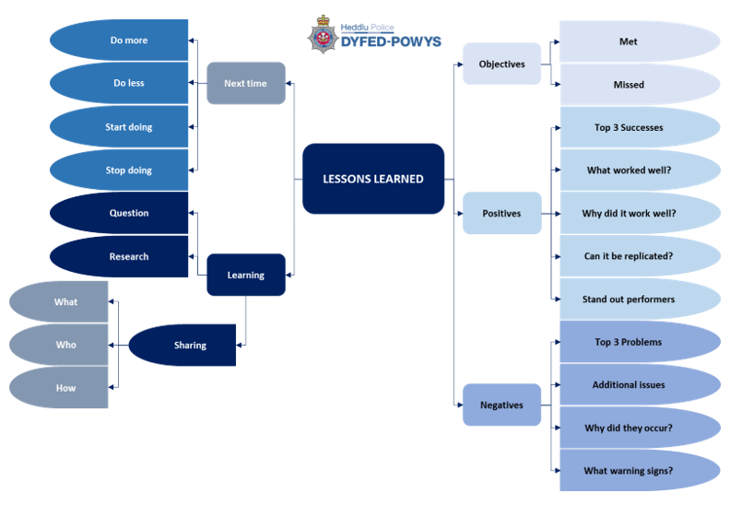

Appendix B – Gibbs Model of Self Reflection

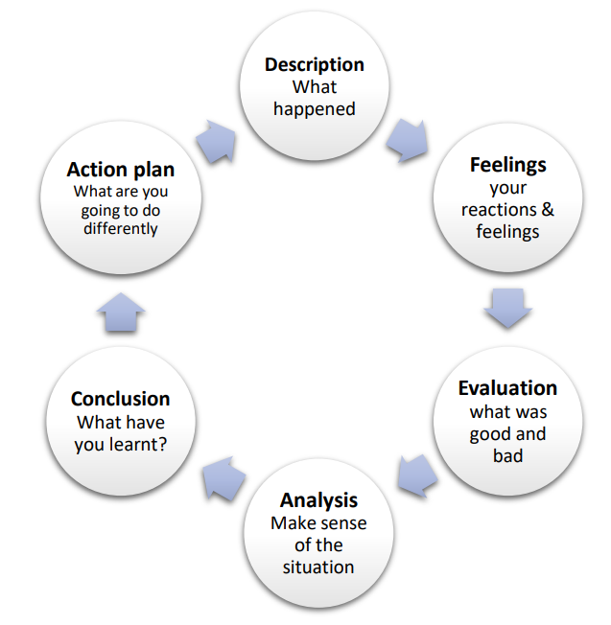

Appendix C – National Decision-Making Model
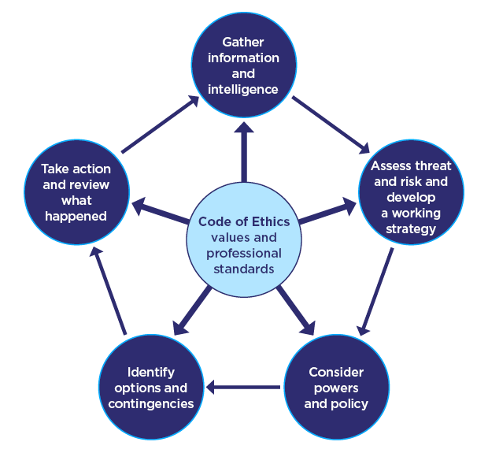

Appendix D – Police Socio-technical systems
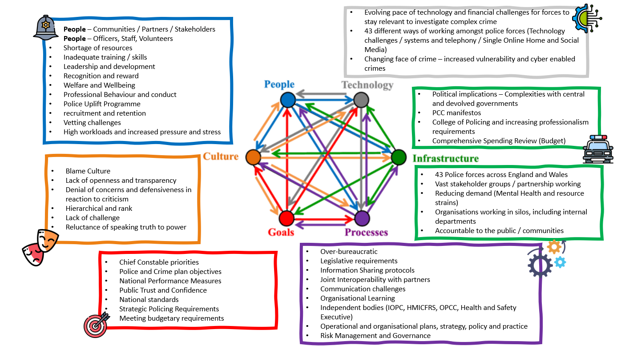


Appendix E – Ethical Risk Considerations for research project

Possible risk factor |  | Mitigation Considerations
1 | The research is focused on ‘Learning Lessons’ from critical incidents. The researcher recognises that some critical incidents can be traumatic and insensitive questioning may trigger participants to suffer psychological or emotional harm through the recollection of memories, which may cause unintentional flashbacks. | The predetermined questions will be carefully crafted, not to ask for specific examples of cases and they will not ask the participant to provide examples of any first-hand experiences they have faced. No questions in the questionnaire will be mandatory, therefore the participant can choose to miss any question they do not feel comfortable to answer. The invited participant can refuse to take part or opt to withdraw from the research at any time. The researcher is satisfied DPP have safeguards in place, via. the Occupational Health Department, to offer support services to participants who may require assistance due to psychological or emotional harm experienced during or following participation in the research.
2 | Reputational issues could arise as an unintended outcome from the research findings. The research seeks to establish if Dyfed-Powys Police learns lessons from critical incidents and shares the lessons with the wider organisation to prevent repeat failings reoccurring. Should the findings reveal that the organisation fails to learn lessons, there may be adverse ramifications for public trust and confidence. | It is important to ensure the research project does not negatively affect public trust and confidence in the police or contribute to any social tensions. The force was notified of the research project and are aware of the ethical considerations. As a mitigating measure, it was agreed the research will be assessed by the UWTSD for examination purposes only. The findings will not be published into the public domain. Should any requests be made for publication, permission must be sought from both the Chief Constable of Dyfed-Powys Police, the research participants, and the researcher.
3 | The findings may also form part of an evidence-base for stakeholders, such as the Police and Crime Commissioner, IOPC and HMICFRS to hold the force to account and they could be used in civil litigation cases or public enquiries against the force should a repeat failing occur in a critical incident, that should/could have been prevented through a robust learning approach. | As per point (2) above.
4 | There is a risk of participants inadvertently disclosing sensitive or confidential information related to law enforcement practices, ongoing investigations, or personal details of police officers or individuals involved in cases. | Robust measures have been put in place to protect the confidentiality of participants, and the researcher will not report on any confidential information which may identify any individual. Data will be securely handled and stored.

Appendix F – Research questionnaire
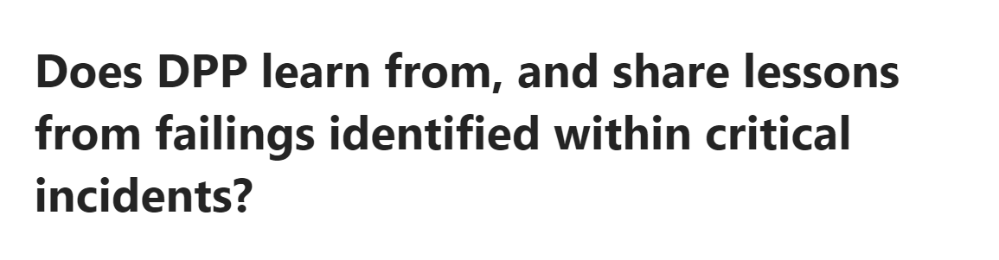

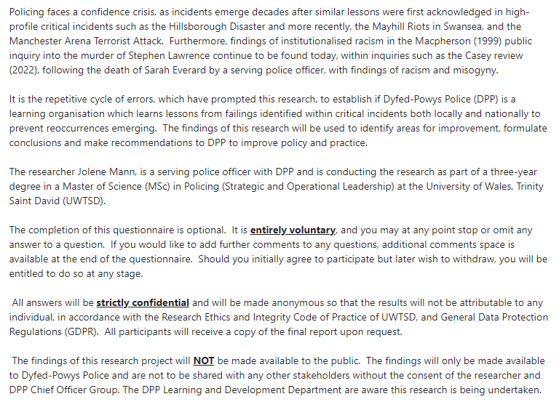

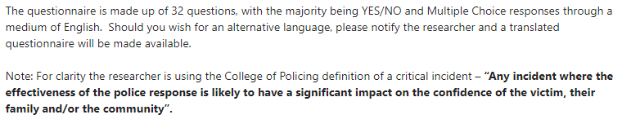

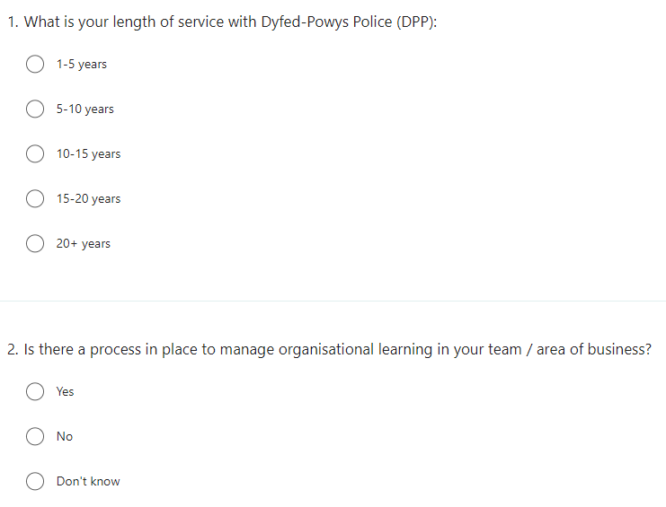

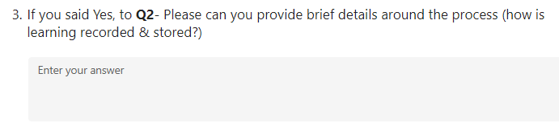
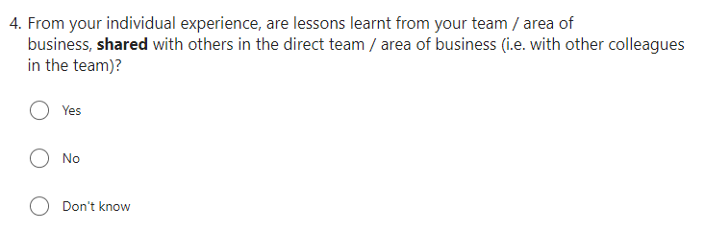

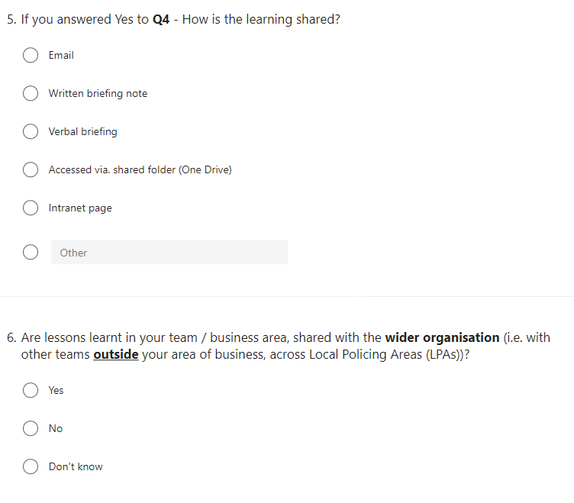

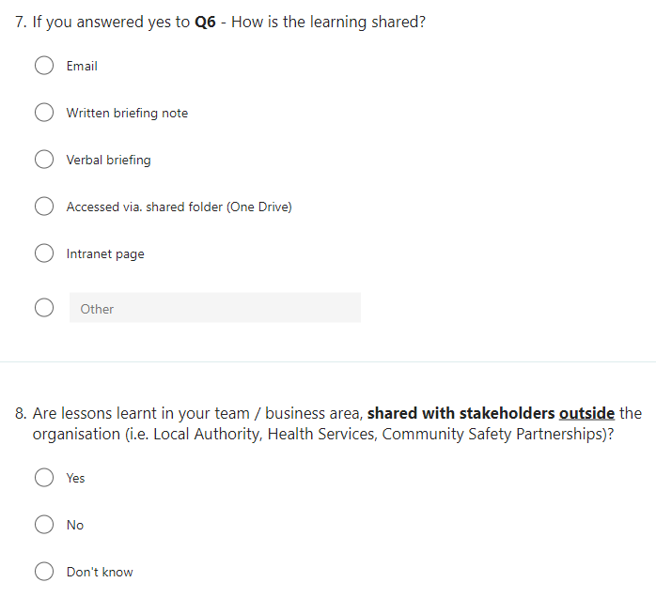

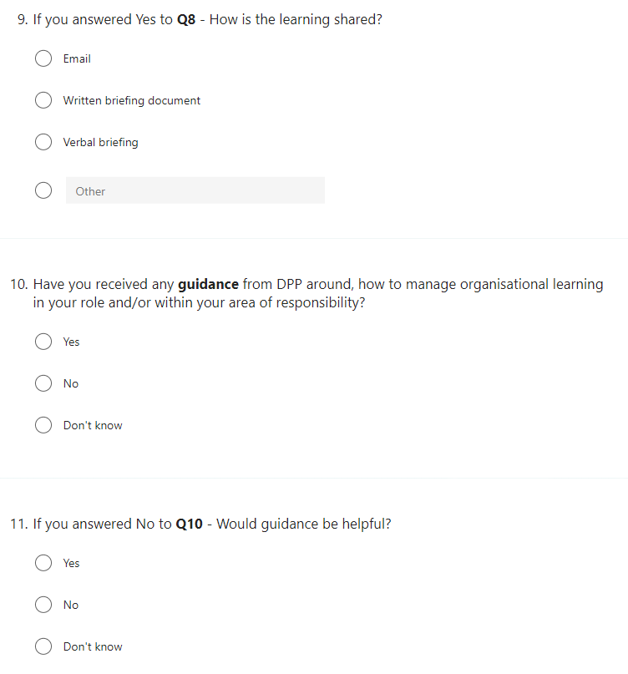

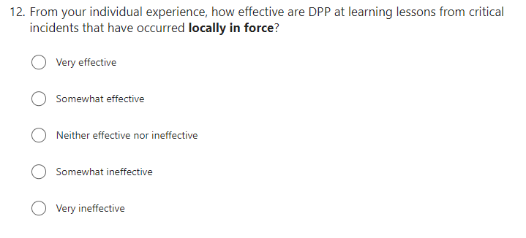

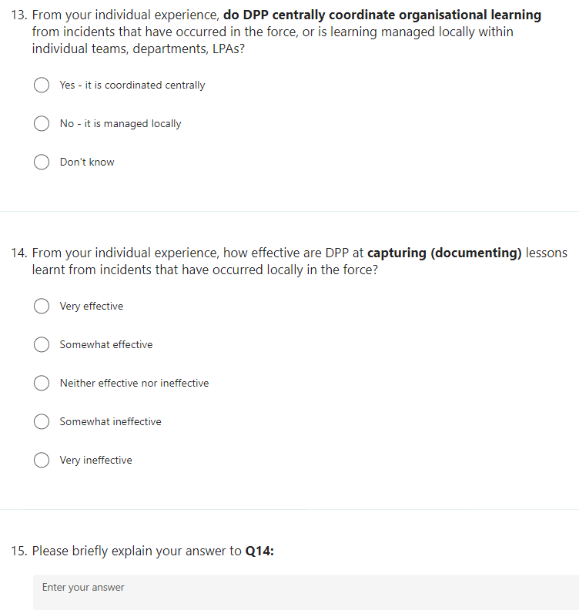

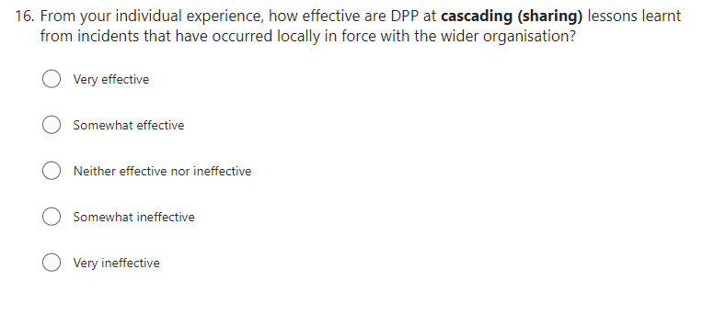


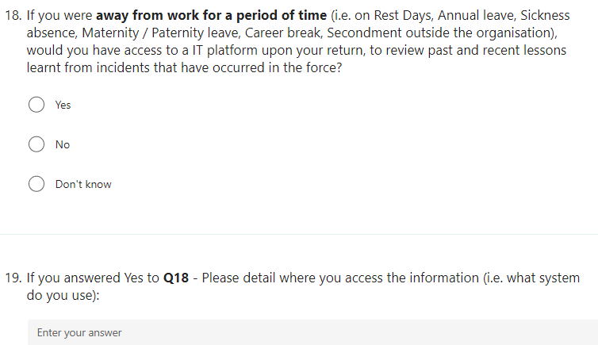

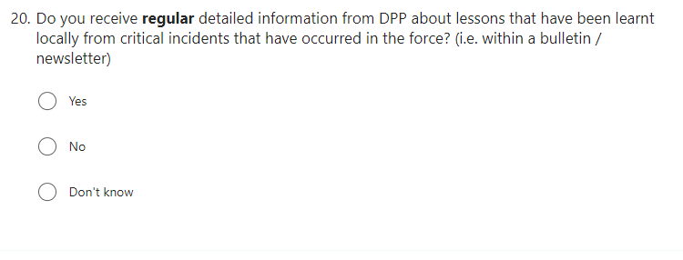

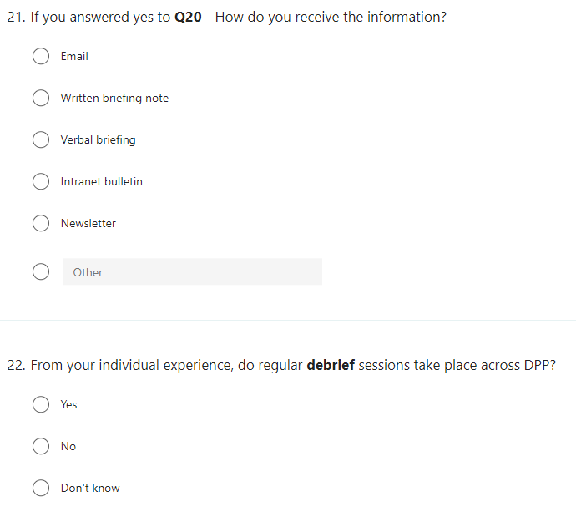

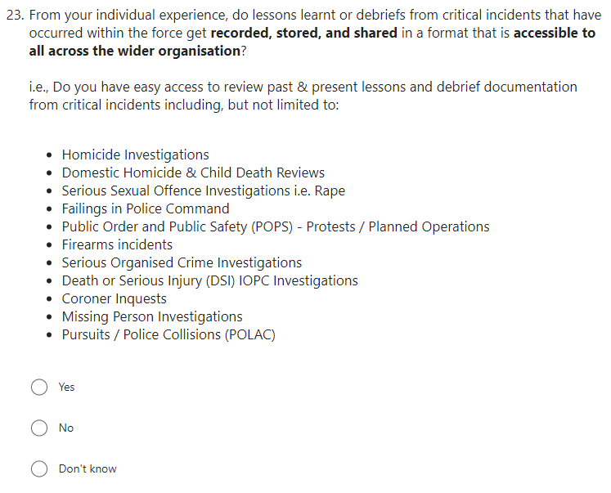

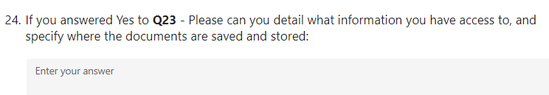

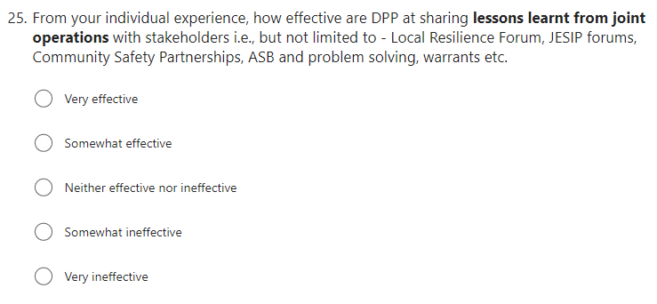

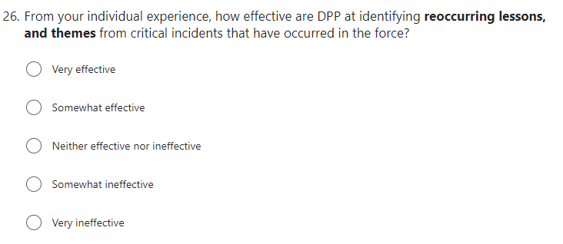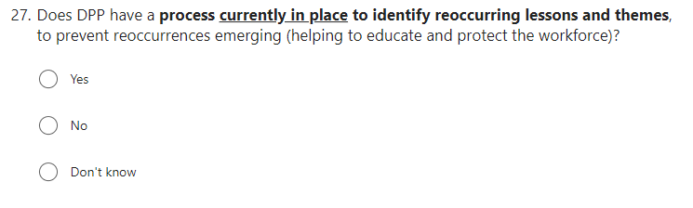

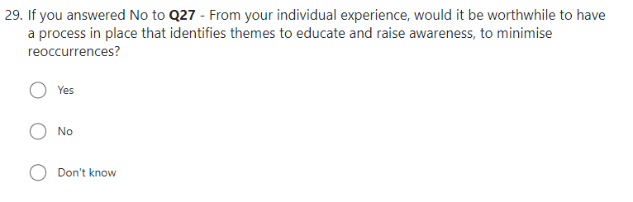

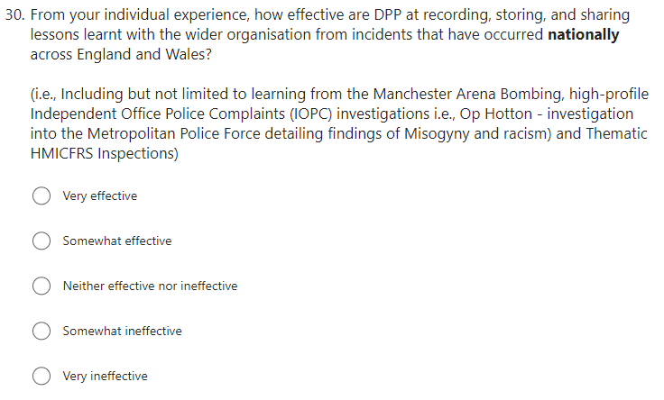


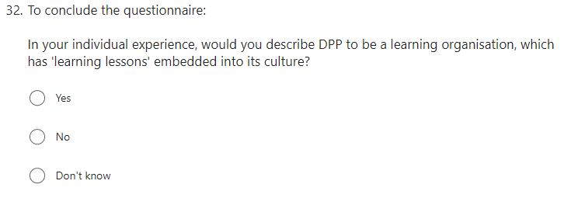

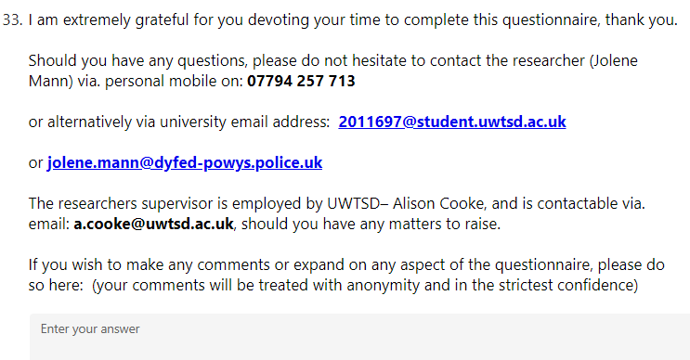

Appendix G – Questionnaire Responses
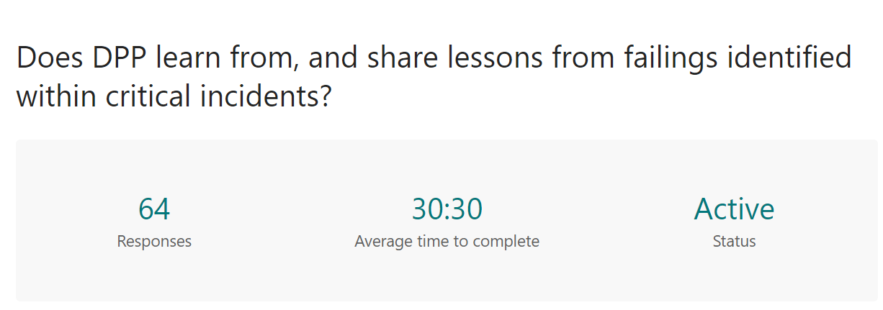

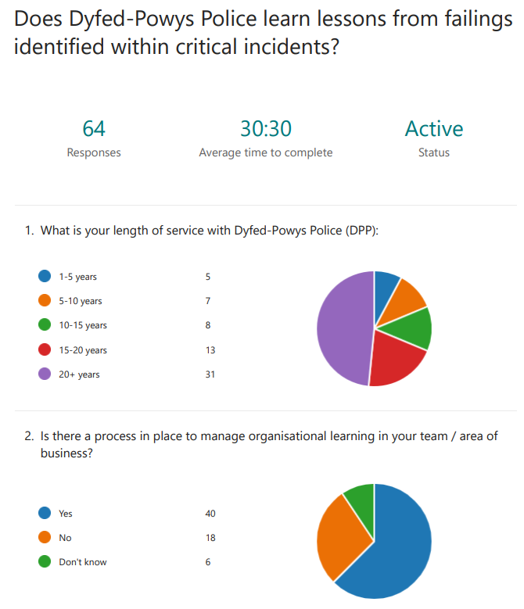

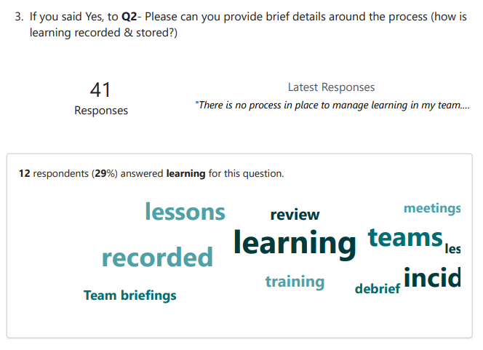

ID | Responses
1 | Any learning is recorded within training and competency records for each individual member of staff, as part of adhering to the ISO 17020 standards. De-brief's also allow any learning to be taken on board after major incidents and any learning can be recorded in our training and competency records.
2 | Dog section, 80 hours a year refresher training.
3 | I am aware of the newly formed learning the lessons board and an attempt has been made to capture lessons learnt in departments through One note on MS365. I am not sure how well this is being utilised by departments yet.
4 | trent system
5 | Held on DPPi2, disseminated to relevant teams and individuals following performance meetings
6 | Discussed in monthly 1-2-1's, Monthly SLT, Criminal Justice Group, Strategic Custody, Criminal Justice and Investigations Board, Learning the Lessons Board.
7 | Structured Team briefings post events ie OP ASPER although unsure where the de-brief notes were subsequently kept/stored
8 | A monthly review of crimes - DI's across the force review two crimes per month from separate divisions . Themes change every month and are decided by the Investigation audit group. Review is conducted by completing a questionnaire. A group consisting of 1 DI per division discuss the results if the audit and feed back learning.
9 | via DAP
10 | NCALT is the main online tool There are courses around any new legislation etc then
11 | Issues and training requirement's can be requested/directed through our line management starting with my first line manager. All courses, learning and training are recorded on my DPPi record.
12 | We discuss lessons learnt and learning opportunities at every weekly Department meeting and these are recorded on the shared drive for Staff to access
13 | In terms of neighbourhood policing, involvement in critical incidents takes place in the form of Community Tension Assessments (CTA). This allows teams to record and subsequently store detail in a database that is accessible through both the Briefing & Tasking System and Neighbourhood Policing Database (called ARDAL). Learning is also captured and stored in the Problem-Oriented Policing System (POPS), relating to solving problems specifically.
14 | Learning the lessons is an agenda item at various SLT level meetings. Learning captured and disseminated as appropriate with upward reporting feeding into the Learning the Lessons Board.
15 | Stored on Trent system. Training and continuation of professional development is required for my role, in order to keep compliant with authorisation levels and within the law.
16 | NCALT packages. On the job learning and sharing of processes and learning points with staff. Recorded it is on each officers Trent and also stored on the college of poling site for the courses that have been completed.
17 | Structured debrief of incident utilising Borton’s Model of Reflection
18 | There is the structured de-brief process. I additionally run informal de-briefs for incidents at their conclusion. I have also consulted with partners for them to review multi-agency incidents.
19 | E Learning other organisational systems
20 | large incidents have had structured debriefs sometimes including external and internal
21 | It is not routine but if required structured de-briefs are conducted for critical/ or any incident to ensure any learning is captured.
22 | I am still in probation, I have regularly reviews where by SGT and I will complete a student review, where it is evidenced the work I have been doing and what I need to improve on.
23 | Captured within action plans and cascaded through established departmental governance including: Daily Management Meetings, Weekly Senior Leadership Meeting, Monthly Performance
24 | It may not be effective but there are sporadic debriefs and lessons learnt platforms in force. These include CID newsletters, major crime debriefs and the feedback loop from audits undertaken. More recently matters are raised and highlighted on MS Teams channels for wider team learning.
25 | In-house trainer delivers training to new recruits and refresher training to all staff on a monthly basis. Supervisors conduct team briefing sessions and regularly deliver quick refresher training to teams.
26 | custody forum meetings and newsletter. not sure how else it is stored
27 | if related to multi agency reviews to MAPF CPR etc review within DPP or with partner agencies issues identified and addressed directly or via line management learning shared via learning event
28 | During routine monthly reviews I have to check a number of custody record against the required standard. Should any issues be identified, feed back is provided to ensure that developments can be made with each custody staff member.
29 | Monthly audits are undertaken for various aspects of the police response within my team. Where learning opportunities are identified, these are address with those involved and are shared wider with DPP where applicable.
30 | Local arrangement, not formalised. My Sergeant will give me / the team verbal feedback after an incident. We tend to reflect on 'how things have gone' during an incident in our team briefing at the start of a shift.  We dont necessarily do a formalised debriefing and we don't record or store any learning. It is a verbal conversation rather than anything structured.
31 | Office based, practical and Ncalt/E learning packages.
32 | A "Learning the Lessons" internal website has been designed. Hopefully this will record and store a whole host of organiational and operational learning across wide ranging topics, with the information being stored in "the cloud".
33 | Major Incident De-briefs are usually held at the conclusion of an incident/investigation. Actions are raised and followed up by the SIO. These are recorded on a national database within a file that is unique to that incident.
34 | DAP system and local records (team)
35 | Structured Training Days within the FCC
36 | I'm aware there are process on the back of misconduct cases and more generally a Forces learning the lessons forum but not really sure how this runs
37 | There are Post Incident Procedures - now for Firearm and DSI, There are debriefs (including Structured Debriefs) of various levels but no specific guidance as to when one or what level they are initiated. Also following audits and reviews in various business areas both internal and external, Identified learning docs / reports may then be circulated.
38 | Learning the lesson board More platforms being created for frontline officers/ SMT to share their opinions and feedback.
39 | PSD investigations should be able to identify where there are lessons to be learned and the best manner in which to disseminate that, either by individual, departmental or organisational learning. Outcomes are recorded on a secure PSD database and would be passed to supervisors/line managers or departmental heads where relevant learning is identified
40 | In my team, when we have dealt with an incident, as a supervisor i always ensure we discuss it as a team and we have a debrief. It is not a specific process, it is more of an informal discussion that i hold with my team. But, i'm not sure if that is replicated by other supervisors. It is not a force stipulated arrangement, it is just something i have always done .
41 | There is no process in place to manage learning in my team. I work in a CID / Investigatory department. We may, however from time to time, discuss learning that has emerged from an investigation, but it is not a regular or routine occurrence.

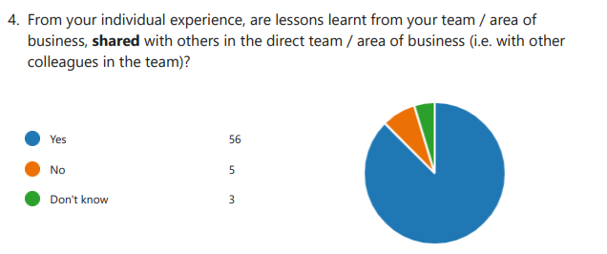

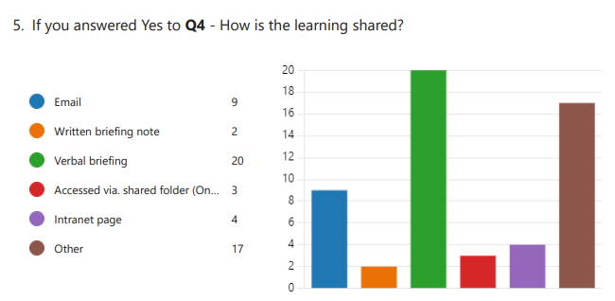

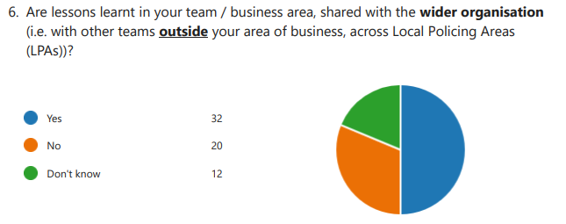

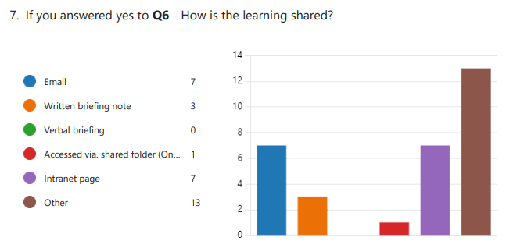

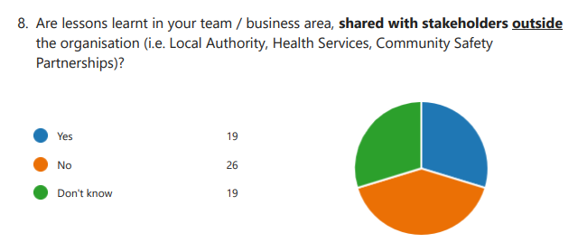

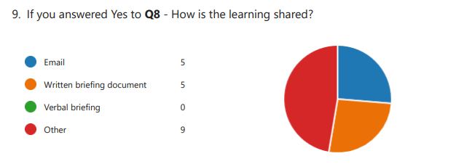

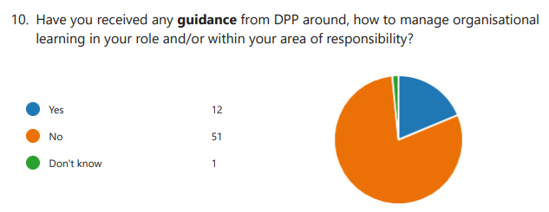

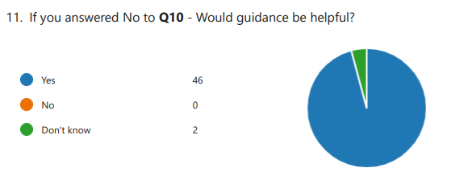

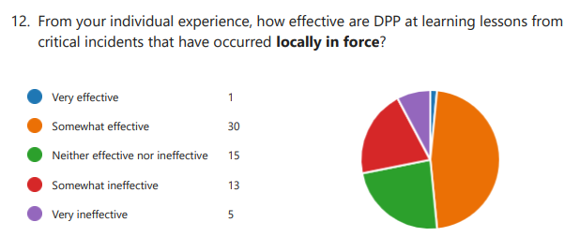

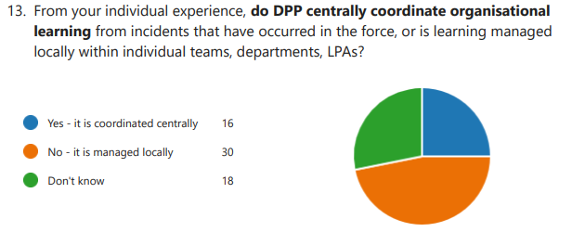

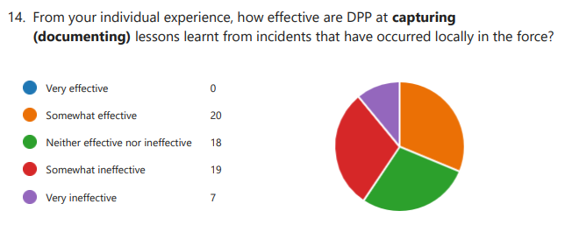

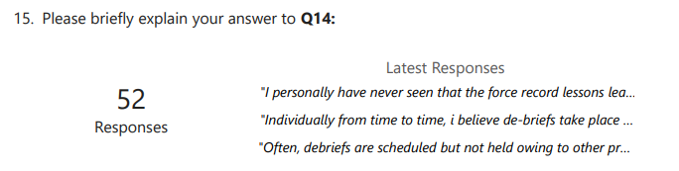

ID | Responses
1 | I would say that learning is held in HQ and does not get disseminated to the individuals that need to know. There is this constant HQ centric mantra and it goes no further.
2 | Learning is not always captured in a format that it can be communicated effectively with all who would benefit.
3 | Previous RPU for 17 years. Attended multiple fatal and been present when fire ambulance and other agencies have de briefs and take learning from incidents. Not once have DPP de briefed following incidents.
4 | I think DPP are improving in this area but there is still some way to go. One of the issues being the analytical capability to capture in a consistent way between departments. This is being developed though i believe.
5 | I do not recall ever hearing of or seeing the capture of lessons learned from such incidents.
6 | Each department will maintain their own learning pertinent to that role
7 | Learning is sporadic unless it is a force wide / national issue it does not receive attention.
8 | Items discussed at Learning the Lessons. Not sure how other incidents are de-briefed.
9 | This would I believe be something discussed at SMT Level, however TEAMS has become an effective tool in meeting/discussing and implementing actions real time with Files that can be accessed 24/7 and updated in real time
10 | As a member of police staff not directly involved in operational matters this is outside of my remit and as such I may not be aware of any processes that are in place.
11 | As per above. De briefs are regularly conducted on major investigations as well
12 | some learning is sent within the team and not further afield.
13 | It does occasionally seem to be a "tick box exercise" and there is no true interest in preventing bad practice from happening again. Whilst de briefs do take place, the lessons learnt are often forgotten or no emphasis is placed on prevention / learning from ineffectiveness.
14 | It depends on the nature of the incident. Near Misses are captured on a force e-system and critical incidents are formally debriefed. Those that fall between these categories are mostly debriefed verbally and no learning is shared formally.
15 | Despite many issues surrounding support of staff especially when providing scene guard and other support away from station, there is always a break down in providing breaks, refs and relief as it appears to be a the bottom of the list of requirements.
16 | There doesn't seem to be an avenue to share lessons learnt or a internet site where Staff and Officers can view best practises, areas where improvements have been identified. This could be local lessons or wider organisational lessons. These normally only come through from external audit results, then the Force responds. No proactive identification of these lessons/improvements so they can be addressed before they become a larger issue.
17 | To the best of my knowledge, whilst learning is captured in the de-brief process, the documenting of learning is inconsistent. The de-brief would ordinally be conducted by a senior leader BUT I cannot be certain where such learning might me documented or reviewed.
18 | Approaches to 'Learning the Lessons' vary from department to department with very little by way of executive oversight - albeit the LTL Board has recently been stood back up - and often it doesn't happen at all.
19 | I cannot recall one incident that has happened within this force that has been shared as a document for future learning. Lessons learned I believe are seen as a negative result of an incident which people tend to shy away from.
20 | Information is usually held with individuals, rather than on a system or within a process. individuals may or may not share what they have learned. Staff are often keen to hide mishaps or errors due to a culture of blame - this is partly due to being such a small force as well - errors will be known to all and this drives an impetus to hide and shift the blame onto others.
21 | we rarely complete de-briefs of critical incidents and without these we are not identifying lessons learnt correctly
22 | We tend to be informed verbally or via email and then this will fade away.
23 | Certain learning is taken on board from incident de briefs or information fed in at the time by staff for example. Some of the learning points are repeated on more than one occasion so sometimes not fully taken on board.
24 | Processes are not consistent and vary from department to department
25 | I do not believe there is much organisational learning as we seem to set ourselves up to make the same mistakes again and again. Capturing and logging learning is one thing but adhering to the previous lessons is another thing altogether.
26 | i refer to learning from operational incidents within the force. I think there is an element of persons learning from dealing with an incident although that learning in reality stays with the personnel involved in the incident.
27 | I think this is more individual learning, I learn from things that are done well, and not so well. Feedback is provided through SGT and also updates on daily state. Regular emails are sent out regarding warnings. The way control room dispatch Officers changed, for example, they now ask Officers to activate BWV which is new. I can only imagine this is because some Officers were not utilising BWV at domestics and this is something as a force we needed to improve.
28 | As outlined, it is sporadic, down to individuals to ensure it is captured and little governance around it.
29 | we only hear when other departments want to blame ours
30 | In my experience lessons learnt usually are linked to failings, and we are not generally good talking about our failings and taking the positives from them. We should be able to centrally capture lessons learned and discuss them openly, in order to collectively improve as an organisation
31 | the same mistakes happen again and again. Once money is involved it is how much can we save. Not what is best for the officer or staff members in the long term. Protocols are put in place but if they become inconvenient they are put aside
32 | some are recorded but no direct reference point for all
33 | Learning is dealt with in isolation, and dealt with in silos. It is early shared wider than with the people involved in the incident. Learning is recorded locally perhaps by the manager, but it’s not accessible to others in the organisation.
34 | I have not seen any learning documented for all to see. But people are able to record individual learning in their DAPs but that’s not available for all to see. So learning is very much done in isolation.
35 | Only once in over 20 years have I been involved in a debrief or critical review of a major incident. Even then when learning was identified it was poorly shared and immediately on subsequent major incidents the same old practices were deployed with little or no consideration to the identified lessons learnt. repeating the same mistakes.
36 | During my service, i have not seen anything that would make me believe the force document lessons that have been learnt in a formalised process. I have not access to past learning. All the debriefs i have been involved in (in my 4 years service, i have only been part of two), i've never seen any documentation.
37 | Unless the incident is relevant to our team, the information captured may not be directly shared to us.
38 | It is very disjointed and the method of communicating this can vary.
39 | As answered in Q3. Although, debriefs are often scheduled but not completed, This makes the process inconsistent and therefore only somewhat effective.
40 | I have limited exposure to local incidents having a Wales wide role, but it seems the strategic intent on doing so is there, and the intranet is the source of my decision making/perception forming.
41 | I think we could be much better about sharing and debating both good and bad practice to ensure we continuously improve as a police force and learn from experience in a way that is constructive and thoughtful.
42 | I'm uncertain about the central repository and sharing of learning the lessons
43 | Large force / diverse business areas and not aware of how effective those areas are. Over the years have seen incidents where learning cold have been better captured - There is reluctance with some leadership roles due to the fear of being criticised for potential failings as they see it.
44 | Bulletins shared weekly and the Newsfeed provide information about news within the force, including updating on the successful detection, arrest or sentencing linked to work undertaken within the force. I think DPP would become very effective when learning is shared, not just from good news stories, but also where something may have gone wrong and we need to learn from going forward. I think the Insight Learning Hub as a central repository, when up and running, would be a great addition for documenting lessons learned.
45 | Post Incident Procedures should document matters relating to critical incidents - Death/Serious Injury matters are addressed by PSD and IOPC and will usually generate a formal report identifying good practices / areas to be addressed. This is however dependent on areas being correctly reported/identified
46 | I dont believe it is documented anywhere centrally. Maybe people keep it in their own one drives, but that does not help or support others to learn
47 | I have been in the organisation 4 years and in that time, i've never seen any learning from any critical incidents that have occurred, including a number of murder enquiries. I have never seen any of the debrief documents and i have no idea how i would access them. I dont believe i can see them. Learning is kept in secret and in silos. I dont feel learning is very transparent.
48 | I tend to learn from others mistakes / omissions, only through third hand discussions. I tend to go looking, to keep my team briefed. But i have never been sent any learning and i have no idea if learning is documented. I dont believe it is documented, i have never seen an official form or process, so i cant see why it would be documented.
49 | In my experience, i dont believe the force capture any lessons that have been learnt. I am a front line officer, and i have never been exposed to any learning that has been learnt from incidents that have occurred. In my team, when we have dealt with a matter, we will have a cup of tea after and discuss how it went, what went well and what didnt go so well. We dont write anything down, and sometimes we dont get a chance to sit down at all. But on the main, we do attempt to make efforts to debrief after an incident. We dont record or store any information.
50 | Often, debriefs are scheduled but not held owing to other pressing matters
51 | Individually from time to time, i believe de-briefs take place and i presume learning is then documented by those involved. But this is a presumption, i've never personally been involved in any debriefs and i have never been involved in any discussions about lessons that have been learnt from an incident.
52 | I personally have never seen that the force record lessons learnt, maybe people learn lessons and keep a record in their DAPS. But there is not overall recording of learning that is accessible to all. Well, not that i'm aware of.

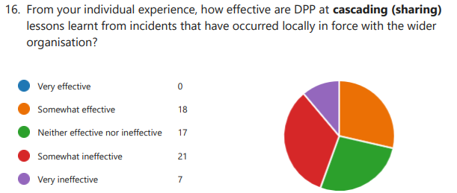

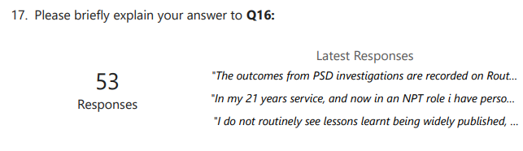

ID | Responses
1 | I would say that learning is held in HQ and does not get disseminated to the individuals that need to know. There is this constant HQ centric mantra and it goes no further.
2 | Learning is not always shared effectively with everyone who it would benefit.
3 | As above
4 | Im not sure we do share our learning wider in the organisation, it seems to be the typical everything stops at middle management with little information being cascaded down to where it is probably needed and valuable more, Pc's sgts are rarely updated with this type of information. This could do with some thought and improvement on how information is appropriately cascaded and actually digested.
5 | Please see Q15.
6 | Im not really sure if we do, why would lessons learnt from a CID job be relevant to Dog section etc. I think it depends on the nature of the incident, if its something an officer has done ( say dishonest) then this would cascade globally regarding integrity issues.
7 | Same mistakes are made repeatedly regardless of what department or area of business.
8 | You don't know what you don't know.
9 | Not really considered this or been involved
10 | As a member of police staff not directly involved in operational matters this is outside of my remit and as such I may not be aware of any processes that are in place.
11 | The lessons get lost in the avalanche of information passed to officers
12 | again most are sent locally and not across the force.
13 | Rarely see any lessons learnt but there are many, many e mails / documents shared and posed via intranet.
14 | We used to have lessons learned forum. This remains a gap for the force at present. There is no set process for sharing learning.
15 | Nothing seems to be shared after the events unless it has gone very well.
16 | I believe there should be a lessons learnt webpage whereby everyone can access lessons learnt or identified best practises by category etc. Individual or department lessons learnt should be directly cascaded to the relevant Managers.
17 | In my experience, the cascading of key learning/ messages is often ineffective. Often, it's luck of the draw in terms of what information you actually receive at the coalface.
18 | As per 15 - different approaches or no approach at all in some areas.
19 | As above in Answer 15
20 | There are some publications, emails containing direction are more common however people are too busy to read them. We have a history of ignoring issues until the wheels comes off, then we will do something about it. learning, accepting fault and being contrite is something that needs to be demonstrated and role modelled by our senior leaders and weaved into the fabric of our organisational culture.
21 | in all my service i can not think of one incident that has been shared correctly with all rank and staff in order for the learning to be shared correctly
22 | Again feedback is usually sent out, but nothing seems to be put in place to assist in managing daily risk such as low response officer numbers, which would have a detrimental effect to a spontaneous major or critical incident, as well as managing the usual demand for service at the same time. There is no longer any resilience with Police Constable numbers on the front line. Other departments seem to be ring fenced (CID, NPT) and protected from cuts in numbers or an increase in responsibilities or expectations.
23 | Some of the learning can be contained to each LPA and or smaller to each department rather than shared as a whole.
24 | again, not process between departments
25 | NA
26 | following structured debriefs information learning hasn’t been spread thought out the force just to persons involved.
27 | This depends on the area of business and person responsible as to how, and how much is cascaded.
28 | I regularly see emails regarding warnings, can be another from the property Officers warning staff that items that are being placed within a safe is getting stuck in the top flap and needs to be pushed in manually to ensure safe keeping, to VMU letting staff know they have located a quantity of cannabis within a vehicle and officers/staff need to check the vehicles better.
29 | Positive examples are highlighted for instance and policy changes occur when things have been missed or learnt.
30 | a bulletin will appear but the reading of it is not mandatory
31 | I rarely see examples of issues identified and problems arisen and a plan to ensure it doesn't happen again. That may be because we are protecting the person that did or did not do something, but its valuable to see an error in order to avoid one in the future
32 | there is no cross learning across teams in the LPU's and younger member of staff are not taught about mistakes made in the past
33 | emails sent out to some and cascaded to some - occasionally miss people
34 | I rarely see any learning being shared. It’s dealt with locally, there is no platform for others to access learning.
35 | As above. Learning is not shared wider. It tends to be done in isolation.
36 | As per the details provided before. There doesn't appear to be an organisational want to improve and learn. Almost a culture of we are good at what we do and will carry on in the same ways.
37 | I have never received any learning that has occurred as a result of incidents that have happened in the force. I have no idea, what learning (if any), has come from recent high profile investigations such as homicides, or coroners inquests. I'm not confident learning is shared. I think it is kept quiet.
38 | As above answer in Q15
39 | I rarely see guidance or lessons learnt cascaded at a place that is easily accessed.
40 | I have limited exposure to local incidents having a Wales wide role, but it seems the strategic intent on doing so is there, and the intranet is the source of my decision making/perception forming.
41 | I think we could be much better at talking about operational practice and discussing incidents in the FCC so that the whole team - understands the golden hour principles around investigative proactive policing.
42 | As per 15
43 | Very intermittent.
44 | April Jones case was a good example being shared with other forces.
45 | Bulletins shared weekly and the Newsfeed provide information about news within the force, including updating on the successful detection, arrest or sentencing linked to work undertaken within the force. These are accessible to all but, perhaps sometimes, not everyone may access due to busy workloads.
46 | As a PSD investigator, I am aware that Reflective Practice outcomes need to be progressed prior to reports being finalised. This would require supervisors and/or line managers speaking with the individuals concerned. in terms of departmental or organisational learning, I would state that department heads would be provided with the IO report in order to cascade findings and deliver suitable learning outcomes
47 | I have never received any learning from the organisation.
48 | As above, i've been a uniform response officer for 4 years and i have never received any force learning and i have no idea where i would go to access it.
49 | I have never been pushed learning by the force, it has never been sent to me. I have to take personal responsibility to go looking for it. Which is far from ideal, especially if i have been off on leave etc.
50 | As above, Learning is not shared with others, in the main learning is done in isolation in teams and it is not shared wider.
51 | I do not routinely see lessons learnt being widely published, but I may not be looking in the right place
52 | In my 21 years’ service, and now in an NPT role i have personally never had access to any force learning from incidents. I would not know where to go or how to find learning from large scale incidents that have impacted the force. For instance, i have no idea where the learning is stored from the murder of April Jones, and if i wanted to learn lessons from the policing response i wouldn’t be able to, as there is no transparency around the documentation.
53 | The outcomes from PSD investigations are recorded on Routine orders, but the lessons identified within those outcomes are not shared. Outside of PSD investigations, i have never seen any force learning that has been shared. Years ago, there used to be a Learning the Lessons newsletter, but that stopped years ago. The Old learning the lessons newsletter used to be useful, but in the main the lessons were focused on PSD matters and not wider learning from incidents. I believe PSD devised the newsletter. Learning should not be seen as a PSD matter, especially if we are trying to create a 'growth' culture

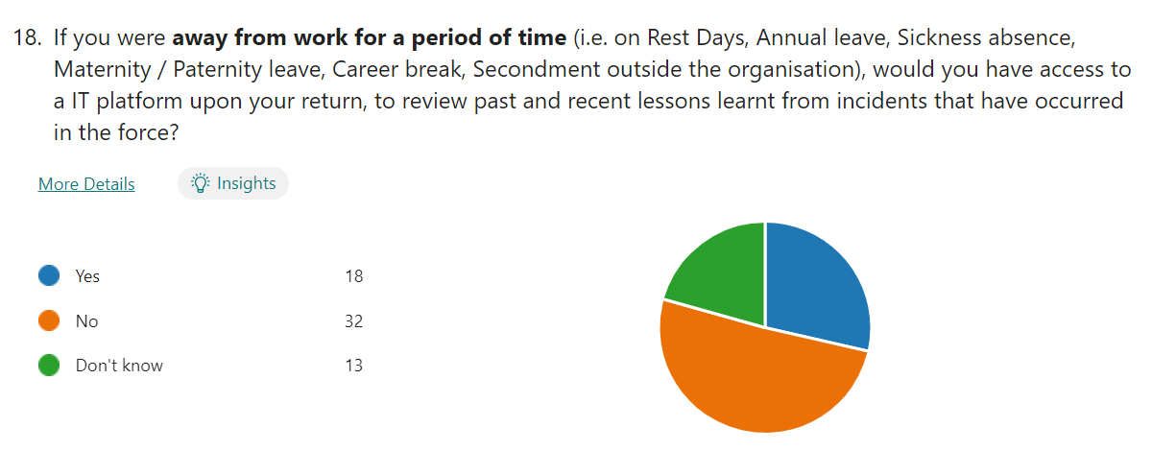

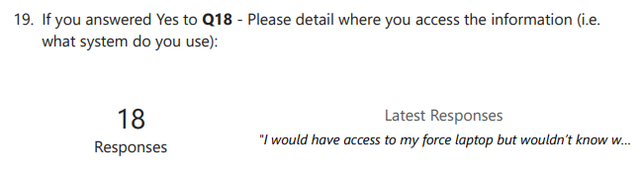

ID | Responses
1 | Tablet
2 | Do not usually have time to look back due to dealing with current workloads. Very little time dedicated to ongoing learning within organisation.
3 | Minutes of meetings, Need to Know et
4 | Dppi2, email, Teams
5 | Laptop issue would allow this. Email, Teams and force bulletins with NCALT packages also.
6 | Laptop
7 | Emails, Bulletins, Daily state records, 'LEARNING THE LESSONS' intranet pages
8 | Daily state? Other than that I do not know.
9 | I understand that a database is about to be setup to capture this learning.
10 | Laptop
11 | the page for my area of business
12 | I still had access to my force laptop whilst on maternity leave but it would be a matter for me whether I looked to access that information whilst away from work. During the 10 'Keeping in Touch' days i had, i was not signposted to any 'learning the lessons' documentation.
13 | Intranet / Briefing pages / emails
14 | force intranet
15 | Intranet signposting
16 | The bulletins and newsfeed would be a good place to start but I think there would be gaps in knowledge as these wouldn't cover all lessons learned from incidents that have occurred in the force.
17 | IT systems have a Daily State Report which captures incidents of note and good work etc, however is dependent on supervisors/line managers making such entries - Routine Orders also provides limited details in relation to PSD Misconduct proceedings. Learning The Lessons Bulletins have been utilised previously but have diminished in recent history and, I feel, should be a monthly/quarterly feature.
18 | I would have access to my force laptop but wouldn’t know where to find the ‘lessons learnt’

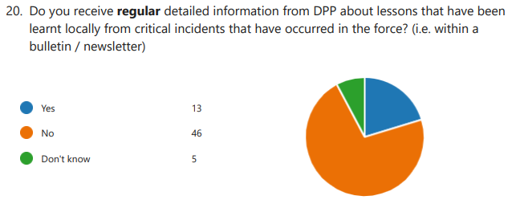

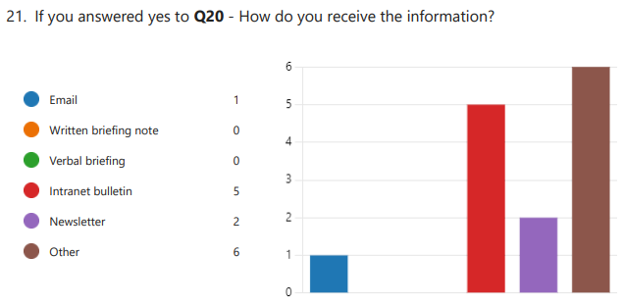

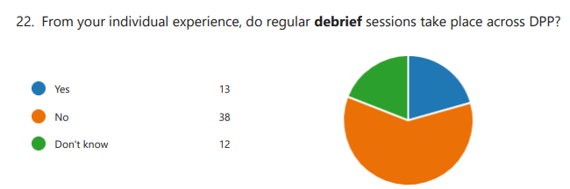

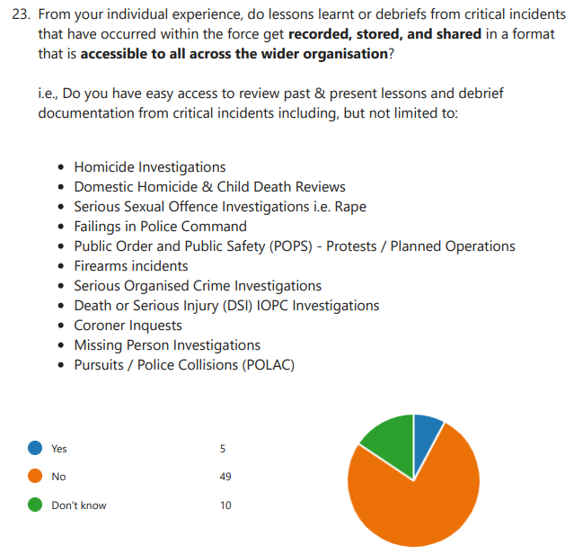

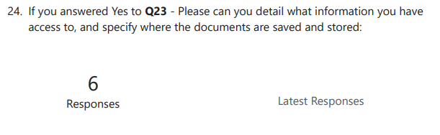

ID | Responses
1 | I believe we have these, but they are not accessible to all. I am not aware of a single platform to access this type of information.
2 | Serious crime investigation de-briefs held on DPPi2 or within shared folders.
3 | this is via AI and intel and good work notes
4 | Serious Organised Crime Investigations should be recorded on 4 P Plans
5 | Near Mis forms
6 | 'LEARNING THE LESSONS' intranet pages

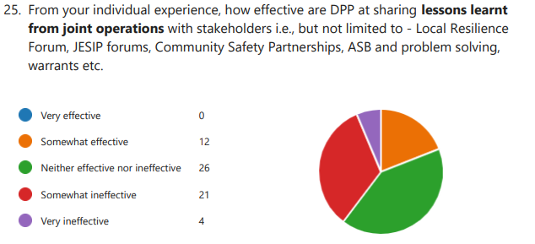

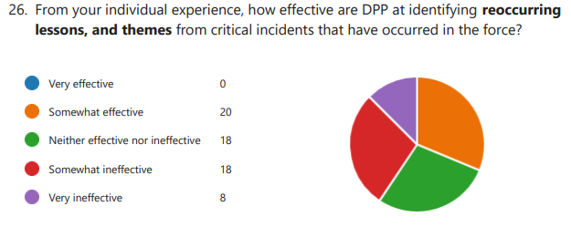

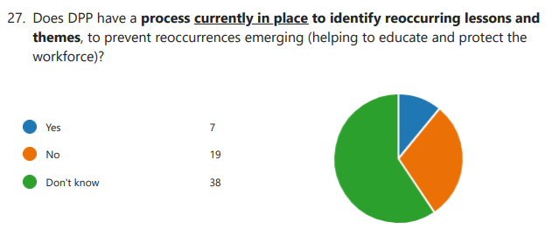

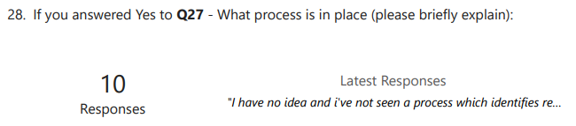

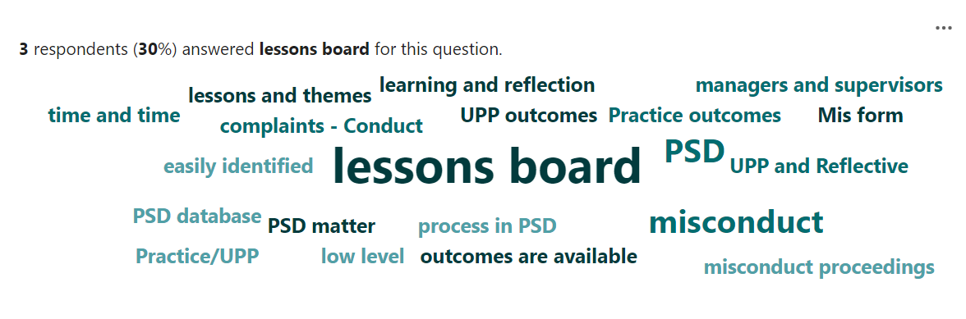

ID | Responses
1 | Learning the lessons board
2 | Platform being developed.
3 | I am aware that a system is currently being developed to do just this.
4 | Learning the Lesson Board stood back up
5 | Near Mis form
6 | I do not know of one.
7 | Learning the lesson board.
8 | as stated above - PSD investigations can result in learning outcomes being identified - This also applies to complaints that are passed to divisional line managers and supervisors to handle (low level complaints) All complaints are recorded on a PSD database and areas of concern should be easily identified. Debriefs, UPP and Reflective Practice outcomes are available for all complaints - Conduct Matters arising from complaints may result in misconduct proceedings or Reflective Practice/UPP outcomes.
9 | I have said no, i dont believe there is a process in place, but i'm not 100% sure. There could be a process in PSD that i'm not aware of. But with that said, learning should not be deemed as a PSD matter, learning should be done by all. Learning does not need to be identified, when misconduct has happened, a culture needs to be breed where learning and reflection is done routinely after an incident.
10 | I have no idea and i've not seen a process which identifies reoccurring lessons and themes. We are on a merry-go round, and continue to make the same mistakes and errors time and time again.

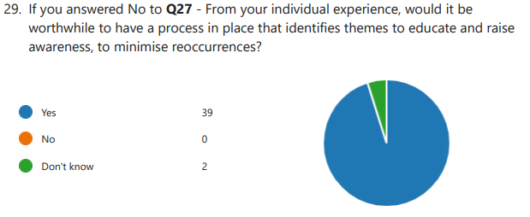

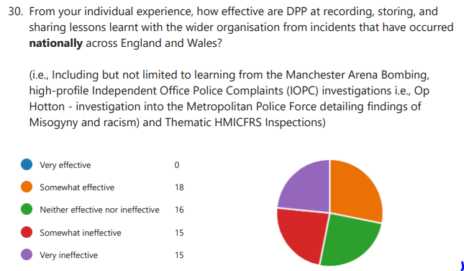

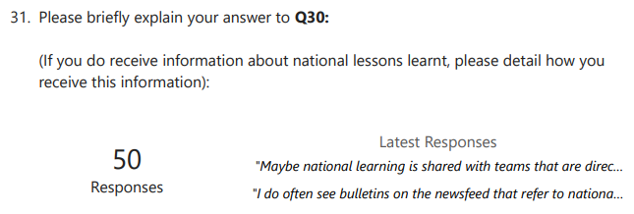

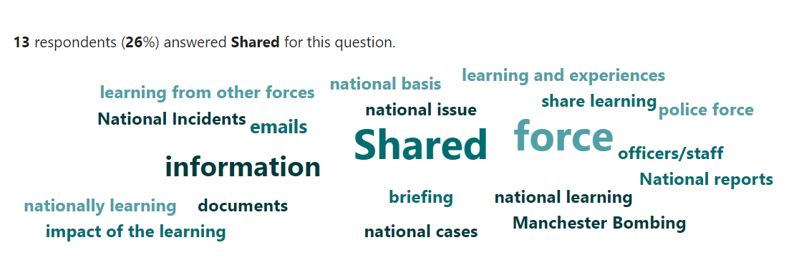

ID | Responses
1 | The problem is that there is no 'go to' place to review or learn.
2 | We do receive some bulletins regarding National Incidents, what went well and what didn't, this could be improved.
3 | I don't
4 | I am not aware that we cascade nationally learning through the force.
5 | I can recall recent emails containing attachments regarding IOPC Investigation Outcomes and the Manchester Arena Bombing. What I would say is these documents tend to be somewhat cumbersome to read and digest and not written in layman's terms. It would be better if a summary or salient bullet points were sent accompanying the documents.
6 | Misogyny was highlighted due to it being raised as a possible national issue
7 | Shared within regional meetings, but gets lost within internal systems.
8 | It's a bit hit and miss.
9 | Not really been involved in receiving any of the above mentioned
10 | As a member of police staff not directly involved in operational matters this is outside of my remit and as such I may not be aware of any processes that are in place.
11 | this is via briefing or via and unless doing it individually does not get shared or passed on,
12 | Unsure but I want to opt for "somewhat ineffective" as from my experience, I am unsure if DPP do or not and if we did then I assume I should know that we do and therefore be effective.
13 | PSD briefings are circulated occasionally - nothing else. We need a forum to manage, record and share learning - e.g. learning the lessons
14 | I personally have not seen or heard of anywhere in DPP where there is any facility to learn from those types of cases
15 | Suring my time in the role I have not been made aware of any "lessons learnt" specific to my job or situation.
16 | I receive some information from other Forces that relate to critical incidents via my counterpart in a neighbouring Force or centrally from my area lead Nationally. This is normally through e-mail.
17 | This just doesn't happen in operational policing
18 | Little by way of commonly understood protocols for storing/sharing/reporting up relevant information, or of tracking the impact of the learning.
19 | I cannot recall the sharing of these types of lessons learnt
20 | it is down to individual departments (i.e. PSD for op Hotton, Spec Ops /JFU for the Manchester arena bombing) to assess National reports and roll out updates or best practice, there is no central depository to check the recommendations or quickly update national best practice.
21 | in recent times DPP have shared such learning from national reports and appear to have improved with such practice. i feel it could be better in sharing and insuring such matters are read by staff.
22 | From experience, I am only aware of what is in the media at that time, which may then trigger a response from HQ (such as the awful behaviour of Met PC Wayne Cousins etc).
23 | Information is usually shared by Email, Bulletin or sent out by the SMT.
24 | I receive some learning from other forces, but it is all on email. Email is a great way of sharing information, but how do we know everyone views that? I cannot suggest an alternative process.
25 | i have been involved with structured briefings from operational incidents and have been able to have an input into some systems and training on a national basis to and to assist in developing training courses for other forces and NCA. This has involved third parties as well such as Coastguard and Mountain Rescue. The reality is that when personnel leave then much of the learning and experiences are lost.
26 | Heavily reliant on bulletins which arent viewed by many officers.
27 | National issues do filter down to portfolio leads to assess.
28 | Occasionally see emails re Learning the Lessons
29 | Cannot recall an example where we have contributed to a national issue with lessons learned
30 | national newsletter which some times get passed down to the practitioners
31 | only receive if directly involved in a multi agency review
32 | I only see national learning by taking it upon myself to search the IOPC, Home Office & HMIC websites. The force does not routinely share national learning and there is no place for people to go, to access documents / learning.
33 | Vicarious learning from issues identified throughout the UK is vital to our service. Learning and developing as a service going forward shouldn’t be feared. Following the recent high-profile criticism of the Metropolitan police force, our service must review and use to our advantage to ensure we maintain public confidence. Public confidence and trust in our officers/staff is paramount to the rural communities we serve, which the majority of officers make daily sacrifices in order to maintain.
34 | I can honestly say, I have never received national learning from the force.
35 | I don't know how information is recorded or where to access the details even if it was recorded / stored.
36 | I dont believe the force shares any national learning. I pick up key headlines from the news and media, re: high profile stats from investigations i.e. Vetting issues within policing. I have never received anything from the force and in the time i've been in the police, there have been a number of national cases where we would benefit from the learning in Dyfed Powys i.e. Mayhill Riots in Swansea - that is over the boarder for us, we could learn alot about those failings. I have no idea, what learning was gleamed from the April Jones murder, or the Asyllum Seekers refugees in Pembrokeshire.
37 | I would not know where to go to access this information
38 | I do sporadically receive information of this nature and this is usually sent by a manager.
39 | Spec OPs briefings from colleagues
40 | Recent briefing around the Manchester Bombing and outcomes for control room. Briefing was by email rather than a discussion.
41 | Whilst some info may be shared on IT pages and or witin the relevant business area it is difficult to know how effective we are as the process to review or self brief on the learning is not mandatory and can easily be missed.
42 | If does occur if required to comply with recommendations. Not aware of implementation of IOPC investigations etc.
43 | Do not believe that DPP shares any learning from other force incidents or if any is then it does not filter down to front line officers/staff.
44 | A very detailed horizon scanning document was produced on a monthly basis. This was shared with all leaders and also utilised as part of board meetings and for the FMS. However, the number of individuals who accessed this document could not be monitored and so it is not known how often this information was used. The individual who used to collate this information has now left the force.
45 | Bulletins and Emails from SLT are utilised where appropriate, however I do not see how this can be effective in delivering messages where teams are facing high workloads and have limited downtime to read non-urgent messages.
46 | I learn about national incidents through twitter by myself. The force do not provide or store any learning in a central location for officers and staff to self brief.
47 | I learn more from BBC News and ITV, about learning for police forces i.e. Casey Review, than i do from Dyfed Powys Police. I have never been sent a debrief or learning document about anything nationally. When i think about it, it is concerning, because i am leading a team that delivers a first line policing response to the public, but i am not provided with regular information about where policing has gone wrong.
48 | I have personally never received any correspondence from the force around national learning that has taken place.
49 | I do often see bulletins on the newsfeed that refer to national issues
50 | Maybe national learning is shared with teams that are directly impacted i.e. Manchester Bombing with Firearms Command Officers, but in the main national learning is not shared with the wider organisation.

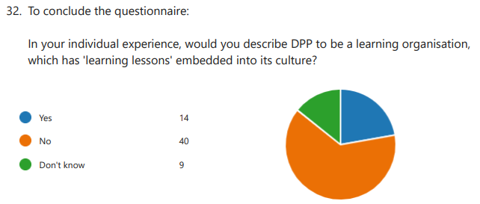

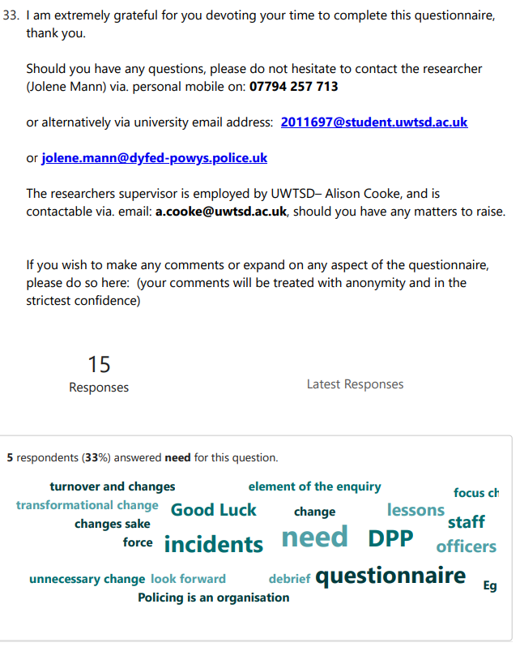

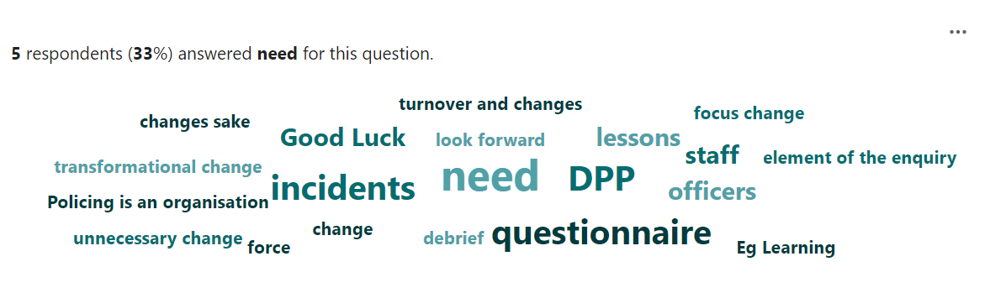

ID | Responses
1 | The problem is that there is no 'go to' place to review or learn.
2 | We do receive some bulletins regarding National Incidents, what went well and what didn't, this could be improved.
3 | I don't
4 | I am not aware that we cascade nationally learning through the force.
5 | I can recall recent emails containing attachments regarding IOPC Investigation Outcomes and the Manchester Arena Bombing. What I would say is these documents tend to be somewhat cumbersome to read and digest and not written in layman's terms. It would be better if a summary or salient bullet points were sent accompanying the documents.
6 | Misogyny was highlighted due to it being raised as a possible national issue
7 | Shared within regional meetings, but gets lost within internal systems.
8 | It's a bit hit and miss.
9 | Not really been involved in receiving any of the above mentioned
10 | As a member of police staff not directly involved in operational matters this is outside of my remit and as such I may not be aware of any processes that are in place.
11 | this is via briefing or via and unless doing it individually does not get shared or passed on,
12 | Unsure but I want to opt for "somewhat ineffective" as from my experience, I am unsure if DPP do or not and if we did then I assume I should know that we do and therefore be effective.
13 | PSD briefings are circulated occasionally - nothing else. We need a forum to manage, record and share learning - e.g. learning the lessons
14 | I personally have not seen or heard of anywhere in DPP where there is any facility to learn from those types of cases
15 | Suring my time in the role I have not been made aware of any "lessons learnt" specific to my job or situation.
16 | I receive some information from other Forces that relate to critical incidents via my counterpart in a neighbouring Force or centrally from my area lead Nationally. This is normally through e-mail.
17 | This just doesn't happen in operational policing
18 | Little by way of commonly understood protocols for storing/sharing/reporting up relevant information, or of tracking the impact of the learning.
19 | I cannot recall the sharing of these types of lessons learnt
20 | it is down to individual departments (i.e. PSD for op Hotton, Spec Ops /JFU for the Manchester arena bombing) to assess National reports and roll out updates or best practice, there is no central depository to check the recommendations or quickly update national best practice.
21 | in recent times DPP have shared such learning from national reports and appear to have improved with such practice. i feel it could be better in sharing and insuring such matters are read by staff.
22 | From experience, I am only aware of what is in the media at that time, which may then trigger a response from HQ (such as the awful behaviour of Met PC Wayne Cousins etc).
23 | Information is usually shared by Email, Bulletin or sent out by the SMT.
24 | I receive some learning from other forces, but it is all on email. Email is a great way of sharing information, but how do we know everyone views that? I cannot suggest an alternative process.
25 | i have been involved with structured briefings from operational incidents and have been able to have an input into some systems and training on a national basis to and to assist in developing training courses for other forces and NCA. This has involved third parties as well such as Coastguard and Mountain Rescue. The reality is that when personnel leave then much of the learning and experiences are lost.
26 | Heavily reliant on bulletins which arent viewed by many officers.
27 | National issues do filter down to portfolio leads to assess.
28 | Occasionally see emails re Learning the Lessons
29 | Cannot recall an example where we have contributed to a national issue with lessons learned
30 | national newsletter which some times get passed down to the practitioners
31 | only receive if directly involved in a multi agency review
32 | I only see national learning by taking it upon myself to search the IOPC, Home Office & HMIC websites. The force does not routinely share national learning and there is no place for people to go, to access documents / learning.
33 | Vicarious learning from issues identified throughout the UK is vital to our service. Learning and developing as a service going forward shouldn’t be feared. Following the recent high-profile criticism of the Metropolitan police force, our service must review and use to our advantage to ensure we maintain public confidence. Public confidence and trust in our officers/staff is paramount to the rural communities we serve, which the majority of officers make daily sacrifices in order to maintain.
34 | I can honestly say, I have never received national learning from the force.
35 | I don't know how information is recorded or where to access the details even if it was recorded / stored.
36 | I dont believe the force shares any national learning. I pick up key headlines from the news and media, re: high profile stats from investigations i.e. Vetting issues within policing. I have never received anything from the force and in the time i've been in the police, there have been a number of national cases where we would benefit from the learning in Dyfed Powys i.e. Mayhill Riots in Swansea - that is over the boarder for us, we could learn alot about those failings. I have no idea, what learning was gleamed from the April Jones murder, or the Asyllum Seekers refugees in Pembrokeshire.
37 | I would not know where to go to access this information
38 | I do sporadically receive information of this nature and this is usually sent by a manager.
39 | Spec OPs briefings from colleagues
40 | Recent briefing around the Manchester Bombing and outcomes for control room. Briefing was by email rather than a discussion.
41 | Whilst some info may be shared on IT pages and or within the relevant business area it is difficult to know how effective we are as the process to review or self brief on the learning is not mandatory and can easily be missed.
42 | If does occur if required to comply with recommendations. Not aware of implementation of IOPC investigations etc.
43 | Do not believe that DPP shares any learning from other force incidents or if any is then it does not filter down to front line officers/staff.
44 | A very detailed horizon scanning document was produced on a monthly basis. This was shared with all leaders and also utilised as part of board meetings and for the FMS. However, the number of individuals who accessed this document could not be monitored and so it is not known how often this information was used. The individual who used to collate this information has now left the force.
45 | Bulletins and Emails from SLT are utilised where appropriate, however I do not see how this can be effective in delivering messages where teams are facing high workloads and have limited downtime to read non-urgent messages.
46 | I learn about national incidents through twitter by myself. The force do not provide or store any learning in a central location for officers and staff to self brief.
47 | I learn more from BBC News and ITV, about learning for police forces i.e. Casey Review, than i do from Dyfed Powys Police. I have never been sent a debrief or learning document about anything nationally. When i think about it, it is concerning, because i am leading a team that delivers a first line policing response to the public, but i am not provided with regular information about where policing has gone wrong.
48 | I have personally never received any correspondence from the force around national learning that has taken place.
49 | I do often see bulletins on the newsfeed that refer to national issues
50 | Maybe national learning is shared with teams that are directly impacted i.e. Manchester Bombing with Firearms Command Officers, but in the main national learning is not shared with the wider organisation.

End of Research Study

