Playing with words

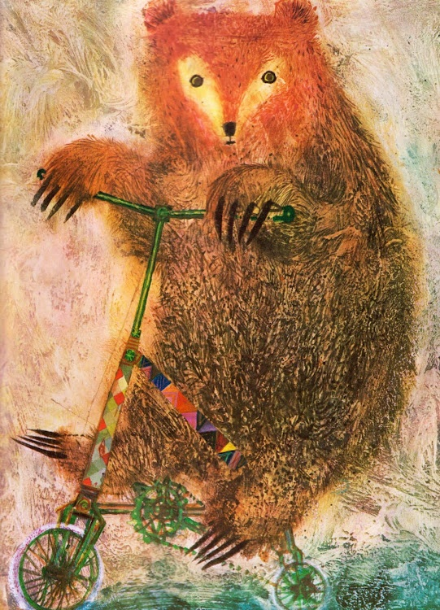
This Photo by Unknown Author is licensed under CC BY-NC-ND
Acknowledgements
There are many people who helped me throughout the process of coming up with an idea for this report, as well as doing research and writing it. Obviously, my lecturer Luci Attala, who taught this module, and the previous model New Materiality is which I heavily used in this report. As well as my classmate’s/friends who suggested and discussed ideas with me on the research. As well as the participants who participated in the actual research. My learning support also help me go through the writing as well as some of my other friends.

Contents

Title page Page... 1

Acknowledgements 2

Abstract 3

Introduction 4

Chapter 1 - Beginning of Spring 4

Chapter 2 – Think, Task and Buzzing Bees 5

Chapter 3 - The Great Adventure 7

Chapter 4 - What does it all mean? 11

Referencing 14

Abstract
This study wanted to investigate different methods of collecting research data and reporting that data. This is because I believe there are more ways of understanding and presenting the theory than writing and reading, which some might find difficulty with. To show that that an individual could understand or benefit from different types of research that was not writing, I decided to go on a walk with participants. At the end of the walk the participants of the study would display their understanding or their feelings in an artistic format (sketching). After this, to clarify the process, individual participants view on the walk and the sketching and unstructured discussion would be recorded. All participants did benefit from the activity in different ways. Most participants enjoyed the walk, but only two could really say that they truly expressed through the artistic sketches. This report shows that there are many ways of achieving understanding and feelings that does not rely on words or written language.

List of images

Bear on a bike illustration Page… 1

Amanita’s drawing done at the end of the walk 9

Badger’s drawing done at the end of the walk 10

Mole’s drawing done at the end of the walk 11

Introduction
This piece of writing aims to demonstrate the different ways that individuals can communicate and exchange knowledge. I will be presenting it in a story format from the perspective of the main character ‘Bear’ doing a task, which is this research. This is because I want to create an interesting way of presenting information that is skewed and not as straightforward as generally telling and reporting. I wanted to query the experience and make it little bit more unstable regarding the meanings and certain things that were happening by using metaphors and characters for actual real-life events. I believe it is a great format to display the muddied way porosity and other methods of gaining information by nonhumans, using no language (Barrett 2013, Ingold 2011). The idea being that one will never get a straightforward answer, and it is up to the individual to interpret what perhaps happened, or is occurring, troubling the concepts and identities (Haraway 2016) and perhaps having a bit of fun as both the writer and the reader.

Chapter 1
Beginning of Spring

As all good folk know, it is the beginning of Spring when life emerges. Perhaps it signifies a beginning of a New Year and the end of the long nights of winter. For how to deal with this little light and little life. Maybe you have the grit to tough it out! Who needs to be sensible about these things? Perhaps you might flee to bright and sunny pastures, to await the return of the brilliant flowers and the thawing of the earth. Or perhaps you are the wisest of them all, using the year to fill your belly, and then when the harsh and tough times come to go to ground and sleep until it is over.
So here we begin our story, for indeed Spring has come, though the gnarled, crooked hands of frosted winter still cling to the air, still not ready to yield its hold, no matter how the spring flowers battle for dominance.
Sleeping deep within the earth, in a cosy warm cave filled with leaves, dried grasses and various trinkets from previous adventures lies a great big brown bear.
The cave is only filled by a light thunderous snore and ever so quietly the sound of Spring birds echo from outside.
Slowly, ever so slowly, the sleepy weight of hibernation lifts from the bones and eyelids of the big bear. Eventually crawling their way out of their cosy cave, they greeted the Spring dawn with a yawn.
The earth itself trembled ever so slightly, and Bear slowly began to make their way to the centre of the forest where the great oak stood. When Bear arrived, they were not the only ones there for all the creatures of the New Year had come to learn the great oak, its whispering branches, and read its gnarled roots.
For it was a new Spring, and new beginning, and a new task had to be set. This time, it seemed that it was up to Bear to decide on what to do.

Chapter 2
Think, Task and Buzzing Bees

Now that the task was set, time to think about what to do. The momentous struggle to make any sort of decision didn’t seem to be taking a holiday today.
So, Bear did the only thing that he knew what to do: he sat on his thinking stump. Perhaps some of the old knowledge that the great oak had gathered could seep into Bear’s mind. As the days passed, bear scratched and tapped at his head, the buzzing getting worse and worse. Maybe talking to some flowers, trees and rocks that remembered so much would help Bear. Still the buzzing bees prevented them doing too much, bugging his brain and making it hard to hear other things. Finally, Bear had had enough and could not live with their annoyance, but they could help on occasion being so beautiful and creative: why was the language so difficult?
Wait; maybe they could do something about it, make it easier for him and others. Bear recalled the previous task that had mentioned a different way of doing a method, a different way of understanding. The previous year had focused on New Materiality, how the material world could create understanding.
Eureka!
Bear would use the previous years, and the understanding of New Materiality, as well as alternative methods to create that understanding, to show that there are many ways of creating knowledge and displaying that knowledge.
Ultimately there are ways the bees could show the strength and the drawbacks, and we should not rely on just one method.
But how to do that?
Bear recalled the previous year, that walking could be used as a way of understanding a place and yourself in the space (Walkinglab 2022, Culhane 2017).
A tiny invisible bee landed on the tip of Bear’s ear. The Bee whispered about a spider named Ingold, who said many things, including that walking could be a way of creating your own meaning within the environment, as well as a different way of changing our perspective from gathering knowledge by sitting, which is common; it changes the dynamics of the observer and participant, therefore changing the perspective (Ingold 2011, Pink 2013).
Also, regarding the idea of communicating and gaining understanding through different species, Bear thought it was best to include a walk that engaged with different individuals, from the tiniest bug to the largest of oaks. This was echoed by Barrett the birch: Bear recalled sitting in front of the birch and looking at the bark, hearing it’s leaves whisper in the wind; it spoke of animism which is an understanding gained from different entities, and porosity, which expanded on animism, using it to gather and create knowledge through the exchanges of energies and the communication of the surrounding world (Barrett 2013).
Bear still thought that something was missing, they had decided to go for a walk as part of their task, but there was another step to it. They thought on the matter a little longer, with days going by; eventually they got off their thinking stool and went on an inspirational walk. They saw trees, birds and friends along the way; eventually finding a badger sitting in the river. Bear smiled at their old friend and sat down. Badger reminded bear that last year they had done a drawing activity, a simple thing. Bear thought that was a great idea to include and asked if badger would mind, they did not.
Bear also thought that the drawing was a good idea as it would be a different way of expressing one’s understanding that was not based on that difficult language.
It was decided that they would go on a walk, draw what they feel, and then discuss it for more clarification. This would be a way of showing there are different ways of creating knowledge, understanding, and demonstrating that. Surely somebody might find it interesting or helpful, besides Bear?
After all, Bear knew there are others that had either invisible bugs bugging their brain or buzzing in their ears, or other sorts of invisible hindrances to their daily lives. Standing up from his thinking stump, Bear considered those that would find it most interesting.
Taking a deep breath of the late spring air, turning green with the omen of Summer. They briskly trotted towards their friends, Mole, Badger, and Amanita, who Bear would ask about doing these activities.

Chapter 3
The Great Adventure

It was now the height of Summer, brightening all the green leaves on top of the trees, creating a sea of emerald colours. It was time to go find those who had agreed to go on a walk; Bear thought the two that were most likely awake during the day were Badger and Amanita. So, making their way through the forest they arrived at a hole in the ground. Bear scratched and stomped at the ground, a short time passed, and they heard scuffling from the inside. Eventually a shaggy fur black-and-white badger emerged grumbling from its cave.
“Good afternoon, Badger! I see you have had an early day-to-day” smiled Bear at his friend.
“Hello there Bear, indeed it has been a busy day, napping.”
“Feeling up for that walk?”
“Yes, but I think we should go for a proper adventure, we will take Fred.”
A little way from Badgers’ hole in the ground stood a giant red ladybug.
Badger strode casually up to the giant bug and exclaimed “Fred me boy, looks like we are going out today. Oh, by the way, are we adding Amanita?
“Oh yes, good you reminded me”, Bear bent down to the ground whispering something to the earth.
A few seconds later a mushroom popped out of the ground, it was brilliantly red, with white snowflakes dotting its cap. The fungus gave a little dance and proclaimed excitedly.
“Of course, I would love to join you on your walk. Doing your task? Let’s go to some new place. Discovery and adventure always keeps the mind thinking.”
The three of them hopped onto the giant ladybug and zoomed off.
The journey was a little long, which made Badger a little growly. Eventually they found an old, secluded woods. The area was quite mossy and damp, smelling of decaying plant matter, with a spongy ground that made your feet sink into it. The walk had started, heading off in any kind of direction; Badger immediately went off the track.
Eventually Bear suggested that they take off their shoes, remembering what Ingold had mentioned, that to understand walking one must imagine a world without shoes (Ingold 2011).
Badger was definitely up for it, so they and Bear took off their shoes. The ground was even more squelchy and wet, but the two creatures did not seem to mind. Badger seemed a little happier with no shoes on.
Eventually they came across a ruin of an old den covered in orange moss, and both participants decided this would be where they ended the walk and did some drawing. The three sat quietly in the woods, until suddenly from behind them Bear could hear growling. Badger was not in a good mood, and they were getting worse, they suddenly got up and proclaimed that they could not do this as they were not concentrating and felt that they should go back to Fred and wait for Bear and Amanita there. Badger scurried off into the woods.
Bear thought it was a small problem but not too much of an issue, they would talk to Badger later when they felt better. But for now, they could talk to Amanita about how the walk and how the drawing went.
Amanita had sat on an old log surrounded by other fungus.
“I quite enjoyed the walk, it was nice to discover a new place and I am always up for doing a bit of drawing.” The mushroom wiggled, content in its surroundings.
The two talked a little while longer, and Amanita explained how they had to put themselves in the image and tried to incorporate sound, textures and their own feelings into the drawing, and quite enjoyed the process (see figure 1). After all they struggled with their own invisible bees.
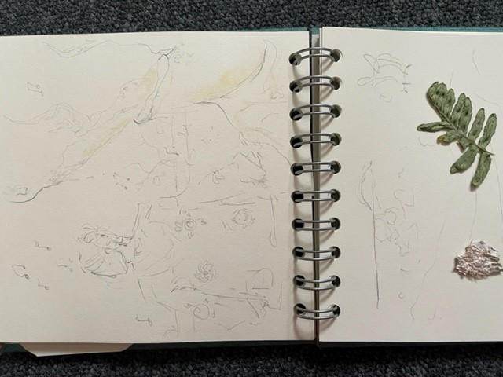
Figure 1, Amanita’s drawing done at the end of the walk.

On a good Summer day Bear returned and scratched at Badgers’ home; they asked if Badger was feeling up to talk about the walk they had done previously. The grumpy Badger was feeling much better today, and both went over to Bear’s cave since it was a little bigger, and talked about the activities. Badger explained why they felt they had to leave; it was because they always felt that when they were in a bad mood, they affect other people surrounding them. The others might also get in a bad mood. This makes Badger anxious and makes the mood worse. So, they felt they had to leave so not to disturb others. They remarked excitedly that walks do make them feel better, after all, the trees and plants in the forest itself would never get in a bad mood.
Bear nodded solemnly and understood why Badger had to leave, they reassured them that it was not a problem and in fact a great insight into how they felt at the time, even if it was an unusual feeling. They discussed a little bit more about doing the walk and the drawing, Badger described how their drawing was quite rough with undefined images apart from occasionally when something stood out (see Figure 2). It was a way for them to display their emotions at the time, and one could see it through the image.
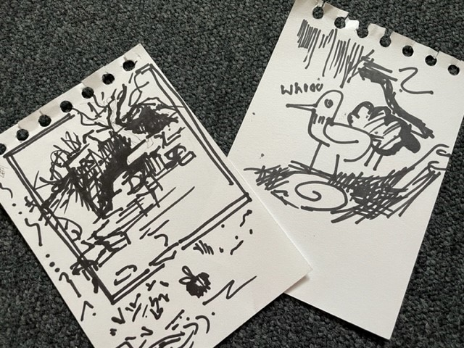
Figure 2, Badger’s drawing done at the end of the walk.

A few days later Bear headed off to talk to the final participant. Bear knew their friend Mole was more of a nocturnal animal and therefore would prefer the night. Both headed off when it got dark. Unlike the other two, Mole preferred familiar surroundings, and started off the walk from their home.
“I go around quite a lot at night, things are quieter and there are less people about. This makes my anxiety not as bad, I’m not constantly being watched.” Mole walked confidently in the blinding dark, unlike Bear who had to watch where they were going.
Mole also sketched and drew while they walked, making the experience more of an action than sitting down. When eventually they sat down, Mole found a little stump to sit on. Bear sat next to them, and they both discussed how the entire process went. Mole’s drawing was more shapes as they were not as artistically inclined and didn’t necessarily try to express their emotions, but rather enjoyed the act of drawing (see Figure 3). Both sat there discussing different topics about the drawing, and even Bear’s own ideas. Mole quite agreed with Bear that buzzing bees should not be a hindrance, having some struggles that they had to deal with, which they commented was quite common in many individuals. Therefore, there should be more action and widespread use of different ways of producing and understanding knowledge.
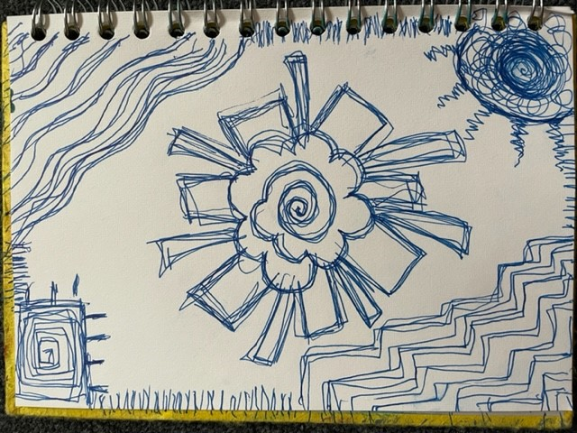Figure 3, Mole’s drawing done at the end of the walk.

Now, having done all the walks and having three different drawings, Bear could collate the tasks, as well as a lot of information buzzing around in their head; they now had to think about what it all meant.

Chapter 4
What does it all mean?

Now late summer, Bear was once again thoughtfully tapping at their head, trying to ignore the bees. Had the walk and drawing helped or not? What did Badger, Mole and Amanita feel about it all? Bear knew that the way to make meaning and understanding of what they had, required a phenomenological analysis. Bear thought they should try to find themes. Yes, they would start with that.
Bear tapped at their head and thought about what each person had said.
All of them had enjoyed doing the walk. But did the walk do anything? Did the walk establish an understanding that would not have been achieved without doing this action? They commented that the walk forced them to be a part of the space. It allowed them to gain knowledge and understanding from other individuals. This is similar perhaps to animism, which emphasises the importance of creating knowledge from beings that do not live the same world as you, nor speak your language (Barrett 2013).
Badger also mentioned that they like going on walks because it creates a different level of thinking for them, they are included more in the environment of the forest instead of the individual. They could become a part of the collective, to the perspective of perhaps the entire forest. Even Badger’s mood was affected by the environment, they mentioned that they did feel better engaging with the forest. And even though they felt that their mood could affect Bear and Amanita, a display of interconnected individuals and objects can affect each other in many different ways. This is echoed in the ideas of mesh works and porosity (Barrett 2013, Ingold 2011).
Both also reflected ideas of knowledge and creation; doing the walking method in the space can create imagination and a different perspective (Walkinglab 2022, Culhane 2017). Mole also said that the walk itself, although they gained no knowledge, calmed their mind and relaxed them, which shows that the environments influenced everyone in their own way.
Badger and Bear also changed their actions and perspectives when they took off their shoes to further other senses that are not just sight and hearing. Badger mentioned that it was something silly to do: the idea of play is an important way to challenge status quo in theoretical action (Ingold 2011).
So doing the action of the walk did affect and change the perspective and the ability to gather understanding and knowledge for everyone in different ways.
Amanita mentioned that because the invisible insects cannot always find the words, or know the language to use to describe the emotions, it was a way to present their artistic understanding, to display something that they had difficulty with. Badger also participated and displayed their emotional state in a drawing format. Bear did feel like they understood both their feelings at the time, through the drawing. Mole was a different scenario; they did not necessarily get a sense of feeling through the art, but the action of drawing did comfort Mole, and allow their mind to relax. During the task the individuals created their own image out of their emotions without the need to create a preconceived idea, this means that drawing can be more fluid and abstract (Ingold 2011).
Though drawing could not accurately display emotion to everyone who viewed it, everyone would see the art differently and feel about it differently. Art, once produced, is no longer the artist’s to own; this could be the same for writing. Everyone will perceive it differently, any form of expression is the individual’s absorbing the surrounding environment, translating that, and then expressing. This is the same for drawing and writing as well as other forms of expression and understanding. Bear also thought that if the individual is trying to understand materiality and meshwork as well as other beings and objects, it would make sense to try and understand this idea through different ways that are not just language based. They also thought that this could be applied to many different other concepts and theories, many different other tasks done throughout the years. Mole made comments and discussed how they felt unsatisfied by certain aspects of the learning community, that not all could participate easily because of difficulty, and that these different methods could perhaps engage those individuals without the difficulties hindering them.
After all Amanita, Badger and Mole all gained unique understanding and were able to express themselves in different ways through these activities. So, in essence, Bear thought the tasks and the forests, and the learning community, should be open to many ways of understanding and presenting knowledge; why not play around with learning?
As the final thought passed through Bear’s head, a crisp autumn breeze brushed against his nose. Winter was indeed coming, and the task was complete. Quickly ignoring the buzzing bees and running through all the fallen leaves, Bear came to the great Oaktree and told them of their task.
Write in time for winter and a great hibernation to come.

References

Barrett, M.J. (2013). Researching through porosity: an animism research methodology. In: The Handbook of Contemporary Animism. Durham.
Culhane, D. and Elliott, D. (2017). A different kind of ethnography: imaginative practices and creative methodologies. [online] Toronto: University Of Toronto Press. Available at: https://www.google.co.uk/books/edition/Staying_with_the_Trouble/ZvDgDAAAQBAJ?hl=en&gbpv=0.
Haraway, D.J. (2016). Staying with the Trouble: Making Kin in the Chthulucene. Durham (N.C.); London: Duke University Press.
Ingold, T. (2011). Being alive: essays on movement, knowledge and description. London; New York: Routledge.
Pink, S. (2012). Situating everyday life: practices and places. [online] SAGE PUBLICATIONS. Available at: https://www-vlebooks-com.ezproxy.uwtsd.ac.uk/Product/Index/441542?page=0.
Pink, S. (2013). Doing visual ethnography. 3rd ed. [online] Los Angeles: SAGE PUBLICATIONS. Available at: https://www-vlebooks-com.ezproxy.uwtsd.ac.uk/Product/Index/549010?page=0.
Springgay, S. and Truman, S.E. (n.d.). WalkingLab. [online] WalkingLab. Available at: https://walkinglab.org/ [Accessed 25 Apr. 2022].

