21/04/2026
University of Wales Trinity Saint David
london campus
Assessment 2
Introduction to Web and Database Concepts
Module Name: Introduction to Web and Database Concepts
Module Code: ACCA4023_LON
Student Name: Dzhenifer Oleksandra Safutina
Student ID: 2514100
Group: 2
Lecturer’s Name: Anum Paracha
Contents
- Introduction……………………………………………………………………3
- Requirements…………………………………………………………………3
- Implementation………………………………………………………………5
- Validation……………………………………………………………………….7
- Evaluation………………………………………………………………………13
- References……………………………………………………………………..14
- Appendices…………………………………………………………………….15

Introduction
This report highlights the development of a website that has been built for the pet shop (Happy Pets Shop). This website has been developed through HTML and CSS technologies, and there are multiple pages linked to it, including “Home,” “Products,” and “Contact.”
The aim of this project is to develop a simple and interactive website for the pet shop. This website has been developed to exhibit the basics of web development, which include structuring, navigation, styling, responsiveness, and usability of the web pages.
Furthermore, there are also some e-commerce functionalities embedded in this website, including product cards, shopping cart, and contact forms.
The use of websites has become increasingly important for companies and e-commerce businesses in particular, since users expect a website to be navigable, well-designed and multi-device compatible. Websites have increasingly been used by pet shops as an effective medium to market products and allow their clients to browse and buy their products online.
The objective of this project was to utilize web development techniques and concepts learned in class to develop a website for a small company that incorporates best design and development principles. These principles included consistency, accessibility, and usability.
For this reason, a pet shop was chosen as the topic since it would provide an opportunity to incorporate features common to e-commerce sites, including shopping features like a shopping cart.
Requirements
The website has been designed by the Happy Pets Shop for marketing their pet products via this website, and making sure that the users get an easy to use website for searching their products.
This website has been built for attracting pet owners who are looking for different types of products, such as food for their pets, toys, accessories, and others.
The following specifications needed to be followed for the construction of this website:
- Develop a website with multiple pages.
- Build a navigation menu on each page.
- Display the products in the form of product cards.
- Include a contact page, as well as a feedback page.
- Implement a shopping cart to provide a simulated online shopping experience.
- Make sure the website is responsive in nature.
Alongside the functionality requirement discussed above, there were some design considerations that needed to be kept in mind while developing the website.
Following were some of the design considerations taken into account during the development of this website.
Use of green colour theme as a symbol of happiness and nature of animals. Incorporation of a splash banner to improve the aesthetics of the home page. Use of product cards for emulating e-commerce websites.
Functional Requirements
The website was required to include several functional features to meet user needs. Users needed to be able to navigate between pages using a clear navigation menu. Product information needed to be displayed clearly using product cards with prices and images. A contact page was required to provide communication between users and the business.
Additional functional features included:
- Home page introducing the business
- Products page displaying items for sale
- Contact form for user enquiries
- Cart interface to simulate e-commerce functionality
- Working navigation links between pages
Non-Functional Requirements
Other non-functional requirements were set for design and usability.
They comprised:
- Adaptive design for both mobile and desktop devices
- Similar layout on all pages
- Adequate font size and colour
- User-friendly interface design
- Fast-loading pages with light coding
Such requirements were necessary for ensuring functionality along with aesthetic appeal of the website.

Planning and Design of Website
Prior to development, planning took place which helped to ensure that the website was organised logically.
The structure for this website consists of a landing page (home), products page and contact page.
The Home Page was developed as a landing page in which to introduce the business and catch users' attention using features such as a hero section and feature blocks.
Products Page was created based on a structure of cards similar to those used in many current e-commerce websites due to their effectiveness in presenting information on each product.
Contact Page was created to provide both business contact information as well as contact forms.
Navigation Structure
A navigation bar was provided on all pages to improve navigation around the website.
Structure of the Website
Home -> Products -> Contact
Such structure was kept simple in order to aid usability.
Design Decisions
During the website development, following design decisions were taken:
Colour scheme - Green colour scheme was chosen since it is associated with nature, wellbeing and pet themes.
Typography - Simple fonts were chosen to help readability.
Layout - Layout based on Flexbox alignment was chosen for better alignment of product cards.
Images - Pet images were added to improve engagement.
Implementation
The website is structured using HTML and uses elements of CSS to make it look professionally presented.
Three main pages were created:
Home Page
The home page includes a navigation menu, hero banner, welcome section and feature section introducing the business and its services.
Products Page
The products page displays products using card layouts with images, prices and “Add to Cart” buttons to simulate an online shopping experience.
Contact Page
The contact page includes business contact details and a contact form allowing users to send messages.
CSS was used to style the layout, colours, buttons, navigation menu and responsive elements. Media queries were used to improve the display on smaller screens.
Elements created using HTML include:
- Headings
- Paragraphs
- Images
- Links
- Forms
- Buttons
- Product cards
Section, heading, and navigation elements were taken into account when developing semantic structure.
Elements that were styled using CSS include:
- Colours
- Spacing
- Buttons
- Product card layouts
- Hero banner
- Contact form
Flexbox was applied to align website elements, especially when displaying products where cards had to be aligned horizontally.
Media queries were applied for responsive purposes as well.
Responsive Design
Responsive design was done by applying media queries for adjustments in smaller screens.
Such examples are:
- Stacking product cards vertically in smaller screens
- Appropriate sizing of images
- Access to navigation links
This made the website responsive.
User Interface Features
Some user interface components were integrated in order to enhance the interface of the website:
Hero banner with call-to-action button
Buttons to "add to cart" to simulate online shopping
Fields on contact form
Buttons' hover effects
This gave the website a more professional look.
Validation
Validation was done to make sure that the website satisfied the criteria and performed efficiently.
Tests conducted on the website included:
- Functional navigation links.
- Proper page display in browsers.
- Successful image loading.
- Correct contact form display.
- Responsive design performance on small screens.
Tools like HTML and CSS validation were used to check for any mistakes in coding and rectify them if any were found.
Tests proved that the website fulfilled the requirements set at the beginning and delivered efficient functionality.
HTML Validation Result
Figure 1. HTML validation results showing errors identified and corrected.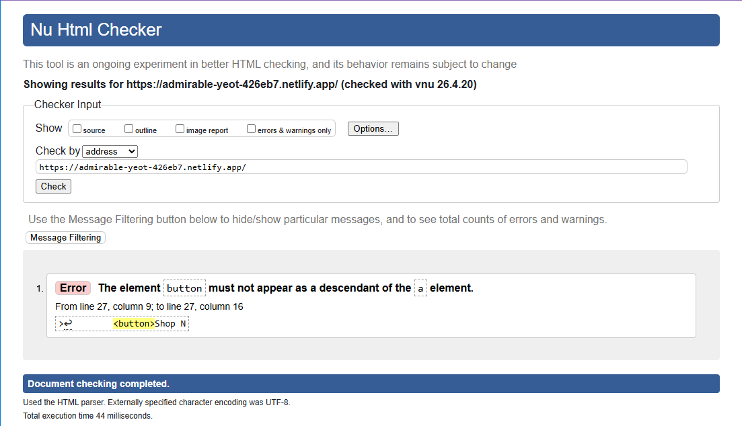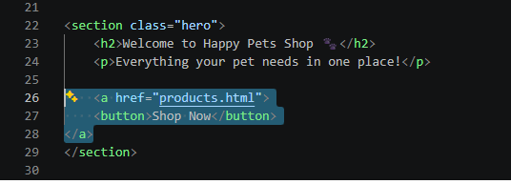
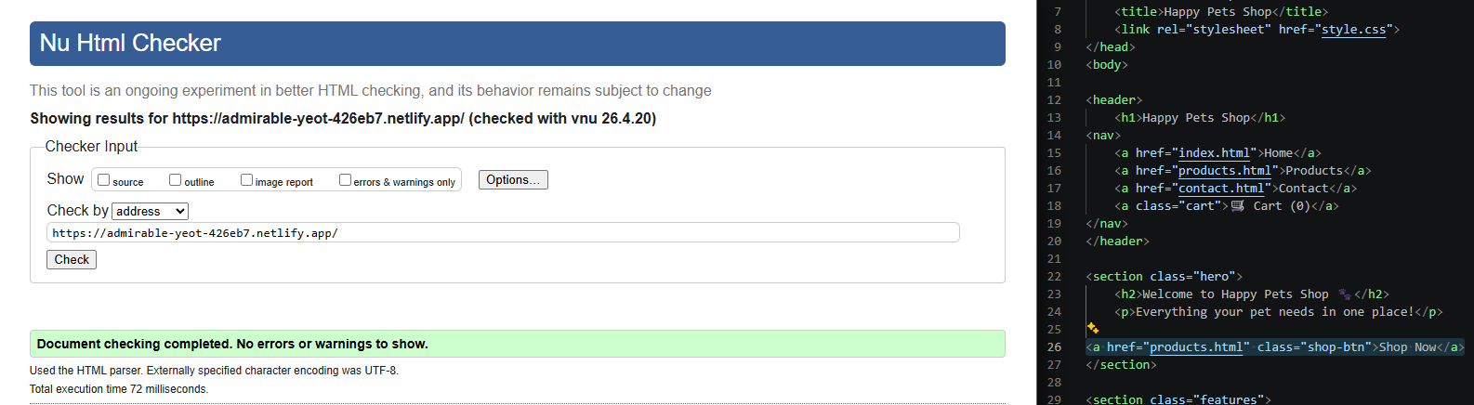
CSS Validation Result
Figure 2. CSS validation results.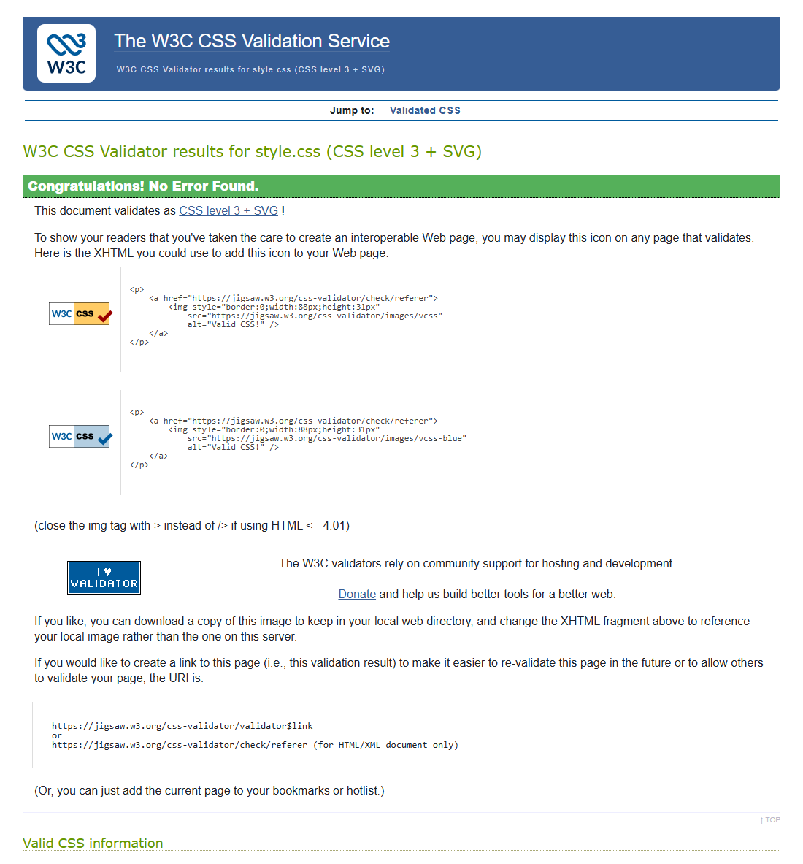
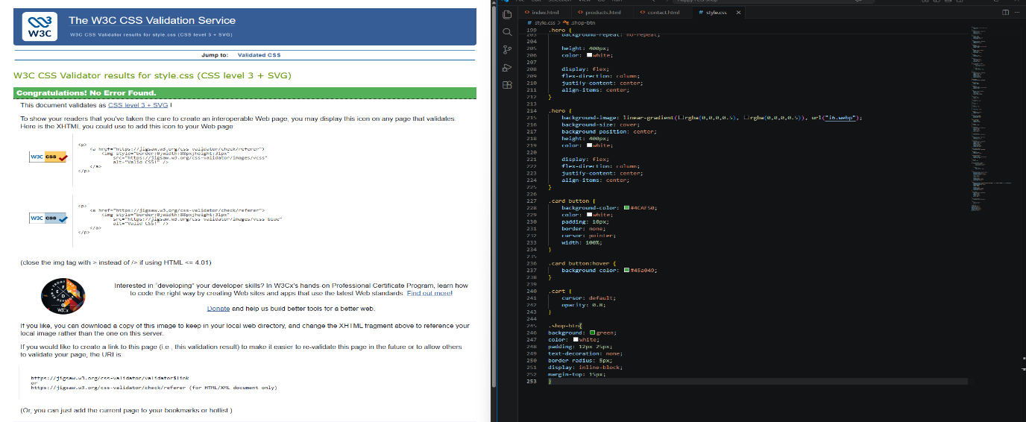
Responsive Testing
Figure 3. Responsive layout tested on mobile view.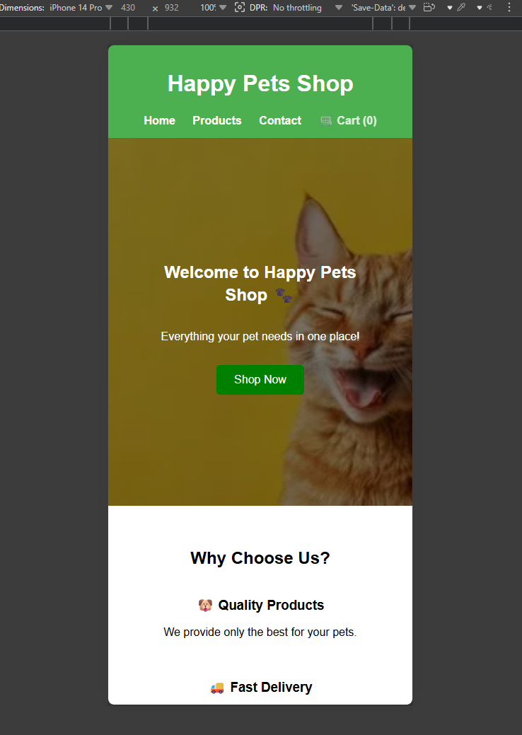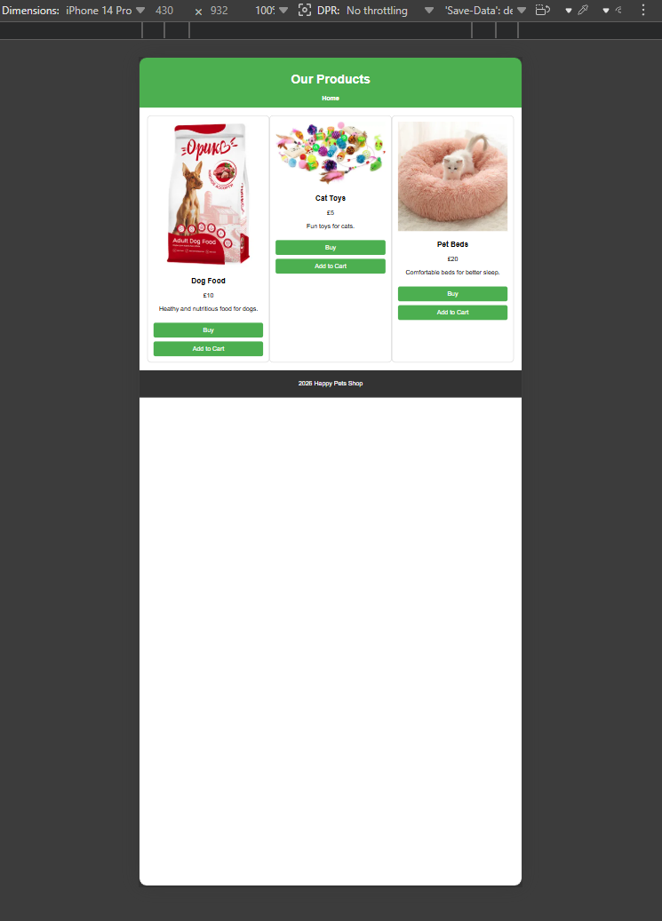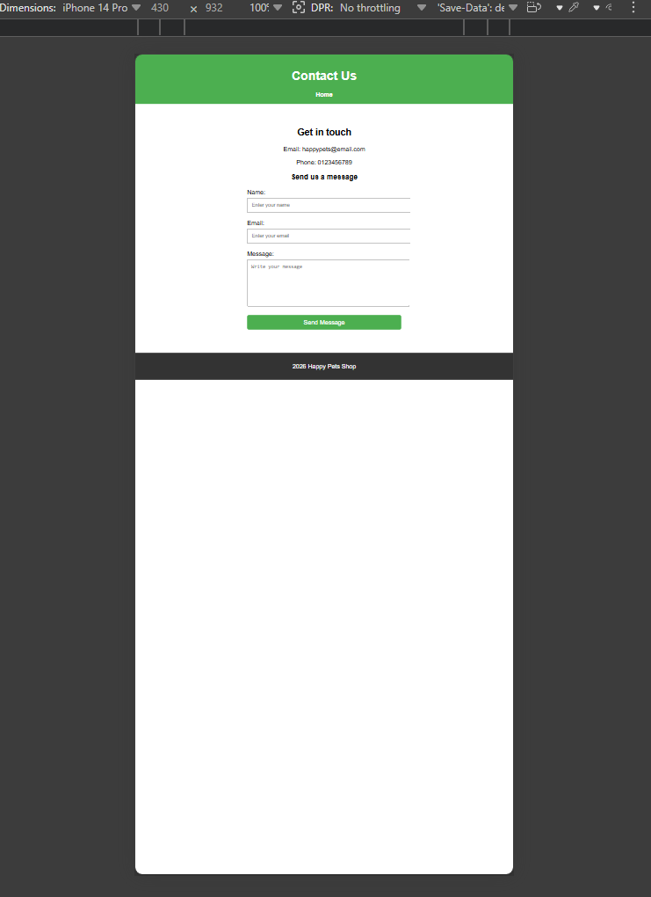
Testing and Validation Process
Testing was carried out throughout development rather than only at the end of the project.
Several forms of testing were used.
Functional Testing
Functional testing involved checking whether:
- Navigation links worked correctly
- Pages loaded as expected
- Buttons displayed correctly
- Images loaded correctly
- Forms displayed properly
Issues identified during testing were corrected.
Code Validation
HTML and CSS validation tools were used to identify coding errors.
One issue identified involved an HTML nesting error where a button had been placed inside an anchor tag. This was corrected by replacing the nested button with a styled link.
Validation helped improve code quality and ensure standards compliance.
Responsive Testing
Responsive testing was carried out using browser developer tools to simulate smaller devices.
This confirmed:
- Layout adapted correctly
- Content remained readable
- Product sections displayed properly
Testing showed the website met its design requirements.
Evaluation
In conclusion, it must be noted that the Happy Pets Shop website met the primary aims of the project. It provided users with an easy-to-navigate, responsive, and user-friendly website of the company operating in the pet store field.
One of the main advantages of the website created was its efficient and intuitive navigation through different pages, namely, through Home, Products, and Contact sections. The second advantage of the website is its aesthetical appearance. The usage of colour schemes, product cards, and a hero banner contributed to making the website look professionally, similar to an ordinary online store. Another important feature of the website is its high responsiveness, thus making it possible to view the website on various devices. Finally, it is possible to improve the Website Contact page by adding the necessary information and filling it with the form to allow contacting the company easier.
Nevertheless, despite the fulfillment of all the requirements of the project, some improvements may be suggested in the future, including the implementation of a working shopping cart (JavaScript), search or filters, more kinds of products and photos, increased accessibility (large texts, forms validations, etc.), contact form integration with the database/email service.
Website Strengths
There are various strengths about the website.
One of the strengths is that it is easy to navigate with well-organised information.
It also has consistency throughout the site through color, layout and styling.
Product cards help improve the presentation while the contact form makes the site interactive.
The other strength is that the website is responsive which enables it to work on any device.
Learning Reflection
From this assignment, I gained insight into:
- HTML structure of pages
- Webpage CSS Styling
- Responsive Web Design
- Website validation and testing process
- Multi-page website development
References
- Mozilla Foundation (2026) HTML: HyperText Markup Language. Available at: https://developer.mozilla.org
- Mozilla Foundation (2026) CSS: Cascading Style Sheets. Available at: https://developer.mozilla.org
- Bootstrap (2026) Documentation. Available at: https://getbootstrap.com/
- World Wide Web Consortium (2026) Markup Validation Service. Available at: https://validator.w3.org
- World Wide Web Consortium (2026) CSS Validation Service. Available at: https://jigsaw.w3.org/css-validator/
Appendices
Screenshot 1. Website ‘Home page’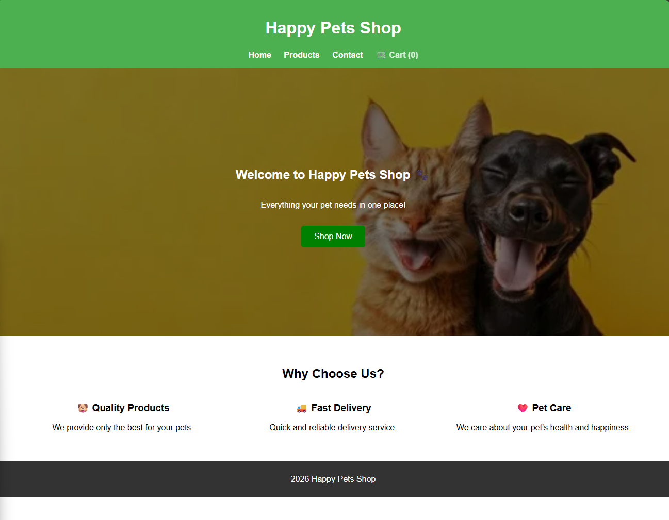
Screenshot 2. Website ‘Products page’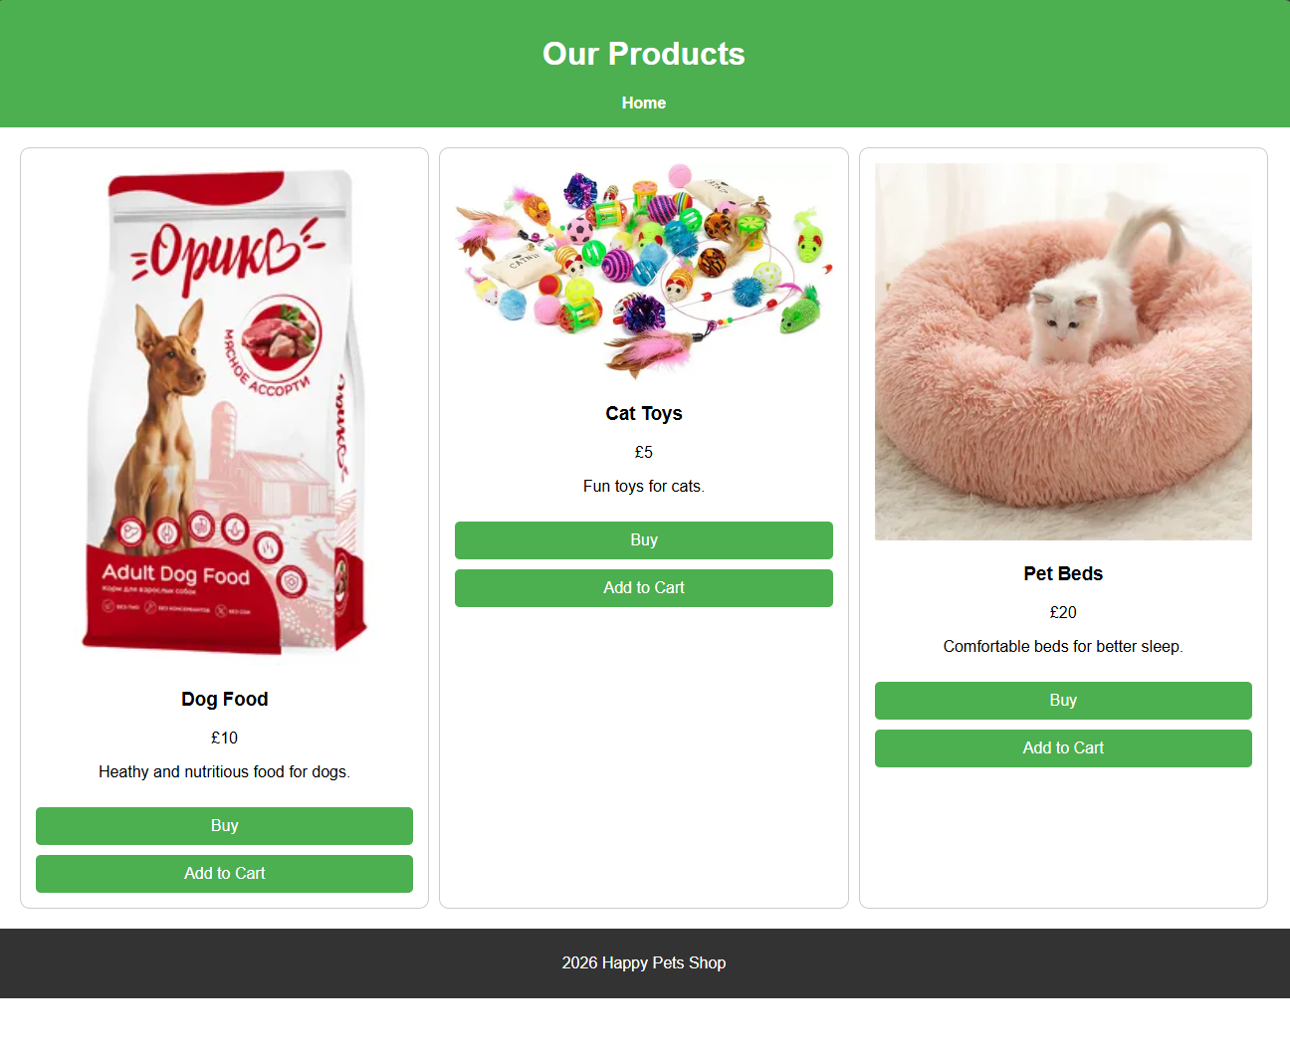
Screenshot 3. Website ‘Contacts page’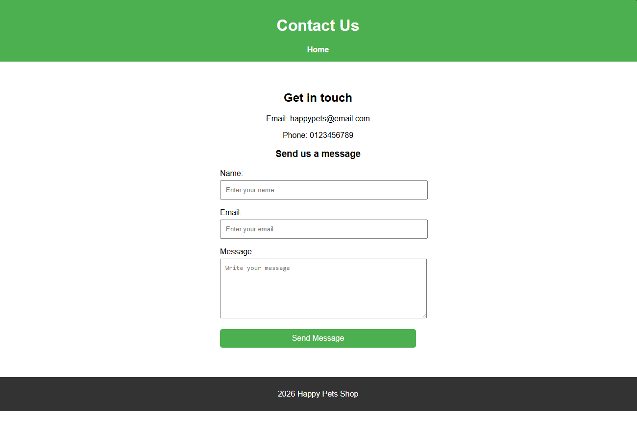

Screenshot 4. Style.CSS Code
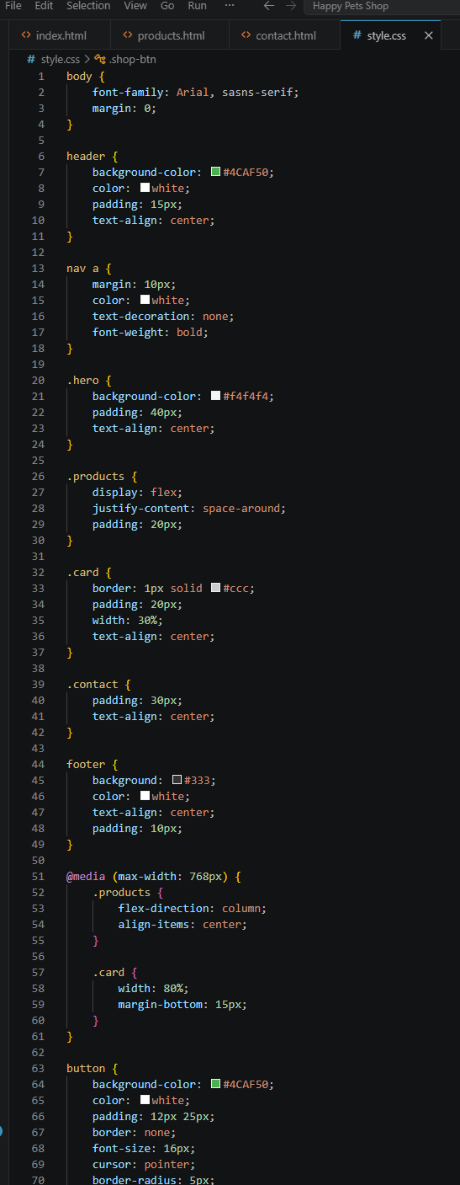
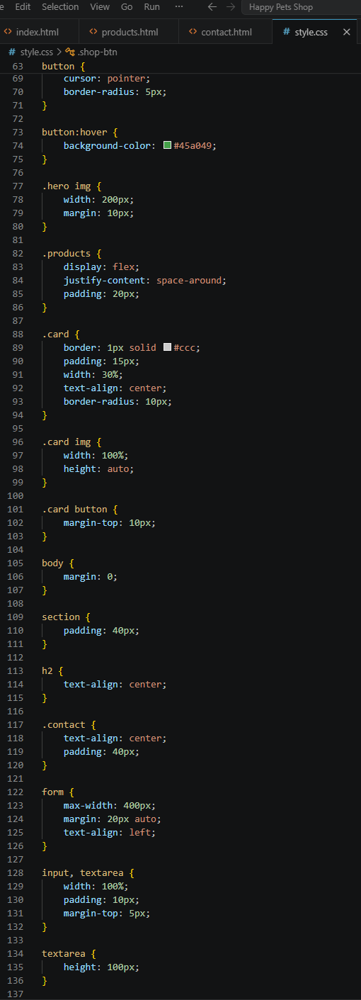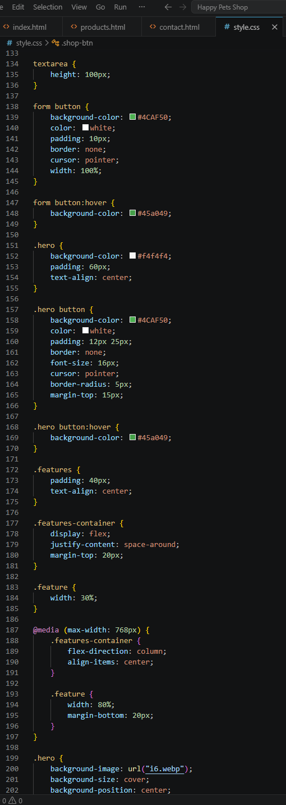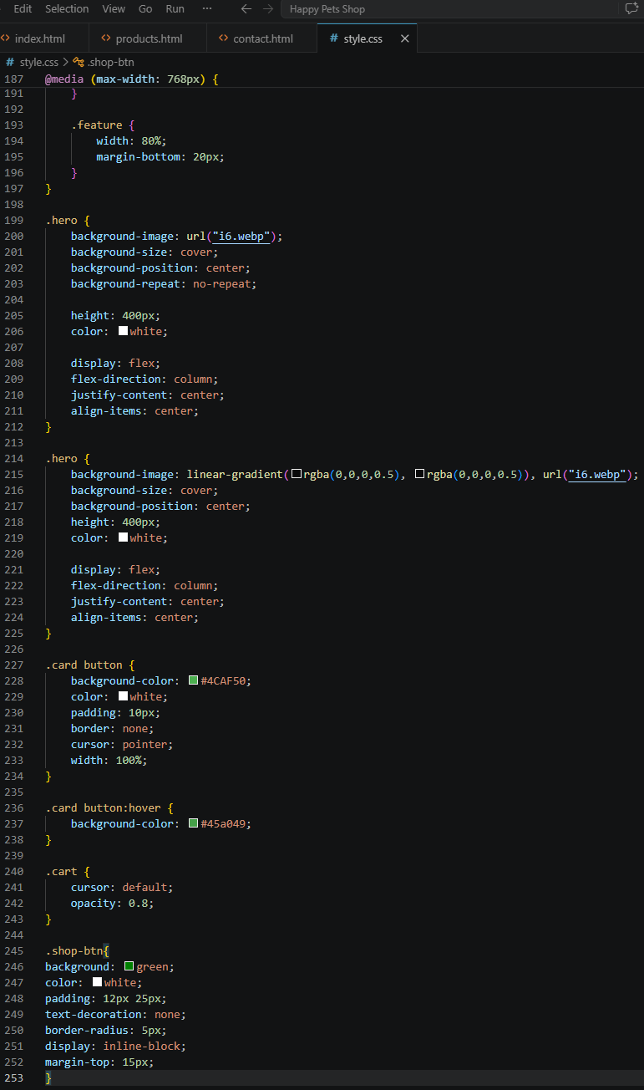
Screenshot 5. HTML Code ‘index.html’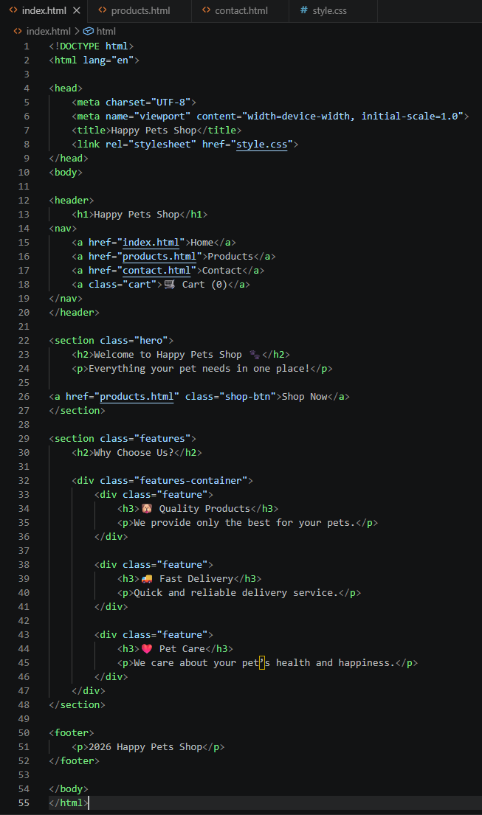
Screenshot 6. HTML Code ‘product.html’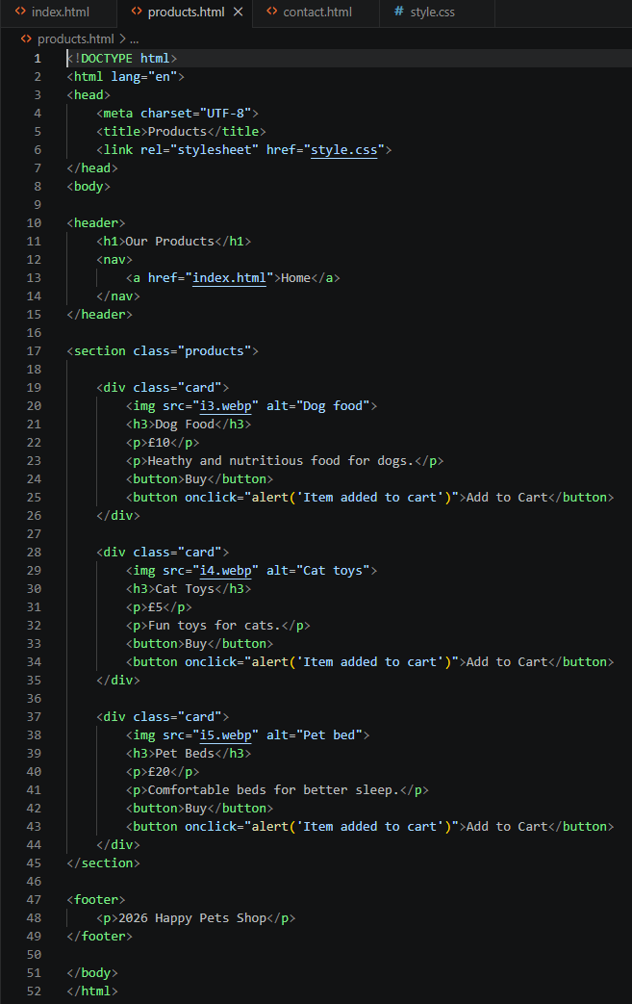
Screenshot 7. HTML Code ‘contact.html’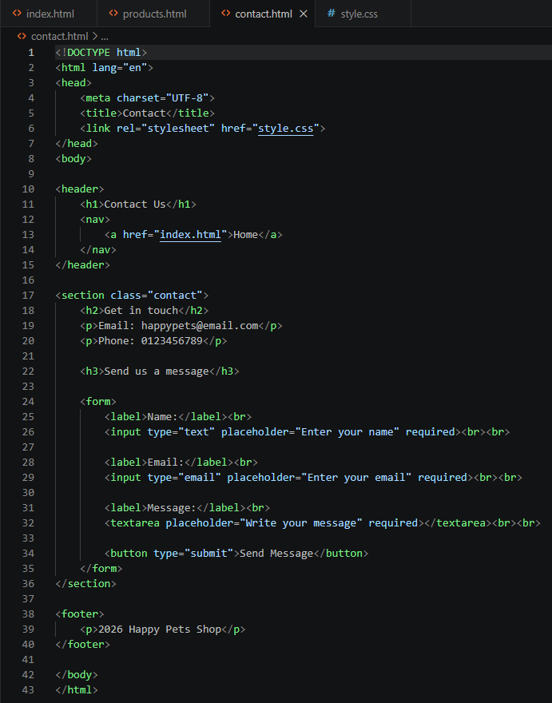

Screenshot 8. Validation and tasting evidence ‘ HTML Validation Results’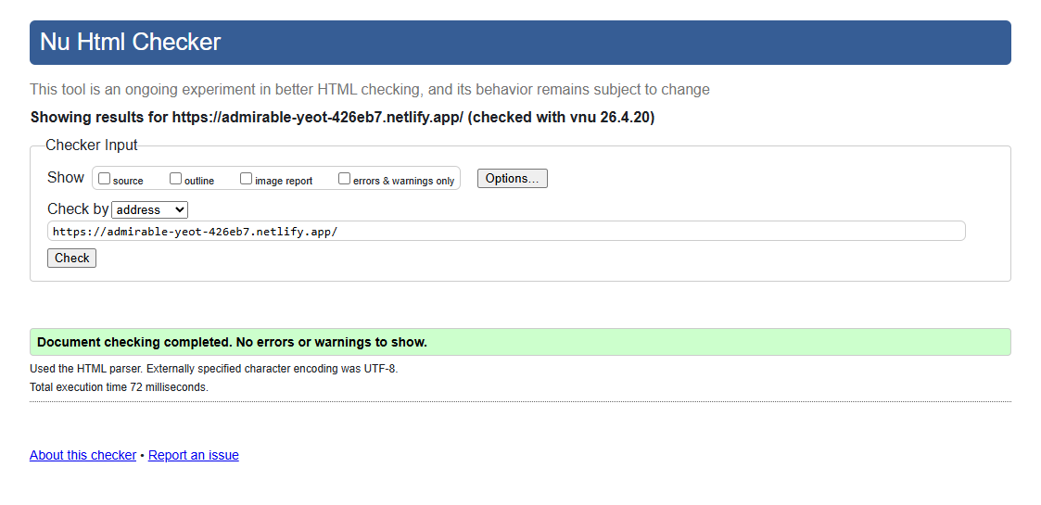
Screenshot 9. Validation and tasting evidence ‘CSS Validation Results’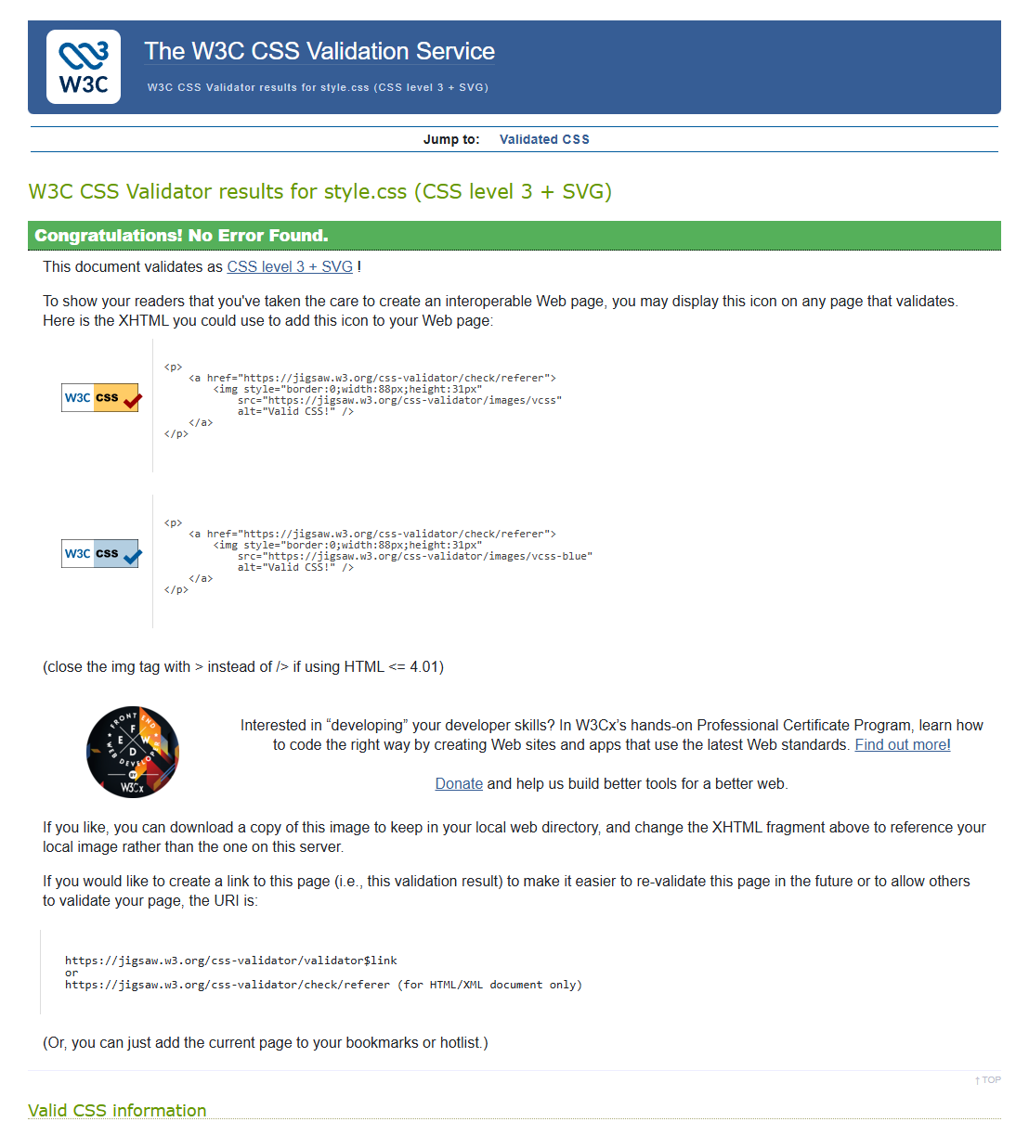
Screenshot 10. Validation and tasting evidence ‘Responsive Testing’

