Task 1: Manifesto
- Colours effect cognitive processors, manipulating human emotions.

- Drawing is more than pen to paper, drawing can be three dimensional, sculptural, written.

- Don’t rush the process, taking time to understand the process is more important.

- Social media is fake. Makers make the process look easier than it is.

- Everyone has self-doubts, positive affirmations can change a mindset.

- Always recycle materials if possible, clay should be reprocessed after failure, don’t waste it.

- People see more value in hand made art than mechanically reproduced art.

- Advertisers use colour theory in marketing to manipulate consumers decisions on a product.

- Colours effect cognitive processors, manipulating human emotions.
The research of colour and psychological functioning has been present since Goethe composed his Theory of Colours in 1840 after Sir Isaac Newton’s theory of how we perceive light. Sir Isacc Newtons’ theory stated that colour was determined by light and the colour spectrum, yet Goethe argued that it is shaped by perception as well as light and darkness (Munsell, 2013). Goethe’s colour theory states that warm colours, are linked to provoking feelings of warmth and comfort or anger and hostility depending on the hue. While the cooler side of the spectrum are related to feelings of calmness and sadness (Goethe, 1840). Therefore, the core of colour theory is understanding that the colour spectrum ranges from influencing positive moods and negative moods. Goldstein (1942) expanded on this theory proposing that specific hues (such as red, yellow ect.) elicit systematic physiological reactions that take the form of overt activity, negative arousal, and cognitive orientation. We can recognise an example of this when looking at the colour red, red is the longest wavelength of light on the spectrum (Bailey, 2019) The link between colour and psychological functioning is colour psychology, which are general associations that people have with colours and their corresponding influence on downstream affect, cognition, and behaviour. Therefore, colour theory causes an emotional response moulded by our perception yet is acknowledged globally due to the universal effects.

- People see more value in hand made art than mechanically reproduced art.

I feel empowered by hand crafted work due to the time and effort put into place to achieve the final creation. Benjamin (1969) refers to mindless reproduced art in the book ‘the work of art in the age of mechanical reproduction’, “Even the most perfect reproduction of a work of art is lacking in one element: its presence in time and space, its unique existence at the place where it happens to be”. I interpretate this quote to state that an influential element of an art piece is the time and thought required. This element could be what subconsciously makes people, like myself see more value in hand crafted products. A study by C. Fusch published by The American Marketing Association, stated that when buying something for a loved one, participants preferred handmade crafts. Many were willing to spend up to 17% more for handmade items in general. Customers favoured the idea that the makers had put thought and love into their creation making it a more valuable gift. This can link to the quote taken from the previous book mentioned as the element that mechanically reproduced craft doesn’t acquire, is the thought and care that consumers value.

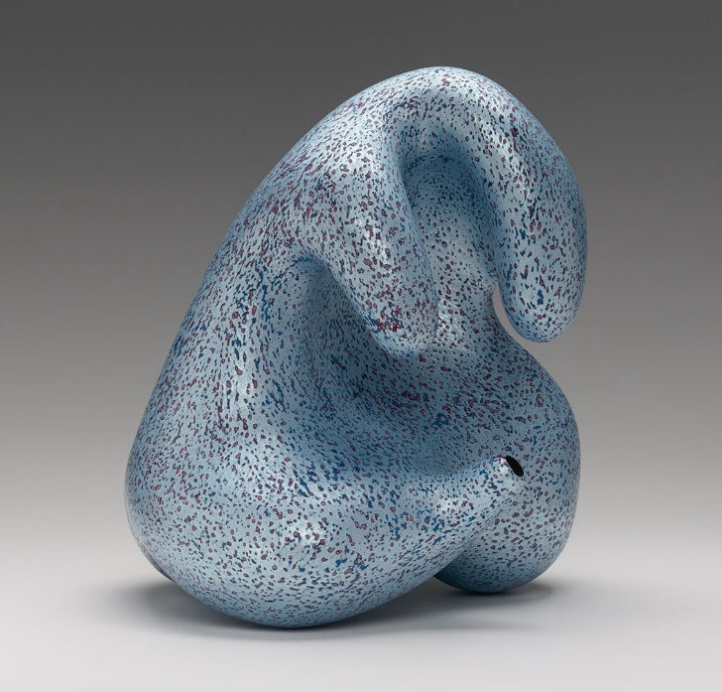
Fig. 1, Kenneth Price, Opaline, 2001.

5. Everyone has self-doubts, Self-affirmations can change a mindset.

For me, self-doubt pauses my creativity and productiveness, however I find that positive affirmations have great impact on my motivation and mindset. Affirmations are statements someone may say to themselves or another that evoke a belief, for example “I am confident”. These types of positive statements manifest themselves and trick the brain into believing them causing a change of behaviour. Furey (2014) says that no matter how successful someone is, everyone experiences uncertainty. He further states that affirmations are an art and a skill to be learned. This is because it takes a lot of courage to change the way that people think and talk to themselves. Furey explains the impact of positive self-affirmations brings peace and irradicates self-doubt which encourages motivation and increase in mood.

Bibliography

Munsell, A. (2013) Sir Isaac Newton’s Influence on the Color Wheel. Available at: https://munsell.com/color-blog/sir-isaac-newton-color-wheel/. (Accessed 20 November 2022)
Goethe, J (1840) Goethe’s theory of colours : Johann Wolfgang von Goethe. J. Murry, Oxford University.
Bailey, R (2019) Color Psychology: How Colors Affect Human Behavior. Available at: https://www.thoughtco.com/color-psychology-and-human-behavior-4151666. (Accessed 20 November 2022)
Benjamin, W (1969) (P03) The Work of Art in the Age of Mechanical Reproduction. Schocken Books, New York.
American Marketing Association (2015) Consumers value handmade products: What’s love got to do with it?
Furey, R (2014) (P.03) The Art of Affirmations, Paulist Press.
List of Figures
Figure 1 : Kenneth Price, Opaline, 2001.Exhibition | The Ceramic Presence in Modern Art: Linda Leonard Schlenger Collection and Yale University Art Gallery. Available at: https://cfileonline.org/exhibition-the-ceramic-presence-in-modern-art-the-linda-leonard-schlenger-collection-and-the-yale-contemporary-ceramic-art-cfile/. (Accessed 10 December, 2022)

Task 2: Observational Writing, Semiotics
Semiotics examine how meaning is produced and how crucially it is transmitted. Its foundations are found in academic studies of the ways in which linguistic and visual cues and images convey meaning. Ferdinand de Saussure proposed semiotics as a way of looking at the world and understanding how our environment, culture, and way of life have a significant impact on how we see and perceive the world. Our unconscious actions and ideas are more frequently represented by a series of cultural conventions and pacts and depend on our ability to translate them instantly and intuitively. (Williamson 2010)
For instance, we instinctively know how to react when we observe the various traffic signal colours. Another example would be the associate we have with the colour red and danger, from red flags, warning signs and siren lights. However, this is a sign that we acquire at a young age that has been developed by culture over a long period of time, and understanding its significance takes a combination of uninformed social knowledge. These indicators are used by businesses in their marketing to persuade customers to act in a way that benefits the business.

Fig. 1, Brad Pitt Chanel No. 5 Campaign.
Using Semiotics to analyse this advertisement, we can first refer to the significance of the celebrity and the clear colour choices. The advertisement shows Brad Pitt, a widely admired Hollywood celebrity in dull monochromatic form, placed behind a vibrant coloured bottle of Chanel No.5 perfume. Given how well-regarded Brad Pitt is, the colour scheme suggests that he is not the focal point of the picture. This denotes that the aroma is more priceless and remarkable and that it deserves to be cherished by others as highly as they do Pitt. He is also positioned behind the perfume bottle, making it quite evident that the perfume is the main attraction and Pitt is the accessory. We can also look at the pose of Brad Pitt as a sign that he is looking towards the fragrance, conveying that it has grabbed his attention, leading consumers to believe that wearing this fragrance will also grab the attention of others. The word ‘Inevitable’ placed above the bottle, paired with Pitt’s envious gaze also emphasises that the fragrance really is an irresistible scent that women should wear to attract the eyes of others. It is also important to note that Brad Pitt was the first male face of Chanel No.5. Maureen Chiquet, C.E.O. of Chanel says “No. 5 is the most iconic fragrance of our time, and Brad Pitt is the most iconic actor of our time. Women in every culture love No 5. No matter where you are, No. 5 is there.” (Collins 2012). This supports my thesis that using the sign of Brad Pitt as an accessory for the fragrance has great significance to convey a message to consumers. To conclude, there are numerous cues throughout this advertisement that subtly suggest to viewers that the fragrance is worthwhile and will benefit them.

Bibliography
Williamson, J. (2010) Decoding advertisements: Ideology and meaning in advertising. London: Marion Boyars.
Ferdinand De Saussure’s Theory Of Semiotics. [online]. Available at: <https://edubirdie.com/examples/ferdinand-de-saussures-theory-of-semiotics/> [Accessed: 30 December 2022].
Semiotic Terminology. [online] Uvm.edu. Available at: http://www.uvm.edu/~tstreete/Courses/Soc43/pages/semiotic_terminology.html [Accessed: 30 December 2022].
Collins, A.F. (2012) Photo: Brad Pitt as the first male face of Chanel no. 5, Vanity Fair. Vanity Fair. Available at: https://www.vanityfair.com/hollywood/2012/11/brad-pitt-chanel-no-5-perfume (Accessed: 4 January, 2023).

Task 3: Practise based writing
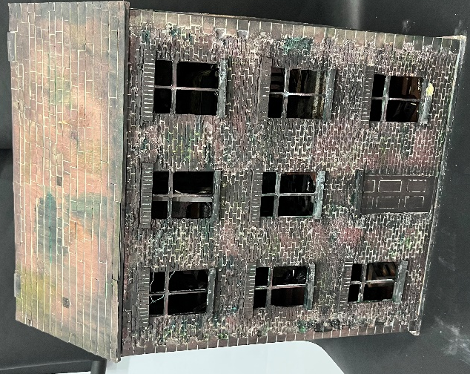
Fig 1, Abandoned house, Emily Jones 2022.

Fig. 2, inside abandoned doll house, Emily Jones 2022.
At the beginning of 2022 I created a 1.5 meter tall, abandoned house using a repurposed dolls house. The doll house I bought on Facebook market for £10, came as a pink, flat surfaced, empty wooden house. I transformed it to have a dark and gloomy brick texture on the outside using a plaster compound, tiled floors using tape, carpets made from socks, wood floors from painted foam, wall papered walls, furniture and grime to create a realistic miniature display. There are 4 bedrooms, a living room and kitchen (fig. 2). I chose the theme of abandonment for A Level and spent most of my time exploring abandoned buildings while having a strong passion to delve into miniature work. I chose the theme because although abandoned spaces to me are spooky, they also hold a thousand stories and signs of different time periods that people have been there. I wanted to capture the mystery of abandonment in an interactive piece.
I looked at three artists, John Smith, Ryan Thomas-Monohan and Julie Steel. I created three smaller pieces, one in each artist’s style before combining all techniques to make this larger scale house. Upon reflection, this research heavily influenced the amount of effort and standard of quality that I strived for in my work. This work enthuses me because of the meticulous attention to detail, time and effort spent on each room.
Exploring figure 1, to add realism to the originally flat and pink house, I bought a 1:20 scale brick stencil and mixed old plaster. It took 3 days to do each surface and sand it down. It took another day to paint and add windowsills, before adding black burn marks to insinuate a fire. To texture the roof, I cut out 1x1cm squares out of my old birthday cards and glued them individually before painting. Reflecting on this technique, I think the brick compound was the best option for getting the texture I wanted however I could have explored more options for tiling the roof. The most crucial method for expressing abandonment is to have a lot of layers of grime, dirt, and mystery.
Looking at figure 2, the kitchen. I created the floor by measuring the perimeter of the space to cut out of foam board. I painted it white using acrylic and measured 1x1cm squares to paint black, to create the old-fashioned kitchen tile pattern. However, the inability to get sharp lines on foam lead me to come up with a new idea of using black tape instead. I cut 1x1cm black squares and strategically placed them on the foam. Obviously, it looked too clean therefore I used different materials such as water colour paint, coffee grounds and tea bags to create a dirt like texture and stains to emphasis the age and wear. I used the brick stencil to create a pattern on the kitchen wall and most importantly added graffiti. I always read people's notes and graffiti on the walls of abandoned buildings, which is what I find most fascinating. In particular, graffiti with a date like "2003," because it illustrates the various eras of existence in that area.
I have pride, enthusiasm, and drive when I look at this piece months after it has been finished. I recall putting in 10 hours a day for weeks on this house and never feeling exhausted. I'm inspired by this piece's development and am occasionally reminded of my own potential by it.

