Manufacturing Systems and Simulation
ACMA 6002

Applying lean techniques
Bryony Stanfield
2008682

Contents
List of figures 3
1.0 Introduction 4
2.0 Current process wastes 5
3.0 Customer value 7
4.0 Evaluation of leaner process 9
5.0 Implementation Problems 21
6.0 Conclusion 22
7.0 Reference 23

List of figures

Equation 1 Economic order quantity – Previous process 18
Equation 2 Total annual order cost – Previous process 18
Equation 3 Economic Batch Quantity – Previous process 18
Equation 4 Total cost of Economic batch quantity – Previous process 18
Equation 5 OEE – Previous Process 19
Equation 6 Economic order quantity – New process 19
Equation 7 Total annual order cost – New process 19
Equation 8 Economic Batch Quantity – New process 20
Equation 9 Total cost of Economic batch quantity – New process 20
Equation 10 OEE – New Process 20

Image 1 Visual components factory layout 1 15
Image 2 Visual components factory layout 2 15
Image 3 Visual components factory layout 3 16
Image 4 Visual components factory layout 4 16
Image 5 Visual components factory stations 17

Introduction
In this report I am going to cover a process in a manufacturing plant and analyse it steps and make recommendations on how to improve the process to make it lean.
The process that I will be covering is UK Official so I will not be able to disclose specific details regarding the product and process, but I will however refer to the products as
- Product A and Product B
- Process A and Process B. There will also be sub sections within the process and these will be marked at Process A.1 and so on.
The Overall process is an assembly and pack production line. This is where sub-assemblies are delivered to the production building, passed through the line, assembled, packed and transported back to storage.
I aim to apply lean techniques to the process in order to minimise Non-value added tasks (NVA) and increase productivity.
By undertaking this study on the process and applying the recommendations made, I aim to generate value for the customer, this should then help us to stand out in the competitive market, making us more desirable for other potential customers.

2.0 Current process wastes

The term Lean with regards to industry processes, encompasses all aspects of the process from beginning to end. It is an ideology that aims to assess a product or process, and look at ways that it could be accomplished more effectively, more economically and ergonomically. It aims to remove procedures or items that are of little to no value to the customer (Non-Value Added) whilst also helping to improve profits and reduce losses (waste material, time or cost).

8 Types of waste

- Inventory
- Waiting
- Defects
- Overproduction
- Motion
- Transportation
- Over processing
- Non-Utilised talent

The main wastes that I will be focussing on, having overviewed the process are,
Waiting, Inventory, Motion & Transportation, Non-Utilised talent.

Problem wastes Identified
Non-Utilised talent

Personnel Limit - The HSE has become stricter in recent years when concerned with the amount of personnel confined to one building/unit when certain hazard types have been identified within production. The reason I have identified this for the process, is that we are currently running at 15 personnel for this process. It is within the HSE Limit but could be reduced to benefit the safety of others.
Number of Stations – I have identified that within the process, there are several stations that call for 1x Operator performing 1x Task, for certain complex tasks across the site this is acceptable, but for this process, there are improvements that could be made. By assigning just one task per station, this can create a build-up of lost time, in-which products continually stop-start along the line.
Inventory
The process has been working with a large quantity of WIP in the building recently. This isn’t very efficient under the lean methodology, and we do aim to work to the Just-In-Time ethic. However, due to the current impending war climate that we are facing as a country, we are working on the Just-In-Case strategy. This is to ensure that we stay ahead of the raw material shortages that are affecting the world as best we can. However, as a company we understand that we can improve and maintain efficiency by keeping material and products aligned with production schedules.

Three categories of inventory:

- Raw materials
- Work-in progress
- Finished goods

Motion
Whilst observing the process, I identified that there is a considerable amount of motion that occurs between stations and tasks. This moving around accumulates to wasted time, energy and increases the risk of damage/injury to personnel or product. This needs to be addressed.
As a result of this apparent excess movement, the process flow appears to be inefficient. This is tied into the amount of tasks per-person. Lots of little steps are unnecessary and cause the process to stall momentarily, and all of this adds up to time-lost.
The path that a product takes through the building is somewhat convoluted and could be improved. Like the amount of steps a product undertakes, the path its undergoes is also important and I have found that this could also be improved.
Transportation
Whilst analysing the production process, it became apparent that the product/materials not only undergo quite a few steps within their process, but also, they are moved between two storage areas before heading to the customer. It would be worth noting which of these stores has the largest capacity in order to address whether moving the product from one to the other is an appropriate use of time and resources.

3.0 Customer value

Motion
As I established in my initial observations of the process, the product no matter its completion percentage, undergoes a lot of movement and waiting. This movement between stations does not add value for the customer, and it also increases the risk of dropping/damaging the product due to human/machine error. From a Process Efficiency standpoint, it also means that we are losing valuable production minutes, which would reduce our hourly/daily output. By reducing motion around the shop floor we are removing NVA. My evaluation which is covered later in this document, explains my recommendations for removing unnecessary motion on the production line. In short, replacing humans with robots on certain stations should help to increases the our product output, thus increasing productivity.

Waiting
Similar to what is mentioned above, the amount of time that a product is stationary, awaiting further manipulation/construction (WIP) does not provide value to the customer. It is a waste that is caused by a production line that seemingly, cannot keep up with the rolling demand as the product passes through the process. By having products constantly moving through the process on their way to becoming completed units, we are bolstering our stock, meaning that we have more product to sell (We appreciate that certain volumes of this produced stock are pre-ordered by our larger customers, however, due to the nature of our Industry, and our possible client base, there are opportunities for other companies to purchase our held stock [JIC], or place more orders) The less time a unit is stationary (waiting) the more units can be produced (provided the product is moving constantly because production can maintain the demand) What is valuable to the customer, is having completed, high quality products delivered on time and/or ready for immediate shipping.

Inventory
Our ability to hold/store large volumes of product adds no value to the customer, provided that they have successfully received their recent orders from ourselves. However, what does add value to the customer, is our ability to produce or ship completed products to them, on demand or in a very short space of time. With regards to our inventory, this can be essential either side of the production line. We need to be able to provide emergency stock to our customers by taking from our JIC Storage of completed products, but also, we need to ensure that we have good inventory stock of the key components that go into construction/building of our product, this is our JIT inventory. We are fortunate enough to have unique buildings dedicated to the manufacture of each type of product. We only have a few variants regarding changes to the type of internals and external (visual; paint & stencils) so changes to product are done before a shift. We authorise a batch type before manufacture, and this process will carry on until we have completed our run.

Process steps
The very specific nature of our product means that the vast majority of steps in the process do indeed add value to the customer. By ensuring that our production line is safe and thorough we can ensure a quality product at the end. This also is important of the parts we source for our inventory for building the product. Years of development means that only the necessary elements are built into the product. Every step in assembly is important and value adding, apart from; Packing, Palletizing and Moving of the product. With regards to the packing and palletising, although it does not add value to the customer, it is a vital role in ensuring that the product remains safe and undamaged during its journey from end of line, through storage and onto the customer. Finally and argument could be made that stencilling and painting the product does not add value, however, it is by these markings that allows ourselves and the customer to identify what is contained within the product and colours to denote whether the product is Live or Inert.

Transportation
The transit of components or completed units does not add value for the customer, it is just a necessary procedure that can be refined, but not totally overhauled. The nature of our product means that storage and production must be undertaken in very separate areas. However, there are opportunities to reduce the amount of transit with regards to storage. This is covered in the next section of the document.

4.0 Evaluation of leaner process

Transportation
Below describes the basic flow of the production line. The items highlighted in red are the storage issues that I have identified and in green I have highlighted a possible simple change dependant on logistical plausibility. Transportation on site is a non-value adding activity to the customer, by reducing the transportation onsite allows us to spend more time on VA activities for the customer.
Current Process Flow
In from supplier> to our stores > stores > production shop.
After production
From Production Shop > Magazine > Stores > To Customer
Possible Improvement for Process Flow
In from Supplier > to our stores > stores > production shop.
After Production
From Production Shop > Magazine > To Customer.
At the moment we are able to remove the ‘stores’ from the step because we sold a great deal of different stock last year from the Magazines. The magazines are the preferred storage area for the product concerned in this document. I feel that removing this unnecessary transit is a good deployment of Lean Methodology.
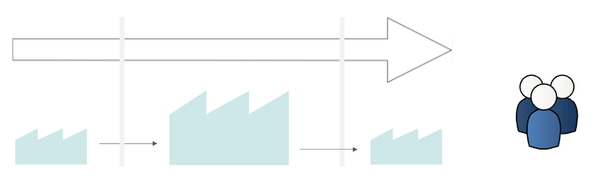
Figure 1 Process to customer flow

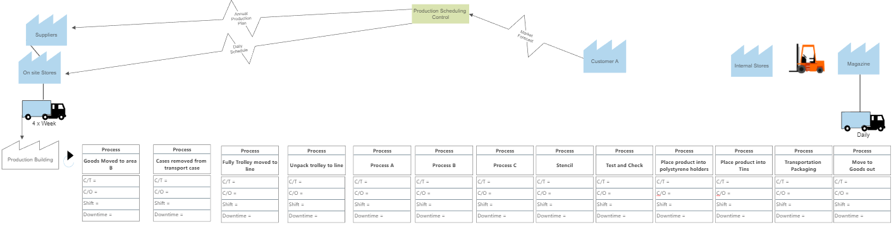
Original transportation plan
Figure 2 Original Transport plan
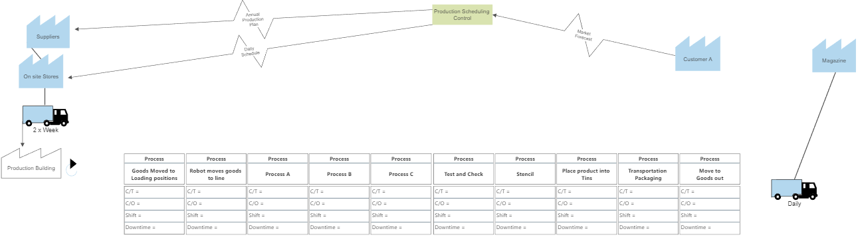
New Transportation plan

Figure 3 New transport plan

Original Process layout

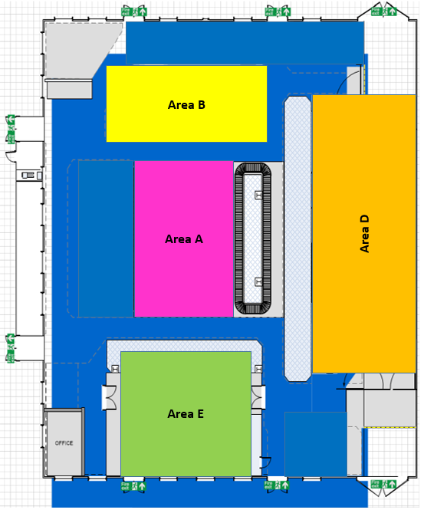
Figure 4 Original process layout

HTA - Process flow

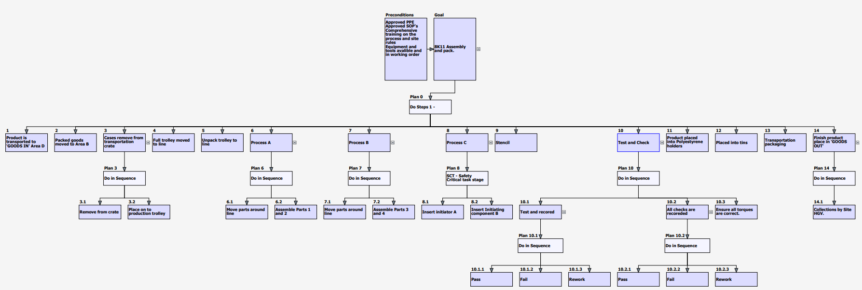
Figure 5 HTA - Process flow

Improved Process layout

Please note that all fencing in the images below represent concrete blast walls in reality.

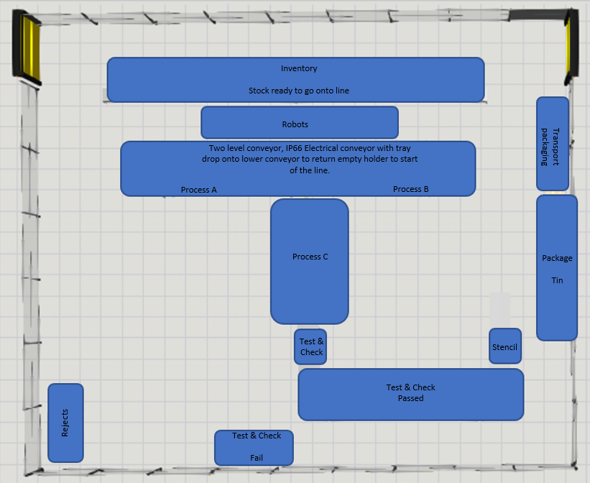

Figure 6 New process layout

HTA – Leaner Process flow
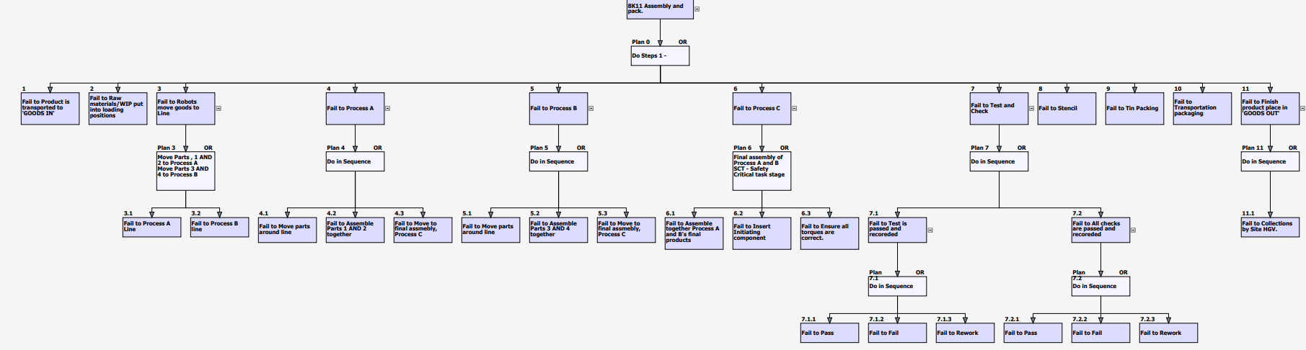Figure 7 HTA - Process flow New
Leaner Building Layout

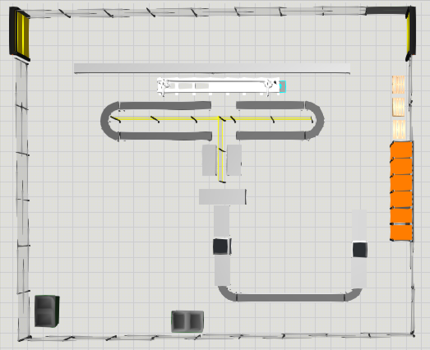
Image 1 Visual components factory layout 1
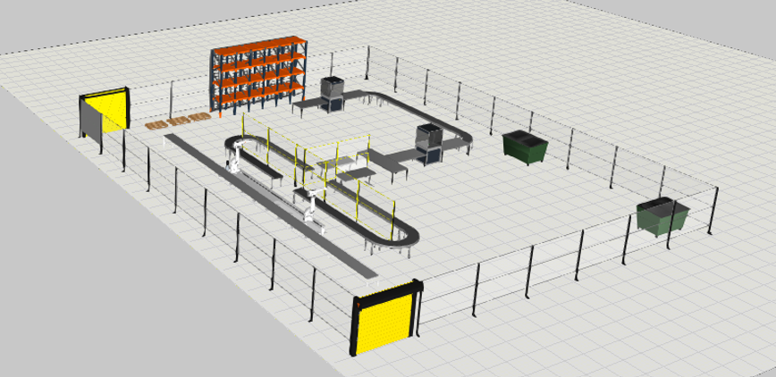
Image 2 Visual components factory layout 2
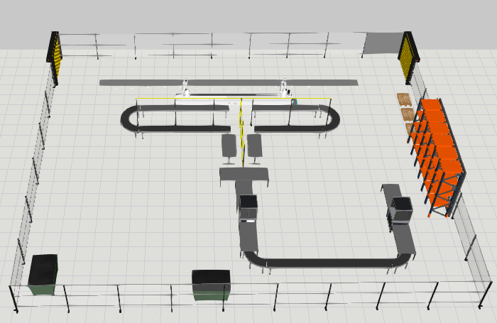
Image 3 Visual components factory layout 3
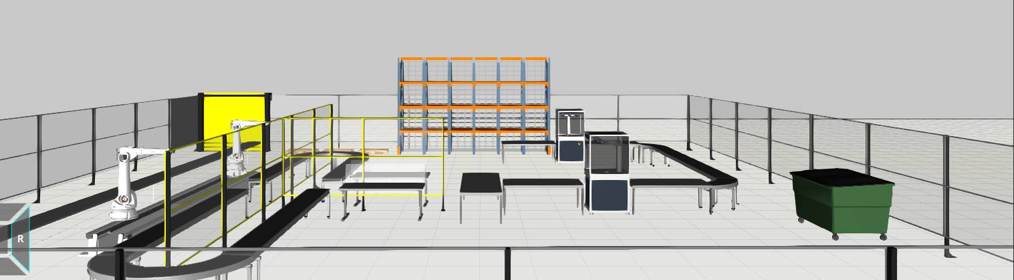
Image 4 Visual components factory layout 4

Material Handling

Powered, Roller conveyor
In order to reduce motion waste for Process A & Process B which would be caused by the operator carrying empty trays that have come round from the robots delivering the parts for the process, I have decided to introduce a waste reduction system in the form of an automatic-feeder that would allow the empty trays to drop down into a well, and go directly underneath the blast wall and reappear the other side, ready for the robot to re-fill the trays. This system is employed in most newly renovated UK Airport Security Zones. This is an effective system that not only removes the motion waste from the process, but also means that the blast wall remains continuous, thus protecting the users and maintains safety standards. The more cost-effective modification would be to make both conveyors full return loops. However, due to the importance of the blast wall being continuous throughout the process, this is why I have chosen to develop the ‘drop under and return’ tray system as it solves all issues, despite the higher implementation cost. (Please note, due to program restrictions, I was unable to illustrate the ‘drop under’ tray design into my VC Simulation images)

Robotic Handling
As mentioned earlier in the document, the HSE have certain restrictions on personnel numbers in buildings when certain hazardous materials are present. In order to make the production line more effective, I believe that investing in two ‘pick and place’ robots that would be housed at the start of the production line would achieve two things. Firstly, it would bring our personnel limit down, keeping us in-line with possible HSE alterations in the future, and secondly, each robot would provide a steady flow of components to the first two operators in the process.

Building Layout
As can be seen from my block diagram of the suggested new layout (Image 5) The process now follows a straightforward ‘J or U’ shape through the building. The new layout of the stations is made possible thanks to the new conveyor system and robotic assistance. Space not used by the build stage, is reserved for Rework & Reject units.

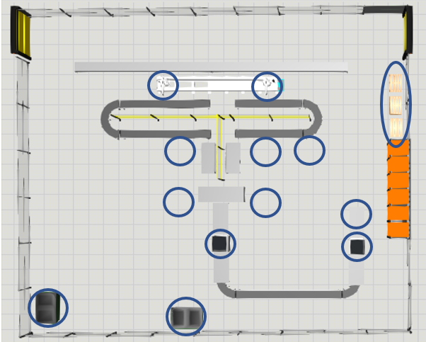
Image 5 Visual components factory stations

Inventory

As mentioned in section 3.0, for this particular product we are making very specific items, of which have been developed over many years. We only have a few variations/changes that the customer can pick from with regards to the product itself. With that being said, from an inventory point of view, it is more important for us to hold healthy stock levels than keep our storage of inventory items on a JIT basis.

Process Calculations

Economic order quantity – Previous process

EOQ | √2 x Co x D / CH
Co | 150
D | 44544
CH | 10
EOQ | √2 x 150 x 44544 / 10
= | 1,156 Units
Equation 1 Economic order quantity – Previous process
Total annual order cost – Previous process

TAC | 𝑄/2 x 𝐶_𝐻 + 𝐷/𝑄 x CO
 | 1156/2 x 10 + 44544/1156 x 150
 | 5780 + 5780
= | £11,560
Equation 2 Total annual order cost – Previous process
Economic Batch Quantity – Previous process

EBQ | √2 x Cs x D / CH(1 – d/p)
 | √2 x 150 x 44544 / 10 (1 – 232/312.5)
= | 2277.63 Units
Equation 3 Economic Batch Quantity – Previous process
Total cost of Economic batch quantity – Previous process

I Max | Q (1 - d/p) = 297.8
TC EBQ
 | (44544/1156 x 150) + 297.8/2 x 10
= | 7268.93
Equation 4 Total cost of Economic batch quantity – Previous process

OEE – Previous Process

OEE
Working time | 7.25 Hours (8 Hours total)
Breakdowns | 40 mins
Change over | 30 mins
Cycle time | 4 mins
End of the day | 232 parts
Scrap | 15
Availability | (7.25 x 60 -40 -30)/435
 | 365/435 x 100 = 84%
Performance | 232/365 x100 = 63%
Quality | 217/232 x 100 = 93%
OEE | 0.84 x 0.63 x 0.93 x 100 = 49%
Equation 5 OEE – Previous Process

Leaner process outcomes

Economic order quantity – New process

EOQ | √2 x Co x D / CH
Co | 150
D | 50000
CH | 10
EOQ | √2 x 150 x 50000 / 10
= | 1,224.74 Units
Equation 6 Economic order quantity – New process
Total annual order cost – New process

TAC | 𝑄/2 x 𝐶_𝐻 + 𝐷/𝑄 x CO
 | 1225/2 x 10 + 50000/1225 x 150
 | 6123.74 + 6123.74
 | £12,247.48
Equation 7 Total annual order cost – New process

Economic Batch Quantity – New process

EBQ | √2 x Cs x D / CH(1 – d/p)
 | √2 x 150 x 50000 / 10 (1 – 260.4/312.5)
= | 3000 Units
Equation 8 Economic Batch Quantity – New process

Total cost of Economic batch quantity – New process

I Max | Q (1 - d/p) = 204.2
TC EBQ
 | (50000/1225 x 150) + 204.2/2 x 10
 | 7143.45
Equation 9 Total cost of Economic batch quantity – New process

OEE – New Process

OEE
Working time | 7.25 Hours (8 Hours total)
Breakdowns | 15 mins
Change over | 20 mins
Cycle time | 3.25 mins
End of the day | 260 parts
Scrap | 3
Availability | (7.25 x 60 - 15 -20 )/435
 | 400/435 x 100 = 92%
Performance | 260/400 x100 = 65%
Quality | 257/260 x 100 = 98%
OEE | 0.92 x 0.65 x 0.98 x 100 = 58%
Equation 10 OEE – New Process

5.0 Implementation Problems

Cost of robots
- Expense, The cost of two ‘pick and place’ robots would be high. However, the strategic placement of these robots would pay for itself in the long-run. By making the production process that little bit faster, we are able to produce more units per day, fulfilling our orders more quickly and creating more available stock.
- It would require the People to maintain and have the knowledge regarding the Robots (PLC Engineer) There are personnel of that qualification on site, so it should be more cost effective to train them on the new equipment and have them perform routine maintenance & checks than employ someone new.
Defects not being identified at start of line
- Even though there are brief visual checks made when assembling at the first two stations, originally before the robots, there used to be checks before the components were added to the line, ‘P&P’ robots would not be able to identify these defects. This could still be done at the start of the shift, but by increasing the rate of products produced, over time we could risk small defects still slipping under the radar with the tighter time schedules created.
JIT/JIC
- We are aware that the perfect processing model works to the JIT ideology. It is something that we have been working towards and understand the financial benefits, and with fluctuating stock levels (complete units) during this current climate, we have been making our order using JIT. For certain areas of our business the JIT model is working but for some products, JIC is a necessary objective.

6.0 Conclusion

From the alterations made in section 4 it can be observed that there has been a marked improvement by making the process leaner in certain sectors. I believe that the implementation of the suggested changes in the long run could be beneficial not only to this process, but could be cascaded out to other process across the business.
The new building/station layout I feel is a step in the right direction as the original floor plan was poorly thought out and created waste that has been easily managed by this simple change. Other factors are harder to predict, and need time to prove any tangible results. Safety is our main priority, and we would not want to endanger our employees or customers due to something missed on our production line (testing should alleviate this, but problems still occur). This is why I feel that it is important that any changes that are brought in are done one at a time, with the more subtle changes coming first to assess whether production has been effected positively. As a business, we aim to adopt a leaner strategy to all of our products in order to benefit our customers and help to reinforce our position as one of the primary manufacturers in our industry.

7.0 Reference

The machine that changed the world
Womack, J., Jones, D., Roos, D. and Sammons Carpenter, D., 2022. The machine that changed the world. 1st ed. New York: Free press.

Lean thinking – Lee Mack Jones
Womack, J. and Jones, D., 2003. Lean thinking. 1st ed. New York: Free press.

The Lean Six Sigma Pocket Toolbook
George, M., Rowlands, D. and Price, M., 2005. The Lean Six Sigma Pocket Toolbook. 1st ed. London: ‎ McGraw-Hill.

Robotics: Modelling, Planning and Control
Siciliano, B., 2008. Robotics: Modelling, Planning and Control. 1st ed. London: Springer.

The 8 wastes of lean
Theleanway. 2012. The 8 wastes of lean. [ONLINE] Available at:
https://theleanway.net/The-8-Wastes-of-Lean#:~:text=The%208%20Wastes%20of%20Lean.%201%201.%20Transport.,4%204.%20Waiting.%205%205.%20Overproduction.%20More%20items. [Accessed 17 June 2022].

Fundamentals of plant layout.
txm. 2017. Fundamentals of plant layout. [ONLINE] Available at: https://txm.com/ultimate-guide-lean-plant-layout/. [Accessed 17 June 2022].

