Problem Solving and Decision Making
(BMSW4004_ION)

Student Name: Nantale Mariam
Student ID: 1905626
Assignment Title: Problem Solving and Decision Making
Lecture’s Name: Magdalena Wronska

Contents
Introduction 3
Workplace Problem 3
Scopes 4
Impacts 4
Literature Review 5
SWOT Analysis 6
PEStel analysis 6
Fishbone Analysis 8
Proposing Solution 9
PMI Chart 10
Implementing Solution 10
Communication and monitoring plan 11
Conclusion 13
References 14

Introduction
The problems are part of the life and businesses of human beings were the basic ideas tend to analyze the situations for having appropriate solutions to the problems. There are different actions, methods, and processes applicable to different sorts of problems. For example, the discriminatory behavior observed in a workplace is a major problem in the current business world due to the globalization process (MacKillop, Knight and Farris-Miles, 2011). The causes behind the problems draw upon some valid pathways to the decision making process for the solution and actions. The current report is trying to discuss the workplace harassment problems faced by me while working at my current workplace. Harassment in the workplace can be in different forms and shapes, such as physical, sexual, retaliation, online, psychological, verbal, personal, discriminatory harassment, etc. (McCarthy, 2018).
Workplace Problem
The first problem that I felt in my current workplace is the lack of experience in workplace and office policies. I have become a victim of office politics by the team leader at our team. I have joined in this job after the completion of my academic qualifications. This is my first job so I have made up my mind to give my best at my workplace. Everything was going according to my desire. But the office politics began with my success. The senior employees and management started to like my performance and instruct others to learn from me. Since I was junior to other employees, they became jealous of my success. Suddenly I feel that the team leader is extremely avoiding me and creating issues with me. It was clear after some time that he did not like me and there are some problems with him about me. Later I came to know that I have better academic qualifications than the operational manager. He felt that I would take his place if I continue my performance like this. The operational manager became violent about me. He implied more pressure on me than other employees of the team. He would not appreciate me with my work. He was very factitious about my work. He complains to the higher management about me even if I have no-fault. At the time of team meeting, he would shout at me any time, pick up quarrels, and call my name, bully me and insult me in front of other employees. Now the situation for me came like this if I have another opportunity to join a company I would leave this job.

Scopes
The workplace harassment is considered to be the violation of different legislative establishments, including the Civil Rights Act of 1964 and Employment Act of 1967 (Michailidis and Banks, 2016). Harassment in the workplace is the workplace hazards in some verbal, psychological, or physical form of behaviors that are offensive to the employees. The verbal forms of harassment are offensive jokes, name-calling, insults, slurs, etc. Physical harassment includes threats and intimidation etc (Morrison, 2017). Because of workplace harassment, the intimidating workplace environment is being observed which is hostile for increasing or maintaining productivity. There are various forms of harassment based on different factors, such as race, gender, religion, power, cultural background, disability, age, etc (Okubote, 2013). These behaviors are not being welcomed by many companies. However, they are still present. One of the main causes behind them can be the superiority complex of the employees working at the upper positions of the organization, as the management.
Impacts
Workplace harassment has some serious impacts on organizational productivity and employee safety or safeguarding. Harassment like discrimination, personal harassment, etc. often causes emotional distress in the minds of the harassed workers (Pluta, 2015). They feel uncomfortable and insecure in working which might degrade their productivity and performance. The harassment can also reduce the confidence within the bullied by which they might not be able to interact with other people in the workplace effectively as they can feel nervous around people (Taatgen, 2011). Thus the person who is being harassed might also feel socially isolated. The different types of harassment are also aligned with psychological stress which in turn decreases the health conditions of workers as well. Harassing the employees is very negatively impactful as the workforce would have lesser job satisfaction and by which higher employee turnover is observed, reducing the organizational performance and profit generation process (Wyse, 2010). The unlawful kinds of workplace harassment can also bring some major legal challenges for organizations.

Literature Review
According to R and B, (2020), workplace harassment consists of many grey areas which might confuse some workers before reporting. However, it is a necessary obligation of the employees to report the harassment to the authority as the laws work to protect their rights. As per Russo and Duci (2016), verbal harassment is the most common form of harassment in the workplace where various offensive or demeaning remarks are being made as well as gestures that are unwelcomed and unreasonable. The verbal harassment might be difficult to identify as this is the violence that is not physical and can be in the form of jokes or comments (Morrison, 2017). But the insults or slurs, curses, non-required yelling, and hurtful jokes are some types that workers should refrain themselves from. By Scott (2008), another confusing kind of workplace harassment is psychological harassment in which victims are being mentally broke by the harasser by pulling off different techniques and behaviors such as having unreasonable demands. These types of harassment surely affect employee self-esteem and psychology which might cause depression, lower performance, decreased job satisfaction, etc. Physical harassment is another kind of harassment, as described by Sousa, Martins, and Sousa (2019), where employees can be harassed by having unwanted physical gestures like touching, assaults, threats, etc. Harassments like sexual, racial, etc. are considered to be discriminatory where because of the person’s background, they are being abused. As shown by Cole and Hollier (2007), this kind of harassment is also highly common in the workplaces where false accusations, unlawful favor requirements, offensiveness towards the cultural background are observed. As mentioned by Ezorsky and Nickel (2003), reporting of the harassment should not be exclusive and workers must have the right to complain if they feel uncomfortable or threatened because of someone in the workplace even if there is not enough physical evidence for reporting. If enough reports are found against a specific person, similar offenses might work as the pieces of evidence against the individual which would help take necessary action (Michailidis and Banks, 2016).

SWOT Analysis
SWOT analysis is a analyzing tool for understanding internal strengths and weaknesses along with the opportunities and threats.
Strengths  - Strong organizational approach towards reducing workplace harassment  - Equal, diverse and inclusive working environment | Weaknesses  - Confusion with policies and company position regarding serious matters like politics  - Enforcing the workplace policies might not be efficient
Opportunities  - Higher productivity and profitability  - Employees are satisfied as their needs are maintained | Threats  - The process might later be unreliable with complex nature of business  - Less effective monitoring and evaluation protocol

PEStel analysis
Political  - Harassment within workplace along with workplace politics is handled by the establishment of proper laws, regulations and policies.  - New and proposed legilslative structure which can be implemented later (Bloom and Snow, 2009). | Economical  - The increase of employee turnover, increasing company’s cost margin.  - The violation of laws and regulations can be fatal with issues like penalty.
Social  - The inequality within orgnaization and lack of respect to diverse workforce might caused by social inequality (Loveday, Wiggins and Searle, 2013).  - The communication and interaction barriers in society. | Environmental  - Unhealthy organizational environment as for politics.  - Lack of quality service delivery.
Technological  - Better surveillence cameras in the organization.  - Personal data protection services as pe Data Protection Act (Flanagan, 2013). | Legal  - The various laws regarding equality and diversity.  - Employee rights, employee safeguarding rights, and personal data protection rights.

Fishbone Analysis

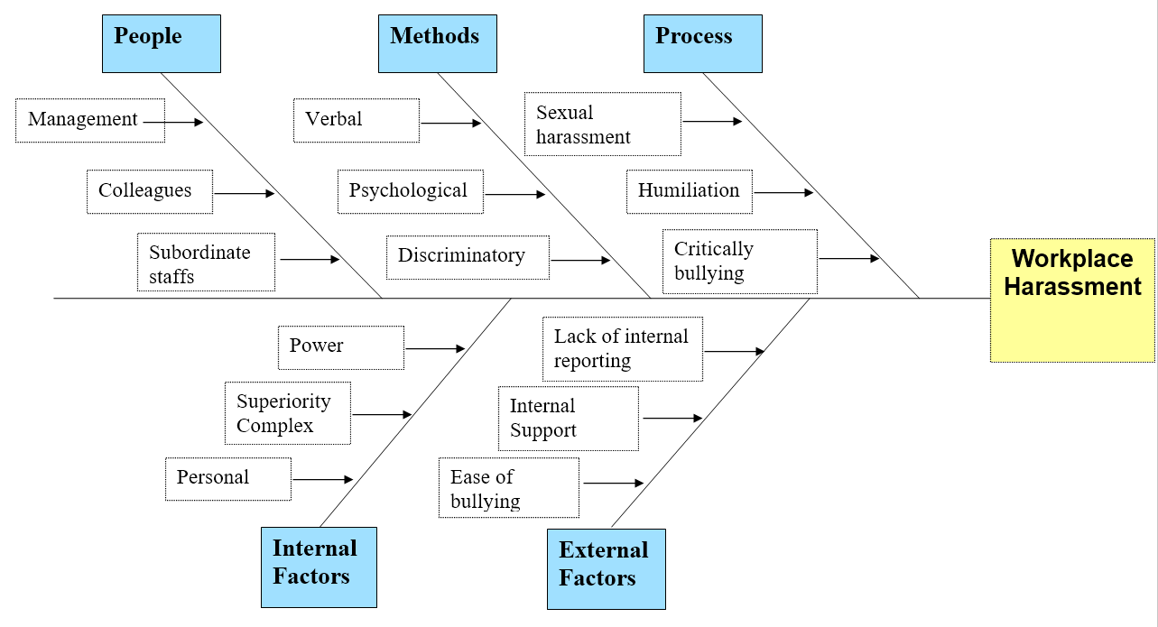

Fishbone analysis of the presented problem
The root cause of the problems is found through fishbone analysis which works through the structured analysis of the problem and its impacts and causes by which solutions to the problem can be found (George, 2019). The analysis includes both internal and external causes of the problem. Other than that, the involved people, process, method, and place of the problem are also being identified to evaluate solutions. Here the fishbone analysis is given for the problem:

Proposing Solution
With the understanding and conduction of the fishbone analysis, some potential solutions to the problem can be indicated (Ghumman, Ryan, and Park, 2015). From these solutions, appropriate measures will be taken for immediate action. The solutions are:
- Personal confrontation with the manager and let him understand the problem being created by him and its psychological impacts on me.
- Going to the nearby law enforcement authority and reporting about the incidents where the manager conducts power and personal harassment on me.
- Reporting to the organizational authorities, such as the top management and leaders about the manager and the ways he treats me and other colleagues.

PMI Chart
Adair (2013) has shown that the PMI chart considers all available viewpoints, including the positive, negative, and neutral points of the taken idea (Herring, 2005).
Plus | Minus | Interesting
- Workplace harassment will decrease. +10  - More employee satisfaction, less turnover. +6 | - Bullied persons can be exposed to controversy. -5  - Power harassment might still be present. -6 | - The harasser will have the chance to be more inclusive, respectful, and empathetic. +7
+ 16 | -11 | +7

Here the plus points are higher than the minus points. Thus proper implementation of the appropriate solution is required.
Implementing Solution
The proper solution to the problem being presented is by involving the upper management of the company and letting them know about every detail of the problem and its impacts upon me, my workflow, and the performance in the organization. I would also include the timeline of the harassment. Based on this reporting, the HR team will investigate and gather the necessary evidence against the manager. The organizational policy and legal structure on workplace harassment will be utilized in the process. Upon identifying the unlawful actions of the harasser, he will be warned. Further employee training and development can be suggested.
Communication and monitoring plan
The current report will be indicative of the monitoring plan of the implementation. In this case, the organizational hierarchy can be followed in the communicating and monitoring plan where the different team leaders will be involved in maintaining the workplace harassment under control (Loveday, Wiggins and Searle, 2013). They will also gather the complaints or reports against any harassment in place. The trainers will have the authority to let workers and middle management know about the seriousness of workplace harassment. In the case of complex issues to implement solutions, upper management can be involved.
Stakeholder Communication Plan
Stakeholder | Power/Interest | Key interest and issues | Communication vehicle | Frequency
Board of Management | Trustees | 8 | Email | Monthly assessment of Workplace harassment
Colleagues | Current Employees | 4 | Verbal Communication | Daily conversation for awareness.
Head of departments | Supervising | 7 | Email | Weekly assessment of workplace harassment
Financiers | Funding | 8 | Email | Yearly review of the harassment cases.

Monitoring Plan
Indicator | Data source | Timing
Verbal Abuse | Employees Complaints | Every month
Some racist incidents among the employees. | Abuses made by colleagues/boss/supervisors etc. | Every week
Physical abuse and sexual harassment among employees. | The employees from diverse cultures complained about the problem. | Every month

Conclusion
It is necessary to know and inform about the problems of workplace harassment and their impact sectors. Proper decisions need to be taken regarding the specific harassment issue and the organizational policies with the legislative structure assist in the process. Discriminatory harassment can also be of different kinds, like racial harassment, gender harassment, religious harassment, etc. It is necessary to identify what kind of harassment is being faced by me to solve the problem through decision making. My personal experience with the workplace manager stated in the following is a very clear indication of both personal harassment and power harassment. The power harassment is mainly referred to as showing the power disparity because of the workplace hierarchy or positions. In the given case scenario the manager plays the part of a bully and I am the victim of bullying where power harassment such as verbal intimidation, high demands that are below my caliber, intrusion to my personal life, etc. Also, personal harassment is being faced by me and this is different than other harassment done towards specific classes like gender and race, etc. in discriminatory harassment. The personal harassments being directed to me are inappropriate comments, offensive jokes, personal humiliations, critical remarks, and unnecessary intimidation. In the report, the presented problem with its scopes and impacts are discussed. The information related to the problem is also being analyzed to come up with alternate solutions. The evaluation plan works in the decision making process by which the appropriate solution will be implemented.

References
1. Adair, J. (2013) Decision making and problem solving strategies. 2nd edn. London: Kogan Page.
2. Cole, P. and Hollier, L., 2007. Decision-Making Process. Journal of Craniofacial Surgery, 18(4), pp.989-990.
3. Ezorsky, G. and Nickel, J., 2003. Moral Rights In The Workplace. Albany: State University of New York Press.
4. George, B., 2019. Legal Aspects of Ethical Decision-Making in the Event of Sexual Harassment and Discrimination in the Workplace. Business Ethics and Leadership, 3(4), pp.34-42.
5. Ghumman, S., Ryan, A. and Park, J., 2015. Religious harassment in the workplace: An examination of observer intervention. Journal of Organizational Behavior, 37(2), pp.279-306.
6. Herring, K., 2005. Toxic Attention: Workplace Sexual HarassmentToxic Attention: Workplace Sexual Harassment. PsycCRITIQUES, 5050(1515), pp. 97-125.
7. Loveday, T., Wiggins, M. and Searle, B., 2013. Cue Utilization and Broad Indicators of Workplace Expertise. Journal of Cognitive Engineering and Decision Making, 8(1), pp.98-113.
8. MacKillop, M., Knight, J. and Farris-Miles, M., 2011. Investigating Harassment In The Workplace. Toronto: Carswell.
9. McCarthy, C., 2018. Take steps to prevent, address sexual harassment in the workplace. Campus Legal Advisor, 18(8), pp.1-5.
10. Michailidis, E. and Banks, A., 2016. The relationship between burnout and risk-taking in workplace decision-making and decision-making style. Work & Stress, 30(3), pp.278-292.
11. Morrison, B., 2017. Immunity in Community: Clergy Experience of Bystander Decision Making in Clergy Workplace Harassment. Practical Theology, 10(4), pp.367-382.
12. Okubote, A., 2013. Bullying and Harassment in the Workplace An International Perspective. SSRN Electronic Journal., 2(5), PP. 40-49.
13. Pluta, J., 2015. Harassment in the Workplace. Laboratory Medicine, 32(2), pp.67-72.
14. R, P. and B, D., 2020. PUBLIC OPINION ON EFFECT OF HARASSMENT IN WORKPLACE. International Journal of Psychosocial Rehabilitation, 24(04), pp.2856-2861.
15. Russo, D. and Duci, S., 2016. Supporting Decision Making and Requirements Evaluation with Knowledge Search and Problem Solving. Procedia CIRP, 39, pp.132-137.
16. Scott, J., 2008. Visual representations in problem solving and decision-making. International Journal of Management and Decision Making, 9(3), p.266.
17. Sousa, M., Martins, J. and Sousa, M., 2019. Decision-Making Processes for Effective Problem Solving to Potentiate Organisations Sustainability. European Journal of Workplace Innovation, 5(1), PP. 93-135.
18. Taatgen, N., 2011. The Minimal Control Principle Predicts Strategy Shifts in the Abstract Decision Making Task. The Journal of Problem Solving, 3(2), pp. 87-110.
19. Wyse, L., 2010. Company Manners. New York: Crown Trade Paperbacks.

