

MASTER OF BUSINESS ADMINISTRATION

FINANCIAL MANAGEMENT

LCMB7002

ASSESSMENT COMPONENT: FINANCIAL PERFORMANCE AND MANAGEMENT

EVALUATING FINANCIAL PERFORMANCE, LIQUIDITY STRATEGY, AND CAPITAL INVESTMENT DECISIONS: A CFO ANALYSIS OF VOLKSWAGEN AG

Lecturer name: Md. Kalam,
Dr Shengfeng Mei

Student name: Arpit Khatra

Student ID: 2526504

Word count: 5,037

Submission date:
Table of Contents
1. Introduction 4
2. Financial Health Check 4
2.1 Overview of Financial Performance (5 years) 4
2.2 Ratio Analysis 5
2.3 Trend Analysis 6
2.4 Key Financial Issues Identified 7
3. Working Capital Management Analysis 7
3.1 Cash Operating Cycle 7
3.2 Liquidity Position Evaluation 8
3.3 Improvement Strategies 9
3.4 Financing Options 9
4. Strategic Financial Restructuring Plan 10
4.1 Need for Restructuring 10
4.2 Recommended Strategies 11
4.3 Impact Analysis 11
4.4 Global & Ethical Considerations 12
5. Investment Appraisal & Capital Budgeting 13
5.1 Evaluation Techniques 13
5.2 Analysis of Projects A, B, C 13
5.3 Recommendation of Best Project 14
5.4 Capital Rationing (Max £100m) 15
5.5 Non-Financial Considerations 15
6. Conclusion 16
References 17
Appendices 21
Appendix 1: Income Statement 21
Appendix 2: Balance Sheet 23
Appendix 3: Cashflow Statement 25
Appendix 4: Ratio Analysis 27
Appendix 5: Investment Appraisal 30

1. Introduction
Volkswagen AG is a top large-scale automotive producer in the world, a company working within several brands and markets, but gradually moving towards the production of electric vehicles (EVs). The auto industry across the globe is facing a structural revolution due to environmental policies, technological shock, and evolving consumerism. The direction of electrification that Volkswagen took as a strategy indicates the pressure imposed on the company by the authorities and the need to remain competitive in the EV market. The financial results of the company in the past few years give us a key understanding of the level at which the company is coping with this transition. This report will review the financial performance of Volkswagen within a period of five years, review its working capital efficiency, come up with strategic restructuring initiatives, and critically examine and analyse the investment decisions using capital budgeting techniques. The analysis is based on a Chief Financial Officer (CFO) level, which includes financial sustainability, the value of shareholders, and competitiveness in the long run.

2. Financial Health Check

2.1 Overview of Financial Performance (5 years)
The financial performance of Volkswagen in the period between 2021 and 2025 demonstrates the period of transition due to its transition to electric mobility [Refer to Appendix 1]. In 2021, the revenue was €250,200 million (Annual Report, 2025). In 2024, it was 324,656 million, which slightly decreased by 2025. This signifies that it has been stabilised in light of the increasing competition in the EV market. This trend indicates that the initial growth has become sluggish with the increase of marketing forces (Babu, 2025). Although there was growth in revenue, the profitability declined considerably. The net income is expected to grow slightly during the first years but sharply decrease by 2025, whereas the operating income is likely to decrease too. The cause of this divergence is an increase in the cost pressures and decreased operational efficiency.
Electrification, which is associated with high capital expenditure and strategic repositioning has led to low earnings (Zhou, 2025). There has been a steady increase in the production costs in terms of the input prices, supply chain interference and massive investment in the EV technologies. The production of EVs is costly on an initial basis, especially regarding battery development and infrastructure (Özdemir and BR-AP393 LCMB7002, 2025). There was a significant increase in total assets, which represents long-term investing, but the decreasing profitability implies low asset efficiency. This is a common occurrence in companies that are in the process of green industrial change (Storm and Schroder, 2025). The sustainability policies of the EU have also increased the pace of the transition of Volkswagen, which has influenced its financial direction (Hojzakaova, 2025).

2.2 Ratio Analysis
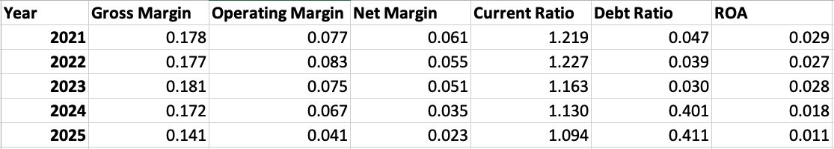
Table 1: Ratio Analysis
(Source: Refer to Excel)
The ratio analysis gives a critical evaluation of the financial performance of Volkswagen, which demonstrates that the company has fallen behind in terms of profitability, liquidity, and efficiency over the five-year span. The profitability ratios indicate that there is a steady decreasing trend, which shows that its earning capacity has reduced. The gross profit margin showed a positive change of 17.79% in 2021 and 18.07% in 2023, then sharply decreased to 14.09% in 2025 due to the increased cost of production and decreasing power prices [Refer to Appendix 4]. There was also a substantial decline in the operating margin from 7.72% to 4.11%, which shows that operating costs are rising and the company is losing control of its processes through cost control. The net profit margin decreased compared to 2021 (6.15) to 2.27 in 2025, which shows an immense drop in the overall profitability. This indicates increased expenses and costs, increased interest rates, and greater investment in EV technologies. As El Gibran and Nainggolan (2025) detailed, higher expenditure in research and development in the EV market makes short-term profitability low because businesses are focused on innovating in the long run. In the same way, it is analysed that decreased profitability is linked with sustainability investment and evolving cost structures [Refer to Appendix 3].
The liquidity ratios show a decrease in the financial position. Current ratio decreased to 1.09 as compared to 1.22, and this indicates that its capacity to cover the short-term liability was reduced. This is even though the downward trend is still above the minimum threshold, and this is a pointer to mounting pressure on working capital management. Babu (25) observes that a fall in liquidity is usually an indicator of inefficiency in the management of receivables, inventory and payables. The leverage ratios indicate that the financial risk is on the increase as the debt ratio rose to 41.07, which is a heavy dependence on debt financing. According to Glova and Panko (2025), over debt is detrimental to financial stability. There was also a decrease in efficiency whereby the ROA dropped by 1.14 to 2.91% and reflected lower efficiency in the determination of asset utilisation throughout technological transition.

2.3 Trend Analysis
The patterns in the financial performance of Volkswagen show that it has several notable trends triggered by the indigenous restructuring of the company and external industry forces. To start with, it means the increase in revenue has reached a steady point due to a growth phase. Revenue grew in 2021 to €250,200 million and in 2023 to €322,284 million (Annual Report, 2025). However, thereafter the growth slowed, which points to the growing competition and saturation of the market. According to Rezaei (2025), the European EV market is now associated with a great level of competition, with new manufacturers undermining leading manufacturers. Second, the profitability has gone down drastically over time. The highest operating income was in 2023 when the figure was at €24,099 million, which however dropped to €13,234 million in 2025, showcasing a reduction of about 45%. On the same note, net income decreased between 2023 (€16,533 million) and 2025 (€7,323 million), which shows the influence of increasing costs and strategic investments [Refer to Appendix 2]. According to Katterbauer et al. (2025), this type of compression of the margin tends to happen in the initial years of EV transition because of the high production and development expenses.
In addition, there is a significant increase in leverage. The total debt increased exponentially in 2021 from €24,640 million to €264,703 million in 2025, indicating the transition to expansion through debt-based means (Annual Report, 2025). Such growth means that Volkswagen is depending on outside sources to fund its dramatic change. Weis (2026) remarks how the shift toward electromobility in Germany has been defined by the emerging greater investments in the industry through corporate and institutional sources, which have resulted in higher levels of debt. The increasing attention to sustainability and ESG efforts is also another major trend. VW has invested more in green technologies, and it has affected the cost structure as well as financial results. Although ESG strategies are relevant in long-term value creation, they are mostly associated with financial trade-offs in the short term because of the enormous costs of initial investment (Shen, 2025).

2.4 Key Financial Issues Identified
The analysis indicates that there are critical financial issues that have impacted the performance of Volkswagen. The most notable problem is a decrease in profitability, which is manifested in the decrease in the operating margin (7.72 to 4.11) and net margin (6.15 to 2.27). Such a fall reveals that increasing production expenses and EV investments are having a serious toll on profits. A steep rise in financial leverage is another major issue of concern. Total debt rose to a higher level of over tenfold, with the developing figures going up to €264,703 million in 2025, as compared to €24,640 million in 2021 (Annual Report, 2025). Such an increased debt raises the financial risk and interest payments, which may impact the credit rating and the financial leverage of the company. The liquidity pressure can also be observed as the current ratio decreased to 1.09, which means that the company has less financial strength in the short term. This implies the inability to manage the working capital effectively, especially in an unstable economic environment. Moreover, the reduction in asset efficiency is also observed in the fall of ROA from 2.91 to 1.14%, meaning that Volkswagen is not earning enough out of its growing asset base [Refer to Appendix 3]. This creates doubts with regard to the efficiency of the investment strategy.
These economic problems are also subject to the overall industry trends. Automobile companies are changing because of regulatory pressures and sustainability needs, which are compelling them to change at an accelerated rate. Hojzaka (2025) points out the effect of the EU environment policies on the financial restructuring, and Cintra et al. (2025) accentuate the significance of the sustainable battery policies in enhancing the long-term performance. The organisational factors are also not negligible because the reluctance to change may impede effective transformation. Moreover, the effective EV transition also involves huge financial and structural readjustments (Esteves, 2025).

3. Working Capital Management Analysis

3.1 Cash Operating Cycle
Cash operating cycle is an indication of the efficiency of working capital supplier of Volkswagen, and the trends are evident that reflect a lack of it by 2021-25. The inventory had gone up to €56,042 million as compared to the previous period of €40,362 million, which means the turnover is slower and the holding cost is also higher. The number of accounts receivable increased to €38,255 million from €30,786 million, indicating longer collections days and poorer cash flows. There was also an increase in accounts payable of massive amounts of money, as the accounts payable rose to €30,490m instead of being at €20,977m due to increased reliance on supplier credit. Yet, this increase is too small to tune up increasing inventory and receivables. As a result, cash outflows are surpassing cash inflows resulting in a lengthening cash conversion cycle. This inefficiency decreases liquidity and in turn, overreliance on external financing, especially in a capital-intensive sector.

3.2 Liquidity Position Evaluation
The liquidity position of Volkswagen is poor over the period of five years, as indicated by both the balance sheet and cash flow. The short-run tools show that current assets increased between 2021 and 2025, as current assets amounted to a higher level of €247.865 million, instead of 200.347 million in the same period. However, the increase in current liabilities was higher between the periods of €164,393 million and €226,525 million, making the current ratio go down to 1.09. This ratio indicates that the company has reduced its capacity to settle short-term due dates despite having a bigger figure of over 1, suggesting a decrease in the capacity of Volkswagen. The fact that there is a narrowed gap between current assets and liabilities signifies the growing pressure on the handling of the working capital. Worse still, operating cash flow is on a downward spiral.
The decline of cash flows attributed to operations was substantial since it was €38,633 million in 2021 and €15,009 million in 2025, which is more than 60% lower. This deterioration brings to the fore decreased internal cash generation, which is important in the provision of finance for day-to-day operations and investment. The decrease in operating cash flow can be explained by the cost hikes, the expansion of working capital and relatively expensive investments in EV manufacturing. The reduced cash flows mean that Volkswagen will not be able to fund its activities internally but rather as a source of external funding will be needed. Fardous (2025) indicates that negative cash flows in operating activities give an indication of inefficiencies in working capital management, as well as operating efficiency. Altogether, the liquidity position of Volkswagen suggests that the company is under increasing financial stress with the decrease in cash flow and the increasing number of liabilities, as well as a threat to its short-term financial health.

3.3 Improvement Strategies
In order to overcome the inefficiencies in the working capital, Volkswagen needs to adopt specific measures aimed at paying attention to inventory, receivables, and payables management. Optimisation of inventory is a concern because surplus inventory is a major expenditure of capital. The adoption of modern demand forecasting models and online supply chain models can increase the turnover of inventories and lower the holding costs (Keith, 2023). It is especially crucial in the EV market, whose demand trends are only developing. Stricter policies on credit control and incentives for early payments should be used, and they enhance receivables management. To boost cash inflows and other liquidity, it is possible to reduce the average period of collections. Furthermore, the embodiment of the digital payment system can simplify the ability to manage its receivables and minimise delays.
Another area of concern is supplier management. VW will be able to bargain long-term with suppliers to enhance cash flow without escalating the level of debt. This should, however, be offset by ensuring good relations with the suppliers to prevent some hitches in the supply chain. Digitalisation is important in enhancing efficiency in working capital. A combination of real-time analytics and supply chain automation may improve decision-making and decrease operational inefficiencies. Stawiarska (2025) states that supply chain management innovation can greatly enhance the financial performance, minimising on-time wastage and resource underutilisation.

3.4 Financing Options
A mix of both short-term and long-term financing can be used by Volkswagen to cover its working capital needs. Among the alternatives of short-term finance, trade credit, bank overdrafts, and short-term loans, which offer a flexible method of running daily operations. Nevertheless, overdependence on the use of short-term finance will heighten the liquidity risk and financial instability. The topics of long-term financing are corporate bonds, equity issuance, and green financing instruments. The world of green bonds has gained more significance in the automotive world, attracting funding for greener projects and EV creation. Cui and Chen (2025) emphasised that green bonds not only provide corporations a boost in efforts of environmental activities, but they also contribute to the improvement of the corporate image and draw investors who base their selections on the ESG principles. A balanced financing strategy is a solution to ensure financial stability. Volkswagen must also seek to optimise the combination of the internal cash flows and the external cash, with less dependence on debts, but with adequate liquidity to conduct its business and investments. This balance is most efficiently obtained through proper financial planning and risk management, especially in a fast-changing, capital-intensive industry.

4. Strategic Financial Restructuring Plan

4.1 Need for Restructuring
The recent financial performance of Volkswagen shows that there are serious requirements for strategic financial reorganisation. It has been showing a decreasing profitability in the form of decreasing net income of the company, which is now down to €7,323 million as compared to €7,634 million in 2023, and a declining operating margin of the company that is currently at 4.11% as compared to 7.72% [Refer to Appendix 4]. Meanwhile, the total debt has risen considerably, reaching the level of €264,703 million, which suggests an increasing dependence on outside financing. These tendencies show that financial pressure and efficiency in operations are growing and need to be corrected within the near future. This restructuring need is facilitated by shifting to manufacturing of EVs. The production of EVs requires a high level of capital investment in battery technology, digital infrastructure, and research and development. These investments have greatly raised the operating expenses and led to low short-term profitability. According to Zhou (2025), the challenges Volkswagen faces in terms of financial risks are closely connected to the capital intensity of the electrification strategy.
Besides financial pressures, there is also the organisational factor that requires restructuring. Organisational inertia and reluctance to change may rise as an obstacle to the implementation of the new technologies and business models. Meloni (2025) added that more developed automotive companies tend to have internal obstacles in switching to disruptive innovation like EVs. This restricts the effectiveness of strategic initiatives and also slows down performance. Moreover, restructuring is heightened due to additional forces on the outside which include regulatory pressures and competition forces. Carbon emission policies and sustainability by the European Union demand a major change in the production processes, as well as product offerings. As further pointed out by Černá (2026), environmental regulations have become a major force behind financial restructuring in the automotive industry. This combination is the key to the long-term sustainability and competitiveness of Volkswagen, which requires restructuring.

4.2 Recommended Strategies
In order to overcome these obstacles, the company Volkswagen needs to pursue a holistic process of restructuring based on cost optimisation, financial restructuring, and strategic alliances. The sale of non-core assets is one of the approaches. Volkswagen has a huge number of brands and business units, some of which are not part of the long-term EV strategy. Liquidity can be created in the sale of under-performing or non-strategic assets that can create more complicated operations and thereby enhance concentration in the main areas of activity. Another aspect of restructuring that is important is strategic partnerships. Cooperation with technology companies and battery companies will help in cutting down the research and development expenses and also speeding up the innovation process. Partnerships in the EV industry are a necessity due to the low cost of battery production and technological development. According to Rezaei (2025), cooperation helps companies to share risks and economies of scale, consequently raising competitiveness.
Equity financing and green bonds should also be suggested to restructure the finances. Green bonds offer long-lasting financing of ecologically viable projects, which correlates with changing the Volkswagen business to electric mobility. Cui and Chen (2025) emphasise that green bonds have gained more significance in the auto industry with the provision of financial and reputational advantages. The use of equity financing may help minimise the use of debt, enhance the capital structure and financial stability of the company. Moreover, they should apply the cost reduction strategies throughout the operations. The cost of operations can be minimised by streamlining production processes, enhancing the efficiency of the supply chain, and adopting digital technologies. It has been added by Stawiarska (2025) that innovation in the supply chain is important in improving financial performance and operational efficiency.

4.3 Impact Analysis
It is believed that the suggested restructuring plans will bring dramatic positive effects to the financial performance and strategic position of Volkswagen. The equity financing and selling of assets can be used to reduce the level of debt, decrease the interest payments, and enhance financial stability. This will improve the credit profile of the company and minimise the financial risk. From the perspectives of Zhou (2025), profitability can grow through cost optimisation and digitalisation, which leads to improved operational efficiency. Examples include the reduction of the cost of production and enhancing efficiency in the supply chain, which have been significantly reduced in recent years and used to maintain the operational margins. The increase in efficiency will lead to the cash flow as well, which means that the dependence on external funding will be diminished.
Strategic partnerships are able to boost the innovativeness capacity and to hasten the processes of producing new technologies. This will help Volkswagen to compete better in the EV market, where one of the success factors is technological development. Teamwork can also lead to decreased cost of research and development, which increases the financial performance. However, restructuring comes with some risks and challenges (Jerab and Mabrouk, 2023). For instance, the overall financial performance may be affected by short-term costs that involve sales of assets, restructuring processes and changes in the organisation. Furthermore, the overcoming of the change in the organisation may be a barrier to its realisation. In the case of successful transformation, it is important to overcome organisational inertia (Meloni, 2025). In general, the restructuring can be associated with short-term problems, but the long-term effects in terms of profitability improvement, risk reduction and competitiveness are in favour of the short-term costs.

4.4 Global & Ethical Considerations
The restructuring plan that Volkswagen implements should also focus on global and ethical aspects, in this case, ESG (Environmental, Social, and Governance). The historical bad behaviour of the company, such as the emissions matter, has had a great impact on its reputation and financial condition. Qureshi and Khan (2025) cited that the effect of the ethical failures may be in the long-term monetary sense, which underscores the need to pursue responsible businesses. One of the priorities of Volkswagen in its focus towards electric mobility is environmental sustainability. There is a necessity for investments in EV ideation, battery technology, and renewable energy sources to meet the needs and demands of regulatory and social demands. According to Cintra et al. (2025), sustainable battery management and strategies related to the realisation of the circular economy can significantly enhance the environmental and financial performance. Economic forces like the value of money and inflation that take place globally also affect the operations of Volkswagen. Being a multinational corporation, Volkswagen is vulnerable to exchange risks and differences in economic situations among markets. To curb these challenges, there is a need to have effective risk management policies in place. The international regulations and climate policy are essential to the success in the long run. According to Černá (2026), the key factor in keeping the market accessible and avoiding fines is compliance with the EU environmental policy. Moreover, ESG-based investments may improve the value of the company in the market, as well as appeal to socially responsible investors. As mentioned by Glova and Panko (2025), an excellent ESG performance is becoming connected with better financial results and confidence among investors.

5. Investment Appraisal & Capital Budgeting

5.1 Evaluation Techniques
During financial decision-making, investment appraisal plays a pivotal role, especially in capital-intensive firms, such as Volkswagen, and are adopting electric mobility. It makes sure that there is efficiency in allocating limited finances so that shareholder value is maximised and helps in supporting the long-term strategy. Purnamasari and Adriza (2024) emphasises that financial analysis and capital budgeting are two important tools that assess the viability of a project. Payback Period is used to measure the speed at which an investment can be recouped and is thus useful in the valuation of liquidity risk; however, it fails to consider the time value of money. The Accounting Rate of Return considers the profitability in relation to accounting profits, but not actual cash flows. According to El Gibran and Nainggolan (2025), this can result in an underestimation of innovation-based investments in such measures. Net Present Value is the surest approach because it includes discounted cash flows, whereas the Internal Rate of Return shows the percentage return. Profitability Index is practical in a capital-limited situation, whereas a combination of methodologies makes the choice more effective.

5.2 Analysis of Projects A, B, C
The three suggested projects possess varying financial aspects, which necessitate a thorough assessment with the usage of various methods. All the projects require an initial investment of 50 million pounds, and different patterns of cash inflows embodying 5 years. The financial performance of Project A is weak. It is possible to contend that the initial investment is sluggishly recovered (payback period 4.5 years), and there is little time to make returns. The prominent ARR of -1.00 indicates that the average profitability will be negative, and this project will not be appealing. The NPV, which is -867,583, shows that the project will not generate the necessary value, which will destroy value [Refer to Appendix 5]. The poor viability of the IRR is proved by the fact that the IRR is much lower than the discount rate (2.72% vs. 10%). The performance of project B is moderate. Compared to Project A, the payback period of 4.55 years is marginally higher, and it provides less liquidity improvement. But the ARR of 0.867 indicates positive profitability. The NPV of the negative -830,346 is negative, showing unsatisfactory returns as compared to the cost of capital.
A higher rate of 3.26 still does not match the necessary rate, restricting its appeal. Before determining that one project is more successful than the others, it is observed that Project C shows fairly impressive performances on all the metrics. The recouping time of 3.6 years implies that the primary capital recovers more quickly, giving less risk to the liquidity. ARR of 0.917 shows maximum, as compared to that of the other two, as a good indicator of profitability. NPV of -198,844 is closer to zero than other projects, which also means less value destruction [Refer to Appendix 5]. The IRR of the project of 8.59% is relatively greater than 0.042 and 0.297 of Projects A and B, respectively, and thus, the project is viably profitable. This is the case with all the projects, though the NPV is negative, Project C always outperforms the rest. That is showing the relevance of relative performance comparison to the case where the absolute value creation is impossible. According to Katterbauer et al. (2025), companies tend to deal with inflated returns already in the short term with high start-up interest and long-term strategic pay-outs, which are common in new sectors among companies such as EVs.

5.3 Recommendation of Best Project
Project C is the best option for Volkswagen, based on the analysis. The payback period of 3.6 years enables it to recover the investment faster, aided by its shorter payback period compared to competitors in the industry because the operating cash flow of the company during the analysed period from 38,633 million to 15,009 million during the analysed period. Such speed enhances liquidity risk, as well as enhancing financial flexibility. The IRR shows that it is highly profitable as compared with the other projects, although it is lower than the required one, which stands at 8.59%. When the NPV of all projects is negative it makes sense to pick out the project that has the highest IRR and the least negative NPV. The NPV of -198,844 in Project C indicates that the value erosion is far less than in the case of Projects A and B, which is, as a planning strategy, part and parcel of the direction that Volkswagen has to follow to become an electric mobility manufacturer. According to Zhou (2025), the leaders of firms in the process of structural transformation can utilise those projects that would assist in the long-term strategic positioning, although the short-term returns may be minimal. Furthermore, Rezaei (2025) points out that the financial and strategic factors are to be taken into consideration when making an investment decision in the EV industry to become competitive.

5.4 Capital Rationing (Max £100m)
VW can choose two projects out of the three projects having a capital requirement of 100 million pounds. Projects B and C have been chosen as the best alternative (best combination) as the choice gives the highest returns and also allows diversification of risk. Project C offers the best financial performance, whereas Project B offers a mediocre level of returns compared to the continued financial performance of Project C in the cash flow scheme [Refer to Appendix 5]. Diversification by merging these two projects is a guarantee that there is a balance in the profitability and spread of risks. The choices of Projects A and C would entail greater risk since Project A will perform poorly, whereas Projects A and B will lead to less overall returns. Use of the Profitability Index would justify this choice because under financial constraint, Project C would be the most valuable, then Project B. Garcia Garcia et al. (2026) argued that the concerns during capital rationing issues should give attention to maximising value creation by the project based on financial constraint.

5.5 Non-Financial Considerations
Non-financial aspects are also important in deciding whether or not to invest in a project, in addition to financial analysis. The automotive industry is one of the sectors where political risk is highly applicable as political policies and rules affecting businesses are very high. The adjustment in the policies of emission standards, subsidies, and taxes can also have a direct effect on the viability of a project. Another major factor is the market demand. The successful EV-related investment will be determined by consumer acceptance, which will be determined by the availability of infrastructure, pricing and technological acceptance. Lechowski and Weis (2025) added that policy frameworks and consumer behaviour influence the shift to electromobility and, thus, to ensure sufficient demand forecasting is a necessity. There are also high risks posed by technological uncertainty. Existing investments might need to be updated in the near future due to astronomical changes in battery technology and manufacturing. The technological trends should be critically considered to enable firms to remain viable in the long run.
According to Ozdemir and Kirhasanoeglu 2025, the production costs are very high, and there is uncertainty in the outcomes of investment strategies due to the change in technologies. The issues of sustainability are becoming increasingly significant, since the ESG factors and their effects on regulatory compliance affect the investor behaviour as well. Environmentally oriented projects have the potential to strengthen the corporate image and appeal to the investor. According to Shen (2025), the ESG strategy also helps to create long-term value despite short-term financial trade-offs. Lastly, there has to be strategic alignment. The investment choices should be based on the long-term goal of Volkswagen to become a leader of electric mobility. Storm and Schroder (2025) reiterate that companies operating in the automotive industry should strike a balance between corporate social responsibility towards sustainability and economic performance in order to be able to compete in the rapidly developing sector.

6. Conclusion
The financial analysis of Volkswagen shows that it is a company in the midst of a major shift towards electric mobility, with stable revenue and deteriorating profitability, growing debts and expanding liquidity strain. It can be seen that the working capital management suffers inefficiencies and under-utilisation of the assets, that are caused by the fact that investment in EV technologies is high. Fiscal restructuring needs to be done to enhance financial performance, such as cost optimisation, alliances and sustainable financing. The outcomes of the investment appraisal indicate that priorities should be given to those projects having quicker returns and a reduction of risk. On the whole, the future success of Volkswagen lies in the ability to achieve a balance between financial discipline, innovation, and sustainability to survive in the world of a rapidly developing automotive industry.

References
Annual Report, (2025). Volkswagen Annual Report 2025. Available at: https://www.volkswagen-group.com/en/financial-reports-18134#2025 [Accessed on: 26 March 2026]
Babu, S.K., (2025). Analyzing the Annual Report. Available at SSRN 5180871. https://papers.ssrn.com/sol3/papers.cfm?abstract_id=5180871
Černá, T., (2026). Phasing Out Internal Combustion Engines in the EU: A Multi-Level Governance Analysis of Volkswagen's Role in European Climate Policy. https://dspace.cuni.cz/bitstream/handle/20.500.11956/206935/130448980.pdf?sequence=1
Cintra, R.S., Avila, L.V., Schvartz, M.A., Filho, W.L., Anholon, R., Moraes, G.H.S.M.D., Siluk, J.C.M., Lisboa, G.D.S. and Khaled, N.N.D., (2025). Analysis of the life cycle and circular economy strategies for batteries adopted by the main electric vehicle manufacturers. Sustainability, 17(8), p.3428. https://www.mdpi.com/2071-1050/17/8/3428
Cui, X. and Chen, J., (2025). Green Bonds in the Automotive Sector: A Performance Analysis of Tesla, Volkswagen and General Motors. Sustainable Development Economics, 1(1), pp.44-51. https://sde.cultechpub.com/index.php/sde/article/view/9
El Gibran, P.A. and Nainggolan, Y.A., (2025). Impact Of Financial Performance on The Innovation and Development of Research and Development in Electric Vehicle Industry. Economic Reviews Journal, 4(2), pp.534-552. http://www.mes-bogor.com/journal/index.php/mrj/article/view/688
Esteves, J.A.Z.N., (2025). Electric vehicle transition: a Renault case study. https://repositorio.ulisboa.pt/entities/publication/3be27782-0151-400c-a056-2c7af45352b8
Fardous, M., (2025). Predictive Analytics for Working Capital Management: Machine Learning Applications in Cash Flow and Liquidity Forecasting. American Journal of Scholarly Research and Innovation, 4(01), pp.662-694. https://researchinnovationjournal.com/index.php/AJSRI/article/download/111/99
García García, F., Garcia, M.D.C., García, S. and Oliver-Muncharaz, J., (2026). Financial analysis and sustainability from a multi-criteria perspective in the automotive sector. Green Finance, 8(1), pp.85-112. https://riunet.upv.es/entities/publication/2367a9e6-c007-4f69-9212-0112b8f8bea9
Glova, J. and Panko, M., (2025). The effects of environmental, social, and governance factors on financial performance and market valuation in the European automotive industry. International Journal of Financial Studies, 13(2), p.82. https://www.mdpi.com/2227-7072/13/2/82
Hojzáková, K., (2025). Revving Up Sustainability: EU's Green Automotive Revolution: EU Policies and Market Dynamics in Germany, Slovakia, and Sweden—A Comparative Analysis of Volvo and Volkswagen. https://www.diva-portal.org/smash/record.jsf?pid=diva2:1967762
Jerab, D. and Mabrouk, T., (2023). Strategies for effective organizational restructuring: A comprehensive guide. Available at SSRN 4584665. https://papers.ssrn.com/sol3/Delivery.cfm?abstractid=4584665
Katterbauer, K., Yılmaz, S., Syed, H. and Özbay, R.D., (2025). Chinese Electric Vehicle (Ev) Financial Performance–Is The Market Supporting It?. Journal of Recycling Economy & Sustainability Policy, 4(2), pp.1-13. https://respjournal.com/index.php/pub/article/view/84
Keith, E., (2023). Optimizing Inventory Management through Advanced Forecasting Techniques in Supply Chains. European Journal of Supply Chain Management, 1(1), pp.22-30. https://forthworthjournals.org/journals/index.php/EJSCM/article/download/38/35
Lechowski, G. and Weis, N., (2025). The German industrial model in transition: Electromobility challenges in the automotive sector. In Global shifts in the automotive sector: Markets, firms and technologies in the age of geopolitical disruption (pp. 115-141). Cham: Springer Nature Switzerland. https://link.springer.com/chapter/10.1007/978-3-031-80641-4_6
Meloni, E., (2025). When Innovation Becomes Crisis: Organizational Inertia, National Culture, and the Challenge of Disruptive Change. The Case of Volkswagen and the EV Market. https://archive.johncabot.edu/items/e4211df1-da6a-40ff-b8a4-c7ccc9a4cc87
Özdemir, M. and Kırhasanoğlu, Ş., (2025). Electric Vehicle Production Costs and Financial Impacts. Değişen ve Dönüşen İş Dünyasında Muhasebe Bilimi Araştırmaları, p.21. https://www.researchgate.net/profile/Mert-Testere/publication/399133761_Degisen_ve_Donusen_Is_Dunyasinda_Muhasebe_Bilimi_Arastirmalari/links/695b9b5506a9ab54f84ebec1/Degisen-ve-Doenuesen-Is-Duenyasinda-Muhasebe-Bilimi-Arastirmalari.pdf#page=28
Purnamasari, P. and Adriza, 2024. Capital budgeting techniques and financial performance: a comparison between SMEs and large listed firms. Cogent Economics & Finance, 12(1), p.2404707. https://www.tandfonline.com/doi/pdf/10.1080/23322039.2024.2404707
Qureshi, A.M. and Khan, M.K., (2025). The Price of Misconduct: Volkswagen's Financial Health and Responsible Business Practices. International Journal of Experiential Learning & Case Studies, 10(2), pp.198-221. https://journals.iobm.edu.pk/index.php/ijelcs/article/view/1432
Rezaei, R., (2025). The Growing Business of Electric Vehicles: A Comprehensive Case Study in Europe. https://www.preprints.org/frontend/manuscript/c081e904367e060c39ee7e988b0976b4/download_pub
Shen, M., (2025). Corporate ESG Strategy Choices Under Green Transition Pressure: A Comparative Analysis of Classic Cases. Advances in Economics and Management Research, 15(1), pp.138-138. https://madison-proceedings.com/index.php/aemr/article/view/4033
Stawiarska, E., (2025). Sustainable electrical innovation: a systemic approach to innovation management in the automotive supply chain. https://www.um.edu.mt/library/oar/handle/123456789/133134
Storm, S. and Schröder, E., (2025). Cars and the Green Transition (Part One): Germany’s Model of Economic Growth (No. 101061198). Working Paper 1/2025. Delft: Delft University of Technology. Funded by the European Union under grant agreement. https://transeuroworks.eu/wp-content/uploads/2025/01/1.2025.Cars-and-the-Green-Transition-Part-One.pdf
Volkswagen, (2025). About Us. Available at: https://www.volkswagen-group.com/en [Accessed on: 26 March 2026]
Weis, N., (2026). Electromobility as a State programme?. Contradictions and coalitions between state and industry in the transition to electric vehicle production in Germany. Revue de la régulation. Capitalisme, institutions, pouvoirs, (39). https://journals.openedition.org/regulation/25954
Zhou, C., (2025), May. Investment suggestion of Volkswagen AG. In Proceedings of the 2025 10th International Conference on Financial Innovation and Economic Development (ICFIED 2025) (p. 445). Springer Nature. https://books.google.com/books?hl=en&lr=&id=-PVaEQAAQBAJ&oi=fnd&pg=PA445&dq=Volkswagen+financial+performance+electric+vehicle+transition+analysis&ots=06tJHpbYYY&sig=iE_VuaTEG3U8GpROrcm9itjWPPQ

Appendices

Appendix 1: Income Statement
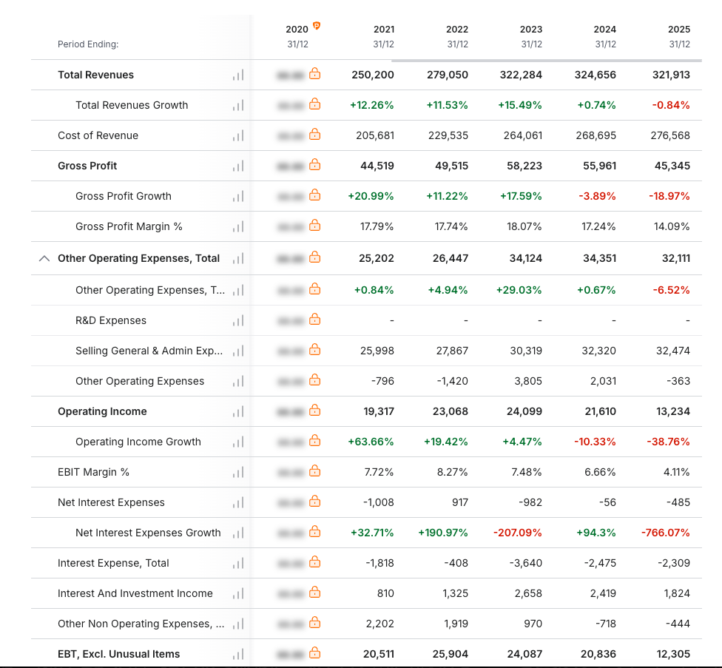
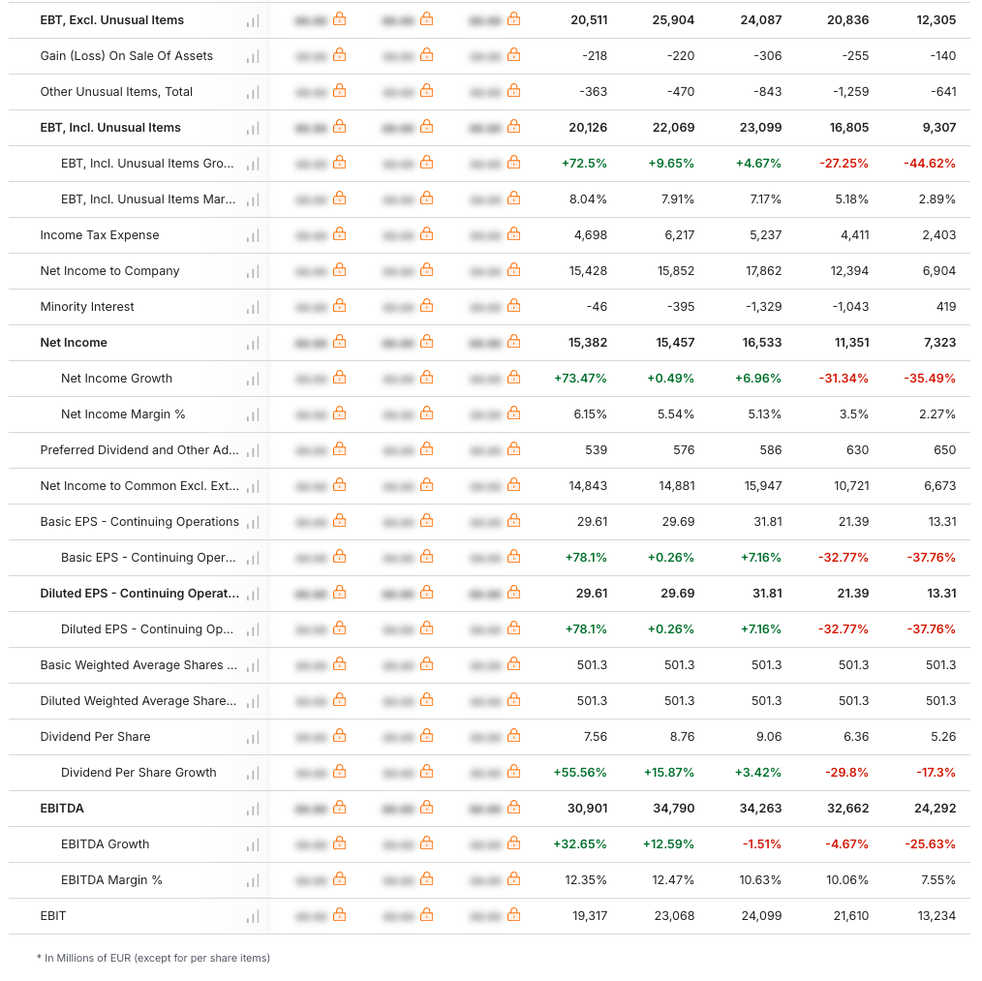
(Source: https://in.investing.com/equities/volkswagen-ag-income-statement)

Appendix 2: Balance Sheet
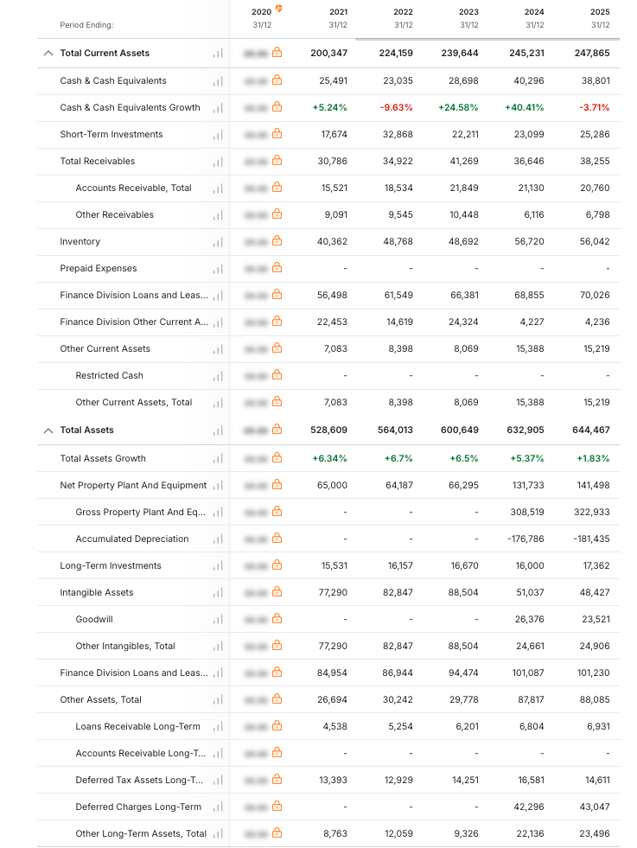
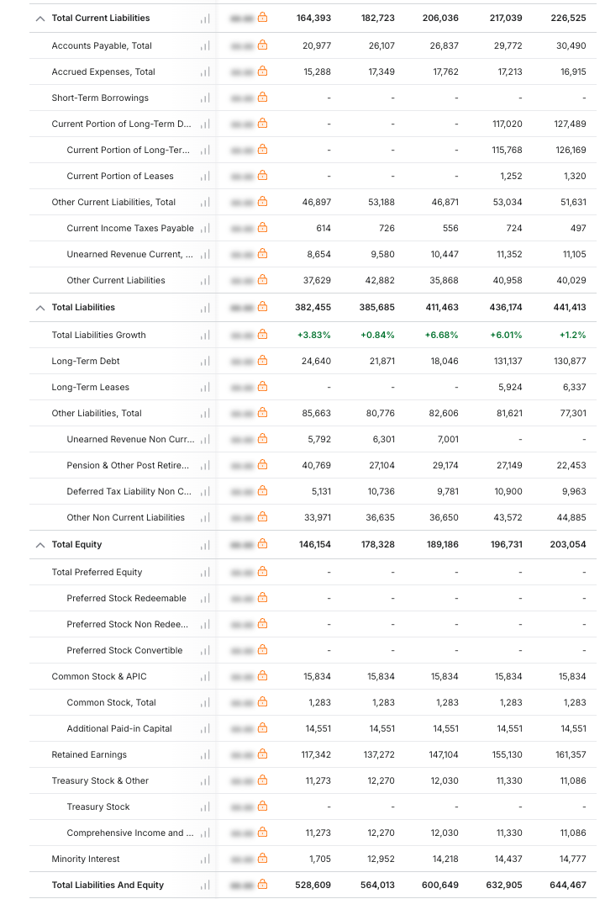
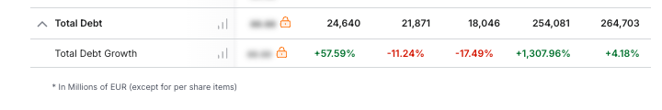
(Source: https://in.investing.com/equities/volkswagen-ag-balance-sheet)

Appendix 3: Cashflow Statement
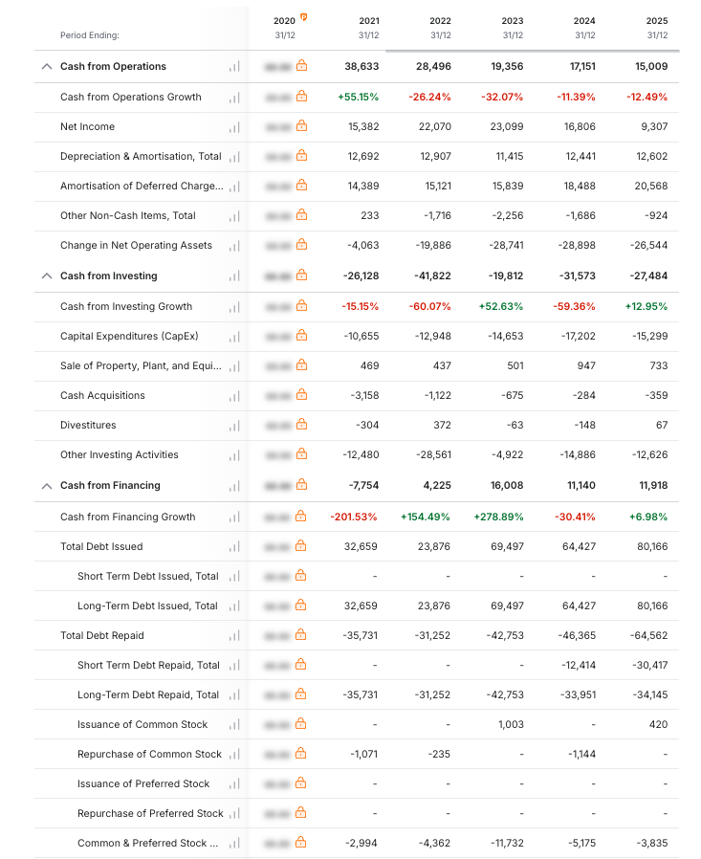
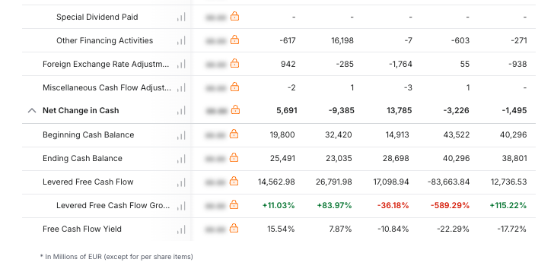
(Source: https://in.investing.com/equities/volkswagen-ag-cash-flow)

Appendix 4: Ratio Analysis

Appendix 5: Investment Appraisal

Year | Project A | Project B | Project C |  | Metric | Project A | Project B | Project C
0 | -50000000 | -50000000 | -50000000 |  | Payback Period | 4.5 | 4.55 | 3.6
1 | 10000000 | 11000000 | 5000000 |  | ARR | -1.000 | 0.867 | 0.917
2 | 12000000 | 11000000 | 10000000 |  | NPV (10%) | -8675823 | -8301346 | -1983844
3 | 14000000 | 11000000 | 20000000 |  | IRR | 2.72% | 3.26% | 8.59%
4 | 10000000 | 11000000 | 25000000 |  | Profitability Index | -0.736 | 2.413 | 2.522
5 | 8000000 | 11000000 | 5000000

