Introduction

In this report I will undertake an in depth strategic analysis and critique issues in the applications of strategic management. The company/institute I will be using to focus my analysis on is University of Bradford. University of Bradford one of the largest Universities in West Yorkshire. It attracts students from all over the world especially China, India and Europe (Bradford 2019).

In this report I have will assess University of Bradford’s (UB or BU) current organisational structure. I will then undertake an environment scan using the PESTEL analysis and Porter 5 forces. Using the results from the above initiated a SWOT analysis. Based on the above I formulated and implement a strategy.

In order to undertake this report I will be holistically using the proposed strategic management model developed by Miller (2003) which is outlined below:

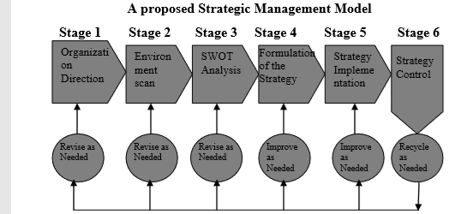

Stage 1 Organisation Direction:

University of Bradford’s vision is to “make knowledge work” (Bradford University 2019). To deliver the vision they have a strategy is to “put students at the heart of learning and be an internally leading University” (Bradford 2019).

Stage 2 Environmental Scan

In order to identify the key strategic issues facing UB in maintaining its competitive advantage I will firstly use the PESTEL framework.

Aquilar (1967) created the PESTEL framework to analyse and monitor the macroeconomic environment of a business. Ethical and legal framework were added to cater for the modern business environment (Chung 2016).

Political Factors
Reduction in funding
There is a direct impact of political factors on Bradford University (BU). The current political environment in the UK is very turbulent and uncertain. The higher education system is directly governed by the government and a huge investor therefore is a major stakeholder. many other, Bradford University is receives public funding directly from the government (Adams 2019). However, recently the government has slowly cut its education budget which will prove a serious problem for Bradford University at present and also in the future. It has also been stated that the higher education sector is being pushed into survival mode.

Increase in tuition fees for foreign students
Over the last 5 years tuition fees for foreign students have rapidly increased by 10% year on year. Nearly, 25% of Bradford University students are from overseas countries (Khalia 2018). This is significant size of there student intake which means any more increase could make unaffordable for students to pay for there student fees, therefore reducing student intake hence making Bradford University a less attractive University to study (Oxford Student). In addition, tuition fees for home students have also increased incrementally over the years therefore the brightest students are making a more of an informed choice into which university they want to study.
Brexit
The uncertainty surrounding free movement people after UK leaves the EU means that that students will require student visas when coming to the UK to study ( (Immigration Advisor Committee 2019). This is an additional hurdle for students which may lead to them incurring more costs. This intern may demotivate students from coming to the UK to study. This will impact Bradford University negatively hence eat there student numbers.
However, the a recent study has shown that the number of international students studying UK universities is increasing year on year. Between 2011/2012 and 2012/2013 there was a sharp decline which could be on the back of the economic downturn, however since then there has been steady growth. This is a positive for Bradford University as it shows overseas students are attracted to study in the UK.
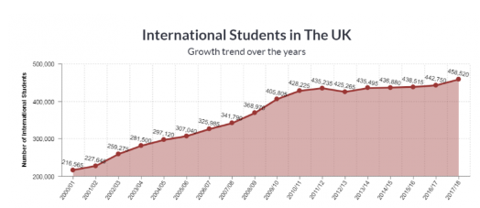
(Immigration Advisory Committee 2019)
Economic Factors

Changes to economic climate:
The effects of economic downturn are still evident within Higher Education (HE). The UK government’s austerity measures are still evolving and are active. The cuts to HE funding means that universities have to priorities there budgets and only spend where there is a need. This means due to limited financial resources they are unable to invest into the development of new courses and specialist human resource whom are required to teach and develop the curriculum.

Student debt
Many students are forced to take on significant amount of student loans to fund there degree programmes. This is becoming a major issue as since many graduates commence their careers with serve financial setback. The main concern is that growing number of graduates are simply unable to pay there student loans, which makes the prospect for going to University least attract.

Weak Jobs Market
The UK has a weak graduate jobs market at present especially when compared to other major educational hubs such as US and Australia. For Many students the end goal of higher education is to have a well paid job after completing their degree.
On a regional basis, Bradford City is the fifth largest city in the UK but the fourth most deprived city in the UK (Kalia 2018). This means that the jobs market is significantly poor with no real concrete career opportunities for graduates . In fact, the unemployment rate in Bradford is 15% compared to the national unemployment rate of 5% indicating a scarce jobs market in Bradford (Kalia 2018).

Social Factors
Across the UK there are major shortages for various different professions (Migration Advisory Committee 2019). The table below outline the UK shortage occupations and the degree courses that are related to them. It can be identified from the table below that undergraduate courses suchas PGCE, Medicine, Social Work and Nursing are in significant demand. However, Bradford University do not offer any of these courses. This is an area that Bradford University could look to expand in (Migration Advisory Committee 2019).

Occupation | Degree Course
Core Subject Teachers (Maths, English and Science) | PGCE (Postgraduate Certificate in Education with Qualified Teacher Status)
GP, Consultants | Medicine, Postgraduate Courses in Neurophysiology, Haematology, Neurology, Occupational Medicine
Nurses | BSc Nursing and Advanced Nurse Practitioner.
Social Workers | Social Work
(Migration Advisory Committee 2019)
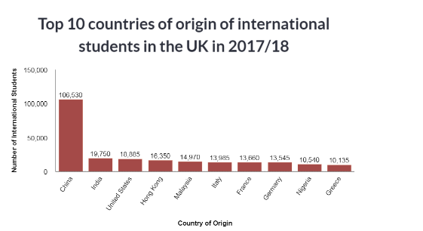

(Migration Advisory Committee 2019)

The table above shows that china countries to be the top country of origin of international students in the UK. As of 2017/2018 more than half of international students where from china followed by India and the US. EU students share 30% of foreign student at UK universities. This creates significant opportunities for Higher Education institutions like Bradford University to direct and market their courses to these lucrative markets.
Bradford has one of the youngest population in the UK (Carter & Sweeney 2018). This means that Bradford University can attract home students, hence a big market for them.

Technological Factors:
The advancement in technology has meant that online learning is a growing a lucrative market for HE institutions like Bradford University (Carla 2018). This is an untapped market and the benefits to both students and the University are immense (Carla 2018). In terms of the University and for the student it is extremely costs effective therefore extremely profitable for the organisation.
Ethical and Legal:
The major legal and ethical issues is the aftermath of Brexit. The lack of knowledge, understanding and accountability of the legal requirements can lead to non-compliance which intern can lead to prosecution for non-compliance.

I will now use Porters 5 forces model to analyse and assess UB’s competitiveness and positioning amongst its competitors.
Porters 5 forces model is well grounded with strategic management (Peteraf 1993), despite criticism from (Richard 200 and Rodriguez 2005), it is still one of most effective strategic management framework. Therefore porters five forces model will be used to assess, analyse and evaluate Bradford University’s competitive strength and positioning withing the HE sector and amongst its competitors. Porter (1981) developed the model. The model has four key areas which are outlined below:

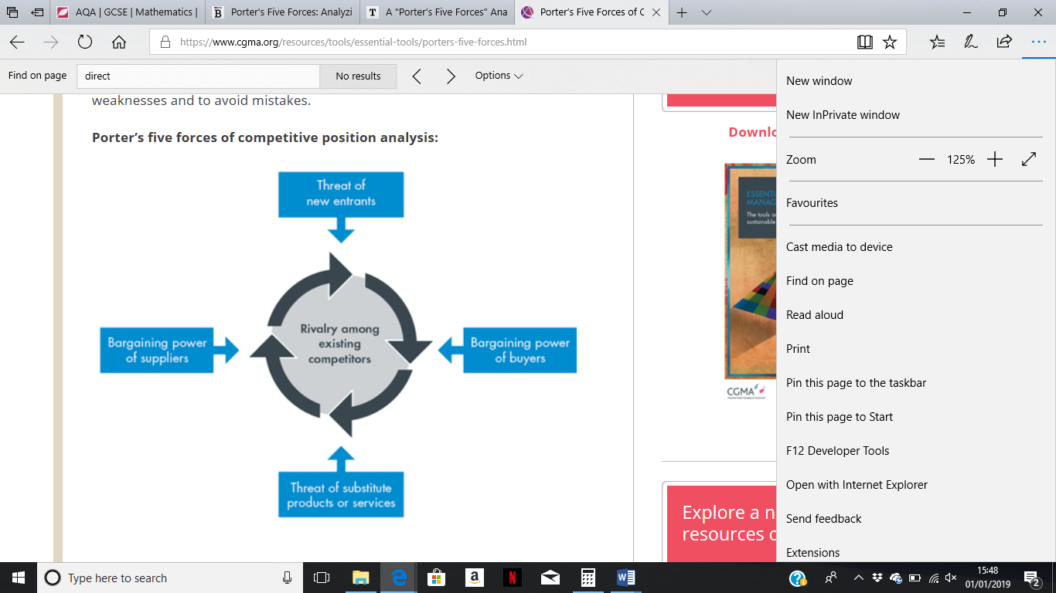

(Porter 1981)
Rivalry Amongst existing Competitors
Bradford University operate in a monopolistic market structure where a large number of universities are competing with each other for students, research support, faculty members and financial contributions (Hopewell 2019). Furthermore, within this industry they deliver and market similar but slightly differentiated degree courses. This gives consumers preference over which university to study at, however on the other hand also gives universities the ability to choose their cohort.
The rivalry amongst universities is fierce, competitive and turbulent than ever before. Bradford University is in fierce competition with other local universities within the Yorkshire region. These include the following:
- University of Leeds
- Leeds Metropolitan University
- University of Huddersfield
- Bradford College University Centre

Ranking | University Name | Entry Standards | Student Satisfaction | Research Quality | Graduate prospects | Overall Score
1st | Oxford Unversity | 224 | 4.90/5 | 4.5 | 95/100 | 1000/1000
14th | University of Leeds | 164 | 4.09/5 | 3.13/5 | 81.2/100 | 838/1000
64th | University Of Huddersfield | 130 | 4.07/5 | 2.6/5 | 80/100 | 668/1000
65th | Leeds Beckett University | 129 | 4.00/100 | 2.4/5 | 75/100 | 602/1000
70th | Bradford University | 120 | 3.91/5 | 2.1/5 | 69/100 | 558/100

(Data compiled from the University Guide 2019)
Looking at the table above UB is the worst performing in terms of entry standards, student satisfaction, research quality and graduate prospects amongst its immediate rivals. Low entry standards means that UB have low entry requirements and therefore are not attracting the brightest and best undergraduates/postgraduates from the market.
Low student satisfaction means that past and current students at UB are not as happy with education experience, services and facilities as compared to rival universities. Furthermore, low graduate prospects means that UB graduates are less employable as compared to Leeds or Huddersfield university. This means that UB needs to focus on developing stronger links with major local employers such as NHS and Local Councils. This can only be done b UB building constructive and collaborative relationships with major employers. UB also need to make there their courses more practical where they have mandatory work placements for pupils. This will graduates/undergraduates pick up work based skills that will enable them to be more employable and hence improve graduate prospects.
The rivalry amongst existing competitors is competitive, fierce and aggressive (Hopewell 2019). Market leaders Samsung and Apple are competing on the basis of quality, positive consumer experience and hardware and software capability (Hopewell 2019). On the other hand, Nokia are significantly lagging behind in competition as it does not have R&D capability and financial resources (Hopwell 2019).

Threat of new entrants:
The threat of new entrants low. This is because the market is well established and therefore it is maturing. However, with the advancement in technology, international and profit making universities are offering 24 our accredited undergraduate and postgraduate degree programmes at significantly reduced fees. These courses are in demand and the market for online degrees is booming (Aston University 2017). This creates a potential opportunity and also a threat for BU.

Threat of substitute products/services
The threat of substitutes within the HE industry is high. The demand for online degree courses and profit making universities’ which offer flexibility, cost savings and better value for money is on the rise. On the other hand, traditional learning at campuses and the experience of “university life” is only promoted within the university settings. This is especially popular amongst younger students and not mature postgraduate students. This means that online degrees are more suited to mature and postgraduate students. Younger students coming out of college want the whole university experience.
Bargaining power of buyers
The bargaining power of students (buyers) is high within the HE industry. Students have multiple universities to choose from if they achieve the necessary grades. Bargaining power is therefore relatively high. The brighter students have the choice of going to the “Russel Group” universities which are world class research intensive universities. These universities are unique institutions which have their own renowned history and ethos. University of Leeds, which is BU’s major competitor is a part of the Russel group (university Guide 2017). However, Bradford University is not part of the “Russel Group” therefore lag behind there competitors in this respect. This means that they can potentially be overlooked my the best students in the market. Parents also play a major part in shaping there children’s decision of choosing a university.
Bargaining power of suppliers

Stage 3 SWOT Analysis
I will now be utilising the findings from the PESTEL analysis and Porters 5 Forces within the SWOT Analysis to see where the company currently sits within its current environment.

Strength | - Hereditary brand loyalty.  - Reputation for postgraduate courses.
Weakness | - Lack of course diversification  - Graduate prospects/student satisfaction/entry standards  - Poor course occupancy  - Poor overall ranking
Opportunities | - Distance/online learning  - Access to new lucrative markets.  - Collaboration with overseas universities  - Introduce degree courses for shortage occupations  - Bargaining power of buyers
Threats | - Competition  - Increased tuition fees for foreign students

SWOT Analysis
Strength
Bradford University is renowned for its postgraduate programmes. The University of Bradford “School of Management and Law” is the 10th best in the UK and the 95th in the world. This means that they have excellent reputation for their management courses.

Weaknesses:
Course Occupancy
One of the major weaknesses of UB is course occupancy. There average course occupancy levels are 51%. This means that they are not maximising their student intake for each course, hence they are not benefiting from economies of scale. Economies of scale is where an institute can make proportionate savings in costs by increasing the level of production. In UB’s case it is where they will increase the level of student intake per course and reduce there average costs per student if they want to benefit from economies of scale.
Looking at the diagram below, currently UB are operating at Q1 (low capacity) where their intake of students is relatively low therefore the average cost per student will be high, therefore UB are operating at P1 (high costs). This means wages and salaries of academic staff and the cost associated with running lecture theatre will be high per student.

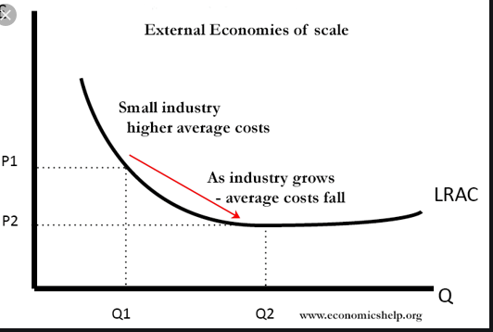

(Werener 2002)
UB can convert this from a weakness to a strength. Through more effective marketing efforts they can increase there student intake and operate at Q2. This will help them reduce there average cost per student therefore costs will be at P2. This will help UB operate at full capacity, and benefit from better asset utilisation. This is because there lecturers will be teaching more student at the same time which will improve the overall productivity and also efficiency of UB.

Lack of course diversification:
Another weakness of UB is that they not offer undergraduate courses which are in significant demand. Courses such as Medicine, Social Work, Nursing and Teaching do not form part of university prospectus. The UK government have categorically outlined that there are significant shortage of Doctors, Teachers, Nurses and Social Workers in the UK. This is one of the key reasons why they are suffering from course underoccupancy. These courses are in demand and the supply of these courses in society is low. The introduction of these courses in the in the long run will benefit UB as will be able to attract the best talent and also gain more funding and bursaries from central government. UB need to stop offering courses such as “criminology” which do not add significant value to society or create job opportunities. This is the reason why UB has low career prospects compared to its competitors.

Graduate prospects/student satisfaction/entry standards
Low graduate prospects, entry standard and below average student satisfaction rating is a significant weakness for UB. These are the three key indicators that potential applicant look at prior to making an application. UB need to put efforts in improving these key areas. To do this, they need to improve the quality of education, quality of faculty and also research output. UB can do this by recruiting academic staff that are globally renowned for example recruit academic academics from the Royal Society the renowned British Academy. They also need to improve graduate prospects my embedding communication, leadership and problem solving skills at the heart of every course that they deliver.
Opportunities
Offer online/distance Learning courses
One of the main opportunities for UB is to tap into the online/distance learning market. They can offer existing courses which they have specialist knowledge online. Currently, student are moving away from the traditional learning platform and are looking for more flexibility where they can manage there personal, professional and academic life better . If UB introduce online undergraduate and postgraduate degrees they will be able to attract a lot of students from around the world and charge high fees. This is a very cost effective opportunity as they can utilise there existing academic staff to deliver online courses. This means that they will include minimal costs.
Collaboration with overseas university to offer Bradford University accredited courses
Another opportunity for Bradford University is that they can collaborate with universities abroad and offer there courses there. This will help them increase their presence internationally. They can increase their presence in countries such as China and India as currently, majority of Bradford University’s overseas students are from these countries.
Introduce degree courses for shortage occupations
Another opportunity for Bradford University is to introduce degree courses for shortage occupations. These include courses such as medicine, teaching, social work and nursing. The benefits of this is twofold. Firstly, they will be able to attract the best in the market place and secondly, their course occupancy will increase incrementally.
Threats
Competition:
One of the major threats for UB is competition from it existing competitors. UB’s competitions have better overall ranking, student satisfaction, career opportunities and research quality. This means that UB are significantly lagging behind competition in all areas which is affecting their market share which is the reason why UB has poor course occupancy. Existing applicants are therefore choosing alternative universities to study at and will not prefer to study at the UB.
Increased tuition fees for foreign students
Another threat to UB is the governments decision to increase tuition fees for foreign students. Currently, more than half of UB’s student intake are foreign students. This means that by increasing fees it will reduce the ability of foreign students to potentially afford to come a study at UB. Tis will significantly impact upon there occupancy level as it will create a significant barrier for foreign students due to affordability and alternative financial reasons.

Using PESTEL, Porters 5 forces and the SWOT framework I will evaluate the corporate level strategy of UB to date.
From the above environmental analysis, it can be identified that UB have a stability strategy. This is where they have attempted to firstly, maintain its size and current line of business. They have a defensive strategy because they possess moderate strengths in this highly volatile, turbulent and uncertain external environment. They have not innovated or diversified there courses and instead have withheld any further development. An example of this can be the lack of course diversification. From the external analysis, it is categorically clear that UB are not offering shortage occupation courses. This is having a knock on effect on there occupancy levels.
A defensive strategy means any revision, adaptation or implementation of growth strategy will mean that UB will need to change itself culturally and become more aggressive. There needs to be a complete cultural shift which will allow UB to diversify, innovate and become a market leader within the west Yorkshire region. However, this can only materialise if UB completely revamp its existing senior leadership and bring in new human capital that will give them a new strategic direction and vision. Without this they will be unable implement such strategy in the long run.
From the above it can be identified that there is no correlation between the organisations long term strategy of “putting students at the heart for learning and be internationally a leading University” and there current market activities. From the PESTEL analysis it can be identified UB’s student satisfaction survey and graduate job prospectus is lowest amongst its competitors. This means that the implementation of such strategy is poor and therefore completely nullifies the vision and objective. The actions and steps that UB are taking towards achieving the vision and goal are completely ineffective.

Based on the PESTEL, Porters 5 forces analysis and SWOT analysis I will formulate a new strategy for Bradford University. I will use Ansoff Matrix to formulate a new strategy.

Stage 4 Formulation of Strategy

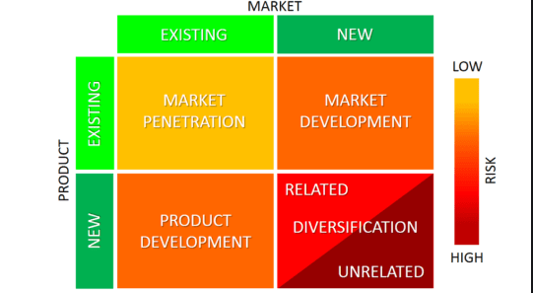

Ansoff Matrix

From the analysis above the best strategy for UB would be product development strategy. This growth strategy is where UB will develop new product within its existing market. Across the UK there is shortage of Teachers, Doctors, Social Workers and Nurses. Bradford University will therefore start to offer courses such as Medicine, PGCE (teaching), Nursing and Social Work. Offering these means that they are able to better compete with there competitors such as University of Leeds who are currently offering both PGCE, Nursing and Medicine. Another benefit would be that they will be able to increase there course occupancy levels and graduate prospects. Due to high demand of these professions Bradford University’s student intake will rise significantly. This means they will benefit from economies of scale in the long run where the average cost per pupil will reduce as student intake increased, which will simultaneously increase the market share of UB.
However, it is a high risk strategy. Large financial investments will be needed in human resource, marketing and the overall production of these courses. Furthermore, as UB will not be established in delivering these courses they might in the short term not be able to recruit many students therefore might be hit with a financial loss in the long run. They will also need to also gain accreditation for there courses from the NHS, teaching and Lecturing agency and other official authorities.

production, research and development and human resource strategies. Marketing strategy issues such as promotion techniques to be used, pricing product mix, and overall image. Financial strategy specifies the capital structure of the organization, debt policy, assets management procedures, and dividend policy. Production strategy is concerned with issues of quality, productivity and technology. Human resource strategy such as compensation, selection, performance appraisal, and other aspects of the organization’s human resources and research development strategy focuses on issues regarding product development, licensing and the organization’s commitment to innovation.

Stage 5 - Implementation of the strategy:

In order to implement the above strategy successfully, there needs to be significant change within UB. Firstly, there needs to be a complete change in the university culture. Currently, UB have a very defensive strategy. However this mindset needs to change and they need to become more aggressive in there approach when implementing or executing any new strategy. Playing a defensive strategy might be safe however it will not maximise gains instead by having a growth strategy will help UB maximise gains in the long run. Furthermore, another factor that needs to be considered is that . UB they will need to look at it from 3 different perspectives. These include:
- Financial Perspective
- Customer Perspective
- Human capital perspective

Financial perspective:
Firstly, to implement the strategy UB will need significant funding. They will apply for loans and grants from the government to build new faculty area for these courses. They will also need additional finances from the bank to fund this change. In the mean time they will also increase tuition fees to fund this big project. Although this might hit occupancy levels for alternative courses in the short term however, it will benefit UB in the long run as they will be able to implement this strategy. Due to financial constraints UB will introduce these courses in phrases and not all at once. The will have less of a financial impact on UB.
Customer Perspective
Once the courses are phased out, marketing of the courses need to be effective. The courses will be advertised on the University of Bradford Website, Billboards, University prospectus and social media. Marketing the courses on social media such as Instagram, Facebook and also Snapchat will help make potential candidates aware of the new courses that the UB are offering. This will increase awareness of the new courses to a larger target market which intern will increase market share of the new courses.
Human Capital Perspective
In order to run the courses successfully significant recruitment drive will be need to find and recruit qualified and talented academics to run and deliver these courses. For PGCE courses UB will need Lecturers and highly experienced teachers to teach the art of teaching to new pupils.
Conclusion:
In this report I have assessed University of Bradford current organisational structure. I then undertook environment scan using the PESTEL analysis and Porter 5 forces. Using the results from the above initiated a SWOT analysis. Based on the above I formulated and implement a strategy.
I can conclude that by implementing a growth Strategy University of Bradford will be able to increase its presence, market share, course occupancy, student satisfaction and overall ranking. However the positive results from the strategy will take time to materialise and will not happen immediately. Instead it will take time and effort. Implementing this strategy can only be viable if UB align its financial, marketing and HR efforts together. All these functional areas will need to communicate with each other. Also communication will need to open, efficient, transparent and also effective. They cannot operate in isolation as all departments are interdependent upon each other.

References

Adams, R. (2019a). Universities hit back after report proposing funding cuts. [online] the Guardian. Available at: https://www.theguardian.com/education/2019/may/30/augar-post-18-report-leaves-university-leaders-fearing-cuts [Accessed 15 Dec. 2019].
Adams, R. (2019b). Universities hit back after report proposing funding cuts. [online] the Guardian. Available at: https://www.theguardian.com/education/2019/may/30/augar-post-18-report-leaves-university-leaders-fearing-cuts.
Aguilar, FJ. (1967). Scanning the international business environment. 2nd ed. [Cambridge].
Aston University. (2017). New online degrees launched as global demand rises. [online] Available at: https://www2.aston.ac.uk/news/releases/2017/july/aston-launches-new-online-degrees-as-global-demand-rises [Accessed 15 Dec. 2019].
Carla, A (2018). 10 Challenges Facing UK Higher Education in 2019. [online] Digital Marketing Institute. Available at: https://digitalmarketinginstitute.com/en-gb/blog/10-challenges-facing-uk-higher-education-in-2019.
Carter, A. and Swinney, P. (2018). Where are the UK’s youngest and oldest city populations? BBC News. [online] 19 Mar. Available at: https://www.bbc.co.uk/news/uk-43316697.
Chung, H.F.L. (2016). “An Analysis of Taiwan’s Distribution System.” International Journal of Retail and Distribution Management 29, 87–98.
Hopewell A. (2008). Breaking Into The Trade Game: A Small Business Guide To Exporting, U.S. Small Business Administration International Publication www.sba.gov/international
Kalia, A (2018). “We’re all competing for the same jobs”: life in Britain’s youngest city. [online] the Guardian. Available at: https://www.theguardian.com/cities/2018/feb/05/life-britain-youngest-city-bradford-uk-unemployment.
Migration Advisory Committee (2019). Full review of the shortage occupation list, May 2019. [online] GOV.UK. Available at: https://www.gov.uk/government/publications/full-review-of-the-shortage-occupation-list-may-2019.
Miller, D. (2003). An asymmetrybased view of advantage: Towards an attainable sustainability. Strategic Management Journal, 24, pp. 961‐976 (2003).
Peteraf, M.A. (1993). The cornerstones of competitive advantage: A resource‐based view. Strategic Management Journal, Vol. 14, 1993, pp. 179‐191.
Porter, M.E. (1981). The contributions of Industrial Organization to Strategic Management. Academy of Management Review. Vol. 6, No. 4, 1981, pp. 609‐620.
Richard, O.C. (2000). Racial diversity, business strategy and firm performance: A Resourcebased view. Academy of Management Journal, Vol. 43, No. 2, pp. 164‐177.
Rodriguez, R.M.G. (2005). Technology and export behaviour: A Resource‐based view approach. International Business Review, Vol.14, pp. 539‐557.
Study in UK. (2019). International Student Statistics in UK 2019 - Study in UK. [online] Available at: https://www.studying-in-uk.org/international-student-statistics-in-uk/.
The Oxford Student. (2019). Overseas student fees to increase by an unprecedented 10% after consultancy body “overruled” – The Oxford Student. [online] Available at: https://www.oxfordstudent.com/2019/06/01/international-student-fees-to-increase-by-an-unprecedented-10-percent/ [Accessed 15 Dec. 2019].
Thecompleteuniversityguide.co.uk. (2019). Top UK University League Tables and Rankings 2019. [online] Available at: https://www.thecompleteuniversityguide.co.uk/league-tables/rankings.
University of Bradford (2018). Bradford’s MBA world’s first for value. [online] University of Bradford. Available at: https://www.bradford.ac.uk/news/archive/2018/bradfords-mba-worlds-first-for-value-1.php.
Werner, S. (2002). Recent developments in international management research: A review of 20 top management journals. Journal of Management, Vol. 28, No.3, pp. 277‐305. European Journal of Social Sciences – Volume 11, Number 3 (2009) 418

