LCMB7013

Assignment 1 – Individual assignment

Student Name:-Vrushik Maheshkumar Patel

Student id:- 2226897

MANAGING PERFORMANCE

University of Wales Trinity Saint David

Table of Contents
1. Introduction 3
2. Implementation of the Contingency Approach Model 4
2.1. What is the Contingency Approach Model 4
2.2. Implementation of the Contingency Approach Model at different stages 4
3. Performance Management Implemented by the organization at different stages 7
Performance Management Cycle at Apple 12
4. Relevant performance management activities 14
4.1. Renewal 14
4.2. Steady-state 15
4.3. Decline 16
5. Improvement of practices 16
6. Recommendations 19
7. Conclusion 20
References 21

1. Introduction
In enhancing the performance of the organization and employee effective Human Resource Management plays a very crucial role. In this situation, the contingency approach model has arisen as a strategic framework. This model underscores the necessity of tailoring performance management practices to the organization's business life cycle unique phase.
In this report, the contingency approach model is examined critically with the main focus on its implementations. So, Overall strategies can be supported at various stages. It also includes the example for each stage is also provided and it is also critically discussed how Apple has implemented performance management. The post-maturity stage is also reflected. At the end of the report some of the strategies are discussed which can be used to improve the practices and some of the recommendations are also provided.

2. Implementation of the Contingency Approach Model

2.1. What is the Contingency Approach Model
The contingency approach can also be termed the situational approach. The contingency approach model can be used for the performance management of the company or the organization. It is the most appropriate style considered for the management according to the situation. This model helps the company to learn something new from different situations at different stages of business strategies. This benefits the organization to implement the learnings in their future management in similar situations. There are many more characteristics of the contingency approach model to be applied (Mole, et al., 2017). The decisions taken after reviewing the performance management are contingent upon the situation. It makes the people or employees ready for the changes occurring in the organization’s environment and their continuous improvement is made sure with this. When applied to the organization or any company, the contingency approach changes the size and preferences of the company. This changes the company’s need for customization and its nature of carrying out the business practices and technologies to be used are also changed (Cao, et al., 2015). There are a lot of advantages to using the contingency approach model. Some of them are:
- There is no chance for the managers to remain stereotyped and be situation-oriented every time.
- The organization moves its ways toward creative management styles and innovates them from time to time.
- It provides a real view of the happenings taking place in the management and the organization too (Niemand, et al., 2021).
The contingency approach model helps in changing the structures and design of the business management strategy and gives the way to change, modify, or develop the control systems and leadership styles for the betterment.

2.2. Implementation of the Contingency Approach Model at different stages
The business strategies of any organization can be supported by implementing the contingency approach. Organizations that have a good effect on the market must see to their plans, and how they organize, lead, and control their particular situations and circumstances. The contingency approach model is applied to focus on the issues and give ideas to change and adjust the leadership styles according to the issues concerned or focused on (Franco, et al., 2020). Every organization follows its way about how to lead the processes of the company. The contingency approach models should be applied to the situations and processes of the company, but there are some variables to be considered when applying this. The employees must recognize and accept the authorities of the company as their leaders. This is important so that the employees and workers must work ethically and with a proper approach. The businesses should be classified by the level of detail that is used to describe and explain the job description of the employees of the organization (de Carvalho, et al., 2015). The other way of describing the business more clearly is by the level of authority that a person, employee, or manager possesses in the particular company. The theory of contingency is used to make a good impression and influence the employees who work for the company with loyalty and complete every task.
The contingency approach model can be applied successfully to support the overall business strategies at the stage of startup, growth, maturity, and post-maturity.
When any organization or company is at the stage of startup, the contingency approach model is used as a backup for the business strategy. This approach tells the company what to do and how to respond in unusual and unforeseen circumstances and situations whenever the business plans go off track. For example, what will be done if the server is lost, and what is to be done when any employee ruins the work by mistake. The contingency approach model at the stage of startup can be applied by first recognizing the expected risks and then weighing them according to their likelihood of happening. After that, conducting a business impact analysis is also important. Then comes creating the contingency plans for the risks with higher weightage and then approving and monitoring them (Min, et al., 2017).
At the time of growth of any organization or company, the relations between the leaders and members of the organization must be maintained, trust should be built among them and there should be confidence to build a sense of productivity. All the tasks should be made clear and must be structured to make the business processes favorable to achieve the heights of success. Alternative plans should be made to make the growth of the business or the company stable in case of any downfall in the performance and growth of the company. These plans should be made to meet the demands in times of unexpected circumstances and situations that can harm the reputation of the company in the market (Su, et al., 2015).
When the company becomes well-established in its industry with its products and loyal customers, then there is a need for a contingency approach model to be implemented. The processes and business strategies should be monitored from time to time. The plan B should be made in case of any downfall of the company. The company or any organization should keep a team of experienced employees or partners who can make important decisions, and who are capable of handling unforeseen circumstances and situations with confidence. The new employees hired in the organization should be enthusiastic and have leadership values in them. At this stage of maturity, the company should develop employee morale and should have loyal employees who can handle the working and processing of business (Kock, et al., 2016).
At the time or phase of post-maturity of the company or business, the process of handing over the business should be done with a contingency approach model to support the future of the business if in case any processes after handling the business to other does not work properly or does not meet the basic demands. This contingency plan or it can be said plan B must be made before keeping the value of the business and organization safe and making sure the future of the company and the business is in good hands. This is known to be the final stage of the business and it is to be made sure that the business does not fail after coming to a final stage of success.

3. Performance Management Implemented by the organization at different stages
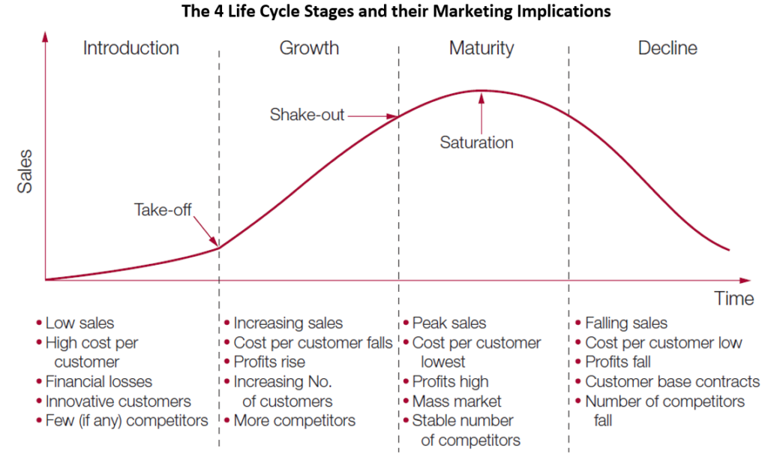
Figure 1. Product Life Cycle of Apple iPhone
- Start-up Phase,
The Company Apple inculcated the alignment of the newly set up organization with the mission and vision, and also the values decided by the founders of Apple. Implementing the performance management plan for the organization and employees is critical when talking about startups. A well-established performance management system and framework must be implemented by the startup companies to achieve success and build a dynamic business environment. This is done to manage and promote the high performance of the employees, their growth, and engagement (Bivona & Cosenz, 2021). Apple allowed the authorities of the company to do the modifications whenever they were required to do so (Sun, et al., 2019). The company Apple also incorporated objectivity in its performance management system and transparency to ensure that the processes are going on with a good flow. The company Apple also ensured 360 Annual Performance Reviews which helped the company to review the performance of the employees and to see how the performance of each employee is impacting the organization and getting benefits to the company and they are told about where improvements can be made in their performance. Apple measured the performance of the employees based on their teamwork, innovation, and results. To encourage the employees, the company started to give ratings that show the employees' performances. The ratings were like exceeds expectations, needs improvement, or met expectations.
The company encouraged the newly hired employees to set their personal goals and have a clear understanding of the mission, vision, and values defined by the organization. They also encouraged the employees to inculcate the must-have characteristics that were defined in the performance management process. Apple was highly advanced when it was in the stage of startup. The company managed to install the software for the performance management system that allowed implementation and modification in the system regarding performance management for the organization and the employees of the company (Van Dooren, et al., 2015).
For making the performance management system, the company Apple recognized its vision, mission, and values as the key factors for guidance and in which direction the company needs to go and work. The annual goals of the company were achieved by succeeding in achieving the short-term goals while keeping the long-term goals in consideration. The goals were made as the motive for the performances of the employees and authorities of the company. It was very difficult for the company Apple to remain in the market and influence the people in the dynamic environment because it became crucial for the company to achieve its short-term goals. The key characteristic required for setting up the performance management system in the startup is flexibility. The employees of the company incorporated organizational values like objectivity, transparency, innovation, and creativity into their performances to achieve company-centered and personal-centered goals (Bianchi, 2016).
Apple required quick and faster action and results that were their desire to achieve, so the company increased the frequency of checking and reviewing the performances of the employees and overall organization. Not annually here, but then the performances were reviewed once a week. These things assessed the gaps that were encountered in the performances. As a result, its products entered the market, and in the phase of startup, the company launched various products including the iPhone, but the first-generation iPhones were sold for only one year. Apple used a premium pricing strategy to address this issue.
- Growth Phase,
When the company Apple reached the very important phase of the business cycle, that is the growth phase, the company encouraged its employees during the performance management cycle to participate in their personal growth as well as the growth and development of the organization. The company had already started working on the design and development of new products that in future were known to be beneficial for the company, just because the company worked according to the planning and also allocated the resources in a planned manner. The company just focused on developing better, more luxurious, and superior designs of products. The company also managed to apply the performance management system at this stage of growth for the company and for better profits, the company reduced its production costs by redistributing and outsourcing its production to China because producing the goods in China was costing much less the company or it can be said that the company created the superior designs at a very cheaper rate. But at the same time, the company managed to keep and meet the quality standards of the products and the company. The company in its growth phase or any other phase, they are owing a sense of continuous innovation. Due to the superior quality and luxurious quality products, the company Apple gained a better marketing position (Cappelli & Tavis, 2016).
During the phase of growth, the company got a demand for its products. With the help of different websites and Google’s digital advertising network, the company promoted itself for growth. The performance of the company got better by implementing performance management at this stage. The performance management system implemented by the company at this stage allowed the company to introduce premium products at premium prices and branding and also creative innovation was seen in their range of products. The good performance was recorded by the company at the growth stage. While the employees were performing better, the company began to sell the products online through e-marketing sources. Along with the performance management strategy or plan or system, the company also developed the content strategy to put the new possibilities into the interface. According to the success of the performance management system, the company started taking feedback and surveys or 360 peer feedback to improve themselves. The company encouraged the managers and employees to self-evaluate themselves. Apple also started tracking the goals, the time to achieve a particular goal, and how and by what ways these goals were achieved or are to be achieved in the future. Not only this but also the company tracked the satisfaction of the employees over time, which built a sense of trust and loyalty among the employees.
- Maturity Phase,
The company at the stage of maturity saw significant sales of the products, and due to this, the company increased its production by asking for contractors. At this maturity stage, the company introduced cloud technology which helped them expand their business and also the possibilities for the customers. The company continuously worked on its promotion and optimized its image that was made by its success in the corporate world. Apple focused on the core elements to achieve the maturity stage of the business life cycle. These core elements were Operational Levers. The operational levers are tools, architecture, processes, integration, and governance. The application of a performance management system at the maturity stage or phase of the company enabled the leaders of the company Apple to understand where they currently stand and what they have to do more for the next phase with the skills, capabilities, and systems for advancement. The company desired to improve its performance at this stage and started exploring new tools for performance management. With a set of clearly defined expectations and objectives, the proper initiatives were taken to integrate the performance management procedures. The company did not focus on strategies at this level, but on the values, they decided to deliver, and those values and their mission and vision were greater than the formal documentation (Moschidis, et al., 2018).
The company Apple at this stage of maturity, assessed its employees and managers based on their performances and not the hierarchical levels. Apple started implementing performance measurement methods like measuring the performance of the employees by selecting and documenting based on key performance indicators. It also employed strategy monitoring tools like dashboards to monitor the strategies it used for the betterment of the performance management system. The company also started coordinating and carefully regulating the performance management processes that were standardized with better process flows and were well-defined. The company at that time went through many levels of performance management. Apple made sure that there was a sense of trust among the employees and business leaders (Bititci, et al., 2015).
It was thoroughly monitored and made sure that the inputs were also to be taken by the employees and the leaders and whether their performance is driving a value or not. The approaches that were attempted at the time of maturity of the company, those approaches are still being driven by the company under the leadership and ownership of business leaders. The company made a performance management system or plans to develop and grow the employees. By this stage and time, the company got to know about what works well and what does not, and then the company makes the strategies accordingly. Implementing performance management at this stage was not easy for the company, so it was under the supervision of leaders and was HR-supported and this was focused on the results of the organization.
- Decline Stage,
At the phase of post-maturity, the company experienced the highest peak of sales of products. This was also seen that the sales were consistent from the time when the phones of Apple products were introduced. At this stage of post-maturity, the company started focusing on the premium brand. The distribution channels like online and offline were known to be beneficial for the company at the post-maturity stage. Not only this but also the company offered a high number of discounts for the old models that were left to be sold. When the company saw that with the new models of phones and many other products, the old models were left to be sold, and then the company sold those products at discounted prices. The company Apple gave good competition in the market and stood out in terms of brand name and quality products. To maintain the morale of the employees and retain the customers, preventing losses, the company applied a good performance management system for this. The company was able to take the brand to heights and was able to grow the value of the business. This stage can be stated as the final stage of the business life cycle and here the performance management system is to be applied to check the cash flow sales and market share of the company (Drobetz, et al., 2015).
The company Apple with its performance management system improved its competitive position of the business by doing the cost cutting. The company always aims to launch new products with new features. Performance management is applied to both the managers and the employees to check their performance and gain new ideas from them. It is also done to check that closure is managed effectively and ethically. To get better results, the company started conducting regular meetings and discussions on the performance of the employees to encourage everyone. The company started involving the senior leaders for their guidance. Apple took feedback from the employees as well as customers and gave the best training to its employees for their better performance. The company checked and applied the process of continuous performance management. Apple encouraged the employees to focus on the vision of the company. Employee motivation was the best thing to be done by the company to get better results of their performance.
Even at this stage, communication, interpersonal relationships, leadership, teamwork, and feedback were properly carried out. This was all done by the recognition and mutual trust in an organization. The company provided its employees with next-level skill training which enhanced their skills and they focused on the resources. They had a nice training plan for the employees to take the company to good heights (Tian, et al., 2015).
The life cycle of the business is one of a dynamic journey and this journey has different phases. The journey of the business starts with the start-up phase and then it comes to the growth stage, then maturity and inevitability, and the last stage is the decline. Every stage has different challenges and it also provides various opportunities for the organization. In the post-maturity stage context, this stage merges with the difficult phase which demands smart strategies for performance management to navigate effectively. After a sustained growth period, this stage occurs typically and it marks the transition where traditional approaches might not be enough. Further discussion will be done about performance management intricacies in the post-maturity stage (Alzoubi, 2019).
Post maturity stage is the final stage of the business life cycle. Since the business was established, consumer behaviour, market conditions, and purchasing habits have changed undoubtedly. In the post-maturity stage, it is the organization's responses to such change that matter, leading to evolution, adoption, or decline. To ensure the renewal of the business, the business must demonstrate the flexibility and leadership skills to adapt the regularly changing situations. It may need to upgrade the technology, new opportunities for persuasion, new service or product development, or learn new skills that can boost competitive edge (Alzoubi, 2019).
By several key factors post maturity stage of an apple is characterized. First and foremost, it shows a decrease in the growth rate which was experienced by Apple previously during its maturity phase. Profit and revenue growth tend to stabilize, and saturation of the market becomes more apparent. By the increased competition, disruptive technologies, changing preferences of the consumers, and all the other factors which can challenge the status quo of the apple this stage is often marked (Louis-Philippe, et al., 2020).
Secondly, the agility and adaptation of Apple are underscored by the post-maturity stage. The structures and strategies that can fuel the business growth may become less effective in this phase. Apple must recognize the imperative transformation, which could involve innovation, diversification, or expansion of new markets. In facilitating and guiding such changes, performance management practices play a vital role (Cattermole, 2019).

Performance Management Cycle at Apple
Planning – The company Apple makes their employees work on the organizational goals set by them and they train their employees on how to achieve those goals. Every person related to that goal or particular objective is measured on their initiatives to fulfill those goals. Their contribution is then informed to them in the form of their achievements.
Action – This part of the performance management life cycle focuses on the actions taken by the employees to fulfill the objectives and goals set by the company and their performance is checked based on the results and their achievements. The employees and managers both are involved in taking the appropriate actions. Good performances are rewarded and any shortage is determined. This is done by peer appraisal and 360-degree feedback.
Monitoring – The company Apple observes the performance of their staff members and feedback is given. Also, the company provides the appropriate and necessary support needed by the employees to achieve the goals, and guidance is also given.
Reviewing – This stage involves the review of the organizational plan of performance which is done through leadership and mentoring. The leaders do the work of reviewing the tasks and they encourage the togetherness and teamwork between the employees. They communicate the information from top to down and also the approach of down or bottom to top is followed by them to improve the performance. The leaders and managers of the company maintain good and strong communication with the employees to develop productivity in the work and performance of the employees (SlideShare, 2023).
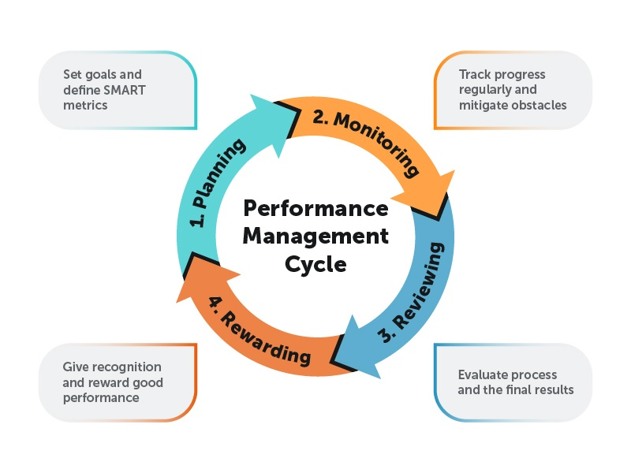
Figure 2. Performance Management Cycle (Valamis, 2023)

4. Relevant performance management activities

4.1. Renewal
In the maturity period, the renewal effort is one of the key components of the performance management system. At this stage, apple should be searching constantly for new opportunities for growth and breaking into a new market.
Some of the performance management activities that are relevant for the renewal in the maturity stage are:
1) A culture of innovation can be fostered: to encourage renewal within the organization apple fosters a culture of innovation and risk-taking. Employees of Apple are encouraged through performance management to come up with new concepts, or novel approaches and experiments can be done (Hilty, et al., 2020).
Example: by fostering the culture of entrepreneurship apple, its employees are empowered to propose and work on innovative projects like Apple Music and Apple Watch.
2) 360 annual performance reviews: apple has implemented the performance review process. This process includes the end-of-year review and semi-annual review.
Example: In this process every employee is reviewed by 3-4 executives, in addition to being reviewed by direct peers or reports, making it a 360 process. This process provided a broader idea of the performance of employees (Cattermole, 2019).
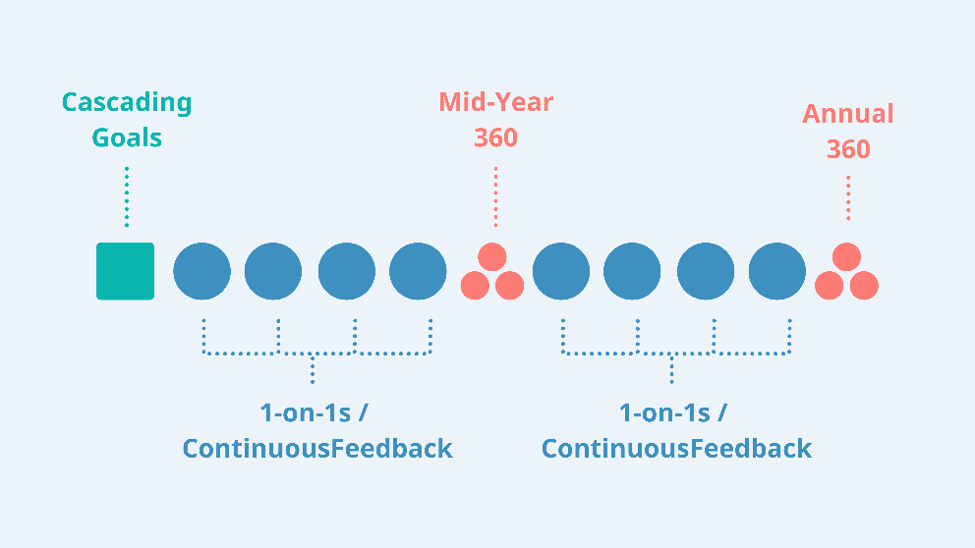
Figure 3. How Apple Does Performance Management (PerformYard, 2023)
3) Market research and consumer insights: a deep understanding is needed often in the renewal stage for evolving the preferences of the consumers and trends of the market.
Example: apple performance management has added different activities like consumer insights collected and market research is also done so that emerging threats and opportunities can be identified. Tracking the performance of the viewer’s Apple also uses data analytics (Lehmann, et al., 2021).

4.2. Steady-state
In the post-maturity stage, the organization is not in a position to embark on a radical transformation. Some of the organizations chosen to maintain the operation's steady state focus on maintaining the current position of market and optimization. In such situations, performance management must emphasize consistency and stability.
Some of the performance management activities that are relevant for the steady state in the maturity stage are:
1) Diversifying product portfolio: In this phase, the focus of HR is on maintaining stability while diversifying the portfolios of products.
Example: The product line of Apple is diversified with the introduction of various services like Apple arcades and Apple TV+, alongside regular development in current categories of products.
2) Customer relationship management: in this phase, retaining the current customers becomes critical.
Example: apple performance activities are focusing on CRM, by making sure that customers are satisfied with the services and products (King & Vaiman, 2019).
3) Employee retention and engagement: since organization stability depends on the employee’s continuous performance, it is important to maintain a high engagement and retain a level of employees.
Example: apple's performance management systems include recognition, feedback, and career development mechanisms due to which its employees are always motivated (Anwar & Abdullah, 2021).

4.3. Decline
At this post-maturity stage, some organizations may experience a decrease in market share and performance. When this situation occurs, performance management shifts its focus to reducing the losses, the cost is managed and strategic decisions are made regarding the future of the organization.
1) Workforce transition: when the decline is faced by the organization then the human resources of the organization must try to manage the workforce transitions sensitively.
Example: apple has not experienced a decline phase yet, but by offering job transition and retaining support, organizations can successfully navigate the decline for the employees who are affected by such a situation (Liu, et al., 2023).
2) Cost control measures: in the decline stage cost becomes paramount. Rigor cost control measures must be implemented by the organizations, expenses must be reviewed and cost reduction areas must be identified while making sure that to the essential operations, there is minimal disruption.
3) Proper allocation of resources: when an organization enters this phase, organization performance management activities shift towards the allocation of resources. Apple has not faced this stage yet but by making difficult choices regarding products or business units to divest and where resources can be concentrated can be made (Xu, et al., 2023).

5. Improvement of practices
Reflecting on this module, the knowledge and insights increased have the potential to greatly improve HR practices. The main takeaways from this module can be applied to enhance the management of human resources within an apple. The module underlines the importance of HR strategies bringing them into line with the overall strategic organizational goals. This knowledge can result in more effective HR practices by ensuring that initiatives HR are closely tied to the overarching mission and vision of Apple. It safeguards that HR becomes a strategic partner, underwriting directly to the success of the company. This module highlights the importance of a demanding process of recruitment, which comprises assessing not only technical skills but also cultural fit. By applying these principles, apple can attract candidates who bring into line better with the values and culture of the company. This will result in a more consistent and high-performing workforce. The module also highlights the value of talent management (King & Vaiman, 2019). By analytically identifying and encouraging high-potential employees, organizations can build a healthy talent channel. This helps in reducing gaps in leadership and safeguards a continuous flow of skilled professionals into main positions.
Performance Management, the understanding increased from this module can improve performance management practices. It pressures the significance of setting perfect objectives, providing regular feedback, and evaluating objective performance. By applying these principles, apple can create a culture of continuous development and higher productivity between employees. Employee Commitment and Well-being Employee engagement and well-being are important components of the success of the organization. This module highlights the importance of adopting a positive environment and offering opportunities for growth and development in a career. These practices can result in increased job satisfaction, higher motivation, and improved performance among employees. Diversity and Inclusion, the module highlights the advantages of diversity and inclusion in driving innovation and complete performance. Apple can improve its practices by enthusiastically promoting diversity in its workforce, creating a comprehensive atmosphere, and safeguarding equal opportunities for all employees. This fosters a more innovative and high-performing work culture. Data-Driven Decision-Making Data analytics in HR procedures can meaningfully develop decision-making.
This module highlights the significance of using data to track and examine key HR metrics such as turnover rates, employee engagement, and training efficiency. By making data-driven decisions, organizations can enhance HR practices and drive improved outcomes. The moral and legal aspects of HR management are serious (Hajro, et al., 2020). The module highlights the requirement of compliance with labour laws and ethical standards. Apple can improve its practices by safeguarding strict obedience to these regulations. This safeguards the organization from lawful risks and reputational damage while adopting trust among employees. The understanding increased from this module can transform HR practices (Anwar & Abdullah, 2021). By applying these principles, organizations can bring into line HR strategies with broader company goals, attract and accomplish talent effectively, increase performance management, increase employee engagement and well-being, encourage diversity and inclusion, leverage data for decision-making, and safeguard ethical and legal compliance. These enhancements are essential to driving organizational accomplishment and achieving high performance in today's reasonable professional landscape (Stahl, et al., 2020).

6. Recommendations
Some of the recommendations are provided that can be used by Apple to enhance its HRM practices:
- Diversity and inclusion: Within Apple inclusion and diversity promotion must be the main focus of HR. when there is a diverse team within the organization it brings innovative ideas, and fresh perspectives and also contributes to enhancing the overall performance of the organization.
- Enhanced recruitment practices: To enhance the employees and organizational performance, apple can implement a more rigorous process of recruitment. This process can not only evaluate technical skills but also cultural fit. Enhanced practices of recruitment will be helpful for Apple to attract more candidates who align with the values and culture of an organization in a better way, resulting in workforce high performance and consistency.
- Wellbeing and employee engagement: A positive work environment can be created and various career growth opportunities must be offered to the employees. Employees' well-being and engagement must be prioritized by Apple because employees who are fully satisfied and motivated perform better for the organization.
- Ethical and legal compliance: Apple must strictly follow the ethical standards and labour laws in HR management. By following the laws and standards legal risks can be mitigated and it also builds trust among the employees.
- Sustainability: In workplace planning, Apple's HR can integrate sustainability practices, by making sure that Apple aligns with the social and environmental responsibilities.
- Alignment with an organizational goal: To enhance HR practices, apple must continue aligning the strategies of HR with its mission and Apple's overreaching goals. HR must collaborate consistently with the senior leadership to make sure that the initiates of HR are contributing directly to the company’s success.

7. Conclusion
In the end, it is concluded that effective HRM successfully places organizations on the highest priority and adjusting different HR practices to the various stages of the business life cycle contingency approach model offers a strategic framework. In this report, the implementation of the contingency approach model is critically examined with the main focus on the post-maturity stage. Complexities of the post-maturity stage effectively various factors like talent management, innovation, and ethical compliance were emphasized. At the end of the report, some of the recommendations like Diversity and inclusion, Enhanced recruitment practices, Well-being and employee engagement, and Ethical and legal compliance are also provided to enhance the HRM practices of Apple.

References
Alzoubi, T., 2019. FIRMS'LIFE CYCLE STAGE AND CASH HOLDING DECISIONS. Academy of Accounting and Financial Studies Journal, 23(1), pp.1-8. https://www.researchgate.net/profile/Tariq-Alzoubi-2/publication/331302539_Firms'_Life_Cycle_Stage_and_Cash_Holding_Decisions/links/5c87fe0092851c1df93d3f91/Firms-Life-Cycle-Stage-and-Cash-Holding-Decisions.pdf
Anwar, G. and Abdullah, N.N., 2021. The impact of Human resource management practice on Organizational performance. International Journal of Engineering, Business and Management (IJEBM), 5. https://aipublications.com/uploads/issue_files/4IJEBM-FEB202141.pdf
Bianchi, C., 2016. Dynamic performance management (Vol. 1, pp. 1-234). Berlin: Springer. Link: https://core.ac.uk/download/pdf/53304187.pdf
Bititci, U.S., Garengo, P., Ates, A. and Nudurupati, S.S., 2015. Value of maturity models in performance measurement. International journal of production research, 53(10), pp.3062-3085. Link: https://pure.strath.ac.uk/ws/portalfiles/portal/41897338/Bititci_etal_IJPR_2015_Value_of_maturity_models_in_performance_measurement.pdf
Bivona, E. and Cosenz, F., 2021. Designing a Multi‐Sided Platform business model assessment framework: a Dynamic Performance Management perspective. Systems Research and Behavioral Science, 38(1), pp.93-107. Link: https://www.researchgate.net/profile/Enzo-Bivona/publication/338210402_Designing_a_Multi-Sided_Platform_business_model_assessment_framework_a_Dynamic_Performance_Management_perspective/links/63ff5f860cf1030a5660c90b/Designing-a-Multi-Sided-Platform-business-model-assessment-framework-a-Dynamic-Performance-Management-perspective.pdf
Cantner, U., Cunningham, J.A., Lehmann, E.E. and Menter, M., 2021. Entrepreneurial ecosystems: a dynamic lifecycle model. Small Business Economics, 57, pp.407-423. https://sci-hub.hkvisa.net/https://link.springer.com/article/10.1007/s11187-020-00316-0
Cao, Z., Huo, B., Li, Y. and Zhao, X., 2015. The impact of organizational culture on supply chain integration: a contingency and configuration approach. Supply Chain Management: An International Journal, 20(1), pp.24-41. Link: https://d1wqtxts1xzle7.cloudfront.net/43442162/The_impact_of_organizational_culture_on_20160306-9605-j58hkg-libre.pdf?1457325692=&response-content-disposition=inline%3B+filename%3DThe_impact_of_organizational_culture_on.pdf&Expires=1695104621&Signature=IJIdjZr1Y98~qIuEx5sIraZfkC4vEqGMukGtiQMZEk3wX9F2LI85e6vW6PooemQMLuzPOqm9h1bRXkwR-4v9g~iwWdFbUu0Vyl3wykSURXidAong8fsObMa7QDo3Ky0~XJzDcrzDyYlg2koEjr8YJBdbC6WE9BO075N6pBj0Q5blXWaVHRoOzo~vXz0tzH9NcbacQ8A12~XYpY6o1yvvm8LLMWmExZn0EVCBpcqPuj7jqO~VDK2ScirysZHjr5ngOqO5NRc3ax9DDGV7UE1L9sMFAf8eDi5UIaO8do23yvluL7IEh~fnUBvh1~RQTp9R-0pbPYUS-JXmh5iwjjl4vg__&Key-Pair-Id=APKAJLOHF5GGSLRBV4ZA
Cappelli, P. and Tavis, A., 2016. The performance management revolution. Harvard Business Review, 94(10), pp.58-67. Link: https://d1wqtxts1xzle7.cloudfront.net/52227804/The_Future_of_Performance_Reviews-libre.pdf?1490061021=&response-content-disposition=inline%3B+filename%3DThe_Performance_Management_Revolution.pdf&Expires=1695105505&Signature=foQjF4s4yMXhxNWU0Sk57lZaY~tGPSGRkKZ9ZDRl97n4eIk1I-4Uzsoc13P8HRxlucI9xohqCBYrTZoS1el80NGsYuoowBwDRkDJNGBjTJf6BYPeWzllhtCeuEGUI8GBFJRUaXKlyx3oHxo-qzjUELDEF4~3glivKeeSAlC64o0yQidEj7qA5rCgAyF4nr9PuWh5G8Q3E6fLhxgB-T8Y~IaYthTTBBirqMOGPMMs35PX5GVHsa~XA~6cmsBFjfrRfvbqrFxGO3WvjBFdFdWpyuTOykl0Ljvyz7BWxoKJTeJLUdvBCiZo9i-8QYtsqquXJeNgaEy-mMbCF4KijMkPgg__&Key-Pair-Id=APKAJLOHF5GGSLRBV4ZA
Cattermole, G., 2019. Developing the employee lifecycle to keep top talent. Strategic HR review, 18(6), pp.258-262. https://sci-hub.hkvisa.net/10.1108/shr-05-2019-0042
de Carvalho, M.M., Patah, L.A. and de Souza Bido, D., 2015. Project management and its effects on project success: Cross-country and cross-industry comparisons. International journal of project management, 33(7), pp.1509-1522. Link: https://e-tarjome.com/storage/btn_uploaded/2019-03-03/1551608676_9341e-tarjome-English.pdf
Drobetz, W., Halling, M., & Schröder, H. (2015). Corporate life-cycle dynamics of cash holdings. Swedish House of Finance Research Paper, (15-07). Link: https://www.efmaefm.org/0EFMAMEETINGS/EFMA%20ANNUAL%20MEETINGS/2016-Switzerland/papers/EFMA2016_0134_fullpaper.pdf
Franco, S., Caroli, M.G., Cappa, F. and Del Chiappa, G., 2020. Are you good enough? CSR, quality management and corporate financial performance in the hospitality industry. International Journal of Hospitality Management, 88, p.102395. Link: https://www.sciencedirect.com/science/article/abs/pii/S0278431919304724
King, K.A. and Vaiman, V., 2019. Enabling effective talent management through a macro-contingent approach: A framework for research and practice. BRQ Business Research Quarterly, 22(3), pp.194-206. https://journals.sagepub.com/doi/pdf/10.1016/j.brq.2019.04.005
Kock, A., Heising, W. and Gemünden, H.G., 2016. A contingency approach on the impact of front‐end success on project portfolio success. Project Management Journal, 47(2), pp.115-129. Link: https://biopen.bi.no/bi-xmlui/bitstream/handle/11250/2401544/Kock_Heising_Gem%C3%BCnden_2016_PMJ_.pdf?sequence=4&isAllowed=y
Louis-Philippe, P.V.C., Jacquemotte, Q.E. and Hilty, L.M., 2020. Sources of variation in life cycle assessments of smartphones and tablet computers. Environmental Impact Assessment Review, 84, p.106416. https://www.zora.uzh.ch/id/eprint/189821/1/2020_Clement_et_al_Sources_of_variation_in_LCA_of_smartphones_and_tablet_computers_AAM.pdf
Min, S., Kim, N. and Zhan, G., 2017. The impact of market size on new market entry: a contingency approach. European Journal of Marketing, 51(1), pp.2-22. Link: https://www.researchgate.net/profile/Sungwook-Min-2/publication/313508100_The_Impact_of_Market_Size_on_New_Market_Entry_A_Contingency_Approach/links/5b1efc55458515270fc46dfc/The-Impact-of-Market-Size-on-New-Market-Entry-A-Contingency-Approach.pdf
Mole, K., North, D. and Baldock, R., 2017. Which SMEs seek external support? Business characteristics, management behavior, and external influences in a contingency approach. Environment and Planning C: Politics and Space, 35(3), pp.476-499. Link: https://journals.sagepub.com/doi/full/10.1177/0263774X16665362
Moschidis, O., Chatzipetrou, E. and Tsiotras, G., 2018. Quality costing and quality management maturity in Greece: An exploratory multi-dimensional data analysis. International Journal of Productivity and Performance Management, 67(1), pp.171-191. Link: https://ruomo.lib.uom.gr/bitstream/7000/613/3/Quality%20Costing%20and%20Quality%20Management%20Maturity%20in%20Greece.pdf
Niemand, T., Rigtering, J.C., Kallmünzer, A., Kraus, S. and Maalaoui, A., 2021. Digitalization in the financial industry: A contingency approach of entrepreneurial orientation and strategic vision on digitalization. European Management Journal, 39(3), pp.317-326. Link: https://durham-repository.worktribe.com/preview/1272518/30656.pdf
Perform Yard., (2023). How Apple Does Performance Management. [ONLINE]. Available at: https://www.performyard.com/articles/apple-performance-management. [Accessed on 16 October 2023].
SlideShare., (2023). Performance management practices of Apple. [ONLINE]. Available at: https://www.slideshare.net/PallaviPriya20/performance-management-practices-of-apple. [Accessed on 16 October 2023].
Stahl, G.K., Brewster, C.J., Collings, D.G. and Hajro, A., 2020. Enhancing the role of human resource management in corporate sustainability and social responsibility: A multi-stakeholder, multidimensional approach to HRM. Human Resource Management Review, 30(3), p.100708. https://sci-hub.hkvisa.net/10.1016/j.hrmr.2019.100708
Su, S., Baird, K. and Schoch, H., 2015. The moderating effect of organizational life cycle stages on the association between the interactive and diagnostic approaches to using controls with organisational performance. Management Accounting Research, 26, pp.40-53. Link: https://www.sciencedirect.com/science/article/abs/pii/S1044500514000407
Sun, Y., Kong, L., Khan, H.A. and Pecht, M.G., 2019. Li-ion battery reliability–a case study of the apple iphone®. IEEE Access, 7, pp.71131-71141. Link: https://ieeexplore.ieee.org/stamp/stamp.jsp?arnumber=8720247
Tian, L., Han, L. and Zhang, S., 2015. Business life cycle and capital structure: evidence from Chinese manufacturing firms. China & World Economy, 23(2), pp.22-39. Link: https://research-repository.st-andrews.ac.uk/bitstream/handle/10023/18519/CWE.pdf?sequence=1
Valamix., (2023). Performance Management Cycle. [ONLINE]. Available at: https://www.valamis.com/hub/performance-management-cycle. [Accessed on 16 October 2023].
Van Dooren, W., Bouckaert, G. and Halligan, J., 2015. Performance management in the public sector. Routledge. Link: http://ndl.ethernet.edu.et/bitstream/123456789/24068/1/11.pdf
Xu, J., Haris, M., & Liu, F. (2023). Intellectual capital efficiency and firms' financial performance based on business life cycle. Journal of Intellectual Capital, 24(3), 653-682. https://www.researchgate.net/profile/Jian-Xu-65/publication/359170616_Intellectual_capital_efficiency_and_firms%27_financial_performance_based_on_business_life_cycle/links/622c4b3c97401151d212a4bb/Intellectual-capital-efficiency-and-firms-financial-performance-based-on-business-life-cycle.pdf

