University of Wales Trinity Saint David
Wales Institute of Science and Art


Electronic circuits and testing applications

Vehicle Electronics

Dylan Price
2501741
19/04/2026

Contents
1 Task 3 1
1.1 Scope Time Division Calculations 1
1.2 Function Generator output square wave 2
1.3 Capacitor charge and discharge wave marked at correct points. 3
1.4 Basic Capacitor Calculations (6) 4
1.5 Capacitor discharge table (5) 5
1.6 Plot log(V) Gradient (5) 5
1.7 Gradient Calculations and Compare (8) 5
1.7.1 Gradient Calculations 5
1.7.2 Comparison table 5
1.8 Capacitor Uses (5) 6
1.9 Inaccuracies Question (4) 6
1.10 Risk Question (10) 7

Task 3

Scope Time Division Calculations

Figure 1
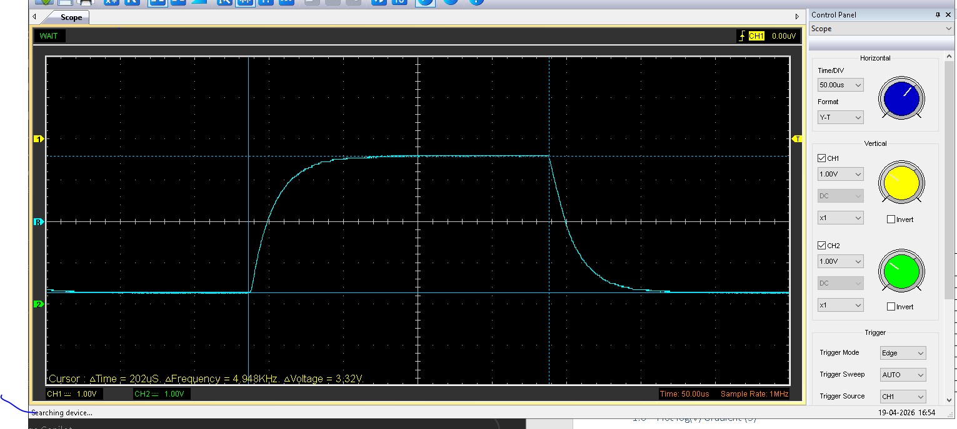
R = 100Ω
C = 1µF
Equation: τ = R × C 100 x 0.0000001 =100µs
Time/div =50µs across 10 divisions

Function Generator output square wave

Figure 2
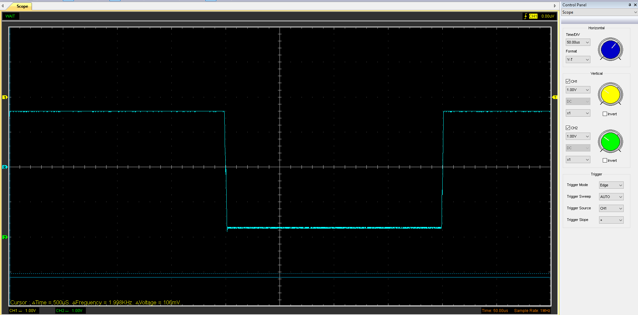
Voltage = 3.34 v
Time base = 200µS
Figure 2 shows the output wave from the function generator. This signal was used to repeatedly charge and discharge the capacitor during the experiment.

Capacitor charge and discharge wave marked at correct points.

Figure 3
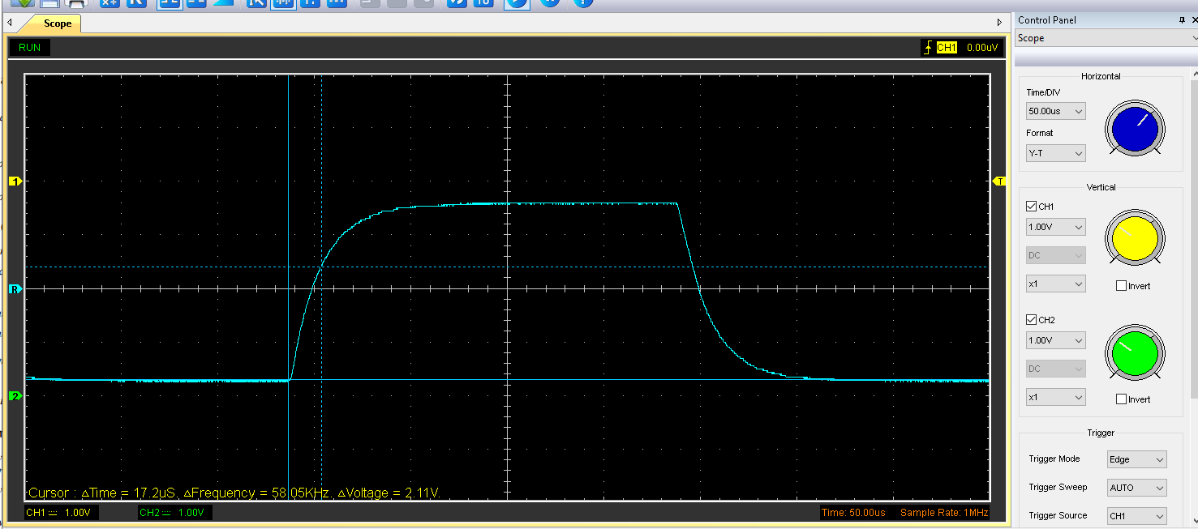
Figure 4
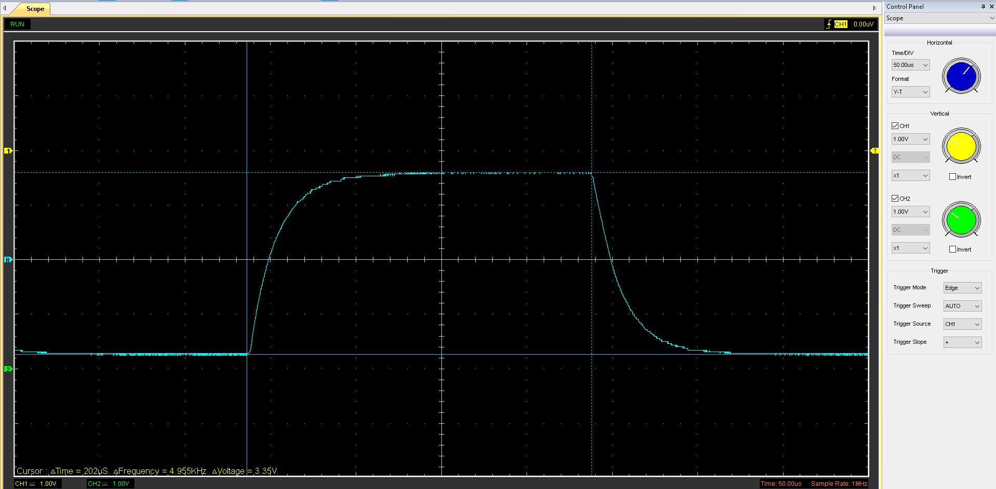
At one time constant the capacitor reaches 63% of its final voltage which confirms first order RC behaviour.

Basic Capacitor Calculations (6)

Equation = C=t/R​ 3.34v x 0.63 =2.10 at 2.10 volts time is 15.8µs
Resistance= 100 Ω
Time = 15.8µs

0.0000158/100= 0.000000158
C=0.158µF

Capacitor discharge table (5)
Time (µs) | Voltage (V) | ln (V) | dy = y2 – y1 | dx = x2- x1 | dy/dx
 |  |  | dy = ln(V)2-ln(V)1 | dx = Time2 – Time1
5 | 3.19 | 1.160020917 | x | x | x
10 | 3.13 | 1.141033005 | -0.018987912 | 5 | -0.003797582
15 | 3.06 | 1.118414916 | -0.022618089 | 5 | -0.004523618
20 | 2.96 | 1.085189268 | -0.033225648 | 5 | -0.00664513
25 | 2.81 | 1.033184483 | -0.052004785 | 5 | -0.010400957
30 | 2.56 | 0.940007258 | -0.093177225 | 5 | -0.018635445
35 | 2.31 | 0.837247525 | -0.102759734 | 5 | -0.020551947
40 | 1.89 | 0.636576829 | -0.200670695 | 5 | -0.040134139
45 | 1.17 | 0.157003749 | -0.47957308 | 5 | -0.095914616
50 | 0.629 | -0.463624022 | -0.620627771 | 5 | -0.124125554

Plot log(V) Gradient (5)

Gradient Calculations and Compare (8)

Gradient Calculations

Comparison table
 | Capacitance | Delta | Percentage difference
Actual | 1 µF | x | X
Marker Calculation
Gradient Calculation

Capacitor Uses (5)
Power supply smoothing- In power supplies, capacitors are used to smooth the output of rectified AC voltage. After an AC signal is converted to DC using a rectifier, the voltage still contains ripple (fluctuations). A smoothing capacitor is placed across the supply output, where it charges up when the voltage rises and discharges when the voltage falls. This action fills in the voltage gaps, resulting in a more stable and continuous DC voltage.
Sensor signal filtering - Capacitors are used in RC low-pass filter circuits to remove high-frequency noise from sensor signals. Automotive sensors such as throttle position, temperature, and pressure sensors produce small analogue signals that can be affected by electrical noise. A capacitor working with a resistor smooths the signal by reducing rapid voltage changes while allowing the useful, slower signal to pass through.
Voltage stabilisation - In voltage stabilisation, capacitors are placed close to electronic components to help keep the supply voltage steady. When a circuit suddenly needs more current, the capacitor provides it, preventing the voltage from dropping. The capacitor also helps absorb voltage spikes caused by switching, protecting sensitive electronics.
Dc motor controllers- Capacitors are used in DC motor controllers to reduce electrical noise and improve control stability. Motors generate voltage spikes and electromagnetic interference when switching currents rapidly, especially in PWM-controlled systems. Capacitors suppress these transients and smooth voltage variations, protecting motor driver circuits and reducing stress on components.

Inaccuracies Question (4)

Throughout the whole experiment and data calculations there were at many points where inaccuracies could’ve affected my final results.
The measurement equipment used immediately introduces inaccuracies. Because I have used the Hantek software small errors in cursor placement can affect the reading for the time constant and plotting the values in the table. Additionally, internal resistance from the oscilloscope probe and function generator could’ve altered the overall effective resistance of the RC circuit. There is also an element of human error, as selecting discrete points from a continuous discharge curve requires too much accuracy for the resolution of the program. This can lead to small deviations having a larger impact on the final result. parasitic effects such as stray capacitance in breadboard wiring and temperature variations during the experiment can subtly affect circuit behaviour. Collectively, these factors explain why the experimentally determined capacitance may not exactly match the actual value.

Risk Question (10)

A Controller Area Network (CAN) bus is a serial communication system used in vehicles to allow electronic control units to exchange information over a shared two-wire network. By broadcasting message-based data rather than using point-to-point wiring, CAN significantly reduces wiring complexity, cost, and weight while maintaining high reliability and real-time performance. The only downside to a Can bus system is that it isn’t very cyber secure. And doesn’t meet ISO/ SAE 21434;20201 standards. This is because it has no encryption no authentication. This means a malicious attack could easily take place and inject fake data. And ECUs cannot easily tell if data is fake. The ways this could happen is through diagnostic ports (OBD-II), telematics units, Bluetooth/infotainment systems and over the air updates. To mitigate these issues for it to meet the standards, the vehicle network is split into multiple CAN domains like powertrain, body, infotainment, these are only connected through secure gateways so if one fails the rest don’t. to prevent any single domain from fully failing in the first place intrusion detection systems are put in place, which look out for things like unexpected message IDs abnormal frequency of messages and timing deviations. Intrusion detection systems can’t fully prevent an attack but does detect them early enough to enable fall back modes.

https://www.iso.org/standard/70918.html

https://pmc.ncbi.nlm.nih.gov/articles/PMC7219335/

https://copperhilltech.com/blog/secure-your-canbus-implementing-isosae-21434-in-embedded-systems/

