BA(Hons) International Hotel Management
BMIH6005
Organisational Consultancy
Student name : Bianca Negreanu
Student number:2244613
Module Leader : Neil Dyer

I confirm that I have not used any AI tools in the research and creation of this assignment. I confirm that I have not presented any AI generated materials as my own work. I
confirm I have copies of my drafts, notes, and other resources I used, which I may be asked to
provide in evidence.

Table of Contents
Executive Summary 3
Introduction 5
Analysis 6
STEEPLED Analysis 6
Core Issues Affecting Hintlesham Hall Hotel 9
SWOT Analysis 10
TOWS Analysis of Hintlesham Hall Hotel 12
Recommendations and Change Management 14
Recommendations 14
Change Management Initiatives 20
Action Plan 22
Conclusion 24
References 26

Executive Summary
In this contemporary era, the Hospitality Sector has evolved its operations towards digitalisation and has determined several policies for rapid development to meet guests’ requirements. For developing a consultancy report on Hintlesham Hall Hotel, the study has considered the organisational background and identified several ongoing issues of the firm that directly and indirectly affect eat overall operations and reputation in the competitive environment. Based on this situation, it becomes necessary to identify the most efficient strategies for overcoming ongoing issues by implementing potential development plans. The report has found that Hintlesham Hall Hotel is a popular and established hotel that is located in Suffolk, England. It is a Grade I hotel and offers a vast range of dining, accommodation, and services related to different events. With 32 guest rooms, the hotel operates its activities through comparatively traditional approaches. Additionally, it can be stated that this project is developed by Heritage Hospitality Consulting, a popular and successful customer-focused organisation that usually provides business development strategies to obtain productive development for distinguished areas. The consultancy report has identified that the company is facing difficulties with a negative reputation due to inefficient front-desk management and uncomfortable rooms for guests. It has also been identified that the organisation follows traditional front-of-house services, which creates difficulties in making seamless customer handling and guest attendance. It has been observed that with traditional approaches, the company faces difficulties in providing prompt services and booking. Based on this situation, the competitiveness of the firm is highly affected, and areas for potential development have been congested. It becomes important to conduct internal as well as external analysis to identify organisational approaches and determine which are the most efficient strategies for the company to enhance operations and me targeted objectives. Thus, this study has considered analyses of multiple strategies and frameworks to make the consultancy report more realistic and relevant to current issues.
In this study, the researcher utilised the SWOT analysis framework and STEEPLED analysis framework to identify both internal and external environments of, based on the identified issues. From both of these frameworks, it has been found that due to different environmental factors, companies face to maintaining relevant activities to implement new policies. Based on the STEEPLED analysis, it has been found that different micro environments and factors, including technological, social environmental, legal, political and other factors, are influencing organisations during the time of conducting large-scale activities and obtaining effective outcomes through proper operations. Due to the rapid development in technology services, especially in the hospitality sector, the absence of advanced booking services and digital help kiosks, the company face competitive pressures from other established and advanced Hotel companies. The SWOT analysis showed its internal strengths, weaknesses, opportunities and potential threats in the marketplace because identification of weaknesses is important to develop mitigation strategies by considering the best plans to overcome organisational limitations by utilising opportunities. On the other hand, identification of the organisational strengths is important to make decisions for reducing external threats and developing potential expansion strategies. The TOWS Matrix combines these strengths, weaknesses, opportunities and threats to develop effective action plans, based on distinct situations. To establish new customer-engaging strategies, how these identifications can bring benefits to the company is discussed in this consultancy report. Based on the market situations and internal capabilities, the company try to consider development strategies to align its activities to meet customer requirements. This consultancy report showed how organisations need to develop effective solutions by considering detailed recommendation plans, based on situational analysis.
By establishing recommendations and change management strategies, the consultancy report showed how Hintlesham Hall Hotel needs to conduct effective development policies to overcome ongoing issues and implement new strategies, based on requirements. These recommendations also showed the impact of individual plans and potential implementation strategies to meet customer needs and organisational requirements. Through the utilisation of different Change management approaches along with a thematic framework, the consultancy report showed how this organisation can obtain benefits through change management initiatives and programs. Additionally, these recommendation plans also develop proper success measurement policies with benefits and probable cost structures. This study also develops a proper measurement and projected budget plan to determine which areas the company needs to foster its operations towards the policies of meeting internal issues and operational gaps. By developing and action plan, the consultancy report identified desired solutions, based on different problems and projected outcomes with a time frame, completion date, estimated budget and required resources. The main benefit of considering this action plan is to identify potential policies which have the ability to make the overall business operation successful and obtain competitive advantages, based on market situations and the latest industrial trends. It is anticipated that this consultancy report will help the firm to initiate multiple development strategies for further expansion and development as per the latest industrial conditions and provide opportunities to become competitive in the evolving landscape.

Introduction
The delivery of services of a high quality is vital in the hospitality industry. Guests are prone to expecting comfort, efficiency, and a positive environment during their stay. Failure to maintain these can damage the reputation of the hotel, along with reducing the loyalty of the customers.
Discussion of the Issue
A review of Hintlesham Hall Hotel by a customer revealed a number of service-related problems. It mentioned a slow level of service, an unstaffed area at the reception and bar, and an error in booking. This required a sizeable amount of hours to fix eventually. The guest was not satisfied in spite of the offer of beverages in a complimentary form (Booking.com, 2025).
Apart from these, the rooms and hallways were described as outdated and extremely warm. The incapability of staff at a core point of service can tend toward frustration and a poor form of impression. A delay in fixing errors in a booking causes stress, along with reducing the trust of guests. An old and uncomfortable condition of rooms may indicate the hotel’s inability to maintain its facilities in a better way. These factors showcase outcomes in the form of negative reviews online, a reduced number of bookings, and a loss of competitive advantage in the market.
Background of the Hotel
Hintlesham Hall Hotel is considered a reputed historic hotel located in Suffolk, England. The building is a manor listed as Grade I. It is generally popular for its appeal, considering history, setting, and impeccable design. The hotel offers a vast range of dining, accommodation, and services related to weddings and events. The hotel has 32 guest rooms at the current stage (Hintlesham Hall, 2025). Hintlesham’s rooms are committed to a personalised form of hospitality. A turnover of around 7.5 million pounds was evident last year (Owner, 2024).
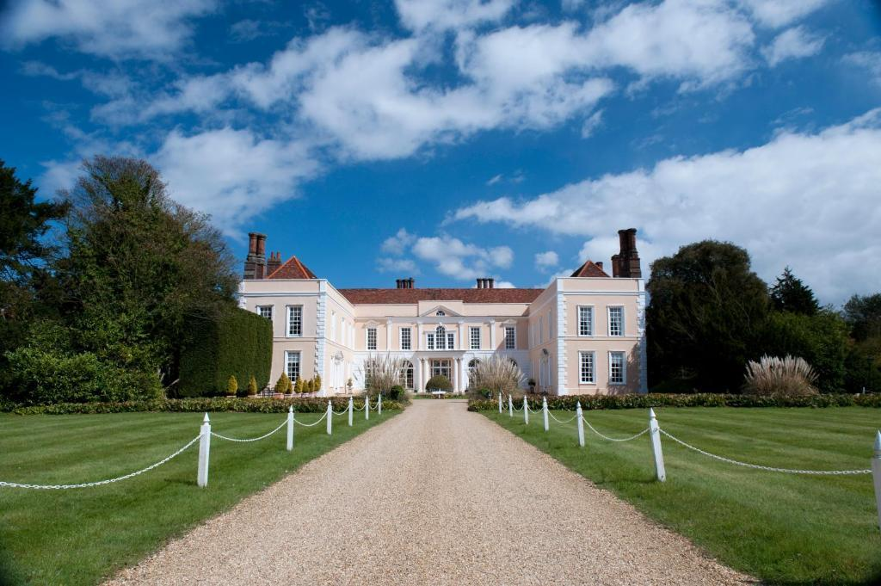
Figure: Hintlesham Hall Hotel
(Source: Booking.com, 2025)
Background of the Consultancy Firm
Heritage Hospitality Consulting is a specialist business entity. It works with a number of historic hotels and boutique-based properties (Heritage Hospitality Consulting, 2025). The firm is helpful for a client in introducing improvements in customer-focused services, operations, and planning for the long term. It focuses on the maintenance of the balance between the traditional approach to service and modernisation. The firm provides a number of advice as an expert. The goal is to ensure the competitiveness of a historic hotel, along with maintaining its respective unique identity.
Theories and Frameworks to Be Used
The report will utilise a range of tools to analyse the problems at Hintlesham Hall Hotel. The STEEPLED framework will be helpful in the identification of a number of factors associated with influencing the hotel at an external level. These include social trends, changes in the economy, and legal issues. The SWOT analysis will proceed to the exploration of the hotel's strengths, weaknesses, opportunities, and threats. Eventually, the TOWS matrix will be utilised to develop a number of strategies based on these eventual findings. As a whole, these tools will support a detailed level of analysis to introduce improvements.

Analysis

STEEPLED Analysis
A number of factors influence the way of operation by the hotel, along with serving its guests. A STEEPLED analysis will explore those factors capable of being active contributors to the issues at Hintlesham Hall Hotel (Sorooshian et al., 2020).
Social
The expectations of guests in hospitality have witnessed growth. A sizeable number of customers are prone to value a service with a fast rate, comfort, and professionalism. Hinton and Richter (2022) showcased more than 50% of European consumers’ probability of being influenced by reviews of customers online, considering booking or purchasing an accommodation. A poor range of reviews due to slow service and outdated rooms can damage the reputation of a hotel.
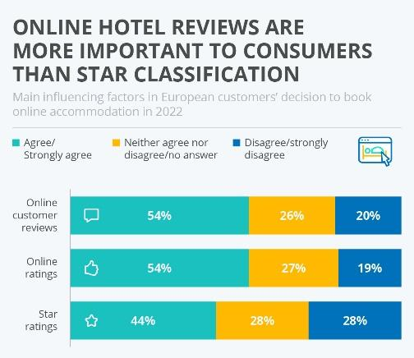
Figure: Online reviews’ importance
(Source: Hinton and Richter, 2022)
Technological
Hotels in the current day are prone to utilising technology to introduce improvements in bookings, communication, and the comfort of guests. Issues in the form of delays may occur in the absence of a modern approach to systems related to booking. The absence of an alert and messaging can cause staff to be absent during guests’ requests for them. 50% of surveyed guests expect a digital form of check-in and payment in a contactless form (Statista, 2024). The absence of a smart system based on modification of the climate inside the room may tend toward overheating, associated with reducing the comfort of guests.
Economic
The average price of electricity for UK-based businesses has increased from around 15 pence/kWh in 2021 to 28.39 pence/kWh in 2023 (ONS, 2025). The growth of such costs has influenced a sizeable number of business entities in a negative way. Hotels may reduce staff or delay maintenance to control such costs. This could explain a low level of presence among staff and the poor condition of the rooms. However, guests paying a high level of price expect comfort and quality. Failing to fulfil these expectations may showcase outcomes in the form of losing an opportunity to generate revenue and a poor review.
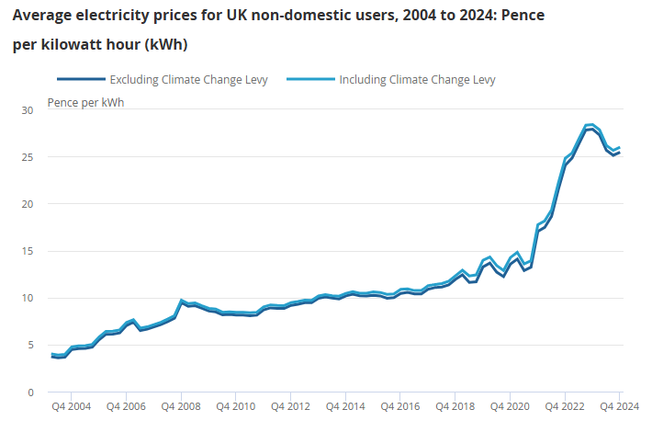
Figure: Electricity price increase for UK businesses
(Source: ONS, 2025)
Environmental
A number of modern hotels are expected to follow a sustainable regime. Older buildings may witness a struggle associated with insulation and saving energy. An outdated system related to heating may tend toward rooms being warm and wasteful. The regulation, named the Energy Performance of Buildings (England and Wales) 2012, requires an assessment and improvement on a regular basis (GOV.UK, 2020). Failure to fulfil these can damage the environment and the reputation of the hotel.
Political and Legal
The rules after Brexit regarding immigration have made it difficult for hotels in the UK to hire staff from outside the country. This eventually caused shortages of around 330,000 workers (Centre for European Reform, 2023). However, the industries still consider hiring workers due to shortages and diversification in the workplace. CIPD (2021) further addressed the issue related to shortages in staff. Hotels are further required to follow the Equality Act 2010 (Evans and Owens, 2024). These laws safeguard a number of guests and staff. Failure to follow these can cause a number of legal consequences.
Ethical and Demographic
Ethical service indicates being respectful, honest, and fair. Guests belonging to a distinct group of ages and backgrounds may have a diverse range of requirements. A long period of waiting and a delay in service can indicate a lack of care, considering the well-being of guests. 57% of surveyed guests stated digitisation of the entire process of booking as a faster approach (Statista, 2021). A balance of tradition and a modern form of service is vital for fulfilling the diverse range of expectations, considering a hotel based on heritage, such as Hintlesham Hall.

Core Issues Affecting Hintlesham Hall Hotel
Slow Service and Staffing Shortages
A number of guests have reported the existence of a staffless area at the reception and bar. This tended toward a long period of waiting and a poor impression, considering Hintlesham. The hospitality sector in the UK is confronted with a shortage of more than 130,000 workers (UKHospitality, 2023). Such a shortage of staff generally reduces the quality of the service, along with tending toward a set of negative reviews. The probability of returning guests due to a hotel’ friendly and available staff is evident. A poor form of service can discourage a repeated visit.
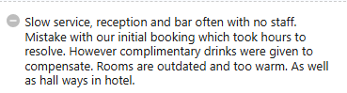
Figure: Negative review of Hintlesham Hall Hotel
(Source: Booking.com, 2025)
Booking Errors and Delayed Resolutions
Mistakes in the booking of guests can damage trust in a major way. One of the guests reported waiting for hours to resolve an issue. An inaccurate approach to bookings creates stress for guests, along with reducing efficiency. A problem related to booking damages the reputation of the hotel, along with being capable of reducing bookings in the future.
Outdated and Uncomfortable Rooms
A sizeable number of reviews described rooms and hallways as extremely warm and outdated. Such aspects made the stay uncomfortable. Currently, guests expect a set of modern and efficient form of features, associated with saving energy and automation. Around 73% of guests prefer hotels with an advanced level of technology in rooms, such as IoT or opening doors with an app (Statista, 2024). Outdated facilities can reduce the satisfaction of guests, along with reducing competitiveness.

SWOT Analysis
The STEEPLED was helpful in showcasing the issues associated with the external environment of Hintlesham. A SWOT analysis can spot the strengths, weaknesses, opportunities, and threats of the hotel in detail at an internal level. It can provide a neater grasp of the situation, along with guiding the development of an effective set of strategies. The goal is to introduce improvements in performance and satisfaction of guests (Benzaghta et al., 2021).
Strengths
Hintlesham Hall Hotel is a historic property associated with a heritage and countryside-based location in Suffolk. The building’s architecture and gardens provide a luxurious atmosphere, extremely helpful in attracting guests. The hotel additionally receives benefits from recognition of the brand and positive range of feedback on its provided experiences. The hotel received praise for offering an attractive Christmas-based experience and deals within a budget-friendly range. A sizeable number of guests on TripAdvisor rated its services at a high level (TripAdvisor, 2025). This adds value to the experience of guests, along with encouraging marketing through word of mouth.
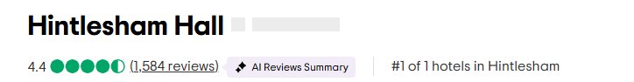
Figure: Overall guest rating of Hintlesham
(Source: TripAdvisor, 2025)
Weaknesses
A number of guests have reported a slow level of service, errors in booking, and outdated facilities in the rooms. These issues reduce satisfaction, along with influencing its online reputation. 92% consider negative reviews as a vital aspect to consider a business at a low level (Dixon, 2022). This can cause a reduction in the number of bookings for a hotel. Hintlesham additionally lacks a modern form of technological advancement. The absence of advanced technological features placed the hotel behind its existing range of rival entities.
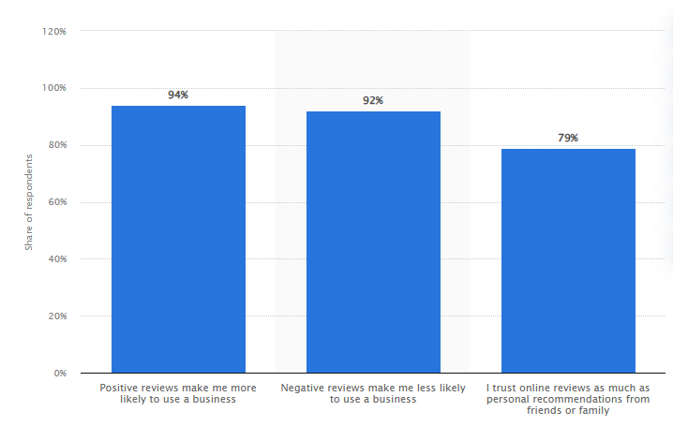
Figure: Impact of online reviews on business
(Source: Dixon, 2022)
Opportunities
There is an opportunity to modernise the services related to guests without avoiding the traditional aspects associated with the hotel. The addition of a number of tools in the form of a system related to the management of bookings or controls of the climate in the room can introduce improvements in comfort and service. The hotel can additionally target a number of markets, consisting of eco-conscious travellers. The upgrading of a system with efficiency, considering energy, and the promotion of sustainability could attract a sizeable number of guests. According to the World Economic Forum (2023), 76% of travellers prefer an eco-friendly form of accommodation.
Threats
The shortage of labour in the hospitality industry in the UK may worsen the availability of skilled staff. This can influence the speed and quality of service. The growth of operation-related costs, associated with the price of energy and wages, may additionally reduce the profit margin of a business. The rate of price growth or inflation hit 2% in May (Rice, 2024). This can potentially reduce the demand for guests. The enhanced competition from boutique-based hotels and platforms in the form of Airbnb can be considered a major threat. The latter is associated with 490 million bookings in 2024 (Statista, 2025). A number of alternatives can generally offer a set of modern facilities at a competitive range of prices.

TOWS Analysis of Hintlesham Hall Hotel
The TOWS analysis combines a number of strengths and weaknesses with opportunities and threats. This can be helpful for Hintlesham to create a neat set of strategies. The goal is to introduce improvements in the quality of services, the satisfaction of guests, and the competitiveness in the market through diversification (Bachtiar, 2020).
TOWS | Strengths  - Attractive countryside-based location  - Strong brand recognition  - High ratings in dining-based experience  - Word-of-mouth promotion | Weaknesses  - Slow level of guest-focused services  - Booking-related errors  - Outdated room facilities  - Limited range of technological features  - Negative online reviews
Opportunities  - Growth of heritage and wellness-based tourism  - Eco-conscious demand for travelling  - Smart room technology's adoption  - Digital check-in and booking systems | Strengths-Opportunities (SO Strategies)  The unique setting of the hotel and experiences of dining can be promoted through a campaign related to heritage-focused tourism. Visiting historic places and religious buildings was ranked within the top 10 participatory activities by visitors from outside the UK (VisitBritain, 2020). Marketing the hotel as a destination for stays based on culture and heritage can attract both domestic and international travellers. The hotel can introduce a number of advanced spa-based facilities or facilities related to yoga. This can be associated with the growth of interest in wellness-related tourism. The industry related to wellness-based tourism witnesses growth at an extremely rapid rate, along with being projected to be valued at around 1.35 trillion USD in 2028 (Sands, 2025). Offering such services in a traditional setting of the countryside can enhance bookings and the satisfaction of guests. | Strengths-Threats (ST Strategies)  The hotel can utilise its high ratings from guests for food and its brand-related image (Hintlesham Hall, 2025). The goal is to build partnerships with a number of suppliers at a local level, along with hosting several culinary events. Such an approach can be helpful to differentiate it from a range of competitors, such as Airbnb. Hosting of menus based on seasons regarding festivals of food could attract a sizeable number of visitors, along with generating additional revenue. The hotel can introduce options regarding self-service for guests, considering a set of tasks, in the form of digital menus or kiosks for check-in. The goal is to reduce the influence of shortages related to staff (Giousmpasoglou and Hua, 2020).
Threats  - Shortages in labour  - Rising costs of energy and wages  - Guests' preference for a modern stay  - Economic inflation  - Popularity of Airbnb | Weaknesses-Opportunities (WO Strategies)  Investment in smart technologies related to the betterment of rooms can enhance the experiences related to guests, along with reducing the cost of energy (Lata and Sharma, 2024). Such technology can be an automated approach to heating or lighting controlled by a mobile app. Smart technology can reduce the usage of energy up to a certain level. Apart from these, training of staff in the digital system can reduce the errors related to booking, along with introducing improvements in efficiency (Kuusamo, 2022). Such an approach can additionally enhance the confidence of staff associated with a reduction in turnover. | Weaknesses-Threats (WT Strategies)  The hotel can implement a plan regarding the recovery of services. The goal is to cope with poor reviews and a loss of trust among guests. The loyalty of customers reduces by up to 20% in the case of not focusing on vital problems by an organisation (Cleveland, 2021). For instance, emails related to follow-up at an immediate level, vouchers of apology, or discounts considering loyalty can be available. The hotel could introduce a number of systems related to controlling costs, audits of energy, or the dynamic range of pricing (Talón-Ballestero et al., 2022). The goal is to manage the growth of costs. These measures can safeguard the profit margin during periods with a low level of demand.
Table: TOWS analysis
(Source: Self-developed)

Recommendations and Change Management

Recommendations
Based on the organisational issues of inefficient front-house services and uncomfortable room conditions, Hintlesham Hall Hotel needs to develop an efficient strategic development goal to overcome these issues and implement flawless customer service. As per the perspective of Buttrick (2009), project management plans of companies need to consider multiple solutions, based on organisational issues that harm their reputation and customer satisfaction index. In this part of the study, some strategic recommendations will be introduced and identify potential impact, implementation strategies, success measurement and projected costs accordingly.
Implementation of Online Front-Desk Services
Impact: Due to the rapid development in digital services in the global hotel sector, companies feel the importance of introducing online services in front-desk services to engage customers (Anwar et al. 2024). It can be recommended that Hintlesham Hall Hotel implement online front-desk services to streamline visitors’ arrival and enhance rapid services to satisfy guests. As per the perspective of Kovacevic et al. (2024), it can be said that online front-desk services might positively impact the company to establish an advanced guest service with the latest digital approaches and become competitive.
Implementation Strategies: By installing self-help kiosks and online portals, the company can implement digital front-desk services. Additionally, by developing mobile-based check-in services, the company can implement digital kiosk operations within the workplace (Ivanov, 2023).
Success Measurements: The success of the online front-desk implementation can be measured by customer feedback analysis. Based on the research work of Bhatti and Alawad (2023), it can be said that digitisation in workplace settings, companies in this contemporary era use different success measuring models, by which employee feedback analysis and customer feedback analysis are important. Apart from making the booking and check-in operations smoother and smarter, digitalised strategies will help to reduce operation times. By analysing overall front desk operations, the company can measure success rates.
Benefits: According to the Harvard Business Review report, it has been seen that smart and developed companies in this current time use the combination of digital and human effort to make customer service perfect (Hbr, 2024). With digital kiosk operations, the company will enhance faster customer services and modernise its brand reputation in the competitive market. Additionally, guest services can be developed and smartened accordingly.
Costs: It is anticipated that the company needs nearly £20,000 to £35,000 for hardware maintenance and software installation. Moreover, nearly £7,200 might be required for staff training purposes.
Implementation of Online Booking and E-Payment Systems
Impact: According to the research work of HAJI and JILENGA (2022), it has been found that hospitality companies in this current era utilise e-payment systems and online booking activities to overcome issues related to operational delays and unwanted human errors. By implementing online booking facilities and e-payment actions, the company might be impacted positively because these services will help the company to overcome inefficiency in front-of-house services. Through online booking facilities and e-payment actions, Hintlesham Hall Hotel achieve energy-efficient services, proficiency in huge customer handling and keeping customer information safe (Jennifer et al. 2022).
Implementation Strategies: Development of customer handling software and implementation of self-help desks in front-of-house services, the company can obtain success in the process of implementing online booking and e-payment approaches. Based on the perspective of Samadyo and Pramudwiatmoko (2025), it has also been identified that by establishing a mobile-based application and integrating digital platforms in the official pages of firms, hotel companies can establish cashless payment and e-booking facilities. It can be recommended to Hintlesham Hall Hotel, implement a mobile application and integrate e-services in its front-of-house activities.
Success Measurements: Analysing customer feedback and customer perspectives for organisational development, a company can identify whether its implementation strategies are beneficial or not for the firm (Noordzife, 2014). For Hintlesham Hall Hotel, it can be recommended that an analysis and identification of customers’ perspectives and feedback on service operations will help the firm to determine its online booking and e-payment strategies.
Benefits: Based on the opinion of Garrouch (2022), it has been found that the implementation of e-payment and online booking systems brings opportunities to companies by reducing guest service operation times and generating seamless services throughout the operational areas of front desks. For Hintlesham Hotel, the implementation of this strategy might benefit errorless customer service even in an employee shortage.
Costs: It is anticipated that to develop mobile-based booking systems and e-payment platforms, the company requires nearly £17,000 for software development and nearly £2,000 for maintenance every year.
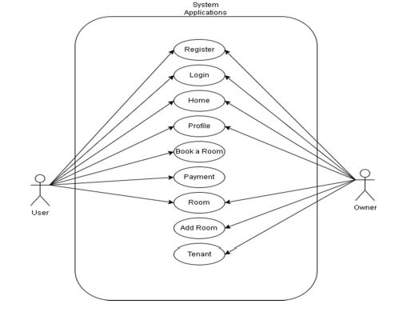
Diagram of E-Payment Strategies in Hotel Operations
(Source: Samadyo and Pramudwiatmoko, 2025)
Developing Accommodations and Frequent Maintenance
Impact: To resolve the issue, inefficient accommodation and uncomfortable room conditions, the company needs to focus on its service quality. Developing accommodations and conducting regular maintenance can help Hintlesham Hall Hotel ensure seamless guest experiences throughout operational areas. Based on the perspective of Shebanina et al. (2023), it has been found that comfortable room conditions and high-end accommodations are the goodwill of a hotel company. Developing accommodations and room conditions, along with regular maintenance, will impact the organisation positively in the long term.
Implementation Strategy: Hintlesham Hall Hotel needs to make its rooms and associated accommodations good and issue-free. By making outdated rooms advanced and integrating the latest services into each room, the company can resolve this issue successfully. As per the opinion of Whittington et al. (2020), it can be recommended to the company that it needs to implement refurbishment strategies and establish regular maintenance schedules can help to develop guest-engaging services throughout its rooms. To achieve more success, Hintlesham Hall Hotel needs to conduct room audits regularly and fix identified issues immediately.
Success Measurement: As per the perspective of Kipping and Clark (2012), it can be said that by maintaining regular development programs in business management activities, companies can obtain success during the time of implementing new strategies. For Hintlesham Hotel, it can be suggested that by conducting regular feedback audits and analysing room satisfaction scores from visitors, conducting success measurement becomes easy for the company. Additionally, as per the opinion of Mavridopoulou and O’Mahoney (2020), it can be suggested that by analysing the tendencies of visitors to select this hotel as their choice option, the company can measure its development scores purposefully.
Benefits: It is anticipated that by implementing a refurbishment plan for accommodation development, the company will benefit from high-end customer satisfaction. As per the perspective of Shebanina et al. (2023), it can be said that in this digital era, smart accommodations with seamless and comfortable room conditions can help a hotel company to obtain competitive advantages in the market. However, through the development of room conditions and supportive accommodations, the company can easily obtain marketplace success along with a good reputation in the competitive environment.
Costs: For overall development and new update installations, the company might require nearly £27,000 to £33,000 early. For maintenance, it might need £7,000 to £8,000 yearly.
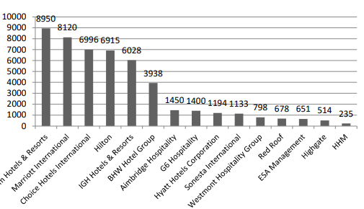
Developing Sustainable Accommodations in the Global Hospitality Companies
(Source: Shebanina et al., 2023)
Employee Training Programs to Meet Guest Requirements
Impact: Training employees is one of the most vital strategies for the company to enhance its overall operations among digital front-desk services and customer-engaging accommodations. According to the perspective of Bilderback and Miller (2023), it has been found that by considering training programs, an organisation can enhance its abilities to meet new objectives and meet customer requirements. The strategy will impact the organisation positively by establishing customer-engaging practices. It will also enhance the skills and competencies of individual worker and foster their professionalism accordingly.
Implementation Strategy: As per the opinion of Urbancová et al. (2021), it can be said that by conducting short-term campaigns and workshops, organisations can enhance employees’ skills and competencies to achieve corporate goals. For Hintlesham, conducting employee training campaigns regularly and introducing different workshops, based on the latest market trends and customers’ behaviours, will be helpful to become efficient in achieving customer requirements. Additionally, it can be said that the company needs to establish key performance indicators to develop benchmarks in front of employees and motivate them to achieve these goals purposefully (Employment-studies.co, 2024 ).
Success Measurement: The company can conduct employees’ skill analysis regularly to identify their achievements and development in organisational fields. Additionally, the company can evaluate customer feedback, and if it is found that the complaint rates are reducing, it can be said that the company is able to achieve its objectives properly. The organisation can measure its success by conducting internal analysis, and if it is found that the development rates are increasing in overall areas, it can be said that the employee training activities are going in the right direction.
Benefits: As per the research work of Yimam (2022), it has been noted that with high-end employee training programs, the company can achieve success, getting higher customer satisfaction. On the other hand, with better employee training programs, the organisation can enhance worker motivation levels and achieve better engagement results (Kuruppu et al. 2021). Finally, it can be deduced that with higher employee training, the company can easily enhance its market reputation and obtain competitive advantages accordingly.
Costs: For conducting effective employee training programs throughout the year, Hintlesham Hotel might need £4,500 to £6,500.
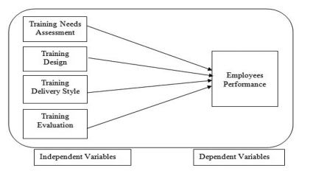
Obtaining High Employee Performance Through Training Programs
(Source: Yimam, 2022)

Change Management Initiatives
The implementation of newly proposed strategies needs to consider an effective change management model in this regard. Based on the perspective of Subramaniam et al. (2011), for further development, organisations need to consider different potential development strategies and initiate operational changes accordingly. By applying Lewin’s Three-Stage Change Management Model, Hintlesham Hall Hotel can implement operational changes and establish new operational strategies accordingly (Burnes, 2014). As per this model, three essential stages, including Unfreeze, Change and Refreeze, denote three conditions of employing new strategies and establishing them in organisational workplaces (Memon et al. 2021).
- Unfreeze: To overcome the issue of inefficient accommodations and front-desk services, the company needs to interrupt its ongoing operations and make employees aware of new changes. As for the opinion of Mahmud et al. (2022), the unfreezing stage is essential because organisations usually face difficulties due to employee resistance in this stage.
- Change: After unfreezing traditional and backdated operations, the company needs to implement new strategies of online front-desk services, developing room conditions, implementing smart accommodations and others in the change stage.
- Refreeze: Finally, in the refresh stage, Hintlesham Hall Hotel needs to implement newly adopted strategies throughout its operation and areas and align them with the latest market trends and customer needs.
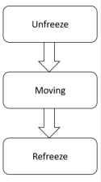
Lewin’s Change Management Model
(Source: Memon et al.2021)
Measuring Success and Projected Benefits
According to the perspective of Kittel et al. (2021), it has been found that organisations need to measure their success by comparing their previous strategies and current strategies thoroughly. For Hintlesham Hall Hotel, it can be said that the company can conduct visitors’ feedback surveys, track employees' performance and evaluate reviews on social media channels to measure its success rates in the competitive environment. Making regular connections with customers through online channels, the company can identify the latest market trends and determine the most effective policies to enhance operations further. Based on the findings of O’Rourke (2021), it can also be stated that through the proper implementation of development policies, an organisation can achieve success in competing with other firms. For Hintlesham Hotel, the implementation of new strategies will be beneficial because it will enhance the opportunity of developing digital-based services and expand brand reputation in the competitive environment.
Projected Budget
Projected Areas for New Installations | Estimated Annual Cost
- Software Development Programs  - Hardware Development Programs  - Implementation of Digital Kiosks  - Establishment Costs  - Rook Refurbishment Cost  - Auting Programs  - Regular Maintenance Activities  - Employee Training Programs | £31,200  £21,000  £5,000  £6,500  £4,700  £4,700  £5,500  £11,000
Projected Total Costs | £89,600

Action Plan
Problem | Solution | Desired Outcome | Timeframe | Completion Date | Estimated Budget | Required Resources
Slow service at the front desk and delays in booking | Implementing online services in the form of mobile-based check-in and kiosks in a digital form (Kant and Koti, 2023) | Faster check-in or check-out, improvement in guest satisfaction, and enhanced image as a brand (Bhuiyan et al., 2022) | 4 months for both setup and beta-testing | October 2025 | Within £20,000-£35,000 | Hardware, software, and training staff
Errors in booking and delays in handling customers | Launching systems related to online booking and payment in the form of a bug-free and user-friendly mobile app or website (Aldaas, 2021) | Streamlining in booking, secure payments, and enhanced operational efficiency (Whittingtoet al., 2020) | 3 months | September 2025 | £19,000 | Software and maintenance
Inefficient accommodations | By conducting regular updates of visitor-friendly accommodation and organising audit programs, the organisation can develop accommodations for customers. Furthermore, by establishing refurbishment plans, the organisation can overcome issues related to inefficient hotel room (Bertolazzi and Micocci, 2023). | Through the implementation of refurbishment plans and regular monitoring incentives, it is anticipated that the organisation will obtain visitors’ positive feedback and be able to attract more tourists and guests accordingly. | 03 months for refurbishment and monitoring will be continued. | September 2025 | £25,000-£45,000 | Fixed assets and the employment of new workers.
Lack of online booking facilities | By developing mobile waste applications and a digital platform, aligned with official websites, the organisation can enhance online booking facilities (Tsai, 2023). By establishing self-help kiosks, the company can implement digital desks for digital front-desk services. | The workplace atmosphere and reputation of the company will be enhanced through these digital initiatives. The company will perform properly in the competition and attract tech-savvy guests | 04 months for overall digital activities development | October 2025 | £5,000-£7,000 | Software development equipment, hardware development items and maintenance items.
Table: Action Plan
(Source: Self-developed)

Conclusion
Hence, it can be concluded that tools in the form of STEEPLED and SWOT analyses proved to be helpful in grasping the situation of the hotel. The hotel has a number of strengths, along with a set of vital problems associated with it in the long term. However, these issues have a major influence on its service and reputation. The hotel has a distinctive set of features in the form of its historic setting, attractive gardens, and an impeccable reputation for food. A sizeable number of guests enjoy the peaceful location of the countryside. A number of positive reviews highlight the hotel’s dining and festive experiences. However, the hotel is associated with a set of serious issues. These include a slow level of service, errors in booking, outdated rooms, and an insufficient number of staff. These problems reduce the satisfaction of customers, along with being prone to influencing bookings in a repeated form. The external environment is additionally changing at a faster rate. Guests expect a quick rate of service and a modern form of technological advancement. A sizeable number of individuals are prone to preferring digital tools in the form of mobile check-in and smart controls of the room. On the other hand, costs associated with energy and labour are rising. Hiring staff has become excessively difficult after the modification of the policy regarding immigration due to Brexit. A range of older hotels, such as Hintlesham, must additionally follow a strict set of rules regarding the environment and safety. These factors may add pressure to introduce improvements in service. The review by customers showcased the hotel’s requirement to update its existing range of systems and rooms. There is a risk of lagging behind rivals without a set of modern services. However, there is a set of opportunities for change in a major way. The report recommended upgrades with a digital approach. The hotel should set up a number of services related to the front desk online. It should offer options regarding booking online and e-payment. These modifications will introduce improvements in speed and accuracy in guest-focused services. Such an approach will additionally be helpful in the reduction of a set of errors, along with introducing improvements in the efficiency of staff. An action plan has been provided. It includes the problem, solution, outcome, cost, and time required for each of the steps. This will be helpful for the hotel to plan in a better way, along with achieving eventual outcomes. The modifications are practical, affordable, and suitable for the size and style of the hotel. Eventually, I would like to thank Hintlesham Hall Hotel for the opportunity to work on this project. It has been a pleasure to provide support and advice. I hope this report can be helpful for the hotel to consider a smart improvement, along with continuing its success in the future.

References
Booking.com, 2025. Hintlesham Hall Hotel. Available at: https://www.booking.com/hotel/gb/hintleshamhallhotel.en-gb.html (Accessed: 7 June 2025).
Hintlesham Hall, 2025. Luxurious accommodation at Hintlesham Hall, Suffolk. Available at: https://hintleshamhall.co.uk/rooms/#:~:text=Experience%20style%20and%20comfort%20with,greeted%20by%20the%20inviting%20ambience (Accessed: 7 June 2025).
Dixon, S. J., 2022. Effect of online reviews on local business customer opinion 2020, Statista. Available at: https://www.statista.com/statistics/315751/online-review-customer-opinion/ (Accessed: 7 June 2025).
Whittington, R., Johnson, G., Scholes, K., Angwin, D. and Regnér, P., 2020. Exploring strategy . Harlow.
CIPD, 2021. Addressing Skills and Labour Shortages Post-Brexit. Available at: https://www.cipd.org/globalassets/media/knowledge/knowledge-hub/reports/addressing-skills-labour-shortages-post-brexit_tcm18-102313.pdf (Accessed: 7 June 2025).
Talón-Ballestero, P., Nieto-García, M. and González-Serrano, L., 2022. The wheel of dynamic pricing: Towards open pricing and one to one pricing in hotel revenue management. International journal of hospitality management, 102, p.103184.
Kuusamo, E., 2022. The development of new and improved online booking system for a small-scale IT maintenance company: a case of Tietsikkari.
Lata, M. and Sharma, V., 2024. Smart City Environment Management: Challenges and Opportunities. Grenze International Journal of Engineering & Technology (GIJET), 10.
Giousmpasoglou, C. and Hua, T.T., 2020. The use of self-service technologies in budget hotels: the case of Bournemouth. European Journal of Tourism, Hospitality and Recreation, 10(3), pp.251-261.
Bhuiyan, K.H., Jahan, I., Zayed, N.M., Islam, K.M.A., Suyaiya, S., Tkachenko, O. and Nitsenko, V., 2022. Smart tourism ecosystem: a new dimension toward sustainable value co-creation. Sustainability, 14(22), p.15043.
Aldaas, A., 2021. A study on electronic payments and economic growth: Global evidences. Accounting, 7(2), pp.409-414.
Kant, S. and Koti, K., 2023. Role of technology in hospitality operations: An overview. International Journal of Language, Literature and Culture (IJLLC), 3(5), pp.32-36.
Cleveland, B., 2021. Three Surprising Facts About Customer Experience. Available at: https://www.forbes.com/councils/forbesbusinesscouncil/2021/07/29/three-surprising-facts-about-customer-experience/ (Accessed: 7 June 2025).
Hintlesham Hall, 2025. Dine in our award-winning restaurant at Hintlesham Hall. Available at: https://hintleshamhall.co.uk/dining/ (Accessed: 7 June 2025).
Sands, R., 2025. Global Wellness Tourism Surges Toward the $1 Trillion Mark. Available at: https://www.forbes.com/sites/rogersands/2025/01/16/global-wellness-tourism-surges-toward-the-1-trillion-mark/ (Accessed: 7 June 2025).
VisitBritain, 2020. Activities in Britain’s nations and regions. Available at: https://www.visitbritain.org/sites/ind/files/2023-04/foresight_165_regional_activities_sep_21.pdf (Accessed: 7 June 2025).
Bachtiar, N.K., 2020. When can SMEs diversify? A study of growth stage model analysis. Journal of Economics, Business, and Management, 8(1), pp.30-37.
Statista, 2025. Topic: Airbnb, Statista. Available at: https://www.statista.com/topics/2273/airbnb/ (Accessed: 7 June 2025).
Rice, C., 2024. Inflation: Hospitality sector struggling with cost pressures, BBC News. Available at: https://www.bbc.com/news/articles/cw99e8v0wg1o (Accessed: 7 June 2025).
World Economic Forum, 2023. Survey of travellers finds 76% want more sustainable options. Available at: https://www.weforum.org/stories/2023/04/survey-of-travelers-finds-76-want-more-sustainable-options/#:~:text=In%20the%202023%20Sustainable%20Travel,over%20the%20next%2012%20months (Accessed: 7 June 2025).
Centre for European Reform, 2023. Brexit has created shortage of 330,000 workers in UK, say economists. Available at: https://www.cer.eu/in-the-press/brexit-has-created-shortage-330000-workers-uk-say-economists#:~:text=Post%2DBrexit%20immigration%20rules%20have,Reform%20think%2Dtanks%20has%20found. (Accessed: 7 June 2025).
Evans, S. and Owens, J., 2024. S Evans.
Benzaghta, M.A., Elwalda, A., Mousa, M.M., Erkan, I. and Rahman, M., 2021. SWOT analysis applications: An integrative literature review. Journal of Global Business Insights, 6(1), pp.54-72.
Statista, 2024. Topic: Digitalization of the hospitality industry worldwide, Statista. Available at: https://www.statista.com/topics/8339/digitalization-of-the-hospitality-industry/#topicOverview (Accessed: 7 June 2025).
UKHospitality, 2023. Worker shortages. Available at: https://www.ukhospitality.org.uk/campaigns/workforce/ (Accessed: 7 June 2025).
Statista, 2021. Guest experiences hotels want to digitalize worldwide 2021, Statista. Available at: https://www.statista.com/statistics/1250380/guest-experiences-hoteliers-want-to-digitalize-worldwide/ (Accessed: 7 June 2025).
Hinton, T. and Richter, F., 2022. Infographic: Online hotel reviews are more important to consumers than star classification, Statista Daily Data. Available at: https://www.statista.com/chart/28992/influenceing-factors-in-accommodation-booking-online/ (Accessed: 7 June 2025).
GOV.UK, 2020. Energy Performance of Buildings Regulations 2012. Available at: https://assets.publishing.service.gov.uk/media/5ebd4b97d3bf7f5d3ff86a7e/Implementation_Report_-_EPB_Regs_2012.pdf (Accessed: 7 June 2025).
Statista, 2024. Hotel technologies global guests want adopted 2022, Statista. Available at: https://www.statista.com/statistics/1398105/hotel-technologies-guests-want-adopted-worldwide/#:~:text=During%20a%202022%20survey%2C%20global,the%20survey%20sample%20saying%20so (Accessed: 7 June 2025).
Owner, H., 2024. Hintlesham Hall Hotel and Spa hits the market for £7.5m: Hotel Owner, Hintlesham Hall Hotel and Spa hits the market for £7.5m | Hotel Owner. Available at: https://www.linkedin.com/posts/hotel-owner-magazine_hintlesham-hall-hotel-and-spa-hits-the-market-activity-7207346974189043714-LK5- (Accessed: 7 June 2025).
Sorooshian, S., Aziz, N.F. and Azizan, N.A., 2020. Ranking of performance measurement systems for smaller businesses. Int J Intelligent Eng Syst, 13(2), pp.108-116.
TripAdvisor, 2025. Hintlesham Hall Hotel. Available at: https://www.tripadvisor.in/Hotel_Review-g2467930-d193556-Reviews-Hintlesham_Hall-Hintlesham_Babergh_District_Suffolk_East_Anglia_England.html (Accessed: 7 June 2025).
ONS, 2025. The impact of higher energy costs on UK businesses: 2021 to 2024, The impact of higher energy costs on UK businesses - Office for National Statistics. Office for National Statistics. Available at: https://www.ons.gov.uk/economy/economicoutputandproductivity/output/articles/theimpactofhigherenergycostsonukbusinesses/2021to2024 (Accessed: 7 June 2025).
Booking.com, 2025. Reviews of Hintlesham Hall Hotel. Available at: https://www.booking.com/reviews/gb/hotel/hintleshamhallhotel.en-gb.html?aid=356980&label=gog235jc-1DCA0oUEITaGludGxlc2hhbWhhbGxob3RlbEgJWANobIgBAZgBCbgBGMgBDNgBA-gBAfgBAogCAagCBLgCx5SPwgbAAgHSAiQ3ZjIwMjM4Ny03OWJjLTQ5M2ItYjFkYS02ZjY4MzhjNmY2NTXYAgTgAgE&sid=e5e3a66978336550bc12b5323c92ea7c&r_lang=en&customer_type=total&order=score_asc (Accessed: 7 June 2025).
Heritage Hospitality Consulting, 2025. Home. Available at: https://www.heritagehospitalityconsulting.co.uk/ (Accessed: 7 June 2025).
Buttrick, R. (2009) The Project Workout, London: Prentice Hall
Anwar, F.A., Deliana, D. and Suyamto, S., 2024. Digital Transformation in the Hospitality Industry: Improving Efficiency and Guest Experience. International Journal of Management Science and Information Technology, 4(2), pp.428-437.
Kovacevic, S., Popovic, T., Jovovic, I., Cakic, S. and Babic, D., 2024, February. Hotel Chatbot Receptionist for Smart Hospitality. In 2024 28th International Conference on Information Technology (IT) (pp. 1-4). IEEE.
Ivanov, S., 2023. Tourism and Hotel Technologies. INSETE.
Hbr, 2024, ‘Integration of Digital Tools’, available at: https://hbr.org/2024/03/integrating-digital-tools-into-every-stage-of-your-sales-strategy accessed on: 07-06-2025
Bhatti, M.A. and Alawad, W.A., 2023. Technology Adoption and Customer loyalty in Hospitality Sector: Mediating Role of Customer Satisfaction and Engagement. Przestrzeń Społeczna (Social Space), 23(3), pp.431-459.
Jennifer, C.C., Katy, M., Amelinda, N. and Anita, T.L., 2023. Continuance intention on using E-payment in hotel business. In E3S Web of Conferences (Vol. 426, p. 02126). EDP Sciences.
HAJI, A.K. and JILENGA, M.T., 2022. Effectiveness of e-payment system on revenue collection in zanzibar.
Noordzife, G. (2014) Project Management of Hotel Opening Processes: Exploring Better Ways to Manage New Hotel Openings, CreateSpace
Samadyo, B. and Pramudwiatmoko, A., 2025. Implementation of Mobile-Based E-Kost System to Optimize Online Search, Booking, and Payment. Jurnal Teknologi dan Open Source, 8(1), pp.76-85.
Whittington, R. et al (2020) Exploring Strategy. Harlow: Pearson Education Limited.
Kipping, and Clark, T. (2012). The Oxford handbook of management consulting. Oxford University Press
Mavridopoulou, and O’Mahoney, J. (2020). Elitism in Strategy Consulting: How Institutional Prestige Influences Recruitment. Management Consulting Journal, 3(1), 12–22.
Garrouch, K.F., 2022. Explaining the comparative perception of e-payment: role of e-shopping value, e-payment benefits and Islamic compliance. Journal of Islamic Marketing, 13(7), pp.1574-1588.
Burnes, B. (2014) 4th Edition, Managing Change, Great Britain, Prentice Hall.
Shebanina, E., Burkovskaia, A. and Poltorak, A., 2023. Management of the Informational Potential of Eco-Hotels in the Conditions of Sustainable Development of Hospitality and Tourist Destinations Based on Agricultural Enterprises in Ukraine.
Bilderback, S.L. and Miller, G.J., 2023. Importance of employee development programs in business. Journal of Management Development, 42(4), pp.327-336.
Employment-studies.co 2024 ‘Outcomes from employer sponsored career development’, available at: https://www.employment-studies.co.uk/resource/outcomes-employer-sponsored-career-development accessed on:07-06-2025
Urbancová, H., Vrabcová, P., Hudáková, M. and Petrů, G.J., 2021. Effective training evaluation: The role of factors influencing the evaluation of effectiveness of employee training and development. Sustainability, 13(5), p.2721.
Yimam, M.H., 2022. Impact of training on employees performance: A case study of Bahir Dar university, Ethiopia. Cogent Education, 9(1), p.2107301.
Kuruppu, C.L., Kavirathne, C.S. and Karunarathna, N., 2021. The impact of training on employee performance in a selected apparel sector organization in Sri Lanka.
Subramaniam, Collier, P., Phang, M., & Burke, G. (2011). The effects of perceived business uncertainty, external consultants and risk management on organisational outcomes. Journal of Accounting & Organizational Change, 7(2), 132–157.
Memon, F.A., Shah, S. and Khoso, I.U., 2021. Improving Employee's Engagement in Change: Reassessing Kurt Lewin's Model. City University Research Journal (CURJ), 11(1).
Mahmud, M.E., Baharun, H., Asykur, M. and Rochmatin, Z., 2022. Increasing Teacher Professionalism Through Change Management in Madrasah: Kurt Lewin's Perspective. Southeast Asian Journal of Islamic Education, 5(1), pp.47-63.
Kittel, A.F., Kunz, R.A. and Seufert, T., 2021. Self-regulation in informal workplace learning: influence of organisational learning culture and job characteristics. Frontiers in psychology, 12, p.643748.
O’Rourke, G.A., 2021. Workplace strategy: a new workplace model. Asia Pacific Journal of Human Resources, 59(4), pp.554-566.
Bertolazzi, A. and Micocci, F., 2023, June. SOLEH (Sustainable Operation Low-cost Energy for Hotels). Innovative tools and guidelines for the sustainable hotels’ refurbishment. In IOP Conference Series: Earth and Environmental Science (Vol. 1196, No. 1, p. 012009). IOP Publishing.
Tsai, C.H., 2023. The study of e-business models in hospitality management: Comparing hotel reservation systems of Booking. com, Expedia and Agoda.

