Dissertation
Topic: “Innovation Model Analysis of New Energy Vehicles in Tesla”

Student name: Topliceanu Ilie
Student ID:1916174
Name of the university: Wales Trinity Saint David
Submission date:13-01-2023
Dissertation Supervisor: Dr.Gregory Cowan

Declaration
I declare that the assignment has been completed solely by me, and in the case of any form of misconduct, I am to be responsible for any actions. The work has been developed adhering to the academic regulations of the institute to the best of my knowledge.
Abstract
The primary aim of this dissertation is to provide an analysis of the "innovation model of new energy vehicles" used by Tesla Inc. it focuses on understanding the impacts of the innovation model in the innovation process of the company. The work has been divided into five chapters. The first chapter provides an introduction to the project. The second chapter provides a literature review section. The third chapter of the research report talks about the methodology used in the project along with its justification. The fourth chapter provides an account of the findings of the report along with its analysis. The final chapter provides a conclusion to the research report along with recommendations.

Acknowledgements
I am thankful to Tesla for providing me with permission to conduct an online survey for this report. I would like to thank my teacher for always being there for me. I would also like to thank my family and friends for being a constant source of motivation and inspiration to me.
Table of contents
Chapter 1: Introduction 7
1.1: Introduction 7
1.2: Background of the study 7
1.3: Problem Statement 7
1.4: Aims, Objectives, Research Questions, Hypothesis, Propositions 7
1.5: Rationale/Importance of the Research 8
1.6: Methodology (sources, population, sample, data collection, data analysis) 8
1.7: Scope of the Study 9
1.8: Structure of the Dissertation 9
1.9: Chapter Summary 10
Chapter 2: “Literature Review” 10
2.1: Introduction 10
2.2: “Base concept of innovation models” 10
2.3: “Theoretical frameworks/models, and related research issues” 10
2.4: “Previous studies and lessons learnt” 11
2.5: Literature Gap 11
2.6: Summary of Chapter 2 12
Chapter 3: “Research Methods and Methodologies” 12
3.1: Introduction 12
3.2: “Philosophical position of the research and why?” 12
3.3: “Paradigm position of the research and why?” 12
3.4: “Position of Research Approach and why?” 13
3.5: “Methodological stance of the Research and why?” 13
3.6: “Stance of the Research Strategy and Design and why” 13
3.7: Research Sample and Population 13
3.8: “Data Collection and Data Analysis Tools/Techniques” 14
3.9: “Ethical Consideration of the Research” 14
3.10: “Summary of Chapter 3” 14
Chapter 4: “Data Analysis and Discussions” 15
4.1: Introduction 15
4.2: Analysis and Discussions 15
4.2.1: Thematic Table and analysis 15
4.2.2: “Survey findings” 18
4.2.3: Discussions 25
4.3: Summary of Chapter 4 26
Chapter 5: “Conclusion, Limitations and Recommendations” 26
5.1: Introduction 26
5.2: “Conclusions on each research issue/objective/proposition” 27
5.3: “Conclusions on the research problem” 27
5.4: “Summary of the research findings and outcomes” 27
5.5: “Original Contribution of the Research” 28
5.6: “Limitations of the Research” 28
5.7: “Recommendations/Areas for further/future research” 28
5.8: “Summary of Chapter 5” 28
List of References 29
Terms of Glossary 32
Appendix 33

List of tables
Table no 1: Thematic Table
Table no 2: Employee age group
Table no 3: “Promotion of innovation in Tesla”
Table no 4: “ Does Tesla implement the innovation model in energy vehicles?”
Table no 5: Is the implementation of the innovation model beneficial for tesla?
Table no 6: What are the benefits of implementing a model of innovation in the energy vehicle of Tesla?
Table no 7: Challenges that the company faces while implementing the innovation model in energy vehicle
List of figures
Fig no. 1: Employee age group
Fig no 2: “Promotion of innovation in Tesla”
Fig no 3: “ Does Tesla implement the innovation model in energy vehicles?”
Fig no 4: Is the implementation of the innovation model beneficial for tesla?
Fig no 5: Benefits of implementing a model of innovation in the energy vehicle of Tesla
Fig no 6: Challenges that the company faces while implementing the innovation model in energy vehicle

Chapter 1: Introduction

1.1: Introduction
This section introduces readers to the study. It provides the details of the study background, the problem statement, aims, objectives, research questions, hypothesis and proposition of the research. It also provides the rationale behind conducting the research along with its significance to future studies and scholars. Furthermore, the section entails a concise description of the methodology used in the research, the scope of the study, the dissertation structure and a section summary.

1.2: Background of the study
Tesla Inc has been a pioneer of clean energy vehicles for a long time. The innovative design that the company uses in its vehicles has been significant in the development of better and more technologically improved vehicles (Bilbeisi and Kesse, 2017). The company has been very vocal about its concerns about the environment. One of the primary reasons behind the company's innovative developments has been the alarming issue of rising pollution in the environment. According to a recent study conducted by the World Bank, air pollution has been the leading cause of diseases and deaths in the world. The same study estimates the total cost of air pollution to the global GDP is about $8 trillion which roughly makes 6.1 % of the global GDP (World Bank, 2021).

1.3: Problem Statement
The world is in need of better and more sustainable technologies, which require innovation. There is a lack of focused study on the impacts of the innovation models on the development of technology in both academic and organisational spheres.

1.4: Aims, Objectives, Research Questions, Hypothesis, Propositions
The primary aim of this dissertation is to provide an analysis of the "innovation model of new energy vehicles" used by Tesla Inc. For the purpose of achieving the set aim structurally, the following objectives have been set:
- Understanding and analysing the underlying concept of innovation model applied in the new energy vehicles
- To evaluate the benefits that came along with the implementation of innovative models in the development of the new energy vehicle in Tesla
- To ascertain and evaluate the obstacle in the process of implementing the new innovative model
The study will be focused on answering the following research questions:
- What is the concept of an innovation model?
- What benefits did Tesla receive with the implementation of innovative models for the development of new energy vehicles?
- What obstacle did Tesla face in the process of implementing innovative models for the development of the new energy vehicle?
The following hypothesis has been set for the project:
H0: Innovation is essential for the development of better and more sustainable technology.
H1: innovative models are not required for the development of better and sustainable technology.
The study has been based on the research proposition: “innovation is important for the development of better and more sustainable technologies”.

1.5: Rationale/Importance of the Research
The need for better and more sustainable technology has led to numerous developments directed towards the fulfilment of this demand. In the automobile industry, “hydrogen fuel cell vehicles and electric vehicles” have been developed, which at present seems like the most effective direction towards the greater goal (Liu et al., 2017). However, at the root of these developments lay some abstract values and attributes that need to be evaluated and understood for maintaining a steady stride toward gaining the ability to meet societal and environmental demands. One of the most important abstract values or attributes is innovation. Thus, this study will be highlighting the impacts that innovative models have on the development of new technologies, by studying their impacts on the new energy vehicle of Tesla. The study will be of significant help to future researchers studying topics and problems in the periphery of the concerned study. Further, it can be of significance to scholars in the development of models and theories of innovation.

1.6: Methodology (sources, population, sample, data collection, data analysis)
The research paper utilises data obtained from both primary and secondary sources. It is a mixed study with both qualitative and quantitative researchers conducted to secure data and information. Engineers working in Tesla make the population in this study. The sample was selected from the population, which included 50 employees of the company. For the collection of data, an online survey was conducted.

1.7: Scope of the Study
The total sample size of the study is 50. All the participants chosen have worked at Tesla for over a year. The participants are based in Fremont, California, where the company has a manufacturing facility. The study is a cross-sectional study, thus, data has been collected once.

1.8: Structure of the Dissertation
Chapter 1: Introduction
It is an introductory chapter that opens a dissertation. In the research report, the introduction chapter provides the study background, problem statement, aim, objectives, research questions, hypothesis and proposition, methodology, the scope of the study, structure and summary.
Chapter 2: Literature Review
It is the identification and evaluation of different literature sources available for the subject being researched or the research problem (Oztemel and Gursev, 2020). In this research report, the literature review opens with an introduction, followed by theoretical underpinning and secondary findings relevant to the topic in concern. It also entails a literature gap and a summary highlighting the key findings.
Chapter 3: Research Methods and Methodologies
It is the section where the methodology and methods in which the research study has been or is to be conducted are discussed. In this study report, the methodology section entails philosophical position, research paradigm, research approach, methodological stance, research strategy, sampling, data collection and analysis, ethical consideration their justification.
Chapter 4: Data Analysis and Discussions
It is the process of extracting key pieces of information and knowledge from the data secure from the data collection process (Mihas, 2019). In the report, an introduction to the section has been provided, further, survey findings have been provided and discussed in the chapter. A thematic analysis has also been included in the section. It concludes with a summary highlighting the achievements and failures of the chapter.
Chapter 5: “Conclusion, Limitations and Recommendations”
In this chapter of the study report, the overall conclusion of the study has been provided, along with the summary of findings, and contributions made by the study in the field of management, scholars and academia. Further, it discusses the research limitations and provides recommendations for future research. The chapter ends with a summary of what has been discussed.

1.9: Chapter Summary
This chapter discussed the background of the study and highlighted the aims, objectives, research question, hypothesis and proposition that the entire study has been based on. It provided summaries of what can be expected in the upcoming chapters and provided readers with a guided framework.

Chapter 2: “Literature Review”

2.1: Introduction
In this chapter, the theoretical and conceptual bases of the study will be discussed. It is followed by the gaps that have been found in the existing literature and a summary highlighted in the key findings.

2.2: “Base concept of innovation models”
Innovation is one of the most important aspects in the world of contemporary business. According to (Kahn, 2018), innovation can be defined as the process of replacing something or improving them. In an organisational context, innovation can be described as the process that helps a firm upgrade its domains, services and products and business practices, through the introduction of new methodologies or techniques and creating new value out of creative ideas. On the same note, innovation models can be defined as guiding frameworks that help businesses implement new ideas of improvement in a structured and systematic manner.

2.3: “Theoretical frameworks/models, and related research issues”
There are numerous models and theories that provide insight into the various aspects being impacted by innovation. One of the most popularly used theories of innovation was provided by Everett Rogers in 1962 called “Innovation Diffusion Theory (IDT)". The theory explains how innovation is accepted by the participants of a social system. It is essential that an organisation bringing innovative solutions for the problems persisting in the world are able to connect to the participants being influenced and impacted by them so that over time the innovation is adopted in social systems. The theory proposes five elements that influence the spread of innovation, namely, "innovation, adopters, communication channels, time and social systems" (Yuen et al., 2021). Further, diffusion of the innovation occurs through the fulfilment of five stages of the decision-making process: “awareness, interest, evaluation, trial and adoption”. It further extends beyond the process of adoption. Rogers stated that there are five attributes that decide if an innovative product, service or technology is adopted in the world or not. These attributes are, “relative advantage, compatibility, complexity, trialability, and observability” of the innovation itself (Bag et al., 2018).

2.4: “Previous studies and lessons learnt”
“Benefits of innovation models”
Innovative models help an organisation strategically address the needs of innovation in the organisation. There are numerous advantages to basing the innovation process on an established model of innovation. According to (Borota et al., 2019), one of the benefits of using an innovation model in business practices is the ability to communicate the need that the model offers the business. Bringing an innovation and working on it requires the consent of several parties influenced by the change. Using an innovative model provides a structured approach to the process which provides the process of communicating information and data about the venture more systematically and structured. Further, it assists an organisation to identify the requirements of the business environment and the opportunities lying underneath the changes in the business environment.
Obstacles in the implementation of the innovation model
Even though innovative models can be of significant help for an organisation to bring in the necessary innovative changes in the company, there are several challenges associated with the use of innovation models in an organisation. According to Orzes et al. (2018), the immeasurability of innovation and the progress of the process is one of the greatest challenges of innovation. Since innovation is all about developing an improved product service of business practices and processes, innovative products and services generally have no alternatives to be compared with. Further, the changes in time and the period of development of the model might have vast differences in the market environment (Pekovic and Bouziri, 2021). Thus, strictly adhering to the theories and concepts might not be the most effective method of approaching innovation.

2.5: Literature Gap
The literature that has been reviewed in this literature review section provided some significant insight into the conceptual and theoretical frameworks relevant to the topic being studied in this research paper. However, the information that has been provided by the sources reviewed address mass industry and is not specific to the concerned industry of the study. Further, they fail to take into consideration any relevant case studies, which limits the practicality of the findings.

2.6: Summary of Chapter 2
The literature review chapter provided a discussion on the concept of innovation. It provided an evaluation of the concept with the help of “Innovation Diffusion Theory (IDT)”. It then reviewed the key findings of some of the literary works available over the internet and identified the gap present in them in accordance with the needs of the current study.

Chapter 3: “Research Methods and Methodologies”

3.1: Introduction
Research methodology can be defined as the way in which a particular research study is to be conducted (Pandey and Pandey, 2021). In this section, the details of the research methodology have been provided in a structured manner.

3.2: “Philosophical position of the research and why?”
Research philosophy concerns the ways in which data and information about a phenomenon should be gathered in a research study. As per the Saunders research onion, there are three major research philosophies, namely, “positivism, interpretivism and pragmatism”. The concerned research study has been conducted adhering to the pragmatism philosophy of research. The philosophy is based on the proposition that there is no single point of view that can provide an overall and on-point picture of a problem (Hürlimann, 2019). There are multiple ways of perceiving reality. The primary reason behind choosing the philosophy in this study is to maintain a bias-free nature of the research findings. Research philosophies like interpretivism and positivism are extremely mutually exclusive about the source and nature of knowledge. The pragmatism philosophy, however, provides an inclusive approach to the nature and source of knowledge.

3.3: “Paradigm position of the research and why?”
A “research paradigm” can be defined as a philosophical framework upon which the entire research is based. For the purpose of this research study, the “constructive research paradigm” has been adopted as it will provide the researcher with the required level of involvement in the project (Kamal, 2019). It will help the researcher have a concise and clear discussion and will assist in the generalisation of the findings made.

3.4: “Position of Research Approach and why?”
Research approach can be described as the way in which a particular research study is to be conducted. It defines the process adopted by the researcher to generate, analyse and interpret information and data. There are two research approaches that a researcher can choose from, inductive and deductive. The concerned study has been conducted with a deductive approach. The approach provides the ability to test out existing theories and concepts (Pandey, 2019). It provides space for the development of hypotheses and their examination through the research.

3.5: “Methodological stance of the Research and why?”
The research utilises a “mixed research method” for the collection of data and information. The primary reason being the adoption of such a research method is the balanced approach that the method provides to the study and the data collected (Sahin and Öztürk, 2019). The research method utilises both qualitative and quantitative data which provides a balance of perspectives and quantitative measures in the study.

3.6: “Stance of the Research Strategy and Design and why”
In this research study, the “descriptive research strategy” has been utilised. The descriptive research strategy helps the researcher adopt a strategic incorporate measure to address topics and issues tagged non-qualified (Mohajan, 2018). It helps the researcher present the data and findings of the study in a descriptive yet concise manner by focusing only on the key findings directed towards the topic of the concerned study.

3.7: Research Sample and Population
Sampling can be defined as the process of selecting a group of individuals from the overall population that share some similar characteristics. There are different methods of sampling that a researcher can choose from depending on the demands or requirements of the study. For the purpose of selecting samples for the quantitative data collection method, the “simple random sampling” method has been utilised. The identified population had been employees of the Tesla factory in Fremont, California. Further, for the selection of secondary sources inclusion and exclusion criteria have been used to help sort the relevant sources of data and information (Kyriazos, 2018). This sampling technique has been used as it helps determine the type of data that should and should not be included in the study.

3.8: “Data Collection and Data Analysis Tools/Techniques”
Data collection can be defined as the process of generating data and information for the study. The research has been based on the data and information collected through an online survey and a review of existing literature. An online survey has been chosen for this research as it allows the accommodation of a large sample population and makes the data collection process time and cost-effective (Mkandawire, 2019). It provides quantitative data for research. On the other hand, a literature review had been used to collect qualitative information and data. It had been used due to its capability of securing perceptual information about the research topic in concern.
Data analysis is the process used by a researcher to analyse the findings of the research. In this research, data had been analysed via the use of analysis and interpretation tools like MS Excel. Further, a thematic table and narrative analysis had been used to analyse data and information secured from the literature review.

3.9: “Ethical Consideration of the Research”
The research was at risk of a number of ethical issues. First, the leakage of personal information of the research participants. To ensure that this risk was not realised, the research was conducted in strict adherence to the policies and regulations as laid down by the “Data Protection Act 2018”. No personal data and information of research participants were recorded at any point in the research. Further, participants of the research were provided consent forms and information sheets to ensure informed and consented participation in the study. The second risk was academic integrity. To ensure that the same was not realised in the project, all secondary sources of information and data used in the project were referenced as per the Harvard Referencing guidance. Proper procedures were followed for the safety and security of the data collected. The questionnaires used were cross-examined to ensure that the participants' integrity and rights were respected at all times.

3.10: “Summary of Chapter 3”
Methodology in a research study provides the way in which research is to be conducted (Pandey and Pandey, 2021). The concerned study has been conducted using a mixed research method. For the collection of qualitative and quantitative data and information, a literature review and survey had been conducted respectively. For the analysis of the collected data, tools like MS Excel have been used. Secondary data collected have been analysed through narrative analysis.

Chapter 4: “Data Analysis and Discussions”

4.1: Introduction
This section will analyse and discuss the findings while providing the tables and diagrams to showcase the reliability and validity of the data. The survey will be conducted in finding the essential data to understand the major concept of innovation in the energy vehicle of Tesla. In addition, the thematic analysis will also be provided to have a proper understanding of the innovation model in the energy vehicle.

4.2: Analysis and Discussions

4.2.1: Thematic Table and analysis

Sl. No. | Theme | Title of the source | Authors | Year of publication
1. | “Concept of innovation” | “Innovation ecosystems: A conceptual review and a new definition.”  “Innovation climate: A systematic review of the literature and agenda for future research.” | “Granstrand, O. and Holgersson, M.”  “Newman, A., Round, H., Wang, S. and Mount, M.” | “2020”  “2020”
2. | “Benefits of innovation models” | “Uncovering two decades of open innovation benefits: A qualitative meta-analysis.”  "Who benefits? Adding inclusive innovation into the evidence-based school counselling research agenda." | “Oumlil, R., Faouzi, H. and Juiz, C.”  “McMahon, H.G. and Patel, S.” | “2020”  “2019”
3. | “Obstacles in the implementation of innovation models” | “Overcoming obstacles to innovation: can environmental management practices help?”  “Obstacles to Social Entrepreneurship. In Social Entrepreneurship.” | “Pekovic, S. and Bouziri, A.”  “Murillo-Luna, J.L., García-Uceda, E. and Asín-Lafuente, J.” | “2021”  “2021”
Table 1: “Thematic Table”
(Source: “Created by the learner”)
Analysis
“Concept of Innovation”
Granstrand and Holgersson (2020), in their work, revisit the concept of an innovative ecosystem which has been gaining popularity over the past 15 years. As per the new definition provided by the duo, an innovation ecosystem comprises the "evolving set" of activities, artefacts and actors, and the relations and institutions, including both substitute and complementary, that are imperative for the innovative performance of an individual actor or a group or population of different actors. The definition provides a holistic preview of all the actors influencing the process of innovation in the market.
The work of Newman et al. (2020), focuses on the outcomes and antecedents of the literature surrounding the topic of innovation and innovation climate. The study suggests the existence of a link between institutional and cultural factors with the innovation climate in an organisation. It suggests that the concept of innovation can foster in an organisation only at a certain degree of leadership, team, workplace and demographic efficiency in the workplace setting. The findings of the study coincide with the findings of both Granstrand and Holgersson's works.
It can be said that the concept of innovation is deeply rooted in the elements of the internal and external elements of an organisation. For an organisation to foster an environment that promotes innovation, it needs to deal with numerous actors or forces that influence it.
“Benefits of innovation models”
There are several benefits of an innovation model, which is the reason why organisations across industries resort to using them to structure their innovation process in the organisation. Oumlil et al. (2020), in their work, categorised the benefits of innovation into different categories. The six benefits of innovation and innovation models in an organisation as provided in the work are: "Performance, innovation process, market, product and service, knowledge, and customer". The use of innovative models helps organisations gain a competitive edge over their rivals in the market, which is essential for the longevity of a firm.
The other article that has been reviewed in this research paper provides an analysis of an innovation model which is used as a research framework to analyse the degree of innovation usefulness to a community that is experiencing high needs. According to McMahon and Patel (2019), innovation is important for human society to maintain a steady stride toward a better and more developed tomorrow. The models of innovation provide a structured approach to innovation, which is essential for the growth and development of an economy.
From the evaluation of the sources used, it can be said that the innovation models are important for an organisation as they provide a structured approach to the process of innovation. It is essential for the growth and development of an economy and its benefits can be classified into different categories.
“Obstacles in the implementation of innovation models”
According to the findings of Pekovic and Bouziri (2021), there are several obstacles that arise from both the internal and external environment of a business organisation. Some of the key obstacles to implementing innovation models in an organisation are the financial shortcomings of an organisation, lack of opportunities and inefficient technological infrastructure in the market. It provides that environmental management and innovation management should have aligned or mutual goals to yield the maximum output from both endeavours.
The findings of the study conducted by Murillo-Luna et al. (2021), suggest that the key obstacle in the path of innovation is a lack of financial resources. The process of developing innovative practices, products or services takes a lot of time and other resources, which is imbued with the possibility of not yielding any positive outcome. This uncertainty involved in the process limits the ability of an organisation to invest in innovation. Further, the fear of failure and change is another significant challenge that impedes the capability of an organisation in the process of bringing innovative change. Another factor that influences innovation in an organisation is its demographics. A direct correlation has been found between the age of employees and innovation in the workplace. Mostly younger employees come up with new and innovative ideas as opposed to older employees.
From the analysis of the findings of the sources being reviewed in the work, it can be said that the key obstacle in the implementation of innovation models in an organisation is a lack of financial capabilities of an organisation. Most large businesses have the required financial resources to back their innovation process. However, these businesses do not even make 1% of the overall business landscape, which limits the flow of innovation in the market.

4.2.2: “Survey findings”
Q1. Please indicate your age.
“Response” | “Total number of responses” | “Total number of respondents” | Percentage
18-30 | 20 | 7 | 35%
31-45 | 20 | 8 | 40%
45 and above | 20 | 5 | 25%
Table no 2: “Employee age group”
(Source: “Created by the learner”)
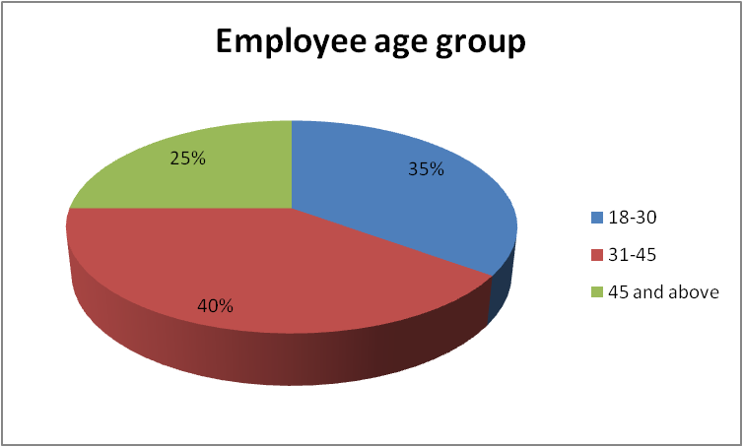
Fig No. 1: “Employee age group”
(Source: “Created by the learner”)
Analysis
The primary objective behind involving this question in the survey was to determine the demographic segmentation of the employees in the workplace. From the data secured, it can be said that Tesla has maintained well-balanced demographics in the workplace. 35% of employees are between the age of 18 and 30, 40% of employees are within the age bracket of 31 and 45 and 25% of the total respondents were 45 or above.
Q2: Do you think managers promote innovation in the workplace?
“Responses | “Total number of responses” | “Total number of respondents” | Percentage
Yes | 20 | 13 | 60%
No | 20 | 4 | 25%
Not sure | 20 | 3 | 15%
Table no 3: “Promotion of innovation in Tesla”
(Source: “created by the learner”)
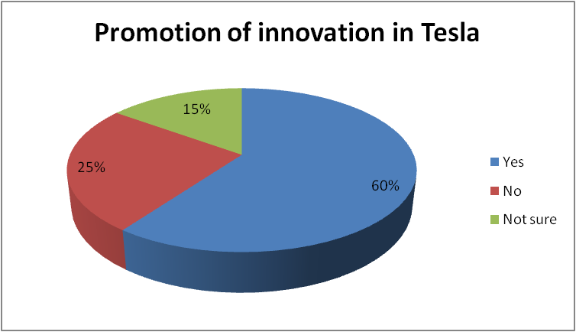
Fig No 2: “Promotion of innovation in Tesla”
(Source: “created by the learner”)
Analysis
A positive response about the company’s culture was secured by the survey question. 60% of employees of the company stated that Tesla’s managers promoted innovation in the workplace, which suggests a positive outlook of the company towards innovation. 25% of the respondents said no, while 15% were unsure. This suggests that the company still needs to work towards developing a better environment in the workplace to promote innovation.
Q3. Does Tesla implement the innovation model in energy vehicles?
“Responses | “Total number of responses” | “Total number of respondents” | Percentage
Yes | 20 | 12 | 60%
No | 20 | 5 | 25%
Not sure | 20 | 3 | 15%
Table no 4: “ Does Tesla implement the innovation model in energy vehicles?”
(Source: “created by the learner”)
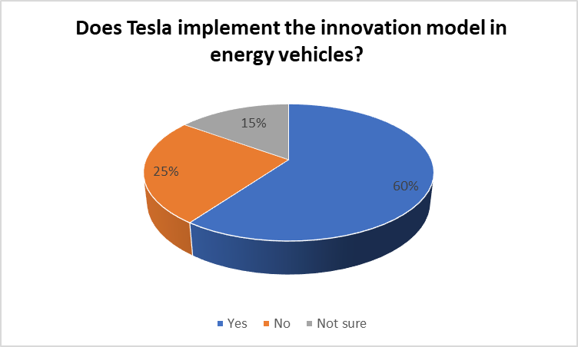
Fig no 3: “ Does Tesla implement the innovation model in energy vehicles?”
(Source: “created by the learner”)
Analysis
In response to question one, the majority of respondents, such as 60%, thought that Tesla has implemented the innovation model in their energy vehicle. 25% of participants thought that Tesla does not implement the innovation model in energy vehicles. The remaining 15% were not sure about the response to the question.
Q4. Is the implementation of the innovation model beneficial for Tesla?
Responses | “Total number of responses” | “Total number of respondents” | Percentage
yes | 20 | 15 | 75
No | 20 | 3 | 15
Not sure | 20 | 2 | 10
Table no 5: “Is the implementation of the innovation model beneficial for tesla?”
(Source: “created by the learner”)
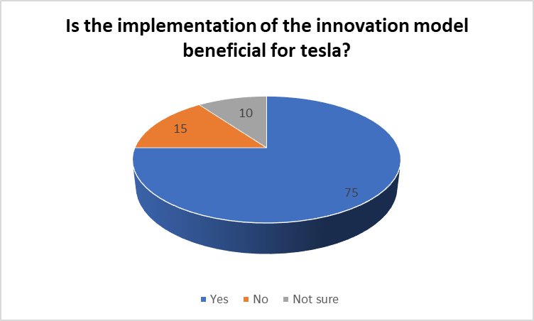
Fig no 4: “Is the implementation of the innovation model beneficial for tesla?”
(Source: “created by the learner”)
Analysis:
In response to question two, the majority of respondents such as 60% thought that implementation of the innovation model is beneficial for tesla. 15% participants thought that implementation of the innovation model is not beneficial for tesla. The remaining 10% were not sure about the response to the question.

Q5. What are the benefits of implementing a model of innovation in the energy vehicle of Tesla?
Responses | “Total number of responses” | “Total number of respondents” | Percentage
Provide competitive advantage. | 20 | 10 | 50%
Meeting customer demand | 20 | 5 | 25%
Further growth and development. | 20 | 5 | 25%
Table no 6: “What are the benefits of implementing a model of innovation in the energy vehicle of Tesla?”
(Source: “created by the learner”)
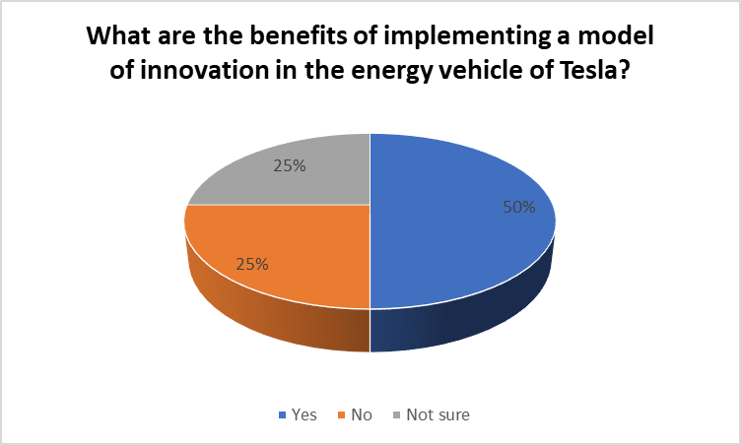
Fig no 5: “Benefits of implementing a model of innovation in the energy vehicle of Tesla”
(Source: “created by the learner”)
Analysis:
In response to question three, the majority of respondents such as 50% thought that implementation of the innovation model will provide a competitive advantage. 15% participants thought that implementation of the innovation model will meet the customer demand. The remaining 20% thought it helps in further growth and development.
Q6.”What are the challenges that the company faces while implementing the innovation model in energy vehicles?”
Responses | “Total number of responses” | “Total number of respondents” | Percentage
Fear of change | 20 | 8 | 40%
Lack of appropriate strategy | 20 | 6 | 30%
Lack of collaboration | 20 | 6 | 30%
Table no 7: “Challenges that the company faces while implementing the innovation model in energy vehicle”
(Source: “created by the learner”)
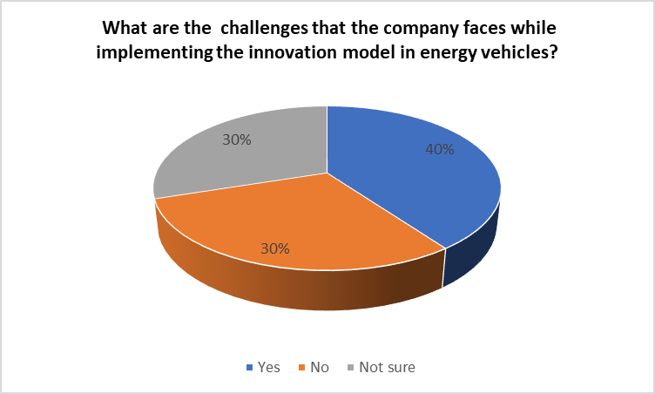
Fig no 4: “Challenges that the company faces while implementing the innovation model in energy vehicle”
(Source: “created by the learner”)
Analysis
In response to question four, the majority of respondents such as 40% thought that challenges were the fear of change. 30% of participants thought that lack of appropriate strategy is the major challenge. The remaining 30% thought that lack of collaboration is one of the challenges in implementing an innovation model.

4.2.3: Discussions
From the findings of the study, it can be stated that Tesla has the right balance of demographics which eliminates the possibility of a disbalance between experience and freshness. A majority of its workforce, 75% to be precise fall under the category of middle-aged and young, which is favourable for the company. As stated Murillo-Luna et al. (2021), demographic are an important factor influencing innovation in an organisation. Further, the company has an organisational culture that supports and promotes innovation in the workplace. However, there is room for improvement as the company has not been able to disperse this sense across the workplace. About 60% of the total respondents of the study, stated that Tesla implements innovation models to provide a structured approach to its innovation strategies. The findings support the commentary of Oumlil et al. (2020) and McMahon and Patel (2019), which suggests the importance of implementing innovation models in the workplace. The findings also extend towards the benefits that the company has had due to the implementation of innovation models in its business practices. The key benefits identified are a competitive advantage, meeting customerdemand and further growth and development. It supports the findings of Oumlil et al. (2020), which suggest that implementation of the innovation model provides an organisation with a competitive edge over its market rivals. The survey findings also highlighted the obstacles faced in the process of implementing change. The key obstacles identified are fear of change, lack of appropriate strategy, and lack of collaboration. The findings of the secondary research provide that the primary obstacles in the implementation of innovation models in an organisation are financial shortcomings of an organisation, lack of opportunities and inefficient technological infrastructure, uncertainty, fear of change and demographics of the workforce. Thus, the findings of the primary study match the findings of the secondary study. From the overall findings of the study, it can be stated that innovation models have been a part of the company. It has enabled the company to meet its innovation demands and maintain its position as one of the most innovative companies in the industry.

4.3: Summary of Chapter 4
This section has discussed and analysed the primary findings with the implementation of thematic analysis and conducting a survey with 20 participants. It has been identified that the innovation model in the development of technology is essential for the organisation to obtain a sustainable position in the industry. Moreover, it has demonstrated the concept of the innovation model and its importance towards organisational development. The implementation of an innovation model is imperative for the organisation in obtaining efficiency in its business operation.

Chapter 5: “Conclusion, Limitations and Recommendations”

5.1: Introduction
This chapter will provide the overall conclusion on the research issues, proposition, research problem, finding and outcomes. It will demonstrate the contribution of the research along with the limitation of the research. Moreover, this section will also provide recommendations for future research.

5.2: “Conclusions on each research issue/objective/proposition”
The research has identified the issues such as the requirement for better and more suitable technologies along with innovation. As industrialization has negatively impacted the environment, the innovation model towards the development of technology is imperative. The major problem that the research study has identified is the lack of focused study regarding the impact of the innovative model in developing technology both in terms of organisational and academic spheres. Hence the aim of the research is to provide detailed analysis regarding the innovation model of the new energy vehicles of Tesla Inc. Moreover, to accomplish the aims the objectives have been set by the researchers. The objectives were to understand the concept of an innovation model and to evaluate the benefits it provides. Lastly, the research study has also evaluated the obstacle while implementing a new model of innovation in developing new energy vehicles. From the finding and discussion in the chapter, it has been identified that the innovation model can provide major benefits to Tesla Inc. Moreover, there are many challenges that the company has faced in implementing the innovation model. It has been identified that the successful implementation of an innovation model can enhance organisational growth and development.

5.3: “Conclusions on the research problem”
As per the research problem identified in the study, it has been identified that the implementation of innovation can enhance the practices and services of a business organisation. Moreover, implementing innovation in energy vehicles is beneficial for both the organisation and the environment. The requirement for more sustainable technologies requires innovation in energy vehicles. The automobile industry is required to meet environmental and societal demands due to its impact on the environment. Hence the study can provide major help for organisations that tend to develop the innovation concept into their business practices.

5.4: “Summary of the research findings and outcomes”
From the outcomes and findings of the research, it has been concluded that the innovation model is essential for the organisation to enhance its overall performance. As the study was based on the automobile sector, the development of new energy vehicles with innovative approaches is beneficial for both the organisation and the environment. The findings have provided the relevant data based on the participants and appropriate sources that the innovation model is beneficial for the organisation for further growth and development and meeting the demand and requirement of the customers.

5.5: “Original Contribution of the Research”
The research study can provide major help to the future researcher studying a similar topic and problem. As the research has highlighted the impact of innovative models towards the development of new technologies, it can offer a better understanding of the innovative concepts for organisations that are planning to implement the innovative connection into their business operations. Moreover, the research study will be significant for scholars who are in the process of developing models and theories of innovation.

5.6: “Limitations of the Research”
The chapter of the literature review has provided the essential details regarding the conceptual and theoretical framework which is relevant towards the main topic of research. However, the information gathered by the source addresses the mass industry instead of the specific industry associated with the research study. Moreover, there was not enough time to obtain the desired outcomes. There were various limitations in conducting the research such as less number of participants and not sufficient time. The insufficient time and lesser number of participants have affected obtaining the desired outcomes.

5.7: “Recommendations/Areas for further/future research”
For future research, the following are the recommendation
- Choosing the most suitable method of research such as the quantitative method or qualitative method instead of focusing on both will be effective in achieving the aims of the research study efficiently.
- It is imperative to maintain the research objectives while conducting the research and to have a proper planning structure to complete the research efficiently.
- In the future using the positivism approach in the research study will be effective in obtaining authentic data (McLaren and Durepos, 2021).
- It is recommended to have a proper estimation of the budget and timeline so that in the future the research can provide more relevant data and meet its desired outcomes.

5.8: “Summary of Chapter 5”
From the section, the overall conclusion of the research study has been identified. It has provided conclusions about the research issues, problems, outcomes and findings. Moreover, this section has provided essential information regarding the contribution of research to the researcher scholars and the organisation itself. It has mentioned the limitation of research and how that limitation has impacted the overall findings of the research. Lastly, it has provided recommendations for future or further research.

List of References
Bag, S., Gupta, S. and Telukdarie, A., 2018. Importance of innovation and flexibility in configuring supply network sustainab
Bilbeisi, K.M. and Kesse, M., 2017. Tesla: A successful entrepreneurship strategy. Morrow, GA: Clayton State University, 1(1), pp.1-18.
Borota, T., Defever, F. and Impullitti, G., 2019. Innovation union: Costs and benefits of innovation policy coordination.
Granstrand, O. and Holgersson, M., 2020. Innovation ecosystems: A conceptual review and a new definition. Technovation, 90, p.102098.
Hürlimann, C., 2019. Research Philosophy and Ethics. In Valuation of Renewable Energy Investments (pp. 111-126). Springer Gabler, Wiesbaden.
Kahn, K.B., 2018. Understanding innovation. Business Horizons, 61(3), pp.453-460.
Kamal, S.S.L.B.A., 2019. Research paradigm and the philosophical foundations of a qualitative study. PEOPLE: International Journal of Social Sciences, 4(3), pp.1386-1394.
Kyriazos, T.A., 2018. Applied psychometrics: sample size and sample power considerations in factor analysis (EFA, CFA) and SEM in general. Psychology, 9(08), p.2207.
Liu, J.-hua and Meng, Z. (2017) Innovation Model Analysis of New Energy Vehicles: Taking Toyota, Tesla and BYD as an example, Procedia Engineering. No longer published by Elsevier. Available at: https://www.sciencedirect.com/science/article/pii/S1877705817302485 (Accessed: October 31, 2022).
McLaren, P.G. and Durepos, G., 2021. A call to practice context in management and organization studies. Journal of Management Inquiry, 30(1), pp.74-84.
McMahon, H.G. and Patel, S., 2019. Who benefits? Adding inclusive innovation into the evidence-based school counseling research agenda. Professional School Counseling, 22(1b), p.2156759X19834439.
Mihas, P., 2019. Qualitative data analysis. In Oxford research encyclopedia of education.
Mkandawire, S.B., 2019. Selected Common Methods and Tools for Data Collection in Research. Marvel Publishers.
Mohajan, H.K., 2018. Qualitative research methodology in social sciences and related subjects. Journal of economic development, environment and people, 7(1), pp.23-48.
Murillo-Luna, J.L., García-Uceda, E. and Asín-Lafuente, J., 2021. Obstacles to Social Entrepreneurship. In Social Entrepreneurship. Emerald Publishing Limited.
Newman, A., Round, H., Wang, S. and Mount, M., 2020. Innovation climate: A systematic review of the literature and agenda for future research. Journal of Occupational and Organizational Psychology, 93(1), pp.73-109.
Orzes, G., Rauch, E., Bednar, S. and Poklemba, R., 2018, December. Industry 4.0 implementation barriers in small and medium sized enterprises: a focus group study. In 2018 IEEE International Conference on Industrial Engineering and Engineering Management (IEEM) (pp. 1348-1352). IEEE.
Oumlil, R., Faouzi, H. and Juiz, C., 2020. Uncovering two decades of open innovation benefits: A qualitative meta-analysis. International Journal of Innovation and Technology Management, 17(08), p.2030006.
Oztemel, E. and Gursev, S., 2020. Literature review of Industry 4.0 and related technologies. Journal of Intelligent Manufacturing, 31(1), pp.127-182.
Pandey, J., 2019. Deductive approach to content analysis. In Qualitative techniques for workplace data analysis (pp. 145-169). IGI Global.
Pandey, P. and Pandey, M.M., 2021. Research methodology tools and techniques. Bridge Center.
Pekovic, S. and Bouziri, A., 2021. Overcoming obstacles to innovation: can environmental management practices help?. Knowledge Management Research & Practice, pp.1-16.
Pekovic, S. and Bouziri, A., 2021. Overcoming obstacles to innovation: can environmental management practices help?. Knowledge Management Research & Practice, pp.1-16.
Sahin, M.D. and Öztürk, G., 2019. Mixed Method Research: Theoretical Foundations, Designs and Its Use in Educational Research. International Journal of Contemporary Educational Research, 6(2), pp.301-310.
World Bank (2021) Pollution, World Bank. Available at: https://www.worldbank.org/en/topic/pollution#:~:text=A%20recent%20World%20Bank%20publication,%2D%20and%20middle%2D%20income%20countries (Accessed: October 31, 2022).
Yuen, K.F., Cai, L., Qi, G. and Wang, X., 2021. Factors influencing autonomous vehicle adoption: An application of the technology acceptance model and innovation diffusion theory. Technology Analysis & Strategic Management, 33(5), pp.505-519.

Terms of Glossary
- Innovation
- Innovation model
- Research
- Research philosophy
- Research paradigm
- Research methodology
- Research approach
- Findings
- Limitations
- Survey

Appendix
Survey questionnaire and findings
Q1. Please indicate your age.
“Response” | “Total number of responses” | “Total number of respondents” | Percentage
18-30 | 20 | 7 | 35%
31-45 | 20 | 8 | 40%
45 and above | 20 | 5 | 25%

Q2: Do you think managers promote innovation in the workplace?
“Responses | “Total number of responses” | “Total number of respondents” | Percentage
Yes | 20 | 13 | 60%
No | 20 | 4 | 25%
Not sure | 20 | 3 | 15%

Q3. Does Tesla implement the innovation model in energy vehicles?
“Responses | “Total number of responses” | “Total number of respondents” | Percentage
Yes | 20 | 12 | 60%
No | 20 | 5 | 25%
Not sure | 20 | 3 | 15%

Q4. Is the implementation of the innovation model beneficial for Tesla?
Responses | “Total number of responses” | “Total number of respondents” | Percentage
yes | 20 | 15 | 75
No | 20 | 3 | 15
Not sure | 20 | 2 | 10

Q5. What are the benefits of implementing a model of innovation in the energy vehicle of Tesla?
Responses | “Total number of responses” | “Total number of respondents” | Percentage
Provide competitive advantage. | 20 | 10 | 50%
Meeting customer demand | 20 | 5 | 25%
Further growth and development. | 20 | 5 | 25%

Q6.What are the challenges that the company faces while implementing the innovation model in energy vehicles?
Responses | “Total number of responses” | “Total number of respondents” | Percentage
Fear of change | 20 | 8 | 40%
Lack of appropriate strategy | 20 | 6 | 30%
Lack of collaboration | 20 | 6 | 30%

