
Marketing Management Assessment 1

Student Name: Ahammed Azharudeen Master House
Student ID: 2229990
Lecturer Name: Tushara Balendran
Submission Date: 30/08/2023

Introduction
Maximising customer satisfaction in an organisation requires attention to the customer's end-to-end journey (Bhatia and Priya, 2021). In this report study, the discussion will focus on the organisation's background, the definition of communication and a diagram with a brief explanation of an SMCR communication model. In addition, it will illustrate the new promotional strategy that can be used for brand awareness in the organisation's context. Moreover, the report will focus on the branding and brand equity definition and explanation of Keller’s brand equity model in the organisation. Also, it will evaluate the customer journey and touch points of the organisation with the total engagement model in the company's context.
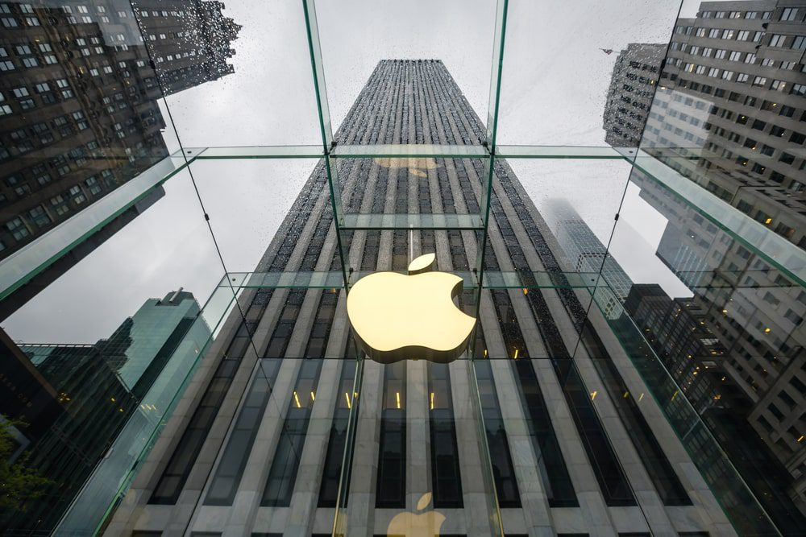
Figure 1: Apple Inc.
(Source: Equities et al. 2023)

Organization’s background: Apple Inc.
The chosen organisation for this report is Apple Inc. It is an American multinational technology company that design, manufacture, and market a wide range of product such as tablets, laptop, personal computers, smartphone, and other devices. As well as The organisation also offers software applications, accessories, related services, and third-party digital content. According to Barley et al. (2020), Apple Inc. was founded by Steve Wozniak and Steve Jobs in 1976. Steve Wozniak and Steve Jobs wished to develop a company that would change individuals' vision toward computers. The organisation's vision statement is 'to make the best product on earth and to leave the world better than we found it'. The mission statement of Apple Inc. is 'to bring the best user experience to customers through innovative hardware software and services'. Apple Inc. is one of the largest and famous organisations and its revenue in the financial year 2022 was 394.33 billion dollars (Laricchia, 2023). The organisation believes in in-depth cross-pollination and collaboration in groups, which allows bringing innovation and creativity. The organisation's branding strategy is mainly focused on emotions with the personality about liberty regained, imagination, lifestyle, fashion, innovation, aspiration, hopes, dreams, and power to the individual with technologies.
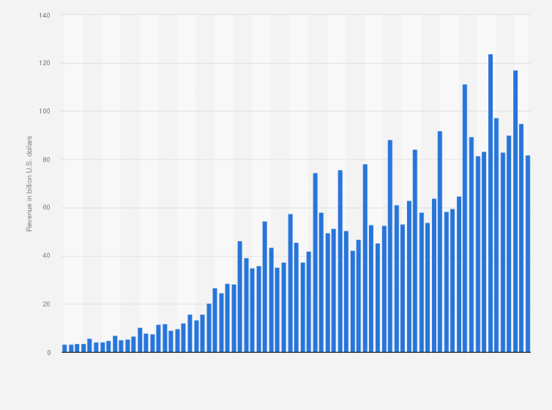
Figure 2: Apple’s revenue
(Source: Laricchia, 2023)

Communication
Communication is the process used to exchange information between individuals throw a common behaviour sign or symbol system. It is a way of transferring information, which can be one-to-one or in groups, or from one person or place to another. According to Hikamah et al. (2021), communication process to share or exchange thoughts, opinions, feelings, emotions, ideas, facts, messages, information, and understanding. Apple practices various communication activities to share and update information with its consumers, and shareholders. As per Hassounah et al. (2020), Apple Inc. uses multiple communication platforms such as social media, press releases, and websites, to communicate with its external audience, which is readily available and helps the company facilitate immediate contact. The organization uses the dynamic communication process to convey innovative brand identity and information to its various stakeholders such as shareholders, employees, customers, and investors to foster anticipation, trust, and loyalty and maintain quality simplicity and innovation as the brand image. Effective communication helps to ensure seamless operation, production, and delivery of products with its suppliers, partners, and target audience.

Berlo's SMCR communication model with a diagram and a brief explanation
Berlo's SMCR communication model was developed by David Berlo. This model shows the communication process as the transfer of information where thoughts, ideas, or information are transferred into a message to the receiver through a communication channel. There are 4 elements present, such as the sender, the message, the channel, and the receiver, between the source and receiver, which determine the transfer and understanding of information's meaning. This communication model is a representation of the communication process that describes the non-verbal and verbal communication and exchange of messages.
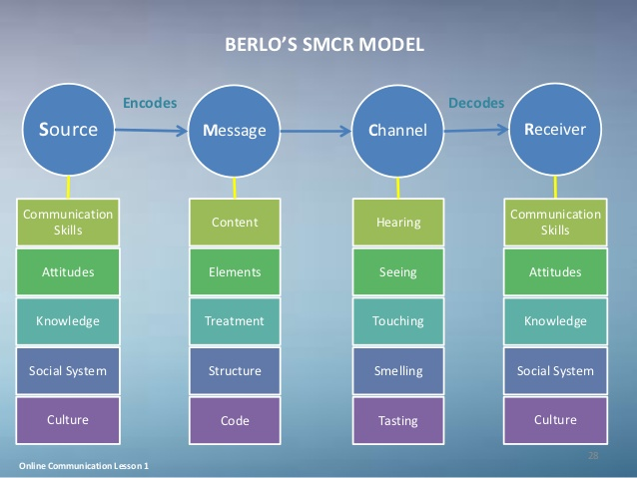
Figure 3: Berlo’s SMCR communication model
(Source: etechmethod, 2016)
The sender or Source: The sender is also the source of the information that originated or developed in the form of a message to communicate with the target audience (Maneerutt, 2021). The source or the sender can be referred to as an organisation, group, or individual, whose job is to encode the message to be communicated. The organisation Apple's source or the sender is referred to its design, marketing team and executive who develops the message.
The message: The message refers to the information or content that the centre wishes to convey. This message can be in the form of a product advertisement, press release, or any information related to the organisation's product or services. In the context of Apple Inc., the message can be referred to its product, brand, services or any announcements or advertisements.
The channel: The channel in the communication process refers to a way to transmit the message. As stated by Lütge and Merse, (2023), Barlo’s communication channels are related and point out the five senses that can convey a message effectively. Apple uses various communication channels to convey their information and message, such as advertising campaigns, social media platforms, and official websites to reach and attract the potential audience.
The receiver: The receiver can refer to an organisation, group, or individual, who has the intention to receive the message. In the context of Apple Inc., the receiver can be referred to as the target audience, media, shareholders, and consumers who receive the message and interpret it.

Integrated Marketing Communications
Integrated marketing communication is a set of business practices and a theory that facilitates the consistent messaging and sharing of information across various communication channels. Also, it helps to produce a unified brand experience for the organisation's potential consumers. Integrated marketing communication is a foundational marketing concept which mainly applied to advertising and as a form of business communication. As stated by Kitchen and Tourky, (2020), Apple has achieved a seamless integration of public relations, advertising, and digital marketing through IMC. In the context of Apple Inc., the IMC refers to a strategic marketing process that helps the organisation to ensure and design the messages and communication strategies to unified across all channels and maintain a customer-centric approach. As an IMC strategy, Apple uses various communications efforts such as consistent branding influential collaboration social media engagement customer feedback and product launch events to reinforce its brand image as innovative, user experience-centric, and quality to enhance consumer loyalty and maintain sustained market dominance.
New promotional strategies to raise brand awareness
A promotional strategy is a plan to develop or enhance a brand or product's demand (Kumar et al. 2020). A promotional strategy outlines the significant practice to raise awareness regarding the brand and product, which enhances individuals' interest in purchasing it. Apple uses several promotional strategies to increase its brand awareness, however, implementing new promotional strategies can further enhance its brand awareness more effectively and despite its global recognition. Some of the effective new promotional strategies for today's brand awareness are-
Original content promotion: Apple Inc. could use original content promotion as a new promotional strategy by featuring its exclusive content related to product launches through Apple TV+. As well as it can also help showcase their device's viewing experience. Bundling Apple TV+ subscriptions with their new product purchases can help attract more potential consumers to explore their streaming platforms and purchase products.
Awareness campaign regarding the environment: The organisation can launch an environmental impact awareness campaign to develop its sustainability efforts and highlight eco-friendly practices to maintain environmental impacts, such as managing waste management and using recycled material to develop its products. As mentioned by Ahmad et al. (2020), with the environmental impact-related awareness campaign, the organization can attract eco-friendly-conscious consumers. Also, the organization can invite or encourage potential consumers to participate in environmental initiatives and provide rewards, discounts, or offers for recycling old Apple devices.
Limited edition collectables: The organisation can launch limited edition collectables as a new promotional strategy by introducing limited edition product accessories tied or collectables Apple merchandise while launching significantly. As pointed out by Macák and Šašalová, (2022), launching limited edition collectables can become sought-after collector's pieces for the target audience. With limited edition collectables product launches and organisations can enhance they are brand awareness and market demand.
Localized content creation: Localized content creation is an effective promotional strategy that refers to encouraging users to develop content worldwide which will be helpful to highlight the unique cultural perspective. Apple can implement localized content creation to encourage its users to develop content and share their perspectives on how Apple products are integrated into their lives. Apple can share these stories on their global platforms to improve brand awareness.
Music collaboration: Collaborate with musicians and brands in a new promotional strategy to attract potential consumers and foster improved brand awareness. Apple can work collaboratively with many brands and museums to release their exclusive albums or tracks on Apple Music to attract new subscribers and establish a connection between Apple's ecosystem and music. According to Musa et al. (2023), working collaboratively with celebrities is a new trend and modern promotional strategy that helps organizations enhance their brand awareness to a wide range of audiences.
Apple store tour and product demos with augmented reality (AR) and virtual reality (VR): Apple can use AR to develop immersive Apple store tours, which can be helpful for consumers to explore the store, interact with the products and make virtual purchases. Apple can also use AR for their product demos. With the help of leveraging augmented reality, an organisation can develop a virtual showroom that can be accessible through their application. It can be helpful for customers to use their smartphones and AR glasses to explore the Apple store and new products virtually.

Concept of Branding and brand equity
Branding refers to the process of developing a distinct identity or providing meaning to a specific organisation, business, product, or service shaping and creating a brand in the target consumers or audience's mind (Shafiee et al. 2020). The most basic level of branding of a company, business, or organisation and its product or services is the visual design, logo, name, mission, and voice tone. In the branding process, a strong brand differentiates its services and product from competitors, foster loyalty and influence consumers' purchasing decision. An effective branding strategy in an organisation is to establish a psychological and emotional connection with the target audience and the brand. Apple's branding strategy is mainly focused on emotions with a forward-thinking creative visionary, which reflects its core values of innovation, design, and imagination.
Alternatively, brand equity refers to the added value that a brand brings to a product or company that results from the positive associations, experiences and perceptions that customers have with the brand over time. It is the culmination of various factors involving brand awareness, perceived quality, brand associations and even brand loyalty. East et al. (2021) stated positive brand equity translates into several benefits for the company life higher price premiums, increased customer loyalty, improved resilience to market fluctuation and the ability to introduce new products or extend the brand into new markets more easily. In simple terms, brand equity can be projected as the reservoir of goodwill and customer preference that a brand accumulates as it consistently delivers on its promises and maintains a positive reputation. This reservoir has a tangible impact on a company's financial performance Brands with strong equity often command higher prices and experience more benefits and customer retention from positive word-of-mouth marketing (Keller and Brexendorf, 2019). In case of Apple Inc. boasts exceptional brand equity. Its design, logo, aesthetics and user experience Have become synonymous with reliability, elegance and innovation. The brand's loyal customer base eagerly anticipates each new product release and is often willing to pay a premium for the Apple experience. This level of brand loyalty and customer attachment is a testament to the brand equity Apple has built over decades.

Keller's brand equity model associated with Apple Inc
Keller's brand equity model is a comprehensive framework that helps businesses understand and manage the various dimensions of brand equity. According to Kevin Lane Keller, this model identifies four key steps that companies can take to build and increase their brand equity (Duman et al. 2018). Each step of the model and how it relates to Apple is explored below:
Step 1: Brand identify
This step includes establishing of clear and unique brand identity. Iglesias et al. (2019) mentioned it includes building brand awareness and ensuring that customers can easily identify and recognise the brand. For Apple, brand identity is exceptionally strong the iconic logo of Apple, consistent product naming conventions and minimalist design contribute to the recognizability of the brand. The focus of the brand on simplicity and elegance resonates with customers making Apple products instantly identified.
Step 2: Brand Meaning
Brand meaning refers to the associations and perceptions that customers have about the brand. These associations can be functional related to product benefits and attributes or symbolic related to self-expressive benefits and emotions (Chitturi, 2018). The brand image of Apple is deeply rooted in innovation, user experience and creativity. The company has consistently delivered cutting-edge technology with a focus on simplicity and ensuring friendliness. Customers associated Apple products with premium quality, a sense of belonging to the community and the design excellence of like-minded individuals.
Step 3: Brand response
Brand response focuses on how customers react to the brand's identity and meaning. This step involves assessing customer attitude, loyalty and preference towards the brand (Soedarto et al. 2019). Apple's brand response is remarkably positive. The company has an intensely loyal customer base that eagerly anticipates new product launches. Customers are willing to wait in long lines and pay premium prices for the latest Apple devices which reflects a strong emotional connection to the brand.
Step 4: Brand Resonance
Brand resonance represents the highest level of brand relationship where customers have a code and meaningful collection with the brand (Duman et al. 2018). This step includes creating an intense and enduring relationship between the brand and its consumers. Apple's brand resonance is exceptionally strong. The brand has nurtured a feeling of companionship among its users to foster a devoted and enthusiastic following akin to a cult. Many Apple users identify themselves as members of the Apple ecosystem to highlight the seamless fusion of Apple products and services in their daily lives.
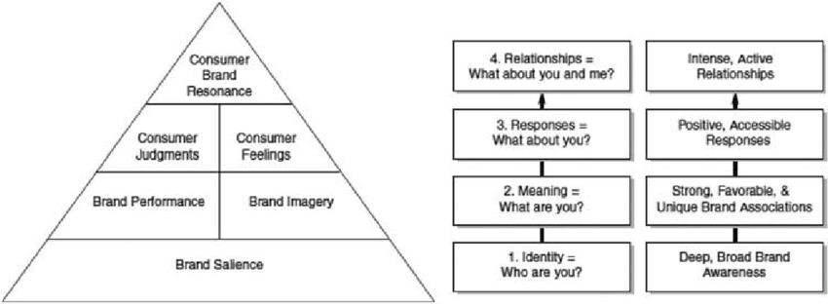
Figure 4: Keller's CBBE (Customer-Based Brand Equity) model
(Source: Cottan-Nir and Lehman-Wilzig, 2022)
Apple’s dedication to innovation, design and delivering exceptional customer experiences has led to building a brand that deeply resonates with customers across various dimensions. The company has successfully built up a brand that fulfils functional needs, emotional and self-expressive needs. The think different campaigns and the focus on creativity and individuality have further robust this emotional resonance (Altstiel et al. 2019). Overall, Keller's brand equity model aligns closely with Apple's brand strategy and success. The model highlights the significance of creating a unique brand identity to establish meaningful brand associations that produce positive customer responses and foster strong brand relationships. Apple's ability to accelerate in each of these steps has contributed to its exceptional band equity and its position as one of the world's most valuable and beloved brands.

Customer journey and customer touch point points of Apple Inc.
Dal customer Janie refers to the entire process that customers go through when interacting within an organization from initial awareness to post-purchase engagement. Grewal and Roggeveen (2020) highlight that the customer journey allows all the stages of a customer experiences involving awareness, purchase, consideration and post-purchase period. On the other side, customer touchpoints are the specific points of interaction between the customer and the organization throughout the customer journey (Bascur et al. 2019). These touch points can involve various channels like social media, websites, customer services, physical stores, advertising and so on. Each touch point is an opportunity for the organization to create a positive operation and increase the overall customer experience.
In the case of Apple, the customer journey begins with the awareness of their product through marketing campaigns and word-of-mouth. The consideration stage includes visiting Apple's website and the physical stores to learn more about the products (Santos and Gonçalves, 2022). The purchase stage involves the actual transaction either online or in-store. Post-purchase touchpoints could involve customer support, community engagement and software updates through online forums. Apple confirms consistency and excellence across these touchpoints to foster brand loyalty and customer satisfaction throughout the entire journey.

Critical analysis of customer journey map for Apple Inc
Stage | Touchpoints | Description and analysis
Awareness | Online ads, social media and word-of-mouth | - Apple generates awareness through captivating ads and social media campaigns, leveraging its strong brand.  - Word-of-mouth from satisfied customers also plays a significant role.
Consideration | Apple website and Apple stores | - The website offers detailed product information and user-friendly navigation.  - Apple stores provide a hands-on experience to promote the brand’s premium image.
Purchase | Online store and physical stores | - The online store offers a seamless purchasing process.  - Physical stores offer personalized assistance and an immersive environment.
Post-purchase | Customer support, software updates and community forums | - Apple excels in customer support, addressing issues promptly.  - Regular software updates increase product longevity.  - Community forums foster user engagement and troubleshooting.
Table 1: Customer journey map for Apple Inc.
(Source: Self-created)
Critical explanation: Apple’s customer journey map showcases strengths in various stages. The awareness stage benefits from Apple’s renowned branding and captivating marketing efforts to contribute to high brand recall. The consideration stage is robust because of the well-organized website and experiential appeal of physical stores (Jaiswal and Singh, 2020). In the purchase stage, the online store's user-friendly interface supports easy transactions. However, the premium pricing might deter some price-sensitive customers. The physical store's personalised assistant is an important advantage though their ability might be limited in certain regions. Apple's post-purchase touchpoints excel the exceptional customer support and frequent software updates. However, the now-close ecosystem of Apple might limit customization for advanced users. Community forums encourage engagement but might not always provide the fastest solutions. Overall, Apple's customer journey is marked by effective touchpoints, strong branding and a focus on customer support. While the premium image enables to maintenance brand's allure to identify price concerns and foster more open user engagement could further increase the overall customer experience.

Total engagement model (TEM) of Apple Inc
The total engagement model is a strategic structure that focuses on building core and lasting relationships between the organization and its target audience (Wong et al. 2023). It went beyond the traditional marketing approach by focusing on holistic customer engagement throughout various touchpoints and interactions. TEM aims to generate emotional connection and drive long-term value for both the customer and the organization along with enhancing customer loyalty. This model is explored in the customer engagement model of Apple Inc.
Brand connection: Moliner et al. (2018) exhibit that building a strong brand connection is initial for an organisation. Apple excels in this aspect with its iconic logo, memorable advertising campaigns and consistent design language. The company's branding efforts create an emotional resonance with customers. This approach fosters a sense of belonging and identification.
Personalisation: Apple's ecosystem encourages personalisation through features like customization options and preferences along with the machine learning-driven suggestions of Siri. The personalisation at this level fosters a stronger connection as users feel that the brand understands their individual needs and preferences.
Customer experience: Apple prioritises user-centric design and simplicity that leads to exceptional customer experience across its products and services. The company ensure that every touchpoint resonates with its brand from intuitive interfaces to sleek packaging (Johnson and Misiaszek, 2022).
Continuous interaction: Apple maintains engagement events after purchase through regular software updates which increase the functionality and security of the devices. This continuous interaction enhances the product value and demonstrates Apple's commitment to its customers' experiences.
Community engagement: Kahney and Pierini (2019) highlight that Apple cultivates a dedicated community through its support forums, developer conferences and user groups. This sense of community fosters knowledge sharing, engagement and the feeling of being a part of a large Apple family.
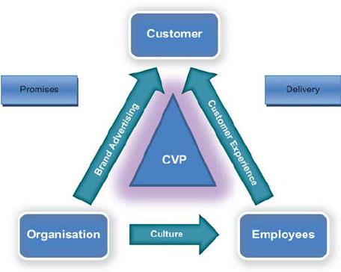
Figure 5: Total engagement model
(Source: Menidjel et al. 2022)

Application in Apple Inc.
Apple's success originated in its effective execution of the total engagement model. The brand connection is evident in how customers often describe themselves as a part of the Apple ecosystem. Logo, iconic product launches and design aesthetics generate excitement and emotional attachment to its customer base. Apple Inc. prioritises customer experience with its user-friendly interfaces, attention to detail and minimalistic design (Batat, 2020). The unboxing experience, packing and intuitive setup processes further increase the emotional connection. Personalisation is a key aspect of Apple's offerings. Features like personalized application recommendations, customizable device settings and face ID recognition create an intimate and tailored experience for each user. The Apple community is reinforced with forums, social media interaction and online communities where users share insights and helpful troubleshooting. Apple's community engagement fosters a sense of loyalty and belonging among its users (Chi et al. 2022). Apple's continuous interaction is represented through regular software updates that extend the life of the device and provide new features. Along with enhancing customer experience, this also drives product longevity and brand loyalty. However, it's significant to note that Apple's approach can be seen as exclusive due to its closed ecosystem. This could limit engagement for users who prefer more customisation and flexibility, potentially hindering wider customer adoption.

Conclusion
In conclusion, Apple Inc.’s success in maximising customer satisfaction is achieved through a multifaceted approach encompassing strategic models like Keller's Brand equity and the total engagement model. The company's iconic branding, exceptional user experience and innovative products create a distinctive identity and foster emotional connections. Apple's holistic strategies like personalisation, community engagement and continuous interaction drive core customer loyalty. However, its closed ecosystem could limit broader customisation aspects. Apple Inc. maintains its position as a global leader in technology and customer-centricity exemplifying the synergy among strategic models and effective brand management by consistently delivering on promises and prioritising engagement.

Reference list
Ahmad, W., Kim, W.G., Anwer, Z. and Zhuang, W., (2020). Schwartz personal values, theory of planned behavior and environmental consciousness: How tourists’ visiting intentions towards eco-friendly destinations are shaped?. Journal of Business Research, 110, pp.228-236. https://www.sciencedirect.com/science/article/abs/pii/S0148296320300527
Altstiel, T., Grow, J. and Jennings, M., (2019). Advertising creative: strategy, copy, and design. Sage Publications. https://books.google.com/books?hl=en&lr=&id=iw57DwAAQBAJ&oi=fnd&pg=PT18&dq=The+think+different+campaigns++of+apple++and+the+focus+on+creativity+and+individuality+have+further+robust+this+emotional+resonance+&ots=PjAz_mi8Bc&sig=CjgXTc_61TLiYwbLipmgk01BafQ
Barley, B., Kitamura, A., Loar, T., Ramon-Samayoa, E., Yuzon, J. and Daim, T.U., (2020). An Investigation of the Motivations and Strategies Behind Apple’s Product Design. Innovation Management in the Intelligent World: Cases and Tools, pp.3-27. https://link.springer.com/chapter/10.1007/978-3-030-58301-9_1
Bascur, C., Rusu, C. and Quiñones, D., (2019). User as a customer: touchpoints and journey map. In Human Systems Engineering and Design: Proceedings of the 1st International Conference on Human Systems Engineering and Design (IHSED2018): Future Trends and Applications, October 25-27, 2018, CHU-Université de Reims Champagne-Ardenne, France 1 (pp. 117-122). Springer International Publishing. https://link.springer.com/chapter/10.1007/978-3-030-02053-8_19
Batat, W., (2020). Experiential marketing: Case studies in customer experience. Routledge. https://books.google.com/books?hl=en&lr=&id=BW0LEAAAQBAJ&oi=fnd&pg=PT13&dq=Apple+Inc.+prioritises+customer+experience+with+its+user-friendly+interfaces,+attention+to+detail+and+minimalistic+design+%5C&ots=NcM4lq_Q7e&sig=xpjOf7FTmO6WYuyvRW_SE1Mxp28
Bhatia, M. and Priya, P., (2021). The Business Case for Customer Experience: Ignoring Customer Experience Is an Expensive Mistake. In Crafting Customer Experience Strategy (pp. 155-174). Emerald Publishing Limited. https://www.emerald.com/insight/content/doi/10.1108/978-1-83909-710-220211009/full/html
Chi, M., Harrigan, P. and Xu, Y., (2022). Customer engagement in online service brand communities. Journal of Services Marketing, 36(2), pp.201-216. https://www.emerald.com/insight/content/doi/10.1108/JSM-09-2020-0392/full/html
Chitturi, R., (2018). Design, emotions, and willingness to pay. In Innovation and Strategy (pp. 205-228). Emerald Publishing Limited. https://www.emerald.com/insight/content/doi/10.1108/S1548-643520180000015010/full/html
Cottan-Nir, O. and Lehman-Wilzig, S., (2022). CEO Brand Equity–Implementation of a Conceptual Model: Comparing CEO Brand Equity during Successful and Crisis Periods. International Journal of Strategic Communication, 16(1), pp.34-49. https://www.tandfonline.com/doi/abs/10.1080/1553118X.2021.2010084
Duman, T., Ozbal, O. and Duerod, M., (2018). The role of affective factors on brand resonance: Measuring customer‐based brand equity for the Sarajevo brand. Journal of destination marketing & management, 8, pp.359-372. https://www.sciencedirect.com/science/article/pii/S2212571X17300136
East, R., Singh, J., Wright, M. and Vanhuele, M., (2021). Consumer behaviour: Applications in marketing. Sage. https://books.google.com/books?hl=en&lr=&id=II9DEAAAQBAJ&oi=fnd&pg=PP1&dq=positive+brand+equity+translates+into+several+benefits+for+the+company+life+higher+price+premiums,+increased+customer+loyalty,+improved+resilience+to+market+fluctuation+&ots=5rLFF_854v&sig=wG920zZSnLXSiXN8R-ATqVeq67E
Equities, D.S., Shvartsman, D. and Equities, expertise: (2023) Apple Inc.: Our Modern-day symbol of knowledge, power, and wealth, Investing.com. Available at: https://www.investing.com/academy/statistics/apple-facts/ (Accessed: 29 August 2023).
etechmethod (2016) Berlo’s SMCR model of communication, etechmethod. Available at: https://etechmethod.wordpress.com/2016/10/11/berlos-smcr-model-of-communication/ (Accessed: 29 August 2023).
Grewal, D. and Roggeveen, A.L., (2020). Understanding retail experiences and customer journey management. Journal of Retailing, 96(1), pp.3-8. https://www.sciencedirect.com/science/article/pii/S0022435920300051
Hassounah, M., Raheel, H. and Alhefzi, M., (2020). Digital response during the COVID-19 pandemic in Saudi Arabia. Journal of medical Internet research, 22(9), p.e19338. https://www.jmir.org/2020/9/e19338/
Hikamah, S.R., Rohman, F. and Kurniawan, N., (2021). Developing Virtual Communication Skills in Online Learning Based on Modified PBL during the COVID-19 Pandemic. International journal of Education and Practice, 9(2), pp.323-339. https://eric.ed.gov/?id=EJ1295402
Iglesias, O., Markovic, S., Singh, J.J. and Sierra, V., (2019). Do customer perceptions of corporate services brand ethicality improve brand equity? Considering the roles of brand heritage, brand image, and recognition benefits. Journal of business ethics, 154, pp.441-459. https://link.springer.com/article/10.1007/s10551-017-3455-0
Jaiswal, S. and Singh, A., (2020). Influence of the determinants of online customer experience on online customer satisfaction. Paradigm, 24(1), pp.41-55. https://journals.sagepub.com/doi/abs/10.1177/0971890720914121
Johnson, M. and Misiaszek, T., (2022). Branding that Means Business: Economist Edge: books that give you the edge (Vol. 1). Profile Books. https://books.google.com/books?hl=en&lr=&id=yPhYEAAAQBAJ&oi=fnd&pg=PT12&dq=The+company+ensure+that+every+touchpoint+resonates+with+its+brand+from+intuitive+interfaces+to+sleek+packaging+&ots=BSNb7WxQRv&sig=bM9wy7saMWr_P6k5cq8Q3N2aTDg
Kahney, L. and Pierini, D., (2019). The cult of Mac. No Starch Press. https://books.google.com/books?hl=en&lr=&id=joBxDwAAQBAJ&oi=fnd&pg=PR14&dq=Apple+cultivates+a+dedicated+community+through+its+support+forums,+developer+conferences+and+user+groups.&ots=VK-2bNcteE&sig=QFKd9-6CWQpYHkBo2-90ZRpjHqE
Keller, K.L. and Brexendorf, T.O., (2019). Measuring brand equity. Handbuch Markenführung, pp.1409-1439. https://link.springer.com/chapter/10.1007/978-3-658-13342-9_72
Kitchen, P. and Tourky, M.E., (2020). Communications at a crossroads: what place for integrated marketing communications in a post-Covid-19 landscape?. Revista de Estudios Empresariales. Segunda Época, (2), pp.7-17. https://revistaselectronicas.ujaen.es/index.php/REE/article/view/5855
Kumar, A., Shankar, R. and Aljohani, N.R., (2020). A big data driven framework for demand-driven forecasting with effects of marketing-mix variables. Industrial marketing management, 90, pp.493-507. https://www.sciencedirect.com/science/article/abs/pii/S0019850118306606
Laricchia, F. (2023) Apple revenue by Fiscal Quarter 2023, Statista. Available at: https://www.statista.com/statistics/263426/apples-global-revenue-since-1st-quarter-2005/ (Accessed: 29 August 2023).
Lütge, C. and Merse, T., (2023). Digital Citizenship in English Language Education. Activating and Engaging Learners and Teachers: Perspectives for English Language Education, 27, p.241. https://books.google.co.in/books?hl=en&lr=&id=D4azEAAAQBAJ&oi=fnd&pg=PA241&dq=Barlo%E2%80%99s+communication+channels+are+related+and+point+out+the+five+senses+that+can+convey+a+message+effectively.+&ots=Jx6RBP_rZb&sig=SS1hUVWGuzHwc2-Pqodu3tLwXw4&redir_esc=y#v=onepage&q&f=false
Macák, M. and Šašalová, V., (2022). Digital Games, Collectors and (Artificial) Scarcity: The Digital Future Might Be a Bit Physical After All. Communication Today, 13(2), pp.4-23. https://www.proquest.com/openview/62a8758ba4db0445c94ee29be106b638/1?pq-origsite=gscholar&cbl=1606370
Maneerutt, G., (2021). Miscommunication at the Workplace: Causes and Ways to Improve Internal Communication. AU-GSB e-JOURNAL, 14(2), pp.155-166. http://www.assumptionjournal.au.edu/index.php/AU-GSB/article/view/5795
Menidjel, C., Hollebeek, L.D., Leppiman, A. and Riivits-Arkonsuo, I., (2022). 24. Role of AI in enhancing customer engagement, loyalty and loyalty programme performance. Handbook of Research on Customer Loyalty, p.316. https://books.google.com/books?hl=en&lr=&id=qLp8EAAAQBAJ&oi=fnd&pg=PA316&dq=Roberts,+Christopher+%26+Alpert,+Frank.+(2010).+Total+customer+engagement:+Designing+and+aligning+key+strategic+elements+to+achieve+growth.+Journal+of+Product+%26+Brand+Management.++&ots=5lL3pRr3gp&sig=kiWRaotv3skJzOZvVB3bwxn7dto
Moliner, M.Á., Monferrer-Tirado, D. and Estrada-Guillén, M., (2018). Consequences of customer engagement and customer self-brand connection. Journal of Services Marketing, 32(4), pp.387-399. https://www.emerald.com/insight/content/doi/10.1108/JSM-08-2016-0320/full/html
Musa, I., Hamka, R.A. and Atifah, N., (2023). Development of Trends, Innovation and Effective Distribution Strategies in International Marketing. Journal Management & Economics Review (JUMPER), 1(1), pp.9-16. https://malaqbipublisher.com/index.php/JUMPER/article/view/22
Santos, S. and Gonçalves, H.M., (2022). Consumer decision journey: Mapping with real-time longitudinal online and offline touchpoint data. European Management Journal. https://www.sciencedirect.com/science/article/pii/S026323732200127X
Shafiee, M., Gheidi, S. and Khorrami, M.S., (2020). Proposing a new framework for personal brand positioning. European research on management and business economics, 26(1), pp.45-54. https://www.sciencedirect.com/science/article/pii/S2444883419300567
Soedarto, T., Kurniawan, G.S.A. and Sunarsono, R.J., (2019). The parceling of loyalty: brand quality, brand affect, and brand trust effect on attitudinal loyalty and behavioral loyalty. Academy of Strategic Management Journal, 18(1), pp.1-15. https://www.researchgate.net/profile/Rifan-Sunarsono-2/publication/331486024_The_Parceling_of_Loyalty_Brand_Quality_Brand_Affect_and_Brand_Trust_Effect_on_Attitudinal_Loyalty_and_Behavioral_Loyalty/links/5c7ca8f5458515831f812e06/The-Parceling-of-Loyalty-Brand-Quality-Brand-Affect-and-Brand-Trust-Effect-on-Attitudinal-Loyalty-and-Behavioral-Loyalty.pdf
Wong, I.A., Lin, Z. and Zhang, X., (2023). A techno-exchange engagement model of social media engagement: a social exchange and engagement theoretical synthesis. Journal of Vacation Marketing, 29(3), pp.461-475. https://journals.sagepub.com/doi/abs/10.1177/13567667221101412

