An environmental analysis of Hiut Denim Company
By
Zeinelabedeen Alkargholi
P149893

Executive Summary
The aim of this report is to present the situational analysis for Hiut Denim company. As the marketing manager of the company, the external and internal marketing environment is evaluated in order to critically appraise the strategic options available for the firm for the development of creative marketing strategies, targeting and positioning. David Hieatt is UK based company clothing brand company which offers eco-friendly products to its customers. The company provides superior quality products and uses technology to sell its products directly to the customers. The company have a novel and highly interesting techniques as promotional tactics.

Table of Contents

1. Introduction 5
2. Situational Analysis 5
2.1. PEST Analysis 5
2.2. SWOT 8
3. Marketing Objectives 10
4. Consumer and the Markets 12
4.1. Segmentation and Targeting 12
4.2. Positioning 12
5. Marketing Strategies 14
6. Marketing mix 15
6.1. Place 15
6.2. Price 15
6.3. Promotion 16
6.4. Product 17
7. Strategic Options – SAF Framework 18
8. Conclusion 22
References 23

List of Figures
Figure 1: Hiut Denim Porter 5 force Model 6
Figure 2: VRIN Model 7
Figure 3: Product Lifecycle 7
Figure 4: SWOT Analysis 8
Figure 5: Strategic Group Analysis 9
Figure 6: Strategic Group Map 10
Figure 7: Ansoff Matrix 11
Figure 8: Perceptual map 12
Figure 9: Place 13
Figure 10: Price 14
Figure 11: Promotion 15
Figure 12: Product 15
Figure 13: SAF Framework 19
Figure 14: SAF framework 19

Introduction
The company Hiut Denim was founded by Clare and David Hieatt and the company was developed as the social enterprise where the concept of generating employment was core purpose. The company set out its vision to make hundreds of people to get back to their jobs as the Cardigan market in the west wales was emerging. About 400 locals were employed and the 35000 pairs of jeans were developed and supplied across the country (Smale and Brosnan, 2020). Huit was actually set up by former advertising copywriter with the purpose to run ethical fashion brand. The core focus was towards the social and environmental aspect. The PEST analysis is presented which guides the external market for Hiut Denim. The products range from sportswear, t-shirts and jeans which is later sold to the Timberland (Hiut Denim, 2020). These techniques include “No wash club” and “Denim breaker club”. Besides this, the use of celebrity endorsement technique further made the company endorse Megan Markle for advertising its product.

Situational Analysis
According to Kolomiets, Grinchenkov and Vodenko (2019), the situational analysis assists the company while developing the marketing strategy. The situational analysis serves as the guide by which the companies could explore the external environment and evaluate the company strengths, weaknesses, threat and opportunities. Gürel and Tat (2017), stated that it is the external and internal factor which allows the firm to identify the business capabilities, potential customers and the environment and its impact on the company. The situational analysis serves as an essential part of the business plan and it must be reviewed periodically in order to ensure successful operations.

PEST Analysis
According to Kolomiets, Grinchenkov and Vodenko (2019), PEST analysis is defined as the political, social, economic factors where the company could access the external environment in which its operate. The model is applied within the strategic planning approach and determine the aspect by which the company can gain a competitive advantage.
Political – The political factor involves the governmental regulations and the legal factor which are evaluated based on the ability of these factors to affect the business environment. The factor specifically includes tax guidelines, political stability, safety regulations, trade regulation and the employment laws. The level of the corporation’s tax within the UK market has been lowered which stimulate the economic activity and further provided cost-benefit to Hiut Denim company (Sourcing Journal, 2020). Within the Russian market, the decrease in interest rate further benefit in trading and it results in smooth business operations (Smale and Brosnan, 2020). Besides this, the concept of ethical clothing is further supported by the government in the UK and its further benefit company to meet the regulatory environment.
Economic – The economic factor includes that aspect which needs to be considered by the company in order to ensure effective business practices. The economic factor includes economic growth rate, interest rate, unemployment rate and the policies. The rise in prices for the cotton further raise the manufacturing cost for Hiut Denim company and affect the profit. Besides this, in the Russian Denim industry, the increase in the retail sale price for the clothing brand and for the finished product does increase the sale price as well as the manufacturing price. However, the increase in consumer spending benefits Hiut Denim company in maximizing sales and attracting more customer because of ethical clothing strategy because of which the products are differentiated (Land, Sutherland and Taylor, 2018).
Social – The social factor includes the ways by which the company can analyse social environment. The social factor contains the customer demographics trends, culture limitations, education, lifestyle and attitude. The businesses must consider the customer need and shape the brand as per the need of the market. In the UK the fashion industry has been growing since the past few decades which further provide benefit to Hiut Denim company in term of expanding the market and successfully maximizing sales. The increase in generation Z further increased the demand for denim product that further benefit Hiut Denim company in term of offering more product variety to successfully cater to the need of the targeted market. The UK is diverse in term of culture, ethnicities and race; thus, the variety can be offered to the customer to meet the distinctive need and sever every customer across UK and Russia (Land, Sutherland and Taylor, 2018). Moreover, the customer is now moving from traditional to ethical means. The concept of ethical clothing further provides Hiut Denim company to gain long-term benefit and achieve a competitive position in the market.
Technological – The technological factor includes a negative or positive impact while the introduction of products and services. The factors involve lifecycle of technology, technology advancement, spending on research and development and role of the internet. The use of digital means further assists Hiut Denim company to sell its products directly to the customers across the globe. The rise in online shopping demand in Russia further provides opportunity by which Hiut Denim company can develop its own platform business. The online technology offered Hiut Denim company to develop a relationship with its customers and attract new customers. Below is the porter 5 force analysis of Hiut Denim:
New entrant  The threat of a new entrant is high as there is extensive competition within the apparel industry. The companies such as Top Shop, Morrison, NEXT are implementing CSR and ensuring sustainable products | High | Suppliers power  With regard to supplier bargaining, the power is low as numerous suppliers are available | Low
Buyers power  The buyer bargaining power is low as the customer are ready to pay a premium amount for sustainable fashion | Low | Substitutes  The threat is higher with regard to substitute and the customer can easily shift towards other substitute products | High
Rivalries  The rivalry is moderate and Hiut Denim operates under the intensive industry which contains high competition that may affect market share |  |  | Moderate
Factors | Weight | Likert Scale |  |  |  |  | Score | Weight Score
Factors | Weight | Favourable Unfavorable |  |  |  |  | Score | Weight Score
Factors | Weight | 1 | 2 | 3 | 4 | 5 | Score | Weight Score
New entrant | 20% |  |  |  |  |  | 3 | 0.6
Suppliers | 20% |  |  |  |  |  | 2 | 0.4
Buyers | 20% |  |  |  |  |  | 2 | 0.4
Substitutes | 20% |  |  |  |  |  | 4 | 0.8
rivalries | 20% |  |  |  |  |  | 3 | 0.6
Overall score | 100% |  |  |  |  |  |  | 2.8
Figure 1: Hiut Denim Porter 5 force Model
Source: Self-designed

SWOT
According to Kolomiets, Grinchenkov and Vodenko (2019), SWOT analysis refers to the analysis which allows exploring the strength and weaknesses within the internal environment while it analyses the threat and opportunities as the external environment. The SWOT analysis assists in the decision making process and it is used to evaluate strategic choices available for the company (Gürel and Tat, 2017).
Hiut Denim company was founded as the small denim-based brand with 50 employees during 2014. The company holds USP with regard to handmade, high quality and eco-friendly jeans. Unlike the regular jeans, the Hiut jeans do not require any washing during its manufacturing processes which is due to 80% of the environmental impact (Land, Sutherland and Taylor, 2018). The company have a lifetime free repair policy and holds denim breaker club and the no-wash club. Below is the VRIO analysis of Hiut Denim company:
Factors | Valuable | Rare | Imitate | Organised | Competitive implications
Pricing strategy | Yes | No | Yes | Yes | Moderate advantage
Brand image | Yes | Yes | No | Yes | Competitive advantage
Distribution system | Yes | No | Yes | Yes | Competitive advantage
Sustainable fashion expertise | yes | No | Yes | Yes | Sustainable advantage
Figure 2: VRIN Model
Source: Self-designed
The company contribute in corporate social responsibility by offering jobs to the local people and the employees are offered with mutual benefit which results in business growth. The company follow the ambitious culture and the employees are highly self-driven (Phadermrod, Crowder and Wills, 2019). The products of denim are wealthy and the demand for denim products is constantly growing and the company is at maturity stage, but in future, the product will be in declining phase; thus, in the coming year to further keep the product at maturity stage the company needs to focus on expansion choices:
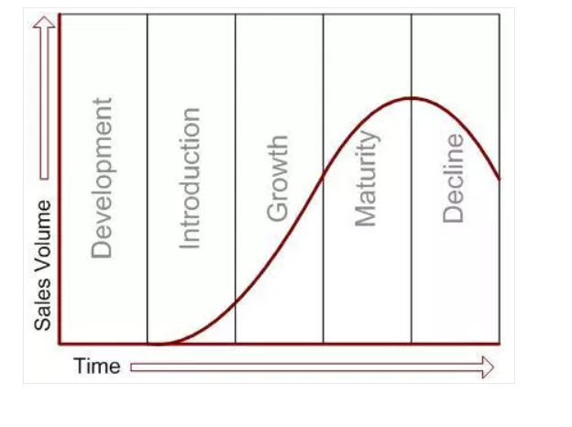
Figure 3: Product Lifecycle
Besides this, the increase in demand for sustainable fashion further increases the product demand. The company is able to have consistency image across the market which provides more chances in order to succeed in the market (Joshi and Mittal, 2018). Below is the SWOT analysis:
Strengths  - The company holds expertise with regard to sustainable fashion  - The company offers high-quality products  - The company holds the British image as it is UK based brand  - The products are of various design and choices  - The excellent marketing strategy serves as an advantage for the firm  - The low overhead and online accessibility benefits company | Weaknesses  - The company products are expensive  - The increase in competition further affect the company  - The slow production time further affect supply  - The importing issues cause severe damage for company image
Opportunities  - The organic and sustainable fashion could use as an opportunity for expansion  - The company can expand its business in the international market  - As jeans have become formal in work norms; thus, more customer could be attracted  - The increase in demand for coloured jeans further provide an opportunity for expansion  - The brand expansion can be adopted as the growth strategy | Threat  - The availability of cheaper alternative further affects the brand image  - The grey market affect company  - The emergence of jeggings further create a threat for the company because of a substitute product
Figure 4: SWOT Analysis
Source: Self-designed

Marketing Objectives
Below are the marketing objectives developed from the situational analysis for Hiut Denim company to further undertake its marketing plans for upcoming years:
- To expand the business in the Russian market by 2021 and increase revenues by 40% while decreasing product prices by 1%
- To add new products within the product mix in the next 6 months and maximize sales by 20%
- To tap new sales and delivery channels and increase customer satisfaction and engagement by 45% by the end of 2021
Hiut Denim company is considered as the premium jeans brand and it is forecasted that the premium jeans sector will be shirk from 8.9% to 5.4% by the year 2022. Therefore, this forecasting can serve as the future direction and the company can further determine the factor which can affect the sales. During 2018, the premium jeans sector in the Russian market have worth of 21,251 million RUB and the industry faced tough coemption due to the availability of numerous brands. The availability of competitors further provides an opportunity for Hiut Denim company to differentiate its product in the market to gain competitive advantage. Below is the strategic group analysis of Hiut Denim:

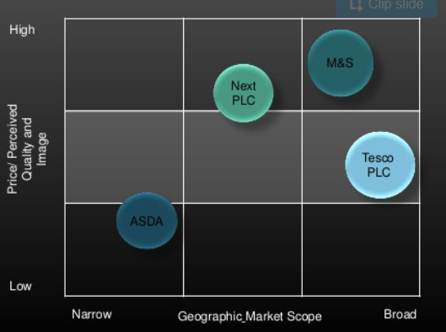
Figure 5: Strategic Group Analysis
Source: Rothaermel (2016)
The Hiut Denim company offers handmade jeans from Wales and they are hand made from scratch. Therefore, this provides the company with a unique advantage and they can easily maintain value in the Russian market. In the Russian market, the jeans of several competitors vary from 3500 to 35000 (McLaren and Goworek, 2017). Levi’s jeans are charged under 3500 to 8500 in Russian Ruble. Guess are 8500 to 12000 while jeans of Huit, Calvin, D&G and Armani are charged under 12000 to 35000 RUB.
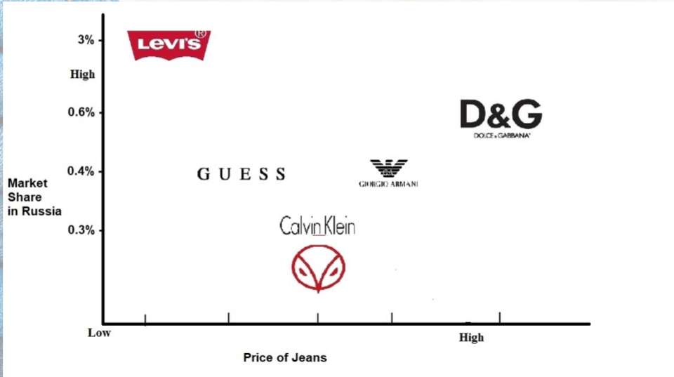
Figure 6: Strategic Group Map
Source: Indartono (2016)

Consumer and the Markets

Segmentation and Targeting
Hiut Denim company targets the young generation majorly. Majority of the customers fall under the age category of 25 to 44 years. The recession affected the consumer buying but after recovering from the recession the demand for the luxury and quality product have increased among the middle-class customer. The jeans have today become the Norm within Russian and the UK market (Griffiths, 2017). The customer has started wearing the jeans formally and informally and especially in Russian the shift in creative workplaces and gig economy further increased the demand for wearing jeans at the workplace (Flint, 2016). In Russia, the central region has the highest spending per household and it has the highest consumer expenditure.

Positioning
According to Ge, Sun and Li (2018), the positioning strategy includes the aspect in which the company chooses one or two important areas in order to concentrate on. Effective positioning allows the company to consider the strength and weaknesses of the organisation. The positioning strategy allows determining the product benefits ad its attributes. It refers to the product price, quality, application and competitors. The product strategy allows determining the company uniqueness by comparing the company with its competitors. Hiut Denim company can position itself as the brand that provides differentiation with regard to the product. The products of Hiut Denim company are unique and the pieces are handmade (Szmydke-Cacciapalle, 2018). The company have gained ownership and the specific advantage based on experience form its hometown. The location advantage is gained based on the wealthy and consumerist market. Lastly, the internationalization advantage provides the company in gaining a competitive advantage. Therefore, through the use of exporting strategy, the Hiut Denim company can expand its business. Below is the strategic position mapping for Hiut Denim company:
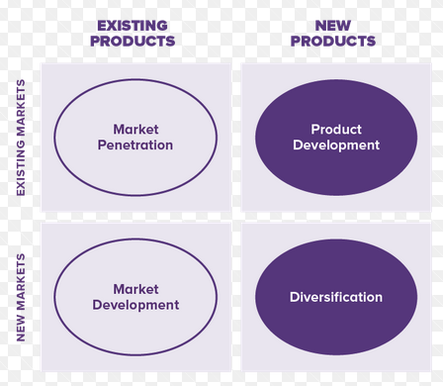
Figure 7: Ansoff Matrix
Source: Hiut Denim (2020)
Hiut Denim company can implement on market development strategy and position the brand as the unique brand within the Russian market. The use of a market development strategy can assist the firm in gaining competitive advantage. The positioning allows the company to create a brand image of the product on the consumer mind (Phillips, 2019). The companies are using positioning maps in order to create and develop their positioning strategy of products. The positioning map allows the customer to develop perception and it helps the company to identify the current and future position of the brand. Below is the current perceptual map of Hiut Denim company and among its competitors:
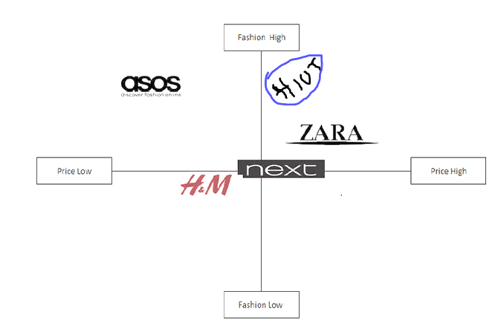
Figure 8: Perceptual map
Source: Hiut Denim (2020)
Hiut Denim company is currently position as the high fashion brand with high prices. The major competitor of the company is Zara and there is limited variability in the pricing of companies (Popova, 2018). Therefore, the core objective of this marketing plan is to reduce the product prices and expand in a new market within the next 3 years and position the brand in the quadrant of high fashion and low price.

Marketing Strategies
The marketing objective is developed for Hiut Denim company in the marketing plan that relies in different marketing strategies. The company needs to adopt changing customer demand and analyse their purchase patterns. The most effectual marketing strategy which could be implanted by Hiut Denim Company is to expand its product in a new market and expand its customer base. The company can also expand its marketing channels by adopting omnichannel retailing (Iyer, Davari, Zolfagharian and Paswan, 2019). The omnichannel retailing can help customer to make the purchases from different application and in different locations. This will further fulfil the need of the customer and the customer will become more satisfied and loyal towards the brand. The reason to suggest the omnichannel strategy is that today customer are more likely to purchase those products that are having an online presence. The availability of product through online means does rise in the customer purchase and it led towards maximizing the sales.

Marketing mix
Szmydke-Cacciapalle (2018), the marketing mix is defined as the business model which refers to the price, place product and promotion. The marketing mix is the marketing tool that is used by the firm to pursue its marketing objective and target market. The marketing mix refers to the four broad category and the businesses use marketing strategies in order to maximize its profit. Below is the marketing mix for Hiut Denim company:

Place
The place refers to the customer services which are provided to the customer for their convenience. Hiut Denim company do not have any owned store and the company have its independent retailers for selling their jeans throughout France, UK and Germany. The company ship its product through its e-commerce website and within the retail format the company used independent retailers’ format. This means that Hiut Denim company have general clothing stores and specialized jeans retailers. The buying is taken place directly from the wholesalers, retailers and agents that are the members of selling or the buying organisations.
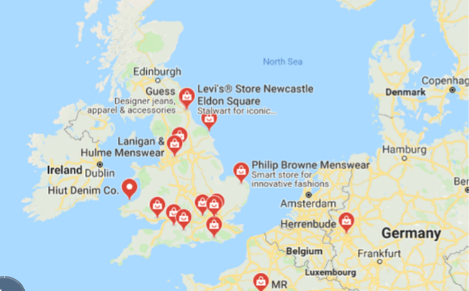
Figure 9: Place
Source: Hiut Denim (2020)

Price
The price refers to the amount which is paid by the customer for the product. The companies used pricing strategies and tactics in order to further attract customers. The product prices of Hiut Denim company do range from product to product:
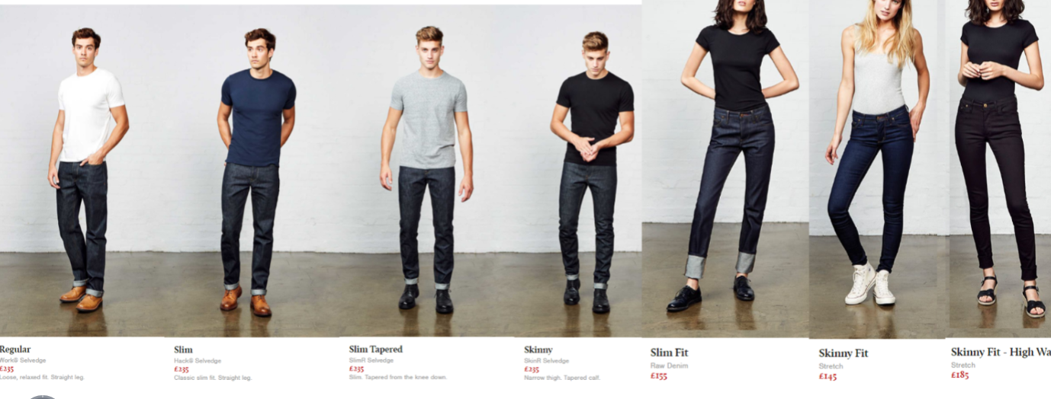
Figure 10: Price
Source: Hiut Denim (2020)
The company set out its prices based on fashion acceptance and price categories. Based on different characterises the customer are differentiated and the prices for products are set. The Hiut Denim company cater the trendsetters and the company generally offer basic jeans but with the special fitting which results in unique finishing. The customized and tailored product are offered to customers; thus, the product pricing strategy is based on value-based pricing (Hübner, Holzapfel and Kuhn, 2016). The value-based pricing does allow Hiut Denim to set up the prices based on the consumer perceived value. However, in future, the company can shift its value-based pricing to competitive pricing. The application on competitive pricing will further help to successfully compete in the new market and gain market share.

Promotion
The promotion refers to the marketing communication which includes advertising, PR and sales promotions. The Hiut Denim company focuses more on a pull strategy rather than a push strategy. The company do not pass the messages of high consumerism but they acquire the singular and the high type of products which will last in term of lifetime repaid for the jeans (Išoraitė, 2016). This results in gaining competitive advantage and it allows to gain the differentiated advantage. The use of digital marketing practices does enable the form to use blogs, social media, email marketing, news and another medium by which they sell their products directly to the customers.
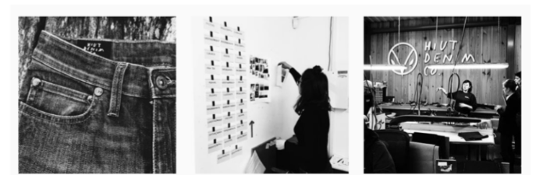
Figure 11: Promotion
Source: Hiut Denim (2020)

Product
Welsh brand offers high-quality handmade products and the jeans are made up from selvedge which are cardboard when they are made first. There is no scale production and 100 pairs are produced by the Grandmaster. The Grandmasters have an expert eye to cut and they are obsessed with every detail.
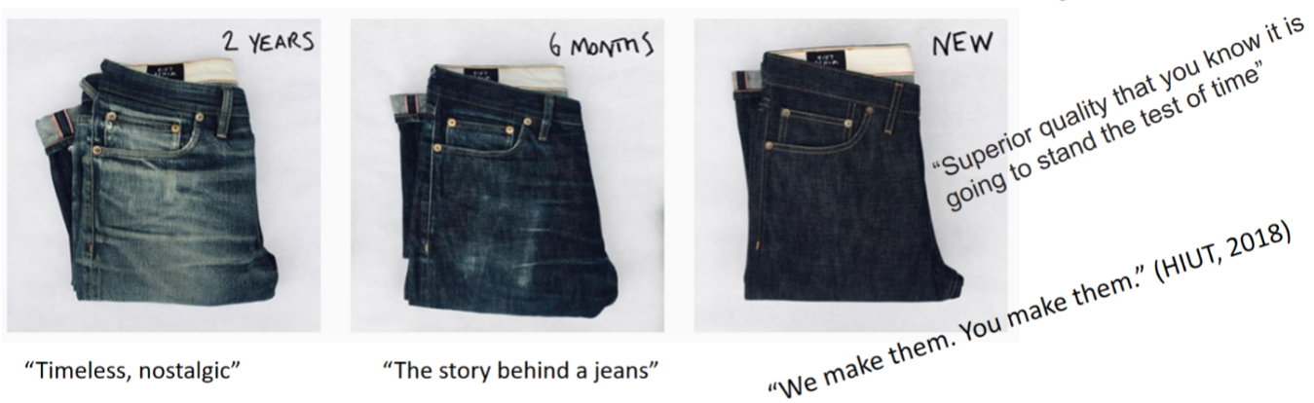
Figure 12: Product
Source: Hiut Denim (2020)
The products of Hiut Denim are of superior quality as they are using innovative technology to reform the denim. The company offer support services and deliver by using Hiut ships. The after-sales services are provided and on the no-wash club, the tips are presented for preserving the jeans. The product attributes include the strong brand image which is held by the company because of its premium jeans, design and creative ideas. The clear image and perceived value are the core benefits in the product.

Strategic Options – SAF Framework
According to Wu and Li (2018), strategic analysis determines the examination of the current strategic position of the brand. It allows evaluating about strategic choice and strategy implementation. The companies select strategic choices based on exploring the current and future need. The evaluation of the external market and the internal capabilities further determine the most suitable strategy which can be adopted. For Hiut Denim the two strategic choices are available. These choices include:
- Differentiation strategy
- Growth strategy
Before making strategic choices the application of Porter competitive strategy helps to examine how an organisation can pursue their goals. From the porter generic strategy, the differentiation strategy is one of the most significant options that can be implanted by the firm in order to gain a unique market share (Anwar and Hasnu, 2016). The customer will be willing to pay a huge amount for the perceived quality and differentiation. Hiut Denim will achieve differentiation by:
Designing differentiation – The design differentiation will differentiate the product based on the design and Hiut Denim will offer the customer with novel products
Quality differentiation – The quality differentiation will allow Hiut Denim to improve the product feature and make them better
Once the differentiation strategy has been elected then the growth direction will be examined through Ansoff matric. The Ansoff matrix describes about the product market strategies as it explores the market in which the company can be entered or leave. Hiut Denim can expand in the new market and Russia is one of the most potential markets. The market development can be selected as the strategic choice and the company can easily tap new markets for existing products. The new market can be the new segment within the current market or in the overseas market. The application of market development strategy will increase the existing sale of Hiut Denim through repositioning the brand into a new market. This will help to tap the additional geographical market and create national regional and interaction expansion. The company will attract the other segment by the development of Hiut jeans and use new entry channels. The market development strategy will help Huit denim to identify potential opportunities and the company can further be repositioning itself by exploiting new opportunities (Sekhon, Cartwright and Francis, 2017). The company resources are structured and the distinctive competencies are developed. Therefore, the below is the SAF framework which evaluates the strategic choices that are available for the company.
Strategies – Suitability
Strategy | Opportunities/ Threat | Resources and capabilities | Expectations | Ranking Scores
Market Penetration is the current strategy | Opportunity – Hiut Denim focuses on improving the product quality for gaining a sustainable position in the current market  Threat- The similar offering by the other brand further affect the company | Hiut Denim holds strong brand recognition  Hiut Denim can further expand in the emerging countries | Enhance the brand image  Expand market share
Sustainability Rating | +01 | +02 | +02 | Total +05
Market Development | Opportunity – Hiut Denim can offer its existing products in the new market and maintain differentiation based on design and quality  Threat –  Existing competitors within the new market can affect the expansion | Hiut Denim needs to further analyse the environment to understand the distinctive customer need and develop products accordingly | Increasing customer involvement  Retention of customers
Sustainability Rating | +02 | +03 | +01 | Total +06
Strategies – Acceptability
Strategy | Financial | Risk | Stakeholders | Ranking Scores
Market Penetration existing strategy | Hiut Denim is currently serving at different locations in the UK and selling numerous denim products | The economic conditions further decrease customer purchase power and it will affect the company sales | Customers  Hiut Denim
Sustainability Rating | +02 | +02 | +02 | Total +06
Market Development (the proposed strategy) | Hiut Denim can focus on offering the range of its products within the apparel line by further tapping the new market that are demanding for sustainable fashion | In future, the customer might not feel attracted that will result in affecting the brand image | Customers  Local and foreign franchises
Sustainability Rating | +02 | +02 | +02 | Total +06

Strategies – Feasibility
Strategy | Tangible Resources | Intangible Resources | Financials | Ranking Scores
Market Penetration (Current) | Hiut Denim clothesline are tangibly touched by Hiut Denim customers | Improvement can be made in services | Increase the sales and growth
Sustainability Rating | +01 | +02 | +02 | Total +05
Market Development (in future) | Expanding the market | Attracting more customers | Increased in revenue and market share
Sustainability Rating | +02 | +02 | +02 | Total +06
Figure 13: SAF Framework
Source: Self-designed
Overall Rankings
Strategies | Suitability | Acceptability | Feasibility | Total Score
Market Penetration (existing) | +05 | +06 | +05 | +16
Market Development (future) | +06 | +06 | +06 | +18
Figure 14: SAF framework
Source: Self-designed

Conclusion
Conclusively, from the report, it is summed that from the SAF criteria it has been evaluated that the market development is the most suitable strategic choice and the company can expand the future in the new market. The expansion of products in the new market will further help the company to achieve its growth objective and expand market share. However, the limitation that might be faced by Hiut Denim while expanding in the new market can be:
- Lack of market knowledge
- Limited demand for sustainable fashion
- Already existing competition

References
- Anwar, J. and Hasnu, S.A.F., 2016. Business strategy and firm performance: a multi-industry analysis. Journal of Strategy and Management.
- Flint, T., 2016. Fiction for Design: Appropriating Hollywood Techniques for Design Fictions. In Digital Make-Believe (pp. 49-66). Springer, Cham.
- Ge, L., Sun, X. and Li, C., 2018. Performance Analysis of China’s Fast Fashion Clothing Market Based on SCP Model. Open Journal of Business and Management, 7(1), pp.106-115.
- Griffiths, H., 2017. Enriching the texture of experience: A media ecology perspective on the Do Lectures as a case study in strategic communication (Doctoral dissertation, Cardiff University).
- Gürel, E. and Tat, M., 2017. SWOT analysis: a theoretical review. Journal of International Social Research, 10(51).
- Hiut Denim. 2020. Company [Online] Available at: https://hiutdenim.co.uk/ (Accessed on: 3rd May 2020)
- Hübner, A., Holzapfel, A. and Kuhn, H., 2016. Distribution systems in omni-channel retailing. Business Research, 9(2), pp.255-296.
- Indartono, S., 2016. STRATEGIC THINKING CONCEPT AMONG MIDDLE MANAGERS. Jurnal Universitas Paramadina, 10(2), pp.720-728.
- Išoraitė, M., 2016. Marketing mix theoretical aspects. International journal of research granthaalayah, 4(6), pp.25-37.
- Iyer, P., Davari, A., Zolfagharian, M. and Paswan, A., 2019. Market orientation, positioning strategy and brand performance. Industrial Marketing Management, 81, pp.16-29.
- Joshi, A. and Mittal, A., 2018. Strategic Management-The Strategies that Leads Sustainable Competitive Advantage. Asian Journal of Research in Business Economics and Management, 8(9), pp.1-7.
- Kolomiets, A., Grinchenkov, D. and Vodenko, K., 2019, November. PEST-and SWOT-analysis of university internationalization factors. In Journal of Physics: Conference Series (Vol. 1415, No. 1, p. 012003). IOP Publishing.
- Land, C., Sutherland, N. and Taylor, S., 2018. Back to the Brewster: Craft brewing, gender and the dialectical interplay of re-traditionalisation and innovation. Routledge.
- McLaren, A. and Goworek, H., 2017. Investigating the relationship between consumer attitudes and sustainable fashion product development. In Sustainability in Fashion (pp. 171-192). Palgrave Macmillan, Cham.
- Phadermrod, B., Crowder, R.M. and Wills, G.B., 2019. Importance-performance analysis based SWOT analysis. International Journal of Information Management, 44, pp.194-203.
- Phillips, R., 2019. Design insights for socially-led interventions. Journal of Design, Business & Society, 5(1), pp.7-33.
- Popova, D.A., 2018. Development of an algorithm for making management decisions based on situational analysis. Juvenis scientia, (12).
- Rothaermel, F.T., 2016. Strategic management: concepts (Vol. 2). McGraw-Hill Education.
- Sekhon, M., Cartwright, M. and Francis, J.J., 2017. Acceptability of healthcare interventions: an overview of reviews and development of a theoretical framework. BMC health services research, 17(1), p.88.
- Smale, W and Brosnan, G. 2020. How Welsh jeans firm become a cult global brand [Online] Available at: https://www.bbc.com/news/business-42237426(Accessed on: 3rd May 2020)
- Sourcing Journal. 2020. Hiut Denim [Online] Available at: https://sourcingjournal.com/denim/denim-brands/hiut-denim-biodegradable-stretch-jeans-candiani-coreva-200777/(Accessed on: 3rd May 2020)
- Szmydke-Cacciapalle, P., 2018. Making Jeans Green: Linking Sustainability, Business and Fashion. Routledge.
- Szmydke-Cacciapalle, P., 2018. Making Jeans Green: Linking Sustainability, Business and Fashion. Routledge.
- Tukdeo, R., 2016. Strategic analysis & recommendation.
- Wu, Y.L. and Li, E.Y., 2018. Marketing mix, customer value, and customer loyalty in social commerce. Internet Research.

