Seeing Singing: Developing an AI-Enhanced Visualisation Tool
Informed by Learning Theory and Application Development Best Practices

Wende Ann Donahue
Student ID: 2333885

Module 5, BMPF7074D
Voice Study Centre, University of Wales Trinity Saint David
30 May 2026
Word Count – Component 1: 1631 words
Word Count – Component 2: 6557 words

TABLE OF CONTENTS
COMPONENT 1 4
I. INTRODUCTION 4
II. PLANNED PROGRAMME OF STUDY 5
III. METHODOLOGY 10

REPORT 13
I. INTRODUCTION 13
II. KNOW THAT 14
A. Know That Theme A: Visualisation Tools 14
B. Know That Theme B: Contemporary Learning Theory 16
i. Learning Theory, Theme 1: Multimodal Systemic Teaching 16
ii. Learning Theory, Theme 2: Chunking, Feedback, and Iteration 16
iii. Learning Theory, Theme 3: Reflection and Self-Awareness 17
C. Know That Theme C: Application Development Best Practices 18
III. KNOW HOW 19
A. Theme 1: Visualisation Tools 21
B. Theme 2: Learning Theory 22
i. Learning Theory, Theme 1: Multimodal Systemic Teaching 22
ii. Learning Theory, Theme 2: Chunking, Feedback, and Iteration 23
iii. Learning Theory, Theme 3: Reflection and Self-Awareness 25
C. Theme 3: Application Development Best Practices 25
IV. KNOW WHAT 28
B. Theme 2: Learning Theory 29
C. Theme 3: Application Development Best Practices 30
V. CONCLUSION 32
VI. CRITICAL REFLECTION 33
A. Reflective Model 34
B. Application of the Reflective Model 35
DISCLOSURE OF AI USE 37
VII. REFERENCES 38
APPENDICES
Appendix A: Reflective Model 49
Appendix B: Visualisation Tools 50
Appendix C: Thematic Analysis of Contemporary Learning Theories 51
Appendix C: Thematic Analysis of Contemporary Learning Theories (continued) 52
Appendix D: Iteration Map 53
Appendix E: Technical Specification 54
Appendix F: Vibe Coding Transcript 75
Appendix G: Inclusion/Exclusion Criteria 109
Appendix H: Search Table 110

LIST OF TABLES AND FIGURES
COMPONENT 1
Figure 1: Modes of Knowing 11

COMPONENT 2
Figure 1: Iteration Map 21
Figure 2: Vibrato Visualiser 22
Figure 3: Dropouts 23
Figure 4: Reference Pitch 24
Figure 5: Colour Changes 24
Figure 7: Timer and Pitch Display 25
Figure 8: Text Note 26
Figure 9: Final UI Design 27
Figure 10: Feedback Tools 28
Figure 11: Vibrato Visualiser v001 28
Figure 12: Artefact Video 33

COMPONENT 1

- INTRODUCTION

Artificial intelligence (AI) is positioned within vocal education as a tool for enhancing voice lessons through personalised, real-time feedback (Liu and Guo, 2025; Wang and Zhang, 2025). While interest is growing among educators, research on AI in vocal education remains limited, with studies concentrated in a small number of geographic areas, characterised by minimal long-term tracking, and focusing on technological features rather than pedagogical relevance (Heryanto et al., 2025; Zhang, 2025).

In my previous research, vocal educators expressed interest that AI-enhanced tools could offer visualisation capabilities, including vibrato, pitch matching, and vocal acoustics, provided the tools are pedagogically sound and ethically created (Donahue, 2025; Smailis and Heliadis, 2025). Because the vocal mechanism is hidden from view, real-time visualisation tools can assist singers by making performance observable while supporting more immediate technical adjustment (Li et al., 2025; Wang and Gan, 2025; Santos and Masiero, 2026). Although spectrographic technology has long been used by voice scientists and pedagogues, it has not been widely adopted or readily accessible to most vocal educators (Moss, 2021).

There is a pressing research need to determine how best to create an ethical and credible space for AI in vocal education, as the majority of research to date has been conducted from a computer science perspective with minimal input from vocal educators (Ovcharenko et al., 2020). Given AI’s technical origins, it is unsurprising most research comes from that discipline; yet, AI’s integration into vocal education requires interdisciplinary collaboration among vocal educators, voice scientists, and AI programmers—exploring AI’s potential while ensuring applications are developed to align with user expectations and needs (Bauer, 2023; Huriye, 2023).

With thirty years of experience as a web applications developer and vocal educator, I am positioned to critically evaluate the intersection of technology and vocal pedagogy. For my professional development, this gap presents an opportunity to strengthen my research practice by critically examining how AI-enhanced tools might support vocal pedagogy. My aim is to leverage this duality to identify and develop vocal visualisation tools for use in my practice and with my students, enabling sound to be seen.

This study will examine how insights from previous vocal visualisation tools, contemporary learning theories, and application development best practices can collectively inform the development of an artefact in the form of a technical specification and an AI-enhanced visualisation application.

- PLANNED PROGRAMME OF STUDY

To inform the creation of this artefact, I researched contemporary learning theories and conducted a thematic analysis of key concepts drawn from sources including Metacognition, Cognitive Load Theory, Educational Neuroscience (EdNeuro), and Embodied Cognition (Appendix C: Thematic Analysis of Contemporary Learning Theories). This analysis revealed three themes that will inform the artefact:

- Multimodal Systemic Teaching: the delivery of information using different modes of learning (visual, auditory, reading/writing, and kinesthetic) within a pedagogically sound structure.
- Chunking, Feedback, and Iteration: the intentional scaffolding and segmenting of information to create actionable, specific tasks to be performed, receive feedback, and adjust iteratively.
- Reflection and Self-Awareness: the learner’s current cognitive state awareness and regulation, and independent and educator-guided reflection on their actions.

Although visualisation tools have existed for decades, from spectrographic displays in the 1970s, limited to universities and labs, to more accessible contemporary software and mobile apps, their adoption in vocal education has been slow due to cost, complexity, and misalignment with pedagogical needs (Moss, 2021; Lã and Fiuza, 2022; Caldera, 2024). My previous research found that while AI-enhanced tools offer potential for personalised, real-time feedback, existing systems were largely developed without practitioner co-design, leading to resistance when introduced into established teacher–student practices (Han, 2022; Doğanyiğit and Yiğit, 2023; Moss, 2021; Xie, 2026). Planning and creating an application requires attention to user needs, including user-interface design (UI) and performance optimisation (Shethiya, 2025).
This research project brings these theoretical and practical principles together to inform the creation of an artefact, guided by the research question:

- How can insights from previous visualisation tools, contemporary learning theories, and application development best practices inform the development of an AI-enhanced vibrato visualisation tool for use in vocal education?

- Aim

To explore how insights from previous visualisation tools, contemporary learning theories, and application development best practices can inform development of an AI-enhanced vibrato visualisation artefact for use in vocal education.

- Objectives

- To critically evaluate research on contemporary learning theories as they apply to vocal education through a narrative literature review, completed before designing the artefact.
- To evaluate evidence-based design principles through a narrative literature review to inform the design of an AI-enhanced vocal education tool, completed before designing the artefact.
- To create a technical specification and working artefact prototype to be iteratively developed, with version 1.0 completed by the module’s end.

- Expected Learning Outcomes

- ELO1: Demonstrate the ability to critically synthesise and communicate research across pedagogy, cognitive science, and technology to justify design decisions.
- ELO2: Produce a technical specification as part of a practice-as-research process demonstrating how an AI-enhanced visualisation tool can make the invisible vocal mechanism accessible for educators and students.
- ELO3: Strengthen reflective practice skills through the development and application of a reflective framework and Nelson's practice-as-research modes of knowing.

- Activities and Assessment Criteria

For this study, I will undertake the following activities:

- Conduct a narrative literature review on visualisation tools for vocal education, contemporary learning theories, and application development best practices.
- Complete coursework in applied neuroscience for voice.
- Study vocal acoustics to inform the spectral visualizer of the artefact.
- Learn AI-assisted rapid prototyping (vibe coding).

As part of the assessment criteria, I will evaluate the artefact using Self-Determination Theory (SDT), which reflects three basic psychological needs in learning contexts: autonomy, feeling in control of one's actions; competence, the sense of doing things well; and relatedness, a sense of belonging (Deci and Ryan, 2002). I will also evaluate whether the application meets its aims and objectives by examining how well its design decisions, functional behaviour, and pedagogical logic align with the principles established in the literature review and the technical specification, comparing the artefact against the criteria set out in both documents (Easterday et al., 2014; Li et al., 2025).

- Timescale/Project Plan
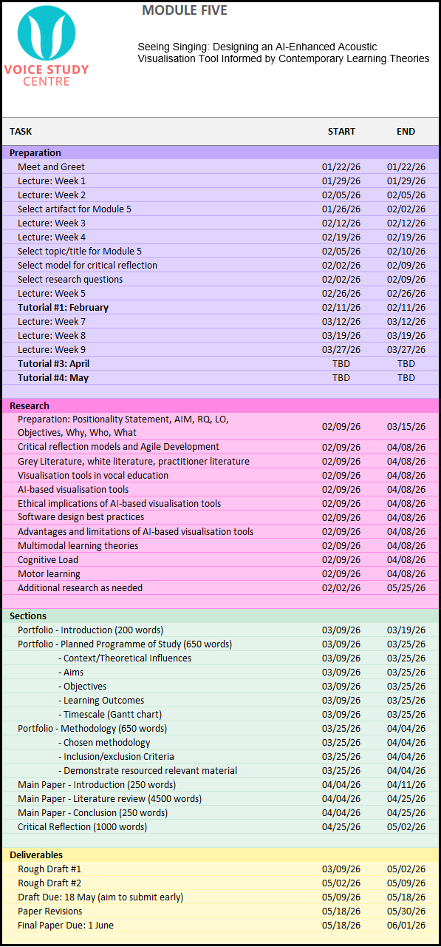

- METHODOLOGY

Several literature review methodologies were considered to leverage the type best suited for this study (Randolph, 2009). A systematic review with its exhaustive search and strict inclusion/exclusion criteria does not lend itself to an interdisciplinary, under-researched topic (Boell and Cecez-Kecmanovic, 2014). Similarly, a scoping review is better suited for examining well-established domains, and a rapid review, while effective for quickly summarising known evidence, is less helpful for an emerging research area (Grant and Booth, 2009). A narrative review was chosen because it can highlight gaps in research, support critical synthesis across adjacent disciplines, and enable the literature to be organised around themes aligned with the research questions, aims, and objectives (Green et al., 2006; Grant and Booth, 2009; Sarkar and Bhatia, 2021; Sukhera, 2022).

This research is being approached from a Critical Realist (CR) paradigm, acknowledging reality as stratified into three layers: the real (underlying mechanisms), the actual (observable events), and the empirical (measurable events) (Shannon-Baker, 2016; Fletcher, 2017; Lawani, 2021). CR is applied by using these three layers to examine AI-enhanced visualisation tools in vocal education by recognising the underlying mechanisms influencing pedagogy and technology (the real), observable practices (the actual), and learner experiences and outcomes reported in the literature (the empirical) (Lawani, 2021). Additionally, Nelson’s practice-as-research modes of knowing were used to organise this paper into three primary sections: Know That (theories informing the artefact), Know How (how the artefact was created), and Know What (artefact impacts and contributions) (Figure 1: Modes of Knowing) (Nelson, 2013, p. 28).

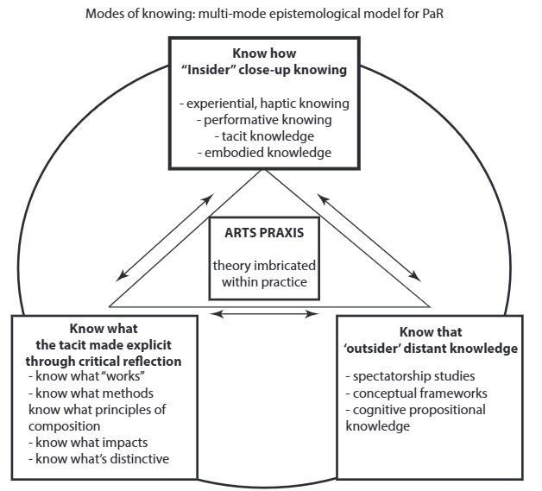
Figure 1: Modes of Knowing (Nelson, 2013, p. 28)

Design-Based Research (DBR) will serve as the methodological structure for this project, as it focuses on designing and developing artefacts to solve context-specific problems in educational settings through integrating research, design, and pedagogical practice to provide deep insight into learning within real-world contexts (Joseph, 2004; Alghamdi and Li, 2013). DBR involves six iterative, but not necessarily linear, phases: focus (identifying an issue), understand (researching the issue to identify the root cause), define (determining goals and assessments), conceive (creating a proposed solution), build (creating an artefact prototype), and test (using an iterative cycle of testing against real-world feedback) (Easterday et al., 2014).

In this study, CR pairs with DBR by using CR’s focus on the mechanisms behind observable events to guide each DBR iteration, helping explain not only why and how the artefact may work, but for whom, under what conditions, and why it may succeed or fail in practice (Mingers, 2004; Shannon-Baker, 2016; Fletcher, 2017; Lawani, 2021).

To facilitate the artefact’s build phase, I will employ AI-assisted rapid prototyping (vibe coding), an emerging software development technique where developers generate code by interacting with large language models (LLMs) through natural language prompts (Fawzy et al. 2025).
Literature was selected prioritising the most recent research, particularly published since January 2025, and using the CRAAP test (Currency, Relevance, Authority, Accuracy, and Purpose) to ensure sources were current, relevant, and credible (Blakeslee, 2004) (Appendix G: Inclusion/Exclusion Criteria). The literature search strategy used keywords such as “learning theory,” “AI in vocal education,” and “UI best practice,” which were entered in Google Scholar, Google, and the University of Wales Trinity Saint David (UWTSD) online library, employing an iterative approach to refine keyword combinations and strengthen results (Appendix H: Search Table) (Aromataris and Riitano, 2014). Google search alerts and ResearchGate filters were set to recommend literature on AI in education.

Given the presence of newer researchers in this field and the use of non-traditional publication outlets conducting internal peer reviews, this study incorporates grey literature, including dissertations, conference proceedings, and websites, together with peer-reviewed sources to capture a broad range of academic perspectives (Adams et al., 2017).

REPORT

Seeing Singing: Developing an AI-Enhanced Visualisation Tool
Informed by Learning Theory and Application Development Best Practices

- INTRODUCTION

Artificial intelligence (AI) is positioned within vocal education as a tool for enhancing voice lessons through personalised, accessible real-time feedback (Han, 2022; Khaydarov, 2024; Hin, 2025). While interest is growing among educators, research on AI in vocal education remains limited, with existing studies focusing on technological features rather than pedagogical relevance and offering limited geographic coverage and minimal long-term tracking (Ovcharenko et al., 2020; Bauer, 2023; Huriye, 2023; Zhang, 2025). AI’s practical integration into vocal education requires interdisciplinary collaboration among vocal educators, voice scientists, and AI programmers—exploring AI’s potential while ensuring applications are developed to align with user expectations (Bauer, 2023; Huriye, 2023).

In my previous research, vocal educators expressed interest that AI-enhanced tools could offer visualisation capabilities, including vibrato, pitch matching, and vocal acoustics, provided the tools are pedagogically sound and ethically created (Donahue, 2025; Smailis and Heliadis, 2025). This study focuses on the design of an AI-enhanced vibrato visualisation tool responding directly to these expressed pedagogical needs. With thirty years of experience as a web applications developer and vocal educator, I am positioned to critically evaluate the intersection of technology and vocal pedagogy.

Because the vocal mechanism consists of internal physiological systems not visible to the naked eye, AI-enhanced visualisation tools may strengthen a vocal learner's experience by supporting immediate technical adjustment, preventing the reinforcement of errors, and managing cognitive load (Han, 2022; Doğanyiğit and Yiğit, 2023; Bin, 2024; Cleveland Clinic, 2025; Wang and Gan, 2025). However, for such tools to be effective and adopted by educators, they must fit within diverse vocal pedagogical frameworks and be supported by intuitive user interfaces (Yu et al., 2023; Donahue, 2025).

Using the three-layered lens of Critical Realism (CR) together with Nelson’s practice-as-research modes of knowing (Know That, Know How, and Know What), this study will culminate in an AI-enhanced vibrato visualisation artefact, delivered as a technical specification and prototype application (Nelson, 2013).

This study is guided by the research question:

- How can insights from previous visualisation tools, contemporary learning theories, and application development best practices inform the development of an AI-enhanced vibrato visualisation tool for use in vocal education?

- KNOW THAT

Three primary themes shaped the creation of this artefact: visualisation tools, contemporary learning theories, and application development best practices.

- Know That Theme A: Visualisation Tools

Unlike instrumentalists who can directly observe their technique, such as a pianist’s fingers on the keys or a violinist’s bow placement, singers work with an entirely internal instrument, requiring learners to rely on proprioception (sensing one’s own position and movements) and aural feedback (Bin, 2024; Li et al., 2025; Wang and Gan, 2025). To compensate for this, voice teachers often use analogies, imagination, and metaphors (AIMs), both verbal and kinesthetic, to convey aspects of vocal technique (Ekholm et al., 1998; Kar, 2021). While experts agree AIMs can improve the voice by affecting involuntary muscles and helping to concretise concepts, AIMs can also confuse students when the educator’s image is not replicated in the student’s mind as intended, highlighting the need for more tangible, visually accessible forms of teaching vocal techniques (Bartlett, 2014; Doğanyiğit and Yiğit, 2023; Bin, 2024; Lim, 2024). Particularly during independent practice and in early learning stages when perceptual skills are still developing, students may struggle to identify and correct errors without timely external feedback, increasing the likelihood of reinforcing inaccuracies (Bin, 2024; Li et al., 2025; Liu and Guo, 2025).

With the technological evolution of computer science and advances in recording technology, visualisation tools in vocal education have progressed from simple feedback systems to AI-powered, real-time diagnostics that make abstract dimensions of vocal instruction more accessible (Elmer, 2000; Bin, 2024) (Appendix B: Visualisation Tools). Spectral waveform analysis transforms a singer’s voice into image-based displays, allowing visual evaluation of timbre, pitch, and intensity (Khan et al., 2020; Bin, 2024). Digital and AI tools can also support multiple modes of learning (visual, auditory, and kinesthetic), but can be difficult for students to interpret without specialised training and are often cost-prohibitive (Han, 2022; Doğanyiğit and Yiğit, 2023; Chen, 2024; Liu et al., 2024).

Current research highlights the development of AI-enhanced visualisation tools that provide analysis of vocal metrics, reflecting a shift from teacher-driven AIMs to student-observed evidence (Caldera, 2024; Liu and Guo, 2025; Rao, 2025; Wang and Gan, 2025). Tools such as the Vocal AI Analyzer and Smart Vocal Coach have demonstrated effectiveness in enhancing vocal skills by identifying microscopic pitch deviations, enabling students to make faster, targeted corrections to vocal technique with or without teacher involvement (Chen, 2022; Wang and Zhang, 2022; Liu and Guo, 2025).

The adoption of real-time visualisation tools in vocal education has been slow since many are misaligned with pedagogical principles, or present monetary or technical barriers, and often encounter resistance when introduced into established teacher–student practices (Erickson, 2021; Xie, 2026). While anecdotally vocal educators are known to use spectrographic software during lessons, there are limited studies available on the overall effectiveness of visualisation tools in vocal education, with most studies involving small samples and short durations (Hoppe et al., 2006; Lã and Fiuza, 2022; Li et al., 2025). Concerns regarding over-reliance on technology suggest it may weaken critical listening skills and cause beginners to lose the ability to critically evaluate the feedback they receive (Odusanya, 2025). To be adopted, vocal visualisation tools must be pedagogically aligned, co-designed with practitioners, and user-friendly, enhancing rather than disrupting established teaching practices (Grassini, 2023; Donahue, 2025).

In summary, while vocal education has a rich tradition, its persistent pedagogical challenges highlight the need for more concrete, multimodal ways to demonstrate technique that support both teacher-led and independent learning (Bartlett, 2014; Ovcharenko et al., 2020; Huang, 2026). With limited evidence on the efficacy, relying solely on AI to provide feedback is insufficient for improving metacognition, highlighting the need for learning theory-informed creation of tools (Wu et al., 2020).

- Know That Theme B: Contemporary Learning Theory

As our understanding of human cognition has grown alongside rapid technological development, contemporary learning theory has shifted with it, treating modern tools as part of an ongoing, lifelong learning process (Ouwehand, 2025). In order to inform the design of this artefact, I researched several contemporary learning theories, including Metacognition, Cognitive Load Theory, Educational Neuroscience (EdNeuro), VARK, TTI, Embodied Cognition, and AI Recursive Theory. While each one has distinctive characteristics, applying thematic analysis revealed 37 key terms, which were grouped into eight categories, then reduced to three primary themes to provide clear criteria from contemporary learning theory to apply to the artefact (Appendix C: Thematic Analysis of Contemporary Learning Theories).

    - Learning Theory, Theme 1: Multimodal Systemic Teaching

The first theme, multimodal systemic teaching, refers to the transfer of knowledge through auditory, visual, reading/writing, and kinesthetic modalities within a pedagogically sound structure, with multisensory integration shown to refine motor responses and strengthen memory (Erickson, 2021; Isma’il and Sodangi, 2025). These multimodal benefits can only be realised when tools are rooted in a structured pedagogical framework informed by student-centred approaches (Wu et al., 2020; Gkintoni et al., 2025; Isma’il and Sodangi, 2025).

    - Learning Theory, Theme 2: Chunking, Feedback, and Iteration

The second theme, chunking, feedback, and iteration, refers to the intentional scaffolding and segmenting of information to gradually introduce new concepts by creating specific, actionable tasks that receive feedback and are adjusted iteratively, allowing learners to integrate new skills and maintain cognitive focus (Gkintoni et al., 2025). Across studies, real-time and iterative feedback has been shown to heighten learners’ awareness of their metacognitive state and deepen cognitive engagement (Molin et al., 2020; Li et al., 2023b; Cosentino et al., 2025; Heryanto et al., 2025). Because feedback requires learners to process verbal, nonverbal, and contextual cues simultaneously, it can elevate cognitive load, making its effectiveness dependent on segmentation, scaffolding, and repetition to manage intrinsic and extraneous demands while supporting efficient skill acquisition (Erickson, 2022; Cosentino et al., 2025; Gkintoni et al., 2025).

    - Learning Theory, Theme 3: Reflection and Self-Awareness

The third theme, reflection and self-awareness, refers to the learner’s understanding of their current cognitive state and their ability to regulate it, along with reflection on their actions, both independently and with guidance from an educator. Reflection and self-awareness shift learning from copying to intentional, self-directed work, allowing learners to identify technical misalignments and incorporate feedback through repeated evaluation cycles (Molin et al., 2020; Li et al., 2023b; Gkintoni, 2025; Heryanto, 2025; Li et al., 2025; Ouwehand, 2025).

Many other learning theory elements fell outside the scope of this thematic analysis since they did not align with the needs of this specific application, including Embodied Cognition’s emphasis on physical engagement with the environment to deepen conceptual understanding, the application of reading/writing from VARK’s theory, and emotion-cognition theory of EdNeuro (Cosentino, 2025; Gkintoni, 2025; Indriyani and Nurmasitah, 2025). Incorporating these elements risked creating a split-attention effect where learners inefficiently divide their focus between different types of content (Xue et al., 2024).

Similarly, some characteristics of learning theory conflict; for example, multimodal approaches encourage rich sensory input, while Cognitive Load Theory cautions against overload, requiring careful synthesis to balance multimodal presentation’s richness with the simplicity needed to optimise working memory (Cosentino, 2025; Gkintoni, 2025). While a single theory offers a streamlined approach, a blended approach is necessary to activate the diverse underlying mechanisms required for deep learning in a multidisciplinary subject like singing (Li et al., 2025).

By integrating these three themes as representative of contemporary learning theory, my aim is to build an artefact that not only functions as a real-time visualisation tool, but also supports the cognitive and reflective processes that underpin effective vocal learning, consistent with a CR approach that considers underlying mechanisms, actual practices, and empirical learner experiences (Bhaskar, 1975; Gkintoni, 2025; Heryanto, 2025; Li et al., 2025; Xie, 2026).
- Know That Theme C: Application Development Best Practices

The effectiveness of digital tools is shaped by their user interface (UI), as poorly designed interfaces can create split-attention effects that increase cognitive overload (Ouwehand, 2025). Effective UI design integrates feedback into the learner’s focus area and aligns cues with attentional patterns, reducing extraneous demands and supporting deeper engagement and self-evaluation to strengthen long-term retention (Cosentino, 2025; Li et al., 2025). Teachers emphasise the need for user-friendly interfaces and seamless lesson-plan integration, underscoring the importance of human-centred design that preserves the teacher’s role (Qian, 2023; Hua and Yi, 2024; Smailis and Heliades, 2025). For vocal training, UI design must translate invisible biological processes into actionable visual cues (Santos and Masiero, 2026). Features such as colour coding can support rapid self-correction, while overly complex feedback systems risk shifting learners toward surface-level verification rather than meaningful exploration (Chen, 2025; Cosentino et al., 2025; Wu, 2026). To be effective, vocal visualisation tools must be co-designed with practitioners to ensure they enhance rather than disrupt established teaching practices (Grassini, 2023; Donahue, 2025).

These objectives are supported through front-end optimisation, efficient backend architecture, and infrastructure choices that enable responsive, accessible delivery (Shethiya, 2025). Developers must prioritise low-latency performance for real-time feedback, ensuring functionality on devices with limited processing power or restricted bandwidth, allowing learners to practice where and when they choose (Li et al., 2025; Gkintoni et al., 2025; Shethiya, 2025; Purba et al., 2025).

The emergence of AI-assisted rapid prototyping, referred to as vibe coding, has introduced a practical way to meet these technical and design requirements quickly, where instead of manually constructing each component, developers use iterative, natural-language prompts to direct an AI model to generate and refine functional code (Sapkota et al., 2025; Sarkar and Drosos, 2025). While this process can significantly accelerate development, vibe coding can also produce code that is overly generalised or structurally fragile, requiring experienced oversight to ensure stability and security (Fawzy et al., 2025; Sapkota et al., 2025). To manage this, developers must perform manual quality checks to ensure the resulting application remains efficient and correctly implemented (Sarkar and Drosos, 2025).

- KNOW HOW

In previous VSC modules, I addressed DBR’s focus, understand, and define phases, justifying the need for visualisation tools in vocal education. Building on this, my initial intention was to develop a vocal acoustics analysis tool, but as I moved through DBR’s define and conceive phases, I discovered producing a well-designed acoustic analysis application would exceed the time constraints of this project. I, therefore, shifted to a more focused tool, a vibrato visualiser, that would still address a pedagogical need expressed by vocal educators. Vibrato is a common area of difficulty for students, with challenges ranging from straight tone to excessively wide vibrato, often requiring teacher guidance to develop control and flexibility between straight tone and vibrancy (Nesterova, 2026). Vibrato was selected because its measurable characteristics, in particular amplitude and periodicity, are directly shaped by vocal training and frequently identified as areas where learners benefit from clear, externalised feedback (Mürbe et al., 2007; Nesterova, 2026).

During DBR’s conceive phase, I created a technical specification and mockups to clearly define the application’s needs as informed by the research (Appendix E: Technical Specification). The remaining phases, build and test, were addressed iteratively to refine and improve the artefact (Easterday et al., 2014) (Figure 1: Iteration Map).

Initially, I attempted to submit a lengthy vibe-coding prompt containing all features and parameters explicitly defined, along with uploading the technical specification into Bolt.ai and Claude.ai simultaneously. While the AI models both implemented all the features requested, the waveform was inaccurately overresponsive to audio input, and iterative prompts to resolve the error compromised other artefact features. I decided to start over using Claude.ai as it had been the more successful AI model during previous attempts, implementing one feature at a time and testing before moving on to the next feature, beginning with the prompt:

I want to create a web-based application to display vocal vibrato as a single waveform. I will add more features as we go along, but I need the proof of concept for the vibrato wave line first...the wave should stay vertically centred regardless of pitch, and only respond to vibrato movements to show the amplitude above and below the centre. (Figure 2: Vibrato Visualiser) (Appendix F: Vibe Coding Transcript).

PROOF OF CONCEPT B
Tools: CoPilot, Claude.AI, Bolt.AI
- Testing different audio extraction tools
- Wave smoothing experiments
- Minimal UI design
PROOF OF CONCEPT A
Tools: Claude.AI, Bolt.AI
- Basic waveform generation
- Basic vibrato visualization
- Pitch detection
- Minimal UI design

12
Retain wave colors after session ends
Iteration 12
2
Waveform stabilisation
Iteration 2
14
Integrate AI for session analysis
Iteration 14
5
Grid opacity, smoothing wave
Iteration 5
4
X & Y axis labels, grid, wave retention
Iteration 4
1
Single waveform, 15s visible, client microphone
Iteration 1
Prototype Build Version 1.0
Tools: Claude.AI
9
Sawtooth wave generator, export PNG, notes, metronome
Iteration 9
8
Reduce display length, WCAG, scroll buffer
Iteration 8
7
Adjust playhead, fix rates
Iteration 7
6
Amplitude & periodicity controls, bumpers, timer
Iteration 6
11
Add colors to wave
Iteration 11
13
Background ‘ghost’ wave sample
Iteration 13
15
UI design and implementation
Iteration 15

10
Spacebar start/stop, save session, mic input level
Iteration 10

Figure 1: Iteration Map
3
Line dropout fixes
Iteration 3
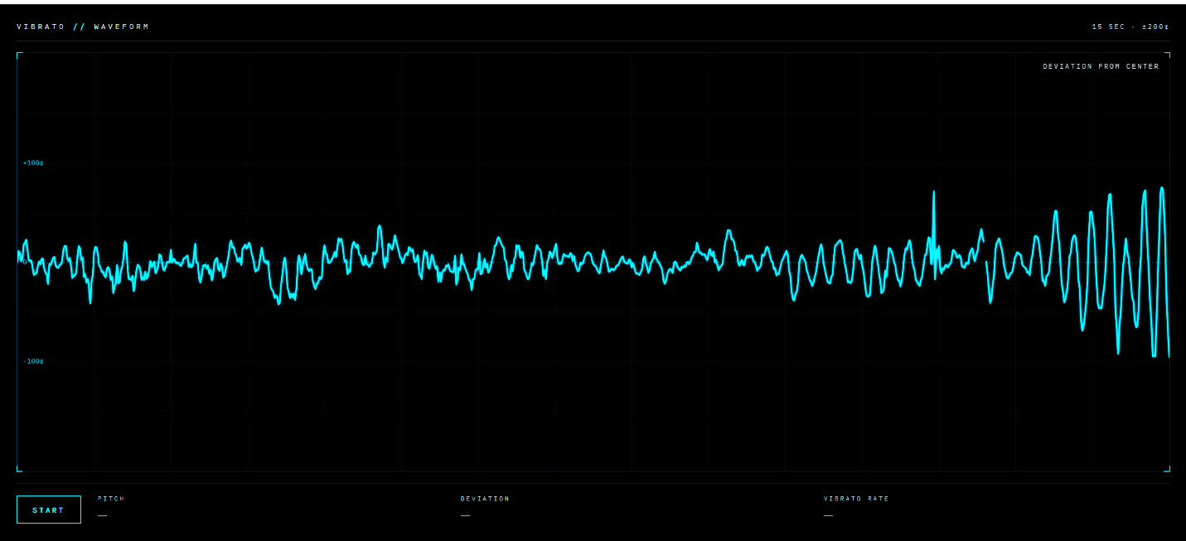
Figure 2: Vibrato Visualiser

- Theme 1: Visualisation Tools

To support clarity and ease of interpretation, I intentionally designed the UI around a single element, the vibrato waveform, which remains fixed in the screen’s centre to maintain the user’s visual stability (Erickson, 2021; Gkintoni et al., 2025) (Figure 2: Vibrato Visualiser). The wave responds in real time to the singer’s audio input, allowing learners to observe how targeted adjustments affect the vibrato pattern, demonstrating the benefit of immediate feedback (Chen, 2022; Wang and Zhang, 2022; Gkintoni et al., 2025).

Due to the difficulty in interpretability of earlier visualisation tools, I chose to prevent the waveform from shifting with pitch, anchoring it in a fixed position to keep the learner’s attention on the oscillatory pattern rather than on distracting pitch fluctuations (Hoppe et al., 2006). Early versions misinterpreted wide vibrato as a pitch change, causing dropouts in waveform generation (Figure 3: Dropouts). This was improved by adding short-window and long-window pitch-comparison averages, multi-stage smoothing, and snap-detection logic to reduce jitter. Additionally, I added dynamic pitch comparison dependent on the user’s periodicity and amplitude settings. Some fluctuation is unavoidable at vocal onset or during pitch changes because the application must interpret rapid pitch movement around the fundamental frequency. This creates a necessary compromise between strict detection for straight-tone singing and greater permissiveness for wide vibrato.
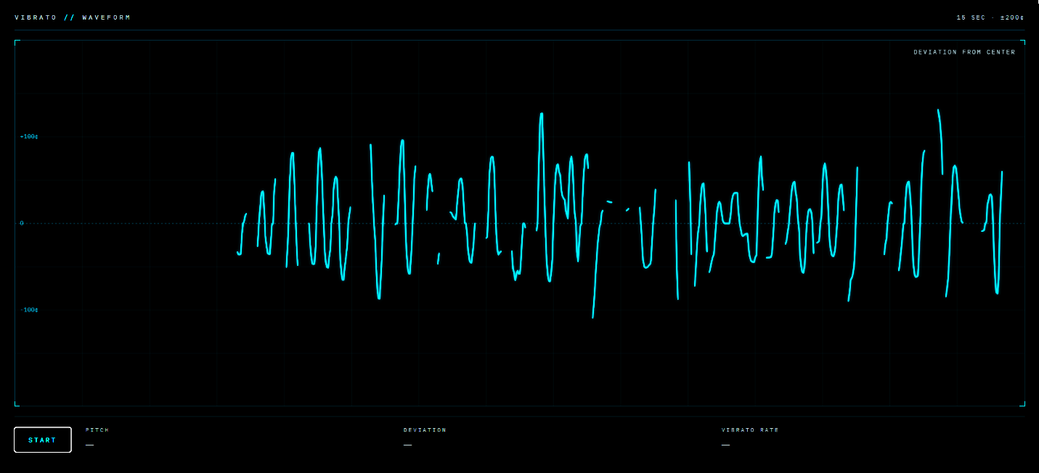
Figure 3: Dropouts

I tested several display waveform orientations, settling on a left-to-right scrolling waveform consistent with established visualisation software conventions such as VoceVista and Audacity, minimising unused space (Erickson, 2021).

Because research shows teachers prefer tools that avoid prescriptive feedback, I kept the artefact pedagogically agnostic, with no evaluative or corrective features, allowing vocal educators to provide their own pedagogical guidance (Erickson, 2021). Within this structure, the artefact acts as a cognitive support tool, providing data-driven feedback rather than replacing teachers’ judgments (Li et al., 2025).

In response to the need for inexpensive, intuitive, and user-centred tools, and because of my extensive experience as a web applications developer, I chose to create this tool as a web-based application supported by AI, able to be used on any desktop or mobile device without extra equipment (Han, 2022; Doğanyiğit and Yiğit, 2023).

- Theme 2: Learning Theory

    - Learning Theory, Theme 1: Multimodal Systemic Teaching

Informed by learning theory theme 1, the artefact pairs auditory and visual input to support more efficient cognitive processing and improved learning outcomes and includes an auditory component in the form of a reference pitch that oscillates at the user-selected periodicity and amplitude, aligning with learning through mimicry (Figure 4: Reference Pitch) (Jarvis, 2019; Erickson, 2021; Gkintoni et al., 2025). At the AI model’s advice, a sawtooth wave with a low-pass filter was used rather than a sine wave to better resemble the timbre of the human voice. Although finger tapping for vibrato has been shown to be effective, the application does not cue any kinesthetic movements currently to avoid cognitive complexity particularly for beginners (Nesterova, 2026).

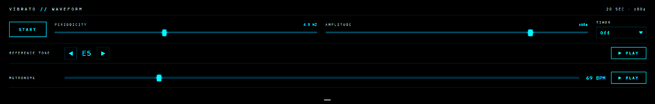
Figure 4: Reference Pitch

To provide an additional visual cue, I introduced colour changes when users maintain consistent amplitude and/or periodicity for a set duration (Figure 5: Colour Changes). This mild gamification supports motivation through reward‑based visual feedback without compromising pedagogical integrity (Gkintoni et al., 2025; Liu and Guo, 2025).

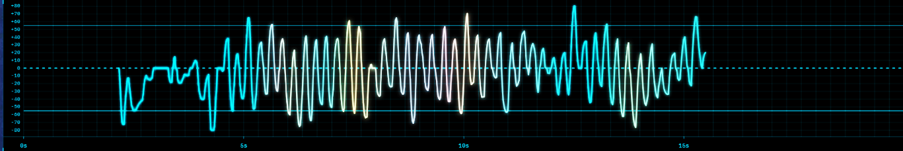
Figure 5: Colour Changes

    - Learning Theory, Theme 2: Chunking, Feedback, and Iteration

To align with learning theory theme 2, the artefact breaks skill development into smaller tasks (chunking) by reducing vibrato to a single, manageable behaviour and providing clear boundaries for practice to prevent overwhelm (Gkintoni et al., 2025). Sliders allow users to select their targeted amplitude and periodicity, generating amplitude guidelines above and below the waveform and vertical lines indicating periodicity (Figure 6: Guidelines and Grid). Adjusting these targets updates the guidelines in real time, and together these markers help learners identify whether the vibrato is too wide, too narrow, too fast, or too slow. A low-opacity sample waveform illustrates the chosen amplitude and periodicity, while the continuously updating trace allows learners to see the effect of each attempt and refine their technique instantly (Liu and Guo, 2025).

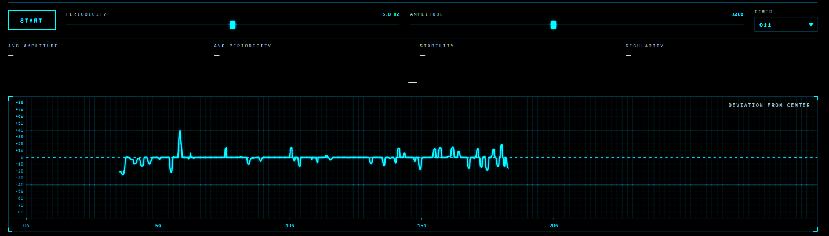Figure 6: Guidelines and Grid

An optional timer (15, 30, 45, or 60 seconds) supports small, repeated units of practice to strengthen skill development and allow complexity to build gradually (Erickson, 2022). Pitch is displayed textually in real time to provide context and uncover vibrato issues across different parts of the vocal range (Figure 7: Timer and Pitch Display).

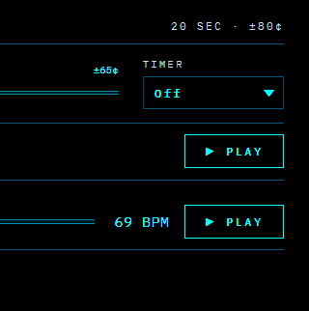
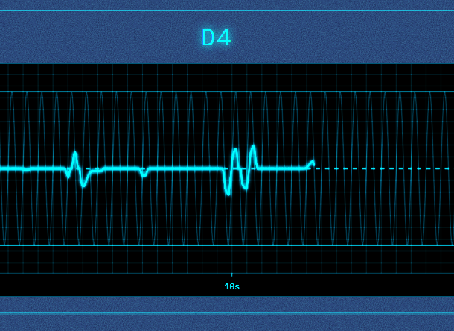
Figure 7: Timer and Pitch Display

To minimise split-attention, a hide/show toggle prioritises essential elements (start/stop control, pitch name, vibrato settings, and the waveform) so the visualisation remains focused and easy to interpret. This minimal design, using a simple waveform and adjustable bumpers rather than complex metrics or spectrogram-style displays, aligns with research showing learners engage more deeply when the task environment is simple, predictable, and free from unnecessary demands, allowing them to clearly see and interpret vibrato stability and irregularity as it occurs (Cosentino et al., 2025).

    - Learning Theory, Theme 3: Reflection and Self-Awareness

To support learning theory theme 3, I added scrollback and waveform retention to facilitate reflection and teacher-led discussion, aligning with research showing that reflection and self-awareness improve learning conditions (Li et al., 2025). The feedback section includes a text field for session notes and waveform metrics stored locally, enabling users to compare their practice over time (Figure 8: Text Note). A history table displays previous averages of amplitude, periodicity, and regularity, and waveforms can be exported as PNGs. Although historical audio data would be useful, I chose to minimally integrate AI by including an API call to Claude.ai that interprets stored session data, allowing experimentation with the technology without compromising privacy or introducing additional ethical concerns, with text notes and waveforms stored locally to support long-term comparison while maintaining a low-risk approach (Rao, 2025).

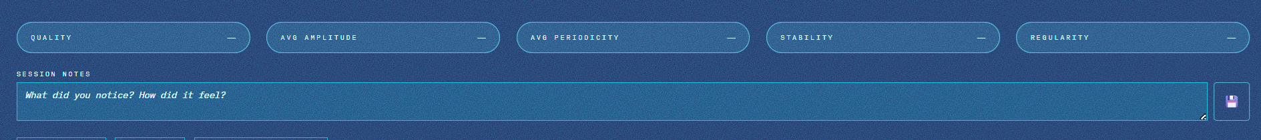
Figure 8: Text Note

- Theme 3: Application Development Best Practices

Given the high demand for applications that run on standard mobile and computer devices that allow learners to practise when and where they choose, I built the artefact as a web-based application with low-latency performance and without the need for high-cost equipment or high processing power (Shethiya, 2025; Purba et al., 2025).

Standard UI elements, including error handling and start/stop buttons, were incorporated. During vibe coding, the AI model recommended the addition of microphone input meter to allow easier troubleshooting if the waveform did not generate.

I attempted to build early prototypes using more robust libraries (Meyda and Pitchy), but they had a difficult time distinguishing between vibrato and pitch change, produced visual artefacts, and introduced latency. I made the decision to use a widely used JavaScript algorithm, YIN, to generate stable, real-time visualisations. Since JavaScript was going to be the most time-consuming part of coding the application, I primarily used vibe coding, knowing I could edit the JavaScript, if needed, and refine the functionality easily.

Although vibe coding with Claude.ai generated a basic UI design, I refined it manually through multiple iterations, adjusting grid opacity levels, fonts, and layouts to maintain visual stability (Li et al., 2025) (Figure 9: Final UI Design; Figure 10: Feedback Tools; Figure 11: Vibrato Visualiser v001; Figure 12: Mobile UI Design). The most significant change was organising the controls by functional need: the periodicity and amplitude sliders are grouped with the timer, as these three controls directly shape the waveform’s interactivity; the tone generator and metronome are grouped together as aural-stimulus tools; and the hide/show toggles for the ghost waveform and feedback section sit alongside one another. All controls are presented on three-dimensional cards and arranged from left to right in order of importance, and colour coding is incorporated across key UI elements to support rapid self-correction (Chen, 2025; Wu, 2026). The completed artefact is available for examination (Appendix I: Artefact Access).

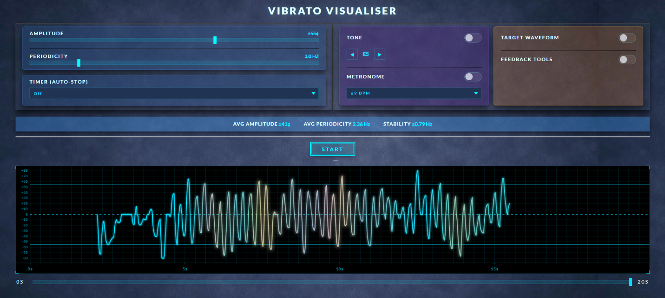
Figure 9: Final UI Design

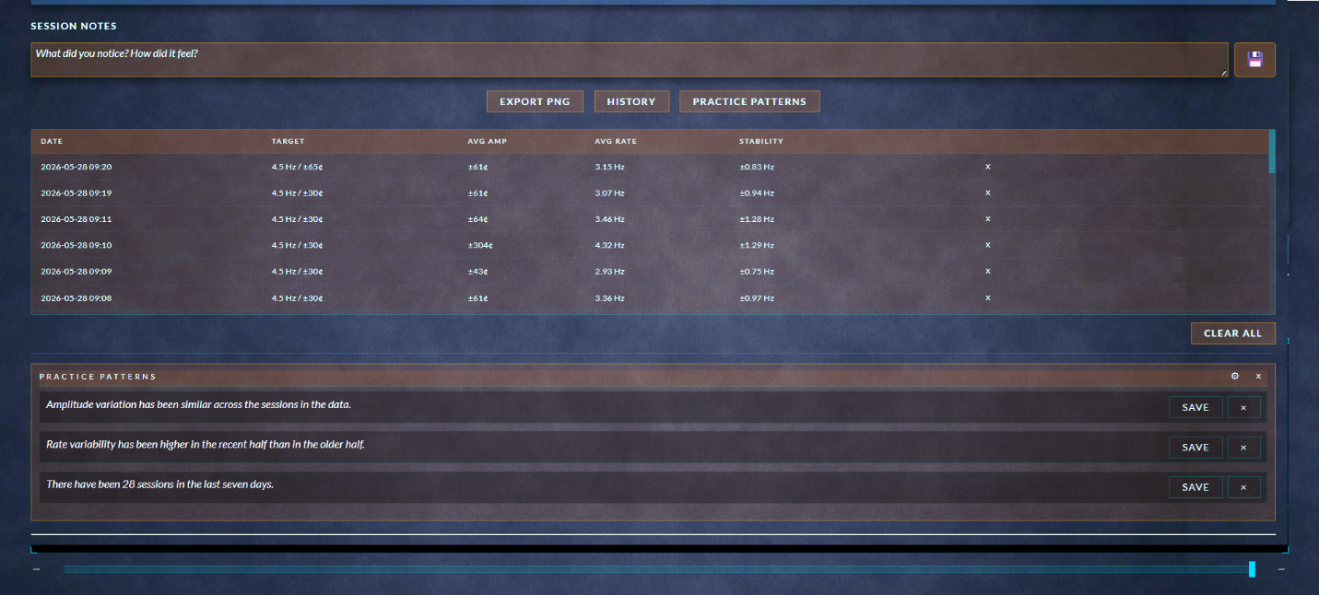
Figure 10: Feedback Tools

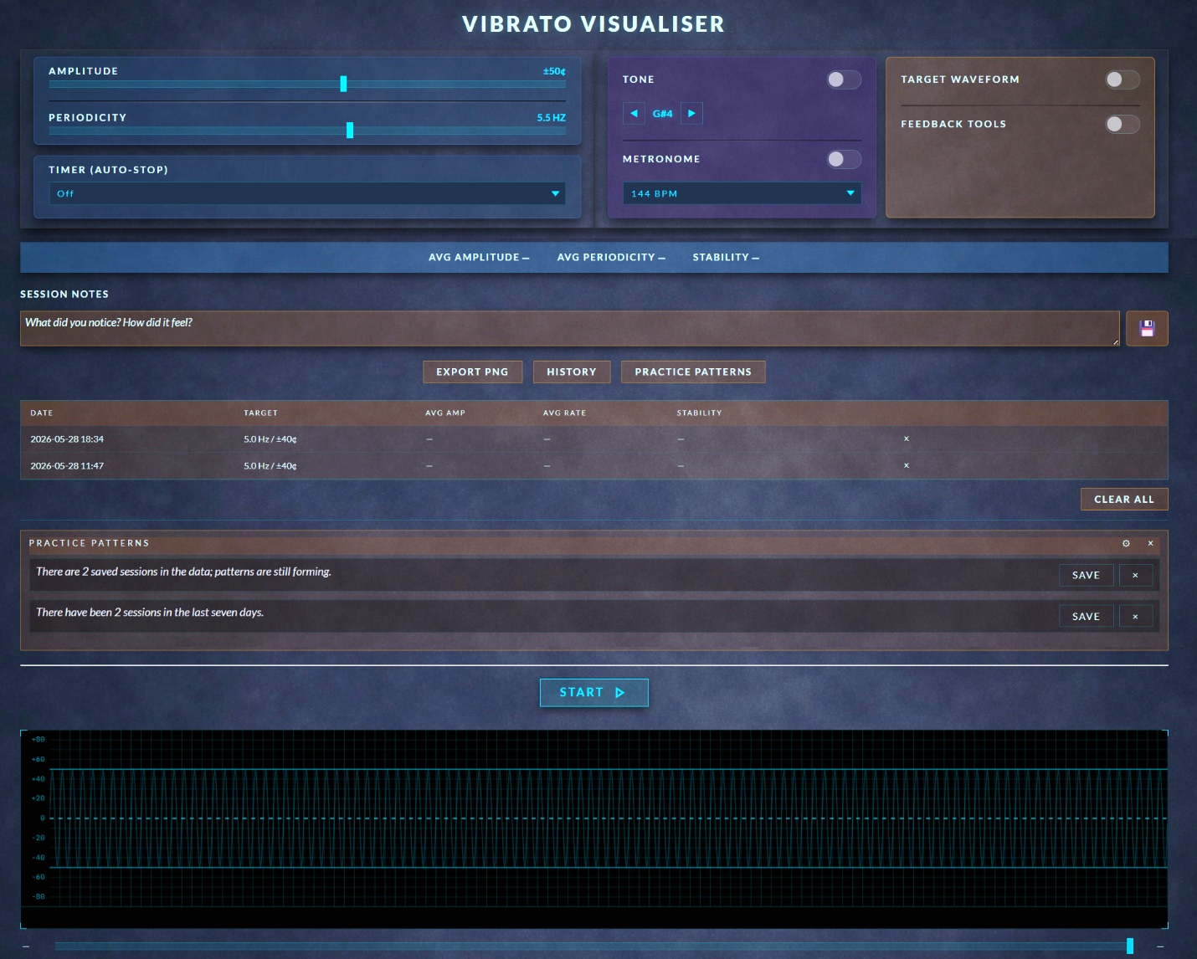
Figure 11: Vibrato Visualiser v001

- KNOW WHAT

This artefact was developed in response to a systemic gap in vocal pedagogy, where accessible, real-time visualisation tools remain limited despite the clear need for precise and immediate feedback in studio and independent practice (Han, 2022; Doğanyiğit and Yiğit, 2023). To address this gap, the artefact was conceptually framed through SDT, DBR, and CR, allowing the design to be examined not only as a technical solution but as a pedagogical one that supports learner autonomy, iterative refinement, and the causal structures that shape metacognitive development (Li et al., 2025). This section explores what the artefact reveals when situated within the wider landscape of visualisation tools, contemporary learning theory, and application development best practices, and considers the implications, tensions, and conceptual contributions that emerged through the design process.

- Theme 1: Visualisation Tools

Previous visualisation tools have paired vibrato with the fundamental pitch and have not offered visual targets, making it difficult for learners to distinguish vibrato from overall pitch movement or to understand the intended amplitude and periodicity of each cycle (Santos and Masiero, 2026). This gap reinforces reliance on teacher interpretation and leaves learners without a concrete reference for deeper concept understanding or independent practice (Li et al., 2025). The real-time waveform addressed this by allowing learners to see the effect of each adjustment as it occurred, echoing findings that immediate feedback strengthens engagement and supports more effective practice (Liu and Guo, 2025). By isolating vibrato from all other pitch information, the tool displays vibrato as a discrete behaviour and offers visual targets in an accessible way that has been needed in vocal education.

From a CR perspective, the study examined not only whether AI-supported feedback was beneficial, but how the tool’s multimodal learning approach functioned as a causal mechanism influencing metacognitive development, suggesting its impact may lie in shaping how learners monitor and evaluate their own practice (Li et al., 2025).

The design process revealed tensions that complicate the creation of visualisation tools in vocal education. Maintaining focus on vibrato alone required resisting the temptation to add additional metrics and features, even though the additions could offer valuable information. This tension between simplicity and feature expansion reflects a broader challenge in educational technology: adding more data does not necessarily support better learning and may instead overwhelm or distract students (Mutlu Bayraktar, 2022; Cosentino et al., 2025). Without real-world testing, it is difficult to predict how educators and learners will interact with the tool in varied studio contexts.

Using SDT as an evaluative lens, the visualisation supports autonomy by allowing learners to explore and adjust without constant teacher prompting, competence by providing an objective yet immediate means of tracking improvement, and relatedness by offering a shared reference point for teacher–student discussion and reflection (Li et al., 2025). However, SDT also highlights the limitation that complete autonomy without guided interpretation and instruction from an educator may lead some learners to misread the visual data or apply incorrect technique to achieve their goals (Li et al., 2025). Learners must therefore understand what periodicity and amplitude represent, what settings are appropriate for their musical style, and how specific technical adjustments affect both.

- Theme 2: Learning Theory

The three learning-theory themes identified through thematic analysis reveal how the artefact functions as part of a broader pedagogical system. The first theme, multimodal systemic learning, emphasises pairing auditory and visual cues within the teacher’s chosen pedagogical framework. This ensured the visualisation functioned as part of a coherent system rather than a standalone stimulus, supporting the teacher’s technical or stylistic focus.
The second theme, chunking, feedback, and iteration, was embedded by creating a single-function interface focused solely on vibrato periodicity and amplitude. This prevented distraction from unnecessary features, reduced cognitive load, and supported a clear, purposeful practice environment (Cosentino et al., 2025). The design aligned with research showing learners benefit from working in small, manageable units and refining them through repeated attempts (Erickson, 2022).
The third theme, reflection and self-awareness, was supported through the persistent waveform trace and session history, which allow learners to compare their performance over time and record notes about their experience. This aligns with evidence that reviewing one’s own performance strengthens metacognitive awareness and supports more intentional adjustment (Li et al., 2025). Although the tool does not include explicit reflective prompts, the visual trace and form field create opportunities for teacher-guided interpretation and learner-led noticing.
Together, these themes show how the artefact translates broad learning principles into a minimal, real-time interface that supports both teacher-led and independent learning. Challenges included maintaining this minimalism without diluting pedagogical value, raising the question of whether selecting a single learning theory might provide a more cohesive foundation for future visualisation-tool design or whether a blended approach remains more appropriate.
Using SDT as an evaluative lens, the learning-theory-informed design supported autonomy by enabling learners to experiment without waiting for external correction, competence by encouraging visible, incremental improvement, and relatedness by preserving the teacher’s role in helping learners interpret what they saw.

- Theme 3: Application Development Best Practices

The application was intentionally designed as a lightweight, browser-based tool requiring no specialised hardware or installation. By storing data locally and avoiding audio storage, the artefact maintained a high level of privacy. Its lightweight build reduced latency, ensuring the visualisation remained stable and responsive, potentially reducing the cognitive and technical friction that can interfere with learning. The technical specification adhered to best-practice strategies for simplicity, accessibility, and cross-browser/cross-platform functionality.

Historically, many applications in vocal education have been created with little practitioner input, resulting in tools that fail to meet pedagogical needs (Barrera Castro et al., 2025). As a dual representative of both the vocal pedagogy and web-development communities, I argue that applications should be grounded in actual pedagogical requirements rather than technological novelty. Leveraging validated research on learning theory increases the likelihood that such tools will be effective, and using thematic analysis to identify commonalities across theories allowed me to balance and maximise relevant research insights. This approach directly addresses the systemic issue of limited, pedagogically aligned visualisation tools by embedding practitioner knowledge and educator perspectives into the artefact.

From a CR perspective, many existing tools remain inaccessible due to cost, limited availability, or misalignment with pedagogical needs, but a deeper underlying mechanism is educators’ fear that technology may devalue their expertise or replace aspects of their role. Tools that provide prescriptive advice can intensify this concern by encroaching on teacher judgement and reducing the educator’s interpretive authority (U.S. Department of Education, 2023). Because these structural and psychological mechanisms shape how technology is adopted in practice, DBR offered a supportive framework for the project’s nonlinear, iterative nature, providing methodological justification for refining the artefact in response to these pedagogical realities and teacher-centred insights rather than prioritising technical novelty (Easterday et al, 2014).

Minimal AI integration allowed for entry-level experimentation without raising privacy concerns or requiring the training of an AI model. The design process revealed many available audio-processing engines are not well developed for specialised pedagogical use and require substantial modification to function beyond basic tuning or pitch-matching tasks. This created tension, as several objectives could not be met using existing libraries without extensive redevelopment.
Using SDT as an evaluative lens and following application-development best practices, the artefact supported autonomy by allowing learners to access the tool independently on standard devices without specialised equipment or teacher supervision. It supported competence by offering a clear, stable interface that reduced technological anxiety and allowed learners to succeed quickly.

Regardless of pedagogical framework, educators can integrate the tool into lessons as a shared reference rather than a replacement for pedagogical interaction, and advanced students can use it to guide self-practice. The visualisation supports this independence by giving learners immediate, interpretable feedback on each attempt, helping them recognise whether their adjustments are moving them closer to their intended periodicity and amplitude and allowing them to refine their technique without waiting for teacher input (Liu and Guo, 2025).

Together, these design choices reveal how ethical, accessible, and minimal development principles can shape the pedagogical function of a visualisation tool. Challenges remain, particularly regarding feature expansion and future data-storage needs, which would require careful and secure handling of sensitive information.

Overall, this project successfully met its aim by creating a vibrato visualisation tool that was designed and developed according to the technical specification, informed by learning theory, and iteratively refined through application-development best practices. The final artefact fulfils the specification’s goals by providing an accessible interface, clear visual feedback, and a user-centred design that can be expanded in future development cycles (Figure 12: Artefact Video).

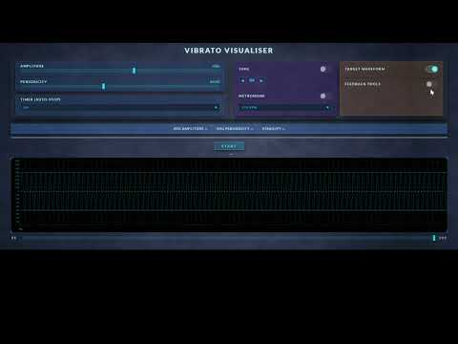
Figure 12: Artefact Video

- CONCLUSION

The aim of this research project was to examine visualisation tools, contemporary learning theory, and application development best practices to inform the creation of an artefact in the form of a technical specification and an AI-enhanced, real-time vibrato visualisation tool. Synthesising the findings across the literature and the development process showed that isolating vibrato as a single, trackable behaviour, presenting it through a stable and minimal interface, and avoiding prescriptive feedback aligned with both pedagogical needs and learning theory principles. Examined using Nelson’s practice-as-research modes of knowing, planned using Design-Based Research, and evaluated using Self-Determination Theory, a working prototype was constructed using vibe coding through iterative natural-language prompts, testing, and refining. Together, these elements show how the research directly informed the tool’s design and shaped the decisions made throughout development.
Through the process of building the artefact, I gained clearer insight into how theoretical principles can inform an artefact’s creation and how design choices shape the learner’s cognitive experience. Without real-world user testing, it is difficult to know whether the implemented features function as intended or if other features should be prioritised. Additional limitations include the constraints of browser-based audio processing, the variability of device microphones, and the risk that learners may misinterpret visual data without teacher guidance. Overall, the project demonstrates how a minimal, ethically-designed visualisation tool can bridge the gap between technical analysis and pedagogical practice in vocal education.

Future revisions could include additional wave-smoothing techniques, optional reflective prompts, and privacy-respecting ways to store audio files, as well as integrations with other visualisation tools. In its current state, the artefact provides a clear visual representation of vibrato that supports, rather than replaces, teacher-led instruction, helping students develop greater awareness and control. It serves as a foundational tool for future research, refinement, and pedagogical implementation of AI-enhanced vocal visualization tools, demonstrating that contemporary learning theory, best-practice application design, and insights from previous tools can meaningfully inform the development of new resources for vocal education. Conceptually, the artefact contributes to the field by showing how a minimal, multimodal, practitioner-informed design can function as a pedagogically aligned alternative to the technologically driven tools that currently dominate vocal education. More broadly, the artefact conceptually fills a gap in cost-effective, user-friendly vocal visualisation tools by offering a user-centred design created collaboratively between voice educators and software developers.

- CRITICAL REFLECTION

In my research, critical reflection, the conscious review and evaluation of past experiences to inform future decisions and actions, has been a personal challenge (Woodruff et al., 2023). Software development students differ from other qualitative researchers since their primary focus is on logical and physical artefacts as opposed to people, and often struggle with critical reflection, making it essential to select a reflective model that provides the structure and guidance needed to support the researcher (Prior et al., 2016).

- Reflective Model

I have found each research project requires a slightly different approach for critical reflection. While there are many established frameworks available, as critical reflection takes different forms across contexts, particularly in interdisciplinary research, generic models may not fully capture the diverse conceptual and methodological needs, and the ongoing debate around these limitations underscores the necessity for frameworks to remain adaptive and continually evolving (Justice et al., 2020). I have experimented with various hybrid models, combining elements from known reflective models with my own added or removed categories. Schön's model of reflection is often used by software engineers due to its simplicity, with focus on reflection in action, encouraging adjustments in real time, and reflection on action, analysing outcomes after project completion (Prior et al., 2016). While Schön’s model presents that doing and thinking are complementary, I prefer to separate these two concepts, believing that to reflect on doing, the thinker must remove themselves from the process to objectively assess their actions and uncover issues (Schön, 1987, p. 280). Gibb’s model offers a rigorous structure through its categories of description, evaluation, analysis, conclusion, and action plan, but it also uses “feelings” and “emotions”, which do not align with my reflective style (Galli and New, 2022).

Driscoll’s cycle of reflection, originally developed for use in healthcare, offers a simple alternative with its three-stage process: “What?” (item description), “So What?” (critical analysis of the item), and “Now What?” (next steps) (Gladd, 2020). Driscoll’s model provided clarity and progression, but I found it limited in capturing the iterative nature needed. In order for Driscoll’s model to meet my needs, I chose to adapt the model by incorporating Agile methods for software development (Agile), which I used previously in web application development as a means to break large projects down into smaller pieces (Hummel, 2014). Agile covers a wide area of beliefs, but its hallmarks are a values-driven framework that emphasises iterative and incremental cycles, flexibility in adapting requirements, and continuous self-assessment to improve practice (Alsaqqa et al., 2020). Agile's iterative process with continuous revisions complements Driscoll’s model by offering additional insight for reflection (Jalali and Wohlin, 2012). Consequently, I developed a hybrid reflective model combining aspects of Driscoll with Agile, utilising Driscoll’s three categories and adding a “Then What?” category to return to the reflection and document whether the issue was resolved or required additional inquiry (Appendix A: Reflective Model). I created a Google form to facilitate tracking and stored the records in a Google sheet, adding keywords to each entry to make sorting and searching data more efficient. These adaptations provided structure and flexibility, allowing me to document challenges, evaluate possible solutions, plan future actions, and revisit past entries in the reflective journal.

- Application of the Reflective Model

Applying this model supported me in addressing several critical decision points. For example, I had intended to create a visualisation tool for vocal acoustic properties (“What?”). Further investigation into the requirement for this tool revealed it may be too complex for my first attempt at creating an AI-enhanced visualisation tool, particularly with the time constraints of this project (“So What?”). This required me to iteratively revisit my options and list potential applications I would like to build (“Now What?”). In my previous research, vocal educators had specifically mentioned the desire for a tool to see vibrato, making it the next logical choice and my final selection, providing a clear trajectory for the study (“Then What?”).

Similar to my experience in Module 4, moments of difficulty, including research fatigue, lack of motivation, and the struggle to maintain a coherent outline, proved pivotal (What?). Rather than viewing these as failures, I reframed them as opportunities for critical learning. Burnout and lack of motivation among newer researchers can result from overcommitment, high workloads, and poor work–life balance, resulting in emotional exhaustion and disengagement from work (Boone et al., 2022). Acknowledging burnout (So What?) led to the development of a detailed revised list of tasks and specific planned times and dates to focus on my research (Now What?). Breaking the project down into small pieces allowed me to focus on one area at a time and avoid feeling overwhelmed. The issue of motivation revealed the emotional dimension of research. Although I tend not to link emotions to technical work, reflection forced me to acknowledge their impact. Recognising fatigue as part of the research process allowed me to plan more realistically, including the possibility of requesting extensions if necessary (Then What?).

Once I began the application-building process, I found while vibe coding hastened development significantly, creating the prompts yielded different results in different AI platforms (Claude.ai, Bolt.ai, and CoPilot.ai). Initially, I attempted to describe the entire application in one prompt and test it on multiple AI platforms and models, which yielded several versions of unusable code which presented display issues, inconsistent audio integration, and significant pitch-shifting issues (“What?”). My next strategy was to separate the functionality from the UI design, knowing it would take significantly longer to handwrite JavaScript to create the functionality than it would manually creating the UI, researching which AI model would likely yield the best results (“So What?”). I selected Claude.ai’s model, Opus, and began with prompting for a simple waveform that used the client’s audio input device along with a start/stop button (“Now What?”). Once this proved successful, I iteratively prompted for each piece of functionality I planned to include in the application, testing the newest version and reviewing the code before moving on to the next iteration (“Then What?”).

Overall, my reflective practice continues to evolve from descriptive journaling to critical evaluation. The hybrid model I developed facilitated documentation and enabled analysis of patterns across my research process. Although this hybrid model was sufficient for this research study, future research would benefit from refining it for greater structural guidance that prompts and sustains my use of the tool and investigating reflective frameworks that have been successfully used in similar cross-disciplinary research, which will guide my next stages of development.

DISCLOSURE OF AI USE

Grammarly AI was used for grammar checking, NotebookLM for organising and searching research notes and papers, and Microsoft CoPilot for organizing structures and checking all citations had corresponding items in the reference list. Claude.AI, CoPilot.AI, and Bolt.AI were used during the initial testing vibe coding of the AI-enhanced, web-based artefact, while Claude.AI was used for the final version to create functionality and a basic UI.

- REFERENCES

Adams, R.J., Smart, P. and Huff, A.S. (2017) ‘Shades of grey: Guidelines for working with the grey literature in systematic reviews for management and organizational studies’, International Journal of Management Reviews, 19(4), pp. 432–454. doi: 10.1111/ijmr.12102.

Adeleye, O.O., Eden, C.A. and Adeniyi, I.S. (2024) ‘Innovative teaching methodologies in the era of artificial intelligence: A review of inclusive educational practices’, World Journal of Advanced Engineering Technology and Sciences, 11(2), pp. 69–79. doi: 10.30574/wjaets.2024.11.2.0091.

Alghamdi, A. and Li, L. (2013) ‘Adapting design-based research as a research methodology in educational settings’, International Journal of Education and Research, 1(10), pp. 1-12. Available at: https://ijern.com/journal/October-2013/27.pdf (Accessed: 01 May 2026).

Aromataris, E. and Riitano, D. (2014) ‘Systematic reviews: Constructing a search strategy and searching for evidence’, American Journal of Nursing, 114(5), pp. 49–56. doi: 10.1097/01.NAJ.0000446779.99522.f6.

Bartlett, I. (2014) ‘Reflections on contemporary commercial singing: An insider’s perspective’, Voice and Speech Review, 8(1), pp. 27–35. doi: 10.1080/23268263.2013.829711.

Bauer, W.I. (2023) ‘Make AI your personal music teaching assistant: 4 ideas you can use now!’, University of Florida Music Education Resources. Available at: https://musiceducation.arts.ufl.edu/resources/ai-music-teaching-assistant/ (Accessed: 7 May 2024).

Bhaskar, R. (1975) A realist theory of science. London: Routledge. doi: 10.4324/9780203090732.

Bin, F. (2024) ‘Innovation and practice of vocal teaching mode in digital environment’, Curriculum and Teaching Methodology, 7(8). doi: 10.23977/curtm.2024.070828.

Blakeslee, S. (2004) ‘The CRAAP test’, LOEX Quarterly, 31(3), pp. 6–7. Available at: https://commons.emich.edu/loexquarterly/vol31/iss3/4 (commons.emich.edu in Bing) (Accessed: 7 May 2024).

Boell, S.K. and Cecez-Kecmanovic, D. (2014) ‘A hermeneutic approach for conducting literature reviews and literature searches’, Communications of the Association for Information Systems, 34(12), pp. 257–286. doi: 10.17705/1CAIS.03412.

Boone, A., Vander Elst, T., Vandenbroeck, S. and Godderis, L. (2022) ‘Burnout profiles among young researchers: A latent profile analysis’, Frontiers in Psychology, 13, 839728.
doi: 10.3389/fpsyg.2022.839728.

Bushuyev, S., Puziichuk, A., Bushuyeva, N., Bushuyeva, V. and Bushuyev, D. (2025) ‘The evolving landscape of education under the influence of AI’, Bulletin of NTU “KhPI”, Series: Strategic Management, Portfolio, Program and Project Management, 2(9), pp. 3–8. doi: 10.20998/2413-3000.2024.9.1.

Caldera, H.T.S. and Vidanage, B.V.K.I. (2024) ‘AI-driven voice training and singing improvement: A comprehensive literature review’, in Proceedings of the 4th Student Symposium, Faculty of Computing, General Sir John Kotelawala Defence University, Sri Lanka, January 2024. Available at: https://www.researchgate.net/publication/378898885_AI-Driven_Voice_Training_and_Singing_Improvement_A_Comprehensive_Literature_Review (researchgate.net in Bing) (Accessed: 3 October 2024).

Chen, W. (2022) ‘Design of music teaching system based on artificial intelligence’, Mathematical Problems in Engineering, Article ID 2627395, pp. 1–7. doi: 10.1155/2022/2627395.

Chen, Y. and Safian, A.R. (2024) ‘A review of online learning pedagogy and vocal music education’, International Journal of Academic Research in Business and Social Sciences, 14(11), pp. 1842–1858. doi: 10.6007/IJARBSS/v14-i11/23561.

Cleveland Clinic (2025) ‘Voice disorders: Symptoms and treatment’. Available at: https://my.clevelandclinic.org/health/diseases/voice-disorders (Accessed: 5 December 2025).
Cosentino, G., Anton, J., Sharma, K., Gelsomini, M., Giannakos, M. and Abrahamson, D. (2025) ‘Generative AI and multimodal data for educational feedback: Insights from embodied math learning’, British Journal of Educational Technology, 56, pp. 1686–1709. doi: 10.1111/bjet.13587.

Deci, E. L., and Ryan, R. M. (Eds.). (2002). Handbook of self-determination research. University of Rochester Press.

Doğanyiğit, S. and Yiğit, N. (2023) ‘The perspective of trainers on the use of imagination in singing training’, Journal of Pedagogical Research, 7(1), pp. 174–186. doi: 10.33902/JPR.202317864.

Donahue, W.A. (2025) ‘A mixed-methods study of vocal educators’ perspectives on the use of artificial intelligence in vocal education: Exploring hopes, concerns, and strategies for effective integration’, Dibon Journal of Education, 1(3), pp. 277–306. doi: 10.64169/dje.121.

Easterday, M., Rees, D., Gerber, E. (2014). ‘Design-based research process: Problems, phases, and applications’, Proceedings of International Conference of the Learning Sciences, ICLS. 1. pp. 317-324. Available at: https://www.researchgate.net/publication/288434629_Design-based_research_process_Problems_phases_and_applications. (Accessed: 28 April 2026).

Ekholm, E., Papagiannis, G.C. and Chagnon, F.P. (1998) ‘Relating objective measurements to expert evaluation of voice quality in western classical singing: Critical perceptual parameters’, Journal of Voice, 12(2), pp. 182–196. doi: 10.1016/S0892-1997(98)80038-6.

Elmer, S.S. and Elmer, F.J. (2000) ‘A new method for analysing and representing singing’, Psychology of Music, 28(1), pp. 23–42. doi: 10.1177/0305735600281003.

Erickson, H.M. (2021) ‘Mobile Apps and Biofeedback in Voice Pedagogy’, Journal of Singing, 77(4), pp. 485–500. Available at: https://www.nats.org/_Library/JOS_On_Point/JOS_077_04_2021_485.pdf. (Accessed: 19 May, 2026).

Erickson, H.M. (2022) ‘Vocal learning and songbirds: An evolutionary tale of singing’, SING, 79, pp. 87–94. doi: 10.53830/XHJI5745.

Fawzy, A., Tahir, A. and Blincoe, K. (2025) ‘Vibe coding in practice: Motivations, challenges, and a future outlook – a grey literature review’, arXiv preprint. doi: 10.48550/arXiv.2510.00328.

Fletcher, A.J. (2017) ‘Applying critical realism in qualitative research: Methodology meets method’, International Journal of Social Research Methodology, 20(2), pp. 181–194. doi: 10.1080/13645579.2016.1144401.

Gai, M. (2025) ‘Implementation of an innovative approach to vocal training in college: The case of artificial intelligence technologies NSynth, Sing Like Me, and Flow Machines’, Asia-Pacific Education Researcher, 34(2), pp. 215–232. doi: 10.1007/s40299-025-01003-y.

Gkintoni, E., Antonopoulou, H., Sortwell, A. and Halkiopoulos, C. (2025) ‘Challenging cognitive load theory: The role of educational neuroscience and artificial intelligence in redefining learning efficacy’, Brain Sciences, 15, 203. doi: 10.3390/brainsci15020203.

Grant, M.J. and Booth, A. (2009) ‘A typology of reviews: An analysis of 14 review types and associated methodologies’, Health Information & Libraries Journal, 26(2), pp. 91–108.

Grassini, S. (2023) ‘Development and validation of the AI attitude scale (AIAS-4): A brief measure of general attitude toward artificial intelligence’, Frontiers in Psychology, 14, 1191628. doi: 10.3389/fpsyg.2023.1191628.

Green, B.N., Johnson, C.D. and Adams, A. (2006) ‘Writing narrative literature reviews for peer-reviewed journals: Secrets of the trade’, Journal of Chiropractic Medicine, 5(3), pp. 101–117.

Han, Y. (2022) ‘Using mobile applications in the study of vocal skills’, Education and Information Technologies, 28(2), pp. 2107–2127. doi: 10.1007/s10639-022-11268-1.

Heryanto, A., Wadiyo, W. and Cahyono, A. (2025) ‘Transforming vocal education through the implementation of Score Creator and cloud-based e-learning within the TTIE framework’, Journal of Education Technology, 9(2), pp. 304–313. doi: 10.23887/jet.v9i2.99061.
Hin, Y. (2025) ‘The Challenges and Issues in Artificial Intelligence (AI) in Vocal Performance Education: A Comprehensive Narrative Review’, International Journal of Research and Innovation In Social Science, 9(10), pp. 4691-4696. doi: 10.47772/IJRISS.2025.910000386.

Hoppe, D., Sadakata, M. and Desain, P. (2006) ‘Development of real-time visual feedback assistance in singing training: A review’, Journal of Computer Assisted Learning, 22(4), pp. 308–316. doi: 10.1111/j.1365-2729.2006.00178.x.

Hua, J. and Yi, W. (2025). ‘Seeing the Singing Voice: The Current State of Vocal Data Visualisation’, in Proceedings of the 29th International Conference Information Visualisation,
pp. 158-163. doi: 10.1109/IV68685.2025.00039.

Huang, X. (2026) ‘Principal Component Analysis Methods and Teaching Reform Paths in Precision Teaching of Vocal Music Education in Colleges and Universities’, International Journal of Computer Information Systems and Industrial Management Applications, 18(11), pp. 1-11. https://doi.org/10.70917/ijcisim-2026-0037.

Huriye, A.Z. (2023) ‘The ethics of artificial intelligence: Examining the ethical considerations surrounding the development and use of AI’, American Journal of Technology, 2(1), pp. 37–44. Available at: https://gprjournals.org/journals/index.php/ajt/article/view/142 (Accessed: 28 December 2025).

Indriyani, F. and Nurmasitah, S. (2025) ‘VARK Learning Styles and Their Relationship to Learning Outcomes in an Instructional Media Course’, Jurnal Penelitian Pendidikan, 42, pp. 299-303. doi: 10.15294/jpp.v42i2.31283.

Isma’il, A. and Sodangi, U. (2025) ‘Development of VARK learning styles assessment instrument for secondary school students’, International Journal of Educational and Psychological Studies, 3, pp. 183–200. doi: 10.59890/ijeps.v3i2.484.

Jalali, S. and Wohlin, C. (2012) ‘Systematic literature studies: Database searches vs. backward snowballing’, in Proceedings of the ACM-IEEE International Symposium on Empirical Software Engineering and Measurement (ESEM ’12), Lund, Sweden, pp. 29–38. doi: 10.1145/2372251.2372257.
Jarvis, E.D. (2019) ‘Evolution of vocal learning and spoken language’, Science, 366, pp. 50–54. doi: 10.1126/science.aax0287.

Justice, S.B., Bang, A., Lundgren, H., Marsick, V.J., Poell, R.F. and Yorks, L. (2020) ‘Operationalizing reflection in experience-based workplace learning: a hybrid approach’, Human Resource Development International, 23(1), pp. 66-87. DOI: 10.1080/13678868.2019.1621250.

Kar, T. (2021) ‘The use of analogy, imagination and metaphors as an instructional tool in voice training: A case study’, Journal for the Interdisciplinary Art and Education, 2(1), pp. 9–31. doi: 10.29228/jiae.12.

Khan, A., Li, J. and Chen, Y. (2020) ‘Deep learning approaches for spectrographic analysis in vocal pedagogy’, Journal of Voice Technology, 34(4), pp. 567–580. doi: 10.1016/j.jvoice.2020.03.015.

Khaydarov, A. (2024) ‘The impact of modern technologies on the development of vocal art’, European Journal of Innovation in Nonformal Education, 4(12), pp. 163–167. Available at: http://innovatus.es/index.php/ejine (Accessed: 5 December 2025).

Knopf, J.W. (2006) ‘Doing a literature review’, PS: Political Science & Politics, 39(1), pp. 127–132. doi: 10.1017/S1049096506060264.

Lã, F.M.B. and Fiuza, M.B. (2022) ‘Real-time visual feedback in singing pedagogy: Current trends and future directions’, Applied Sciences, 12(21), 10781. doi: 10.3390/app122110781.

Lawani, A. (2021) ‘Critical realism: What you should know and how to apply it’, Qualitative Research Journal, 21(3), pp. 320–333. doi: 10.1108/QRJ-08-2020-0101.

Li, P. and Wang, B. (2023) ‘Artificial intelligence in music education’, International Journal of Human–Computer Interaction, pp. 1–10. doi: 10.1080/10447318.2023.2209984.

Li, W., Cui, X., Manoharan, P., Dai, L. and Liu, K. (2025) ‘AI-assisted feedback and reflection in vocal music training: Effects on metacognition and singing performance’, Frontiers in Psychology, 16, 1598867. doi: 10.3389/fpsyg.2025.1598867.
Lim, W.M. (2024) ‘What is quantitative research? An overview and guidelines’, Australasian Marketing Journal, 33(3), pp. 325–348. doi: 10.1177/14413582241264622.

Liu, H. and Guo, W. (2025) ‘Effectiveness of AI-driven vocal art tools in enhancing student performance and creativity’, European Journal of Education, 60(3), e70037. doi: 10.1111/ejed.70037.

Liu, Y., Zhang, L., Chen, H. and Wang, J. (2024) ‘Multimodal learning with AI in music education: Enhancing engagement and retention’, Computers & Education, 195, 104657. doi: 10.1016/j.compedu.2024.104657.

Mingers, J. (2004) ‘Re-establishing the real: critical realism and information systems,’ in Social Theory and Philosophy for Information Systems, pp. 1-29, books.google.com.

Molin, F., Li, J. and Zhang, Y. (2020) ‘Feedback in music education: A systematic review’, Music Education Research, 22(4), pp. 389–405. doi: 10.1080/14613808.2020.123456.

Mürbe, D., Zahnert, T., Kuhlisch, E., and Sundberg, J. (2007) ‘Effects of Professional Singing Education on Vocal Vibrato—A Longitudinal Study’, Journal of Singing, 21(6), pp. 683-688. doi:10.1016/j.jvoice.2006.06.002.

Nelson, R. (2006) ‘Practice-as-research and the Problem of Knowledge, Performance Research’, Performance Research, 11(4), pp. 105-116. DOI: 10.1080/13528160701363556.

Nestorova, T. (2026) ‘To Teach or Not to Teach Vibrato? Implicit and Explicit Instruction in the Vocal Studio’, Journal of Singing, 82(5), pp. 545-559. https://dx.doi.org/10.53830/sing.00219.

Odusanya, O.S, Aremu, D., Niyi-Ojo, M., and Alabi, A. (2025) ‘Exploring the Applications of Artificial Intelligence in Choral Rehearsal Techniques’, International Journal of Recent Research in Mathematics Computer Science and Information Technology, 11(2), pp. 65–73. Available at: https://doi.org/10.5281/zenodo.14788936.

Sapkota, R., Roumeliotis, K. I., and Karkee, M. (2025) ‘Vibe Coding vs. Agentic Coding: Fundamentals and Practical Implications of Agentic AI’, arXiv preprint. Available at: https://arxiv.org/abs/2505.19443.

Olorunfemi, O., Shoetan, P., Amoo, O., Atadoga, A., Farayola, O. and Abrahams, T. (2024) ‘Towards a conceptual framework for ethical AI development in IT systems’, Computer Science and IT Research Journal, 5(3), pp. 616–627. doi: 10.51594/csitrj.v5i3.910.

Ouwehand, K., Lespiau, F., Tricot, A. and Paas, F. (2025) ‘Cognitive load theory: Emerging trends and innovations’, Education Sciences, 15, 458. doi: 10.3390/educsci15040458.

Ovcharenko, N., Samoilenko, O., Moskva, O. and Chebotarenko, O. (2020) ‘Innovative technologies in vocal training: Technological culture formation of future musical art teachers’, Journal of History, Culture and Art Research, 9(3), pp. 115–126. doi: 10.7596/taksad.v9i3.2729.

Prior, J., Ferguson, S. and Leaney, J. (2016) ‘Reflection is hard: Teaching and learning reflective practice in a software studio’, in ACSW ’16: Proceedings of the Australasian Computer Science Week Multiconference, Article 7, pp. 1–8. doi: 10.1145/2843043.2843346.

Purba, S., Silitonga, B., and Yang, J. (2025) ‘AI-Assisted Learning: A Systemic Review’, Turkish Online Journal of Distance Education, 26(4), pp. 77-93. doi: 10.17718/tojde.1591404.

Qian, Y. (2023) ‘Artificial intelligence in music composition: A review of current approaches’, Journal of Creative Technologies, 15(2), pp. 77–89. doi: 10.1080/jct.2023.123456.

Randolph, J.J. (2009) ‘A guide to writing the dissertation literature review’, Practical Assessment, Research & Evaluation, 14(13), pp. 1–13. Available at: https://pareonline.net/getvn.asp?v=14&n=13 (Accessed: 7 May 2024).

Rao, H. (2025) ‘Artificial intelligence reshapes music teaching: Application scenarios and practical challenges’, Journal of Music Pedagogy and Technology, 12(1), pp. 33–47. doi: 10.1080/jmpt.2025.123456.

Santos, A. and Masiero, B. (2026) ‘A Survey on 30+ Years of Automatic Singing Assessment and Singing Information Processing’, arXiv preprint,
https://doi.org/10.48550/arXiv.2601.12153

Sarkar, S. and Bhatia, G. (2021) ‘Writing and appraising narrative reviews’, Journal of Clinical and Scientific Research, 10(3), pp. 169–172. doi: 10.4103/jcsr.jcsr_1_21

Sarkar, A., and Drosos, I. (2025) ‘Vibe coding: programming through conversation with artificial intelligence’, in Proceedings of the 36th Annual Conference of the Psychology of Programming Interest Group (PPIG 2025).

Schön, D.A. (1987) Educating the reflective practitioner: Toward a new design for teaching and learning in the professions. San Francisco: Jossey-Bass.

Shannon-Baker, P. (2016) ‘Making paradigms meaningful in mixed methods research’, Journal of Mixed Methods Research, 10(4), pp. 319–334. doi: 10.1177/1558689815575861

Shethiya, A. (2025) ‘Scalability and Performance Optimization in Web Application Development’, Integrated Journal of Science and Technology, 2(1), pp. 1-7. Available at: https://ijstpublication.com/.

Siddiqui, M.A. (2024) ‘A comprehensive review of AI: Ethical frameworks, challenges, and development’, Adhyayan: A Journal of Management Sciences, 14(1), pp. 68–75. doi: 10.21567/adhyayan.v14i1.12

Smailis, D.E. and Heliades, G.P. (2025) ‘Artificial intelligence in music education: Teachers’ views and applications’, Journal of Music Pedagogy, 11(2), pp. 145–162. doi: 10.1080/jmp.2025.123456

Sukhera, J. (2022) ‘Narrative reviews: Flexible, rigorous, and practical’, Journal of Graduate Medical Education, 14(4), pp. 414–417. doi: 10.4300/JGME-D-22-00480.1

Tsai, W.-H. and Lee, H.-C. (2012) ‘Automatic evaluation of karaoke singing based on pitch, volume, and rhythm features’, IEEE Transactions on Audio, Speech, and Language Processing, 20(4), pp. 1233–1243. doi: 10.1109/TASL.2011.2174224

U.S. Department of Education (2025) Artificial Intelligence and Future of Teaching and Learning: Insights and Recommendations. Washington, DC: U.S. Department of Education. Available at: https://www.ed.gov/sites/ed/files/documents/ai-report/ai-report.pdf (Accessed: 27 05 2026).

VoceVista (2025) ‘VoceVista Video Pro: Real-time visual feedback for singers’. Available at: https://www.vocevista.com (Accessed: 5 December 2025)

Wang, L. and Gan, Y. (2025) ‘AI-driven feedback in vocal pedagogy: A systematic review’, Journal of Music Education Research, 27(3), pp. 233–249. doi: 10.1080/jmer.2025.123456

Wang, A. and Zhang, L. (2022) ‘Design and implementation of computer visualisation assisted vocal music teaching system’, Computer-Aided Design and Applications, 19(S3), pp. 44–55. doi: 10.14733/cadaps.2022.S7.44-55

Wang, K. and Zhang, P. (2025) ‘Enhancing opera vocal education through advanced machine learning algorithms: Analytics for talent development and curriculum design’, Interactive Learning Environments, pp. 1–21. doi: 10.1080/10494820.2025.2488991

Woodruff, K., Hutson, J. and Arnone, K. (2023) ‘Perceptions and barriers to adopting artificial intelligence in K-12 education: A survey of educators in fifty states’, in Reimagining education – The role of e-learning, creativity, and technology in the post-pandemic era. Faculty Scholarship, pp. 1–28. Available at: https://digitalcommons.lindenwood.edu/faculty-research-papers/506

Wu, D. (2026) ‘Utilizing AI and machine learning in vocal training programs: A contemporary approach’, Learning and Instruction, 102, pp. 1-9. Available at: https://doi.org/10.1016/j.learninstruc.2025.102278.

Xie, Y. (2026) ‘Modern Approaches to Teaching Pop Singers: Comparing Virtual Reality Technologies and Voice Analysis Software’, European Journal of Education, 61(1), pp. 1-10. https://doi-org.uwtsd.idm.oclc.org/10.1111/ejed.70312.
Yang, G. and Yang, L. (2020) ‘Exploration of vocal music teaching mode from the perspective of the age of artificial intelligence’, International Journal of Frontiers in Engineering Technology, 2(1), pp. 31–40. Available at: https://francis-press.com/papers/1462

Yu, H., Zhang, J. and Li, W. (2023) ‘Artificial intelligence in creative arts education: Opportunities and challenges’, Arts Education Policy Review, 124(6), pp. 345–359. doi: 10.1080/10632913.2023.123456

Zhang, H. (2025) ‘Artificial Intelligence in Music Education: A Scoping Review of Practices, Strategies, and Challenges’, Journal of Advanced Research in Education, 4(5), pp. 69–82. https://doi.org/10.56397/JARE.2025.09.09.

Appendix A: Reflective Model
Based on Driscoll’s Cycle of Reflection (Gladd, 2020)
What?
The issue, thought, question, or hypothesis that needs to be addressed.
So What?
- Why is this an issue?
- What was the evolution of the issue?
- Evaluate. What are the implications of this?
Now What?
- Brainstorm all possible solutions and alternatives, listing their pros and cons where applicable.
- Outline an implementation strategy.
- What needs to be done and when.
- Create a plan of action including timeline for completion and a quantifiable means for knowing the issue is closed.
*Not all solutions need to be feasible, but may help evolve other solutions.
Then What?
- Was the chosen solution successful?
- If the solution was not successful, what needs to be done next? Does this item need to start over?
Keywords
- Assign keywords to the item to be easily searchable and to be able to link similar thoughts together and look for patterns, connections, and cross-solutions.
and Agile Project Management Tools (Azanha et al., 2017)

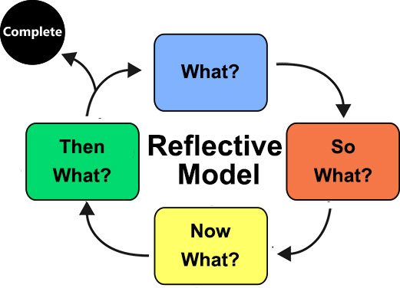

Appendix B: Visualisation Tools

App Name | Available? | Platforms | Cost | Real-Time? | Description
FingerVoice | Discontinued | iOS | $ 9.99 | Yes | Real-time or recorded spectrogram viewer
Mirusinger | Discontinued | Windows |  | Yes | Real-time analysis of F0 and vibrato in real-time compared to the vocal part on a CD recording
PitchLab | Discontinued | Android |  | Yes | Chromatic tuner app with real-time pitch display
SingScope | Discontinued | iOS |  | Yes | Real-time pitch graph for singing practice
Virtual Singing Studio | Discontinued | Windows |  | Yes | Singing analysis software with spectral data
WinSINGAD/SINGAD | Discontinued | Windows |  | Yes | Displays of sound waveform over time
Live Spectrogram | Yes | iOS | $ 1.99 | Yes | Real-time spectrogram viewer with color shading
Melodyne Studio | Yes | Windows, iOS | $ 300.00 | No | Pitch/time editing with visualization
Praat | Yes | Windows, iOS, Linux | Free | Yes | Phonetics analysis visualization tool
Sing&See | Yes | Windows, iOS | $ 99.00 | Yes | Real-time spectrogram and pitch display for singers
Spectrogram Pro | Yes | iOS iPad | $ 3.99 | Yes | Spectral analysis
SpectrumView | Yes | iOS | Free | Yes | Real-time spectrogram and spectrum analyzer.
Vocal Tract Lab | Yes | Windows | Free | No | Visualization of vocal tract model along with spectral data
VoceVista | Yes | Windows, iOS | $ 400.00 | Yes | Professional voice analysis for singing pedagogy
Vox Plot | Yes | Windows, iOS | Free | No | The analysis of a total of 19 acoustic parameters
Yousician | Yes | iOS, Android, Windows | $10/month | Yes | Gamification of pitch matching
Spectro-Real | Yes--not updated since 2019 | iOS | Free | Yes | Spectrogram data
AudioAnalyzer | Yes | Web based | Free | Yes | Spectrogram data
SingSharp | Yes | iOS, Android | Free | Yes | Vocal training application

Appendix C: Thematic Analysis of Contemporary Learning Theories

Theory | Primary Elements | Core Focus
Cognitive Load Theory | • Intrinsic load (task complexity) | Optimizing working memory to support learning
 | • Extraneous load (presentation inefficiencies) | Optimizing working memory to support learning
 | • Germane load (schema construction) | Optimizing working memory to support learning
Educational Neuroscience (EdNeuro) | • Neural plasticity | Biological mechanisms that shape learning
 | • Attention & reward systems | Biological mechanisms that shape learning
 | • Emotion–cognition interaction | Biological mechanisms that shape learning
 | • Multisensory integration | Biological mechanisms that shape learning
Metacognition | • Planning | Awareness and control of one’s own learning (thinking about thinking)
 | • Monitoring
 | • Evaluating
 | • Self-regulation
Brain-Body-Environment Continuum | • External focus of attention | Efficient skill acquisition through optimized attentional focus and feedback
 | • Implicit learning
 | • Feedback loops
 | • Variability of practice
VARK | • Visual | Preferred sensory modalities for receiving information
 | • Auditory | Preferred sensory modalities for receiving information
 | • Reading/Writing | Preferred sensory modalities for receiving information
 | • Kinesthetic | Preferred sensory modalities for receiving information
TTI (Transfer, Translate, Imitate) | • Transfer (understand concept) | Progressive skill internalization through staged learning
 | • Translate (apply to new context) | Progressive skill internalization through staged learning
 | • Imitate (model expert performance) | Progressive skill internalization through staged learning
Embodied Cognition | • Sensorimotor grounding | Cognition arises from bodily interaction with the world
 | • Environment–body interaction | Cognition arises from bodily interaction with the world
 | • Action-based reasoning | Cognition arises from bodily interaction with the world
AI Recursive Learning | • Iteration loops | Learning through repeated cycles of evaluation and adjustment
 | • Feedback refinement
 | • Pattern extraction
 | • Self-improving cycles
 | • Specific tasks

Appendix C: Thematic Analysis of Contemporary Learning Theories (continued)

ROUND 1 | ROUND 2 | ROUND 3
Actionable solutions | Chunking | Chunking, Feedback, and Iteration
Adjustment and iteration | Iterative | Chunking, Feedback, and Iteration
Auditory | Modes | Multimodal Systemic Teaching
Awareness of current state | Self-Awareness | Reflection and Self Awareness
Awareness of own cognitive processes | Self-Awareness | Reflection and Self Awareness
Chunking | Chunking | Chunking, Feedback, and Iteration
Cognitive link to physical | Memory | Multimodal Systemic Teaching
Control over own cognitive processes | Self-Awareness | Reflection and Self Awareness
Cyclical | Iterative | Chunking, Feedback, and Iteration
Deeper reflection with teachers | Reflection | Reflection and Self Awareness
Executive functions | Memory | Multimodal Systemic Teaching
Expose issues in practice | Chunking | Chunking, Feedback, and Iteration
Feedback | Feedback | Chunking, Feedback, and Iteration
Feedback CLT | Feedback | Chunking, Feedback, and Iteration
Feedback meta | Feedback | Chunking, Feedback, and Iteration
Feedback with AI | Feedback | Chunking, Feedback, and Iteration
Imitation | Systemic teaching | Multimodal Systemic Teaching
Iterative | Iterative | Chunking, Feedback, and Iteration
Iterative Meta | Iterative | Chunking, Feedback, and Iteration
Kinesthetic | Modes | Multimodal Systemic Teaching
Learning styles | Modes | Multimodal Systemic Teaching
Lower metacognition results in inefficient self-directed learning | Self-Awareness | Reflection and Self Awareness
Memory | Memory | Multimodal Systemic Teaching
Multimodal | Modes | Multimodal Systemic Teaching
Optimize cognition | Memory | Multimodal Systemic Teaching
Reading/writing | Modes | Multimodal Systemic Teaching
Reflection | Reflection | Reflection and Self Awareness
Reflection air | Reflection | Reflection and Self Awareness
Repetition | Iterative | Chunking, Feedback, and Iteration
Rest | Chunking | Chunking, Feedback, and Iteration
Segment and Scaffold | Chunking | Chunking, Feedback, and Iteration
Self-evaluation | Reflection | Reflection and Self Awareness
Specific tasks | Chunking | Chunking, Feedback, and Iteration
Systemic teaching | Systemic teaching | Multimodal Systemic Teaching
Transfer of core knowledge | Systemic teaching | Multimodal Systemic Teaching
Translation of knowledge by learner | Systemic teaching | Multimodal Systemic Teaching
Visual | Modes | Multimodal Systemic Teaching

Appendix D: Iteration Map
PROOF OF CONCEPT A
Tools: Claude.AI, Bolt.AI
- Basic waveform generation
- Basic vibrato visualization
- Pitch detection
- Minimal UI design
PROOF OF CONCEPT B
Tools: CoPilot, Claude.AI, Bolt.AI
- Testing different audio extraction tools
- Wave smoothing experiments
- Minimal UI design

12
Retain wave colors after session ends
Iteration 12
2
Waveform stabilisation
Iteration 2
3
Line dropout fixes
Iteration 3
14
Integrate AI for session analysis
Iteration 14
5
Grid opacity, smoothing wave
Iteration 5
4
X & Y axis labels, grid, wave retention
Iteration 4
1
Single waveform, 15s visible, client microphone
Iteration 1
Prototype Build Version 1.0
Tools: Claude.AI
9
Sawtooth wave generator, export PNG, notes, metronome
Iteration 9
8
Reduce display length, WCAG, scroll buffer
Iteration 8
7
Adjust playhead, fix rates
Iteration 7
6
Amplitude & periodicity controls, bumpers, timer
Iteration 6
11
Add colors to wave
Iteration 11
13
Background ‘ghost’ wave sample
Iteration 13
15
UI design and implementation
Iteration 15

10
Spacebar start/stop, save session, mic input level
Iteration 10

Appendix E: Technical Specification

Technical and
Design
Specification

VIBRATO VISUALISATION TOOL

Wende Ann Donahue

May 2026

Version 1.0.0

REVISION HISTORY
DATE | VERSION | DESCRIPTION | AUTHOR
May 2026 | 1.0.0 | Initial application version | WD

Table of Contents

INTRODUCTION 57
PURPOSE 57
INTENDED AUDIENCE 57
PROJECT SCOPE 57
REFERENCES 58
DESCRIPTION 59
PRODUCT PERSPECTIVE 59
PRIMARY FEATURES 59
USER OVERVIEW 60
OPERATING ENVIRONMENT 60
CONTRAINTS: IMPLEMENTATION / DESIGN 60
SYSTEM FEATURES 61
SYSTEM FEATURE 1 61
SYSTEM FEATURE 2 61
SYSTEM FEATURE 3 62
SYSTEM FEATURE 4 62
SYSTEM FEATURE 5 62
SYSTEM FEATURE 6 63
SYSTEM FEATURE 7 63
SYSTEM FEATURE 8 64
SYSTEM FEATURE 9 64
FEATURES/FUNCTIONALITY ADDED DURING PROTOTYPE BUILD 65
ADDED FEATURE 1 65
ADDED FEATURE 2 65
ADDED FEATURE 3 66
ADDED FEATURE 4 66
ADDED FEATURE 5 66
ADDED FEATURE 6 67
ADDED FEATURE 7 67
ADDED FEATURE 8 67
ADDED FEATURE 9 68
ADDED FEATURE 10 68
ADDED FEATURE 11 68
MOCKUPS 69
Mockup of potential gamified version of a vibrato visualizer. 69
Mockup of basic user interface for a vibrato visualizer. 70
USER INTERFACE WORKING PROOF OF CONCEPTS 71
APPENDIX A: GLOSSARY OF TERMS 73
APPENDIX B: FUTURE REVISIONS 74

INTRODUCTION

PURPOSE
The purpose of this application is to provide a real-time visualization of vocal vibrato for use in vocal education. The tool displays vibrato as a simple waveform, allowing singers and educators to observe periodicity and amplitude during vocal exercises. The design and functionality are informed by contemporary learning theory, insights from previous vocal-visualization tools, and best practices in web and AI application design to support effective skill acquisition and reflective practice within the context of the Voice Study Centre (VSC) Module 5 artefact.

INTENDED AUDIENCE
This document is intended for evaluators of the VSC Module 5 artefact and for developers involved in planning or implementing this visual vibrato prototype.

PROJECT SCOPE
This application represents a prototype for a vibrato visualization tool designed for use in vocal education. Its scope is limited to capturing microphone input, displaying vibrato as a simple waveform, and providing basic user-controlled settings for periodicity, amplitude, and timed practice intervals. While the prototype may inform future development of additional visualization tools, this version focuses solely on real-time vibrato display and immediate post-exercise reflection.

REFERENCES
This specification is supported by the accompanying research paper:
Donahue, W.A. (2026) Seeing Singing: Developing an AI-Enhanced Vocal Visualisation Tool Informed by Learning Theory and Best Practices Application Design. Voice Study Centre.
This paper provides the theoretical framework, pedagogical rationale, and design considerations that inform the development of the artefact.

DESCRIPTION

PRODUCT PERSPECTIVE
This application is a standalone, browser-based prototype designed to provide real-time visual feedback on vocal vibrato. It functions as an independent tool that processes microphone input on the client device and displays vibrato as a simple waveform with user-defined boundaries for periodicity and amplitude. The prototype addresses limitations identified in previous vocal-visualization tools such as cost, equipment requirements, and usability by offering a lightweight, accessible solution that runs without specialized hardware. Although self-contained, the application is designed with modularity in mind and may serve as the foundation for a broader suite of vocal-visualization tools in future development.

PRIMARY FEATURES
- Real-time Vibrato Waveform Display
  - Displays a simple waveform representing vibrato periodicity and amplitude in real time.
  - The waveform remains in the center of the screen for ease of visibility on both desktop and mobile devices.
- User-defined Vibrato Targets (Bumpers)
  - Users can set target vibrato periodicity and amplitude values.
  - Visual boundaries (bumpers) appear around the waveform to provide a visual anchor to indicate alignment as it responds to the vocalist.
- Timer-based Cycles
  - Users can select a timed interval, allowing for short periods of learning intensity followed by reflection.
  - At the end of the interval, the session stops the visualisation.

- Waveform Review
  - The most recent waveforms will be available to view after completion of an exercise cycle.
  - The review includes average periodicity and amplitude for the timed interval.
- Pitch Reference Display
  - The current pitch e.g.; A3, will be displayed next to the waveform for reference purposes to review if vibrato differs across the vocal range.
  - Pitch does not affect waveform behavior.

USER OVERVIEW
The primary users of this application will be vocal educators and their students. Because the tool provides visual feedback without prescriptive instruction, it is intended to be used with voice teachers to maximize results and ensure appropriate vocal technique is used.

OPERATING ENVIRONMENT
This application will be web-based, built primarily using JavaScript audio libraries, HTML, and CSS with AI integration via an API call. The application will be functional cross-browser/cross-platform. All audio processing occurs on the client device, using the device’s built-in microphone. When the tool is launched, the application will request permission to access the microphone.
Artificial Intelligence (AI) will be used to assist in the creation of the application using rapid AI prototyping (vibe coding) through the prompting tools Claude.AI, Microsoft CoPilot, and Bolt. Additionally, AI will be used to analyse information for users to track their progress and practice sessions over time.

CONTRAINTS: IMPLEMENTATION / DESIGN
The application must be informed by best practices in UI design including ensuring WCAG 2.0 compliance.

SYSTEM FEATURES
System features are ordered and grouped based on their themes as discussed in the accompanying research paper, not in the order of importance or implementation.

SYSTEM FEATURE 1

DESCRIPTION | Settings for periodicity and amplitude displayed as visual boundaries.
STIMULUS / RESPONSE SEQUENCES | A change in periodicity and/or amplitude settings will realign the borders (bumpers) around the waveform to indicate alignment with user-defined targets. Additionally, a low-opacity “ghost” waveform will display on the grid as a visual cue as to what the wave should look like according to the selected parameters.
SUPPORTIVE THEORY | Theme 1: Visualisation Tools; Theme 2: Learning Theory (Chunking, Feedback, and Iteration)

SYSTEM FEATURE 2

DESCRIPTION | Real-time waveform display
STIMULUS / RESPONSE SEQUENCES | The waveform will respond to the user’s audio input, displaying a single waveform with periodicity and amplitude. At the end of a user session, the average periodicity and amplitude will be displayed. The waveform will not alter with change in pitch only in change in vibrato.
SUPPORTIVE THEORY | Theme 1: Visualisation Tools; Theme 2: Learning Theory (Chunking, Feedback, and Iteration)

SYSTEM FEATURE 3

DESCRIPTION | Pitch reference display.
STIMULUS / RESPONSE SEQUENCES | During audio capture, the system will display the detected pitch; e.g., A3, alongside the waveform. The pitch label updates in real time and serves as a reference for users observing vibrato consistency in different parts of the vocal range.
SUPPORTIVE THEORY | Theme 2: Learning Theory (Multimodal Systemic Teaching)

SYSTEM FEATURE 4

DESCRIPTION | Timer function.
STIMULUS / RESPONSE SEQUENCES | The user will be able to select from 15-second, 30-second, 45-second, and 60-second intervals to track their vibrato. At the end of the interval, audio capture halts.
SUPPORTIVE THEORY | Theme 2: Learning Theory (Chunking, Feedback, and Iteration)

SYSTEM FEATURE 5

DESCRIPTION | Display of previous waveform.
STIMULUS / RESPONSE SEQUENCES | After completing a timed interval, the user will be able to view the waveform to reflect on what was accomplished. Average periodicity and amplitude will be displayed.
SUPPORTIVE THEORY | Theme 2: Learning Theory (Reflection and Self Awareness)

SYSTEM FEATURE 6

DESCRIPTION | Start/Stop button
STIMULUS / RESPONSE SEQUENCES | Clicking Start will trigger the client to request application access to the microphone and begin displaying the waveform in response to the user’s audio input.  Selecting Stop halts the display of the waveform.
SUPPORTIVE THEORY | Theme 3: Application Development Best Practices

SYSTEM FEATURE 7

DESCRIPTION | Cross-browser/cross-platform functionality.
STIMULUS / RESPONSE SEQUENCES | The application will be functional on any supported browser or device. This includes mobile responsive formatting.
SUPPORTIVE THEORY | Theme 3: Application Development Best Practices

SYSTEM FEATURE 8

DESCRIPTION | User permission request for microphone access.
STIMULUS / RESPONSE SEQUENCES | When the user click Start, the application will request permission to access the device’s microphone. If permission is denied, the application will not display the waveform
SUPPORTIVE THEORY | Theme 3: Application Development Best Practices

SYSTEM FEATURE 9

DESCRIPTION | Error handling.
STIMULUS / RESPONSE SEQUENCES | If the application encounters a basic error, such as no microphone found, a brief message will be displayed prompting the user with information on how to resolve the issue.
SUPPORTIVE THEORY | Theme 3: Application Development Best Practices

FEATURES/FUNCTIONALITY ADDED DURING PROTOTYPE BUILD
Added features are ordered and grouped based on their themes as discussed in the accompanying research paper, not in the order of importance or implementation.

ADDED FEATURE 1

DESCRIPTION | Metronome with selectable BPMs
STIMULUS / RESPONSE SEQUENCES | To provide an additional aural reference for the user for use with literature or timing of held notes.
SUPPORTIVE THEORY | Theme 1: Visualisation Tools; Theme 2: Learning Theory (Chunking, Feedback, and Iteration)

ADDED FEATURE 2

DESCRIPTION | Sample ‘ghost’ wave background based on selected amplitude and periodicity
STIMULUS / RESPONSE SEQUENCES | To provide an additional visual reference for the user of how the waveform should look based on their selections.
SUPPORTIVE THEORY | Theme 1: Visualisation Tools; Theme 2: Learning Theory (Chunking, Feedback, and Iteration)

ADDED FEATURE 3

DESCRIPTION | Wave colors
STIMULUS / RESPONSE SEQUENCES | To provide an additional reference for the user to identify periods of goal matching.
SUPPORTIVE THEORY | Theme 2: Learning Theory (Multimodal Systemic Teaching)

ADDED FEATURE 4

DESCRIPTION | Text field
STIMULUS / RESPONSE SEQUENCES | To provide the user with a means to reflect and store their notes about the session for future comparison.
SUPPORTIVE THEORY | Theme 2: Learning Theory (Reflection and Self Awareness)

ADDED FEATURE 5

DESCRIPTION | History table
STIMULUS / RESPONSE SEQUENCES | To provide the user with data for future comparison.
SUPPORTIVE THEORY | Theme 2: Learning Theory (Reflection and Self Awareness)

ADDED FEATURE 6

DESCRIPTION | PNG export
STIMULUS / RESPONSE SEQUENCES | To provide the user with a visual for future comparison.
SUPPORTIVE THEORY | Theme 2: Learning Theory (Reflection and Self Awareness)

ADDED FEATURE 7

DESCRIPTION | Hide/show feedback section
STIMULUS / RESPONSE SEQUENCES | To reduce information displayed on the screen, if desired, so the user can focus on the waveform.
SUPPORTIVE THEORY | Theme 2: Learning Theory (Chunking, Feedback, and Iteration)

ADDED FEATURE 8

DESCRIPTION | Feedback provided through API call to AI.
STIMULUS / RESPONSE SEQUENCES | Compiles information from past sessions to detect and report patterns.
SUPPORTIVE THEORY | Theme 2: Leare

ADDED FEATURE 9

DESCRIPTION | Metrics row with averages
STIMULUS / RESPONSE SEQUENCES | To provide the user with feedback on their session.
SUPPORTIVE THEORY | Theme 2: Learning Theory (Chunking, Feedback, and Iteration; Reflection and Self Awareness)

ADDED FEATURE 10

DESCRIPTION | Spacebar start/stop session
STIMULUS / RESPONSE SEQUENCES | Allows easy tactile stopping of the session.
SUPPORTIVE THEORY | Theme 3: Application Design Best Practices

ADDED FEATURE 11

DESCRIPTION | Microphone input level meter
STIMULUS / RESPONSE SEQUENCES | To provide a visual means to troubleshoot if the wave is not activated.
SUPPORTIVE THEORY | Theme 3: Application Development Best Practices

MOCKUPS

Mockup of potential gamified version of a vibrato visualizer.
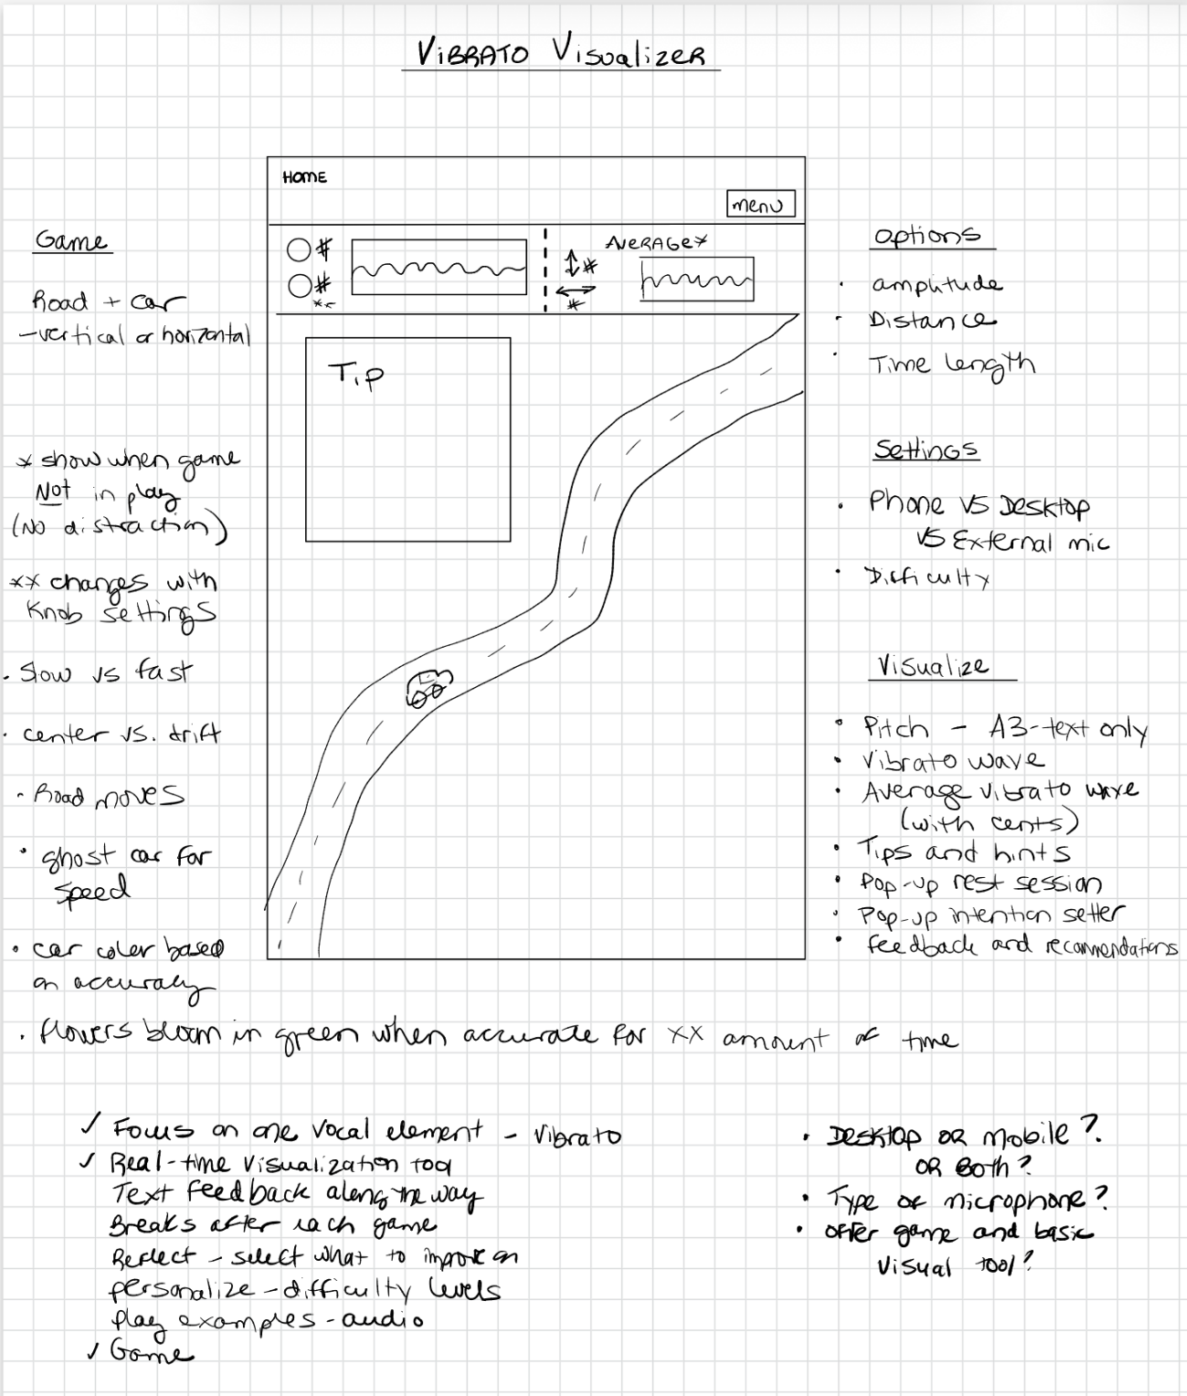

Mockup of basic user interface for a vibrato visualizer.

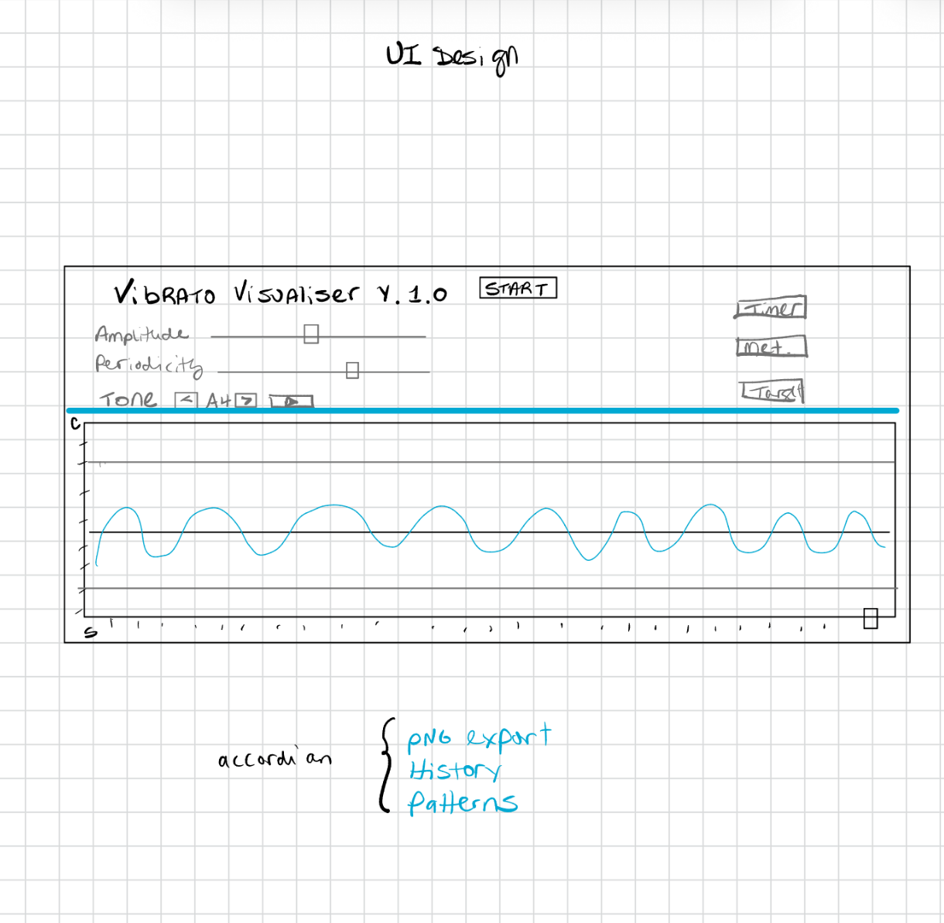

USER INTERFACE WORKING PROOF OF CONCEPTS
V001: Proof of concept showing that a waveform visualizer can be created as a web-based application.
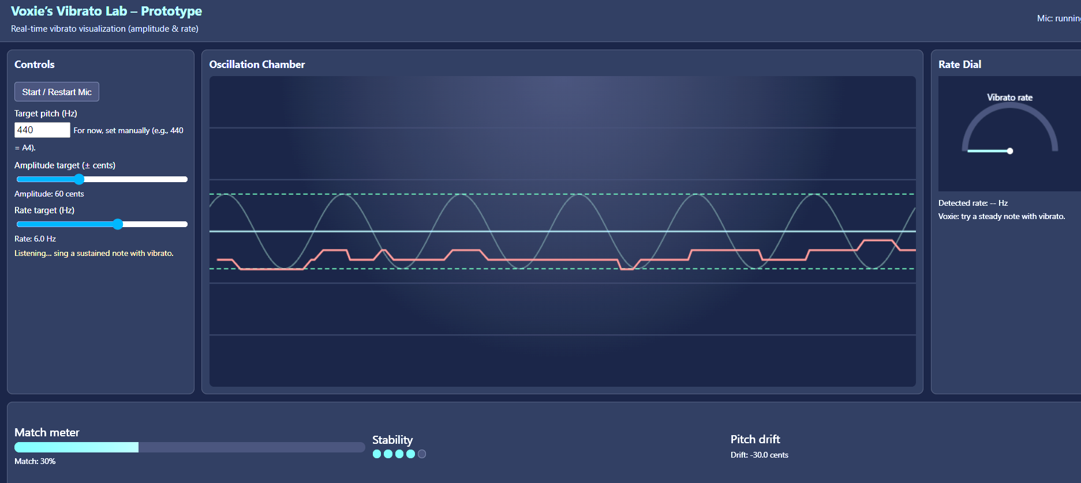

V004: Proof of concept expanding on initial design to test abilities of the audio analyser.
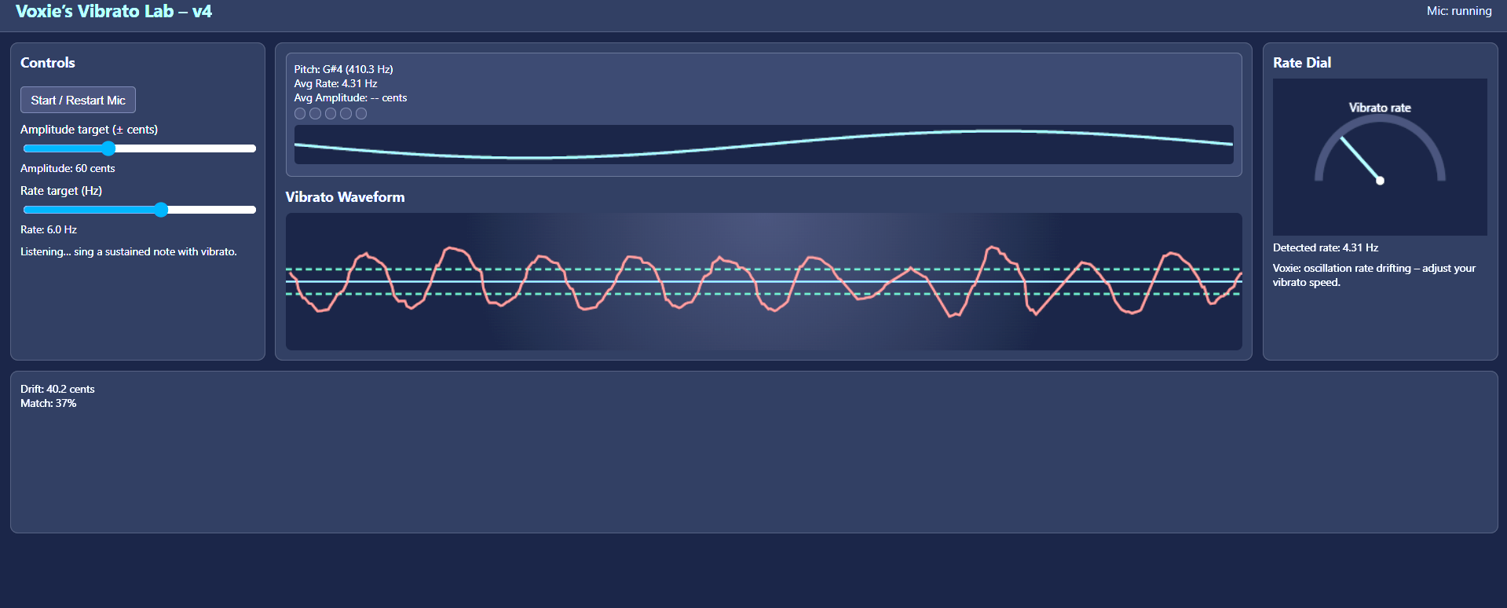

V005: Proof of concept of a prototype gamified version using a car (represented by the yellow rectangle) on a road (the green boundaries). The car must stay on the road (the boundary lines are the desired amplitude) and must keep pace with the other car (represented by the grey rectangle which indicates the desired periodicity).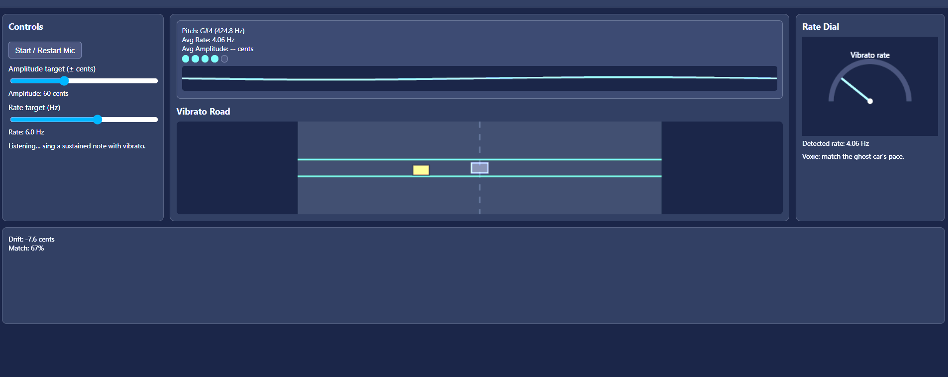

APPENDIX A: GLOSSARY OF TERMS

Amplitude: An oscillation of pitch measured as the distance above and below the fundamental frequency; represents the vertical extent of vibrato movement.
Client: The user’s browser environment that loads, runs, and interacts with the application.
Cross-Browser / Cross-Platform: The ability of the application to function consistently across modern browsers and operating systems without requiring device-specific adjustments.
Explainable AI (XAI): AI methods designed to make system behavior transparent, allowing users to understand how outputs are generated rather than treating the system as a black box.
HTML/CSS: The structural and styling languages used to define the layout, hierarchy, and visual presentation of the application’s interface.
JavaScript: The client-side scripting language that enables real-time audio processing, waveform rendering, and interactive system behavior.
Periodicity: The regularity and spacing of vibrato cycles over time; how consistently each oscillation repeats.
Vibe Coding: A workflow in which developers describe goals in natural language and iteratively refine AI-generated code, enabling rapid prototyping with minimal manual coding.
Vibrato: A periodic oscillation of pitch characterized by measurable rate and amplitude.
Waveform: A visual representation of the audio signal over time.
WCAG Compliance: Adherence to the Web Content Accessibility Guidelines which is an international single shared standard for web content including text, images, sounds, code, and markup. WCAG provides testable guidelines to ensure web accessibility for people with disabilities.

APPENDIX B: FUTURE REVISIONS

FUTURE REVISIONS AND SUPPLEMENTAL FEATURES
ID | DESCRIPTION | STATUS
001 | Create a gamified version; e.g., a car driving or other lab-related visualisation.
002 | Create a tool that shows real-time pitch display of the fundamental only, similar to the former application Pitch Lab.
003 | Create a vocal acoustic tool that displays different vocal qualities; e.g., twang, brightness, breathiness, etc., not on a waveform that is difficult to interpret, but instead more in a gamified version with visual targets.

Appendix F: Vibe Coding Transcript
Claude.AI, Opus 4.7

- Prompt 1
- Create proof of concept of visual vibrator tracker. Respond to questions from the AI model.

You said: So, I want to create a web-based application to display vocal vibrato as a single waveform.
So, I want to create a web-based application to display vocal vibrato as a single waveform. I will add more features as we go along, but I need the proof of concept for the vibrato wave line first. It should not be tied to pitch, meaning the wave should not move up or down with the pitch. The wave should stay vertically centered regardless of pitch, and only respond to vibrato movements to show the amplitude above and below the center. Ask me any questions you need to before beginning.
8:52 AM
Claude responded: Great project.
Architected pitch detection strategy and identified critical implementation questions
Great project. Here's the approach I'm planning so you can sanity-check it before I ask my questions:
The wave line will represent pitch deviation over time. Pitch is detected from audio frame-by-frame, then a moving average over the last ~1-2 seconds becomes the "centerline." The displayed wave is just the difference between current pitch and that running average. This way, slow pitch changes (sliding up to a new note) get absorbed into the centerline and don't push the wave off vertically, but vibrato oscillations (typically 4-7 Hz) ride on top and show clearly as deviations above and below center.
A few decisions before I build:
Two open questions on top of those, if you have opinions — otherwise I'll pick sensible defaults:
- Vertical scale — fixed range (e.g., ±100 cents, so a beginner's wobble looks small and a pro's controlled vibrato looks bold) or auto-scaling (always fills the canvas)?
- Visual style — any preferences on color, line thickness, background, glow, etc.?
You said: Q: Input source for the proof of concept?
Q: Input source for the proof of concept? A: Live microphone
Q: Tech stack preference? A: No preference
Q: How much time should be visible on screen at once? A: 15 seconds
You said: The vertical scale should be a fixed range.
The vertical scale should be a fixed range. The vibrato should not look overly large. I would rather it be smaller visually than take up a lot of space. A cyan color line on a black background.
8:56 AM
Claude responded: Got it — fixed scale, restrained visual size, cyan on black.
Architected minimalist pitch-tracking visualizer with constrained vertical scaling
Architected minimalist pitch-tracking visualizer with constrained vertical scaling
Got it — fixed scale, restrained visual size, cyan on black. I'll go with vanilla single-file HTML so it's easy to extend later. Building it now.
Created a file, read a file
How it works:
The wave shows pitch deviation in cents from a moving-average centerline. Pitch is detected each frame with a YIN algorithm (with parabolic interpolation, which is what makes the line smooth instead of stair-stepped). The centerline is the geometric mean of the last 1.5 seconds of detected pitch — so when you slide to a new note, the centerline catches up within ~1.5s and the wave returns to vertical center, while vibrato oscillations (4-7 Hz) stay visible above and below.
A few choices worth flagging so you can push back:
- Vertical scale is ±200 cents (two semitones up and two down). A typical ±50¢ vibrato fills only the middle quarter of the canvas, which matches your "smaller, not overly large" preference. Easy to change — top of script, RANGE_CENTS.
- Silence breaks the line rather than drawing through gaps, so pauses and breaths read accurately.
- A "CALIBRATING…" overlay appears for the first ~1.5 seconds while the baseline builds, otherwise the wave would jump around wildly until enough samples accumulated.
- Three readouts at the bottom: current pitch (Hz), instantaneous deviation (¢), and estimated vibrato rate (Hz). I added rate since it's a natural companion to amplitude — easy to remove if you don't want it yet.
A couple of things to know going in:
- It needs to be served over HTTPS or file:// for mic permission. Opening the HTML directly should work; if you host it later, use HTTPS.
- I disabled echo cancellation, noise suppression, and AGC on the mic input. Those are great for calls but they smear pitch and would distort the vibrato signal.
Try it out and let me know what's off — I'm expecting we'll want to tune the baseline window length, the vertical range, or the YIN threshold once you see real voices on it. What feature do you want to add next?

- Prompt 2
- Fix over-reactivity of wave and stabilize. Respond to questions from the AI model.

You said: Not bad.
Not bad. This is the closest I have gotten in days on this project. Two changes: 1. The wave goes up or down first with pitch change before stabilizing around vertical center. Can this either happen faster, have the line not move with pitch change, or not display the moment of pitch change and only display once stabilized to show the vibrato. 2. The wave is overreactive. Can the response be more stabilized. Example if the pitch is being sung without vibrato, I would expect the wave to be relatively straight. Ask questions before generating.
9:06 AM
Claude responded: Glad it's getting close.
Diagnosed pitch-tracking artifacts and formulated clarifying questions
Diagnosed pitch-tracking artifacts and formulated clarifying questions
Glad it's getting close. Both problems trace to specific things in the current build, and the right fix depends on what you'd like to prioritize.
The pitch-change swing happens because the centerline is a 1.5-second moving average — when you change notes, the line shoots up or down until the average catches up. The over-reactive jitter on steady notes is the natural noise floor of pitch detection (YIN gives roughly ±5-10 cents of frame-to-frame wobble even on a perfectly steady tone). Both are fixable, but the fixes involve trade-offs worth your input on.
Two notes on the trade-offs:
For Q1, "snap" is technically the cleanest but means I have to detect pitch jumps reliably — the algorithm watches for the pitch consistently sitting far from the baseline for a few frames in a row and then snaps. "Hide the line" is the safest visually but means continuous pitch slides (portamento) wouldn't display vibrato during the slide.
For Q2, more smoothing introduces a small amount of visual lag (~30-80ms behind real time) and slightly softens the peaks of fast vibrato. For typical 5 Hz vibrato that's still totally fine, but if a singer ever does a very fast tremolo it'd get smoothed too. If you want, I can give you a slider to tune it live so you can dial it in by ear.
You said: Q: When pitch changes (jump or slide to a new note), how should the line behave?
Q: When pitch changes (jump or slide to a new note), how should the line behave? A: Snap centerline instantly so no swing is visible
Q: How smooth should the line be on a steady note with no vibrato? A: Nearly flat (aggressive smoothing)
9:08 AM
Claude responded: Got it.
Architected pitch-detection algorithm with snap detection and adaptive smoothing
Architected pitch-detection algorithm with snap detection and adaptive smoothing
Got it. I'll add jump-detection so the centerline snaps the moment a new pitch is sustained, and apply layered smoothing so steady notes show as a flat line.
Approach:
For the snap: track the last few frames; if pitch sits more than ~60 cents off the current centerline in the same direction for 5 frames in a row (~85ms), that's a real pitch change, not vibrato (vibrato oscillates back through center). When that triggers, the centerline jumps to the new pitch and the brief pre-snap swing gets erased from the displayed history so you never see it.
For the smoothing: a 5-frame median filter on raw pitch (kills outlier glitches), then an adaptive exponential filter on deviation that smooths heavily when the signal is steady and lightens up when real vibrato peaks happen, plus a soft squelch that flattens deviations under ~6 cents to zero.
Ran a command, created a file, read a file
Ran a command, created a file, read a file
What changed:
The detection runs every frame: when pitch sits more than 60¢ off the centerline in the same direction for 5 frames in a row, it confirms a real pitch change, snaps the centerline to the new pitch, and erases the last 8 frames of line so the swing never appears. Vibrato can't trigger this because it crosses back through center too fast — it never sustains one direction long enough.
The smoothing has three stages: a 5-frame median on raw pitch readings (kills any single-frame YIN glitches), an adaptive exponential filter on deviation (heavy smoothing when the signal is steady, lighter when real vibrato is happening so the peaks aren't flattened), and a soft squelch that fades anything under ~6¢ to zero. On a clean, steady note the line should be effectively flat now.
All the tuning constants are at the top of the script in a labeled CONFIG block — STEP_THRESHOLD_CENTS, STEP_FRAMES_REQUIRED, ALPHA_MIN/ALPHA_MAX, SQUELCH_CENTS, etc. — so we can dial them in once you see how it behaves on real voices. A few directions you might want to push:
- If the snap is too eager and triggers on big vibrato peaks, raise STEP_THRESHOLD_CENTS to 80.
- If the snap is too sluggish, drop STEP_FRAMES_REQUIRED to 4.
- If the line still wobbles too much on steady notes, raise SQUELCH_CENTS to 8 or 10.
- If real vibrato is getting flattened too much, lower SQUELCH_CENTS to 4.
Try it out and tell me what's still off.

- Prompt 3
- Fix of break in line rendering function.

You said: when singing with vibrato, the line doesn't always render - there is dropout
when singing with vibrato, the line doesn't always render - there is dropout
9:26 AM
Claude responded: I see the issue.
Diagnosed vibrato-triggered snap detection and engineered robust fixes
Diagnosed vibrato-triggered snap detection and engineered robust fixes
I see the issue. Looking at the dropouts and where they occur — mid-vibrato, on what look like the high-amplitude peaks — the snap detector is firing on vibrato itself, not just on real pitch changes. Wide vibrato can sustain a single direction past +60¢ for 5+ frames if the peak is high enough and the rate is slow enough, which trips the snap and erases the surrounding 8 frames.
The fix is to change how step detection works. Instead of counting consecutive frames over a threshold (which vibrato can game), I'll compare a short-window average of recent pitch (200ms, which always covers at least ~1 vibrato period) against the longer baseline. Vibrato averages out to near zero over a full period, so the short average matches the baseline; a real pitch change shows up as sustained divergence between the two. This is mathematically immune to vibrato amplitude — even ±150¢ wide vibrato won't trigger it as long as the rate is faster than ~3.5 Hz, which covers all real singing.
I'll also add a couple of related fixes:
- After a snap, seed the baseline with only the last few frames in the buffer (not all of it) so dev returns to ~0 immediately rather than briefly sitting offset
- Inline gap-filling in the draw step — if there are 1-4 null frames in a row from a transient pitch detection failure (not from a snap), connect across them with a short linear interpolation. Snap-erased gaps stay as gaps so transitions still read clearly
- Keep the smoother state across brief 1-3 frame nulls so it doesn't re-initialize on every detection hiccup
- Relax the YIN threshold slightly (0.15 → 0.18) to lose fewer frames during fast pitch sweeps through vibrato inflection points
Ran a command, created a file, read a file
Ran a command, created a file, read a file
Three changes that should kill the dropouts during sustained vibrato:
The snap detector now compares the average pitch over the last 200ms against the 1.5-second baseline. Because 200ms covers a full vibrato period for any rate from ~3.5Hz on up, vibrato averages out to near zero in the short window — the two averages stay aligned, and no false snap fires no matter how wide the vibrato gets. A real pitch change still produces a sustained divergence and triggers within ~100-200ms.
If a frame still drops out for unrelated reasons (a YIN frame that didn't pass the confidence threshold during a fast pitch sweep, for example), and there's a valid frame within 4 frames on either side, the line now interpolates smoothly across that gap. Snap-erased gaps are tagged separately so they're never interpolated — pitch transitions still read as visible breaks.
I also relaxed the YIN confidence threshold from 0.15 to 0.18 so fewer frames get rejected during the fastest part of vibrato cycles, and the smoother now keeps its state through brief 1-3 frame nulls instead of resetting on every hiccup.
If you still see dropouts after this, the next-likeliest cause would be the volume gate flickering (RMS_GATE at top of script), which we can address next. Try it and let me know what the line looks like now.

- Prompt 4
- Set correct values on Y access, add X access time labels in seconds, retention of wave after completion of audio capture. Create a grid behind wave. Respond to questions from the AI model.

You said: Next step: The Y axis values should range +/-80 cents with labels every 10 cents.
Next step: The Y axis values should range +/-80 cents with labels every 10 cents. Display a grid behind the wave with the line at 0 being dashed as it is currently, but bolder. Reduce the height of the wave display area to about half of what it is now. Display up to 30 seconds on the screen at a time (yes, this will reduce the visual size of everything which is the point). Beneath the wave under the x axis, show the time in seconds, labeling every 5 seconds. Add a scroll bar so the user can scroll back to see previous parts of the wave after stopping the audio capture if they have gone off screen. Continue to display the last wave after stopping the audio capture. Ask any questions you need before generating.
9:47 AM
Claude responded: Quick question before I build: A few smaller defaults I'll go with unless you push back:
Architected comprehensive UI redesign with scrollback functionality and clarifying questions
Architected comprehensive UI redesign with scrollback functionality and clarifying questions
Quick question before I build:
A few smaller defaults I'll go with unless you push back:
- Pressing START again after stopping clears the saved wave and begins a new recording. If you want to preserve previous waves between sessions, that's a separate feature (saved recordings list, etc.) we can add later.
- History retention capped at 10 minutes max — beyond that, the oldest data falls off. Easy to change.
- Vibrato that exceeds ±80¢ will hard-clip at the top/bottom edges of the wave area (true to the data).
- Pitch / Deviation / Vibrato Rate readouts freeze on the last value when you stop.
- The scrollbar is only interactive when stopped, since that's what you asked for. During recording the wave auto-scrolls and the scrollbar tracks live.
Push back on any of these and I'll adjust.
You said: Q: Time axis labels — count absolute time from recording start, or count back from now?
Q: Time axis labels — count absolute time from recording start, or count back from now? A: Absolute (0s, 5s, 10s ... slide left as recording continues)
9:57 AM
Claude responded: Building it.
Architected comprehensive waveform display redesign with scrollback functionality
Architected comprehensive waveform display redesign with scrollback functionality
Building it.
Remove old version before rewriting
Remove old version before rewriting
Created a file, read a file
Created a file, read a file
All in:
- Range is ±80¢, with horizontal grid every 10¢ and labels in a left-side gutter (left edge of the wave starts after the cent labels so the line can't overlap them)
- 0¢ centerline thicker (1.6px) and brighter, still dashed
- Wave area height clamped to roughly half the previous size — clamp(220px, 36vh, 340px)
- 30 seconds visible at once; meta label updated to read "30 SEC · ±80¢"
- Time axis lives in the bottom strip of the canvas itself, with vertical grid lines aligned to the same 5-second ticks. Labels count up from start of recording (0s, 5s, 10s…) and slide left as recording continues
- Custom cyan-styled scrollbar with elapsed-time labels at each end. Disabled during recording (auto-tracks live position), interactive after you stop
- Stopping no longer clears the wave or readouts — they freeze. The view pins to where you left off so the slider has something meaningful to do
- Pressing START again clears for a fresh recording (mentioned this earlier — easy to change later if you want to preserve takes)
A few small under-the-hood things I tweaked to fit the new range: MIN_BASELINE_FRAMES is now 5 (down from 8) so the line resumes faster after a snap, and SQUELCH_CENTS is 4 instead of 6 — the old 6¢ squelch was a much bigger fraction of ±80 than it was of ±200, and was starting to flatten real micro-vibrato. History caps at 10 minutes.
Try it and let me know what's next.

- Prompt 5
- Fix opacity of grid. Smooth responsivity of wave to audio input. Request explanation of JavaScript variables.

You said: If there is a grid behind, I cannot see it.
If there is a grid behind, I cannot see it. Tell me if there is CSS I can alter to accomplish this. The beginning of the wave in the screen shot is a relative straight tone, vibrato applied at the end. Any way we can smooth is a bit more and be less responsive? Tell me if there are variables I can alter to accomplish this. Don't make any changes yet, just let me know if I can do things.
10:16 AM
Claude responded: For the grid: it's drawn in canvas via JavaScript, not via CSS — so the CSS variable --cyan-grid I defined is unused (my mistake, will wire it up next round).
Identified grid visibility issue and smoothing variables to adjust
Identified grid visibility issue and smoothing variables to adjust
For the grid: it's drawn in canvas via JavaScript, not via CSS — so the CSS variable --cyan-grid I defined is unused (my mistake, will wire it up next round). For now, find this line inside drawGrid():
js
ctx.strokeStyle = 'rgba(0, 217, 255, 0.07)';
The 0.07 is the alpha. There are two of these in drawGrid() — one for horizontal cent lines, one for vertical second lines. Bump both to 0.15 or 0.20 and the grid will appear behind the wave. (The 0.65 value in drawCenterline() is the bold dashed 0¢ line — leave that alone unless you want it different.)
For making the line less responsive on steady tones, all the relevant knobs are at the top of the script in the // --- Smoothing --- block:
- ALPHA_MIN (currently 0.10) — how aggressively to smooth tiny movements. Lower this (try 0.04) and the line becomes much calmer on a flat tone.
- SQUELCH_CENTS (currently 4) — width of the "treat as zero" zone around the centerline. Raise this (try 6 or 8) to widen that zone. Most direct way to flatten residual jitter.
- ALPHA_MAX (currently 0.55) — how fast the line tracks real vibrato peaks. Lowering this (e.g. 0.40) softens vibrato too, not just jitter.
- ALPHA_RANGE_CENTS (currently 12) — the deviation size at which smoothing fully releases. Raise this (try 18 or 20) to keep smoothing engaged for medium-sized wobbles.
- PITCH_MEDIAN_LEN (currently 5) — outlier rejection on raw pitch. Bump to 7 for slightly more rejection (must be odd).
If you only want to touch one or two: lower ALPHA_MIN to 0.04 and raise SQUELCH_CENTS to 6. Those two will quiet the steady-tone wobbles you saw at the start of that screenshot without meaningfully softening the vibrato peaks at the end.

- Prompt 6
- Add features: periodicity and amplitude sliders, bumpers above and below 0 on axis Y, add optional timer, display averages after end of audio capture, move pitch tracker to wave area and change labelling. Respond to questions from AI model.

You said: OK, I reset alphamin to ,04, squelchcents to 6, pitchmedianlen to 7, alpharangecents to 20, alphamax…
OK, I reset alpha_min to ,04, squelch_cents to 6, pitch_median_len to 7, alpha_range_cents to 20, alpha_max to .4, alpha_min to .04. Seems better. Time to add some more features. More all controls and data to be above the wave area. I want to add two sliders: one for Periodicity with a range of 2hz to 8hz with step size of .5; one for amplitude with range of +/-10cents to +/- 80cents, with step size of 5. These user selected values will control the grid. Amplitude will control two lines or "bumpers", one above and one below Y axis 0 value, set to the selected amplitude to allow a visual cue to users; lines should be brighter/bolder than the rest of the grid lines; vertical lines on the grid will be controlled by periodicity. Both sets of lines should change with change of value on the sliders. Add an optional Timer with values of 15 seconds, 30 seconds, 45 seconds, and 60 seconds. If the timer is selected, audio capture will automatically stop at the end of the selected time unit. At the end of a session (after the user hits stop), display averages for: amplitude, periodicity, vibrato stability (rate variation--standard deviation), and vibrato regularity (extent variation--consistency of amplitude from cycle to cycle). Begin the time with 0 at horizontal center and have the wave form begin there instead of on the far right, this way the user maintains focus on the center of the screen easily. Also, move the pitch tracker to the wave area. Place it just above the wave area at horizontal center. Do not label it pitch, and rather than providing the numeric hz, display in the format A3, etc. Ask any questions that you need for clarification before building.
Show more
10:48 AM
Claude responded: A few things to confirm before building, since some of these are interpretation calls.
Deliberated playhead positioning and grid density ambiguities before implementation
Deliberated playhead positioning and grid density ambiguities before implementation
A few things to confirm before building, since some of these are interpretation calls.
The biggest one is what "wave begins at center" means once recording continues past that opening moment:
Defaults I'll use unless you push back:
- Pitch tracker centered above the wave will display only the note name (e.g. "A4"), no Hz, no cents offset, prominent in cyan. Shows "—" when no pitch is detected.
- Sliders default values — Periodicity at 5 Hz, Amplitude at ±40¢ (typical vibrato targets). Both visibly update the bumpers/grid as you drag.
- Timer dropdown defaults to "Off". When set and triggered, it auto-stops exactly like clicking STOP — no chime or popup, just the stats appear and the wave freezes.
- Stats panel (Avg Amplitude, Avg Periodicity, Stability, Regularity) replaces the live Deviation/Rate readouts after stop. Same screen real-estate, different content depending on state.
- Top control row layout: Start/Stop button on the left, then Periodicity slider, Amplitude slider, Timer dropdown, then the live readouts — wrapping to two rows if the viewport is too narrow.
- Scrollbar stays below the wave area since it's spatially tied to the time axis, even though it's technically a control. Tell me if you want it moved up with the others.
- The bumpers (target amplitude lines) — same cyan as the centerline at moderate brightness, solid (not dashed), thinner than the centerline so the centerline still reads as the strongest reference.
- Grid alpha — I'll bump the cents grid from 0.07 to 0.18 while I'm in there so you can actually see it, and wire up the unused --cyan-grid CSS variable so future tweaks are one place.
- Stats math — peak detection between zero crossings of the displayed wave; cycles with too-small amplitude (under ~5¢) get excluded so non-vibrato sections don't pollute the averages. Will mention if too few cycles were captured to compute meaningful stats.
You said: Q: Where should the live playhead sit on screen during recording?
Q: Where should the live playhead sit on screen during recording? A: Wave moves as it currently does, but instead of starting at the right side, it starts center and then moves left. The currently sung tone is therefore always in the center of the screen. Does that make sense?
Q: Periodicity grid density. With 30s visible at 5Hz that’s 150 cycles — how should the vertical grid look? A: One thin line for each user selected cycle length, so a thin line every 5hz for that selection. We can always revise if it is too much. The important thing is the lines respond instantly to the change in periodicity selection.
10:59 AM
Claude responded: Got it — playhead always at horizontal center, wave grows leftward from center, right half stays blank during live.
Architected center-aligned playhead with scrolling waveform visualization
Architected center-aligned playhead with scrolling waveform visualization
Got it — playhead always at horizontal center, wave grows leftward from center, right half stays blank during live. Periodicity grid at every cycle, instantly responsive.
Building.
Ran a command, created a file, read a file
Ran a command, created a file, read a file
All in. A quick tour of what's there:
Layout — Header at top, then the control row with Start/Stop, Periodicity slider (2–8 Hz, step 0.5), Amplitude slider (10–80¢, step 5), and Timer dropdown. Below that, the readouts row, then the centered note tracker, then the wave area, then the scrollbar.
Center playhead — During recording, the most recent moment sits at horizontal center. Wave grows leftward, right half stays blank. The scrollbar's value is now the "view center" time, so dragging anywhere in the recording brings that moment to center.
Periodicity grid — Vertical lines at every cycle of your selected periodicity, anchored to horizontal center so the slider response is instant and the spacing is always evenly distributed across the screen. They're subtle (alpha 0.13) — at 8 Hz with 30s visible they form a fine texture; at 2 Hz they're spread out. If a value is so high the lines would be solid (under 2px apart) they automatically suppress.
Bumpers — Two bright cyan lines at +amplitude and -amplitude. Brighter than the cents grid, dimmer than the dashed centerline. Update live with the slider.
Cents grid — Now at alpha 0.10, visibly behind the wave but not loud. The 10¢ line that coincides with the bumper position gets skipped to keep the bumpers reading as bumpers.
Pitch tracker — Centered above the wave, just the note name (A4, C#5, etc.), no Hz, no cents offset, with a soft cyan glow.
Timer — Pick a duration, hit START, and a countdown appears next to "Timer" while recording. At zero it auto-stops exactly like clicking STOP.
Stats — On stop (manual or timer), the live Deviation/Rate readouts swap out for Avg Amplitude, Avg Periodicity, Stability (rate std dev), and Regularity (amplitude std dev). Values shown as ±N¢ and Hz with appropriate precision. If there weren't enough vibrato cycles to compute stats meaningfully, all four show —. Half-cycles with peaks under 5¢ are excluded from the average so non-vibrato sections (steady tones) don't pull the numbers down.
Smoothing constants preserved at the values you settled on (ALPHA_MIN=0.04, ALPHA_MAX=0.40, ALPHA_RANGE_CENTS=20, PITCH_MEDIAN_LEN=7, SQUELCH_CENTS=6).
A note about the 30s + half-blank choice: with the playhead pinned at center, you only ever see 15s of past on screen during live recording (the right half is "future"). If after using it you find that's too little visible context, two natural responses are (1) drop the visible window to 20s so you see ~10s past + 10s future-blank with bigger features, or (2) keep the 30s window but shift the playhead off-center (say, 75% across) so you see 22.5s past + 7.5s future-blank. Both are easy to dial in.
Try it and let me know what's next.

- Prompt 7
- Repair rate display, change wave form to begin left to right. Respond to questions from AI model.

You said: So I see deviation, rate, avg amplitude, avg periodicity, stability, and regularity.
So I see deviation, rate, avg amplitude, avg periodicity, stability, and regularity...I think some of that is redundant, no? I also do not see values under anything except deviation and rate. Also, yeah, I was totally wrong about the wave form starting center. I want the user to focus center of the screen, but it looks weird with nothing on the right. Can we maybe reverse the direction of the wave so that it starts left and moves right? I feel like that is what is usually done on spectrograms, no? Ask questions before redoing anything.
11:17 AM
Claude responded: Two things on the readouts before we change anything:
Diagnosed CSS display bug, identified metric redundancy, formulated readout restructuring options
Diagnosed CSS display bug, identified metric redundancy, formulated readout restructuring options
Two things on the readouts before we change anything:
First, you're seeing all six because of a CSS bug, not by design. I set hidden attributes on the stats boxes, but my .readout { display: flex } rule overrides the hidden attribute. So everything shows; only Deviation and Rate ever get values populated. The fix is one line of CSS — [hidden] { display: none !important; } — and after that you'd only see two readouts during recording and four after stop.
Second, you're right about real conceptual redundancy: live "Rate" and post-stop "Avg Periodicity" are the same metric on different time windows. "Deviation" and "Avg Amplitude" are not the same (instantaneous offset vs. average peak per cycle), but Deviation as a numeric readout might still be redundant with the wave itself, which already shows you live deviation visually as the rightmost point's Y position.
So: how minimal do you want the live row?
On the wave direction — yes, left-to-right is the standard spectrogram / DAW timeline convention, and it'll feel more natural. To confirm what I'll do:
- Recording starts with the wave at the left edge, growing rightward as time passes
- Once 30 seconds of data exists, the right edge becomes the live playhead — newest data stays pinned at the right, oldest scrolls off the left (this is what we had before center-playhead)
- The "focus on center" wish gets met passively: once the screen is full, the wave occupies the whole width, so center is naturally where the eye lands
The center stops being a special pinned point — it's just where the screen happens to be. Tell me if that's not quite right; otherwise I'll proceed with that plus the readout choice once you pick.
You said: Q: What should the live readouts show during recording?
Q: What should the live readouts show during recording? (Post-stop will always be the 4 stats: Avg Amplitude, Avg Periodicity, Stability, Regularity.) A: Just the note tracker and the wave — no numeric readouts during recording
11:22 AM
Claude responded: Got it.
Architected minimal UI with deferred stats display and scrolling waveform
Architected minimal UI with deferred stats display and scrolling waveform
Got it. Building.
Ran a command, created a file, read a file
Ran a command, created a file, read a file
Summary of what changed:
The CSS bug is fixed — added [hidden] { display: none !important; } so the hidden attribute actually hides things despite the display: flex on .readout. The two live readouts (Deviation, Rate) are gone entirely, replaced by no readouts at all during recording. The stats panel only appears after stop, populated with the four session metrics.
Wave direction is now left-to-right. Mechanically: during the first 30 seconds of a recording, the visible window is fixed at [recordingStart, recordingStart + 30], so the wave grows out from the left edge into empty space on the right. Once the recording exceeds 30 seconds, the right edge starts tracking live time and the wave scrolls left like before. The math is "right edge = viewEnd, left edge = viewEnd − 30s," with viewEnd pinned at recordingStart + 30 until the recording catches up to it.
The periodicity grid is now anchored to recordingStart rather than the screen center, so its lines have absolute time stamps and scroll with the wave once scrolling starts. Before recording (idle), it anchors to the right edge as a static preview, so dragging the periodicity slider still gives you immediate visual feedback.
The scrollback slider's range is now in viewEnd terms — minimum is recordingStart + 30 (oldest data at left edge), maximum is the most recent data (newest at right edge). It only enables if the recording exceeds 30 seconds.
Other things you'll notice: layout shifts down slightly when you stop and the stats panel appears between the controls and the note tracker, since the row was hidden during recording. If that visual jump bothers you, easy fix is to keep the row reserved at all times with muted "—" placeholders during recording. Just say the word.

- Prompt 8
- Reduce length of display, apply WCAG guidelines. Respond to questions from AI model.

You said: Currently, more than 30 seconds are displaying on the screen.
Currently, more than 30 seconds are displaying on the screen. Can we reduce to 20 seconds on screen, and instead of going all the wave to the right edge, can there be a short buffer. Audacity leave a little bit of space then bumps everything over a few seconds. Would that be too confusing for a user in this context? It is how most DAW function. Also, the line is showing gaps and missing chunks again while vibrato-ing. Keep in mind this needs to be responsive and cross-platform/cross-browser functional and align with ADA WCAG guidelines.
11:42 AM
Claude responded: Three things in your message — let me break them out.
Analyzed timeline behavior, diagnosed vibrato detection gaps, and weighed UI design tradeoffs
Analyzed timeline behavior, diagnosed vibrato detection gaps, and weighed UI design tradeoffs
Three things in your message — let me break them out.
The dropouts: Yes, I can see them in the image, mostly at the troughs. With your stats showing Avg Amplitude ±89¢ and Avg Periodicity 3.33 Hz, this is a genuinely difficult case for the snap detector — slow vibrato (3.3 Hz = 300ms period) with very wide amplitude. My snap-detection short-window is 200ms, which only covers two-thirds of one cycle at that rate, so the moving average doesn't fully average out vibrato peaks — residual divergence can creep close to the 50¢ threshold and false-trigger on big troughs. Widening the snap window from 200ms to 300ms (full period at 3.3 Hz) plus bumping the threshold slightly should fix it. I'll also bump the gap-fill window from 4 to 6 frames to absorb any small detection misses that aren't snap-related.
Visible window 20s and buffer: Easy on the 20s. On the buffer:
My honest take: for a real-time singing tool where the user is focused on matching the wave to the bumpers, continuous-with-buffer is gentler. Audacity-style page jumps work great for editing/navigation, but in a live monitoring context the sudden shift can break visual continuity right when the user is concentrating. That said, both are easy to build — let me know which feels right.
WCAG / cross-browser / responsive: Already mostly there but I'll tighten things up while I'm in:
- The high-contrast cyan-on-black palette is well over the AA contrast ratio for both normal and large text.
- I'll add explicit ARIA labels on the canvas, sliders, and timer (currently relying on visible labels only — fine for sighted users, but screen readers can't infer the canvas content).
- I'll add a visible :focus-visible ring on all interactive elements so keyboard users can see where they are.
- Add aria-live updates on the post-stop stats so screen readers announce the session results.
- Verify the layout still works at 200% browser zoom (it should — clamp and flex-wrap handle it).
- Reduce time-axis label density on narrow viewports if needed (might overlap on a phone).
- All the Web APIs I'm using (Web Audio, Canvas, getUserMedia) work in current Chrome, Firefox, Safari, and Edge. The only gotcha is that iOS Safari requires a user gesture to start AudioContext — already handled by the START button.
Once you pick a buffer style I'll roll all of this together.
You said: Q: How should the timeline behave once recording exceeds the visible window?
Q: How should the timeline behave once recording exceeds the visible window? A: Continuous scroll with constant buffer (newest data always ~2-3s from right edge, wave glides smoothly leftward)
11:49 AM
Claude responded: Building.
Architected continuous-scroll buffer system with accessibility enhancements
Building.
Ran a command, created a file, read a file
Summary of what changed:
Visible window is now 20 seconds with a 3-second buffer at the right edge. The math collapses cleanly: viewEnd = max(recordingStart + 20, currentTime + 3). During the first 17 seconds the view is fixed, wave grows from left into the buffer. At 17 seconds in, the wave reaches the buffer threshold and the view starts gliding leftward — newest data permanently sits 3s from the right edge after that.
Snap detection widened to 300ms with a 60¢ threshold. At your Avg Periodicity 3.33 Hz and Avg Amplitude ±89¢, the previous 200ms window only covered two-thirds of one vibrato cycle, so the moving-average residual at trough peaks was creeping toward the 50¢ threshold and false-firing. A 300ms window now covers a full cycle even at 3 Hz, and the residual is mathematically bounded under ~5¢ regardless of amplitude. Combined with the threshold bump, the snap detector should now ignore vibrato up to about ±150¢ at 3 Hz before any risk of false trigger. Gap-fill bumped from 4 to 6 frames (~100ms) so any remaining transient detection failures get bridged smoothly.
WCAG additions:
- Proper <label for="…"> associations on all sliders and select, so screen readers announce them correctly
- aria-valuetext updates on each slider change ("5.0 Hertz", "plus or minus 40 cents")
- role="region" and aria-live="polite" on the stats panel so values are announced when they appear after stop
- role="status" and aria-live="polite" on the pitch tracker so note changes are announced
- role="img" and a descriptive aria-label on the canvas
- role="alert" on the error box
- aria-label on the START/STOP button that updates with state ("Start recording" / "Stop recording")
- A visible 2px cyan focus ring on all interactive elements via :focus-visible
- prefers-reduced-motion hook that disables the calibrating fade and button transition (the wave itself is still kinetic — that's the data, not decoration)
- Adaptive Y-axis label density: at narrow heights (under 14px between labels), the cent labels switch from every 10¢ to every 20¢ so they don't overlap
Cross-browser/cross-platform notes:
- All Web APIs in use (Web Audio, Canvas, getUserMedia, AudioContext) are supported in current Chrome, Firefox, Safari, and Edge
- iOS Safari requires user gesture for AudioContext — already satisfied by the START button click
- The webkitAudioContext fallback is there for older Safari
- Vendor-prefixed slider thumb styles for both WebKit and Firefox
- flex-wrap on the control row handles narrow viewports gracefully
- Canvas DPR scaling means crisp text and lines on retina/high-DPI displays
- HTML <input type="range"> works correctly with touch on mobile
Try it and tell me what's still off.

- Prompt 9
- Request input from AI model on potential additional features. Respond to questions from AI model.

You said: It's.
It's...so...beautiful....is there anything else you think that this needs? Next step is making the interface a bit fancier.
12:09 PM
Claude responded: Glad it landed!
Prioritized feature gaps and aesthetic direction for vibrato training tool
Prioritized feature gaps and aesthetic direction for vibrato training tool
Glad it landed!
Honest take on what would lift this from neat tool to genuinely useful:
Saved sessions is the big one. Every recording vanishes when you hit START again. For real vibrato training, the value is in comparing today's stability number to last week's, watching the trend over time. Browser localStorage could hold a list of completed sessions (timestamp, target settings, the four stats) without ever storing the waveform itself, and the side effect is that the slider/timer settings would also survive a page reload.
A reference drone. Most vocal vibrato practice happens over a sustained tone. A small "play reference pitch" control — pick a note, hear a quiet sine or organ tone — would make this immediately practical for practice instead of just diagnostic. Web Audio synthesizes a tone in five lines.
Active target feedback. Right now the bumpers and the periodicity grid are passive reference. When a vibrato peak touches a bumper, that bumper could briefly pulse brighter; when the wave is genuinely in the target zone (hitting amplitude AND matching rate), the wave itself could subtly tint or thicken. That converts the reference lines into live feedback, which is the heart of a training tool.
First-time guidance. One sentence above the wave on first load explaining what the bumpers and grid mean, dismissed once you've recorded. The interface is clean but currently assumes you already know what you're looking at.
Smaller stuff: spacebar to toggle start/stop, an export-as-image button on the post-stop view, a favicon.
For the fancier interface — since "so beautiful" suggests you're happy with the technical-instrument direction, I'm assuming you want more polish in that vein rather than a redesign. There are a few directions that direction could go:
You can pick more than one — they layer well together. Or pick the surprise option and I'll commit to a coherent direction.
You said: Question: could the reference tone have the same periodicity and amplitude as selected so that user hears what the vibrato is supposed to sound like?
Question: could the reference tone have the same periodicity and amplitude as selected so that user hears what the vibrato is supposed to sound like?
12:26 PM
Claude responded: Yes, and this is actually one of the most useful versions of a reference tone for a training tool.
Validated feasibility and architected reference tone synthesis implementation
Validated feasibility and architected reference tone synthesis implementation
Yes, and this is actually one of the most useful versions of a reference tone for a training tool. Web Audio makes it trivial — you create one oscillator at the base note frequency, a second oscillator (the LFO) running at the periodicity rate, scale that LFO's output by the amplitude in cents, and feed it into the base oscillator's detune parameter (which is conveniently already calibrated in cents). Three nodes plus a gain stage.
So the user picks A4, sets periodicity to 5 Hz and amplitude to ±40¢, presses play, and hears exactly what 5Hz/40¢ vibrato sounds like on A4. Move the periodicity slider while it's playing and the audible vibrato slows or speeds in real time. Move the amplitude slider and the depth widens or narrows. It becomes a vibrato calibrator, not just a pitch reference.
A few practical things worth knowing before we build it:
Headphones strongly recommended. If the user is on a laptop with built-in speakers and built-in mic, the reference tone bleeds into the microphone and the visualizer ends up tracking your reference, not the singer. We can add a "use headphones" hint near the play button, but we can't really enforce it. (One option is to disable the reference tone while recording is active — listen first, sing second — which is also closer to how singers actually practice.)
Base note selection. Singers' tessituras vary a lot. We'd want a note picker, probably a dropdown of common practice notes (say C4 through C5 for most voices, with maybe a wider range for low and high voice types). Or even simpler: a small octave +/- pair of buttons starting at A4.
Tone character. A pure sine wave is the cleanest demonstration of pitch motion but sounds clinical. A slightly richer waveform (sawtooth softened with a low-pass filter, or two sines an octave apart) reads as more vocal-like and is easier to sing along with. Personal preference — both are easy.
Smooth start/stop. A 50ms attack and release ramp on the gain prevents the click that you'd otherwise hear when the oscillator turns on/off.
Want me to build this as the next feature, alongside the saved-sessions/active-feedback work, or should we tackle the fancier interface first while these are still fresh ideas? I can do them in any order.
You said: I would not want the tone to play while capturing user audio.
I would not want the tone to play while capturing user audio. I would want the user to be able to start and stop the play of the tone. I would want the user to listen and then practice. I like the sawtooth with low-pass filter option. Smooth start and stop = yes. I want a variety of pitches for different voice types. I will let you recommend the best way to do this whether it is a dropdown list or small octave +/- buttons thing. Additionally, please add the spacebar to toggle start/stop. Export as image button seems cool. Saved sessions would be great especially with local storage. Long-term, I plan to have this application be a part of a suite of applications that would be accessible via a login and have AI assistance. No on the first-time guidance. I will add that stuff when I prettify the UI. Targeted feedback absolutely. I leave that to you to design/create.
12:33 PM
Claude responded: Building.
Architected comprehensive vibrato trainer with reference tone, session persistence, and real-time feedback
Architected comprehensive vibrato trainer with reference tone, session persistence, and real-time feedback
Building. This is a meaningful jump in functionality so it'll be a longer file, but the plan is:
Reference tone — sawtooth through a lowpass at 1500 Hz for that warm vocal-ish character; an LFO modulates the oscillator's detune (which is conveniently in cents) at the live periodicity rate; gain stages ramp 50ms in/out for clean starts and stops; live periodicity/amplitude slider changes propagate to the running tone in real time. The mic recording and the reference share one persistent AudioContext (created on first user gesture). Reference is auto-stopped and the play button disabled the moment START is pressed; re-enabled on STOP.
Pitch picker — ◀ A4 ▶ style stepper, chromatic from C3 to B5. I went with the stepper over a dropdown because it matches the instrument-feel aesthetic of the rest, and arrow keys step through it when focused for keyboard users. PLAY button next to the stepper.
Spacebar toggle — global keydown listener that only fires when no form element has focus, so it doesn't interfere with sliders or the select.
Export PNG — composites a header (date, target settings) + the current wave canvas + the four stats into a 2x-resolution PNG and triggers a download.
Saved sessions — localStorage, capped at 100 most recent, auto-saves on every stop with valid stats. A HISTORY button reveals a panel listing them with date, targets, and stats; per-row delete plus a Clear All.
Target feedback — three layers: bumpers pulse brighter when the wave touches them (within 5¢), the wave line itself thickens and brightens its glow when in-zone, and an "ON TARGET" LED in the scope's top-left lights up when both periodicity and amplitude have been within tolerance for the last few cycles. Tolerances are ±10¢ on amplitude and ±0.5 Hz on rate.
Ran a command, created a file, read a file
Ran a command, created a file, read a file
A walkthrough of what's there and a few notes for actual use:
Reference tone — pick a note with ◀ ▶, hit ▶ PLAY. The button glows cyan while playing and the label flips to ■ STOP. Move the periodicity or amplitude sliders while it's playing and the audible vibrato updates in real time, so you can dial in what you're trying to match. Pressing START kills the tone immediately and disables the play button until you stop recording. The whole audio chain shares one AudioContext that persists for the page lifetime, so there's no startup cost to subsequent reference plays.
Note range is C3 to B5, three octaves. Reasonable coverage for almost all voice types. Default is A4. If you find you need lower or higher, the constants REF_MIDI_MIN / REF_MIDI_MAX are at the top of the script.
Spacebar toggles START/STOP whenever focus isn't sitting on a form control or button. The standard browser behavior of activating a focused button with space still works, so it doesn't double-trigger.
Target feedback has three layers and they only activate during recording:
- Bumpers pulse when a vibrato peak comes within 5¢ of the target — they brighten, thicken, and add a brief glow that fades over 400ms. Easy to see in your peripheral vision.
- Wave intensifies in-zone — when both your average amplitude (last 6 half-cycles) and your live rate are within tolerance (±10¢ amplitude, ±0.5 Hz rate), the wave line itself thickens slightly and its glow doubles. Subtle but noticeable.
- ON TARGET indicator — small LED in the top-left of the scope. Off when not in zone, glowing cyan with the text "ON TARGET" lit up when you've held both targets for at least 3 cycles. The strict criterion means it doesn't flicker.
Saved sessions — auto-save on every stop with valid stats, no extra click. The HISTORY button toggles a panel showing date, target settings, and the four metrics for each session, with per-row delete and a Clear All. localStorage cap is 100 most recent sessions.
Export PNG — composites the current wave at 2x resolution, header with date and targets, and a stats footer. Filename is timestamped (vibrato-2026-05-09_14-23-15.png).
A few things I want to flag honestly:
The "ON TARGET" detection is intentionally cautious — it requires sustained matching across multiple cycles before lighting up, so it won't spam-flicker but it also won't trigger on a brief moment of perfect form. If it feels too strict in practice, lowering TARGET_MIN_CYCLES or widening TARGET_AMP_TOL / TARGET_RATE_TOL (top of script) makes it more responsive.
The reference tone doesn't have a volume control. I went with 15% gain hard-coded which is safely quiet on most setups. If the user wants to control it, that's a small slider to add later. Same goes for filter cutoff if you want a brighter or darker timbre.
For the long-term suite-with-login direction: the session save format is plain JSON, easy to ship to a backend later. Each session is small (~250 bytes), so the localStorage layer is just a holding pattern until there's an account system to persist them server-side.
Tell me what wants tweaking, and we can move on to the fancier UI direction whenever you're ready.

- Prompt 10
- Request for any additional recommendations. Removal of extraneous text. Fix wave line breaks. Ensure mobile and desktop are being addressed. Respond to questions from AI model.

You said: Any other features…
Any other features you can think of? The only thing that concerns me is mobile responsiveness. Everything is pretty squished on mobile. Is there a way for mobile to see everything less squished, or should the display be 15 seconds plus the buffer of 3 or 4 seconds on the right side? It compromises the desktop version, but prioritises mobile. Also, the breaks in the line are where I have changed pitches. Is there a way to have these transitions happen more cleanly either faster or smoother? Remove the "use headphones disabled during recording message". Remove text from wave grid that says "ON TARGET" and "DEVIATION FROM CENTER." They do not serve a purpose.
2:09 PM
Claude responded: A few thoughts and then I'll build the changes.
Architected responsive layout, smoothed pitch transitions, and pruned redundant UI elements
Architected responsive layout, smoothed pitch transitions, and pruned redundant UI elements
A few thoughts and then I'll build the changes.
Features I'd consider (you tell me which to actually pursue):
- Live input level indicator — small VU-style meter showing mic level, so when nothing seems to be working you can immediately see if it's a mic problem vs a pitch-detection problem. Diagnostic gold.
- Settings persistence — slider values, target periodicity/amplitude, timer choice, reference note all survive a page reload. Tiny code, real quality-of-life win.
- Reference click track — alongside the reference tone, optional metronome-style ticks at the periodicity rate so you can hear the rhythm independent of the pitch. Some singers find this easier to lock onto than a continuous tone.
- Session notes — a text field on each saved session ("morning warmup", "post-coffee, felt tight"). Especially useful when you're tracking trends in the AI-assisted version later.
- Quality score — single 0-100 number combining all four stats with weighting, for quick "was this better than last time" assessment. Also a natural hook for AI feedback later.
The first two are tiny additions and high value. The others are bigger features that should probably wait for the suite/login version.
Mobile responsiveness — my recommendation: make it adaptive rather than universal. Desktop keeps 20 seconds because there's plenty of room; mobile drops to 15 seconds with a 2-second buffer instead of 3. Plus tighter page padding and a narrower y-axis label gutter on small viewports — those alone reclaim about 35 pixels of canvas width on a phone. Better than compromising desktop, since on a wide display 15s + 4s buffer feels sparse.
Pitch transition smoothness: the gaps you're seeing happen because when the snap fires, I was erasing the last 8 frames (the swing-up to the new pitch) to hide the transient before the centerline catches up. The cleaner approach is to not erase anything and instead let the smoother handle the transition naturally. The smoother sees the dev value drop rapidly from the swing peak to ~0 (because the baseline just reset to the new pitch), and its adaptive-alpha decays the displayed line from peak to zero over about 5 frames (~80ms). You'll see a brief spike and a smooth descent to center, instead of a gap. The transition is honest visual feedback ("yes, your pitch jumped") rather than a blank space.
I'll also add a half-cycle duration filter to the stats so the transition's "fake half-cycle" (the long span between vibrato A's last zero-crossing and vibrato B's first) doesn't pollute the average amplitude.
Removing the labels — confirmed. Both the headphone hint and both scope text overlays. I'll keep the wave glow intensification and bumper pulses as the in-zone feedback (the LED dot was redundant with those two anyway, so I'll drop it too — it'd be a mystery dot without its label).
Ran a command, created a file
Ran a command, created a file
You said: A small live input level detector would be nice.
A small live input level detector would be nice. Settings persistence = yes. Optional metronome = yes, which obviously will need the user to select the beats per minute (BPM). Session notes is a good idea. I want the user to reflect on their sessions and make note of things so a text field would be nice. Quality score is a good idea as well. I might as well add the functionality now. Some of these I would not use for this basic version since it will cognitively overload the student with so much visual data, but for the future gamified version, these will be useful.
2:24 PM
Claude responded: Let me restart since the last file got truncated. Here's the plan for everything to land in one file:
From the previous round (still need to land): mobile responsive layout, smooth pitch transitions, removed text labels.
This round's additions:
- Input level meter — small horizontal bar in the scope's top-left corner, only visible during recording. Uses perceptual scaling on the RMS (mic gets quiet quickly otherwise), so quiet speech is visible movement, not a barely-twitching dot.
- Settings persistence — periodicity, amplitude, timer, reference note, BPM all save to localStorage on change (debounced 300ms) and restore on load.
- Metronome — separate audio chain from the reference tone, scheduled with the lookahead pattern Web Audio uses for sample-accurate timing. Sine-wave clicks at 1000 Hz with a 30ms exponential decay so they're audible but not piercing. BPM slider 40-200, default 80. Auto-stops on recording start. Reference tone and metronome can run together.
- Session notes — textarea appears below stats after stopping. Auto-saves to the just-saved session 500ms after the user stops typing (so no save button needed). Shown in italics under the row in history view if present.
- Quality score — Gaussian falloff scoring on each of four dimensions (amplitude accuracy, rate accuracy, stability, regularity), averaged. Sigmas scale with target so the score behaves the same whether you're aiming for ±20¢ or ±60¢. Displayed as the first stat (most prominent), shown as a percentage. Brightens when ≥75, dims when <50.
Claude responded: A few notes on what's there and how each piece behaves:
Input level meter sits at the top-left of the scope, only visible during recording. The label "MIC" sits below the bar so it's identifiable without a tooltip. The scaling uses pow(rms * 6, 0.55) — quiet speech registers around 30-40% fill, comfortable singing pushes it past 70%, and it caps at the bar's right edge. If the bar stays dark when you think you're singing, that's the diagnostic signal.
Settings persistence auto-saves on every slider/select/stepper change (debounced 300ms so a slider drag doesn't write 50 times), and applies on load before the first render. Validates ranges so a stale value from an older version won't crash the loader.
Metronome is its own row below the reference tone. The two are independent — you can play both simultaneously (pitch + tempo together) or just one. The click is a 1000 Hz sine with a 40ms exponential decay, audible without being piercing. BPM changes during play take effect at the next scheduled click (since the lookahead scheduler reads bpmValue each pass). Auto-stops on recording start, button disables along with the reference tone's button.
Session notes appear as a textarea below the stats only when stats successfully computed (no point asking for reflection on a recording that was too short). Auto-saves to the just-saved session 500ms after typing stops, plus on blur as a safety net. In the history view, notes appear in italic on a separate row below the main stats row, which keeps the table grid clean while still surfacing the reflection.
Quality score is the first stat in the readouts row — placed prominently because it's the most useful at-a-glance number. Component scoring uses Gaussian falloff with target-scaled sigmas, so:
- Amplitude accuracy: σ = max(5, target × 0.25). A ±10¢ deviation from a ±40¢ target costs about 60% of that component's score; from a ±20¢ target it costs more.
- Rate accuracy: σ = 0.5 Hz. So 0.5 Hz off target = 60% score on that dimension.
- Stability and regularity scored similarly on their std devs.
The four components average to a single 0-100 number. It brightens when ≥75 and dims when <50 — within the cyan-only palette, just tonal variation.
The export PNG now also includes the quality score and any session notes as italic text below the stats row.
A note on the quality score formula: these sigmas are reasonable starting points but not tuned against actual user data. The first time you record several sessions of varying quality, you'll likely find the score either too generous or too harsh in some range. The four sigma constants in computeQualityScore are the dials to turn — small file edit. For the gamified version later, I'd consider adding a "difficulty" parameter that tightens these sigmas, since right now a beginner doing pretty well and an advanced singer doing very well might both score 85%.
What's still on the table from earlier brainstorms when you want them: cycle markers on the wave (small dots at zero crossings), comparison view for two saved sessions, pitch-accuracy mode (deviation from a fixed note rather than moving baseline), audio-recording playback. Tell me which to pursue next.
You said: Where would an audio recording be stored?
Where would an audio recording be stored? Would it play in sync with the wave form?
2:42 PM
Claude responded: Good questions to ask before committing — this is the biggest single feature on the brainstorm list and the answers shape whether it's worth the work.
Weighed storage solutions and mapped playback synchronization feasibility
Weighed storage solutions and mapped playback synchronization feasibility
Good questions to ask before committing — this is the biggest single feature on the brainstorm list and the answers shape whether it's worth the work.
Where it'd be stored: not localStorage. localStorage has a hard cap around 5-10 MB per origin and we'd burn through that in ~20 recordings. The right home is IndexedDB — a different browser storage API designed exactly for binary data. Quota is typically multiple gigabytes, blobs go in directly without base64 encoding, and it persists across reloads just like localStorage. You'd add another DB layer, but the existing session metadata stays in localStorage; only the audio blobs themselves live in IndexedDB, keyed by session ID.
For sizing context: WebM/Opus at 32 kbps (plenty for voice playback) is about 240 KB per minute. 100 saved sessions of 30 seconds each ≈ 12 MB. Well within IndexedDB territory, totally infeasible in localStorage.
When the suite/login version comes, the natural migration is: keep the same recording flow, but POST the blob to a server-side store instead of saving locally. The IndexedDB phase is interim, exactly like the current localStorage approach for session metadata.
Sync with the waveform: yes, and pretty cleanly. The recording side uses MediaRecorder on the same getUserMedia stream the pitch detector is already analyzing — it produces a compressed audio blob in chunks while the YIN loop runs as it does now. Both the audio and the waveform share a single t=0 (the moment recording starts).
On playback, the model is: audio's currentTime is the master clock. A vertical cursor on the existing waveform sits at recordingStartT + audio.currentTime. As the audio plays, the cursor moves left-to-right across the wave. Pausing the audio stops the cursor; scrubbing the audio jumps it. requestAnimationFrame at 60fps is way more update bandwidth than the ear can perceive in audio-visual sync (the perceptual threshold is around 80-100ms — we'd be comfortably under that).
One honest caveat: there's typically a 20-50ms startup delay between MediaRecorder firing and the first audio bytes arriving. We'd handle it one of two ways — either capture the actual recorder-start timestamp from the onstart event and use that as the audio's true t=0, or just accept the tiny drift since it's well below the perceptual threshold for voice training. The first approach is cleaner; either is workable.
The real cost is UI surface area, not the storage or sync. We'd need playback controls (play/pause/scrub) per saved session, a cursor overlay on the wave that only shows during playback, mode handling so playback mode doesn't fight with live-recording mode, and a way to enter playback from the history panel. Probably the biggest single feature on the brainstorm list — comparable in scope to everything we just added combined.
Worth it eventually for the gamified version where comparing your attempt audibly + visually against a reference is the core loop. For the basic training tool you're building now, it's defensible to defer until you have the backend, since IndexedDB is a stepping stone you'd throw away when you migrate to server storage anyway. The metadata you already have (stats, notes, quality score) gives meaningful session review without audio.
Want me to build it now, or hold off until the backend exists?

- Prompt 11
- Request suggestions for response behavior based on user achieving goals. Respond to questions from the AI model.

You said: Hold off.
Hold off. That gets ethics involved which I don't want to have to write about yet. The only other detail is what happens when the user stays within the periodicity or amplitude. The bumpers glow when touched or crossed, but ultimately the desired behaviour is that the user stay within the boundaries not cross them. It's more about consistency of amplitude and periodicity that should be highlighted or rewarded. Any suggestions?
You've spotted a real UX bug — the bumper pulse currently rewards crossing the line, which is the opposite of what you want. "Stay within" should be the rewarded state, not "reach the edge."
Before specific options, a definitional thing worth deciding: "consistency" actually splits into two signals that can be in-spec independently:
- Amplitude consistency — peaks land near the target without exceeding it, and they're similar to each other from cycle to cycle
- Rate consistency — periods are similar from cycle to cycle, near the target rate
A singer can have rock-solid rhythm with wandering amplitude, or the reverse. Whether to surface these as one combined signal or two separate ones is itself a design choice.
The options I'd consider:
Streak counter. Count consecutive cycles where both peak and period landed within tolerance and the peak didn't exceed the bumper. Display as a small number ("× 14") near the pitch tracker. Wave brightness scales with the streak so visual reward builds the longer they hold form; streak resets the moment a cycle breaks any criterion. Simple, gamification-friendly, easy to extend later. The drawback is binary-per-cycle: a near-miss feels the same as a wild miss.
Rolling consistency score. Each completed cycle is scored continuously based on how close peak and period are to target (Gaussian falloff, like the quality score). Average the last 4-6 scores to get a current consistency between 0 and 1. The wave's brightness and glow scale with this number smoothly. No counter, just a continuous reward. More forgiving — a near-miss only dings consistency a little. The drawback is no "milestone" feel; it's harder to know "is this good?"
Lane visualization. When consistency is high for several cycles, draw a subtle pair of horizontal bands at the actual amplitudes the user has been hitting — not the target bumpers, but their observed peak range. Bands fade in as consistency builds, fade out when broken. The diagnostic value is high: the user can see "I'm consistent but a bit low" or "I'm consistent right at target." Drawback is it adds visual complexity to the scope and could compete with the wave itself.
Per-peak success marks. A small dot appears at each peak that landed within tolerance and didn't exceed the bumper. They accumulate visibly along the wave during a good run, stop appearing on misses. Per-cycle visibility, low noise per mark, but it clutters older parts of the wave and lacks the escalating-reward feel of a streak.
The bumper-touch pulse should change either way. Either remove it entirely (consistency feedback handles in-zone reward), or repurpose it as a violation flash — a brief muted flash when a peak crosses the bumper, marking the fault rather than celebrating the touch. The latter still gives useful information ("you overshot here") without celebrating the wrong behavior.
My recommendation: the streak counter and the rolling score together. The streak is the explicit, gamification-ready signal — it's the number that goes up when you do well and resets when you don't. The rolling score quietly drives wave brightness underneath, so improvement is visible even before you've completed a streak-worthy cycle. Drop the touch pulse; replace it with a faint violation flash so the user gets crossing feedback without it being celebratory.
For the gamified version later, the streak counter is the natural anchor — earning thresholds, escalating challenges based on streak length, comparison against personal best.
Two more decisions you'd want to make before I build it:
Tolerances. What counts as a "good" cycle? Reasonable defaults might be peak within target ±20% (e.g., 32-48¢ peaks count when target is ±40¢) and period within target ±15%. Tighter feels more demanding; looser feels more achievable. Could also be a difficulty setting later.
The peak-not-exceeding rule — strict or forgiving? A peak that exceeds the bumper by 1¢ feels morally identical to one that's exactly at the bumper, but the strict version would treat them differently. Probably want a small allowance, like "doesn't exceed bumper by more than ~10% of target," so the rule punishes real overshoot rather than rounding noise.
Tell me which direction and I'll build it.
You said: So, I don't want to use numbers.
So, I don't want to use numbers. I want an easy way to visualise targets using minimum cognition so as not to distract the user. Maybe the waveform itself glows with consistency within the target range. Glows the same color for amplitude consistency; glows green for periodicity consistency; glows orange for consistency in both? Or are there better colors that would reward the brain and pump out some dopamine or better WCAG colors?
2:59 PM
Claude responded: A few problems with the green/orange proposal worth flagging before picking colors:
Evaluated color schemes for visual consistency feedback and accessibility concerns
Evaluated color schemes for visual consistency feedback and accessibility concerns
A few problems with the green/orange proposal worth flagging before picking colors:
The "same color for amplitude" part doesn't visually work. If cyan is the default state AND the amplitude-consistency state, the user can't tell which they're in. The state of "I'm being consistent on amplitude" needs to look different from "I just started recording and nothing is happening yet."
Green is close to cyan in hue. For deuteranopia (the most common color-blindness type, ~6% of men), cyan and green sit near each other on the confusion line. The user might not see it as a distinct state at all. Green-vs-cyan is one of the riskier hue separations available.
Orange for "both" reads as warning, not reward. Culturally, orange is closer to caution than achievement — think hazard signs, "proceed carefully." Gold/amber is the achievement signal the brain has been trained on for thousands of years (literally). For game-trained brains specifically: gray → green → blue → purple → gold is the universal rarity progression. Gold is the top of that ladder. Orange is what something looks like a moment before it kills you.
A few directions that would work better:
Continuous shift, not discrete states. Combined consistency score 0→1 smoothly interpolates the wave color from cyan to gold (#ffb000-ish). Brightness/glow intensity scales with it too, so there are two rewards happening at once: the glow gets stronger AND the hue warms toward gold. No "which state am I in" cognitive load — the user just sees "warmer + brighter = doing better." This is the lowest cognition and probably the highest dopamine option, because the reward is continuously responsive rather than gated behind threshold transitions. Each tiny improvement gets visible feedback.
The downside: you lose the "amplitude vs rate" distinction. The user can't see which dimension they're nailing, just that they're nailing things overall.
Two-axis mapping, if you want to keep the dimension distinction. Instead of mapping each dimension to a color, map them to different visual properties:
- Amplitude consistency → glow intensity / halo size
- Rate consistency → hue shift toward gold
So consistent amplitude makes the wave brighter and more luminous; consistent rate warms the hue. Both consistent = bright AND gold = the obvious peak state. This still has continuous feedback rather than discrete states, and it preserves diagnostic value (the user can intuit "I'm bright but still cyan = my rhythm is off").
Three discrete states with safer colors. If you really want stepped states:
- Default: cyan (#00d9ff) — your current
- One dimension consistent: a noticeable brightening of the cyan with bigger halo, no hue change
- Both consistent: gold/amber (#ffb000)
This collapses your "amp only" and "rate only" into one intermediate state — losing dimension distinction but gaining clarity. Going from cyan → gold is a long hue jump, very perceptible, color-blind safe (cyan and gold are far apart on every confusion line).
On dopamine specifically. A few things spike reward response more than color choice does:
- Continuous responsiveness beats threshold gating. Brain gives more dopamine for "every effort improves the visible state slightly" than for "you crossed a line and now it's green." Slot machines work because of partial reinforcement, not because the lights are green.
- Anticipation matters. If the color is approaching gold but not quite there, the brain is more engaged than if it's already there.
- Halos and bloom (light spreading beyond the line) feel more rewarding than flat color changes. Phosphor-glow aesthetics evolved partly because that scattering of light reads as "energy."
On WCAG specifically. Strict WCAG contrast rules are mostly about text and interactive UI elements — they don't really apply to a decorative glow on a waveform. What matters here is color-blindness safety (which rules out cyan-vs-green) and photosensitivity (avoid rapid-flashing transitions, ease them over a few hundred ms). Both your existing reduced-motion handling and a smooth interpolation cover those bases.
My recommendation: the continuous cyan → gold gradient, driven by a combined consistency score. Glow intensity (shadow blur radius, line thickness) scales with the same score so brightness amplifies the message. Drop the bumper-touch pulse, replace it with a brief faint amber flash on overshoot (warm but muted — clearly a fault signal but not punitive). No counter, no numbers. The wave's own color is the dashboard.
If you want to preserve the amp-vs-rate distinction for diagnostic purposes, the two-axis mapping (brightness = amplitude, hue = rate) does that without adding cognitive load — both still resolve to "brighter + warmer = better." The user doesn't have to decode it consciously; they'll learn the mapping in a few practice runs without anyone telling them.
Want me to build option 1 (single combined gradient) or option 2 (two-axis mapping)?
You said: Yeah, so, I have a mild form of color blindness (blue-green-purple-black-gray) are often too close for me to tell the difference.
Yeah, so, I have a mild form of color blindness (blue-green-purple-black-gray) are often too close for me to tell the difference. I really want different colors for amplitude, periodicity, and alignment for both. I am all for the dopamine suggestions, but want three states of change for the wave line. Suggestions?
3:05 PM
Claude responded: Given the blue/green/purple/black/gray confusion zone, the safe palette is warm colors (yellow/orange/red), pinks with a red lean (not pure purple-magenta), an…
Mapped color-blind-safe palette and engineered three distinct dopamine-reward states
Mapped color-blind-safe palette and engineered three distinct dopamine-reward states
Given the blue/green/purple/black/gray confusion zone, the safe palette is warm colors (yellow/orange/red), pinks with a red lean (not pure purple-magenta), and white. Plenty to work with — and conveniently, those are also the colors brains have been culturally trained to read as "positive event" via thousands of years of fire, sunshine, gold, and trophies.
A specific triplet I'd suggest:
Amplitude consistency → Yellow (#ffe600) Bright, warm, sunshine-coded. Reads as positive feedback without ambiguity. Maximally far from cyan in hue, far from white in saturation, far from pink in warmth. The brain has zero work to do parsing it.
Periodicity consistency → Hot pink (#ff1493) Pure magenta (#ff00ff) leans too purple for your eyes — it's got equal blue and red. Hot pink shifts the balance toward red, which sits well outside your confusion zone. Bonus: vibrant pink is one of the more dopamine-active colors in gamification research (it's not coincidence that high-rarity items in games trend pink/gold rather than green/blue). Distinct from yellow at any saturation.
Both / alignment → White (#ffffff) with maximum glow Pure white at peak brightness, big halo, thicker line. Universal achievement signal — bright stars, lightning bolts, supernovas in every cartoon you've ever seen. Outshines both yellow and pink because brightness is the reward, not just hue.
A nice mathematical bonus: in additive light, yellow + magenta = white. Yellow is (red + green), magenta is (red + blue), sum is (red + green + blue) = white. So when both consistencies are firing, the wave is literally the sum of its component states. Whether or not the user notices consciously, the color-mixing logic is intuitive — both means both, and both = brightest.
The progression:
- Cyan (default) — cool, neutral, "ready"
- Yellow OR pink (one dimension consistent) — warm, "you're getting there"
- White (both consistent) — peak brightness, "locked in"
For low cognitive load — continuous interpolation, not discrete switching. Don't snap between states. Compute two scores (amp consistency, rate consistency, each 0-1) and bilinearly interpolate the wave color across the four corners: cyan, yellow, pink, white. Glow intensity scales with max(ampScore, rateScore) so the halo grows continuously. The user doesn't have to consciously parse "which state am I in" — they see warming + brightening as they improve, regardless of which dimension is improving. They'll learn the mapping ("when it's pink, my rhythm is solid but my width is off") within a few practice runs without anyone telling them, because the colors will correlate with what they were doing differently.
This also handles the partial-credit case beautifully. If amp is at 0.7 and rate is at 0.3, the color isn't "yellow" or "pink" — it's a yellow-leaning warm tone that means "amp is mostly there, rate has a way to go." Way more information than three discrete states could carry, but no extra cognition required to read.
For overshoot, two options that don't fight the wave's color system:
The cleanest: when a peak crosses a bumper, briefly dim the bumper line at that point — like the line "absorbs" the hit. No new color introduced, no flash demanding attention, just a momentary fade that registers as "you bumped against the boundary." Honest fault signal without punishment energy.
The more visible: amber flash (#ff8800) on the bumper itself — orange-leaning enough to be distinct from yellow, warm enough to not feel hostile. Stays on the bumper line, never touches the wave, so the wave's color system stays clean.
I'd lean toward the dim-on-overshoot — it matches the rest of the design philosophy of subtle continuous feedback rather than discrete reward/punishment events. Plus you specifically said "stay within the boundaries" should be the rewarded state, not "don't cross" being a punished state. Making overshoot feel like a quiet absence of reward rather than an active fault sits better with that framing.
Want me to build it with these colors? I'd implement the bilinear interpolation (so every tiny improvement has visible feedback), keep the cyan baseline, and use the dim-on-overshoot for the bumper.
You said: Yes.
Yes. Do all that.
3:09 PM
Claude responded: Architected comprehensive refactor replacing binary feedback with continuous scoring system
Architected comprehensive refactor replacing binary feedback with continuous scoring system
Let me view the existing file and plan the targeted edits — there are several pieces to swap out and adding rather than rebuilding minimizes the truncation risk.
Orchestrating CONFIG and STATE section modifications
Orchestrating CONFIG and STATE section modifications
Let me view the exact text I need to modify:
Viewed 3 files, edited 2 files
Viewed 3 files, edited 2 files
Now update the start() function to reset the new state:
Viewed a file, edited a file
Viewed a file, edited a file
Now update the snap-reset block in the loop to reset the new scoring state:
Viewed a file, edited a file
Viewed a file, edited a file
Now update the loop to call the new functions and add EMA smoothing:
Replace bumper-touch call with overshoot-detection call, and add EMA smoothing for the scores
Replace bumper-touch call with overshoot-detection call, and add EMA smoothing for the scores
Now replace the updateBumperTouches and updateTargetTracking functions with the new logic:
Now replace drawBumpers with the dim-on-overshoot version:
Viewed a file, edited a file
Viewed a file, edited a file
Now replace the wave color logic in drawWaveform:
Viewed a file, edited a file
Viewed a file, edited a file
Let me verify nothing else still references the removed names:
Verified structural integrity and eliminated obsolete references
Verified structural integrity and eliminated obsolete references
All old references cleaned up. Let me check the file is structurally complete:
Ran 2 commands
Ran 2 commands
All wired up. Presenting:
Presented file
Presented file
Here's what changed and how each piece behaves now:
Wave color — bilinear interpolation across four corners. Two scores drive it: displayedAmpScore and displayedRateScore, both 0-1, smoothed via EMA per render frame so the color glides rather than snaps. The four corners:
- Cyan (#00d9ff) when both scores are zero — the resting/neutral state
- Yellow (#ffe600) when amplitude is consistent but rate isn't
- Hot pink (#ff1493) when rate is consistent but amplitude isn't
- White (#ffffff) when both are dialed in — the achievement state, and mathematically the additive sum of yellow + magenta in light
Partial credit shows up naturally: amp at 0.7, rate at 0.3 produces a warm amber-leaning color that's clearly closer to "yellow corner" than "pink corner." No discrete states, no flickering on a single bad cycle — small improvements get visible reward immediately.
Glow scales with max(amp, rate). Line thickness goes 1.6 → 2.6, shadow blur 5 → 15. Either dimension improving brightens the wave. Both at 1.0 produces a thick white line with a strong halo, which is the "you nailed it" peak state.
Scoring formulas:
computeAmpScore factors in three things:
- Closeness — Gaussian falloff between average peak and target, sigma scales with target (so ±10¢ off ±20¢ hurts more than ±10¢ off ±60¢)
- Variability — peaks consistent with each other (low std across peaks)
- Overshoot penalty — peaks exceeding target with 5% grace each cost 20% of the score, floored at 0.2 so one stray overshoot doesn't zero you out
computeRateScore factors in:
- Closeness — average rate vs target periodicity, σ = 0.6 Hz
- Period variability — std dev of half-cycle durations (low std = locked tempo)
Both scores require at least 6 recent half-cycle peaks before they engage; until then they're zero and the wave stays cyan.
Bumper behavior reversed. The pulse-on-touch logic is gone. Instead, updateOvershoot watches for the wave actually crossing ±amplitudeCents (sign flip on displayDev - amplitudeCents). A crossing records a timestamp. drawBumpers then dims that bumper's alpha for 500ms — fades from 0.55 down to 0.15 and back. The bumper "absorbs the hit" rather than celebrating contact. Quiet fault signal, no warning red, no aggressive flash — consistent with rewarding "stay within" rather than punishing "cross."
During pitch transitions, the snap detection now also resets targetAmpScore and targetRateScore to zero. The wave color drifts back toward cyan during the swing-and-decay, then warms again as new peaks accumulate on the new pitch. So changing notes effectively resets the "are you locked in" reward, which is honest — you were locked in on note A, you're rebuilding lock on note B.
A note about tuning. The sigmas in computeAmpScore and computeRateScore are starting points, not optimized values. Until you record several sessions, you might find the wave goes white too easily (formulas too forgiving) or stays cyan too long (too strict). The constants to turn are at the top of those two functions — ampSigma, rateSigma, the variability sigmas, and the overshoot penalty per offense (currently 20%). Good first thing to validate: do a sloppy run and a careful run back-to-back, see if the colors actually look different.
The streak counter from the earlier discussion isn't here — you said no numbers, and this delivers all the same information continuously through color and glow alone. If later you want a streak number for the gamified version, it's a small addition layered on top of this same scoring substrate.

- Prompt 12
- Refine color and keep line segments separate colors for review after audio input stops.

You said: Can the wave keep its color, so if a section goes pink, that section stays pink as the wave moves along, or that section turns pink after the audio input stops so when viewing the history to see patterns of goal reaching? The Yellow reads too close to the white color. Can you recommend another color for one of them?
8:21 PM
Claude responded: Both reasonable. Yellow vs white is genuinely hard to separate at high luminosity — let me swap to orange (#ff8800), which has the green channel at mid rather than max. Distinctly different from white in luminosity, distinct from pink (orange and pink have opposite undertones — orange leans green/yellow, pink leans blue), and stays in the safe zone for your color blindness.
Per-segment coloring is the right call. The wave becomes a story you can read: "this stretch was pink, so my rate locked in here; this stretch was orange, so my amplitude was right but my rhythm was off; this glowing white middle is where I had it together." Each frame's score gets baked into the history entry so the colors persist through scrolling and after stop.
Let me make the edits:
Swap amp consistency color from yellow to orange — more distinct from white, still safe for color blindness
Swap amp consistency color from yellow to orange — more distinct from white, still safe for color blindness
Now restructure the loop so the EMA smoothing happens before the history.push, and store the scores per frame:
Viewed a file, edited a file
Viewed a file, edited a file
Now rewrite drawWaveform to color each segment based on the scores stored at that frame:
Viewed a file, edited a file
Viewed a file, edited a file
Verify the file is intact:
Ran a command, read a file
Ran a command, read a file
What you'll see now:
Each frame banks its own color. When the loop pushes a history entry, it tags it with the smoothed amp and rate scores at that moment. Drawing then iterates through history and emits one short stroke per consecutive point pair, picking the color from the endpoint frame's stored scores. So a stretch that was pink stays pink as it scrolls left, and after stop the entire wave is a colored map of where each dimension was locked in.
Stroke width and glow blur also persist per segment, scaling with max(amp, rate) from the stored scores. Bright thick stretches mark where you were dialed in; thinner cyan stretches mark where you weren't. The wave reads as a heatmap of competence over time.
Color swap. Yellow → orange (#ff8800). Distinct from white (lower luminosity, mid green channel rather than max), distinct from pink (orange undertones lean green/yellow, pink undertones lean blue), and stays well outside your confusion zone — long-wavelength red/orange territory.
Export PNG inherits this for free. Since it copies the canvas, the exported image now shows the colored wave story. Same for the displayed wave after stop — no extra logic needed for those, they just pull from the same colored history.
One thing worth flagging honestly. The bilinear interpolation between cyan and orange passes through a muted khaki-green at the midpoint (~50% amp, 0% rate). Cyan-to-pink passes through a muted blue-purple. These intermediate colors aren't great anywhere, but especially given your color blindness pattern they may read as "muddy" or hard to identify. In practice you might not notice — partial scores spend less visual time at the midpoint than at the corners since the EMA smoothing gradually pulls toward whatever the latest cycle scored, and most stretches will be either clearly approaching a corner or clearly cyan — but if those midpoint colors do bother you, the fix is to apply a power curve to the scores before color computation (e.g. score = pow(score, 0.5) to lift mid-values toward the corners faster). Easy edit, just say the word if it's an issue.
The performance cost of one stroke per segment instead of one path-stroke for the whole wave is real but small — at typical recording lengths (1500-1800 history entries) it's a few extra milliseconds per draw call, well within the 16ms frame budget. If you ever record 10+ minute sessions and notice slowdown, we can batch consecutive segments with similar colors into runs. Not needed for the current use case.

- Prompt 13

You said: OK, different request. Can you add a "ghost" waveform on the grid that matches the selected amplitude and periodicity set my the sliders. It should be visible, but the opacity should be low enough that it does not complete with the real time audio waveform. Ask any questions for clarification.
Claude responded: Most of the decisions here have natural defaults, but let me share my thinking and flag the one I'd want your call on before building.
Architected ghost waveform overlay with sine wave anchoring strategy
Architected ghost waveform overlay with sine wave anchoring strategy
Most of the decisions here have natural defaults, but let me share my thinking and flag the one I'd want your call on before building.
Wave shape: Sine. Real vibrato approximates a sine, so this is the canonical reference.
Anchoring: Phase-aligned to the recording-start anchor that the periodicity grid lines already use. The result is that the sine's zero crossings land exactly on the vertical grid lines, and its peaks land exactly on the bumper lines. It snaps into place visually with the existing grid as a unified target structure rather than a separate floating element. Before recording starts, it anchors to the right edge (matching the grid's pre-record anchor) so it appears in a sensible phase.
Color: Faint cyan (matching the aesthetic), continuous solid line, about 18% opacity, 1.4px width. Sits visually below the real wave at all times — the live wave has its own glow/halo plus consistency-driven brightness, so even at its dimmest cyan baseline it dominates the ghost.
Visibility timing: Always — before recording, during, and after. The ghost serves as "what you're aiming for" regardless of state, and it updates the instant either slider changes.
Layer order: Below the real wave but above the grid/centerline/bumpers. So the target shape reads as a structural element of the scope, not as another wave competing with the live trace.
The one question worth asking: do you want a way to toggle it off? A keyboard shortcut, or a tiny visibility button somewhere? I lean toward "always on" because it's already low-opacity enough to be ignorable and toggling adds UI surface, but if you anticipate moments where you want to see the wave alone (e.g., for screenshots or focused analysis), a toggle is easy to add.
I'll build the always-on version now. If you want a toggle later, that's a small follow-up:
Ran a command, viewed a file
Ran a command, viewed a file
Now add the ghost wave function right after drawCenterline:
Add drawGhostWave function that renders the target sine reference, phase-aligned to the periodicity grid so peaks land on the bumpers and zero crossings land on the grid lines
Add drawGhostWave function that renders the target sine reference, phase-aligned to the periodicity grid so peaks land on the bumpers and zero crossings land on the grid lines
Now wire it into the draw() function so it's called every frame:
Viewed a file, edited a file, ran a command
Viewed a file, edited a file, ran a command
What you'll see:
Open it before pressing record, and there's a faint sine wave running across the scope, peaks touching the bumpers, zero crossings landing on the vertical periodicity grid lines. Move the amplitude slider — the peaks immediately stretch or shrink toward the new bumper position. Move the periodicity slider — the wavelength tightens or stretches, and you can watch the new grid lines appear alongside the new sine cycles. The two stay locked together because they share the same time anchor.
Press start, and the ghost stays put while the live wave begins drawing on top. Now the comparison is direct: your peaks land where they should, or they don't; your cycles align with the ghost's cycles, or they drift.
A couple of behavior notes worth flagging:
At the highest periodicity (8 Hz) on a narrow viewport, the ghost gets visually dense — about 5 pixels per cycle. It still renders smoothly because we sample one pixel at a time, but it reads more as a "band of cyan" than as distinct cycles. This isn't a bug; that rate genuinely is hard to perceive as individual cycles in a 20-second window. Slow your viewing window or accept the haze. The live wave at the same rate has the same issue.
During pitch transitions (snap events), the ghost doesn't reset or shift — it stays anchored to the original recording start. So after a snap, your live wave decays back to center on the new pitch while the ghost continues its target oscillation. The phases between the two won't realign unless your post-snap vibrato happens to phase-match. That's actually informationally honest: the ghost shows the target shape independent of which note you're on, and the alignment between live and ghost is a coincidence either way.
Pre-recording, the ghost is anchored to the right edge of the scope because that's where the periodicity grid lines anchor before recording starts. Once recording begins, both jump to anchoring at the actual recording-start position. You may see a brief phase shift in the ghost the moment you press start — the grid and ghost re-anchor together. Mentioning so it doesn't look like a glitch.
If 18% opacity reads as too faint or too prominent once you actually see it in practice, the relevant value is rgba(0, 217, 255, 0.18) in the drawGhostWave function — drop to 0.12 for fainter, push to 0.25 for more visible. Easy to tune once you've sat with it.

You said: A toggle on and off button would be great

Claude responded: Let me find the right insertion points: Now wrap the pitch-tracker in HTML and add the toggle button: Now add the JS state, DOM ref, handler, and guard in draw…
Architected UI placement and styling for ghost waveform toggle button
Architected UI placement and styling for ghost waveform toggle button
Let me find the right insertion points:
Ran a command, viewed a file, edited a file
Ran a command, viewed a file, edited a file
Now wrap the pitch-tracker in HTML and add the toggle button:
Viewed 2 files, edited a file
Viewed 2 files, edited a file
Now add the JS state, DOM ref, handler, and guard in drawGhostWave. First the state variable:
Viewed a file, edited a file
Viewed a file, edited a file
Now add the DOM ref and click handler. Find an existing block in the DOM section to insert near:
Ran a command, viewed a file, edited a file
Ran a command, viewed a file, edited a file
Now add the click handler. Let me find the metronome handlers section since they're nearby:
Ran a command, viewed a file, edited a file
Ran a command, viewed a file, edited a file
Now guard drawGhostWave to early-return when off:
Guard drawGhostWave to skip drawing when toggle is off
Guard drawGhostWave to skip drawing when toggle is off
Now hook into settings persistence so the choice survives reloads. Find saveSettings and applySavedSettings:
Ran 2 commands, viewed a file, edited a file
Ran 2 commands, viewed a file, edited a file
A small "TARGET" button now sits at the right edge of the row where the pitch tracker lives, vertically aligned with the note display. Click to toggle.
Two states:
- On (default): filled cyan border, cyan text. Ghost wave visible on the scope.
- Off: dim border, dim text. Wave hidden, but periodicity grid lines and bumpers still show the target.
Hover state on the off button gives a hint preview — cyan border lights up so it's clear the button is alive.
The choice persists across page reloads through the existing settings system (saved as ghostVisible alongside the other slider values). debouncedSaveSettings gets called on each toggle so the state writes 300ms after the last click — debouncing is overkill for a button but it shares the path with the sliders, so it inherits the same write throttling for free.
The pitch tracker stays centered because the toggle is position: absolute within a relative wrapper, so the note display's flexbox centering isn't affected by the button's presence on the right side.
If you'd prefer the toggle elsewhere — for instance, lighter and tucked into the scope's top-right corner rather than next to the note — that's a small CSS move. Easier to evaluate placement once you've used it for a few sessions and seen whether your eye looks for it where it currently is, or somewhere else.

- Prompt 14

You said: Add an API called to AI to evaluate previous performance. Do not offer prescriptive guidance. Just fact.

Claude responded: Yes. Single HTML file, no backend, no build step. The app stays exactly as it is — it just gains the ability to call Anthropic's API directly from the browser via fetch().
The minimum requirements are two things:
- Three headers on the fetch call: x-api-key, anthropic-version: 2023-06-01, and anthropic-dangerous-direct-browser-access: true. The last one is what bypasses CORS for browser-direct calls.
- A small input somewhere for you to paste your API key, which gets stored in localStorage.
That's it. No server, no proxy, no framework. Same single HTML file that already runs.
One caveat worth knowing: Anthropic explicitly marks browser-direct usage as "dangerous" because the API key lives in the browser, and anyone with dev tools open can read it. For personal use — your machine, your paper, your demo — this is fine. The moment the file gets shared with someone else, the key travels with it. So: build it, run it for the paper, don't host the file publicly with your key embedded.
Want me to build it now? I can ship the full feature in one pass — pattern extraction, API call with the system prompt, local validation against your forbidden-phrase list, template fallback when validation fails or AI is disabled, and the panel UI. The design you wrote earlier is good enough to implement directly; I won't redesign it.
Yes
6:14 PM
Architected comprehensive AI observation system with validation and fallback mechanisms
Architected comprehensive AI observation system with validation and fallback mechanisms
Building. This will land in pieces — CSS first, then HTML, then JS in chunks to avoid truncation.
First, let me locate the key insertion points:
Ran a command, viewed a file
Ran a command, viewed a file
Edit 1: Add CSS for patterns panel.
Add CSS for the Practice Patterns panel — calm visual treatment distinct from the real-time wave
Add CSS for the Practice Patterns panel — calm visual treatment distinct from the real-time wave
Edit 2: Add Practice Patterns button to actions row.
Add Practice Patterns button to actions row
Add Practice Patterns button to actions row
Edit 3: Add the patterns panel HTML after the history panel.
Add patterns panel HTML structure — header, body for cards, settings sub-panel with API key, log viewer
Add patterns panel HTML structure — header, body for cards, settings sub-panel with API key, log viewer
Edit 4: Add the pattern extraction, validation, prepareForAPI, and audit log functions.
Find a good anchor near the bottom of the JS:
Ran a command, viewed a file
Ran a command, viewed a file
Now insert the AI module just before INIT. This is a large block so I'll be careful:
Insert AI pattern detection module — extractPatternSummary, validateObservation with FORBIDDEN_PATTERNS, prepareForAPI with audit log, templateObservations fallback
Insert AI pattern detection module — extractPatternSummary, validateObservation with FORBIDDEN_PATTERNS, prepareForAPI with audit log, templateObservations fallback
Edit 5: Add the system prompt, generateObservations, and UI handlers. Insert just before INIT:
Investigated missing code comment location
Investigated missing code comment location
Edit 6: Hide patterns panel and invalidate cache when a new session starts.
Viewed 2 files, ran a command, edited a file
Viewed 2 files, ran a command, edited a file
Verify the file is intact:
Ran a command, read a file
Ran a command, read a file
Built. Here's what shipped and how to drive it:
To use the AI path: complete a session so the actions row appears. Click Practice Patterns, then the ⚙ in the panel header. Paste your Anthropic API key into the input. The first call should fire on the next panel open.
Settings stored in localStorage:
- vibrato-anthropic-key — your API key (password input; never exposed to the server, just sent with the API call)
- vibrato-ai-enabled — toggle for AI vs templates
- vibrato-api-log — capped at 50 most recent entries, viewable via the "View API Log" button
Flow on click:
- loadSessions() reads saved sessions from localStorage
- extractPatternSummary strips notes/audio/timestamps, produces anonymized rolling averages, trends, cadence, outliers, target settings exploration, data confidence
- prepareForAPI defensively re-strips and writes a log entry
- generateObservations calls Claude with the strict system prompt
- Each returned observation runs through validateObservation — the regex panel checks for should/must, try to, focus on, work on, too X, not enough, etc.
- If at least one passes, those are displayed. If none pass after 3 retries, falls back to templates
- Cards render with Save (writes to session notes) and Dismiss (×) actions
Failure modes that fall through to templates gracefully:
- AI disabled in settings
- No API key configured
- Network/API error (4xx, 5xx, CORS preflight, etc.)
- JSON parse failure on the response
- All observations fail validation after retries
A footer line below the cards reads either "AI observations · validated locally" or "Local observations · AI disabled or unavailable" so you can always tell which path produced what you're seeing.
For the paper, the writable components are all here and labeled in code comments:
- Hybrid architecture (lines clearly marked with the comment block at the top of the AI section)
- Anonymization at extraction time + defensive re-strip at prepareForAPI
- Validation as a local guardrail with retry behavior
- Templated fallback for graceful degradation
- User-visible audit log
One thing to verify on your end: the model string claude-sonnet-4-5 is set as the default in the AI_MODEL constant near the top of the AI section. If the API returns a "model not found" error, swap to whatever current Sonnet model your account has access to (e.g., a more specific dated version) — single constant to edit.
Try it once with a couple of saved sessions and let me know what the observations actually look like. The validator may be too strict in practice — if real Claude outputs keep failing on phrases the regex flagged that turn out to be fine in context, those are easy to relax.
Appendix G: Inclusion/Exclusion Criteria

- Include grey literature such as websites, blogs, conference proceedings, reports, editorials, podcasts, PhD dissertations, and videos.*
- Prioritise peer-reviewed literature.
- Prioritise most recent dates, but include all available research.
- Include literature that addresses both positive and negative aspects of using AI.
- Include all literature about AI, software, mobile applications, and VR related to vocal education.
- Use CRAAP for evaluations of literature.
- Include all studies regardless of number of participants.

*Many newer researchers in this area are only recently getting published.
Additionally, some foremost experts write blogs rather than traditional publications.

Appendix H: Search Table
Topic | Database | Search Terms
AI in education | Google  Google Scholar  UWTSD library Database | AI in education  +hesitancy to use
AI in vocal education | Google  Google Scholar  UWTSD library Database | AI in vocal education  +hesitancy to use  AI in voice teaching  AI teaching singing  AI voice teacher  AI in singing
AI in music education | Google  Google Scholar  UWTSD library Database | AI in music education >2023  +hesitancy to use
Artificial Intelligence | Google  Google Scholar  UWTSD library Database | AI earliest remote controlled  AI prompts  Artificial Intelligence  +attitudes in  +categories > 2023  +categories weak strong  +creating ethical frameworks  +education  +energy usage  +environmental  +ethics  +general  +green  +intellectual property  +music education  +narrow  +scales  -AIAI  -AIAS-4  -ATTARI-12  -GAIA  -GAAIS  +singing  +types  +vocal education
Learning Theory | Google  Google Scholar | TCognitive Load Theory  +> 2025  Embodied Learning  Multimodal education theory  VARK  +>2025
Literature evaluation | Google  Google Scholar  UWTSD library Database | CRAAP test
Literature reviews | Google  Google Scholar  UWTSD library Database | Literature process review  +Commentary  +Types  Narrative literature review
Search strategies | Google  Google Scholar  UWTSD library Database | Snowballing  +Backward  +Forward
Technology in vocal education | Google  Google Scholar  UWTSD library Database | Software  +music education  +singing  +vocal education
Thematic Analysis | Google  Google Scholar | Thematic Analysis  Latent Thematic Analysis
UI Best Practice | Google  Google Scholar | UI best practice  +web based
Vibrato | Google  Google Scholar | Vibrato  +rate > 2025
Vibe coding | Google  Google Scholar | Vibe Coding
Visualisation | Google  Google Scholar | Vocal Education  Tools in Music  Singing
Vocal education | Google  Google Scholar  UWTSD library Database | Singing and vibrato  Vocal education  +Imagery  +Online  +Subjectivity  +Visualisation > 2020  Voice science vibrato > 2023  Vocal visualisation in singing education

Additionally, ResearchGate was configured to provide recommendations of articles pertaining to artificial intelligence in vocal education, music education, or education.

Appendix I: Artefact Access (Restricted Use)

The artefact can be accessed at the following URL for assessment purposes: https://vocalvistools.com/visualiser/v20.html
Please note: This link is provided solely for academic evaluation and is not intended for public distribution as it is still being refined and tested.

