Research Methodology

Introduction
This chapter will outline the methodology used in this research, it will illustrate the steps that will be taken to gather primary data in order to achieve the aim and objectives that have been set at the beginning of this dissertation. Firstly, the research question will be reiterated then talk about the research design, explaining the framework that will be used for the research. Secondly, the researcher will go on to talk about research paradigm and what paradigm has been chosen for this research, identifying what are the disadvantages and advantages of the different methods. The researcher will then discuss the research approach, breaking down each method and to understand why one method will be better suited for this research. Then moving onto the research strategy, where the researcher will discuss the method that will be used to collect data, such as using surveys or focus groups. After this time horizons, sampling and questionnaire design will be discussed, detailing time limits of the research, what sampling strategy will be used and how many samples will be collected, and how the questionnaire will be designed. Lastly the research will discuss reliability and validity of the study, how the findings will be analysed and identify any limitations of the study.

Research Question
As mentioned before, the aim of this research is to establish what rural crime is and how it affects farmers and other within the community while also analysing how Dyfed Powys police deal with rural crime.

Research Design
Research design is a key component for developing your research ideas and turning them in to an achievable research project. Research design is a fundamental step to create an overall framework and strategies that are needed guide the research in order to complete the best possible research project that effectively addresses the research problem (Saunders, 2016). The research design process includes making decisions on what type of data you intend to collect and the methods that will be used to collect and analyse the data and who will participate in the research and what sources of information will be used to compare. These steps help to ensure that the research conducted is reliable and valid (McCombes, 2020)

The research onion which was developed by Saunders et al (2007) is a great tool to develop a research design. It is great to use as a template to insure everything is being included within the methodology. The research onion shows the six stages that will be needed to successfully write a research strategy, each layer of the onion explains what need to be included (from outer to inner); philosophy, approach, methods, strategies, time horizon, techniques and procedures; and for each layer there are different research tactics that can be used, The following diagram shows what the research onion looks like.
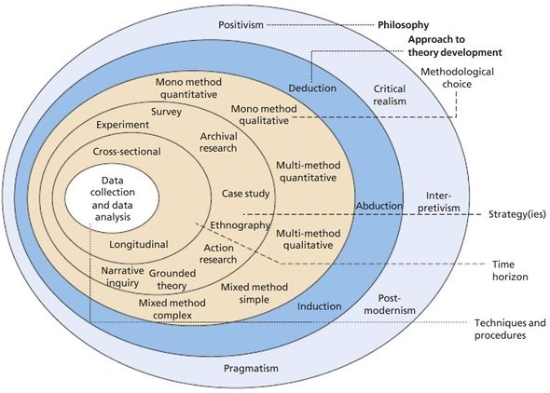
Source: Saunders, et al. (2007, p. 132)
Paradigm
This research will be utilizing a post-positivism paradigm, as if fits well for the study. Saunders, et al (2009) defines research philosophy as “the development of knowledge and the nature of knowledge”. Putting it simply, it is what every individual that conducts any form of research does, they develop their knowledge in their chosen field of research. The table below shows the different research paradigms:

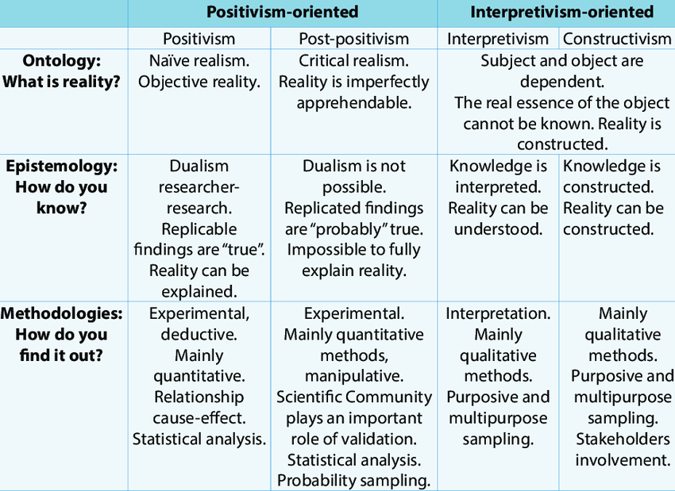

Source: Iofrida et al. (2014)

As the table above states, post- positivism balances both positivist and interpretivist approaches. Post-positivism uses perspectives of historical, comparative, philosophical, and phenomenological analysis (Fisher, 1998) as well as including quantitative analysis. Unlike positivists, post positivists believe that there are no absolute truths (Guba and Lincoln, 1994). The aim of post-positivism is not do disapprove any factors of positivism in research but rather to understanding and having a perspective on all aspects of the research, by using multiple methods and dimensions (Fischer, 1998).

Using a post- positivist approach there is a flexible research perspective will allow for the use of multiple methods to gather information and data in order to answer the research question. Using this research paradigm will decrease personal biases and prejudices throughout the research; the use of different research techniques and methods allows for a broader understanding of the subject from more than one angle (Panhwar et al., 2017)

Research Approach.
There are two main mind sets of reasoning when it comes to research and those are deductive (quantitative) and inductive (qualitative) approaches. The difference between the approaches is, with an inductive approach the research begins with a theory and collect information and data confirming the theory while deductive is the reverse, where the theory comes last as seen in the diagram below.
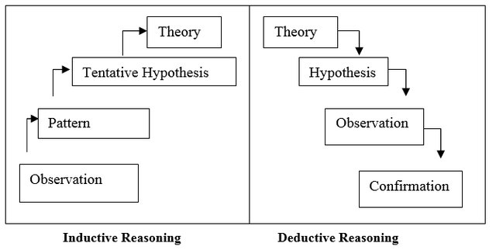

Source: Trochim and Donnelly (2006)

Creswell and Plano Clark (2007) work from the assumption that both reasonings address the same thing, they are not mutually exclusive; the same question will be addressed either way, but the methods in which the information will be collected will be different. Wilson (2006) suggests that deductive reasoning requires the research to begin with a few general ideas (premises) and then apply them to a specific area. It can visually be seen as a funnel; you begin with a broad generalisation and as the research continues the idea begins to narrow eventually forming a specific conclusion. Inductive reasoning is visually similar to a pyramid, you start with a narrow premise and throughout the research the conclusion will expand. Inductive reasoning is based on finding a conclusion that will fit into the premise, and not having a clear-cut answer, just explaining that the conclusion is the most probable one. Deductive arguments work towards proving a conclusion whereas inductive arguments are meant to predict what the conclusion will be.
Soiferman (2010) believes that quantitative researchers tend to distance themselves from the participants of the research while researchers who use a qualitative approach gravitate towards making a connection and a relationship with the participants to be able to observe and understand them better. Quantitative research often uses data and statistical analysis, drawing from logic, evidence and argument to reach a conclusion (Trochim, 2006). Qualitative researchers analyse the words the participants use trying to find common themes, this makes the researcher a key instrument within the data collection.
This research will use both inductive and deductive research approaches. Using surveys to collect data from a large number of people while also conducting interviews and analysing what each participant says, this will assist in drawing a valid conclusion.

Research Strategy
By using a combination of both inductive and deductive approaches and using post-positivism philosophy, it will increase understanding of how rural crime affects farmers, the community and the part that Dyfed Powys Police play in preventing and protecting rural communities. Mixed methods is a great way to avoid limitations when gathering all the information needed for the research, it allows for better data collection and analysis (Creswell & Poth, 2017). Combining the elements of both qualitative and quantitative research approaches allows for “the broad purposes of breadth and depth of understanding and corroboration”(Johnson et al. 2007, p. 123). It is a useful research method that expands and strengthens the conclusion of any research. Ultimately, mixed methods research will further increase the validity of the research and heighten knowledge. Using only one method means that you are more restricted while conducting research, the understanding and knowledge cultivated by using a mixed methods approach cannot be done while only use one research method (Venkatesh et al, 2013). Although a mixed methods approach will be more time consuming and require more resources than if only one method is used, the extra work will improve the research. Distributing questionnaires along with conducting interviews will help avoid bias and the data collected will assist in answering the research question from multiple angles (Creswell, 2017).

Online questionnaires will be used to gather data and information on rural crime and its effect on farmers and rural communities within Dyfed Powys. Distributing questionnaires allows for a larger sample of data to be collected and distributing the questionnaires online will aid in gathering a wider range of participants. By using social media to share the questionnaire, there will be less bias due to the fact that the collection of data will not be collected from only one location but all across Dyfed Powys policing area. Additionally, gathering data by using questionnaires is economical and makes all the data easier to manage and analyse (Bryman & Bell, 2015). Another advantage of online questionnaires compared to other forms of large sample data collecting; is the level of flexibility for both the researcher and the participant to administer and complete. Participant can complete the survey quickly on their mobile phone or laptop without taking too much time out of their day. Semi- structured interviews will be held with a small group of people who are members of Young Farmers Clubs. The participants within the focus group will be chosen by the researcher as they need to reach a criteria: are they willing to do the interview? How old are they? Where are they from? Have they or their family been victim to rural crime? A semi-structured interview will also be conducted with the Police and Crime Commissioner (PCC) of Dyfed Powys Police to gather insight into what they think about the issue of rural crime and how police are helping to protect rural communities prevent further crime. Along with the PCC, there will be another semi-structured interview with a police officer who is part of the Dyfed Powys Police rural crimes team in Pembrokeshire. Due to the current pandemic, the group discussion will be conducted using an online video conferencing service and the individual interviews will be conducted either by video conference or by telephone.

Time Horizons
For this study a cross-sectional time horizon will be applied rather than longitudinal due to the time limitations of this dissertation. Cross- sectional study looks at data that has been collected from a single point in time for a short period of time. This time horizon records the information that is present at that specific time when the research was being carried out and considers many variables all at once while also not manipulation any variables. Cross-sectional studies give the researcher a snapshot of what is currently happening; it is a great way to collect a large amount of data and information in a timely manner, it is a very inexpensive way to collect information and easier to implement (Cherry, 2019). Using this time horizon will allow the research to see the current state of rural crime and its effects on others as well as what Dyfed Powys Police are doing at this time to decrease the rate of rural crime and what they do protect communities. Additionally, it will allow the researcher to compare with rural crime rates to see if anything has changed and if the Dyfed Powys Police rural crime strategy has had any positive outcomes. It can also be a springboard for further research into the issue of crime in rural area.

Sampling
The sampling method that will be used will be non-probability sampling; individuals are selected bases on non-random criteria, only certain individuals will be chosen to be in the sample. There are four main types of non-probability sampling: convenience, voluntary response, purposive and snowball. The one that will be used in the research will be purposive. This type of sampling means that the researcher has control of who is in the sample depending on the requirements needed for the purpose of the research. This sampling method allows the researcher to gain more extensive knowledge on the chosen subject matter by having participants who have experienced rural crime and removing individuals within the sample who have never been victim to rural crime. (McCombes, 2020).
The target sample for the online questionnaires will be farmers within Dyfed Powys Police who have been targeted by criminals, and also any others who live in rural communities within the Dyfed Powys Policing area who have been victim to rural crime. To enhance the validity of the research the questionnaire will be shared online to people all over Dyfed Powys as to get data from all areas and to avoid only gathering data from one area of Dyfed Powys. In order to collect more in-depth data and information, a focus group and interviews will be held; the focus groups will be comprised of members of Young Farmers Clubs and the interviews will be conducted with an officer within the rural crime’s unit and the PCC.

Sample Size
For the online questionnaire the goal sample size would be 100 individuals who live within the Dyfed Powys policing area that have experienced rural crime in their lifetime. The minimum number of participants will be 50 participants, this number should still ensure that the results of the questionnaire are reliable. The focus group will be conducted with a minimum of 5 participant and a maximum of 10, this sample size should allow for everyone in the group to have their say about the subject and get their views across clearly. A group of between 5-10 individuals will be more manageable for the researcher, allowing the researcher to get the chance to build a rapport with the individuals that might help them feel more comfortable sharing their views.

Questionnaire Design
It is important for the research that the questionnaire is fully completed with the answers needed, and for this to happen the researcher will aim to design a questionnaire that the respondents understand and can answer confidently. The researcher will be using more conversational English for the questionnaire as opposed to academic English to avoid confusion. If the questions are too complicated or hard to understand respondents may simply give up halfway through the questionnaire (De Vaus, 2014, p. 128). To ensure that the questionnaire is easy to comprehend, a small sample of people will be asked to fill in the questionnaire and give their thoughts on it; giving ideas on how to improve the questionnaire, if some of the questions need adapting or potentially develop new questions.

The use of both open and closed questions will be included in the questionnaire, allowing the researcher to gather quantitative and qualitative data. Some questions will allow for the respondent to enter their own opinions about the subject; half of the questions will be multiple option, this allowing for the researcher to get a quicker and easier answer that will be simpler to analyse and present (Saunders, et al., 2016, p. 452). The closed questions will be used to find out, for example, if the respondernts has been victim to rural crime, and if they think rural crime rates have improved or worsened over the years. The open questions will allow for “respondents to express themsleves using their own words” (Foddy, 1993, p. 128). Open questions will be used to establish the respondents views on how police deal with rural crime and what the police can do to possibly improve their response.

Reliability and Validity
Newman & Benz (1998, pp. 32-33) believe that “validity cannot exist without reliability”, one-way other researchers can estimate the validity of the research of others is by measuring the reliability of their work. According to Creswell (2013) there are two types of errors that could affect the reliability of a study: systematic error and random error. Systematic errors area caused when something systematically compromises the measurement of the variable within the sample and random error is caused by any factors that affect the measurement of the variable randomly (Trochim, 2020). To decrease the chances of random error the sample size needs to be bigger, which is why, as stated before, the minimum sample number will be 50. High reliability is one indicator that a measurement is valid; a method cannot be valid if it is not reliable. However, having high reliability does not guarantee validity as real situations may not be accurately reflected in the research. (Middleton, 2020)

Analysis of Findings
Survey Monkey will be used to create the questionnaire and all the results will be analysed through the use of the tools on the website. When analysing the data, the results of the questionnaire will be shown through the use of graphs and tables, displaying the data like this will ensure that the finding are easily understood. The analysis of the data collected during the focus group and interviews will search for patterns or themes between each discussion. When analysing all the data the researcher much determine whether the results of the research are in line with the existing literature or is the research showing different results; then explaining what could have made this difference in results occur.

Limitations of the Study
There are a few limitations in this study. One of those limitations would be the possibility of demand characteristics; the participants of the questionnaire, focus group and interviews may answer the questions in a way they think the researcher wants and not providing truthful answers, or possibly giving answers that are false or embellished. With distributing the questionnaire online through social media sites, there may be a possibility that participants who complete the questionnaire may live outside of the Dyfed Powys Policing area, this could affect the validity of the research.

In addition, it will be difficult for the researcher to gather a sample that truly represents rural society, this is due to the fact that some farmers and members of rural communities may be harder to reach out to. For example, there are a lot of small rural farms that are being run by older generations, reaching them will be hard due to the questionnaire being online. This could leave a gap in the results, as older generations and small farms typically get targeted more the bigger farms as they are more vulnerable and hidden.

Bibliography
Beck, M. (2009). Epistemology – The true nature of knowledge: How do people really “know” what’s true and what’s false in life? Retrieved on January 25, 2010 from http://www.epistemology.suite101.com/article.cfm/epistemology
Bryman, A., & Bell, E. (2015), Business research methods. Oxford University Press, USA.

Cherry, K (2019) How Does the Cross-Sectional Research Method Work? Available at https://www.verywellmind.com/what-is-a-cross-sectional-study-2794978

Comte, A., & Congreve, R. (1891), Catechism of Positivism, Translated by R. Congreve. London: Kegan Paul.

Copi, I. M., Cohen, C., & McMahon, K. (2016), Introduction to logic, Routledge.
Creswell, J.W., & Plano Clark, V.L. (2007). Designing and conducting mixed methods research. Thousand Oaks, CA: Sage Publications
Creswell, J. W. (2013), Research design: Qualitative, quantitative, and mixed methods approaches, Sage publications.

Creswell, J. W., & Poth, C. N. (2017), Qualitative inquiry and research design: Choosing among five approaches, Sage publications.

De Vaus, D., 2014. Surveys in Social Research. 6th ed. Oxon: Routledge.

Felder, R. M., & Silverman, L. K. (1988), ‘Learning and teaching styles in engineering education’, Engineering education, 78:7, pp.674-681.

Fisher. F (1998) Beyond Empiricism: Policy Inquiry in Postpositivist Perspective. Policy Studies Journal, Vol. 26. No.1. (online) Available at https://www.cddc.vt.edu/tps/e-print/peter.pdf

Foddy, W., 1993. Constructing Questions for Interviews and Questionnaires: Theory and Practice in Social Research. Cambridge: Cambridge University Press.

Guba E.G. (1990). The alternative paradigm dialogs. In: Guba, EG (ed.), The paradigm Dialog. Sage publications, London, pp.17-27.

Guba E.G., Lincoln Y.S. (1994). Competing paradigms in qualitative research. In Denzin N.K. and Lincoln Y.S. (Eds), Handbook of qualitative research (pp.105-117). Thousand Oaks, CA: Sage.

Iofrida. N, DeLuca. A.I, Strano. A, Gulisano. G (2014) Social Life Cycle Assessment in a constructivist realism perspective: a methodological proposal. Research Gate. Available at https://www.researchgate.net/publication/268743377_Social_Life_Cycle_Assessment_in_a_constructivist_realism_perspective_a_methodological_proposal

Johnson B.R, Onwuegbuzie A.J, Turner L.A. (2007), Toward a definition of mixed methods research. Journal of Mixed Methods Research; 1:112–133. doi: 10.1177/1558689806298224.

Kamil, M. (2004). The current state of quantitative research. Reading Research Quarterly, 39, 100-107.
McCombes. S (2020) How to create a research design. Scribbr. (online) Available at https://www.scribbr.com/research-process/research-design/

McCombes. S (2020) An introduction to sampling methods. Scribbr. (online) Available at https://www.scribbr.com/methodology/sampling-methods/

Miller, R. L., & Brewer, J. D. (Eds.). (2003), The A-Z of social research: A dictionary of key social science research concepts, Sage.

Middleton, F (2020). Reliability vs validity: what’s the difference? Scribbr (online) Available at https://www.scribbr.com/methodology/reliability-vs-validity/

Newman, I. & Benz, C. R., 1998. Qualitative-quantitative Research Methodology: Exploring the Interactive Continuum. Illinois: SIU Press.

Panhwar. A.H, Ansari. S, Shah. A.A (2017) Post-Positivism: An Effective Paradigm for Social and Educational Research. Academic Journal Article: International Research Journal of Arts and Humanities. (online) Available on https://www.questia.com/library/journal/1P4-2044301228/post-positivism-an-effective-paradigm-for-social

Patton, M.Q. (2002) Qualitative Research and Evaluation Methods (3rd edn), Thousand Oaks, CA, Sage.

Saunders, M. N. (2016), Research methods for business students, 7/e, Pearson Education India.

Saunders, M., Lewis, P. & Thornhill, A., 2016. Research Methods for Business Students. 7th ed. Essex: Pearson Education Limited.

Saunders, M., Lewis, P., & Thornhill, A. (2009), Research Methods for Business Students 5/e, Pearson Education.

Schoonenboom J, Johnson R.B (2017) How to Construct a Mixed Methods Research Design. Kolner Z Soz Sozpsychol ;69(Suppl 2):107–131. doi: 10.1007/s11577-017-0454-1. (online) Available on https://www.ncbi.nlm.nih.gov/pmc/articles/PMC5602001/

Soiferman. L (2010) Compare and Contrast Inductive and Deductive Research Approaches. University of Manitoba. (online) Available on https://files.eric.ed.gov/fulltext/ED542066.pdf

Sekaran, U., & Bougie, R. (2016). Research methods for business: A skill building approach. John Wiley & Sons.
Trochim, W.M.K. (2006). Research methods knowledge base. (online) Available on https://conjointly.com/kb/
Trochim, W.M. K (2020) Measurement Error. Research Methods Knowledge Base. (online) Available at https://conjointly.com/kb/measurement-error/
Trochim, W. M. K. & Donnelly, J. P. (2006), Research Methods Knowledge Base. Cincinnati, OH: Atomic Dog Publishers
Venkatesh, V., Brown, S. A., & Bala, H. (2013). Bridging the qualitative-quantitative divide: Guidelines for conducting mixed methods research in information systems. MIS quarterly, 37(1).
Walliman, N. (2015). Social research methods: The essentials. Sage.
Wilson. R (2016) Deductive and Inductive Reasoning. (online) Available on https://www.mscc.edu/documents/writingcenter/Deductive-and-Inductive-Reasoning.pdf
Zeller, R. A. & Carmines, E. G., 1979. Reliability and Validity Assessment. London: SAGE Publications.

