I confirm that I have not used any AI tools in the research and creation of this assignment. I confirm that I have not presented any AI generated materials as my own work. I confirm I have copies of my drafts, notes, and other resources I used, which I may be asked to provide in evidence.

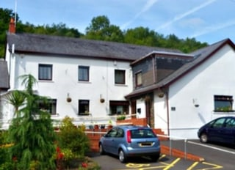

Work Placement Portfolio. Further Counselling Skills
16/01/2025



Jessica Morgan
Psychology and Counselling
2024-2025

Table of Contents

Table of Contents 3
Element one: Reflective commentary 4
References 7
Element Two: training completed on placement 8
Element Three: work completed whilst on placement 12
ELEMENT FOUR: Supervision process 14
Appendicies 16
Appendix A 16
Appendix B 17
Appendix C 18
Appendix D 20
Appendix E 21

Element one: Reflective commentary
I have had time to reflect on my overall experience whilst being on placement at Ty Camlas. There are many new things that I have come to learn as well as experience. To help me reflect I have been using the Gibbs Reflective Cycle. (GRC). The Gibbs Reflective cycle was developed by Graham Gibbs in 1988. It’s cyclical in its design, helping to learn from repeated experiences, hence a great model to use when working in mental health. I have learned a lot about the rules and regulations that support workers must abide by when working with vulnerable adults. I have learned about the different rights individuals have whilst they are living in a residential setting. I have gained an understanding of the Mental Capacity Act (MCA) and how it supports vulnerable individuals. It gives the individuals the right to make decisions about their care and treatment. Just because someone is suffering from ill mental health, it does not mean that they have no capacity. (NHS, 2024). There are many new experiences I have had whilst being in the organization, one example would be the time that I had to sit in on a psychiatric meeting. I had never been able to experience this type of interaction before as I would rarely meet the psychiatrist. The client was there at the meeting as there had been some conversations between the client and the social worker that had concerned both parties. I was not sure of how the meeting would be set up and I was not sure of what topics would be brought to light. I came to learn that this can sometimes be a heated meeting between the client, the social worker, and the psychiatrist. I found this uncomfortable at times as I knew that what the client was saying was untrue, but I was only there in support of the client and not there to speak on his behalf. It was interesting to witness how the psychiatrist used different distraction techniques to diffuse heated situations. Whilst on placement there are skills that I feel I’ve had to learn whilst working. Negotiation skills are one. Every day is different in this placement and every client has a different personality. The use of negative wording is discouraged, so instead of using the word NO, negotiation skills were paramount, it gave the client a choice, even though the task is something that they did not want to do. This meant that the uncomfortable task was being completed and there was no conflict between myself and the client. This is very much a person-centered approach used every day. The personal centered model is a humanistic approach that Carl Rogers founded in the 1940’s. It is about giving the person the right conditions so that they can reach their full potential. (British Association for Counselling & Psychotherapy, 2025). Problem solving is another important skill. Supporting individuals with different personalities can sometimes be challenging as not everyone will want to go with the flow and not all the individuals can work cooperatively. Problem solving skills could be deciding who is going to use the home car first without causing conflict, negotiation skills also come into this as being able to negotiate with the client on how best to use their time. During this placement I kept an open mind as I was not sure of what could happen on any given day. The incident that surprised me the most was how even though we are there to support and protect them, if they have the status of being informal, which 90% of the adults do, they can still put themselves in questionable situations and there is nothing that the staff can do but just “encourage” them, for example some of the mediations that the clients take are given warnings such as do not drink alcohol and take the medication. As the client is informal there is nothing that we can do to stop them from consuming alcohol, even though we know the consequences of this. This links back to the Mental Capacity Act as well as Carl Rogers and the person-centered model. Within the person-centered model, there is something called unconditional positive regard (UPR). This is accepting and valuing the client for who they are. (British Association for Counselling & Psychotherapy, 2025) Empathy also links into working with individuals with ill mental health. Sometimes the choices that they make can seem erratic or unwise and this is where empathy is important as you must try and see the word from their viewpoint. They have the right to make unwise decisions. In contrast there were many rewarding situations during my placement. I was chosen to go with someone on their birthday. The client enjoys horse racing, so the client and I were able to go to a ‘ladies' day’ at the races. This not only reflected the fact that the manager trusted me to be responsible for such a task, but that the client I was with felt comfortable enough to spend her time with me. It gave me great satisfaction that I made it possible for the client to enjoy something that they may not have been able to enjoy or plan on their own. There were problems I faced whilst on my placement. There was the issue of drivers on shift and the number of medications trained people. On this shift I was both the only driver insured and the only person who was signed off to give medications. This meant I could not leave the home as the staff who remained could not give out medications, but there was a client on home leave who needed medication. I had to ring the on-call manager to ask for further assistance as I did not have the credentials to book outside agency workers. Whilst she asked her staff members if anyone could work some overtime, I had to ask off duty members of staff from my home if they could spare any of their time, whilst trying to resolve this issue I also had to support any clients that had come down from their rooms. Eventually someone contacted me, who worked at my placement and was able to come in so that I could leave and drive medications to the other client. Overall, there were many emotions that I experienced while on placement. Fear, happiness, gratitude, self-worth. With this kind of placement, self-reflection is key as you need to be able to feel and learn from your experiences and then move on.

References
British Association for Counselling & Psychotherapy. (2025). What is person-centered counselling? BACP. https://www.bacp.co.uk
NHS. (2024, January 17). Mental Capacity Act – Social care and support guide. NHS. https://www.nhs.uk
University of Edinburgh. (2024, October 15). Gibbs’s reflective cycle. Reflection Toolkit. Retrieved January 16, 2025, from https://reflection.ed.ac.uk/reflectors-toolkit/reflecting-on-experience/gibbs-reflective-cycle

Element Two: training completed on placement

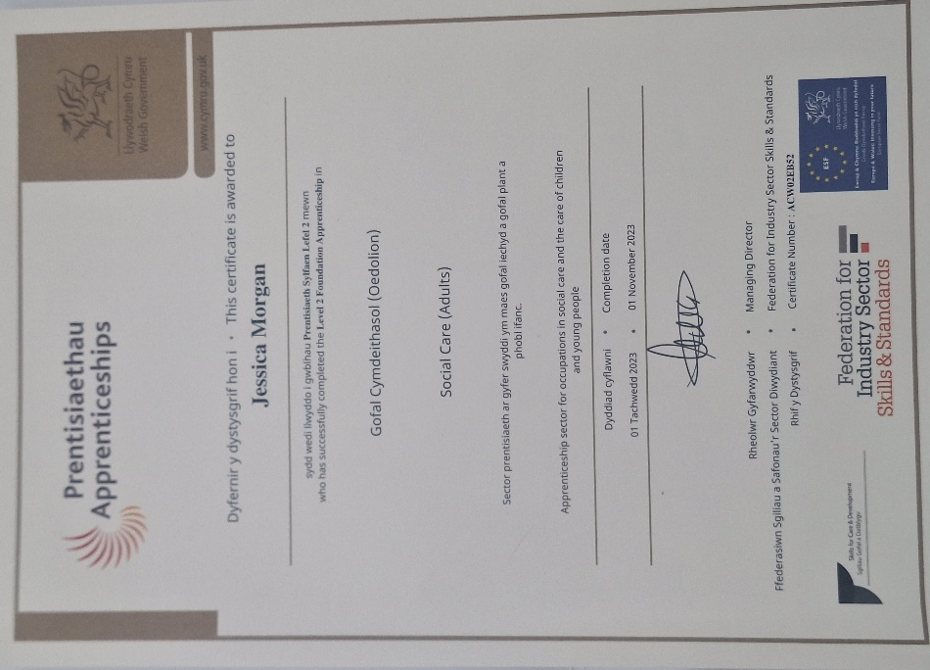
This is the Level 2 Foundation Apprenticeship in Health and Social Care Core Adults that I was able to gain whilst working in Ty Camlas. For part of this qualification, I had to use A reflective cycle, the cycle used was Gibbs Reflective Cycle. This helped me to reflect not only on my coursework but skills I used whilst working.

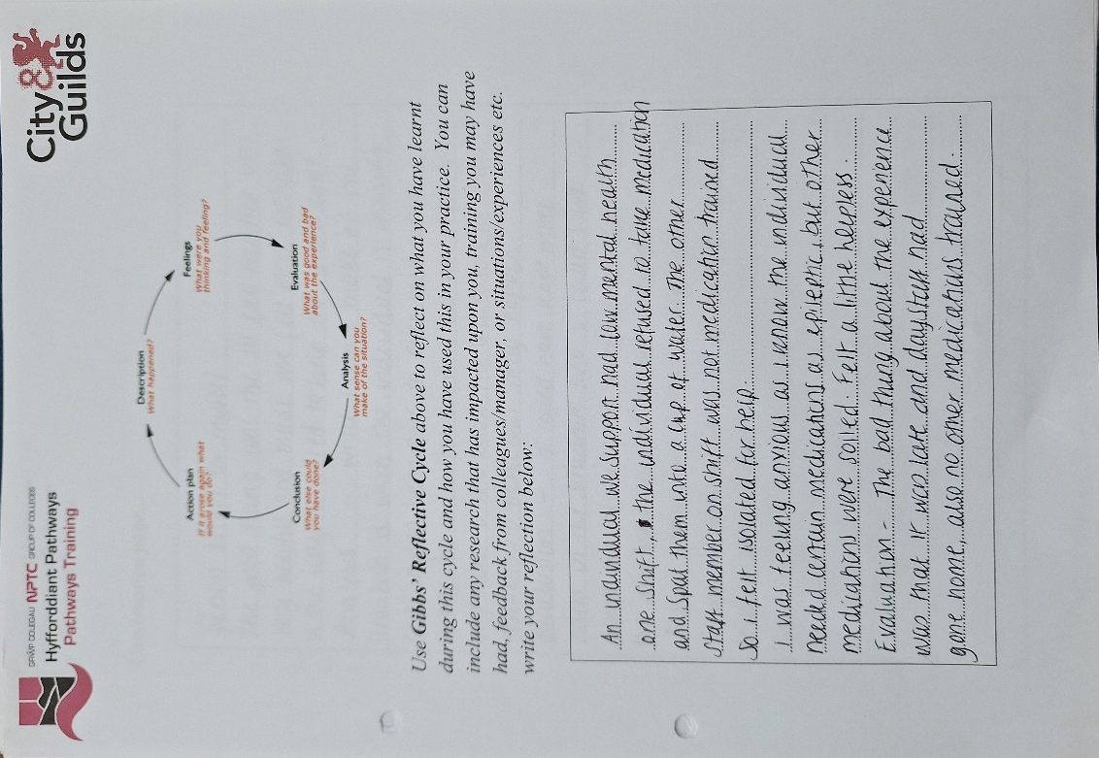

This is the Gibbs reflective Cycle that I used while in Ty Camlas and working towards by Level 2 apprenticeship. This is one of many reflections that I had to complete for my assessor. The Gibbs Reflective Cycle is the one that I chose to stick with through the module.

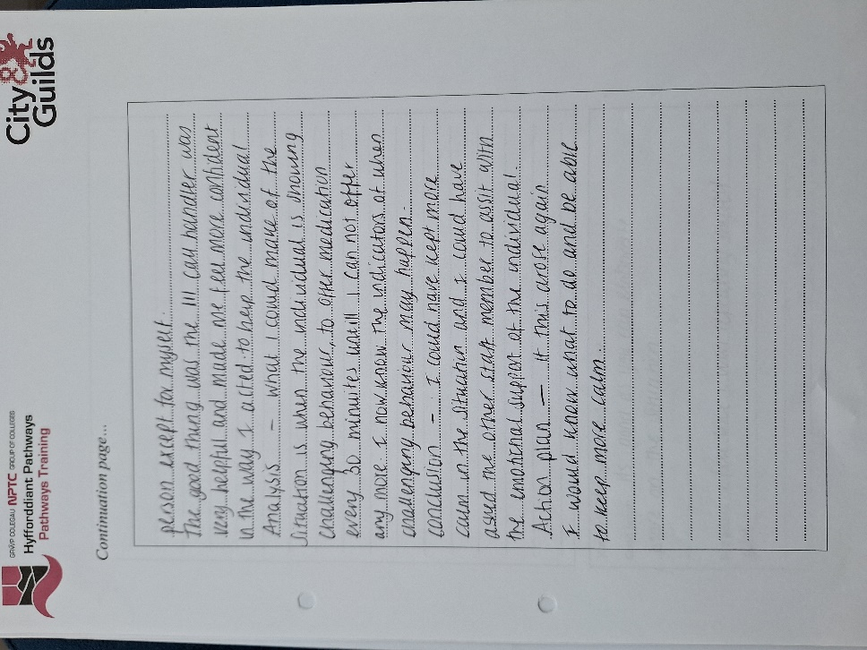

This is more of the reflective cycle going through the six different stages reflecting on what I could have done differently in the situation and writing what I felt I had learned from the situation.

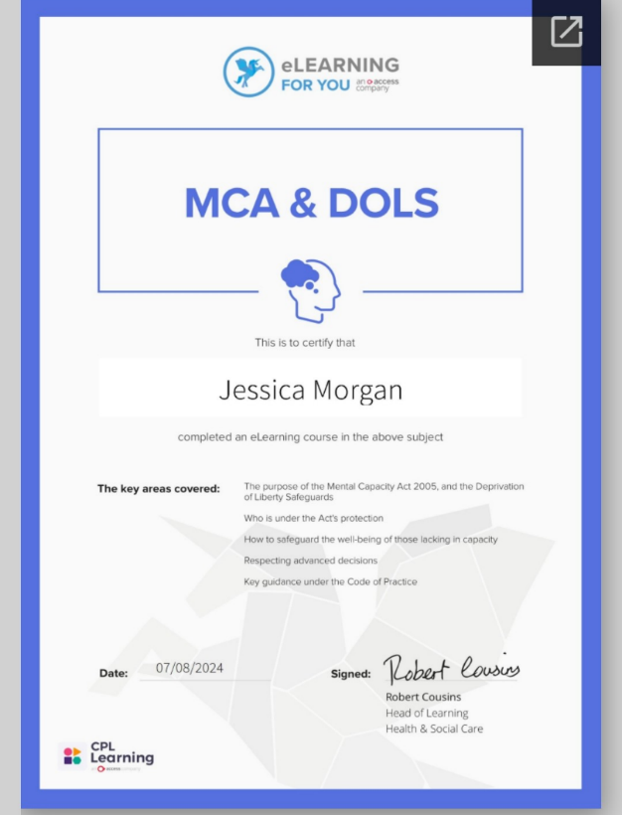

This is the MCA and DOLS certificate gained through the online training portal. This was a course on the MCA (Mental Capacity Act) and DOLS (Deprivation of Liberty). This taught me about the Mental Capacity Act, how it works to protect vulnerable adults and how it is used within the workplace. This is an important course, and this can apply to many other jobs working within mental health such as counselling skills. Completing this course helped me to gain a deeper understanding of how we can protect others without taking away their freedoms and choices.

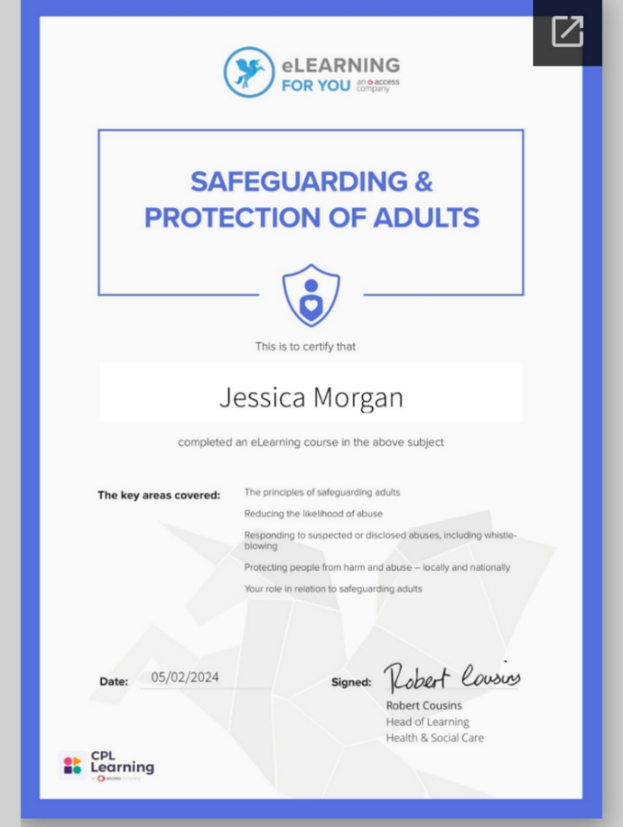
This is a certificate for Safeguarding and Protection of Adults. This was also gained through my training portal online. This course has helped me to recognize the signs and symptoms of harm, even though the individual may have not told me this. It helped me to understand how to support the client if there is a risk and how to share information with those who would be a part of the safeguarding processes. This course being paramount to counselling.

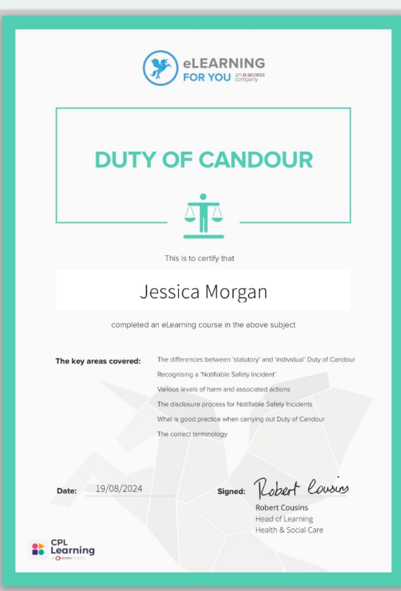

Another certificate gained here is Duty of Candour. I learned the difference between Statutory and individual duty of candour. I learned that within the health care sector, we must be open and honest with clients and their families if something is to go wrong. They have a right to an explanation. This is also important in counselling as rapport between client and counsellor should be one of trust and respect.

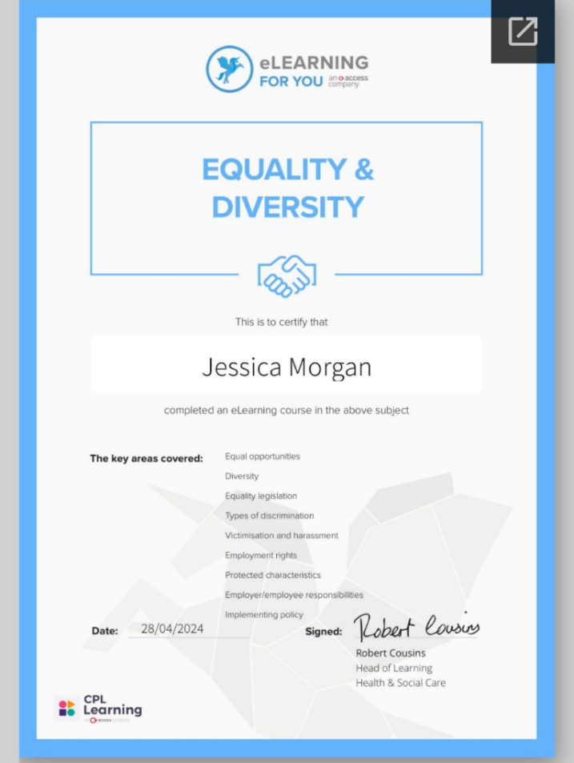
Equality and diversity is another important and interesting course. There are numerous clients from diverse cultures and backgrounds so being able to provide personal centered care is part of the responsibility. Everyone receiving care or support should be given equal opportunities regardless of their background, abilities or lifestyle. This helped me to understand different beliefs that I may have not come across previously.

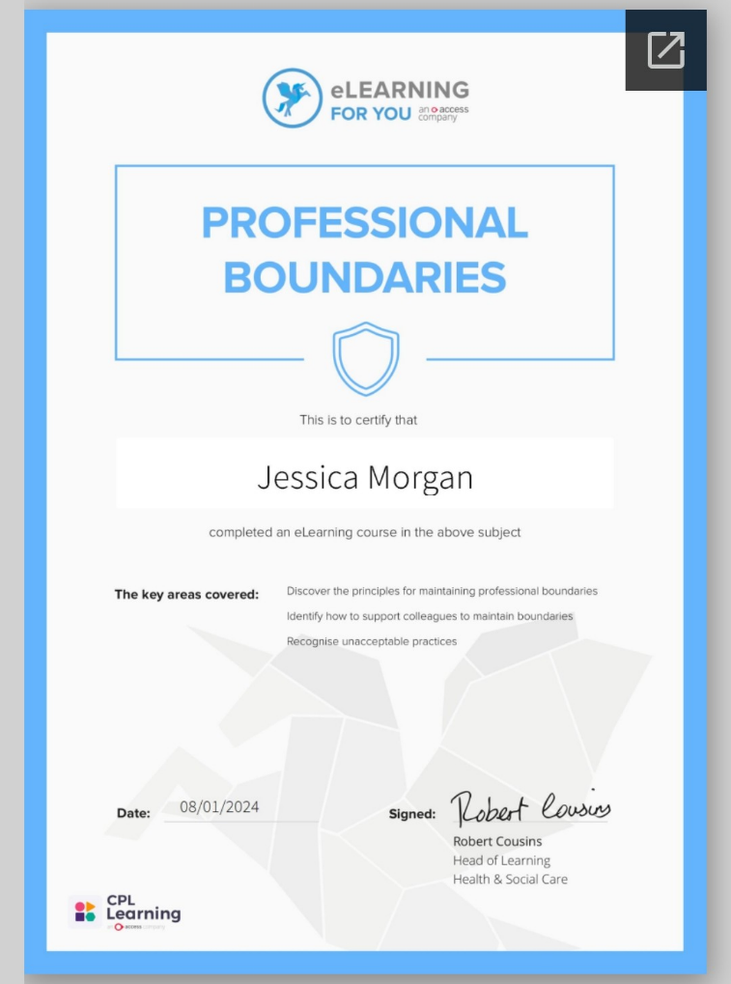

Professional Boundaries was another online learning course, not only is this important in residential care, but in all professions where a relationship is formed, such as the relationship between a counsellor and a client. It protects both the client and the counsellor from harm and protects both physical and emotional health.

Element Three: work completed whilst on placement
Below are some examples of the paperwork completed whilst on work placement. Some of the documents are on general health and safety such as fire alarm checks, tumble dryer lint checks. The other documentation is a legal requirement to fill out when administering medications, failure to complete the documentation could result in disciplinary action or dismissal.
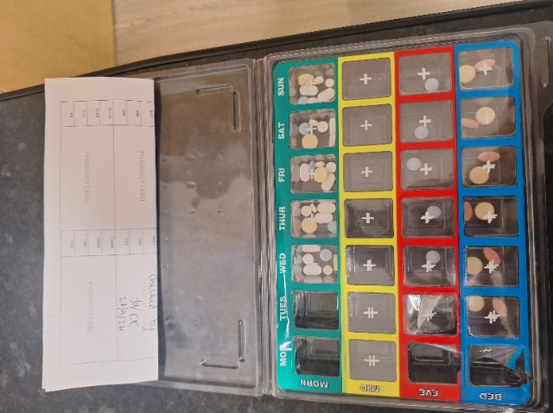

This is a dosset box. Each client has their own with their specific medications. Each has 1 weeks’ worth of medications. The different colours indicate the different times of administration.
.

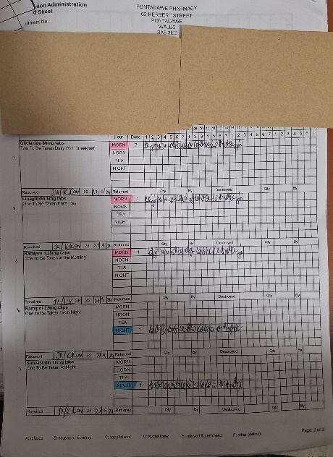
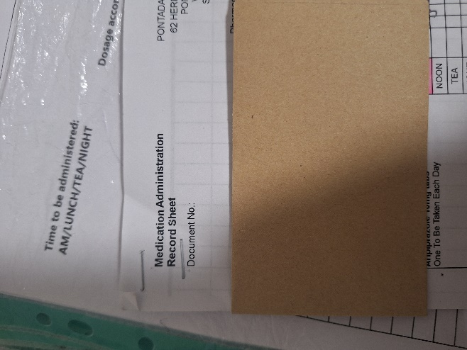
This along with the image on the right is a Medication Administration Record or MAR chart for short. Each client has their own identifying them and any allergies they may have. The medication is listed, along with the time of administration. If the MAR is filled in incorrectly then this can lead to disciplinary actions.

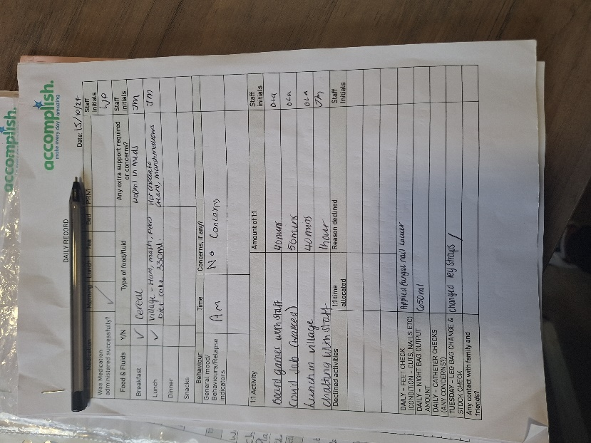

This is a daily record that I completed every day whilst working in Ty Camlas. Every client has one that is tailored to suit their needs. The one shown has a food and fluid chart and another for information about feet checks and catheter checks. This Is showing person centred working as not everyone has the same needs, so every diary is suited to the individual needs.

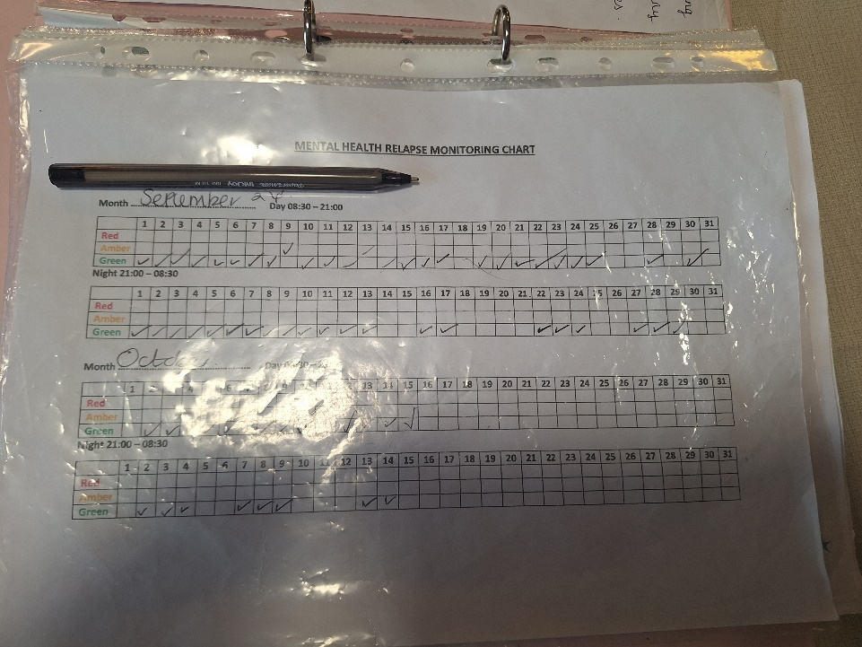
To the right a mental health relapse monitoring chart is shown (MHRMT). This completed every day and night, and it gives other staff members who may be starting shifts at a different time an idea on how the individual is doing. Red is off baseline mental health. Green is good mental health, and amber is when the clients have needed some extra support throughout the day. Everyone has different indicators in their own file outlining the stages. Knowing when a client is becoming off baseline is particularly important as this avoids them having a crisis. This is where de-escalation skills and diverting the persons thoughts are especially important.

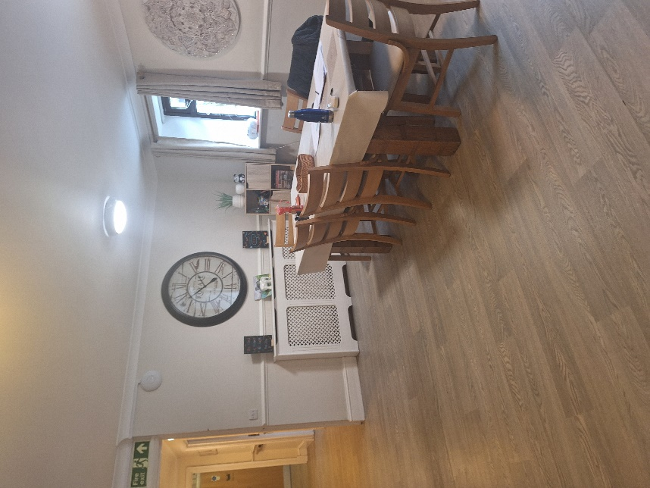
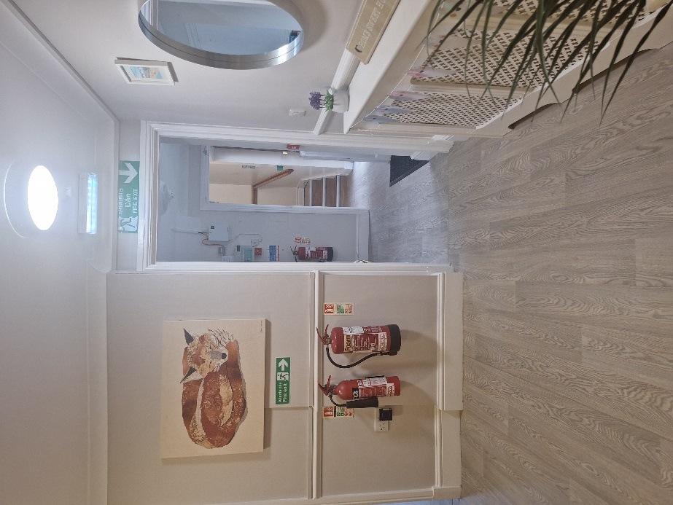

ELEMENT FOUR: Supervision process
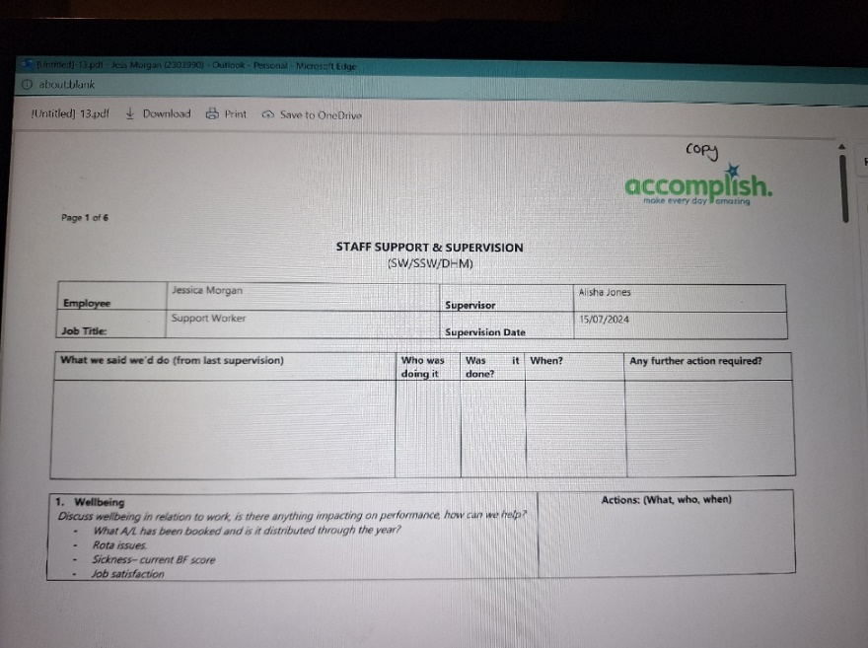
This is a supervision that I had with the deputy manager at the time. A manager, deputy or senior can carry out supervisions. They are conducted every three months after you have successfully completed your six-month probation period.

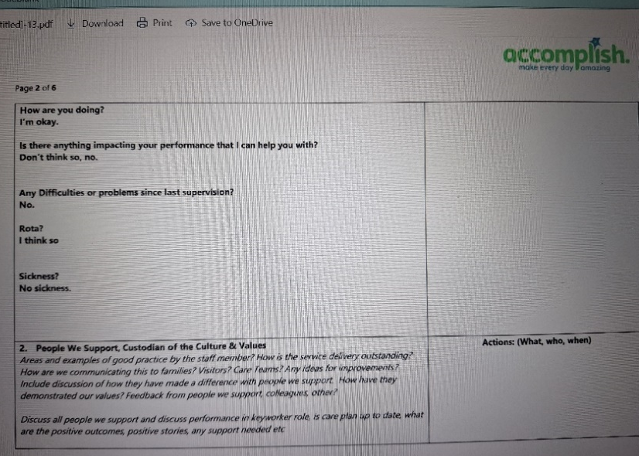
This is a very brief question and answer as I was only working there for one day a week, so I was not experiencing as much as my other colleagues who were working full time. A supervision is the opportunity to ask any questions or relay anything to the management that may be of concern. I could not comment on the key worker role as this is something I cannot complete working one shift a week.

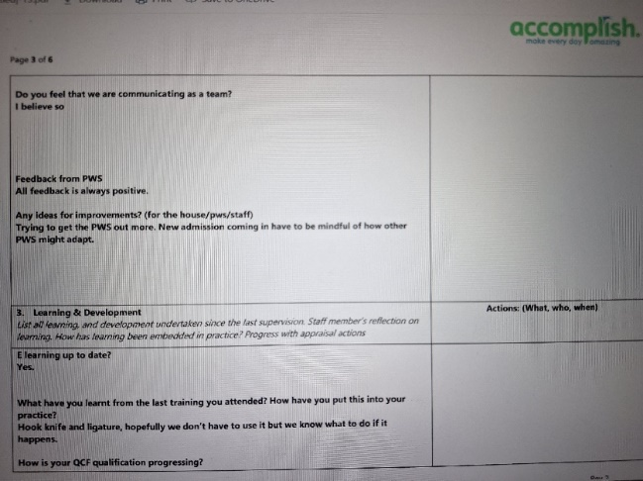
This is where any feedback from the people supported is given whether that is helpful feedback or bad feedback this is the time where it will be discussed. This helps me to understand my strengths and weaknesses and helps me to understand how to better support individuals in their own care.
In this last page of the supervision, it is shown how a misunderstanding was corrected earlier that day. It shows how communication skills are useful not only between the people being supported but within the staff team. Communication is especially important as if there is information miss construed on shift it can cause errors and sometimes tensions. From this supervision I learned that the way in which information is presented can often be miss translated so it is important to be clear and concise in what you say.

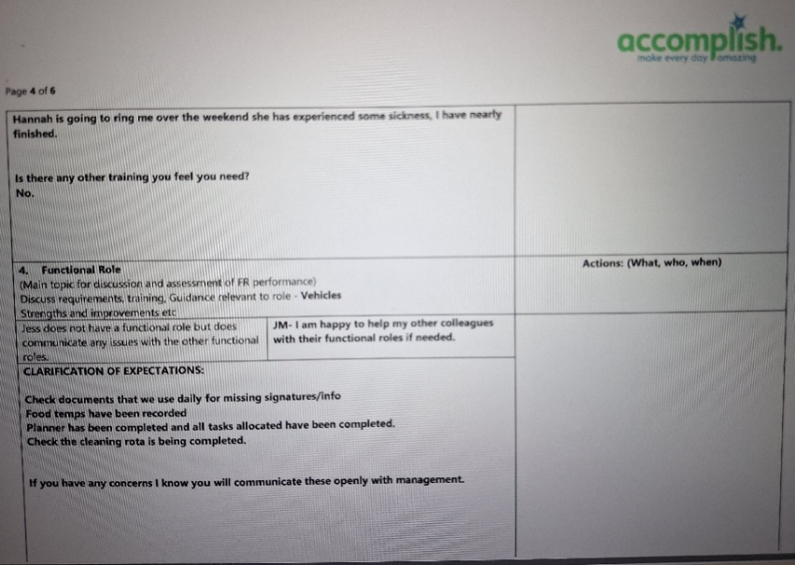

Here she is asking if I need any more training. If I was struggling, then I could reflect and ask if I could be given more opportunities to learn.

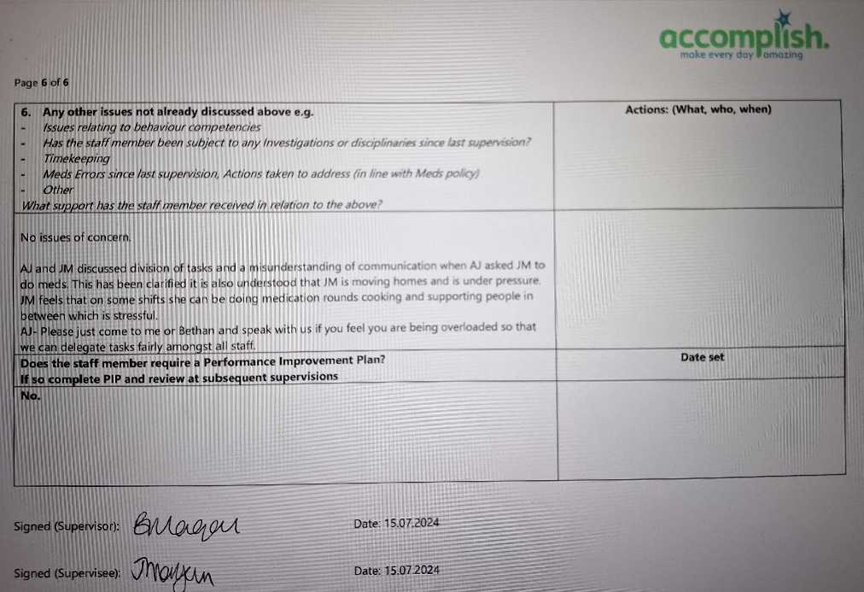

Appendicies

Appendix A
Initial email sent to the manager of the placement
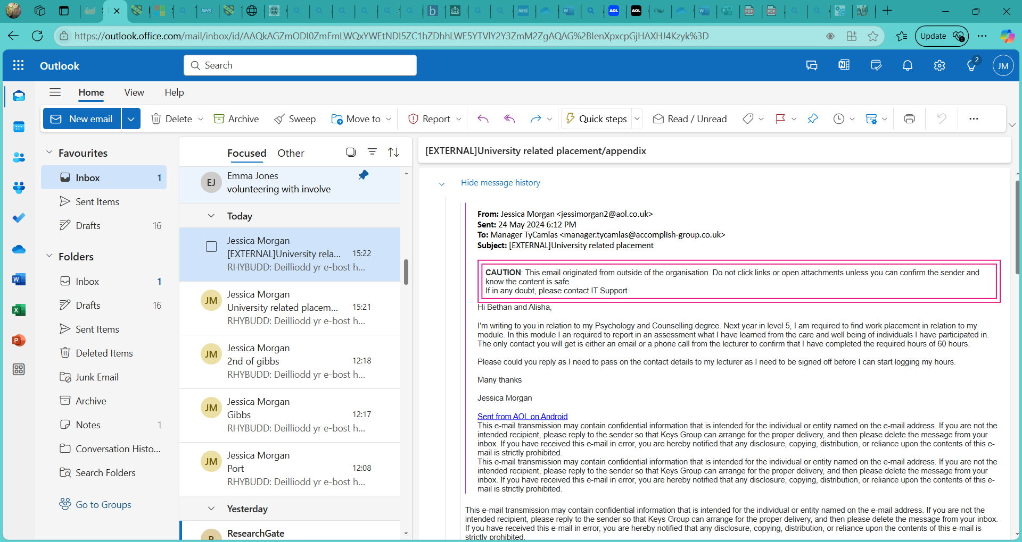

Appendix B
An email sent from the home manager stating that the regional manager has given permission for the placement.
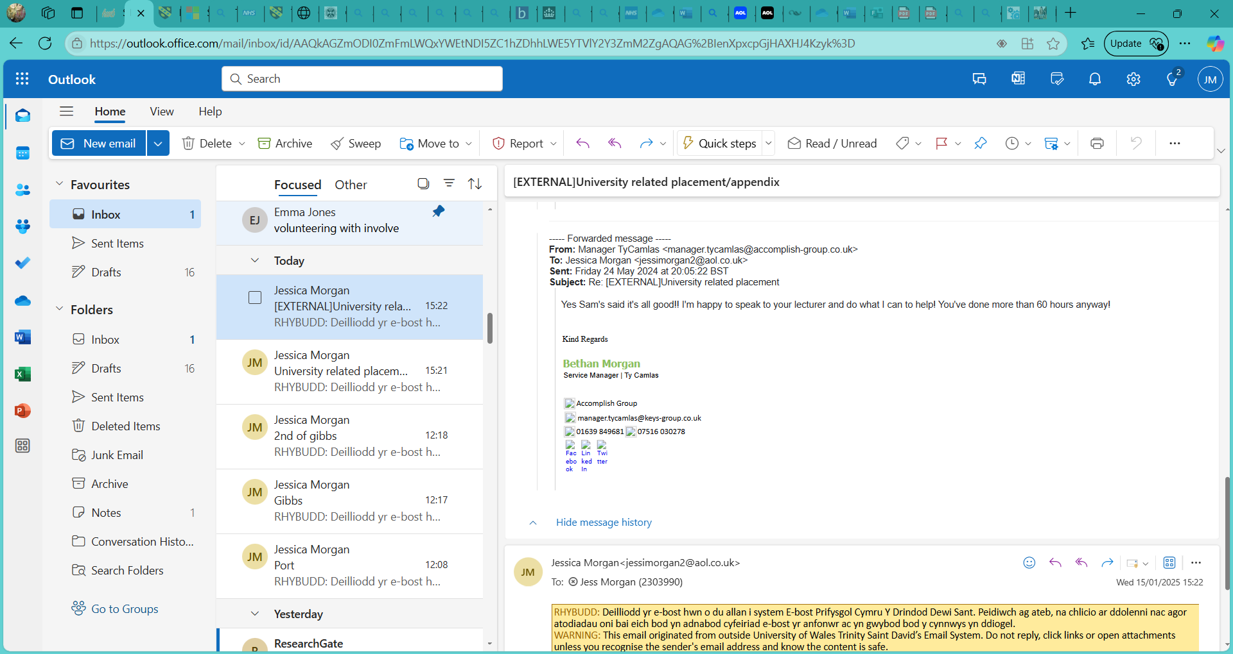

Appendix C
Placement information form

Placement Information Form
Name of student: | Jessica Morgan
Proposed placement setting and address: | Adult mental health support worker.  6 Llys Tawel  Ystradgynlais  Swansea  SA9 1BL
Proposed dates of placement: | 3rd of June - 29th of June 2024.
Name and position of contact: | Bethan Morgan  Home manager
Email address: | Manager.tycamlas@keys-group.co.uk
Telephone number: | 01639 849681 (main)  07516 030278 (manager)
Is a DBS required for you to attend this placement: | - Yes✔️  - No  If yes, have you applied for this?  - ✔️Yes applied on ____gained on 1.5.2024. Can provide dbs number if required ____________  - No
Explain how your role in this organisation/on this placement meets the criteria for the assessment for the module  (e.g., what duties/tasks will you be undertaking that are relevant for the module assessment) | Within this role I will be responsible for the safety and care of individuals who live within the home. I will be involved in the day-to-day tasks with the individuals such as attending hospital appointments, shopping, personal care, administering medications and preparing food or helping individuals to make meals.  I will be expected to complete individuals care plans for the day and to ensure that they have attended appointments and monitor mental health. If there are any altercations between adults who live in the home, then I will be responsible for using low arousal techniques to diffuse the situation.

Appendix D
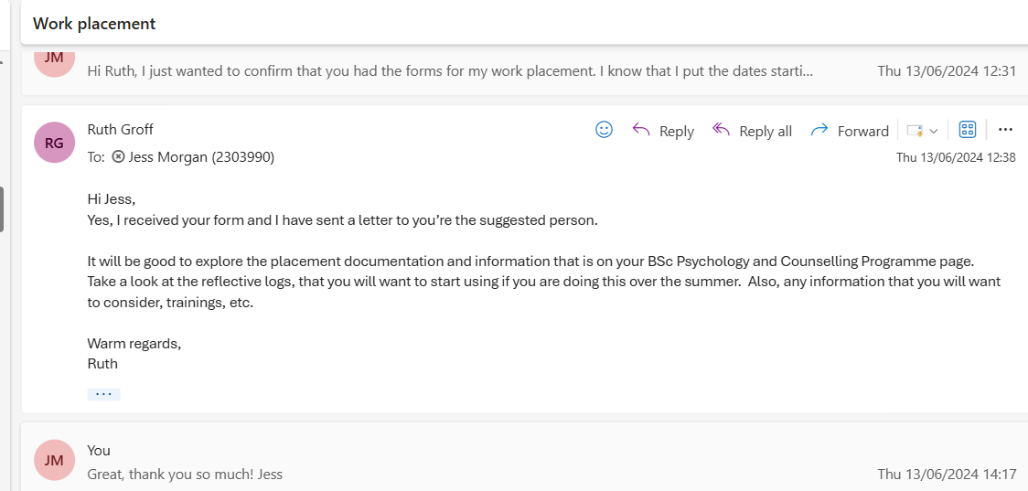
Email received from module lead giving approval for the placement

Appendix E
Student logbook with the logged hours and tasks carried out that day

Student Work Placement Logbook

Logbook
Student Name: | Jessica Morgan
Name of Host Employer: | Accomplish Ty Camlas

Record of project work carried out (add more entries as needed)
Date: | 10-6-2024 8am-9pm
Tasks completed: | - Accompanied client to a psychiatrist meeting  - Driving client home, after meeting
Reflection: | I had to accompany a client to a meeting with himself, the psychiatrist and his social worker. I had no idea what to expect as I had never done this kind of meeting before or been in a meeting within a mental health facility. The meeting was called as the client had been messaging and calling his social worker about things that had not happened. The client is diagnosed as schizophrenic and has drug-induced psychosis, so this was of concern to the social worker. The meeting was held in the community mental health team, based within the hospital. The meeting started off as usual, but it did get very tense very quickly as the client was being questioned in his conversations and became very angry. At this time, I was just sitting in the meeting room as I wasn’t sure if I was meant to contribute or just to sit there and listen. I could see from the way that the psychiatrist diffused the situation and asked the client did he wanted a cup of tea. This way he could leave the room and diffuse any arguments. When he came back into the room the atmosphere quickly changed, and the client and the Dr were able to talk about what had been said to the social worker and talked about how easily a delusional thought can appear as a reality. At the end of the meeting everyone left happy and there were no bad feelings. I then had to drive an hour to take the client to his home, so I had to be careful with what we talked about in order not to provoke any anger or frustration whilst in the car. It was an uncomfortable experience, but it was a very important one.

Date: | 17-6-2024 8am-9pm
Tasks completed: | - Settling in a new client into the home who doesn’t speak much English.  - Getting to know how to use the translation app that the client uses to communicate.  - Making sure that the new client did not bring alcohol into the services, knowing the protocol when alcohol was brought into the services.
Reflection: | I knew the protocols of when a new client moves into the home but this time it was different as the client moving in didn’t speak much English and was totally unfamiliar with the area. The client had a tablet that he uses to be able to translate Bulgarian to English but didn’t always carry this around. This was difficult as when he was trying to ask questions, we couldn’t understand what he was asking. We then asked permission if we could download an app to our own personal phones as this appeared to be quicker and more efficient. I quickly learned that I couldn’t appear shy, and I had to remind him that he needed to be more proactive in using his tablet to communicate. There is no alcohol policy in the service, so I had to be confident in knowing the protocols when this happened. If he brings alcohol into the service then we are allowed to ask him to remove this as the home is alcohol free, there is also a policy on alcohol so as staff we must follow this rule. As the client does have some alcohol dependence then we as staff can support him to go to the pub and support him to consume alcohol responsibly.

Date: | 24.06.2024 8am-9pm
Tasks completed: | - Navigating emotions when giving medications to a client off baseline.  - Recording medications refusals and navigating the emotions after the event.
Reflection: | The client in question is allowed to keep pets whilst living in the service. She initially moved in with one rabbit but was allowed to purchase another one. She has been advised that she needs to keep both rabbits’ cages clean, and it is not the responsibility of the staff to look after her rabbits when she goes to visit her family in London. She had left to go to London and not clean the cages. When she returned home, she got annoyed with the male rabbit and she had moved the cage onto the landing and kept the other residents awake with the noise and the smell. I was on medication rounds this shift and the client is second on my round. My senior had already been to her room before me to remind her about the rabbit on the shared landing area. When I was there to give medications, she had already been woken and was not in the best mood. Unknowingly I had also spoken to her about the rabbit making the situation worse. She did get aggressive and was swearing and shouting at me, I said if you can take the medication then I can leave. This made her then throw her medications at me and her cup of water. When medications are refused there are policies in place, one of these is to collect the medications and keep them separate within the medications room. As the client was already off baseline, I couldn’t do this, I left the room and told the manager what had happened. I had to document what had happened on the medication administration record of the person as if I had not done this then I could face some serious implications and receive disciplinary action.

Date: | 26.06.2024 8am-9pm
Tasks completed: | - Problem solving skills used when managing the time of the use of the company car.  - Negotiating and thinking on my feet when trying to avoid conflict between the clients in the home.  - Learnt about Deprivation of Liberty (DOLS) and how it works to protect individuals.  - Communication skills between clients.
Reflection: | I knew that the midweek shifts are slightly busier than the shifts at the weekend as the clients living in the home attend hospital appointments and other appointments such as going to the hairdressers or going food shopping. After looking at the daily planner for the day it was noted that there was a hospital appointment and there was also a note that someone wanted to go shopping down in Morfa in Swansea. The times of the appointment and the times of the shopping trip clashed so another plan had to be made. The hospital appointment couldn’t be moved so it was my job to go and speak to the lady who wanted to go shopping and make her aware of the issue. It was suggested that she could catch the bus, but she didn’t want to do this. I explained to her that hospital appointments are important, and they cannot be cancelled so we could still go shopping later. I was the only driver on that shift, so I was the only person allowed to drive the company car. This client is also under a DOLS, which means deprivation of liberty, this essentially means that she cannot go out alone as she is unsafe to do so. If I were to take the two clients out together and the female was to abscond, I would have to leave the male going to the hospital appointment, so it was unwise to take the two clients together at the same time. I explained that the shops closed later in Morfa and that she could still do what she needed but just later in the day. There was a lot of conversation about the use of the home car and a lot of negotiating as I didn’t want to upset the client as she enjoys days out. We managed to come to the agreement that I would take her as soon as I got back from the shopping trip.

Date: | 29.06.2024 8am-9pm
Tasks completed: | - Problem solving skills used when managing the time of the use of the company car.  - Communicating with the out-of-hours manager  - Being confident in asking other colleagues to come to work  - Communication skills between clients.  - Communication between agency staff and the agency company.
Reflection: | I had picked up an overtime shift on Saturday as they were staff short that week. I was the only driver on plus I was the only medications trained staff working. This wasn’t an issue until it was noted that there was a client on home leave who needed medications twice that day, however the client was on home leave in Brecon, this is about an hour drive there and an hour drive back to the placement. I was the only trained medication staff working so I couldn’t leave home to drive to Brecon as the staff member I would be leaving on shift was unable to give out medications. The manager doesn’t work at weekends, so we had to ring the manager on call to ask for further advice. There was a lot of calling other people’s homes and asking for extra cover but at the weekends this proves difficult. When we got through to the on-call manager she said that she would book an agency worker from her laptop as we do not have access to the credentials. There appeared to be no reply from any agency workers so I and the other staff members had to message other colleagues to ask if they could cover the time I was driving, so this would have been two hours in the afternoon and two hours in the evening. This was all happening during the medication round and making the evening meal so there was a lot of multi-tasking and answering the phone in between. A colleague eventually offered to come in and cover, so I was able to make the journey to and from Brecon.

