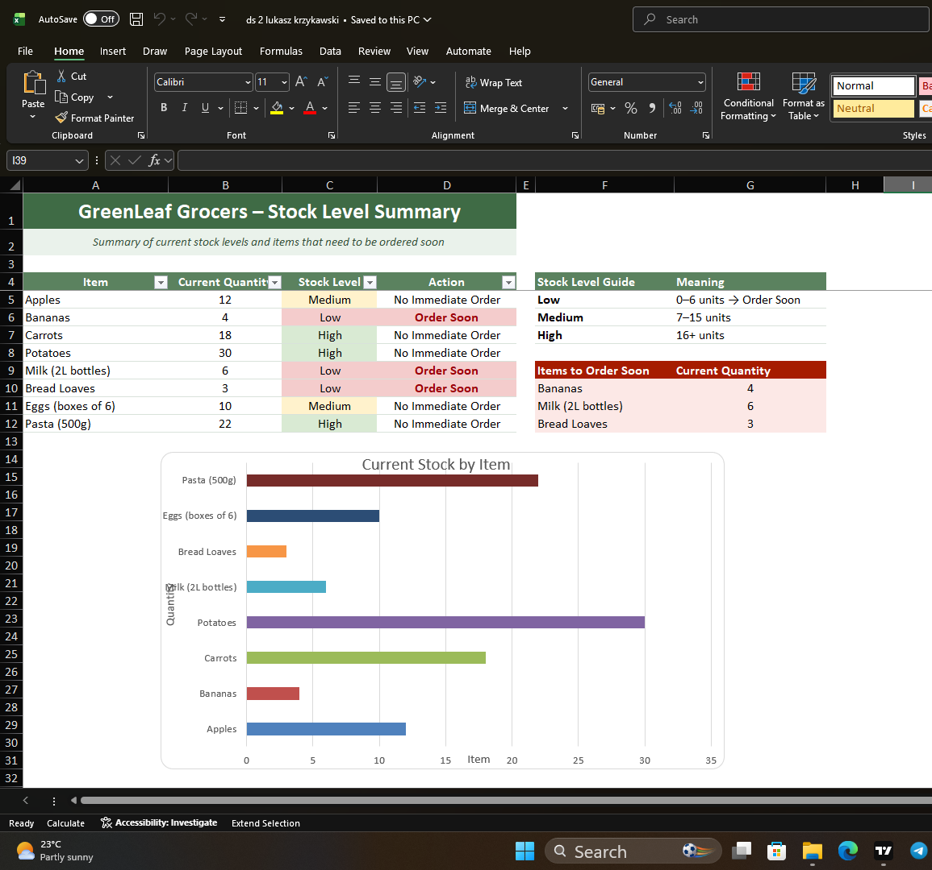
  - DS 2 SCENARIO 1: GreenLeaf Grocers

1. Why I chose my tool
I chose Microsoft Excel because it is good for organising numbers, tables and charts. Many businesses use Excel to manage stock and other business information. I think it was the best tool for this task because it is simple and easy to use.
Excel helped me organise the stock information clearly. I could use tables, colours and a chart to make the information easier to read. This makes it easier for the shop manager to understand the stock levels.
I also looked at Microsoft Support to learn more about conditional formatting. It explained how colours can help highlight important information. I also used the UWTSD Digital Skills Bitesize materials because they explained how to present business information clearly.

2. What information I used
I used the information from the GreenLeaf Grocers scenario.
The information included:
- Product names.
- Current stock quantity.
- Eight different products.
I entered all of the information into an Excel table. I then added two new columns called Stock Level and Action.
I did not change the original stock numbers because I wanted my spreadsheet to match the scenario.

3. How I created my artefact
- First, I entered all of the stock information into an Excel table.
- Then I added a Stock Level column to show if the stock was low, medium or high.
- Next, I added an Action column to show if a product should be ordered soon or if no action was needed.
- After that, I used conditional formatting. I coloured low stock red, medium stock yellow and high stock green.
- Then I created a simple bar chart to compare all of the products.
- I looked at the Microsoft Support page about charts to make sure I used a suitable chart for my spreadsheet.
- Finally, I checked all the numbers again to make sure everything was correct and easy to understand.

4. What changes I made
- At first, my spreadsheet only showed the product names and quantities. I added the Stock Level column to make the information clearer.
- I added the Action column because it tells the manager which products should be ordered soon.
- I used colours because they make low stock easier to see.
- I added a bar chart because it is easier to compare products with a chart than with only numbers.
- I changed the headings to bold so they were easier to read.
- I checked the layout and made sure everything was organised neatly.
These changes made the spreadsheet clearer and easier to use.

5. Feedback I used
Before I finished my work, I checked the spreadsheet again.
I noticed that the headings could be clearer, so I made them bold.
I also changed the chart title so it explained the information better.
Finally, I checked that the colours were used in the same way throughout the spreadsheet. This made the final version look more organised and easier to understand.

6. Final explanation
This task helped me understand how Excel can be used in a business. I learned how to organise information, create a simple table and use colours to make important information easier to see.
After looking at my spreadsheet, I could clearly see that Bread Loaves, Bananas and Milk had the lowest stock, so they should be ordered soon. Potatoes had the highest stock level, so they do not need to be ordered now.
I think my final spreadsheet is much better than the original list because it is easier to read and understand. The table, colours and chart help the manager quickly see the stock situation and make simple decisions.
I also used information from Microsoft Support and the materials to help me choose the best way to present the information. These sources helped me understand how to use Excel more effectively.
Overall, I am happy with my final digital artefact. I think it is clear, organised and suitable for the GreenLeaf Grocers scenario.

Reference list

Microsoft (n.d.) Create a chart from start to finish. Microsoft Support. Available at: https://support.microsoft.com/en-us/office/create-a-chart-from-start-to-finish-0baf399e-c8d5-4e7a-a18d-6a3d5e0b0d38 (Accessed: 25 July 2026).
Microsoft (n.d.) Use conditional formatting to highlight information in Excel. Microsoft Support. Available at: https://support.microsoft.com/en-us/excel/use-conditional-formatting-to-highlight-information-in-excel (Accessed: 25 July 2026).

