
COMPONENT 2
Report
Name | Sofia Jabeen | ID Number | 2309199
Programme | BSc Health and Social Care
Module | Changemakers: Building your Personal Brand for Sustainable Employment
Module code | BMHP5015
Tutor’s Name | Tsiwani Khumalo
Word Count | 2103 Words

Table of Contents
Introduction -----------------------------------------------------------------------------------------------3
Job Advertisement---------------------------------------------------------------------------------------4
Job Role Employability Skills------------------------------------------------------------------------8
Self-Assessment ----------------------------------------------------------------------------------------8
Strengths-----------------------------------------------------------------------------------------------------9
Areas of Improvement------------------------------------------------------------------------------------9
Who Can Help?--------------------------------------------------------------------------------------------9
5 Years Action Plan and Timeline-----------------------------------------------------------------10
Building a Personal Brand--------------------------------------------------------------------------11
Promoting a Professional Identity
CV -----------------------------------------------------------------------------------------------------------12
Cover Letter-----------------------------------------------------------------------------------------------13
Building a Network For Successful Employment
Importance of Networking----------------------------------------------------------------------------14
Potential Mentors --------------------------------------------------------------------------------------14
Professional Association------------------------------------------------------------------------------14
Networking Events--------------------------------------------------------------------------------------14
Conclusion -----------------------------------------------------------------------------------------------15
References -----------------------------------------------------------------------------------------------16

Introduction
This report mainly focusses on the role of Care Manager in healthcare setting which is crucial in enhancing the dignity of service users and their welfare by using person centred care approach with effective standards. Care Managers work in different settings, like domiciliary care services, community health services, and residential care homes.
Roles and Responsibilities
Coordinating care services, supervising employees, upholding quality standards, and guaranteeing adherence to legal and regulatory frameworks are all duties of the care manager (Hafford-Letchfield,2009).
Interest: It coalesces leadership with direct impact on human’s lives and offer opportunity for professional development.
Motivation: The chance to lead a group of people, raise service standards, and positively impact users' dignity and well-being inspires me.
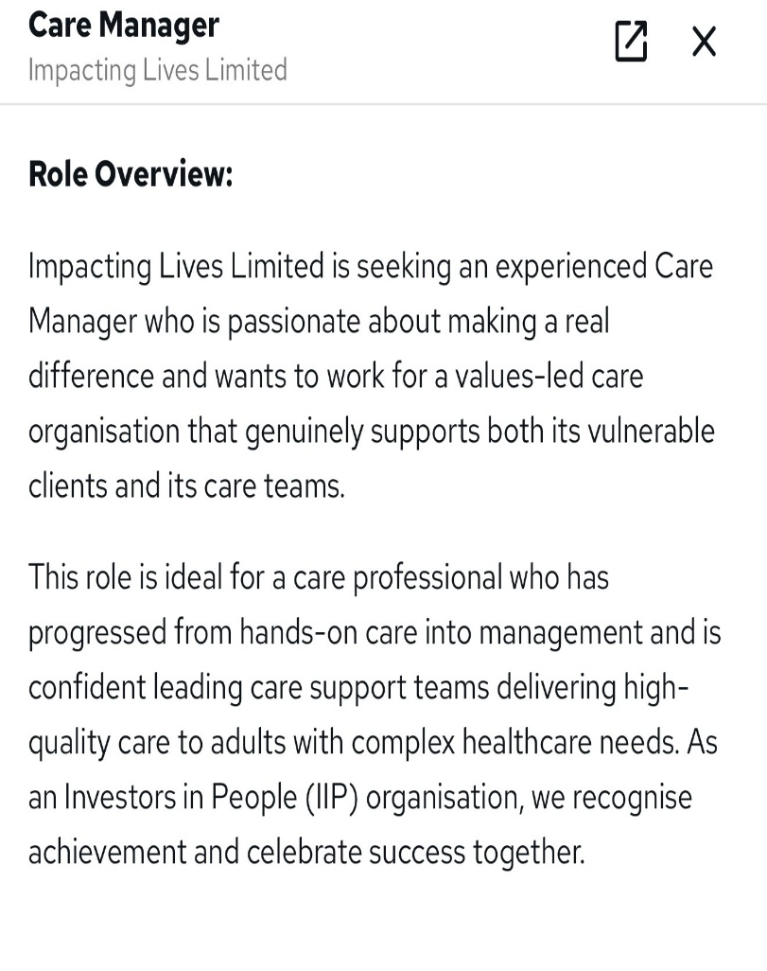
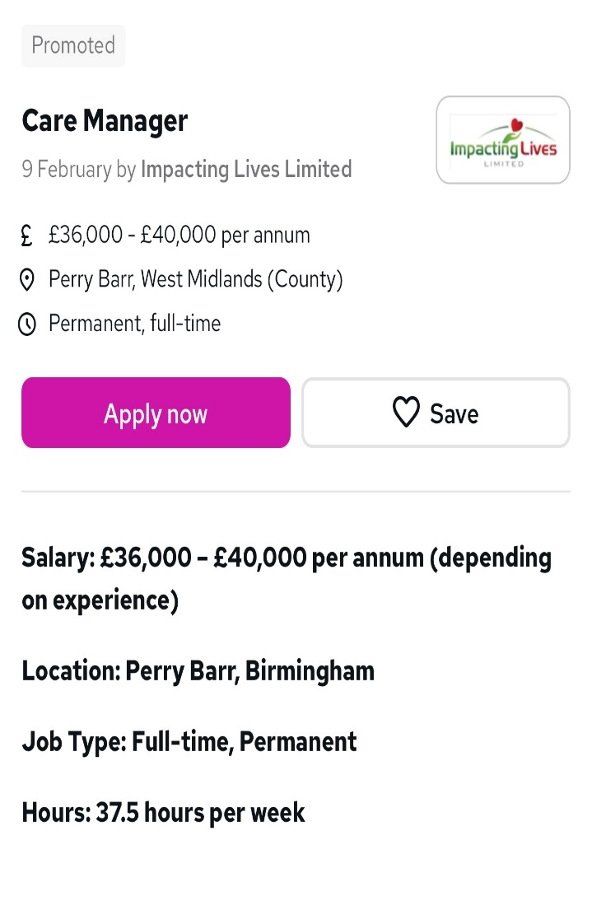
Job Advertisement

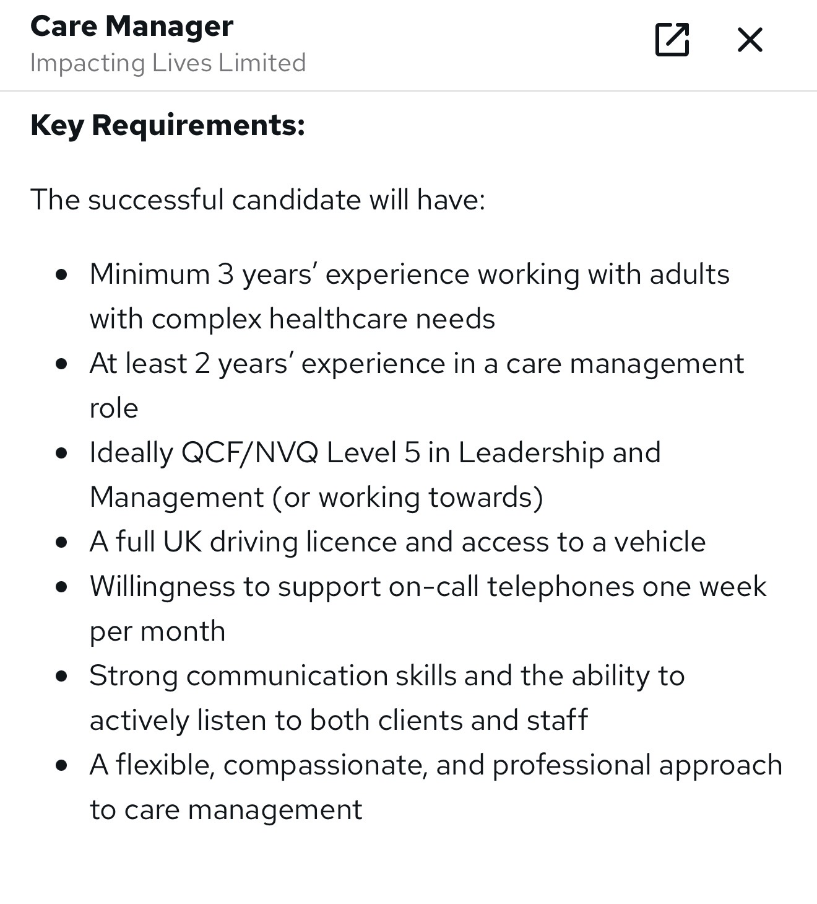
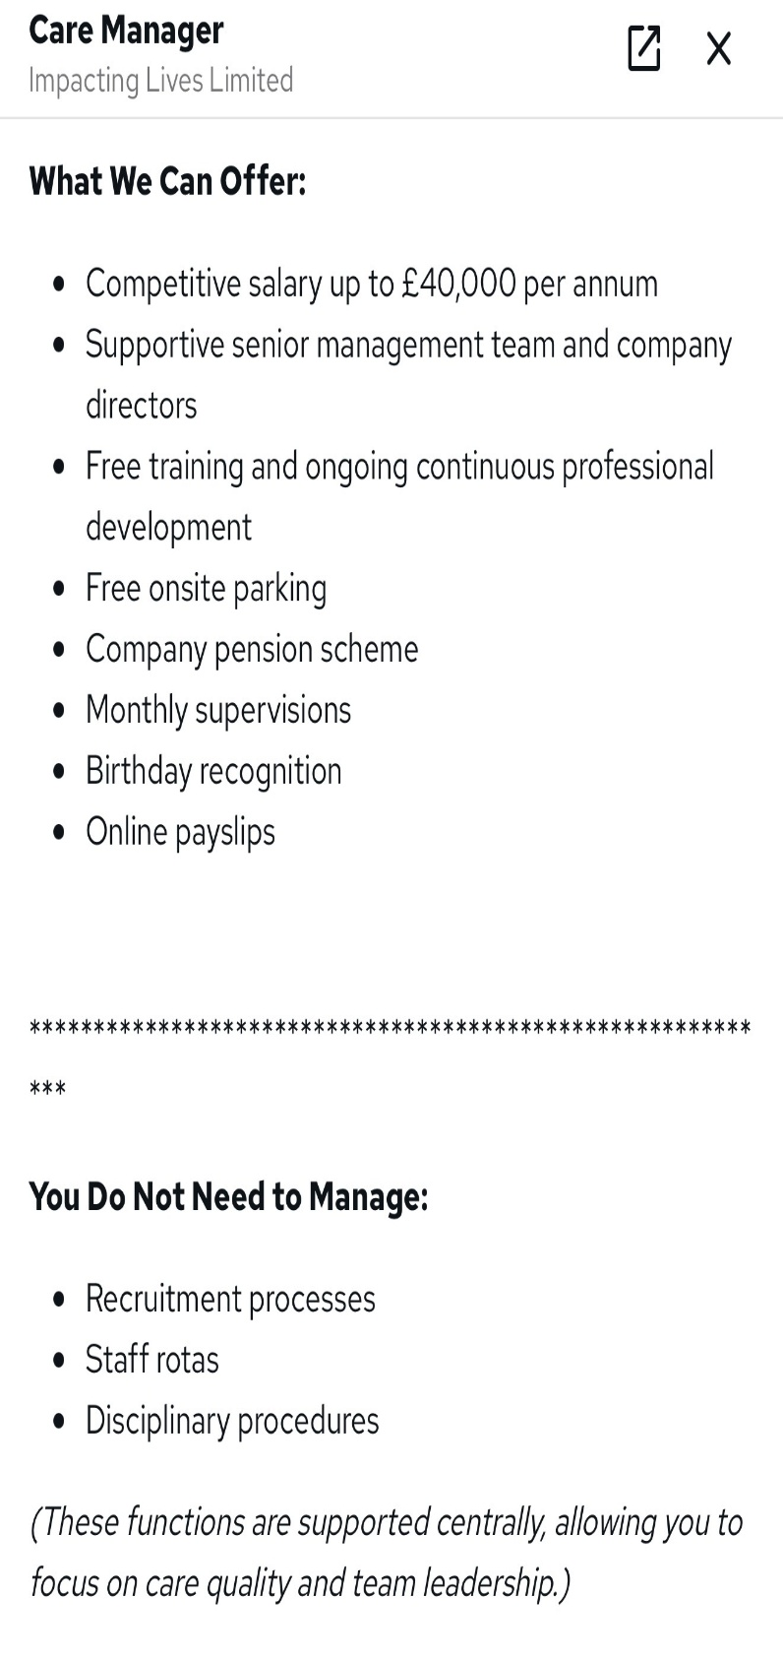

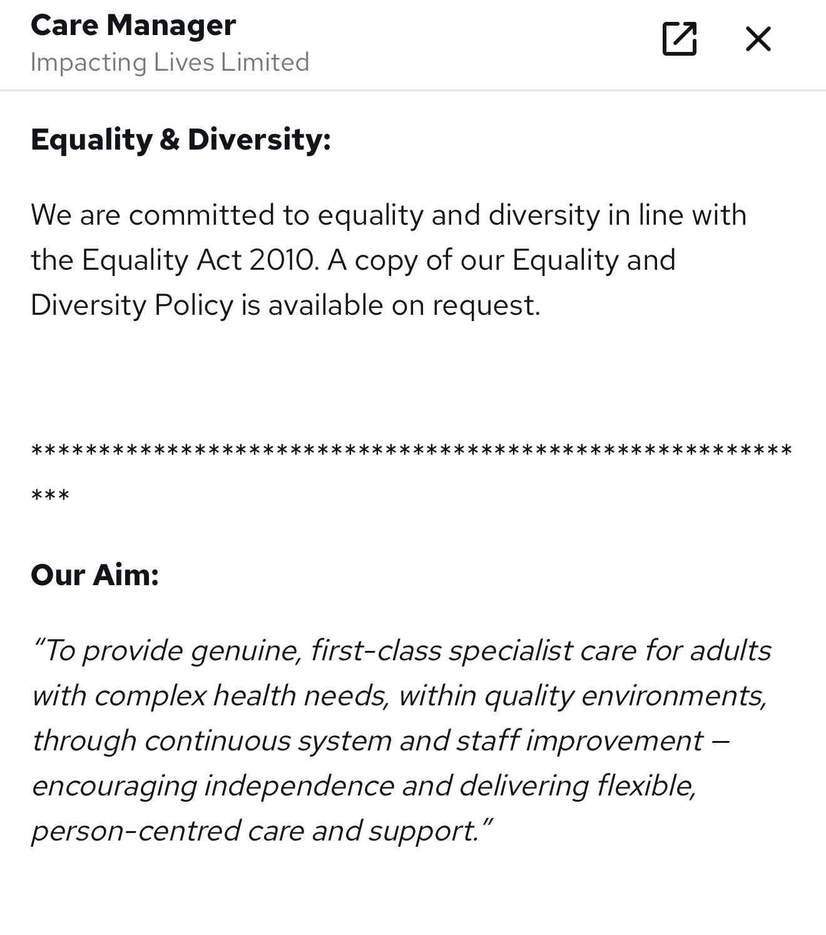
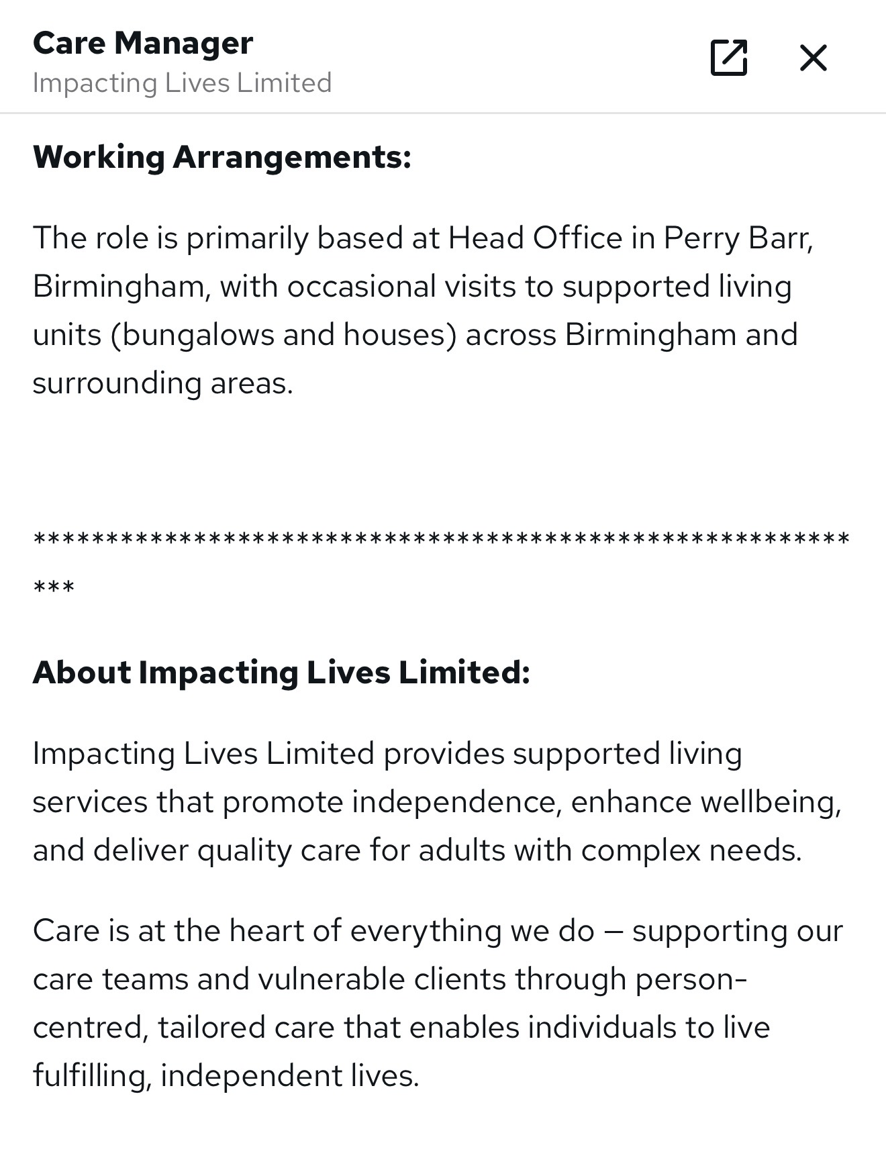
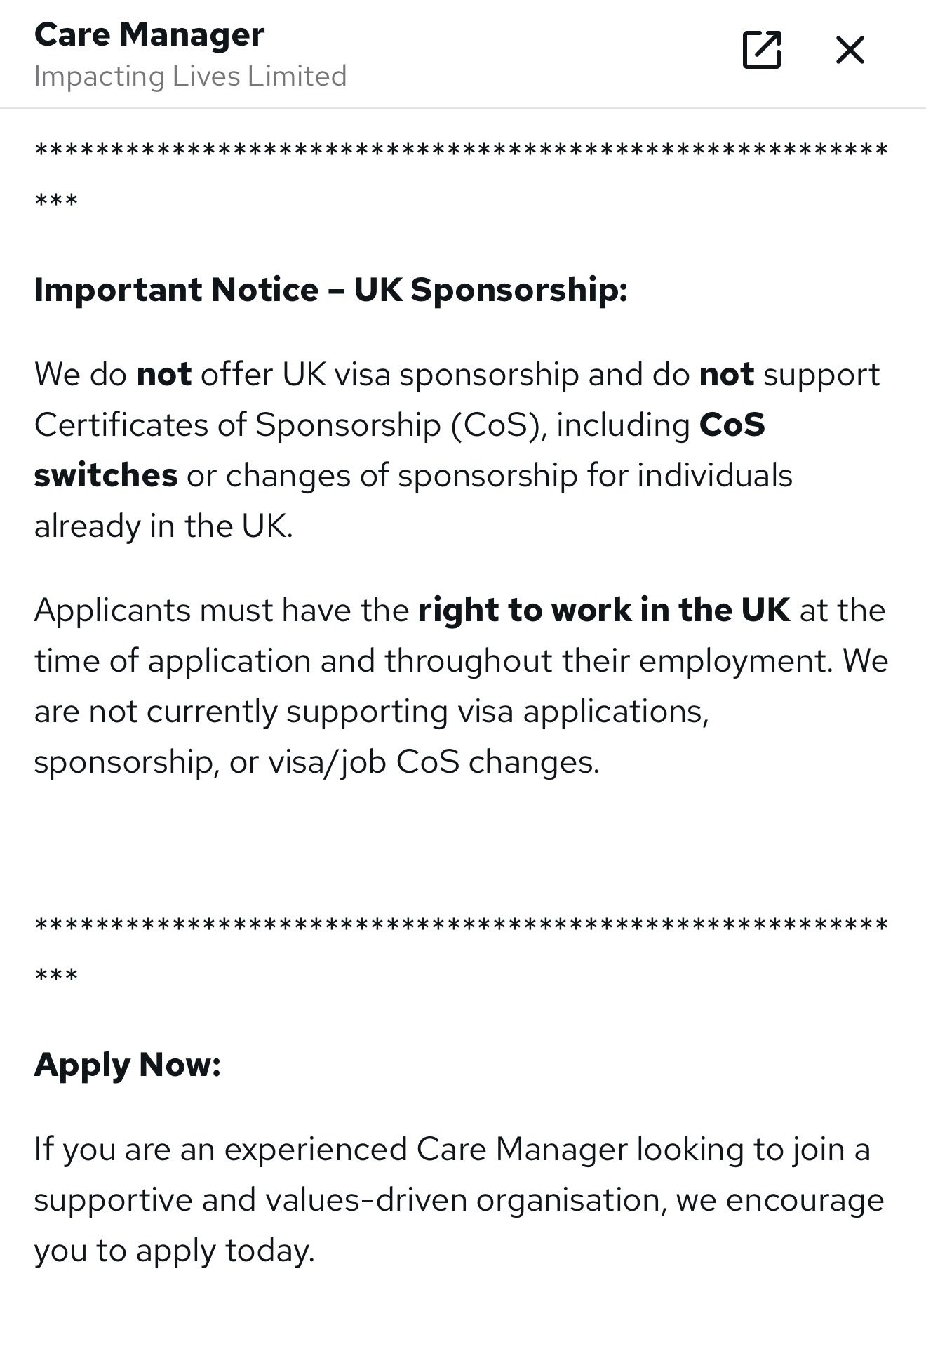
(Reed.co.uk, 2025)
Job Role Employability Skills
A care manager is in charge of supervising the provision of excellent, person-centred services while guaranteeing adherence to legal and regulatory obligations. To effectively manage employees and satisfy the demands of consumers, the position calls for an amalgamation of interpersonal, organisational, and leadership potentialities in place.
Leadership: Necessary for inspiring teams, assigning tasks, and fostering a healthy work environment. Good leadership covenant that employees deliver compassionate, safe care that complies with statutory frameworks established by the CQC (CQC, 2024).
Communication Skills: Essential in coordination and collaborative approach. It supports care planning and sets the seal on user’s preferences in line with person-centred care essence. (NHS, 2023).
Teamwork and Intellectuality: This ability helps with dispute resolution and efficient staff monitoring. Care managers contribute to equity, fairness, heterogeneity and the provision of high-quality care by enhancing inclusion and regard for one another. As this job role mainly focuses on the equality and diversity in line with the Equality Act (2010) polices in its work setting.
Organisational and Time-Management Skills: This skill helps care managers to strike a balance between staff supervision, compliance monitoring, budgeting, and care plan evaluations. To have this skilled manager can maintain service sustainability requires careful resource allocation at different settings with perfect financial management (Hafford-Letchfield,2009).
Decision Making and Problem-Solving:Care managers frequently dispense with snags related to service rendering, safeguarding, and staffing. In light of law and order like the Care Act 2014, which places a strong focus on care and safeguarding, they must make well-informed decisions beforehand that put safety and welfare first.
Self-Assessment
I have acquired a number of transferable skills pertinent to the Care Manager position from my academic work regarding health and social care (level 4 completed, pursuing level 5 and 6) and real-world experiences (private home care worker) and several training regarding childcare worker as well. My knowledge of safeguarding, duty of care, equity, and professional standards has improved in this result. Furthermore, volunteering has improved my cooperation and communication skills in this field.
Strengths
- Strongest Trait – communication skill. Communicating with employees, clients, and families requires this proficient ability. Effective communication guarantees individual specific plans and stimulates trust. Like in my previous job as a private care worker I had a great bond with my clients because having a strong linguistic skill assures the work enhancement in a best way with greater empathy and console.
- Leadership and Teamwork is another strength. I successfully cooperated and collaborated with stakeholders to accomplish the common objective. Group projects and task are executed to achieve the set goal so leading a teamworking is essential for a care manager to sustain worker morale and coordinate interdisciplinary services. Above mentioned job requires this trait specifically because a care manger should be transitive and capable to follow the current flow within the regulatory framework boundary.
- I also exhibit organisational abilities, such as prioritising and time management. Managing other obligations and academic deadlines has equipped me to manage several things well. This would help with staff scheduling, paperwork, and compliance monitoring in a management capacity. Likewise in future I am thinking to launch my own brand (agency) as providing care support workers for door-to-door accessibility to those who are being homebound so this trait will assist me to plan the workers availability and successful patient provision (Hafford-Letchfield,2009).
Areas for Improvement
Notwithstanding these benefits, I am aware of my foibles. I need more hands-on leadership ability experience, especially when it comes to managing bigger teams(future target). Even though I have worked in groups, organizational proficiency calls for highly developed consigning and leadership potentialities.
Further knowledge of financial planning and budget management would also be beneficial to me in my future upcoming launching project.
Who Can Help
- I may look for guidance from seasoned managers and senior pioneers.
- By enrolling in leadership development courses and pursuing management degrees with a perspective of healthcare.
- By polishing my fundamental capabilities to enhance professional growth.
5 Year Action Plan and Timeline
I have created a structured action plan following the Care Act 2014 mandate that centres on obtaining credentials, real-world leadership experience, regulatory understanding, and ongoing professional development in order to become an effective care manager within the next five years.
Year 1(Short Term Goals): Basic Structuring
Advancing my basic adroitness and gaining supervisory experience are my objectives for the 1st year. I want to work as a team leader or senior care worker so that I can begin acknowledging my leadership and delegation competencies. According to Skills for Care (2023), gaining practical leadership experience is crucial for moving up into registered manager roles. I will complete the necessary coursework in health and safety. I will also enrol in the Level 5 Diploma in Leadership and Management for Adult Care, as recommended for licensed managers (Skills for Care, 2023).
Years 2–3 (Medium Term Goals):Honing of Management and Leadership Adroitness
I want to take on more management tasks and finish the Level 5 Diploma in 2-3 years. I will look for chances to supervise junior workers, set up staff schedules, and help with hiring and performance reviews. Good leadership has been linked to keeping staff and improving the quality of care (Skills for Care, 2023).I will also learn about quality assurance and following the rules by taking part in internal audits and getting ready for inspections. The CQC looks at five main things when judging services: whether they are well-led, safe, effective, caring, and responsive (CQC, 2024). Understanding these requirements will help me develop the governance and compliance skills I need for the Care Manager job. To better understand how to allocate resources and keep services going, I will also enrol in short courses in budgeting and financial management.
Year 4-5 (Long Term Goals): Advanced Professional Practice and Transitioning
In my 4th year, I want to move up to the position of assistant manager or deputy manager. At this point, I will be able to gain real-world experience in operational management, which will cover budget monitoring, performance management, and leadership development.
In order to ensure that my knowledge of laws, equality, diversity, and best practices remains up to date, I will continue to place a high value on CPD (Health, 2020).
I plan to apply for a position as a registered care manager by the 5th year. By now, I hope to have earned my certification, strengthened my leadership abilities, and acquired real-world experience in service management and compliance. Through continued training and reflective practice, I will continue to grow professionally.
Building a Personal Brand
In my career goals, building a personal brand with the name of Helping Hands Be Friends as a door-to-door Healthcare Support Provider Agency kept its identity as:
- Empathy and Compassion
- Person-Centred Medicaments
- Community Involvement
- Nobility (Labrecque et al., 2011)
These tenets of the company promote dignity, independence, and wellbeing within the community, brand vision statement promoting by the social media:
LinkedIn (Professional Networking Tool) | Personal Website( Digital Portfolio)
Qualified Profile | Brand Vision Statement
Business page for Helping Hands Be Friends. | Offered Services, Resources and Methods
Disseminate information about community projects, successes, and offerings. | Testimonies and Case Studies
Writing pieces about providing services and updated health matters. | Posting blogs about health intervention.
Participate in online conferences and workshops pertaining to healthcare. | Contact Information

Through blog posting (healthcare articles content) on the business website, protect the community from risk, it establishes as an informed healthcare advocate entity. Career development in the field, upholding professional legal standards and exhibiting CPD helps in continuous improvement, according to the HCPC (2024).
Ethical Standards
Ethical branding promotes long-term trust with patients, families, and healthcare partners covers:
- Data Confidentiality
- Safety Regulations
- Employee Training and Qualifications
- Honest and Transparent Communication between professionals and patients.
Promoting a Professional Identity (CV)
Name: Sofia Malik Email: maliksofia89@gmail.com
I am a dedicated, organized and methodical individual. I have an active and dynamic approach to work and getting things done.
Core Competencies

- Technology Competent
- Accountability
- Caring and Compassion
- Organization and attention to detail
- Multitasking

Professional Experience
- Teaching Assistant Job with SEN Children at Leycroft School with NOW Education Agency (Feb,2021-upto date)
- SEN Pupil Guide Job with AFJ Agency (April 2020- Feb 2024)
- Private Care Assistant (Sep 2022- June 2023)
Qualifications
- Health and Social Care Level 5 ( May 2025- up to date)
- Health and Social Care Level 4 ( Sep 2023- July 2024)
- Birmingham Adult Education Services
Literacy and Numeracy Level 2 (Sep 2011- July 2012)
- Birmingham Adult Education Services
CCLD NVQ Level 3(passed) + Key Skills-Communication Level 2 (passed) ICT Skills, CLAIT (Sep 2010- July 2011)
Soft Skills
- Leadership
- Time Management Skills
- Interpersonal Skills
- Communication Skills
- Decision Making Skills

Hobbies : I am fond of being busy at work.
Declaration: These all the above-mentioned details are true to the best of my knowledge.

Cover Letter
10 Drews Lane, Birmingham.
B8 2QE.
2nd March,2026.

To,
HR
Impacting Lives Limited,
Tamebridge Industrial Estate , Aldridge Rd, Birmingham.
B42 2T.
Dear HR Manager,
This letter is written to show my great interest in the posted position of Care manager at your organization. With my strong competencies, I am fully confident in my capacity to support your team effectively.
My experience in administrative roles has equipped me with the skills necessary to handle organizational stuff and ensure a smooth healthcare intervention provision. I am dedicated, proactive, and eager to contribute to the success of your institution.

Thanking in Advance,

Sincerely,
Sofia Malik

Building a Network for Successful Employment
Building a strong professional network, a candidate can be facilitated for career advancement by sharing info, professional headway and mentoring to enhance the service quality.
Importance of Networking
According to the CQC (2024) and Skills for Care( 2023), networking fosters teamwork, inter and intra disciplinary mutual learning, and career advancement because these help in the establishing connectivity among the communal groups, healthcare caregivers and local authorities.
Potential Mentors
According to the Skills for Care (2023), mentoring is essential for developing the leaders in financial management, service growth, regulatory compliance. Mentor could be a:
- Medical Practitioner
- Local Authority Commissioning Officer
- Registered Care Manager
- Deputy Manager with extensive expertise in compliance and inspection.
Professional Associations
Being a part of apropos association, you are approachable to many opportunities, trainings and resources like:
- National Care Association provide info about updated care policies.
- UK Homecare Association helps in promoting homecare business.
- Skills For Care assists in leadership development programs and healthcare sector guidance.
- CQC provides regulatory framework.
Networking Events
Conferences, training, workshops, forums of local authority providers and events for CQC for health and social care are essential for establishing a business (agency),its growth and leadership. Digital Profile on LinkedIn also offer chances to connect with professionals in the field, exchange ideas, and keep up with industry latest advancements.

Conclusion
This report gives a thorough review on the advertising job on the Impacting lives Limited portal about a care manager position, its required employability skills and professional standards which I would likely to join in future having interest in the healthcare industry. It is linked to my future ambition of establishing my own care company Helping Hands Be Friends which provide domiciliary care.
Hence, according to the CQC (2024) and Care Act 2014, a care manager fosters dignity, wellbeing, high standards of care through leadership , safeguarding, team management, regulatory compliance, and financial oversight.
This report gives insights about the significant skills for employability, self-evaluation and 5 years future plan to get into this field that how a personal brand could be launched and increase its industry value by following the peer insights through networking, opportunities and exploiting the own employability skills.
Furthermore, social connectivity develops the network among different community groups and stakeholders which help in job progression and readiness for pursuing the long- term objective of starting a domiciliary care agency that offers door to door support care. Also, it equips me to contribute to the healthcare industry and eventually establish a top-notch, individual-centred care service platform.

References
- Care Act (2014). Care Act 2014. [online] Legislation.gov.uk. Available at: https://www.legislation.gov.uk/ukpga/2014/23/contents.
- Care Quality Commission (2024). State of health and adult social care in England: 2023 to 2024. [online] GOV.UK. Available at: https://www.gov.uk/government/publications/state-of-health-and-adult-social-care-in-england-2023-to-2024.
- GOV.UK (2013). Equality Act 2010. [online] GOV.UK. Available at: https://www.gov.uk/guidance/equality-act-2010-guidance.
- Hafford-Letchfield, T. (2009). Management and organisations in social work. United Kingdom: SAGE Publications.
- Health, S. for (2020). CQC in Care Homes: Providers Call for Stronger Regulation | Skills for Health. [online] Skills for Health. Available at: https://www.skillsforhealth.org.uk/article/cqc-in-care-homes-providers-call-for-stronger-regulation/?gad_source=1&gad_campaignid=23236899010&gbraid=0AAAAADSALUF7C7LQ83IruPCxlutJVT9Bc&gclid=EAIaIQobChMIkr7E65P9kgMVe5pQBh2YuykOEAAYASAAEgKI5vD_BwE [Accessed 28 Feb. 2026].
- Health and Care Professions Council (2024). Standards of Conduct, Performance and Ethics. [online] Health and Care Professions Council. Available at: https://www.hcpc-uk.org/standards/standards-of-conduct-performance-and-ethics/.
- Labrecque, L.I., Markos, E. and Milne, G.R. (2011). Online Personal Branding: Processes, Challenges, and Implications. Journal of Interactive Marketing, [online] 25(1), pp.37–50. Available at: https://journals.sagepub.com/doi/abs/10.1016/j.intmar.2010.09.002.
- NHS (2023). The NHS Constitution for England. London: Department of Health and Social Care.
- Reed.co.uk. (2025). Care Manager Perry Barr - Reed.co.uk. [online] Available at: https://www.reed.co.uk/jobs/care-manager/56177866?source=searchResults&filter=%2Fjobs%2Fcareworker-jobs-in-birmingham [Accessed 21 Feb. 2026].
- Skills for Care (2023). Support for leaders and managers. [online] www.skillsforcare.org.uk. Available at: https://www.skillsforcare.org.uk/Support-for-leaders-and-managers/Support-for-leaders-and-managers.aspx.

