CAN FEA REPLACE PHYSICAL TESTING?
Advanced Stress Analysis & FEA (M6X00420) – Kyle Cummings (1700852) 09/03/20

University of Wales Trinity St David: School of Engineering
Motorcycle Engineering

Table of Contents
1. Introduction 2
2. How FEA Is Used in Industry 3
3. Correlating an FEA Model 6
4. Could FEA Ever Replace Physical Testing? 9
5. Bibliography 11

- Introduction

As part of the Advanced Stress Analysis & FEA module this piece of coursework must be undertaken in which the process of FEA is discussed and analysed. Finite Element Analysis (FEA) is an engineering method used to predict and model how an object will react when subjected to different effects such as mechanical stress, vibration and heat transfer. The process of FEA however revolves around a method known as the Finite Element Method (FEM). This involves taking a real-world object which is ready to be analysed and breaking it down into thousands of small sections (also known as finite elements), a mathematical analysis is then conducted on each individual element and the results from each element are brought together in order to give the final analysed model of the whole object.

FEA has rapidly increased in popularity in recent years due to its ability to predict how a material reacts in different situations using software such as ANSYS, Autodesk and Solidworks which will model where and how the object will wear down the most before it will eventually fail. Being able to conduct this analysis is a huge help to companies who are designing new products and want to be able to conduct tests on them before spending money putting them through any kind of production stage just to find out that unexpected failures could occur. Using FEA decreases the likelihood of these issues and so the small investment into purchasing specialist FEA software could save companies a lot of money in the long run, another reason as to why it has become so favourable. FEA on its own however is not perfect and like everything has its own drawbacks which is why companies continue to conduct physical testing. The following report details how companies combine both physical testing and FEA and whether FEA could exist solely on its own without the need for physical testing during the design of new products.
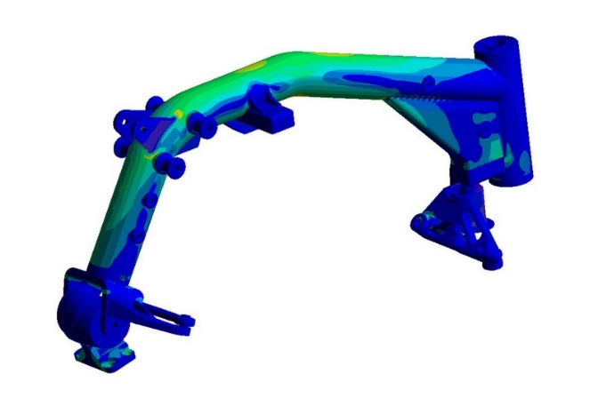

Figure 1 – FEA Stiffness Analysis of Bike Frame
- How FEA Is Used in Industry

As previously explained, FEA is extremely important to companies when designing new products as it gives different advantages (and disadvantages) in comparison to physical testing. One such area within which FEA is used heavily is in the design of motorcycle frame or chassis section (such as the swingarm), a subject that will form the basis of a case study throughout this report. The frame is the core structure of the motorcycle with most areas normally connected in some way to this structure, this means it is put under a lot of stress throughout the process of riding and so it is vital to get a clear picture on how strong it is using FEA software. Of course, the computerised FEA testing of the design is not the only testing that takes place before the chassis is sent into mass production, it must also observe regimented physical testing before being sent into the production phase. This key balance is what will be discussed during this section of the report.

Any motorcycle engineer will tell you that one of the main things a rider wants is feeling throughout the motorcycle (especially within racing) and this is why frame stiffness is so important. The stiffness of the frame determines how a large amount of the bike reacts under different circumstances such as braking, accelerating or steering due to it being the central hub of the bike. Stiffnesses in different areas of the frame can be calculated using FEA software as seen in figure 1, however whether these results are technically correct or not is unknown due to them only being theoretically determined via a computer simulation. As all the different situations that the frame is subjected to in the software is due to algorithms, these are just projections of how the frame could react. It’s also possible that some human errors could have been made when inputting data to conduct the virtual test meaning some results may be completely incorrect. The FEA results can be verified however using multiple steps - checking deformation values and shapes, checking reaction forces, taking stress averages and completing the hand calculations to check the theory behind the simulation. FEA is however highly unlikely to ever be 100% accurate compared to real world testing due to limiting factors such as boundary conditions, meshing and how simplified the model is. The simplification of the model is a big issue as it can be more simplified to give a lower solving time however this will give slightly less accurate results. As results in this case need to be as accurate as possible then the model must be as detailed as it can be so long as the hardware in use is capable of forming the task, however when it comes to physical testing such things are not an issue as the prototype is already in front of your eyes in the exact detail it would be when in use. Those FEA test results are produced using split second calculations to create real time analysis as to how the structure reacts under different situations, while doing hand calculations for the physical tests would take quite a while longer to complete giving the FEA simulation an advantage over the real world tests. The only way to conduct a test that will give real, true to reality answers is through the old-fashioned way, physical testing.

A physical test (like the one shown in figure 2) will give answers which do not rely on software and subject a manufactured prototype to tests which will see it perform under real stresses as though it was being ridden. The model in figure 2 is also connected to a real engine from the bike which the frame was developed for. Of course, the real stresses and pressures will not be known until the bike has been physically ridden as different riders provide different forces upon the bike due to different riding styles and rider weights, however the physical tests and the FEA simulation provide a good prediction. Once these tests are complete, they are used to draw comparisons between the two types of simulations and see whether similar results are produced. If the two tests produce similar results within a certain tolerance determined by the manufacturer (usually between 10-15%) the physical test will have successfully validated the results from the FEA simulation.
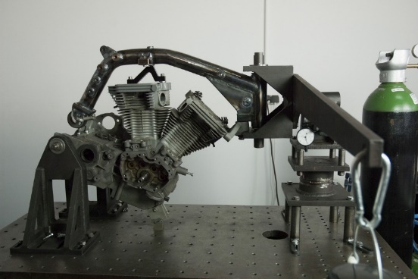

Figure 2 – Physical Stiffness Test of BOTT XR1 Motorcycle Frame

Aside from the main idea of validation, the other idea used by companies in relation to physical testing is to conduct some tests that the FEA simulation could not do. For example, when doing tests on a motorcycle chassis (whether frame or swingarm) there are torsional and lateral loads applied to the structure between different materials such as carbon and aluminium. This can be done in FEA however there was then a timed test done on both of the two prototype structures, this involved putting this previously mentioned loads on the prototype and timing how long before they return back to the original position compared to how the structure changed. The test results showed that aluminium returns more gradually to the original position and the carbon essentially snaps straight back to the original position, but how to do this in an FEA simulation is so far unknown by the manufacturers and so being able to do these other physical tests is a great advantage over FEA.

- Correlating an FEA Model

As previously mentioned in this report physical testing is widely used in industry to validate the results from an FEA model to confirm whether they are correct. In order to be able to validate the results then the FEA model and physical testing must be correlated between the two by completing similar tests to those conducted in the FEA simulation. Four of the main tests completed in physical testing in order to correlate them to the simulation are stress/strain tests, natural frequency tests, dynamic response tests along with temperature and pressure distribution tests. Of course, all of these tests are equally important and are definitely required to connect a physical test and a computerised simulation, covering all of the exceptionally important parameters that the FEA simulation analyses.

A physical test is essentially the same as an FEA test in the sense that it must be simulate the expected forces that would take place while the product is in real-world use, then providing useful data back to the design team so they can analyse what those results mean. These tests are also extremely important when compared back to the idea of motorcycle frame design. An example of a physical test revolving around stiffness was seen in figure 2 in the previous section of this report and this would be one of many tests which may be used to help correlate the FEA simulation undertaken on a motorcycle frame. To use an example of a strain gauge test in this context, a chassis would be set up in a rig with a system used to simulate the tension applied upon the handlebars and other effected areas such as the seat and foot pegs with strain gauges attached to the frame itself in perhaps weaker areas such as where the frame has been welded such as the headstock or where the down-tubes meet the engine mounts (figure 3). This then measures the strain on each specified area of the frame based on the values produced by the strain gauges in each section. The results from this test can then be compared with the results from the FEA simulation in order to give the simulation its validity.

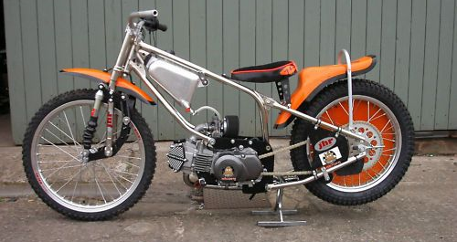

Downtube connected to engine plate
Headstock

Figure 3 – Labelled Chassis Points on Speedway Motorcycle
When tests like these on frames or swingarms are conducted however, the part is stuck in a rig as previously mentioned are often connected with real parts that would be used on the bike when being ridden such as the wheel rim (seen in figure 4) or the engine. This is done with the aim of getting data back from the bearings and back lashes of components to then compare back to FEA simulation results. The four main test types known to be conducted in this area would be the lateral load and longitudinal load tests along with two sets of torsional load tests. The first torsional load test is conducted in line of the bike axis in order to work out how the bike reacts to torsional load under turning conditions and the other test is measured in the headstock axis to understand the bike’s reaction to load under braking. These tests are also completed in the FEA simulation using CAD drawings of the parts and then the results from the both the FEA and physical tests are compared and contrasted, then as previously explained should the FEA and physical tests come within a tolerance under 15% then the FEA is considered validated.
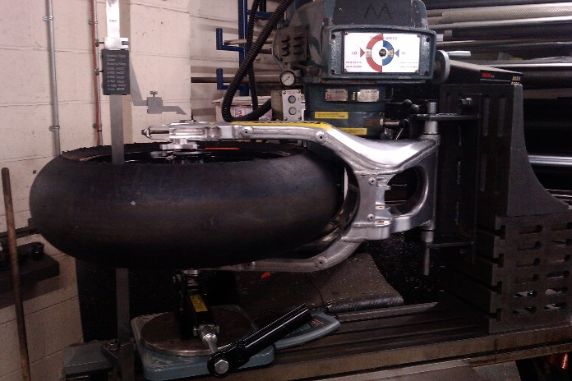
During the correlation process the FEA model itself also has to be refined especially if the physical tests come back at a higher tolerance to what is expected or sub-standard. In some cases, meshing, welding elements and boundary conditions may have to be altered in the model should the results fall outside of the tolerance. Once the two tests fall within the same tolerance the model may be able to become even more refined if it is possible to do so in order to bring it even closer to the real-world test results. The results are analysed using three-dimensional graphs and charts in order to see the different effects in different areas. Similar graphs can be created from the physical tests in terms of temperature and pressure distributions or values of stress or strain in different sections of the chassis, these can also then be used as a mode of comparison between physical testing and FEA to test the difference between them. One new form of physical testing being trialled is using strain gauges as previously mentioned however in an on-track test to see how a prototype would react in different circumstances on track in as real-world an environment as you will get in terms of testing a new prototype part. The strain gauges could then record the measurements over the course of the testing session seeing how the chassis reacts over the course of the test providing useful information for the design team who can only simulate the process in FEA. Temperature measurements during on track tests are also being looked into to see how the chassis reacts to changes due to heat (especially important due to the physical properties of aluminium), this will also give even better links to FEA in terms of correlation depending on the simulations ran.

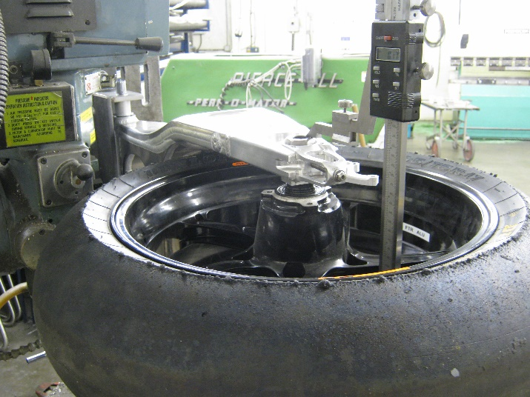

Figure 4 – Physical Tests Taking Place on Motorcycle Swingarms
- Could FEA Ever Replace Physical Testing?

As previously explained, there is a very harmonious balance between the use of both FEA simulation and physical testing as each have their own advantages and disadvantages. On one hand FEA is extremely useful in terms of creating software before the production of a prototype needs to take place as this saves many companies a good amount of money, however it does also have its limitations in terms of being solely a computer software. The FEA simulation in a partial sense is also only as good as the designer’s computer hardware in terms of how quick you can run a simulation and if it will actually make it through the simulation without causing crash errors within the software. This is something a company would ultimately have to weigh up as to where the investment in FEA software and some very good computer hardware would save money overall compared to just conducting physical tests instead and relying on lengthy hand calculations. There is no substitute for hard evidence that is right in front of an engineer’s eyes and that is what many engineers favour, especially for the generation that grew up without the use of computers and high-tech software. FEA also has a lot of drawbacks in this sense due to the fact you have to be skilled enough with the software (some of which can be complex) in order to use it at a high level while also understanding the theory of where the data it produces comes from. This is in part why the FEA model needs physical testing for it to be considered as valid data, as the FEA on its own is an unknown quantity as many things with it could be inaccurate if the person inputting data and creating the designs is not capable.

Without physical testing companies would no doubt be sceptical and are so in many situations surrounding FEA. One motorcycle company had 3D printed an Aluminium swingarm based solely from an FEA simulation however when physical tested afterwards the results were very different when compared back to the simulation and the reason why cannot be worked out, for this reason the swingarm has never been used on track as the company refuse to take the risk with it. FEA has simply been described by one motorcycle chassis designer as “a guide and an indication”, something that you “could not count on the results of alone” (Taylor, 2020) and for this reason it will always need some form of validation or refinement as designers refuse to give it an all clear before proceeding to endanger a rider with the possibly fatal results of a crash caused by a design error. The fact also remains that there is no computer simulation replacement to model exactly what a rider feels through the bike and whether it will actually work out on track in a real world simulation, no matter what the numbers and engineering statistics say on paper. This is something that only real physical testing can provide the answers to which is why this form of testing is in current development and use by some manufacturers. There are some tests which cannot be simulated in a computerised environment as have been previously discussed in section three of this report, in this context physical testing would be essential as it is not like these tests could just be left out of the design phase. It is absolutely crucial that those tests are completed, as a failure due to something which has not been tested or just through reliance on FEA results (which could simply be inaccurate) could well be disastrous. In some cases, FEA simulations cannot be done entirely accurately when simulating a motorcycle chassis due to the fact it is not possible to obtain CAD designs for other parts of the same motorcycle that another company has designed. As the motorcycle exists as one overall structure with different sections connected together the chassis must be modelled with different parts connected to it such as the engine or wheels to give fully accurate data. If this data is unavailable then the FEA would not give entirely accurate results like physical testing could, hence another need for the physical or on-track testing to remain in use.

Once again there is one overriding fact that remains constant throughout all of the discussion surrounding comparisons between physical testing and FEA simulations – they must exist as one combined entity. FEA could not exist without some form of validation and whether or not that comes from physical tests could change in the future, however for now it is important they remain working alongside each other. The two testing forms balance one another out with the FEA simulations completing complex hand calculations easily within the blink of an eye and the physical testing can validate these results to make sure the simulation was completed correctly. When all of this context is considered there is definitely no way FEA simulations could exist solely without physical testing.

- Bibliography
Abbey, T., 2015. Verification Vs. Validation In Relation To FEA - Digital Engineering. [online] Digital Engineering. Available at: <https://www.digitalengineering247.com/article/verification-vs-validation/> [Accessed 27 March 2020].
Caliberdesign.co.nz. n.d. Why Use FEA?. [online] Available at: <https://www.caliberdesign.co.nz/wp-content/uploads/2015/05/Caliber-Design-HowToGuide-Intro-to-FEA.pdf> [Accessed 22 March 2020].
Enterfea. 2020. 5 Steps Of FEA Results Verification. [online] Available at: <https://enterfea.com/5-steps-fea-results-verification/> [Accessed 8 April 2020].
Enterfea. n.d. How Accurate Is Finite Element Analysis? | Enterfea. [online] Available at: <https://enterfea.com/how-accurate-is-finite-element-analysis/> [Accessed 1 April 2020].
Gregefors, C., 2016. Correlation Study Between FEA And Physical Testing For Hypoid Gear Set. [online] Stockholm. Available at: <http://www.diva-portal.se/smash/get/diva2:1017681/FULLTEXT01.pdf> [Accessed 2 April 2020].
n.d. Speedway Bike. [image] Available at: <https://www.google.co.uk/url?sa=i&url=https%3A%2F%2Fwww.pinterest.com%2Fpin%2F2674080998892562%2F&psig=AOvVaw0bpeE4d9IuHQisQx54ehll&ust=1586200222631000&source=images&cd=vfe&ved=0CA0QjhxqFwoTCPCavLr-0egCFQAAAAAdAAAAABAD> [Accessed 3 April 2020].
ResearchGate. 2012. How Reliable Is FEM Analysis Or Simulation In A Test, For Example, Machining Simulation? How Can We Judge That Our Simulation Is Correct?. [online] Available at: <https://www.researchgate.net/post/How_reliable_is_FEM_analysis_or_simulation_in_a_test_for_example_machining_simulation_How_can_we_judge_that_our_simulation_is_correct> [Accessed 29 March 2020].
Sanchez, D., 2017. Measuring Frame Stiffness | Custom Motorcycles - Bottpower. [online] Bottpower.com. Available at: <https://bottpower.com/measuring-frame-stiffness/> [Accessed 19 March 2020].
Taylor, M., 2020. [email].
Vieira, C., 2014. Structural Evaluation Of Motorcyle Frame. Masters. Universidade Do Porto.

