Module: Project Management

Module code : LCBB5005

Student Name: Adelina Camelia Perva
Student ID: 2020310
Lecturer: Sadeque Imam Shaikh

Assignment Title: Assessment 1

Contents
Introduction 3
About the Crossrail Project 4
Rationale of the Project 5
Cost of the Project 7
Financing 8
Analysis of Stakeholders 9
Issues concerning the project 10
Project Risk Management 11
Conclusion 12
References 13

Introduction
A portion of the requirements for the Project Management course will be met by the completion of this individual report. The report's goals are to provide an in-depth analysis of the Crossrail project, from its goals and reasoning through its business case analysis, financial projections, and potential problems. Therefore, this report's goals are derived from the project's stated objectives, which include performance, cost, and timeline metrics. The Elizabeth line is the biggest improvement to London's public transportation system in a generation. It is vital to a future of low-carbon transportation since it will improve London's connections and stimulate its revitalization (Tucker, 2017). This fully digitalized 72-mile (118-km) train line will revolutionise travel both east-west through London, interfacing with the entire U.K. It is one of the largest transport network projects in Europe.

About the Crossrail Project
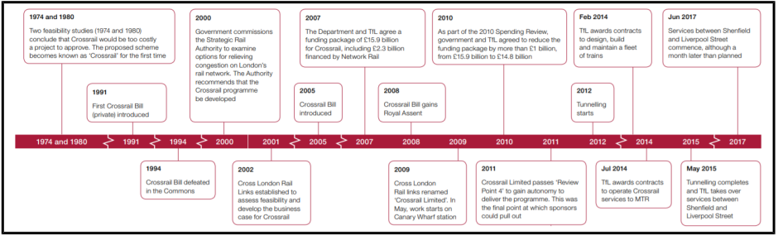
Figure 1: Timeline of the Project (Taylor, 2017).
The Elizabeth line, which is part of the Transport for London system, will make it easier for more people to get throughout London, which will lead to a more equitable and welcoming community. The addition of additional, universally accessible stations improves the quality of life for everyone and makes it possible to build more homes. In the end, the Elizabeth line is about making people's lives better by enhancing their access to better economic opportunities and by making society more welcoming of all types of individuals (Morrice and Hands, 2017). Millions of people in London and the surrounding area will benefit from the improved accessibility and shorter commute times. People will have easier access to services such as work, education, and recreation thanks to the 41 stations that are completely accessible without the use of stairs. The Elizabeth line is an example of a rapid, dependable service that can entice more people to take public transportation, which in turn benefits bicycles and pedestrians by making roads safer.
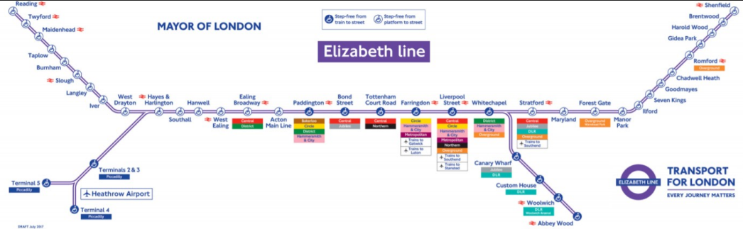
Figure 2: Route Map of the Project (Morrice and Hands, 2017).
Although planning for Crossrail began in the 1970s, building on the Crossrail Canary Wharf station began in May 2009 after the Crossrail Act of 2008 was passed by Parliament. Currently, Transport for London (TfL) and the Department of Transport (DfT) are co-sponsoring the Crossrail project, and TfL's special-purpose company, CRL (Crossrail Ltd.), is in charge of managing the endeavour. Crossrail's overarching goals are to shorten commutes, ease congestion on existing train lines, and provide passengers additional transportation choices (Fraser et al., 2017). The project's goals were outlined in the Mayor's Transport Strategy 2010 statement.
- Growing the economy and population sustainably can be aided by increasing transportation capacity and decreasing traffic on existing roads.
- Saving time on commutes is a step toward better transportation links.
- Examining the broader benefits, such as allowing more people (including those with mobility restrictions) to get where they need to go (like schools, workplaces, and other locations), reducing the number of people injured in traffic accidents, and bettering the environment through measures like cutting down on carbon emissions.
Based on data gathered by the Greater London Authority (GLA) and Transport for London (TfL), it has been determined that public transportation demand in the City of London is at or near capacity. With the Elizabeth Line running at full capacity, an additional 1.5 million passengers will be transported to within 45 minutes of central London, expanding the capacity of the London rail network by 10%. For instance, whereas the current system makes it take 58 minutes to get from Bond Street to Langley, the Crossrail will only make it take 28 minutes (Taylor, 2017). At the end of the day, individuals may look forward to better health, wellness, and happiness as a consequence of the Crossrail's reduced travel times and increased connection.

Rationale of the Project
The Association for Project Management (APM) defines a business case as the reasons to undertake a project or programme, including an analysis of the potential benefits, costs, and risks, as well as an explanation of why the proposed solution is the best option (Maylor, 2010). The Crossrail project's business case has been modified three times so far, which is in keeping with the norm for large infrastructure projects requiring such updates. The first was created in 2005 by the Department for Transport, Transport for London, and Cross London Rail Links Ltd. The second and third were created by Crossrail's sponsors (the DfT and TfL) as part of the Mayor's Transport Strategy and the Comprehensive Spending Review, respectively, in 2010 and 2011. The standard method of doing a transport economic analysis for every given project involves comparing the entire cost of the project over a predetermined time period with the estimated benefits, such as reduced travel time and improved travel quality (Buck, 2017). Crossrail's economic evaluation accounts for the advantages of reduced travel times by employing the "Value of Time" (VoT) measure, as recommended by HM Treasury's Green Book. Crossrail's "Present Value" was calculated using a discount rate of 3.5% for the first 30 years and a discount rate of 3% for the remaining 30 years, with a price base of 2002, and an evaluation period of 60 years, based on the assumption that Crossrail services would continue until 2076.
The summary comparisons of economic assessments of Crossrail were carried out in 2005, 2010, and 2011. With a benefit-cost ratio (BCR) of 1.80, as estimated by the business case in 2005, Crossrail is expected to generate a total of $16.09 billion in benefits while incurring just $1.80 in costs. The BCR was 1.87 in the 2010 business case and 1.97 in the 2011 business case, with an additional BCR of 3.10 for the broader economic advantages (Fraser et al., 2017). However, the net user benefits dropped to £11.03bn in 2011 from £16.09 in 2005. More time saved on the road and in public transportation, less money spent on gas, fewer accidents, better service in a pleasant setting, and more ease of movement for those with physical impairments are all possible outcomes. According to official recommendations, a BCR of 1.97 indicates "mid" value for money, while a BCR of 3.09 indicates "great" value for money in evaluations of cost-effectiveness (Morrice and Hands, 2017). The economic benefits of Crossrail are well-documented under the standard evaluation approach. Crossrail will also have a major effect on the British economy as a whole by boosting GDP (gross domestic product) and jobs in the capital city of London. Crossrail would have a £6bn to £15bn welfare impact, with an additional £6bn to £9bn in tax revenue from enterprises alone. In light of these advantages, Crossrail seems like a good investment, especially if it can ease traffic on London's current networks and give the City a leg up in creating high-paying employment.

Cost of the Project
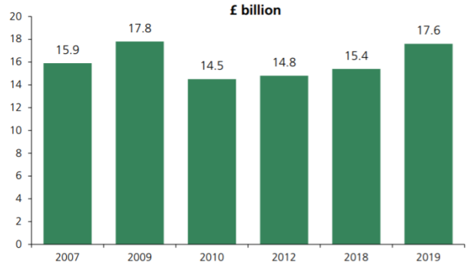
Figure 3: Changes in estimated cost of the project (Buck, 2017).
As can be seen in above chart, the expected costs of building the Crossrail have been altered throughout time. The National Audit Office calculated that the total cost to construct the Crossrail railway would be £18.9bn. In 2010, it was given a budget of £14.8bn, which has increased over the years (Taylor, 2017). The Elizabeth line has been delayed for nearly three years, and its cost has already risen by four times its original estimate. Following the Prime Minister's announcement of a nationwide coronavirus lockdown on the morning of March 24, construction on the Elizabeth Line came to a halt. The massive infrastructure project was expected to cost £14.8 billion, and services across central London were scheduled to begin running in December 2018. However, issues with the project's implementation were only publicly acknowledged a few months before the scheduled inauguration by the Queen. Beyond £19 billion has been spent on the project so far, which is more than £1 billion over the agreed upon financing amount.

Financing
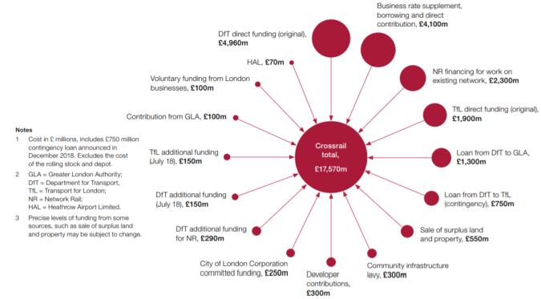
Figure 4: Analysis of the Funding (Buck, 2017).
Funding and finance are two different concepts that are sometimes used interchangeably but have important differences. Crossrail used a variety of funding and financing techniques, reflecting the interests of multiple stakeholders, in contrast to the typical publicly financed project, in which expenses are absorbed by the private sector or by the taxpayers and finance by industry and markets (Black, 2017). Ultimately, Crossrail was financed by the TfL through contributions from taxpayers, future ticket payers, and London companies. The $19.2bn financing package from 2007 was decreased to $14.8bn in 2010. However, the GLA decided to return the DfT loan through the Community Infrastructure Levy and the London Business Rate Supplement when the project's costs increased and the completion date was pushed back (Buck, 2017). The GLA also agreed to provide an additional £100m in cash, and the DfT guaranteed an additional £750m in loan for contingencies. As a result, the current estimate for Crossrail's total funding is £17.6bn, an increase of £3.1bn over the estimate made in 2010. On the other hand, the project's ultimate initial cost has not been calculated as yet.

Analysis of Stakeholders
Stakeholder | Type | Interest | Success indicators
- Managers | Internal | High Interest | Throughout the entirety of the project, it is the duty of the project manager to preserve the greatest possible degree of authority at all times (Tinnirello, 2019).
- London businesses | Internal | High Power | They pay for thirty percent of the reasonably priced rooms as one of the major sponsors of the undertaking.
- Politicians | External | High Power | One of the most important parties involved in the project who has considerable authority over how it is carried out (Portny, 2019).
- Site managers | Internal | Low Power | In charge of overseeing the whole of the set up as well as the day-to-day operations.
- Government | External | High Power | The political party that commands the largest degree of political and legal influence in the country. There are significant sponsors behind thirty percent of the reasonably priced accommodations (Carroll, 2019).
- Impacted communities | External | High Interest | This includes a diverse selection of establishments, such as private homes, public businesses, and charitable organizations.
- Environment | External | Low Power | The process of construction has the possibility to have a detrimental impact on the environment in a variety of ways, including the fact that it leaves a substantial carbon footprint and exposes employees to substances that might be hazardous to their health.

Issues concerning the project
Crossrail is Europe's greatest infrastructure project, so it's fair to say that the plan is ambitious. However, similar to other mega-projects, the launch of Crossrail was delayed due to issues with digging and testing additional lines and stops. Crossrail's potential cost overruns of £1.3–£1.7 billion call into question the wisdom of public sector project funding and management. As a result of this unexpected expense, other transportation initiatives in London will likely be impacted (Black, 2017). Delays in Crossrail not only cause a loss of talent, but also impede other projects, like the construction of a new stadium for Tottenham Hotspur, from hiring the workers they need to finish on time. Crossrail has had issues with engineering and software, in addition to budget overruns and schedule slips, which calls into question the project's governance structures due to a lack of effective information exchange among the project's top officials. For instance, it was revealed on 31 August 2018 that the Mayor had been kept in the dark about Crossrail's delayed. In addition, Sir Terry Morgan, who was in charge of both Crossrail and the high-speed rail connection (HS2), sat in the chair, and it was too much for one person to handle (Bennett, 2017). New Engineering Contract Option C target-cost contracts, which encourage efficiency and good behaviour by dividing risks and rewards, are the basis of Crossrail's procurement policies. Despite the fact that this approach owes a great deal to the London 2012 Olympics, the one-off nature of its procurement strategy may make it obsolete; as a result, a more sustainable, long-term integrated procurement relationship is preferable. Road closures and reroutes, vegetation clearing, archaeology and historical projects, increased noise and vibration, soil and EMF contamination, and tainted water supplies all highlight the need for careful environmental management.

Project Risk Management
Risks | Probability | Management Strategy
- Communication Risks | Low | Assessing how well the different lines of communication within the team will work together and how well they will integrate (Portny, 2019).
- Risks of Procurement | Low | Choosing the most trustworthy providers via social networks to save money on the overall cost of the event.
- Emergency | Low | Developing backup plans and other strategies in case of unexpected events
- Scope Risk | High | Making constant preparations for any extra work that may become necessary as the project progresses (Tinnirello, 2019).
- Time | High | The workforce and the teams that make up the workforce need to be made aware of the fact that schedule slips were somewhat common.
- Injury | High | The presence of medical facilities on the premises is indicative of the presence of drugs with the potential to cause damage, and frequent site checks are carried out.
- Planning | Low | Maintaining open communication with everyone to confirm that everyone is on the same track and can make valuable contributions to the development (Cooke and Tate, 2014).

Conclusion
Crossrail will function as an integral element of London's public transportation system. Financial constraints have resulted in an estimated £17.6 billion in financing, although the true cost is yet unknown. Creative methods of fundraising and funding are crucial to the project's success. In light of what has been said above, some suggestions might be made for future big infrastructure projects.
- Before constructing a solid plan, it is important to provide sufficient time for thinking through a full implementation approach. The execution plan must consider the project's lifespan in order to adapt to the various stages and their associated changes (Deeprose, 2012). In addition, the right reporting systems need to be created so that funds may be distributed to different divisions that work in different fields.
- Project managers should evaluate their own skills and knowledge to learn how to make the most of their strategic partners and supply chains during the program's implementation (Heerkens, 2015). In order to carry out the plan effectively, a solid control structure and interface management must be created.
- The project's investors and managers need to establish an overarching philosophy to guide their actions. Every action and metric selected must remain in line with the goals and principles set out at the beginning (Hobbs, 2015). It is also important to assess progress against predetermined targets and to ensure that everyone involved in the project is aware of and committed to its overall objectives.
- Given the private sector's shown interest in future megaprojects, the DfT would be wise to actively pursue further finance contributions from the industry. In order to get an accurate picture of how many initiatives really cost, the DfT needs to keep an eye on every single expense, from the initial seed money to the labour involved in keeping the project running (Tucker, 2017). This will ensure that the projects have enough cash to allow for some room and to keep opportunity costs to a minimum.

References
Bennett, S. (2017). Crossrail project to deliver London’s Elizabeth line: from options to parliamentary bill. Proceedings of the Institution of Civil Engineers - Civil Engineering, 170(6), pp.3–9. doi:10.1680/jcien.17.00006.
Black, M. (2017). Crossrail project: managing geotechnical risk on London’s Elizabeth line. Proceedings of the Institution of Civil Engineers - Civil Engineering, [online] 170(5), pp.23–30. doi:10.1680/jcien.16.00024.
Buck, M. (2017). Crossrail project: finance, funding and value capture for London’s Elizabeth line. Proceedings of the Institution of Civil Engineers - Civil Engineering, [online] 170(6), pp.15–22. doi:10.1680/jcien.17.00005.
Carroll, J. (2019). Project management. Southam, Warwickshire, England: Easy Steps Ltd.
Cooke, H. and Tate, K. (2014). Project management. 1st ed. New York: Mcgraw-Hill.
Deeprose, D. (2012). Project Management. Oxford: Capstone.
Fraser, D., Haig, J., Heduan, M. and Limna, G. (2017). Crossrail project: logistics management strategy for the Elizabeth line, London. Proceedings of the Institution of Civil Engineers - Civil Engineering, 170(5), pp.57–64. doi:10.1680/jcien.16.00012.
Heerkens, G.R. (2015). Project management. Mcgraw-Hill Education.
Hobbs, P. (2015). Project management. 1st ed. London: Dorling Kindersley.
Maylor, H. (2010). Project Management. 4th ed. London ; New York: Financial Times/Prentice Hall.
Morrice, D. and Hands, M. (2017). Crossrail project: commercial aspects of works contracts for London’s Elizabeth line. Proceedings of the Institution of Civil Engineers - Civil Engineering, 170(6), pp.42–47. doi:10.1680/jcien.17.00003.
Portny, S. (2019). Project Management for Dummies. 5th ed. Hoboken, Nj: John Wiley & Sons, Inc.
Taylor, M. (2017). Crossrail project: building a virtual version of London’s Elizabeth line. Proceedings of the Institution of Civil Engineers - Civil Engineering, 170(6), pp.56–63. doi:10.1680/jcien.17.00022.
Tinnirello, P. (2019). Project management. 1st ed. Boca Raton: Auerbach.
Tucker, W. (2017). Crossrail project: the execution strategy for delivering London’s Elizabeth line. Proceedings of the Institution of Civil Engineers - Civil Engineering, [online] 170(5), pp.3–14. doi:10.1680/jcien.16.00021.

