Rhydian Jones 1701731

Lighting Layout and sound index Calculation

Content page

Introduction: Page 3

Part 1
Room index: Pages 3 and 4

Utilisation factor: Page 4

Number of lamps required: Page 5

Lighting layout: Page 5

Part 2

Overall sound reduction index: Page 6 - 7

Implications of the factors of frequency and wavelength in internal sound management, partition wall construction and insulation material choice: Pages 7 - 8

Appendices: Page 9

Reference list: Page 10

Introduction
There are two separate parts to this assignment. Part one of the assignment looks at lighting calculations and a lighting layout within a factory.

Part 1
When looking at the layout of the lighting and the calculations the first aspect or calculation that is required to be carried out is the room index (RI) of the production area within a factory. Following finding the RI, it is then necessary to find the utilisation factor value. Having found these aspects, it is then possible to find the number of lamps required within the room.

The area in the factory measures 60 meters x 24 metres x 8 metres in height and the work benches are 1 meter above the floor level.
The areas reflectance’s are 0.3 for the ceiling and 0.5 for the floors.
The lighting design specifies Fluorescent lamps in recessed louvre with DLOR (downward light output ratio) of 50%
The size of the luminaires is 1200mm in length and 200mm wide
LDL (lighting design lumen) output of 18,000 lumens
illumination required for the factory area is 200 lux at the working plane
LLF (light loss factor) is 0.75

Room Index (RI)
The RI is calculated using the length, width and height of a room.
The formula used to calculate RI is: RI = (L x W)
(Hm (L + W))

L = Length of the room
W = Width of the room
Hm = Height

In regard to this factory the values are: length = 60m, width = 24m and height = 7m

RI = (60 x 24) RI = 1440 RI = 1440
(7 (60 + 24)) 7 x 84 558
From these calculations it can be found that the RI for the factory room is:
RI = 2.4489795918367…. which when converted to two decimal places is: RI = 2.45

Utilisation Factor (UF)
As stated previously, having now found the RI it is now possible to work out the Utilisation Factor (UF). The UF is the relative amount of total flux that reaches the working level in comparison to the amount of flux that the lamps produce. The UF is found by combining the reflectance of walls and ceilings, the RI and type of fitting to achieve an individual value. Having now got all of these values, a Utilisation factor table is used to calculate the UF
The values for this factory are:

Reflectance of walls = 0.5
Reflectance of ceiling = 0.3

RI = 2.45

DLOR = 50%
Ceiling
UF = 0.46
Walls
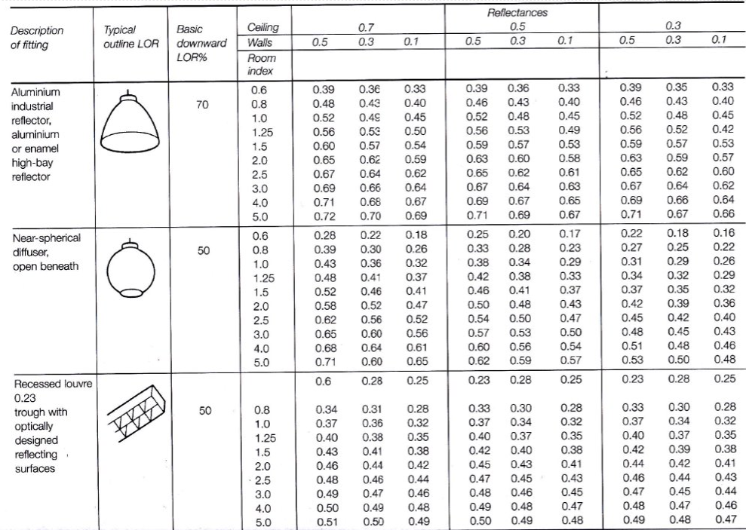

Fitting
DLOR
RI
UF
Number of Lamps required
In order to work out the number of lamps needed a formula is used. This formula is: N = E x A
F x UF x LLF

N = number of lamps required
E = illuminance level required (lux) = 200 lux
A = area at working plane height (m²) = 1400m²
F = average luminous flux from each lamp (lm) = 18,000 lumens
UF = utilisation factor = 0.46
LLF = light loss factor = 0.75

N = 200 x 1440 N = 288000 N = 46.37681159….
18000 x 0.46 x 0.75 6210

Number of lamps required = 48 lamps

Layout of the fittings
When looking at the layout of the lamp fittings it is vital to ensure that they are evenly spaced out and leaving no dark areas.

Smax = Maximum spacing
Hm = Height of luminaire from benches

Smax = 1.5 x Hm Smax = 1.5 x 7 = 10.5m

See appendix 1 for factory lighting layout drawing

Part 2
In this section, the first aspect that will be covered will be calculation of the overall sound reduction index of a brick wall containing a window fitting. The brick wall has an area of 20m² and the window fitting has an area of 4m². The values of sound reduction indexes area: brickwork 50db, window 10db
In order to find the overall sound reduction index, transmission coefficient for the brickwork and window must be calculated. This is done using the formula SRI = 10 x (log 10 (1/T))

Brickwork Window

50 = 10 x log ₁₀ (1/T₁)) 10 = 10 x log ₁₀ (1/T₂))
5 = log₁₀ x (1/T₁) 1 = log₁₀ x (1/T₂)
1/T₁ = 10⁵ 1/T₂ = 10¹
T₁ = 10⁻⁵ T₂ = 10⁻¹

Transmission coefficient for brickwork = 0.000010 Transmission coefficient for window = 0.10

The formula used for finding the overall transmission coefficient is: T₀ = (T₁ X A₁) + (T₂ x A₂)
A₁ + A₂

T₀ = overall (averaged) transmission coefficient
T₁/T₂ = transmission coefficient of asset
A₁/A₂ = area of asset

For this calculation the values are:
T₁ = 10⁻⁵
T₂ = 10⁻¹
A₁ = 16
A₂ = 4

T₀ = (10⁻⁵ x 16) + (10⁻ ¹ x 4) T₀ = 0.00016 + 0.4
16 + 4 20

Overall transmission coefficient (T₀) = 0.020008

Now having all of these figures it is possible to work out the overall sound reduction index for the entire wall. This is calculated using the sound reduction index produced previously.

SRI = 10 x log ₁₀ (1/T))
= 10 x (log ₁₀ (1/0.020008))
= 10 x (log ₁₀ (49.980007))
= 10 x 1.69

Overall SRI = 17 dB

The last aspect of this part is to discuss the implications of the factors of frequency and wavelength in internal sound management, partition wall construction and insulation material choice

When looking at the management of internal sounds it is important to ensure that all aspects are taken into consideration to achieve what end goal you want. When a sound is created within a closed space or internal room it will either travel through the object that it hits, bounce from the object or be absorbed by it. Taking these three outcomes into consideration, when constructing buildings and rooms it is vital that there are adequate measures in place to ensure that any issues from sound are dealt with. There are many methods that can be used to manage internal sound, however some sounds are harder to manage than others. With sounds, “Each frequency has a different wavelength. The deeper the sound you are hearing the longer the wavelength” (Soundstop, 2020). Sounds with longer frequencies tend to be able to travel through objects such as walls with greater effect as they lose less energy when transmitting through solid objects that that of shorter wavelengths. One of the most common methods of managing internal sounds is to make the wall thicker. This can be done by adding more insulation and the use of specialist plasterboards and sealants. Even when walls are made thicker it is not always effective with low frequency as they can have wave lengths of up to 5m (Soundstop, 2021). Another issue faced when increasing the thickness of partition walls is the loss of space due to thicker walls, which in current new build homes is often undesirable as the rooms are not very large to begin with. with this in mind when constructing partition walls, it is important to try and disturb the wavelengths in as little space as possible. In order to do this, it is vital that builders should use “smarter” (Soundstop, 2021) materials in the partition walls construction such as Tecsound which is an acoustic membrane. This will provide greater soundproofing whilst maximizing the space within the room. In order to do this the materials must combine: “Mass, Resilience, and Absorption” (Soundstop, 2021). By using these smarter materials in the there is a greater chance that the walls will absorb the sound as it attempts to transmit through, even at the lower frequency. In terms of insulation within the walls, any form of insulation will act as a form of sound barrier, however some are not as effective as others. Products such as rock wool which provide a thick layer for sound to transmit through, however it is not specifically for sound proofing. There are specialist insulation boards that have been manufactured to combat noise such as SBx boards. To achieve the best results products such as SM20 sound proofing panels can be fitted, which are rubber panels which sit beneath the plasterboard. The rubber provides flexibility allowing the waves to be disturbed and absorbed easier. Alongside these smarter materials specific acoustic plasterboards can be used again creating a greater soundproofing. By using all of these methods and materials within the construction of partition wales the energy levels that create vibrations are reduced leading to lower noise levels to the human ear.

Appendix 1
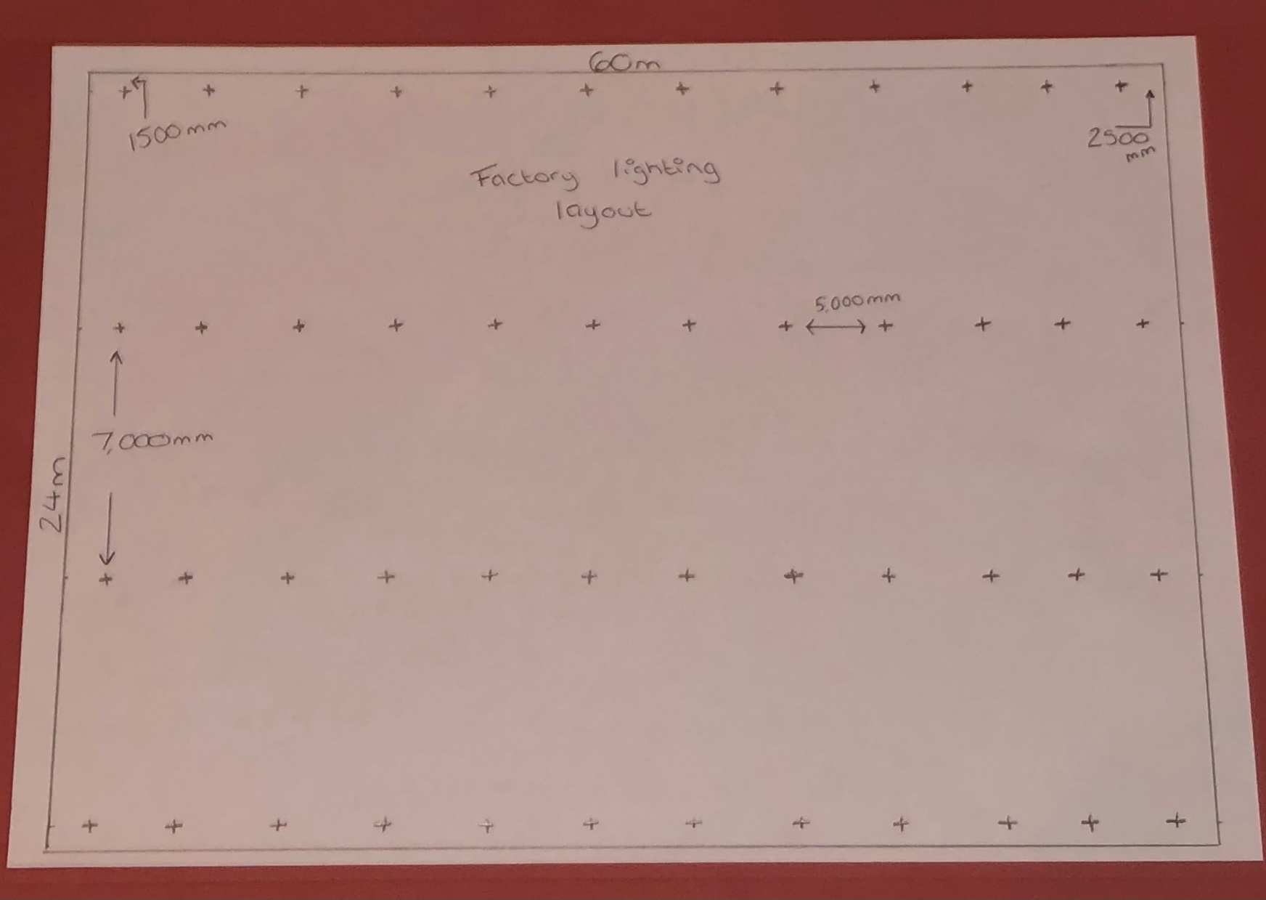

Reference list

Soundstop. (2021). The science of soundproofing. Available: https://www.soundstop.co.uk/science-of-soundproofing. Last accessed 20/04/2021.

