Games Design and History

Game Review / Analysis - Far: Lone Sails

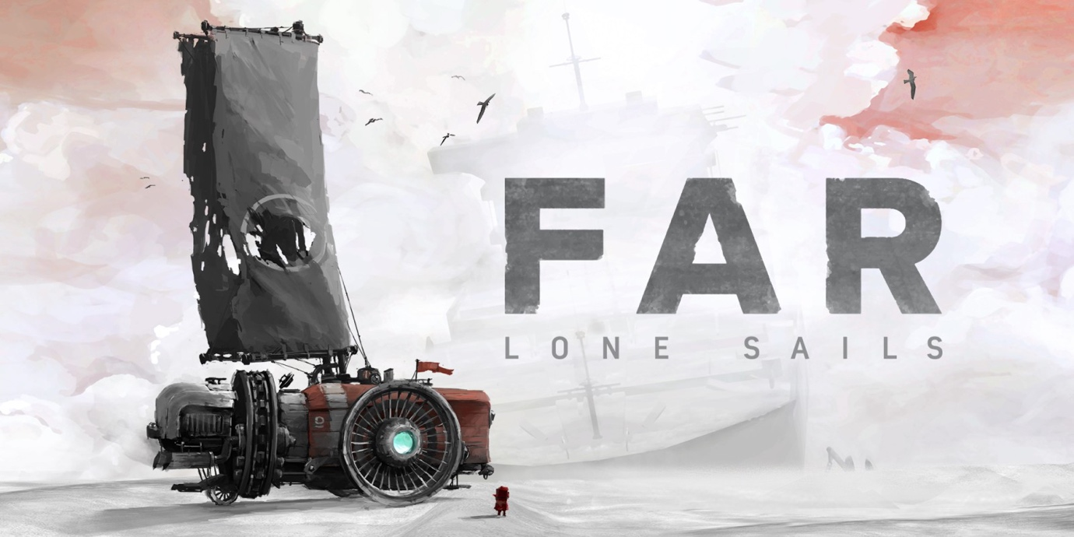

Frankie Snow (2305483)

Table of Contents
Introduction 3
Genre 3
Visual Style 4
Intended Demographic 5
Use of Audio/Visual Feedback and its Impact on the Player 5
Game Structure 6
Challenges 7
Game Flow 8
Replay Value 9
Conclusion 10
Bibliography 10

Introduction

In this report, I will be analysing my assigned game, ‘Far: Lone Sails’. Within my analysis, I will consider a variation of design choices and discuss the effects of these on the overall game, and player experience.


[1]
‘Far: Lone Sails’ [2] was developed by Swiss video-game development company ‘Okomotive’ and released for Windows and macOS in May of 2018, with subsequent versions released for other platforms in 2019.

With exceedingly positive reviews, the game’s Steam page description [3] reads as follows; “Traverse a dried-out seabed littered with the remains of a decaying civilisation. Keep your unique vessel going, overcome numerous obstacles and withstand the hazardous weather conditions. How far can you make it? What will you find?’’

Genre

The genre of a video game is usually defined by gameplay mechanics and features that are common across a group of games, and these identifying features will vary from game to game. [4]

‘FAR: Lone Sails’ is described by Metacritic as a ‘linear action adventure’ game [5] and by the FAR website as an “atmospheric vehicle adventure” game [6]. From playing the game it is clear to see how it would fall into these categories, however there are gameplay mechanics that could influence this classification.

To progress within the game, the player must travel through an unknown environment in their vehicle and complete set puzzles at each roadblock that they encounter.

This mechanic of player progression would loosely give this game the classification of puzzle/problem-solving, as it is necessary to further explore the landscape that the player completes these puzzles. They encourage the player to use problem-solving skills and keep them engaged by never breaking the immersion.

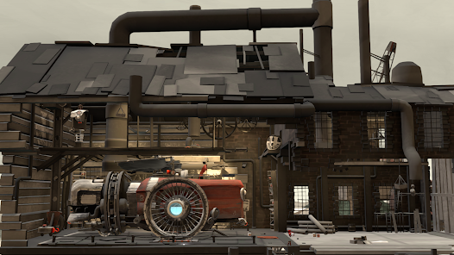[7]
The visual and audible features of this game have also influenced the genre by creating an atmosphere that is crucial to improving the immersion and experience of gameplay.

Visual Style

The visual style of a game greatly influences the player experience by conveying ideas without explicitly stating them.
FAR: Lone Sails has a very minimalist yet complex visual style, combining post-apocalyptic and steampunk visuals while utilising a strong colour palette to enhance the way the player feels immersed in the game and its story.

When interviewed, Lead Animator Martina Hugentobler spoke about the colour palette of the game, and how they wanted to convey strong feelings of loneliness through it [8]. This is evident even at a first glance as the use of colour is very limited except for accents and objects of importance. It creates a dull and empty-feeling environment.

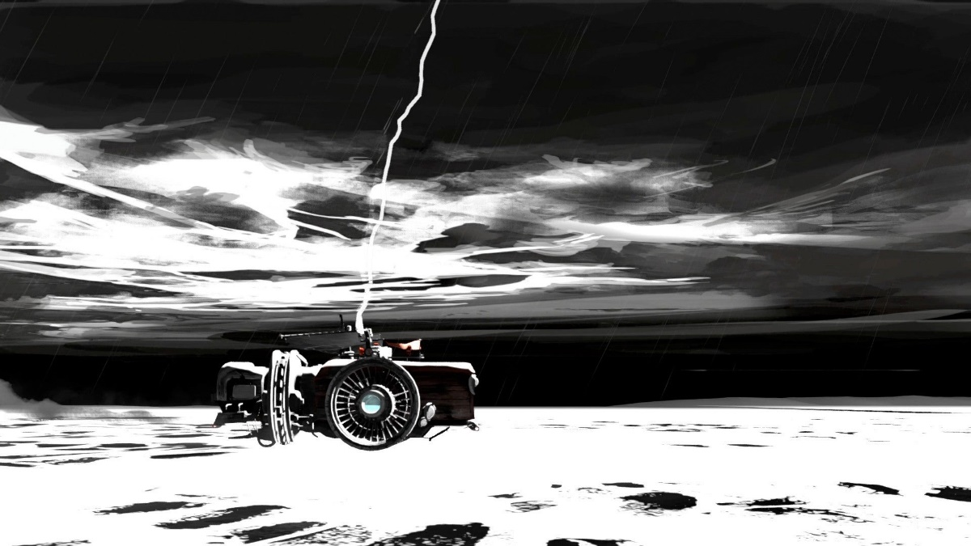 [9]
As well as the, the almost forgotten-feeling steampunk stylisation of the vehicle and objects found within the environment also helps to convey the narrative of the game and feelings of the character.

Visual elements are very beneficial to helping the player feel connected to the story as there is lack of dialogue to explain this, allowing the player to almost experience the loneliness of the character and emptiness of the landscape.

Intended Demographic

The intended demographic of a game affects the type of gameplay and the content of the story, so it is important to consider this. In terms of age, ‘FAR: Lone Sails’ is rated PEGI 7, meaning that there may be content like imagery or sounds within the game that are unsuitable or frightening for younger children. This rating implies that the intended demographic could be anyone ages 7+.

While the content may be suitable for some younger audiences, considering the level of understanding needed to work out the mechanics of the game and for story elements to be impactful for the player, the intended demographic of the game may be higher than this, sitting more towards the most common demographic of 16-24. [10]

Use of Audio/Visual Feedback and its Impact on the Player

Visual and auditory elements are very important to furthering the gameplay experience and can have a big impact on the player. To help further the atmosphere visually, puzzles are well integrated into the landscape and appear as a part of the environment.

As mentioned previously [8], Martina Hugentobler told interviewers that the colour palette was also used to highlight important gameplay features. This impacts the player positively as it allows them to quickly learn the mechanics of the game and also helps to keep the visual elements minimalistic.
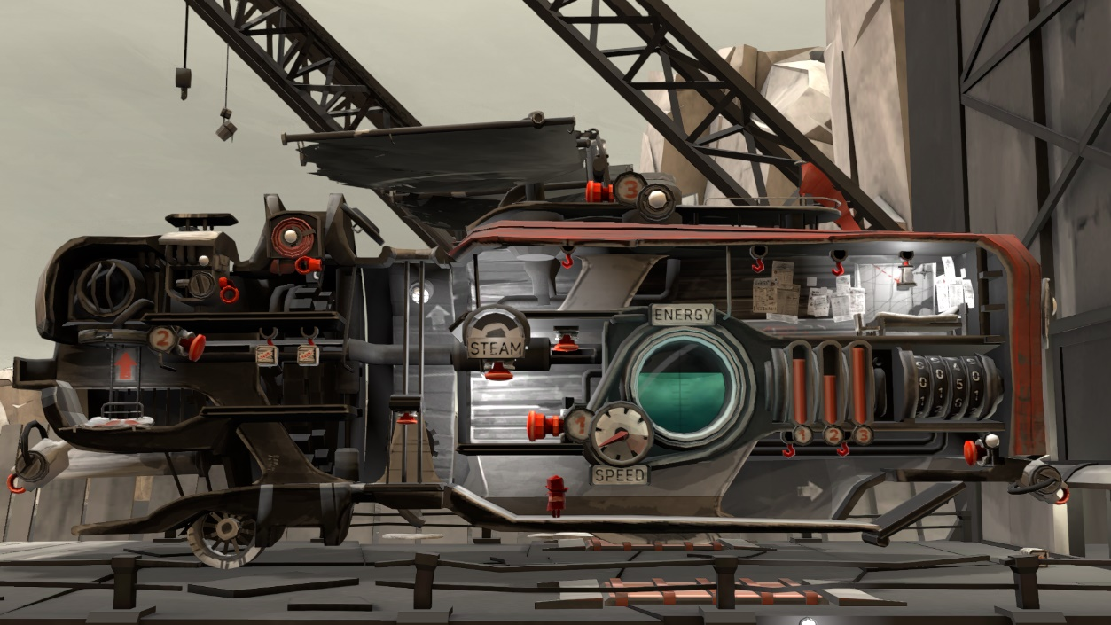[11]
In terms of audio, the game has a soundtrack that is relatively relaxed but doesn’t add much to the substance of the game. However, this is beneficial to the gameplay as it allows for the environmental noises (wind, thunder, etc.) to be highlighted.

In comparison to the soundtrack, these environmental noises have a positive impact on the player as they build upon the atmosphere created by visual elements and can help to further the story and move the player along through audio cues during notable events.

Combining both audio and visual feedback, the player knows when they are arriving in a new area or if conditions have changed as the environment colour scheme and music will change; during a section of the game, the player encounters a storm, the lighting and colour scheme becomes dark, and the music becomes louder and more orchestral.

Game Structure

‘FAR: Lone Sails’ has a very basic structure and uses three main features of construction, which Eng speaks about in his University XP article [12].

To begin, there is the initial set-up of the game where the story and gameplay is introduced to us, the player, through the use of visual elements. Next comes the ‘progress of play’ [12] or the game-loop, in which the player traverses the landscape in their vehicle, collecting items and solving puzzles.

During the game-loop, checkpoints are used when the player completes actions like solving a puzzle to remove a roadblock or to add a new part to their vehicle. Finally, there is the end game, where the player reaches the end of the road, arriving at their final destination.

As this game is an atmospheric, vehicle adventure game, the structure does not rely on a scoring system, or on the player completing tasks within a certain time as there is no way to win or lose the game.

The game is more of a visual experience for the player, and the core loop is only there to progress the story. For some players this can be a negative aspect as the main goal has no real meaning due to a lack of consequence for missing fuel or taking too much time to complete puzzles.

Challenges

The main challenges found within this game are passive and generally technical, these include managing your fuel consumption and removing roadblocks. 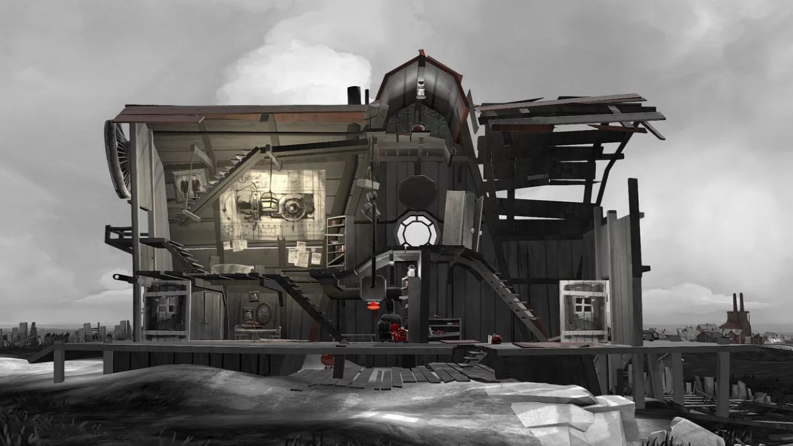[13]

While this initially is enjoyable, it can become repetitive and have a negative impact on the player experience as the challenge is the same throughout the game. Chris Crawford mentions this dilemma in his book ‘The Art of Computer Game Design’; he says, “A puzzle will always present the player with exactly the same challenge.” [14]

Further in the text he speaks about the concept of puzzles in comparison to games and how players spend time working out how to solve the puzzle, “Once the secret is known, the puzzle is no longer interesting.” [14] This reflects the downside of having repetitive-feeling challenges.

As well as this, through experiencing the game, the challenge of resource management seems to be a perceived challenge. The player is able to continue moving long after they have used up their fuel, exploiting a mechanic allowing them to drag their ship, keeping the vehicle rolling forwards towards their next destination. This exploitative mechanic diminishes the element of conflict within the game and has a negative impact on the idea of challenge.

Game Flow

The game flow of FAR: Lone Sails varies throughout the experience. Narratively, it flows very well as it follows a set path from start to finish. As well as this, the pacing of the game affects the flow, and this also changes throughout gameplay - it slows when facing challenges like running out of fuel and stopping to solve puzzles.

However, narrative and pace aren’t the only things that affect the flow of the game. As mentioned by Daniel in his article “THE FLOW THEORY APPLIED TO GAME DESIGN” [15], good game flow creates player engagement.

Important factors that affect the flow includes rewards, clear goals, ‘loss sense of time’ (immersion), a balance between skill and challenge, and control. These factors all can have a positive effect on player experience as they help to move the game along and keep the player engaged.

The player can experience some of these factors within my game, with rewards in the form of achievements and upgrades for the vehicle, ‘loss sense of time’ as the player can become fully immersed in the landscape through the use of visual and audible elements, and control in the form of resource management and starting and stopping the vehicle.
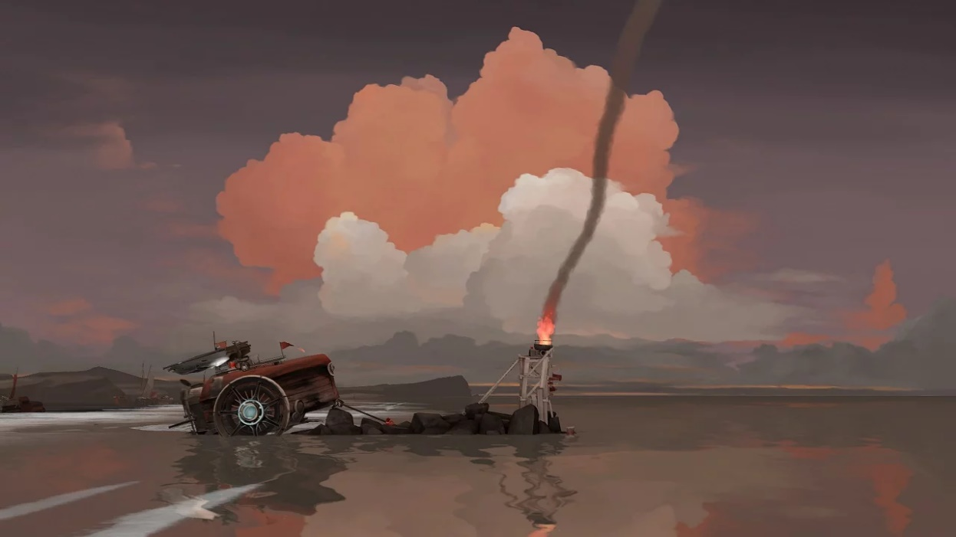[13]
The game lacks a clear goal as there is little that prompts the player and informs them of their task, all they know is from inference and that is to travel forwards and collect fuel. This can be detrimental to the player experience as there isn’t really an over-arching challenge to overcome.

There is also a lack of skill-challenge balance, as the puzzles do not scale in difficulty with the players skill – however, this is not a necessary element as the game is more of a visual-narrative experience.

Replay Value
When designing a game, replay value is a massively important aspect that is necessary to consider. From playing the game, it is clear to see that it has a very linear narrative, and a limited number of objects the player can interact with.

Due to the repetitive challenges faced and lack of dialogue or interaction with any characters, the narrative can be difficult to decipher and there are few opportunities for players to have unique experiences when playing the story.

As well as this, there are few hidden secrets for players to find, meaning the game has little value for those who specifically play to enjoy in-depth exploration and achievement hunting.
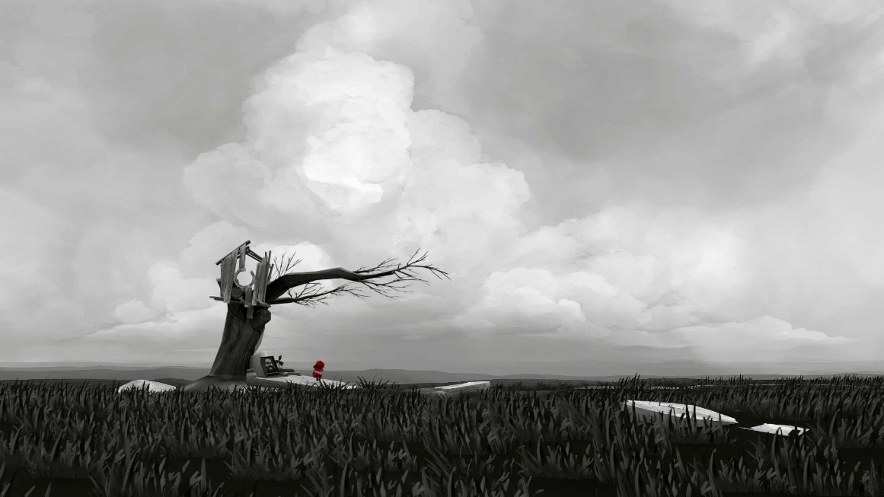 [16]

This direct way of storytelling can be effective in story-driven games; however, it removes the element of choice and the excitement of exploration from the player. This has a negative impact on the player as it can feel like they have received nothing in return for the time, effort and money they have spent.

Positive and Negative Aspects
FAR: Lone Sails as a game has both positive and negative aspects that affect the player experience. Positively, the game offers good theming through its visual elements; the colours and art style have an ability to well illustrate the player’s journey through the rough landscape. This is beneficial when it comes to player immersion as the stylisation draws the player in and keeps them engaged with changes in the landscape.

As well as this, I feel that the game’s structure could also be a positive aspect. After setting up the story, there is a simple game loop for players to become hooked by; and while it is not inherently challenging, it is something that you can become lost in while admiring the changing scenery.

On a more negative note, the game has little replay value. I feel this could be detrimental as once the game has been completed, there is little that can motivate casual players to start a new game and complete another playthrough. While the atmosphere is redeeming, there is only so much to experience.
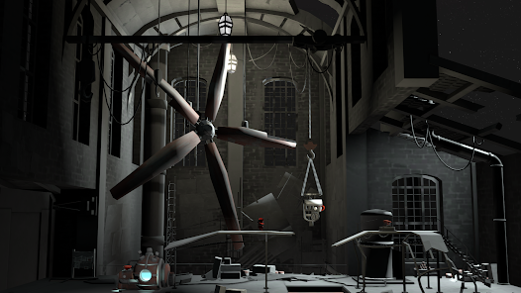[17]

In relation to that, like I mentioned previously, there is a lack of challenge within the game. The perceived challenge of resource management is only a challenge until the player realises, they are able to drag their vehicle to the next destination or next pile of fuel. As well as this, with the puzzles required to remove roadblocks, if the player is able to quickly work out these puzzles, or has seen someone else play, the challenge of each roadblock is removed.

Conclusion
To conclude my analysis, FAR: Lone Sails has a lot to offer players who are looking for a very visual and atmospheric journey, and is a relaxed, slower-paced game with an almost hidden story. The genre classification is accurate to the gameplay, with the addition of puzzle/problem solving to cover the section of the game with these elements.

It relies heavily on audio and visual elements to push the games story and I feel would not be suitable for many younger players due to the understanding needed to piece together the story.
In relation to this, the use of colour and sound is a huge part of the game and is very important to the overall experience; not only does it help to create the meticulously designed atmosphere, but it is also functional and ties in with game mechanics, showing change in the environment and hinting to the player what their next task will be.

Bibliography
[1] Okomotive, “Profile Picture,” Twitter. [Online]
Available: https://twitter.com/okomotive
[Accessed Oct. 10, 2023.]

[2] Far: Lone Sails. [Software], Wiesbaden:
Assemble Entertainment, 2018.

[3] Assemble Entertainment, “Far: Lone Sails,” Steam Store, (2018, May. 17). [Online] store.steampowered.com.
Available: https://store.steampowered.com/app/609320/FAR_Lone_Sails/
(Accessed Oct. 10, 2023.)

[4] B. Svitlana and B. Alina, "Game Mechanics as Videogame Genre Identifier," Global Media Journal, vol. 16, (30), pp. 1-6, 2018. Available: https://www.proquest.com/scholarly-journals/game-mechanics-as-videogame-genre-identifier/docview/2057263566/se-2.
(Accessed Oct. 12, 2023.)

[5] Metacritic, “FAR: Lone Sails details,” Metacritic, (2018). [Online]
Available: https://www.metacritic.com/game/far-lone-sails/details/
(Accessed Oct. 12, 2023.)

[6] Okomotive / Mixtvision, “Lone Sails - An Atmospheric Vehicle Adventure Game”, FAR, (2018). [Online] Available: https://www.far-game.com/#
(Accessed Oct. 12, 2023.)

[7] Assemble Entertainment, ”FAR: Lone Sails - Apps on Google Play”, Google, (2020, Oct. 8). [Online] Available: https://play.google.com/store/apps/details?id=ch.misterwhale.far&hl=en_US
(Accessed Oct. 15, 2023.)

[8] prankster101, “Interview with Okomotive - developer of FAR: Lone Sails”, PRANKSTER101 PRODUCTIONS, (2017, Dec. 6) [Online]
Available: https://www.prankster101.com/articles/interview-with-okomotive-developer-of-far-lone-sails/ , (Accessed Oct. 15, 2023.)

[9] T. Marks, “Far: Lone Sails Review”, IGN, (2019, Aug. 18) [Online] Available: https://www.ign.com/articles/2019/08/16/far-lone-sails-review (Accessed Oct. 15, 2023.)

[10] J. Clement, “UK gaming by age and gender 2022”, Statista, (2023, Aug.18). [Online] Available: https://www.statista.com/statistics/300513/gaming-by-demographic-group-uk/ (Accessed Oct. 15, 2023.)

[11] R. Ismail, [Press Kit], Okomotive, [Online]. Available: https://www.okomotive.ch/presskit/sheet.php?p=far_lone_sails#images

[12] D. Eng, “Formal Game Structures”, University XP, (2019, Jun. 4). [Online] Available: https://www.universityxp.com/blog/2019/6/04/formal-game-structures (Accessed Oct. 20, 2023.)

[13] S. Sannerude, “FAR: Lone Sails (PS4) Review - GamePitt – Mixtvision”, GamePitt (2019, May. 10) [Online] Available: https://www.gamepitt.co.uk/far-lone-sails-ps4-review/
(Accessed Oct. 20, 2023.)

[14] Digital Press, “The Art of Computer Game Design - digitpress.com”, digitpress. [Online]
Available: https://www.digitpress.com/library/books/book_art_of_computer_game_design.pdf (Accessed Oct. 21, 2023.)

[15] Daniel, “THE FLOW THEORY APPLIED TO GAME DESIGN”, (2019, Apr. 16), Design Better Games. [Online] Available:
https://thinkgamedesign.com/flow-theory-game-design/#:~:text=It%20is%20a%20state%20and,the%20flows%20in%20video%20games. (Accessed Oct. 25, 2023.)

[16] C. Byrd, “FAR: Lone Sails' is a tranquil adventure game – GreenwichTime”, (2018, Jun. 15), Greenwich Time. [Online] Available: https://www.greenwichtime.com/entertainment/article/FAR-Lone-Sails-is-a-tranquil-adventure-game-12998107.php (Accessed Oct. 27, 2023.)

[17] Assemble Entertainment,” FAR: Lone Sails - Apps on Google Play”, Google, (2020, Oct. 8). [Online] Available: https://play.google.com/store/apps/details?id=ch.misterwhale.far&hl=en_GB (Accessed Oct. 27, 2023.)

