CONFIRMATIVE PRAXIS
(M7X02024)
TOMOS JAC EDWARDS
P149510
MA PRODUCT DESIGN


Journey through a
Volume of identity –
Exploring design
methodologies in
relation with poetry
and language

Confirmative Praxis

CONTENTS

Table of
Chapter
Page

1.
Note to Reader/Abstract

1.
Introduction
1.
The Project: Theorising Praxis

Steps and Inspiration -
Part 1: Data Extraction Methodologies
1.

1.
Part 2: Blank Design
Part 3: Application and manipulation of data to design
1.
1.
Bibliography

1.
Design Response – (Case studies)
Reflection and Conclusion
1.

Note to Reader/Abstract

Within this report I aim to give context to my project for the confirmative praxis module. In short, the project comes initially from a volume of identity researched in explorative research and praxis, in this report I aim to show where initial inspiration came for the idea, the theory as to why I am doing said project, influences of artists and designers and their projects. Capping off with my design response in relation to my theoretical work (research). I will critically analyse my project and develop self-reflection in order to summarise and conclude the project.

I can confirm that all report writing is of my own doing and follows the Harvard referencing system when necessary. Any works not of my own, will be correctly credited throughout.

Introduction
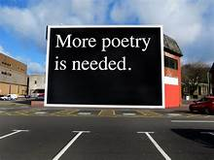
To think for the first three years of my university life in Swansea, I would rarely give this slogan a second glance as passing by to my accommodation is quite mad to think about now. Commissioned as part of a Dylan Thomas 100 project (Dalling,2018) It sits on the end of the quadrant shopping centre and is one of a number of pieces dotted around the city as part of the 100th anniversary of Dylan Thomas. A very direct message from the producer of the art piece Jeremy Deller and since it’s unveiling has proved to be effective, with writer Rachel Trezise responding to the piece with six micro fictions on coasters and gifted to bars and cafes around Swansea.
(Deller,2015) via The Modern Institute/Toby Webster

A very simple but breath-taking piece which has had a resulting effect not only on Trezise but also myself, helping along with other influences start my crazy journey into poetry and resulting fascination with the quite alien discipline. The last time I had really thought about poetry was in primary school where we where tasked to write a poem on a topic of our choice, low and behold my entry which was based on the football player Didier Drogba was included in that year’s addition of ‘Little Laureates – Poems from Wales (2008). Never in my wildest dreams did I think when I arrived to study product design would I be even considering the thought of poetry, Exploring identity in small volumes in explorative research and praxis allowed me to follow this journey to poetry and it’s uses in design.
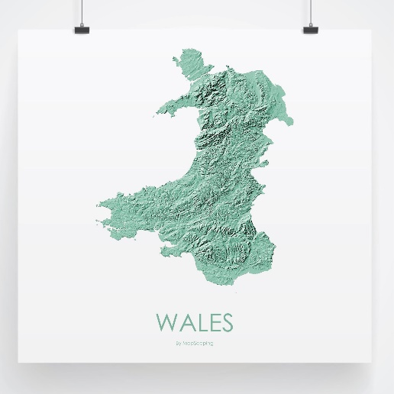
The volumed stemmed from the idea of further researching into Wales and the Welsh language, having lived in Wales my entire life and Welsh being my first language I thought what better opportunity will I get to understand Wales at a deeper level. I found Wales to have such a vast history covering everything from the Celtic roots using their symbols to convey your feelings to a young lady through the craft of a love spoon to the adoption of ‘Hen Wlad fy Nhadau’ as the national anthem in 1856 and the first transmission of S4C in 1982.
I had the opportunity to really experiment through an array of disciplines to gain a better understanding of just how great Welsh history and culture is. As you can see below some of the work that I created during that project which played a role in shaping Welsh history and culture as we know it. In (fig 3) I was looking at the language and how in different areas of Wales we have different ways of saying things, finding a Facebook page which upload a variety of slang words to see if anyone had ever heard them before. (Fig 4) is where I learn more about the Celtic symbols and there meaning toward love and support to the carvers who used the as gifts to the women that they wanted to pursue a relationship with the illustrations are just two of many that I sketched at the time playing with the form of the spoon whenever possible. (figs 5- 7) are all in relation to the Welsh not which was used in schools to discourage the use of the Welsh language, I wanted to do the opposite an antipodal as such through posters which would be placed all over the school premises and public spaces. (fig 8) is also in response to the Welsh not and instead of having to wear the wooden block around your neck in shame of speaking Welsh, the necklace was made to promote using the Welsh language and would be awarded to the best Welsh speaker of each year. In (fig 9) I was inspired to do some drawings of the countryside surrounding me following research into Kyffin Williams, Thomas Jones, Peter Prendergast.
(O’Donohue,2018) via Mapscaping, 2021

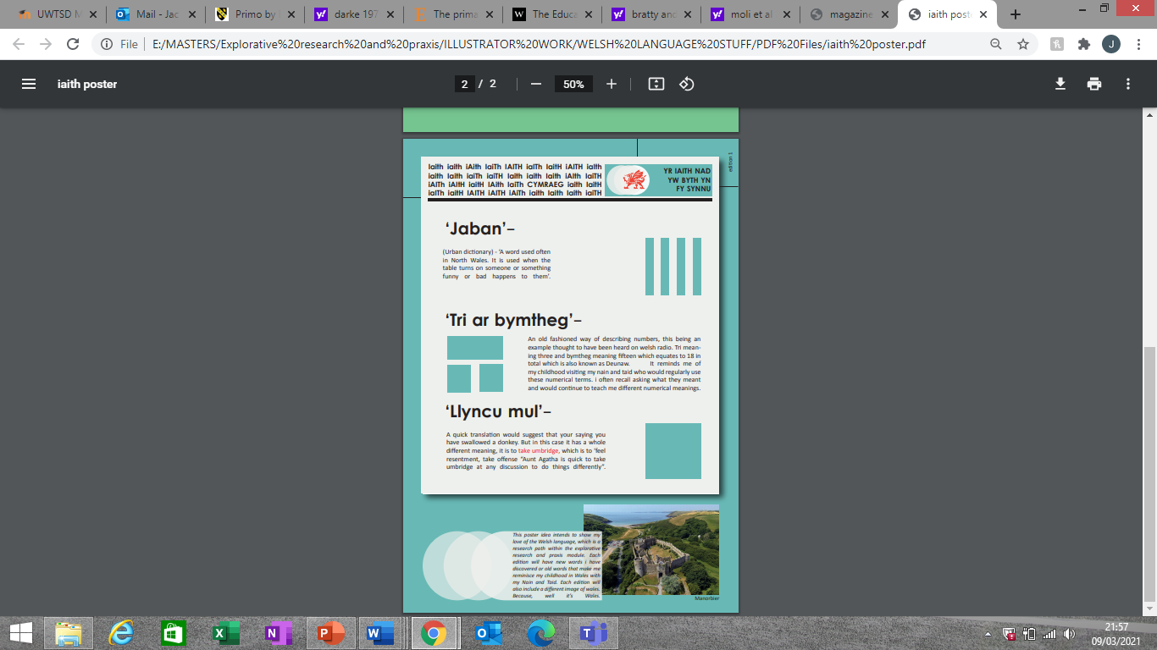
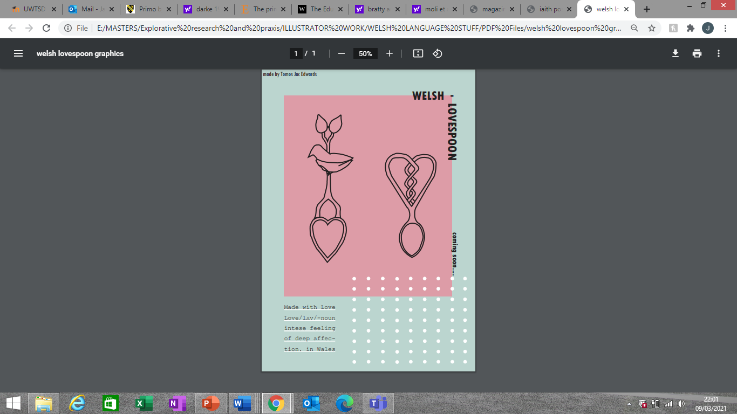
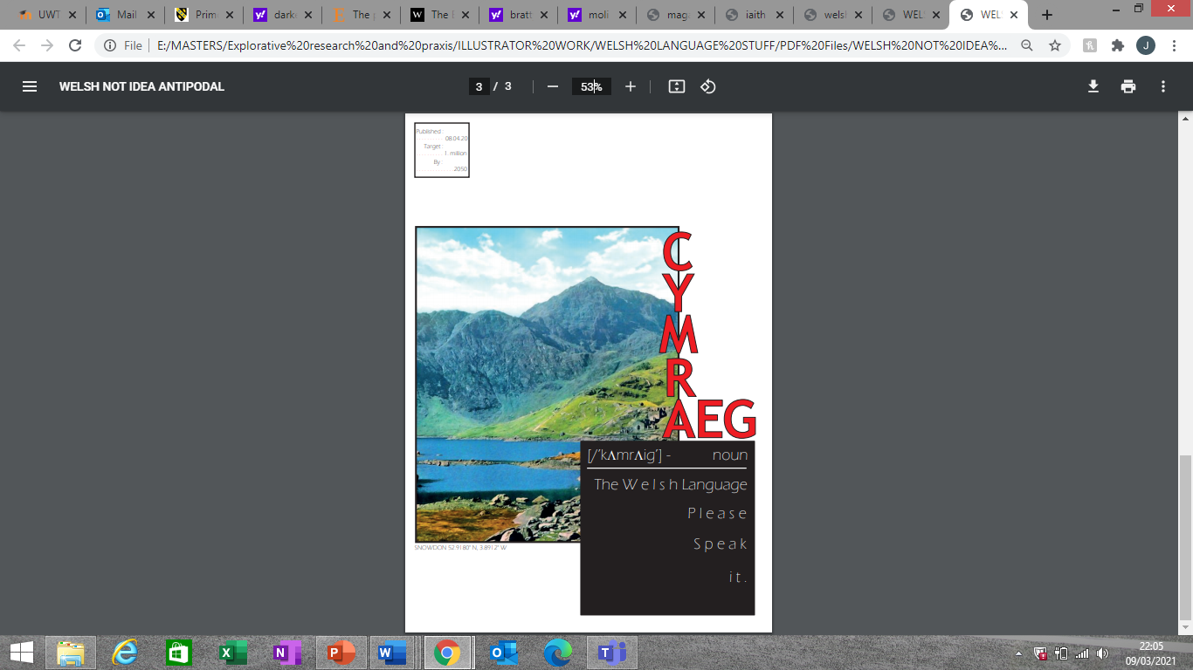
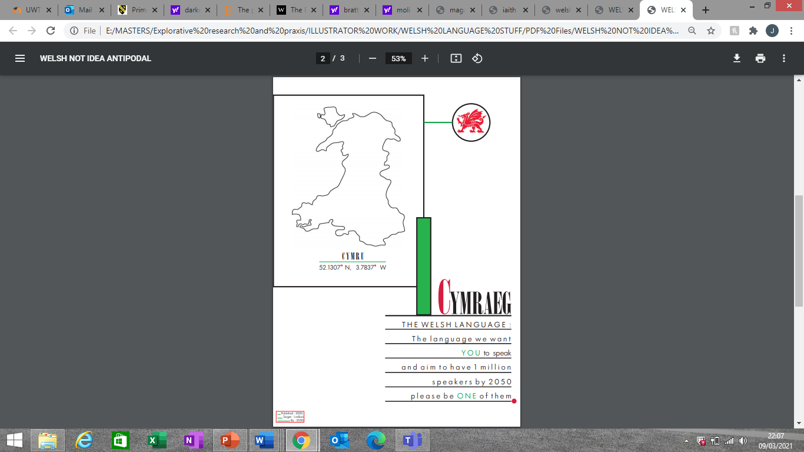
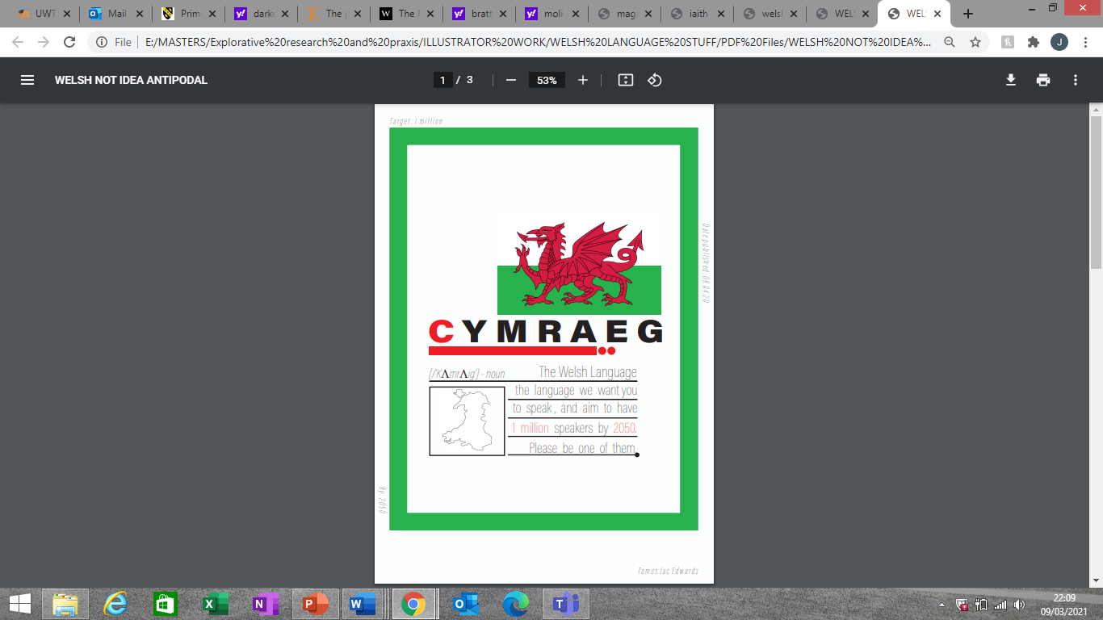
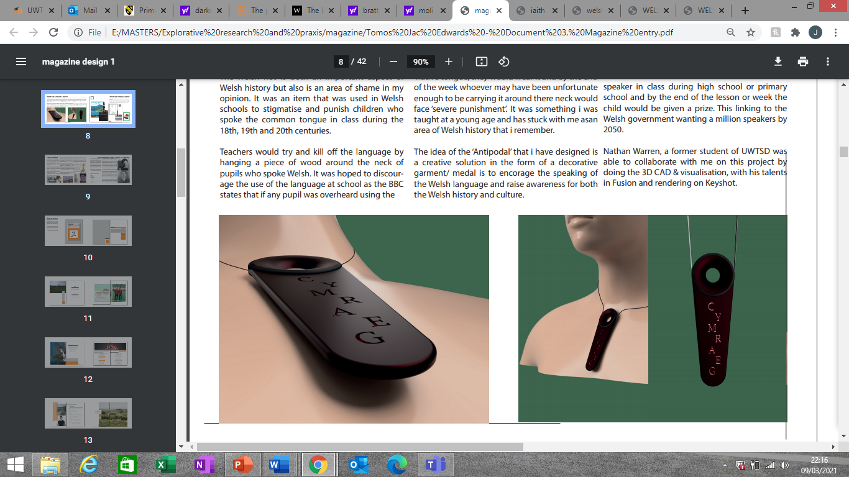
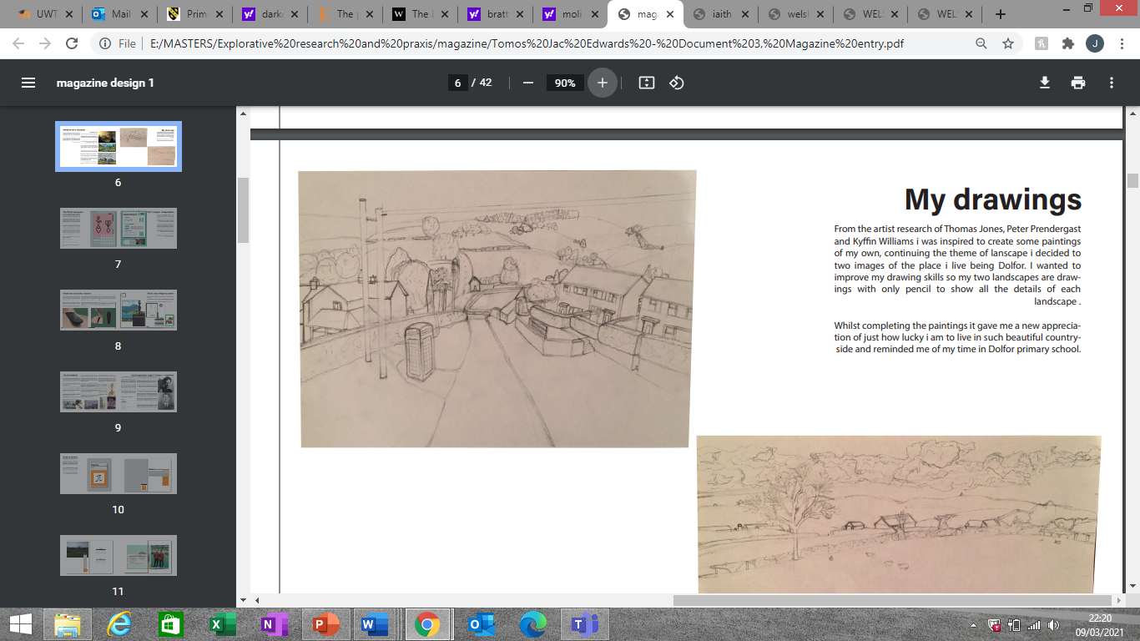
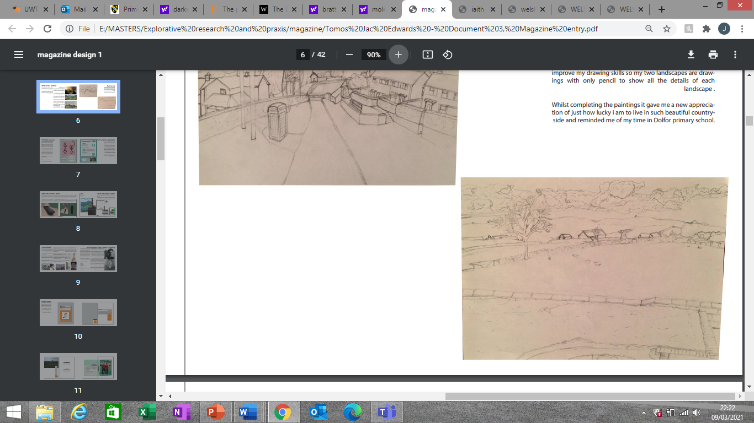
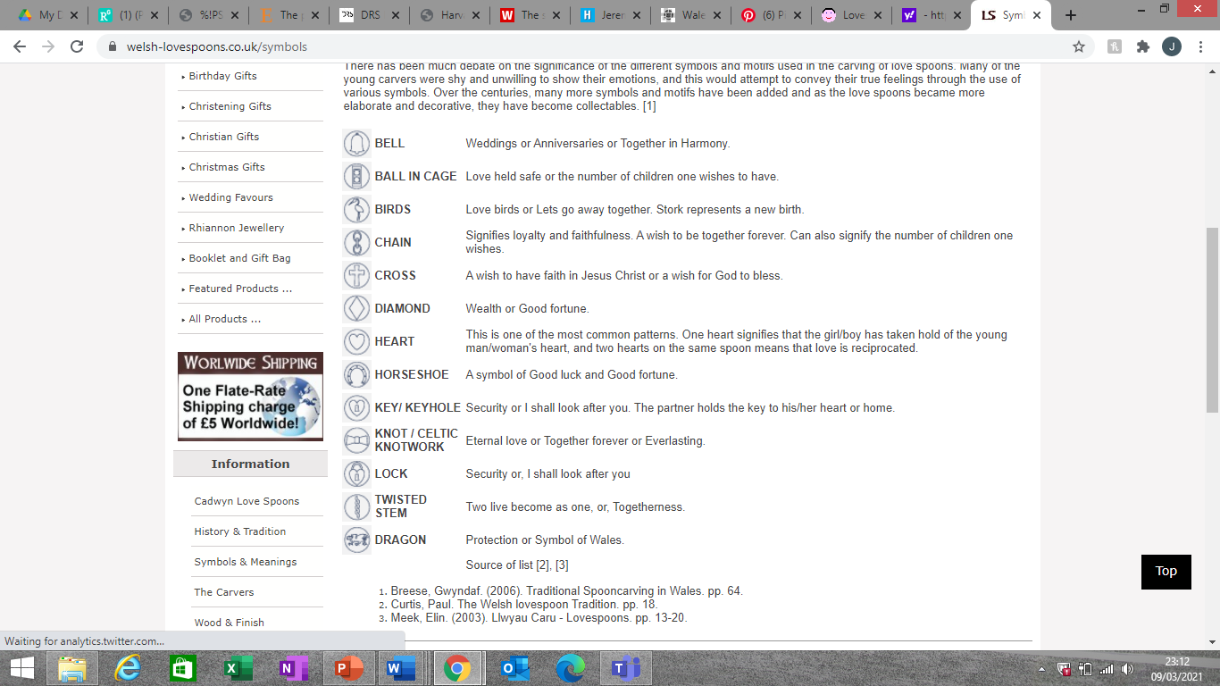
(Curtis,2021) via Welsh love-spoons
(fig 3 – ‘Iaith poster’)
(fig 4 – ‘Welsh love-spoon concepts’)
(fig 5 – Welsh not antipodal #1)
(fig 6 – Welsh not antipodal #2)
(fig 7 – Welsh not antipodal #3)
(fig 8 – Welsh not antipodal product)
(fig 9 – Drawings inspired by Welsh artists)

There was however one area in Welsh culture that really was above the rest in terms of it’s importance to Wales, popularity and uniqueness. This being the Eisteddfod, one of the biggest events on the Welsh calendar, Welsh speakers and enthusiasts gather every year to celebrate the Welsh language and Wales’ culture and history. Dating back as far as 1176 there are many traditions and events which take place throughout the week. These events range from traditional dance and singing to piano solos and theatrical performances.
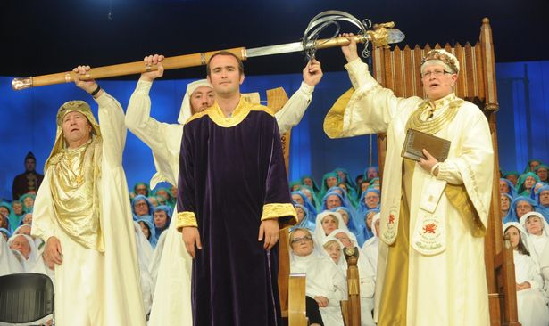
This is really where the project kicked in for me, thinking back to a conversation with my Nain and Taid (grandparents) who are fluent Welsh speaking and big fans of the Eisteddfod. I visited them at there home in Llanbrynmair in 2018 and it was on the Friday of the Eisteddfod, I was at the time telling them about my final year of undergraduate study and trying to come up with an idea to do as a major project. My Nain suggested the idea of the Eisteddfod chair, she believed that there was an open competition held every year to be able to design said chair, having chose another project for the major project I thought what better time to research the idea of designing the chair than now. I began looking in detail at the reason for the chair and its significance and quickly came to the realisation that it’s considered as one of the most important aspects of the whole week of the Eisteddfod. A ceremony to celebrate the best Awdl which is in strict Welsh metre form known as cynghanedd (National Library of Wales,2013) The winner is brought onto the stage to begin the ceremony and is treated almost like royalty throughout with the chairing being awarded to the poet to take home with them.
(Crump,2015) via the Daily Post
The significance of the poem and poet and the fact that in some years the chair has not actually been won as the poems entered where not worthy was where my fascination and amazement of not only Welsh poetry, but all poetry began, researching particularly famous poets from Wales in Hedd Wyn and Dylan Thomas along with walking by the ‘More poetry is needed’ sign, inspired me to write some of my own poetry.
Discussions with Catrin Webster about the project led to challenging the relationship between poetry, language, and design and whether there where opportunities to use characteristics of poetry and language analysis in the design process, as a design tool as such. Thus, began the obsession for myself to find practitioners and ideas who had explored these notions previously to good effect, learning about their methods, characteristics of different poems and exploration into language. Compiling ideas from the likes of Stephane Mallarme, Patrizia Marti, Virginia La Charite, John Cage and Russell West Pavlov. Along with information gathered on sounds of languages, rhythm in poetry and design, structure, and mood/tone of poetry. I had just this mass of fantastic data and led to the first addition of ‘A guide to: Language and poetry as a design tool’.

I understood at the end of the project that this was the volume that I wanted to pursue further in confirmative praxis, originally wanting to solely create an Eisteddfod chair toward the national Eisteddfod which would use some of the methods from the handbook to shape the final outcome. Pressures of COVID – 19 creating problems logistically to be able to create models with access to workshops and some software where undoubtedly on mind, and also, I had the epiphany of what was it that I really wanted from the project what did I see as the key driving force to continue with this project. Well, it was clear in that moment that the potential of the handbook was really what was fascinating to me. The idea that I had culminated all of these methods that could be used as an approach to design not only for me but for other creatives in their respective fields a chance to explore their practice through a new medium. That, that’s what has excited me throughout the course of this project and will explain further as I continue through this piece of writing.
The Project: Theorising Praxis
As discussed earlier the project has really been about creating a new methodological approach to design through the medium of language and poetry. Understanding what it is that shapes and forms poetry and how this has a relationship with art and design. The idea behind the ‘approach’ is to allow multiple creative minds use the methods enlisted in the handbook easily and effectively without any further need for explanation from it’s creator/author (being me initially).
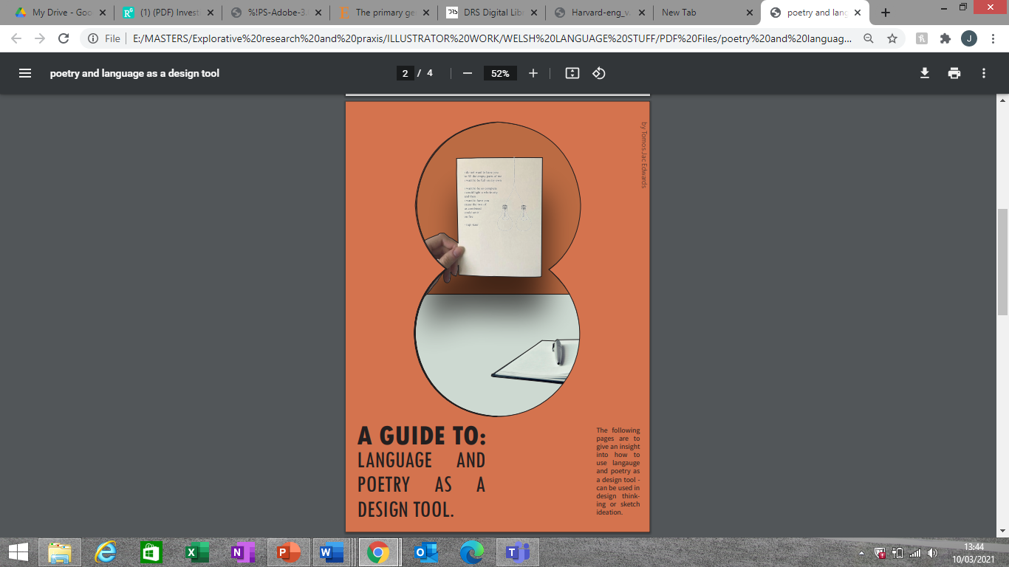
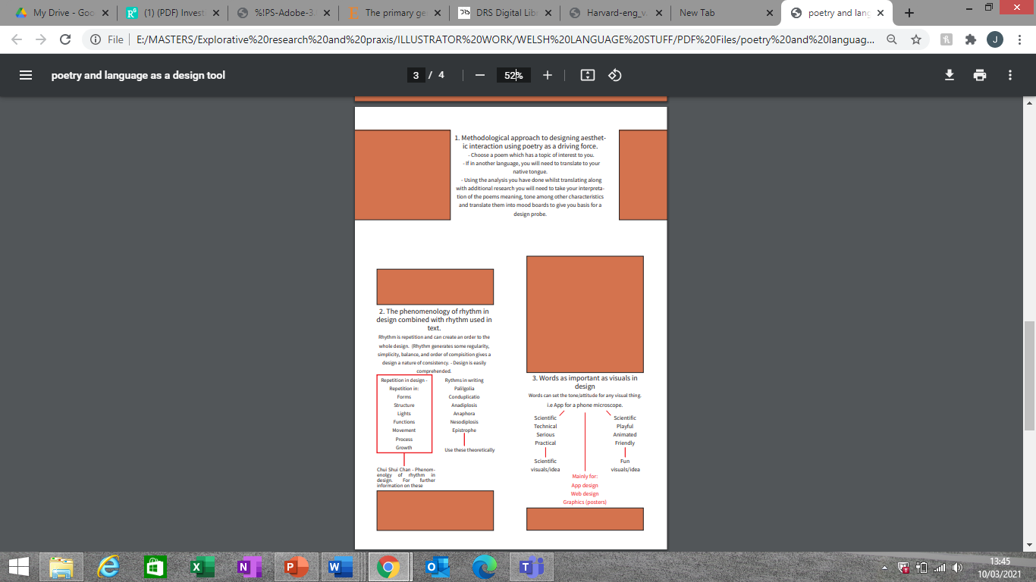
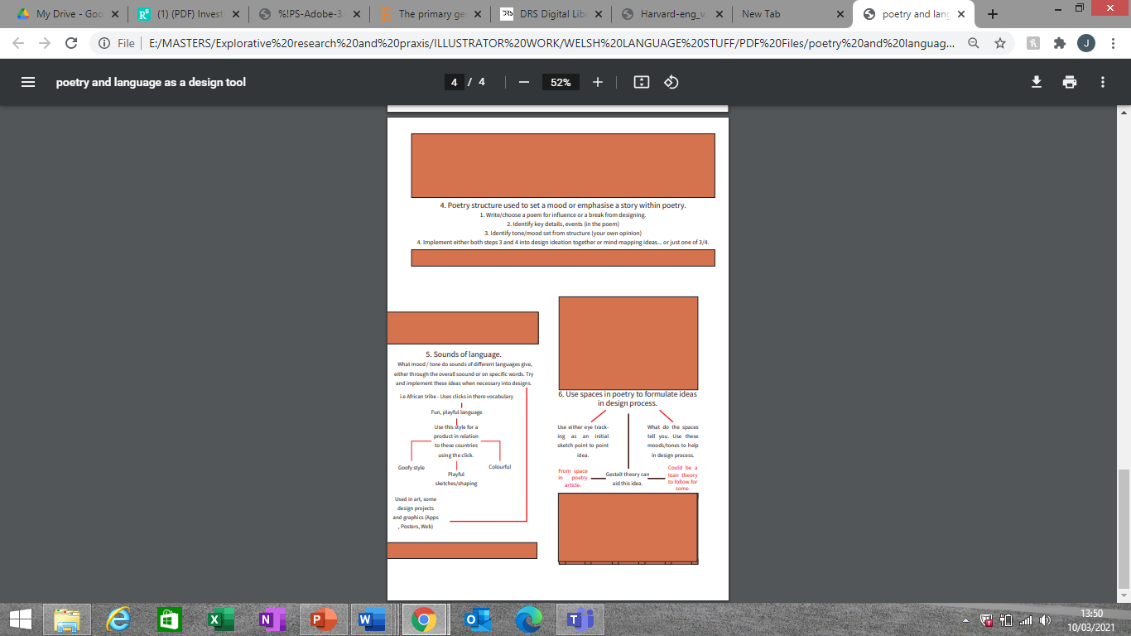
The project in it’s simplest form has been to understand my original methods, refining and fine tuning each one meticulously.
(fig 11 – Original language and poetry as a design tool handbook)

Re reading the original guide (fig 11) I was able to understand straight away how there is lack of information and guidance provided with limited description as to why the method is included and how to use it effectively. Hence the need to for a re-edit to include reason, easy to follow steps and visual aids/ideas in order for not only a 3rd part to use but also myself. Without digging into data and conception from last years extensive diary of research I did not feel confident enough to implement and execute any one of these methods processes into a product of choice. Choosing not to create a fully fledged final design for the Eisteddfod in the form of a bardic chair personally is the best choice, it allows for a wider understanding of the potential of the main focus of the project being the design tool (handbook). This being done through a case study as such, the case studies still follow the three core steps that are needed in order to use the handbook effectively.

These steps are as follows:

Step 1 – Data extraction – Upon application of selected methods from handbook to chosen poetry.
Step 2 – Blank design – A result of time pressured volume centric sketch and model development
Step 3 – Application and manipulation of data into selected design/artefact – Using step 1 to ultimately edit and dictate aesthetic and characteristics of your chosen project.

Note: Step 2 will not always be needed, depending on your practice as to whether it is necessary to have a design/piece to work from to manipulate or if would be more beneficial for the methods to produce your chosen piece in its entirety.

Before going into each step, let’s first take a look at the theory behind the idea. Poetry is more thatn just rhyming words over a series of lines it’s about being able to express your feelings and ideas in a creative way, for the people who may not be artistic and feel language is their art form then poetry is the perfect substitute.
Simply typing ‘what is poetry?’ in the search bar on Google instantly gives you this description:
/ˈpəʊɪtri/
Noun – “literary work in which the expression of feelings and ideas is given intensity by the use of distinctive style and rhythm; poems collectively or as a genre of literature” (Oxford English Dictionaries,1395-2005)
This basic definition toward poetry allowed me to understand just how important poetry really is, allowing anyone and everyone to express their feelings who may not feel comfortable doing so out loud to an audience is truly empowering. Something that I began to grasp somewhat when writing my own collection of poems, having done various poems in Welsh and English, it was when my mother expressed a desire to write a poem for the collection when I really understood this idea of expression. Her poem was about COVID – 19 and how other factors in the world where making her feel, you could see an anger toward people who where not listening to the guidelines set for the lockdown: (Edwards,2020)
“And yet there are those who are willing
To take risks and not distance at all
Think they’ll stay hail an hearty
And continue to party
… yet even the mighty can fall
Do not mock at the measures for lockdown”
This was not the only expression of feeling however, as nearer the end of the poem she expressed joy and positivity explaining the shift into spring and the hot weather, ending on a note of care telling the reader “STAY SAFE during lockdown STAY SAFE”. These feelings where all in one poem, I could see then and there how and why people choose to write poetry and could see the benefits myself when expressing my own feelings of joy and pride when composing my own poetry.
Osborn (2016) explains how we use poetry to understand and appreciate the world. It has the ability to shed light onto the world around us, teaching us how to live and shows humans vulnerabilities allowing people to relate to each other a little bit better. Being able to analyse these poems and these people’s deepest thoughts and feelings and having the opportunity to attempt to translate these ideas into another medium such as design, to me is incredibly moving, that I get to understand a part of them, and their creative minds is incredible. I am attempting to be the middleman, a translator/message giver for even more creative people than myself who come up with these amazing pieces of poetry/literature. There’s language that I could not even fathom to attempt to write and understand myself. But having the opportunity to interpret their ideas to the best of my ability certainly helped drive the project and excited me throughout.
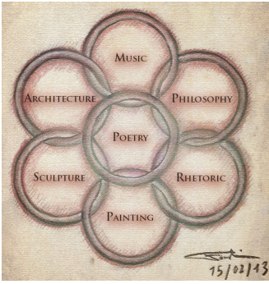
To first understand the use of poetry in design, you must first see the relationship one and other have as a pair already. Understanding there similarities in forming outcomes is identified in works by Linden Ball, Erin Beatty and Jane Darke. All of whom are outlined in works by a recurring practitioner in this project Patrizia Marti who is an advocate for the use of poetry in design. But let’s start with two students who attended Cologne university of applied studies and University of Burgos, Spain. Arash and Roozbeh Faroughi (2013) In there paper ‘On the poetry of design’, they seek to understand why the original design concept was created and which disciplines helped develop this concept. Works from the Renaissance and classical antiquity where selected to help analyse the design concept. Design as a sole concept had been developed in the Renaissance using ‘Disegno’ as it’s title. With Giorgio Vasari placing the term over architecture, sculpture and painting. According to the Faroughi’s (2013) “It was the primary concept of supporting innovations by bringing ideas to life and creating ‘never-before-seen’ things”. The likes of Da Vinci would use this concept as it would produce an infinite amount of things compared to nature. Within the paper they provide an image which depicts all of the disciplines believed to have played a part in the original creation of the concept of design. (right)
Poetry is at the centre of all of these disciplines. As the Faroughi’s explain (Faroughi,2013) “of particular importance for the invention of design was poetry. During the Renaissance period, it grew up to the art of all arts [..] and can thus also be called the mother of design”. The term poetry was seen to be derived from Ancient Greek word ‘poiesis’ meaning ‘to make or create things.’
The students close out there argument/paper, having researched each discipline by relating each to interaction design (original design concept). Ending on a note from Giannazzo Manetti (1396 – 1459) who defined the creation of things as the meaning of life. According to the Faroughi’s (2013) Manetti believed that the purpose of humans was to “reinvent, beautify and complete the world.” – This led them to deduce that the poetry of design was to invent a better world for the future. So this tells me that the formation and creation of design as a sole entity was derived from a central idea of poetry and thus rendering the never ending relationship of poetry and design.
(A & R Faroughi, 2013)
Further backed up by the other practitoners noted, best put in a summarized format in Patrizia Marti’s paper ‘poetry as a cross-cultural analysing and sensitizing tool in design’ (Marti,2017) Within the paper Marti attempts to show the need for more methodologies and tools for cultural design are needed. Identifying poetry as an avenue to follow, having previously this topic and devised a basic teaching module for her students at the Eindhoven university of technology, where she is a visiting lecturer. Here she is delving further into this idea to actually create a fully fledged poetry inspired design method for use in the design process. The idea that poetry techniques and reading can sensitize designers “to the subtleties and diversity of a (new or known) culture so that the design can be given new aesthetic and cultural significance” (Marti,2017). Having found two schools of thought:
The first – ‘A need to define taxonomies, categories and standards for cross cultural design’ and secondly a less rigid and fixed set of strategies, rather “An acknowledgement of the fluid nature of culture, calling for more sensitivity and empathy between designers and users/community”.
Feeling that there approach (working alongside E.B (Ward) Van Der Houwen) fell into eh second school of thought. Marti initially needed to understand the art of using poetry in design. Very much like myself, she attempted to understand what the similarities and relationship is between poetry and design, and further to that explore others who had been using poetry in design before her.
(Marti,2017) “Poetry is an access door to experience cultural elements and to embed them in the design of meaningful cultural interactions. Poets and artists possess the ability of thoughtfulness and observation, through which they transform existing images into a novel language of meaning and emotion”.
She first mentions the practitioners Beatty and Ball who in 2011 conducted interviews with poets about their practice and analyse these findings to find similarities between them and design. There study revealed that poets and designers use ‘sources of inspiration’ and the involvement of primary generators. Taking Darke’s ideas after studying ‘The primary generator and the design process’ where she finds there to be similarities to ‘constrain the space of possibilities’ at an initial concept phase.
These ideas really give a full understanding that there are similarities seen and a relationship there, which provides a base to tackle the main challenge of using poetry in design. I know that if I was to find practitioners who use poetry in design it would give me a frame to work from instantly and prove to me that it is in fact possible to create such a methodology. Again, looking to Marti here as a solid and successful implementation of this idea. As well as Mahsa Sanami x Siamak Panahi, who researched poetry by Forough Farrokhzad and based their findings into creating interior design solutions.
First seeing Patrizia Marti’s idea into this concept in her paper ‘poetry in design’ (Marti,2015) The paper “is a contribution to the field of Aesthetics of interaction”. Focusing on discovering new methodologies to experience elements of culture and transform these elements to endow design with new aesthetic proposals. Poetry is the driving force within this stream of thought to create a new methodological approach to design. In order to show how this approach can ultimately be used by designers. She adopts the methodology into a module for her students at Eindhoven university of technology, which she calls ‘cultural sensitivity’ First understanding work related to the subject, so understanding what similarities are there in poetry and in design (as previously mentioned in her other paper (Marti,2017)). Marti also finds works of similar goals, which follow the idea of poetic interaction in design, one of these being Moli Yeh, who adopted an operational approach “by developing a model that illustrates the process for extracting cultural elements from poetry and conveying them in design” (Marti,2015). The methodology is given through steps to follow and is inspired by Chinese poetry and turning these into representations of visual and 3D design. Furthermore, Marti discovers another practitioner’s approach. Rungtai Lin explains that poetic interaction design as a design which conveys an image of “ambiguous expression”, which can in turn visualise the writer’s personal experiences. The key to good poetic interaction is ambiguity and uncertainty. Transforming these thoughts through the understanding and ability to use Gestalt (theory). Doing said interaction should stimulate sense-making, reflection, and participation.
At the time of writing Marti believed that these concepts, in writing, showed potential of the use of poetry in design was indeed possible but where still in the early stages. With many practitioners believing in the benefits of the concept toward design, she felt that she could further the potential by contributing her own ideas into the subject which are shown in the form of Marti’s cultural sensitivity module. Marti’s process of refining the concept was still on going and can be seen to have been updated and improved upon in more recent work in 2017 (Marti,2017). But the core ideas are still the same as she presented to the students to use the first time around. Firstly, Marti gave the students a masterclass in reading and writing poetry, conducted by Dutch poet Jan Glas, who performed and wrote his poems in order in order for the reader to take their own thoughts and meanings from their experiences with the poem. Her steps for each student to use where as follows:
- Choosing poems within topics of interest to the student, Marti asked for the poems to be in another language to allow the students to translate into their ‘mother tongue’. This would not only improve skills of language but also give you a deeper, more meaningful relationship with the text.

- Extraction of values – Understanding themes, moods and emotions portrayed within the poems.

- These values are then translated into mood boards which were used as the basis for designing probes.

- These probes where transmitted into a form of working prototype(s)

- Finally, reflection from other students where asked upon, to see if the initial poems values could be identified in the design prototype.

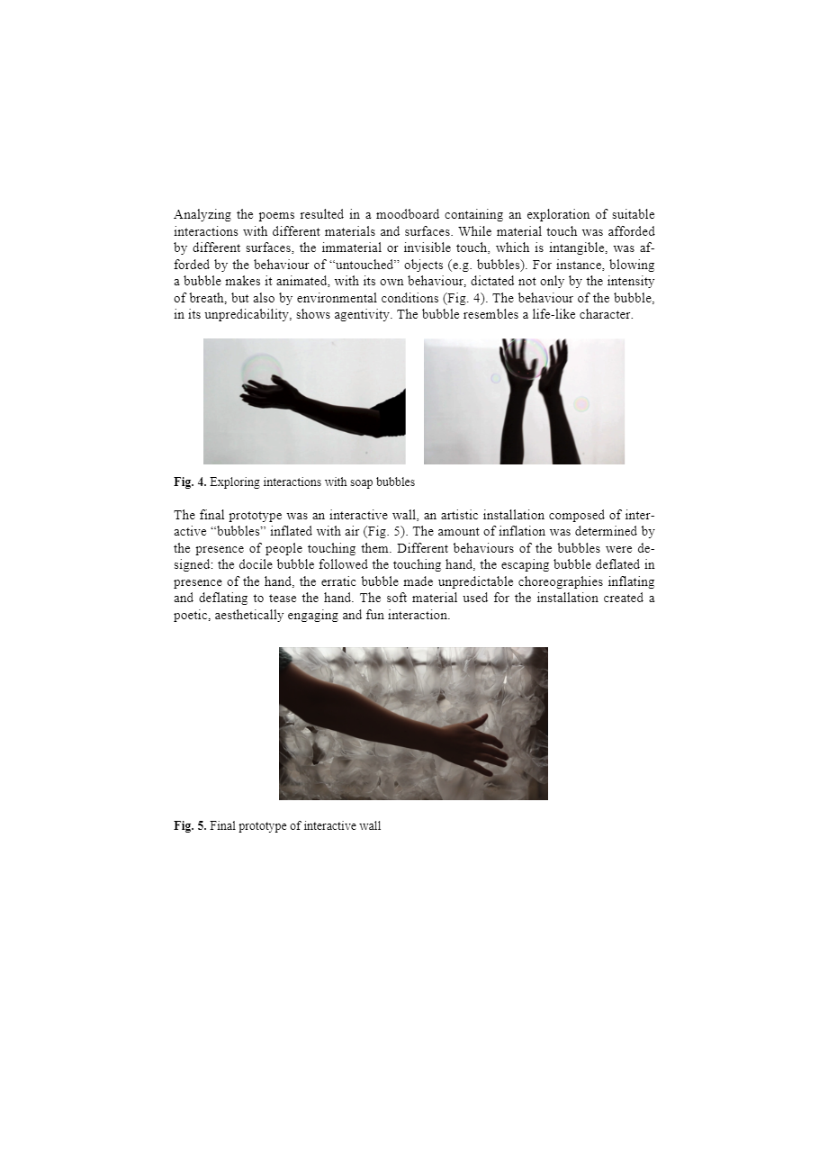
One of the students created a project titled ‘invisible touch’, using ‘View with a grain of sand’ and ‘Het Water’. The students took two concepts from these poems: “Intangibility (touching without touching), and humanization of objects (giving human qualities to objects or materials that are inhuman) – Fascinated by bubbles from soap which in turn influenced the final prototype created, an interactive wall which invited the viewer to touch the ‘bubbles’ (inflated domes/balls) in order to have a variety of sensations from feeling the balls in different states (different amounts of inflation).
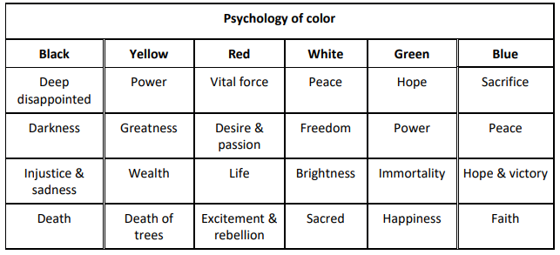
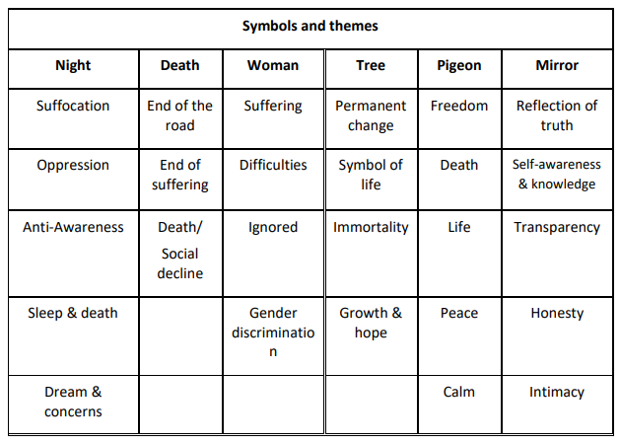
This instantly proved to me that there is a possibility to explore the use of poetry in design and will give a creative outcome filled with fantastic emotional meaning and storyline. Sanami and Panahi (2018) only back up the theory behind the concept. The aim of the paper was to review interior design based on analysis of relatable poems from Iranian poet Forough Farrokhzad. The authors look at key areas of Farrokhzad’s poetry which in turn gave data sets for symbols, subjects/themes and colours.
Fig 15 & 16 (Sanami, M & Panahi, S, 2018)
Figs 13 & 14 (Marti,2015)
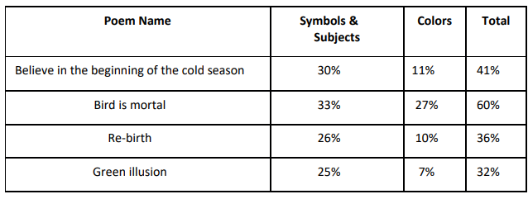
Fig 17 (Sanami, M & Panahi, S, 2018)

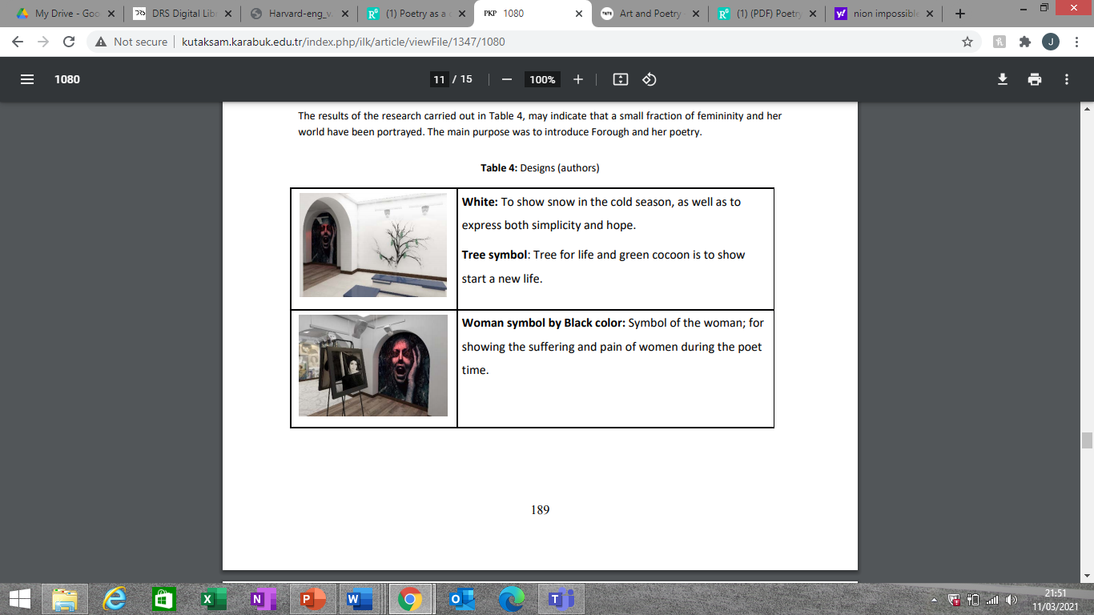
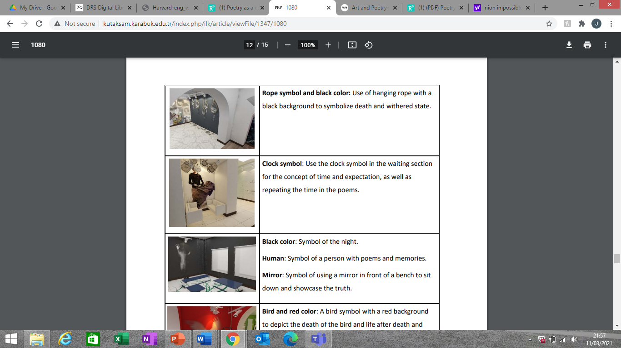
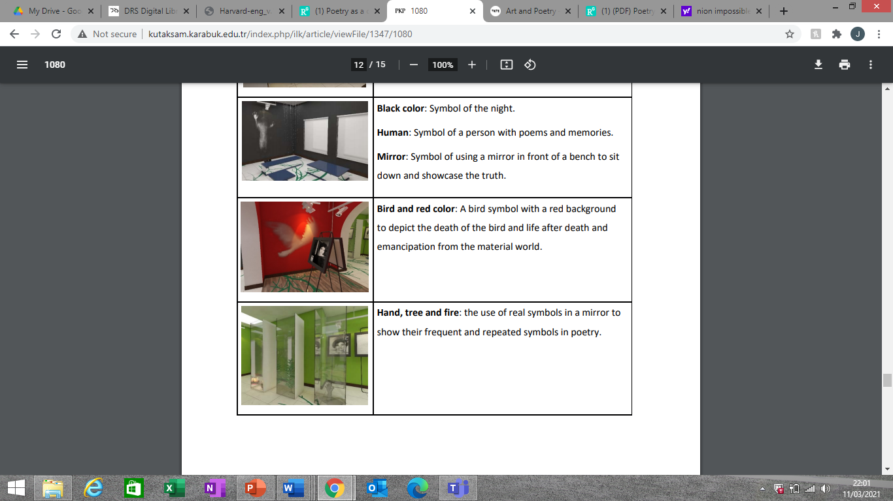
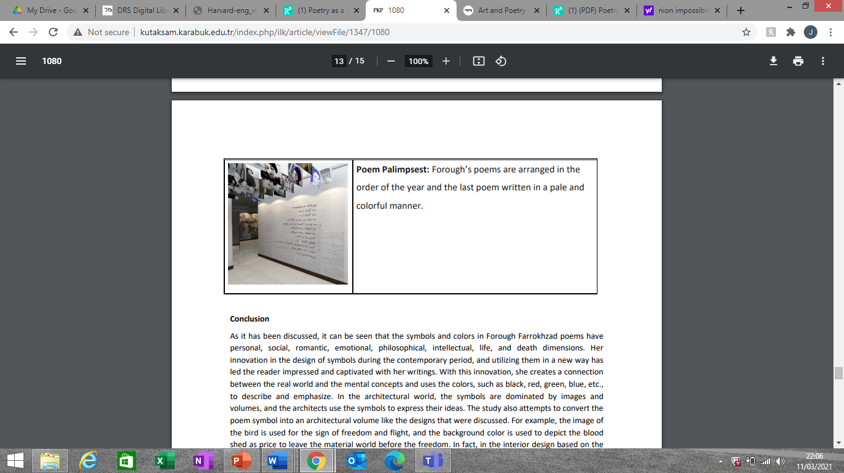
The authors understood that it is nigh on impossible to achieve the poets thoughts in there entirety (purest form), but the addition to this being that you get a look at the readers analysis and sensitizing tool/skill set toward design following these ideas from the poem and conveying them into a design form.
The results are shared in the form of a table as can be seen (left):
The results gave a fantastic visual example to myself as to how poetry can instrumentally effect such a visual aesthetic centric thing in design and architecture. It just adds a new perspective to your practice.
I understood from a theoretical perspective that the concept of using poetry in design was in the realms of possibility as Marti explained in her ‘poetry in design’ paper, the overall concept is there and the potential can be seen but it’s still “in its dawn” (Marti,2015).
I could see the benefits of collecting the ideas already theorised and add my own concepts into some form of book or guide for others to experience and use as a solution in their own practice.

Steps and inspiration
To truly gain an understanding of my project in its entirety you need to delve into each step of the process at a much deeper level. Once you gain confidence in grasping the whole point of each step, why it is needed and what made it become what it is to this point, then, that is when you can truly immerse yourself into this project and create really powerful, meaningful work influenced by poetry at its core.I think it’s appropriate to note here that the more you allow the poetry to do the thinking in its earliest stage the more storied and creative piece you will ultimately possess at the end of your journey.
Part 1: Data Extraction methodologies

Beginning with step 1 – that initial stage and one of the harder parts to understand and use to good effect,

