Student name: Poly Begum (2116759) Lecturer: Charles Nimoh
professional career development
(BMSW4005_BIRM)

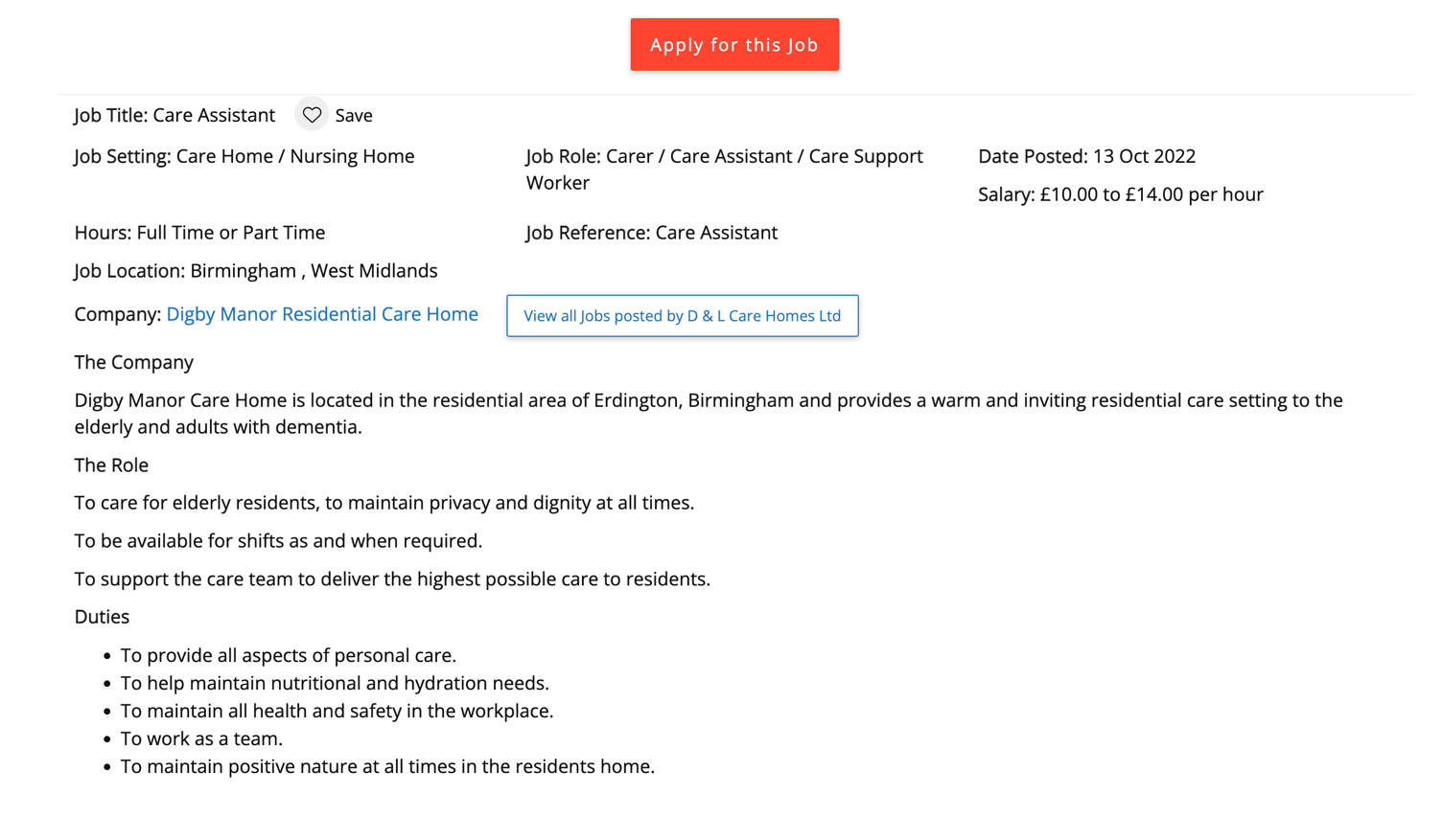

Poly Begum
Number: 0770809745
Email: begumpoly786@gmail.com

I am a hardworking, reliable, patient, and trustworthy person who can work both in a team and independently. I have good listening and communication skills which enable me to understand and meet new people. I can adapt to complex situations and affectively produce the correct outcomes to ensure when meeting new people. I am good at timekeeping and have excellent attendance and punctuality.

Working experience:
Green destination company – January 2022 - Present

I did my work experience in a green destinations company, where I communicated with SEN (special education need) children. I would be there from morning time 7 am till 9 am and afternoon time 3 pm till 5 pm.

Skill and qualities:
- Good communication skill
- Can work as team and individually
- Able to work with special needs children and adult
- Hard working
- Able to take patient all difficult situation

Education:

- Secondary school/ S.S.C in Bangladesh 2000
- Higher secondary school/ HSC in Bangladesh 2002
- Functional skills entry 3 in English. (UK) 2016
- Functional skills entry 3 in Mathematics. (UK) 2016
- Functional skills level 1 in English. (UK) 2017
- Functional skills level 1 and 2 in Mathematics. (UK) 2017

Language:
English and Bengali

Reference:
Available on request

Cover letter

Dear manager,

I would like to apply for the care assistant role which is advertised on your website carehome.co.uk. I have included my CV above for you to check.

I feel like this would be a good role for me because I used to work for special need kids and kids that would have a disability. I feel like I have gained skills from this job which I can apply in a care home and take care of the old people. I have good listening and communication skills which will help me to understand and talk to the elderly people that are living in a care home. I also have good patience which will me to take my time with the elderly.

I am studying a course in health and social care where I am gaining knowledge which will help me with my career. I believe that this job would be an excellent opportunity for me to further grow both personally and professionally. The duties that are required in this job I will be able to do.

Thank you for your time and consideration.

Yours sincerely,

Poly Begum

