
B E N E F I T S O F T E A M W O R K I N G

G R O U P P R E S E N T A T I O N

2018139

NEH NATACH CHE

•

•

HISTORY
History has repeated itself over many years in accomplishing sophisticated missions, environmental crises, mega projects and current workplaces, making a critical difference through practical teamwork.

A strong collaboration and practical mind locking ideas enabled Apollos 13 astronauts to return from the moon landing successfully to their families in
1970.

• Disney PLC typifies an example of an effective team working with a varied knowledge base, including software engineers, storytellers, actors and actresses, and production team to create unique stories (Edmondson, 2017).

OVERVIEW
THE NINE BELBIN TEAM ROLES • Currently, most companies are breaking cultural barriers to amalgamate
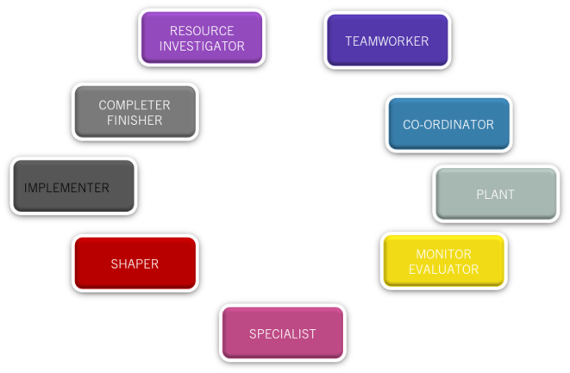
diverse employees into collaborative teams with experts to position businesses in a competitive advantage over others within industries.

• Despite the importance of teams to the overall success of goals and organisations, Belbin (2021) outlines that individual roles within teams play a fundamental contribution to the goal. The author further outlines 9 roles with associated strengths and weaknesses to bolster the theory.

• In teamworking, scholars gather the importance of robust measurement as benchmark to success, while reducing risks and errors and ultimately keeping an apt attitude towards the goal (Limaye, 2009, p400).

• The Open University (2021) highlights six components of a quality teamwork, including;

1. Communication

2. Coordination

3. Balance of member contributions

4. Mutual support

5. Effort

6. Cohesion

IMPORTANCE OF
TEAMWORKIN

G
• Improves Communication Skills

• Simplify Conflict revolution

• Develops leadership qualities

• Overcome obstacles

• Enhances Flexibility

• Promotes Innovation

• Improves Productivity

• Improves career progress

• Encourage Employee Engagement

• Builds Trust

• Greater Synergy

•

•

REFERENCES
Belbin, M., 2021. The Nine Belbin Team Roles. [online] Belbin.com. Available at: <https://www.belbin.com/about/belbin-team-roles> [Accessed 4 August 2021].

Edmondson, A., 2017. How to turn a group of strangers into a team. [online] Ted.com. Available at: <https://www.ted.com/talks/amy_edmondson_how_to_turn_ a_group_of_strangers_into_a_team> [Accessed 4 August
2021].

• Limaye, M., 2009. Software engineering. 1st ed. New Delhi: Tata McGraw-Hill Education, p.400.

• Open.ac.uk. 2021. Team working. [online] Available at: <https://www.open.ac.uk/choose/unison/develop/my-skills/team-working> [Accessed 4 August 2021].


belbin's team roles - Bing images

BELBIN’S TEAM ROLES

Veronika Brunnerova (2020488)

Effective team working and communication BMSW4002

OVERVIEW - INTRODUCTION

What is team?

Nine Belbin’s team roles Team roles - examples Hersey-Blanchard model Situational leadership styles

WHAT IS TEAM?

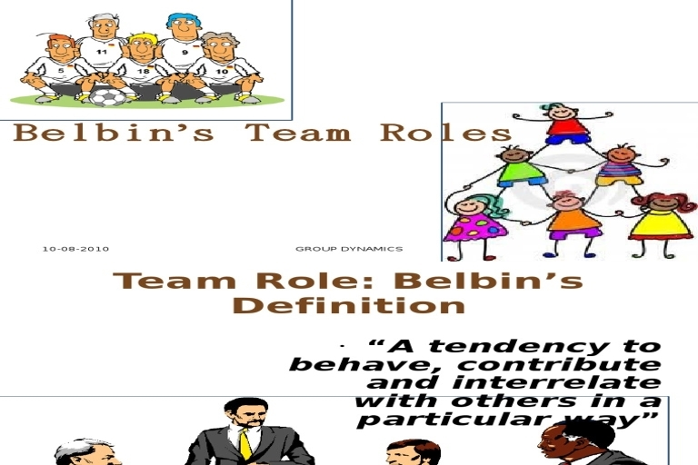
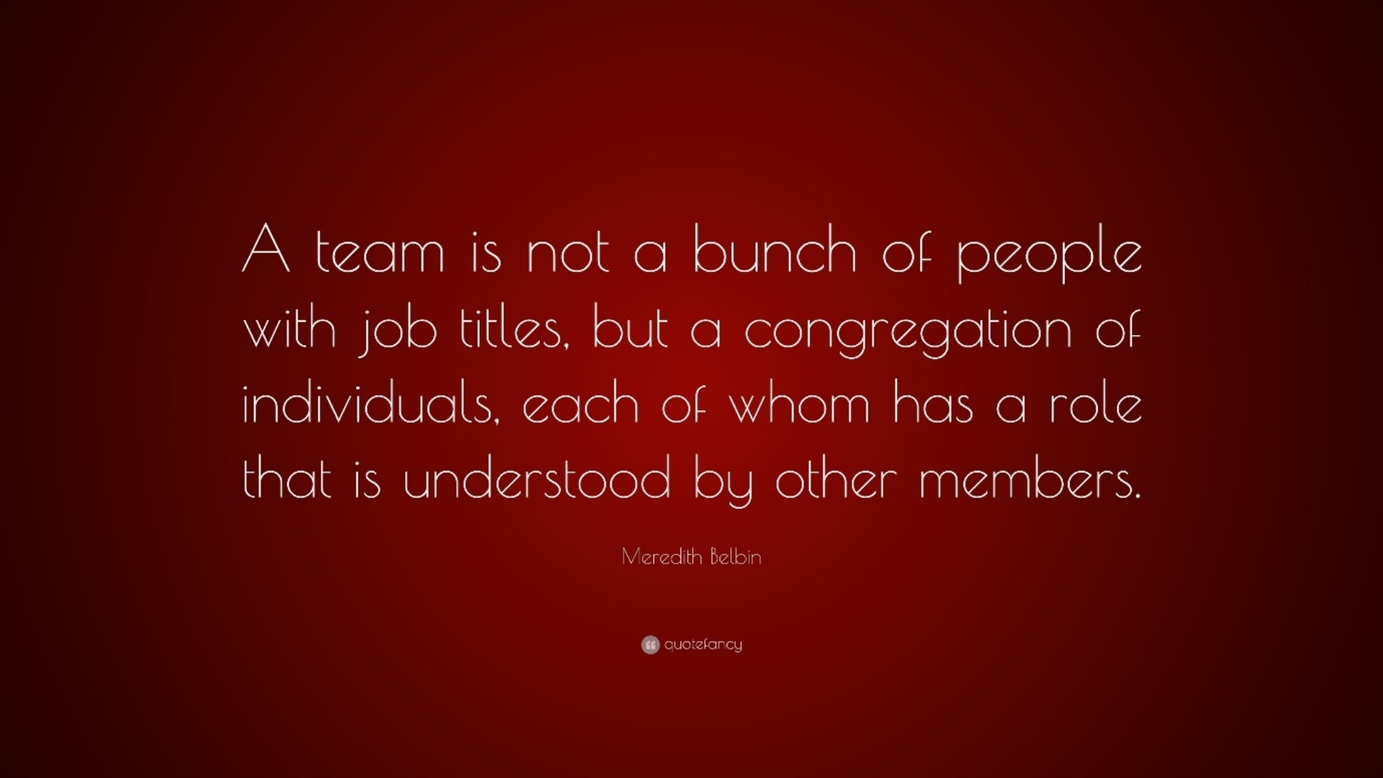
Illustrations Belbin Team's Role - Bing images Meredith Belbin Team Roles - Bing images

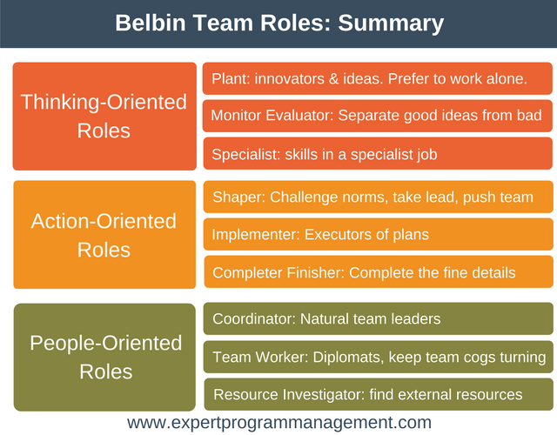
NINE BELBIN’S TEAM ROLES

TEAM ROLES - EXAMPLES


Thinking oriented roles (Plant)

Action oriented roles (Shaper)

People oriented roles (Coordinator)

pic of team roles - Bing images

HERSEY-BLANCHARD MODEL
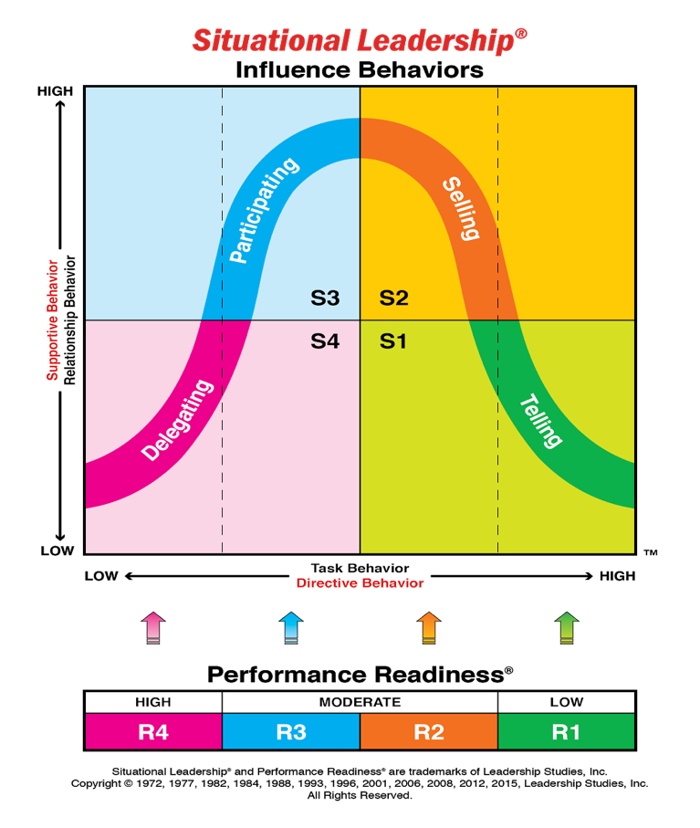
(ALSO KNOWN AS SITUATIONAL LEADERSHIP MODEL)

REFERENCES

CFI Education Inc. (2015-2021), Hersey-Blanchard Model - Overview, Leadership Style, and Downsides
(corporatefinanceinstitute.com) (online) [accessed August 6, 2021]
Halford, J. (2018), Belbin Team Roles Definition and Theory Explained (actiondays.co.uk) (online) [accessed July 26, 2021]
Illustrations Belbin Team's Role - Bing images (online) [accessed July 26, 2021]

Ken Blanchard Leadership Styles - Bing images (online) [accessed July 26, 2021]

Meredith Belbin Team Roles - Bing images (online) [accessed July 26, 2021]

Noon, M.and Heery, E. (2017), Belbin’s team roles, Dictionary of Human Resource Management, 3rd. ed., Oxford University Press

team roles - Bing images (online) [accessed July 26, 2021]

6bc866d8042e47ded57fe72d5efaaa6e.png (640×500) (pinimg.com) (online) [accessed July 26, 2021]


CONFLICT IN THE WORKPLACE

What is a conflict? The differences of lives,
jobs, beliefs in a group of

people can create a
conflict, especially when

This Photo by Unknown Author is licensed under CC BY-SA-NC

there is a situation where this people needs to confront each other and exchange ideas

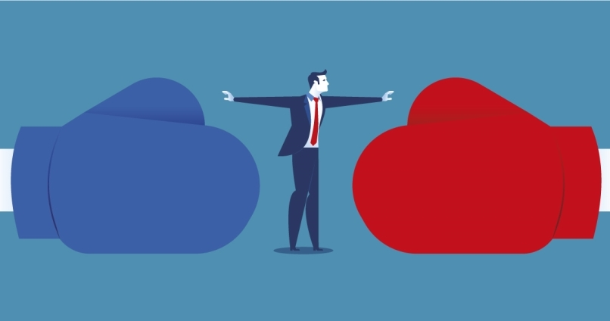
It is good or bad thing a conflict?

Advantage | Disadvantages
Storming process | Anger
It can be a brainstorming for everybody | Some people could be targeted
Very stimulating | Bullism
Finding new solutions | Disrespect
Growing | Persecution

This Photo by Unknown Author is licensed under CC BY

According to Varney (1989) the main cause of a conflict are




■ Communication factors ■ Structural factors
■ Personal factors

According to Thomas and Kilmann the best way to manage a conflict is….

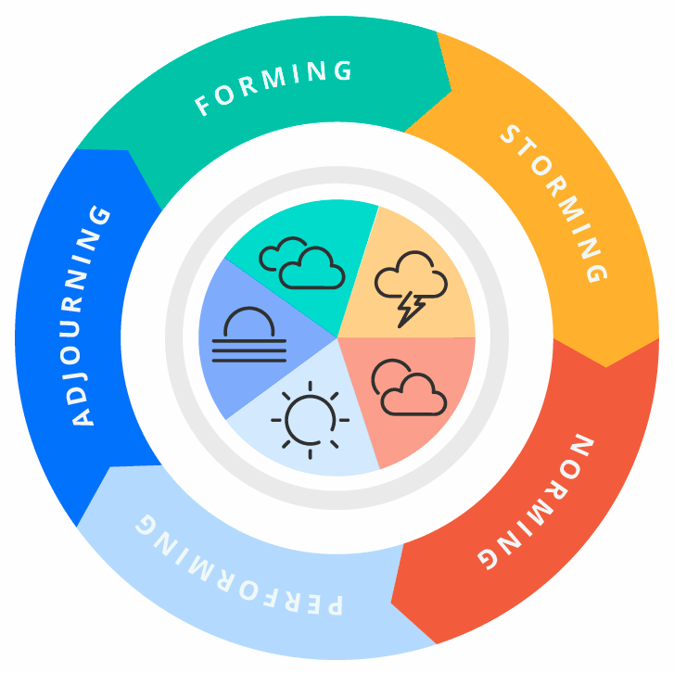
Tuckman's Model for Nurturing a Team to High Performance

References:

-Batista, E. (2007). Conflict Modes and Managerial Styles. [online] Ed Batista. Available at:

https://www.edbatista.com/2007/01/conflict_modes_.html [Accessed 7 Aug. 2021].

Riter (2018). 8 Models of Team Effectiveness. [online] Medium. Available at:

https://medium.com/@RiterApp/8-models-of-team-effectiveness-3a3b84efb3ae [Accessed 7 Aug. 2021].

- Wikipedia Contributors (2018). Tuckman’s stages of group development. [online] Wikipedia. Available at:

https://en.wikipedia.org/wiki/Tuckman%27s_stages_of_group_development.

