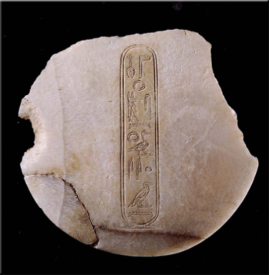  Khyan’s lid: Hyksos ruler. Found in palace at Knossos but not in a secure stratigraphic context. | 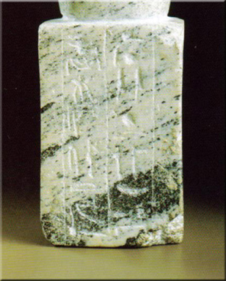  Middle Kingdom statue of official User. Found in Knossos, close to Throne Room (but not in secure stratigraphic context)
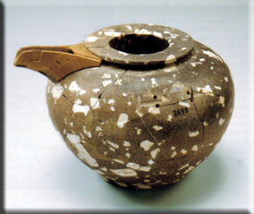  Diorite vase, found in palace at Knossos. Transformed into Minoa bridge-spouted vase | 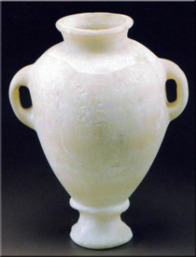  Alabaster vase, from tomb at Katsamba (near Knossos). Inscribed with name of Thutmosis III
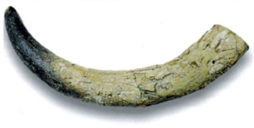  Ivory tusk from palace at Zakros (East Crete) | 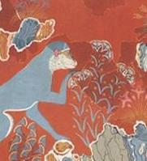  Monkey painting, Knossos (Palace)  Cercopithecus aethiops aethiops (Ethipa)  C. aethiops tantalus (south of the Sahara)
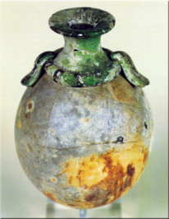  Ostrich egg transformed into rhyton  Sector Delta room16, Akrotiri | 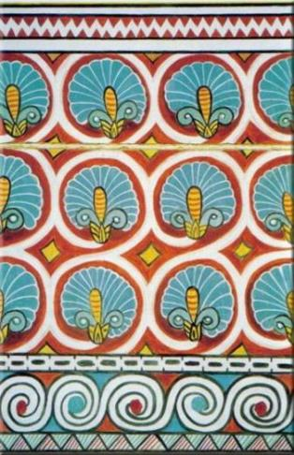  Tomb painting from Egypt – Minoanising iconography (mimicking textiles?)
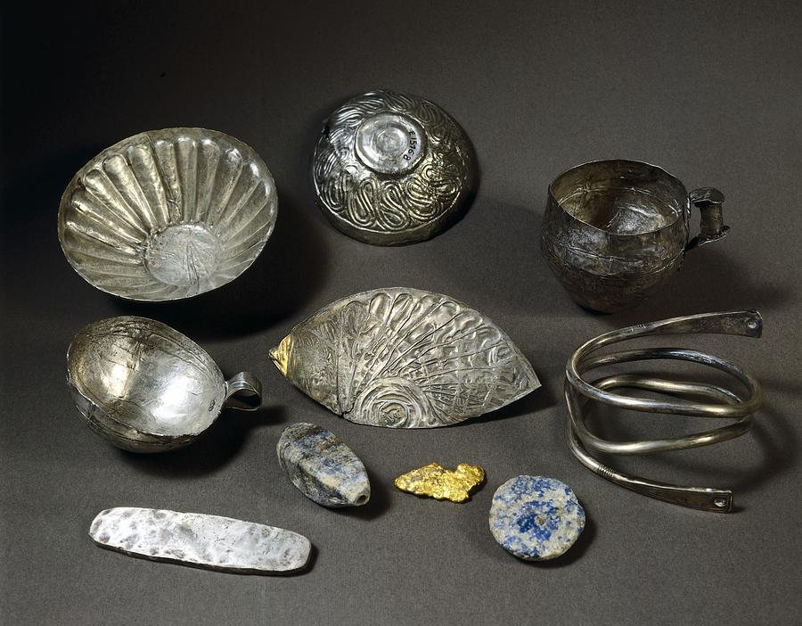  Tod treasure: 153 Aegean silver vases found in chest inscribed with name of Amenemhet III. Buried in temple at Tod | 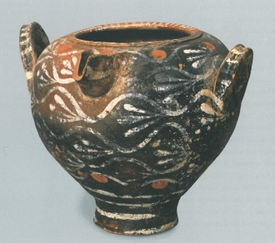  Kamares ware vase, Byblos
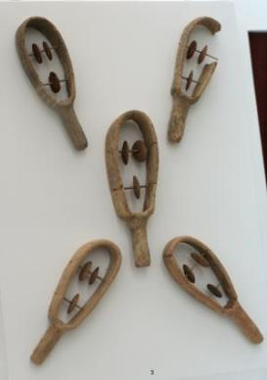  Clay sistra (made in Crete), from tomb at Charalambos, East Crete | 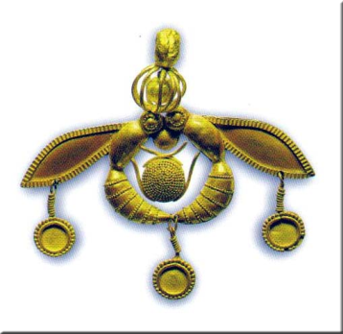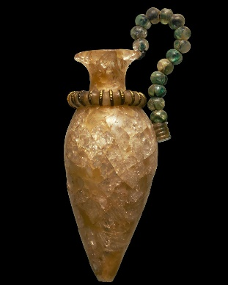Ignore the objects!  Raw materials: gold, rock crystal, carnelian, amethyst transformed into sealstones, jewellery, stone vases etc. by attached specialists

