17/12/2025
University of Wales Trinity Saint Davids
London Campus
Module Name: Computer Architecture and Operating Systems
Module Code: ACCA 4022

Student Name: Giuseppe Palumbo
Student ID: 2335642
Group: 3

Lecturer’s Name: Koushik Modak
Computer Architecture and Operating Systems.
Assignment 2
Table of Contents
Introduction 2
Main Body 3
Key functions of general Operating Systems 3
Use of Windows OS CLI commands 10
Use of Linux OS CLI commands 15
Use of Windows OS scripts (Batch Scripting) 17
Use of Linux OS scripts (Bash Scripting) 20
Conclusion 22
References 23

Introduction
This report presents my work with Windows PowerShell and Ubuntu Linux, focusing on how command-line tools and scripts help me understand the basic functions of an operating system. I explore how to create folders, manage files, write simple scripts, and run commands that automate small tasks. Using both systems allows me to compare their features and learn how each environment supports efficiency and problem-solving.
This introduction prepares the reader for the detailed explanations and screenshots that follow, showing each step clearly and demonstrating how these tools support learning and practical computer skills.

Main Body

Key functions of general Operating Systems
An operating system (OS) is the most important software on a computer. It controls hardware, runs programs, manages files, handles memory, and provides security. The OS is the connection between the user and the computer hardware. Silberschatz describes the OS as a system that manages hardware resources and provides services to applications [1]. Tanenbaum also explains that all modern operating systems share similar core functions, even if they look different [2]. In this task, I use Windows 11 to show the key OS functions.

Hardware Management
One main function of an OS is hardware management. The OS communicates with hardware devices such as the CPU, RAM, hard drive, keyboard, mouse, and graphics card through drivers [1]. Windows 11 uses Device Manager to show all installed hardware and their driver status.
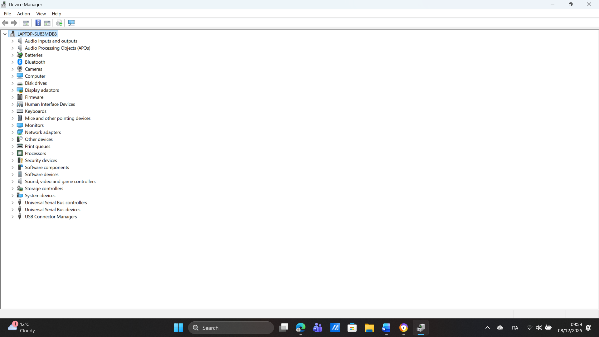
Device Manager shows items such as Display Adapters, Network Adapters, Disk Drives, and more. If a device does not work, the OS will usually report a driver problem. Good hardware management is essential because without it, programs would not be able to use the hardware correctly.

Process Management
A process is a program that is running on the computer. The OS manages all processes by dividing CPU time between them. It ensures programs do not crash into each other. Windows 11 includes Task Manager, which shows all running processes.

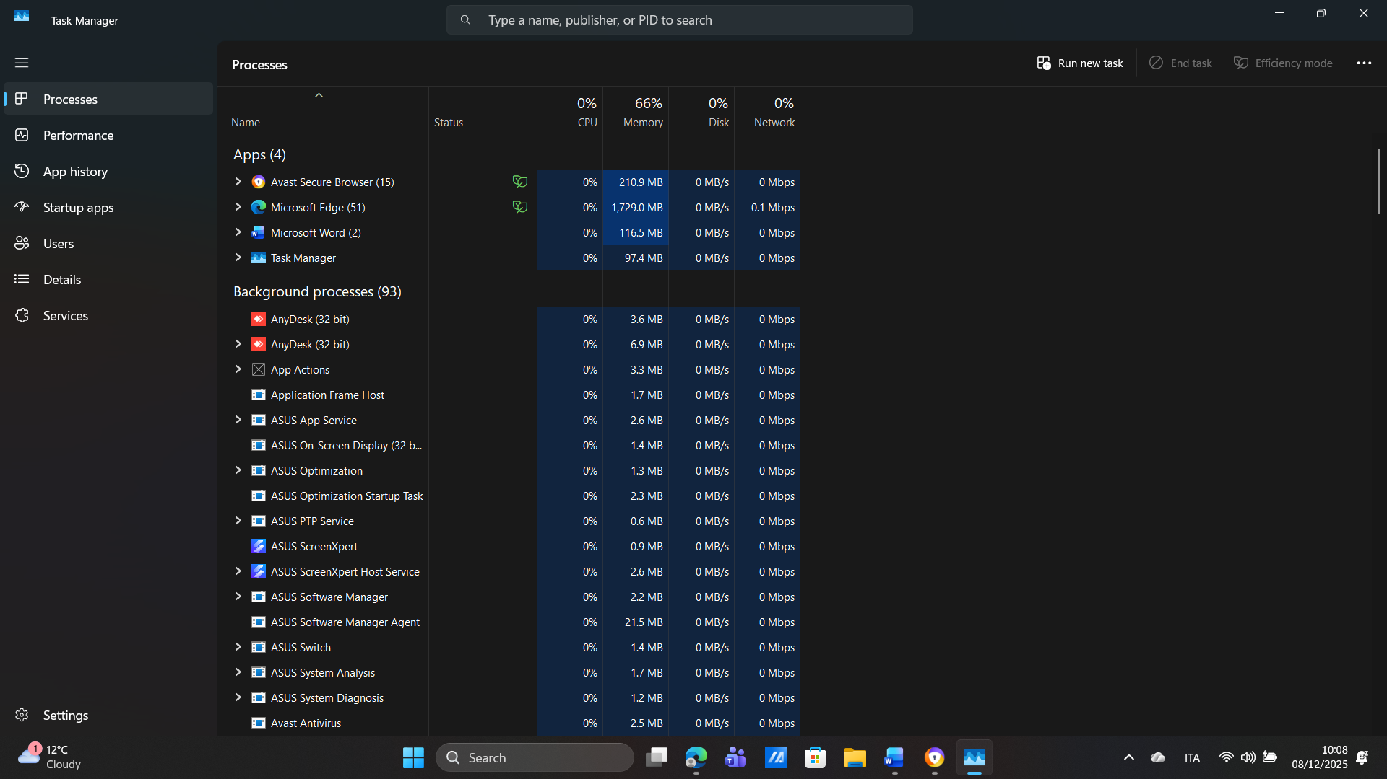

Task Manager displays CPU, memory, disk, and network usage for each process. This helps users understand which programs are using the most resources. The OS also allows users to end processes if needed. Process management keeps the system stable and responsive [1].

File System Management
The OS organises data in files and folders. Windows 11 uses the NTFS file system, which supports permissions, encryption, and large file sizes. Tanenbaum states that file systems are essential for organising and protecting user data [2].
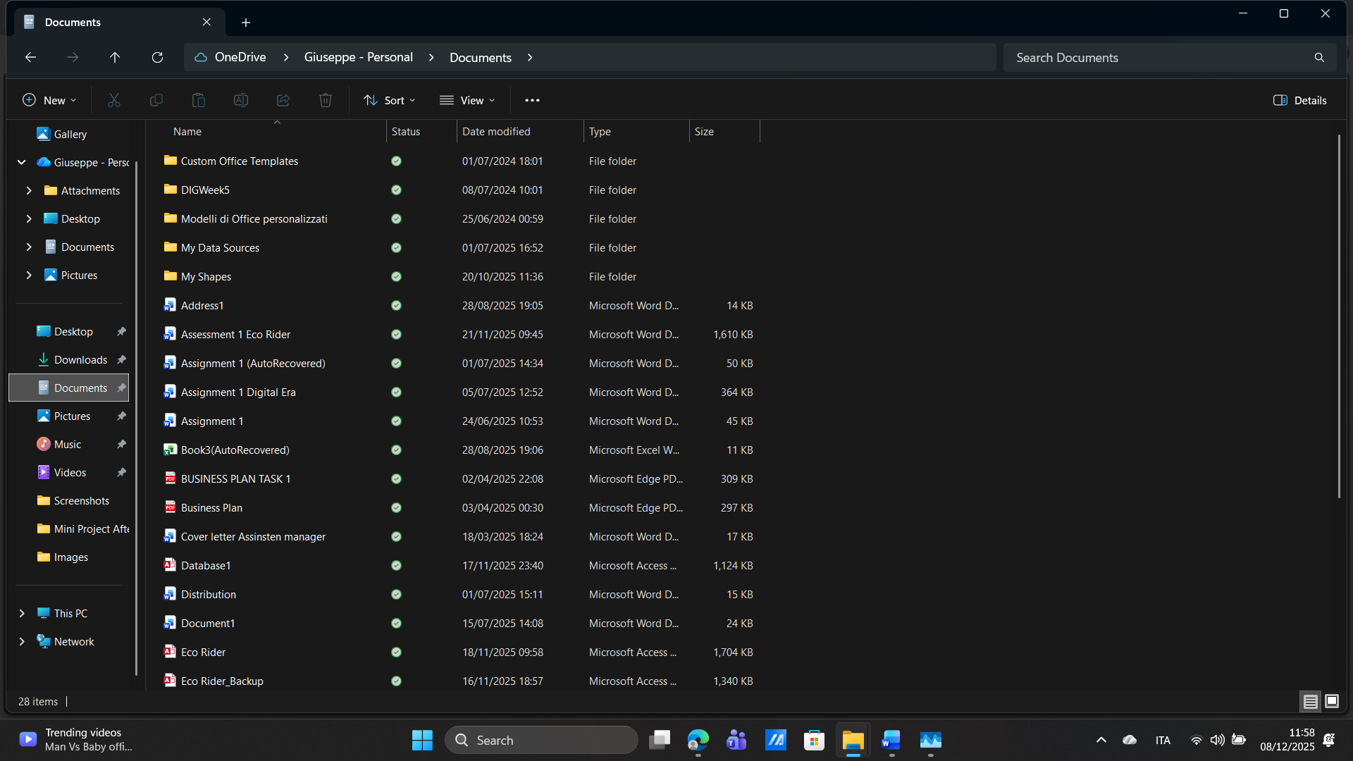
Windows 11 File Explorer lets users create, rename, move, and delete files. The OS ensures files are stored safely and can be accessed quickly. This makes it easy for users to manage documents, pictures, downloads, and other data.

Memory Management
The OS controls how programs use RAM. When RAM becomes full, Windows 11 uses virtual memory, which uses part of the hard drive as temporary storage. Memory management prevents programs from crashing and keeps the system running smoothly [1].
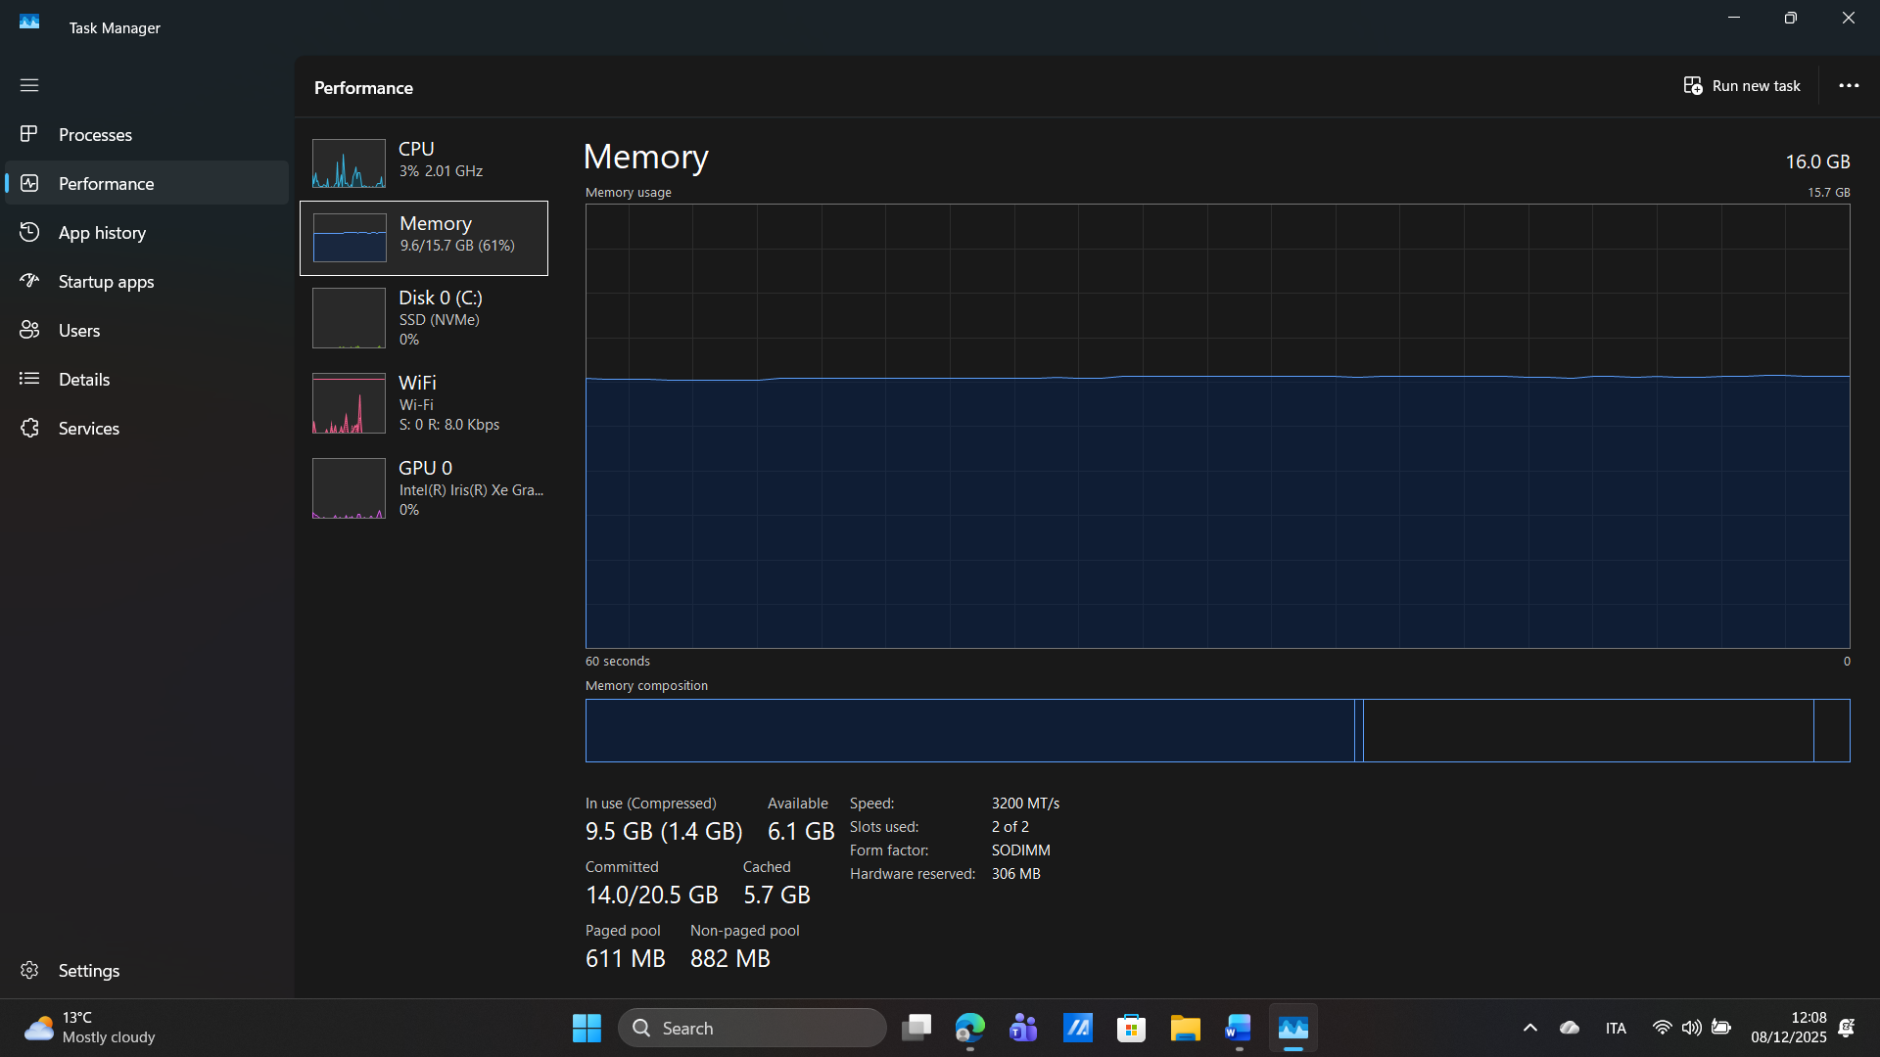

The Memory section in Task Manager shows how much RAM is being used. The OS decides how memory is shared between programs, helping the computer run multiple apps at the same time.

Security Management
Security is one of the most important OS functions. Windows 11 includes Windows Security, which protects the system from viruses, malware, spyware, and network attacks. Microsoft explains that Windows Security includes antivirus, firewall, and device protection features [3].
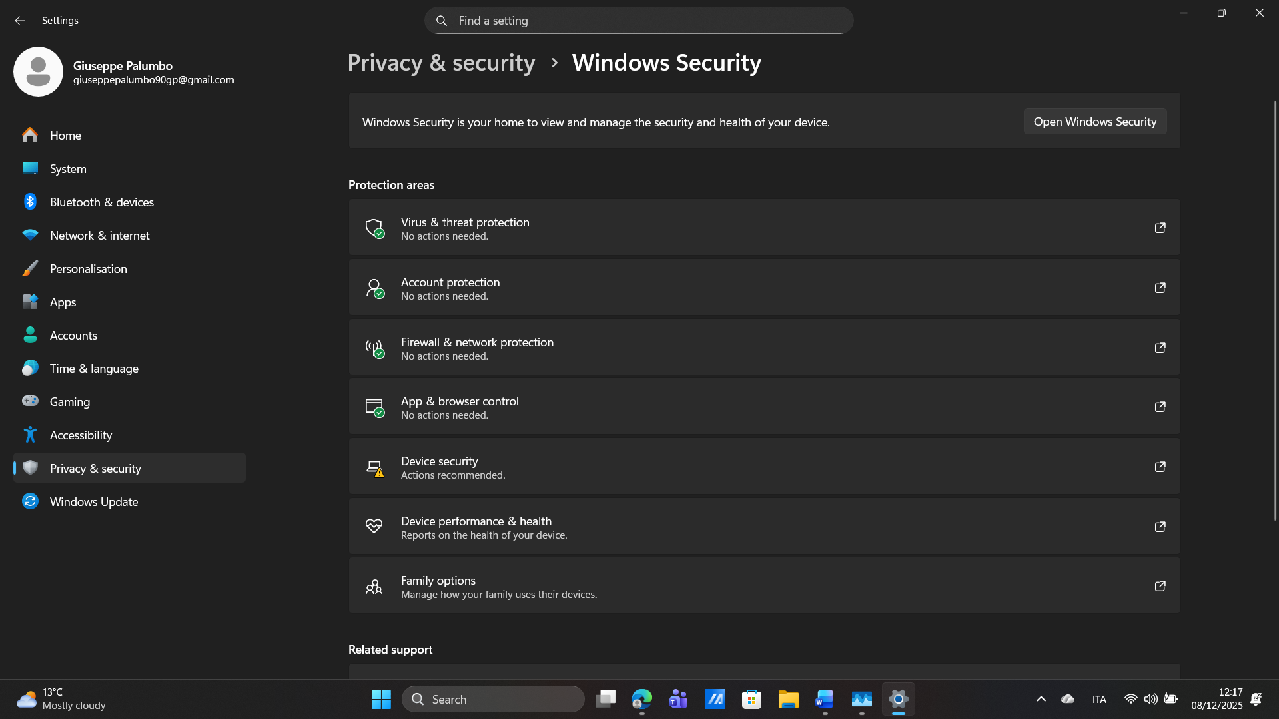

The OS checks for threats, scans the system, and blocks harmful programs. It also manages user accounts, passwords, and permissions to prevent unauthorised access.

System Security
Modern operating systems need strong security to protect from viruses, malware, ransomware, and hackers. Windows 11 uses Windows Security, which includes antivirus, firewall, and security updates.
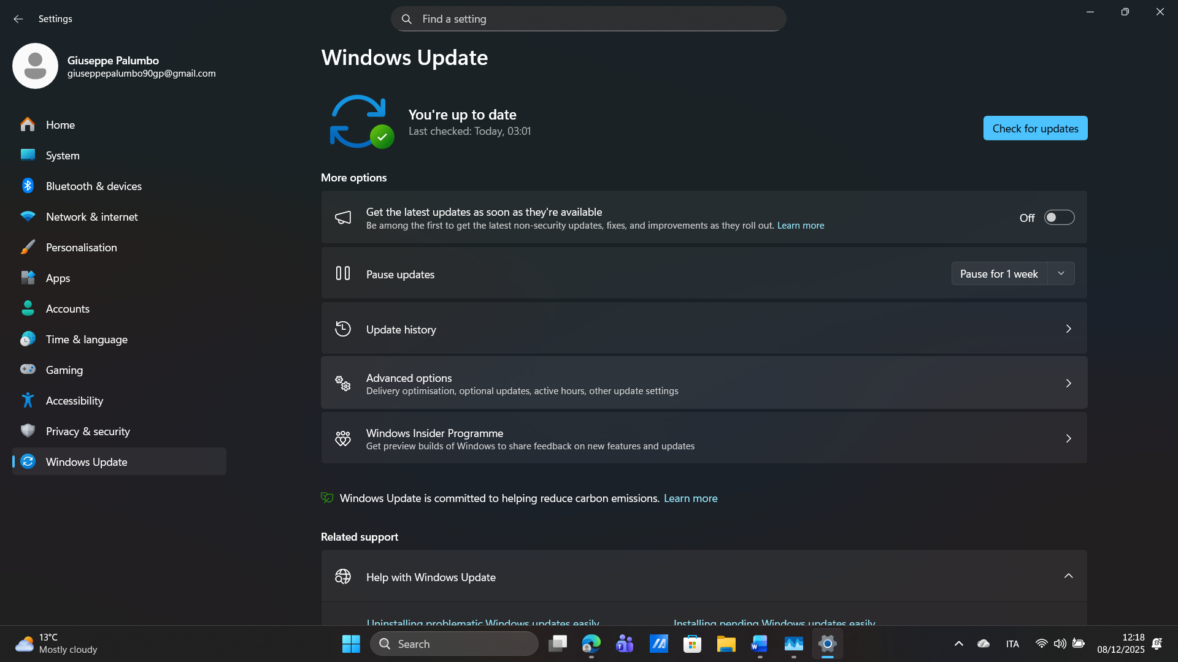

The OS controls which apps can run, checks for threats, and protects important files. It also manages user accounts and passwords. Security is a major OS function because computers are always online and face many threats every day [3].

Summary
I learned that an OS performs many important functions: managing hardware, processes, memory, files, security, and updates. These features make the computer reliable and safe to use.

Use of Windows OS CLI commands
Windows 11 includes two command-line tools: Command Prompt (CMD) and PowerShell. The command line gives users powerful control over the computer and is useful for troubleshooting and automation. Microsoft explains that the command line allows faster and more precise actions than the graphical interface [4]. In this task, I will use ten Windows commands.
Step 1 Opening Command Prompt
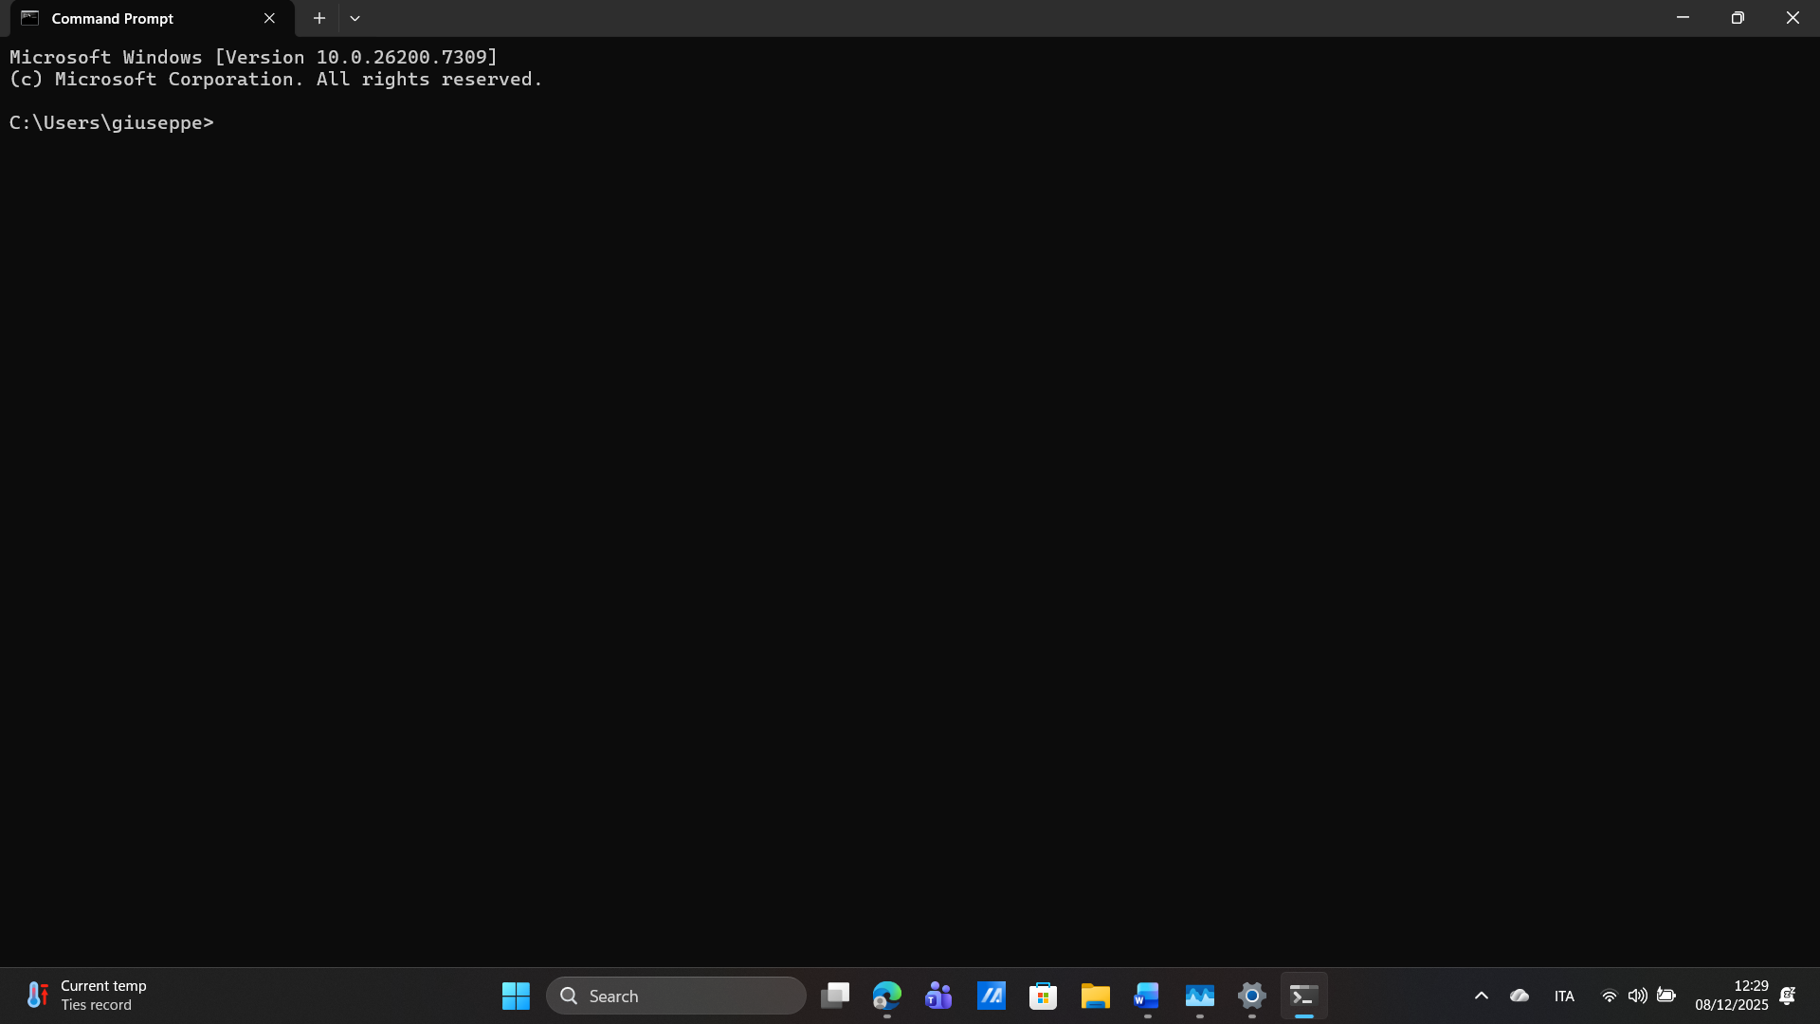

Step 2 Add command
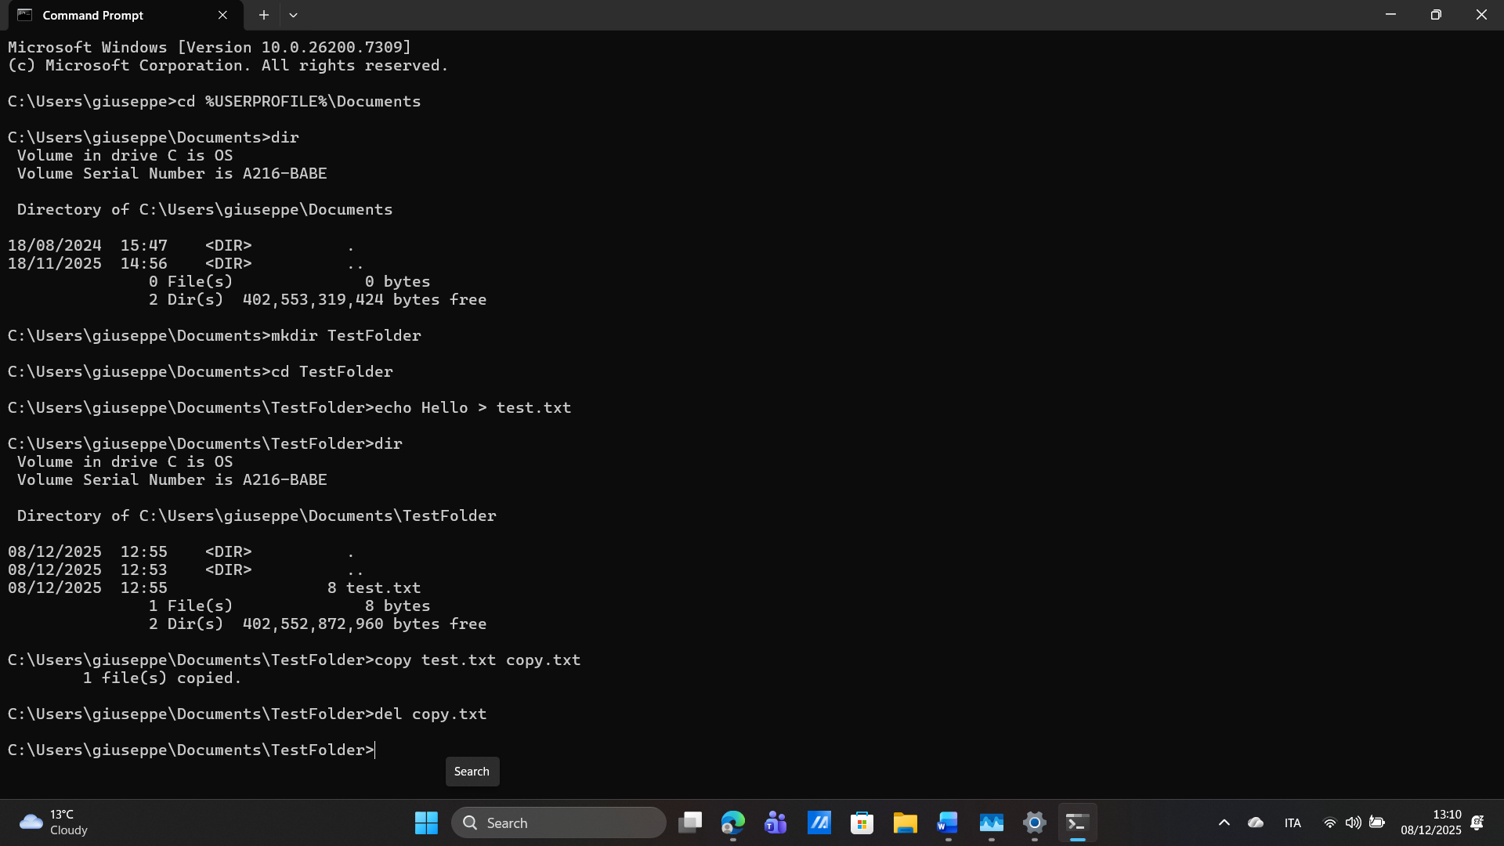
In this screenshot I used several file and folder commands in Command Prompt. First, I used cd to move to the Documents folder and dir to list its contents. I created a new folder using mkdir TestFolder and entered it with cd TestFolder. Then I created a text file using echo Hello > test.txt. I copied this file using copy test.txt copy.txt and deleted the copy using del copy.txt. Finally, dir showed the updated contents of the folder. These commands demonstrate how the Windows command line can create, copy, and delete files without using File Explorer [4].

Step 3 Network Command
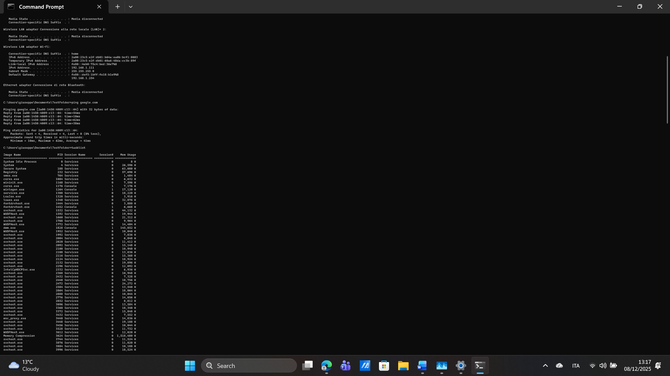
In this screenshot I used network and process commands in Command Prompt. The command ipconfig displayed my network configuration, including the IP address, default gateway and wireless adapter information. Then I used ping google.com to test my internet connection. The replies show that the connection is working correctly. Finally, the tasklist command produced a long list of all running processes on the system. This information is useful for understanding what applications and background services are currently active on Windows [4].

PowerShell commands
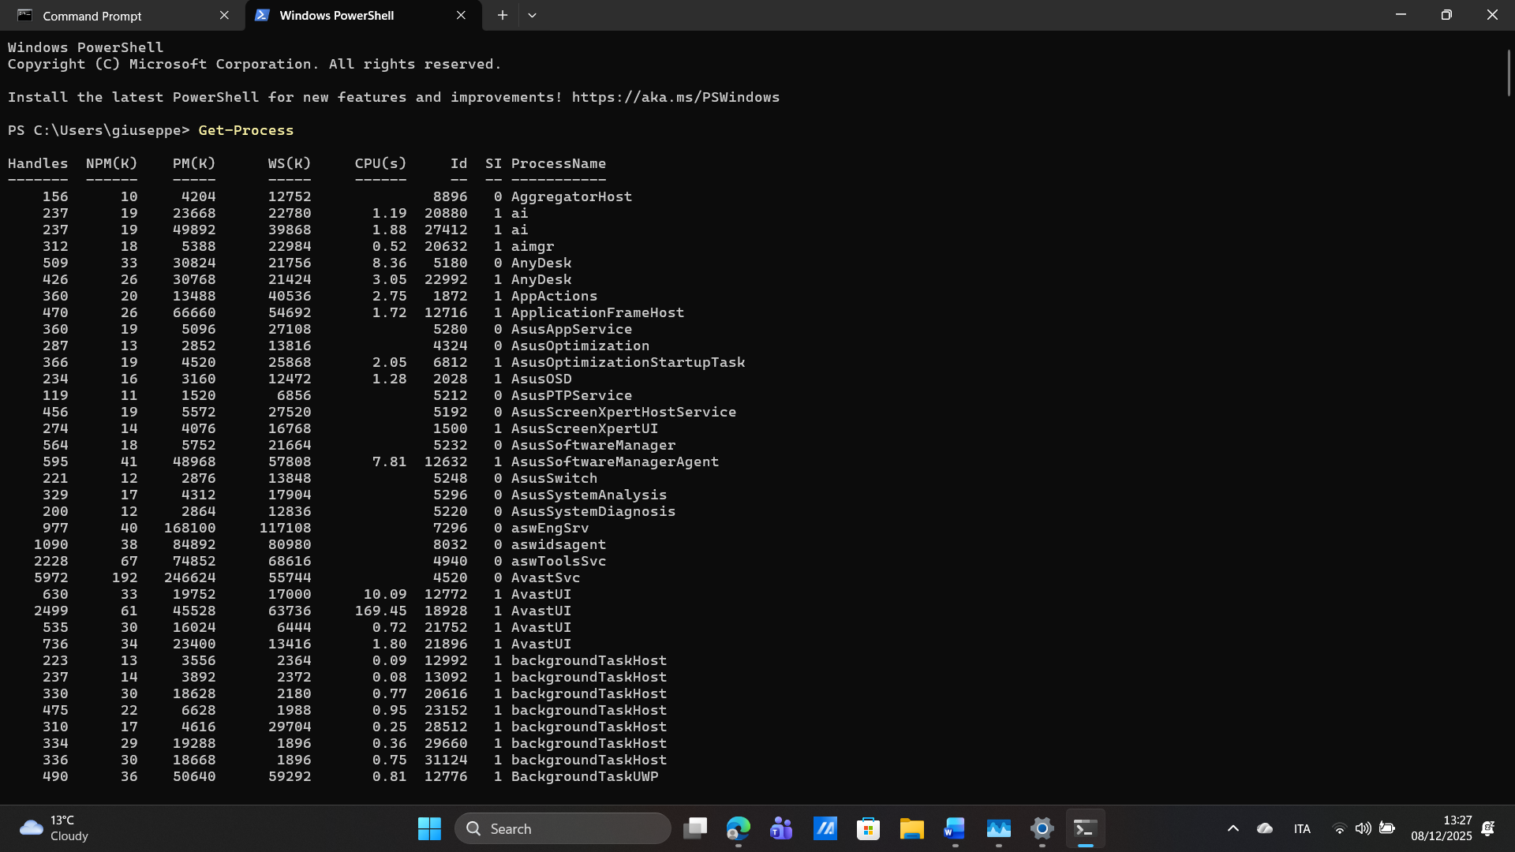
This screenshot shows the Get-Process command in Windows PowerShell. This command lists all active processes on the system, including information such as memory usage, CPU usage, and process IDs. It allows users to monitor what programs and background tasks are currently running. PowerShell gives more detailed and powerful system information compared to the traditional Command Prompt [4].

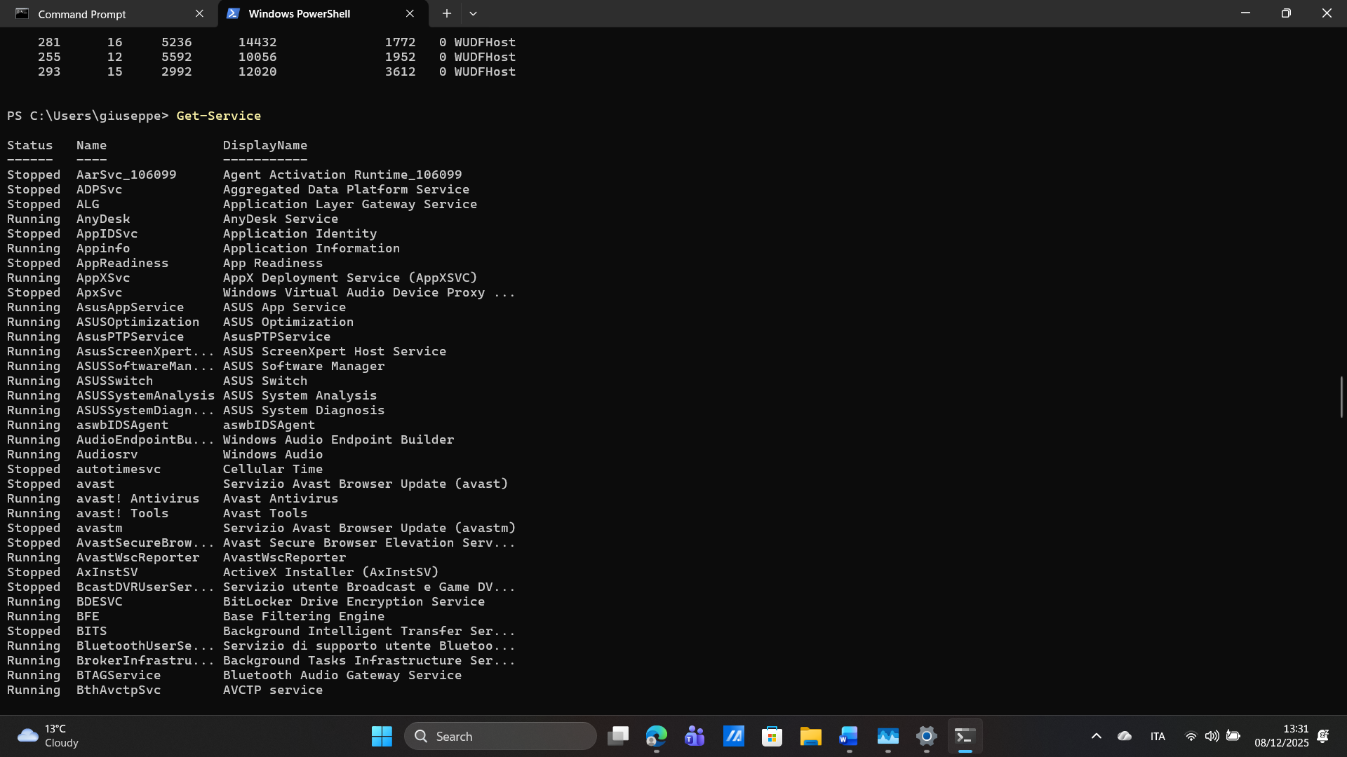
This screenshot shows the Get-Service command in Windows PowerShell. It lists all Windows services, showing whether each service is running or stopped. This helps users check the status of important system services and troubleshoot issues related to Windows updates, networking, or background applications. PowerShell offers advanced control for managing services efficiently on Windows 11 [5], [8].

Use of Linux OS CLI commands
For this task, I used the Ubuntu terminal inside Windows 11 through WSL (Windows Subsystem for Linux) [5]. Linux systems usually rely on the command line, so learning basic Bash commands is important for file management and system navigation. The two screenshots below show the start of my Linux session and all the commands I used during the task.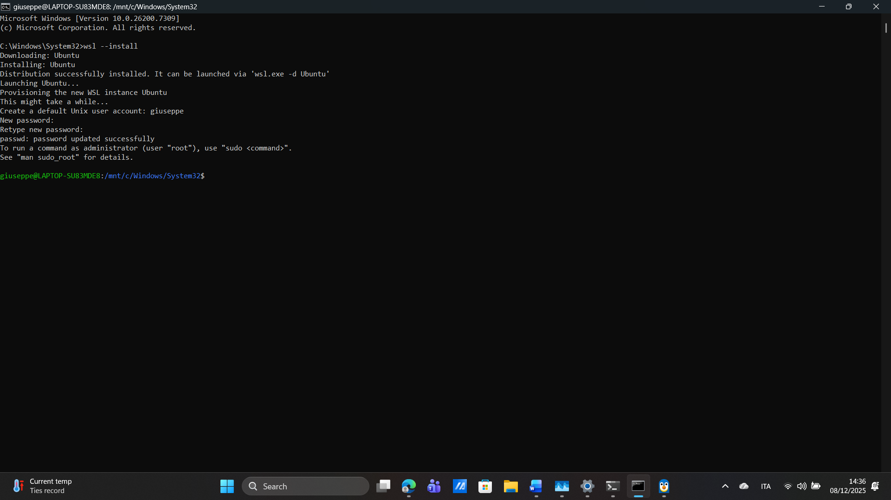

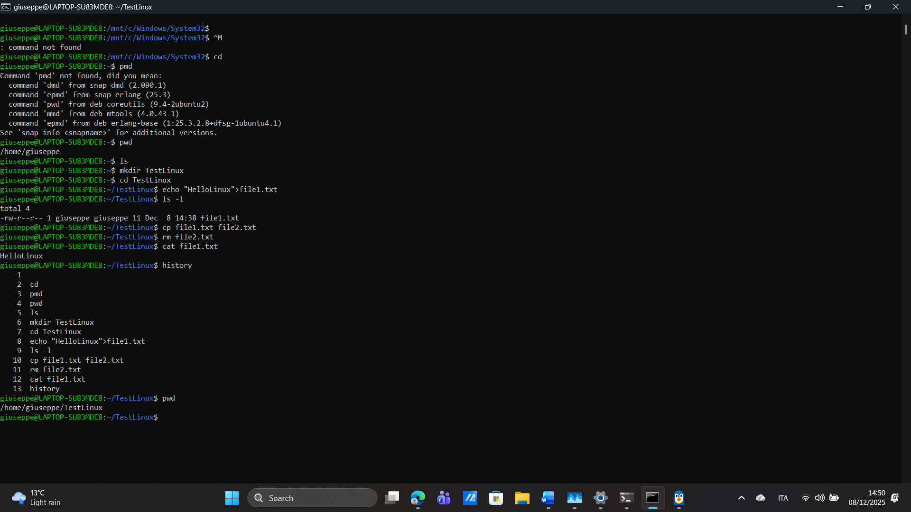
The first commands I used were pwd and ls. The command pwd shows the current working directory, which helps the user understand their location inside the Linux file system [1]. The command ls lists the files and folders in the current directory, making it easy to see what is stored in that location [2].
Next, I created a new folder using the command mkdir TestLinux. After creating this folder, I entered it using cd TestLinux. These two commands are useful for organising work and moving between different directories when using Linux.
Inside the new folder, I created a file using the command echo "HelloLinux" > file1.txt. This command creates a text file and writes the message “HelloLinux” inside it. After that, I used ls -l, which shows detailed information about the files in the folder, including size and permissions [5].
Then, I copied the file using the command cp file1.txt file2.txt, which created a second file with the same content. To show how file deletion works, I used the command rm file2.txt. This command permanently deletes a file from the system [3].
To read the content of the remaining file, I used the cat file1.txt command. This displayed the text directly in the terminal, which is useful for quickly checking what a file contains. Finally, I used the history command, which shows all the commands typed during the session. This helps users review their work and repeat commands easily [3].
Overall, this task helped me understand basic Linux operations such as navigating directories, creating files, copying files, deleting files, and checking file contents. These are essential skills for beginners working with Linux systems.

Use of Windows OS scripts (Batch Scripting)
PowerShell scripting helps users automate tasks in Windows, making work faster and easier. Instead of doing actions manually, a script can complete the task with one command. Automation is an important part of modern operating systems because it saves time and reduces mistakes [1],[2]. In this task, I created four simple scripts to learn how PowerShell works. These scripts helped me understand how to show messages, ask for input, make calculations, and create files automatically. Learning these skills also showed how PowerShell supports system management and improves productivity [3].

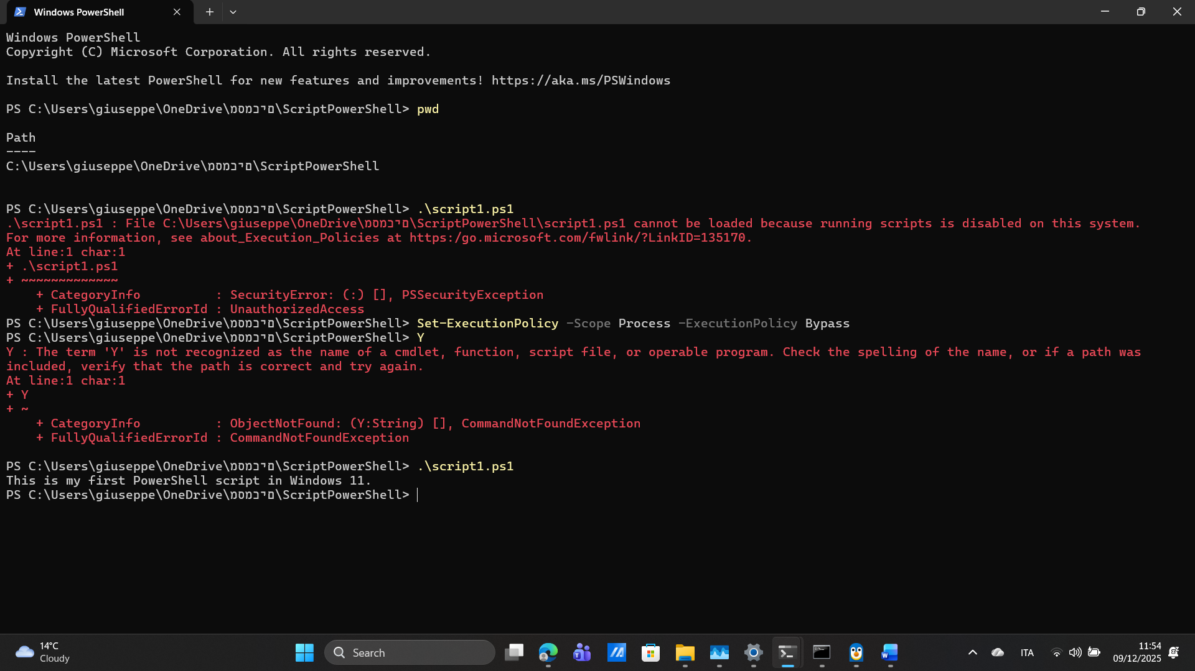
Script 1 was my first PowerShell script. It used the Write-Host command to show a message on the screen. Before running the script, I needed to change the execution policy because Windows blocks scripts by default for security reasons [3]. After the policy was updated, the script ran correctly and displayed a welcome message. This task helped me learn the basic structure of a PowerShell script and how Windows manages script execution [6].

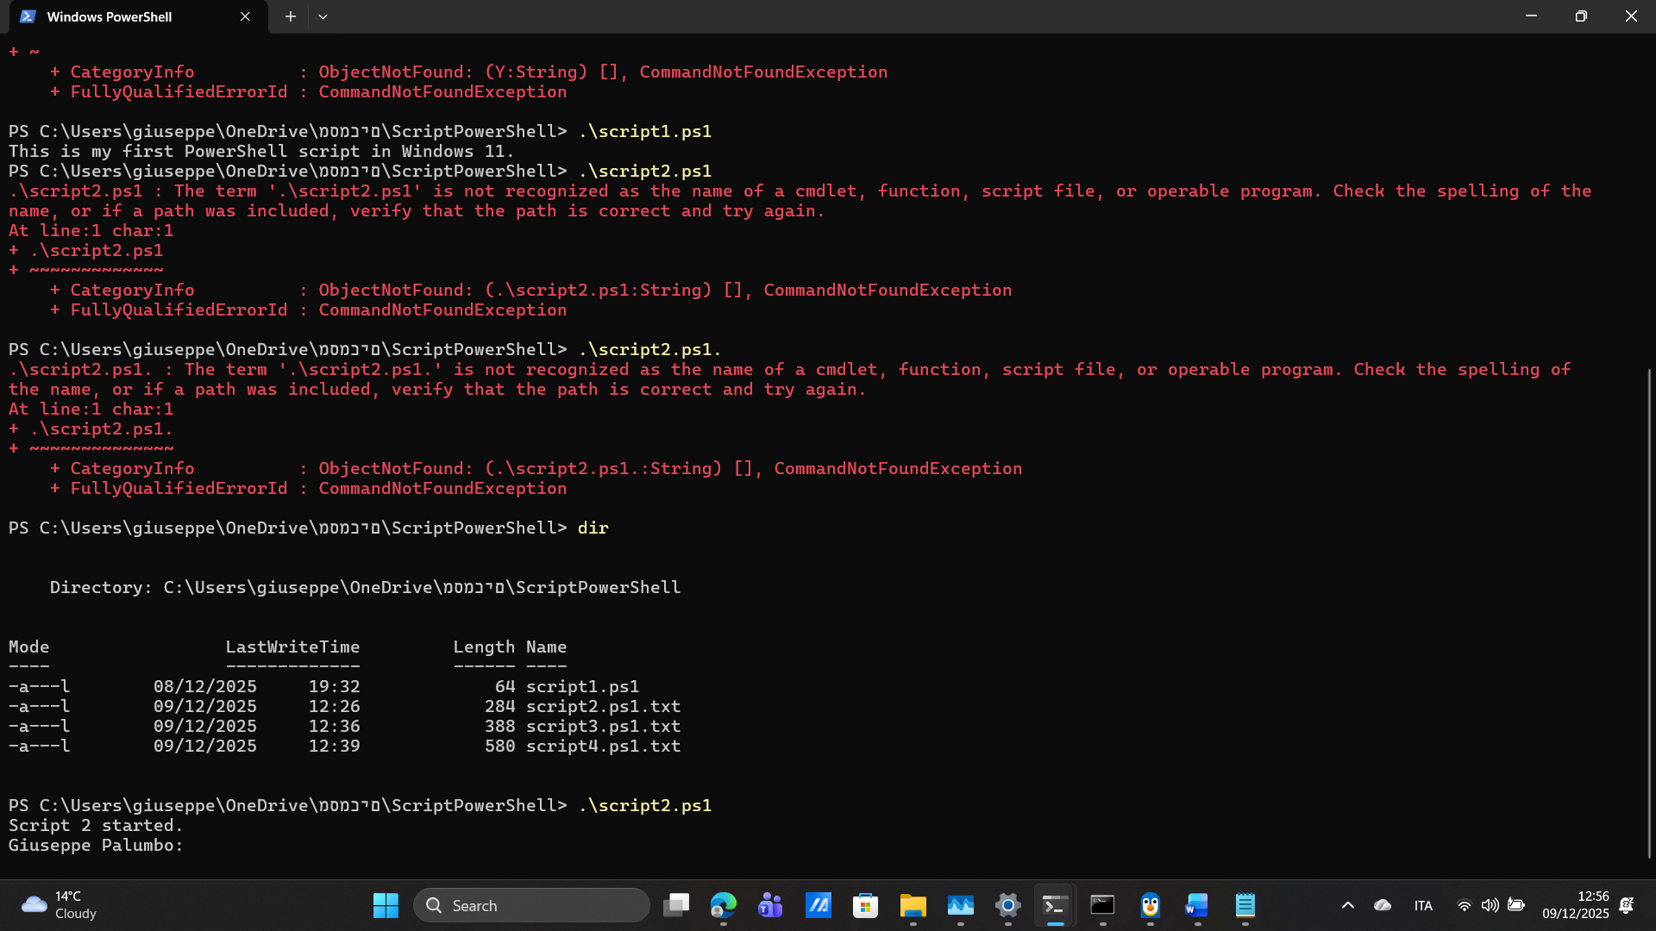
Script 2 asked the user to enter their name using the Read-Host command. The name was stored in a variable and then shown in a custom message. This script taught me how PowerShell can interact with users and how variables store information for later use [1]. It also showed how operating systems support user interaction and input processing [6]. The script ended with a message confirming that it had finished.

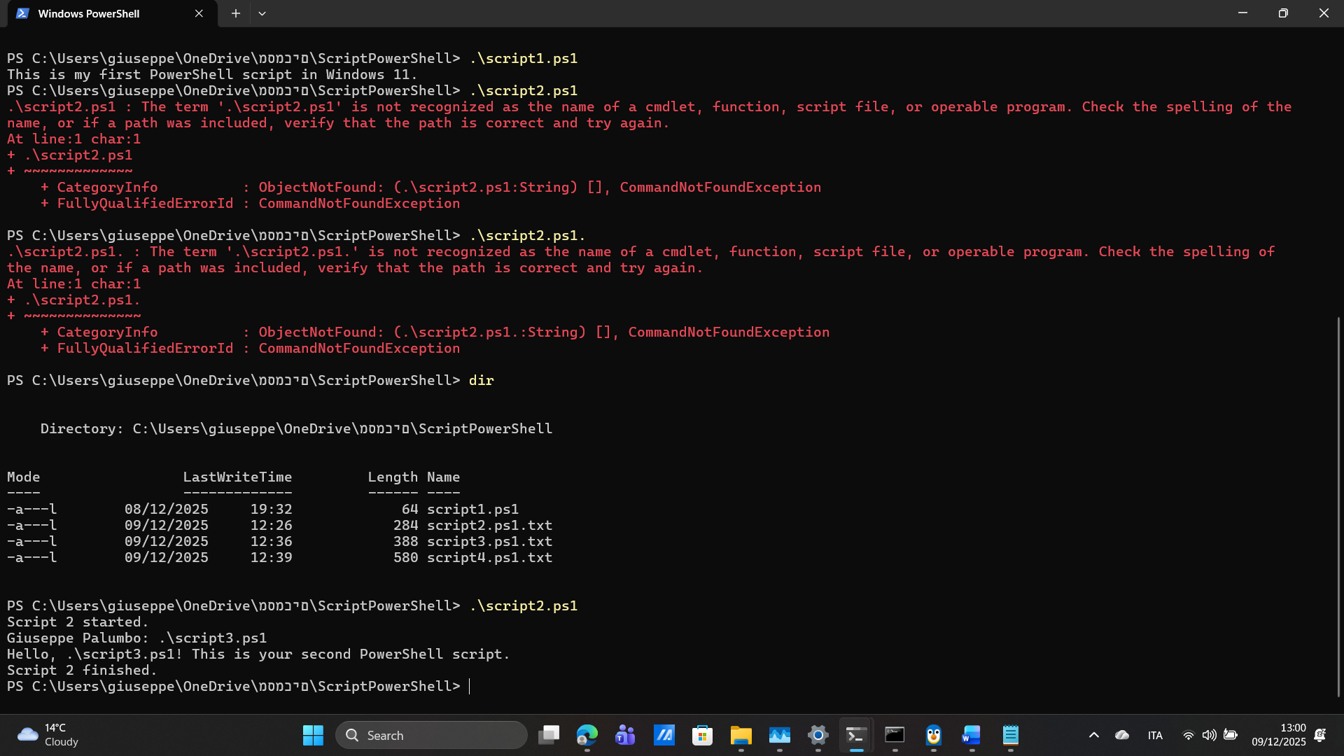
Script 3 introduced simple calculations. The user entered two numbers, which PowerShell converted into integers before adding them together. This task showed how scripts can process data, perform mathematical operations, and automate small tasks that would otherwise be done manually [2]. Automation like this improves accuracy and reduces repeated work inside an operating system [6]. The final output displayed the total of the two numbers.

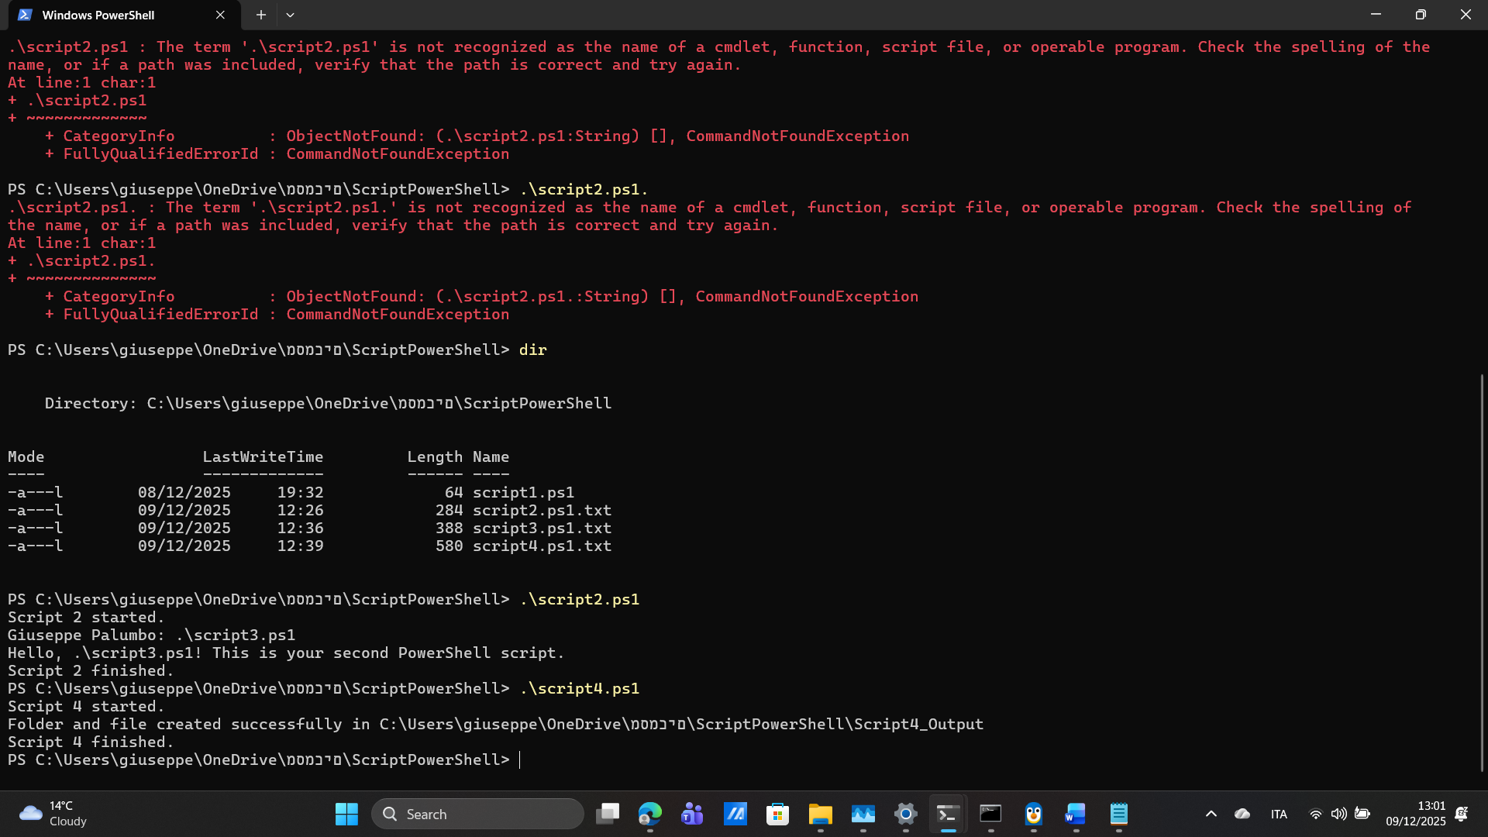
Script 4 demonstrated how PowerShell can interact with the Windows file system. The script created a new folder and a text file using the New-Item command. This helped me understand how scripts can automate file-management tasks, which is useful for organisation and system administration [7]. Automating folder and file creation is important because it saves time and prevents human errors. The script ended by showing a message that confirmed success.

Use of Linux OS scripts (Bash Scripting)
Using the Linux terminal is an important skill for understanding how operating systems manage files and processes. Shell scripting allows users to automate tasks and work more efficiently, which is why it is widely used in IT support, networking, and cybersecurity [1].
In this activity, I used basic Linux commands to create, view, copy, rename, and delete files. This helped me understand how Linux handles file operations and why command-line skills are essential in technical environments [2].
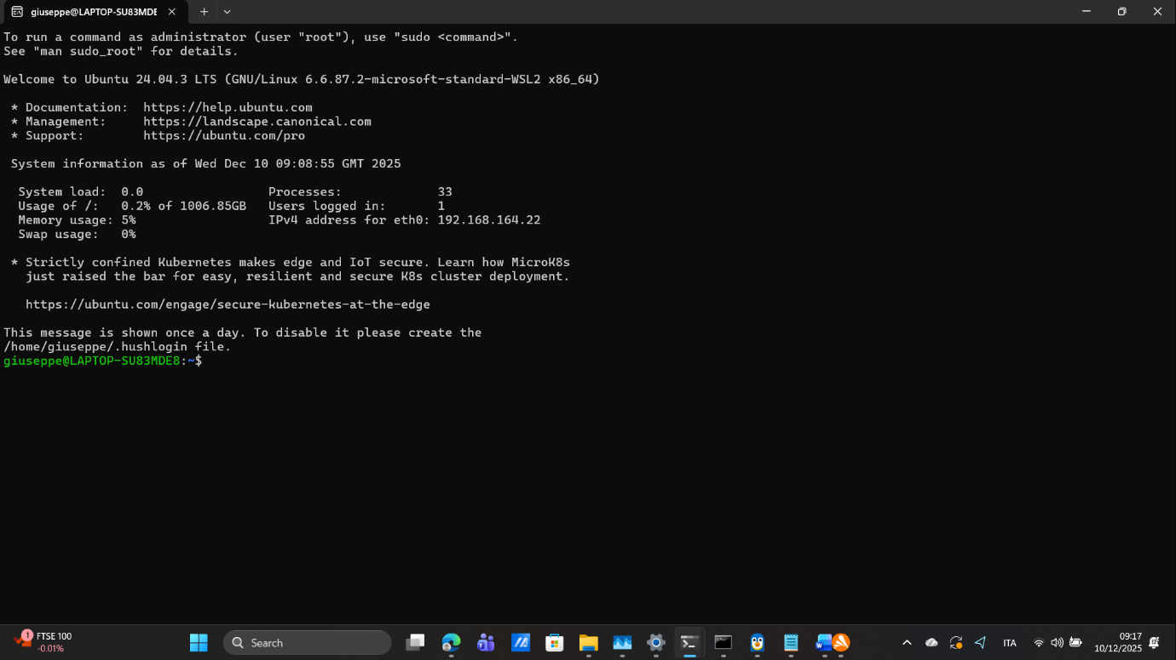

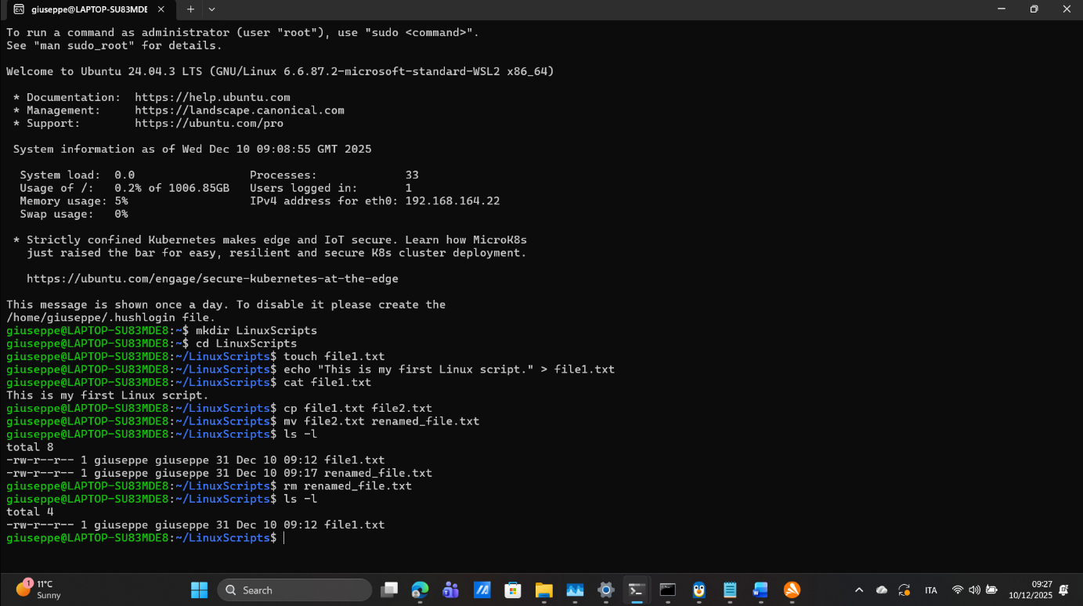
I started by creating a new folder using the command mkdir LinuxScripts, which makes a directory. After that, I entered the folder using cd LinuxScripts. To create a new empty file, I used touch file1.txt.
Next, I added text to the file with:
echo "This is my first Linux script." > file1.txt,
which writes a message inside the file. I checked the text using cat file1.txt, a command that displays the file content on the screen [1].
I created a copy of the file using cp file1.txt file2.txt and then renamed the copied file using mv file2.txt renamed_file.txt. To view all files and their details, I used ls -l, which shows permissions, size, and last modified time. Finally, I removed a file with rm renamed_file.txt, confirming the deletion by running ls -l again [2].
This activity demonstrated how simple commands can be combined to manage files efficiently inside a Linux environment.

Conclusion
This activity helped me understand the practical differences between Windows and Linux scripting while also showing how both systems rely on automation to complete tasks efficiently. By creating and running scripts in PowerShell and Linux, I learned how commands interact directly with the operating system and how automation can save time and reduce errors in real technical environments [1].
Using PowerShell taught me how Windows manages execution policies, user input, folders, and files. Working with Linux improved my confidence with terminal commands such as creating files, editing their content, copying, renaming, and deleting them. These skills are important in IT support, system administration, and cybersecurity, where command-line operations are used every day [2].
Overall, completing both scripting tasks strengthened my technical skills and gave me a clearer understanding of why scripting is essential for problem-solving and system management in modern computing environments.

References
[1] “Operating System Concepts,” Google Books, 2018. https://books.google.co.uk/books?id=FHJlDwAAQBAJ&printsec=frontcover&source=gbs_ge_summary_r&cad=0#v=onepage&q&f=false
[2] “MODERN OPERATING SYSTEMS FOURTH EDITION.” Available: http://repository.bitscollege.edu.et:8080/bitstream/handle/123456789/720/Andrew%20S.%20Tanenbaum%20-%20Modern%20Operating%20Systems.pdf?sequence=1
[3] Paolomatarazzo, “Windows security documentation,” Microsoft.com, 2025.
https://learn.microsoft.com/en-gb/windows/security/
[4] “Windows Server Automation with PowerShell Cookbook,” Google Books, 2022. https://books.google.co.uk/books?hl=en&lr=&id=fQKqEAAAQBAJ&oi=fnd&pg=PP1&dq=Microsoft
[5] “Ubuntu Server documentation,” Ubuntu Server, 2024. https://documentation.ubuntu.com/server/

[6] W. E. Shotts, The Linux command line. San Francisco: No Starch Press, 2019.
[7] “Search results: advanced bash techniques | Pearson GB,” Pearson.com, 2025.
https://www.pearson.com/en-gb/search/Shop?aq=advanced%20bash%20techniques

[8] “Understanding the Linux File System: A Comprehensive Guide – TecAdmin,” Apr. 04, 2023. https://tecadmin.net/linux-file-system/
[9] S. Boyd-Wickizer et al., “An Analysis of Linux Scalability to Many Cores.” Available: https://www.usenix.org/legacy/event/osdi10/tech/full_papers/Boyd-Wickizer.pdf

