Knowledge and Information Management Skills for the Workplace (BMSW 5106)

Knowledge and Information Management of Amazon.com

Module Coordinator: Md Kalam
Student Name: Md Sajjadur Rahman
Student ID: 2011252

Executive Summary
This report will present the given case based on Amazon's information and knowledge management. Here there will be key knowledge management theories and the significance of realising that efficient information production, storage, sharing, implementation, and integration are necessary conditions for strong knowledge management improvement methods. The good scenario of Amazon's information systems and potential challenges will carry out a few recommendations for the organisation and clarify the reader's perception of knowledge and information management.
Contents
Introduction 4
The Key Knowledge Management Theories 4
The Importance of Understanding Information for Good Knowledge Management 5
The Evaluations of Knowledge and Information Management 7
Amazon.Com 8
Importance of ISs for Amazon 9
Different Information Systems of Amazon 10
Information Systems and Amazon's Effectiveness 11
Amazon's Potential Knowledge Management Challenges 13
Recommendations 14
Conclusion 14
References 15
Appendix 18

Introduction
In the twenty-first-century business world, knowledge is the only crucial element that shapes a business's total operational and managerial behaviour. Competition is a very common factor here to do any business and delivering the cycles with proper information is nothing but a must for giant companies, especially companies like Amazon. Amazon.com has been providing services to customers all around the globe for the last two decades. Here, the case of Amazon's success factors for better understanding the knowledge and information management will enlarge the thinking of the topic. Besides, the study here will also reveal some of the challenges of knowledge management and how Amazon should overcome the issues.

The Key Knowledge Management Theories
A person's knowledge (Leong, 2018) is a foundation for assessing and assimilating new experiences and understanding; it is a fluid mixture of structured perspective, ideals, relevant information, and expert opinion. Knowledge management (Ammirato et al., 2021) fosters conditions that foster exemplary output, originality in the workplace, efficiency in daily operations, and high-quality goods and services.
Knowledge management is a business practice. When information is shared inside an organisation in return for tangible benefits like pay, status, career advancement, new skills, or even simply the goodwill of coworkers, the organisation functions as a knowledge market. Understanding how businesses generate new information, store and update current data, and dispose of outdated data is made possible through knowledge management procedures.
There are few models of knowledge management in general practice. The intellectual capital model (Harlow, 2018) in knowledge management emphasises the intellectual assets an organisation has. It argues that information, in addition to physical assets like buildings and machines, is a kind of intellectual capital. It presumes that human resources and physical capital comprise intellectual capital and knowledge management and that these two types (Salehi et al., 2021) of capital may be further subdivided into people, consumers, procedures, and development parts. Besides, the organisational capital here includes innovative capital and process capital, which control the real-time operations and managerial activities of a business's knowledge management.
Knowledge transcription (Durst and Zieba, 2019) is based on the administration of an institution's internal and external information and the transformation of that knowledge into an approachable and useful form via the application of information technology and computer management expertise. Information exchange in the context of knowledge management is the dissemination of information within an organisation so that it may be accessed by those who need it. It also requires motivating coworkers to pool and repurpose their expertise. Knowledge appropriation (Harlow, 2018) is the process through which an organisation uses new information to improve its operations and continue to attract and retain customers. A competitive edge increased productivity and decreased operating expenses may all be achieved via the intelligent use of information.
Knowledge preservation procedures (Adeinat and Abdulfatah, 2019) are knowledge management practices a concentrate on security, with the goal of preventing the loss, misuse, or theft of a company's proprietary information. They protect the unique and valuable aspects of information, which guarantees a lead in the market. The implementation of information technology shapes all the procedures in knowledge management.

The Importance of Understanding Information for Good Knowledge Management
Knowledge management has four key components (Durst and Zieba, 2019): knowledge, people, logical artefacts, and technology. So, for designing an effective knowledge management process, it is essential to understand the information or knowledge that is necessary or interlinked.
Knowledge also can be described in two ways (Maravilhas and Martins, 2019) - tacit and explicit knowledge (SECI). Tacit knowledge lies in a person's thoughts, behaviour, and experience. It develops via people's relationships and takes practice. Tacit knowledge is communicated via action-based abilities and cannot be simplified to norms and formulas. Explicit knowledge may be formalised, gathered, maintained, and shared (Roy and Mitra, 2018). It is not tied to an individual and resembles data. Explicit knowledge may be explained using textual or coding methods. The portion of tacit information that can be articulated orally is known as explicit knowledge. However, explicit knowledge does not reflect the whole collection of knowledge. Contrarily, one need not have an explicit form of information in order to acquire tacit knowledge.
As the company now knows about the type of information, it will deal with, here come the other integrated works of storing and applying those integrated information. The essential prerequisite here is to adjust and combine the activities for processing the data into effective knowledge management.
Information may have a major influence on the sustainability of a firm. Therefore, firms are paying out millions in resources to design their systems for managing information – and people to deploy them. Likewise, it is the duty of businesses to maintain their data well, preventing its loss or theft and making optimal use of its storage space. It is vital that information be acquired and maintained both professionally and effectively.
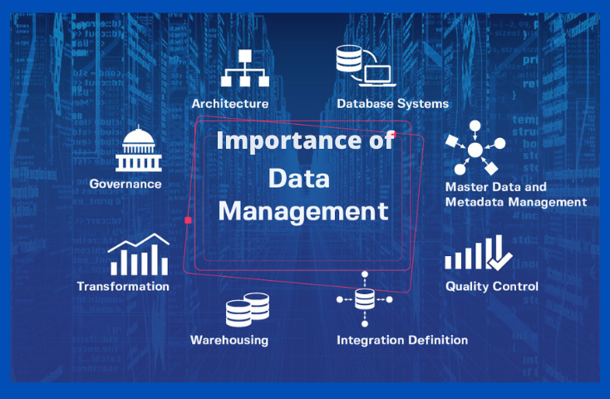
Figure 01: Importance of Data for KM
Source: Isaca.org, 2016
By providing useful business data, this site will improve the lines of communication between staff and management. Papers and files may be exchanged and quickly accessible by all appropriate people, ensuring data is delivered effortlessly. Intellectual capital will be effective and natural consequences.
Having a well-organised database is helpful for businesses that want to grow, improve their product or service, and secure their position in the industry for the long term. The information system of a corporation (Ferraris et al., 2018) facilitates the analysis of decentralised operations and guarantees the highest level of organisation in the workplace. By employing information management properly, an organisation will grasp the best approaches to build the information cycle and create and sell solutions or goods via market analysis and integrated information governance (Leong, 2018).
Knowing how to handle information effectively is a skill that may be used in a wide variety of fields and careers. Someone with experience in the field may do wonders for a company's growth and safety. Moreover, additional responsibilities will have both direct and indirect effects on the company's enhanced knowledge management.

The Evaluations of Knowledge and Information Management
Various firms' knowledge management strategies are built around knowledge collaboration. Furthermore, because it is unique, tacit knowledge is extremely important in the framework of knowledge management. The primary goal (Emerson and Berge, 2018) of knowledge management is to obtain long-term comparative benefits, and maintaining tacit knowledge helps to accomplish this. Also, tacit knowledge is tougher to share and thus more complicated to embed inside the product and service activities.
In the first place, it is important to capture the tacit knowledge of the customers. Customer service call records, running Q&A sessions, helpful chat conversations, customer stories, etc. (Simamora, 2019) , can be great ways to capture the tacit knowledge of the users. The evaluation here is largely related to social media and other advanced ways.
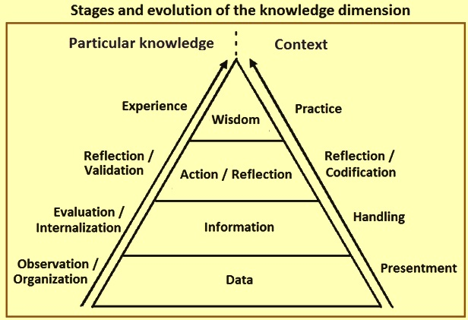
Figure 02: KM – Stages of Evaluation
Source: IspatGuru, 2017
The mapping of attributes (Durst and Zieba, 2019) to a framework, which considers functional, structural, and implementation-related information, is at the core of goods cognitive design. Designing any product is an activity of pleasing the customers. So, those embedded tacit knowledge is the key to designing any product or service concept. The perpetual adjectives (Ferreira et al., 2018) from the tacit knowledge are mapped via different abstract features. The suitable each of them produces functions and different structures. There are now multiple functions, and these functions bring multiple components. Finally, the conceptual product (Li et al., 2021) design must satisfy the explicit model of tacit knowledge, and the company now has an elevated product that may shine in the market.
The Nonaka and Takeuchi model (Arantes et al., 2021) elevates the knowledge creation process in the Management and Information Systems in both direct and indirect ways. Here, through an innovative platform, the management conveys tacit knowledge into explicit concepts, and the MIS keeps the record of different combinations. MIS here also analyses the trends and regularly generates a summary for the administration, also helping the TPS and DSS.
The WIIGS KM model says (Husain and Ermine, 2021) the KIM must be proper and reasonable to make useful and valuable knowledge. This model is helped by the MIS and ESS for better holding and pooling of knowledge. Besides, the building and application of information here are significantly purposeful and connected to the evaluation of organisational systems.

Amazon.Com
For more than 25 years, Amazon.com has been offering online retail purchasing services to customers, sellers, businesses, and other groupings. It offers ranges, values, and simplicity to customers through its commercial websites. It creates its websites so that the corporation and other parties may sell its items throughout hundreds of market segments. It also produces and distributes the Kindle e-reader and aims to provide clients with the best deals by offering free shipping deals and low-cost standard shipping rates, such as through subscription (Sadq et al., 2018).
The business provides vendors with programs that let them sell various wares on its online sites and webpages under their own brands, earning set costs, revenue-share bills, or other activity service charges from the sales.
The business is divided into the North American and International markets (Sadq et al., 2018). The sales of household goods and memberships through websites with a North American audience make up the North American category. Sales of consumer goods and services through international-focused locations make up the global sector. These overseas locations' foreign sales, particularly those to clients in the United States and Canada, are included in this section.

Importance of ISs for Amazon
Amazon has a massive consumer base, making it one of the most successful e-commerce companies worldwide. Amazon's use of sophisticated information management in its corporate operations has helped it gain a competitive edge by streamlining the gathering, storing, and analysis of sensitive consumer data.
Critical business processes have become more efficient because of the independence of decision-making made possible by the information systems embedded into business process evaluation. Amazon runs a two-part information (Williamson et al., 2022) management system that includes the Simple Storage Service linked to its centralised system and the Amazon Web Service, which encourages connection to the E-commerce system. In order to streamline the transaction processing, the online service enables clients to create user accounts and tailor their profiles.
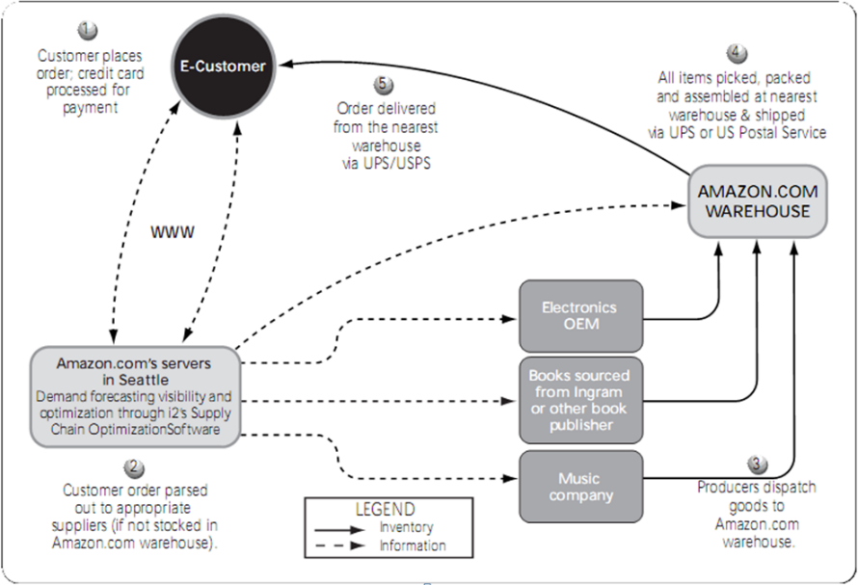
Figure 03: Process of Information Systems in Amazon
Source: Organimi, 2018
The technology is cutting-edge to provide high degrees of interconnectivity with any form of internet-enabled technology for efficient communication between customers, vendors, and Amazon employees (Ives et al., 2019). The powerful web service is excellent at providing business operations through a Customer Relationship Management (Ramadan et al., 2021) system because it combines unique characteristics such as dependability, flexibility, privacy, and effectiveness.
Amazon.com has consistently pioneered new approaches to business and technology. Smart Analysis Lookup is a method that works together to ensure user data is safe and to encourage customised service focused on a user's profile. In addition, an Oriented Service Structure (Vollero et al., 2021) was used in its construction, which encourages service dispersion and hence increases the system's adaptability.
Amazon's success can largely be dependent to the company's ways of gathering consumer data, maintaining it, and then using that information to guide business choices. Amazon.com has protected its customers and maintain its significance, and although there is always space for improvements, particularly in relation to the company's WIS (Sadq et al., 2018), these safeguards have been put in place. Knowledge management and information systems allow businesses to improve customer service, streamline supply chain operations, and protect profit margins.

Different Information Systems of Amazon
Amazon has always known that its success depends on its consumers' positive user experience or their ability to locate the products swiftly and easily they're looking for. An additional layer of value may be added if the system provides users with a clear and individualised path to success. Here are some information systems that Amazon uses:
Transaction Processing System
TPS is the main information system for Amazon for daily operations activities. Under the system, there are multiple options.
- All-in-one purchasing. The customer experience and the site are identical. Users become more comfortable and at ease as a result, which reduces their fear as they discover new parts of the website.
- Uniformity of presentation. Wherever feasible, Amazon presents all product-related information, including reviews and item specs, uniformly and in a similar sequence (Vollero et al., 2021). This results from excellent resource management, where they create the knowledge and then consistently broadcast it to consumers.
- Crowdsourcing. Amazon helps consumers become more knowledgeable and aware by offering tools like user-submitted ratings, reviews, and photographs, as well as an assessment of what consumers have previously purchased or purchased together (Ives et al., 2019).
- Easy and consistent transactions. The users of the website find anything insanely easy and consistent. The most important factor in any KM endeavour will be the convenience of use, followed by content integrity.
Management and Information System
By using MIS processes, Amazon can transform raw data into useful insights that can be incorporated into future business decisions. By maintaining its mechanical and operational system and running the information system efficiently, the firm can realise (Ramadan et al., 2021) success in its deployment of an interconnected solution through the internet. When it comes to doing experiments, Amazon finds MIS systems particularly useful because of the raw data they collect. In order to foretell potential outcomes (Altun, 2019), these simulations are quite helpful. Information management technologies are used by Amazon to compile large amounts of data into meaningful reports. Managers may make sound strategic decisions with the help of this well-organised data. Managers (Lorne and Gogireddy, 2021) use the analyses and statements to spot information trends and economic correlations that might guide development strategy.
Decision Support System
Amazon's adoption of web-based DSS allows the corporation to have access to novel, high-risk, enterprise-wide DSS (Haque et al., 2018) that facilitates strategic planning and business expansion in the cutthroat e-commerce industry. Additionally, DSS boosts satisfaction by reducing decision-maker irritation (Altun, 2019). Moreover, DSS lessens the price tag of making business decisions (Haque et al., 2018). That's great news for supervisors and those in charge. DSS also boosts management and decision-maker authority over the retail giant. Amazon's culture of learning is fostered by a DSS. All levels of staff and management get exposure to novel ideas and methods for enhancing the company's performance.

Information Systems and Amazon's Effectiveness
Amazon's information systems are only as good as their ability to facilitate fundamental company operations, including order taking, transaction processing, shipment, and consumer relationship maintenance. In order to better analyse business processes, Amazon has unified many parts of its information system, including its database and client contact planning system.
The corporation has enabled the use of business analytics insights to learn about the industry and guide the development of enhancement methods for increasing order throughput per unit of time. To better comprehend shifts in supply and demand, Amazon's information management system (Burroughs and Burroughs, 2020) builds a digital replica of the real-world marketplace. Optimisation of corporate processes and quicker responses to client inquiries are made possible by the information system's seamless integration with existing communication infrastructures. In addition, the ordering procedure is integrated with the order fulfilment and shipping systems to optimise the timely handling of consumer inquiries.
Amazon's Business Information System (Husain and Ermine, 2021) relies heavily on its transaction processing system, which ensures safe and streamlined shopping for consumers. This data management platform is both safe and simple to use, thanks to innovations like one-click purchasing and secured credit card processing. Amazon's information administration methods also include advanced features like the sophisticated recommendation framework (Aversa et al., 2021), which uses data mining to examine a customer's past purchases and search history to create helpful suggestions. Consequently, the system becomes very participatory, much to the delight of the company's clientele. The online service and payment system are both tied into the SCM system, which processes the data on client orders.
When a client order using the online service, the information management queries the database system and provides the product specifics to the customer's console. When a consumer places an item in their shopping cart, the system automatically takes them to a secure payment page where they may enter billing and shipping information and submit the money electronically. A receipt for the transaction and product information is sent to the buyer by email or SMS. The order is processed and sent once the financial information is recorded and transmitted by the payment mechanism to the supply chain. When a product is dispatched, the customer is notified via the supply chain and helps the consumers.
Amazon data is crucial in centralised decision assistance (Aversa et al., 2021) by facilitating not just access to and understanding of data but also centralisation of data. When used in both formal and informal decision-making procedures, the information system plays the role of a decision system. Multiple groups may now collaborate on a single project using the information system to provide a set of concrete recommendations for enhancing a specific enterprise procedure.

Amazon's Potential Knowledge Management Challenges
Amazon is doing business in a very competitive market with a multi-billion-dollar value proposition. So, the size of the knowledge management activities is not small, and there might be and are some problems in the knowledge and information management.
As the company expanded its operations during the Coronavirus pandemic, the number of personnel here is huge now. The transaction process systems here are now more complicated and need regular calculations. So, the motivation level of the executives and employees (Ying and Anikina, 2019) is very tough to remain positive. The company is likely to face issues related to motivating its workers as the information is huge, and they are facing severe pressures.
Another issue that may occur inside their information systems is the security (Forkus et al., 2022) of the management and executive information systems data. Besides, the simultaneous exchange and sharing of information make the data tough to remain secure and accurate. The competition is huge in the market. So, the company must look after the website and information on the website so that the data is accurate, and the system is free from any loopholes. Amazon must keep the externalisation (Forkus et al., 2022) from the Nonaka and Takeuchi KM model here to secure and maintain the information.
In the competitive environment, the company must be up to date with any technological and information-related management. The overall leadership of Bezos is not only the main thing here to cope with the market. Besides, the whole team must know the market and the customers regularly. So, the leadership advancement issues in the management information systems, executive information systems (Ioris, 2018), and transaction process systems should be strongly kept in mind.
As Amazon is very big and complex, the knowledge and information management system may not all-time make the company profitable. The structure of the industry here is complicated, and thus only maintaining the pace is all Amazon can do. So, the company's ultimate issue maybe not be properly profitable as the information systems, structures, and other operations activities are too complex.

Recommendations
There must be a few things that Amazon can do to get rid of the potential problems. In the first place, it has to take stock of its strengths and focus relentlessly on improving those areas. Now is the time to get rid of any diversifications that aren't essential. The organisations may benefit from this exercise since it will inspire workers while dealing with intricate information and knowledge management systems.
Strategically, there is no greater move than branching out into cloud-based service. Given that cloud computing is poised to become one of the industry's most prominent developments and that big data is also becoming more prevalent in IT infrastructure, Amazon is well positioned to become a market pioneer in both areas.
Finally, Amazon can include third-party service providers in the integrated and embedded information systems for greater security and accuracy management of the information. The company can refocus on the market and combine its internal stakeholders for the purpose of information management. Also, the company must implement the KM models more to ensure the highest productivity.

Conclusion
The knowledge management and Amazon's position during the pandemic time have changed the perspective of the importance of information in business and the necessity of consumer opinion in the retail industry. A simple market analysis of the consumers' perspective and how they wanted the items to come to them had scaled up the margins for Amazon. The company effectively integrated the information systems with its software and management systems and processed the knowledge and information management in an integrated manner. Amazon presented the world with the indirect theories and implementations of knowledge management and gave us some crucial insights into KIM. Though there are some loopholes in the company's information systems, it may have effectively overcome them. Otherwise, Amazon's loopholes will be patches of its competitors.

References
Adeinat, I.M. and Abdulfatah, F.H., 2019. Organizational culture and knowledge management processes: case study in a public university. VINE Journal of Information and Knowledge Management Systems, 49(1), pp.35-53.
Altun, L., 2019. A Corpus Based Study: Analysis of the Positive Reviews of Amazon. com Users. Advances in Language and Literary Studies, 10(1), pp.123-128.
Ammirato, S., Linzalone, R. and Felicetti, A.M., 2021. Knowledge management in pandemics. A critical literature reviews. Knowledge Management Research & Practice, 19(4), pp.415-426.
Arantes, L.S., Martinelli Junior, O., Viegas, T.D.O.C. and Rohenkoh, J.E., 2021. Maturity and level of knowledge management in the company: an application of Nonaka and Takeuchi model and Fuzzy Logic. Gestão & Produção, 28.
Aversa, P., Haefliger, S., Hueller, F. and Reza, D.G., 2021. Customer complementarity in the digital space: Exploring Amazon’s business model diversification. Long Range Planning, 54(5), p.101985.
Burroughs, B. and Burroughs, W.J., 2020. Digital logistics: Enchantment in distribution channels. Technology in Society, 62, p.101277.
Durst, S. and Zieba, M., 2019. Mapping knowledge risks: towards a better understanding of knowledge management. Knowledge Management Research & Practice, 17(1), pp.1-13.
Emerson, L.C. and Berge, Z.L., 2018. Microlearning: Knowledge management applications and competency-based training in the workplace. UMBC Faculty Collection.
Ferraris, A., Mazzoleni, A., Devalle, A. and Couturier, J., 2018. Big data analytics capabilities and knowledge management: impact on firm performance. Management Decision.
Ferreira, J., Mueller, J. and Papa, A., 2018. Strategic knowledge management: theory, practice and future challenges. Journal of knowledge management.
Forkus, S.R., Contractor, A.A., Goncharenko, S., Goldstein, S.C. and Weiss, N.H., 2022. Online crowdsourcing to study trauma and mental health symptoms in military populations: A case for Amazon’s Mechanical Turk (MTurk) platform. Psychological trauma: theory, research, practice, and policy.
Haque, T.U., Saber, N.N. and Shah, F.M., 2018, May. Sentiment analysis on large scale Amazon product reviews. In 2018 IEEE international conference on innovative research and development (ICIRD) (pp. 1-6). IEEE.
Harlow, H.D., 2018. Developing a knowledge management strategy for data analytics and intellectual capital. Meditari Accountancy Research.
Husain, S. and Ermine, J.L., 2021. Knowledge Management: Processes and Models. In Knowledge Management Systems. Emerald Publishing Limited.
Ioris, A.A., 2018. Amazon's dead ends: Frontier-making the centre. Political Geography, 65, pp.98-106.
Ives, B., Cossick, K. and Adams, D., 2019. Amazon Go: disrupting retail? Journal of Information Technology Teaching Cases, 9(1), pp.2-12.
Leong, E., 2018. Recipes and everyday knowledge. In Recipes and Everyday Knowledge. University of Chicago Press.
Li, X., Lyu, M., Wang, Z., Chen, C.H. and Zheng, P., 2021. Exploiting knowledge graphs in industrial products and services: a survey of key aspects, challenges, and future perspectives. Computers in Industry, 129, p.103449.
Lorne, F.T. and Gogireddy, M.R., 2021, March. Digital social contracts with AI robots: some implications for Amazon. Com. In European, Asian, Middle Eastern, North African Conference on Management & Information Systems (pp. 78-89). Springer, Cham.
Maravilhas, S. and Martins, J., 2019. Strategic knowledge management in a digital environment: Tacit and explicit knowledge in Fab Labs. Journal of business research, 94, pp.353-359.
Ramadan, Z., F Farah, M. and El Essrawi, L., 2021. From Amazon. com to Amazon. love: How Alexa is redefining companionship and interdependence for people with special needs. Psychology & Marketing, 38(4), pp.596-609.
Roy, S. and Mitra, J., 2018. Tacit and explicit knowledge management and assessment of quality performance of public R&D in emerging economies: An Indian perspective. Journal of Organizational Change Management.
Sadq, Z.M., Sabir, H.N. and Saeed, V.S.H., 2018. Analyzing the Amazon success strategies. Journal of process management and new technologies, 6(4).
Salehi, M., Fahimi, M.A., Zimon, G. and Homayoun, S., 2021. The effect of knowledge management on intellectual capital, social capital, and firm innovation. Journal of Facilities Management.
Simamora, R.H., 2019. Socialization of information technology utilization and knowledge of information system effectiveness at Hospital Nurses in Medan, North Sumatra. International Journal of Advanced Computer Science and Applications, 10(9).
Vollero, A., Sardanelli, D. and Siano, A., 2021. Exploring the role of the Amazon effect on customer expectations: An analysis of user‐generated content in consumer electronics retailing. Journal of Consumer Behaviour.
Williamson, B., Gulson, K.N., Perrotta, C. and Witzenberger, K., 2022. Amazon and the new global connective architectures of education governance. Harvard Educational Review, 92(2), pp.231-256.
Ying, W. and Anikina, Y.A., 2019. PROBLEMS AND PROSPECTS OF ELECTRONIC BUSINESS IN AN INTERNATIONAL ENVIRONMENT. Актуальные проблемы авиации и космонавтики, 3, pp.402-404.

Appendix


