

Cover page
ACBA 4006 Material science & Building services – Assignment 1: construction materials
Ryan Lewis-Edwards 1808182

Table of Contents
Contents
Cover Page 0
Table of Contents 1
Abstract 2
Introduction 2
Case Studies 3
Empire State Building (ESB) 3
Burj Khalifa 5
Comparison 7
Conclusion 9
References 10

|LATE ENTRY SUBMISSION FROM THE STUDENT
CAPPED AT 40% MARK

Allan Nantel 11/03/2021

Abstract
Structural frames are to be considered in the construction of all buildings from traditional build houses to skyscrapers. Selecting the suitable underlying form of a building can sometimes prove difficult due to a plethora of implications that need to be considered e.g., Time to construct, sustainability, climate, cost constraints etc. The case studies will consider the advantages and disadvantages of concrete and steel frame structures used in industry looking into the sustainability of each material. to compare and contrast how and the two different materials favour different environments and why contractors may favour one of the materials over the other.

Introduction
In the construction of a building, there are a plethora of considerations that need to be decided in the planning and design stages of the build, one of the most important early considerations is the underlying form of the building - the structural frame that is to be used. The purpose of a structural frame is to ensure that the build is strong enough to withstand the weight of the walls, roof etc. Adequate framing is also important to ensure the occupants are protected against environmental forces and to support the buildings activities. There is short- and long-term implications involved in the selection of a buildings structural frame, short term implications include how long the structure will take to construct, long term implications include the expected life span of the framing structure material.
Sustainability is an important factor in any modern build and consideration needs to be taken when considering sourcing of materials, the methods of construction being used, vulnerabilities possibly caused by the climate and environment of the structure.

Case Studies

Empire State Building (ESB)
The Empire State building was constructed from 1930-1931 and is the eight tallest building in the world standing at 443m tall and was erected and ready for tenants in a twenty-month period of time. The design of the building is said to have been based on a pencil and is 102 storeys making it the first building in the world to exceed 100floors and the first construction project to integrate the use of Gantt charts in the project planning stage which contributed in its fast erection. The ESB was founded using pile foundations which were excavated 55 feet deep to provide a solid base for the 381m tall skyscraper. The ESB has a steel frame which involves a steel truss braced with diagonal beams around the central elevator shaft to improve the steel frames wind resistance around this area. The frame was erected using a time efficient and exceptionally strong method of hot rivets driven into the steel frame joints, the efficiency of this method again contributed to the fast erection of the ESB. Despite the steel framed structure, the ESB used 1300m2 of concrete in its construction the majority of this being in the foundation and basement. The use of steel frame was because during the 1920s stronger concrete was not capable of being made.
“The Theological Evolution of Three Office Buildings Over Time” (May 2013) Available at: https://web.wpi.edu/Pubs/ETD/Available/etd-042513-150621/unrestricted/Giatas.pdf - (Accessed 02 March 2021)
Environmentally speaking, the construction of the ESB used mass production of steel girders to form the structure had a massive environmental effect. “Steel production has a number of impacts on the environment, including air emissions (CO, SOx, NOx, PM2), wastewater contaminants, hazardous wastes, and solid wastes. The major environmental impacts from integrated steel mills are from coking and iron-making” “Steel production & Environmental impact” (2020) Available
at: https://www.greenspec.co.uk/building-design/steel-products-and-environmental-impact/ - (Accessed 02 March 2021)
Case study: Empire State Building
Design Planning:  Location  Climatic zone  Construction Started  Completed  Typology  Capital cost  Height  Type of Construction  Structure  Building envelope material  Partition walls  Types of windows  Floor area  Volume  Surface area | New York City, NY  Subtropical (CWA)  1930  1931  Art deco, Skyscraper  $40,948,900  381m, (443.2m including spire)  On site  Steel Frame  Bedford Indiana limestone  Marble  R-8  254,000 m2  10315.6771 m2  8094 m2 | 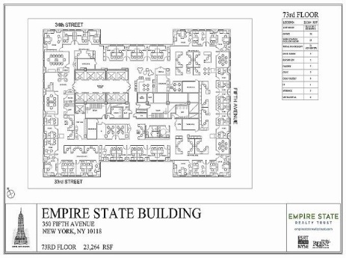  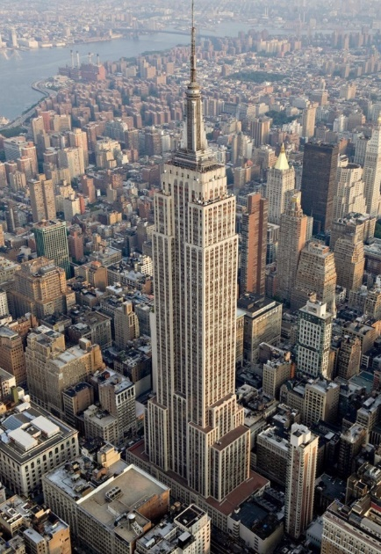  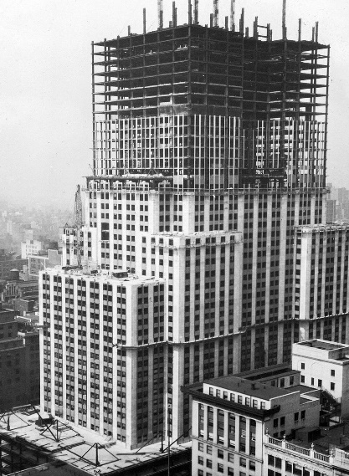

Burj Khalifa
The Burj Khalifa building was constructed from 2004-2009 and is the tallest building in the world at 830m tall. The Burj utilised 330,000 m3 of concrete, 39,000 tonnes of steel, 103,000 m2 of glass and 15,500 m2 of embossed stainless steel to construct. The architecture of the Burj features a triple-lobed footprint arranged around a central core. The foundation consists of bored reinforced concrete piles which supports a 3.7 metres thick reinforced concrete mat totalling 12,500 metres of concrete. The structural “Y” shaped core plan of the Burj is not only a simplistic design which helped the constructability of the building but it also reduces the wind forces on the tower which is important because of the height and climate of the building.
“At The Top Burj Khalifa Fact Sheet” (2020) Available at: https://www.burjkhalifa.ae/img/FACT-SHEET.pdf -(Accessed 02 March 2021)
The Burj has an enormous environmental impact requiring at peak “12,500 tons of cooling per hour and consuming 250,000 gallons of water a day” with a “peak electrical demand of 50MVA.” – “Quick Facts on Burj Khalifa” by Pierre Tristam (2018) Available at: https://www.thoughtco.com/facts-on-burj-dubai-burj-khalifa - (Accessed 02 March 2021)

Case study: Burj Khalifa
Design Planning:  Location  Climatic zone  Construction Started  Completed  Typology  Capital cost  Height  Type of Construction  Structure  Building envelope material  Partition walls  Types of windows  Floor area  Volume  Surface area | Dubai, UAE  Desert  2004  2009  Concrete tower structure  $1,500,000,000  828m (830m to tip)  Mix of on/off site  Reinforced Concrete  Reflective glazing  Reinforced Concrete  R-8  309,473 m2  2954.0554 m2  2954.0554 m2 | 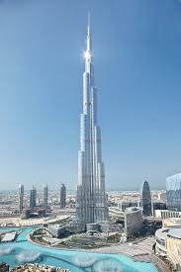  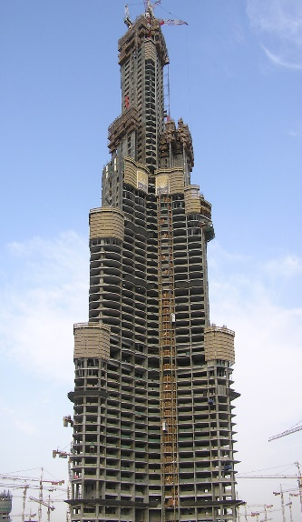  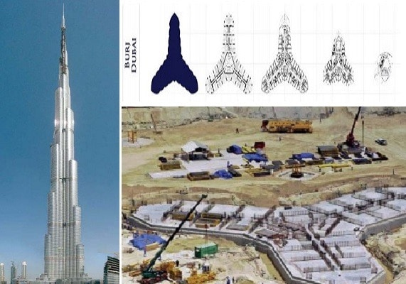

Comparison
Concrete Advantages
- Thermal Conductivity & Fire Resistance – Concrete can withstand high temperatures for long periods of time and offers fire resistance improving the safety of occupants while minimising damage.
- Durability - Concrete buildings last longer and require less maintenance. They better survive disasters and can be reused many times over in their lifetime, meaning less demolition and reconstruction
- Design for Disassembly - Very fast to construct, can be pre-fabricated off site meaning less time developing and more time using working on the structure leading to time and cost savings. Saves on storage of materials.
- Cost – Ingredients used in concrete e.g., cement, aggregates and water readily available and cheap.
- Versatile – Concrete can be shaped and moulded or poured and cast into any shape.
- Compressive Strength – High compressive strength makes it reliable in structures under heavy compressive loads.
- Easily repaired - on concrete structures it is quicker and simpler than steel structure repairs.
- Economics – Price of cement fluctuates less than similarly used materials.
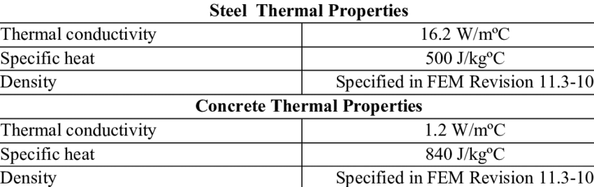
- Concrete’s thermal properties can reduce temperature fluctuations in buildings significantly reducing the electricity cost of the building

- GCC Association (2020) Available at: https://gccassociation.org/concrete-and-sustainability/ (Accessed 02 March 2021)
- ‘Building’ Publication (2006) Available at: https://www.building.co.uk/whole-life-costs-concrete-vs-steel/3069406.article (Accessed 02 March 2021)
Steel Frame Advantages

- Speed of construction – Structural steel enhances productivity due to minimised fabrication required while maintaining tight construction tolerances.
- Sustainability – 90% of steel used in construction is recycled reducing excess waste removal and promoting sustainable construction.
- Offsite construction – Fabrication in closely controlled factory conditions means everything is produced to high standards of accuracy and defect free – effectively “right first time” – “Building” Publication (2018) With Steel Frames allowing for offsite assembly of structures on-site work is therefore minimised reducing noise and dust pollution that is inevitably generated in construction.
- BIM Technologies – Factory based manufacture allows for integration of the latest CAD and BIM technologies creating new skills in the construction sector.
- Procurement – Steelwork contractors can quantify the amount of steel and labour required for the job from the tender specifications of the building. This allows for a quick estimate of the job.
- Reduced Labour – The easier fabrication and reduced labour required due to pre fabrication off site mitigates skilled labour shortages and helps to keep construction costs minimised and promotes work site safety by requiring less labourers on site.
- Weight – Steel frame structures alone are very light in comparison to concrete structures and have a high strength to weight ratio.
- Reduced Sudden Failure – Steel is a ductile material unlike concrete that can cause sudden failure to occur. Steel gives clear indication before failure.

Conclusion
 | Steel Frame Structure | Concrete Frame Structure
Sustainability | 90% recyclable. Low carbon footprint. | Only 10% recyclable.
Durability | Susceptible to weather condition, rust and corrosion. | Highly durable, not often affected by environment.
Ductility | High ductility, will give clear indication before failure occurs. | Low ductility, susceptible to sudden failure.
Weight | 60% lighter than concrete. | Heavy weight.
Erection time | Pre-fabricated fast erection, can be utilised soon after erection. | Concrete structure requires 28 days to set before use.
Cost | Higher cost of construction. | Lower cost of construction.
Labour | Higher skilled labour required | Less skilled labour required.
Load carrying capacity | High load carrying capacity. | Low load carrying capacity in comparison to steel structures.
Foundation | Structure doesn’t require a foundation. | Strong foundation required due to high weight of concrete.

Both Concrete and Steel offer diverse advantages and disadvantages which can be applied together to have major benefits. Reinforced steel rebar concrete is a better construction material over concrete or steel separately due to concretes low tensile strength and ductility. The Rebar used is 100% recycled scrap steel which promotes sustainability in construction and is a lower cost solution in comparison to steel structures and other alternatives.

References
https://www.metabuild.io/en/four-things-you-must-consider-when-designing-in-different-geographies/
https://docs.google.com/presentation/d/1DMCsE7DeAiG6N8ZbUjC22Fdh8swtyfxc/edit#slide=id.p1
https://docs.google.com/document/d/128wP0A4k-OVTRjCD1r0Ir7ODQHiVN5h_/edit
https://www.steelconstruction.info/Sustainable_construction_legislation,_regulation_and_drivers
https://www.designingbuildings.co.uk/wiki/Sustainability_in_building_design_and_construction
https://blog.glwengineering.co.uk/structural-steel-vs-reinforced-concrete-which-is-stronger
https://www.google.com/search?q=case+study+table+construction&tbm=isch&ved=2ahUKEwjVn-6q5KLvAhXGwoUKHd1QCJ8Q2-cCegQIABAA&oq=case+study+table+construction&gs_lcp=CgNpbWcQAzoCCAA6BAgAEB46BggAEAUQHjoGCAAQCBAeUIy8BVjS1wVgktkFaAFwAHgAgAFIiAGrBpIBAjE0mAEAoAEBqgELZ3dzLXdpei1pbWfAAQE&sclient=img&ei=mjBHYNXqBsaFlwTdoaH4CQ&bih=1777&biw=1080&rlz=1C1CHBF_en-GBGB901GB901&safe=strict#imgrc=wCxLIbukF5gmMM
https://web.wpi.edu/Pubs/ETD/Available/etd-042513-150621/unrestricted/Giatas.pdf
https://core.ac.uk/download/pdf/288377435.pdf
https://repository.lboro.ac.uk/articles/thesis/Investigating_the_structural_frame_decision_making_process/9579473
https://www.building.co.uk/whole-life-costs-concrete-vs-steel/3069406.article
https://gccassociation.org/concrete-and-sustainability/
https://web.wpi.edu/Pubs/ETD/Available/etd-042513-150621/unrestricted/Giatas.pdf
https://www.researchgate.net/figure/Thermal-properties-of-Steel-and-Concrete_tbl2_228521944
https://www.thoughtco.com/facts-on-burj-dubai-burj-khalifa-2353671#:~:text=The%20Burj%20is%20expected%20to,100%2Dwatt%20bulbs%20burning%20simultaneously.&text=The%20equivalent%20of%20100%2C000%20elephants,concrete%20was%20used%20during%20construction.
https://www.greenspec.co.uk/building-design/steel-products-and-environmental-impact/#:~:text=Steel%20production%20has%20a%20number,from%20coking%20and%20iron%2Dmaking.
https://www.building.co.uk/cpd/cpd-17-2018-steel-and-offsite-construction/5095342.article

