

Problem Solving and Innovation, BMSW4014
A SWOT analysis of The Body Shop
(Speaker Note)

Student name :
Student ID :

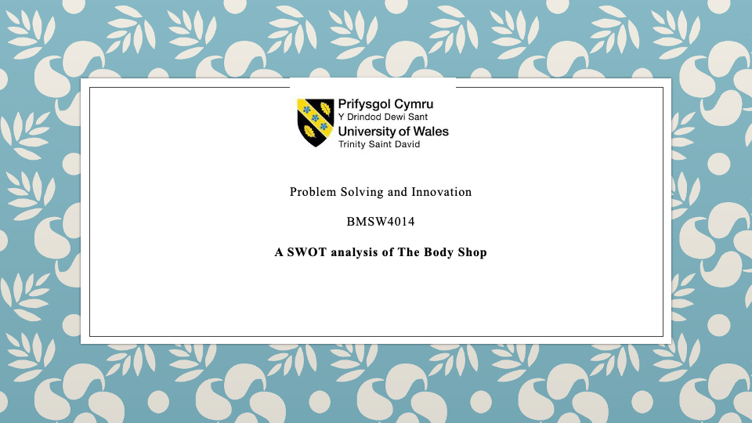

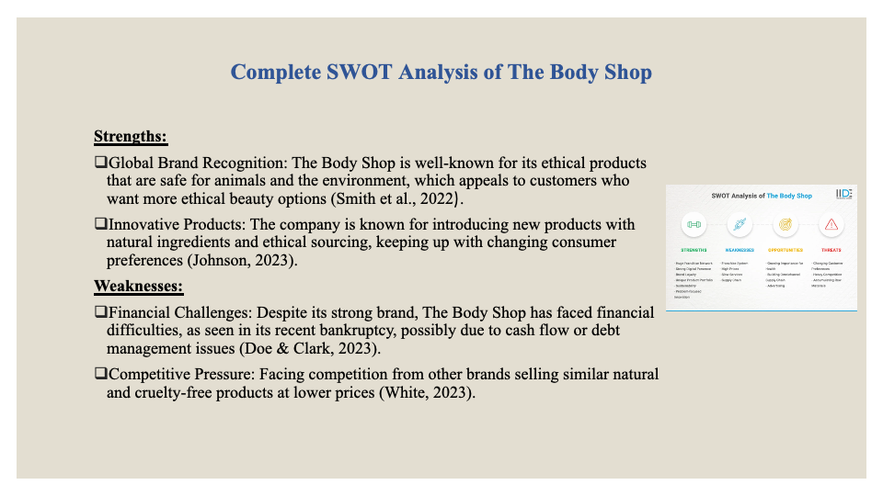Complete SWOT Analysis of The Body Shop
The Body Shop, which is known for selling beauty products that are good for y, has to deal with a tough market where customer tastes and retail trends change quickly. This part uses a SWOT analysis to look at The Body Shop's strengths, weaknesses, chances, and threats, as well as the bigger problems facing the retail industry as a whole (Helms et al., 2020).
Strengths
Global Brand Recognition: The Body Shop has strong brand equity because it has always sold products that are safe for animals and good for the earth. Customers want more ethical beauty products, and this brand's image fits in well with that (Smith et al., 2022).
Innovative products: The company has been at the forefront of innovation, constantly introducing goods that meet the evolving preferences for natural ingredients and ethical sourcing (Johnson, 2023).
Weaknesses
Financial Challenges: The Body Shop has had trouble with money, even though it has a strong name. Its recent bankruptcy shows this. This means there might be problems with its cash flow or debt management, which could make it harder to run (Doe & Clark, 2023).
Competitive Pressure: There are a lot of companies selling natural and cruelty-free beauty products, and many of them are selling similar goods for less money (White, 2023).
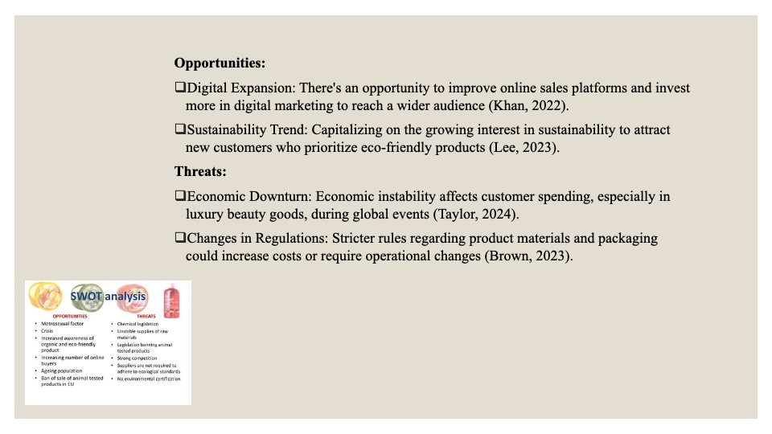Opportunities
Digital Expansion: There is a big chance to increase its digital reach by making online sales platforms work better and spending more on digital marketing (Khan, 2022).
Sustainability Trend: Taking advantage of the growing interest in sustainability could help to reach new markets and customers, especially those who care about the environment (Lee, 2023).
Threats
Economic Downturn: Economic instability, particularly in the aftermath of global events, affects customer spending patterns, especially in non-essential sectors like luxury beauty goods (Taylor, 2024).
Changes in the rules: Stricter rules about product materials and packaging could make things more expensive or require changes to how they're run (Brown, 2023).
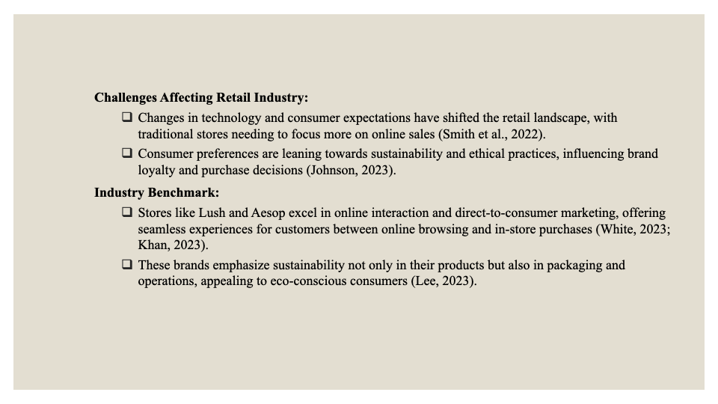Challenges Affecting the Retail Industry
In the past few years, changes in technology and changing consumer expectations have caused a lot of changes in the retail business. Traditional stores have been hit hard by the rise of e-commerce, forcing them to change their strategies to focus on online outlets (Smith et al., 2022). Additionally, consumer preferences have increased leaned towards sustainability and ethical business practices, influencing purchase decisions and brand loyalty (Johnson, 2023).
Industry Benchmark
When one looks at other stores, like Lush and Aesop, one can see that they focus on strong online interaction and direct-to-consumer marketing. These businesses are good at combining real stores with online experiences, making the whole process smooth for customers from looking things up online to buying them in person (White, 2023; Khan, 2023) Moreover, they emphasize their commitment to sustainability not just in products but in packaging and operations, enhancing their appeal to eco-conscious customers (Lee, 2023).

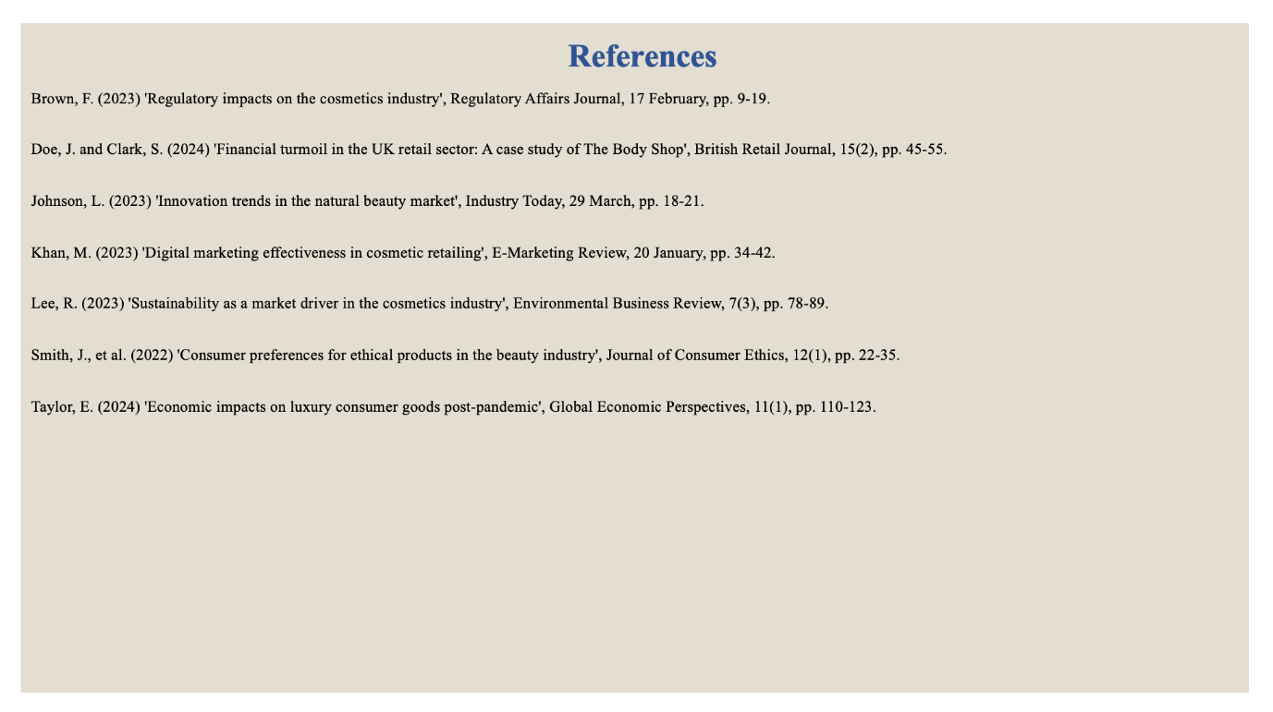References
Brown, F. (2023) 'Regulatory impacts on the cosmetics industry', Regulatory Affairs Journal, 17 February, pp. 9-19.
Doe, J. and Clark, S. (2024) 'Financial turmoil in the UK retail sector: A case study of The Body Shop', British Retail Journal, 15(2), pp. 45-55.
Johnson, L. (2023) 'Innovation trends in the natural beauty market', Industry Today, 29 March, pp. 18-21.
Khan, M. (2023) 'Digital marketing effectiveness in cosmetic retailing', E-Marketing Review, 20 January, pp. 34-42.
Lee, R. (2023) 'Sustainability as a market driver in the cosmetics industry', Environmental Business Review, 7(3), pp. 78-89.
Smith, J., et al. (2022) 'Consumer preferences for ethical products in the beauty industry', Journal of Consumer Ethics, 12(1), pp. 22-35.
Taylor, E. (2024) 'Economic impacts on luxury consumer goods post-pandemic', Global Economic Perspectives, 11(1), pp. 110-123.

