PROJECT MANAGEMENT PLAN
Redevelopment of the Central Transport Hub
Parts A, B and C

Student: Idrissa Traore
Student ID: 2426109
Course: BA (Hons) Leadership and Management Skills in the Workplace
Module: LCLM5003
Lecturer: Dr Xavier Matieni

Executive Summary
This submission proposes a 30-month, £550 million redevelopment of a closed metropolitan central transport hub. The project will restore safe rail, bus and freight interchange capacity while improving inclusive access, digital passenger and logistics systems, climate resilience and progress towards net-zero operation. The hub is treated as critical public infrastructure because its closure affects everyday mobility, freight reliability, local businesses and public confidence. Part A presents the poster separately. Part B reflects on tutor and peer feedback and identifies improvements in spelling, pronunciation, accuracy and presentation delivery. Part C applies a hybrid stage-gate and iterative delivery approach through scope, WBS, Quad Chart, Gantt schedule, stakeholder strategy, resource plan and risk register. The plan identifies strong governance, early operator involvement, systems integration, risk ownership and benefits management as key success factors.

Contents
​
Executive Summary 2
Contents 2
Part A – Project Proposal Poster 4
Part B – Critical Reflection Using Gibbs’ Reflective Cycle 5
Description 5
Feelings 5
Evaluation 5
Analysis 5
Conclusion and Action Plan 5
Part C – Project Management Plan 6
1. Introduction 6
2. Project Description 6
2.1 Project Triangle 7
3. Scope 8
4. Work Breakdown Structure 8
5. Quad Chart 9
6. Gantt Chart 11
7. Stakeholder Involvement 11
7.1 Stakeholder Communication Plan 12
8. Allocation of Resources 12
9. Risk Analysis 13
10. Conclusion 14
11. References 15

​

Part A – Project Proposal Poster

Part B – Critical Reflection Using Gibbs’ Reflective Cycle
Gibbs’ Reflective Cycle (1988) is used to reflect on the transport hub poster presentation. The model covers description, feelings, evaluation, analysis, conclusion and action planning. It supports focused critical reflection by showing the strengths of the presentation, the areas needing improvement and the actions required to strengthen future presentations.

Description
The presentation focused on the redevelopment of the central transport hub and explained how the project would restore rail, bus and freight services while improving safety, accessibility, digital innovation, sustainability and economic growth. It used project management tools such as the Quad Chart, project triangle, risk assessment, RACI matrix, WBS, Gantt chart, quality plan and communication plan to present a structured proposal. The project was planned over 30 months with an estimated budget of £550 million, including a 10% contingency.

Feelings
Before presenting, I felt confident because the poster had been prepared thoroughly and I understood the project well. The professional design, clear title, transport imagery and blue colour scheme created a positive impression. The project-management tools also demonstrated the research and preparation completed. During the presentation, my confidence remained steady and I communicated the main purpose of the redevelopment. However, spelling and pronunciation required improvement. Some words were difficult to pronounce clearly, which affected the fluency of parts of the presentation. Despite this, I completed the presentation and communicated the main ideas effectively.

Evaluation
Several aspects of the presentation were successful. It explained the project objectives clearly and showed how the WBS, Gantt chart, RACI matrix and risk assessment supported delivery. The poster gave the presentation a clear structure and helped the audience understand the proposed project. However, it also contained a spelling issue and a scenario error. The introduction referred to flooding in July 2025, while the assessment brief stated that the hub closed following a structural inspection in November 2025. Some sections were also crowded with information and were difficult to read from a distance. In the verbal delivery, the tools could have been explained in greater depth rather than relying heavily on the poster.

Analysis
This experience showed that confidence is important, but effective preparation must also include checking spelling, scenario accuracy, pronunciation and timing. A professional-looking poster can lose credibility if it contains incorrect information or spelling mistakes. Recording the presentation made it possible to listen back and identify where speech became too quick, hesitant or unclear. This demonstrated that recording is an effective reflective tool because it provides evidence of performance and highlights weaknesses that may not be noticeable during delivery.

Conclusion and Action Plan
Overall, the presentation was confident and communicated the main project proposal successfully. However, spelling, pronunciation, accuracy and presentation fluency require further improvement. For future presentations, I will check the work carefully using spelling software and proofreading support from another person. Presentation practice will include recording, listening back and repeating difficult words. Rehearsing with a timer will also support slower delivery, clearer explanation and improved eye contact with the audience. Regular practice will help future presentations become clearer, more accurate and more professional.

Part C – Project Management Plan

1. Introduction
Closure of a major metropolitan transport hub creates an urgent public service and economic problem. The hub supports rail, bus and freight interchange, but its ageing structure no longer meets safety and accessibility expectations. Closure displaces passengers, disrupts logistics, increases pressure on alternative routes, reduces local business activity and weakens public confidence. The situation also creates a reputational risk for the client organisation because users expect safe, reliable and inclusive transport infrastructure. This plan recommends redevelopment supported by temporary operations, digital modernisation and sustainable design.
Redevelopment is the strongest option because it addresses the asset condition that caused closure and creates an opportunity to improve long-term performance. Temporary multimodal arrangements reduce disruption but cannot solve structural failure. Digital-only or sustainability-only options would improve specific areas but would not restore physical capacity or remove the safety concern. The preferred project therefore combines renewal, temporary operations, digital integration and low-carbon design within one accountable programme. This option is more complex than a short-term repair, but it provides greater value because it links reopening with resilience, accessibility and future operational efficiency.
A hybrid delivery approach will be used. Stage-gate controls suit safety-critical infrastructure because design, consent, procurement and construction require formal approval before resources are committed. This protects the client from moving into construction before surveys, approvals and cost checks are complete. Iterative methods suit passenger information, logistics tools and user testing because requirements may develop through feedback from operators, passengers and accessibility groups. This reflects project management guidance that methods should match project complexity, uncertainty and stakeholder needs (APM, 2019; PMI, 2021; Turner, 2014).

2. Project Description
The project will replace or strengthen unsafe structural elements, reorganise interchange movements, provide step-free inclusive access, modernise passenger information and freight coordination, improve energy performance and reopen the hub through staged commissioning. The indicative control budget is £550 million, including a 10% contingency, and the baseline duration is 30 months. A Project Board, chaired by the Senior Responsible Owner, will approve gateways, changes above tolerance and benefits decisions.
The project aim is to restore a safe, accessible, resilient and digitally enabled central interchange that supports metropolitan mobility, freight reliability and inclusive economic recovery. The main objectives are to complete concept approval by month 4, detailed design by month 10, main construction by month 24 and operational handover by month 30. The project will also deliver the approved scope within the £550 million control budget. It will achieve full step-free access along designated passenger routes, restore agreed rail, bus and freight throughput, integrate tested digital systems and reduce operational carbon emissions compared with the pre-closure baseline.
Governance will be led by a Project Board chaired by the Senior Responsible Owner. The Board will approve the business case, gateways, major changes and benefits strategy. The project manager will coordinate scope, schedule, cost, quality, risk, communications and procurement so that decisions are based on one integrated view of progress. Technical leads will manage structural design, operations, digital systems, environment and accessibility, supported by independent assurance. Clear accountability reduces the risk of delay, overspend and weak decision-making because each workstream has an owner, escalation route and approval threshold (Too and Weaver, 2014; Müller, 2009; Flyvbjerg, 2014).
Figure 1. RACI Matrix
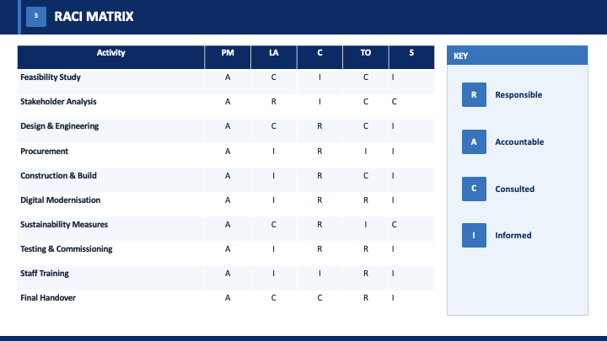
RACI summary: For the business case and gateways, the SRO is accountable, the Project Manager is responsible, the technical lead and stakeholders are consulted, and the contractor is informed. For design assurance, the SRO is accountable, while the Project Manager and technical lead are responsible. For construction delivery, the Project Manager is accountable, the contractor is responsible and the technical lead is consulted. For stakeholder communication, the SRO is accountable, the Project Manager is responsible and stakeholders are consulted. For operational handover, the SRO is accountable, while the Project Manager and contractor are responsible.

2.1 Project Triangle
The project triangle shows the relationship between time, cost and scope/quality. For this redevelopment, the baseline is a 30-month schedule, a £550 million budget and a defined scope covering structural renewal, accessibility, digital systems, temporary arrangements and handover.
Figure 2. Project Triangle
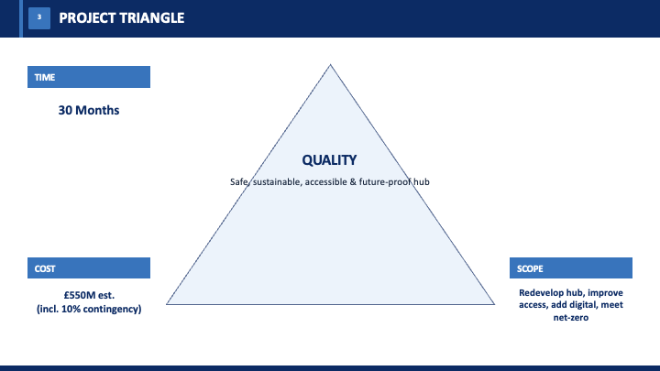
TIME
30-month baseline
Gateway schedule and commissioning milestones
COST
£550 million control budget including contingency
SCOPE / QUALITY
Safe redevelopment, inclusive access, digital systems and sustainable operation
The triangle supports change control by showing that any change to time, cost or scope has consequences for the other two areas. This helps the Project Board assess trade-offs before approving changes.

3. Scope
The project scope includes feasibility studies, stakeholder consultation, design, procurement, site preparation, structural redevelopment, rail, bus and freight interchange works, passenger facilities, accessibility upgrades and digital modernisation. It also includes smart ticketing, real-time passenger information, energy-efficient systems, safety inspections, testing, staff training and final handover.
The project boundaries exclude unrelated city-wide transport upgrades, private commercial or residential development outside the hub boundary, and long-term transport operations after handover. Temporary transport arrangements will support continuity during construction, but they will remain a supporting activity rather than part of the permanent scope. These boundaries help control cost, time and quality while reducing the risk of uncontrolled scope growth.

4. Work Breakdown Structure
The WBS links strategy to delivery by breaking the project into deliverable groups with assigned responsibility, budget, schedule and quality criteria. Each work package will have an owner, duration, dependencies, inspection points and acceptance evidence. This makes it easier to connect progress reporting with real outputs such as completed surveys, approved designs, finished enabling works, installed systems and accepted handover documents. Reporting will focus on completed outputs rather than general activity, giving stakeholders reliable evidence of progress towards reopening (PMI, 2021; Winch, 2010).
Figure 3. Work Breakdown Structure
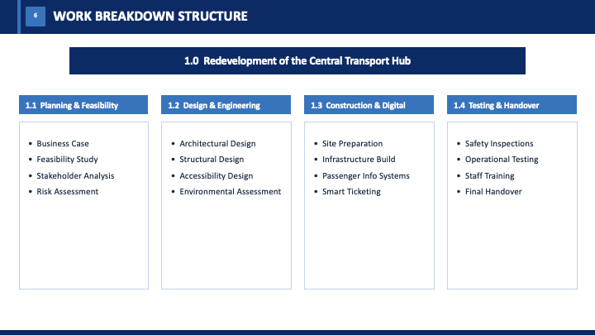
WBS summary: 1. Governance and assurance; 2. Design and consents; 3. Enabling and temporary transport works; 4. Structural redevelopment and interchange construction; 5. Digital systems and logistics coordination; and 6. Testing, training, commissioning and handover.

5. Quad Chart
The Quad Chart acts as a concise governance tool, summarising the project need, proposed approach, success measures, risks and decisions required from senior stakeholders.
Figure 4. Project Quad Chart
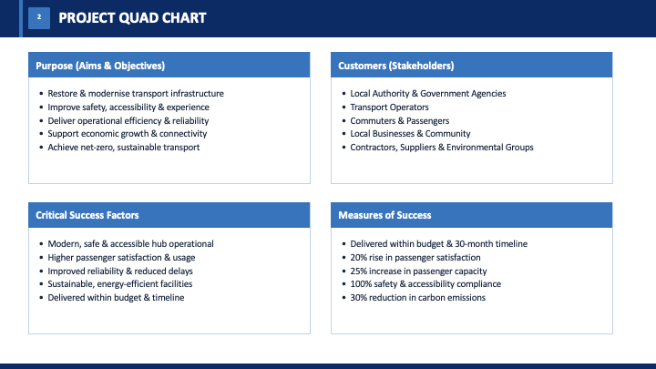
Need  Closed ageing hub, safety risk, commuter disruption and freight delay. | Solution  Redevelop the hub with inclusive access, temporary operations, digital integration and sustainable design.
Benefits  Restored capacity, safer interchange, improved accessibility, lower operational carbon and stronger local economy. | Key risks  Structural uncertainty, cost inflation, consent delays, operational disruption and systems integration failure.

6. Gantt Chart
Figure 5. High-level Gantt Chart
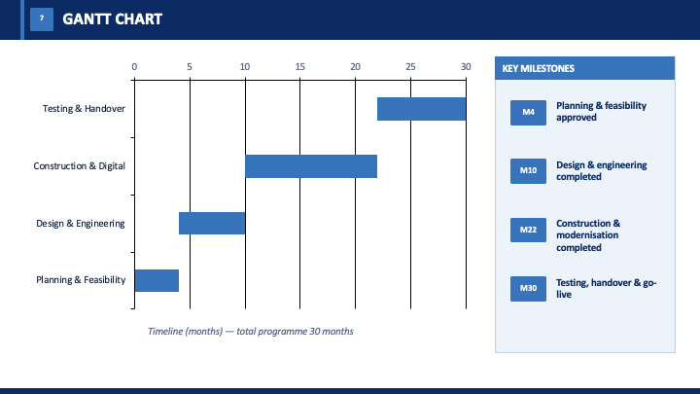
Workstream | M1-4 | M5-10 | M11-18 | M19-24 | M25-30
Feasibility and business case | ●
Design and consents | ● | ●
Procurement and enabling works |  | ● | ●
Construction and systems installation |  |  | ● | ●
Testing, training and handover |  |  |  |  | ●

Figure 5 summarises the main workstreams, dates and milestones in the 30-month baseline.
Schedule management will use a detailed network plan beneath the high-level Gantt chart. The project manager will monitor the critical path and float across surveys, consents, procurement, structural works, systems integration and commissioning. The schedule will be reviewed with workstream leads so that delays in one area, such as late approvals or unavailable materials, can be assessed for their effect on later activities. Rolling-wave planning will support short-term control while preserving the 30-month baseline. Acceleration will be carefully assessed because compressing construction or testing can increase safety and quality risk (Kerzner, 2022; PMI, 2021).

7. Stakeholder Involvement
Stakeholder engagement is essential for project success. Authorities and funders will receive formal reports, while transport operators, passengers, disabled-user groups, freight companies, local businesses and residents will be consulted throughout the project. Communication will include meetings, workshops, newsletters, website updates and accessible formats. A commitments register will track concerns, actions and responsibilities to ensure stakeholder feedback influences project decisions (Freeman, 1984; Olander, 2007).

7.1 Stakeholder Communication Plan
Stakeholder communication will be managed as a planned process. The aim is to provide accurate information to each group through suitable channels and at suitable times. This is important because closure affects travel, freight, business activity, accessibility and public trust. Communication must therefore explain both short-term disruption and the long-term benefits of redevelopment. A structured plan reduces misinformation, supports transparency and shows how stakeholder concerns influence decisions (Freeman, 1984; Olander, 2007; Prebanić and Vukomanović, 2023).
Figure 6. Stakeholder Communication Plan
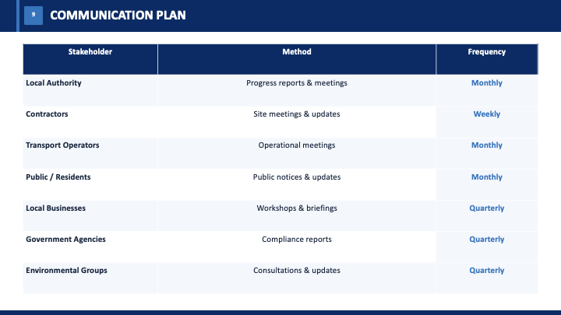
Stakeholder | Information need | Channel | Frequency
Local authority and funders | Cost, risk, milestones and benefits | Project Board reports | Monthly
Transport operators | Operational phasing and readiness | Workshops and interface meetings | Fortnightly
Passengers and residents | Disruption, access and reopening updates | Website, notices and newsletters | Monthly / as required
Disabled-user groups | Accessibility design and user testing | Co-design sessions | At design gateways

8. Allocation of Resources
Resource allocation will consider both skills and budget. The client team will manage governance and controls, the design team will provide technical expertise, and the principal contractor will oversee construction, safety and quality. Procurement will prioritise whole-life value, supplier capability and early ordering of long-lead materials. This approach will support effective delivery while controlling cost, time and quality (Winch, 2010; Turner, 2014).
Table 1. Resource Allocation
Resource area | Allocation | Primary control
Governance and assurance | £33m | Gateway and independent assurance
Design and consents | £66m | Design approval and statutory compliance
Enabling works | £55m | Service continuity and site readiness
Construction and systems | £286m | Cost, programme, quality and interface control
Digital and training | £44m | Systems integration, testing and competence
Contingency | £55m | Evidence-based Project Board drawdown
Handover | £11m | Operational acceptance and benefits baseline
Total | £550m | Approved control budget

9. Risk Analysis
Table 2. Risk Analysis
Risk | Likelihood | Impact | Score | Response / mitigation | Owner
Unknown structural condition | 4 | 5 | 20 | Early intrusive surveys; design allowance; independent review. | Technical lead
Consent or approval delay | 3 | 4 | 12 | Early regulator engagement; approvals tracker; gateway readiness reviews. | PM
Cost inflation / supply constraint | 4 | 4 | 16 | Early market testing; indexed allowances; long-lead procurement. | Commercial lead
Operational disruption | 3 | 5 | 15 | Temporary service plan; possessions strategy; public communications. | Operations lead
Digital interface or cyber failure | 3 | 5 | 15 | Interface control documents; staged integration; cyber and resilience testing. | Digital lead
Safety incident during construction | 2 | 5 | 10 | CDM controls; competent supervision; audits; stop-work authority. | Principal contractor
Accessibility requirements missed | 2 | 5 | 10 | Co-design; accessibility audits; user trials before acceptance. | Accessibility lead

Risk management will focus on the most likely and highest-impact threats to cost, time, safety and public confidence. Each risk will have an owner, mitigation action and review frequency. High-scoring risks will be reviewed weekly by the delivery team and escalated to the Project Board where they could affect the 30-month schedule or £550 million budget.
Contingency will only be used when a risk has occurred and the need for drawdown is evidenced. This prevents the contingency budget from being treated as spare funding.
Figure 7. Quality Management Framework
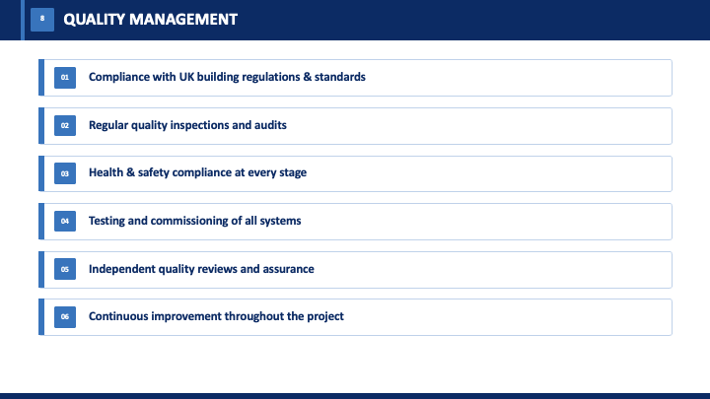
Quality Management Framework
Plan standards and acceptance criteria; assure design, safety and accessibility; control inspections, testing and non-conformances; verify operational readiness and handover evidence; and review lessons learned and benefits.
Quality management will be planned from the start. The quality plan will define standards, inspections, approvals, document control and non-conformance processes. Structural works will require independent checks, while digital systems will need cybersecurity, resilience and user acceptance testing. Accessibility will be verified through design review, audit and user trials, ensuring that inclusive access is treated as an acceptance requirement rather than an optional enhancement. Handover will require documentation, training, asset data, defects arrangements and operational acceptance before the hub is formally reopened (ISO, 2020; Kerzner, 2022).
Sustainability will be a core requirement. Design decisions will consider embodied carbon, energy use, renewable potential, durable materials, water management, waste reduction, climate resilience and social value. The project should also support more reliable public transport use by improving interchange quality and passenger confidence after reopening. Carbon and accessibility requirements will be protected at gateway reviews so they are not weakened by cost pressure without transparent approval (Silvius and Schipper, 2014; Martens and Carvalho, 2017).

10. Conclusion
Redevelopment of the central transport hub is the most defensible project because it resolves the structural cause of closure while restoring multimodal capacity and enabling inclusive, digital and low-carbon transport. The 30-month, £550 million baseline is supported by clear scope, WBS deliverables, staged governance, integrated scheduling, stakeholder participation, resource planning and risk ownership. Delivery will depend on early surveys, credible temporary operations, strong interface management and independent assurance. If these controls are applied consistently, the project can move beyond reopening the hub and create a safer, more resilient and more useful transport asset for passengers, freight users and the wider city economy.

11. References
Association for Project Management (APM) (2019) APM Body of Knowledge. 7th edn. Princes Risborough: Association for Project Management.
Flyvbjerg, B. (2014) ‘What you should know about megaprojects and why: An overview’, Project Management Journal, 45(2), pp. 6-19.
Freeman, R.E. (1984) Strategic Management: A Stakeholder Approach. Boston: Pitman.
International Organization for Standardization (ISO) (2020) ISO 21502:2020 Project, programme and portfolio management - Guidance on project management. Geneva: ISO.
Kerzner, H. (2022) Project Management: A Systems Approach to Planning, Scheduling, and Controlling. 13th edn. Hoboken, NJ: Wiley.
Martens, M.L. and Carvalho, M.M. (2017) ‘Key factors of sustainability in project management context: A survey exploring the project managers’ perspective’, International Journal of Project Management, 35(6), pp. 1084-1102.
Müller, R. (2009) Project Governance. Farnham: Gower.
Olander, S. (2007) ‘Stakeholder impact analysis in construction project management’, Construction Management and Economics, 25(3), pp. 277-287.
Prebanić, K.R. and Vukomanović, M. (2023) ‘Exploring stakeholder engagement process as the success factor for infrastructure projects’, Buildings, 13(7), 1785.
Project Management Institute (PMI) (2021) A Guide to the Project Management Body of Knowledge. 7th edn. Newtown Square, PA: Project Management Institute.
Serra, C.E.M. and Kunc, M. (2015) ‘Benefits realisation management and its influence on project success and on the execution of business strategies’, International Journal of Project Management, 33(1), pp. 53-66.
Silvius, A.J.G. and Schipper, R.P.J. (2014) ‘Sustainability in project management: A literature review and impact analysis’, Social Business, 4(1), pp. 63-96.
Too, E.G. and Weaver, P. (2014) ‘The management of project management: A conceptual framework for project governance’, International Journal of Project Management, 32(8), pp. 1382-1394.
Turner, J.R. (2014) The Handbook of Project-Based Management. 4th edn. New York: McGraw-Hill Education.
Ward, S. and Chapman, C. (2003) ‘Transforming project risk management into project uncertainty management’, International Journal of Project Management, 21(2), pp. 97-105.
Winch, G.M. (2010) Managing Construction Projects. 2nd edn. Chichester: Wiley-Blackwell.
Zou, P.X.W., Zhang, G. and Wang, J. (2007) ‘Understanding the key risks in construction projects in China’, International Journal of Project Management, 25(6), pp. 601-614.

