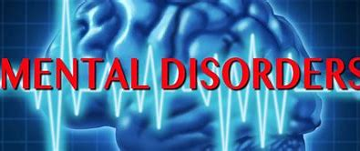

Assessment 2

Student name:​Carlene Campbell
Student ID: ​1908537
Module name: Mental Disorders and Psychopathology​
Module code: BMHP6006
Lecturer name: Bianca Sanfilippo ​
Date: 05/01/22

Contents
Introduction 4
What is general anxiety disorder? 4
Classification of GAD within ICD-10 4
Aetiology 5
Signs and Symptoms 6
Case Study 6
Diagnosis 6
Treatment 6
Principles of care for people with generalised anxiety disorder (GAD) (NICE) 7
Measurements of Rehabilitation. 7
Recommendations for improvement of anxiety (Complementary therapies) 7
Conclusion 7
Schizophrenia 7
Aetiology 8
Signs of Schizophrenia 8
Classification of Schizophrenia within the ICD –10 9
Diagnosis 9
Current Treatment 9
Measurements of Rehabilitation 10
Guidance and Principles of Care 10
Recommendations for Improvement of Schizophrenia 10
Conclusion 10
What is Autism? 11
Classification of Autism within the ICD-10 11
Causes (Aetiology) 11
Diagnosis 12
Treatment 12
Measurements of Rehabilitation 12
Recommendations for Improvement 13
Conclusion 13
References 13
Appendix A: 15
Appendix B 16
Appendix: C 17

Introduction
In the present report critical analysis of the classification, diagnosing, aetiology, signs and symptoms, therapy, and efficacy of rehabilitation of three mental disorders from the ICD-10 (WHO, 2010) will be provided, such as: General Anxiety Disorder, Schizophrenia and Autism. The principles of care for people with generalised anxiety disorder (GAD)
(NICE). Recommendations for improvement of anxiety, schizophrenia, and autism (Complementary therapies) will be proposed.

What is general anxiety disorder?
According to the NHS (2021) General Anxiety Disorder, is defined as a constant sense of stress, worry and fear which can have severe negative effects on an individual in daily life, having an impact on the mental and physical health and wellbeing.
Between the 19th and the 20th century, anxiety has been known by different names such as anxiety neurosis and pantophobia. These expressions were related to panic attacks and the apprehensive mental state (Dialogues-cns.org, 2021). Throughout the past eras, several different treatments have been used for anxiety such as asylums, opium, sterilization and modern medicine to name a few (Sanfilippo. B, 2021. wk3).

Classification of GAD within ICD-10

“GAD is classified within ‘F40-F48 Neurotic, stress-related and somatoform disorders”. F41.1Generalized anxiety disorder
“Anxiety that is generalized and persistent but not restricted to, or even strongly predominating in, any particular environmental circumstances (i.e., it is "free-floating"). The dominant symptoms are variable but include complaints of persistent nervousness, trembling, muscular tensions, sweating, light-headedness, palpitations, dizziness, and epigastric discomfort. Fears that the patient or a relative will shortly become ill or have an accident are often expressed” (WHO,2010).
Anxiety UK, (2021) also defines generalised anxiety disorder (GAD) as a feeling of being anxious about everything and anything for no obvious reason. Frequently, those affected by GAD will feel very worried about a range of things related to a topic such as health, money, work, school, and relationships. GAD is therefore a condition leaves people feeling anxious about a multitude of things rather than any one specific thing.
“Generalized anxiety disorder (GAD) is a chronic state of severe worry and tension, often without provocation. Those with GAD regularly anticipate disaster, often worrying excessively about health (Psychology Today, 2021).
GAD in the UK is known as a longstanding disorder with different types of treatments that are effective. The first step when an individual is diagnosed, before any form of medication is given is psychological therapy. The NHS offers therapies such as cognitive behavioural therapy and applied relaxation. Individuals can be referred by themselves without a GP referral to the psychological therapy service (NHS, 2021).

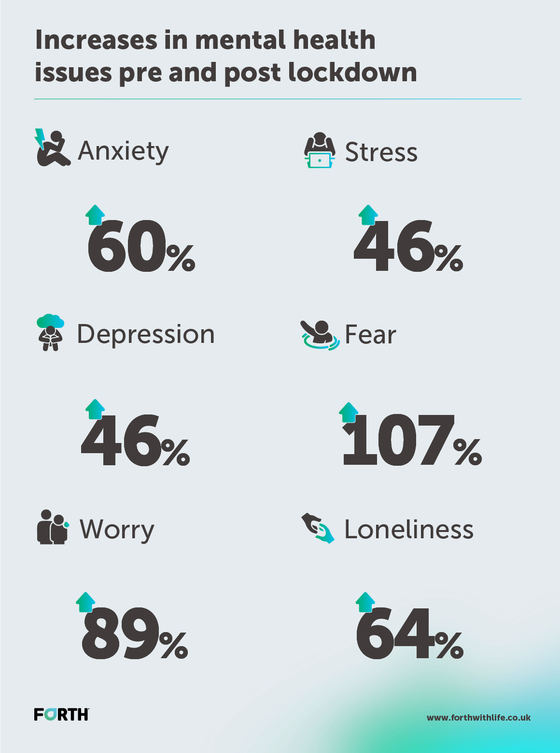
Source: forthwithlife.co.uk

Aetiology
Anxiety disorders do not have one main cause as there are several different things that can lead to anxiety. Certain factors that can contribute to anxiety are genetics which means that individuals can have anxiety in their bloodline. Other causes of this disorder include drugs, life experiences and different circumstances that people face each day in their lives. Drugs may include alcohol, caffeine, or illegal substance but all these can add to a person feeling anxious. Depending on the experiences that people go through for example, death, abuse, unemployment, having a child they can see these as bad experiences and as a result they can develop anxiety (Mental health UK, 2020).

Signs and Symptoms
GAD has different symptoms which can be physical or mental that will make things difficult for individuals to perform normal tasks that can force them into depression. Some mental indication of anxiety can be appetite changes, dissociation, lack of concentration, overpowering thoughts, irritation, sharp awareness, panic, or escapism. Physical indicators involve loss of hair, sweating, irregular heartbeat, nausea, stomach cramps, excessive shaking, dryness of mouth and heavy breathing (NHS, 2021).
Case Study (see Appendix C).

Diagnosis
Diagnosing GAD can be quite challenging and in certain cases it can be hard to differentiate from other psychological health disorders for example depression. GAD can be self-diagnosed by answering certain questions from GAD-7 tools. The answer to those questions will help to determine if you have GAD. Examples of specific questions are, ‘are you experiencing bad dreams or wake up worried?’, ‘are you having problems to go to sleep?’, ‘have you been feeling nervous regularly for over six months?’, ‘are you feeling tense?’, ‘are you feeling frustrated like you want to scream?’. It is believed that individuals may be suffering from GAD if they have constantly worry about things such as their job, life, felt worried for over a period of six months or have been incredibly stressed out or upset because of worrying. Individuals are encouraged to see their GP if they have been experiencing those things or if they were affected by anxiety or distress (NHS, 2021).

Treatment
There are several ways to treat GAD. Some of these ways involve self-treatment where individuals are encouraged to put things in place or to refrain from doing some things such as smoking. Other things can be done in moderation or decrease the intake of them, for example drinking coffee or alcohol. People with GAD are encouraged to do regular exercise, try an app or tools available in the NHS library and completing a self-assist course. If these things are done but there is still evidence that they have not been effective as a result of the individuals’ symptoms, then they will be offered medication, mental health therapies such as Cognitive Behavioural Therapy available from the NHS. The medication given to persons with GAD is Selective Serotonin Reuptake Inhibitors or SSRIs which are antidepressants (NICE, 2020).

Principles of care for people with generalised anxiety disorder (GAD)
(NICE)
This involves the carer building relationships with the individuals with GAD, being open and honest, and unprejudiced. Those working with people with anxiety are expected to investigate their choice of treatment as well as try to understand their fears and the effect it has on them. This way the individual will feel that the decision process is mutual and will feel confident that their self-esteem and discretion is respected. Any information given to the individual must be suitable and written in a language so they can understand and if needs be interpreters must be offered (NICE, 2021).

Measurements of Rehabilitation.
Assessing the effectiveness of therapies, it is essential to know the metrics of recovery. Reason for this is if the treatment is ineffective, it needs to be changed. The main measurements of treatment in GAD are the (GAD-7) Questionnaire for Generalised Anxiety Disorder. Present questionnaire tool measures the level of anxiety over a two-week period (Bianca, 2021). (See appendix A).

Recommendations for improvement of anxiety (Complementary therapies)
GAD and various other anxiety disorders are most common mental disorders. Large quantity of available data from randomized clinical trials allows interpretation of strong evidence-based recommendations regarding the care of GAD, SAD, and PDA. In most instances, medication treatments and CBT therapy can significantly improve the quality of life within GAD sufferers (Bandelow. B, Michaelis. S, Wedekind. D, 2017).

Conclusion
This may be considered a promising aspect of General Anxiety Disorder (GAD) with all the support available for people suffering with GAD. While the study has not reviewed social or psychological therapies for GAD, it is worth mentioning that cognitive-behavioural therapy (CBT) is also regarded as first line of intervention to GAD (Gomez. A, Barthel. A, Hofmann. S).

Schizophrenia
Schizophrenia comes from the Greek words ‘schizo’ which means split and ‘phren’ which means mind. Paul Eugen Bleuler a psychiatrist from Switzerland created the word in 1910. People who are diagnosed as being schizophrenic will have symptoms which will influence their thinking process and how they perceive the world they live in such as hallucinations and delusions. Delusions happen when a person have a belief in something notwithstanding facts or proof to show otherwise. An hallucination is false evidence appearing to be real which are shaped by a person’s own mind. This involves experiencing things that other people around them might not have such as hearing voices or seeing things. Individuals with schizophrenia do not have two personalities (WHO, 2021).
Schizophrenia is classed as a chronic and austere extended mental health disorder that produces a variety of psychological indicators, which affects twenty million people worldwide. It is depicted by misrepresentations in emotions, thinking, language, perception, behaviour and self-awareness. Schizophrenia is regularly described by doctors as psychosis, which means the individual is not capable of distinguishing thoughts and concepts from realism. Often times psychosis is confused for schizophrenia even though they are different. Schizophrenia is classed as a mental health disorder, whereas psychosis is classed as an indicator of it. The WHO states that schizophrenia affects one in every hundred people, which makes it more popular than what society thinks (WHO, 2021).

Aetiology
Different things can be contributed to schizophrenia such as genes or ecological and psychosocial factors. There is no research done that has recognised one specific factor. Studies done recently have proposed that imaging trials done on individuals coping with schizophrenia show irregularities in brain constructions. Chemical irregularities in the brain is thought to be liable for some of the indicators relating to schizophrenia. Scientist also think that when certain chemicals in the brain are low, it affects the individual’s behaviour and emotions and can be responsible for psychiatric syndrome. Research is ongoing in this area (Healthline.com, 2021).

Signs of Schizophrenia
This mental disorder should not be untreated or ignored as it increases the risk of serious problems that may occur. These problems may include self-harm or injury, depression, suicide, anxiety, drug or alcohol use and family issues. Some common signs of schizophrenia involve hallucination, delusion, irregular behaviour, muddled speech and emotional disturbances (WHO, 2021). Irregular behaviour may be identified as the individual talking to themselves, walking around meaninglessly, neglecting themselves or laughing to themselves. Emotional disturbances however are usually a disconnection between body language, facial expression, and emotion (WHO, 2021).

Classification of Schizophrenia within the ICD –10
“The schizophrenic disorders are characterized in general by fundamental and characteristic distortions of thinking and perception and affects that are inappropriate or blunted” (WHO ICD-10, 2021). Strong awareness and rational capacity are normally upheld, though positive cognitive shortfalls may progress over time. The vital psycho-extreme singularities comprise of withdrawal, belief dissemination, delusional awareness, misconceptions of control, stimulus or inactiveness, hallucinations, referring to oneself in third person, negative indicators, supposed disorders and thought repetition. The progression of schizophrenia can be incessant or sporadic with liberal discrepancy. Remission can be incomplete or complete resulting from several episodes. Schizophrenia should not be diagnosed with severe depression or hyper symptoms present unless there is clarity that indicators predate the emotional disruption. Also, if there are evidence of obvious brain sickness, drug or alcohol use or retraction diagnosis should not be made (ICD-10, 2021).

Diagnosis
Specific test for schizophrenia is not available so therefore the illness is frequently diagnosed after an assessment is conducted by a mental health specialist. Early diagnosis of this disorder will lead to early treatment which makes it easier for individuals. During diagnosis, doctors will ask questions relating to symptoms a person might be experiencing to ensure that they are not related to the use of drugs ICD-10, 2021). Diagnosis for children or young adults should be done very soon after they have experienced their first occurrence of schizophrenia, for them to be referred to a specialist. Specialised mental health service for young people and children involves a expert psychiatrist with guidance in children’s psychological health (NHS, 2019).

Current Treatment
Schizophrenia cannot be cured but will require permanent treatment. These treatments can regulate or diminish the harshness of the indictors. It is vital for individuals to receive treatments from a professional or expert in mental health who are competent in giving treatment to schizophrenic people. Treatment is usually tailored to individuals and is a blend of medicine along with speaking therapy. However, there is another option available for treating schizophrenia which is psychosocial interference which is a form of therapy used to assist individuals to manage stress. Medication for this disorder is usually antipsychotic and is used to prevent psychosis, delusions, hallucinations. Training can be given to help individuals to socialise and increase or develop social skills (NHS, 2021).

Measurements of Rehabilitation
Schizophrenia can only be measured by the treatments and quality of care provided to direct and regulate the disorder to evade difficulties like suicide, self-destruction, defilement of human privileges and drug misuse. The quality of life can be measured with the gauges used for ongoing permanent mental health illnesses (NHS, 2021).
A common tool used to measure precise symptoms and the care quality given to individuals is the Quality Indicator for Rehabilitative Care (QuIRC-SA). Good care quality is vital to persons coping with permanent mental issues and so this can be measured by use of indicators for rehabilitation (quirc.eu,).

Guidance and Principles of Care
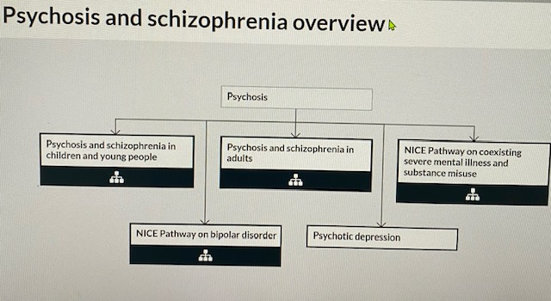

Recommendations for Improvement of Schizophrenia
Individuals living with this illness may be prone to violations of human moralities whether in society or institutions for mental incapacities. There is also a very high level of shame which adds to false judgement towards these people. This can contribute to inadequate access to proper health care, employment and even schooling (Bianca, wk4). This will only be improved when the wall of division between these individuals and society is eradicated, and they are seen as normal instead of dysfunctional.

Conclusion
Despite this, the underlying mechanisms of various mental disorders, including schizophrenia, have not been established, with the evidence to support a number of theories. Such future research will not simply provide potentially new nutraceutical and pharmacological therapies for schizophrenia, they would also enable us to continuously improve the knowledge around this complicated disorder (Murry. A, et al, 2021).

What is Autism?
According to the NHS, (2020) autism spectrum disorder (ASD), commonly referred to as autism, this is something with which you were born, or it can appear when you are quite young. Autism means that their thoughts and world experience is unlike most humans. Meaning you can function differently than most individuals and has different advantages and difficulty. For instance, certain autism traits such as, things that they think, do and feel may be difficult to express themselves in social settings, but they can also be interested and enthusiastic about special subject. (NHS Inform, 2020).
Autism is a spectrum the word ‘spectrum’ refers to the way autism has been experienced in a unique way from different people. Autism is thought to be a spectrum because it differs for each person with autism. A few individuals with autism may require greater support than others to live the life they desire. As they grow older, and experience, diverse environments this can change the way autism affects the individual (NHS, 2020). At least one in three or four people diagnosed with autism are females.

Classification of Autism within the ICD-10
F84.0Childhood autism
“A type of pervasive developmental disorder that is defined by: (a) the presence of abnormal or impaired development that is manifest before the age of three years, and (b) the characteristic type of abnormal functioning in all the three areas of psychopathology: reciprocal social interaction, communication, and restricted, stereotyped, repetitive behaviour. In addition to these specific diagnostic features, a range of other nonspecific problems are common, such as phobias, sleeping and eating disturbances, temper tantrums, and (self-directed) aggression.” Autistic disorder. Infantile: autism psychosis Kanner syndrome Excl.: autistic psychopathy (F84.5)(WHO, 2010).

Causes (Aetiology)
Autism is not cause by a disease or illness it means the brain operates in a distinct way from others. Once you are autistic, this is a lifelong condition. Autism is not a medical problem with a cure or can be treated. However, there are people who need assistance to help them with different things. There are myths that poor parenting, diseases, nutrition, trauma and anxiety in early age, vaccines and ingredients in vaccines can cause autism this is not true (Bianca, 2021). However autistic people can find it difficult to interact and communicate with other people.
Research has stated that people with autism have challenges with communicating with others, understanding how others think, consider noises and vivid lights to be a discomfort, worrying and devastating. Autistic people will become anxious when dealing with unacquainted situations and societal events and will experience delays in understanding information and will perform the same task repetitively. People with autism will sometimes suffer with other illnesses such as dyslexia, depression, anxiety and attention deficit hyperactivity disorder (NHS, 2019).

Diagnosis
Autism is typically present from a child is born but sometimes is not acknowledged until a child is older or even as an adult. The earlier autism has been diagnosed the better it is for the individual. Diagnosis will be done by an assessment where a particular tool is used to determine if you are autistic. There are diverse ways in which diagnosis can be done such as a letter from the GP, consulting a professional, an assessment as well as children under the age of five may be assessed by a health visitor. There are signs that will be evident of autism from a child such as them not making eye contact, not responding to their name, not communicating well with their peers and inadequate emotive reaction to smiles. The signs in adults might be slightly different but are still recognisable as these individuals might be very rigid in their routine, have difficulty expressing emotions, likes isolation and challenges with being thoughtful of others’ emotions (NHS, 2019).

Treatment
There is no current medication or cure for autism. However, they are psychological therapies that are available as a support for them. Cognitive behavioural therapy is the most common therapy used as a treatment for anxiety, sleeping disorders and depression but it is not used as a treatment for autism. There are different therapy methods that are also modified to use with an autistic person. The NHS and other local groups offer therapies to support people living with autism and some of these therapies comprise communication support for the individual as well as their family members, sensory valuations, courses for people who care for autistic people and groups where they can share and receive knowledge from others living with the same condition (NHS, 2019).

Measurements of Rehabilitation
There are two ways that autism is measured which are CARS meaning childhood autism rating scale and autism diagnostic observation schedule otherwise known as ADOS. A team of specialists will assess a child with autism in relation to the challenges they go through, with information received from teachers, doctors, or parents (Sanfilippo. B, 2021,wk6).

Recommendations for Improvement
Various interventions can be supportive in handling indicators namely, behaviour interference, CBT, or initial intervention. There are several means of support available for people with autism. These range from family and friends, local support, social media support or charities. There is also an autism website available where individuals can connect with support groups in their communities as well as The National Autistic Society and the NHS (NAS, 2021).

Conclusion
On this basis, we conclude that it is important that a person-centred approach is taken when you work with people with autism. Moreover, one need to make sure the Human Rights Act non-discriminatory practice based on Equality Act 2010 will be followed.

References
Anxiety UK, (2021)Generalised Anxiety Disorder . Available at: https://www.anxietyuk.org.uk/anxiety-type/generalised-anxiety-disorder/(Accessed: (19 December 2021).
Borwin Bandelow, MD, PhD; Sophie Michaelis, MD; Dirk Wedekind, MD, PhD (2017) Treatment of anxiety disorders. Available at: https//: www.dialogues-cns.org/(Accessed: 20 December 2021).
Gomez. A, Barthel. A, Hofmann. S, Comparing the Efficacy of Benzodiazepines and Serotonergic Anti-Depressants for Adults with Generalized Anxiety Disorder: A meta-analytic review. Available at: DOI: 10.1080/14656566.2018.1472767 /(Accessed:26 December 2021).
Murray. A, et al (2021) Oxidative Stress and the Pathophysiology and Symptom Profile of Schizophrenia Spectrum Disorders. Journal: Frontiers in psychiatry. Publisher: Frontiers Media S.A. Available at: http://www.pubmedcentral.nih.gov/articlerender.fcgi?artid=PMC8339376/(Accessed: 26 December 2021).
NHS (2021) Anxiety Fear and Panic. Get help with anxiety, fear or panic. Available at: https//: www.nhs.uk/ (Accessed: 20 December 2021).
NHS (2021) Anxiety and panic attacks. (online). Available at: Anxiety and panic attacks - NHS (www.nhs.uk) (Accessed: 05th November 2021).
NHS, (2020) Overview - Generalised anxiety disorder in adults – NHS. Available at: https://www.nhs.uk/mental-health/condition/generalised-anxity-disorder-overview/(Accessed: 19 December 2021).
NHS, (2019) How to get diagnosed with autism. Available at: httpa//: www.nhs.uk/ (Accessed: 26 December 2021).
NICE (2021) Guidance principle of care for people with disorder. Available at: https://www.nice.org.uk/guidance/cg113/chapter/1-Guidance#principles-of-care-for-people-with-panic-disorder/ (Accessed: 16 Decembet 2021).
Psychology Today (2021)Generalized Anxiety Disorder. Available at: https://psychologytoday.com/us/condition/generalize-anxiety-disorder/(Accessed: 19 December2021).
Sanfilippo. B, (2021) Mental Disorder and Psychopathology. University of Wales Trinity Saint David. Available at: https//: www.uwtsd.ac.uk/ (Accessed: 16 December 2021).
The impact of Covid-19 on UK mental health survey. Increases in mental health issues pre and post lockdown. Source: https://www.forthewithlife.co.uk/(Accessed: 18 December 2021).
World Health Organisation, WHO (2010) ICD-10 VERSION. (online). Available at: https://icd.who.int/browse10/2010/en#/F30-F39 (Accessed: 16 December 2021).
Source: https://mentalhealth-uk.org/help-and-information/conditions/anxiety-disorders/causes

Appendix A:

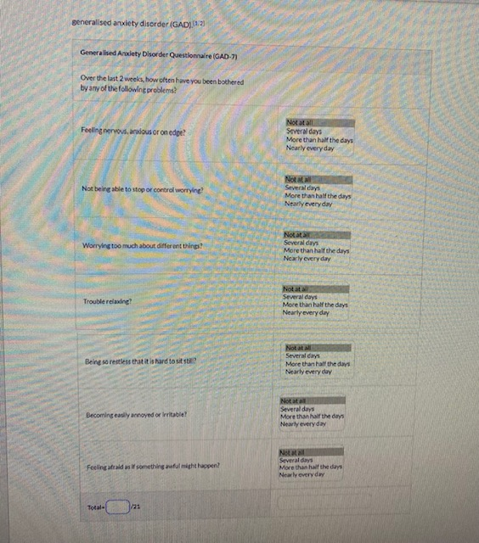

Appendix B



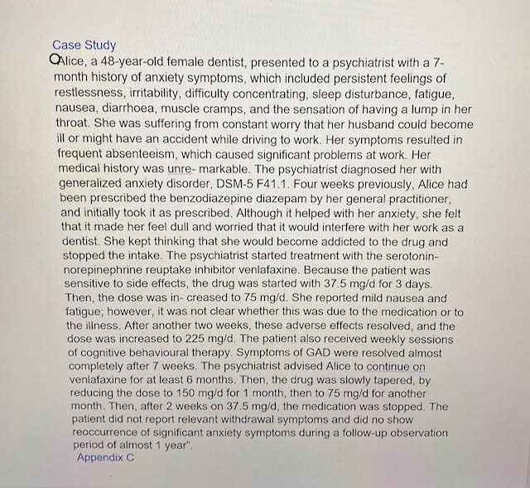

Appendix: C

