DATA WAREHOUSING REPORT FOR NHS ENGLAND
Module: ACCA6026 Data Warehousing & Data Mining

DATA WAREHOUSING REPORT
FOR NHS ENGLAND

Module: ACCA6026 Data Warehousing & Data Mining

Student Name
Hafsa Gul
Student ID
2323803

BSc Applied Computing

Submission Date:
10July 2026

TABLE OF CONTENTS

- Introduction ............................................................................................................................................................ 4

2. Task 1: Data Warehousing Concepts for NHS England....................................................................................... 5
2.1 OLTP vs Data Warehouse ............................................................................................................................. 5
2.2 Data Warehouse Architecture and ETL ........................................................................................................ 6
Figure 1: Proposed NHS England Data Warehouse Architecture ........................................................ 6
2.3 Data Marts for Management Decision-Making............................................................................................... 7
2.4 OLTP Normalisation vs Data Warehouse Dimensional Modeling................................................................ 8
Table 1: Comparison of OLTP Normalisation and Dimensional Modelling.......................................... 9

3. Task 2: NHS England Data Warehouse Design ........................................................................................................ 9
3.1 Source System Identification ......................................................................................................................... 9
Table 2: NHS England Source Systems .................................................................................................10
3.2 Star Schema Design .......................................................................................................................................11
Figure 2: Proposed NHS England Star Schema Design ...................................................................... 11
3.3 Data Marts and Schema .................................................................................................................................12
Table 3: NHS England Data Marts and Their Purpose ....................................................................... 12
Figure 3: Proposed NHS England Data Mart Architecture................................................................... 13
3.4 ETL Plan ……………….................................................................................................................................... 15
Figure 4: Proposed NHS England ETL Process Workflow.................................................................. 15
3.5 Data Quality and Governance……................................................................................................................ 17
Table 4: Data Quality Issues and Mitigation Strategies....................................................................... 17

4. Conclusion................................................................................................................................................................... 19

5. References................................................................................................................................................................... 20

List of Figures

Figure | Title | Page
Figure 1 | Proposed NHS England Data Warehouse Architecture | 6
Figure 1A | Distribution of NHS England Data Mart Usage by Business Function | 7
Figure 2 | Proposed NHS England Star Schema Design | 10
Figure 2A | Estimated Data Volume Managed by NHS England Source Systems | 12
Figure 3 | Proposed NHS England Data Mart Architecture | 13
Figure 3A | Comparative Data Volume Across NHS England Data Marts | 13
Figure 3B | Performance Comparison of NHS England Data Marts | 14
Figure 3C | Hierarchical Distribution of Information Within NHS England Data Marts | 18
Figure 4 | Proposed NHS England ETL Process Workflow | 16

List of Table
Table | Title | Page
Table 1 | Comparison of OLTP Normalisation and Dimensional Modelling | 9
Table 2 | NHS England Source Systems | 10
Table 3 | NHS England Data Marts and Their Purpose | 12
Table 4 | Data Quality Issues and Mitigation Strategies | 17

Introduction
NHS England is liable for managing the planning, delivery and performance of healthcare services across England. It works with Integrated Care Systems (ICSs), NHS Trusts and partner organisations to provide a wide range of services, including acute care, community healthcare, mental health services and specialist treatments. Due to the scale of its operations, NHS generates and manages massive volumes of patient, clinical, operational, workforce and financial data daily.
Although valuable information is collected through systems such as Electronic Patient Records (EPR), Patient Administration Systems (PAS), workforce management platforms and financial systems, much of this data remains distributed across separate operational systems. As a result, decision-makers may face challenges in obtaining a unified view of healthcare performance, patient outcomes, resource utilisation and financial efficiency across different regions and services. This fragmented data landscape can limit the organisation's ability to make timely and evidence-based decisions.
A data warehouse gives a potential solution by integrating data from multiple sources into a central repository designed for analysis and reporting. This report evaluates how a data warehousing solution could support NHS England by improving access to reliable information and enabling data-driven decision-making. The report discusses key data warehousing concepts, including OLTP systems, data warehouse architecture, ETL processes, data marts, dimensional modelling, star schema design, data quality and governance considerations within the NHS England context.
NHS generate data continuously from a wide range of clinical and administrative activities. Patient consultations, diagnostic tests, prescriptions, emergency admissions, laboratory services, financial transactions and workforce operations all contribute to rapidly increasing volumes of structured data. As healthcare services continue to expand and become more digitally connected, effectively managing these large and diverse datasets has become essential for improving operational efficiency, maintaining service quality and supporting long-term healthcare planning.
By consolidating information from multiple systems into a single analytical platform, healthcare organisations can monitor key performance indicators, identify trends, evaluate resource utilisation and support strategic policy development. For NHS England, implementing an enterprise data warehouse would enable healthcare managers and decision-makers to access reliable, integrated information that supports continuous service improvement and evidence-based decision-making across the organisation.

2. Task 1: Data Warehousing Concepts for NHS England

2.1 OLTP vs Data Warehouse

Online Transaction Processing (OLTP) systems and data warehouses serve different purposes within an organisation. OLTP systems are designed to support day-to-day business operations by processing large numbers of transactions quickly and accurately. In the healthcare environment, systems such as Electronic Patient Records (EPR), Patient Administration Systems (PAS) and financial management applications are examples of OLTP systems. These platforms are primarily focused on recording, updating and retrieving current operational data required for clinical and administrative activities.
In contrast, a data warehouse is designed to support analytical processing and strategic decision-making. Managing individual transactions, it consolidates data from multiple operational systems into a central repository for reporting, trend analysis, and performance monitoring. Data stored in a warehouse is typically historical, integrated and structured to support complex queries.
OLTP systems and data warehouses serve different purposes; they complement each other within the NHS information ecosystem. Operational systems continue to capture real-time patient and administrative transactions, while the enterprise data warehouse periodically receives data through ETL processes for analytical use. This separation ensures that daily healthcare operations remain efficient while providing decision-makers with reliable historical information for performance evaluation, service planning and strategic policy development. Together, both environments create a balanced architecture that supports operational excellence and long-term organisational improvement.

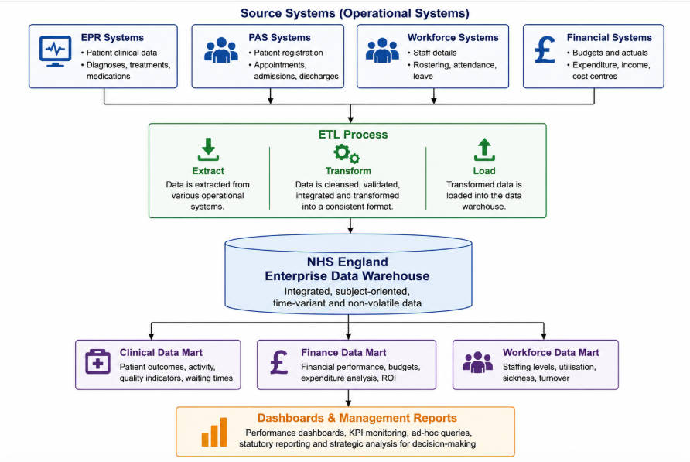
2.2 Data Warehouse Architecture and ETL

Figure 1: Proposed NHS England Data Warehouse Architecture

The architecture integrates data from multiple operational systems, including (EPR) systems, (PAS), workforce management systems and financial management systems. These systems generate large volumes of operational data that support day-to-day healthcare activities across the organisation.
The ETL (Extract, Transform and Load) process acts as the foundation of the architecture. During the extraction stage, data is collected from the various source systems. The transformation stage involves cleansing, validating and standardising the data to ensure consistency and accuracy. Finally, the transformed data is loaded into the enterprise data warehouse, where it is stored in an integrated and structured format suitable for analysis and reporting.
The enterprise data warehouse serves as a central repository that combines information from different departments and services. By storing historical and current data in a single location, it provides a consistent view of organisational performance. This enables NHS England to overcome data silos and improve access to reliable information for decision-making.
To support specific business functions, the warehouse feeds data into specialised data marts, including clinical, financial and workforce data marts. These data marts provide focused datasets for different user groups and support dashboards, performance reports and key performance indicator (KPI) monitoring. As a result, managers and healthcare leaders can make more informed decisions regarding patient care, resource allocation, workforce planning and financial performance.

2.3 Data Marts for Management Decision-Making
Data marts are specialised subsets of a data warehouse that are designed to meet the information needs of specific departments or business functions. Unlike the enterprise data warehouse, which stores integrated data from across the organisation, data marts provide focused, relevant information for specific user groups. This approach improves query performance and enables faster access to information required for decision-making.
Within NHS England, different data marts can be developed to support clinical, financial and workforce management activities. A clinical data mart may contain information on patient outcomes, treatment effectiveness, waiting times,+- and quality indicators. Healthcare managers can use this information to monitor service performance, identify areas requiring improvement and support evidence-based patient care decisions.
A financial data mart focuses on budgeting, expenditure, revenue and cost management. By analysing financial information through dedicated dashboards and reports, managers can monitor spending patterns, evaluate resource utilisation and ensure that healthcare services operate within budgetary constraints. This supports financial planning and improves accountability across NHS organisations.
Similarly, a workforce data mart contains information related to staffing levels, employee attendance, training records and workforce utilisation. Access to this information enables managers to identify staffing shortages, monitor employee performance and plan future workforce requirements. As healthcare services depend heavily on skilled personnel, workforce analytics plays a significant role in maintaining service quality and operational efficiency

Figure 1A: Distribution of NHS England Data Mart Usage by Business Function
Mart Usage by Business Function
The chart shows that the Clinical Data Mart accounts for the largest proportion of data warehouse usage (45%), followed by the Financial Data Mart (30%) and Workforce Data Mart (25%), reflecting their relative importance in organisational reporting and decision-making.
Overall, data marts enhance the decision-making capabilities of NHS England by providing targeted, relevant and easily accessible information. They reduce the complexity of analysing large volumes of enterprise-wide data and allow managers to focus on the specific performance indicators that are most relevant to their responsibilities. As a result, data marts contribute to improved operational efficiency, resource allocation and strategic planning across the organisation

2.4 OLTP Normalisation vs Data Warehouse Dimensional Modelling

OLTP systems and data warehouses are designed for different purposes, which is reflected in their database structures. OLTP databases typically use highly normalised data models to reduce redundancy and maintain data integrity. Data is divided into multiple related tables, ensuring that updates, inserts and deletions can be performed efficiently while minimising inconsistencies. In NHS operational systems such as (EPR) and (PAS), normalisation helps maintain accurate and up-to-date patient information.
Data warehouses use dimensional modelling techniques that are optimised for reporting and analytical processing. Instead of storing data across many related tables, dimensional models organise data into fact tables and dimension tables. Fact tables contain measurable business events, while dimension tables provide descriptive information that gives context to those events. This structure simplifies queries and improves reporting performance.
A commonly used dimensional model is the star schema. In an NHS England data warehouse, a fact table may store information about patient admissions, appointments or financial transactions. Related dimension tables could include Patient, Time, Hospital, Department and Treatment dimensions. This design enables analysts to quickly examine trends and performance indicators across multiple perspectives without the complexity of joining numerous normalised tables.
While normalisation is highly effective for transaction processing, it can make analytical queries slower and more complex. Dimensional modelling sacrifices some level of normalisation in favour of simplicity, faster query execution and easier reporting. Therefore, NHS England operational systems benefit from normalised structures, whereas the enterprise data warehouse benefits from dimensional modelling that supports strategic analysis and decision-making
Table 1: Comparison of OLTP Normalisation and Dimensional Modelling

Aspect | OLTP Normalisation | Dimensional Modelling
Purpose | Transaction processing | Analysis and reporting
Structure | Highly normalised tables | Fact and dimension tables
Data Redundancy | Minimal | Controlled redundancy
Query Performance | Optimised for transactions | Optimised for analytics
Complexity | Multiple table joins | Simpler queries
Example in the NHS | EPR, PAS systems | Enterprise Data Warehouse

3. Task 2: NHS England Data Warehouse Design

3.1 Source System Identification

The first step in designing a data warehouse for NHS England is identifying the operational systems that generate and store healthcare data. These source systems support daily healthcare activities and provide the raw data required for analysis, reporting and decision-making. Since information is often stored across different applications, data from these systems must be integrated into a central data warehouse.
Electronic Patient Record (EPR) system, which stores patient clinical information such as diagnoses, treatments, medications, laboratory results and clinical notes. EPR systems are essential for supporting patient care and provide valuable data for clinical performance analysis and healthcare outcome monitoring.
Patient Administration System (PAS), which manages administrative activities including patient registration, appointment scheduling, admissions, discharges and referrals. The information stored within PAS helps NHS England monitor patient flow, waiting times and service utilisation across healthcare facilities.
Workforce management systems provide information related to healthcare staff, including employee records, attendance, shift schedules, leave management and workforce utilisation. This data supports workforce planning, staffing analysis and resource allocation decisions.
Financial management systems store data relating to budgets, expenditure, revenue, procurement activities and cost centres. Financial information is critical for monitoring organisational performance, controlling costs and supporting strategic financial planning.
All these provide decision-makers with a comprehensive view of organisational performance and support evidence-based healthcare management.

Table 2: NHS England Source Systems
Source System | Main Data Stored | Business Purpose
Electronic Patient Record (EPR) | Diagnoses, treatments, medications, and test results | Clinical care and patient management
Patient Administration System (PAS) | Registrations, appointments, admissions, discharges | Administrative operations
Workforce System | Staff records, attendance, shifts, leave | Workforce planning and monitoring
Financial System | Budgets, expenditure, revenue, cost centres | Financial management and reporting

Figure 2A: Estimated Data Volume Managed by NHS England Source Systems

3.2 Star Schema Design
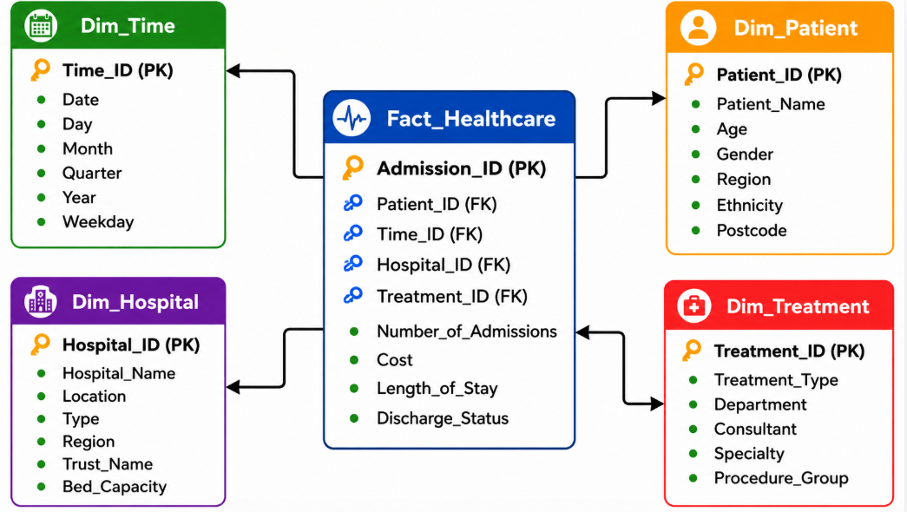
Figure 2: Proposed NHS England Star Schema Design

A star schema is a dimensional modelling technique commonly used in data warehouses to support analytical processing and reporting. It consists of a central fact table connected to multiple dimension tables. This structure simplifies complex queries and improves reporting performance compared to highly normalised operational databases.
In a proposed data warehouse, the Fact Healthcare table stores measurable business events such as patient admissions, treatment costs and length of stay. The fact table contains foreign keys that link to related dimension tables, allowing data to be analysed from multiple perspectives.
The Patient Dimension provides demographic information such as age, gender and region. The Time Dimension enables analysis by day, month and year, supporting trend analysis and performance monitoring. The Hospital Dimension contains information about healthcare facilities, while the Treatment Dimension stores details regarding treatments, departments and consultants.
By organising data using a star schema, analytical queries and generate reports more efficiently. Decision-makers can analyse healthcare performance across hospitals, patient groups, treatment categories and time periods without dealing with the complexity of operational databases.

3.3 Data Marts and Schema

Data marts are specialised subsets of the enterprise data warehouse that are designed to meet the reporting and analytical requirements of specific business areas. While the enterprise data warehouse stores integrated data from across NHS England, data marts provide focused access to information relevant to departments and management functions.
The proposed NHS England data warehouse includes three primary data marts:
The Clinical Data Mart supports healthcare service analysis by storing information related to patient admissions, diagnoses, treatments, discharge outcomes and waiting times. This data mart enables healthcare managers to evaluate service quality, monitor patient outcomes and identify trends affecting clinical performance.
The Financial Data Mart focuses on budgeting, expenditure, revenue and cost management. It provides managers with access to financial performance indicators and supports activities such as budget monitoring, expenditure analysis and resource allocation planning.
The Workforce Data Mart contains information related to staffing levels, employee attendance, shift utilisation, training records and workforce performance. The data mart assists managers in workforce planning, identifying staffing shortages and evaluating employee productivity.
By separating information into specialised data marts, NHS England can improve reporting efficiency, reduce query complexity and provide users with faster access to relevant information. This approach ensures that decision-makers can obtain meaningful insights without accessing unnecessary enterprise-wide data.

Table 3: NHS England Data Marts and Their Purpose
Data Mart | Key Data Included | Primary Users | Purpose
Clinical Data Mart | Admissions, treatments, diagnoses, outcomes, waiting times | Clinical Managers, Healthcare Leaders | Monitor patient care and clinical performance
Financial Data Mart | Budgets, expenditure, revenue, costs | Finance Managers, Executives | Financial planning and cost control
Workforce Data Mart | Staff records, attendance, shifts, utilisation | HR Managers, Workforce Planners | Workforce planning and staffing analysis

Table 3 demonstrates how the enterprise data warehouse is divided into specialised data marts that support different organisational functions. This structure improves reporting performance and enables NHS England managers to focus on information that is most relevant to their responsibilities.

Figure 3A: Analytical Importance of NHS England Data Marts
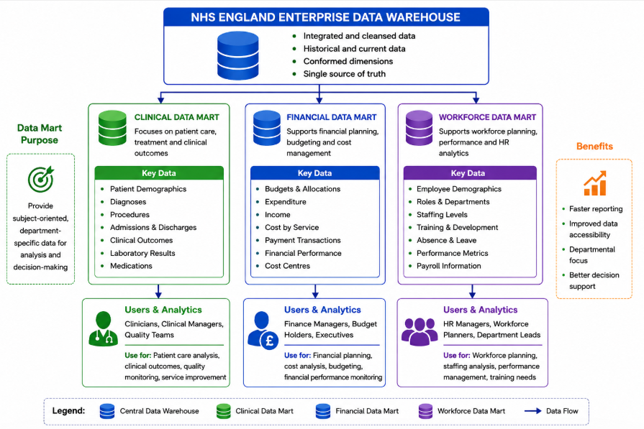

Figure 3: Proposed NHS England Data Mart Architecture
Figure 3 illustrates how the NHS England Enterprise Data Warehouse is divided into specialised data marts to support different organisational functions. The Clinical Data Mart provides information for patient care and clinical performance monitoring; the Financial Data Mart supports budgeting and cost analysis, while the Workforce Data Mart enables staffing and resource planning. By organising data into subject-specific data marts, NHS England can improve reporting performance, simplify analytical queries and provide decision-makers with timely, relevant information for evidence-based decision-making.

Figure 3B: Performance Comparison of NHS England Data Marts
Figure 3B compares the analytical characteristics of the proposed Clinical, Financial and Workforce Data Marts across key performance dimensions, including data volume, query frequency, update frequency, reporting requirements and decision impact. The Clinical Data Mart records the highest scores in most categories because it supports patient care, diagnosis, treatment monitoring and clinical decision-making, which require frequent access to large volumes of data. The Financial Data Mart demonstrates moderate performance across all dimensions, reflecting its role in budgeting, expenditure analysis, revenue monitoring and financial reporting. The Workforce Data Mart shows comparatively lower data volume but maintains consistent performance in workforce planning, employee attendance, staffing analysis and resource allocation. Overall, the comparison highlights how each specialised data mart serves different organisational requirements while collectively improving reporting efficiency, analytical performance and evidence-based decision-making within the proposed NHS England Enterprise Data Warehouse.

3.4 ETL Plan

The Extract, Transform and Load (ETL) process is a critical component of the proposed NHS data warehouse. The ETL process ensures that information collected from different healthcare systems is accurate, consistent and suitable for decision-making.
During the Extract phase, data is collected from source systems, including (EPR) systems, (PAS), workforce management applications and financial management systems. Data is extracted at scheduled intervals to ensure that the warehouse contains up-to-date information while minimising the impact on operational systems.
The Transform phase focuses on data cleansing, validation and standardisation. Duplicate records are removed, missing values are addressed, and data formats are standardised across different systems. Business rules are applied to ensure consistency in patient identifiers, department names, treatment codes and financial categories. This stage improves data quality and ensures that information from multiple sources can be integrated effectively.
Following the transformation, the Load phase transfers the processed data into the enterprise data warehouse. Historical and current records are stored to support trend analysis and performance monitoring. Once loaded, the data becomes available for use within clinical, financial and workforce data marts.
ETL process plays a significant role in maintaining data governance and compliance within NHS England. Healthcare information is often generated from multiple hospitals, clinics and administrative departments, resulting in variations in data formats and coding standards. During transformation, these differences are resolved through standardisation rules and validation checks. This ensures that patient records, workforce information and financial data are represented consistently throughout the enterprise data warehouse. Consistent data improves reporting accuracy and supports regulatory and operational requirements.
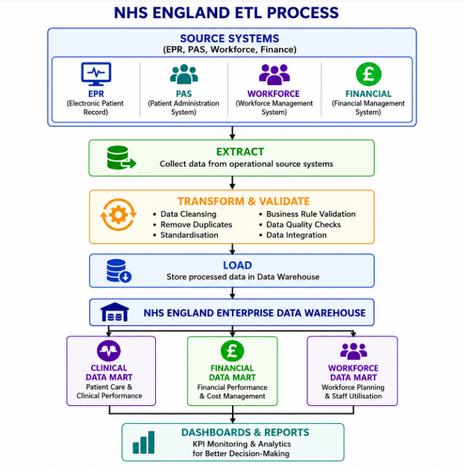

Figure 4: Proposed NHS England ETL Process Workflow

3.5 Data Quality and Governance
Data governance provides the policies, standards and responsibilities required to manage data effectively. NHS should establish clear governance procedures that define data ownership, access controls and quality standards. Data stewards and system administrators should be responsible for monitoring data quality, resolving issues and ensuring compliance with organisational policies and healthcare regulations.
Security and privacy are particularly important in healthcare environments due to the sensitive nature of patient information. Access to data should be controlled through role-based permissions, ensuring that users can only view information relevant to their responsibilities. Data encryption, audit trails and regular security reviews should be implemented to protect confidential information and maintain compliance with data protection regulations.
By combining strong data governance practices with effective data quality controls, NHS can ensure that its enterprise data warehouse remains a trusted source of information. High-quality data improves reporting accuracy, supports evidence-based decision-making and enhances organisational performance across clinical, financial and workforce management functions.
Table 4: Data Quality Issues and Mitigation Strategies
Data Quality Issue | Description | Mitigation Strategy
Duplicate Records | Multiple entries for the same patient or staff member | Data deduplication and validation rules
Missing Values | Incomplete patient, workforce or financial data | Mandatory field checks and data validation
Inconsistent Formats | Different date formats or coding standards | Data standardisation during ETL
Inaccurate Data | Incorrect entries caused by human error | Automated validation and quality audits
Unauthorised Access | Access to sensitive healthcare information | Role-based access control and encryption

Table 4 highlights common data quality challenges that may affect NHS England's data warehouse environment. Implementing appropriate mitigation strategies improves data accuracy, consistency and security while reducing operational risks. Effective governance and quality management ensure that healthcare managers and decision-makers can rely on the information stored within the enterprise data warehouse for reporting, planning and performance monitoring.

Figure 3C: Hierarchical Distribution of Information Within NHS England Data Marts

Figure 3C presents a hierarchical view of the major information categories stored within the proposed NHS England Enterprise Data Warehouse. The treemap visually groups data into clinical, workforce and financial domains, with the relative size of each section representing its importance and contribution to organisational reporting and decision-making. Clinical information, including admissions, diagnoses, treatments and laboratory results, occupies the largest proportion because it forms the core of healthcare operations. Workforce information, such as staff records, attendance, shift scheduling and performance monitoring, supports resource planning and operational management, while financial information focuses on budgeting, revenue and cost analysis. The treemap provides an intuitive representation of how enterprise data is organised into logical subject areas, enabling decision-makers to quickly identify major business domains and understand the overall structure of the proposed data warehouse.

4. Conclusion

This report presented the design of a proposed data warehouse solution for NHS England to support strategic decision-making, performance monitoring and healthcare service improvement. The study examined the fundamental concepts of data warehousing, including enterprise data warehouse architecture, ETL processes, data marts and dimensional modelling. It also highlighted the differences between OLTP systems and data warehouse environments and demonstrated the importance of integrating data from multiple operational systems.
A star schema was developed to provide a scalable and efficient analytical structure for storing and analysing healthcare information. The proposed design incorporates data from (EPR), (PAS), workforce management and financial management systems into a central enterprise data warehouse. Specialised clinical, financial and workforce data marts were also designed to support the reporting requirements of different user groups.
The ETL plan and data governance framework ensure that data is extracted, transformed and loaded in a consistent, reliable and secure manner. By implementing appropriate data quality controls, validation procedures and governance policies, NHS England can improve the accuracy and trustworthiness of organisational data.
Overall, the proposed data warehouse provides an integrated platform for healthcare analytics, enabling faster reporting, improved operational visibility and evidence-based decision-making. The solution supports NHS objectives of enhancing patient care, improving resource utilisation and achieving greater organisational efficiency through effective use of data.
Furthermore, the proposed solution provides a foundation for future healthcare analytics initiatives such as predictive modelling, population health analysis and resource forecasting. As data volumes continue to increase, a scalable enterprise data warehouse will enable NHS England to adapt to changing organisational requirements while maintaining high standards of data quality, governance and security.
The successful implementation of the proposed architecture would support continuous improvement across healthcare services by transforming operational data into actionable insights. This would ultimately contribute to better patient outcomes, improved efficiency and more effective management of healthcare resources.

5. References

Amazon Web Services (AWS). (2025). What is a Data Warehouse? Available at: https://aws.amazon.com/data-warehouse/ (Accessed: 24 June 2026).
Health Education England. (2024). Data and Information Governance. Available at: https://www.hee.nhs.uk/our-work/data-information-governance (Accessed: 24 June 2026).
IBM. (2025). Data Warehouse Overview. Available at: https://www.ibm.com/topics/data-warehouse (Accessed: 24 June 2026).
Informatica. (2025). What is ETL? Available at: https://www.informatica.com/resources/articles/what-is-etl.html (Accessed: 24 June 2026).
Inmon, W.H. (2005). Building the Data Warehouse. 4th ed. Indianapolis: Wiley Publishing.
Kimball, R. and Ross, M. (2013). The Data Warehouse Toolkit: The Definitive Guide to Dimensional Modeling. 3rd ed. Hoboken, NJ: John Wiley & Sons.
Microsoft. (2025). Data warehouse architecture. Available at: https://learn.microsoft.com/en-us/azure/architecture/data-guide/relational-data/data-warehousing (Accessed: 24 June 2026).
Microsoft. (2025). Dimensional Modeling in Data Warehousing. Available at: https://learn.microsoft.com/en-us/fabric/data-warehouse/dimensional-modeling-overview (Accessed: 24 June 2026).
NHS England. (2025). NHS England. Available at: https://www.england.nhs.uk/ (Accessed: 24 June 2026).
Oracle Corporation. (2025). Data Warehousing Guide. Available at: https://docs.oracle.com/en/database/oracle/oracle-database/19/dwhsg/index.html (Accessed: 24 June 2026).
Talend. (2025). ETL (Extract ,Transform, Load) Process Overview. Available at: https://www.talend.com/resources/what-is-etl/ (Accessed: 24 June 2026).
The Data Governance Institute. (2025). Data Governance Framework. Available at: https://datagovernance.com/the-dgi-data-governance-framework/ (Accessed: 24 June 2026).

