

Student name: MA.Corazo Osborne
Student ID: 2414115
Module name: Principles of Health and Social Care Practice
Component: 1
Module code: BMHP5016
Lecturer name: Mark Kane

Table of contents
Introduction …………………………………………………………………………………..3
Key Concepts in Health and Social Care Practice ………………………………………3-4
Application of Key Concepts to a Case Study …………………………………………….4-6
Reflective Analysis Using Gibbs’ Reflective Cycle (1988) ……………………...............6-9
3.1Description of what happened……………………………….……………………………6
3.2 Feelings and emotional feedback…………….…………………………………............6
3.3 Evaluation for the experience…………………………………………………………….7
3.4 Analysis for the experience……………………………………………………………….7-8
3.5 Conclusion ………………………………………………………………………………….8
3.6 Action Plan for later practice………………………………………………………...........8-9
References………………………………………………………………………………………10-11

Introduction
This assignment looks at ethical behaviour, collaborative teamwork, and person-centred care, which are three basic characteristics of UK health and social care. It investigates how these notions influence professional practice and provide safe, effective, and compassionate care through theoretical discussion, a case study, and reflective analysis based on Gibbs' Cycle (1988).

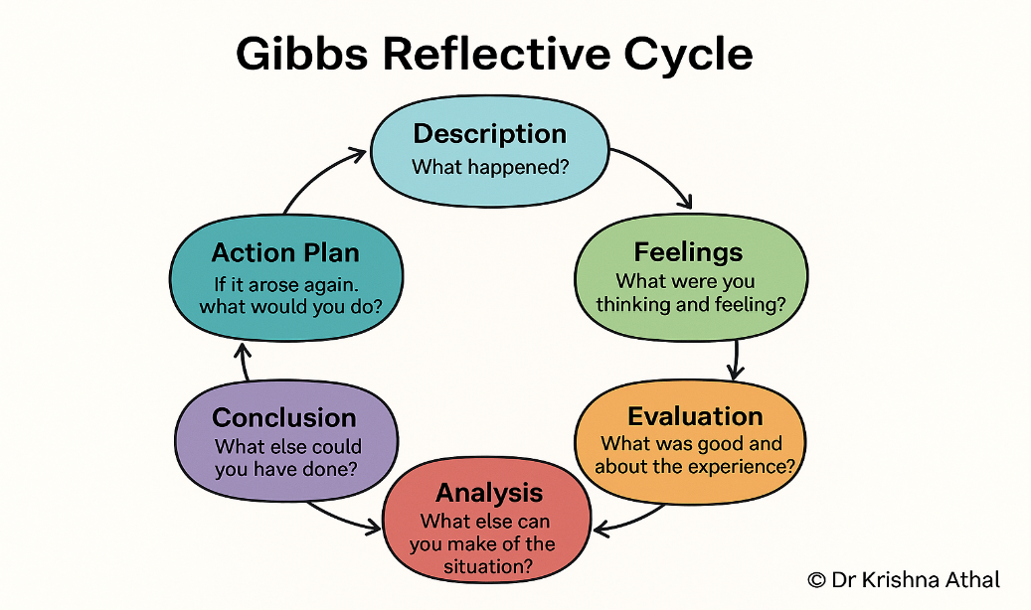

Figure 1: Dr Krishna Athal - Dr Krishna Athal.

Reflection on the importance of Principles and Health and Social care
In the UK, person-centred care, teamwork, and moral conduct are the cornerstones of high-quality health and social care. Although these ideas are ingrained in policy frameworks, their real worth is found in how consistently and critically they are applied in real-world situations to advance equality, dignity, and favourable results for service users. In order to guarantee that people receive support that is safe, considerate, and sensitive to their needs, these values serve as the cornerstone of contemporary care delivery.
Person-centred care is a change from paternalistic approaches to ones that put people's autonomy, choices, and lives experiences first. Abraham Maslow's Hierarchy of Needs, which highlights the significance of attending to both bodily and psychological welfare, is the foundation of this strategy. By allowing patients to actively engage in decisions regarding their treatment, person-centred care fosters independence and self-worth. This strategy is highly recommended by the NHS England Person Centred Care Framework (2021), which emphasises how it may enhance patient satisfaction and health outcomes. However, there is frequently uneven implementation. Opportunities for genuine interaction may be limited by time limits, personnel shortages, organisational demands, and task-oriented care.
Delivering coordinated and comprehensive care requires collaboration, especially in complex systems with several agencies and professions. To avoid fragmented services and enhance outcomes, the Care Act of 2014 highlights the value of teamwork. Knowledge exchange and thorough care planning are supported when healthcare providers, social workers, service users, and families work well together (Glasby and Dickinson, 2014). Successful partnerships provide continuity of service and lower the possibility of duplication or support gaps. Collaboration can be hampered, though, by organisational silos, communication impediments, and conflicting professional agendas. Therefore, to guarantee that all stakeholders strive toward common objectives, strong leadership, respect for one another, and effective communication techniques are required. Regular interdisciplinary meetings and interprofessional communication training can enhance collaborative practice.
Ethical practice serves as the moral framework for health and social care services. Beauchamp and Childress (2019) describe the concepts of autonomy, beneficence, nonmaleficence, and justice, which guide professionals in making decisions that are courteous, fair, and in the best interests of service users. Legislative frameworks, such as the Health and Care Act 2022, strengthen accountability, transparency, and patient safety within integrated care systems. Ethical quandaries are widespread in practice, especially when it comes to reconciling autonomy with protective obligations. When people refuse care, practitioners must carefully assess ethical and legal contexts before taking appropriate action. This necessitates sensitivity, solid judgement, and a clear knowledge of professional duties.
Summing-up, ethical practice, partnership functioning, and person-centred care are all interrelated principles that improve care quality. Although policies offer a solid framework, effective execution necessitates organisational support, professional skill, and the ability to deal with complicated care circumstances. Integrating these concepts into daily practice ensures that treatment is not just efficient, but also compassionate, egalitarian, and sensitive to individual needs. However, the efficacy of person-centred care is contingent on constant personnel and enough resources, as time constraints might result in task-focused rather than comprehensive care.

Application of Key Concepts to a Case Study (Mrs D)

The case study of Mrs D, an 82-year-old woman living with mild dementia in the United Kingdom In summation, ethical practice, partnership functioning, and person-centred care are all interrelated principles that improve care quality. Although policies offer a solid framework, effective execution necessitates organisational support, professional skill, and the ability to deal with complicated care circumstances. Integrating these concepts into daily practice ensures that treatment is not just efficient, but also compassionate, egalitarian, and sensitive to individual needs. However, the efficacy of person-centred care is contingent on constant personnel and enough resources, as time constraints might result in task-focused rather than comprehensive care.
Person centred care is essential for Mrs D’s well-being. Drawing on Tom Kitwood's work, dementia care should emphasise the individual above the ailment, acknowledging that identity, history, and emotional needs remain important even when cognitive ability deteriorate. Mrs D's care plan is therefore adapted to her specific history, preferences, and habits. As a former teacher, she favours regular daily hobbies like reading and silent thought since they bring familiarity and help to relieve anxiety. Staff incorporates these preferences into her daily routine to give her a feeling of continuity and purpose. However, the efficacy of person-centred care is strongly reliant on constant personnel and sufficient resources. Time constraints, shift changes, and conflicting demands might result in task-focused rather than personalised care, violating the ideals of dignity and autonomy.
Collaboration is essential for ensuring that Mrs D receives thorough and coordinated support. Social workers, family members, her general practitioner, and care home staff work together to address her needs. The Care Act of 2014 encourages collaborative working and shared responsibility for welfare, underlining that no one expert can address the complex requirements of people with dementia. Regular multidisciplinary meetings allow for coordinated decision making and information exchange, ensuring that all clinicians have a common awareness of Mrs D's health and care goals. Involving family members is very crucial since they may give information on Mrs D's preferences, historical habits, and stress triggers. Staff, for example, adopt soothing measures based on family input, such as playing familiar music or employing reminiscing techniques when Mrs D becomes anxious in the evening. Despite its advantages, partnership work might be restricted by communication issues, conflicting professional attitudes, or ambiguous role boundaries
Mrs D's treatment be focused on ethical issues because of her shifting mental ability. Ethical quandaries, such as refusing medication or personal care, need a delicate balance between autonomy and responsibility of care. When individuals are unable to make their own decisions, the Mental ability Act of 2005 offers a clear framework for assessing ability and making best-interest judgements. This is consistent with the ethical concepts set forth by Beauchamp and Childress (2019), notably autonomy, beneficence, and nonmaleficence. Upholding dignity, avoiding compulsion, and guaranteeing justice are all important aspects of ethical behaviour. To promote openness and accountability, staff members must properly document their judgements.
The NICE (2018) endorses evidence-based dementia care, highlighting customised, integrated, and ethically grounded methods. However, issues like as shortages of staff, insufficient training, and time restrictions might impede successful adoption. In conclusion, Mrs D’s case study illustrates how person-centred care, cooperation, and ethical behaviour lead to better results and quality of life. Their achievement is dependent on effective communication, professional skill, and dedicated support from the organization.

Self-Reflection as a Health and Social Care Professional

Reflecting on my professional growth as a health and social care worker, I realise that person-centred care, collaborative practice, and ethical decision making are critical to providing high-quality care and achieving positive results for service users. Using Gibbs' Reflective Cycle (1988), I investigate how these ideas affected my work during a placement in a residential care facility and how they continue to influence my professional development.
Description
During my placement, I helped Mrs D an elderly lady with dementia, she was continually getting agitated and refusing personal care. This issue required me to use person-centred techniques, communicate effectively with colleagues and family members, and make ethical judgements. This action was influenced by the Care Act of 2014 and the Mental Capacity Act of 2005, both of which highlight dignity, autonomy, protection, and the significance of taking action in an individual's best interests. The complexities of the issue underscored the importance of careful communication, patience, and a thorough awareness of legal and ethical duties.
Feelings
When the service user denied care, I felt hesitant and unsure. I was worried about balancing respect for their autonomy with my responsibility of care, especially when refusal presented a risk to their well-being. This emotional distress made me wonder if I was behaving correctly and if my behaviours were consistent with professional norms. However, with the help of experienced personnel, I gained confidence in using ethical frameworks and adjusting my speech to decrease discomfort. Over time, I learned to approach the situation with greater empathy and reassurance, which helped build trust with the service user.

Evaluation
This event revealed both my strengths and opportunities for growth in my work. My ability to speak calmly and empathetically was a significant asset since it reduced the individual's apprehension and promoted collaboration. I also participated constructively to team conversations, exhibiting my awareness of collaborative functioning and the need of shared decision making. These attributes contributed to a more person-centred approach and ensured that the service user's choices were respected.
However, I also realised my limitations. At times, I valued work completion above emotional support, which is a typical issue in time-pressured care settings. This occasionally decreased the quality of the contact and put the individual's emotional needs at risk of being overlooked.
In addition, I saw the need to improve my awareness of legal and ethical frameworks, notably ability evaluations and best interest decision making.
Analysis
Person-centred care, as defined in the NHS England Person Centred Care Framework (2021), entails seeing individuals as active partners in their care and adapting assistance to their preferences, values, and needs. In this case, altering my communication style, providing options, and establishing familiar routines increased Mrs D’s comfort and participation. This is consistent with Maslow's (1943) Hierarchy of Needs, which highlights the value of psychological stability and connection as foundations for well-being.
Collaboration with co-workers and family members of Mrs D was also necessary. Collaborating closely with the interdisciplinary team allowed for a more thorough knowledge of the Mrs D’s requirements, behaviours, and triggers. The Care Act of 2014 encourages collaborative working to improve results, and my experience has shown how shared information and coordinated planning may improve care quality. However, communication difficulties and opposing professional viewpoints occasionally hampered collaboration. This underlined the importance of clarity, mutual respect, and constant communication to ensure that all professionals work toward common goals.
Ethical practice guided all judgements made during this encounter. When the service user refused to receive care, the principles of autonomy, beneficence, nonmaleficence, and justice had to be considered. The Mental Capacity Act of 2005 established a legal framework for determining capacity and acting in the person's best interests when appropriate. This event underlined the necessity of striking a balance between autonomy and safety, as well as making judgements that are open, responsible, and based on ethical reasoning. The Health and Care Act of 2022 highlighted the importance of safe, high-quality, and person-centred care, as well as the larger professional duties that govern practice.

Conclusion
Gibbs' Reflective Cycle (1988) allowed me to conduct a methodical review of my practice, focusing on person-centred care, cooperation, and ethical decision-making. When contrasted to the brief model of Rolfe et al. (2001), each framework has different strengths: Gibbs encourages complete emotional and analytical contemplation, whereas Rolfe et al. promote concentrated critical thought. Understanding both models improve my reflecting skills and helps me continue my professional development (Rolfe et al., 2001).

The Action Plan
To strengthen my practice, I will get further training on the Mental Capacity Act 2005 and safeguarding to boost my confidence in legal and ethical decision-making. I will continue to improve my communication skills by practicing active listening, empathy, and de-escalation strategies, while also prioritising emotional and physical needs. I plan to participate more actively in interdisciplinary talks and get input from colleagues to improve collaborative work. In addition, to improve my reflective abilities, I want to reflect on my practice on a regular basis utilising both organised and condensed methods. Finally, I will abide by professional standards such as the Code of Conduct for Healthcare Support Workers (Skills for Care, 2013) to ensure ethical, responsible, and person-centred behaviour.
Gibbs' Reflective Cycle (1988) and Rolfe et al.'s (2001) model are both well-established frameworks for promoting reflective practice, although they differ in structure, depth, and intended use. Gibbs provides a precise six-stage structure for emotional exploration, critical analysis, and action planning. This makes it especially effective for students who benefit from explicit direction and a structured approach to introspection. The addition of a "feelings" stage invites practitioners to evaluate how emotions impact conduct and decision-making, which can increase self-awareness.
In contrast, Rolfe et al. (2001) provide a succinct three-stage model based on the queries "What?" So, what? What happens now? This paradigm helps practitioners to move swiftly from noticing an event to assessing its significance and selecting next steps. While it fosters concentrated analytical thinking, it may leave less scope for emotional contemplation than Gibbs’ approach.
Overall, Gibbs favours lengthy, systematic reflection, whereas Rolfe et al. (2001) advocate a more streamlined approach that prioritises practical understanding and action.

References
- Beauchamp, T.L. and Childress, J.F. (2019) Principles of Biomedical Ethics.
8th edn. Oxford: Oxford University Press.

- Care Act 2014. London: The Stationery Office.

- Gibbs, G. (1988) Learning by Doing: A Guide to Teaching and Learning Methods. Oxford: Oxford Polytechnic.

- Glasby, J. and Dickinson, H. (2014) Partnership Working in Health and Social Care. Bristol: Policy Press.

- Health and Care Act 2022. London: The Stationery Office.

- Kitwood, T. (1997) Dementia Reconsidered: The Person Comes First. Buckingham: Open University Press.

- Maslow, A.H. (1943) ‘A theory of human motivation’, Psychological Review, 50(4), pp. 370–396.

- Mental Capacity Act 2005. London: The Stationery Office.

- NHS England (2021) Person-centred care framework. Available at: https://www.england.nhs.uk⁠/ (Accessed: 30/03/2026)

- NHS England (2021) Universal Personalised Care: Implementing the Comprehensive Model. London: NHS England.

- NICE (2018) Dementia: assessment, management and support for people living with dementia and their carers. London: NICE.

- Rolfe, G., Freshwater, D. and Jasper, M. (2001) Critical reflection for nursing and the helping professions. Basingstoke: Palgrave Macmillan.

- Skills for Care (2013) Code of Conduct for Healthcare Support Workers and Adult Social Care Workers in England. Leeds: Skills for Care.

