ECAD5004
1706413
What helps me learn language and mathematics? : An analysis of a child’s learning in mathematics and language with recommendations for ensuring progress.

Introduction
Within this assignment there will be a critical analysis of a five-year old child’s learning in mathematics and language. This will draw upon a range of evidence gathered during the autumn term 2018 teaching placement. This took place in a year one class, within a west Swansea school, with approximately six per cent FSM (My Local School, 2019).
The analysis will be informed by elements of ‘the mosaic approach’ (Clark and Moss, 2011), although the school’s ethical stance towards photography prevents this element being included. Other elements within appendices, referred to and analysed within the text, comply with ethical guidelines (BERA 2018). The child will be referred to as X throughout.
At the beginning of the placement (Appendix 2) Child X generally appeared to lack confidence when compared to her peers notably in oracy, although, from the outset, she demonstrated considerably greater interest and ability in reading. The quality of her writing both in presentation and content was perceived by the class teacher (Appendix 1) to be behind the majority of her year one peers. Her mathematical ability, within her class again, according to her teacher (Appendix 1), initially saw her present as, at best, an average learner. Her individual performance and level of attainment will be considered against national frameworks to gain a deeper sense of perspective on this child’s actual position within Wales.
Each of the statements in the previous paragraph will be systematically and critically analysed since it is considered that there are possible interpretations for each of these initial summary positions. This analytical approach will include relevant learning theory, the views of subject authors and evidence gained from pupil X, included within the appendices.
Following analysis there will be a proposal for future learning opportunities that will hypothetically help pupil X make greater progress in both her language and mathematical development.

Analysis of the learner
The mosaic approach (Clark and Moss, 2011) offers opportunities for researchers to collect data through a wider range of means termed by the authors as ‘individual tiles.’ It is the researcher’s task to put these individual pieces together to form one big picture, just like many little tiles are formed into one big mosaic. Key ‘tiles’ within this mosaic are: classroom observation, map making, an interview and in-class conversations with Child X, samples of her work and background information from the class teacher.
Through early observation (Appendix 2), Child X clearly lacked the confidence of many of her peers and rarely made contributions to oral exchanges within the class. She did respond in class routines such as ‘Yma’ during registration and was as vocal as her peers when responding to any familiar questions. Even within small group collaborative discussions, she was extremely reticent and offered little in the way of new information choosing to listen to her peers.
Within Wales, there is an established Foundation Phase (FP) curriculum framework (Welsh Government, 2015) for pupils aged three to seven. This planned progressive framework recognises that pupil progress is not even, and that children should move on to the next stage of their learning when they are developmentally ready and at their own pace.
The school’s approach to many aspects of learning allowed children to choose one of three chilli challenges for many of the teacher-initiated learning experiences and activities. At the beginning of the placement Child X chose the least demanding of these challenges, Chilli 1, (Appendix 2) and although the school approach theoretically enabled children to choose their learning path, there appeared a great degree of conformity to a set level of challenge for children in this class. This seemed to be largely controlled by the teacher rather than owned by the children.
The Foundation Phase documentation (Welsh Government, 2015) also explains that children learn through first-hand experiential activities with the serious business of play providing the vehicle for this. However, within this class, there seemed an emphasis on pupil attainment that seemed fixated on facilitating rapid progress rather than an appreciation and application of the principles of the Welsh curriculum model.
Talking informally with Child X (Appendix 3), revealed that she liked plants and animals and that she had a cat at home of whom she was clearly fond. She also volunteered that she liked going for walks at the weekend with her family. Child X is the youngest of three children and the class teacher stated( Appendix 1) that her parents considered her to be academically ‘behind’ elder siblings, a concern raised at the initial parental consultation held prior to the placement.
My informal interview with Child X (Appendix 4) reinforced her preference for the practical elements of mathematics and her love of playing with numicon. During this discussion, Child X demonstrated mastery of several elements of the Oracy strand for Year 1, particularly when focusing on her counting stick and the numicon tray. For this child these practical experiences are significant aspects of her school experience.
Analysis of Child X’s map (Appendix 5) showed that she only recorded mathematical class landmarks which related to equipment she used and where it was kept. Interestingly, perhaps controversially, this year one class did not have a role play area and during placement there was no use of the outside area of the school by the class teacher, even though there were interesting designated areas within the school site.
Analysis of Child X’s observations (Appendix 2) and informal conversations and comments (Appendix 3), both provided similar findings. These indicate that her self-esteem and interest in school activities appeared to suffer from a lack of what the FP Framework describes as ‘indoor and outdoor environments that are fun, exciting, stimulating and safe, promoting children’s development and natural curiosity to explore and learn through first-hand experiences.’ (Welsh Government, 2015). The majority of children in the class, however, seemed to have accepted, adapted and conformed to the teacher’s approach that saw ambitious targets and high expectations of presentation as ‘the norm’.
Child X read confidently (Appendix 2), and this, throughout the placement, seemed an optimum time for her within the range of language learning experiences. She enjoyed being listened to when reading and liked reading groups. She preferred to read from the Oxford Reading Tree scheme (2018) to the structured school reading approach ‘Read, Write, Inc’ (Miskin 2018), enjoying and commenting knowledgeably on characters Biff and Chip in particular. During placement she progressed through two ‘stages’ of the scheme and showed a growing determination, confidence and increasing expression.
My continued interest in this pupil seemed to act as a stimulus in this process. Her reading diary, which was the conduit between home and school, became filled with regular comments about her developing a positive attitude and perseverance. Her progress in reading appears to reflect and confirm the FP (Welsh Government, 2015) assertion that pupil progress is not even.
During reading, Child X addressed ‘tricky’ words by using a personally invented and highly individual ‘drive over’ technique (Appendix 2), where she would place a toy car on the page and sound the word out phonetically as she drove over the word. She then continued to blend the phonics together, using prior knowledge of common consonant digraphs such as ‘sh’, ‘ch’, ‘th’. This seemed to enable her to sound out words confidently and accurately most of the time with very little prompt or support from the adult present. As part of her strategy it was also clear that Child X was influenced by a growing ability to use language comprehension. (Kelly and Safford, 2008). This child, in common with children in the class, was reading at a Year 2 level (Welsh Government, 2015) with many pupils in the class exceeding this level.
By contrast, Child X was generally writing at an age appropriate level (Appendix 6). The child was able to organise ideas and information ‘following the form modelled by the teacher.’ There is evidence of ‘using specific words which related to the topic’ and ‘forming upper and lower case letters that are usually clearly shaped’ (Welsh Government, 2015) although there are some issues with ‘orientation’ and a lack of ‘connectives’, with a repetition in sentence starters using either ‘Rama’ or ‘He’.
Closer analysis identifies a number of letters require attention to formation, notably ‘p’ and ‘a’, the latter of which is often sized differently. The majority of children within the class have mastered the skill of handwriting to a much greater extent (Child Y Appendix 7).
Whilst this evidence (Appendix 7) accurately represents and demonstrates the high standards achieved within this school, it is important to consider Child X against the national framework (Welsh Government, 2015) to appreciate that, whilst this child is considered average by the class teacher and a cause for concern to parents, she is actually making progress commensurate with her age.
From analysis of pieces of writing from two contrasting children Child X and a more able child Y (Appendix 6 and 7), there is evidence of the oral rehearsal that took place as both children used some of the vocabulary that was used including ‘jewels’ and ‘pink’. I decided, as part of my pedagogical approach, to include role play and oral rehearsal since I felt these were in line with the Foundation Phase philosophy.
However, despite this, Child X (Appendix 2) found the many additional demands on her when writing, difficult. The Foundation Phase in this school uses a ‘Mr Marker’ technique which helps many of the more able children within the class to correct their writing and this regularly featured as a selected success criterion. However, for Child X, this seemed to be an unnecessary additional demand and it poses the question as to what the main emphasis of a writing lesson should be for five-year old children and to what extent too much can be asked of young children grappling with this complex learning skill? The extensive range of strategies being expected are in line with what has been described as the traditional approach to writing (Smith and Elley, 1998). In the next future steps section this position will be considered.
Comparison with pupils in my previous teaching placement in a school, with considerably higher FSM, would have seen this child considered above average which shows the importance of understanding context, teacher and parental perception on pupil self-esteem. Drawing on my previous experience really informed my analytical approach to this child’s learning, supported by the statutory national frameworks including the LNF (2013).

At the beginning of the placement, Child X seemed to lack interest in certain aspects of mathematics (Appendix 2) and this seemed to be exacerbated by the class teacher’s insistence on neat presentation which often appeared to detract from the focus of learning. Rather like the addition of ‘Mr Marker’ in writing, the school’s ethos of high standards of presentation seemed overwhelming for a group of children and this even seemed to dictate the approach taken with the intervention group for mathematics.
The FP documentation (Welsh Government, 2015) states that children should be given the opportunity to develop their skills, knowledge and understanding through a developmentally appropriate curriculum. Examples of this include different types of play, different resources including ICT and activities that allow them to use their senses and be creative and imaginative. However, when I first started placement the teaching approach seemed quite rigid and formal.
The class culture of rewards and ranking and the summative use of the traffic light system as a supposed AFL technique, seemed to result in a group of children, including Child X, avoiding difficult tasks (Appendix 2) and opting for the easiest chilli challenge. In this way, Child X seemed to confirm the views of Black and Wiliam (1998) in that she was reluctant to ask questions out of fear of failure ‘retiring hurt’ with a loss of self-esteem. It was clear from the class teacher’s comments that she was more influenced by the high achievers’ rapid progress, rather than some children’s under-achievement. Adopting a one size fits all approach to teaching seems to miss the individual needs of children that were highlighted in this study and analysis of one learner. Child X seemed to need to experience learning as a process of social engagement with co-learners (Lave and Wenger, 1991) something the classroom environment and teaching approach mitigated against.
At the beginning of the placement, the class were focused on ordinal numbers and I immediately utilised a number of practical games to help introduce and stimulate the learning. Evidence of child X’s recorded work is included (Appendix 8) and from this the child has initially indicated her ‘red’ traffic light summative self-assessment reflecting her perceived low self-esteem. When compared with a more able Child Y (Appendix 9), the only difference in outcome is actually the presentation. Marking from the class teacher reflects that both children required ‘support with spellings’ but other than presentation there is actually no other difference in mathematical ability.
My interview with Child X (Appendix 4) confirmed that whilst there were always warm up games, there was little use of the Interactive Whiteboard in this process and I sought to address this which was well received by the children. (Appendix 10) I also attempted to raise the personal aspiration of Child X (Appendix 1) who, as reflected in the interview (Appendix 4), did appear to like aspects of mathematics, notably practical activities involving numicon. It was suggested that she might consider attempting the more difficult Chilli challenges. She seemed quite motivated by this personal interest as can be seen from an analysis of the various examples of work from Child X (Appendix 8) and the supposedly more able Child Y (Appendix 9). Child X certainly seemed capable of tackling more challenging activities and make more marked progress.
It is noticeable from the traffic light responses that even the more able Child Y, does not consistently possess the high level of self esteem that their progress might merit, whilst Child X does not always complete this AFL process. Further analysis reveals that, when the children ‘find different ways to make 20p’ the more able Child Y opts for a red traffic light whilst Child X has decided upon amber hinting at an increasing level of self-confidence.
The more able Child Y has certainly completed more calculations when solving ‘money word problems’ (Appendix 9) but despite this, Child X has accepted the hardest challenge (Appendix 8) and has been successful in all that she has attempted. Whilst Child Y has received positive feedback from the Class teacher with the words ‘Excellent’ and the comment, ‘Well Done for challenging yourself’ Child X has received only ticks. Nevertheless, Child X remains committed to the hottest Chilli challenges as can be evidenced on 19/11 with her Rangoli pattern example included as the final piece of evidence (Appendix 8).
Analysing the level of mathematics ‘finding different ways to make 20p’ is year 1 work (Welsh Government, 2015) whereas ‘solving money word problems’ would seem more in line with year 2 skills that require children to ‘find a small difference between two numbers by counting on’ although the example in the national framework uses number only. The LNF (Welsh Government 2014) sees ‘using mental strategies to add and subtract 2-digit numbers’ as a Year 3 skill within the element of ‘calculate using mental and written methods.’ It should be remembered that this analysis considers teaching and activities in the first term of year one which further suggests that Child X, presentation aside, is actually performing at a high level of mathematical capability.

Future Progress
Reflecting on the ASK model (Nottingham, 2013), from referencing examples to national frameworks (Welsh Government 2014, 2015) Child X appears to have a reasonable level of knowledge and understanding, at least commensurate with her age and year group. Future progress is therefore more likely to be relevantly addressed and enabled by focusing on the ‘Attitudes’ and ‘Skills’ elements of the model.
Evidence from observation (Appendix 2), interviews (Appendix 3 and 4) and consideration of both learning theory and statutory guidance (Welsh Government, 2015) suggests that Child X would be likely to benefit from engaging in more first-hand experiences, both in the classroom and from participating in outside activities. There is room for a role play area within the classroom and use of the school’s grounds would enable this child to demonstrate and develop their stated interest in plants (Appendix 3).
There are clear links to the development of mathematics with more of an emphasis on exploratory problem solving. Pound and Lee (2015) assert, drawing upon examples from Rhydderch-Evans (1993), children can learn that mathematics is actually part of the real world. The importance of teaching mathematics creatively is expansively developed in Table 9.1(Pound and Lee, 2015 p115) and many of the elements offer opportunities for Child X to build upon her natural curiosity. This could see Child X benefitting from having the space and time to try things out in order to develop spatial and temporal understanding. Such an approach would respond to Boaler’s (2009) views that there is an urgent need to improve the teaching and learning of mathematics and create exciting opportunities for exploring mathematical ideas.
Such changes would enable Child X to enjoy the challenge of learning (Hattie) and share a level of personal knowledge with peers that would raise self-esteem and demonstrate knowledge and prior learning that has links to personal curiosity (Nottingham, 2013).
It would also develop Child X’s social skills (Nottingham, 2013) reflecting Dewey (1897) who advocated group learning where the stimulation of the child’s powers can be exercised by social settings and gain from the value of focused communication. This view was developed by Vygotsky (1962) who believed concepts were more easily formed, understood and permanent when the learner thought, spoke and discovered with others.
Within class, greater use of the Interactive Whiteboard during whole class carpet experiences to build on the successes of using the Topmarks website materials might act as a catalyst for greater oral contributions from Child X who clearly identified this as an area of personal interest (Appendix 3). Keefe and Steiner (2018) see technology as an asset to the expertise of the teacher through thoughtful pedagogical decisions when carefully aligned with both curricular foci and learner profiles. This approach would develop the intellectual skills of all children (Nottingham, 2013) whilst also adding to Child X’s knowledge (Nottingham, 2013).
Greater use of mini-whiteboards in whole class introductions and plenaries could provide the teacher with the opportunity to give regular positive feedback to successful responses by those perceived to be less able which would include Child X. This approach can reward success and mitigate against any potential embarrassment whilst also providing good AFL opportunities that can feed into future personalised learning. This approach also supports the views of Hattie (2012) who sees a major teacher aim as helping students gain a reputation among their peers as a good learner. This approach should help raise the self- esteem of Child X which could also be supported by more targeted praise in written feedback.
Greater encouraged freedom for children with respect to choosing Chilli challenges would address seemingly embedded attitudes, which, as evidenced by the liberation of Child X in mathematics, can enable children, hitherto, ‘fearing failure’ (Black and Wiliam, 1998) or demonstrating ‘learned helplessness’ (Hattie, 2011) to develop greater confidence.
This approach could be further supported by a move to mixed ability grouping which should be accompanied and developed by encouraging a climate of peer scaffolding (Bruner, 1960), witnessed as effective in this school in Year 6 in the second half of my placement. In this example from older pupils, more able children created a zone of proximal development (Vygotsky 1962), that is currently restricted in Year 1 by a focus on ability groups. This would enable Child X to immediately and more regularly gain from working with more able peers on a regular basis.
Whilst this Year 1 class reflected Black and Wiliam’s (1998) concerns over the relative and promoted importance of presentation rather than time spent on developing AFL, it is accepted that Child X could, nevertheless, benefit from intervention to improve their handwriting and the formation of numbers.
According to Medwell et al (2014) the most important point in teaching early handwriting, is that fluent letter formation movements must be learnt early as they are hard to change and poor letter formation inhibits joining letters. If writers cannot easily join letters, their handwriting will be less fluent in later life. This example seems to support Tomlinson’s (2005) view that challenge is calibrated to the particular needs of the learner. In line with Foundation Phase philosophy, I would seek to include the use of foam within this learning experience whilst also providing opportunities within the new role play area to develop fine motor skills.
There is a need to address the traditional approach (Smith and Elley, 2011) taken to the teaching of writing. To engage a more Foundation Phase friendly scenario that builds on oral rehearsal and role play, there could be an active consideration of the ‘Talk for Writing’ resources (Corbett and Strong, 2016). These provide a structured multi-sensory approach that enables children to internalise the language so that they can imitate it, innovate on it and create effective stories independently. This is an approach that has a focus for both teachers and parents which would seem appropriate for Child X in particular.
To accompany these classroom activities there is a need to build on the reading diary and spend time explaining the pedagogy of the Foundation Phase to parents. Their current expectations and understanding seem to contradict the philosophy of learning considered appropriate for young children (Welsh Government, 2015).
Harris and Goodall (2007) stated that, whilst there was little research into the sustained impact of successful school initiatives into parental involvement, there was evidence to show that there were examples where individual teachers had made a significant difference to the educational attainment of pupils.
Achieving a consistent philosophy between home and school would seem likely to have the potential to improve the attitude of Child X (Nottingham, 2013) with respect to self-esteem and develop the communication to include more than reading progress. It would be important to develop a supportive networked system for all children in the class that promoted objectivity and shared experiences (Desforges, 2003). This would also seem to be in line with the pedagogical Professional standard, ‘Including Partners in learning’ (Welsh Government,2017) which requires newly qualified teachers as an Induction standard to make an ‘effort to consistently involve parents in learner development in terms of the four purposes of the curriculum.’ It would seem that schools will need to embrace this professional standard with the introduction of the Donaldson (2015) curriculum and be prepared to explain to parents the underlying philosophy and what these means for all children.
Moving forward, therefore, Child X requires a teaching approach that is both proactive and adaptive (Hammerness et al 2005) where it is critical that there is a balance between innovation, knowledge, diagnostic and instructional skills.

References
British Educational Research Association [BERA] (2018) Ethical Guidelines for Educational Research, (4th Edition), London (online) Available at:
https://www.bera.ac.uk/researchers-resources/publications/ethicalguidelines-for-educational-research-2018
Black, P. and Wiliam, D. (1998) Inside the black box: Raising standards through classroom assessment. London: Vantage
Boaler, J. (2009) The Elephant in the Classroom. London: Souvenir Press
Bruner, J. (1960) The Process of Education. Cambridge, MA: Harvard University Press
Clark, A. and Moss, P. (2011) Listening to Young Children: The Mosaic Approach (2nd Edition) National Children’s Bureau
Corbett, P. and Strong, J. (2016) Talk for Writing in the Early Years. Oxford University Press
Desforges, C. and Abouchaar, A. (2003) The impact of parental involvement, parental support and family education on pupil achievement and adjustment: A literature review. Report Number 433, Department of Education and Skills
Dewey, J. (1897) My Pedagogic Creed. The School Journal, vol 54, no 3 pp 77-80
Donaldson, G. (2015) Successful Futures. Welsh Government. Available at:
https://gweddill.gov.wales/docs/dcells/publications/150225-successful-futures-en.pdfnh
Hammerness, K., Darling-Hammond, L., and Bransford, J. (2005) How teachers learn and develop. San Francisco: Wiley and Sons
Harris, A. and Goodall, J. (2007) Engaging Parents in Raising Achievement Do Parents Know They Matter? Research Report DCSF-RW004 Available at:
https://dera.ioe.ac.uk/6639/1/DCSF-RW004.pdf
Hattie, J. (2012) Visible Learning for Teachers London: Routledge
Keefe, E. and Steiner, A. (2018) Remixing the Curriculum. London: Rowman and Littlefield
Kelly, A. and Safford, K. (2008) ‘The Reading Journey’ in Graham, J. and Kelly. A (editors) Reading Under Control: Teaching reading in the primary school. Oxon: David Fulton
Lave, J. and Wenger, E. (1991) Situated Learning: Legitimate Peripheral Participation. Cambridge: Cambridge University Press
Medwell, J., Wray, D., Moore, G. and Griffiths, V (2014) Primary English Knowledge and Understanding 7th Edition London: Sage
Miskin, R. (2018) Read, Write, Inc. Oxford University Press
My Local School beta.gov.wales (2019) Available at:
https://gov.wales/my-local-school-guide
Nottingham, J. (2013) Encouraging Learning Oxon: Routledge
Oxford Reading Tree (2018) Oxford University Press
Pound, L. and Lee, T. (2015) Teaching Mathematics Creatively 2nd Edition London: Routledge
Rhydderch-Evans, Z. (1993) Mathematics in the School Grounds. Winchester, UK: Learning through Landscapes/Crediton, UK: Southgate
Smith, J. and Elley, W. (1998) How Children Learn to Write London: Paul Chapman
Tomlinson, C. (2005) Differentiation in practice : A resource guide for differentiating curriculum, grades 9-12 Alexandria, VA : ASCD
Topmarks (2019) Available at:
https://www.topmarks.co.uk/maths-games/5-7years/counting
Vygotsky, L. (1962) Thought and Language. New York: Wiley

Welsh Government (2014) National Literacy and Numeracy Available at:
https://learning.gov.wales/resources/browse-all/nlnf/framework?component=numeracy&year=6938350_2&selectedYear=col_8&lang=en
Welsh Government (2015) Foundation Phase Framework available at:
https://gov.wales/sites/default/files/publications/2018-02/foundation-phase-framework-revised-2015.pdf
Welsh Government (2017) Professional Standards for teaching and leadership. Available at:
https://learning.gov.wales/docs/learningwales/publications/170901-professional-standards-for-teaching-and-leadership-en.pdf

Appendices

Appendix 2 – Observations

Child X seems to lose concentration in the run up to lunchtime which is usually a numeracy session. I have also noticed that Child X seems to have a fascination with numicon and often in numeracy sessions can be seen fiddling with this.
Child X is very quiet most of the time. She doesn’t seem to engage with her peers or really with the teacher or the TA. She doesn’t talk much and hasn’t really added much to any learning activity. (I think I will try and build a bond with her and will discuss this with the class teacher)
I heard Child X read today. She was surprisingly good and sustained this for longer than I had imagined she would. This confirmed the teacher’s views that she appears better at reading than writing. She had this strange idea for attempting words which saw her use a toy car which she said she always used when reading. She sort of used it to go over the word and this seemed to engage her. It also seemed to help her and she said she liked driving over the words! I asked her where she got the idea from and she said that she just decided to do it one day and liked the feeling of pushing the car over the book!
(I followed up this session with Child X and discussed the weekend whilst filling in her reading diary. See Appendix 3)
I felt that Child X struggled to cope with the many instructions that preceded the writing lesson. Unlike some of the more able children she forgot about Mr Marker and when I suggested this to her, she seemed quite angry and rather uncomfortable so I didn’t mention it again!
During week 2 I noticed that Child X uses a counting stick and this also seems to help her focus during the maths warm up. She was okay counting in 2’s and 5’s and 10’s as part of a class but didn’t volunteer any answers as part of the class questions. She was also quiet within her group and seemed happy to do the least challenging Chilli challenge.
Having interviewed Child X, I started using the Interactive whiteboard for games from Topmarks website. This seemed to get her interested to a greater extent and I used this position to suggest that Child X consider a harder Chilli Challenge in mathematics which she did.
Child X coped quite well with harder maths challenges and, whilst still fiddling with numicon at any opportunity, she did make more progress than I had expected. She seems to lack the concentration of more able pupils but what she completed was of a reasonable/improved standard.
There is a reluctance to use ‘new’ resources’ at first, but I gave her more attention than she would normally receive within class and this did appear to help.
There were days when Child X seemed more interested in mathematics than others and certainly she continued to find the end of the morning a bit too long.
Literacy sessions after lunch didn’t go well when writing was involved. There is a fixed regime happening and I do wonder if this has an impact on pupils and their level of motivation/stamina. (I wonder what might happen if writing could be in the morning. Maths seems to get the best learning spot of the day).
Appendix 3
This took place towards the end of the first week of placement. These are some summary thoughts from what was, actually a fairly brief conversation.
Child X and I had the conversation after I had listened to her read and I was completing her reading diary. This is the link document between home and school.
I had just congratulated Child X who had read from the Oxford Reading tree and she had demonstrated that she was a good reader as the class teacher had said. She clearly enjoyed reading the book and said that she liked taking them home to read at the weekend. It was clear that her parents always wrote in the diary and the comments were generally positive on both sides.
Once I had filled in my comments, we discussed Biff and Chip, which were clearly Child X’s favourite characters. As it was Friday, I asked Child X what she would do at the weekend? She hoped that she would go out for a walk with her parents and said that she liked walking through the leaves and crunching them. She had done this last weekend. When asked, she said that they often went for walks in summer and she liked picking flowers and mentioned daisies.
I asked her what else she enjoyed at home and she said that she liked her cat and that she would stroke her and play with her.
I asked her what she liked about school, but it was clear she preferred to talk about her cat and she lost interest in the conversation which sort of ended at this point.

Appendix 4
Interview with Pupil X

(November 2018) Year 1 class

Interviewer (me)

I: So, how do you learn maths?

PX: We learn maths every day after playtime.

I: What maths do you learn?

PX: We learn money, adding, taking away, lots and lots and lots of maths.

I: Do you enjoy learning maths?

PX: I like maths. I like the money and numicon.

I: Do you think they help you learn maths?

PX: Umm…

I: Do you like having the money and numicon infront of you while you trying to work out the sums?

PX: Yes.

I: Does your teacher help you learn maths?

PX: Yes, we always do a maths warm up game before going off to our groups. I’m in the rectangles.

I: Do you use the interactive whiteboard for these maths games?

PX: No, Mrs…… doesn’t use the interactive whiteboard a lot.

I: Aw that’s a shame. What types of games do you play with Mrs…..?

PX: We always use the counting stick. Every day we count up in 2s, 5s and 10s. Sometimes we count up in Welsh too.

I: Oh, I bet that’s quite fun! Do you enjoy using the counting stick?

PX: Yes, we all have our own little counting stick that where we put our finger on the different colours when we move up the number sequences.

I: That sounds like fun! I would love to see that tomorrow. Could you show me where you could find things to help you learn maths? Maybe the numicon or counting sticks to start with.

PX: Come over here. This is my counting stick (located in a scissor block with individual name on). See it has my name on it. We all have one. And here is the numicon tray. We come and choose whatever helps us best.

I: So you can choose whatever resource you like if it helps you learn in the maths lesson?

PX: Yeah. I love the numicon.

I: Why do you like the numicon the best?

PX: Because they’re all different colours and you can poke your finger through the spaces.

I: What would you use the numicon to help you with in maths?

PX: Probably number bonds and my adding sums.
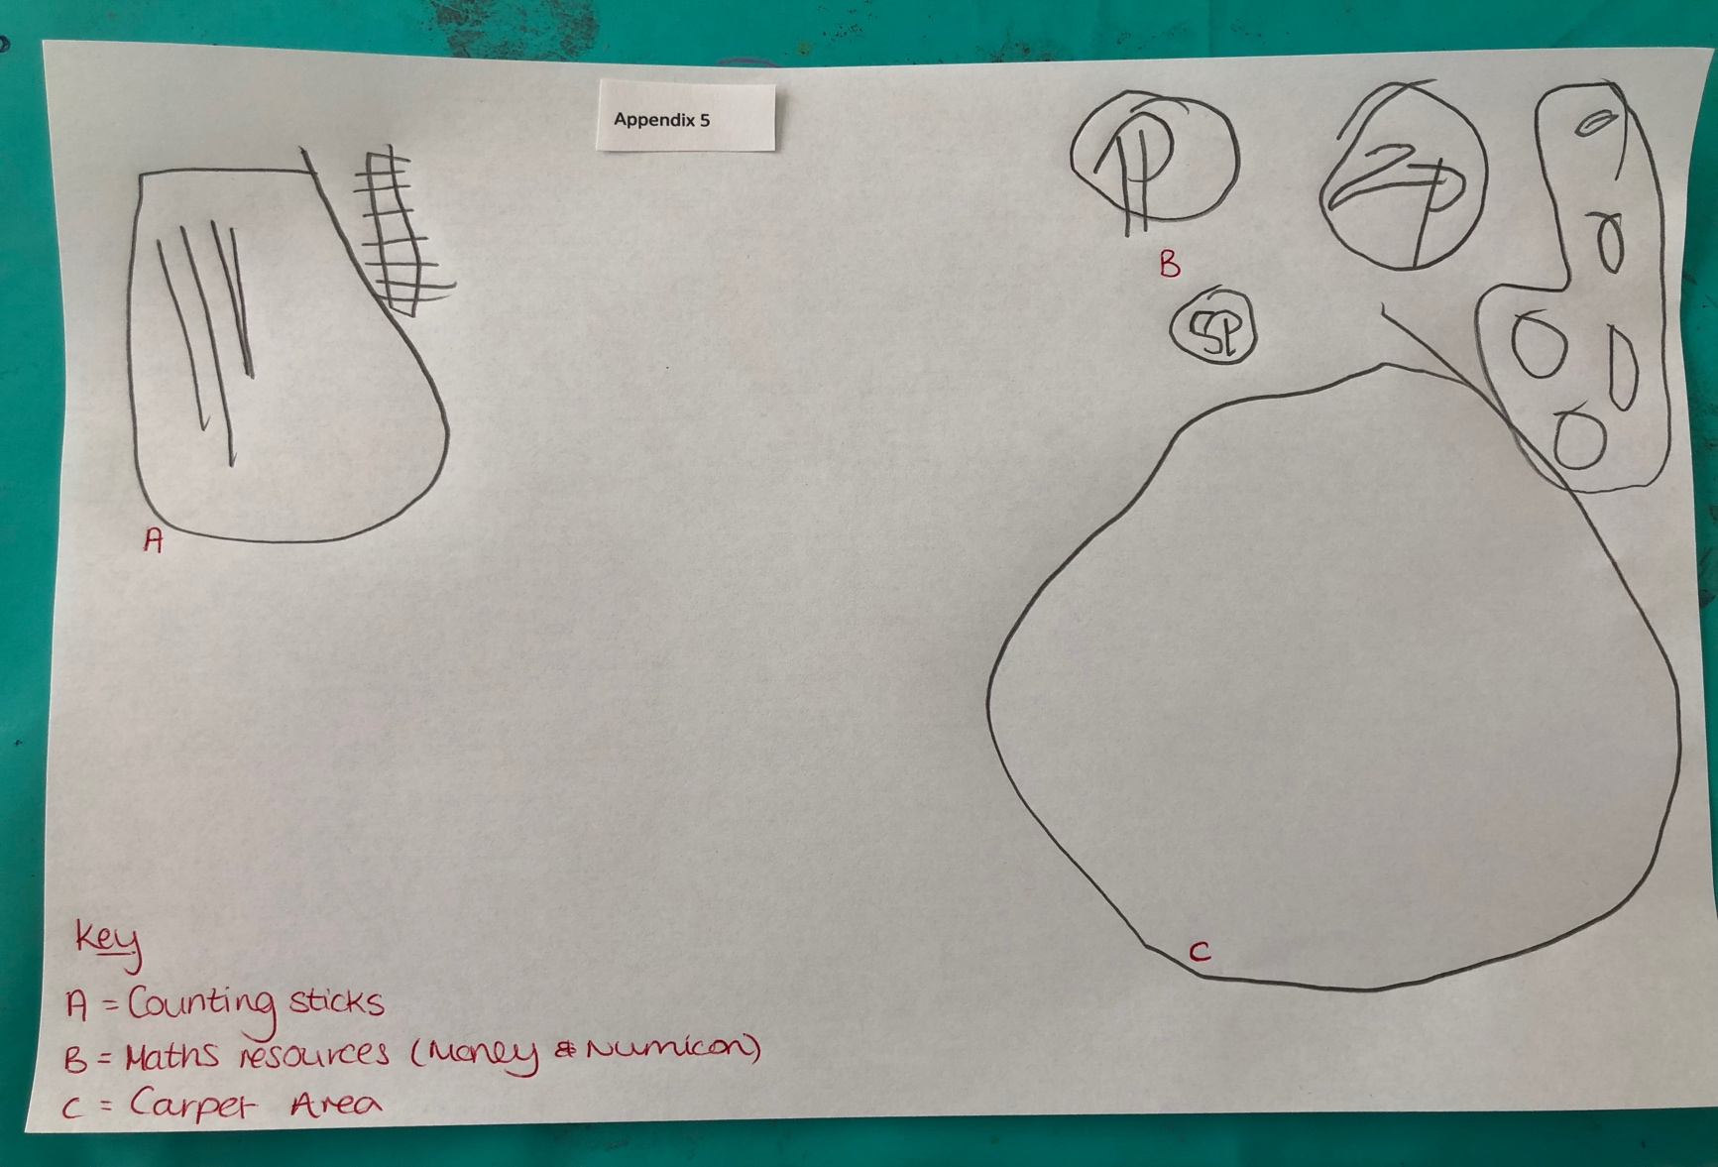
Appendix 5

Appendix 6
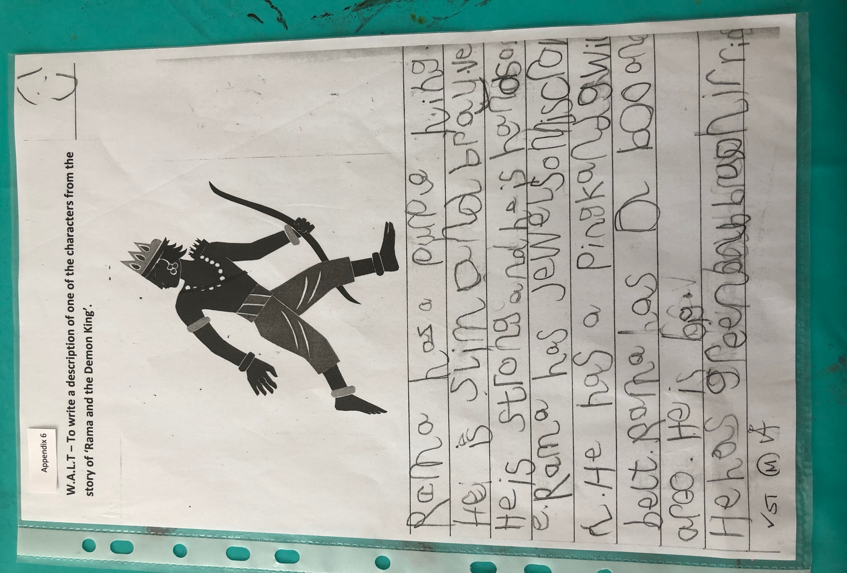
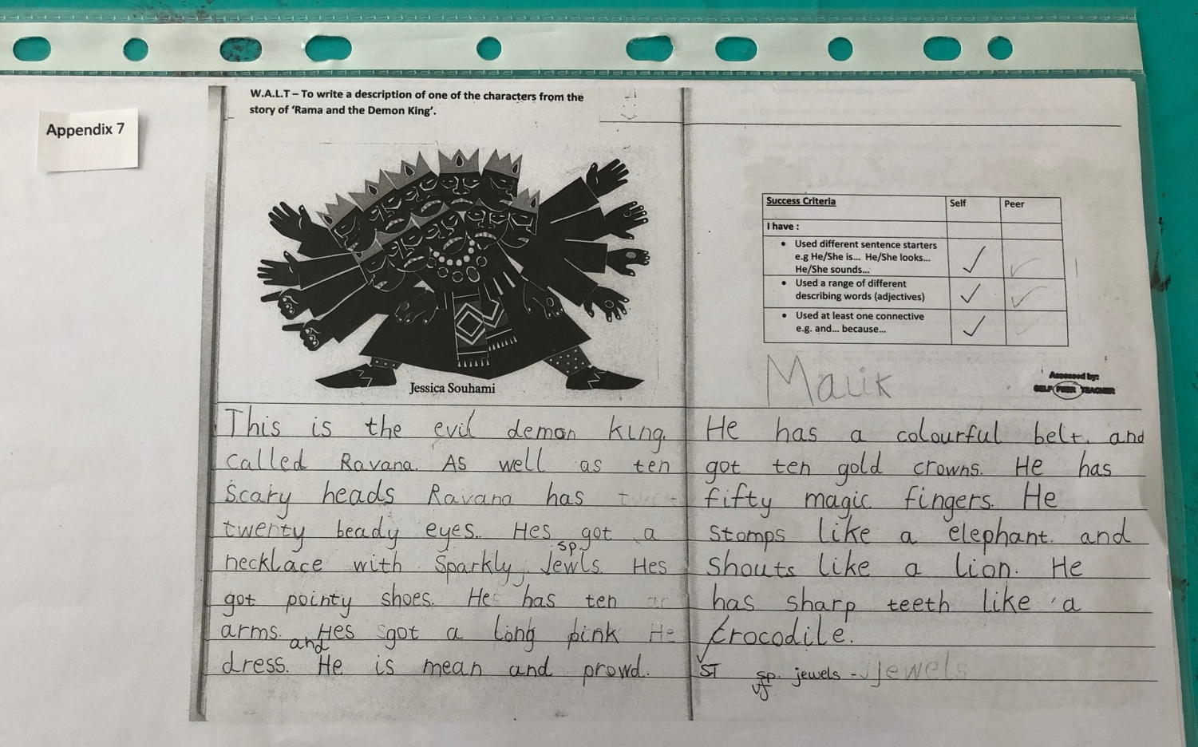
Appendix 7

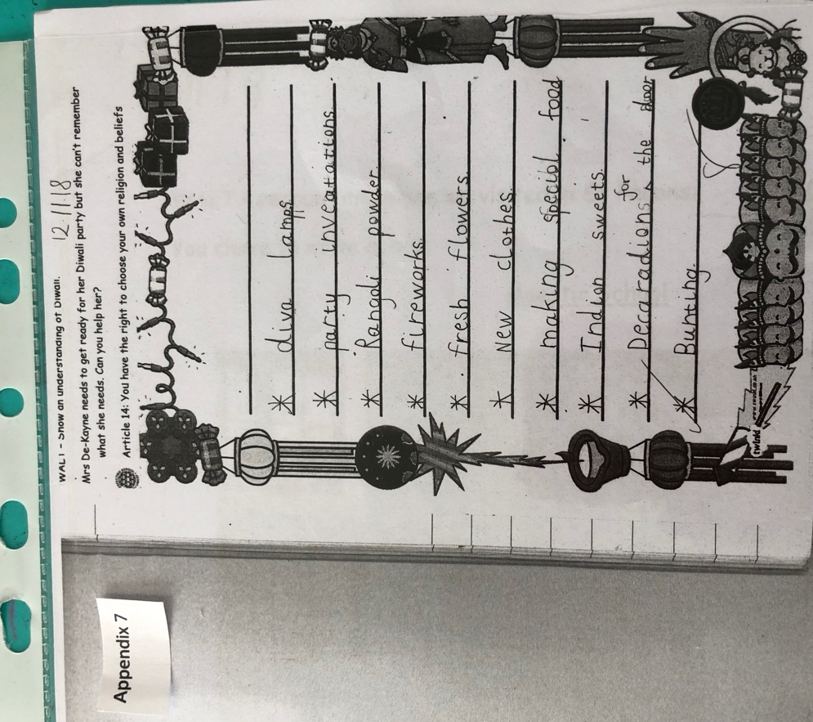

Appendix 8
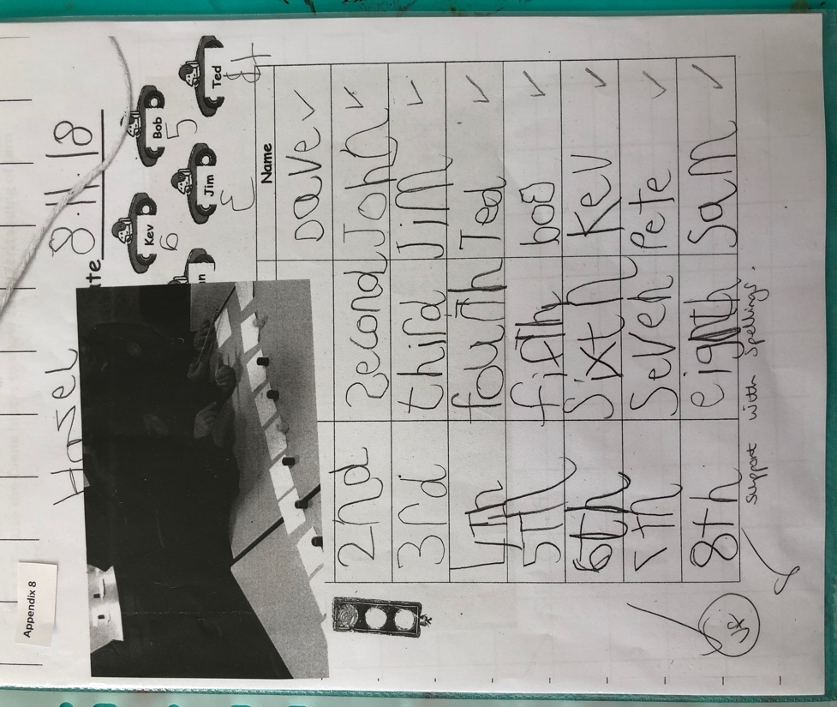
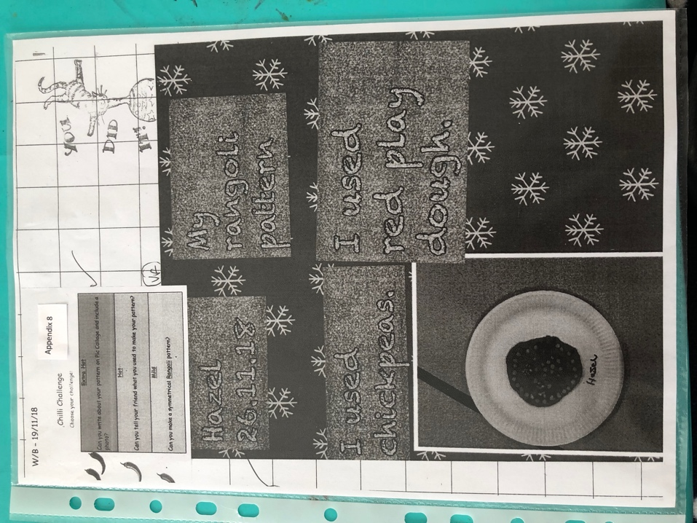
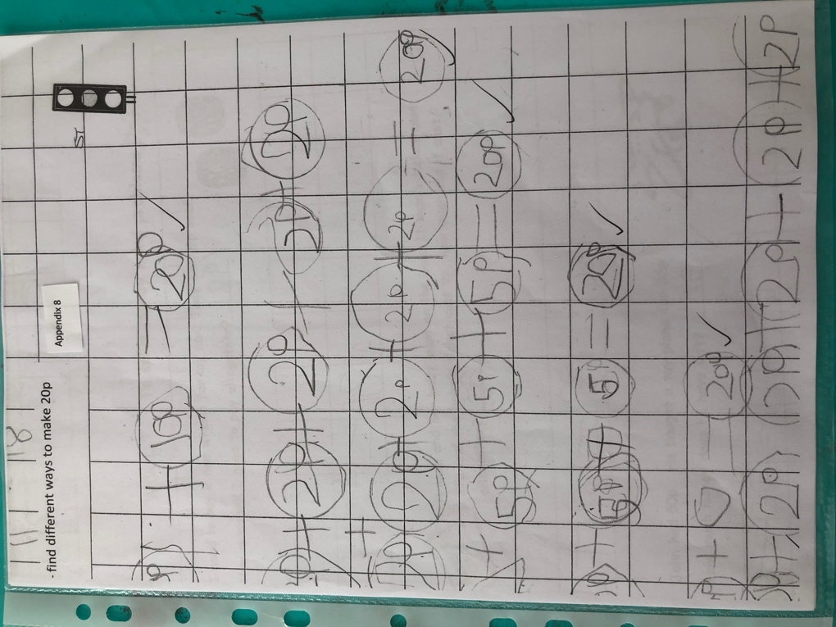

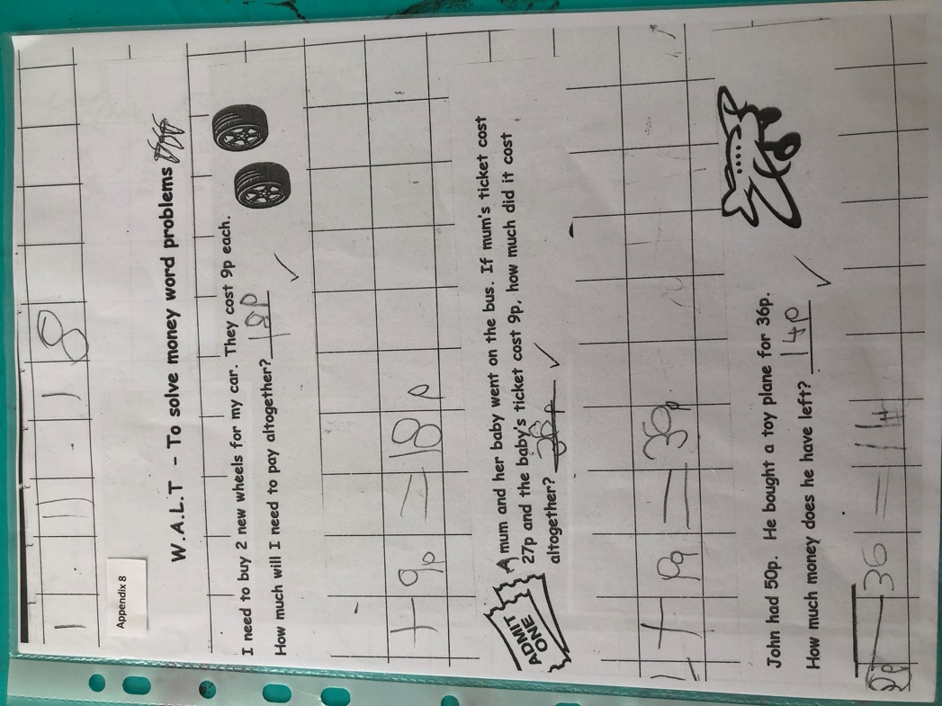

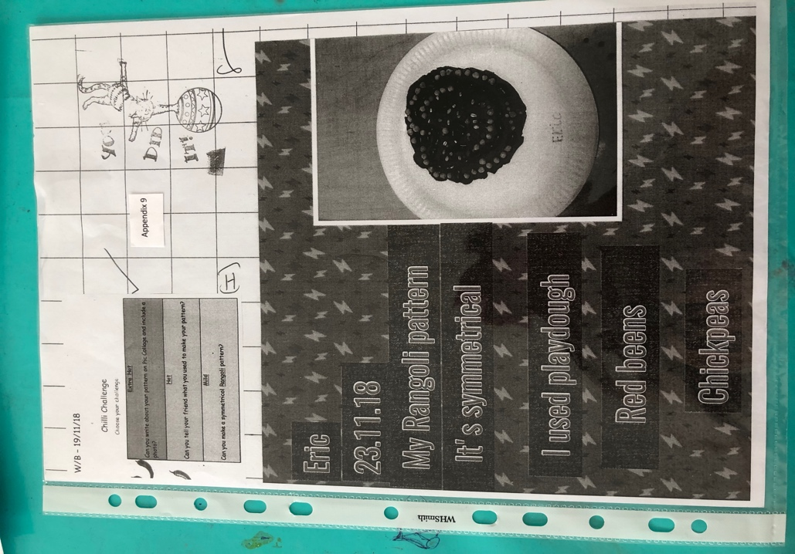
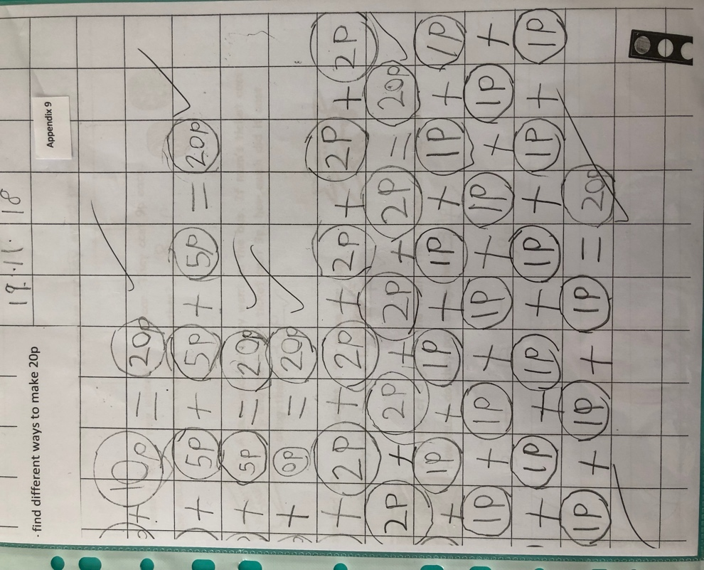
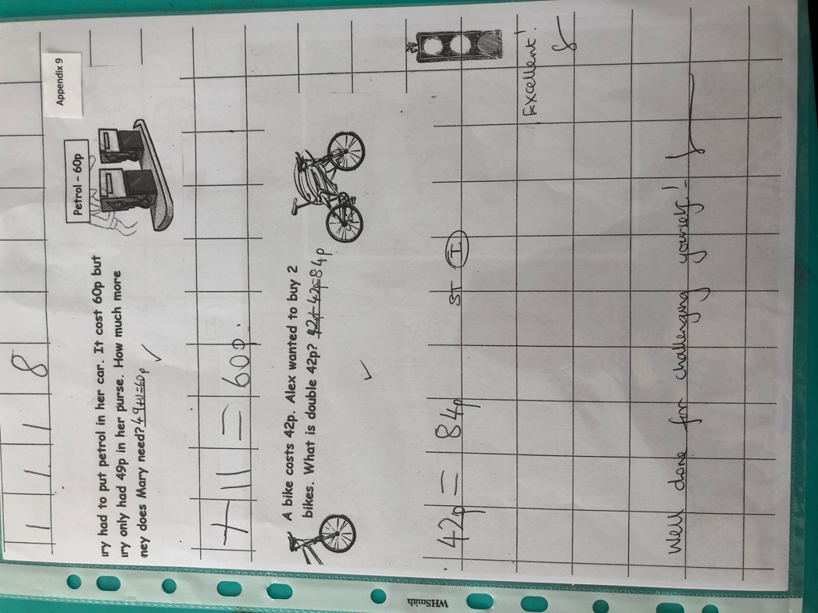
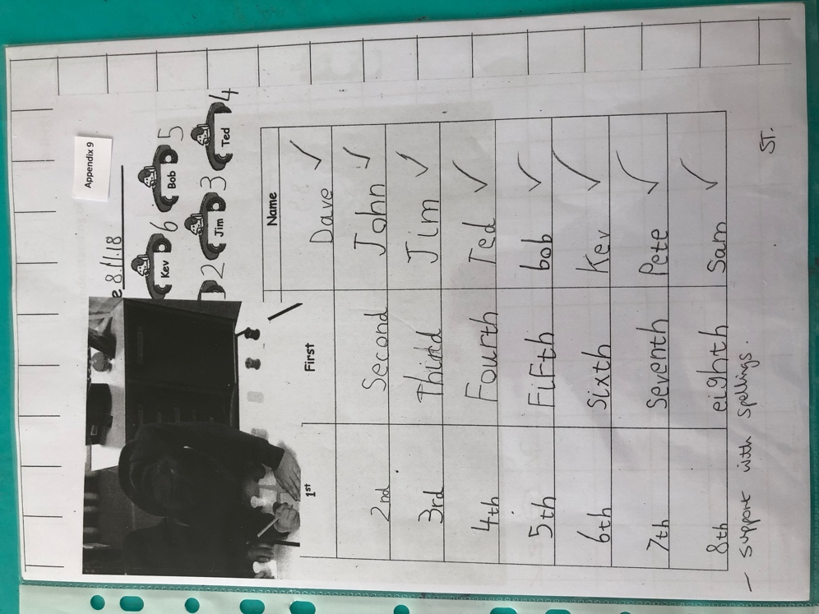
Appendix 9

