
Student Name: | Amiben kinteshkumar patel
Student Number: | 2526924
Programme: | MSc Public Health and Social Care in Practice
Module: | Population Health and Digital Health Promotion
Module Code: | LCHS7009
Lecturer: | Diola Bijlhout`
Assignment Title: | Component 1  2 Blogs

Table of Contents
Blog 1: Digital Health Applications for Alcohol Harm Reduction: A Critical Evaluation of the MyDrinkaware App 3
Introduction 3
Public health problem 3
Existing Digital Technology- MyDrinkaware App 4
MyDrinkaware App’s Health Promotion 4
Critical Evaluation 4
Conclusion 5
Recommendations 5
References 6
Blog 2: AI-SmartRecovery: An AI-Powered Digital Health Platform for Alcohol Harm Reduction in the UK 8
Introduction 8
Public Health Problem 9
Designed Digital Technology 9
Usage in Health Promotion 9
Critical Evaluation 10
Recommendations and Conclusion 11
References 12

Blog 1: Digital Health Applications for Alcohol Harm Reduction: A Critical Evaluation of the MyDrinkaware App

Introduction
Alcohol consumption is a public health problem as it causes millions of people deaths worldwide (Dasgupta, 2026). Drinking too much alcohol can have immediate and lasting damage to the body. The liver can only absorb a small amount of alcohol, so drinking less is good for the body, but drinking larger amounts of alcohol can lead to cancer, chronic diseases like liver and heart diseases and even cause miscarriages in women (D'Alessandro, Carter and Webster, 2023). Around 3 million people die globally each year due to drinking alcohol (Alcohol and Drug Foundation, 2024). According to the Theory of Planned Behaviour, individuals perceive their drinking behaviour through influencing social norms (Adams, Gringart and Strobel, 2022).

Public health problem
Excessive alcohol consumption affects the health and well-being of a person by resulting in issues like headaches and sleep disorders; it also impacts the long-term health of a person, such as high blood pressure, cholesterol and cancer (UK Parliament, 2026).
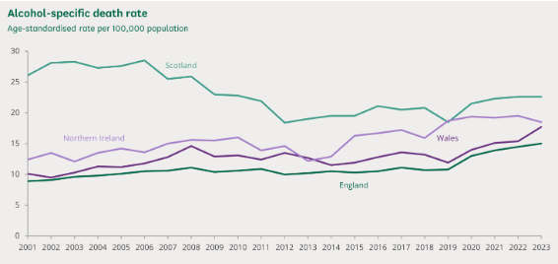
Figure 1: Alcohol-specific death rate in the UK
(Source: UK Parliament, 2026)
In the year 2024-2025, around 147,713 adult clients were hospitalised for drinking alcohol in the UK (UK Parliament, 2026). It is determined that alcohol consumption is the primary factor in severe illness among people living in the UK (GovUK, 2025).

Existing Digital Technology- MyDrinkaware App
This application enables users to record alcohol consumption, calculate its units, monitor spending and calories related to drinking, assess the impact of alcohol on sleep and set personalised alcohol reduction goals. It primarily helps users to meet goals of cutting down alcohol consumption or lessening the quantity of consumption to lose weight (Drinkaware, 2026).
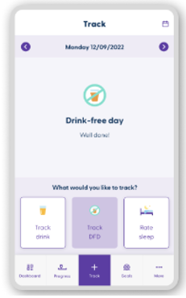
Figure 2: MyDrinkaware App alcohol tracker
(Source: Drinkaware, 2026)

MyDrinkaware App’s Health Promotion
This application is developed to support people in reducing alcohol consumption and cultivating a moderate drinking habit (Drinkaware, 2026). MyDrinkaware highlights the drawbacks of drinking alcohol, especially how it can affect behaviour and negatively affect the relationships of users. Personalised goal-settings encourage users to adopt realistic alcohol-consumption reduction goals, increasing self-awareness and supporting sustained behaviour change (Drinkaware, 2026b).

Critical Evaluation
Strengths
● It motivates individuals to improve their behaviour and enhance their well-being (Drinkware, 2026c).
● The application’s sleep tracking tools analyses how alcohol negatively disturbs the sleep cycle (Drinkaware, 2026b).
Weakness
● It mainly depends on consistent user participation.
● However, it is not very effective for mentioning severe health issues like cancers compared to healthcare services (Highley and Petticrew, 2025).

Conclusion
MyDrinkaware promotes mindful drinking habits for its users by encouraging self-monitoring, informed decision-making and behavioural changes.

Recommendations
● The application will incorporate AI- powered feedback (Deepshikha, 2025).
● It might offer multilingual support and also offline support (Ayoband Omidire, 2021).
● MyDrinkaware would provide stronger peer support to elevate engagement to long-term alcohol reduction.

References
Adams, C., Gringart, E. and Strobel, N. (2022) ‘Explaining adults’ mental health help-seeking through the lens of the theory of planned behavior: A scoping review’, Systematic reviews, 11(1), p.160. Available at: https://link.springer.com/article/10.1186/s13643-022-02034-y (Accessed: 19 July 2026).
Alcohol and Drug Foundation (2024) The long-term health impacts of alcohol Available at: https://adf.org.au/insights/health-impacts-alcohol (Accessed: 19 July 2026).
Ayob, S. and Omidire, M.F. (2021) ‘Storyboards as a qualitative method of exploring learners’ experience with the use of a multilingual support strategy’, International Journal of Qualitative Methods, 20, p.16094069211034391. Available at: https://journals.sagepub.com/doi/full/10.1177/16094069211034391 (Accessed: 19 July 2026).
D'Alessandro, S., Carter, L. and Webster, C. (2023) ‘Binge drinking: A review and research agenda’, Journal of Consumer Behaviour, 22(1), pp.177-198. Available at: https://onlinelibrary.wiley.com/doi/full/10.1002/cb.2102 (Accessed: 19 July 2026).
Dasgupta, A. (2026) The science of drinking: how alcohol affects your body and mind. Bloomsbury Publishing USA. Available at: https://books.google.co.in/books?hl=en&lr=&id=y9SiEQAAQBAJ&oi=fnd&pg=PP1&dq=Drinking+too+much+alcohol+can+have+immediate+and+lasting+damage+to+the+body&ots=2U-ENkngcq&sig=kTUQvZVBQljG6qPac5i83iXCjPM&redir_esc=y#v=onepage&q&f=false
Deepshikha, D., (2025) ‘A comprehensive review of AI-powered grading and tailored feedback in universities’, Discover Artificial Intelligence, 5(1), p.251. Available at: https://link.springer.com/article/10.1007/s44163-025-00517-0 (Accessed: 19 July 2026).
Drinkaware (2026b) Keep Track This Summer. Available at: https://www.drinkaware.co.uk/ (Accessed: 19 July 2026).
Drinkware (2026a) MyDrinkware app: alcohol tracker to help you drink less. Available at: https://www.drinkaware.co.uk/tools/mydrinkaware-app (Accessed: 19 July 2026).
Drinkware (2026c) MyDrinkaware app: alcohol tracker to help you drink less. Available at: https://www.drinkaware.co.uk/tools/mydrinkaware-app (Accessed: 19 July 2026).
GovUK (2025) Chapter 12: alcohol, Available at:https://www.gov.uk/government/publications/delivering-better-oral-health-an-evidence-based-toolkit-for-prevention/chapter-12-alcohol (Accessed: 19 July 2026).
Highley, E. and Petticrew, M (2025) ‘Dark Apps’ uncovered: popular alcohol gtracking apps backed by the alcohol industry misled users, Available at: https://www.ias.org.uk/2025/02/25/dark-apps-uncovered-popular-alcohol-tracking-apps-backed-by-the-alcohol-industry-mislead-users/ (Accessed: 19 July 2026).
UK Parliament (2026) Statistics on alcohol: England. Available at: https://commonslibrary.parliament.uk/research-briefings/cbp-7626/ (Accessed: 19 July 2026).

Blog 2: AI-SmartRecovery: An AI-Powered Digital Health Platform for Alcohol Harm Reduction in the UK

Introduction
Alcohol consumption remains one of the leading public health issues in the UK and also increases preventable deaths worldwide (Buss et al., 2026). Drinking alcohol increases the risk of noncommunicable diseases such as cardiovascular problems, liver diseases, cancers as well as causes mental health disorders including anxiety, depression (WHO, 2024).
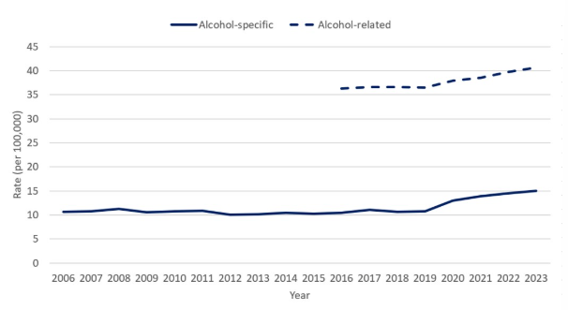
Figure 1: Alcohol consumption deaths in England
(Source: GOV.UK, 2025)
As of 2023, 8,274 alcohol-specific deaths occurred in England which increased 4.6% from the previous year and significantly caused regional deaths across the UK (GOV.UK, 2025). These negative consequences need proper intervention to improve population health by reducing alcohol consumption subsequently.
To decrease this substantial burden on individuals and the UK healthcare context, the blog proposes the effectiveness of the AI-SmartRecovery digital health platform. It will be designed to reduce harmful alcohol consumption through real-time behavioural interventions, predictive analytics and personalised coaching.

Public Health Problem
In the UK economy, alcohol-related harm continuously imposes a substantial burden on society by reducing productivity and the loss of people's quality of life.
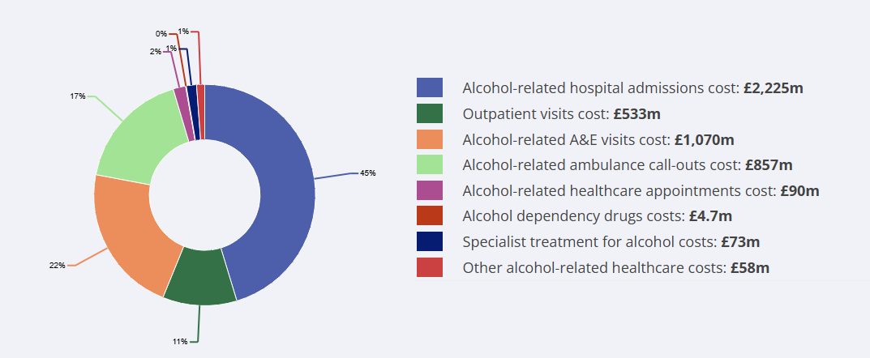
Figure 2: Alcohol-based hospital admission cost
(Source: IAS, 2026)
In the UK, alcohol-related hospital admission costs amount to around £2,225 million every year, which widely affects the nation’s economy (IAS, 2026). This statistic indicates that alcohol contributes to thousands of hospital admissions annually which require continuous clinical support for improvement.

Designed Digital Technology
According to Yahoo! (2024) the MyDrinkware app only depends on user participation consistency and sometimes provides misinformation to users’ which mislead buyers regarding alcohol consumption. Unlike traditional alcohol tracking applications, AI-SmartRecovery will be introduced as a new digital mobile application which will deliver personalised alcohol reduction support through measuring users’ real-time behavioural interventions. Users’ enable to record their alcohol intake, sleep quality and daily activities while AI algorithms identify behavioural patterns to deliver personalised support and promote sustained recovery. GPS-based alerts will also easily recognise high-risk drinking environments (Duggal et al., 2025).

Usage in Health Promotion
According to the COM-B model, the application of AI-SmartRecovery will encourage long-term behaviour changes in users by offering educational support and improving their psychological capabilities to understand the harmfulness of alcohol-related risks (Timlin, McCormack and Simpson, 2021). The framework is primarily used to diagnose behavioural issues and set strategic interventions for producing better outcomes (Willmott, Pang and Rundle-Thiele, 2021). AI chatbots will send real-time motivational messages and digital rewards to strengthen behaviour of personalised goal setting which enables users to select healthier lifestyle choices (Chen et al., 2025). Therefore, it depicts that the usage of AI-SmartRecovery will positively contribute to the UK’s public health objectives for preventing alcohol-related harms.
Capability
Education
Alcohol awareness
Motivation
AI coaching
Digital rewards
Opportunity
NHS guidance
Family support
Behaviour
Better health
Less drinking
Figure 3: COM-B Model application within AI-SmartRecovery
(Source: Self-created)

Critical Evaluation
Advantages
- AI-driven personalisation continuously identifies individual behavioural patterns (Ajayi, 2025).
- Wearable integration to avoid manual alcohol tracking which delivers clinical support.
Disadvantages
- Depending on smartphone accessibility and reliable internet connectivity.
- AI algorithms require personal health information accessibility (Asthana et al., 2024).

Recommendations and Conclusion
Recommendations
- AI-SmartRecovery should integrate transparent AI governance systems to enhance cybersecurity across digital services (Oluoha et al., 2022).
- It should enable offline functionality to offer community-based support for underserved populations.
Conclusion
Overall, AI-SmartRecovery would be represented as an innovative digital health intervention that complies with AI integration to deliver personalised healthcare support to address alcohol misuse in the UK.

References
Ajayi, R. (2025) ‘AI-powered innovations for managing complex mental health conditions and addiction treatments’, International Research Journal of Modernization in Engineering Technology and Science, 7(1), p.87. Available at: https://www.doi.org/10.56726/IRJMETS65895
Asthana, S., Im, J., Chen, Z. and Banovic, N. (2024) ‘" I know even if you don't tell me": Understanding Users' Privacy Preferences Regarding AI-based Inferences of Sensitive Information for Personalization’, In Proceedings of the 2024 CHI Conference on Human Factors in Computing Systems (pp. 1-21).
Buss, V.H., Oldham, M., Jackson, S.E., Shahab, L., Angus, C., Holmes, J. and Brown, J., (2026) ‘Has alcohol consumption in England returned to pre‐COVID‐19 pandemic levels? A monthly population study, 2014 to 2024’, Addiction, 121(4), pp.839-850. Available at: https://doi.org/10.1111/add.70258
Chen, Y.M., Chuang, C.C., Lin, Y.C., Liu, P.Y., Wu, Y.J., Yuan, C.W., Bi, N., Hsu, S.H., Chang, H.M., Huang, M.C. and You, C.W. (2025) ‘Beyond the Sharing of Personal Data: Design of Collaborative Chatbot-based Mobile Support Systems to Facilitate Recovery from Alcohol Use Disorder’, In Companion of the 2025 ACM International Joint Conference on Pervasive and Ubiquitous Computing (pp. 45-49). Available at: https://doi.org/10.1145/3714394.3754355
Duggal, S., Kaur, P., Kumar, M. and Bhardwaj, V. (2025) ‘IoT-enabled fog computing framework: heat stroke risk analysis’, Journal of Cloud Computing, 14(1), p.51. Available at: https://doi.org/10.1186/s13677-025-00776-3
GOV.UK (2025) Alcohol profile: short statistical commentary, February 2025. Available at: https://www.gov.uk/government/statistics/alcohol-profile-february-2025-update/alcohol-profile-short-statistical-commentary-february-2025 (Accessed: 19 July 2026).
IAS (2026) Economy. Available at: https://www.ias.org.uk/factsheet/economy/ (Accessed: 19 July 2026).
Oluoha, O.M., Odeshina, A., Reis, O., Okpeke, F., Attipoe, V. and Orieno, O.H. (2022) ‘Artificial intelligence integration in regulatory compliance: A strategic model for cybersecurity enhancement’, Journal of Frontiers in Multidisciplinary Research, 3(1), pp.35-46.
Timlin, D., McCormack, J.M. and Simpson, E.E. (2021) ‘Using the COM-B model to identify barriers and facilitators towards adoption of a diet associated with cognitive function (MIND diet)’, Public health nutrition, 24(7), pp.1657-1670. Available at: https://doi.org/10.1017/S1368980020001445
WHO (2024) Alcohol. Available at: https://www.who.int/news-room/fact-sheets/detail/alcohol (Accessed: 19 July 2026).
Willmott, T.J., Pang, B. and Rundle-Thiele, S. (2021) ‘Capability, opportunity, and motivation: an across contexts empirical examination of the COM-B model’, BMC Public Health, 21(1), p.1014. Available at: https://doi.org/10.1186/s12889-021-11019-w
Yahoo! (2024) Industry-backed apps designed to cut drinking are 'misleading users'. Available at: https://www.yahoo.com/news/industry-backed-apps-designed-cut-010336293.html?guccounter=1&guce_referrer=aHR0cHM6Ly93d3cuZ29vZ2xlLmNvbS8&guce_referrer_sig=AQAAAKID-cvJdKOJ8OeD288B0IJcDyyScbpVAeP3KGeec_MstHnx6rJiK3sKRldDzheiw2IbFT_0mUqlRhuE7JrbCzKZxezlhw3co4vNFz14lG3nyYm-tmhUX5CGnQVEuApmjRTTSItA2Lp6Q5TS9tdiMt8fS8UijtUB5ky_L-NGV4ej (Accessed: 19 July 2026).

