“Impact of Hybrid Work Models on Employee Productivity and Job Satisfaction in the UK IT Sector.”

Table of Contents
Introduction 3
Background of the Study 3
Research Problem 3
Aim 4
Objectives 4
Research Questions 4
Literature Review 4
Concept of Hybrid Work Model 4
Hybrid Work and Employee Performance 5
Challenges of Hybrid Work Models 6
Hybrid Work and Organisational Performance 6
Research Gap 7
Significance of the Study 7
Methodology 7
Research Philosophy 7
Research Approach 7
Research Strategy 7
Data Collection Method 8
Sampling Method and Sample Size 8
Data Analysis Technique 8
Expected Results and Discussion 8
Significance and Contribution of the Study 9
Conclusion 9
Limitation 9
Timeline 9
References 10

Introduction

Background of the Study
With the evolution of time, the nature of work has significantly evolved and post covid-19 pandemic, there has been an adoption of flexible work arrangements where hybrid work models have been focused on to make sure that the workers can work at their convenience. The hybrid work model refers to a system where employees have the privilege to work remotely or at the office as per their choice. In the case of the presence of such a system, the employees can divide their time by working from a physical office location or working remotely. With the help of this, it is possible to have flexibility in the day-to-day working and fatigue can be avoided.
With the introduction of hybrid working, one of the most affected industries is that of information technology (Sunkesula and Subba Reddy, 2025). There is a heavy reliance on IT companies on online communication tools and it is easier for them to work remotely. Various organisations in the United Kingdom have now focused on the adoption of hybrid work arrangements and they get several advantages with such adoption, leading to enhanced flexibility and work-life balance for the employees. This also helps in the enhancement of the overall productivity, making it possible to have a positive impact on the organisation.
However, even after the presence of significant advantages through such adoption, there are certain challenges that continue to exist. The issues usually include the presence of communication barriers and difficulty in maintaining collaboration. The presence of challenges in the maintenance of a strong organisational culture needs to be dealt with effectively with the right strategies. The examination of these aspects will help in having effective insights with regard to both the benefits and the challenges, and ensure that the right strategies are designed for the optimisation of the productivity of employees.

Research Problem & Rationale
With the adoption of the hybrid work models, the traditional organisational structures have been transformed, and there is now a presence of better flexibility as well as convenience for the employees (Krajčík, Schmidt and Baráth, 2023). However, one of the major concerns in this situation is related to the impact of such practice on the performance of the organisation and the productivity of the employees. The presence of hybrid work leads to dissatisfaction and work-life balance issues for employees, but it also involves communication gaps, disengagement of employees and a reduction in the overall engagement. Due to this, efficiency and innovation are significantly impacted and there is a need to focus on the exploration of both the opportunities and challenges to make sure that the overall impact on organisational performance can be examined.

Aim
The aim of the study is to focus on the impact of the hybrid work arrangements on employee’s commitment in UK IT industry.

Objectives
- To emphasize the assessment of the factors that have an impact on the employee commitment and job satisfaction in the UK IT sector.
- To focus on the identification of opportunities and challenges present in the IT organisations.
- To analyse the role of hybrid work models in influencing the employee commitment and job satisfaction of the organization.
- To recommend effective strategies for dealing with the challenges associated with the role of hybrid work models.

Research Questions
- What are the key factors that have an impact on employee commitment in the UK IT sector?
- What are the opportunities and challenges associated with hybrid work arrangements?
- How do hybrid work models have an impact on the employee commitment and job satisfaction in the UK IT industry?

Literature Review

Concept of Hybrid Work Model
In modern organisations, the hybrid work model is a significant workplace arrangement that has taken place after Covid 19 (Yang, Kim and Hong, 2023). It refers to a flexible work arrangement where it is possible to focus on ensuring that the time between remote working and working from the office is duly divided. The combination of traditional work methods as well as remote work helps in the presence of flexibility and ensures efficiency because the task gets completed in a fast manner.
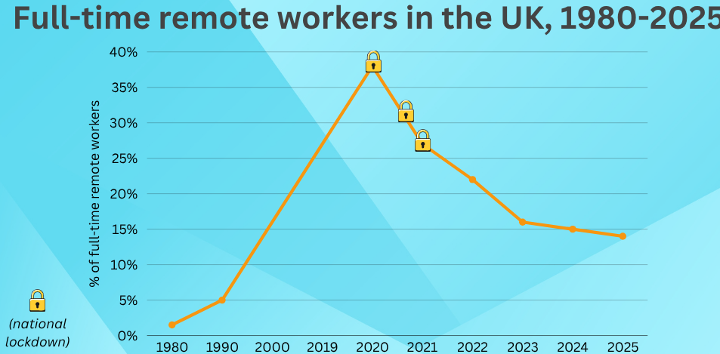
Figure 1: Remote working statistics UK
Source: Andrew Fennell, 2025
In this scenario, the employees are in a position to effectively utilize communication tools and digital technology. The presence of greater flexibility and autonomy helps them in improved job satisfaction as well as the presence of work-life balance. Further, the adoption of hybrid work models also plays an important role, as the employees can perform their tasks remotely without an impact on the operational process.

Hybrid Work and Employee Performance
There is a positive relationship between hybrid work arrangements and the performance of the employees (Toscano, González-Romá and Zappalà, 2025). This is because it enhances the overall flexibility and makes it possible to reduce the stress leading to job satisfaction. The employees are more motivated and they perform their responsibilities actively when they are given a sense of autonomy and flexibility. This also leads to work-life balance because the employees have greater autonomy in terms of managing their personal and professional responsibilities. With the help of such models, it is possible to ensure the overall enhancement of productivity and help in greater autonomy as well as accountability. This duly contributes to the improvement in the overall dynamics.

Challenges of Hybrid Work Models
Even after the potential benefits of the hybrid work model exist, there are several challenges that need to be focused on for effective outcomes. One of the most significant concerns is the difficulty in maintaining effective and continuous communication when employees operate from different locations. The interaction becomes limited and due to this, the coordination is often affected (Alasoini, Hirvonen and Känsälä, 2025). The presence of a communication gap leads to a reduction in the overall efficiency and it also feels isolating to work in such an environment. The reduction in engagement is not good for the long-term benefits of the organisation and often leads to decreased motivation.
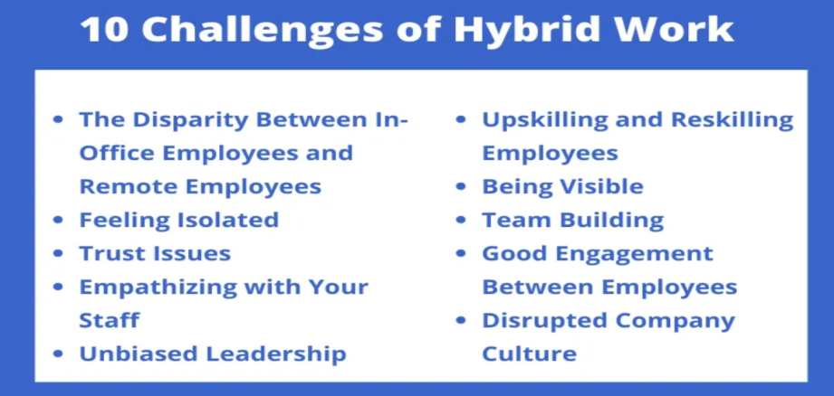
Figure 2: Challenges of Hybrid work
Source: Abhishek Tahlan, 2026
Further, it is also difficult to monitor the employees when they do not operate from the same location. Due to this, the productivity levels get impacted and there is a struggle in the maintenance of a supportive work environment. It is important for the organisations to focus on the development of effective management strategies for better results.

Hybrid Work and Organisational Performance
The presence of a particular type of work environment has a significant impact on the performance of the organisation. This is mainly because the performance of the organisation is dependent upon the productivity of employees and their job satisfaction. The presence of greater flexibility and work-life balance helps the employees in completing the task more efficiently, making it possible to contribute towards the organisation (Putri and Hendarman, 2023). However, it is also important to balance the situation and have in place the right strategies for the maintenance of organisational culture in a positive way. Thus, even though the presence of hybrid models is important for long-term growth, there is also a need to focus on carefully designing such an environment for maximizing the benefits.

Research Gap
The research in terms of the impact of the hybrid models or organisational performance is limited and thus, this research will focus on investigating the hybrid work arrangements as well as their influence on the collaboration and overall productivity of both the employees and the organisation.

Significance of the Study
The research is extremely important because it focuses on providing insights with regard to the impact of the hybrid work models on the performance of the organisation in the UK IT industry. With the help of these findings,it will be possible to get a better understanding of the benefits and challenges of hybrid work and help in designing effective strategies for the improvement of productivity and collaboration.

Methodology

Research Philosophy
The emphasis will be laid on the adoption of a positivist research philosophy where measurable data will be taken into account to ensure that the relationships between the variables are effectively understood (Ali, 2024). Through this study, it will be possible to examine the relationships that exist between the models, making it possible to focus on the use of quantifiable data from the employees.

Research Approach
The deductive research approach lays emphasis on the development of research questions based on the existing literature and theories. With the help of this approach, it is possible for the researchers to lay emphasis on empirical data collection and make sure that an in-depth understanding of the research topic is built. Through this study, the focus will be on the analysis of the data gathered from different sources, and it will evaluate the ways in which hybrid work has an impact on the performance of the organization.

Research Strategy
The adoption of the survey method will make it possible to collect data from a large number of participants in an effective manner. The use of a questionnaire will be done to make sure that the information with regard to the experiences of employees is taken into account and the various aspects, including communication, job satisfaction, productivity and collaboration, are considered. Through the study, it will be possible to focus on the standardisation of the responses of employees and their effective analysis.

Data Collection Method
The emphasis will be laid on the adoption of primary data collection methods where a structured questionnaire will be used to collect the data (Ganesha and Aithal, 2022). The inclusion of both the closed-ended and Likert-scale questions will be designed to make sure that the perception of the hybrid work arrangement is duly taken into account. By focusing on the communication with colleagues, employee productivity, and work-life balance, the overall effectiveness will be assessed.The designing of the questions will be done in such a manner that they take into account the work-life balance, communication with colleagues, overall effectiveness of the organisation and their job satisfaction. It is important to collect such first-hand insights to understand the experience of the employees with hybrid work models.

Sampling Method and Sample Size
The convenience sampling technique will be used for the selection of participants in the research. In this process, such individuals will be selected who are accessible and willing to participate in the study. Approximately 60 employees will be targeted who work across different IT companies in the United Kingdom. Based on their experience in a hybrid work arrangement, the data will be collected and the perspective of such employees will be taken who have been apart of such a situation.

Data Analysis Technique
The employment of quantitative data analysis techniques will be made a part of the research and for the organisation and analysis of data, Microsoft Excel will be used. Further, the use of percentages, graphical representations, and frequency distributions will be used to ensure that the data is interpreted effectively. With the help of charts and tables, it will be possible to ensure the effective presentation of the data and the relationships will also be identified to understand the research topic.

Expected Results and Discussion
The hybrid work environments have both a positive and negative impact on the overall productivity and experience of the employees (Albreikiet al.,2023). On the positive side, it is possible to have flexibility for the employees, which leads to satisfaction for them, and this makes it possible to manage the professional responsibilities better. However, on the negative side, the challenges involve a gap in communication as well as limited collaboration, making it difficult for employers to monitor the performance of the employees. Thus, the research is expected to focus on both the positive and negative sides of hybrid work and provide strategies with which productivity can be enhanced through hybrid work strategies.

Significance and Contribution of the Study
Through this research, the contribution will be made towards the academic knowledge and organisational practice, making it possible to ensure the examination of the relationship that exists between the hybrid work arrangement and its impact on the organisation. Further, the development of effective hybrid work policies will make it possible to get better insights with regard to the strategies needed for dealing with the challenges effectively.

Conclusion
In conclusion, the research proposal has focused on the examination of the impact of hybrid work models on the performance of the organisation. With the analysis of the opportunities and challenges, it will be possible to get valuable insights with regard to the development of strategies and improvement in the overall performance.

Limitation
The explanation and generalization of the results of the study may be impacted by a number of constraints. First, a small sample size could affect the study's capacity to fairly represent the larger population. Moreover, the study might be limited to an area in particular, which would restrict the implications of the findings to other areas with distinct cultural or socioeconomic characteristics. The study may also be impacted by time constraints because a shorter period may miss long-term patterns or behavioural shifts.

Timeline
Activities | Week 1 | Week 2 | Week 3 | Week 4 | Week 5 | Week 6
Title selection
Aim and objectives
Introduction
Literature review
Research methodology
Result and discussion
Conclusion and recommendations

References
Abhishek Tahlan, 2026.Challenges of Hybrid work.[Online].Available at;<https://www.prohance.ai/blog/hybrid-work-environments-what-are-they-and-what-are-their-benefits/>.[Accessed on:16th March, 2026]
Alasoini, T., Hirvonen, S. and Känsälä, M., 2025. Hybrid work model as a success factor: Guide to the opportunities and challenges of hybrid work.
Albreiki, J., Dhaiban, A., Alkatheeri, M., Almansoori, N.B. and Amer, S., 2023. The physical and mental effects of working in a hybrid work environment on an employee's well-being and performance. In Proceedings of the 6th European Conference on Industrial Engineering and Operations Management, Lisbon, Portugal, July 18 (Vol. 20, No. 2023, pp. 1157-1168).
Ali, I.M., 2024. A guide for positivist research paradigm: From philosophy to methodology. Ideology Journal, 9(2).
Andrew Fennell, 2025.Remote working statistics UK.[Online].Available at;<https://standout-cv.com/stats/remote-working-statistics-uk>.[Accessed on:16th March, 2026]
Ganesha, H.R. and Aithal, P.S., 2022. How to choose an appropriate research data collection method and method choice among various research data collection methods and method choices during Ph. D. program in India. International Journal of Management, Technology, and Social Sciences, 7(2), pp.455-489.
Krajčík, M., Schmidt, D.A. and Baráth, M., 2023. Hybrid work model: An approach to work–life flexibility in a changing environment. Administrative Sciences, 13(6), p.150.
Putri, S.I. and Hendarman, A.F., 2023. Relationship between Different Work Arrangements and Generation Z Employees Individual Work Performance. American International Journal of Business Management (AIJBM) ISSN, 6.
Sunkesula, S. and Subba Reddy, S.V., 2025, January. Impact of Hybrid Work Model on Job Satisfaction of Tech Professionals in Information Technology Industry. In International Conference on Sustainable Business: People, Planet and Profit (pp. 273-289). Cham: Springer Nature Switzerland.
Toscano, F., González-Romá, V. and Zappalà, S., 2025. The influence of working from home vs. working at the office on job performance in a hybrid work arrangement: A diary study. Journal of business and psychology, 40(2), pp.497-512.
Yang, E., Kim, Y. and Hong, S., 2023. Does working from home work? Experience of working from home and the value of hybrid workplace post-COVID-19. Journal of corporate real estate, 25(1), pp.50-76.

