Programme: BA Leadership and Management

Module: Understanding and Engaging in the Customer Experience Module code: BMSW 5103
Lecturer: Vajira Balasuriya
Assignment Title: Customer Relationship Management and Ethical Practices Part 1 (report)
Student Name: Ameera Khan
Student Number: 1810760

Executive Summary

The objectives of this report are to investigate the customer experience of organisations based on their ethical and sustainability policies, as requested by the Principal Researcher at ‘The Research and Analysis Wing’ of the Aviation Research Centre.
The report will firstly consider ethical and sustainability aspects affecting the aviation industry, followed by a critical review of literature pertaining to quality models which are utilised by the aviation industry to improve customer relationship management.
The quality models discussed are Lambe’s CRM Model, Payne’s Five Forces Model and the IDIC Model. They are significant strategies which allow businesses to provide critical insights to improve customer engagement and relationship management.
From these evaluations, my conclusions are that the aviation industry requires the strategies of a CRM Model which is flexible, adaptable and there is scope for change. As times become more unpredictable, it seems contradictory to endeavour to predict the future. However, with the help of artificial intelligence, the aviation industry can profile their customers, this would aid a contingency style CRM Model in terms of predicting customer demands and opinions regarding sustainability and ethics.
To assess managerial implications and evaluate any potential recommendations that the aviation industry could consider, the study first analysed the current sustainability policies of British Airways, Turkish Airlines and Ryanair. This research was conducted to understand the current provision of airlines, for customer experience and satisfaction. Based on the findings, providing awareness to customers is key, in regards to ‘reduce, re-use, recycle’ being an effort which is required globally. Targeting customers with awareness marketing, can achieve a greater acceptance and improve customer relation with the further understanding between airlines and their customers. There is a constant requirement for airlines to review current factors which impact customer satisfaction levels such as seat comfort, entertainment, eco-friendly products/services and airline brand, an ideal asset of an airline would be an evolving CRM Model, which could keep them updated faster than the rate of change.

Contents
Executive Summary 1
List of Tables 2
List of Figures and Graphs 3
Defining Ethics and Sustainability 4
What are ethics? 4
What are business ethics? 5
Sustainability 5
Ethical and Sustainability Policies and Efforts 6
British Airways 6
Turkish Airlines 7
Ryanair 8
Conclusion 9
Waste and recycling 9
British Airways 10
Turkish Airlines 10
Ryanair 10
Unethical and Sustainability Issues within the Airline Industry 11
Conclusion 11
Customer Relations Management Models 12
Lambe’s CRM Model 12
Payne’s Five Forces model 14
IDIC model 16
Identify 16
Differentiate 16
Interact 16
Customize 17
The Impact of Ethical and Sustainability Policies on the Quality of CRM Systems 17
Recommendations 17
References 18

List of Tables
Table 1. British Airways: Ethical and Sustainability Policies and Efforts...............Page 6-7
Table 2. Turkish Airlines: Ethical and Sustainability Policies and Efforts..............PAGE 7-8
Table 3. Ryanair: Ethical and Sustainability Policies and.....................................Page 8-9

List of Figures and Graphs
Figure 1. How many people care about how the aviation industry affects the environment. Source.......................................................................................................................Page 6
Figure 2. Knowledge-enabled CRM Model................................................................Page 13
Figure 3. Four Dimensions of Knowledge in CRM....................................................Page 14
Figure 4. Payne’s Five Forces Process Model..........................................................Page 15
Figure 5. IDIC Model..................................................................................................Page 17

Defining Ethics and Sustainability
Organisations around the world have a social responsibility to the internal and external environment of their business. This report focuses on the airline industry.

What are ethics?
Ethics are rules suggesting what is good or bad and whether something is right or wrong. Ethics can be influenced by cultures, religion and other circumstances surrounding upbringing. Ethical responsibility is considered to be the conduct in business and manner which is in sync with the expectations, ethical and moral norms of the society (Palihawadana, D. 2016).

What are business ethics?
Ethics within organisations means businesses should operate with honesty, confidence, respect and act fairly and with consideration. Ethics is a key principle and when practiced within organisations, business ethics can improve the wellbeing of employees and the world we live in (D Crowther, et al 2008).

Sustainability
Sustainability within an organisation would be to consider and fulfil the needs of the present customers and the preservation of resources for future provision.
There is a growing trend of organisations incorporating sustainability policies in their businesses. Sustainability within the business is concerning effects the business has on the environment and the effect it has on society. The objective of a sustainable business is to positively effect these areas.
The aviation industry has grown globally and significantly over the past decades. In the U.S. the air transportation system has grown six-fold (Waitz, Townsend, Cutcher-Gershenfeld, Greitzer & Kerrebrock, 2004). The reason for this growing strength is that aviation is a network of transport, connecting people and goods worldwide (Nettey, 2007). This creates many employment opportunities for local communities; in the tourism industry, trade, businesses and cross-cultural understanding (Sustainability Reporting Guidelines, 2011). As a consequence of the growing global demand, the aviation infrastructure is also growing and as a result of this the sustainability and ethical effects have considerably grown too.
Some of the negative effects of the growing aviation industry include the significant amount of waste which is produced, various types of pollution, over use of natural resources and growing concerns of carbon emissions. These effects can pose health and safety risks for those working within airports and communities living around airports. In connection to customer relations management the aviation industry has been under increased pressure to face ethical and sustainability issues and create policies to demonstrate their efforts in tackling these issues in their business model and strategies.
Figure 1 below, demonstrates the number of respondents in a global survey, (conducted by ‘The Conference Board’) who care about how the aviation industry effects the environment.
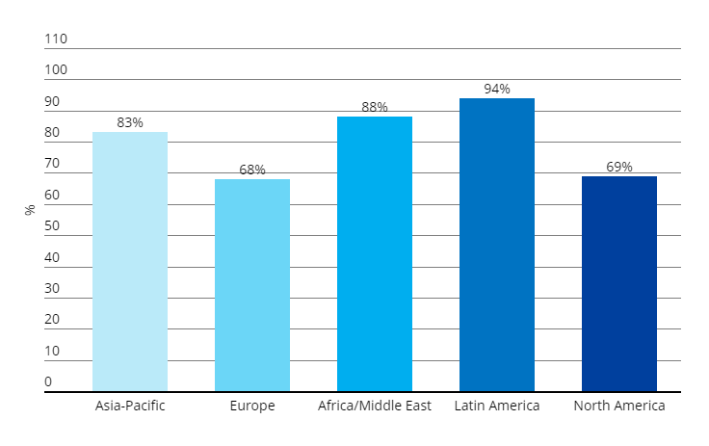
Figure 1. How many people care about how the aviation industry affects the environment. Source: The Conference Board® Global Consumer Confidence Survey, conducted in collaboration with Nielsen Q2 2017.

Ethical and Sustainability Policies and Efforts
The report will now consider the ethical and sustainability policies created by three major airlines, which effect customer relations management.

British Airways
Airline | Features | Ethical & Sustainability Efforts
British Airways | A major international airline. Over 40 million customers and provides services globally to over 70 nations. | January 2020 saw British Airways announce efforts to counterbalance carbon emissions for all domestic flights, by investing in carbon-reduction projects including reforestation and rainforest protection schemes.
 |  | Investments in sustainable fuel projects to aid the entry into a new era of “green” aviation.
 |  | Investment in more fuel-efficient aircraft like the Airbus A350 which is 50% quieter and 25% more fuel efficient.
 |  | Innovative engineering efforts to convert domestic waste into renewable jet fuel.
 |  | Lowering emissions by optimising flight routes.
 |  | Active member of the EUETS from the outset in 2012.
Table 1. British Airways: Ethical and Sustainability Policies and Efforts (BA, 2020a; BA, 2020b; Air France KLM, 2020).

Turkish Airlines
Airline | Features | Ethical & Sustainability Efforts
Turkish Airlines | Operates to over 300 destinations globally including: Africa, Asia, Europe and North America. | Collaborating with IATA Green Team to implement fuel efficiency strategies and decrease carbon emissions.
 |  | Working together with over 70 projects to optimise the way they operate and reduce their carbon footprint.
 |  | Investing in new technologies, which have the least harmful effects on the environment.
 |  | Certified in 2013, by the ISO 14001.
 |  | Integrating their efforts in reducing electricity, natural gas, fuel and the use of paper.
 |  | One of the biggest and most state-of-the-art airlines of the world with over 500 efficient and environmentally friendly aircraft.
Table 2. Turkish Airlines: Ethical and Sustainability Policies and Efforts (Turkish Airlines 2019), (Turkish Airlines, 2020).

Ryanair
Airline | Features | Ethical & Sustainability Efforts
Ryanair | Low-cost airline established in 1984 and headquartered (HQ) in Dublin | Greater emphasis on technology use to minimise fuel use.
 | Ryanair is regarded as the “greenest, cleanest airline” in Europe (Ryanair, 2020). | The airline operates high seat density in aircraft, decreasing fuel burn and emissions per passenger by around 14%.
 |  | Received delivery of new Boeing 737-800NG aircraft which allowed a 2% improvement in fuel consumption.
 |  | The airline operates “paperless cockpits” with pilots using tablets and electronic flight bags.
 |  | A “green HQ” in Dublin promoting paperless business practices, reducing waste and recycling. Firm commitment to become “plastic free” by 2023.
 |  | The use of mainly secondary and regional airports helps to minimise congestion and noise at major cities.
Table 3. Ryanair: Ethical and Sustainability Policies and Efforts (Ryanair 2020a, Ryanair 2020b).

Conclusion
The tables above demonstrate many examples of how British Airways, Turkish Airlines and Ryanair are implementing efforts to fulfil their ethical and sustainability responsibilities.
Studies show us that customers react to how well an industry tackles their ethical and sustainability responsibilities. Customers form perceptions of organisations, pre and post purchase (Inoue, Y, Et al. 2017). Today the aviation industry seeks to develop sustainability by maintaining environmental and social expectations, like using energy saving strategies and eco-friendly fuels. Airlines promote positive customer relations by publicly communicating their strategies to the stakeholders. Many airlines such as Turkish Airlines are collaborating with other organisations like Green Team, to boost their efforts by working with other specialists. As Carroll states “social responsibility becomes reality only when more companies and practitioners become moral and ethical in doing their business” (Carroll, A.B. 1991).

Waste and recycling
A major worldwide environmental concern is the significant use of single-use plastics and their disposal. An example of how airlines are trying to meet the sustainability targets within customer service, is how they are reducing the amount of single use plastics. With British Airways, Turkish Airlines and Ryanair involved in numerous sustainability efforts, from a customer perspective the visual impact will have the most significant effect on building customer relations. Although many customers care about sustainability, a vast majority of customers are not actually researching the sustainability policies of the airlines. In this case the visual impact of bamboo cutlery replacing plastic cutlery, plastic packaging replaced by paper packaging, etc, these efforts incorporated into customer service is more notable.

British Airways
British Airways sustainability policies include the ambitious target of reducing over 700 tonnes of single-use plastic for on board flights during 2020. Some of the changes which can be seen by British Airways customers include;
- Plastic stirrers swapped with bamboo.
- The packaging of their ‘Club World’ amenity kits has been reduced.
- The plastic wrap from the headsets in the ‘World Traveller’ cabins has been removed.
- Now using water bottles manufactured from 50% recycled plastic.
- The plastic wrapping on the bedding and blankets is being replaced with paper (www.britishairways.com, 2020)

Turkish Airlines
Turkish Airlines has also initiated various sustainability efforts, which encompass the visual impact for customers. Including;
- Minimising single-use plastics by conforming to bio-plastic bags to package earphones and blankets offered to the passengers.
- Toys made from FSC forestry certified offered to child passengers, instead of plastic toys.
- The travel sets are being offered unpackaged to eliminate further single-use plastic waste.
(investor.turkishairlines.com, 2020)

Ryanair
For a customer of Ryanair, the initial visual evidence of Ryanair’s sustainability efforts could be found in their marketing campaign, as they now boast the title of ‘Europe’s number 1 airline, for carbon efficiency’. This gives environmentally conscious customers a sense of guilt free travel from the outset.
- Ryanair has a 5-year plan to eliminate any non-recyclable plastics from their operations
- Ryanair has cut out 82% of all consumables onboard made from plastic.
- Ryanair work with manufacturers to create eco-friendly alternatives like bio-degradable cups, wooden cutlery & paper packaging.
(corporate.ryanair.com, 2020)

Unethical and Sustainability Issues within the Airline Industry
With growing awareness of environmental issues, many consumers have an expectation of industries to implement strategies to help the environment.
With the global pandemic Covid-19 effecting businesses around the world, the current stance airlines take, can soon come under a negative spotlight. The airline industry like many others has been forced to re-evaluate the way they operate. Due to travel restrictions around the world and growing fears, the travel industry has been hit hard. It has been projected that 2019 travel level can take upto 2023 to recover. British Airways and Turkish Airlines both have the Airbus A380 in their fleet, which is a much larger aircraft, to cater for their premium services, including comfort, extra luggage allowance, additional services and first-class seats boasting 6.5 feet of legroom. Even though the current demand is too low for such a large aircraft the airlines have not retired them from their fleet yet, to continue providing the premium service for their customers.
Air France have decided to scrap all of their Airbus A380’s from their fleet, which means they may struggle when the demand increases in 2023. However, they would have addressed the sustainability issue of having such a large aircraft in their fleet unlike Turkish Airlines and British Airways (Ash L, 2020).
The former CEO of Unilever Paul Polman and also the founder of ‘Imagine’ an organisation which is tackling climate change, has recently stated that Ryanair is the world’s most polluting and unethical businesses.
Polman stated that Ryanair was one of the first organisation to refuse to adhere to ‘The Paris Agreement’, the agreements main aim is to act against the threats of climate change. More recently Ryanair’s response to the Covid-19 pandemic was to lay off staff as soon as it impacted the aviation industry, this unethical response has had a negative impact on consumer perceptions of Ryanair. Although Ryanair boast that they are ‘Europe’s number 1 airline, for carbon efficiency’, Polman claims that Ryanair is one of the biggest greenhouse gas emitters in Europe (Ash, 2020).

Conclusion
British Airways, Turkish Airlines and budget airline Ryanair have all implemented sustainability strategies. Ryanair are championing their slogan ‘Low Carbon, Low Cost’ (https://corporate.ryanair.com, 2020) combining sustainability with the added appeal of a lower cost. This effectively builds customers satisfaction and loyalty. British Airways and Turkish Airlines are implementing many strategies and focussing on reducing their carbon footprint, as they include services for more comfort and cater for the customers willing to pay more for inclusive additional services. Airlines need to consider the needs of all their customers, as all their customers do have uniform beliefs about sustainability. However, to ethically tackle sustainability issues would require, re-evaluating their fleet and using smaller aircraft during this period when there is a lower demand.
Ethical conduct may lead to a loss in profits for organisations within the airline industry. However, it achieves goals of sustainable marketing and achieving their long-term objectives. Unethical conduct may be more costly than the savings it can lead to. For airlines to preserve good customer relationships it is essential to maintain a good image in the public eye.

Customer Relations Management Models
Customer Relationship Management or CRM is the fundamental strategies used by an organisation to develop a culture which is focussed on managing the relationship of the business with their current and future customers.
It is more cost effective for businesses to retain existing customers, in comparison to gaining new customers. Utilising Customer Relationship Management Models aids businesses to promote and boost customer loyalty by improving the customer experience. Successful implementation also maximises profits and the future success of a business.
According to researchers, Customer Relationship Management or CRM is defined as ‘the implementation of the relationship marketing principles through managing customer data and use of technology’ (Domazet, Zubović, & Jeločnik, 2010; Hoang, 2015).

Lambe’s CRM Model
There are a vast array of CRM models. Researchers have focussed their efforts on specific factors effecting CRM. A CRM business model which is knowledge-based was designed by Patrick Lambe (2001). The model’s focus is on proactive CRM which has two laws, is dependent on two tools, and three activities. As shown below in figure 2.
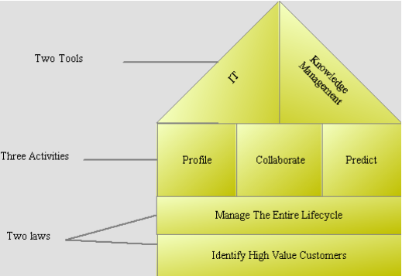
Figure 2. Knowledge-enabled CRM Model. (Source: Lambe, 2001, p.1)
The laws and activities of the CRM model are dependent on technology and knowledge management. Airlines can utilise this model to profile their current high value customers, using information management systems. Knowledge management is essential to process customer information effectively. The model requires customer and business collaboration and depends on an exchange of tacit knowledge between them. Airlines would then be enabled to pre-empt their customers’ needs and deliver a quality service to them timely and effectively, using the strategies which utilise statistics, technology and tacit knowledge exchange, as illustrated in figure 3 (Lambe, 2001, p.2).
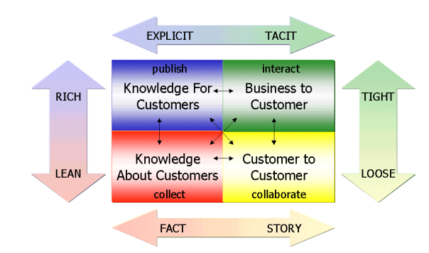
Figure 3. Four Dimensions of Knowledge in CRM (Lambe, 2001).

Payne’s Five Forces model
Payne’s Five Forces CRM model was constructed by Adrian Payne and Pennie Frow. This model puts an emphasis on a cross-functional approach for CRM processes to function effectively (Thakur, S. 2019).
The main components of the model are: cross-functional CRM processes and key elements of CRM implementation.
The five processes of Payne’s model highlight:
- Strategy development
- Value creation
- Multichannel integration
- Information management
- Performance assessment
(DeNisi & Pritchard, 2006).
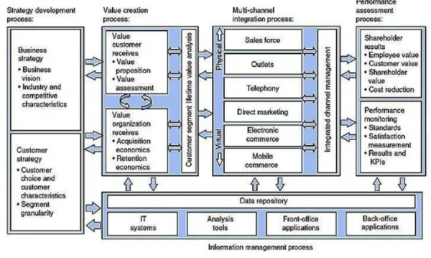
Figure 4 Payne’s Five Forces Process Model (Payne, A., & Frow, P 2006)
The main feature of Payne’s Five Forces Model, is the focus on acquisition and retention of customers. Payne and Frow stress using the model at a strategic level. Airlines can use the model when developing strategies to build and maintain relationships with their customers.
The strategy development process is further divided into two parts; business strategy and customer strategy. For business strategy, a business needs to develop a vision in relation to its offerings. The purpose is to create a goal to establish itself as a key player in the industry (Starkey & Woodcock, 2002). The model states that invariably:
- business strategies pave the way for understanding
- how customer strategy should be shaped
- how strategies should change in conjunction with the changing needs of the customer
Airlines can benefit greatly by focusing on understanding the choice of their customers and then develop strategies to provide effective products and services. According to Payne and Frow, it essential to analyse current and potential customers, as a part of customer strategy. It aids organisations with necessary segmentation of the market and enables organisations to identify future actions to provide for varying customer needs.

The use of technology to build business intelligence and aid in segmentation is a crucial. However, many customers are crossing the segment boundaries. Within the airline industry, a British Airways customer who carries a frequent flyer card, may also carry a frequent flyer card for many other airlines, for which the buying habits maybe completely different. The customer may use British Airways for first class and business flights when they travel for work and use Ryanair for social and family travel. One way to tackle this issue could be to offer frequent flyer travel discounts or ‘price match promise’ to monitor the customers overall buying habits.

IDIC model
Created by the Peppers and Rogers Group, the IDIC model is a comprehensive strategy to implement CRM in varying situations. The acronym IDIC stands for the stages of implementing CRM; Identify, Differentiate, Interact and Customise.

Identify
An organisation would first need to identify their customers. One way of achieving this would be to collect their personal information and purchase history.
The purpose of data collection is to be able to predict the customers buying behaviour and understand their wants and needs better.

Differentiate
All customers do not have the same value to an organisation. For example, a frequent flyer would be of a higher value as a customer, than someone who rarely travels. Differentiation or segmenting customers would allow airlines to prioritise their relationships and efforts with high value customers.

Interact
The interaction stage is where an airline would apply their CRM strategies for interacting with their customers. Once the customers are analysed and categorised, an airline could action customised interaction. For example, higher value customers, could receive loyalty benefits or rewards to encourage customer retention.
This strategy is further boosted when the business learns from each interaction to continue improving their customer relationships.

Customize
With a data base of customer interactions, a business could customise their service to meet the needs and expectations of their customers. A higher quality of service would encourage customer loyalty (Siddiqi, 2002).
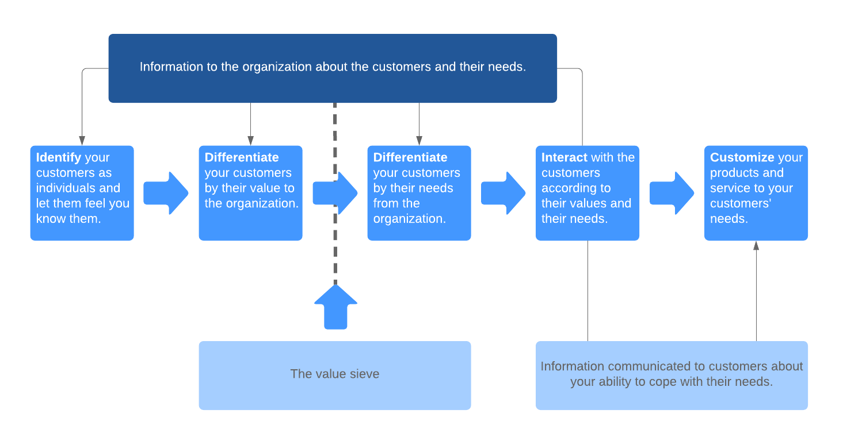
Figure 4. IDIC Model (Lucidchart, 2020)

The Impact of Ethical and Sustainability Policies on the Quality of CRM Systems
Customer relationship management has globally increased in importance for airlines and many other organisations. This report has considered the ethical and sustainability policies of British Airways, Turkish Airlines and Ryanair and the impact on the quality of their CRM systems. From the analysis it is evident that customer retention strategies are essential. Another important tool is change management, due to the rapidly changing current times.
The CRM model an organisation utilises can protect their image, when facing criticism from green and sustainability organisations. CRM models that focus on customer loyalty can help offset the effects of negative publicity. Customer will return to the same service providers, if the service provided is of high quality and caters for all their needs. The information management systems can help airlines customise the service they provide for their customers’ needs.

Recommendations
Investing in the future technological advancements is critical, as natural resources are being used at a rapid rate, the future of aviation is increasingly looking into the use of electric planes. Albeit we are atleast 30 years away from such advancements in larger passenger carriers, investment and interest is essential. Placing a hold on global expansion in aviation and focussing efforts on future advancements would be perceived as a positive worldwide.
To further build positive customer relationships, efforts to curb the effects of carbon emissions and considerably reducing waste can be made, other airline service providers could follow suit and offer basic services at reduced costs and only offer additional services at an extra cost.
Customers that are concerned about sustainability issues may consider alternative travel options and organisations may market their sustainability efforts by only holding virtual meetings and cut out air travel for business purposes. To tackle the issues of potentially losing customers, airlines could increase their efforts that have a visual impact for customers, such as the changes in on-board reduced plastics and invest in sustainability efforts outside of the aviation industry, like reducing noise for local residents, creating work opportunities for local communities and the local environment. Creating more awareness is also important as air travel is not the most environmentally unfriendly mode of transport.
Airlines could increase sustainability efforts by switching to ‘green’ brands and include vegan options in their menus. This will show customers that airlines care and consider sustainability a global effort. These strategies can attract many new customers too, when sustainability conscious customers need to travel they will seek to find the most green service provider.
When implementing a CRM system a core element should be an emphasis on building an excellent corporate reputation and brand which is perceived positively. The CRM system should also have flexibility and a contingency for change in the industry.
Ethical treatment of employees is essential to successfully implement all strategies of a CRM model. Employees should grasp all elements of the CRM strategies and engage with the customers in an innovative sustainability customer central culture.

References
Airfranceklm, 2020. Editorial.https://csrreport2018.airfranceklm.com/en/ Retrieved 13.11.2020, from. [Google Scholar]
Ash, L., 2020. Airlines Struggle To Decide The Fate Of Their Airbus A380 Fleets - Simple Flying. [online] Simple Flying. Available at: <https://simpleflying.com/remaining-a380-fleets-limbo/> [Accessed 24 November 2020].
Ash, L., 2020. Airlines Struggle To Decide The Fate Of Their Airbus A380 Fleets - Simple Flying. [online] Simple Flying. Available at: <https://simpleflying.com/remaining-a380-fleets-limbo/> [Accessed 24 November 2020].
BA, 2020. British Airways Environmental Policy.https://www.britishairways.com/assets/pdfs/information/about-ba/british-airways-environmental-policy.pdf Retrieved 12.11.2020, from. [Google Scholar]
BA, 2020. Corporate Responsibility.https://www.britishairways.com/en-gb/information/about-ba/csr/corporate-responsibility Retrieved 12.11.2020, from. [Google Scholar]
Carroll, A.B. The pyramid of corporate social responsibility: Toward the oral management of organizational stakeholders. Bus. Horiz. 1991, 34, 39–48. [CrossRef]
Corporate.ryanair.com. 2020. Environment | Ryanair's Corporate Website. [online] Available at: <https://corporate.ryanair.com/environment/> [Accessed 25 November 2020].
David Crowther & Guler Aras, 2008 corporate social responsibility, p54
DeNisi, A., & Pritchard, R. (2006). Performance appraisal, performance management and improving individual performance: A motivational framework. Management and Organization Review, 2(2), 253–277.
Domazet, I., Zubović, J., & Jeločnik, M. (2010). Development of Long-term Relationships with Clients in Financial Sector Companies as a Source of Competitive Advantage. Bulletin Universitǎţii Petrol-Gaze din Ploieşti, 62(2), 1-10.
Hoang, D. T. L. (2015). The impact of relationship marketing on customer loyalty in the airline industry: Case study finnair. (Degree Programme in Business Management), Centria University of Applied Sciences, Finland.
https://www.britishairways.com/en-gb/information/about-ba/csr/corporate-responsibility, 2020. [Accessed 24 November 2020].
Inoue, Y.; Funk, D.C.; McDonald, H. Predicting behavioral loyalty through corporate social responsibility: The mediating role of involvement and commitment. J. Bus. Res. 2017, 75, 46–56. [CrossRef]
Lambe, Patrick, (2001), [Online] “Knowledge-Based CRM: A Map”, Available at: http://www.greenchameleon.com/thoughtpieces/kcrm.pdf [Accessed 24 November 2020].
Nettey, I. R. (2007). Airport Management (TECH 35340) class notes, Kent State University, Kent, Ohio
Palihawadana, D.; Oghazi, P.; Liu, Y. Effects of ethical ideologies and perceptions of CSR on consumer behavior. J. Bus. Res. 2016, 69, 4964–4969.
Payne, A., & Frow, P. (2006). Customer Relationship Management: from Strategy to Implementation. Journal of Marketing Management, 22(1–2), 135 168. https://doi.org/10.1362/026725706776022272
Ranchhod A. & Gurau C. Marketing Strategies: A Contemporary Approach, Prentice Hall 2007
Ryanair . 2020. Environmental & Social.https://investor.ryanair.com/esg/#1470928745132-e25f42e1-ded2 Retrieved 13.11.2020, from. [Google Scholar]
Ryanair . 2020. Introducing Our Environmental Policy Europe’s Greenest Airline.https://corporate.ryanair.com/wp-content/uploads/2018/03/Enviromental-Policy-Doc.pdf Retrieved 13.11.2020. [Google Scholar]
Siddiqi. J. Babak. A. Wise. T. 2002. “A framework for implementation of a Customer relationship management strategy in retail sector”.
Starkey, M., & Woodcock, N. (2002). CRM systems: Necessary, but not sufficient. REAP the benefits of customer management. Journal of Database Marketing & Customer Strategy Management, 9(3), 267–275. https://doi.org/10.1057/palgrave.jdm.3240008
Sustainability Reporting Guidelines & Airport Operators Sector Supplement. (2011). Retrieved from https://www.globalreporting.org/resourcelibrary/AOSSComplete.pdf [Accessed 24 November 2020].
Thakur, S. and Chetty, P. (2019). How Payne's Five Process model can help to improve CRM?. [online] Project Guru. Available at: https://www.projectguru.in/paynes-five-process-model-crm-strategy/ [Accessed 22 Nov. 2020].
Turkish Airlines Sustainability Report https://investor.turkishairlines.com/documents/sustainability, 2020. [online] [Accessed 25 November 2020].
Turkish Airlines, 2019. 2018 Sustainability Report.https://investor.turkishairlines.com/documents/surdurulebilirlik/thy-sustainability-report_compressed.pdf Retrieved 13.11.2020, from. [Google Scholar]
Turkish Airlines, 2020. Environmental and Social Responsibility Report. Turkish Airlines Investor Relations. [Google Scholar]
Waitz, I.,Townsend, J., Cutcher-Gershenfeld,J., Greitzer,E., & Kerrebrock,J.(2004) . Aviation and the environment. A National vision statement, framework for goals and recommended actions, Retrieved from http://www.faa.gov/library/reports/media/congrept_aviation_envirn.pdf [Accessed 24 November 2020].
Wang, Yonggui; Po Lo, Hing; Chi, Renyong; Yang, Yongheng (2004) “An integrated framework for customer value and customer-relationship-management performance: a customer-based perspective from China” Managing Service Quality, 14 (2), pp. 169-182.

