
MANAGEMENT ECONOMICS
FERRARI


Contents
INTRODUCTION 2
COMPANY AND ITS PRODUCTS 3
MARKET EQUILIBRIUM 3
DEMAND AND FACTORS AFFECTING DEMAND OF FERRARI SF 90 SPIDER 4
ELASTICITY OF DEMAND 7
INCOME EFFECTS 7
PRICING POLICY FOR FERRARI 11
SUMMARY AND CONCLUSION 12
REFERENCES 13

INTRODUCTION
Luxury cars are one of the most fascinating markets in the world that has a very limited target market. In this report, the information related to the company and the product will be selected to determine the elasticity of demand and the factors that affect its demand. The company will be Ferrari and as a product SF90 spider is taken. This report will help in understanding the degree of elasticity and the factors that will affect the demand for Sf 90 Spider. Also, the income effects of the consumer that is in a position to buy a supercar will be discussed in the report with an analysis of the pricing policy that Ferrari should adopt as per the analysis of factors affecting demand.

COMPANY AND ITS PRODUCTS
Ferrari is a modern and exclusive sports car brand that combines the feel of supreme luxury with the sportiness and boldness of supercar engines. It was founded in 1939 by Enzo Ferrari. The company produced its first Ferrari-badged car in 1947. The history of more than 80 years defines the rich callability of the brand and the success of the company through reinvention, style, luxury and performance. The company has been acquired by Fiat and later restructured as Ferrari NV as the new holding company of the Ferrari group (Hammami, 2020).
The chosen product is Ferrari SF90 spider. the reason this product is chosen is because of its luxury attribute that in combination with performance cars places the SF90 as one of the most demanded cars in the luxury care market. Luxury supercars have a very concentrated user base in which there are very people who can purchase the cars made by Ferrari. This product is chosen because of its position among other luxury car makers and also the success of the brand that has taken Ferrari to the extent of what it is today. Understanding the economics of this product will help in analyzing how the luxury super car market behaves and how the competitors impact the sale of the product in the economy (Hammami, 2020; Ferrari. 2022).

MARKET EQUILIBRIUM
Economics is the study of potentially scarce resources that should be used in business operations so that maximum satisfaction can be provided to the consumers. price in any market from excepting monopoly is set as the result of market forces of demand and supply. Therefore, markets need to be in a state of equilibrium (Nguyen et al., 2018).
Equilibrium in the market is established when the demand and supply of a commodity are equal and the prices are stable as per the market forces of demand and supply. Since there are very less people that have a demand for luxury cars therefore it is relatively easy to establish an equilibrium in the market. With certain factors affecting the demand of the luxury car segment market, companies like Ferrari need to keep track of these factors like changes in the taste and preferences of consumers to set better prices for the market (Nguyen et al., 2018).
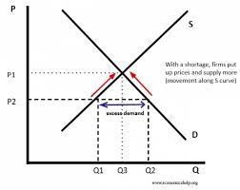
Figure: market equilibrium of luxury goods
Source: Pettinger, 2019

DEMAND AND FACTORS AFFECTING DEMAND OF FERRARI SF 90 SPIDER
As stated by Besanko and Braeutigam (2020) demand can be understood as the quantities of the commodities that a consumer is able and willing to purchase at a certain price level over a period of time. Demand is influenced by price and has an inverse relationship with price sensitivity. This governs the behaviour of the law of demand as it states that an “increase in prices leads to falling in quantity demanded and decrease in prices leads to the rise in quantity demanded of the commodity".
Price of substitutes: a substitute is a product or service that is similar to the product in concern and is either developed by a competitive or the same firm. Simply, substitutes can be used in place of each other. It plays an important role in markets as the consumer sees it as an advantage, but the price changes will impact the demand for good inconsideration. there are very few substitutes for the company including McLaren, Lamborghini, and Bugatti among the major luxury supercar manufacturers in the world. The price of substitute cars such as Ford GT, Porsche Carrera GT, McLaren Elva, and McLaren 720S is continuously increasing because of the changes in tax patterns of supercars. The rise in prices of these substitute cars will impact the demand for the SF90 spider as people will demand this car instead of its competitors (Kreps, 2019).
Price of complement: complements is a good or service that is used with the product in consideration. Or in other words, it adds to the value of the product. The rise in prices of complementary reduces the demand for main goods as more money needed to be spent to accommodate the product or service. The complementary goods of making a Ferrari includes microchips, leather and plastic materials, fuel and others. It has been seen that the prices of Fuel are rising constantly, and along with that there are shortages of micro-chips in the automobile industry. Therefore, this will lead to a rise in the prices of SF 90 spider and this will reduce the demand for the car but up to some extent only (Holmes, 2020).
Consumer income: Ferrari makes supercars that are luxury and very costly. Thus, it is not possible for everyone to acquire a Ferrari. Since being a luxury product, the change in consumer level will not bring any significant change in the demand for Ferrari supercars. The consumer would still be able to purchase SF 90 spider because of having a significant amount of net worth. Thus, a significant target market will always be able to purchase a Ferrari irrespective of changes in the level of income (Browning and Zupan, 2020).
Consumer taste and preference: in the luxury supercar segment, consumer taste and preference are very important to make customers happy and satisfied as there is only a limited number of cars that are made and all these cars are made as per the specifications that a consumer would want in a supercar. Consumers' tastes and preferences are changing as a consumer are looking for more environment-friendly options in a supercar and also how the range per 100 litres can be increased. Along with that, customers are also expecting a shift to electricity-based cars in the price segment of $300,000 to $500,000 and beyond $500,000. All these changes will impact the demand for Ferrari SF 90 as it is a fuel-based supercar. And it will decrease in the future. As these preferences are shaping, implementing them in future development models may help the company in making more sales (Chakraborty et al., 2019; Guan et al., 2022).
Consumer expectation of prices: consumer expectation of prices refers to the expectation of price rise or fall in the future by consumers. If the price increase is expected in the future consumers may purchase the product right now and that will lead to an increase in the demand for the product. If the consumer of Ferrari expects a price rise in the future, they will place more orders at the present state so that the rise in cost can be avoided and significantly the demand for cars will be increased. Along with that, it is to be noted that Ferrari has a very limited targeted customer base that's why the expectant rise or fall will not impact the demand for SF 90 Spider to a very large extent (Browning and Zupan, 2020).
Demographics: the numbers of consumers are gradually increasing in the world with more and more people becoming millionaires and billionaires. This gradual increase in the number of people increases the demand for SF 90 Spider and other supercars made by Ferrari. An increase in demand will lead to lower prices for cars and thus more and more will be able to afford luxury supercars. In the upcoming years, the Luxury segment will see significant growth in the non-traditional sectors like China and South Asia gaining momentum in UHNWI and HNWI (understood as ultra-high net worth individuals and high net worth individuals). This will lead to more demand in the Asian markets along with traditional markets (Guan et al., 2022).
All of the above factors help in understanding the changes that will impact the demand for SF 90 spider and help the organisation in making future strategies to help make better sales in the future (Browning and Zupan, 2020).

ELASTICITY OF DEMAND
The elasticity of luxury goods is more than one as the proportional change in quantity demanded is more than the proportional changes in prices of the luxury goods. Ferrari, a luxury car manufacturing company, measures the elasticity of its goods more than one which means it is likely for the business to record an increase in quantity demanded with a less proportional decrease in the price (EconomicsOnline, 2020).
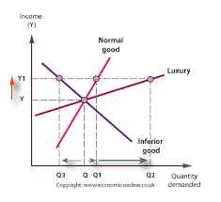
Figure: graph of elasticity of demand for luxury cars
Source: EconomicsOnline, 2020
Therefore, it can be seen that the curve of luxury goods is more tinted that showing its tendency for having more elasticity.

INCOME EFFECTS
The income effect describes the impact of increasing purchasing power over the consumption of a commodity. As per the analysis of the above factors and in a study presented by McKinsey, a gradual rise in the number of UHNWI and HNWI will lead to an increase in the demand for expensive cars. Thus, it can be said that the cars lying in the bracket of %300,000 and above will be more demanded in the future years. the expected compounded annual growth rate for the luxury segment is between 8% to 14% as compared to 1% in the market of cars below $80,000 (Baqaee and Burstein, 2021; Guan et al., 2022).
This indicates that with the rise in income levels of the people the demand for luxury cars like SF90 Spider will also increase leading to more consumption. Since the elasticity of the luxury car segment is more than 1 that means that proportional changes in the demand will be more than that of prices. It is because it represents a larger share of overspending and also a very large part of the income of consumers. this makes the demand for these goods more elastic as a fall in the prices will attract more demand because the consumer will save a lot of money while purchasing a car like SF90 Spider and vice-versa when the price rises in the market (Thinkib, 2022).

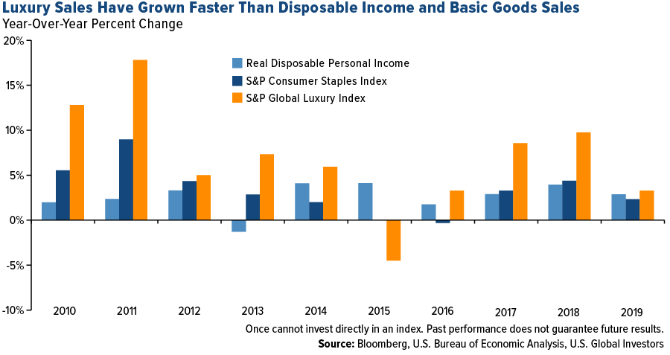
Figure: changes in sales of luxury goods as compared to rise in income levels
Source: Holmes, 2020
From the above graph, it is understood that the changes in the luxury index are more than the increase in the consumer disposable income index. It is because the degree of change or the momentum of change in quantity demanded is more than that of an increase in income level. Or in other words, the more the income of the consumer rises the more households will be willing to splurge on luxury items (Holmes, 2020).
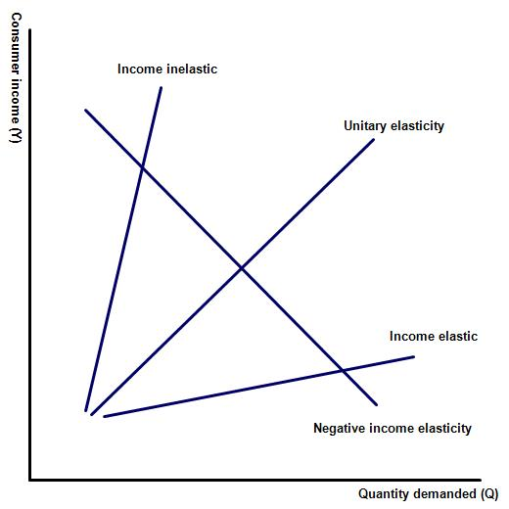
Figure: Income elasticity of demand
Source: Thinkib, 2022
As presented by Holmes (2020) income is rising all over the globe and especially in emerging economies pushing people towards having more disposable income and therefore increasing consumption of luxury items. With almost 40% of the total world’s population climbing towards the upper-middle class (any household that holds daily expenditure per person between $11 and $100) the demand for luxury segment in cars will be expected to grow. overall, it is understood that a rise in income of people will make them more inclined towards purchasing a luxury car and therefore contributes to an increase in the demand for luxury cars in the long run (Kreps, 2019).
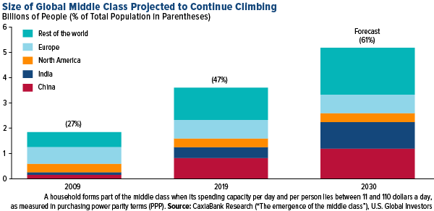
Figure: Global middle-class projection
Source: Holmes, 2020

PRICING POLICY FOR FERRARI
Pricing strategies are the part of a marketing mix that helps in selecting a correct pricing strategy for a company based on the analysis of certain factors that impact the profitability of the company. based on the analysis of the above factors a suggestion related to what pricing strategy a should business employs will be explained below.
Based on the above analysis it is understood that the luxury segment has a more elastic demand and thus the demand will have a greater impact than that of changes in prices. Since being in a luxury car segment Ferrari needs to look for taste and customization in the cars as per the demand of individual customers. If a person purchases Ferrari it will also be eligible for certain other benefits, because it does not only give ownership of the vehicle to its customers but also gives its customers entry into its privileged “Ferrari Owners Club”. These events are attended by some of the richest people on this planet and also give the customer invites to its grand events (Guan et al., 2022). Thus, Ferrari should employ a premium pricing policy in setting the prices of its products so that pricing as per individual customization can be charged to the customers. Premium pricing is important for a luxury car manufacturing company like Ferrari. The pricing policy of Ferrari is driven by the Veblen effect, a 150 years old economic theory that explains an abnormal market behaviour where the rise in prices leads to the rise in quantity demanded (Chakraborty et al., 2019). This is because customers believe that higher prices will improve quality. this enhances the social standard of people and thus makes them demand more when price rises in the market. Due to this Veblen effect, Ferrari can charge higher prices per additional services or customization that it provides to its customers. Because of the premium pricing strategy the gross margin of the company has skyrocketed and increased to 40-50% (Jedidi and Heil, 2019; Morsiani, 2020).

SUMMARY AND CONCLUSION
Through this report, it is concluded that the concept of managerial economics is very important as it helps in framing strategies so that better business decisions can be taken. This report, analysis of factors that affects the demand for Ferrari SF90 Spider. Through the analysis, it is understood that Ferrari being a luxury supercar manufacturing company does not incorporate the law of demand. But with highly elastic demand, the rise in income will also bring the rise in the use of luxury goods at a certain price point in an economy. Thus, with the income effect, it is understood that an increase in UHNWI and HNWI, will increase the demand for luxury cars like the Ferrari SF90 Spider in the long run. This is because more people will be able to afford a Ferrari. Also, the pricing strategy that should be employed in Ferrari has been recommended based on the behaviour of demand of Ferrari as per the Veblen effect.

REFERENCES
- Baqaee, D. and Burstein, A. T. (2021). Welfare and output with income effects and taste shocks. NBER Working Paper, (w28754).
- Besanko, D. and Braeutigam, R. (2020). Microeconomics. John Wiley & Sons.
- Browning, E. K. and Zupan, M. A. (2020). Microeconomics: Theory and applications. John Wiley & Sons.
- Chakraborty, D., Bunch, D. S., Lee, J. H. and Tal, G. (2019). Demand drivers for charging infrastructure-charging behavior of plug-in electric vehicle commuters. Transportation Research Part D: Transport and Environment, 76, 255-272.
- EconomicsOnline. 2020. Demand and Income. Online available at https://www.economicsonline.co.uk/competitive_markets/demand_and_income.html/ [Accessed on 10 July 2022].
- Ferrari. 2022. SF90 Spiider. Online available at https://www.ferrari.com/en-IN/auto/sf90-spider [Accessed on 10 July 2022].
- Guan, M., Köstring, JC., Middleton, S. and Möller, T. 2022. McKinsey. Five trends shaping tomorrow’s luxury-car market. Online available at https://www.mckinsey.com/industries/automotive-and-assembly/our-insights/five-trends-shaping-tomorrows-luxury-car-market [Accessed on 10 July 2022].
- Hammami, S. (2020). Double concept: Mercedes vs Ferrari.
- Holmes, F. 2020. What is luxury goods? Online available at https://www.etftrends.com/retirement-income-channel/what-is-a-luxury-good/ [Accessed on 10 July 2022].
- Jedidi, H. and Heil, O. (2019). PRESTIGE PRICING IN MARKETS FOR LUXURY & PREMIUM PRODUCTS. In 2019 Global Fashion Management Conference at Paris (pp. 636-649).
- Kreps, D. M. (2019). Microeconomics for managers. Princeton University Press.
- Morsiani, S. (2020). Equity valuation: Ferrari NV (Doctoral dissertation).
- Nguyen, D. T., Le, L. B. and Bhargava, V. (2018). Price-based resource allocation for edge computing: A market equilibrium approach. IEEE Transactions on Cloud Computing, 9(1), 302-317.
- Pettinger, T. 2019. Economics Help. Market equilibrium. Online available at https://www.economicshelp.org/microessays/equilibrium/market-equilibrium/ [Accessed on 10 July 2022].
- Thinkib. 2022. Unit 2.5: Income elasticity of demand. Online available at https://www.thinkib.net/economics/page/21259/unit-25-income-elasticity-of-demand-yed [Accessed on 10 July 2022].

