An Analysis of the Impact of Staff Shortage and Lack of Professional Behaviours Impacting Guest Service and Guest Satisfaction: A Case Study on Premier Inn Leeds City Centre Hotel.

Module Name: Hotel Placement Research Project
Module Code: BMIH6006/8

Submitted to: Ernest Wavei
Submitted by: Nurul Amin (2109799)

Executive Summary
The hospitality industry of the UK is flourishing while facing different challenges. One of the biggest challenges faced by the industry is the staff shortage challenge. This placement research report is based on the theme of analysing the impacts of staff shortage and lack of professional behaviour on guest service quality and guest satisfaction. This report aimed to provide an analysis of the impacts of a lack of professional staff behaviour on customer service and experiences based on the case study of Premier Inn City Centre (Leeds Arena) Hotel. Premier Inn operates under the parent company Whitbread where the company has a good brand value and reputation. A literature review on the theme was provided by exploring different relevant journals and articles. The research followed a case study methodology where data were collected through observation techniques. In the case study discussion section, the case of Premier Inn is explored by reviewing the brand background, SWOT analysis, and PESTLE analysis. The theme exploration section explores the theme with the examples of the case study analysis. Finally, conclusions and recommendations are drawn based on the findings.
The hospitality industry of the UK has over 100,000 job positions that need to be filled in the past few years. Brexit, the COVID-19 pandemic, low wages, longer duty time, lack of work-life balance, etc. are major reasons for the staff shortage in the hospitality industry of the UK. The case study research found a correlation between professional staff behaviour and guest satisfaction. Due to staff shortage, workload increases on the existing staff. And the hotel also fails to recruit competent workers. Thus, employees working under pressure with a lack of efficiency fail to express professionalism when serving guests. The unprofessional staff behaviour creates dissatisfaction among guests. A huge number of online reviews about the bad service quality of Premier Inn revealed how the company is suffering because of this staff shortage challenge. Premier Inn has increased salaries and provides bonuses to attract the most talented people. The report suggested ensuring work-life balance to tackle the challenge of staff shortage and lack of professional behaviour.

Contents
Executive Summary 2
Introduction 4
Literature Review 5
Concept of Staff Shortage 5
Employee Shortage in the Hospitality Industry 5
Employee Shortage and Lack of Professional Behaviour 6
Lack of Professional behaviour impacts on Guest Satisfaction 6
Methods 7
Case Study Methodology 7
Benefits 7
Limitations 8
Techniques 8
Reflective Writing 8
Case Study Discussion 9
Brand Overview 9
Location 10
Staffing 11
SWOT Analysis 11
PESTLE Analysis 14
Competitors Analysis 17
Theme Exploration 19
Theme Analysis 19
Theme Exploration in Premier Inn City Centre Hotel 21
Conclusions and Recommendations 25
Conclusions 25
Recommendations 26
Reflective Account 27
References 31

Introduction
Meeting the needs of customers in the hospitality industry is becoming more challenging and companies are coming up with different innovative services to overcome challenges and satisfy customers (Akarsu, Marvi and Foroudi, 2022). Professional behaviour of the hotel staff is necessary for every hotel that can satisfy and delight a customer (Ekinci, Dawes and Massey, 2008). Smart hotels are promoting professional behaviour in hotel staff of hospitality services to delight and enhance customer experiences. Premier Inn Leeds City Centre Hotel also tries to increase professional behaviour in its hotel staff in every service area. Under the supervision of Whitbread, Premier Inn is trying to improve its hotel services by creating a competent workforce by recovering employee shortages. The hospitality industry is a service-based industry where human interaction is important for ensuring service quality. In the COVID-19 pandemic time, the demand for professional services was high (Davahli et al., 2020). The demand for high-quality guest services is rising. Companies are trying to increase employee professional behaviour in hospitality services to outperform their competitors in customer services and experiences.
The research aims to provide an analysis of the impacts of staff shortage and lack of professional staff behaviour on customer services and experiences based on the case study of Premier Inn City Centre Hotel. The report will explain the theme of lack of professional behaviour in hospitality services and its impacts. An evaluation of the relationship between professional staff behaviour and guest satisfaction level will be provided. A literature review on this topic will be provided in this research project with proper referencing and citation. The report will overview the case study methodology with its benefits, limitations and techniques. A detailed review on the case of Premier Inn Leeds City Centre Hotel through PESTLE, SWOT, and competitor analysis will also be provided in this report. Then, the theme of this research report will be explored with proper examples and analysis. This report will provide recommendations for further improvement. Finally, the reflective account will be drawn from personal experiences of doing an internship at the food service department of Premier Inn Leeds City Centre Hotel.

Literature Review
The evolving demand of customers in the hospitality industry requires companies to offer professional services (Brunner-Sperdin, Peters and Strobl, 2012). To sustain and grow fast, meeting the needs of the customers has become the primary concern of the hospitality business. The professional behaviour of the hotel staff enables companies to meet customer preferences (Ktait, 2020). The professional behaviour of the employees and guest satisfaction are interrelated. This literature review explored different studies on employee shortage in the hospitality industry, lack of professional behaviour, and its impacts on guest service and satisfaction.

Concept of Staff Shortage
Inadequate skilled workers to meet the demands of the hospitality industry can be referred to as staff shortages in the hospitality industry. The deficit of skilled workers in the industry creates operational difficulties and ultimately affects hotel guest satisfaction (Ng and Feldman, 2012). The term staff shortage may appear to lack of enough staff, but it also relates to the quality of the hotel staff (restaurantonline.co.uk, 2024). When an industry does not get the skilled workers that can meet the industry demand, it can be called an employee or staff shortage. Some changes like the use of robotics, AI, self-check-in, and the use of other advanced technologies may create challenges for the workers and some workers may fail to adapt to the situation (Li, Bonn and Ye, 2019). The introduction of robots may influence the employee turnover rate of a hotel brand.

Employee Shortage in the Hospitality Industry
A skilled workforce can drive the hotel resources to meet the needs and expectations with excellence (Wilson, 2017). Competent employee shortage prevails in the hospitality industry across the world. The service-based industry needs professional competent hotel staff to serve the guest by understanding their needs and expectations. The hospitality industry is facing employee shortages mainly from the time of the Covid-19 pandemic (Zhang et al., 2020). To avoid Covid-19 infection, many hotel brands had to postpone their operation by following government restrictions. Again, to survive and meet the guest demand during the COVID-19 time, many hotels introduced contactless hospitality services and cut their jobs. The greater demand for contactless services was created because of the need for impersonal contact to avoid the infection of the coronavirus among hotel guests (Hao and Chon, 2021). Contactless hospitality services do not need any person to provide hotel services (Michalis, 2023). The Covid-19 pandemic created an unstable job environment in the hospitality industry and it lost attraction to competent employees. After the pandemic time, the hospitality industry is also facing a skilled employee shortage. The hospitality industry is recovering from the situation. Gaining employee trust for job security is also needed to increase the professional behaviour of the hotel staff. Hotels focusing on ensuring the job security of the hotel staff and offering convenient salaries have more chance of having a more competent workforce (Boadi et al., 2022). The hospitality industry faced a lot during the Covid-19 pandemic time (Baum and Hai, 2020). The challenge of having a skilled workforce is rising day by day. There are many reasons why the hospitality industry is facing a skilled employee shortage. Poor working conditions, lower wages, lack of work recognition, and lack of job security are some reasons which might create an employee shortage in the hospitality industry (Innerhofer, Nasta and Zehrer, 2022). The high turnover rate also affects the ability of a company to build a competent workforce. Brexit, Covid-19 pandemic impacts, Visa challenges, changes in work preferences, etc. are some other reasons for employee shortage in the hospitality industry (Roelen-Blasberg, 2023). After Brexit, UK companies are facing more employee shortages. Employee shortage reduces employee commitment (Krajcsák and Kozák, 2018).

Employee Shortage and Lack of Professional Behaviour
Employee shortage in the hospitality industry is a hinder for offering professional hotel services. Employees with a lack of talent in serving customers may not offer professional behaviour (Hendy, Can and Black, 2018). When a hotel brand is lacking in building an excellent workforce with competent workers, it can fail to provide guests’ expected services (Ashton, 2018). Retaining hotel staff is important for a hotel to offer good guest service. The number of competent employees, employee professional behaviour, and guest service and satisfaction are interrelated. A professional hotel staff can maintain eye while serving guests which may not be possible in an employee shortage situation. A company facing an employee shortage may not ensure the required hotel staff to serve a vast number of guests. An incompetent employee may be less attentive to a guest's problem which may raise dissatisfaction with the guest (Eade, 2023). Due to employee shortages in the hospitality industry, companies operating in the industry may not find their expected people. This may create a challenge for the companies to ensure professional service for the guests and ultimately to ensure guest satisfaction.

Lack of Professional behaviour impacts on Guest Satisfaction
The need for professional behaviour by the hotel staff did not end during and after the pandemic time. The increase in the customers’ feeling of fascination can happen by taking Professional hospitality services. As part of premium hotel services, hotel brands need to ensure professionalism. To make hotel services more convenient, ensuring professional behaviour from hotel staff is mandatory (Karatepe and Olugbade, 2009). Hotel companies need to develop a competent workforce by overcoming the challenge of employee shortage in the hospitality industry. Professional employees may play a key role in solving any guest problem. For example, professional employees can reduce the waiting time of the guests for their good understanding of guest needs and work excellence and thus enhance the guest experience. A company which has more information about the customers has a better chance to improve its services by analyzing the data (Zhang, 2018). A hotel needs competent workers who can leverage data and offer hospitality services innovatively while maintaining professional behaviour. The face-to-face interaction helps hotel staff to convince guests and build bonds with them. Customers’ needs and preferences have changed in taking hospitality services after the COVID-19 pandemic time (Nayak, Bhinder and Kaur, 2021). Guests are now expecting more human touch to get their expected services. Employees’ attitudes and behaviour matter to guests.

Methods

Case Study Methodology
The case study methodology refers to a qualitative design in which a researcher delves into a certain event, program, process or activity (Held, 2009). There is a time bound for a case study where a researcher collects data by using different data collection processes (Mackrill, 2011). This research strategy allows a researcher to get in-depth information about a specific phenomenon (Priya, 2020). In this placement research report, the case study of Premier Inn Leeds City Centre Hotel is selected. The subject area is the impacts of staff shortage and lack of professional behaviour in hospitality services on customer service and experiences.

Benefits
The case study research strategy offers several benefits to a researcher. To get insights into a complex case, the research methodology can be applied (Ji-Hae Kang, 2013). By using the methodology, this research can get a thorough evaluation of the theme of the research topic (Cherry, 2022). In the case of Premier Inn Leeds City Centre Hotel, this strategy allows to analyse the impacts of staff shortage and lack of professional behaviour in hospitality services on customer experiences. An advantage of this case study is that it offers the opportunity for the researcher to get comprehensive knowledge of the research topic. The comprehensive knowledge about the staff shortage and lack of professional behaviour in hospitality services at this time on customer experience would be found.

Limitations
Case studies carry some limitations. The findings of a case study may not be applicable to broader areas (Shankar, 2009). The case study of Premier Inn Leeds City Centre Hotel may not reflect the whole industry scenario. In this research strategy, there are chances of biases of the researchers. With the aim of showing the impacts of the staff shortage and lack of professional behaviour in hospitality services on the customer experience, the case study explored. The impacts which are observed in Premier Inn Leeds City Centre Hotel may not reflect the whole industry rather they can reflect a certain category of the hotel industry.

Techniques
Several techniques can be followed when using the case study methodology for data collection. Based on the purpose of the case study research, the techniques for data collection should be selected (Bass, 2019). Several techniques for data collection are questionnaires, surveys, observations, direct interviews, etc. (Held, 2009b). To get a complete understanding of the research topic, there needs an in-depth investigation. Reliable websites and journals are the secondary source of data.
For gathering data, the observation technique was mainly used. By observing the hotel operation of Premier Inn Leeds City Centre Hotel, the data is collected. Reliable internet sources are also utilized for this case study research. Journals and articles related to the research topic is also used as the source of secondary data for the research.

Reflective Writing
For critical analysis of an experience gathered through an event, or certain circumstance, reflective writing is effective. Reflective writing can portray a researcher’s journey in conducting a study (Otienoh, 2020). Reflective writing helps a researcher to review the journey where limitations can be identified (Kaufka, 2020). It helps to evaluate the researcher’s own beliefs and assumptions. The researcher can see the reflection of the personal experience while conducting the study. Reflective writing refers to an analytical practice of the situation or event which an individual has gone through. The reflective writing of this placement research report will portray the journey of feelings, achievements, lack, etc. of the researcher in carrying out the research and preparing the report.

Case Study Discussion
In this section of the case study discussion, the full details of Premier Inn Leeds City Centre Hotel is provided. A comprehensive discussion of Premier Inn Leeds City Centre Hotel is provided. This overview of the background, service offerings, location, employment, etc. of the hotel brand. This also provides SWOT, PESTLE, and competitor analysis of the hotel company. The information is provided in the descriptive format and the quantitative data is provided where necessary.

Brand Overview
Premier Inn Leeds City Centre Hotel is a renowned hotel in the United Kingdom. The parent company of the hotel brand is Whitbread PLC. Whitbread PLC is a multinational hotel company. It operates hotels across the UK, Ireland, and other nations of the world. In the UK, Premier Inn is recognized as the largest hotel group in the UK. The hotel company was founded in 1987 and has become a dominant hotel company in the UK (Premier Inn, 2024). The company claimed that the reasons for its success of the company are its employees, passion for sustainability and innovation, fostering a culture of fairness and integrity, etc. Brand recognition is important for attracting new customers and creating a positive influence among the people (Gerber, Terblanche-Smit and Crommelin, 2014). Premier Inn operates by following the policies and regulations of the parent company. The hotel brand aims to delight the guests with its modern hotel services were ensuring professional service by hotel staff. The company’s mission is to help guests to get out of their most of the day.
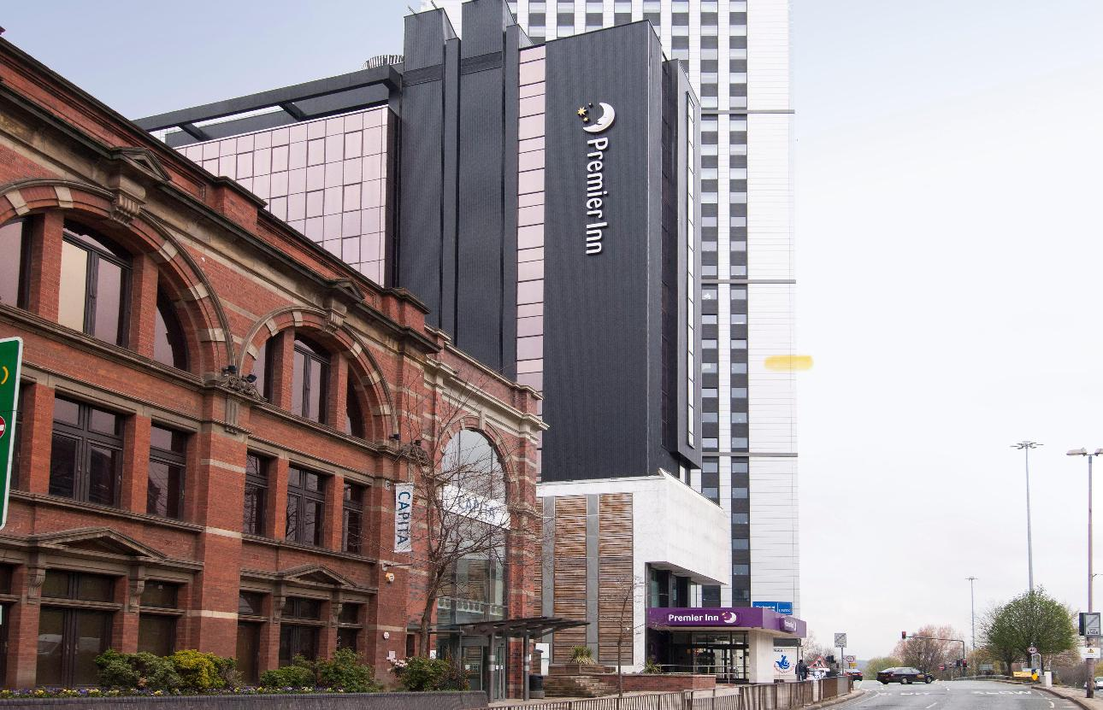
Figure 1: Premier Inn. Source: (Premier Inn, 2024).

The hotel provides a warm welcome to every traveler. It offers rooms for various categories of guests such as couples, families, business trips, solo adventures, etc. It wants to ensure that guests may get reminded of the hotel brand name for their rest and relaxation. The brand recognition helps the hotel to attract more customers. Improving the hotel services along with the implementation of contactless hospitality services, the hotel brand may further progress with good customer satisfaction.

Location
Premier Inn of Whitbread Plc is situated in 800 key areas across the UK. Hotel location is a critical factor in the customer’s choice of hotel service. Hotel location can offer a competitive advantage to a hotel brand (Johnson and Vanetti, 2005). A hotel located in an area with convenient transportation can help guests to take their service easily (Yang and Mao, 2020). Premier Inn Leeds City Centre Hotel is situated in Hepworth Point, Clay Pit Ln, Leeds LS2 8BQ, UK.
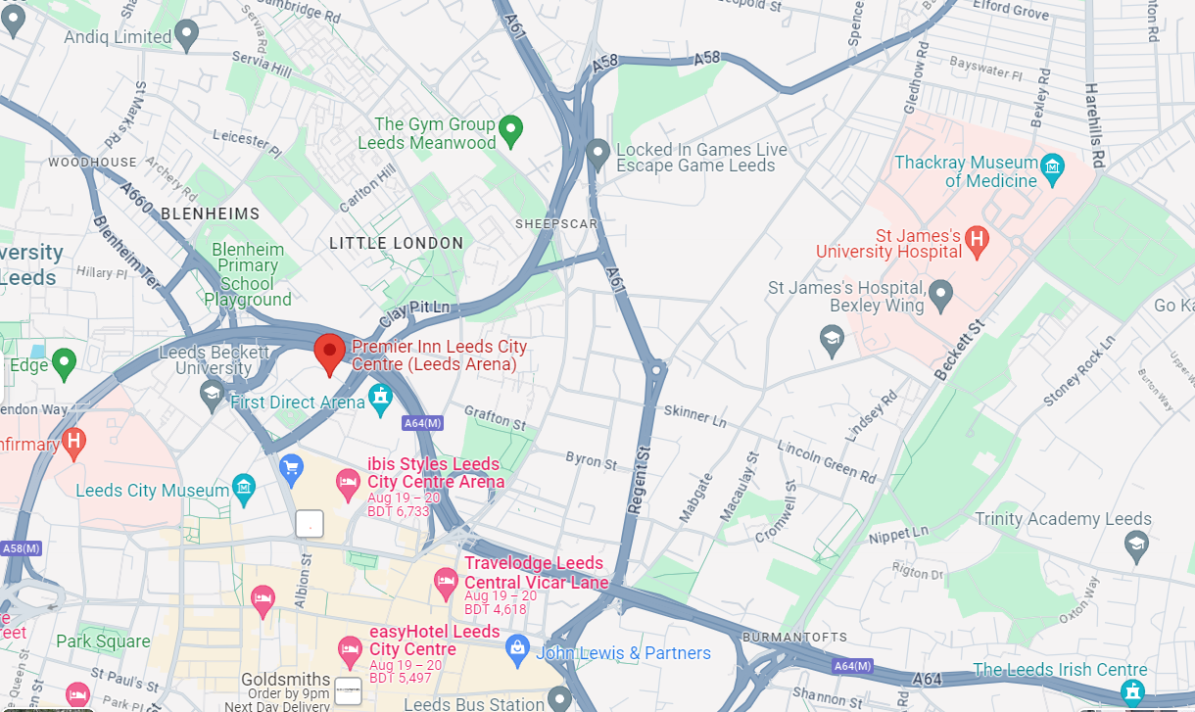
Figure 2: Premier Inn Leeds City Centre (Leeds Arena) Hotel. Source:(Premier Inn, 2024).
The hotel brand enjoys location benefits over its competitors. This gives convenient transportation opportunities while taking the hotel service.

Staffing
Premier Inn Leeds City Centre Hotel takes employees as part of its success in serving guests. For being a global brand, the hotel can attract competent people. Building a competitive workforce has now become a prerequisite for starting and succeeding in the hotel industry (Li, Bonn and Ye, 2019). Li, Bonn and Ye, (2019) further stated that the use of AI and robotics affects the employee turnover rate. Premier Inn Leeds City Centre Hotel uses modern technologies for room and lift services. This helps the company to reduce duty hours of the operation team and it also accelerates revenue through increasing room service orders (Wadcock, 2023). The employees now can focus more on their other duties. To experience the new service, the hotel is also having new customers. Due to the pandemic, the hotel faced challenges in employee retention. The company recovered from the situation by integrating advanced technologies into its operation.

SWOT Analysis
A framework designed to analyze an organization’s strengths. weaknesses, opportunities, and threats is called SWOT analysis. This framework is widely used in business corporations and other corporations. By using the framework, an organisation can know its strengths and weaknesses and then take action accordingly (Vanek, 2022). It can enhance the strategic planning and decision-making of an organization. The SWOT analysis of Premier Inn Leeds City Centre (Leeds Arena) Hotel will help us to know the key strengths and competitive advantage of the company. The SWOT analysis of Premier Inn Leeds City Centre Hotel is given below.

Figure 3: SWOT Analysis of Premier Inn Leeds City Centre Hotel.
From this SWOT analysis, a clear view of the strengths of Premier Inn Leeds City Centre Hotel will be known.
Strengths
- Strong Brand Recognition: Premier Inn Leeds City Centre Hotel brand is a widely known hotel brand and has a very good influence on the UK hospitality industry. The parent company Whitbread Plc has a strong brand recognition. For this brand recognition and reputation, the hotel brand can easily attract new customers (Giglio et al., 2019). The brand has already gained customer trust which leads the brand to have more customers and ultimately revenue.
- Location Advantage: Being situated at the center of Arena and being near of many important places, the hotel enjoys the advantage of location over the competitors. 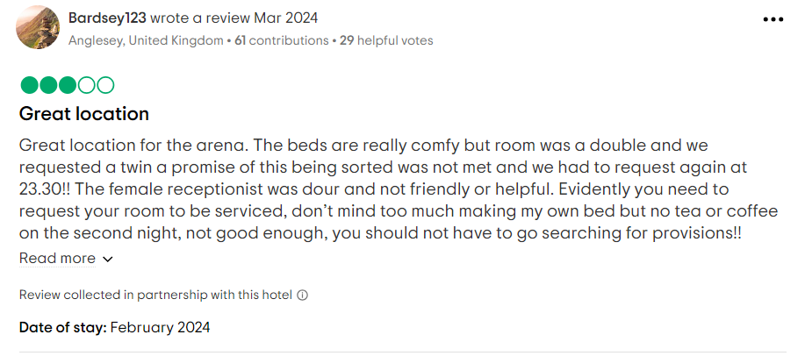
Figure 4: Reviews on Location. Source: TripAdvisor.
- Tech-based Innovative Services: Premier Inn Leeds City Centre Hotel executed app-based hospitality services. This facilitates customer experience in taking the hotel service.
Weaknesses
- Budget Limitation: For recovering from the staff shortage challenge, the hotel needs a big budget. Although the parent company allocated some budget for recovering staff shortage challenge, still, the company is facing a budget shortage.
- Bad Reviews: The company has many bad reviews in the online medium. This can negatively affect the customer's choice of taking their hotel service.
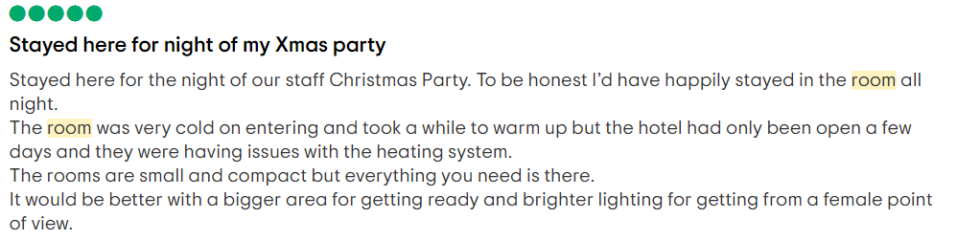
Figure 5: Review of Premier Inn. Source: TripAdvisor, 2023.
Opportunities
- Increasing Investment in Sustainable Operations: The demand for sustainable operations is increasing. Companies behaving sustainably without hampering nature have more credibility among the customers (Chen et al., 2018). Premier Inn Leeds City Centre Hotel can invest in sustainable operation and increase its brand reputation.
- Increasing Social Media Presence: The heavy use of social media is affecting customer choice (Kim and Ko, 2019). Brands can connect with people through social media. Premier Inn Leeds City Centre Hotel can engage with customers through effective social media management for the brand.
Threats
- Intense Competition: Intense competition among the competitors means small margins for the brand (Parker, 2019).
- Economic Uncertainty: World economic uncertainty due to war, and natural calamities, can affect the profitability of the hospitality industry. The occurrence of COVID-19 affected the world’s economy which affected business operations. An economic downturn reduces people’s purchasing power and ultimately reduces the demand for products or services (Kumar, 2020).

PESTLE Analysis
To understand the external environment of a business organisation, the PESTLE analysis is the most popular and effective medium (Gheibi, 2020). Premier Inn Leeds City Centre Hotel is a renowned hotel in the UK. The external environment analysis for the brand is presented below.

Figure 6: PESTLE Analysis of Premier Inn Leeds City Centre Hotel.
Political Factors
Political factors include political status, relationship with the government, government trade policies, fiscal policies, etc. One of the crucial factors that a business must consider when starting a business and continuing the business is the political environment (O’Reilly, 2017). Any decision of the government related to business can affect the operation of Premier Inn Leeds City Centre Hotel.
- Operating in the UK market, Premier Inn Leeds City Centre Hotel has to follow all political regulations. The political status of the UK heavily affects the operation of Premier Inn Leeds City Center Hotel in the UK. UK’s political stability provides a good business environment.
- Political stability in the UK encourages businesses to operate independently. Premier Inn Leeds City Centre Hotel does not face any political turmoil. The UK government provided incentives during the Covid-19 to protect businesses and recover their losses (Hickman, Morris and McDonald, 2021). Premier Inn enjoyed the incentive at that time.
Economic Factors
The economic growth of a country is an important factor in the profitability of a business. The economic environment of Premier Inn Leeds City Centre Hotel is given below.
- The UK economy is enjoying growth (McGarvey, 2024). The country observed economic growth of 0.66% in the first quarter of 2024 (McGarvey, 2024). This economic growth indicates that a good economic environment is prevailing across the UK. Premier Inn Leeds City Centre Hotel has planned to grow in the market by considering the market potential.
- The purchasing power of people of the UK is also a crucial factor for service offerings by Premier Inn Leeds City Centre Hotel (Canarella, Miller and Pollard, 2013). There are millennium customers to pay a premium for premium services. Considering the customers’ purchase power and needs, Premier Inn Leeds City Centre Hotel is invested in tech-based services.
Social Factors
- Demand for convenience tech-based services is increasing as people are becoming smarter (Lee, Lee and Kim, 2021). Knowing the customer’s needs, the hotel needs to design its services.
- Staff shortage is a problem in the hospitality industry. People do not prefer to work in hotels due to low wages, longer duty time, etc. Premier Inn Leeds City Centre Hotel is also facing many operational challenges like a lack of professional staff behaviour due to this staff shortage problem.
- The increased use of social media helps hotels to be closer to their customers (Gupta, 2019). By creating emotional content, a hotel can create a bond with the customers. Premier Inn Leeds City Centre Hotel maintains a good presence on all social media to maintain the connection with the customers.
Technological Factors
- The hotel executed the what3words location technology designed to help guests to find out the correct entrance (Rahman, 2022).
- Again, the hotel is moving forward to manage hotel operations through advanced hotel management apps. The hotel staff are monitored and valued through devices rather than manual observation.
Legal Factors
- Following existing laws is that are relevant to the company operation will help the company to avoid any legal hassle. Premier Inn Leeds City Centre Hotel follows the laws and regulations to avoid any legal problems.
- Protecting the data privacy of the hotel guests is a compulsory option for the hotel. If the company breaches any privacy laws of the customers, it may face legal issues and lose its credential.
- Premier Inn Leeds City Centre Hotel follows the General Data Protection Regulation (GDPR) to ensure the data privacy of the customers.
Environmental Factors
- The environment is an important aspect that needs to be considered in every business operation.
- Premier Inn understands the responsibility of taking action to save the earth. The hotel is committed to achieving net zero emissions of carbon by 2050.
- It also targets to reduce the water use of guests by 20 per cent by 2030. It also planned to cut 50% of food waste by 2030 (Premier Inn, 2022).

Competitors Analysis
Competitor analysis is extremely helpful for knowing the competitors’ position in terms of branding, value proposition, product or service offerings, key strengths, weaknesses, marketing strategies, etc. (Souza, Borgert and Gasparetto, 2016). Investigating and comparing the firms operating in the same industry can be referred to as competitor analysis. To understand the market and to take the right strategy, knowing the competitors is important.
There are many hotels ranging from 3-star to 5-star in the UK. Leeds is a renowned city in West Yorkshire in the UK. The city is famous for its industrial heritage and popular nightlife and other beautiful places for tourists. For these beautiful places, the city attracts many guests from the country and outside the country. Thus, there remains high competition among the hotel brands to grab this customer base. The most renowned hotel brands such as Hilton, The Country Hotel, Hilton, Marriot International, Copthorne Hotel, Crowne Plaza, Jesmond Dene House, Holiday Inn, etc. compete (Rhodes, 2022). In terms of pricing, Crowne Plaza charges higher than any other competitors. It is the most luxurious hotel brand in the UK.
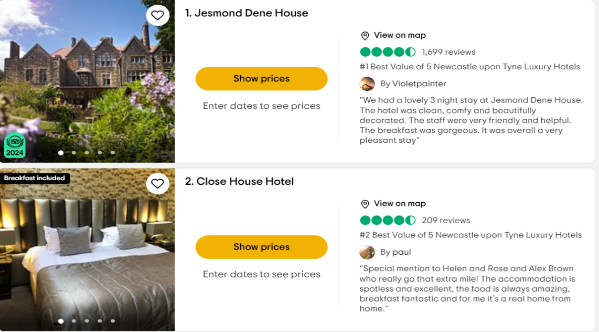
Figure 7: Source: Tripadvisor.
Jesmond Dene House and Close House Hotel have very good reviews on Tripadvisor. The good reviews on Tripadvisor give advantage to the companies over their competitors. Premier Inn should try to get good reviews on TripAdvisor. Premier Inn in its competition in terms of price and quality is doing excellent. The hotel has already gained trust among its customers. By introducing contactless hospitality services, the hotel is giving more convenience and luxury feelings to its customers over its competitors.

Theme Exploration
The theme exploration section provides a complete overview of the theme: analyzing the impacts of staff shortage and lack of professional behaviour on guest service and satisfaction. By analyzing the case of Premier Inn Leeds City Centre Hotel, a detailed complete overview of the theme is developed. Later, this section provides examples and references of Premier Inn Leeds City Centre Hotel.

Theme Analysis
Staff Shortage Statistics in the UK
One of the prominent challenges in which the hospitality industry is going through is staff shortage. The hospitality industry has over 100,000 job positions to be filled in the past few years (Carruthers, 2024).
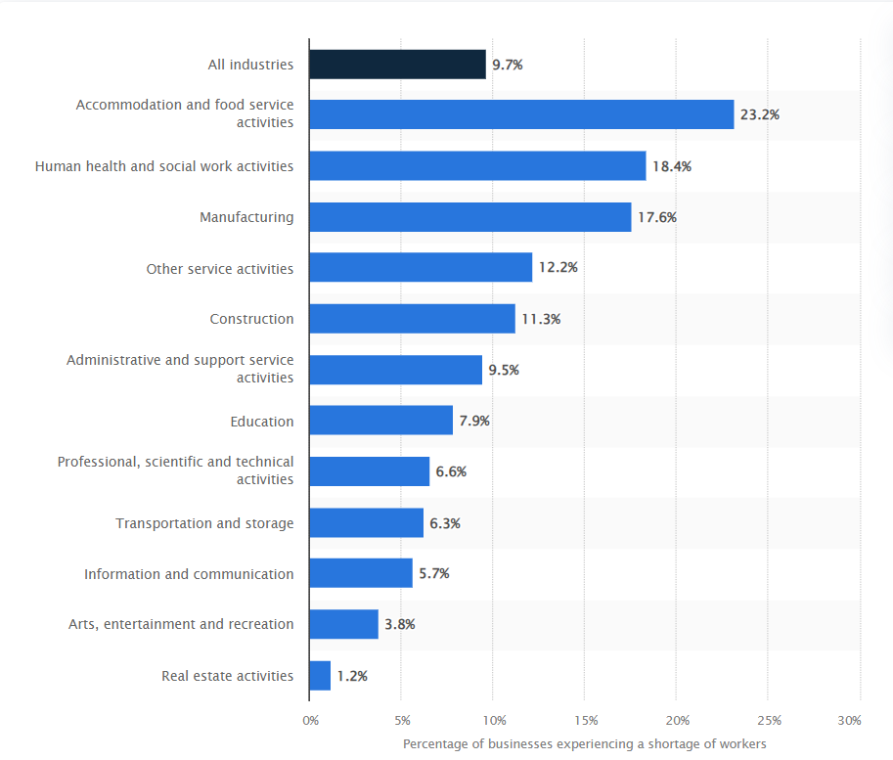
Figure 8: Staff Shortage in the UK. Source: (Clark, 2023)
The above figure shows staff shortage in the UK by businesses. These statistics of October 2023 showed that about 9.7 per cent of UK’s businesses are experiencing the issue of staff shortage in their business operation. The accommodation and food service sector has 23.2 percent and the other service sector has a 12.2 percent staff shortage. From this analysis, it is clear that the hospitality industry of the UK is going through a staff shortage challenge.
A study by UK Hospitality found that 80 percent of the hospitality business firms are finding it hard to recruit in their front-of-house roles (Grenside, 2023). And 85 per cent had challenge of filling chef positions. The estimated active vacancy in the hospitality industry is 9 per cent and missing approximately 188000 employees according to the study (UK Hospitality, 2023). Thus, workforce challenges in the hospitality industry are in peak levels in the UK.
Causes of Staff Shortage in the Hospitality Industry of the UK
This staff shortage creates many challenges for the hospitality industry. Staff shortage is a phenomenon where a particular sector or industry does not get the required employees to fulfil its objectives (Liu-Lastres, Wen and Huang, 2022). Staff shortage not only involves quantity but also it is related to the quality of staff. Staff shortage affects operation efficiency and ultimately the guest experience. In theme analysis, it can be drawn that several reasons work behind staff shortage in the hospitality industry.
Brexit: Brexit has a profound impact on the employee shortage in the UK and it is reported that Brexit led to the shortage of 330000 employees across the UK (O’Carroll, 2023). The Center for European Reform reported that due to Brexit, immigration increases from non-EU countries but there was no compensation plan for losses of employees from the neighboring countries.
Instability Due to the COVID-19 Pandemic: The restrictions of the COVID-19 pandemic have created unstable work conditions in the hospitality industry (Popa et al., 2023). Many skilled workers left the hospitality industry during the COVID-19 pandemic due to the lack of job security (Khawaja et al., 2021). This also led to staff shortages in the hospitality industry.
Economic Factors: Economic factors are another reason that is also leading staff shortage in the hospitality industry. Workers claimed that hospitality industry pays lower compared to other industries (Jeetesh K, 2015). Despite companies like Premier Inn trying to increase wages, employees found themselves to afford the livelihood and thus leaving the industry.
Changes in Workforce Choices: Employees’ attitudes toward the workplace has been going through different changes. Employees are now expecting more flexible work schedules and work-life balance. Many restaurants and hotels are not able to provide flexible work schedules. Thus the industry is facing a high turnover rate and employee shortage.
Challenges Faced by the Hospitality Industry for Staff Shortage
Staff shortage in the hospitality industry brings many challenges for the industry. The hospitality firms may face staffing issues with guest satisfaction including operational challenges due to the staff shortage in the industry.
Challenges in Staffing: Due to staff shortages, different staffing issues such as workplace conflict, high turnover rate, unskilled workforce, etc. rise. Now, it is a big challenge for a hotel company to maintain a competent and stable workforce because of this staff shortage.
Challenges in Hotel Operations: Hotel faces different issues in their hotel operation in low staffing levels. The lower staffing level leads to a high work burden, and poor work-life balance, and reduces work productivity and quality (Kele, Mohsin and Lengler, 2017). The employee shortages may require a hotel brand to reduce their service areas or operating hours.
Challenges in Achieving Guest Satisfaction: A lower staffing level means compromising hotel service quality which leads to a reduction in guest satisfaction. The impact of employee shortage is very detrimental to a hotel business because it can be the root cause of guest satisfaction in taking a hotel service. Due to hotel staff shortages, guests’ waiting times may increase and reduced service quality can frustrate guests and make them dissatisfied (Tung, Chen and Schuckert, 2017). Dissatisfied hotel guests are likely to share online reviews. Through word-of-mouth, guests can release bad reviews. These bad reviews can further hamper the hotel's reputation, which can affect guest loyalty.

Theme Exploration in Premier Inn City Centre Hotel
Premier Inn Leeds City Centre Hotel is continuously trying to improve its employee job efficiency with the aim of greater guest satisfaction and greater reputation. Despite of the UK’s largest hotel brand, Premier Inn is also facing the impact of staff shortage.
Staff Shortage Challenge in Premier Inn
The whole hospitality industry of the UK is facing staff shortages. Premier Inn Leeds City Centre (Leeds Arena) Hotel is also facing issues in building a talented workforce for the company from the Covid-19 pandemic (M and Peters, 2021). For early recovery from the impacts of the Covid-19, Premier Inn needed to build a strong workforce. Being a reputed hotel brand, maintaining hotel service quality reputation is very important for Premier Inn. To ensure high quality of hotel service, Premier Inn Leeds City Centre (Leeds Arena) Hotel needs the best talent workforce. The competition for growth in the hospitality industry is high in the UK. To make travelers’ hotel experience seamless, Premier Inn must need to meet the guest needs and demands. Welcoming a guest with a smile and showing sincerity in solving guest service is an example of the professional behaviour of a hotel staff (Robinson et al., 2016). The Premier Inn Leeds City Centre Hotel gives much importance to ensuring professional behaviour. The importance of Professional behaviour is rising day by day. Due to employee shortage, the workload is rising on the employees of Premier Inn. Again, to ensure the quality of work and get back its customers, Premier Inn needs to tackle the staff shortage challenges as early as possible.
Staff Shortage Impacts on Guest Service Quality in Premier Inn
Staff shortage leads to a lack of professional behaviour among the employees. Staff shortage in the hospitality industry creates barriers to building a competent workforce. Because of the staff shortage, companies fail to get skilled employees for quality hotel services. Employees’ communication skills, attitudes, gestures, etc. are important for serving guests effectively. Busy employees mean less attention to guest problems. Due to workload and lack of time on hand, employees may not have enough time to attentively listen guests’ problem. This may raise dissatisfaction among the guests.
Impacts of Lack of Professional Behaviour on Guest Satisfaction in Premier Inn
Developing hotel staff and guest relationships in the Premier Inn Leeds City Centre Hotel can lead the hotel to get more customer satisfaction. Premier Inn is having issues in finding the talented workers fail to deliver guests’ expected services. Employees in a chaotic situation may not express professionalism. Employees’ behaviour whether it is positive or negative, it is highly correlated with guest satisfaction in a hotel (Kattara, Weheba and El-Said, 2008). Employees’ professional behaviour is important for the successful delivery of a hotel service. Intelligent workers can understand the guest expectations from hotel staff and deliver such type of behaviour. Premier Inn can know the guest's reaction to employee behaviour from the guests' online reviews or collect information through queries. The following online review about Premier Inn tells how the lack of professional staff behaviour is affecting guest satisfaction.
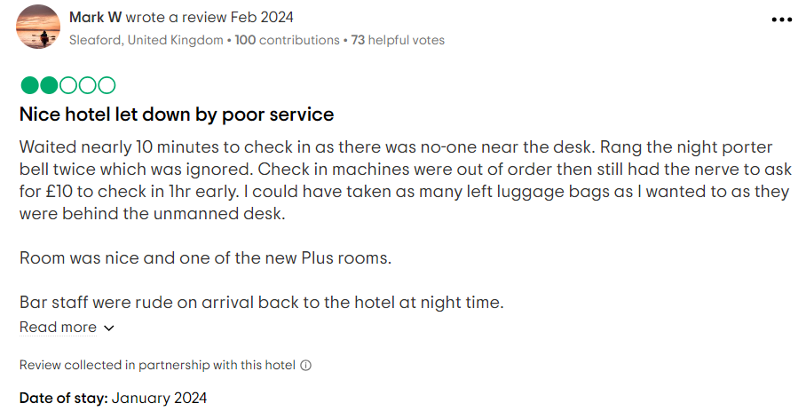
Figure 9: Online Reviews of Premier Inn. Source: (TripAdvisor, 2024).
Premier Inn has faced many bad reviews. In this review, a guest of Premier Inn Leeds City Centre Hotel stated that there was no one at the front desk. The guest waited for 10 minutes to check in. Again, after pressing the night porter bell twice, no one responded to the guest. This made the guest dissatisfied. This is the staff shortage scenario of Premier Inn. The staff shortage has made the operating environment of Premier Inn more challenging. The unprofessional behaviour of the hotel staff made them dissatisfied, and the brand's reputation was damaged. This is a big loss for the Premier Inn Leeds City Centre Hotel. Check another review of the hotel below.
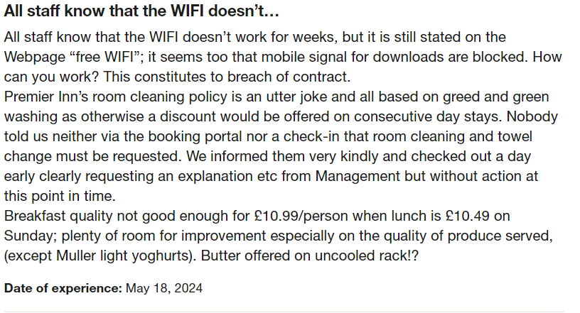
Figure 10: Online Review of Premier Inn. Source: (Trustpilot, 2024).
Premier Inn is getting many bad reviews for unprofessional behaviour in its service area. The above figure shows an online review stating that employees knew that the WIFI was not working, still, the employees stated on their webpage “free WIFI”. This created frustration among the guests. The employees of Premier Inn should have been more responsive. They should announce the problem in their free WIFI delivery. Again, in-room cleaning management is not very sincere. There needs to be a request for a room cleaning service which was not disclosed to the guests. Guests faced problems in having a clean room. Thus, the unprofessional behaviour of Premier Inn hotel staff has made guests dissatisfied.
Managing Staff Shortage in Premier Inn
Employee shortage was high in the pandemic and post-pandemic time. Premier Inn Leeds City Centre Hotel to return its pre-pandemic profits by next year has given most priority to managing employee shortage. The parent company Whitbread announced to offer of increased salary and a one-off bonus for the hotel staff (Ambrose, 2021). The company deals with a “material number of vacancies”. Whitbread wanted the early recovery of its hotel businesses. The company shared its plan of spending about 23 million British Pounds for increasing salaries and one-off bonuses. It is expecting to recover from the situation through its new investment in managing staff shortages. Areas of Improvement
Premier Inn is facing the challenge of getting experienced workers. The lack of experienced workers creates a challenging operating environment for Premier Inn Leeds City Centre Hotel. Rather than being a temporary issue, the staff shortage issue has become a structured issue for the hospitality industry. Only increasing salaries and one-off bonuses may not support Premier Inn Leeds City Centre Hotel in recovering from the staff shortage challenges. The hotel can appoint an expert to understand where the gap is needed to attract and retain a talented workforce. Again, as the days are going people are more adapting to technologies (Buhalis and Law, 2020). The implementation of advanced technologies can be an option for the hotel brand to manage employees effectively and efficiently so that the most possible outcome can be brought from the hotel staff. To build trust among the employees about job security, the hotel can sign a contract paper for job security. Job security can increase employee trust and thus professional behaviour will increase which will lead to more customer engagement for the hotel.

Conclusions and Recommendations
This placement research report has been prepared based on the theme of analyzing the impacts of staff shortage and lack of professional behaviour impacting guest service and guest satisfaction based on the case study of Premier Inn Leeds City Centre Hotel. Personal experience in this placement hotel is provided in the reflective account. Literature on the theme: of the impacts of staff shortage and lack of professional behaviour impacting guest service and guest satisfaction is provided in the literature part. The methodology section tells about the benefits, limitations, and techniques of the case study method and reflective writing. Then, the case study discussion part provides background, location, staffing, SWOT analysis, and PESTLE analysis of Premier Inn is provided. In the theme exploration part, an analysis of staff shortage and lack of professional staff behaviour is provided along with the theme exploration in Premier Inn Leeds City Centre (Leeds Arena) Hotel. The conclusions are provided based on the whole report along with the necessary recommendations.

Conclusions
- Concept of staff shortage and lack of professional staff behaviour : The literature part of the research has given a clear idea about the concept of staff shortage and lack of professional staff behaviour. When there is a lack of competent workers within an industry, it can be referred to staff shortage. Lack of professional behaviour in the hospitality industry means any behaviour by the hotel staff that makes guests uncomfortable (Awasth and Dhawan, 2020).
- Premier Inn Leeds City Center (Leeds Arena) Hotel: This renowned hotel brand is situated in Hepworth Point, Clay Pit Ln, Leeds LS2 8BQ of the UK. Whitbread is the father company of the hotel brand. The brand recognition helps the hotel to get customers. The 4-star hotel offers many premium services to grab premium customers in Leeds Arena. From the SWOT analysis, the strengths and weaknesses of Premier Inn Leeds City Centre Hotel are known. The hotel has good brand value. Another strength of the hotel is its location where a convenient location helps the hotel to get more customers. UK’s GDP growth, stable political environment, and technological revolution offer a good business environment (Spence, Jeurissen and Rutherfoord, 2020). Again, for brand recognition, customer pressure for environmentally and socially responsible operations is high.

- Impacts of lack of professional behaviour on Premier Inn: The hotel is facing the challenges of staff shortage. The hospitality industry of the UK has an average of 9% vacancy (UKHospitality, 2023). Some online reviews disclosed the poor service by its hotel staff. Due to heavy workload, hotel staff have to work under pressure. This pressure leads to unprofessional behaviour from the hotel staff. Again, due to staff shortage, the hotel faces hassle in recruiting the necessary competent workers for the hotel. Thus, incompetent and inexperienced workers can not able to maintain professionalism in serving the guests. The poor service from the hotel staff is creating dissatisfaction among the guests and brand reputation is being damaged.

Recommendations
Premier Inn Leeds City Centre Hotel should continue their ongoing initiatives to tackle the staff shortage in the hospitality industry. In addition, the replacement research report provides some recommendations for the hotel brand.
- Preparing present hotel staff for professional behaviour. Premier Inn can arrange training programs on professional behaviour to guests for the present hotel staff. Developing workers as competent through employee development process can help the hotel to recover staff shortage challenge to some extent.
- Premier Inn already increased salary and bonus for the employee for attracting new talents and employee retention. Along with these initiatives, the hotel brand should identify and analyze the reasons why the hospitality industry is not getting their expected employees. For example, working conditions are an important aspect for employee satisfaction. Employee satisfaction is important for getting peak performance from them. To make hotel staff satisfied, the hotel can offer shifts in work for flexible work schedule.
- Understanding employee psychology is important. The hotel can conduct a survey on the present staff to know their needs and demands and fulfilling those needs may lead to higher employee satisfaction and higher professional behaviour from the hotel staff.

Reflective Account
My reflective writing follows Gibbs's Reflective Model. Gibbs's reflective writing has six steps. By using these six steps, I will explore my journey at Premier Inn Leeds City Centre Hotel as an internee in the food service department where I worked for the company in a team of the food service department. Reflective writing is like a mirror where the author can see the overall feeling and experience of a certain event, journey, or situation (Coleman and Willis, 2020). This reflective account is prepared for sharing my personal journey at Premier Inn Leeds City Centre Hotel.
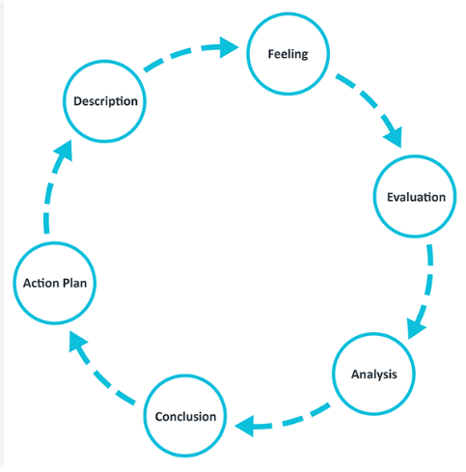
Figure 11: Gibbs Réflective Cycle. Source : (Main, 2023).
Description
Description is the first stage of this reflective writing. The description part provides detail of my journey with Premier Inn Leeds City Centre Hotel. I was an internee at Premier Inn Leeds City Centre Hotel where I was appointed in the food service department of the hotel.
I want to remember one incident from where we learnt a lot. Once there was problem in serving a dish to a guest. The guest found the served dish did not match with the guest’s requirement. There was the mistake of a hotel staff who served the dish of one guest to another one. We as a team immediately understood the problem and tried out best to provide solution as soon as possible. The immediate actions from our team delight the guest, although the guest was furious in the first phase. From this mistake, we learnt that being patient and calm in the workplace is very necessary.
The knowledge and understanding gathered from this internee period is drawn in this section of my reflective account. Working at such type of well-known hotel brand has given me an amazing experience. From the intern period, I have learnt about different technological use for service delivery. I have worked in the food service department where teamwork was emphasized. Under a senior food service assistant, I have completed my internship period. We had a team of internees who are assigned to ensure cleanliness of utensils and serving dishes to guests. Premier Inn Leeds City Centre Hotel, to serve food to guests promotes teamwork and collaboration among teams. The internship journey has provided me the opportunity of observing a renowned hotel operation very closely. Based on my observation about team operation and employee behaviour with the guest and its impacts on the guest experiences, this placement research report is prepared.
Feeling
My initial feeling of working in this renowned hotel of Premier Inn is a lot of excitement. Having the chance to work in such a big hotel with a huge customer base and a big workforce. It was a great journey for me. Working at such type of a renowned hotel brand was a big opportunity for me. I had both excitement and nervousness after getting the news of having the opportunity at Premier Inn Leeds City Centre Hotel. In the primary days of the hotel, I was skilled enough to perform the job of serving foods to guests. In the first 10-15 days, I was mainly observing everything in the ways other colleagues doing. I was very attentive to knowing things and learning in the initial days of hotel work. There was a high workload because of the employee shortage. After some days, I was experiencing a heavy workload, and I felt the need of work excellence for handling a heavy workload. My other teammates and the supervisor were cooperative. In a team, one learns from another teammate.
Evaluation
My learning journey with Premier Inn Leeds City Centre Hotel is good. I had a lot of opportunities there to learn from real examples and practical fields. I tried to use those opportunities. I have observed the hotel's operation very closely. I observed that for hotel service efficiency, Premier Inn faces problems in recruiting talented workers. The hotel prioritises guest satisfaction by ensuring service quality. The professional behaviour of the hotel staff is a part of the hotel's quality service. The hotel looks for the most talented personnel to serve the motive of ensuring premium quality services to the guests. The hotel staff tried to ensure to meet the specific need of every guest. Every guest is equally treated in this hotel. I have learnt about professional behaviour from the internee period.
Analysis
From the analysis of my journey at Premier Inn, I have found the relation between employee professional behaviour and guest satisfaction. In serving foods to guest or solving any guest problem, the guest like employees who can maintain eye-contact and show sincerity in helping the guests. Effective communication, teamwork, and collaboration among the hotel staff help the hotel to get expected service outcomes from the hotel staff. In different situations of guest service, the hotel staff need to be empathetic to understand the guest's needs and expectations. The competitive environment poses different challenges to a hotel brand like Premier Inn where utilising hotel staff by increasing their skills and knowledge can help the hotel in this case.
Conclusion
In conclusion, I want to say that learning from working in a hotel brand will be very helpful for developing my career in the hospitality industry. I have gained knowledge about different operational fields of a hotel brand. The importance of employees’ behaviour for greater customer satisfaction is also observed in my learning period. I would love to work in a hotel brand and learn more about the hospitality industry. The direct connection between employee behaviour and guest service quality requires hotel brands to focus on building a talented workforce by providing the necessary training. I have also identified my lack of skills. I have lacking in communication skills and identifying guest needs. Focusing on those areas, I can do well in my job field in the hospitality industry.
Action Plan
From my journey in Premier Inn, I have understood that I need to go through certain self-development for making me professional and competent employee for a hotel brand.
Actions | Work Needed to be Done
Communication Skills | - Improving my communication skills is become very vital for me. Listening and understanding to others is an important part of communication skills.  - I will improve my communication skills through online courses, YouTube videos, etc.
Taking Courses on Hotel Management | - I will look for training opportunities and courses related to the hospitality industry.
Increasing Knowledge of Professional Behaviour | - The experience in Premier Inn City Centre Hotel tells me the importance of professional behaviour to the guests.  - I need to learn more about professional behaviour in the job field.
Continuous Self Reviewing and Analysis | - Continuous reviewing and analysing myself can help me to be more professional in the job field.

References
Davahli, M.R., Karwowski, W., Sonmez, S. and Apostolopoulos, Y. (2020). The Hospitality Industry in the Face of the COVID-19 Pandemic: Current Topics and Research Methods. International Journal of Environmental Research and Public Health, [online] 17(20), pp.1–20. doi:https://doi.org/10.3390/ijerph17207366.
Akarsu, T.N., Marvi, R. and Foroudi, P. (2022). Service Failure Research in the Hospitality and Tourism industry: a Synopsis of past, Present and Future Dynamics from 2001 to 2020. International Journal of Contemporary Hospitality Management, 35(1). doi:https://doi.org/10.1108/ijchm-11-2021-1441.
Ambrose, J. (2021). Premier Inn warns over staff shortages as hotel bookings recover. [online] the Guardian. Available at: https://www.theguardian.com/business/2021/oct/26/premier-inn-staff-shortages-hotel-salaries-bonuses.
Ashton, A.S. (2018). How human resources management best practice influence employee satisfaction and job retention in the Thai hotel industry. Journal of Human Resources in Hospitality & Tourism, 17(2), pp.175–199. doi:https://doi.org/10.1080/15332845.2017.1340759.
Awasth, A. and Dhawan, D. (2020). Role Of Employee Behaviour In Hospitality Industry. International Journal of Scientific & Technology Research .
Bass, F.M. (2019). The Future of Research in Marketing: Marketing Science. Journal of Marketing Research, 30(1), p.1. doi:https://doi.org/10.2307/3172509.
Baum, T. and Hai, N.T.T. (2020). Hospitality, tourism, human rights and the impact of COVID-19. International Journal of Contemporary Hospitality Management, 32(7). doi:https://doi.org/10.1108/ijchm-03-2020-0242.
Boadi, E.A., He, Z., Antwi, C.O., Md Altab, H., Bosompem, J., Hinson, R.E. and Atuobuah Boadi, V. (2022). Value co-creation and employee service behaviours: The moderating role of trust in employee - hotel relationship. Journal of Retailing and Consumer Services, 66, p.102898. doi:https://doi.org/10.1016/j.jretconser.2021.102898.
Brunner-Sperdin, A., Peters, M. and Strobl, A. (2012). It is all about the emotional state: Managing tourists’ experiences. International Journal of Hospitality Management, 31(1), pp.23–30. doi:https://doi.org/10.1016/j.ijhm.2011.03.004.
Buhalis, D. and Law, R. (2020). Progress in Information Technology and Tourism management: 20 Years on and 10 Years after the Internet—The State of eTourism Research. Tourism Management, 29(4), pp.609–623.
Canarella, G., Miller, S.M. and Pollard, S.K. (2013). Purchasing Power Parity between the UK and the Euro Area. SSRN Electronic Journal. doi:https://doi.org/10.2139/ssrn.2209991.
Carruthers, N. (2024). Inquiry to explore UK hospitality staffing issue. [online] The Spirits Business. Available at: https://www.thespiritsbusiness.com/2024/04/inquiry-to-explore-uk-hospitality-staffing-issue/ [Accessed 25 May 2024].
Chen, S., Chen, H.H., Zhang, K.Q. and Xu, X. (2018). A comprehensive theoretical framework for examining learning effects in green and conventionally managed hotels. Journal of Cleaner Production, 174, pp.1392–1399. doi:https://doi.org/10.1016/j.jclepro.2017.10.321.
Cherry, K. (2022). How to Write a Psychology Case Study. [online] Verywell Mind. Available at: https://www.verywellmind.com/how-to-write-a-psychology-case-study-2795722.
Clark, D. (2023). UK worker shortages by sector 2023. [online] Statista. Available at: https://www.statista.com/statistics/1369216/uk-worker-shortages-by-sector/.
Coleman, D. and Willis, D.S. (2020). Reflective writing: The student nurse’s perspective on reflective writing and poetry writing. Nurse Education Today, 35(7), pp.906–911.
Davahli, M.R., Karwowski, W., Sonmez, S. and Apostolopoulos, Y. (2020). The Hospitality Industry in the Face of the COVID-19 Pandemic: Current Topics and Research Methods. International Journal of Environmental Research and Public Health, [online] 17(20), pp.1–20. doi:https://doi.org/10.3390/ijerph17207366.
Eade, M. (2023). The doors of hospitality are open, but where are the staff? [online] Gallagher UK. Available at: https://www.ajg.com/uk/news-and-insights/2023/february/the-doors-of-hospitality-are-open/.
Ekinci, Y., Dawes, P.L. and Massey, G.R. (2008). An extended model of the antecedents and consequences of consumer satisfaction for hospitality services. European Journal of Marketing, 42(1/2), pp.35–68. doi:https://doi.org/10.1108/03090560810840907.
Gerber, C., Terblanche-Smit, M. and Crommelin, T. (2014). Brand recognition in television advertising: The influence of brand presence and brand introduction. Acta Commercii, 14(1). doi:https://doi.org/10.4102/ac.v14i1.182.
Gheibi, M. (2020). PESTLE analysis. Integrated Environmental Assessment and Management, 14(4), pp.480–488.
Giglio, S., Pantano, E., Bilotta, E. and Melewar, T.C. (2019). Branding luxury hotels: Evidence from the analysis of consumers’ ‘big’ visual data on TripAdvisor. Journal of Business Research, 119. doi:https://doi.org/10.1016/j.jbusres.2019.10.053.
Grenside, J. (2023). How to Tackle Staff Shortages in Hospitality Industry? [online] www.theaccessgroup.com. Available at: https://www.theaccessgroup.com/en-gb/hospitality/resources/hospitality-staff-and-hr-resources/tackle-staff-shortages/#:~:text=A%20survey%20conducted%20in%202021.
Gupta, V. (2019). The influencing role of social media in the consumer’s hotel decision-making process. Worldwide Hospitality and Tourism Themes, 11(4), pp.378–391. doi:https://doi.org/10.1108/whatt-04-2019-0019.
Hao, F. and Chon, K.K.-S. (2021). Contactless service in hospitality: bridging customer equity, experience, delight, satisfaction, and trust. International Journal of Contemporary Hospitality Management, 34(1), pp.113–134. doi:https://doi.org/10.1108/ijchm-05-2021-0559.
Held, B.S. (2009a). The Logic of Case-Study Methodology. Pragmatic Case Studies in Psychotherapy, 5(3). doi:https://doi.org/10.14713/pcsp.v5i3.979.
Held, B.S. (2009b). The Logic of Case-Study Methodology. Pragmatic Case Studies in Psychotherapy, 5(3). doi:https://doi.org/10.14713/pcsp.v5i3.979.
Hendy, H.M., Can, S.H. and Black, P. (2018). Workplace Deviance as a Possible ‘Maladaptive Coping’ Behaviour Displayed in Association with Workplace Stressors. Deviant Behaviour, pp.1–8. doi:https://doi.org/10.1080/01639625.2018.1441684.
Hickman, J., Morris, P. and McDonald, R. (2021). COVID-19: Government support for individuals and businesses. [online] www.bdo.co.uk. Available at: https://www.bdo.co.uk/en-gb/insights/tax/corporate-tax/covid-19-government-support-for-individuals-and-businesses#:~:text=Business%20Rates%20reliefs.
Innerhofer, J., Nasta, L. and Zehrer, A. (2022). Antecedents of labor shortage in the rural hospitality industry: a comparative study of employees and employers. Journal of Hospitality and Tourism Insights. doi:https://doi.org/10.1108/jhti-04-2022-0125.
Jeetesh K, S.G. (2015). The Effects of Job Satisfaction towards Employee Turnover in the Hotel Industry: A Case Study of Hotels in Kuala Lumpur City Center. Journal of Tourism & Hospitality, 04(01). doi:https://doi.org/10.4172/2167-0269.1000142.
Ji-Hae Kang (2013). On Empirical Research and the Case Study Method in Translation Studies. The Journal of Translation Studies, 14(2), pp.7–38. doi:https://doi.org/10.15749/jts.2013.14.2.001.
Johnson, C. and Vanetti, M. (2005). Locational strategies of international hotel chains. Annals of Tourism Research, 32(4), pp.1077–1099. doi:https://doi.org/10.1016/j.annals.2005.03.003.
Karatepe, O.M. and Olugbade, O.A. (2009). The effects of job and personal resources on hotel employees’ work engagement. International Journal of Hospitality Management, 28(4), pp.504–512. doi:https://doi.org/10.1016/j.ijhm.2009.02.003.
Kattara, H.S., Weheba, D. and El-Said, O.A. (2008). The impact of employee behaviour on customers’ service quality perceptions and overall satisfaction. Tourism and Hospitality Research, 8(4), pp.309–323. doi:https://doi.org/10.1057/thr.2008.35.
Kaufka, B. (2020). The shadows within: internalized racism and reflective writing. Reflective Practice, 10(2), pp.137–148. doi:https://doi.org/10.1080/14623940902786115.
Kele, A.T.B.A., Mohsin, A. and Lengler, J. (2017). How willing/unwilling are luxury hotels’ staff to be empowered? A case of East Malaysia. Tourism Management Perspectives, 22, pp.44–53. doi:https://doi.org/10.1016/j.tmp.2017.01.006.
Khawaja, K.F., Sarfraz, M., Rashid, M. and Rashid, M. (2021). How is COVID-19 pandemic causing employee withdrawal behaviour in the hospitality industry? An empirical investigation. Journal of Hospitality and Tourism Insights, ahead-of-print(ahead-of-print). doi:https://doi.org/10.1108/jhti-01-2021-0002.
Kim, A.J. and Ko, E. (2019). Impacts of Luxury Fashion Brand’s Social Media Marketing on Customer Relationship and Purchase Intention. Journal of Global Fashion Marketing, [online] 1(3), pp.164–171. doi:https://doi.org/10.1080/20932685.2010.10593068.
Krajcsák, Z. and Kozák, A. (2018). The impact of labor shortage on the employee commitment. Journal of Human Behaviour in the Social Environment, 28(8), pp.1060–1067. doi:https://doi.org/10.1080/10911359.2018.1496865.
Ktait, M.A. (2020). The Assessment of Factors Influencing Hotel Services Consumers Behaviour. Journal of Advanced Research in Dynamical and Control Systems, 12(SP3), pp.1453–1471. doi:https://doi.org/10.5373/jardcs/v12sp3/20201398.
Kumar, V. (2020). Tourism Industry and COVID-19: Present Scenario. Journal of Tourism and Hospitality Education, 10, pp.179–185. doi:https://doi.org/10.3126/jthe.v10i0.28768.
Lee, Y., Lee, S. and Kim, D.-Y. (2021). Exploring hotel guests’ perceptions of using robot assistants. Tourism Management Perspectives, 37, p.100781. doi:https://doi.org/10.1016/j.tmp.2020.100781.
Li, J. (Justin), Bonn, M.A. and Ye, B.H. (2019). Hotel employee’s artificial intelligence and robotics awareness and its impact on turnover intention: The moderating roles of perceived organizational support and competitive psychological climate. Tourism Management, 73, pp.172–181.
Liu-Lastres, B., Wen, H. and Huang, W.-J. (2022). A reflection on the Great Resignation in the hospitality and tourism industry. International Journal of Contemporary Hospitality Management, 35(1), pp.235–249. doi:https://doi.org/10.1108/ijchm-05-2022-0551.
M, M. and Peters, C. (2021). Labour shortages cloud Premier Inn owner’s bullish outlook. Reuters. [online] 26 Oct. Available at: https://www.reuters.com/world/uk/premier-inn-owner-eyes-full-uk-recovery-2022-losses-narrow-2021-10-26/.
Mackrill, T. (2011). A Diary-Based, Cross-Contextual Case Study Methodology: Background for the Case of ‘Jane and Joe’. Pragmatic Case Studies in Psychotherapy, 7(1). doi:https://doi.org/10.14713/pcsp.v7i1.1077.
Main, P. (2023). Gibbs’ Reflective Cycle. [online] Structural Learning. Available at: https://www.structural-learning.com/post/gibbs-reflective-cycle.
McGarvey, E. (2024). UK exits recession with fastest growth in two years - BBC News. [online] BBC News. Available at: https://www.bbc.com/news/live/business-68986351/page/2 [Accessed 13 May 2024].
Michalis, B. (2023). Why Guests Increasingly Expect Contactless Hospitality in 2022. [online] www.canarytechnologies.com. Available at: https://www.canarytechnologies.com/post/contactless-hospitality.
Nayak, K.P., Bhinder, Dr.H.S. and Kaur, N. (2021). A STUDY ON THE PREFERENCE OF HOTEL BOOKING ATTRIBUTES, POST COVID-19 PANDEMIC. Journal of Tourism Insights, 11(1). doi:https://doi.org/10.9707/2328-0824.1182.
Ng, T.W.H. and Feldman, D.C. (2012). Employee voice behaviour: A meta-analytic test of the conservation of resources framework. Journal of Organizational Behaviour, 33(2), pp.216–234. doi:https://doi.org/10.1002/job.754.
O’Carroll, L. (2023). Shortfall of 330,000 workers in UK due to Brexit, say thinktanks. [online] the Guardian. Available at: https://www.theguardian.com/politics/2023/jan/17/shortfall-of-330000-workers-in-uk-due-to-brexit-say-thinktanks#:~:text=Brexit%20has%20led%20to%20a.
O’Reilly, J.E. (2017). The length of a pestle: A class exercise in measurement and statistical analysis. Journal of Chemical Education, 63(10), p.894. doi:https://doi.org/10.1021/ed063p894.
Otienoh, R.O. (2020). Reflective practice: the challenge of journal writing. Reflective Practice, 10(4), pp.477–489. doi:https://doi.org/10.1080/14623940903138332.
Parker, A. (2019). The Future Development of the UK Hospitality Industry: The Role of the British Hospitality Association. Tourism and Hospitality Research, 1(3), pp.279–282. doi:https://doi.org/10.1177/146735849900100310.
Popa, I., Lee, L., Yu, H. and Madera, J.M. (2023). Losing talent due to COVID-19: The roles of anger and fear on industry turnover intentions. Journal of Hospitality and Tourism Management, 54, pp.119–127. doi:https://doi.org/10.1016/j.jhtm.2022.12.010.
Premier Inn (2024). Premier Inn Home. [online] Premier Inn. Available at: https://www.premierinn.com/gb/en/home.html.
Premier Inn (2022). Force for Good. [online] premierinn.com. Available at: https://www.premierinn.com/gb/en/why/force-for-good.html#:~:text=Understanding%20our%20impact%20on%20the.
Priya, A. (2020). Case study methodology of qualitative research: Key attributes and navigating the conundrums in its application. Sociological Bulletin, [online] 70(1), pp.94–110. doi:https://doi.org/10.1177/0038022920970318.
Rahman, M. (2022). PESTEL analysis of Premier Inn. [online] howandwhat. Available at: https://www.howandwhat.net/pestel-analysis-premier-inn/.
restaurantonline.co.uk (2024). Hospitality vacancies fall ‘considerably’ but remain above pre-Covid levels. [online] restaurantonline.co.uk. Available at: https://www.restaurantonline.co.uk/Article/2024/01/17/hospitality-vacancies-fall-considerably-but-remain-above-pre-covid-levels.
Robinson, R.N.S., Kralj, A., Solnet, D.J., Goh, E. and Callan, V.J. (2016). Attitudinal similarities and differences of hotel frontline occupations. International Journal of Contemporary Hospitality Management, 28(5), pp.1051–1072. doi:https://doi.org/10.1108/ijchm-08-2014-0391.
Roelen-Blasberg, T. (2023). Navigating the Staff Shortage Challenge in the Hospitality Industry. [online] www.mara-solutions.com. Available at: https://www.mara-solutions.com/post/staff-shortage-challenge-in-the-hospitality-industry.
Shankar, M.M. (2009). Does Case Study Research Strategy get along with the Information System (IS)? Adarsh Journal of Management Research, 2(1), p.35. doi:https://doi.org/10.21095/ajmr/2009/v2/i1/88333.
Souza, F.F., Borgert, A. and Gasparetto, V. (2016). Competitors analysis: opportunities based in research in accounting. Revista Capital Científico - Eletrônica, 14(4). doi:https://doi.org/10.5935/2177-4153.20160029.
Trustpilot (2024). Premier Inn is rated ‘Poor’ with 2.2 / 5 on Trustpilot. [online] Trustpilot. Available at: https://www.trustpilot.com/review/www.premierinn.com.
Tung, V.W.S., Chen, P.-J. and Schuckert, M. (2017). Managing customer citizenship behaviour: The moderating roles of employee responsiveness and organizational reassurance. Tourism Management, 59, pp.23–35. doi:https://doi.org/10.1016/j.tourman.2016.07.010.
UKHospitality (2023). UKHospitality. [online] Ukhospitality.org.uk. Available at: https://www.ukhospitality.org.uk/.
Vanek, M. (2022). Evaluation methods of swot analysis . GeoScience Engineering, 58(2), pp.23–31.
Wadcock, A. (2023). Revenues boosted at Maldron Hotel with innovative new technology. [online] Destination North East England. Available at: https://destinationnortheastengland.co.uk/news/revenues-boosted-at-maldron-hotel-with-innovative-new-technology [Accessed 13 May 2024].
Wilson, D. (2017). THE NEED FOR A CULTURALLY COMPETENT WORKFORCE TO ADDRESS DIVERSITY AND INCLUSION. Innovation in Aging, 1(suppl_1), pp.1384–1384. doi:https://doi.org/10.1093/geroni/igx004.5094.
Yang, Y. and Mao, Z. (2020). Location advantages of lodging properties: A comparison between hotels and Airbnb units in an urban environment. Annals of Tourism Research, 81, p.102861. doi:https://doi.org/10.1016/j.annals.2020.102861.
Zhang, J., Xie, C., Wang, J., Morrison, A.M. and Coca-Stefaniak, J.A. (2020). Responding to a major global crisis: the effects of hotel safety leadership on employee safety behaviour during COVID-19. International Journal of Contemporary Hospitality Management, ahead-of-print(ahead-of-print). doi:https://doi.org/10.1108/ijchm-04-2020-0335.
Zhang, Y. (2018). Customer Focused Collection Services in the Age of Big Data. International Journal of Intelligent Information Systems, 7(1), p.5. doi:https://doi.org/10.11648/j.ijiis.20180701.12.
Zhong, L., Coca-Stefaniak, J.A., Morrison, A.M., Yang, L. and Deng, B. (2022). Technology acceptance before and after COVID-19: no-touch service from hotel robots. Tourism Review, 77(4). doi:https://doi.org/10.1108/tr-06-2021-0276.

