

Energy in a Flywheel

Engineering Science 1
M4X00385
Lecturer: Abi Summerfield

By Evan Morcom (1802426)

Contents

1.0 Introduction
1.1 What is being proved
2.0 Experimental Procedure
2.1 Apparatus

2.2 Setup

2.3 Procedure
3.0 Results

4.0 Analysis

5.0 Conclusion

6.0 Evaluation

7.0 Further Work

8.0 References

- Introduction
Within this technical report, the focus will be directed at the ‘Energy in a Flywheel’ experiment from the ‘Potential and Kinetic Energy Kit ES9’. The method will be explained, and data will be collected. Using that data, derived calculations will arise which will prove the below statement. (TecQuipment, 2012)

1.1 What is being proved
This experiment is trying to prove the theory of energy in a flywheel, Kinetic energy can be ‘stored’ in the moving parts of a machine such as a flywheel. The larger the mass or speed of the moving object, the more kinetic energy it can store.
To support this statement, an experiment from the ‘Potential and Kinetic Energy Kit ES9’ can be used to set up a flywheel and pulley system which weights can be added, multiple results can be recorded which all assist the prior statement (TecQuipment, 2012)
- Experimental Procedure
For the experiment, there are multiple pieces of apparatus which are required to set up before following the method to successfully perform the experiment.
  - Apparatus


- 1x Work panel
- 1x Flywheel
- 1x Pulley block
- 1x Cord
- 1x Weight hanger (10g)
- 1x Magnetic rule
- 49x 10g weights
- 1x Stopwatch
- 1x Securing clip
- 1x Plastic guide
Figure 1. 10g Weights

  - Setup
Before the experiment can begin, the setup must be complete. Firstly, the flywheel will need to be bolted to the pulley block using the small 4mm grub screw within the flywheel. The pulley block should be fixed to the centre of the work panel leaving 7 remaining holes either side. Once this is complete, the cord will need to be threaded through small hole in the pulley arm. This cord will need to have a loop at the lowest point to allow for the weight hanger to be attached. The magnetic rule should be attached the work plate ready to take measurements.

  - Procedure

To start, place the plastic guide onto the weight hanger, attach the hanger with no weights onto the cord and let the hanger fully drop.
At its lowest point now, move the rule so 0mm it is in line with the plastic guide. Add 9x 10g weights to add to a total of 100g and securing clip to the hanger.
Wind the flywheel up so the plastic guide is in line with the 290mm mark on the rule (see figure 2). Using a stopwatch, measure and record how many seconds it takes the hanger to drop to 0mm and return to its maximum height, the maximum height is the height of where the hanger bounces back and the cord winds itself back up.
The maximum height will also have to be recorded. Repeat these steps 3 or more times to receive enough information to calculate a stronger average value. This will have to be repeated for 100, 200, 300, 400 and 500g weights.
Figure 2. 100g Weight at release point 280mm

3.0 Results
Following completion of the experiment, the gathered raw data was as below:
Raw Data:



Figure 3. Table of Raw Data

- Analysis

Derived Results:
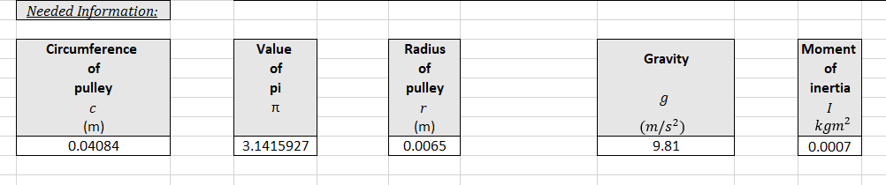
Figure 5. Table of Needed Information
Figure 4. Table of Derived Results


Figure 6. Graph plotting torque against angular acceleration.

From reviewing the gathered raw data and calculated derived results (Figure 4, 5, 6). There are few anomalous results which can relate to accurate measurements when the data was collected. As the data was measured 3 times at each weight set, it can be considered as reliable data when calculating derived data.
An easy trend to see straight away is the time to fall and rise decreases ($t_{t}$) as the mass is increased, this would see to considered as common knowledge, however below is looking further into the reasons why.
Knowing that when energy changes from one state to another there is energy loss as an outcome. In the case of this experiment, before release the flywheel has a kinetic energy value of 0, however once the weight is release from its start height of ${mgh}_{1}$, it transfers its initial potential energy in turning the flywheel until the string is fully unwound as it reaches the bottom and the flywheel reaches maximum acceleration. At this point there is a conversion from PE to KE, this allows the flywheel to use its energy to lift the weight back up.
Though, there are other forces which act in the opposition of the falling weight such as friction and air resistance. Because of this the weights will not return to the original height, as a replacement for this, the new height is called ${mgh}_{2}.$ This transfer of energy is called PE Loss.
PE Loss can be calculated by subtracting ${mgh}_{2}$ away from ${mgh}_{1}$. This can be clearly seen within the results. To compare this figure with KE which only for the downward falling. It can be multiplied by the height ratio; this is called PE Loss Adjusted as seen within the results.
Moving forward, the falling time value ($t_{f}$) is needed to calculate the acceleration and velocity of the weight and flywheel. Unfortunately, the falling time is not half of the total time ($t_{t}$), using the equation $t_{f= }t_{t}×\frac{h_{1}}{h_{1}+h_{2}}$ will give an accurate value. This can be noticed within the results.
The acceleration of the falling weights and flywheel reaches its maximum value at the bottom of the strings length as previously mentioned, the acceleration is need to calculate velocity of the falling weights, torque and the angular acceleration.
The graph demonstrates torque acting with angular acceleration, analysing the graph there is a relationship between the two. To understand how this relationship works, first the torque must be identified as either static or dynamic. For this experiment, the torque is dynamic as there is an angular accelerating force being applied which is the weights falling.
On the graph, the moment of inertia was calculated by find the gradient of the straight line on the trendline using $y=mx+c$. This gave a good average value as it is based on the collected data and derived results.
The falling weights produce angular acceleration which means that the torque produced from the flywheel turning is equal to the product of the angular acceleration and the moment of inertia of the rotating flywheel. This can be written as the equation below;
$$τ=I×α$$
That equation can be used as an expression to explain the trend between torque and angular acceleration. It is also directly linked Newton’s 2nd law of motion, it is the direct equivalent to $F=ma$ (Khan Academy, 2019)

- Conclusion
To conclude, there was multiple points of relevance throughout the experiment. The first area that will be highlighted is the potential energy and the change in potential energy or PE Loss as it’s named in the results.
The potential energy ${mgh}_{1}$ that was calculated in the results has a big impact on all of the other calculations as they all link and depend on this value. This calculation had to be correct to keep the other results valid. This also applies to ${mgh}_{2}$ as both were in the calculation to find the change in potential energy which divided the initial value by the final value. As previously mention within the analysis, the potential energy loss adjusted values can be directly compared to the values for kinetic energy.
Looking into this comparison the torque created, the moment of inertia and the angular velocity all need to be taken into consideration. As kinetic energy calculations use these values and the results will differ if these values change. The moment of inertia is its resistance to a change in rotation, this average value was found by plotting the graph with torque to angular acceleration and taking the gradient of the line, this technique is preferred over the equation for moment of inertia as it can be very difficult to find the true total moment of inertia. The value that was calculated using this method was different to the supplied values within the ES9 handout, this has been discussed with Abi Summerfield. It has since been carried out with the supplier and since had had no further values, therefore 0.007 ${kgm}^{2}$ has been used throughout the calculations and report
The angular velocity was found converting the linear velocity, by using the circumference of the pulley and of course the flywheel. Torque can be found by converting Newton’s 2nd law of motion to angular rather than linear forces.
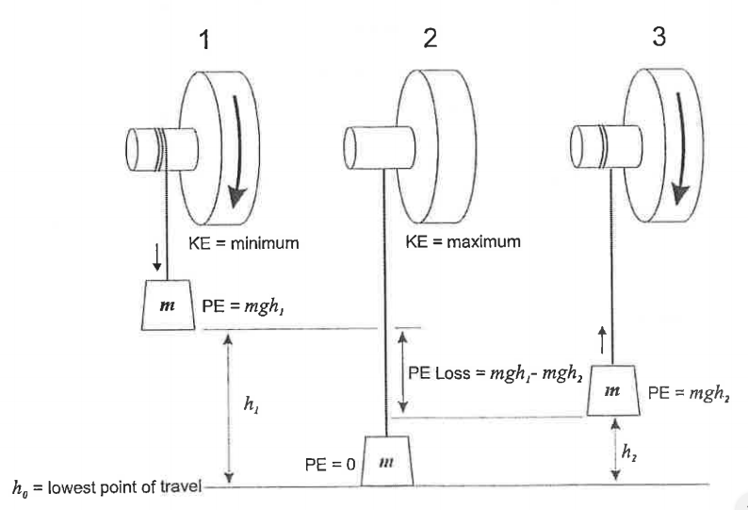
So, as the weight is slowly raised to its highest point, it is gaining potential energy as the release cord is being wound around the flywheel. It is the energy representing the potential a body has to do work because of being located at a particular location in a gravitational field (Khan Academy,2019). When the flywheel is released, the weights fall down until it reaches the end of the cord which is the datum, whilst it is falling it is losing all of its potential energy. However, following the First Law of Thermodynamics. Energy can neither be created nor destroyed, it can only be transferred or changed from one to the other (Lumen Learning, 2019).

Figure 7. Energy in a flywheel TecQuipment (2012)
Knowing this, the reducing potential energy transfers to kinetic energy as the weight falls and bounces back up. Kinetic energy is the energy a body has because of its motion.
Kinetic energy is subject to on the velocity of the body squared, so therefore when the velocity of the weight doubles, the kinetic energy quadruples. Therefore, kinetic energy will always be a positive number as both positive and negative velocities, when squared will always result in a positive number (Khan Academy, 2019).
From this, it is clear that when the change in potential energy or potential energy loss becomes larger, the kinetic energy value increases, this is known as an energy conversion. The flywheel is the reasoning for the increase in kinetic energy.
The flywheel is a rotating wheel that requires the force of the falling weights to rotate. Due to needing this force to start rotating, it also requires a force to stop rotation, it will have the impact from air resistance and the friction from the bearings. Therefore, it can be said that the flywheel uses all of the potential energy and converts it kinetic energy as it rotates.

- Evaluation
The experiment performed well for taking into considerations of limitations within the ES9 Kit, science lab rooms and resources. However, when the experiment was being carrying out there was certain areas that could have caused discrepancies which may have hindered the results.
The first area which could have caused discrepancies was the weights, the weights may have been damaged by being dropped over time and slightly changing the individual weight which will have an impact on the potential energy and torque values. To eliminate the chance of this error, it would be good practice to weigh each weight with a calibrated device.
The length of the cord may not have been at a perfect measurement of 290mm, this being the incorrect length can cause a big impact on the PE, KE, total falling time, acceleration and velocity. To minimise the chance of this error, it would be good to check the length of the cord prior to performing the experiment. Also, the cord had some elastic properties which may tamper the data.
The next two areas both revolve around human error being the main cause. First being the initial and final height measurements, the initial height when reset each drop may have been slightly off from 280mm +/- a few mm. Using a lockout device on the work panel may have helped finding the initial height each time easier. The final height was read by eye on the rule, this can cause a large error as the hanger can fall and bounce quickly making it hard to accurately read the data. Using a slow-motion camera to film the bounce to review the video clip to help find the final height. The second area being the timing, the timing was started when the weights were released and stopped when the weights reached final height. There will be human error with when the timer was started and stopped. Once again using a video camera, the process could be timed externally, helping the time being more accurate.

- Further Work
In addition, the experiment could be further improved if there were no limitations with budget to eradicate possible errors within the procedure and equipment.
A major improvement would be using a plc system to control the initial height release, this could be achieved with an electronic motor with a pin releasing the hanger. This would remove the chance of human error which is releasing the hanger from an incorrect height. It can also trigger the timer as it would be matched with the release
A laser distance sensor can be used underneath the hanger to measure when it reaches its final height at which it can stop the timer, therefore removing the human error with manual timing.
Using a cord with equal flexibility but with less elastic properties will also help as it will reduce the amount of energy wasted which transfers to other forces other than PE or KE.
Low friction bearings will aid the flywheel in spinning, thus helping with reducing the resisting forces acting against the flywheel and pulley block.

- References

Khan Academy (2019) Torque. Available at: https://www.khanacademy.org/science/physics/torque-angular-momentum/torque-tutorial/a/torque (Accessed: 7th December 2019)

Khan Academy (2019) What is gravitational potential energy. Available at: https://www.khanacademy.org/science/physics/work-and-energy/work-and-energy-tutorial/a/what-is-gravitational-potential-energy (Accessed: 7th December 2019)

Khan Academy (2019) What is kinetic energy. Available at: https://www.khanacademy.org/science/ap-physics-1/ap-work-and-energy/kinetic-energy-ap/a/what-is-kinetic-energy (Accessed: 7th December 2019)

Lumen Learning (2019) The Laws of Thermodynamics. Available at: https://courses.lumenlearning.com/boundless-chemistry/chapter/the-laws-of-thermodynamics/ (Accessed: 7th December 2019)

TecQuipment (2012) Potential and Kinetic Energy Kit ES9. TecQuipment.

