Omar Sufer LEVEL 7 ASSESSMENT Report

Introduction
This report will contain information on what group ALU-CAR-D managed to do for the car rental text-based console application and what my personal contributions were to the project.
Evaluation of Software Design
our team adhered to Object-Oriented Programming (OOP) principles. We organised our code into multiples classes which made our code more scalable and maintainable to work on simultaneously, especially when using git to update our work. By doing it this way, we were able to work on different files and push to git regularly without having many if any git merge conflicts at all. Our layered structure work like the following. model -> repository -> service -> seam -> User Interaction layer.

The model
In here we defined and represent the core structure of our data and a toString method that prints a string representation of the models fields.

The repositories
This layer interacts with the database to perform CRUD operations, although in our project we did not utilise the delete operation as it was causing us many issues, this is because of the vehicle data being dependent on in multiple tables. In general the repository is connects to the database, retrieves the data and manipulates it with SQL functions. For example in the vehicle repository I created a function that talks to the database and retrieves data that will match the user input (searching for vehicle make function).
The service
the service layer was implemented but was not utilised correctly, this is because this layer should have been the layer where business logic was supposed to be implemented but instead, all of that portion of code was put into the seams layer. It’s mostly used as a place to put our calls our repository methods which could’ve been used in seams and saves time on working on another file.

User Interaction Layer
This layer created what the user will be seeing in the console. It was used to create multiple menus, connect application functionality and user input to make a working application. Switch statements were used to deal with the different options that the user might decide on.

My 3 Stories
  - Story 1: UI Implementation
My largest task for the project was connecting all the layers we have created in a class called User Interface. The functionality for this class is to be the main user interaction handler, it contains various pages with different functionality that the user can choose from and decide what they want to do. While the overall difficulty for this story was relatively low, it was still a large story that takes time. I tackled this story by immediately breaking it down into smaller tasks, such as modelling different pages that will handle different functionalities, a home page that handles directing the user to all other pages, a vehicle page that handles all functionalities for creating, removing, searching and listing vehicles, a booking page that does all booking functionalities, a Location page that handles location functionalities. They biggest advantage of breaking down the story this way was that the implementation for UI relied on the functionalities to be set-up and ready to be plugged into the UI page, by setting up different pages in the console for specific functionalities, I can immediately plug them in and test if they are working correctly and give feedback to the team or amend the code myself until the intended output is there. In addition, I was able to freely focus on other tasks at certain times when no other functionalities were finished and easily come back to plug new ones when needed. The UI was the last stage of the layered structure we had, so it relied on the model -> repository -> service -> seam -> factory to all be finished which is why breaking it down to many small subtasks made it easier to work on and see what is needed by the end.
  - Story 2: Vehicle Searching
The first task I was assigned to work on was creating multiple search functionalities for a vehicle using a specific criteria. For example, a user being able to search for a car based on its model, id, make(company), or type(car, minibus, etc…). For this task I worked on 2 layers that we had set up which were the repository and service layers. I broke down the story into subtasks, each one relating to one search functionality and each tasks would be about implementing it in the repository and then the service layer.
  - Story 3: Testing Vehicles
My final story was writing tests for the vehicle service layer. It was not a very big story because I only worked on half of the vehicle tests while Justin Hendy worked on the other half. This story was supposed to be done using test driven development but due to time constraints and finding the tasks difficult I did not prioritise it and implemented the tests at the end.

Story Points and individual Contribution
The team had a total of 104 story points and I finished 16 points of them. The biggest reason for this is that I initially struggled to work on a OOP project with multiple layers but throughout the week I gained more confidence and experience which is shown by the massive increase in points throughout the week. In addition, at some points during the project I was working on tasks that I felt were needed but would forget to add them to the Miro board and correctly communicate it with the team.

Database Design Evaluation
The picture below was the initial ERD that we decided to use on the Monday spring planning session.
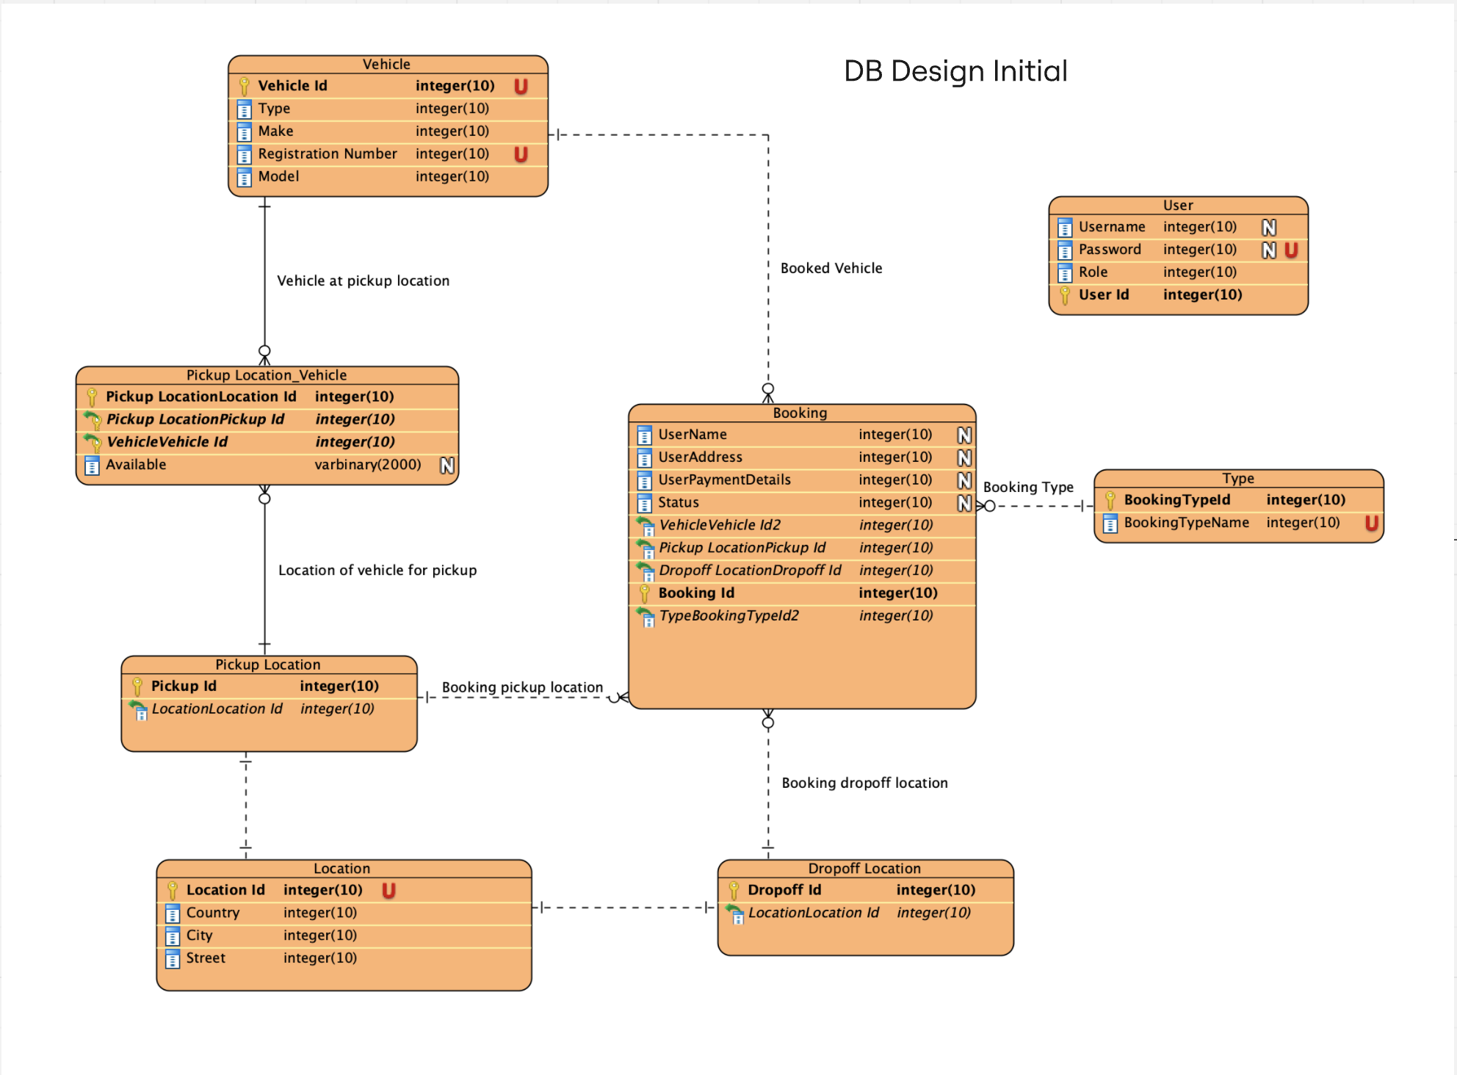
The picture below is the final ERD that we changed to throughout the week.

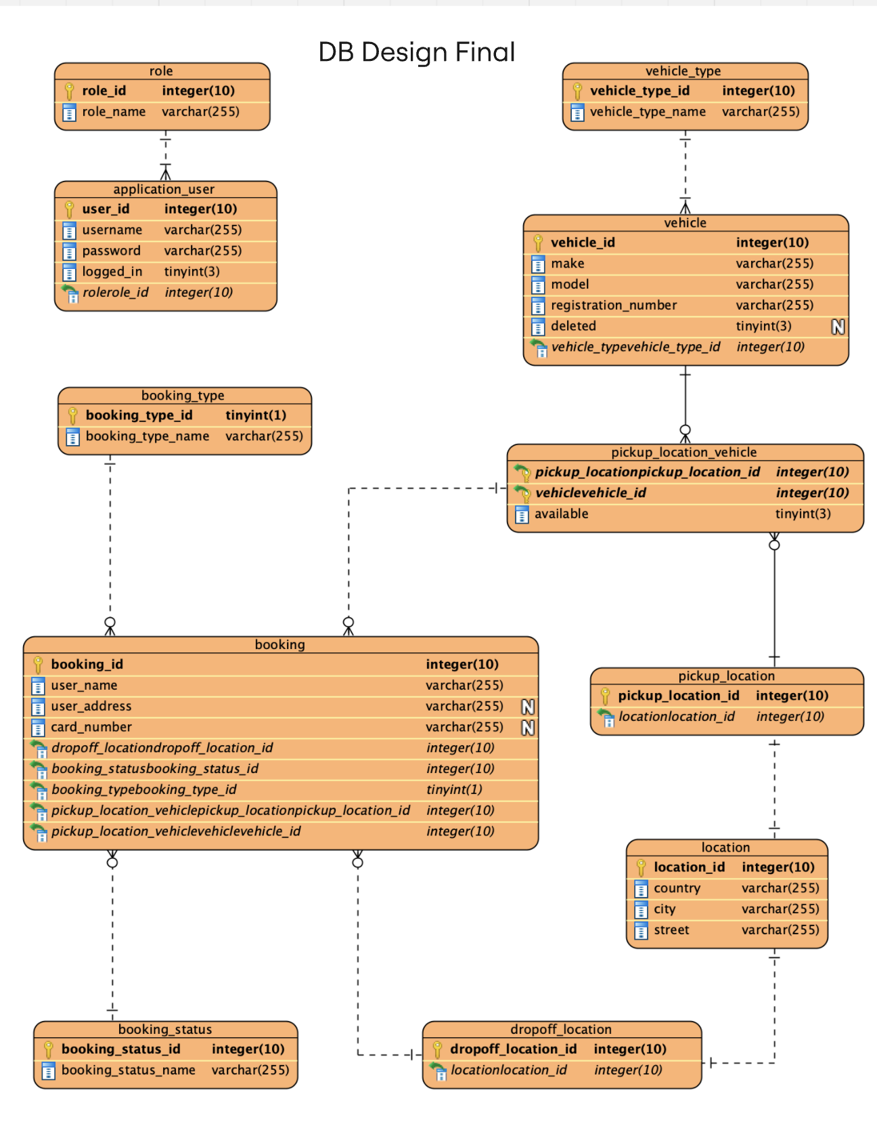

While we didn’t end up using the initial ERD in the end, it was very useful to us. This is because it allowed all of us to work together and create the database and start working on the application immediately.
The main aspects of the final ERD are using tables to that have the types of booking/vehicles this was done so that we can constraint the values rather than having free values (set the value to anything). In addition, to removing status values from the booking table, the card number was added since we didn’t plan on adding it initially.

The user role was also broken into a table on its own, this allowed us create only 2 roles that we wanted which were user and admin and made it easier to set constraints on what they can do.

Ceremonies and Meetings
Spring planning
On the first day of the project we a had a spring planning session in which we built a spring backlog and translated the requirements into user stories.
Daily Standups
We had daily stand-ups every day except on the Monday. The daily standups consisted of us discussing what work everyone implemented the day prior and what work is needed to be prioritised and implemented on the day, I or other people in my group would volunteer to do certain tasks they think they would be good at and would log it in the Miro Kanban board.
Retrospective
on the Wednesday 18th we decided to have a retrospective ceremony to discuss how we are individually progressing and how close are we to achieving the project MVP (minimal viable product)
Reflection on Agile
Spring planning
The main advantage I found with the spring planning session is how easy it was during the week to find and discuss what tasks are left to do, this was because we broke them down into small and concise user stories so that throughout the week everyone knows what tasks are left to do and what they mean.

Daily Standups
Meeting and discussing everyone’s progress at the beginning of the day was very helpful because it allowed better communication between the team especially in moments where I or another team member were struggling. It allowed others to jump in and help explain tasks more thoroughly or help fix any misunderstanding in our goals, for example, creating a searching for a vehicle by availability task did not need working on since someone already created a show all available vehicles functionality.

Retrospective
Having a day to discuss what is left to do and how close we are to reaching our MVP was helpful in knowing what tasks to prioritise and what tasks to leave behind unless we finish earlier than expected. Although the retrospective should and could have been longer to discuss thing in more detail but we were working with a short deadline which stopped us from taking the full benefits of a retro.

Spring review and sprint refinement
Two of the main components of agile are the spring review and spring refinement which were both not done during this project, the main reason for this decision is that there was no time and massive advantage is doing either. Since we had a single week, a spring review did not make sense since we were on a 1 sprint cycle. Although we did our best to discuss what we did well in some of the daily standups. For spring refinement we attempted to also incorporate it as much as possible during our daily standup by breaking down large user stories that did not make a lot of sense into smaller easier to understand chunks. Both are great agile components that we were lacking in because of short time we had with the project.

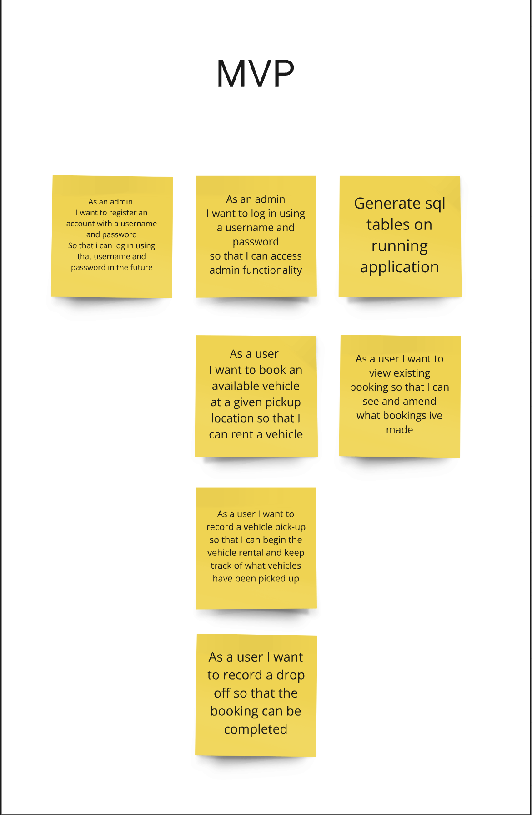
Overall Reflection

Above is the MVP(minimal viable product ) that we decided on during early stage development of the product. We have reached the MVP and implemented even implemented all functionalities from the specification because of our time management and out code structure allowing an easier time for scalability.

Skill and confidence
Initially I was very confused and did less progress than expected because of my lack of understanding on how to work correctly on a OOP project with multiple people but by Wednesday I started to finish more stories than expected. On the other hand, due to my lack of knowledge, I started to amend issues made by myself or other people in the code rather than confidently take on more stories especially during the first 2 day of development. Finally, I think by the end of the week ive done a lot of work and improved my understanding of OOP.

Issues found
There was some issues I faced during the projects difficult time limit which were communicating with the team correctly at all times, what I mean by this is, sometimes I would finish work intended and submit a pull request but I would forget to update it on the Miro board and communicate to everyone in the team what I implemented. This caused some of my functions created to be redundant since they were created by other people as well or forgotten till the end of the project. This was an aspect I could have improved on when discussed during a spring review session if we had a longer time to do the project. Finally, I did not actively add stories of tasks I worked on which made it seem like not only did I do less work but my team did not know what I have finished at times.

