

A comparative analysis of driving performance and styles across simulators and real-world scenarios
by
Farley Staines

Supervisor: Nik Whitehead

Project submitted as part of the requirements for the award of
CDISH Computing (Data and Information Systems)

April 2025

DECLARATION

I, Farley Staines, declare that I am the sole author of this Project; that all references cited have been consulted; that I have conducted all work of which this is a record, and that the finished work lies within the prescribed word limits.

This work has not previously been accepted as part of any other degree submission.

Date : 28/04/2025

FORM OF CONSENT

I, Farley Staines, hereby consent that my Project, submitted in candidature for the CDISH Computing (Data and Information Systems) degree, if successful, may be made available for inter-library loan or photocopying (subject to the law of copyright), and that the title and abstract may be made available to outside organisations.

Date : 28/04/2025

Abstract
This research investigates the development of specialized software for motorsport telemetry. Modern motorsport relies on data-driven approaches for performance optimization, yet smaller teams and educational needs lack significant analysis tools. Using a positivist philosophy and deductive approach, this project implements a solution that enables motorsport professionals to import, visualize, and compare data across different sources.
The literature review establishes a foundation by examining driver performance metrics, specialized racing contexts, and technological advances in motorsport. The evolution of data collection methods, from basic timing boards to sophisticated sensors generating terabytes of information, has created both opportunities and challenges for performance analysis.
The developed software provides key functionalities, including multi-source data comparison, custom data grouping, lap selection, and various visualization options. These features allow users to analyse driver techniques, compare performance across sessions, and demonstrate racing concepts in education. The system supports both real-world and simulator data, allowing on and off-track comparison.
Testing during a track day event revealed both strengths and limitations, with System Usability Scale assessments averaging 58.75. Users valued the ability to compare data across sources, create custom variable groups, and switch between different visualization methods. The experienced users appreciated the specialized functionality, while novice users identified opportunities for improved interface design.
The software successfully improves upon previous Excel-based workflows while establishing a foundation for future development. Some interface design issues were identified, with improvements needed in feature discoverability and visual organization. Recommendations include global selection features, mathematical channels, interactive data points, and improved interface design.
This work contributes to motorsport data analysis by providing an accessible framework for telemetry comparison. The findings offer practical benefits for race engineers, teams comparing simulator and real-world performance, and educators demonstrating racing concepts. Future development should prioritize balancing technical capabilities with user accessibility to make telemetry analysis more approachable for diverse motorsport applications.

Contents
1. Introduction (max ~300) 7
2. Literature review (5015 words) 7
2.1. Introduction 7
2.2. Driver Performance Analysis 8
2.2.1. Performance Metrics 8
2.2.2. Driver Training 8
2.3. Specialized Racing Contexts 10
2.3.1. Racing Format Considerations 10
2.3.2. Performance in Extreme Conditions 10
2.4. Data between real life F1 and the F1 games 11
2.4.1. Private F1 data 11
2.4.2. Public F1 data 12
2.4.3. F1 Game data 13
2.5. Technology in Modern Motorsport 14
2.5.1. Data Collection Methods in Modern Vehicles 14
2.5.2. Simulation Technologies 15
2.5.3. Driver Assistance Systems 16
2.6. Data Visualisation 18
2.6.1. Visualisations tools 18
2.6.2. Visualisation methods 18
2.7. Future Directions 19
2.8. Conclusion 20
3. Methodology (967 words) 21
3.1. Research Methodology 21
3.1.1. Philosophy 21
3.1.2. Strategy 21
3.1.3. Approaches 21
3.1.4. Risks & Limitations 22
3.1.5. Validity, Reliability & Generalisability 22
3.1.6. Data Evaluation Methods 22
3.2. Development Methodology 22
3.2.1. Software Development Methodology 22
3.3. Resources 23
3.3.1. Hardware Resources 23
3.3.2. Software Resources 23
3.3.3. Information Resources 23
3.3.4. Human Resources 23
4. Development and implementation (2221 words) 24
4.1. MoSCoW 24
4.1.1. Must have 24
4.1.2. Should have. 24
4.1.3. Could have 24
4.1.4. Will not have. 24
4.2. Csv file to database 24
4.3. Main UI 27
4.4. Creating graphs 29
4.5. Data implementation 29
4.6. Group Management UI 31
4.7. Lap Selection UI 33
4.8. Synchronising data of different sizes 35
4.9. Update the graph synchronising 36
4.10. Settings UI 36
5. Testing and results (773 words max ~1000) 41
6. Discussions and Recommendations (426 words) 44
7. Personal reflection (max ~300) 45
8. References 46
9. Appendices 51

Table of Figures
Figure 1: 1989 graphics compared to 2023 graphics [25] 12
Figure 2: The start of a race, showing a live track map and split times between drivers 12
Figure 3: Lap 33, showing lap time, current tyre and pit count 12
Figure 4: CAN transceiver and controller [33] 14
Figure 5: Obd USB kkl interface 15
Figure 6: Dashboard with a few graphs 19
Figure 7: Database structure, version 1 25
Figure 8: Database structure, version 2 26
Figure 9: Database structure, version 3 27
Figure 10: Main UI, wireframe 28
Figure 11: Main UI, layered structure 28
Figure 12: Empty Main UI 29
Figure 13: Database structure, version 3 30
Figure 14: Main UI with graph 31
Figure 15: Group management UI, wireframe 32
Figure 16: Management UI with data 33
Figure 17: Lap selection UI, wireframe 34
Figure 18: Lap selection UI with data 35
Figure 19: Generic settings UI, wireframe 37
Figure 20: Page 1 settings UI, wireframe 38
Figure 21: Page 2 settings UI, wireframe 39
Figure 22: General page, settings UI 40
Figure 23: Display options, settings UI 40
Figure 24: Cramped buttons 41
Figure 25: SUS answers 42

Table of Tables
Table 1: Table of packet information 14

Introduction
This research investigates the evolving landscape of modern motorsport, focusing on the intersection of human performance, technological innovation, and data analytics. In a competitive racing environment, the ability to collect, analyse, and visualise telemetry data has become essential for performance optimisation. Teams across all levels of motorsport rely on data-driven approaches to gain competitive advantages; however, significant gaps remain in the accessibility of analysis tools for smaller teams and educational settings.
The literature review establishes a foundation by examining driver performance metrics, specialised racing contexts, and the technological advances changing motorsport. From formula racing to endurance events, data collection methods have evolved dramatically—from basic timing boards in early Formula 1 to sophisticated sensor networks generating terabytes of information per race weekend. This evolution has created both opportunities and challenges for performance analysis.
Building on identified needs of the motorsports department, this research presents the development of specialised software designed to bridge the gap between data collection and actionable insights. Using a positivist philosophy and deductive approach, the project implements a tool enabling motorsport professionals to import, visualise, and compare telemetry data across different sources with features including lap selection, custom data grouping, and multiple visualisation options.
Testing during an actual track day event provided valuable insights into practical usability, with System Usability Scale assessments revealing mixed responses that sit between technical capability and interface accessibility. The software successfully improves upon previous Excel-based workflows while identifying opportunities for enhanced user experience through improved interface design and additional functionality.
This work contributes to motorsport data visualisation by providing an accessible framework for comparing telemetry. The findings offer practical benefits for race engineers analysing driver techniques, teams seeking performance improvements across sessions, and educators demonstrating racing concepts. Future development includes interface improvements and advanced analytical features.

Literature review

Introduction
This literature review examines the broad landscape of modern motorsport, focusing on the overlapping areas of human performance, technological innovation, and data analytics. The analysis involves driver performance metrics, specialised racing contexts, and the evolution of vehicle technology, while also exploring the psychological and physical demands placed on drivers. Through examination of both real-world Formula 1 data and racing simulation. This review provides a comprehensive insight into how driver capabilities, technical advances, and human factors combine to shape modern motorsport performance and development.

Driver Performance Analysis
This section examines the technical and psychological areas of motorsport. Starting with an analysis of performance metrics. Comparing quasi-steady-state and optimal control simulation methods reveals significant variations in lap time predictions. The section then shifts over to driver training methodologies, challenging conventional approaches by highlighting the effectiveness of structured practice, simulator training, and psychological preparation techniques that collectively contribute to racing performance.

Performance Metrics
Research done by Bianco Et Al. [1] demonstrates that lap time simulations can be categorised into two main approaches: quasi-steady-state (QSS) and optimal control (OC). The QSS approach assumes a predefined racing line and computes vehicle acceleration limits through nonlinear optimisation problems, while OC methods simultaneously determine optimal driver inputs and racing lines to minimise lap time.
The research highlights that while QSS methods are computationally efficient, they can lead to significant inaccuracies - showing a 2.19-second discrepancy in predicted lap times compared to OC methods for the Barcelona-Catalunya circuit. The study implemented a 14 degrees of freedom vehicle model incorporating full chassis motion, suspension travels, and wheel spins to achieve more accurate results.
Work by Guhan and Karthikeyan [2] takes a different approach by using polynomial regression to analyse how regulation changes affect lap time performance. Their study spanning three engine eras (V10, V8, and V6) demonstrated that engine regulations significantly impact lap time trends, with some tracks showing up to 8-second variations over a 10-year period.
Gabiccini Et Al. [3] builds on the work done by Bianco Et Al. [1] by analysing driving styles of GP2 cars. They investigate how driving style can be quantitatively analysed through the examination of three key parameters: aero balance, weight distribution, and roll balance. Their research demonstrated that these parameters significantly affect cornering techniques and lap times, with aero balance and weight distribution showing the strongest influence on overall performance.

Driver Training
This section examines driver training methodologies and psychological aspects in motorsport. It explores structured practice techniques, simulator training, vision development, and mental preparation strategies that contribute to racing performance, challenging traditional training approaches.

Practice Methodologies
Research indicates that effective driver training extends beyond simple accumulated practice hours. A blog by Driver61 [4] challenges the traditional "10,000-hour rule" in motorsport, suggesting that structured, variable practice produces better results than prolonged repetitive training. The research shows that practicing at approximately 4% above your current performance level optimises learning without overwhelming cognitive capacity.
According to Bentley [5], deliberate practice techniques reveal that focusing on discrete skills rather than continuous lapping yields superior results. Key practice methodologies include "fast-fast," which targets immediate performance, includes dedicated braking exercises, and targets corner exit optimisation. These structured approaches demonstrate measurable improvements in driver capabilities compared to traditional practice methods.
Burgess [6] highlights how Formula 1 teams have adapted their training approaches, incorporating sophisticated simulators to complement track time. Since the 2009 ban on private testing, teams have developed comprehensive simulator programs that replicate exact vehicle models and track conditions. This technology-enhanced practice allows drivers to maintain sharp skills while mimicking on-track situations.
The research presented by Von Moltke [7] emphasises the importance of vision training in skill development. Professional drivers consistently practice looking through traffic to spot brake lights multiple cars ahead, demonstrating how focused practice on specific skills translates to improved race performance. This approach to visual skill development shows a clear correlation with enhanced race start performance and high-speed corner navigation.

Psychological aspects
Research demonstrates that racing psychology extends far beyond technical driving abilities. Francks [8] work emphasises that successful racers must maintain exceptional focus under pressure through specific mental training techniques. Drivers should practice staying calm and learn to ignore distractions while concentrating solely on driving rather than outcomes.
A blog by Speedway Motorsports UK [9] explored how professional drivers maintain rigorous practice schedules through combining physical fitness, mental preparation, and technical training. The research indicates that successful drivers integrate multiple training modalities to develop comprehensive race preparation.
Further work by Bentley [5] highlights the importance of focus training, noting that elite drivers differentiate themselves through their ability to quickly regain concentration after distractions. The research shows that developing specific trigger phrases helps drivers maintain optimal performance levels during extended sessions. Additionally, consistency training at slightly reduced speeds often leads to improved overall performance.
The psychological demands of racing require drivers to process information at exceptional speeds. Bohra [10] highlights how modern race cars push human cognitive limits, requiring drivers to balance logic and emotion subconsciously within fractions of a second. This makes racing drivers exemplars of trained instinctual behaviour, operating like supercomputers in processing track conditions, car feedback, and competitor behaviours simultaneously.
Eggleston [11] identifies unique psychological aspects of auto racing, particularly noticing the limited practice opportunities compared to other sports. This shortage of physical practice time necessitates heavy reliance on visualisation and simulation techniques. Additionally, the margin for error in racing is extremely small, with thousandths of a second potentially determining outcomes, creating distinct mental challenges for competitors.
Managing fear and risk is vital in racing psychology. Further work by Francks [8] discusses how drivers must accept that some stress is normal while developing techniques like deep breathing and positive thinking to maintain optimal performance. This balance between acknowledging danger while maintaining confidence is crucial for success.

Specialized Racing Contexts
This section explores key aspects of competitive motorsport with a focus on racing formats and performance adaptation. It investigates distinct characteristics of sprint versus endurance racing formats. Additionally, this review investigates how extreme weather conditions, particularly rain, impact racing performance and necessitate adaptive driving techniques.

Racing Format Considerations
Sprint and endurance racing formats showcase distinct characteristics in competitive motorsport. Sprint races focus on pure speed and immediate performance, with formats like Formula 1's Sprint Races typically lasting around 100 km or 30 minutes [12]. These shorter formats encourage aggressive driving and speedy results, with points awarded to the top eight finishers to boost competitive racing throughout the field.
Endurance racing, by contrast, tests both driver and machine over extended periods, with events like the Le Mans requiring teams to maintain performance for 24 hours continuously. The format emerged early in automotive history, with the first 24-hour race taking place at Brooklands in 1907 [13]. Modern endurance racing combines elements of speed, strategy, and sustainability, with teams managing multiple drivers through precisely planned stint rotations.
Technical considerations vary significantly between the formats. Endurance racing has historically driven innovations in fuel efficiency, reliability, and aerodynamics as teams seek to minimise pit stops while maintaining a competitive pace [13]. These technological advances often translate to consumer vehicles, particularly in areas of tire longevity and fuel efficiency. Sprint racing, meanwhile, prioritises outright performance, with less emphasis on long-term durability and more focus on maximising short-term speed potential [14].

Performance in Extreme Conditions
This section examines the impact of wet weather conditions in motorsport and the necessary adaptations in driving techniques. It explores how rainfall affects track conditions, visibility, and grip levels, requiring drivers to modify their approaches and strategic decisions.

Weather Impact
Wet weather conditions significantly alter how a race will turn out, requiring substantial adaptations in driving styles and vehicle setup. Reduced visibility and significantly less tire grip are the primary challenges that drivers face in wet conditions [15]. The traditional racing line becomes less optimal as the rubber previously laid down on the track surface becomes particularly slippery, forcing drivers to seek alternative lines around corners, typically utilising the outside of turns where more grip is available [15].
The impact of wet conditions on racing performance is particularly evident in Formula 1, where the absence of stability control, traction control, and antilock brakes makes wet weather driving especially challenging [16]. Historical examples demonstrate the significance of wet weather skill, such as Michael Schumacher's noteworthy victory in the 1996 Spanish Grand Prix under heavy rain, highlighting how wet weather can emphasise driver skill over pure engine power and car performance [16].

Adaptive Driving Styles
Adaptive driving styles are essential for successful wet weather racing, with smoothness being a fundamental principle. Drivers must carefully regulate the throttle and brake inputs, as aggressive applications can lead to loss of traction [15]. Strategic visualisation becomes crucial, with drivers needing to identify alternative reference points using peripheral vision when spray from other vehicles reduces forward visibility [15].
Track condition assessment plays a vital role in adapting driving styles. Drivers must continuously evaluate surface conditions, paying attention to areas that appear particularly dry or wet, and adjust their racing lines accordingly [15]. The addition of having to time when tire changes occur also becomes a critical strategic element, as teams must balance the risks of switching to different compounds too early or too late based on evolving track conditions [17].
Temperature management also influences adaptive driving strategies. Changes in both ambient and track temperatures can significantly impact tire performance and grip levels. Drivers must adapt their techniques to maintain optimal tire temperatures, particularly challenging in wet conditions where water cooling effects can prevent tires from reaching their ideal operating temperature [18], [19].

Data between real life F1 and the F1 games
This part will examine Formula 1's data evolution across three domains: private team telemetry systems, public data accessibility, and gaming simulations. It traces the progression from basic timing boards to sophisticated real-time analytics and explores how data shapes modern motorsport experiences.

Private F1 data
Formula 1's data journey began in 1950 with manual timing boards [20] with little to no computer technology and everything relying on driver feedback, manual measurements, and basic tools [21]. The first significant advancement for McLaren came in 1975 when they implemented basic telemetry in IndyCar, capturing 14 data points that could be downloaded in the garage [22]. The 1980s marked the introduction of burst telemetry, allowing teams to receive snapshots of car performance data as vehicles passed the pits [22]. The data included engine performance, fuel flow, and tire temperature, which allowed the development of the engine management system, and by the mid-1980s, teams began experimenting with telemetry [21]. By the 1990s, real-time telemetry had become widespread, enabling teams to monitor critical data during races, fundamentally changing how teams approached race strategy and car development [21].
Modern F1 cars generate massive amounts of private data through an extensive sensor network. Mercedes-AMG reveals that each car contains over 250 sensors across 17 separate CAN buses, generating approximately 30 megabytes of data per lap [23]. Controller area network, or CAN bus, is an automotive standard for network buses that connects multiple devices. These sensors measure three main categories: control, instrumental, and monitoring, which can include everything from physical quantities like temperatures to system operations such as gearboxes and ERS units. During a race weekend, a single car can generate over 1 terabyte of data, which can triple after post-processing [23]. During one of their race weekends, “roughly 11 terabytes of actual data were transferred backwards and forwards between the factories and the trackside team.” Teams process this data in real-time, with European races experiencing delays of just 10 milliseconds, while flyaway races like Australia see delays around 300 milliseconds [23]. Teams will utilise specialist software like ATLAS (Advanced Telemetry Linked Acquisition System) [24] from McLaren Applied to analyse and review their data in real time or in retrospect. According to Bell [21], teams will leverage this data for everything from predictive analytics to machine learning applications, enabling them to optimise their performance and to simulate various race scenarios, with modern teams running thousands of simulations within seconds to evaluate potential outcomes.

Public F1 data
The public display of Formula 1 data has evolved significantly through different platforms and technologies. In the late 1980s, F1 introduced basic graphics showing lap times and gaps between drivers. The graphics have been improving continuously each year, with the figure displaying the 2023 Spanish Grand Prix containing all the drivers and the gap between them and an on-board display showing the current cars live telemetry.
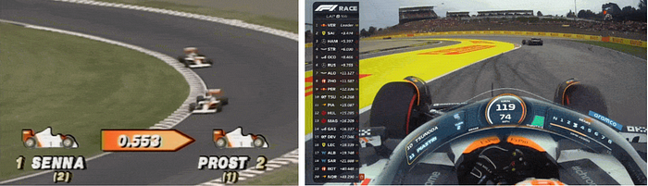
Figure 1: 1989 graphics compared to 2023 graphics [25]
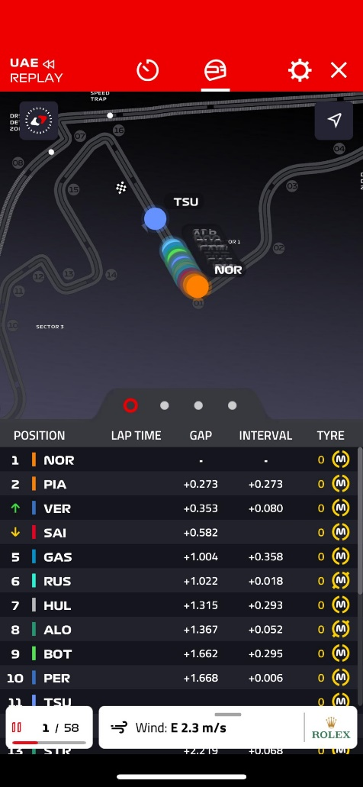
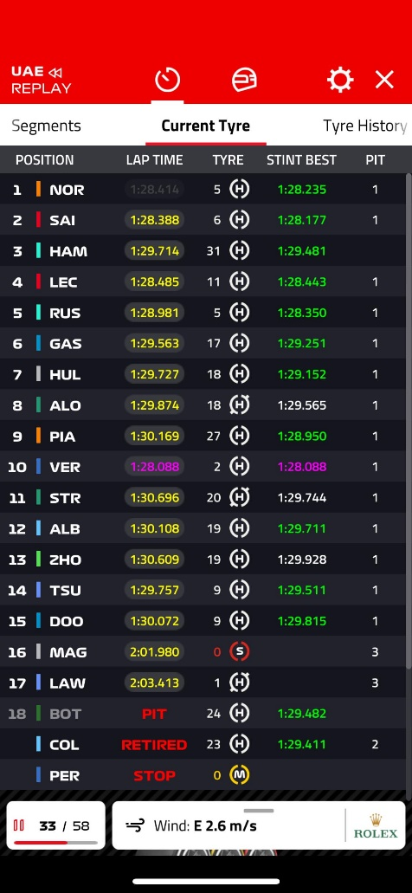
The introduction of Soft Pauer's F1 Live Timing and Track Positioning App in 2008 marked a significant milestone, processing data from trackside sensors and delivering real-time car positioning, timing data, and race information to fans worldwide [26], [27]. Sebastian Vettel noted the app's value for race analysis, particularly using the dynamic circuit map and live timing features [27]. Since then, F1 has introduced their own live timing service in 2018, F1 TV, which includes more features like team radios and tire usage history [28].
Figure 2: The start of a race, showing a live track map and split times between drivers
Figure 3: Lap 33, showing lap time, current tyre, and pit count

Since 2012, the Fédération Internationale de l'Automobile (FIA) has slowly been providing the public with more data from each of the races. In 2012 they only provided the lap chart of the race as well as the results for the race and qualifying; now in 2024 they provide the results, best sector times, top speed, a lap analysis, and race control messages for each session that takes place [29]. From this and other sources, people have created their own database containing all the available information since 1950 [30].

F1 Game data
With the increase in publicly available data, games and simulators can take advantage of that. The F1 game series has taken advantage of that by constantly evolving through direct collaboration with F1 teams and drivers. According to Mather from EA Sports, F1 23's physics engine was fundamentally redesigned based on driver feedback, particularly focusing on traction characteristics [31]. Former F1 driver Anthony Davidson notably influenced the game's development by highlighting that real F1 cars have "phenomenal traction," leading to significant adjustments in the game's physics model [31].
F1 racing games have evolved to provide progressively more data telemetry through UDP (User Datagram Protocol), allowing players to mirror more closely that of real-world Formula 1. While real F1 teams generate over 1 terabyte of data per race weekend [23], the F1 24 game offers players access to an extensive range of telemetry data through UDP connections. According to the official documentation [32], players can access 15 different types of data packets, ranging from basic motion data to detailed car telemetry and session information. These packets include crucial racing metrics such as car speed, throttle application, tire wear, ERS deployment, and G-forces, allowing players to analyse their performance with many of the same tools used by real F1 teams [32]. Using certain packets, these give the players insights into all aspects of car performance, from precise timing calculations to setup optimisation, mirroring the data-driven approach taken by modern Formula 1 teams.

Packet Name | Value | Description
Motion | 0 | Contains all motion data for player’s car—only sent while player is in control
Session | 1 | Data about the session—track, time left
Lap Data | 2 | Data about all the lap times of cars in the session
Event | 3 | Various notable events that happen during a session
Participants | 4 | List of participants in the session, mostly relevant for multiplayer
Car Setups | 5 | Packet detailing car setups for cars in the race
Car Telemetry | 6 | Telemetry data for all cars
Car Status | 7 | Status data for all cars
Final Classification | 8 | Final classification confirmation at the end of a race
Lobby Info | 9 | Information about players in a multiplayer lobby
Car Damage | 10 | Damage status for all cars
Session History | 11 | Lap and tyre data for session
Tyre Sets | 12 | Extended tyre set data
Motion Ex | 13 | Extended motion data for player car
Time Trial | 14 | Time Trial specific data
Table 1: Table of packet information

Technology in Modern Motorsport
This section examines modern vehicle data collection systems and simulation technologies. It explores how vehicles gather information through sensor networks and CAN bus systems while also investigating the evolution of gaming physics engines and virtual reality in driving simulations.

Data Collection Methods in Modern Vehicles
Modern vehicles have evolved into complex data collection platforms that integrate multiple sensor systems to gather and process information continuously. The primary data collection infrastructure relies on a complex network of sensors connected to the CAN bus and On-Board-Diagnostics II (OBD-II) port [33]. These sensors are strategically positioned throughout the vehicle's critical systems, including the engine, brakes, and infotainment systems. Modern vehicles supplement this traditional infrastructure with smartphone integration, allowing for additional environmental data collection through mobile device sensors [33], [34].
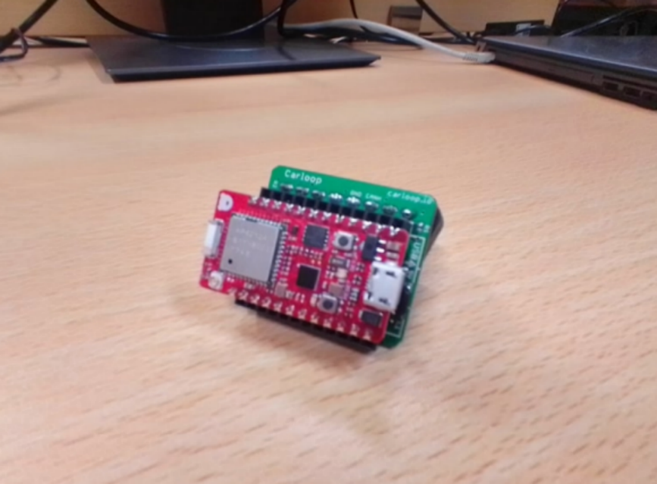
Figure 4: CAN transceiver and controller [33]
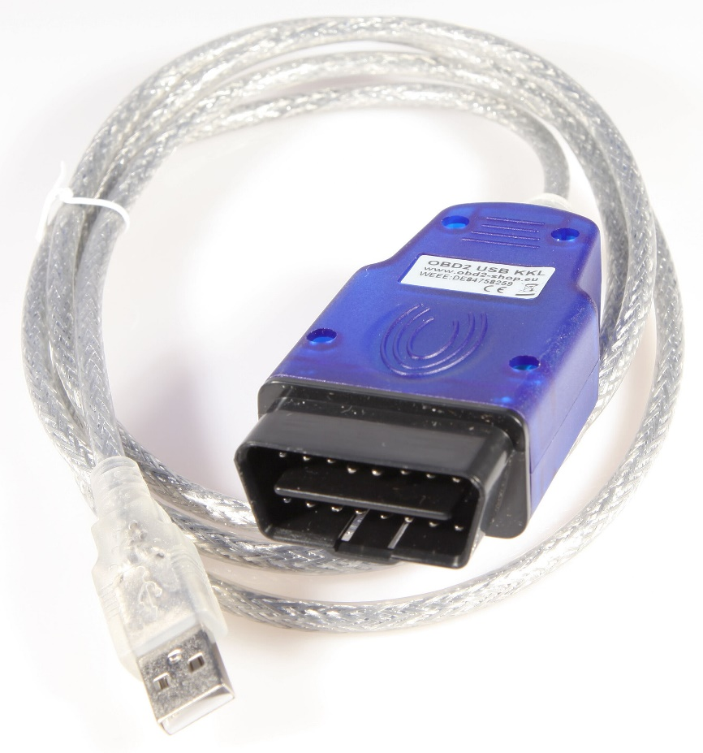
Figure 5: Obd USB kkl interface
The scope of collected data is remarkably comprehensive, encompassing seven primary categories: vehicle identification, customer account information, vehicle health metrics, driver behaviour patterns, biometric data, location tracking, and infotainment usage statistics [34]. The volume of data generated is substantial, often reaching terabytes per day from a single vehicle. This massive data stream requires complex processing systems and utilises both short-range communication technologies, such as Bluetooth Low Energy (BLE) and Wi-Fi, and long-range cellular networks for cloud connectivity [33].

Simulation Technologies
This segment investigates the technological advancements in gaming physics engines and virtual reality integration in driving simulations. It examines how physics engines have evolved from basic collision detection to complex real-time simulations while evaluating VR's effectiveness in driving simulators.

Evolution of Physics Engines in Gaming
The gaming industry has found creative ways to harness this collection of vehicle data through the evolution of physics engines. These engines first emerged in the late 1990s, with initial implementations focusing on basic collision detection and rigid body dynamics [35]. The development of sophisticated physics engines, such as the Bullet Physics SDK [35], marked a significant advancement in this field. These physics engines employ complex algorithms like Gilbert-Johnson-Keerthi (GJK) for convex shapes and the Expanding Polytope Algorithm (EPA) for calculating penetration depth in collisions [35].
As technology has progressed, physics engines have expanded their capabilities to include more advanced simulations, such as soft body dynamics for realistic cloth and rope movements. The integration of real-world vehicular data has enhanced these simulations, though developers must carefully balance accuracy and performance optimisations [35], [36]. Modern physics engines utilise GPU acceleration and multi-threading support to manage increasingly complex simulations while maintaining real-time performance. This has resulted in a gaming experience that combines authentic physical behaviour with engaging gameplay, creating virtual environments that respond and behave in ways that closely mirror real-world physics while remaining computationally efficient [35].

Virtual Reality Integration
As automotive interfaces and driver-vehicle interactions continue to evolve, researchers have turned to driving simulators for evaluation and testing. The advancement of physics engines in gaming platforms has significantly improved the realism of vehicle dynamics simulation, making them viable platforms for research. Building on this foundation, Walch Et Al. [37] investigated whether affordable virtual reality (VR) technology could enhance immersion in low-cost driving simulator setups. Their study compared VR headset displays with traditional flat-screen configurations. Their findings revealed that VR integration did not significantly improve overall immersion scores, though it did enhance real-world dissociation.
Previous research has shown that interface naturalness can influence perceived realism and spatial presence [38], [39], but the study found limitations with current VR technologies, such as reduced field of view and potential discomfort. Suggesting that while VR holds promise for driving simulation, current technological constraints may limit its advantages over traditional display methods in certain research contexts.

Driver Assistance Systems
This part will investigate the evolution and impact of vehicle safety systems, focusing on Traction Control Systems (TCS) and Anti-lock Braking Systems (ABS). It explores their technological development, implementation methods, and how these systems enhance both vehicle safety and performance capabilities.

Traction Control
Traction control systems (TCS) have evolved significantly since their introduction in the 1970s, becoming a mandatory safety feature in vehicles manufactured from 2011 onwards [40]. The system's primary function is to prevent wheel spin by utilising sensors shared with the anti-lock braking system (ABS) to maintain optimal road grip and vehicle stability [41].
Early traction control systems were limited by technological constraints, but significant advancements emerged in the late 1980s when premium manufacturers like Mercedes-Benz and BMW began implementing these systems in their high-end vehicles [40]. The technology gradually became more widespread as electronic control systems evolved, and manufacturing costs decreased [41].
Modern traction control systems operate continuously in the background, automatically activating when wheel spin is detected. The system responds by either reducing engine power to the affected wheel, applying brake pressure, or both [41]. This intervention is particularly crucial during acceleration from a standstill or when navigating slippery conditions [40].
Recent research has focused on developing more sophisticated control methods. According to Huang Et Al. [42], various control approaches have been explored, including fuzzy control, sliding mode control, and active disturbance rejection control (ADRC). These methods are particularly relevant for on-demand four-wheel-drive (OD4WD) vehicles, which face complex traction challenges during startup conditions. These advanced control strategies aim to improve system response and vehicle stability, particularly on μ-split surfaces where wheels encounter different friction coefficients.

ABS Implementation
Anti-lock braking systems (ABS) have evolved significantly since their initial development by Bosch in 1930, with the first electronically controlled four-wheel system appearing in 1978 [43]. This safety technology has become a standard feature in modern vehicles, fundamentally changing how drivers handle emergency braking situations.
The system operates by monitoring wheel slip, which is described as the relative movement between the wheel and road surface. When a wheel begins to lock, the ABS rapidly modulates brake pressure several times per second [44]. This pulsating action, often felt through the brake pedal, allows drivers to maintain steering control while maximising braking efficiency.
The core functionality of ABS relies on four main components: speed sensors, valves, a pump, and a controller [44]. These components work together to prevent the wheels from locking up during braking by monitoring wheel rotation and modulating the brake pressure. The speed sensors detect wheel rotation rates, while the valves control brake line pressure, with the pump maintaining appropriate pressure levels. The controller, effectively the system's brain, processes sensor data and manages the valves accordingly.
Research from Unguritu and Nichițelea [43] demonstrates that ABS effectiveness varies significantly across different road conditions. Their empirical research showed that the coefficient of friction between tires and road surfaces varies, with values ranging from 1.2801 on dry roads to just 0.05 on icy surfaces. This variation directly impacts ABS performance and stopping distances.

Impact on Performance
Recent research has highlighted the importance of traction control systems (TCS) in enhancing vehicle performance and efficiency. Indriawati Et Al. [45] investigated an innovative approach combining regenerative braking with ABS to improve both performance and energy efficiency. Their research showed that using sliding mode control (SMC) with feedback mechanisms allowed for dynamic adjustment of braking force based on real-time friction conditions. This integrated system achieved a 3.39% increase in battery state of charge while maintaining optimal slip ratios around 0.2 for maximum traction.
The development of anti-lock braking systems has significantly evolved to enhance vehicle performance and safety. According to Perkins [46], modern traction and stability control systems have transformed from being performance limitations to becoming performance enhancers. His investigation demonstrated that contemporary ABS systems can improve lap times by allowing drivers to brake later and harder while maintaining steering control, particularly in wet conditions.
Abdullah Et Al. [47] conducted extensive research on adaptive control techniques for ABS, revealing that traditional braking systems struggle with varying road surfaces and friction coefficients. Their study proposed a new feedback control mechanism that dynamically adjusts braking force based on current friction conditions. The research showed significant improvements in stopping distances and stability across different road conditions through the implementation of P-controllers for both input signals and friction parameters.

Data Visualisation
Data visualisation in motorsport has evolved significantly, transforming huge quantities of telemetry data into actionable insights. This section examines the development of visualisation tools and methods that enable teams to interpret complex data quickly, supporting strategic decision-making and performance optimisation in competitive racing environments.

Visualisations tools
Modern motorsport teams rely heavily on data visualisation tools to gain competitive advantages by analysing vast amounts of telemetry data generated during races. As Parker and Hargrave [48] note, "Data acquisition and analysis are an intrinsic part of motorsport, helping a race team objectively evaluate the performance of both their car and driver." The evolution of these tools has been driven by both technological advancements and the increase in the amount of data available.
To address these limitations, more advanced visualisation tools have been developed. Lowe and Matthee [49] identify six key requirements for effective big data visualisation tools: dimensionality reduction, data reduction, scalability and readability, interactivity, fast retrieval of results, and user assistance. In motorsport applications, these requirements translate to tools that can "squeeze a billion records into a million pixels" [49], ensuring that large visualisations remain readable across all screen sizes.
Traditional data visualisation approaches have remained unchanged despite significant advances in data collection technology. According to Parker and Hargrave [48], commercially available software has shown little development, with tools being “mainly tabular or graph-based software.” These conventional methods, while valuable for analysing broad performance trends, have limitations when examining specific events requiring the consideration of multiple data channels simultaneously.
According to Burnett-Thompson [50], modern visualisation dashboards help bring different data together. These dashboards include a wide range of visualisations such as speedometer gauges, RPM gauges, and G-force meters. Other common visualisation techniques include radar charts for multivariate data display, histograms for frequency distribution analysis, and scatter plots for correlation examination, along with using bar/column charts and line charts [50].
Three-dimensional visualisation tools have been investigated as an alternative to traditional methods. Taking inspiration from aircraft pilot training software that recreates flights as 3D animations using GPS and altitude data. Parker and Hargrave [48] developed a visualisation tool that graphically recreates a race car outing based on recorded data. This offers advantages including unlimited viewpoints, direct connection to captured data, and the ability to visualise vehicle components inaccessible to cameras.
As motorsport continues to generate volumes of data, the need for improved visualisation tools to accelerate data interpretation will become increasingly important.

Visualisation methods
Motorsport data visualisation methods have evolved to address the challenge of interpreting vast quantities of telemetry data quickly and effectively. As described in "How data visualisation is transforming motorsports," visualisation has become "a game-changer in motorsports by providing teams and drivers with valuable insights and strategic advantages" [51]. Understanding how these methods are implemented, and their respective strengths is crucial for maximising their effectiveness.
Performance dashboards are a fundamental visualisation method in motorsport. These dashboards serve as "user-friendly data displays, facilitating quick decisions based on live data feeds" [51]. By monitoring metrics like lap times, fuel consumption, and tire wear, teams can identify trends, detect anomalies, and adjust strategies during races. Dashboards combine multiple data streams into comprehensive visual displays that support rapid decision-making.
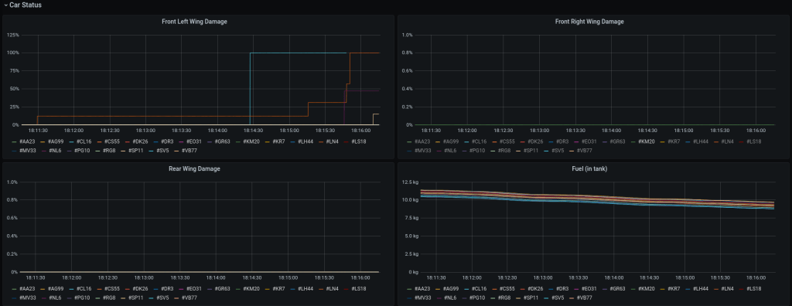
Figure 6: Dashboard with a few graphs
More advanced methods incorporate trajectory reconstruction to visualise vehicle paths. Parker and Hargrave [48] describe a technique that treats "the vehicle as a particle and approximating its cornering radius from the measured lateral acceleration and forward speed data." This allows teams to compare racing lines and analyse cornering techniques visually.
Bastin and Healey [52] demonstrate how modern visualisation methods have evolved to combine multiple data sources, using Sankey diagrams to visualise "the important events during the race for a driver, performance over the race, and perhaps most importantly, how performance changed if interventions to the car were performed during pit stops."
The development of optical displacement sensors (ODS) by Parker and Hargrave [48] represents a significant advancement in data collection for visualisation. When integrated with kinematic models, this approach enables the recreation of suspension behaviours and vehicle motion with high accuracy, offering an enhanced impression of the vehicle's dynamic behaviours.
As motorsport continues to embrace data-driven decision-making, the evolution of these visualisation methods will remain critical for extracting maximum performance from both vehicles and drivers.

Future Directions
Recent research has identified significant differences between simulated and real-world autonomous racing behaviours. Kalaria, Lin, and Dolan [53] demonstrate that traditional methods relying on already estimated tire models would often struggle to account for dynamic changes during actual races [53]. Their work highlights how environmental factors and tire conditions in real-world scenarios create complications that are difficult to replicate in simulations.
Further research by Kalaria Et Al. [53] shows that combining frameworks that use Extreme Learning Machines (ELMs) for tire force prediction can help close the gap between simulation and reality. Their approach demonstrates the ability to learn and adapt to changing environmental conditions in real-time, a key capability for transferring simulated learning to real-world scenarios [53].
Other studies have proven promising results in using deep reinforcement learning (DRL) to address the gap between simulation and reality. As documented by Evans Et Al. [54], trajectory-aided learning (TAL) achieves higher completion rates at high speeds compared to baseline DRL agents. The research highlights how TAL agents select realistic speed profiles that more closely match real-world racing conditions.

Conclusion
The reviewed literature displays the complex interaction between human performance, technological advancement, and data analytics in modern motorsport. From the evolution of driver training methodologies to the integration of advanced data collection systems, the field continues to push boundaries in both human achievement and technical innovation. The emergence of new technologies, particularly in simulation and autonomous racing, suggests future developments will further blur the lines between virtual and real-world racing. This combination of human expertise and technological capability will define the next era of motorsport, creating new opportunities for performance optimisation and competition formats.

Methodology

Research Methodology

Philosophy
The positivist philosophy will be used since there is a focus on observable data, which can then rely on factual evidence and statistical analysis for reviewing the data.
The positivist approach treats the data as objective, measurable facts. By collecting quantifiable data like lap times, speeds, and throttle position, these can then be analysed systematically. This philosophy supports the goal of making direct comparisons between different drivers and scenarios, as it relies on observable results. Statistical analysis can then be used to identify patterns in driving styles and establish conclusions between external factors and performance.
The main challenge with positivism is that it can overlook subjective aspects of driving performance, such as driver comfort, stress levels, or decision-making processes that are not directly measurable. To address this issue, collecting feedback from the drivers about their experience will help support the quantitative data. Additionally, including driver interviews can help with providing context about the data.

Strategy
The deductive approach was chosen as it allows a theory to be created and then proven with the data provided.
The deductive approach starts with new or existing theories about driving performance and tests them using the telemetry data. From this, hypotheses can be formed about how different factors affect driving performance, which can then be systematically tested. This helps validate or deny theories about driving techniques in addition to also providing a clear tool for comparing different scenarios and driving styles.
The limitation of this approach is that it might restrict the discovery of unexpected patterns or innovative driving techniques that were not part of the initial hypotheses. To help mitigate this, include tools that will allow the users to explore the data freely. This allows the users to visualise and interact with their own data at will, allowing them to identify unexpected relationships or patterns.

Approaches

Literature Review
A literature review was conducted so that some information was collected to provide some academic context before starting to develop the project.

Software Development
The software development was chosen since the project revolves around creating a data visualisation tool that the motorsports department can use.

Case study
A case study was used because the project will be built for the motorsports department and tailored to what they need. This will involve communication to find out what the issue is and how they will use the program.

Risks & Limitations
Some of the potential risks and solutions for the project include:
Lack of data: If there is not enough data, then more data must be collected. Collecting data for the simulator can be done in a simulator, whereas data for real life involves having to take the car out for a track day.
Software takes too long to complete. If the software cannot be completed by the due date, then the priority for the program is to get the essentials done plus one feature request.

Validity, Reliability & Generalisability

Validity
Since the problem revolves around needing to create displays of different X and Y axes, creating software is a good way to solve this problem since it allows for a quick and easy way of displaying data. This project also uses real and simulator data, so this is an ideal way to solve this problem.

Reliability
If another researcher were to do the same experiment and they used the same or similar type of data, with the requirements allowed for this project, it means someone else is likely to get the same results.

Generalisability
This can be applied to any situation that involves telemetry data of cars going round a track. It can be applied to any file if it has the same file structure; otherwise, the program will need minor tweaks to be able to convert the data.

Data Evaluation Methods

Data Collection
The data used will be provided by the motorsports department, and this will include their simulator and real-life data of Brands Hatch and Pembury circuits in the MCR and some ViGrade data of Brands Hatch. This data will be provided as a CSV file.

Data Evaluation
The way the software will be evaluated will be based on user feedback and expectations. This will be done by the end user and will cover whether it is easy to learn, can be used effectively, and if the user understands what it is doing.

Development Methodology

Software Development Methodology
The development methodology that will be used is the feature-driven development, since this is a more structured approach that focuses on developing features. Each feature will be planned out and designed, followed by implementing it and then testing it to make sure it works.

Resources

Hardware Resources
The only hardware that would be needed is a computer to run the software. However, if more data is needed, then a simulator would be required to gather more data.

Software Resources
No additional software is required to run the program. If the user wanted to edit the program, then Python would be required. If more data needs to be collected, then the software needed would be simulator software like Automobilista.

Information Resources
The data will be provided by the motorsports department and will consist of real-life and sim data, with the data formats consisting of Motec and ViGrade data.

Human Resources
The only other person that is needed for the project is someone from the motorsports department since it is a case study and will require their input about what will be included in the project. This could be the driver or someone from the team to provide feedback about what the project will be about and to provide feedback about the result of the project.

Development and implementation

MoSCoW
To gather the MoSCoW requirements, a meeting was set up with a representative at the motorsports department, Dr. Tim Tudor, to discuss the issues he was having with his current software and what he would or would not want in this new software.

Must have
The program must have a user interface.
It can allow raw data (CSV files) or converted data (database files) to be imported.
It must overlay each channel (data) with each other and across other databases.
It must contain a list of checkboxes to allow the user to select which channels (data) to view.

Should have.
It should default to a time/distance graph.
It should have an option to offset data for synchronisation across databases.
It should display custom graphs like scatter and histogram, also allowing any variable on the x and y axis.

Could have
It could have the ability to create Math Channels (write equations to calculate additional channels from measured data).
It could have unit selection so data can be converted to different units.
It could have graph customisation (labels, legend, line colour) so users know what they are looking at.

Will not have.
It will not have a full user interface customisation (colour, style, layout).
It will not have any live display for sim or real-life data to compare against.
It will not have the ability to display 3D graphs for track maps and custom graphs.

Csv file to database
The converter transforms an input file (as a path to the location of the file) into an SQLite database while preserving all data and metadata.
The system accepts file paths as input parameters, validates file existence and readability, and initially it only supported Motec CSV files. It processes data by reading and formatting content from input files, extracting relevant metadata, and structuring everything for SQLite storage. The converter creates an SQLite database in the same directory as the source file, implementing a table structure where column headers represent variable names.
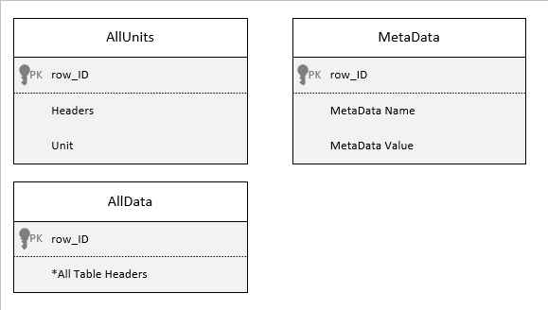
Figure 7: Database structure, version 1
The main challenge encountered was handling different data sources with varying formats, variable names, and units. The solution was to convert each source, regardless of its format, and convert it into an SQLite file, allowing for easier data manipulation. This would then require the main program to manage format differences. Data inconsistency between files posed another issue, particularly with comma-separated beacon marker information in CSV files, which required selective skipping during processing.
Testing with various datasets confirmed successful SQLite database creation with all required data. The simulator data generated warnings about extra commas, but these were effectively bypassed as they originated from metadata fields.
The database structure was later modified from the original design because it could not easily handle different data sources and complicated data retrieval. The new structure, though increasing file size by approximately 2.5 times and significantly extending database creation and processing time, provided better flexibility.
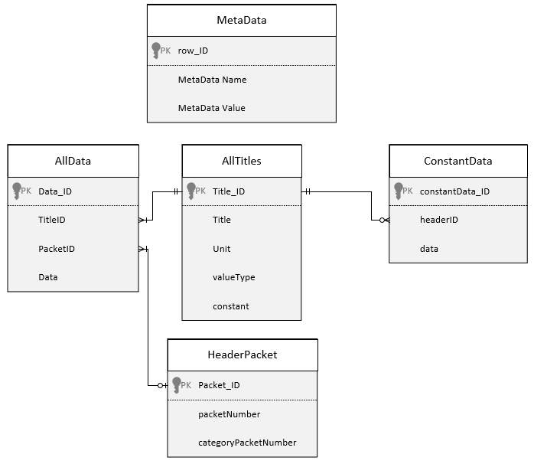
Figure 8: Database structure, version 2
The design went through another smaller redesign for it to store similar data on the same row across multiple columns rather than each data point in its own row, making it easier to organise related telemetry data into groups for analysis and comparison.
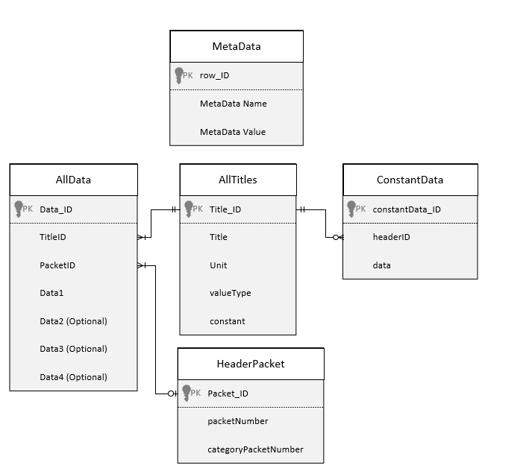
Figure 9: Database structure, version 3

Main UI
The main UI is the foundational framework for the application; it was designed with placeholders for future features. The interface has been designed with distinct colour-coded elements to distinguish elements from each other.
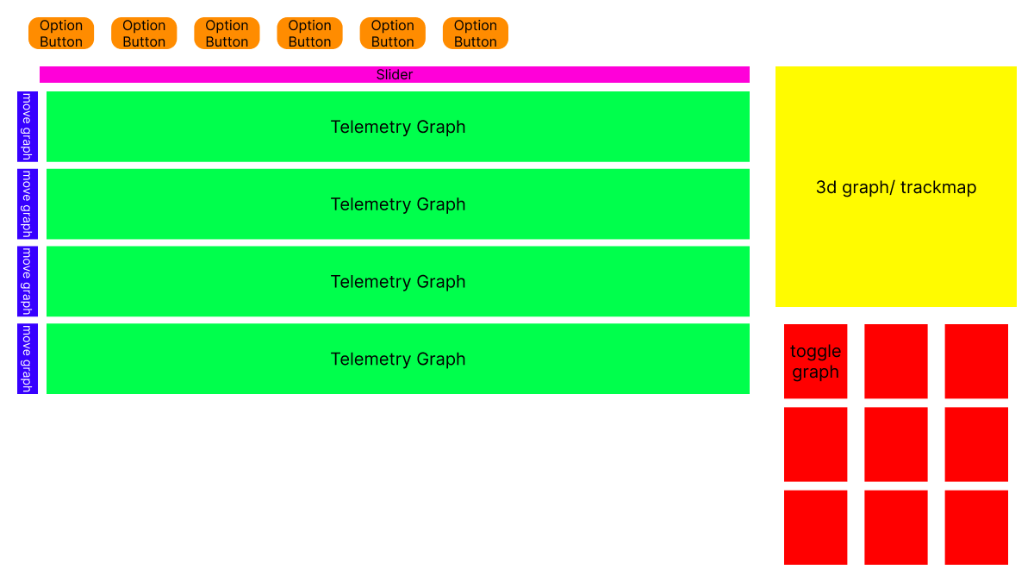
Figure 10: Main UI, wireframe
The primary challenge during implementation was arranging interface elements efficiently. This was resolved by organising components into separate layer groups, allowing elements to be modified individually. This approach allowed easier management of the interface's complexity.

Figure 11: Main UI, layered structure
Testing confirmed the UI ran without errors and responsively adapted to window size changes. The interface displays differently on Windows 10 and Windows 11, with alternative styles documented in the appendix.
Later improvements included a performance upgrade by migrating from matplotlib to pyqtgraph, which significantly increased graph rendering speed. This change allowed graphs to be preserved rather than deleted when closed, improving the user experience by reducing loading times when reopening graphs.
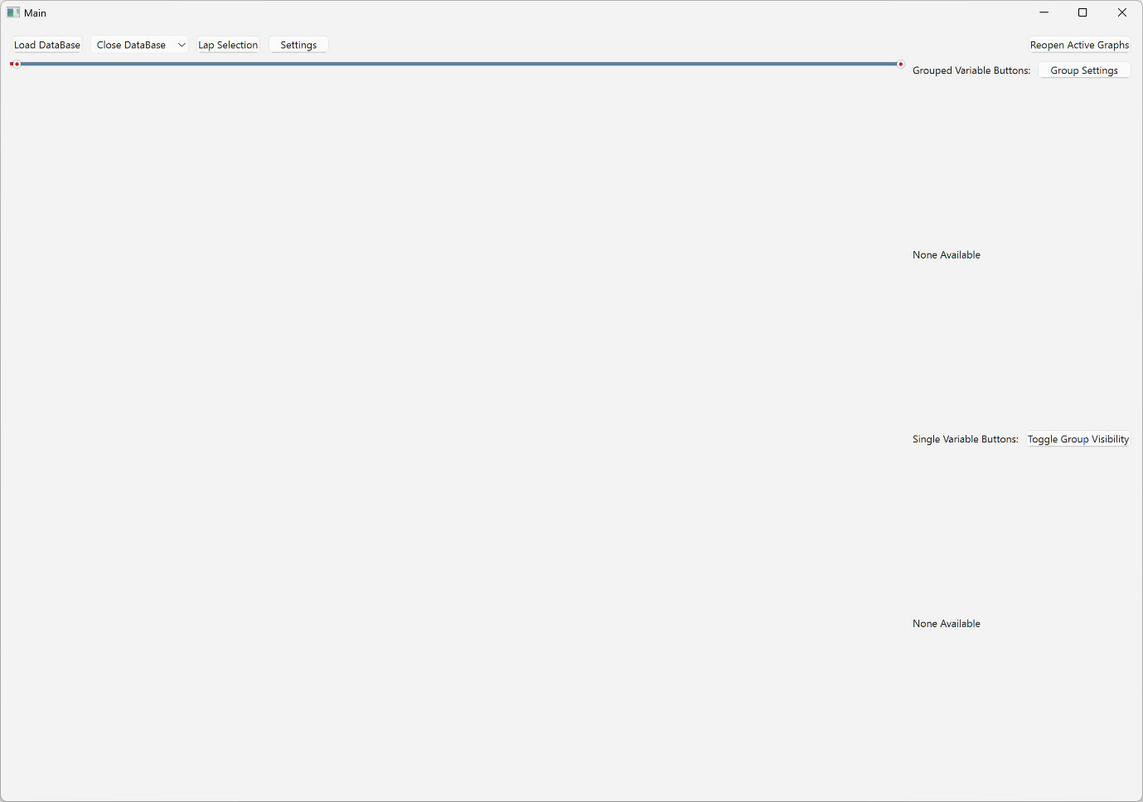
Figure 12: Empty Main UI

Creating graphs
The plan for implementing graphs was to create a system around class instances to encapsulate the graph functionality. This approach allowed data to be directly assigned to specific graphs upon class creation.
The first feature for the graphs after it was implemented was to allow the user to reorder them through dedicated up and down arrows positioned beside each graph. The next feature that was implemented was a way to toggle the graphs. This initially started out by deleting and recreating the graphs each time, but this was later changed, due to performance benefits when loading large amounts of data, by simply showing and hiding the graphs.
The main challenge encountered was optimising performance when displaying multiple graphs simultaneously. As more graphs were added to the display, noticeable slowdowns occurred during content updates but were later changed by swapping the module that was used to display the graphs from matplotlib to pygraph.

Data implementation
The data implementation features enabled file importing through a user interface. When a user selects a file via a file explorer dialogue, the system reads header names from the allHeaders table and generates corresponding buttons. Pressing these buttons opens the database, selects the relevant data, and displays it on a graph. The system retains data in memory when toggles are hidden to improve performance. Initially, support was limited to a single database while button organisation and variable grouping frameworks were being built and tested.
To enhance organisation, grouped button functionality was introduced above the single variable buttons. This required the database to be altered to be able to store similar variables together in multiple columns rather than separate rows. During database imports, the system now reads the headers table and categorises variables as either grouped or single based on the columnType field. Group buttons generate graphs displaying multiple related data points simultaneously. This change significantly reduced file sizes (25-64% decrease) for most test files, though some increased by approximately 11%.
Figure 13: Database structure, version 3
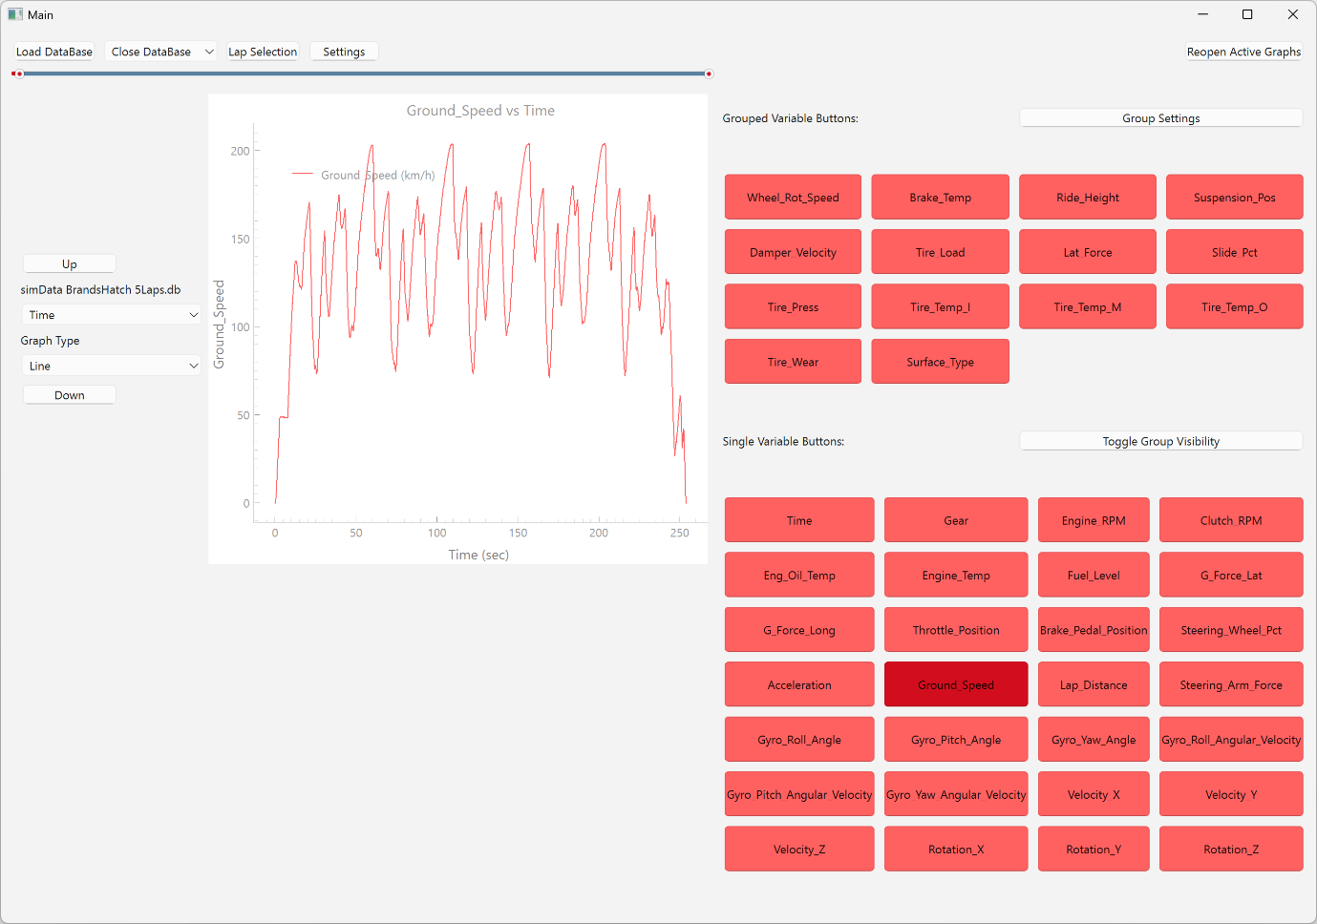
Figure 14: Main UI with graph

Group Management UI
Group management functionality was then implemented after grouped data was introduced.
This allows users to create, modify, and delete data groups. To manage these features, a new user interface was created. This new UI can display all the groups and provides controls to create new groups, select variables from available telemetry data, and save and update the current group. When a user selects a group, the system displays all available variables with checkboxes, highlighting those currently included. Visualisation capabilities allow users to display all group variables on a single graph with one click. Testing revealed no significant issues, except when importing a second database—the UI continued displaying information from the first database, and interaction attempts generated errors.
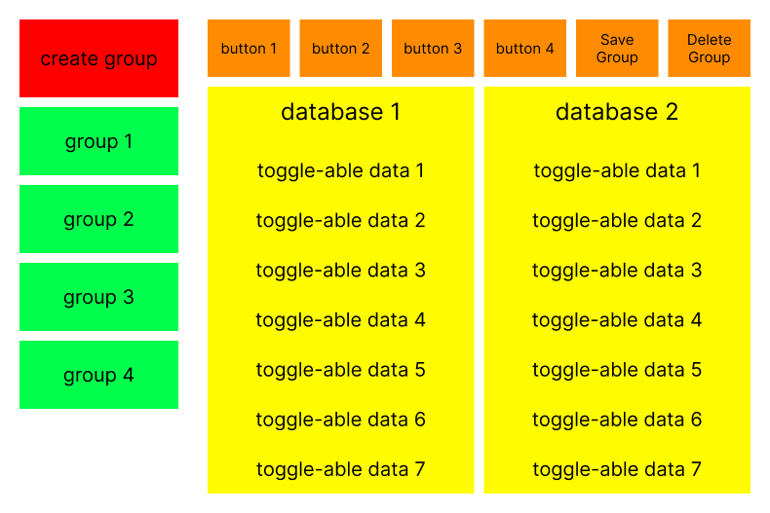
Figure 15: Group management UI, wireframe
The issue was later fixed, but a new problem occurred. All the buttons look the same, making selecting data for a certain database more difficult. So single and grouped buttons were now assigned colours based on their source database, with new databases appearing below existing ones and separated by colour. Further work was added to accommodate when databases were disconnected, linked buttons disappeared, and remaining buttons shifted upward. Similarly, in the group management interface, new databases appeared at the bottom of the list, and their variables appeared side by side in the variable list. When variables were selected from different databases, groups correctly assigned the appropriate variables. Testing confirmed successful implementation, with the only notable issue being inconsistent visual scaling of differently sized data.
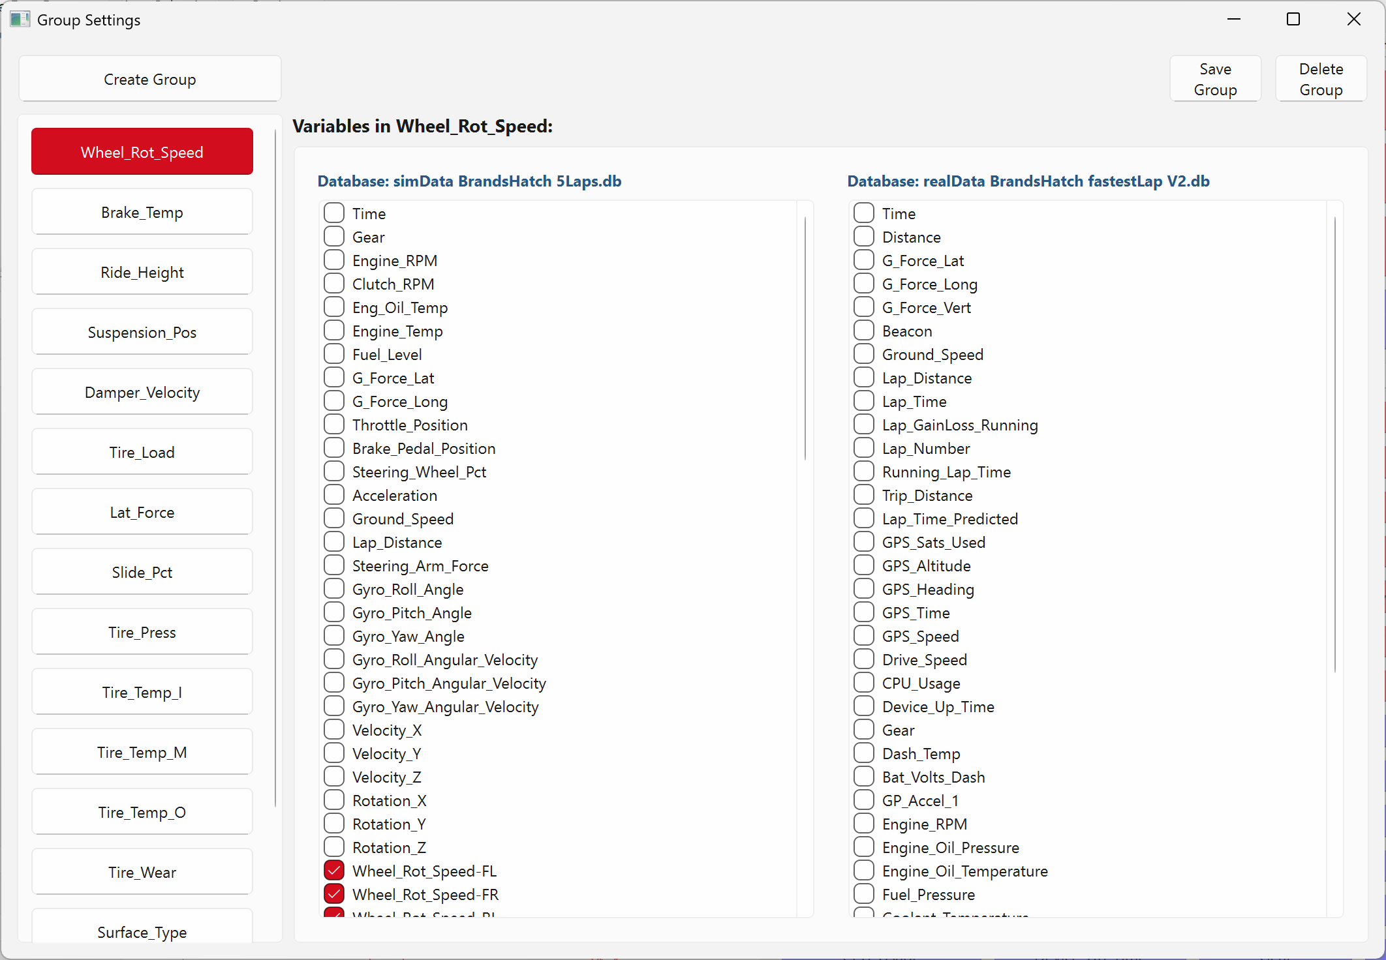
Figure 16: Management UI with data

Lap Selection UI
The next feature that was implemented was splitting the data into laps and a UI to select the available laps.
The lap splitting feature allows the user to identify and display specific laps from telemetry data. Users select a data variable (such as distance or lap number) and a detection method, which then processes the data to identify individual laps.
Two primary algorithms were implemented. The first uses lap number data, searching for unique values and determining their packet ID ranges. The second analyses distance data to detect lap boundaries by identifying significant drops in value, which indicate crossing the start/finish line. Multiple detection methods were refined to improve accuracy and handle gradually resetting measurements.
After detection, laps are stored with their starting and ending indices, allowing users to select specific laps to display on the graph. When selected, the system retrieves only the relevant data points for each chosen lap, displaying them stacked vertically for easy comparison.
The feature was later enhanced to store detected lap information directly in the database, eliminating the need to reprocess data each time the software is launched. This improvement significantly reduced processing time when reopening previously analysed databases.
Along with the method implementations, a UI was created that allows the user to identify laps and display them on graphs. There was a section at the top that was broken down into sections for each database; within those sections was a dropdown to select a variable from the data and a method that was going to be used. Below that you can select a graph, then select what laps to display, with it defaulting to all data.
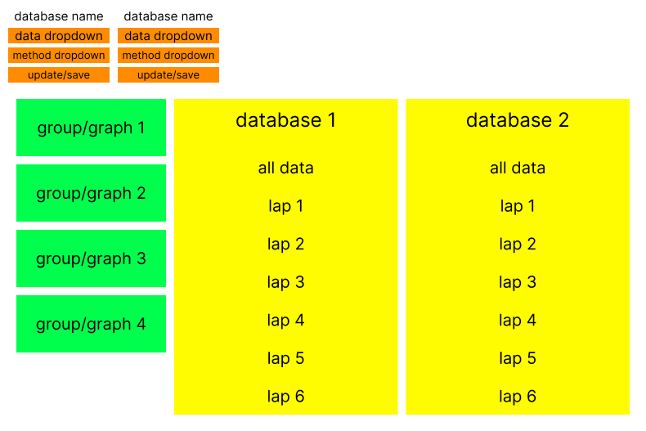
Figure 17: Lap selection UI, wireframe
The lap selection UI successfully displays selected laps stacked above each other for comparison. Testing confirmed that all functionality worked correctly, with selected laps appearing in graphs as expected.
Figure 18: Lap selection UI with data

Synchronising data of different sizes
Most of the time, when plotting datasets from different databases, they appear misaligned, with one dataset being bigger than the other one. To properly align datasets of different sizes would require a solution to ensure accurate graphical comparison. Therefore, two methods were implemented to address this issue, prioritising either performance or precision based on the user’s needs.
The destructive method evenly down-samples larger datasets to match the length of smaller ones by removing values equally spaced apart. This approach prioritises computational efficiency but sacrifices some data resolution. Alternatively, the constructive method inserts NaN (Not-a-Number) values at equal intervals within smaller datasets to match the length of larger ones. When plotted, the graph maintains visual continuity by connecting data points across these NaN values.
Implementing this required modifying the data processing order to include a preprocessing step that analyses dataset dimensions and applies the appropriate synchronisation method before visualisation. Later this system would be changed to accommodate different X axes, which is when the realisation came that this synchronisation was not needed since data would automatically be synchronised with distance or time. This resulted in this feature becoming a backup option for when data could not be plotted with distance or time.

Update the graph synchronising
The graphing system was enhanced to allow more flexible plotting options. Previously, data was displayed against fixed axes, but this new feature enables users to select custom variables for the X-axis.
The system will maintain backward compatibility by defaulting to the fixed axes method when no data is defined. When the user specifies data preferences, the system prioritises them in a logical sequence: cumulative lap distance, cumulative lap time, running lap distance, and running lap time.
The user can change what is plotted on the X-axis with a dropdown that is next to the graph and in between the up and down arrows. In addition to this, the interface was expanded with functionality to generate scatter plots and histograms through a simple button toggle, which has been placed below the dropdown.
Testing revealed that single database operations function as expected, but multi-database graphs experienced issues with the X-axis selection dropdown. This limitation was identified for future resolution to ensure consistent functionality across different data sources.

Settings UI
The Settings UI was designed as a tabbed interface to manage various configurable options. It consisted of pages accessed through bookmarks at the top, with each page containing related settings. Figure 19 shows what a generic page of the settings UI looks like.
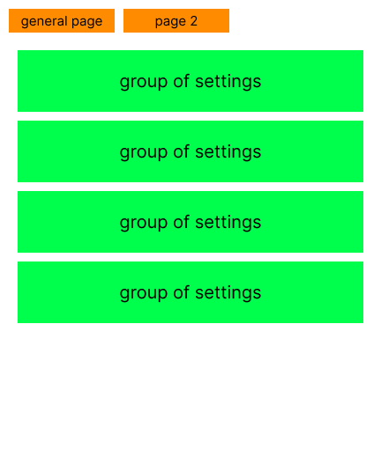
Figure 19: Generic settings UI, wireframe
The first page collected standard data variables through dropdowns for each database, allowing users to select headers representing specific data types. Upon saving, any new graphs will be plotted against one of the data specified. With this implementation, the identifying laps feature in the lap selection UI was not needed since this feature would automatically identify laps based upon what data was given. With the identifying laps feature not needed, it could be removed or repurposed.
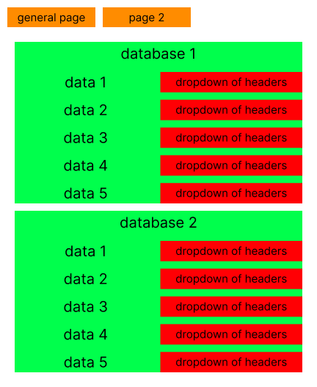
Figure 20: Page 1 settings UI, wireframe
The second page focused on data display customisation, providing controls for each database's headers. Users could toggle data inversion and adjust shift amounts to properly align datasets. This functionality was particularly important for comparing data from different sources where data might not always start and end at the same point.
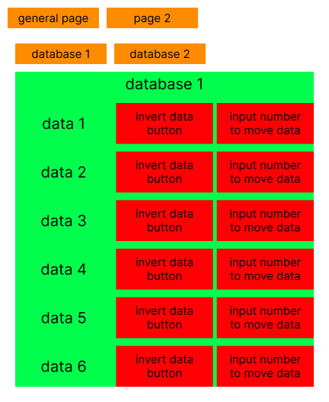
Figure 21: Page 2 settings UI, wireframe
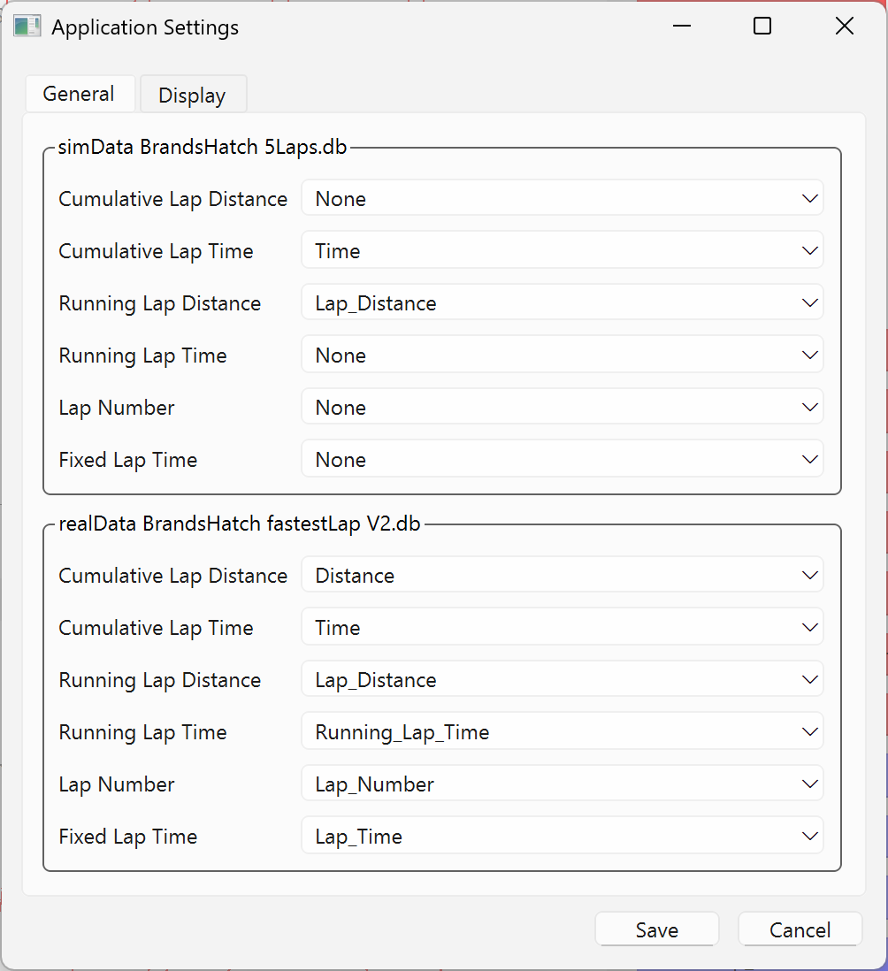
Figure 22: General page, settings UI
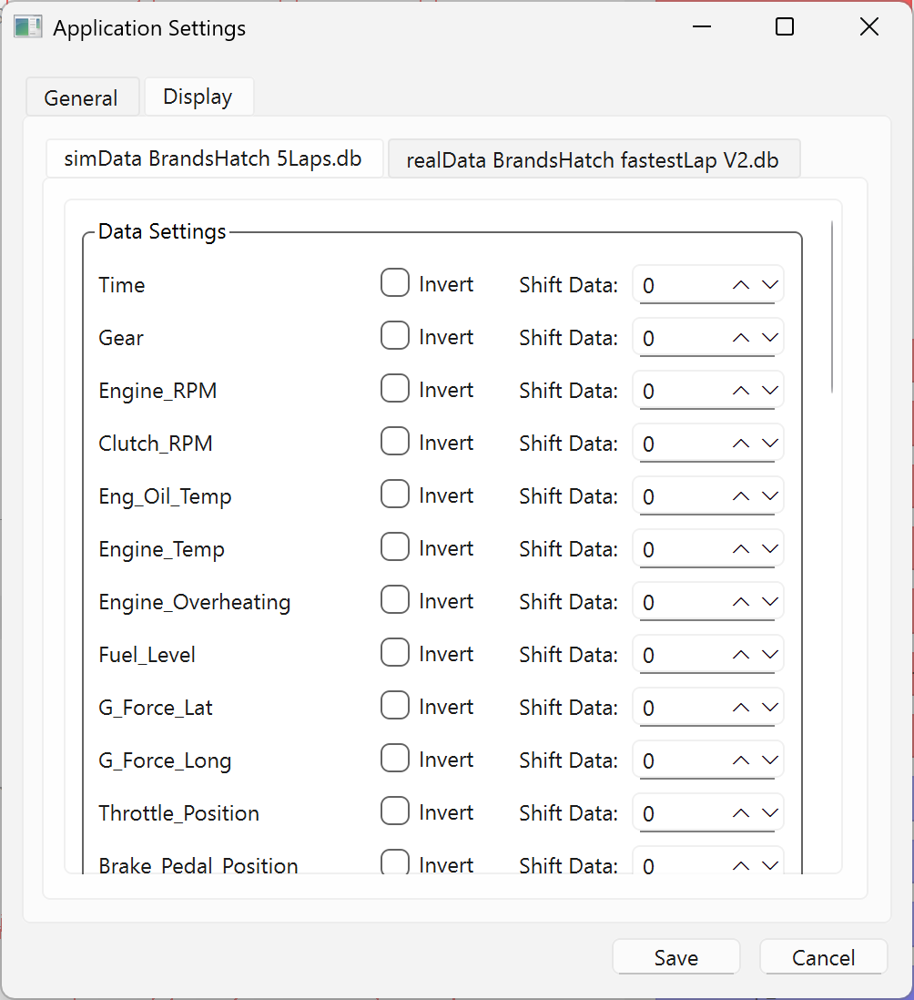
Figure 23: Display options, settings UI

Testing and results
The testing phase of the software consisted of evaluation during a track day event, and user feedback collection from interviews and surveys, with the survey containing a usability assessment using the System Usability Scale (SUS). These methods provided insights into the software's functionality, user experience, and areas requiring improvement.
During a private track day test, the program was tested to make sure everything worked as intended. After receiving new data from sessions earlier in the day, the first issue occurred. Performance issues were observed during the test day, primarily with the data conversion, when the testing laptop used is either slow or operated in battery-saving mode. The conversion process took over 10 minutes under power conservation settings; upon plugging the laptop in and operating in high performance mode, it completed the process within one minute. Highlighting a potential limitation when the program needs to run on multiple devices of differing power and processing speeds.
After the processing of all the new data was completed, testing with that new data showed that there was not any other technical issue with the program that needed to be fixed; however, it did highlight some quality-of-life features that could be implemented. A significant issue was the repetitive workflow required when a user needed to display the same lap across multiple graphs, as each graph required individual lap selection. This suggested a need for a global lap selection feature to improve the efficiency. A problem emerged with the user interface when trying to compare multiple databases. The high number of variables caused buttons to become compressed and unreadable, making accurate selection difficult.
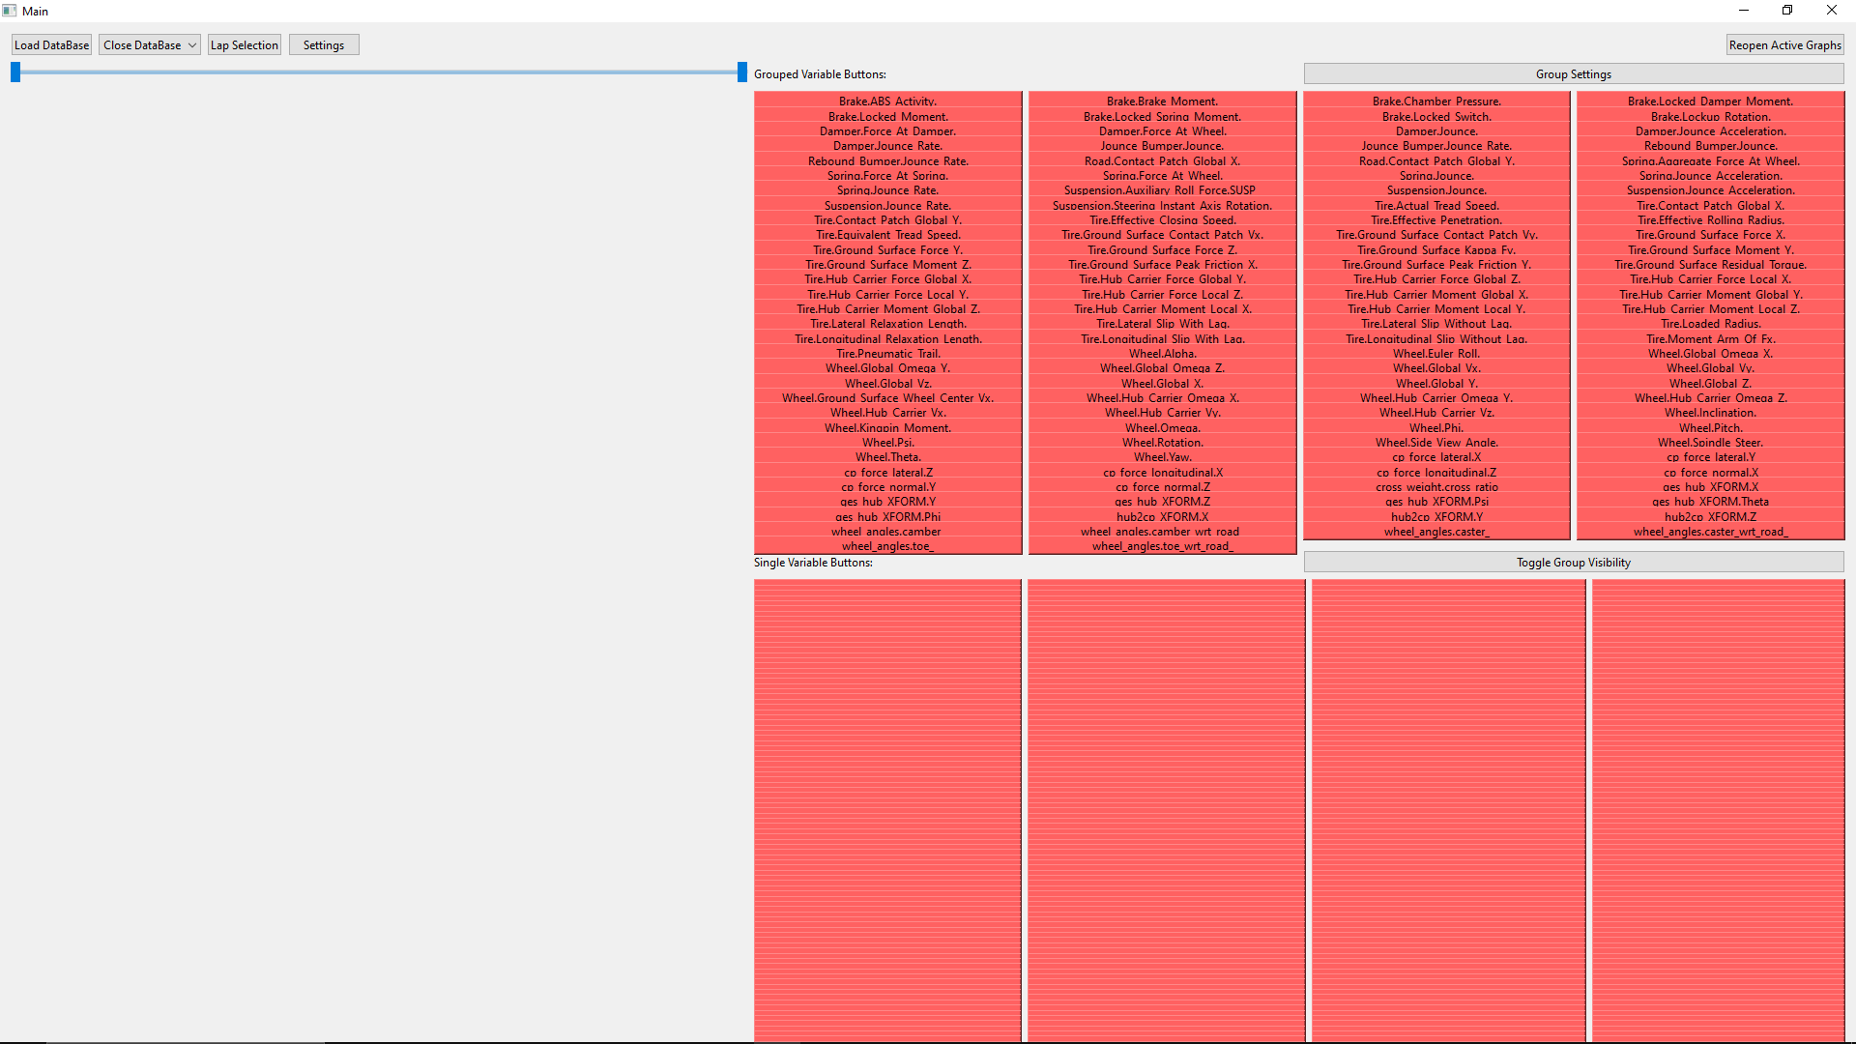
Figure 24: Cramped buttons
During the survey they filled out a set of questions for the System Usability Scale (SUS) [55]. The SUS assessment yielded an average score of 58.75, falling slightly below the industry average of 68 [56], which indicates acceptable usability. Individual scores varied greatly (82.5, 80, 50, 52.5, 47.5, 40), suggesting inconsistent user experiences across different participants. The higher scores (80+) came from users who valued the program's specialised functionality, while lower scores reflected difficulties with interface clarity and feature discoverability. This highlights the need to address both the experienced users who appreciate the technical capabilities and novice users who require clearer guidance.
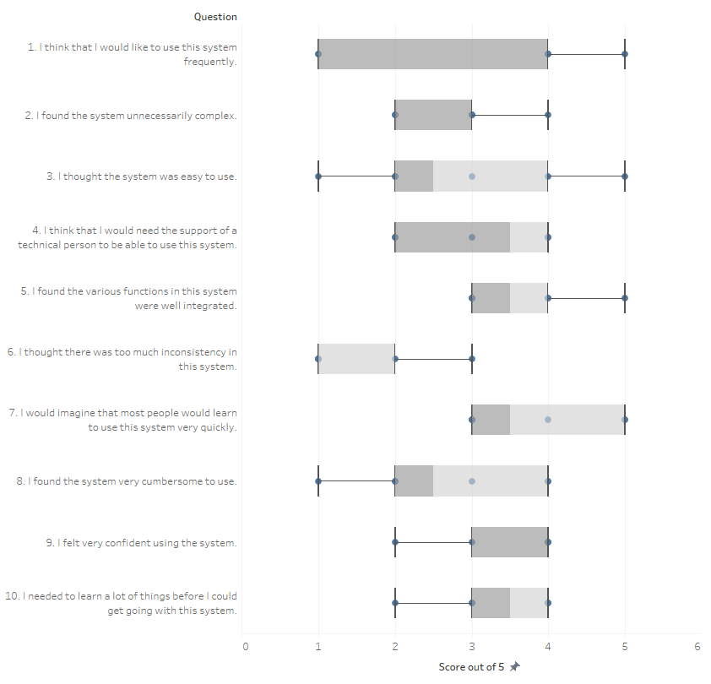
Figure 25: SUS box plot answers
User feedback from interviews and surveys revealed several strengths of the application. Participants specifically appreciated the ability to graph individual data measures and allow them to alter the graph type (line, scatter, or histogram) or change the X-axis value. Users also like the ability to create custom groups of related variables and the effective use of widescreen display for visualisation. The software was noted as being "easy to use" after an initial learning period, with users reporting that it became more intuitive over time. Compared to the previous Excel-based workflow, users found the new system more efficient, especially for viewing individual laps. It was also convenient to have all its functionality in a single package that required only one file to be opened.
However, users identified several areas for enhancement. The slider that adjusts the graph data range lacked sufficient explanation, causing initial confusion about its function, but they quickly understood what it did after trying it out a few times. The inconsistent ordering of variables in dropdown menus between databases created difficulties when searching for specific data points, with a suggestion saying to sort the dropdown menus alphabetically. Some interface elements, particularly buttons, lacked visual cues that would make their function more apparent to users. These issues point to opportunities for improving interface design and providing clearer visual indicators of interactive elements.
Users also suggested several features that would enhance the software's functionality. The ability to rename groups, especially for new groups, would improve organisation and reference. Adding interactive data points, when the user hovers over the graph points, information about what is in that column would facilitate more detailed analysis. Several users expressed a desire for a tutorial or a guide on how to use the program, particularly to explain what something does and how to use it, with recommendations saying to add a help button to explain specific features like the graph reordering controls. These suggestions align with the observed SUS scores and highlight the need for improved onboarding for new users while maintaining the advanced functionality valued by experienced analysts.
In conclusion, the testing phase revealed that while the software provides valuable functionality for telemetry analysis that improves upon previous methods, there are significant opportunities to enhance usability, particularly for new users. Addressing the identified interface issues and implementing the suggested features would improve the overall user experience and increase the software's effectiveness as an analytical tool.

Discussions and Recommendations
The development of this telemetry analysis software addresses a critical need in motorsport by enabling efficient visualisation and comparison of data across different sources. The research demonstrates that while powerful data collection systems exist in motorsport, there remains a significant gap in accessible analysis tools for smaller teams and educational environments. The software successfully implements core functionality for importing, visualising, and comparing telemetry data, with features like lap selection, custom grouping, and visualisation options providing substantial improvements over previous Excel-based workflows.
User testing revealed a mixed response with SUS scores averaging 58.75, suggesting a moderate usability challenge that particularly affected new users. While experienced analysts valued the specialised functionality, the interface design could be improved to develop exploration and feature discoveries. The performance issues during data conversion highlight the importance of considering varied hardware environments in motorsport applications.
This software offers practical benefits for race engineers analysing driver techniques across multiple sessions. For racing applications, teams can quickly identify performance differences between their simulator and previous sessions. In teaching environments, instructors can overlay student and instructor data, visually demonstrating proper racing lines and braking points with synchronised telemetry, or it can also be used to show technical concepts about what the car is doing.
There are a few recommendations and future ideas that could be implemented. The data synchronisation could be improved through a global shifting option and a simple drag-and-drop system, eliminating the need to access separate interfaces. On top of this can be Y-axis shifting to provide additional visualisation flexibility.
The lap selection interface could benefit from a global selection feature, allowing users to view specific laps across multiple graphs simultaneously. An update to the distance algorithm would improve visualisation, though some data might be sacrificed during reset periods.
For advanced users, implementing math channels would enable custom data creation through mathematical operations, from basic arithmetic to complex functions like logarithms.
Additional improvements could include the ability to hide specific data points cluttering graphs, such as zero readings during gear changes. Another way to declutter graphs is to add a moving average functionality, smoothing out noisy data points.
A few user interface changes, like a scrollable grid for the variable buttons, to prevent interface congestion when handling databases with vast amounts of variables.
Future development should focus on implementing user-suggested features such as interactive data points, improved organisation of variables, and user interface changes. These enhancements would bridge the gap between the software's technical capabilities and its accessibility, allowing telemetry analysis to be more approachable for a range of motorsport professionals and students.

Personal reflection
Throughout the project, I found that consistent, incremental progress yielded better results than sporadic effort. Daily short sessions proved more effective than longer, less frequent work periods. This approached allowed me to maintain steady momentum and progress while preventing burnout.
Whenever I had to do a lot of work for one section I preferred to break it down into manageable components. The main situation this was used was with the literature review, dividing the work into smaller segments made the task less daunting. This occurred while working on the literature review, by dividing it into smaller segments making the tasks less daunting and easier to approach daily. Similarly, when developing the program, I created small test programs for specific modules and features. This allowed me to try multiple options before implementation and test smaller functions independently before integrating them into the main program, enabling easier debugging and experimentation.
I gained particular satisfaction from successful user interface implementations. Seeing components function as intended provided visible evidence of achievement, especially given that I anticipated struggling with UI development from the start.
Initially, I overestimated how much I could get done, incorporating too many features into my plan. However, a mid-project rethink helped me adjust the priorities and exclude some non-essential elements, resulting in a simpler yet more refined final product. Nevertheless there are plans for the program project to continue development afterwards allowing for some of the excludes features to be implemented at a later data.
Upon reflection, I would have approached certain aspects differently. With thorough planning for the UI layout would have improved the usability. Additionally, restructuring my implementation sequence to focus more on building a solid program foundation first would have facilitated easier feature implementation throughout the development process.

References
[1] D. Bianco Nicola, L. Roberto, and G. Marco, ‘Minimum time optimal control simulation of a GP2 race car’, Aug. 2018.
[2] T. Guhan and K. Karthikeyan, ‘Analysis of Lap Times in Formula-1 Motorsport due to Regulation Changes Using Polynomial Regression’, Jan. 2021. [Online]. Available: https://www.researchgate.net/publication/361588838
[3] M. Gabiccini, L. Bartali, and M. Guiggiani, ‘Analysis of driving styles of a GP2 car via minimum lap-time direct trajectory optimization’, Multibody Syst Dyn, vol. 53, no. 1, pp. 85–113, May 2021, doi: 10.1007/s11044-021-09789-7.
[4] Driver61, ‘Is 10 000 hours of practice necessary? | Youth61 - Driver61’, https://driver61.com/sim-racing/3-tips-for-improving-your-childs-race-performance-is-10-000-hours-of-practice-necessary/. Accessed: Jan. 02, 2025. [Online]. Available: https://driver61.com/sim-racing/3-tips-for-improving-your-childs-race-performance-is-10-000-hours-of-practice-necessary/
[5] R. Bentley, ‘Q: What’s the best way to practice sim racing? | Speed Secrets’, https://speedsecrets.com/q-whats-the-best-way-to-practice-sim-racing/. Accessed: Jan. 02, 2025. [Online]. Available: https://speedsecrets.com/q-whats-the-best-way-to-practice-sim-racing/
[6] M. Burgess II, ‘Track sessions to simulators: discover how F1 drivers sharpen their skills’, https://www.redbull.com/gb-en/how-f1-drivers-practice. Accessed: Jan. 02, 2025. [Online]. Available: https://www.redbull.com/gb-en/how-f1-drivers-practice
[7] D. von Moltke, ‘Learn To Drive Like a Professional Driver Off the Racetrack. A Few Skills You Can Work on While Driving Your Everyday Car.’, https://blayze.io/blog/car-racing/learn-to-drive-like-a-professional-racecar-driver. Accessed: Jan. 02, 2025. [Online]. Available: https://blayze.io/blog/car-racing/learn-to-drive-like-a-professional-racecar-driver
[8] T. Francks, ‘The Mindset of a Racer: Understanding Racing Psychology’, https://www.grandprix247.com/2023/12/22/the-mindset-of-a-racer-understanding-racing-psychology/. Accessed: Jan. 02, 2025. [Online]. Available: https://www.grandprix247.com/2023/12/22/the-mindset-of-a-racer-understanding-racing-psychology/
[9] Speedway Motorsports UK, ‘How often do professional racecar drivers practice?’, https://slkmotorsltd.co.uk/how-often-do-professional-racecar-drivers-practice. Accessed: Jan. 02, 2025. [Online]. Available: https://slkmotorsltd.co.uk/how-often-do-professional-racecar-drivers-practice
[10] N. Bohra, ‘The Psychology of Racing’, https://medium.com/@nkbohra47/the-psychology-of-racing-4839bbce45ac. Accessed: Jan. 02, 2025. [Online]. Available: https://medium.com/@nkbohra47/the-psychology-of-racing-4839bbce45ac
[11] T. Eggleston, ‘Inside the Helmet of Extreme Sports: The Psychology of Auto Racing’, https://appliedsportpsych.org/blog/2017/05/inside-the-helmet-of-extreme-sports-the-psychology-of-auto-racing/. Accessed: Jan. 02, 2025. [Online]. Available: https://appliedsportpsych.org/blog/2017/05/inside-the-helmet-of-extreme-sports-the-psychology-of-auto-racing/
[12] W. Longman, ‘F1 Sprint Races: How they work and Sprint qualifying changes in 2024’, https://motorsporttickets.com/blog/f1-sprint-races-how-the-qualifying-format-will-work/. Accessed: Dec. 28, 2024. [Online]. Available: https://motorsporttickets.com/blog/f1-sprint-races-how-the-qualifying-format-will-work/
[13] T. Parry, ‘Sprint Racing Vs. Endurance Racing’, https://www.racingjunk.com/news/sprint-racing-vs-endurance-racing/. Accessed: Dec. 28, 2024. [Online]. Available: https://www.racingjunk.com/news/sprint-racing-vs-endurance-racing/
[14] N. Gerbis, ‘How Endurance Racing Works’, https://auto.howstuffworks.com/auto-racing/motorsports/endurance-racing.htm. Accessed: Dec. 28, 2024. [Online]. Available: https://auto.howstuffworks.com/auto-racing/motorsports/formula-one.htm
[15] Driver61, ‘Circuit Driving in the Rain | Driver 61’, https://driver61.com/blog/circuit-driving-in-the-rain/. Accessed: Jan. 01, 2025. [Online]. Available: https://driver61.com/blog/circuit-driving-in-the-rain/
[16] Williams Hill News Team, ‘How Weather Affects Formula 1’, https://news.williamhill.com/motor-racing/weather-effect-formula-one/. Accessed: Jan. 01, 2025. [Online]. Available: https://news.williamhill.com/motor-racing/weather-effect-formula-one/
[17] Motorsport Engineer, ‘How Weather Conditions Influence Performance In Formula 1’, https://motorsportengineer.net/how-weather-conditions-influence-performance-in-formula-1/. Accessed: Jan. 01, 2025. [Online]. Available: https://motorsportengineer.net/how-weather-conditions-influence-performance-in-formula-1/
[18] Suspension Secrets, ‘Set Up Alterations For Changing Weather Conditions – Blog Suspension Secrets’, https://suspensionsecrets.co.uk/set-up-alterations-for-changing-weather-conditions/. Accessed: Jan. 01, 2025. [Online]. Available: https://suspensionsecrets.co.uk/set-up-alterations-for-changing-weather-conditions/
[19] Rabah, ‘Weather Affects Car Racing: Performance and Outcomes - Capital Exotics’, https://capitalexotic.com/weather-affects-car-racing/. Accessed: Jan. 01, 2025. [Online]. Available: https://capitalexotic.com/weather-affects-car-racing/
[20] S. Cooper, ‘Inside the world of data that drives the Formula 1 show every year’, https://www.planetf1.com/features/inside-world-data-drives-formula-1.
[21] J. Bell, ‘The History of Technology in Formula 1 Racing’, https://www.linkedin.com/pulse/history-technology-formula-1-racing-jeff-bell-bphce/.
[22] Mclaren, ‘A brief history of computing in Formula 1’, https://www.mclaren.com/racing/team/a-brief-history-of-computing-in-f1-1052199/.
[23] Mercedes AMG Petronas F1 team, ‘Feature: Data and Electronics in F1, Explained! - Mercedes-AMG PETRONAS F1 Team’, https://www.mercedesamgf1.com/news/feature-data-and-electronics-in-f1-explained.
[24] McLaren Applied, ‘ATLAS’, https://mclarenapplied.com/products/atlas-advanced-telemetry-linked-acquisition-system.
[25] M. Tsyupka, ‘Evolution of F1 Telemetry Graphics’, https://medium.com/@myroslavtsyupka/evolution-of-f1-telemetry-graphics-58d2e2e1e270.
[26] A. Smith, ‘Formula One app’, https://www.oxfordmail.co.uk/news/8791691.formula-one-app/.
[27] S. Worland, ‘IOS and Android Sport timing Apps’, https://site.softpauer.com/ios-and-android-sport-timing-apps/.
[28] F1, ‘Follow F1 pit wall live data and historic races | F1 TV’, https://www.formula1.com/en-gb/subscribe-to-f1-tv?lead_source=web_f1core_livetiming_sub#live-timing.
[29] FIA, ‘Formula One Season 2024 calendar’, https://www.fia.com/events/fia-formula-one-world-championship/season-2024/formula-one.
[30] R. (Vopani) Rao, ‘Formula 1 World Championship (1950 - 2024)’, https://www.kaggle.com/datasets/rohanrao/formula-1-world-championship-1950-2020/data.
[31] N. Bliss, ‘How real-life F1 drivers inspired F1 23’s handling and physics changes’, https://www.mirror.co.uk/gaming/f1-23-how-real-life-30251820.
[32] Hoobiechoobie, ‘F1 24 UDP Specification’, https://answers.ea.com/t5/General-Discussion/F1-24-UDP-Specification/td-p/13745220.
[33] D. Rocha, G. Teixeira, E. Vieira, J. Almeida, and J. Ferreira, ‘A Modular In-Vehicle C-ITS Architecture for Sensor Data Collection, Vehicular Communications and Cloud Connectivity’, Sensors, vol. 23, no. 3, Feb. 2023, doi: 10.3390/s23031724.
[34] T. Nawrath, D. Fischer, and B. Markscheffel, Privacy-Sensitive Data in Connected Cars An Overview of Their Collection, Usage and Protection. 2016. [Online]. Available: http://www.bmw.com/com/en/insights/technology/
[35] Erwin Coumans, ‘Bullet 2.80 Physics SDK Manual’, 2012. [Online]. Available: http://bulletphysics.org
[36] Chris Hecker, ‘Physics in computer games’, Commun ACM, vol. 43, Jul. 2000.
[37] M. Walch et al., ‘Evaluating VR driving simulation from a player experience perspective’, in Conference on Human Factors in Computing Systems - Proceedings, Association for Computing Machinery, May 2017, pp. 2982–2989. doi: 10.1145/3027063.3053202.
[38] R. Mcgloin, K. M. Farrar, and M. Krcmar, ‘The Impact of Controller Naturalness on Spatial Presence, Gamer Enjoyment, and Perceived Realism in a Tennis Simulation Video Game’, PRESENCE: Teleoperators and Virtual Environments, vol. 20, pp. 309–324, Aug. 2011.
[39] D. M. Shafer, C. P. Carbonara, and L. Popova, ‘Controller required? The impact of natural mapping on interactivity, realism, presence, and enjoyment in motion-based video games’, Presence: Teleoperators and Virtual Environments, vol. 23, no. 3, pp. 267–286, Oct. 2014, doi: 10.1162/PRES_a_00193.
[40] S. Wilkinson, ‘Traction Control – what is it, and how does it work? | Auto Express’, https://www.autoexpress.co.uk/tips-advice/108191/traction-control-what-it-and-how-does-it-work. Accessed: Jan. 05, 2025. [Online]. Available: https://www.autoexpress.co.uk/tips-advice/108191/traction-control-what-it-and-how-does-it-work
[41] E. Dyer-Brown, ‘What Is Traction Control? | FixMyCar’, https://www.whocanfixmycar.com/advice/what-is-traction-control. Accessed: Jan. 05, 2025. [Online]. Available: https://www.whocanfixmycar.com/advice/what-is-traction-control
[42] C. Huang, Z. Zhang, Z. Xue, X. Wang, and L. Li, ‘Coordinated traction control of on-demand four-wheel-drive vehicles under complex start-up situation’, Proceedings of the Institution of Mechanical Engineers, Part D: Journal of Automobile Engineering, vol. 238, no. 5, pp. 1144–1153, Nov. 2022, doi: 10.1177/09544070221143159.
[43] M.-G. Unguritu, T.-C. Nichit¸elea, and N. Nichit¸elea, ‘Design and Assessment of an Anti-lock Braking System Controller’, ROMANIAN JOURNAL OF INFORMATION SCIENCE AND TECHNOLOGY, vol. 26, no. 1, pp. 21–32, Nov. 2023.
[44] The AA, ‘ABS Anti-lock Brakes’, https://www.theaa.com/driving-advice/service-repair/anti-lock-brakes. Accessed: Jan. 05, 2025. [Online]. Available: https://www.theaa.com/driving-advice/service-repair/anti-lock-brakes
[45] K. Indriawati, B. Sudarmanta, B. L. Widjiantoro, N. A. Hafiizh, and A. H. Said, ‘Analysis of Combined Braking Torque on The Regenerative Anti-Lock Braking System in The Quarter Electric Vehicle Model’, International Journal of Technology, vol. 15, no. 3, pp. 628–640, Mar. 2022, doi: 10.14716/ijtech.v15i3.5265.
[46] C. Perkins, ‘How Modern Traction and Stability Control Makes You Faster’, https://www.roadandtrack.com/car-culture/a44007466/modern-traction-stability-control-analysis/. Accessed: Jan. 05, 2025. [Online]. Available: https://www.roadandtrack.com/car-culture/a44007466/modern-traction-stability-control-analysis/
[47] M. F. Abdullah, G. A. A. Qasem, M. Farid, H. S. Lim, C. P. Lee, and N. Alsakkaf, ‘Adaptive control techniques for improving anti-lock braking system performance in diverse friction scenarios’, International Journal of Electrical and Computer Engineering, vol. 15, no. 1, pp. 260–279, Oct. 2024, doi: 10.11591/ijece.v15i1.pp260-279.
[48] M. C. Parker and G. K. Hargrave, ‘The development of a visualisation tool for acquired motorsport data’, Proc Inst Mech Eng P J Sport Eng Technol, vol. 230, pp. 225–235, Dec. 2016, doi: 10.1177/1754337115615256.
[49] J. Lowe and M. Matthee, ‘Requirements of Data Visualisation Tools to Analyse Big Data: A Structured Literature Review’, in Lecture Notes in Computer Science (including subseries Lecture Notes in Artificial Intelligence and Lecture Notes in Bioinformatics), Springer, 2020, pp. 469–480. doi: 10.1007/978-3-030-44999-5_39.
[50] A. Burnett-Thompson, ‘Best realtime visualization of telemetry sensors for motorsport’, https://www.scichart.com/blog/best-real-time-visualization-telemetry-sensors-motorsport/.
[51] Motorsport Engineer, ‘How Data Visualisation Is Transforming Motorsports’, https://motorsportengineer.net/how-data-visualisation-is-transforming-motorsports/.
[52] K. Bastin and C. G. Healey, ‘Visual Analytics for NASCAR Motorsports’, Journal of Data Science, pp. 1–22, Jan. 2024, doi: 10.6339/24-jds1141.
[53] D. Kalaria, Q. Lin, and J. M. Dolan, ‘Adaptive Planning and Control with Time-Varying Tire Models for Autonomous Racing Using Extreme Learning Machine’, Mar. 2023, [Online]. Available: http://arxiv.org/abs/2303.08235
[54] B. D. Evans, H. A. Engelbrecht, and H. W. Jordaan, ‘High-speed Autonomous Racing using Trajectory-aided Deep Reinforcement Learning’, Jun. 2023, [Online]. Available: http://arxiv.org/abs/2306.07003
[55] J. Brooke, ‘(PDF) SUS -- a quick and dirty usability scale’, https://www.researchgate.net/publication/319394819_SUS_--_a_quick_and_dirty_usability_scale.
[56] J. Sauro, ‘Measuring Usability with the System Usability Scale (SUS)’, https://measuringu.com/sus/.

Appendices
All features from the development and implementation document
Images of the final product

Images

Windows 10

Main UI
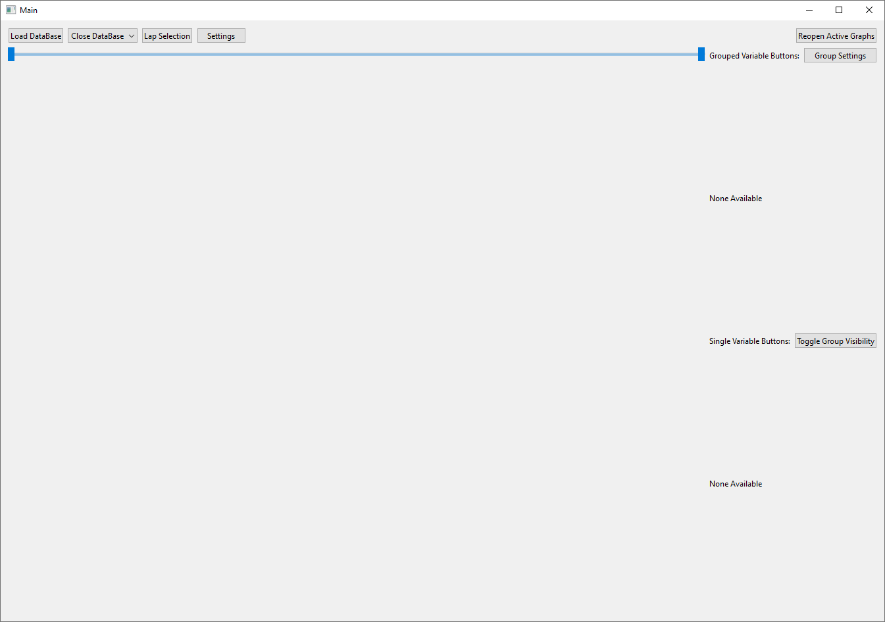
Figure 26: windows 10, empty main UI
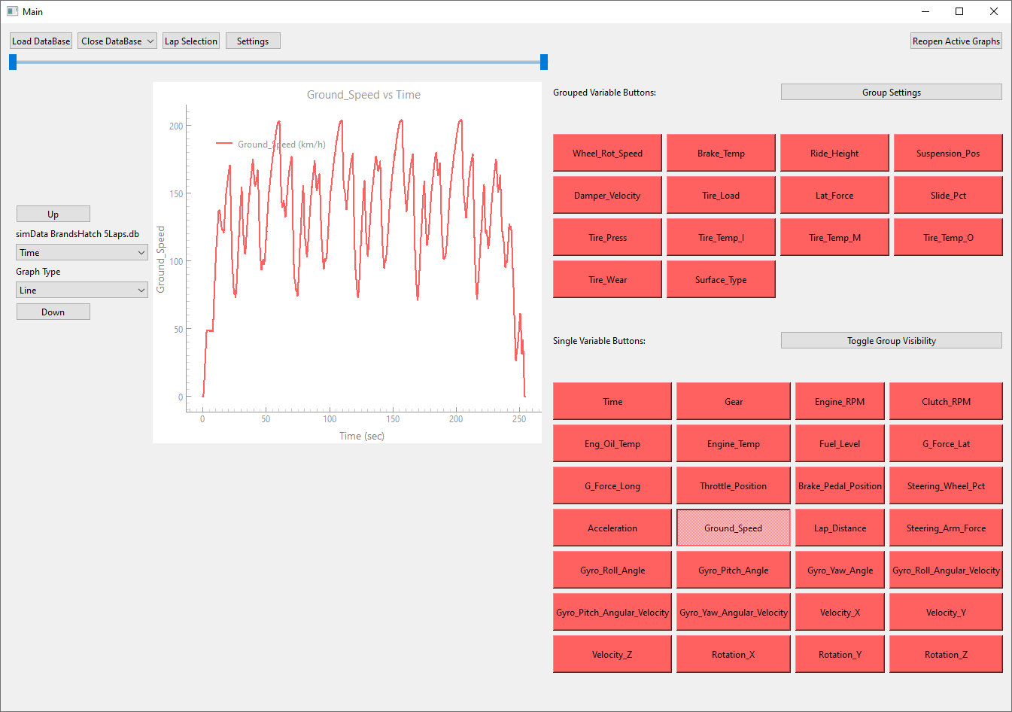
Figure 27: windows 10, main UI, 1 database
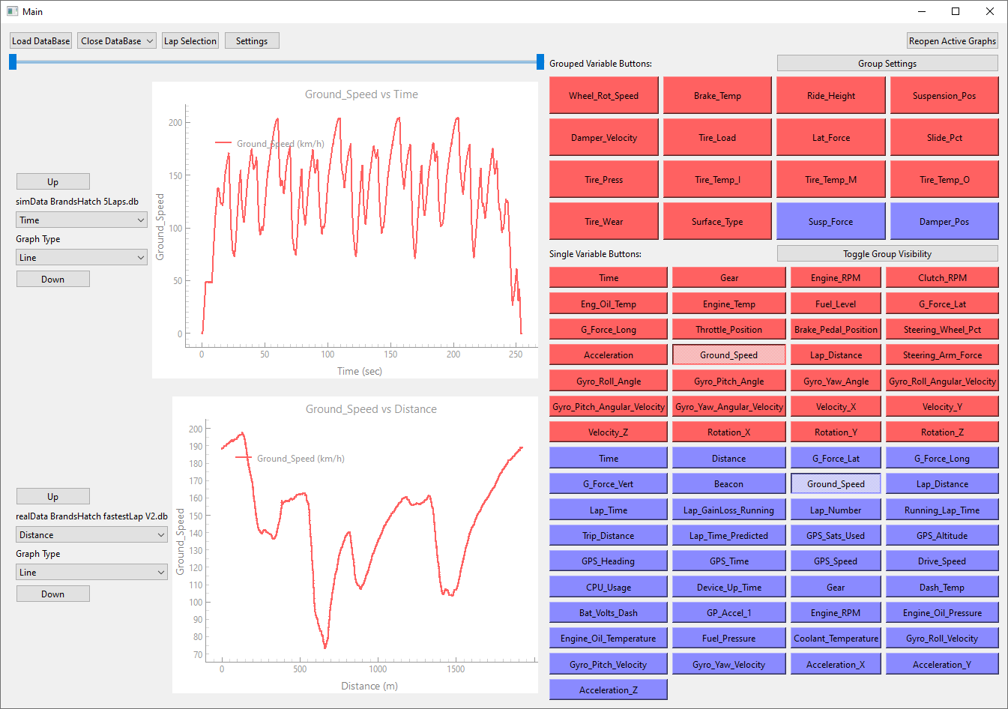
Figure 28: windows 10, main UI, 2 databases

Lap selection UI
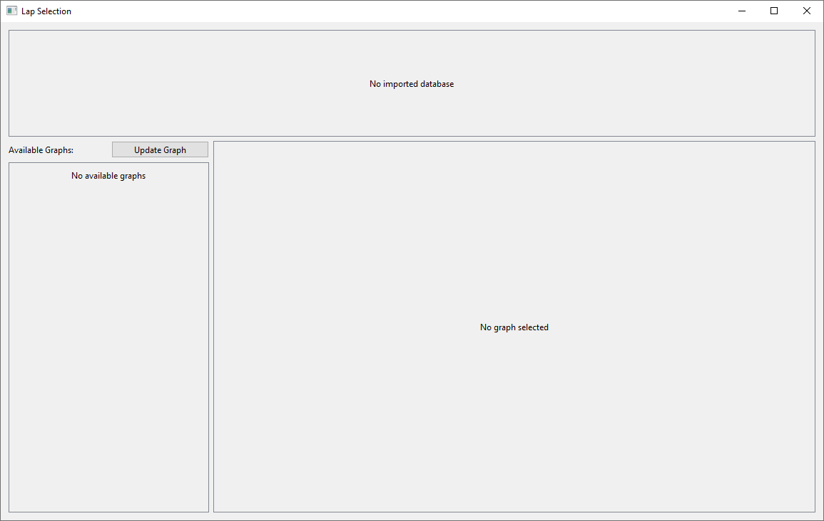
Figure 29: windows 10, empty lap selection
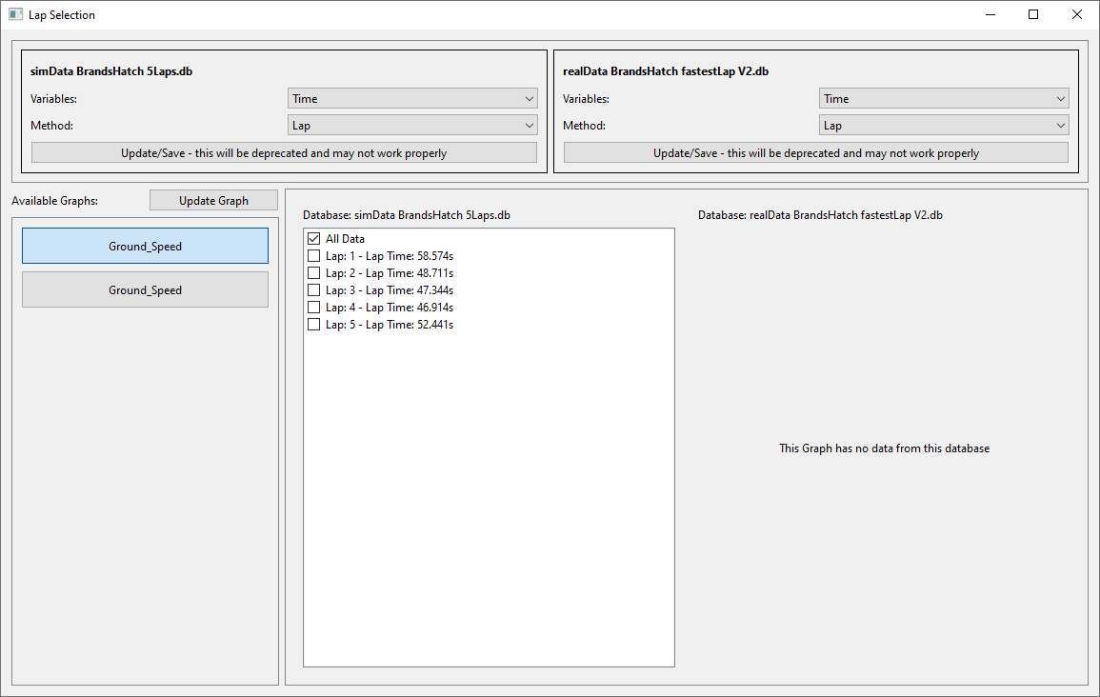
Figure 30: windows 10, lap selection

Group management UI
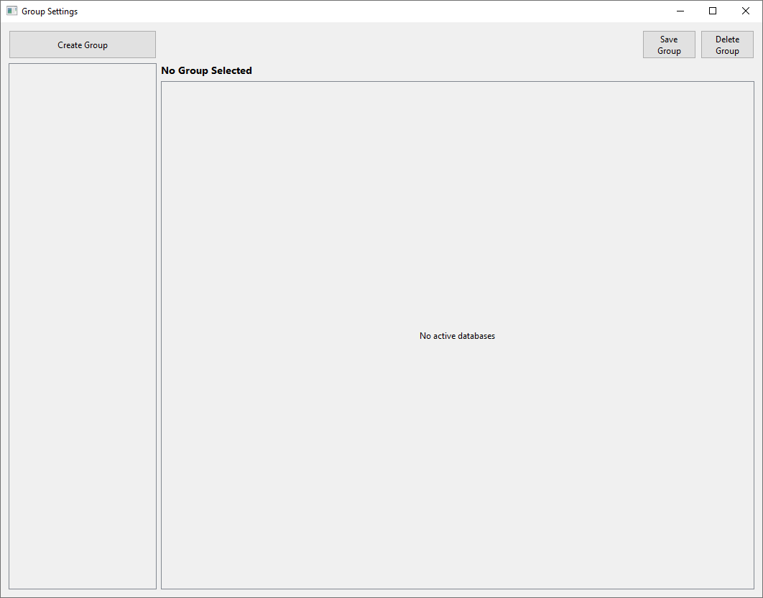
Figure 31: windows 10, empty group management
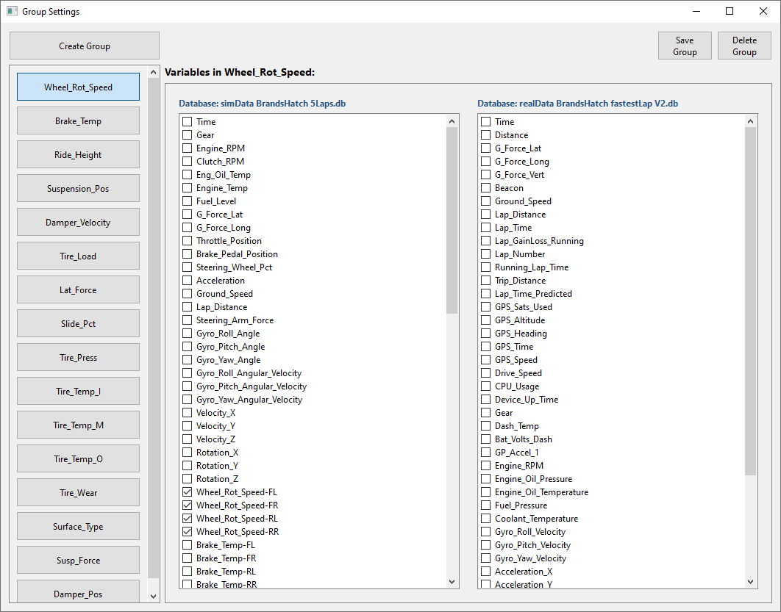
Figure 32: windows 10, group management

Settings UI
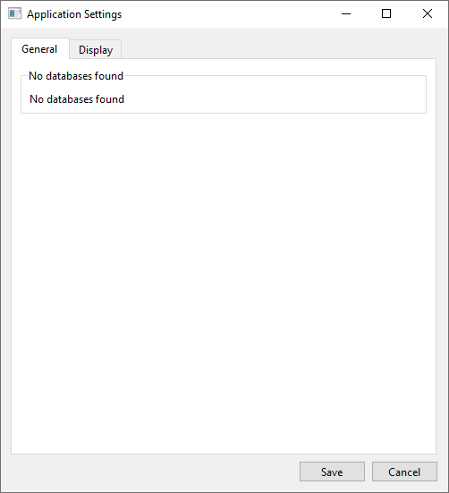
Figure 33: windows 10, empty general settings
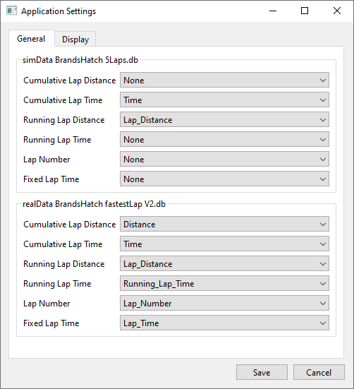
Figure 34: windows 10, general settings
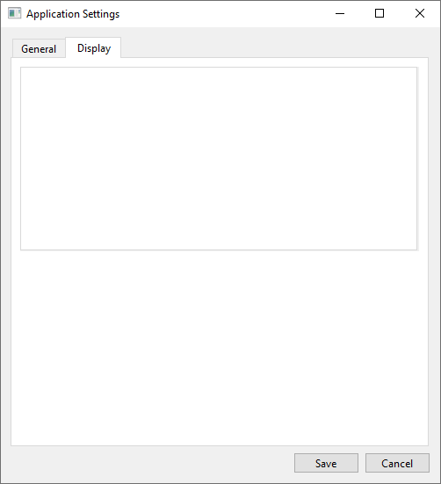
Figure 35: windows 10, empty display settings
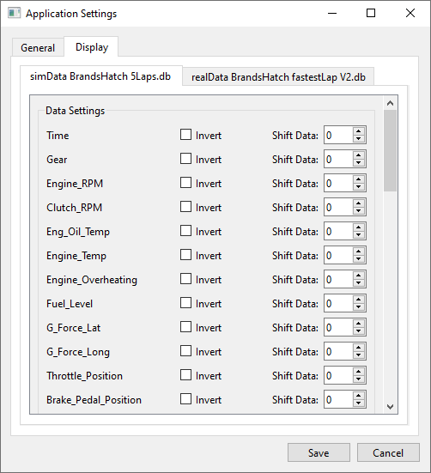
Figure 36: windows 10, display settings

Windows 11

Main UI
Figure 37: windows 11, empty main UI
Figure 38: windows 11, main UI, 1 database
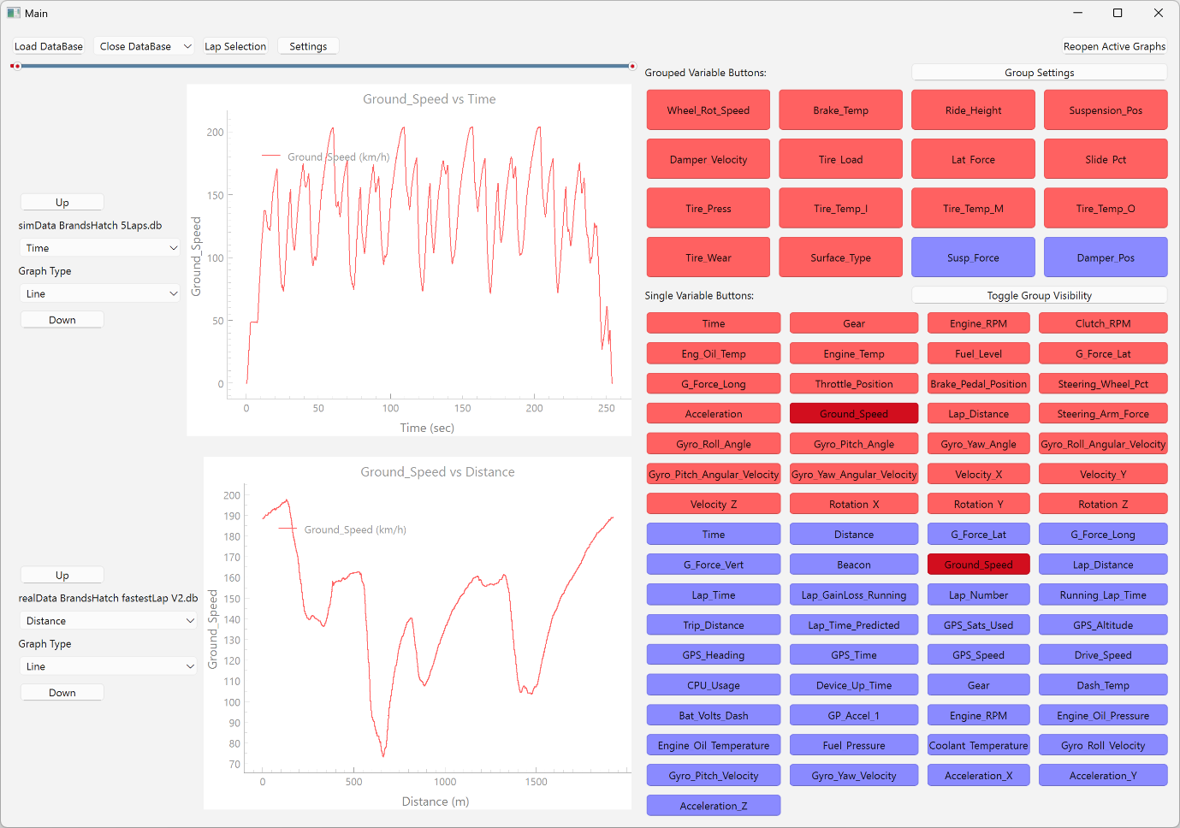
Figure 39: windows 11, main UI, 2 databases

Lap Selection UI
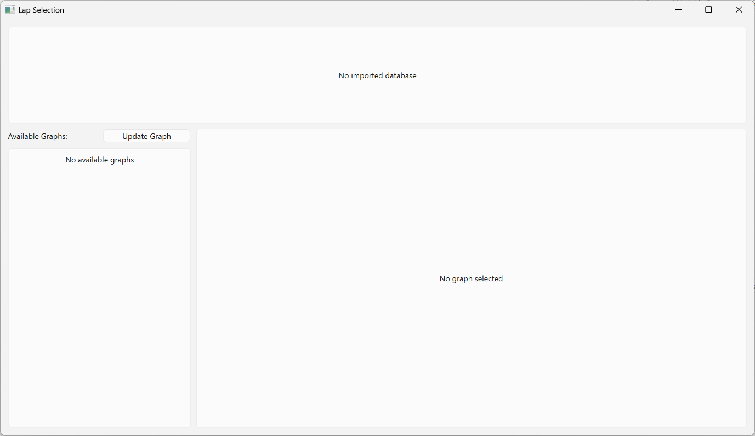
Figure 40: windows 11, empty lap selection
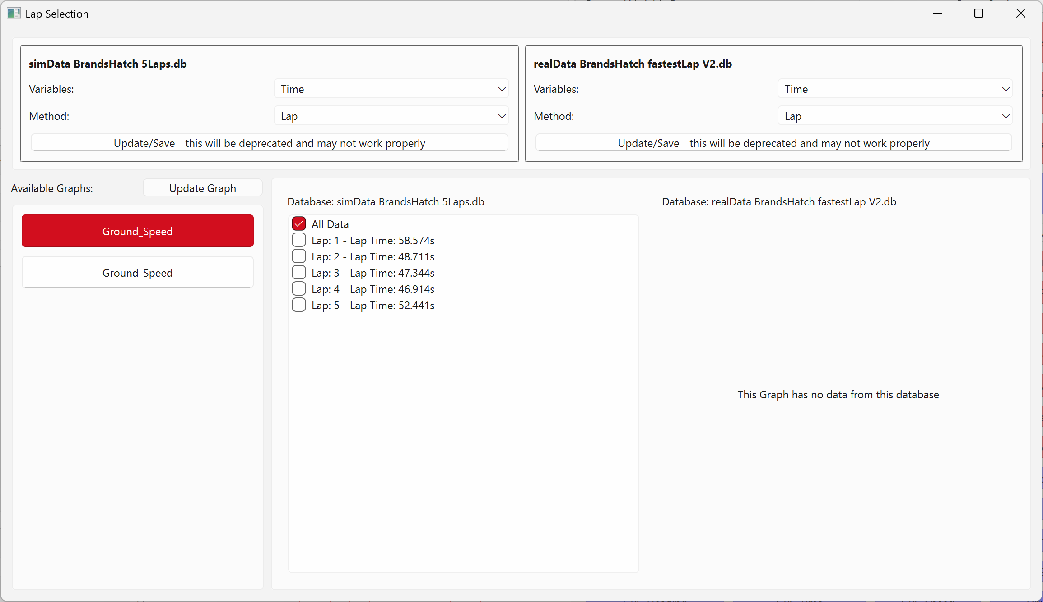
Figure 41: windows 11, lap selection

Group Management UI
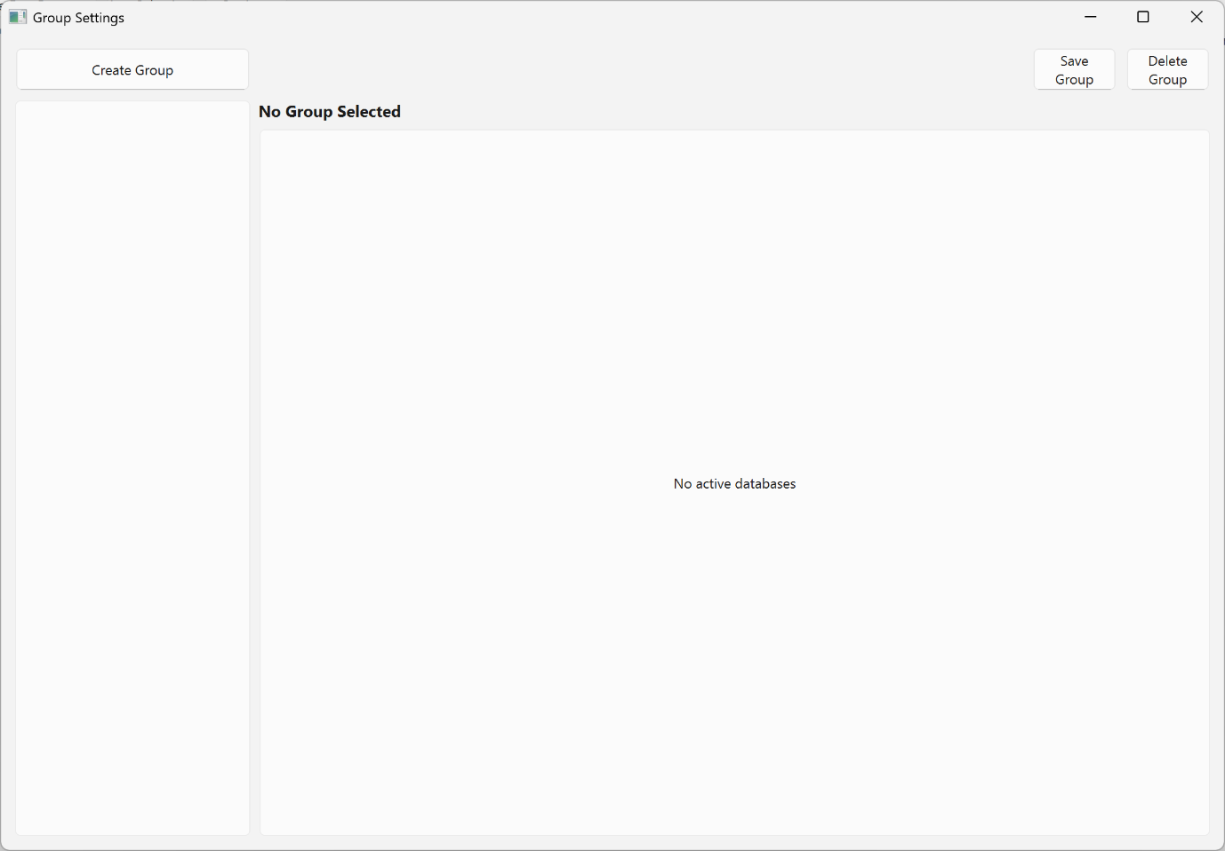
Figure 42: windows 11, empty group management
Figure 43: windows 11, group management

Settings UI
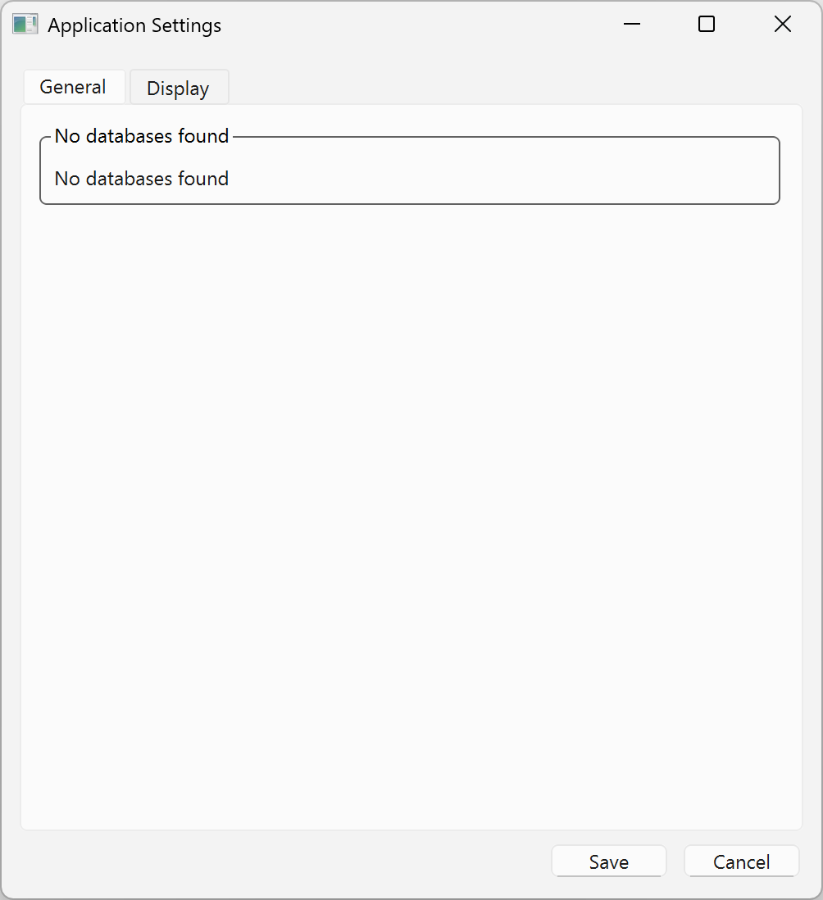
Figure 44: windows 11, empty general settings
Figure 45: windows 11, general settings
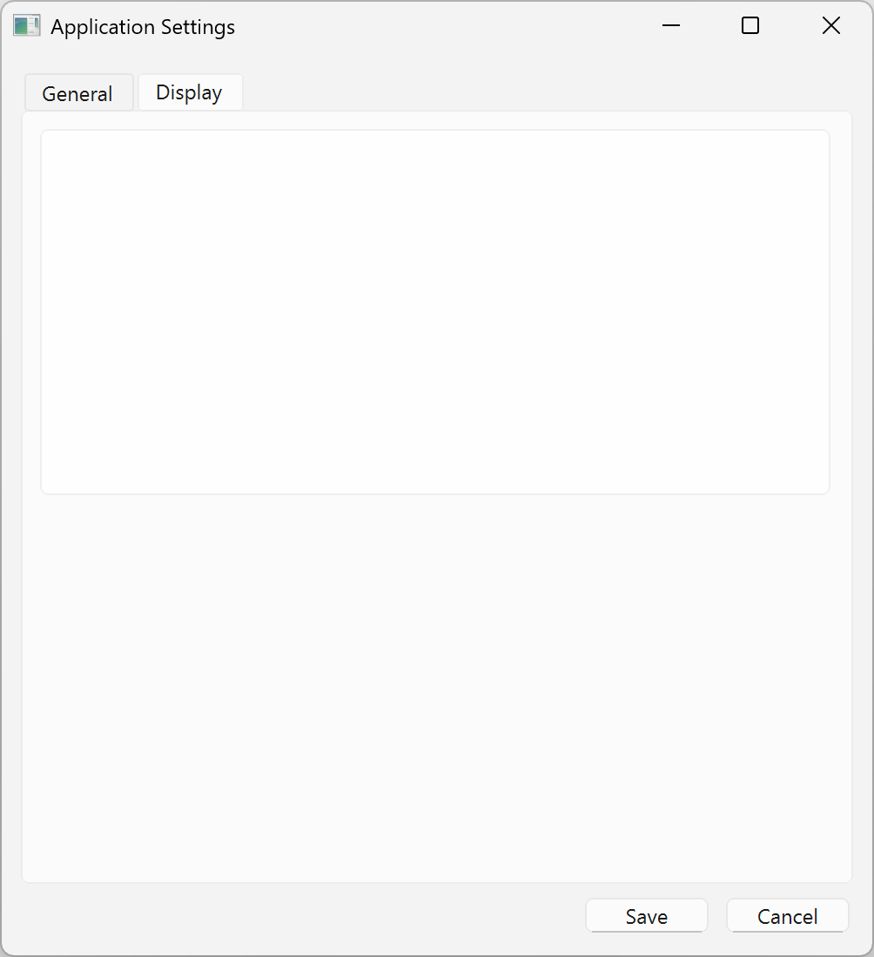
Figure 46: windows 11, empty display settings
Figure 47: windows 11, display settings

Development features

Data file to SQLite converter

Plan
Convert an inputted file to an SQLite database while maintaining all the data and some metadata within and of the file. When the file is created, it will be assigned an ID based on the structure, which will be used to extract the data.

Design

Input handling
- It will accept a file path as the input parameter.
- Validate that the file exists and is readable.
- Current support for Motec csv files

Data processing
- Read and format data from the input file.
- Extract relevant metadata.
- Structure the data for SQLite storage.

Database operation
- Create an SQLite database in the same directory as the source file.
- Design and implement table structure.
- Wite data and metadata to respective tables

Database structure
Figure 48: database structure V1
When the allData table gets created, the table header is the variable names, with the data getting inserted into their respective columns later.

Challenges
The main problem that was encountered was that each source of data had its own format with different variable names and units; the solution for this is to just convert each into an SQLite file for easier data manipulation, then have the main program deal with the different data formats. With the data provided, the only challenge faced with this program is data inconsistency between the files; for example, since the files are a CSV, the beacon marker information was provided as a list separated by a comma. The temporary solution to this is to skip this.

Test
After running the program with each of the provided datasets, it created an SQLite database with all the required data. The simulator data produced a warning mentioning that there were extra commas in the file; however, because it came from metadata, it is currently being skipped.

Main UI

Plan
Create the main framework of the user interface so that additional features can be implemented later. Temporary placeholders will be put in place for each feature so that they can be added in gradually.

Design
Below is a rough design for what the user interface will look like, with each colour representing something the user can interact with.
Figure 49: main UI wireframe

Challenges
The main challenge with the UI was the tedious process of arranging every element into its position. This was achieved by splitting each element into groups of layers, which can then be altered separately from other elements.
Figure 50: main UI layers

Testing
When the program runs, no errors occur. Changing the size of the window dynamically changes the element size to a suitable degree.

Telemetry graph features

Plan
Allow the telemetry graphs to be reordered using dedicated up and down arrows beside the graph. Make interaction with each graph easier by using class instances to allow data to be assigned to each graph.

Design

Input handling
- Data will be handed to the graph upon creation of the class.

Data processing
- Manipulate and interact with the data.
- Be able to interact with the graph.

Output
- The graph updates when there are changes.
- Graph and data stay when moving them.
- Move graph when button is pressed.

Testing
Moving the graphs does not output any errors and appears to move the graph correctly.

Toggle graphs with temporary data.

Plan
Toggling the graph visibility and have each button have their own data assigned to them that gets shown on the graph.

Design

Input
- The button gets created in a grid pattern.
- When the button is created it will have data assigned to.

Data processing
- Create a graph with the assigned data when pressed.
- The graph will be positioned at the bottom of the list.
- When pressed again it will delete the graph?

Output
- A graph appears at the button of the list.
- The graph contains the data assigned to the button.

Challenges
This feature was made a lot easier to add because the graph ordering was already added in. The only challenges were to register a button press and to update the display for when a graph needs to be removed. When more graphs are displayed, the performance of the graph and the program are slowed down, this is most noticeable when the graphs need to update their content.

Testing
The graphs can be created, moved around, and deleted with any issue.

Data implementation

Plan
Be able to import and close a file, then create toggleable buttons for each header in the dataset which will then display the corresponding data on the graph. It will only import the top 12 headers because the button layout will change to accommodate a lot more variables.

Design

Input
- When a button is pressed a file explorer will pop up, the user will then navigate to the file and import it.
- It will read the header names from the allHeaders table and create a button for each.

Data processing
- When a button is pressed it will open the database and select the data. Then creates and displays the data on a graph.
- When the button is pressed again to hide the graph, it will keep the data in memory so save processing time.

Output
- Buttons will be created with table header names.
- A graph with data assigned to it.

Notes
Currently it only supports 1 database, since work needs to be done on the buttons and grouping of variables, but some of the framework has been done to support additional databases.

Testing
A file can be selected and imported, then a graph with the relevant data is shown. The file can also be closed for another file to be imported.

Grouped buttons.

Plan
Create a section above the singles buttons for grouped buttons. Edit the database so it can store similar variables together. With the database change it will be used for premade groups.
Figure 51: database structure V3

Design

Database changes
- Instead of storing each data in its own row, it will store similar data on the same row in multiple columns.

Input
- Import the new database.

Data processing
- When the database gets imported, it reads the headers table, then splits the headers into groups and single variables based on the columnType field.
- If the columnType has a value, then it will create a group button otherwise a single button.
- When group button is pressed, it creates a graph with all the data displayed on it.

Output
- 2 categories of buttons grouped and single.
- When a button is pressed, a graph with multiple data will be displayed.

Testing
With the test files available, the size of the file either decreased between 25% to 64% or increased by an average of 11%. The new grouped button section gets created and graphs can be created and moved without issue.

Group management

Plan
Create a group management UI that will allow the user to create, modify and delete groups of telemetry data, this will allow the user to organize related telemetry data in groups for easier analysis and comparison.

Design
Below is a design for what the new UI will look like.
Figure 52: group management wireframe

Group creation
User can create a new empty group that will appear in the group list section.
Steps:
- User clicks "Create Group" button.
- System creates a new group with default name "Group X" (where X is incremented)
- System adds group to the group list.
- System notifies main application about the new group.

Group selection
User can select which variables to include in a group from all available telemetry variables.
Steps:
- User selects a group from the group list.
- System displays all available variables with checkboxes.
- System shows currently included variables as checked.
- User selects/deselects variables by toggling checkboxes.
- User clicks "Save Group" to confirm selections.

Group visualization
User can display all variables in a group on a single graph with a single button click.
Steps:
- User clicks on a group button.
- System retrieves data for all variables in the group.
- System creates a new graph displaying all group variables.
- System adds the graph to the graph display area.

Group deletion
User can delete groups that are no longer needed.
Steps:
- User selects a group.
- User clicks "Delete Group" button.
- System displays confirmation dialog.
- If confirmed, system removes the group from the list.
- System removes any associated graph if displayed.
- System notifies main application about deletion.

Input
- create group button – adds a new group on the side.
- save group button – updates the group with the toggled data.
- delete group button.
- a list of togglable data from each database

Data processing
- save group button – identifies all toggled data, retrieves data from database then updates the graph with the new data.
- delete group button – deletes graph and all saved data.

Output
- create group button – adds a new group on the side, and a button to create graph.
- save group button – graph has new data.
- delete group button – removes group, button, and graph.

Testing
During testing no significant issues or errors occurred that would affect the outcome of the functionality of the group management UI. The only main issue that occurred involved importing different databases. After importing the second database, the full UI displays information from the first database and trying to interact with anything causes an error to occur.

Using multiple databases

Plan
Update the previous features so that they can work with multiple databases.

Design

Single/ grouped buttons.
- Each button will still represent the same data.
- When a button gets created it will be given a colour based on the database it came from.
- When a second database is imported, more buttons will appear below to current buttons and be separated by the colour.
- When a database is disconnected, all buttons that came from that database will disappear and the rest of the button will move up.

Group management – group list.
- New databases will appear at the bottom of the list.
- When a database is disconnected, all the rest of the buttons will move up.

Group management – variable list.
- If multiple databases are imported then, their list of variables will appear next to each other.
- When a group is selected, the correct variables will be toggled from the current database.
- When variables are selected from different databases, then the group should be assigned the correct variables.

Testing
It works as intended, the only notable issue is, data with different sizes will not stretch out to visually become the same size.

Splitting data into laps

Plan
The user will select a data type and a method that will be used to identify laps in the data. once the laps have been identified, the user will be able to select what laps are displayed.

Design
Below is a design for what the new UI will look like.
Figure 53: lap selection wireframe

Database list
Each active database imported will be displayed on the top row. It contains a dropdown for data selection and a dropdown for a method, followed by a button to update the database display below.

Distance method
If distance data type is given it will perform the following actions
- Loop through the data
- Find the lowest value then the highest value before dropping to the lowest value
- For the lowest and highest value found it will identify the packet id
- The packet id will then be used for finding relevant data

Lap method
If lap data type is given it will perform the following actions
- Identify all unique values
- For each unique value it will
  - Filter the data by that value
  - Then find the smallest and largest packet
  - It will use the smallest and largest packet to retrieve relevant data

Graph list
When selecting a graph, it will update the database list with the available laps. The user will be able to select which laps get displayed on the graph.

Testing
All the selected laps appear in the graph stacked one above each other.

Synchronising different sized data

Plan
The plan is to alter one of the datasets so that it becomes the same size as the other datasets, this should then align graphs together when plotted

Design
One of 2 methods will be used to alter the size of the dataset, depending on whether the user wants performance or precision.

Destructive method
It will evenly down sample the larger dataset to match the length of the smaller dataset, this will be done by removing values equally spaced apart.

Constructive method
It will insert NaN values into the smaller dataset to match the length of the larger dataset, the NaN values will be inserted into the smaller dataset with even spacing between them. When plotted the graph will connect the points together even if there are NaN values between them.

Testing
The graphs are created and seem to align correctly with both methods.

Reopen last sessions graphs

Plan
When you close the program is will save any active graphs along with any information needed to reopen them in a config file. Then when the program is reopened is will read in the configuration and reopen any graphs.

Design
One of the premade buttons has been changed into a switch that when toggled will reopen the current selection of graphs when the program is next opened. The program will save any actives graph even if the switch is toggled off but would be require editing the config file to get the graphs to redisplay when opened.

What is saved when closing the program
- Slider value
- A list of all active databases
  - The database id that was assigned
  - The database location
- A list of graph information
  - Name
  - Unique ID
  - Is it created
  - Is it edited
  - Graph position
  - A dictionary containing what laps are being displayed
  - A list of data references
    - Database id where the data is located
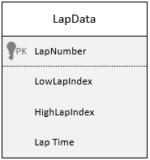
    - Header id in the database
Figure 54: lap data table

Save lap data
When the user identifies laps in the data, using the lap selection UI, it will save the lap number, starting index and final index for that lap into the database. So, when the user loads a database, it checks if there are laps present, if so, it loads them.

Testing
Everything reopens from the previous session, and no issues seem to occur.

Settings UI

plan
create a settings UI that will be used to select standard variables (cumulative time and distance, running lap time and lap distance)

design
The UI will be done in pages or bookmarks where each page contains settings relating to the title. Initially the general page will contain dropdown entries for some common data that will be used later. Each page will look slightly differently depending on what is needed.
Below contains a wireframe for what the generic design of the settings screen will look like. The orange at the top is a bookmark system so that you can navigate to each page, the green is a group of settings that the user can change.
Figure 55: generic settings page wireframe
Below is a wireframe of the first page that will be used to collect some standard data. It contains sections for each database, within each section the user can select a header, from a dropdown, to represent that data.
Figure 56: general settings wireframe
Below is page 2 and is a wireframe of how the user will alter the display of data. On this page there will be pages representing each available database, for each database there will be a list of all the headers the user can edit. Each header will allow the user to toggle whether the data is inverted and how much the data has been shifted over.
Figure 57: page 2 settings

testing
The user can open and navigate to each page without issue

change graph synchronising

plan
Change the way data is displayed, by plotting the data against time or distance, but also have the option to allow the user to plot it against any other value.

Design
If the user has not defined any data yet, it will default to the previous method.
If the user has defined some or all the data, it will use that data in the X axis. It will priority that data in the following order: cumulative lap distance, cumulative lap time, running lap distance, running lap time.
A button will be added to be able to change the graph to scatter or histogram.

Testing
With just one database, it works as intended, but when more databases are being used on the same graph some features fail, with the main one being the dropdown to select the x axis

graph settings

plan
allow the user to invert or shift data on a per data basis

design

input handling
- tab system to select the database
- a toggleable invert button
- an area to input the shift amount
- save button

data processing
- column headers and value are loaded in when the UI is opened
- when saved:
  - it will update each class with a Boolean invert value
  - update each class with a shift amount

output
any open graphs will have their data updated, and shift across
next time the program fetches data, it checks if it needs to be inverted, then returns an invert dataset
when data needs to be shifted, it takes its current X axis data and applies the shift value to it, the data will then be plotted as normal.
A wireframe of the new tab in the settings UI

