

Skills for the Workplace
Module Assignment Submission

Student Name: | SYLVIYA SPASOVA
Student Number: | 1817128
Module No: | BMSW4003_LON
Module Title: | Digital skills and research methods
Lecturer: | Amitave Banik

Statement of Confirmation of Authenticity
I declare that this work is mine own and have never been posted in other courses or modules.

Table of Contents
Introduction 3
Data Collection 3
qualitative and quantitative methods 3
Research Project explanation 4
Analysis of the data with proper tools as well as technique 7
Conclusion 9
References: 10
Appendix 1 11

Introduction
In this report, the research will be made to evaluate the project task on Them impact of VLE (visual learning environment) and Moodle on student learning experience. I will describe meaning of information, why need to collect it, data collection sources and methods will be also answered.
A virtual learning environment (VLE) is a set of learning tools designed to improve the learning experience of a student via computer and the internet. The key components of VLE are course mapping, student monitoring, online support for teacher and students, electronic communication (E-Mail, threaded conversations, chat, web publication), as well as internet links to outside curriculum tools. VLE-users usually have a teacher ID or student ID assigned to them. (Wikipedia).
Moodle is an app framework for students, administrators and educators to create customised learning environments using a single flexible, safe and integrated Framework. We can download the software onto our own web server or request assistance from one of the well-known Moodle partners.
Data collection
In every research study, data collection is an essential step. Learning how to collect data for analysis will help me complete my job in the best possible way. Incorrect procedures affect the results of my investigation. I will need to ensure that my implement appropriate technologies for information collection, whether qualitative or quantitative data are obtained.
Data collected through the primary and secondary data collection methods was used in this report. The most important data sources came from the reactions of teachers and students of selected university of Wales Trinity Saint David London Campus. High quality assessment and e-learning in universities were given from secondary sources including books, brochures, unpublished material and other articling document. A questionnaire based on the goals and specific research issues related to successful quality assurance in VLE is the main data collection tool used in this report. During the trial run, an informal interview is also carried out in order to improve the tool and give input on the quality of the questionnaire. As soon as the respondents are completed to obtain a high percentage recovery rate the questionnaires shall be distributed personally and collected.
Qualitative and Quantitative methods of research
Quantitative data is information on amounts and thus numbers, while qualitative data, which can be observed but not calculated as objects like language, is symbolic.
- Therefore, quantitative analysis can be described and understood more easily. The generated data are always numerical, and mathematical and statistical methods are used for analysis. It is not quantitative analysis, if there are no numbers involved. Clearly, these events appear to be quantitative studied because they already exist as numbers. For example, increases in achievement at different educational stages or an increase in the number of senior management graduates. · Data collection techniques include different forms of surveys, such as web surveys, paper surveys, smart and retail store surveys, face-to-face and mobile and observer surveys, online database interceptors, and systematic surveys.
- Qualitative research involves no measurements or numerical tests. Occasionally words or sentences, but also pictures or videos and observations can be used. It is often the preferred method of research in the UK and the rest of Europe; US studies tend to employ quantitative methods, although this distinction is not at all absolute. Most other common methods include focus groups, interviews and participatory / comments. The sample size is typically small, and the respondents have a certain daily limit to follow.
Research Project explanation
Virtual learning environments (VLE) are a standard feature of most higher education courses which offer the potential to improve and promote education and learning. Although the VLEs are ostensibly assumed to support student education, a lot of the evidence comes from the students ' direct questioning of their contentment of the VLE itself. To decide what effect VLEs have on student satisfaction with higher education and teaching. (Wikipedia, VLE).

Research report background: I am a student on the Saint David University London campus and will now analysis the usefulness of the virtual learning system. We all know that the online analysis that I will do online today is the most revolutionary, comfortable and effective way to operate. My main reason for this research, nevertheless, is Moodle, the tool for scanning the tools of our library classes. We also access tasks, read comments, in this chapter. All we need is Moodle. Nevertheless, can this work as a classroom research correctly and successfully? The main project goal will be.
- Overview of the research: Overview of the research: Evaluate the effectiveness of the project, testing will be carried out. This project will be performed to a limited degree and an effects analysis will be carried out on the learning experiences of students at Virtual Learning Environment (VLE) Trinity Saint David London Campus.
- Research aims and objectives. The aim is to boost the student experience through the implementation of Moodle by offering versatile VLE, which could be used in mixed learning.
- Research methods and data collection: Quantitative data was collected in the form of a google docs (e-questionnaire), allowing Excel analysis. Five research questions have been organized and grouped (Appendix 1). The survey was invited to all 30 first year UWTC students. The survey was encouraged, and students were invited to finish it at their own time during community lectures. A measurement of sample sizes was done to determine a minimum representative sample. A minimum sample size of 30 was required to produce representative outcomes at a response rate of 37 per cent.
This work should follow the graphical and quantitative method of analysis. This analysis will gather the impression of UWTC students and quantitatively evaluate the categorical variables from the results. There will also be asked from another city client. The quantitative and qualitative research methodology is applied in this study.
- Simple size: This is small study and the size of it is 30 students from University of Wells Trinity Saint David Campus London.
- Data collection: I was using a questionnaire and face to face interview to collect information for my case.
- Research questions: Each questionnaire was voluntary and was alerted to students before the survey was completed. The students were given a fact sheet during the tutorial and they were available on the SFC VLE. The survey was conducted as informed consent to the use of data in the analysis. The survey was "open" for two weeks and community tutors were asked to facilitate participation in order to ensure that a broad enough sample had been obtained.
- Research's validity and reliability are concepts used to evaluate the quality of research. I demonstrated the measurement of something by a process, technique or examination. The quality of a measure is reliability and the performance of a measure is validity. The participants in the study will concentrate on the students as the basis for study. The participation of both men and women will be assured in this study. Age diversity is also given to participants in the study. The scope for partiality is limited in this study for any category.
- Analysis: The purpose of the scale evaluated the categories of answer highly and very, very strongly, with five categories at either end of the scale. Responses were also combined to questions concerning satisfaction with the consistency of learning outcomes, evaluation processes and employees. The combination of responses and questions offered a better and more accurate structure for understanding and recording the results.
Research question survey
Quantitively Methods
1. Are you male or female?
1. male
2. Female

2. How many hours do you spend in Moodle per day?
1. 1 hour
2. 2 hours
3. 4 hours
4. 8 hours

3. Is a VLE used for the course you’re undertaking?
1. yes | 2. no

4. How often do/did you use a VLE to help you in the course per week?
1. 1time | 2. 3 times | 3. 5times | 4.7 times

5. How helpful do you think VLE is for your Study?
1. not very effective | 2. effective | 3. very effective | 4.excellent

The analysis of the research after the collection of the data is given below according to the research questions and methods.
From the survey and face to face meeting I have been collected the primary show on fig.1 and after we need to perform in secondary and analyses it.
Fig.1 shows primary data collected.
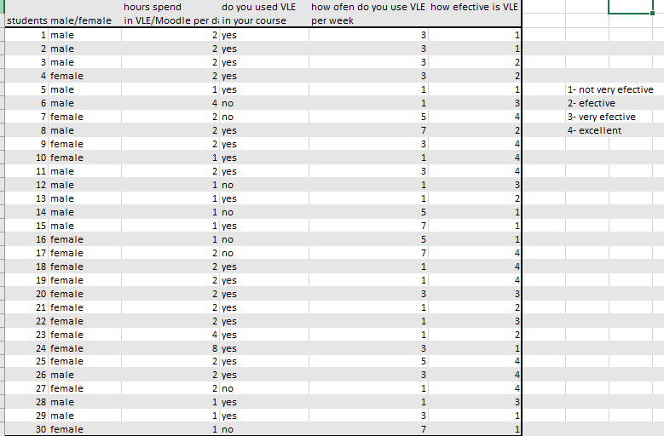

From the research I made we can see that most of student interviewed find the VLE and Moodle as effective way to study. Some of them use it only to upload their assignments but big part is interesting and from other tools Moodle offer.
Secondary Data /Quantitative Research
q.1 What’s your sex?
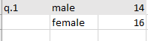

According to given data we can see that in my research took part almost the same percent of male and female.
q.2 Hours spend in Moodle or VLE?
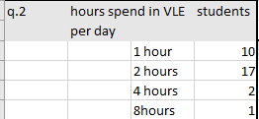
From given answers above, I can say that big part of participants in study spend 2 hours per day in Moodle, to their exams, see their grades, check emails, upload assessment etc.
q.3 Are you using VLE in you course?
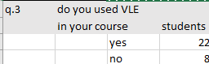
The results of this question make me quite happy. It is amazing most of students use VLE.
q.4 How many times per week are you using VLE?
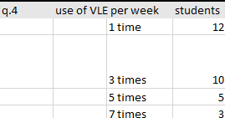
q.5 How effective is VLE?
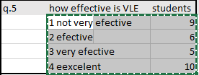

Many learners who attended course with a VLE and used it, viewed the VLE as a positive and helpful aspect of their course. 30 percent of them still do not find VLE useful for their study.
Students expect to find help and resources in VLE, which will help them to take responsibility for learning more effectively. The main reasons for this are the service to be more accessible and the reviews instant. Daily highlights and explanations of how assessment is being produced and related to student course mark books and calendars are electronic assessments and final exams for the BTEC diplomas.
The VLE strategy was focused on first dealing with the more optimistic workers. They build on this, promulgate good practice and focus to a certain degree on student desire for improvement when they observe and appreciate VLE courses. Best ideas are communicated by newsies and continuing professional development and are rewarded for the more successful courses by granting' Moodle Medals'
Conclusion
Findings showed that after the introduction of a virtual environment to facilitate the delivery of undergraduate modules, students were more fulfilled in a variety of teaching and learning areas. In addition, it is suggested that VLE may well deliver the expected or known benefits, having a positive impact in higher education (Barker and Grossman 2013). The present study offers insights in addition to studies that focus purely on evaluating VLE. However, only one of the two modules studied was better satisfied and negative reactions were demonstrated.

References:
Barker, J., & Gossman, P. (2013). The learning impact of a virtual learning environment: students’ views. Teen Journal, 5(2). Retrieved from: http://bit.ly/AtMwtr [Accessed 23/12/2019]
Skills you need, (no date). Quantitative and Qualitative Research Methods. [online].Available from: https://www.skillsyouneed.com/learn/quantitative-and-qualitative.html [Accessed 26/12/2019]
Sigmund, W. (2016). Business Research Methods. New York: McGraw Hill Education.
Wikipedia (no date). Quantitative research. [ online]. Available from : https://en.wikipedia.org/wiki/Quantitative_research [Accessed 21/12/019]
Wikipedia, (no date). Virtual Learning Environment. [online]. Available from. https://en.wikipedia.org/wiki/Virtual_learning_environment [Accessed 19/12/2019]

Appendix 1.
Questions




