ECIE4003

Additional Needs in Context

Portfolio

Student Number: 2317639

Element 1

Poster – Outlining good practice in terms of supporting learners with a specific learning need

References

Image 1: ‘Maslow’s Hierarchy of needs’ (1954) pyramid image. Available at: https://www.simplypsychology.org/maslow.html Accessed on: [11/09/2024].
Image 2: Transgender Flag. Available at: https://en.wikipedia.org/wiki/Transgender_flag Accessed on: [11/09/2024].
‘Supporting transgender young people in schools: guidance for Scottish schools.’ (2024). Available at: https://www.gov.scot/publications/supporting-transgender-young-people-schools-guidance-scottish-schools/pages/3/#page-top [Accessed on: 25/09/2024].
‘Trans Equality: Frequently asked questions about Transgender people.’ (2024). Available at: https://transequality.org/issues/resources/frequently-asked-questions-about-transgender-people Accessed on: [11/09/2024].
‘Unicef. Article 2: UNCRC Rights of the Child.’ (2024). Available at: https://www.unicef.org.uk/wp-content/uploads/2019/10/UNCRC_summary-1_1.pdf Accessed on: [11/09/2024].
Unicef. Article 16: UNCRC Rights of the Child.’ (2024). Available at: https://www.unicef.org.uk/wp-content/uploads/2019/10/UNCRC_summary-1_1.pdf Accessed on: [11/09/2024].
Welsh Government: ‘LQBTQ+ Action plan for Wales’ (2023). Available at: https://www.gov.wales/sites/default/files/publications/2023-02/lgbtq-action-plan-for-wales.pdf Accessed on: [25/09/2024].

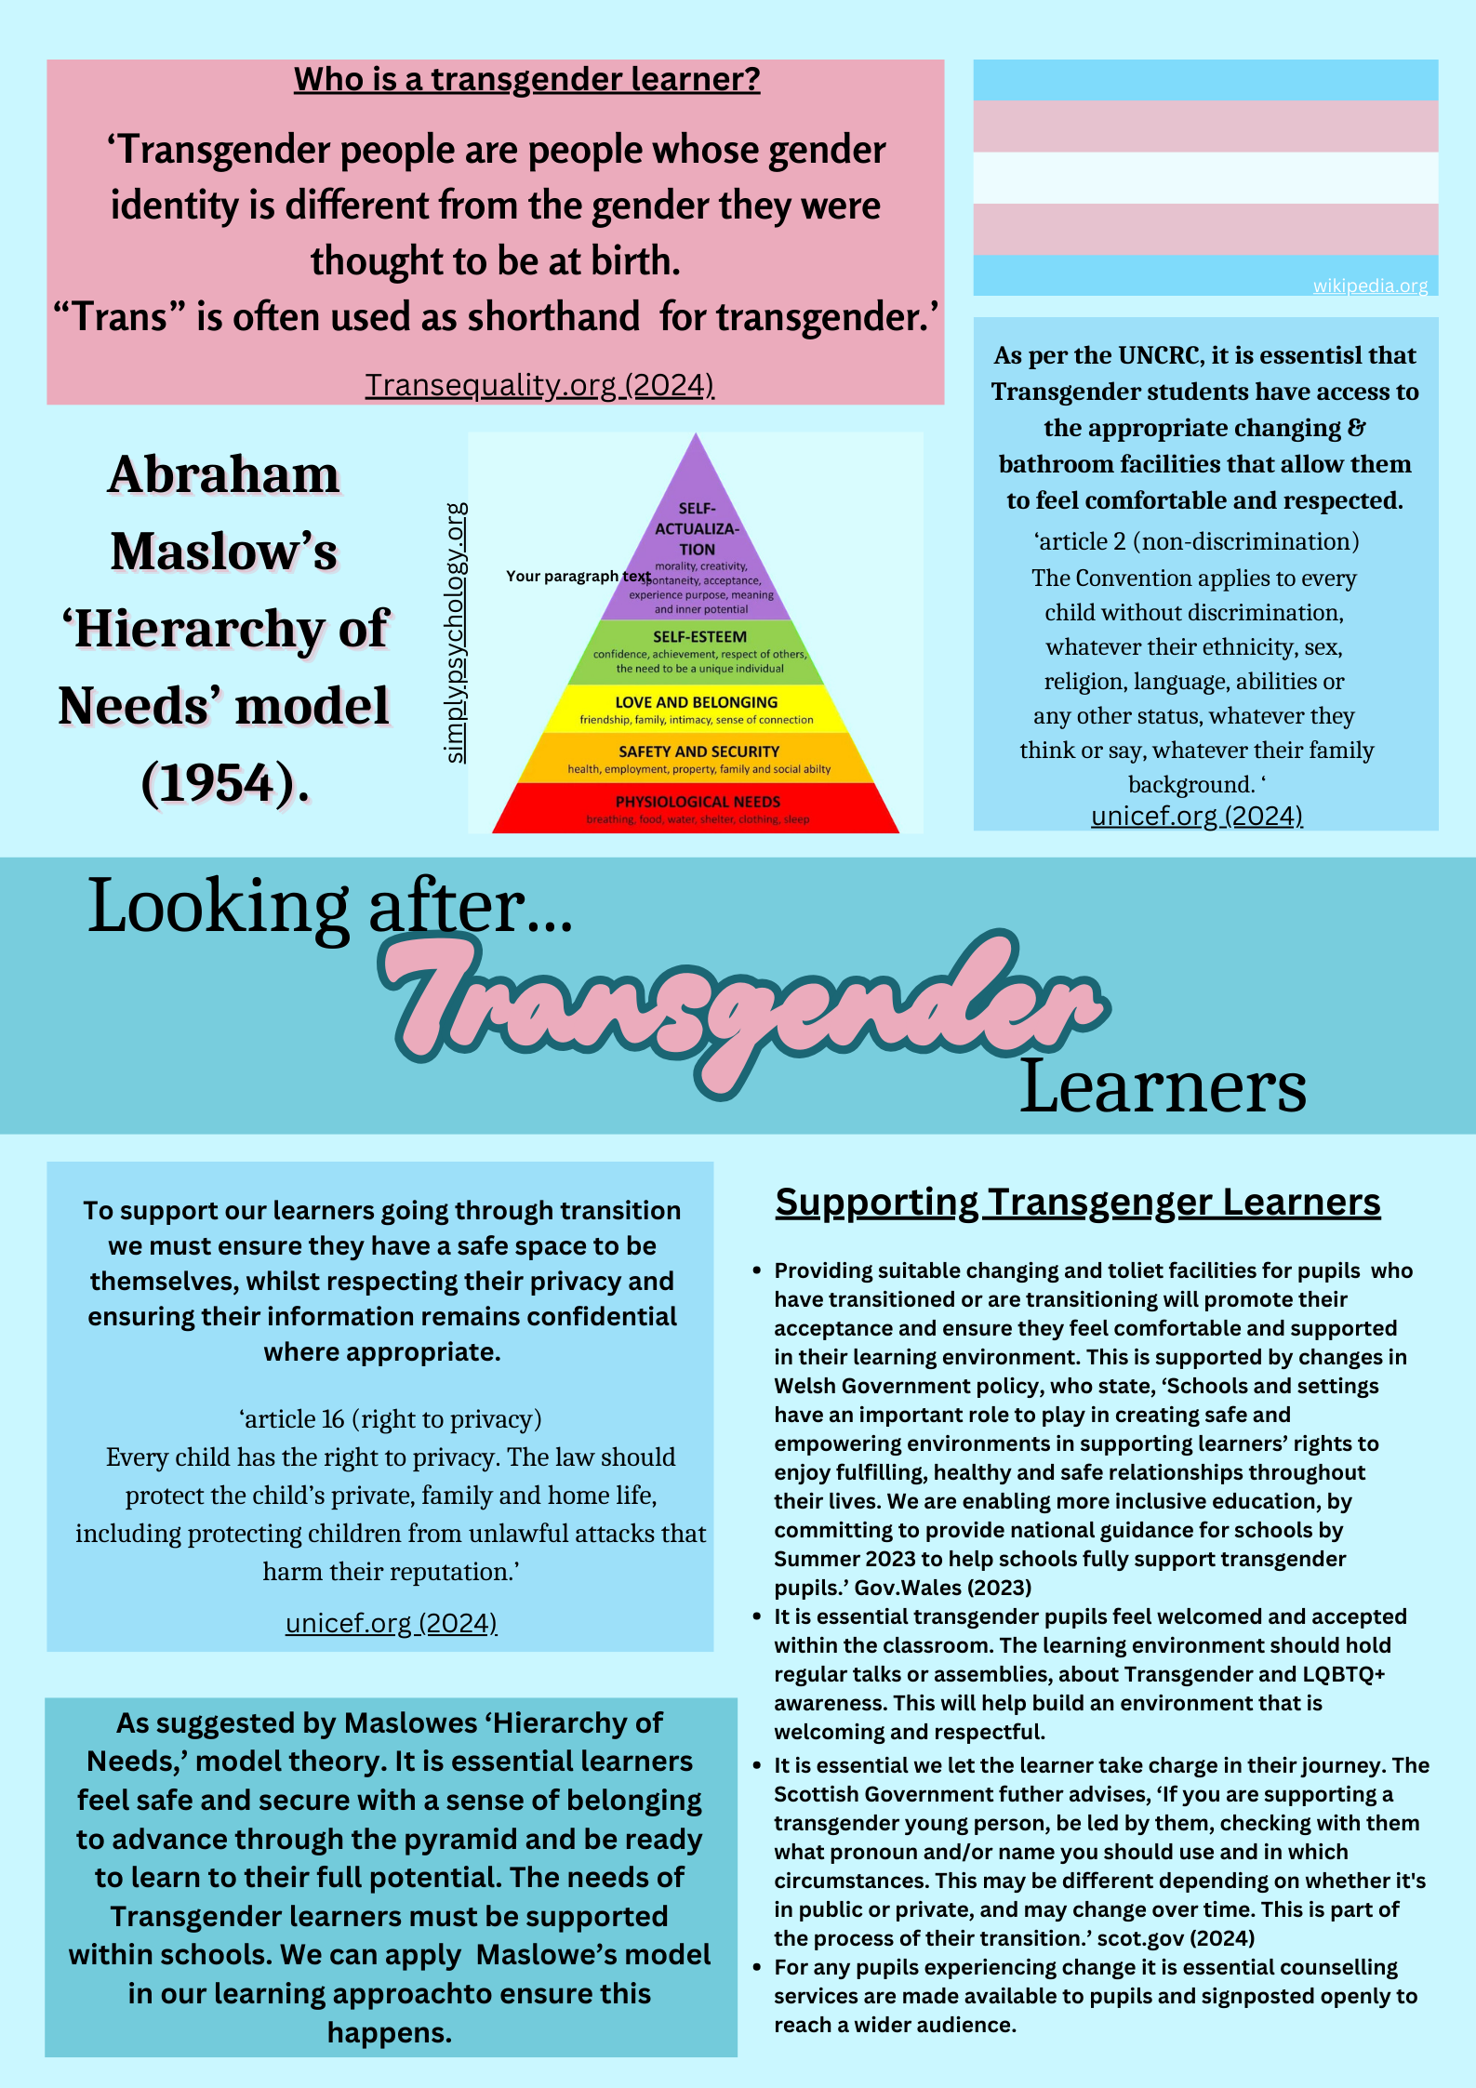

Element 2
Essay - Explore the wide and complex spectrum of additional needs

This essay will explore the broad and complex spectrum of additional learning needs (ALN). SNAP Cymru (2024) defines an ALN as follows, ‘a new term used to describe learning difficulties or disabilities that make it harder for a child to learn compared to children of the same age.’ As set out within the Education Act 1996 and the SEN Code of Practice for Wales (2002), ‘The term ‘Special Educational Needs (SEN), is used to identify those learners who have severe, complex and/or specific learning difficulties’ Welsh Government (2009). Within Wales there has been a recent reform which is the ALN Act (2018) and ALN Code (2021) that means the term used in education is now ALN.
To ensure good practice we must focus our approach on the Social Model of Disability. The model focuses on how societal and environmental factors can be the barrier. It states that people are disabled by barriers in society, not by their impairment or difference. Barriers can be physical, like buildings not having accessible toilets. Or they can be caused by people's attitudes to difference, like assuming disabled people can't do certain things. Scope (2024).
This differs greatly to Medical Model of disability which can potentially create low expectations for learners. According to Mencap (2024) ‘The medical model sees the disability as a difference that needs to be 'fixed' or 'cured'.’ It focuses on the disability as a negative and does not consider what can be done to aid the learner and provide them with equal opportunities. As we know from the UN convention, rights of a child (UNCRC), article 23 (2024) states, ‘A child with a disability has the right to live a full and decent life with dignity and, as far as possible, independence and to play an active part in the community.’ This directly contradicts the ethos of the disability model, who believes the person and their disability are the barrier.
The Social Model of Disability is more appropriate for the learner as it is an inclusive approach for children of all circumstances to receive help in the classroom, regardless of whether that additional need is temporary or long term. The movement toward the Social Model, is heavily supported by the recent changes made by the Welsh Government who reformed previous legislation in the Additional Learning Need (Wales) Act (2018) and The Additional Learning Needs (2021) Code. The introduction of these pieces of legislation signifies moving towards a more inclusive approach within education in Wales. The legislation takes steps to improve access to education and appropriate support by removing barriers (United Nations, 1994). The key focus of the social model is to remove barriers and ensure that the individual has access to education and opportunities. The ALN Code (2021) makes it a legal requirement for organisations to work together to provide appropriate services and moves beyond just a focus on education (Pembrokeshire County Council, 2023).
Working from the Social Model means that the learning environment itself should be appropriate to all learners. All work areas should be wheelchair accessible as a basic starting point, as well as consideration to classroom space, lighting levels and environment. Such conditions are the foundation of a learner friendly environment for those with sensory issues and diagnoses on the Autism Spectrum. As discussed by Zulkanain & Mydin (2019) Some leaners might be disturbed by the light, and some might feel annoyed by sound. Therefore, the environment should be reflecting clarity to ease the stimulation of information in the children’s brains. It is good practice to ensure these learning conditions are provided for learners as standard and comply with School Policies and legislation.
Breaking down these barriers allows the learner to feel accepted and enhances their sense of belonging. We know from Maslow’s (1954) Hierarchy of Needs theory that when a learner feels a sense of belonging in the classroom it facilitates learner engagement that creates a positive environment, promoting self-worth allowing the learner to progress through the ‘pyramid’ to an education without barriers. Capes, K (2024). It is the role of staff to ensure additional learning provisions are available for their learners needs when required. Estyn (2020) highlights the good practice in St David’s College where a wide range of ALN is present in the school and is supported by a whole school policy that has many reasonable adjustments available as an everyday feature. For example, pupil passports give individualised information and specialist staff are already on site and accessible. Estyn (2022) demonstrates how learners develop best when they are alongside their peers and can mix with all learners. This approach is based on Vygotsky’s (1934, 1978) concept of the More Knowledgeable Other (MKO) where learners can scaffold their learning not only from staff, but from learners around them. MacLeod, S (2024).
Vygotsky’s (1934, 1978) theory of modelling and scaffolding is a theory used to support learners visually within the classroom. This particular additional learning provision (ALP) is effective for children with autism, or cognitive development delay where communication may be the barrier. For example, if the learner has difficulty understanding or processing words, the act of watching the task being performed by staff or peers may be more beneficial to their learning. Effective and appropriate scaffolding of learning ensures that students have some level of a safety net to work with but that they are still able to work through the different stages by themselves (Twinkl, 2024). Adopting this approach with learners is good practice, and compliant with the policies and legislation already discussed. The barriers are being removed and the learner is provided with equal opportunities to their peers.
This essay has explored the complex spectrum of additional needs. It has shown how good practice and following the social model of learning is both encouraging and effective in breaking down the barriers in place. It has discussed the wide spectrum of additional needs and shown how good practice coincides with the relevant social theories and current legislation to create confident and successful learners.

Reference list

Capes, K (2024) Understanding Maslow’s Hierarchy of Needs in education. Available at: https://brooksandkirk.co.uk/understanding-maslows-hierarchy-of-needs-in-education/ [Accessed on: 2/10/2024]
MacLeod, S: Vygotsky’s Theory of cognitive development (2024). Available at: https://www.simplypsychology.org/vygotsky.html [Accessed on: 02/10/2024]
Mencap: ‘The models of disability,’ (2024). Available at: https://www.mencap.org.uk/easyread/models-disability#:~:text=The%20social%20model%20of%20disability,disabled%20by%20barriers%20in%20society.&text=Accessible%20means%20something%20is%20easy,easy%20to%20read%20and%20understand. [Accessed on: 8/10/2024].
Scope: ‘The social model of disability’ (2024). Available at: https://www.scope.org.uk/social-model-of-disability [Accessed on: 8/10/2024].
SNAP Cymru: ‘What is ALN?’ (2024). Available at: https://www.snapcymru.org/get-support/what-is-aln/ [Accessed on: 18/09/2024]
Twinkl: Scaffolding Learning (2024). Available at: https://www.twinkl.co.uk/teaching-wiki/scaffolding-learning [Accessed on: 11/10/2024]
Understanding the new ALN Transformation Act: Parent Partnership Service (2023) Available at: https://www.pembrokeshire.gov.uk/parent-partnership-service/understanding-the-new-aln-transformation-act [Accessed on: 30/09/2024]
Unicef: ‘A summary of the UN convention on the rights of the child’ (2024). Available at: https://www.unicef.org.uk/wp-content/uploads/2019/10/UNCRC_summary-1_1.pdf [Accessed on: 8/10/2024].
United Nations: The Salamanca statement and framework for action on special needs education (1994). Available at: https://www.european-agency.org/sites/default/files/salamanca-statement-and-framework.pdf [Accessed on: 02/10/2024]
Zulkanain.M, Mydi. O (2019). ‘Autism friendly classroom to stimulate learning setting’. Available at: http://anale-ing.uem.ro/2019/31.pdf [Accessed on: 8/10/2024]

Welsh Government: Children with Additional Learning Needs (2009) Available at: https://www.gov.wales/sites/default/files/publications/2018-03/13-children-with-additional-learning-needs.pdf [Accessed on: 30/09/2024]

Element 3
Explore and summarise the additional learning needs of a pupil using a person centred planning approach.
(Based upon Section 1C IDP : Profile (About me)
and
2A IDP : Description of the child or young person’s additional learning needs (ALN))

Section 1C: Profile (About me)
• What is important to the learner
Spending time on the yard with friends in mainstream.
I want to get my work right, I do not like getting work wrong.
Spending time texting my friends.

• What is important for the learner
-To spend time with friends on the ‘mainstream yard’ but have clear and consistent rules whilst outside. As the learner gets overstimulated and needs reminding about appropriate behaviour and boundaries.
-Ensuring the learner is aware that mistakes are okay. They should be encouraged in their learning, despite mistakes. It is important that staff and the learner communicate openly about these feelings as the negative feelings encourage unwanted behaviours. It is important to the learner to feel safe and secure in their choices and the staff working on a 1-1 basis should encourage this.
-Whilst communication is great, the learners’ carers report texting is being prioritised over sleeping. This is triggering low moods, which is becoming noticeable in school. Whilst friendships are important, sleep is equally, if not more important for the learner. We are discussing time limits, and more structured bedtime routines to maintain the social interaction the learner craves, whilst protecting his mental wellbeing with improved sleep patterns.
-Pupil has mobility difficulties due to a congenital leg condition. It is important that all staff are aware of this and where his wheelchair is kept when required.

• What is working and should be built on
-The learner enjoys time in mainstream for recreational subjects such as art & drama – This shall continue to grow and improve confidence and relationships.
-Member of staff trained on manual handling to assist the learner on school trips and outings where he requires the use of his wheelchair.
-The learner is currently receiving time in the Therapy Centre for Lego Therapy to process their emotions. Both the learner, and their carer report that it is helping the learner verbalise his emotions during these sessions. This is currently in a 1-1 setting, going forward we are going to introduce the learner to a small group setting to encourage social interactions and turn taking.

• What is not working and needs to change.
-As the learner does not want to miss out on activities or time with friends due to his physical needs, he is reluctant to take time out or ask for assistance. Pain medication is kept in school for these instances as is his manual wheelchair. It is important that staff and the learner liaise and monitor pain levels frequently as the learner is reluctant to miss out. Activities should be planned with this in mind, and the wheelchair should always be readily available.
-As well as the above, we are going to trial traffic light cards as an additional learning provision as a way of monitoring the learner’s pain/tolerance level during days out and activities. This will allow staff to know how the pupil is feeling without the learner having to verbally communicate.
Section 2A: Description of the child or young person’s additional learning needs (ALN)
Cognition and Learning
Diagnosis of Autism Spectrum Disorder, with a cognitive delay of around 24 months. This affects their ability to learn within a mainstream setting. The learner requires targeted support in a small group setting which is being provided. The learner is making great progress within the setting and has a good relationship with staff. Visual learning is what best suits the learner and this should be always encouraged, especially during maths. Scaffolding support is a great benefit to the learner as they prefer to see tasks modelled, rather than using vocabulary to teach or explain.
The learner thrives in expressive subjects such as art and is being supported within a mainstream setting for this.

Communication and Interaction

Sensory and/or Physical
Learner has frequent surgeries and requires the support of a wheelchair when out on school trips. Manual handling staff must be available during school visits to allow this and support the learner. The learner is being encouraged to voice their pain levels and encouraged to take breaks. This sometimes means the leaner finds it difficult to interact with peers as sporting events, or physical lessons can leave the learner in pain or struggling mentally. Measures should be taken to ensure the leaner can fully participate with peers and regular breaks made available.

Behaviour, Emotional and social development
The learner is making great progress with their social skills. They should continue to do this with the support of staff to develop their friendships and avoid conflict with peers. The learner is receiving daily support in classroom setting to understand social boundaries and appropriate responses.
The learner is also receiving daily support in a small targeted groups to maintain daily contact with staff to encourage emotional and social development.

Element 4
Discuss the potential support provided to your chosen pupil (utilising the key principles, approaches and policies that guide inclusive practice).
Based upon Section 2B IDP : Description and delivery of the child or young person’s additional learning provision (ALP)

I have provided 4 section boxes in this template 2B1, 2B2, 2B3, 2B4.
This will provide space for 4 ALPs

If you require more, copy and paste the section box as needed – each ALP should be contained in its’ own individual section box.

n.b. Each section box contains 858 title words – these do not count towards your word count for this element

Section 2B1: Description and delivery of the child or young person’s additional learning provision (ALP)
2B1.1) Intended outcome:  These outcomes should be SMART (Specific, Measurable, Achievable, Realistic,  Timebound). | To help mood and mental health, I will develop communication skills so I can express my worries.
2B1.2) ALP to be provided:  This should include how often (daily, weekly); the type of support; who provides the support. The description of the Additional Learning Provision (ALP) should be very clear and precise, the above could then be split into smaller goals and targets. |  | 2B1.3) Should the ALP be provided in Welsh? | 2B1.4) Organisation/  Service to provide the ALP, (e.g. NHS, Inclusion Service, Specialist Teacher, etc.): | 2B1.5) Start date: | 2B1.6) End / Review date:
The learner will be supported in a small teaching group with high adult/pupil ratio in a specialised environment for pupils with Autism. These sessions will provide targeted work on expressing emotions, check in sessions to promote communication between pupils and staff for up to 1 hour per day.  In these sessions we will build upon existing work with the colour coded ‘emotion’ cards to encourage the learner to express their moods. |  | No | Teaching and support staff in classroom. | Immediately | Ongoing, to be reviewed in a month.
2B1.7) Rationale for the ALP listed above:
If there is a difference of opinion it should be recorded here e.g. a difference of opinion between the child, child’s parent or young
person and professionals. The section could explain how different opinions have been taken into consideration before a particular decision was reached.
Section 2B2: Description and delivery of the child or young person’s additional learning provision (ALP)
2B2.1) Intended outcome:  These outcomes should be SMART (Specific, Measurable, Achievable, Realistic,  Timebound). | I can develop my ability to gather information from maths questions, so I can answer two step problem solving questions.
2B2.2) ALP to be provided:  This should include how often (daily, weekly); the type of support; who provides the support. The description of the Additional Learning Provision (ALP) should be very clear and precise, the above could then be split into smaller goals and targets. |  | 2B2.3) Should the ALP be provided in Welsh? | 2B2.4) Organisation/  Service to provide the ALP, (e.g. NHS, Inclusion Service, Specialist Teacher, etc.): | 2B2.5) Start date: | 2B2.6) End / Review date:
The learner prefers to learn visually, to support this the learner will practice solving two step problems by modelling the support staff.  This will allow the learner to develop the confidence to solve two step maths problems.  These sessions will be provided daily for up to half hour. This will take place in small, group with a high adult to learner ratio for targeted support. |  | No | Teaching & support staff | immediately | Ongoing, weekly tests. To be reviewed in next meeting (6 weeks)
2B2.7) Rationale for the ALP listed above:
If there is a difference of opinion it should be recorded here e.g. a difference of opinion between the child, child’s parent or young
person and professionals. The section could explain how different opinions have been taken into consideration before a particular decision was reached.
Section 2B3: Description and delivery of the child or young person’s additional learning provision (ALP)
2B3.1) Intended outcome:  These outcomes should be SMART (Specific, Measurable, Achievable, Realistic,  Timebound). | I will add details to my writing with particular focus on adjectives.
2B3.2) ALP to be provided:  This should include how often (daily, weekly); the type of support; who provides the support. The description of the Additional Learning Provision (ALP) should be very clear and precise, the above could then be split into smaller goals and targets. |  | 2B3.3) Should the ALP be provided in Welsh? | 2B3.4) Organisation/  Service to provide the ALP, (e.g. NHS, Inclusion Service, Specialist Teacher, etc.): | 2B3.5) Start date: | 2B3.6) End / Review date:
Daily literacy lessons to build up use of adjectives. This will be provided in small targeted groups specifically for learners with Autism.  With the help of staff, earner to make use of library and select books, not comics that will help develop descriptive skills.  Drafting exercises to be completely weekly to provide feedback and direction for the learner.  During literacy lessons, learner will be supported with ‘adjective’ flashcards to assist with their preference of learning visually. |  | No | TA and teacher support within class. | Immediately | Ongoing, review weekly in drafting work,
2B3.7) Rationale for the ALP listed above:
If there is a difference of opinion it should be recorded here e.g. a difference of opinion between the child, child’s parent or young
person and professionals. The section could explain how different opinions have been taken into consideration before a particular decision was reached.
Section 2B4: Description and delivery of the child or young person’s additional learning provision (ALP)
2B4.1) Intended outcome:

These outcomes should be SMART (Specific, Measurable, Achievable, Realistic,
Timebound).
2B4.2) ALP to be provided:  This should include how often (daily, weekly); the type of support; who provides the support. The description of the Additional Learning Provision (ALP) should be very clear and precise, the above could then be split into smaller goals and targets. |  | 2B4.3) Should the ALP be provided in Welsh? | 2B4.4) Organisation/  Service to provide the ALP, (e.g. NHS, Inclusion Service, Specialist Teacher, etc.): | 2B4.5) Start date: | 2B4.6) End / Review date:
 |  | Yes / No
2B4.7) Rationale for the ALP listed above:
If there is a difference of opinion it should be recorded here e.g. a difference of opinion between the child, child’s parent or young
person and professionals. The section could explain how different opinions have been taken into consideration before a particular decision was reached.

