Mobile Application Development II
  - Lecture 6 Lab Tutorial Exercise

The Criminal Intent App Part I

Objectives
In today’s exercise, you will start work on an app we will be adding to over the following weeks. Today’s exercise is about laying the foundation for this app and may seem a bit basic, but you will be adding more features, including database access, to it in the following weeks.

Exercise 1: Getting Started
- Create a new project for today’s exercise and target a minimum SDK of API 16, and the app should be for Phones and Tablets.
- Add an Empty Activity called CrimeActivity or whatever you wish.
- Next, you need to add the Fragment Dependencies to the project. You can do this manually by adding the build.gradle file or using the GUI.

Manual Gradle Edit
- Open up the build.gradle (Module:app) file and make the highlighted changes below.
  - You will need to delete the default (replace with the 25 version)
compile 'com.android.support:appcompat-v7:24.2.1'.
  - Note you may need also to change the target and compiled SWK versions too as shown.
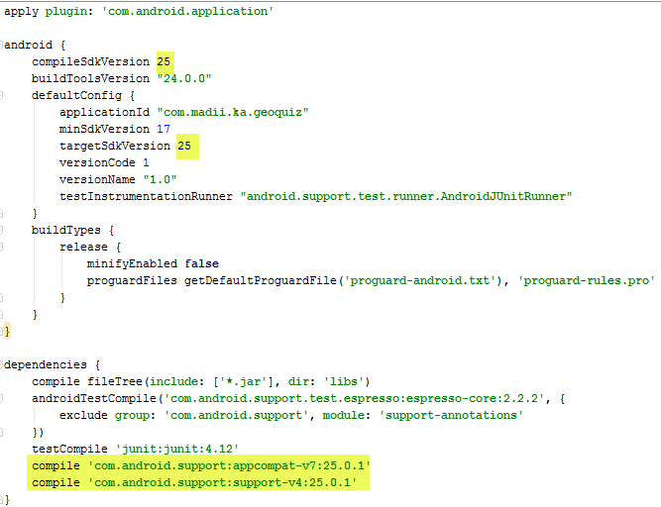

GUI
- Go to File Project Structure.
- In the window that opens, select the app tab from the left pane, and then the Dependencies tab from the right pane.
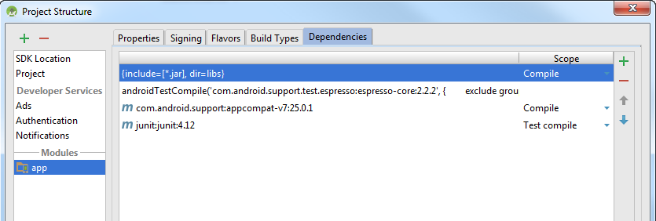
- You need to delete the highlighted blue line and then two options highlighted in the red box. Use the plus button and select Library dependency to add the new options required and use the minus symbol to delete.
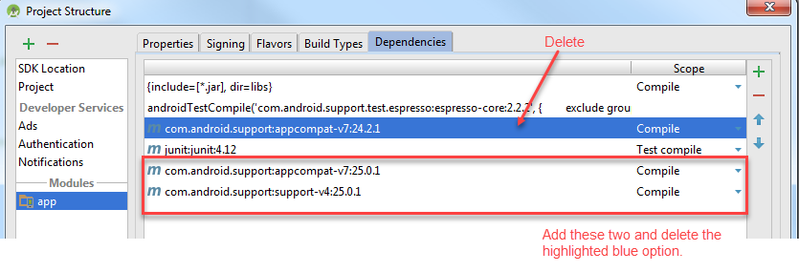
- When done, open up your build.gradle file – you may need to check that there is no SDK version conflict. Compare it with the screen shot above.

Exercise 2: Creating the Model
- Create a new Java Class called Crime.
- Each Crime has the following data. Create the private members and generate the getter and setter methods, if applicable, as indicated.
Member Name | Type | Getter | Setter
Id | UUID | Yes | No
Title | String | Yes | Yes
Date | Date | Yes | Yes
Solved | Boolean | Yes | Yes

- Add the following constructor method to the Crime class.
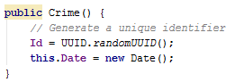
- You will add more to the model in later lectures.

Exercise 3: Creating the View

Adding String Resources
- Add the following string resources:
Name | Value
crime_title_hint | Enter a title for the crime.
crime_title_label | Title
crime_details_label | Details
crime_solved_label | Solved

The Layout

The Fragment Container
- Open up the activity layout file.
- You will use a FrameLayout for the activity page, which will act as a container for the UI fragments. Make the following changes:
  - Change the layout used from a RelativeLayout to a FrameLayout.
  - Change the ID to the more generic fragment_container as this activity will be a container for different UI fragments.
  - Delete the default Text View added to the activity.
- Save your changes.

The Crime Fragment
- You need to create a fragment for this.
- Right-click on your app package folder in the java folder and select New Fragment Fragment (Blank) and create a new fragment called CrimeFragment or whatever you want.
  - Check the option to Create the layout XML
  - Uncheck the other two options shown, as you don’t need Android to create a lot of extra code you do not need.
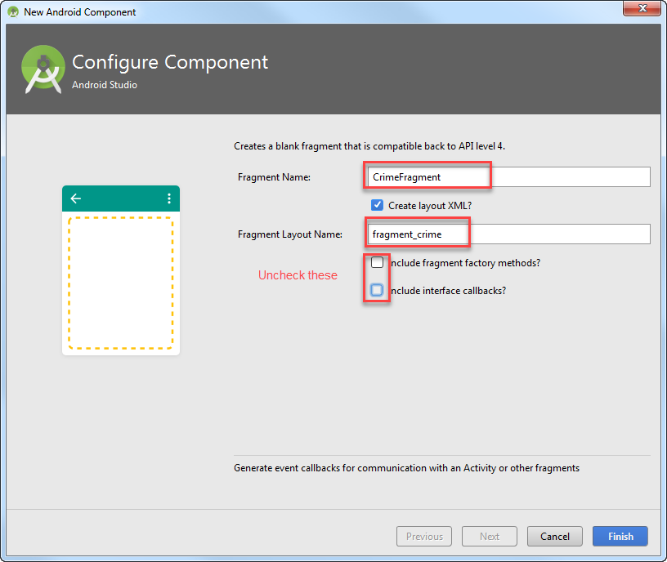
- Open up the fragment’s XML layout view.
- Change the default FrameLayout to a Linear Layout and add (replace the default content) the view objects listed below.
- Text View: represents a label for the input field for entering the title of the crime field.
  - The style attribute added is one of Android’s predefined theme styles. You can also create your own styles.
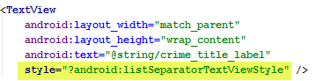
- Edit Text: an editable field to input the title of the crime committed.
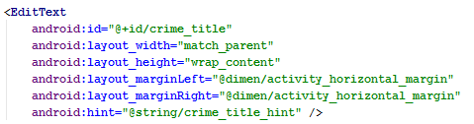
- Text View: represents the crime details.
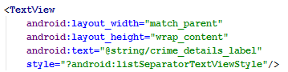
- Button: represents the date the crime was committed. While it may seem strange that we are using a button field, this will be used later for a date picker.
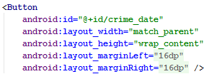
- Checkbox: used to indicate whether or not the crime has been solved.
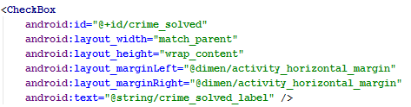
- That’s the layout done for now.

Exercise 4: Creating the Controller
- By default, activity classes inherit from the AppCompatActivity class. As the CrimeActivity is going to host fragments, you need to update this to inherit from the FragmentActivity class instead.
- Open up the Crime Activity java file and make the following change.
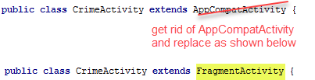
- Fragments to be hosted will be added dynamically using code. It provides a more flexible approach than adding the fragments manually to the layout files.

The Crime Fragment Class
- The crime fragment java class is the controller that interacts with the model and view, providing details of a specific crime to the user and updating the model when the user makes changes.
- Open up the Crime Fragment Java class created earlier.
- First things, make sure the class is inheriting from the right Fragment class. In the imports section, you want the following:
- Add a private member called Crime to the crime fragment represent the Crime to be displayed to the user.
- Override the onCreate(Bundle) method in the class – note this is not the default onCreateView that has already been added.
Info: Unlike an activity’s onCreate method, which is protected, a fragment’s own is public to enable hosting activities access to them.
- In the fragment’s onCreate() method added in the last step, initialise the crime variable created to a new Crime object instance.

Access to the Layout View Objects
- Create private member variables to reference the different view objects.
  - crimeTitleText
  - crimeDateButton
  - crimeSolvedCheckbox

The onCreateView() Method
- Locate the onCreateView() method. Make the following changes to this method.
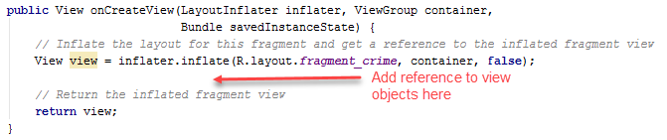
- Next, use Android’s findViewById() method to initialise each of these objects in the onCreateView() method before it returns the inflated view. An example is shown below – do it for the three view objects.
Info: you have to use the onCreateView() method as the view objects are not yet available in the onCreate() method.
- Set the text for the date button to the crime model object’s date property.
// Set the date button to the current crime object's date
- Disable the date button for now.
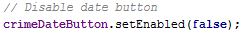
- Also, you are going to initialise the button’s text with the Crime

Create Event Listener Methods
- Create a TextWatcher for the CrimeTitle Edit Text and correctly link it to the variable representing the crime title field. It will create three events: afterTextChanged, beforeTextChanged and onTextChanged.
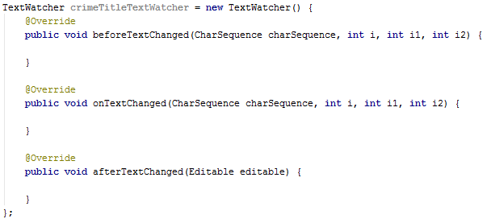
- Create a CheckBox.OnCheckedChangeListener for the crime solved checkbox and also correctly link this to the corresponding variable.
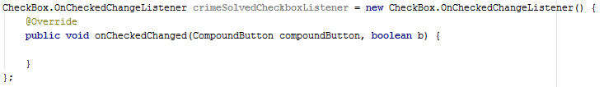
- Link the methods to the corresponding view object variables in the onCreateView() method.
- Next, locate the onTextChanged() method in the Text Watcher and add the following to update the model based on the user’s input.
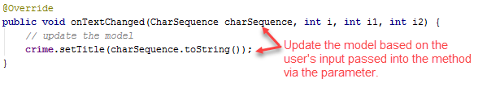
- You will do the same for the crime solved checkbox and use its value (checked or not) to update the model.
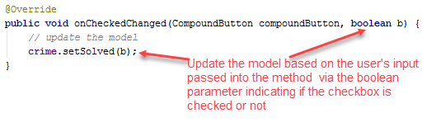

Exercise 5: Loading the Fragment
- Return to the CrimeActivity Java file.
- The activity needs to locate the fragment and load it. You use the Fragment Manager to handle this.
- First get a reference to the fragment manager as shown. You are using the support fragment because you are using the support library version.
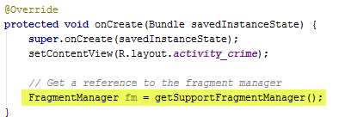
- Next you need to create the fragment transaction.
- First you need to make sure that the fragment has not already been added to the view. Do this by searching for the fragment container.
Note: You do this to avoid creating multiple instances when the activity is destroyed and recreated (e.g. app loses focus, device is rotated, etc.). Existing fragments in the view will be part of the state saved.
// Search for the fragment container that the crime fragment will be added to.
- Check that the fragment does not exist and if it doesn’t create a transaction to add the new fragment – note how the transaction methods have been chained together.
// Check that fragment container does not already exist
// Create the required fragment
// Begin a transaction to add the fragment to the fragment container
// and commit the transaction
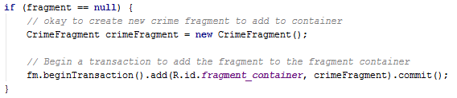
- Save your changes and preview.

Exercise 6: Making a Landscape Version of the Crime Fragment
- Go back to your crime fragment Layout file and switch to the design view.
- Use the graphical tool, as shown, to help you initially generate a landscape version of the fragment.
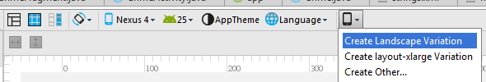
- Apart from the button, the generated layout doesn’t look too bad.
- You will, however, move the button and the checkbox into a nested linear layout.
- Just after the crime details text view create a linear layout with the following properties:
  - Orientation: horizontal
  - Layout width: match parent
  - Layout height: wrap content
  - Margin left and right: horizontal margin (16dp)
- Drag the “Date” button and the “Solved” checkbox into the linear layout and add the following Android property to both of them:
  - Layout weight: 1

Exercise 7: Extending the Model
- In this exercise, you will extend the model to include a CrimeLab class – this will be centralised repository (collection) for all Crime objects.
As it is a centralised repository, only one instance is needed. Thus, you will use the Singleton pattern to implement it. You will store the List of crimes in a singleton. A singleton exists as long as the application stays in memory, so it will keep the crime data available throughout any lifecycle changes in the activities and fragments. Note: Singleton classes will get destroyed once Android removes your application from memory.
- Create a new Java class called CrimeLab. Note: Android Studio does have a templating tool for generating a Singleton when you create a new class, but the generated class does not really adhere to the pattern implementation practice.
- Add the private instance to itself first.
// private instance
- Add the private constructor. The constructor will also accept one parameter of type Context. This is allowed.
// Private constructor, accepting one parameter
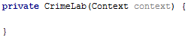
- Now implement, the public get method. Remember, you need to check if the instance exists first, and if not initialise it.
// Private get method that returns the instance
// Check that instance exists first
// If not, create (initialise) it
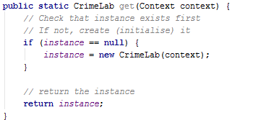
- Recall that the purpose of the Singleton class is to provide access to a List of Crimes in the application. You need to add a property to represent this.
- Add the following private member that will be used to store the list of crimes.
- Modify the constructor to initialise the Crimes private member to a brand new empty list when the Singleton first becomes available.
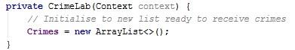
- Generate a getter only for the Crimes private member.
- Next, you will add a private method to return a Crime with a specified UUID (the unique identifier of a crime).
// Return the crime with the specified id
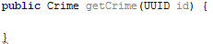
- Loop through the crimes and return the Crime if a match to the specified id was found, otherwise return null.
// Loop through the Crimes
// If the Id matches the passed in parameter value
// Return the crime
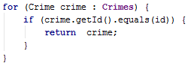
// Otherwise, mo match was found
- Next, you are going to modify the constructor to generate a set of dummy crimes that can be used for now in the app. Every other crime generated, will be set to solved. This will allow you to use this list for the List fragment you will create in the next class and produce an output similar to the figure shown.
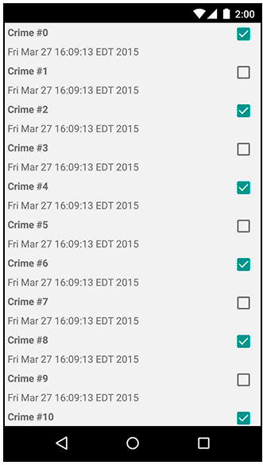
- Go back to the constructor method and add the following:
// Generate a set of dummy crimes
// Every other crime is set to solved (true),
// if there is a remainder when the loop variable
// is divided by 2

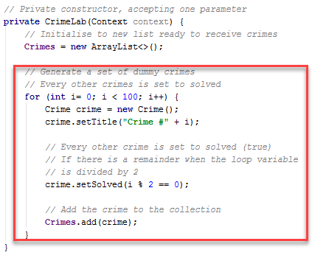

- Now you have a model that can be used for a List Detail UI interface. You will implement the List fragment in the next class.
- That’s all for today

Adapted from Android Programming: The Big Nerd Ranch Guide
Image from Android Programming: The Big Nerd Ranch Guide, Pg. 167

